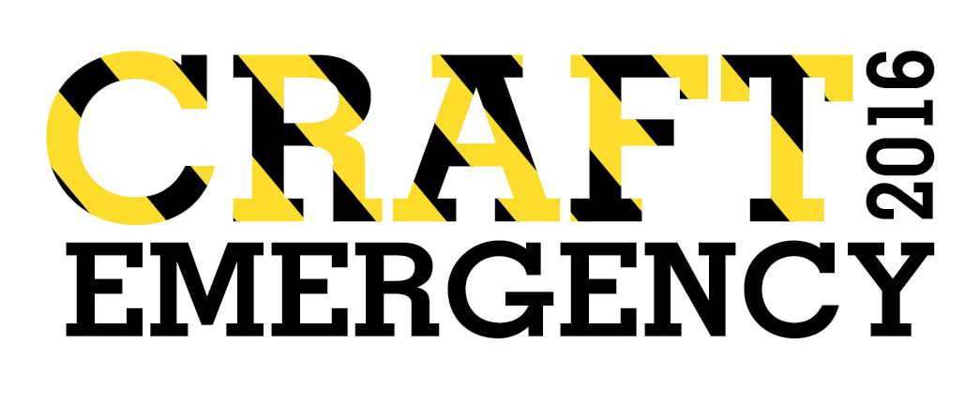


CRAFT EMERGENCY is Aspex’s open submission craft and design group exhibition, which seeks to highlight the work of emerging designers and makers working in all media. This years CRAFT EMERGENCY is in collaboration with Making Space, a studio and craft development organisation located in Havant. Submissions can be made by artists from anywhere in the UK or abroad. There are no age restrictions and we are looking for applications from anyone who considers him or herself an emerging artist, but undergraduate students must be in their final year of study. The exhibition is not themed. We will be exhibiting a selection of craft and can accommodate work designed for exhibitions or for retail.

Deadline for submissions: Sunday 10 July 2016

Please see below for full Terms & Conditions.

Prize A prize of a solo exhibition at Aspex, including artist’s fee, will be awarded to ONE selected artist.

Selectors: Annabelle Campbell, Head of Exhibitions & Collections, Crafts Council
Lynne Dick, Director, Making Space
Thomas Appleton, Letter Carver & Stone Mason
Jo Bushnell, Director of Aspex

Exhibition dates: 25 November 2016 – 22 January 2017

Submissions Procedure:
Please read the following information carefully and ensure that you complete the application form in full, enclosing the following material:
- Printed hard copy or digital version of completed application form.
- An up-to-date CV/resume. (Max 2 pages)
- Maximum 5 Images (please see specifications). No further supporting material will be considered.
- Return postage & self addressed packaging for return of submission if necessary.
- Submission fee £15 sterling, (please see payment methods).

Submission specifications:
- We accept applications by post or upload
- Moving image submissions must be edited to a showreel of a maximum of 5 minutes including up to 5 works. Please do not submit whole works. Blu-ray cannot be accepted.
- Please ensure that all supporting material in digital format is Mac compatible.
- Preferred formats are jpegs, tiffs, mov, avi, mp3, wave and Mpeg 4.
- Total size of submission (images and text) should not exceed 20mb.
- Please submit single images only. No powerpoint/keynote presentations please.
- All uploaded files MUST be clearly labelled with the artist’s name and number corresponding to works listed on the application form

Payment Methods:
The submission fee payment is £15 sterling.
Please pay in one of the following ways:

- Charity Check out via www.aspex.org.uk/craftemergency.
- Complete application with your credit/debit card details. You will be notified once payment has been taken and receipt will be issued if required.

Reference number – office use only

CRAFT EMERGENCY: Application Form (Please use BLOCK CAPITALS)
This application page must be included with your submission

Artist information

Name
Address

Postcode
Country
Telephone
Email
Website

Payment amount Please tick appropriate box

 £15 sterling

Payment method Please tick appropriate box

 Credit/debit card details (fill in details below)  Charity Checkout (enter order No. below)

Full name on card
Address card is registered to (if different to above)
Card number |  |  | Type of card
Expiry date |  | Security code |  | Issue number
Charity Checkout Order No.

Submission information Please tick appropriate box

Type of submission

 Images  Moving Image

1: Title
Date
Medium
Dimensions
Duration

2: Title
Date
Medium
Dimensions
Duration

Reference number – office use only

3: Title
Date
Medium
Dimensions
Duration

4: Title
Date
Medium
Dimensions
Duration

5: Title
Date
Medium
Dimensions
Duration

Personal statement

Please include a 100 word max statement about your work in general or the specific work submitted

Returning submissions
Would you like your submission to be returned:

 Yes  No

If yes you must supply an appropriate stamped self addressed envelope.
If no submissions will be discarded 3 months after the deadline.
General Terms & Conditions (Please read carefully)

- Applications must be sent by post, or uploaded via www.aspex.org.uk

- Do not submit ORIGINAL artworks. No hard copy photographs or slides can be accepted

- All supporting material in the form of digital media must be Mac compatible.

- All supporting material in the form of video (DVD & moving image files only) must be edited to a show-reel of a maximum of 5 minutes.

- A maximum of 5 works may be submitted per applicant.

- A maximum of 5 images or moving images may be used to describe the works (i.e. 4 images and 1 moving image). If more is submitted only the first 5 will be seen.

- Each submitted work must be clearly identified on the Application Form (title, date, medium, dimensions), including a 100 word max statement.

- Each application must be accompanied by a submission fee of £15 sterling, to be paid by card, via Charity Checkout, cheque (made payable to aspex gallery) or cash.

- Undergraduate students must be in their final year of study.

- Only original and recent works (made in last 3 years) are eligible.

- Works in all media will be considered.

- Where return postage & packing has not been supplied, submitted materials will be discarded 3 months after the submission deadline.

- The deadline for receiving submissions by post is Sunday 10 July 2016.

- Receipt of payment will act as confirmation that you agree to the terms and conditions of CRAFT EMERGENCY.

Shortlisted Exhibition Terms & Conditions

- Each selected artist will be responsible for the transportation and in-transit insurance to and from the gallery of their own work.

- Works included in the exhibition with a value of £5,000 or more cannot be covered by the gallery’s insurance.

- Works offered for sale will be subject to a 50% gallery commission.

- Selected artists will be notified by Friday 29 July 2016.

- The selectors’ and prize givers’ decision is final.

Reference number – office use only

In order to comply with the Data Protection Act, aspex requires your permission to hold your personal details on file. If you would like to be added to or remain on the aspex database, please tick the relevant options and sign below.

 I would like to be included on the aspex database and agree that the personal details given on this form will be used by aspex only.

I would like to be included on the aspex email list. My email address is:

I have read the purposes for which my personal data will be held and used by aspex, I understand and agree to the uses I have selected and I agree to the Terms and Conditions of CRAFT EMERGENCY.

Signed
Date

Postal applications:
CRAFT EMERGENCY
aspex
The Vulcan Building
Gunwharf Quays
Portsmouth
PO5 3BP

Upload Applications:
www.aspex.org.uk and follow the CRAFT EMERGENCY links.

Further information:
T: 023 9277 8080
www.aspex.org.uk
info@aspex.org.uk

Aspex Visual Arts Trust is a registered charity (1007620) & is financially supported by Arts Council England & Portsmouth City Council

