SECURITY USING SOFT ENIGMA

Ananth C.M. & Shahul Hameed A.
III M.Sc. Software Engineering
Department of Computer Applications
Sri Krishna college of Engineering and Technology
Coimbatore-64 1008, Tamil Nadu, India
E-mail: ananthcm@gmail.com
Ph.no: 9043727908

ABSTRACT — Today security concerns are on the rise in all areas such as banks, governmental applications, healthcare industry, military organization, educational institutions, etc. Government organizations are setting standards, passing laws and forcing organizations and agencies to comply with these standards with non-compliance being met with wide-ranging consequences. There are several issues when it comes to security concerns in these numerous and varying industries with one common weak link being passwords and confidential statements. Most systems today rely on security in confidential messages. However, such messages come with major management security concerns. Users tend to use easy-to-guess statements, use the same in multiple accounts, write the message or store them on their machines, etc. Furthermore, hackers have the option of

Using many techniques to steal passwords such as shoulder surfing, snooping, sniffing, guessing, etc. Several proper strategies for u sensitive data have been proposed. But they didn’t meet the company’s security concerns.
I. INTRODUCTION
The Most systems today rely on static passwords to verify the user’s identity in online transaction, but it is not implemented in credit card user in online transition. By using static passwords there is no full authentication and any one can hack that even. Later there exist some third party organizations where they have introduced Tokens. Token is a hardware device which is provided externally to every account holder. By this we have some problems like; cost of purchasing is more, issuing of token is overhead and the system requires multiple tokens and even these may be lost or stolen. This secret key is sent to the account holder’s mobile directly using the GSM Modem. To generate the dynamic password using the personal information of the card holder and the current date, day, time and is send to the customer and the key is valid for the short duration of three minutes. Firewall is a type of security system that creates a wall that checks all incoming and outgoing messages to ensure only authorized traffic goes through. There are many different forms of this application such as Norton and Windows Security Essentials. Another way to protect your information is encryption. Encryption basically scrambles and makes any message sent unreadable to anyone who does not have a key. The key is then used to decrypt the scrambled message into the original format. Whenever you go to a website that has an S after the HTTP that means it is a secure web page. Meaning the entire web page is encrypted, so people hacking to your web browser cannot get you credit card number or SSN. A VPN creates a link between the user and some other destination. In order to access the VPN you will need a username and password, in order to keep it more secure and to block out hacker.

2. RELATED WORK
We study the impact of selected parameters on the random number generator (RNG) is a computational or physical device designed to generate a sequence of numbers or symbols that lack any pattern, i.e. appear random. The many applications of randomness have led to the development of several different methods for generating random data. Because of the mechanical nature of these techniques, generating large numbers of sufficiently random numbers (important in statistics) required a lot of work and/or time. Thus, results would sometimes be collected and distributed as random number tables. However, carefully designed cryptographically secure computationally based methods of generating random numbers do exist, such as those based on the A good deal of research has gone into pseudo-random number theory, and modern algorithms for generating pseudo-random numbers are so good that the numbers look exactly like they were really random.

3. IMPLEMENTATION
3.1 System Design
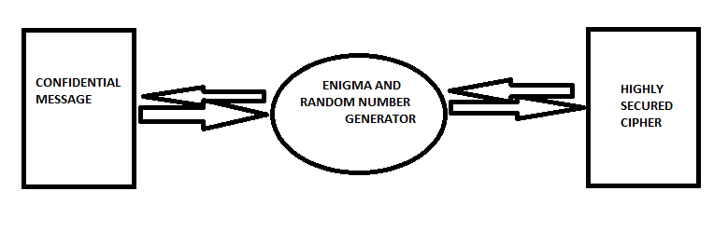
3.2 IMPLEMENTATION DETAILS
3.2.1 Key setting phase
Enigma featured the major operational convenience of being symmetrical (or self-inverse). This meant that decipherment worked in the same way as encipherment, so that when the cipher text was typed in, the sequence of lamps that lit yielded the plaintext.
Identical setting of the machines at the transmitting and receiving ends was achieved by key setting procedures. These varied from time to time and across different networks. They consisted of setting sheets in a codebook which were distributed to all users of a network, and were changed regularly. The message key was transmitted in an indicator as part of the message preamble. Confusingly, the word key was also used at Bletchley Park to describe the network that used the same Enigma setting sheets. Initially these were recorded using colored pencils and were given the names red, light blue etc., and later the names of birds such as kestrel. During World War II the settings for most networks lasted for 24 hours, although towards the end of the war, some were changed more frequently. The sheets had columns specifying, for each day of the month, the rotors to be used and their positions, the ring positions and the plug board connections. For security, the dates were in reverse chronological order down the page, so that each row could be cut off and destroyed when it was finished with.
3.2.2 Message phase
The original message consists of plain text .These plain text is taken for encryption. The plain can be a character or numeric values or alphanumeric, whatever the data type of the message it can encrypted in soft enigma.

3.2.3 Ciphered Phase
The message that is been ciphered consist of key and the cipher text. Using the cipher text we can decrypt the data back by reversing the process of the encryption .The main implementation of soft enigma is that by combining the concept of enigma with time variant random number. This involves random number generation which is based on the time the user starts to encrypt. This time is noted and it is used as the key for the random number generation. Once user enters the message the ASCII value of the message is obtain and using which the substitution of alternate value is the result of the enigma computation.
Protocols | Security Of data | Anti- Key logger | Key Reuse
Soft Enigma
DES-EEE3 |  |  | X
Phool Proof |  | X | X
4. PERFORMANCE ANALYSIS:

5. CONCLUSIONS AND FUTURE WORK:
Conclusion:
The key escrow encryption has emerged as one approach that can meet the confidentiality and data recovery needs of organizations while allowing authorized government access to fight terrorism and crime. It can facilitate the promulgation of standards and products that support the information security requirements of the global information infrastructure.
Future Work: Future work proposed is to implement the Soft Enigma along with the time variant random numbers to encrypt the most Sensitive Data into a successful project for the confidential data maintaining sectors.

6. REFERENCES
1. Applied Cryptography - Alfred J. Menezes, Paul C. van Oorschot and Scott A. Vanstone

2. The code Breaker – David kahn
3. Theory to cryptography: From enigma – David joyner

