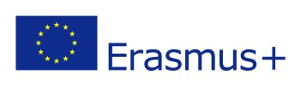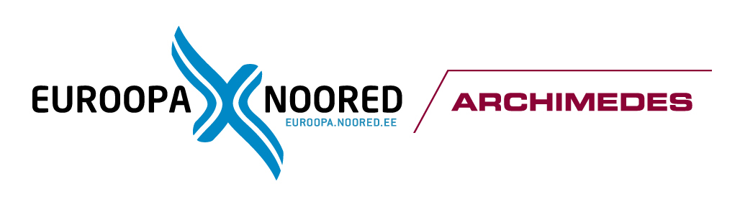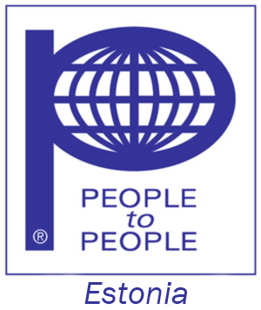

“Youthpass – your path”
August 11-18, 2016
Taevaskoja, Estonia
The project is granted by Estonian NA

Introduction

"Youthpass - youth path" Erasmus+ Programme Key Action1 project for youth workers aims to improve exchange of the best practices in youth work in Europe, partnership between youth organisations and enhance quality of training and youth work in Europe. The main topic for this project is Youthpass as certificate of the recognition of non-formal education and also learning process of youth workers and young people. Applicant organisation is Eesti People to People (Estonia) www.ptpest.ee

Every country is currently reforming public education and within this transition phase non-formal education and intercultural learning are spreading out. Always more, governments recognize them as key elements for civil society development. One of the most debated issues is the recognition of non-formal competences. Since 2007, year when the Youthpass was launched, youth workers and professionals in the youth field have been seeking on familiarizing with such tool, and of course, not without concerns and disputes. Participants of this project will share their experience and best practices from non-formal education when work on 8 key competences and on Youthpass which can be and often is path to future education and employability.

Specific objectives of "Youthpass - your path" project are:
- To familiarize participants with the concept of Youthpass as learning program and its possibilities within the outside of Erasmus+ Programme.
- To explore the 8 key competences in details.
- To develop participant’s competences in planning non-formal education with particular attention on structured learning processes.
- To set up strategies for the better recognition of youth work and non-formal education.
- To share tools and methods from partners' and other organisations in order to support young people self-learning and self-assessment.

This project is designed in a way that has preparatory stage on June-July 2016, the training course for youth workers in Taevaskoja, Estonia on August 11-18, 2016 and follow-up and dissemination activities on August-September 2016. Youth workers from Austria, Bulgaria, Czech Republic, Finland, Italy, Poland, Portugal, Romania, Spain, UK, Latvia and Estonia will participate in the training course and then will be multipliers of new gained competences in their organisations and countries. Trainers from Estonia and Poland and facilitators from Estonia and UK will run the training course and other project activities.

The project will bring together youth leaders, workers, trainers and teachers to speak up about Youthpass certificate and its’ creation, validation and recognition as non-formal education document.

PROFILE OF THE PARTICIPANTS:

This project and its training course is targeted at first for the leaders of youth organisations, also youth workers, young leaders, teachers and volunteers who work with youth on daily base, use non-formal education methods and have need to learn in deep about Youthpass. They have experience of working with young people with fewer opportunities, coming mostly from the regions where rates of unemployment are particularly high and at the same way, there are undeniable obstacles which influence the access to the labor market.

- Partners organisations will send 3 participants per country to the training course in Estonia.
- Youth workers, youth leaders and teachers who work with non-formal education methods and are interested to practice different methods of non-formal education and to empower young people within an certification of non-formal education in ERASMUS + projects;
- Youth leader and workers would like to share their working experiences with Youthpass and contribute with specific expertise in the field of inter-cultural activities;
- Youth workers would like to act as multipliers and can share their experiences with youth leaders and young people in their countries after the training course in Estonia;
- Youth leaders and youth workers share the information about their organization, institution and about the training activities in which they have been involved;
- Youth workers and leaders can take responsibilities and have motivation be involved in evaluation, dissemination and follow up process;
- Youth workers and leaders will take responsibility to organize dissemination activities on a local level.
- The participants should be over 18 years old.

ACCOMMODATION/FOOD
The accommodation and food will be provided during the project time between August 11-18, 2016. The accommodation will be in multiply rooms in Taevaskoja Holiday Center www.taevaskoja.ee
Eesti People to People members will provide instructions how to go from the airport to Ülemiste train station and take trains to Taevaskoja (about 3 hours by trains from Tallinn with connection in Tartu 3 times every day) www.elron.ee

PARTICIPATION FEE: Euro 50.00

TRAVEL COST INFORMATION:

The travelling costs are covered for all the participants in the specific limits offered by Erasmus+ conditions. The participants need to organize their travel the most economical way according the project dates. The travel costs will be covered upon the receipt of all needed documents.
Your travel expenses will ONLY be reimbursed upon presentation of documentary evidence of the sum ACTUALLY PAID and you need to present:
1. Original Invoices
2. Original travel tickets (train, flight or bus)
3. Bank /credit card overview with your e-tickets payment
5. Original boarding passes for airplanes

MEDICAL / TRAVEL INSURANCE:
Participants need to cover their own medical/travel insurance and send them to ptpest@hot.ee together with their tickets.

Application form
Answer the questions below:

Country
Name and Surname
Gender
Date of birth
Place of birth
Email of the applicant
Address of the applicant

Your experience in Youth work

Motivation:
(Why you would like to participate)

How you imagine to continue the work after the project- the follow up steps

The application form please, send by email :
Deadline : June 20, 2016
alena.jeslinkova@gmail.com

