A Study of Intelligence-Diagnosis Method “HID” for Global Production Strategy:

- Development of “Advanced TPS” Using New JIT at Toyota -

Hirohisa Sakai
Toyota Motor Corporation
1 Motomachi, Toyota-shi, Aichi-ken, 471-8573 Japan
Tel: +81.565.71.4864 Fax: +81.565.71.4952
E-mail: h_sakai@mail.toyota.co.jp
Kakuro Amasaka
Aoyama Gakuin University
5-10-1 Fuchinobe, Sagamihara-shi, Kanagawa-ken, 229-8558 Japan
Tel: +81.42.759.6313 Fax: +81.42.759.6556
E-mail: kakuro_amasaka@ise.aoyama.ac.jp

Abstract- The Japanese manufacturers today have established their production facilities and are operating for global production strategy. To overcome this sense of crisis, the authors believed it crucial to improve the intelligence skill level of the production operators who are the foundation of manufacturing. The authors recognized the requirements for ‘creating a new production system: “Advanced TPS” that centers around people,’ where they can be more creative and find their jobs worth working for. As a solution, the authors have suggested ‘HI-POS’ (Human Intelligence-Production Operating System) which was designed to realize improvement as the intelligence operator. In this article, the authors suggested implementation of ‘HID’ (Human Intelligence Diagnosis System), which is the core system of ‘HI-POS’ for global production strategy and assessed its effectiveness at Toyota, a leading global company. More specifically, the authors discussed the training processes for the assembly line operators in order to become more intelligent.

Keywords- Global production strategy, Advanced TPS, New JIT, HI-POS, core system (HID)

1. Introduction
Recent Japanese enterprises have been promoting “global production” to realize “uniform quality worldwide and production at optimal locations” for survival through severe competition. Considering the production environment surrounding those manufacturing enterprise, therefore, this paper verifies the effectiveness of the authors’ proposed the Advanced TPS by excellent manufacturing technology as the key to successful strategy at Toyota, a most advanced automotive manufacturing enterprise [1-2].
Therefore, the authors considered the necessity of including the above with strategic application of the TPS, and clarified the Advanced TPS as the key to success in global production by excellent manufacturing technology. Nowadays, the authors believed it crucial to improve the intellectual skill level of the production operators who are the foundation of manufacturing. The authors recognized the needs for ‘creating a new production system that centers around people’, where they can be more creative and find their jobs worth working for. As a solution, the authors have suggested ‘HI-POS’ (Human Intelligence-Production Operating System) which was designed to realize improvement in intellectual productivity. Furthermore, the authors applied this system to ‘TOYOTA’, a leading global company, and are discussing its effectiveness in this paper.
In this article, the authors suggested implementation of ‘HID’ (Human Intelligence Diagnosis System) which is the core system of ‘HI-POS’ for global production strategy and assessed its effectiveness at TOYOTA. More specifically, the authors discussed the training processes for the assembly line operators. To realize improvement in the intellectual productivity of the production operators, a new modeling method called ‘TLSC’ was introduced. ‘TLSC’ consists of (1) visualization of advanced production processes and (2) an evaluation method of the production processes to eliminate production bottlenecks that obstruct advanced production and quality assurance.

2. Background- Necessity of New Manufacturing Technologies
The manufacturing companies may be dismissed unless they develop their own ways of manufacturing to meet the needs of the day by appropriately judging customer requirements. It is generally perceived that the Japanese style production system represented by the TPS was Japan’s manufacturing technology, which contributed to the world in the latter half of the 20th [3-5]. Today when most consumers can obtain the most recent information in the world thanks to the developing IT, however, the ability to supply highly reliable products with enhanced value for customers ahead of competitors is an important task. For the realization of production, with the top priority given to customers, creation of core technologies is indispensable. Rapid establishment and development of new manufacturing technologies will enhance production processes in all departments related to management and ultimately realize production with high quality assurance from the viewpoint of high corporate reliability [6-7]. Even Toyota is not an exception with regard to these challenges. The TPS has already been established in the form of an internationally accepted JIT [8], and is no more an exclusive technology of Toyota. Importance of quality assurance is being recognized in the United States through the study of Japanese TQM. Because of the spread of TQM in the United States, the quality superiority of Japanese products is decreasing gradually [9-10].
In order to compete in this severe quality competition all over the world hereafter, it is not recommend to be prepossessed with previous successful experiences. In other words, it is an urgent issue to establish the advanced new model instead of the traditional TPS (Toyota Production System) toward the global production.

3. Advanced TPS, Key to Successful Strategy using New JIT at Toyota
In recent years, ‘a new production system that centers around people’ concept has been expanding to cover the quality of business processes and company management in addition to product quality. Along with this trend, the area of business administration activities has been widened. To create customer-oriented attractive products, therefore, we proposed “Advanced TPS” [1] toward the establishment of Toyota’s global production strategy.
The mission of the Advanced TPS for global deployment strategy is to realize CS (customer satisfaction) and ES (employee satisfaction) through production with high quality assurance and shortening of production preparation. In implementing the Advanced TPS for uniform quality worldwide and production at optimal locations (concurrent production), renewal of production management systems appropriate for the intellectual skill level of the production operators is the fundamental requirement. In more definite terms, one is to strengthen the process capability maintenance and improvement by establishment of an intelligent quality control system. The second is to establish a high-reliability production system for high quality assurance. The third is reformation of the work environment for enhancement of intelligent productivity. The fourth and last is to develop intelligent operators (skill level improvement) and to establish an intelligent production operating system. The authors considered the necessity of including and organically integrating these four elements with strategic application of the TPS in view of global production, and clarified the Advanced TPS as the global production technology and management model as shown in Figure 1 [11-13].
It is the implementation of high quality assurance utilizing digital engineering that the necessary requirement in order to succeed the global production, which is the manufacturing issue toward “the advanced manufacturing”, as shown in Figure 1.
So the expectation for the Advanced TPS is realized the following, (a) Intelligent quality control system, (b) High reliable production system, (c) Renovating work environment and (d) Bringing up intelligent operators. It is the realization of “high-cycle of production process in production division” toward the quick realization of “uniform quality worldwide and production at optimal locations”.
In the future, reformation of the production workshops transformed by production processes and facilities, and progress of the TPS for high quality assurance making the most of the intellectual skill level of the production operators will further be required. By using core technologies (a) through (d), in order to global production -same quality worldwide, production at optimum locations, - concerning production processes and facilities, we established
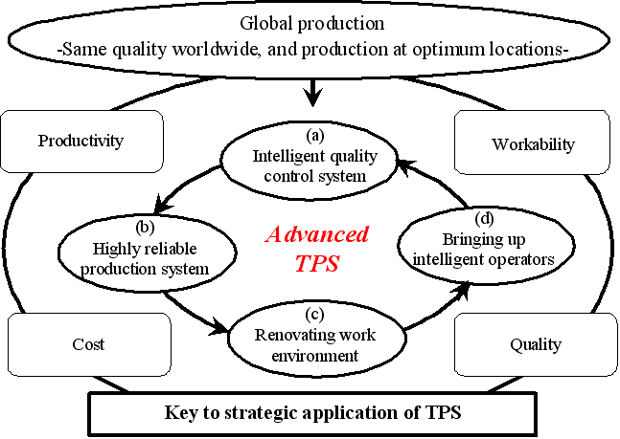
Figure 1Advanced TPS, as global production technology and management model

manufacturing technology for global production by proposing and implementing ‘HI-POS’ to align optimum in productivity, workability, cost and as well as quality when we start up the global production both domestic and overseas plants. In this paper, we give a report of ‘HID’ which is the core system of ‘HI-POS’ for global production strategy.

4. Needs for improving human intelligence diagnostic capability of production operators
Today, Japanese manufacturers are rapidly deploying global production in an effort to realize ‘High-quality, customer first manufacturing’ throughout the world. Hasty expansion of production facilities overseas has resulted in numerous new issues that challenge the Japanese ‘High-quality manufacturing.’ Automobile manufacturers, for example, are proliferating ‘advanced production system technologies’ all over the world to achieve the same productivity (QCD level) as that in Japan. Unfortunately, some of those facilities show lower productivity (availability) than that of their counterparts in their homeland.
The primary reason for this is a realistic issue. As compared to the Japanese production operators, those in other countries often have less ‘intelligence diagnostic capability’ that helps them quickly discover and correct factors obstructing high quality, instead of being dependent on the performance of the production equipment. In Japan, for example, as shown in Table 1, intelligence production operators (skilled labor) predict equipment failures based on noise and vibration and prevent the equipment from breaking down. Those intelligence production operators are a fruit of the time-consuming, man-to-man (face-to-face), acquired skills training
Table 1. Comparison of the characteristics between Japanese and Overseas operators
item | Japan | Overseas
Actual activity | Prediction of equipment failures based on noise and vibration and prevention of equipment from breaking down | Exclusive placement to operation relative to manufacturing (depending upon operation relative to maintain and repair of equipment (for instance; discovery of sign for equipment defect upon maintenance operator)
Transfer of skill | Time-consuming, face-to-face, on the job training | on the job training ⇒ they cannot be accomplished by human wave tactics
Misc. (productivity; availability) | maintain conventional availability | Lower availability than Japan
(hands-on training) unique to Japan.
Outside Japan, on the other hand, they were no cooperation between the conventional production operator and maintenance one. Concretely, the production operators put themselves to the operation relative to the manufacturing due to the restriction of employ formation, and the maintenance operators engage in the operation relative to maintain and repair the equipment (for instance; discovery of the sign for the equipment defect). So the transfer of their know-how (expertise) between them cannot be accomplished by the human wave tactics.
As a result, the local production operators lack in the diagnostic skills of the equipment failures, hampering proper equipment maintenance and repair, and delaying availability improvement. To reverse this situation, it is imperative to build ‘a new system’ that is designed for global production and that ‘will improve the intelligence diagnostic capability of the production operators’ (improvement and unification of the intellectual skill level).

5. Necessity of Human Intelligence Diagnosis System, HID
5-1. Structure of production operators’ intelligent operation support systems V-MICS, V-IOS and HI-POS
The authors propose V-MICS [14] (A), which improves production operators’ operational technology abilities in regard to integrated equipment, in preparation for global production. This system works to make possible support for improvements in production operators’ operating skills and techniques, such as equipment availability administration, defect analysis [15-16], and other intelligence-based functions. As a result of this, production operators are able to understand the status of their equipment, and establish a system that deals with problems as they occur, resulting in the given benefits. In addition to this, the introduction of a system incorporating computer graphics and databases into new IT-based operating sheets allows operators throughout the world, who function in different languages, to access a unified understanding of their work. The benefits of this system have already been verified and are now being applied.
In addition to this, the authors proposed the intelligent operator educational system V-IOS [17] (B), which improves levels of mastered skills among production operators. The contribution this system makes to the evolution and dissemination of production operators’ mastered skills leads to improved productivity among production operators when setting up a new overseas plant, and the given benefits have already been acknowledged.
As mentioned earlier, the key to global production success lies in improving the intelligent productivity of production operators. In order to achieve this, it is important to ensure that the visualization of the integrated production processes, which are changing so much as a result of the introduction of IT and computerization, is achieved. A basic element of this is the use of V-MICS (C), which facilitates production operators in understanding the whole range of integrated production processes.
Following on from this is the use of V-IOS (D) in raising the level of mastered skills and the dissemination of skills and information in response to the evolution taking place in production.
In addition to this, it is important to establish a system (E) for sharing the latest intelligent information relating to operational technology within integrated equipment, and mastered skills, between production lines and divisions, since this information changes gradually and consistently.
Based on the five viewpoints expressed above (A), (B), (C), (D) and (E), the authors propose that the objective, in other words the improvement of production operators’ intelligent productivity, can be achieved through the utilization of the five core systems shown in figure 2 ((A) V-MICS, (B) V-IOS, (C) HID, (D) HIA, (E) HDP), facilitating a next-generation intelligent production framework. HI-POS is proposed as this system, with the added benefit of realizing a new, people-centered production system.
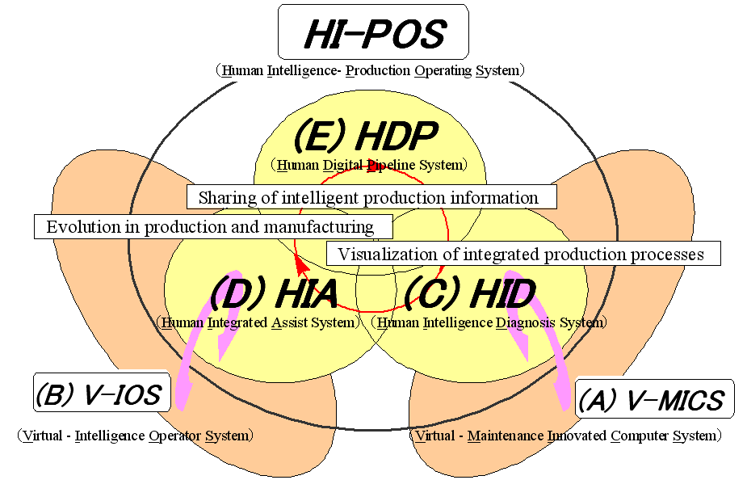
Figure 2 HI-POS architecture

5-2. Necessity of Human Intelligence Diagnosis System, HID
Recently, the authors recognized the needs for ‘creating a new production system that centers around people,’ where they can be more creative and find their jobs worth working for, and suggested ‘HI-POS’ (Human Intelligence-Production Operating System) [18]. There are two fundamental requirements in the suggested ‘HI-POS’ manufacturing, as shown in Table 2.
Table 2. Fundamental requirement for “HI-POS”
Fundamental requirement | Concrete countermeasures
(1) Production system that ensures reliability and serviceability over the entire production line and improvement in ‘operation technologies for advanced production equipment’ | Making advanced production process of manufacturing visible
(2) Securement of technology/skill level of Japanese and improvement of intelligence diagnostic capability of production operators | Allowing production operators to readily grasp status of total picture of advanced production processes
(1) Production system that ensures reliability and serviceability over the entire production line to prevent availability drop or quality defects, and improvement in the ‘operation technologies for advanced production equipment’ (breakdown diagnostics, maintenance, and preventive maintenance of the production equipment).
(2) In a general assembly industry such as the automobile manufacturing industry, many operations cannot be automated, particularly in the developing nations where the production volume is small and many production lines depend on the manual labor. Under the circumstances, it is critical for these nations to secure the technology/skill level of the Japanese to cope with their expanding scope of work. In the developed nations where factories are equipped with advanced mass-production equipment, it is necessary to improve the intelligence diagnostic capability (‘advanced skills’) of the production operators as they build critical qualities into products.
As the authors build a system that accomplishes these goals, the authors need to make the advanced production process of manufacturing visible. In other words, while ‘computerization/digitization’ of the continuously changing ‘advanced production processes’ continues to store the information in a black box forcing decisions to be made by individual judgment, the authors should allow production operators to readily grasp the status of the total picture of the advanced production processes.
To help achieve this visualization, the authors recommend ‘HID (Human Intelligence Diagnosis System)’ as a core system for ‘HI-POS’. It is the item that becomes necessary first，and the core of a new, people-centered production system. More concretely it deals with problem resolution, identification of corrective actions, advance evaluation, implementation of corrective actions, and assessment, that are necessary for making the ‘advanced production processes visible’ as a part of the global production strategy.
The basic elements can be summarized as follows.
(1) When dealing with the advanced production equipment, it is important to focus on the material flow, and then make the total operation status ‘visible’, which includes those specific line components such as equipment, operators, control devices, and computers.
(2) As to the advanced production processes, too, ‘visible production processes’ must be realized by converting the information of the control devices, etc. into the ‘manufacturing engineering data’.
The visualization should reveal the contents of the black box or the know-how about the advanced production equipment and production processes.

6. Building ‘HID’ and its components
Figure 3 shows the concept of ‘HID’ that the authors recommend.
Especially the visualization will be enhanced by the use of ‘V-MICS’ [14]. It allows incorporation of intelligence functions, such as operation control and failure analysis of equipment, to support improvement in the operation skills (techniques and skills) of the production operators.
‘V-MICS’ provides the production operators with the equipment conditions and helps create a
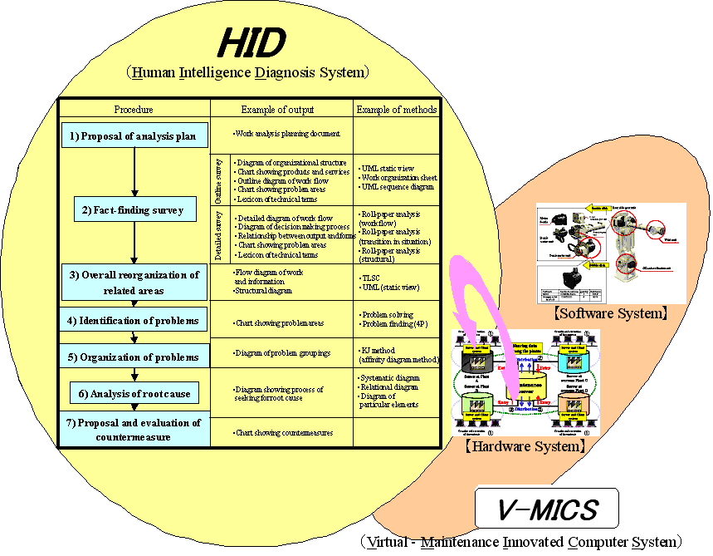
Figure 3Conceptual diagram of ‘HID’

system that is able to process problems should they occur. It has proven to be effective. Additionally, ‘intelligent operation manuals’ are created utilizing CG (computer graphics) and DB (database) for the same purpose. This system offers a single understanding of the operations to all the production operators on the globe with different languages. Its effectiveness has been proven and the system is being utilized.
The components of the ‘HID’ system are shown in Figure 4.
They consist of the following seven steps.
(1) ‘Drafting an analysis plan’ clarifies the objectives and the directions of the analysis.
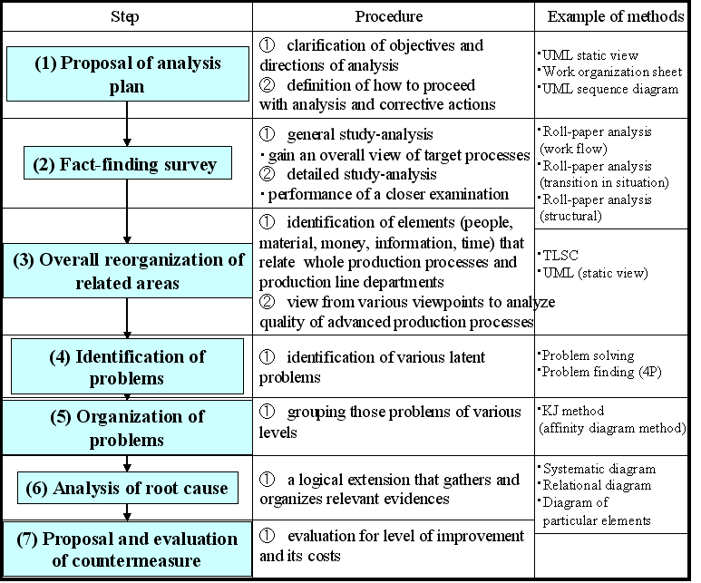
Figure 4Components of ‘HID’

It also defines how to proceed with the analysis and corrective actions for common understanding and agreement among the parties concerned.
(2) ‘Fact-finding’ is performed based on GENCHI-GENBUTSU in accordance with the objectives and directions of the analysis. The fact-finding can be divided into a general study-analysis and a detailed study-analysis. The former attempts to gain an overall view of the target processes and identifies problems. Based on this analysis, the latter performs a closer examination of the problems.
(3) ‘Organizing all problems.’ In this step, all the problems identified are detailed by the elements (people, material, money, information, time, etc.) that relate the whole production processes and the production line departments. Then, these problems are viewed from various viewpoints to analyze the quality of the advanced production processes.
The authors have established and been applying a new modeling method called ‘TLSC’ (Total Link System Chart), which allows evaluation of the contents and the method of KAIZEN that has been implemented.
Figure 5 shows an example of ‘TLSC’. It is characterized primarily by (a) clarification of
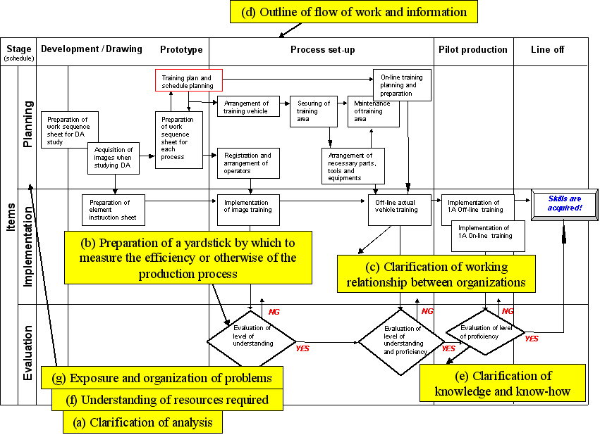
Figure 5 Sample of ‘TLSC

analysis, (b) organized criteria with which to determine the quality of the production processes, (c) clarification of the task relationship among the organization, (d) overview of the task and the information flow, (e) clarification of knowledge and know-how, (f) understanding of resource requirements, and (g) identification and organization of problems.
(4) ‘Identification of problems’ utilizes the above-mentioned ‘TLSC’ and identifies various latent problems.
(5) ‘Organizing problems’ is the process where those problems of various levels are grouped using different methods such as the KJ method.
(6) ‘Finding true causes’ is a logical extension that gathers and organizes relevant evidences.
(7) ‘Corrective actions and assessment’ evaluates the level of improvement and its costs for the corrective action (selected problem).

7. ‘HID’ case study and its Effectiveness
Let us explain an ‘HID’ case study at ‘TOYOTA’, a leading global company. At TOYOTA, the authors applied the suggested Human Intelligence Diagnosis System, ‘HID’ and implemented ‘visualization of advanced production processes’ in their overseas facilities at their production preparation stages. As a result, the authors were able to eliminate what is referred to as ‘rework’.

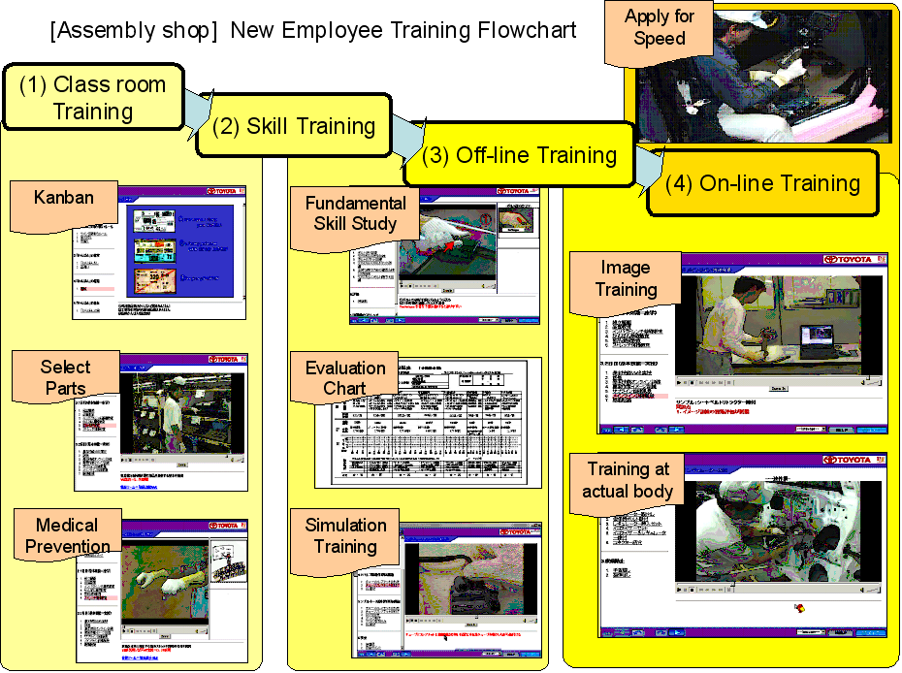
Figure 6 Operator training processes for assembly works

As an example, the operator training processes for the assembly works are shown in Figure 6. The operator training processes are training given upon model changes to new models for the production operators to learn to perform their works accurately in accordance with the operation instruction sheet. In operations such as assembly works in particular, the production operators are expected to complete their works with accuracy within a predetermined time allocation. It is necessary for those operators to reach the target before the model change, at an early stage.
The operator training processes for assembly works provide trainees with (1) class room training, (2) skill training, (3) OFF-line training, and (4) ON-line training in this order.
Once the trainees complete the class room training on quality, safety, etc., they are ready to acquire the skills for actual works. The skill training breaks down the fundamental skills into eight categories, they are; (1) Tightening, (2) Screws and grommets, (3) Attaching, (4) Connectors, (5) Hoses, (6) Hole plugs, (7) Flare nuts, and (8) Inserting. The training also identifies knacks and key points, which are taught in appropriate sequence. The training is repeated until the trainees reach the goals based on the evaluation sheet. For the OFF-line training, an actual vehicle will be used and the trainees receive an OJT on parts assembly on a stationary vehicle, followed, finally, by the ON-line training where they are placed on real assembly lines. The ON-line training gives the trainees another OJT that is conducted under the actual line speed.
Figure 7 shows the assembly work training curriculum and the traditional and the ‘HID’ training results. The traditional Man-to-man method that focused on OJT relying on the individual capabilities of the ‘Highly-skilled trainers’ with years of experiences in Japan resulted in inconsistency among the factories (factories A through D) in terms of the training hours and contents of ‘Class room training’, ‘Skill training’, ‘OFF-line training’, and ‘ON-line training.’ Some trainers skipped the ‘OFF-line training’ and took the trainees directly to the ‘ON-line training’ for exposure to the speed.
In contrast, the ‘HID’ training cut the target completion of the course by more than half, at 2.5
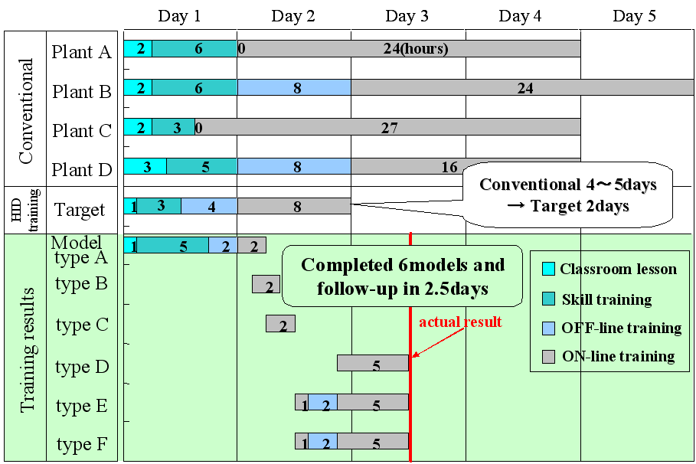
Figure 7 Training curriculum for assembly works and current status

days. It also set the training hours for each segment, ‘Class room training (1 hour)’, ‘Skill training (3 hours)’, ‘OFF-line training (4 hours)’, and ‘ON-line training (8 hours)’. When the training was given, the OFF-line training took one day and the ON-line training 1.5 days. The training finished in 2.5 days. The On-line training in this particular case study had to deal with many different model types (model type A to model type F), causing some trouble. However, it brought us a good feeling that the training could be completed in two days under normal circumstances.
Figure 8 shows the skills acquisition evaluations that were conducted on the seven new hires who were trained under the ‘HID’ training method. The graphs compare the skills acquisition
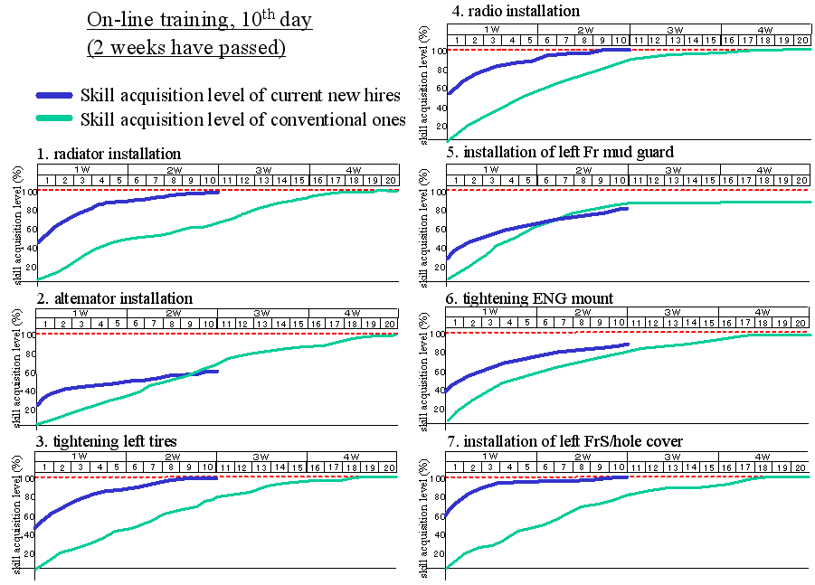
Figure 8Skills acquisition evaluation

levels of the trainees who were trained by the conventional OJT-focused man-to-man training conducted by the ‘highly-skilled trainers’ and those trained by the ‘HID’ operator training processes. The graphs identify the chronological skills acquisition levels by day of these trainees for select assembly works. The skills acquisition level data were imported from the individual evaluation sheet (details are omitted). The trainees traditionally needed four weeks to perfect their skills to satisfy the time and the accuracy requirements. Under the ‘HID’ operator training processes, all the trainees were able to acquire the skills in about half that time. Let us analyze the result.
(1) The class room training allowed the trainees to paint more accurate images about their works. The skills training broke down the skills into more detailed elements such as tightening. It clarified the skill level of each individual in specific elements. The training focused on his/her low skill level elements, resulting in quick improvement in the trainee’s skills.
(2) The teaching processes and the sequence were clearly identified. It eliminated variation of training by trainers and achieved consistency in the teaching and its method. Consequently, the training was efficient and resulted in even acquisition of the skills by the trainees.
This case study has proven effectiveness of the ‘HID’ operator training processes in faster skills acquisition through breaking down the skills, visualizing the skill level of each individual, focusing on select skills, and repeating training on these specific skills.
A supplementary benefit of these processes was noticed with the disabled operators. The operator training for the disabled has typically been a special session. The ‘HID’ operator training processes, however, made it possible to train these operators along with the others. It eliminated the special session, contributed to faster skills acquisition, and improved the training efficiency. Despite these benefits, the ‘HID’ operator training processes proved to be slightly less effective than the conventional man-to-man method in some specific work items where operators need to improve their skills even to a higher level. This issue should be studied in the future.

8. Summary
In this report, the authors have perceived the need to develop the Advanced TPS as the key to development of Toyota’s global production strategy, and presented ‘HI-POS’ (Human Intelligence-Production Operating System) which was designed to realize improvement as the intelligence operator. In the course of its implementation, the authors also created ‘HID’ (Human Intelligence Diagnosis System), which is the core system of ‘HI-POS’, verified the effectiveness as the following,
(1) The operator training for the new hires and the temporary workers at a Japanese company were able to be completed quickly, thus enabling them to deal with the high workload associated with the new model production start-up.
(2) In a new overseas factory, too, the skills training were able to be completed within a short period of time for the new hires who had had no prior experience with the manufacturing industry.
(3) As a result, this factory reached the target availability as quickly and as high as that of their Japanese factory as measured from the production start-up.
As the Advanced TPS, the same high productivity and quality were achieved for both domestic and overseas plants, and the reduction of overseas support of labor force for the global production in the world. It was also added here that the result of this study is deployed in Toyota’s global production strategy, and its effectiveness is verified by the top ranked reputation of recent Toyota vehicles with regard to their reliabilities and common workability in Europe and the United States [19].

References
[1] Amasaka, K., (2002). New JIT, A New Management Technology Principle at Toyota, International Journal of Production Economics, Vol. 80, pp.135-144.
[2] Amasaka, K., (2003). Development of “Science TQM”, A New Principle of Quality Management：Effectiveness of Strategic Stratified Task Team at Toyota-, International Journal of Production Research, Vol.42, No.17, pp.3691-3706.
[3] Ohno, T., (1977). Toyota Production System, Diamond-Sha and Toyota Motor Corp. (in Japanese)
[4] Womack, JP et al., (1991). The Machine that change the World - The Story of Lean Production, Rawson/ Harper Perennial, New York.
[5] Womack, JP, and Jones, D. T., (1994). From Lean Production to the Lean Enterprise, Harvard Business Review, pp.93-103.
[6] Amasaka, K., (2004). Applying New JIT—A Management Technology Strategy Model at Toyota-Strategic QCD Studies with Affiliated and Non-affiliated Suppliers-, Proceedings of the Production and Operations Management Society, Cancun, Mexico, pp.1-11 (CD-ROM).
[7] Amasaka, K., (2004). (keynote lecture) The Past, Present, Future of Production Management, The Japan Society for Production Management, the 20th Annual Technical Conference, Nagoya Technical College, Japan, pp. 1-8. (in Japanese)
[8] Taylor, D and Brunt, D., (2001). Manufacturing Operations and Supply Chain Management- Lean Approach, 1st edition, Thomson Learning, Florence, K, Y.
[9] Gabor, A., (1990). The Man Who Discovered Quality; How Deming W. E., Brought the Quality Revolution to America, Random House Inc.
[10] Joiner, B. L., (1994). Forth Generation Management: The New Business Consciousness, Joiner Associates Inc., New York.
[11] Amasaka, K., and Sakai, H., (2004). TPS-QAS, New Production Quality Management Model: Key to New JIT－Toyota’s Global Production Strategy, International Journal of Manufacturing Technology and Management, pp. 1-18. (Proceedings)
[12] Sakai, H., and Amasaka, K., (2005). Development of Robot Control Method for Curved Seal Extrusion: High Productivity by Advanced Toyota Production System, Proceedings of the International Manufacturing Leaders Forum, Adelaide, Australia, pp.1-8 (CD- ROM).
[13] Amasaka, K., (2005). Applying New JIT- Toyota’s Global Production Strategy: Epoch-making Innovation in the Work Environment, Proceedings of the International Manufacturing Leaders Forum, Adelaide, Australia, pp. 1-9 (CD-ROM).
[14] Sakai, H., and Amasaka, K., “V-MICS in the Production Facilities Administration by Utilizing DB and CG for the Maintenance Activities”, Proceedings of the Second Euro-Japanese Workshop on Stochastic Risk Modelling for Finance, Insurance, Production and Reliability, France, pp.443-452 (Sep 2002).
[15] Amasaka, K., and Sakai, H., (1996). Improving the Reliability of Body Assembly Line Equipment, International Journal of Reliability, Quality and Safety Engineering, Vol.3, No.1, pp.11-24.
[16] Amasaka, K., and Sakai, H., (1998). Availability and Reliability Information Administration System “ARIM-BL” by Methodology in Inline-Online SQC, International Journal of Reliability, Quality and Safety Engineering, Vol.5, No.1. pp.55-63.
[17] Sakai, H., and Amasaka, K., “Proposal and Demonstration of “V-MICS-EM” by Digital Engineering”, Proceedings of 17th International Conference on Production Research, U.S.A., pp.1-8 (Aug 2003).
[18] Sakai, H., and Amasaka, K., (2004). Proposal and Implementation of Human Intelligence-Production Operation System ‘HI-POS’, Proceedings of the 2nd World Conference and 15th Annual POMS Conference, Cancun, Mexico, pp.1-11 (CD-ROM).
[19] JD Power and Associates at http://www.jdpower.com/ (2004)

