MINISTRY OF Public HEALTH OF UKRAINE
BUKOVINIAN STATE MEDICAL UNIVERSITY

“Approved”
on methodological meeting
of Department of Obstetrics and Gynecology
with course of Infant and Adolescent Gynecology
“___”______________________ 201_ year
protocol #
T.a.the Head of the department
Professor
________________ O.A. Andriyets

METHODICAL INSTRUCTIONS
for practical lesson
« Clinical and physiological changes of the female reproductive organs
in different age periods. Neuroendocrine regulation of the function
of the female reproductive system»
MODULE 4: Obstetrics and gynecology
Context module 12: Gynecological diseases

Subject: Obstetrics and Gynecology
6th year of studying medical faculty № 2
Number of academic hours – 5,5
Methodological instruction developed
by: assist.prof. Berbets .A.

Chernivtsi – 2010
1. Objectives: to learn clinical anatomy and physiology of the female genital organs.
Professional motivation: clinical anatomy of the genitals has a great value for studying gynecology. The structure of external and internal genitals, their blood supply enables to understand pathogenesis of gynecologic diseases.
2. Number of hours: 5,5
3. Educational objectives:
3.1. To know:

- External female reproductive organs: structure, blood vessels, innervations;
- Vagina: structure, blood vessels, innervations;
- Uterus: structure, function, blood vessels, innervations
- Uterine tubes: structure, function, blood vessels;
- Ovaries: structure, function, blood vessels;
- Suspensive apparatus of the uterus
- Clinical peculiarities of anatomical structure of the female reproductive organs in different age periods;
- Regulation of menstrual cycle on different steps;
- The role of hormones, bioactive substances.

3.2. To be able to:
- Collection of special gynecological anamnesis;
- Do special methods of diagnostic gynecological diseases (bimanual, vaginal, rectal, with vaginal mirrors);
- Clinical, special gynecological and additional research of the patient;
- Interpretation of the results of the functional tests of the female reproductive system;
- How to take material for the tests of functional diagnostic;
- Use on the practice deontological methods of communication with gynecological patient.
3.3. Practical skills :
- Collection of special gynecological anamnesis;
- Do the main methods of gynecological inspection;
- Interpretation of the data of the clinical, special gynecological and additional research of the patient;
- To make the plan of inspection of the patient to diagnose functional state of the reproductive system;
- To estimate the results of the inspection.

4. Basic knowledge.

Name of the course | Received skills
Human anatomy | To show on the phantom the structure of the female reproductive organs
Biochemistry | To analyze the results of laboratory tests
Hystology | To analyze the microscopic picture of endometrium in different phases of menstrual cycle
Normal and pathological physiology | Interpretation the data of hormonal function of the female reproductive system, hormonal changes
Internal deseaeses | Collection the anamnesis, to make the physical inspection, to see the clinical symptoms and syndromes, to find methods of diagnostic, estimate the results of paraclinic

5. Summary.
CLINICAL ANATOMY AND PHYSIOLOGY OF THE FEMALE GENITAL ORGANS
ANATOMY OF THE FEMALE GENITAL ORGANS
The female genital organs are considered to be external and internal. They are separated by hymen (fig. 1.)
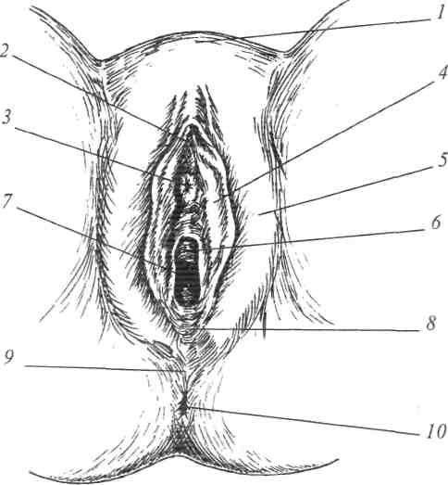
Fig. 1. External female genital organs:
- — mons pubis
- — clitoris
- — external uretheral orifice
- — labia minora
- — labia majora
- — hymen
- — vestibule of vagina
- — fourchette posterior
- — perineum
- — anus

EXTERNAL FEMALE GENITAL ORGANS
To external female genital organs (genitalia externa, vulva) belong: mons pubis, labia majora, labia minora, clitoris and vaginal vestibule.
Mons pubis (mons pubis) is the fatty cushion that lies over the anterior surface of the symphysis pubis. There is no hair on the mons pubis before puberty. In females the skin of the mons pubis is covered by curly hair that forms thefemale linea horizontales. During menopause the hair becomes thick. If the hair growth on linea alba is up to the umbilicus, and covers inner thighs it indicates the functional disorders of the ovaries or adrenal glands.
Labia majora (labia majora pudendi) are two protruding folds of skin with adipose tissue, that enclose the pudendal cleft. They extend downward and backward from the mons pubis up to posterior fourchette where they join.
The region between the posterior fourchette and anus is called obstetric perineum. Its height in most women is 3-4 cm. If it is more than 4 cm it is called high perineum and if it is less than 3 cm it is called low perineum. The skin and muscles of this region may tear during delivery and then the structure of pelvic floor becomes abnormal. It is the pubococcygeus, the main part of the levator ani, that is usually torn. Weakening of the levator ani and pelvic fascia resulting from stretching or tearing during childbirth may alter the position of the neck of the bladder and urethra. These changes can cause urinary stress incompetence, characterized by dribbling of urine when intraabdominal pressure is raised during coughing and lifting, for instance.
Major vestibular glands. Bartholin's glands are a pair of small compound glands about 0,5-lcm in diameter, each of which is situated beneath the vestibule on either side of the vaginal opening. The Bartholin's glands lie under the constrictor muscle of the vagina and sometimes are partially covered by the vestibular bulbs. These are alveolar-tubular glands secreting mucus into the vestibule during sexual intercourse, and their ducts open into the fissura just between the labia minora and hymen. Bartholinitis is an inflammation of the vestibular glands, which may result from the number of pathogenic organisms. Bartholin's glands are often the site of gonococcal infections and. Due to the pathogen the external orifices of the Bartoline ducts become hyperemic.
Labia minora (labia minora pudendi) are two flat reddish folds, visible when the labia majora are disclosed (the junction of the labia minora on the ventral surface is called frenulum). The labia minora may vary from scarcely noticeable structures to leaf-like flaps measuring up to 3 cm in length. The labia minora extend from the clitoris laterally around the external urethral orifice and the orifice of the vagina. They are extremely sensitive and are supplied with a variety of nerve endings.
Clitoris (clitoris) is a small cylindric erectible body located at the superior part of the vulva. The clitoris is composed of glans, body and two crura. The glans is richly supplied with nerves and is therefore extremely sensitive to touch. The clitoris is erogenous organ of women.
Vaginal vestibule (vestibulum vagina) is the space between the labia minora laterally and extending from the clitoris above to the comissura posterior below. It is usually perforated by six openings: the urethra, the vagina, the two Bartholin glands, the ductus of the two paraurethral glands, also called as Skene's ducts.
Urethra (urethra) is approximately 4 cm long and 6 mm in diameter and lies immediatly above the anterior vaginal wall and terminates externally at the urethral orifice. The urethral orifice is 2-2,5 cm below clitoris. Urethra has external and internal sphincters.
Hymen is a thin fold of mucous membrane surrounding the vaginal outer in virgin women. The hymen may take many forms, such as a cribriform plate with many small openings or a completely inperforated diaphragm (in this case it must be removed to allow menstrual outflow). The openings in the hymen are usually greatly enlarged during the first sexual intercourse. In nulliparous hymen is represented by a circle of carunculae hymenalis, and after childbirth a circle of carunculae myrtiformes.
INTERNAL GENITAL ORGANS
The female internal organs include vagina, uterus, uterine tubes and ovaries
Vagina
Vagina, a musculomembranous tube (8-1 Ocm long) extends from the uterine cervix to the vestibule of the vagina (cleft between the labia minora). The superior end of the vagina surrounds the cervix. The vaginal vault is subdivided into anterior, posterior and two lateral fornices. The posterior fornix is the deepest part and it is closely related to the cul-de-sac. It allows easy access to the peritoneal cavity from the vagina by either culdocentesis or colpotomy. Vagina lies posteriorly to the urethra and urinary bladder and anteriorly to the rectum.
The vagina layers: the mucosa of the vagina is composed of non keratinizing stratified squamous epithelium (fig. 2). Beneath the epithelium there is a thin fibromuscular layer; an inner circular layer and an outer longitudinal layer of smooth muscle can be identified. A thin layer of connective tissue overlying the mucosa and muscularis layer is rich in blood vessels and a few small lymphoid nodules drain there. Normally, glands are not present in the vagina.
Vaginal secretions appear as a result of liquid' exudation from lymphatic and blood vessels and also at the excessive cervical glands mucus. Vagina of healthy woman has a small amount of white colour disharge. The acidic reaction is owing to lactic acid which is produced from the breakdown of glycogen in the mucosa by lactobacilli.
Concentration of lactic acid within vagina is 0, 4%. It liquidates pathogenic microorganisms that may enter into vagina from outside. This process is called vaginal "self cleaning".
Vaginal "self cleaning" is possible due to normal ovarian function. Only estrogenic hormones affect maturation of epithelial cells of mucous membrane and glycogen synthesis. Glycogen is the material for lactobacilli. The pH of vaginal secretion in adult women ranges between 4,0 and 5,0. Ovarian dysfunction leads to alcaline reaction of vaginal secretions. As a result of this pathogenic bacteria and fungi may grow in the vagina and provoke inflammatory process of vagina called vaginitis.
Such term as vaginal "self cleaning" characterises vaginal flora.
There are four stages of vaginal secretions "self cleaning". They are:
- I — lactobacilli and epithelial cells are present only in vaginal secretions. The reaction of vaginal secretions is acidic
- II — lactobacilli and some leukocytes are present, the reaction of vaginal secretions is acidic
- III — symbyotic infection of anaerobic bacteria predominates, large number of leukocytes; the reaction of vaginal secretions is slightly alkaline
- IV — lactobacilli are absent; considerable number of pathogenic infective agents predominate (such as synergistic bacteria, fungi and protozoa), the reaction of vaginal secretions is alkaline
The vagina:
- serves as the excretory passway for menstrual outflow
- forms the inferior part of the birth canal
- receives the penis and ejaculates during sexual intercourse
vaginal "self-cleaning" doesn't allow pathogenic microorganisms to enter the uterus.
Uterus
Uterus (hystera) is a thick-walled, hollow muscular pear-shaped organ, somewhat flattened anterposteriorly.
The uterus is approximately 7.5 cm long, 5 cm broad, 2 cm thick and weighs 50-100 grams. In the postpuberal women two third is body and one third is cervix. During childhood and postmenopause body and cervix are approximately of equal length.
Uterus consists of the body and the cervix. Body forming the upper two third has two parts. The frontal plane has a triangle form. The base of triangle is fundus uterus. It's apex is the internal orifice. The angles of the triangle arc the internal orifices of the Fallopian tubes. The posterior and anterior walls of the uterus touch each other, that's why uterine cavity is rather a narrow hollow/
The uterine isthmus (fig. 3) represents a transitional area where the endo-cervical epithelium gradually changes into the endometrial lining. In this region the cezarean section is made.
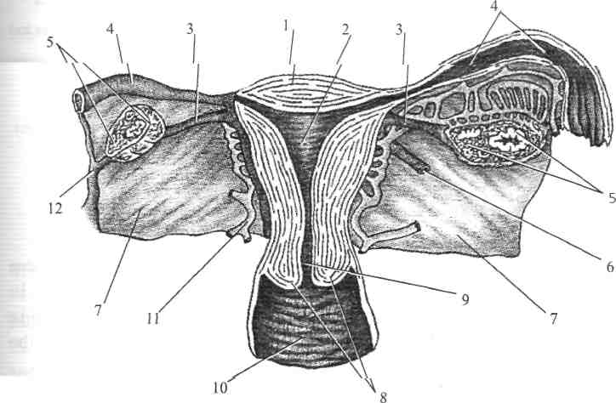
Fig. 3. Uterus, fallopian tubes, ovaries, vagina (sagittal section):
1 — fundus of uterus; 2 — uterine cavity; 3 — ovarian ligament; 4 — fallopian tube
5 — ovary; 6 — round ligament; 7 — broad ligament; 8 — uterine cervix
9 — cervical canal; 10 — vaginal wall; 11 — uterine artery
12 — infundibulopelvic ligament (suspensory ligament)
The cervix is from 2 to 3 cm in length. The portion that protrudes into the vagina and is surrounded by the fornices is covered with a keratinizzed stratied squamous epithelium. At about the external cervical os the squamous epithelium covering the exocervix changes to simple columnar epithelium, the site of transition being referred to as squamocolumnar junction. The cervical canal (fig. 5) is lined by irregular, arborized, simple columnar epithelium which extends into the stroma as cervical "glands" or crypts.
The cervical canal is fusiform and opens at each end at the internal os and external os.
The wall of the body of the uterus is composed of three layers: serosa, muscular and mucosa. The inner layer of the uterus is the mucosal layer, which lines the uterine cavity in nonpregnant women. It is called the endometrium. This lining of the uterine corpus may vary from 2 to 10 mm in thickness, depending on the phase of the menstrual cycle. The endometrium is composed of surface epithelium, glands and interglandular mesenchymal tissue containing numerous blood vessels.
/
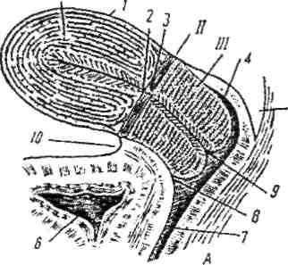
Fig. 4. Schematic correlation between uterus, fornices and peritoneum in normal position of the uterus:
5 I — body of uterus; II — isthmus of uterus
III — cervix of uterus; 1 — peritoneum; 2 — anatomic internal uterine ostium; 3 — histological uterine ostium 4 — posterior fornix; 5 — cul-de-sac (rectouterine pouch) 6 — urinary bladder; 7 — vagina
- — anterior fornix
- — external ostium of the cervical canal
10 — vesico-uterine pouch
The myometrium is quite thick, consists of smooth muscles and has three layers: external (longitudinal), medial (circulative), internal (longitudinal). In the body of the uterus the muscular layer has more circulative fibers and cervix contains longitudinal, therefore cervix is more rigid and less contractile than the whole uterus.
The perimetrium (serous coat) of the uterus is the peritoneum, only the upper portion of the anterior wall of the uterus is covered by serosa; then the bladder is covered and forms the vesicouterine pouch (excavatio vesico-uterina); almost the entire posterior wall of the uterus is covered by peritoneum, the lower portion of which forms cul-de-sac or rectouterine pouch of Douglas (excavatio recto-uterina).
Normally the uterus is anteversio (with the body of the uterus tipped slightly anteriorly) — tipped anterosuperiorly relative to the axis of the vagina and anteflexed (the uterine body is flexed or bent anteriorly relative to the cervix).
The position of the uterus changes with the degree of filling of the bladder and rectum. The angle between the axis of the body and the cervix varies from anteflexion to retroflexion, and normally is near 120°.
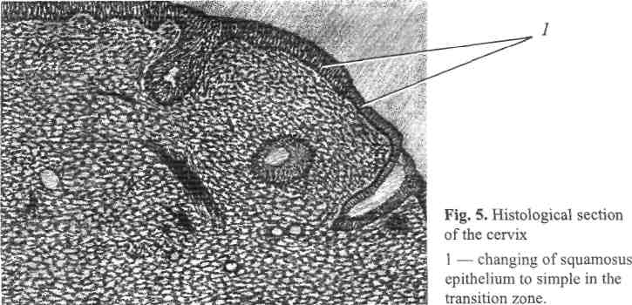
Functions of uterus:
- in sexual maturity period uterus provides menstrual function
- during pregnancy the uterus serves for reception and implantation of the conceptus and nutrition of the fetus
- during delivery it expels fetus
Uterine tubes
Uterine tubes (tubae uterinae) or fallopian tubes extend from the uterus to the site near the ovaries and provide access for the ovum to the uterine cavity.
Each tube is divided into interstitial portion, isthmus, ampulla and infundi-bulum. The uterine tube varies considerably in thickness; the narrow portion of the isthmus measures from 2-3 mm, and the widest portion of the ampulla measures between 5 and 8 mm in diameter. The opening of the infundibulum is surrounded by a number of long thin processes called fimbriae. The wall of each uterine tube consists of three layers: the external serosa is formed by the peritoneum, the middle muscular layer consists of longitudinal and circular smooth muscle fibers and the innner mucosa consists of a mucous membrane of simple ciliated columnar epithelium. Tubal peristalsis depends on the menstrual cycle and is believed to be important factor in transport of the ovum. The ciliated epithelium helps to move the ovum through the uterine tubes (fig. 6, 7)
Functions of the uterine tubes:
- oocytes expelled from the ovaries usually are fertilized in ampulla the widest and longest portion of tube
- ovum is transported through the tubes to the uterine cavity

Ovaries
The ovaries are almond-shaped organs. They provides the double function. The ovaries work as endocrine glands (produce estrogens and progesteron). The ovaries provides the ovums maturing.
The sizes of ovaries are 4x2x1 cm. Each is attached to the posterior surface of the broad ligament by a peritoneal fold called the mesovarium. Two other ligaments are attached to the ovary: the suspensory ligament extends from the mesovarium to the uterine body wall and the ovarian ligament attaches the ovary to the superior margin of the uterus. The ovarian arteries, veins and nerves pass within the suspensory ligament and enter the ovary through the mesovarium.
Occasionally the mesosalpinx between the uterine tube and the ovary contains: the epoophoron is formed from the remnants of the mesonephric tubules — the transistory embrionic kidney; the paroophoron may accumulate fluid and form cycts.
The layers: externally the ovaries are covered by the ovarian epithelium or cuboidal cells. Just below the epithelium the tunica albuginea surrounds the ovary. The ovary is divided into outer portion called the cortex and inner portion called medulla. Blood vessels, lymph vessels and nerves from the mesovarium enter the medulla. In cortex the ova and graafian follicles are located (fig. 8).

Fig. 8. Ovarian section:
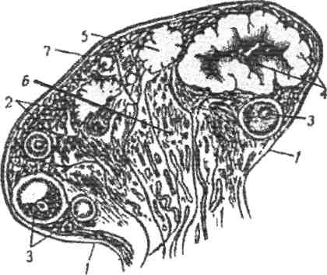
- — germinal epithelium
- — ovarian cortex
- — different stages of ovarian follicle development
- — corpus luteum
- — corpus albicans
- — medulla ovarii
- — tunica albuginea

Ovarian functions:
producing of sexual hormones — is its endocrine function
follicular development and ovulation — is its generative function
if fertilization occurs, the corpus luteum persists and secrets large amounts of
progesterone. This insures a normal duration of the first trimester of pregnancy
Ligaments of the uterus
The uterus is a dense structure located in the centre of the pelvic cavity. This position is provided by the supportive, suspensive and fixative apparatus of the uterus.
Suspensive apparatus of the uterus:
- Two broad ligaments each passes from the side of the uterus to the lateral walls of the pelvis. Between the two leaves of each broad ligament there is the fallopian tube, the round ligament, the ovarian ligament, nerves, blood vessels, and lymphatics.
- Each round ligament inserts in the anterior surface of the uterus just in front of the fallopian tube, passes to the pelvic side wall in a fold of the broad ligament, transverses the inguinal canal and ends in the labium major. Its function is to hold uterus in anterflexion position.
- The utero-ovarian ligament also called the ovarian ligament (lig. ovarii proprium) extends from the lateral and posterior portions of the uterus just beneath the tubal insertion to the uterine (lower) pole of the ovary.
- Infundibulopelvic ligament (suspensory ligament) is a distal part of broad ligaments that extends into peritoneum of lateral pelvic wall. It contains ovarian artery and vein.
The infundibulopelvic (suspensory) ligament of the ovary extends from the upper (tubal) pole to the pelvic wall; the ovarian vessels and nerves pass through it. Fixative apparatus of the uterus is composed of:
- Cardinal (transverse cervical) ligaments which extend from the cervix and lateral parts of the vaginal fornix to the lateral walls of the pelvis.
- Uterosacral ligaments which pass superiorly and slightly posteriorly from the sides of the cervix to the middle of the sacrum.
In addition to the ligaments much support is provided inferiorly to the uterus by the skeletal muscles of the pelvic diaphragm. If these muscles are weakened (e.g. because of childbirth), the uterus can descend inferiorly to the vagina. This condition is called as uterine prolapse.
Fixative apparatus of the uterus are the pelvic diaphragm muscles.
Blood supply of the genital organs
The external genital female organs are supplied by branches from internal pudendal artery (a.pudenda interna) and partly from iliac arteries. Internal pudendal artery is the anterior branch of internal iliac artery.
The vascular supply of internal genital organs (fig. 9,10). The uterine artery is the main branch of the anterior division of the internal iliac or hypogasric artery. It descends for a short distance, enters the base of the broad ligament and makes its way medially to the side of the uterus. Reaching the side of the cervix, the uterine artery is divided into a large superior branch that supplies the body and fundus of the uterus and a smaller vaginal branch that supplies the cervix and upper third of vagina.

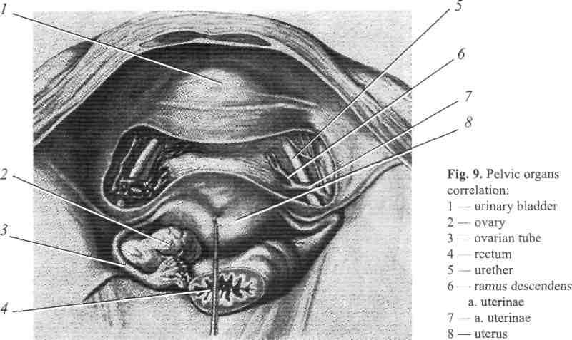
The ovarian artery arises from the abdominal aorta inferior to the renal artery (sometimes left ovarian artery arises from renal artery). It is divided into ovarian and tubal branches that supply the ovary and uterine tube. These branches anastomose with the branches of the uterine artery.
The vaginal veins form vaginal venous plexuses along the sides of vagina. These veins are continuous with the uterine venous plexux as the uterovaginal venous plexus and drain into the internal iliac veins through the uterine vein.
Lymphatic drainage
The vulva contains a rich network of lymphatic vessels that pass laterally to the superficial inguinal lymph nodes. The vaginal lymphatic vessels drain into the internal and external iliac lymph nodes and to the sacral and common iliac nodes.
The uterine lymphatic vessels follow three main routes. Most vessels from the fundus pass to the lumbar lymph nodes, but some vessels pass to the external iliac lymph nodes.
Vessels from the uterine body pass within the broad ligament to the external iliac lymph nodes.
Vessels from the uterine cervix pass to the internal iliac and sacral lymph nodes.

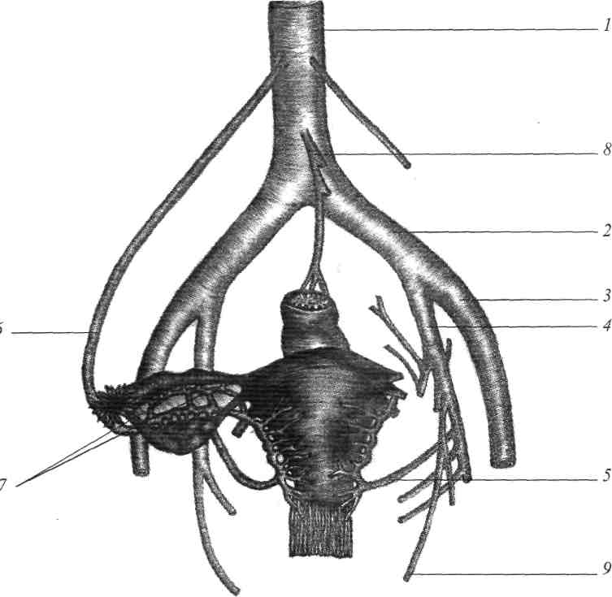
. 10. Principal arterias of the genital organs:
- — aorta abdominalis
- — a. iliaca communis
- — a. iliaca externa
- — a. iliaca interna
- — a. uterina
- — a. ovarica
- — rami tubarii;
- — a. mesenterica inferior
- — a. pudenda interna
Innervation of the genital organs
The nerve supply of the genital organs is derived from superior and inferior hypogastric plexus. Uterus has the sympathetic innervation, and uterine cervix has parasympathetic innervation.
Nerve supply of the external genital organs is provided by the pudendal nerve (n. pudendus).
Pelvic peritoneum
There are four peritoneal folds. Anteriorly, the vesicouterine fold passes from the level of the uterine isthmus on the bladder. Posteriorly, the rectouterine fold passes from the posterior wall of the uterus to the upper fourth of the vagina, and descents onto the rectum. Laterally, the both broad ligaments passes from the side of the uterus to the lateral wall of the pelvis. Between the two leaves of each broad ligament there is the fallopian tube, the round ligament and the ovarian ligament, in addition to nerves, blood and lymphatics vessels.
Pelvic cellular spaces
Pelvic viscera are surrounded by connective tissue called cellular of pelvic cavity. There is paravesical parametrial, which compose of fatty tissue between broad ligament leaves; paravaginal and pararectal ones. All these cellular spaces are connected between themselves. Infection in these spaces can be spread as cellulitis.
PHYSIOLOGY OF THE FEMALE
GENITAL ORGANS
Normal menstrual cycle
Reproduction relies on a complex system of communications between the hypothalamus, pituitary and the ovarian follicular development and ovulation. Sex steroid hormones provides regularity of the phases of the reproductive cycle.
Normal ovulation depends on the complex and interactive hypothalamic — pituitary — ovarian system.
There are responsible changes during the complete reproductive cycle in the target organs: endometrium, breasts, vagina, fallopian tubes. Nervous and endocryne systems undergo cyclic changes too.
In response to the changes, sex steroid hormones are secreted during the ovarian cycle (follicular maturation, ovulation, development of corpus luteum). There are four main stages of the endometrial cycle: desquamation that is menstruation, regeneration, proliferation, and secretion phases. Due to these changes reproductive function can be perfomed: ovulation, fertilization, implantation and emryo development. If implantation doesn't occur functional layer of the endometrium desquamates and the menstrual bleeding begins.
Regular menstrual cycle is a sign of normal function of female reproductive system.
The rythm is genetically determinated and healthy women have it stable during reproductive age. The first day of menstrual bleeding is considered to be the first day of the menstrual cycle.
The modal interval when menstruation occurs is considered to be 27-29 days and may vary from 21 till 35 days.
The duration of menstrual flow is 3-4 days (from 2 till 7 days)
The amount of blood lost is about 50-150 ml per cycle.
The menstruation must be regular, painless.
The reproductive cycle has two phases.
Regulation of menstrual cycle
The function of reproductive system is controlled by the complex of brain cortex-hypothalamus, composed of the groups of nerve fibers and cells in which biogenic amines, steroid hormones and gonadotropins perfom reception, translation and transmission of signals from environment and organism. This system has 5 levels and is regulated by feedback mechanisms, while high level structures control the lower level (fig 11,13).
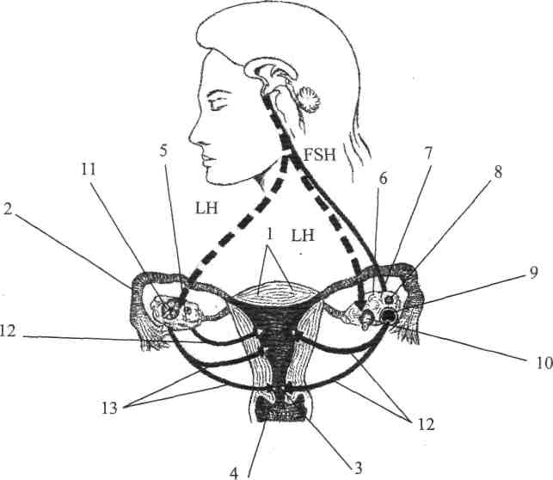
Fig. 11. Regulation of menstrual cycle:
1 — uterus; 2 — fallopian tube; 3 — cervix of uterus; 4 — vagina; 5 — ovary
6, 7, 8 — different stages of ovarian development; 9 — secondary follicle
10 — ovulation; 11 — corpus luteum; 12 — effect of estradiol into uterus
13 — effect of progesterone into uterus
V-level is suprahypothalamic cerebral structures. The menstrual cycle is regulated by brain cortex. Stress or climatic changes can cause abnormalities of ovulation and menstrual cycle. Receiving of information from environment and interreceptions with neurotransmitter structures of central nerves system sends impulses to neurosecretory hypothalamic nuclei.
IVlevel—hypothalamus. Hypothalamic nuclei produce the specific neurohormones, which stimulate pituitary (called as Liberins) and inhibit it (called Statins).

Follicular phase Ovulation Luteal phase
Progesterone ng/ml ~~■"■■ LH mU/ml ' ■
Estradiol 17 pr/ml ——■ FSH lmU/ml —
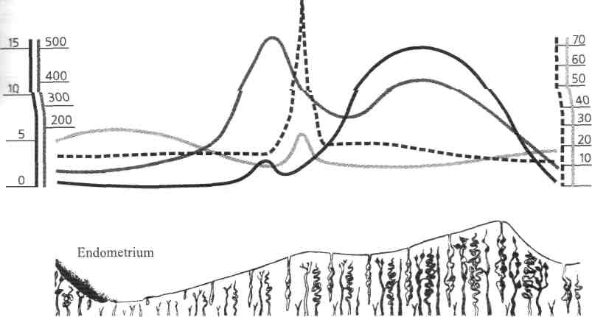
Fig. 12. Level of hormones in female blood during by menstrual cycle
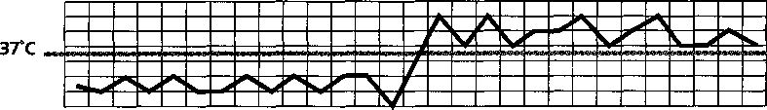
Basal temperature

Hypothalamic ventromedial, arcuate and dorsomedial nuclei produce such hormones as Lul'iberin — releasing hormone that stimulates luteonizing hormone (LH) secretion and Foliberin — releasing hormone that stimulates follicle-stimulating hormone (FSH) secretion by the anterior pituitary.
Gonadotropic liberins mark as GT-RH (gonadotropic releasing hormones) because only they stimulate the pituitary LH and FSH secretion.
The hypothalamus is the pulse generator of the reproductive clock. There is a network of neurons in the anterior and medial parts of the hypothalamus that produces GT-RH. The drops of this neurosecretion have been released from the ends of the brain medial eminentia neurons. GT-RH reaches the anterior pituitary gland through the hypothalamic-pituitary portal plexus. Another goes via veins that flow through dura mater sinuses to the general flow.
Besides GT-RH, there are hypothalamic prolactin-releasing factors and depressing substances which contain dopamine. As hypothalamus responds tosteroid hormones secretion with estradiol production, there is a negative feedback which has been controlled by vertebral arteries. There are estradiol receptors in the arcuate nucleus of hypothalamus. Pulsative infusion of GnRH at 70-90-minutes intervals depends on the level of estradiol hormones.
Ш level—anterior pituitary. Anterior pituitary produces such gonadotropin hormones as follicular-stimulating hormone, luteinizing hormone, prolactin and other tropin hormones such as tireotropic, somatotropic, adrenocorticotropic and lipotropic.
Basophilic cells of the peripheral areas of the anterior pituitary produce FSH. By the chemical structure it is a glycoproteid which has been stimulating the growth and maturation of follicles and follicular fluid secretion.
The basophilic cells of the anterior pituitary central area produce LH. It responds massive estradiol secretion, follicular rupture, ovulation, corpus luteum formation and progesterone production.
Prolactin is a polypeptide. It has opposite function as FSH and LH have had. It responds to breast and target organs growth, maturation and milk secretion.
/7 level — ovaries. An ovary is a target organ for the pituitary hormones. Ovaries respond to pituitary gonadotropin secretion. Ovarian follicles are the basic anatomo-physiologic structure of the ovarian theca.
At birth, human ovary is filled with approximately one million primordial follicles. Each follicle contains an oocyte that is arrested in the prophase stage of meiosis. A single layer of pregranulosa cells surrounds the oocyte, which become the granulosa cells. Premordial follicle is surrounded by basilar membrane that is called hematofollicular barrier. The last one protects oocyte from the uncontrolled influence. The next stage of the development is the transformation of premordial follicle into the primary one. It occurs as a result of excessive reproduction of granulosa cells which contain mucopolysaccharide. The last one forms a special brilliance membrane, which surrounds the oocyte. It is the second protective barrier. As a primary follicle is stimulated, the pretheca cells form two layers — internal (theca interna) which is situated near basilar membrane and secretes hormones and external layer (theca externa). Primary follicle is transformed into antral follicle that contains follicular antrum between the ovum and granulosa cells.
Dominant follicle is the final stage of the follicular maturation. Antral follicles can be transformed into dominant follicles. The follicles undergo ovulation or degeneration.
At the period of puberty only 200 out of 400 000 follicles undergo maturation. Rest of them degenerate.
During the complete reproductive cycle one oocyte is brought to maturity before ovulation. In the process of bringing one oocyte to maturation, a number of oocytes are stimulated to partial maturation but subsequently undergo atresia before reaching ovulation.
Ovarian cycle
An ovarian cycle consists of two phases. The first one —follicular phase, the second — luteal phase. There is an increase of FSH, which stimulates the growth and maturation of follicles in the first phase (fig. 14). It lasts 14 days in 28-days reproductive cycle, 10-11 days in 21-days reproductive cycle, and 17-18 days in 35-days reproductive cycle.
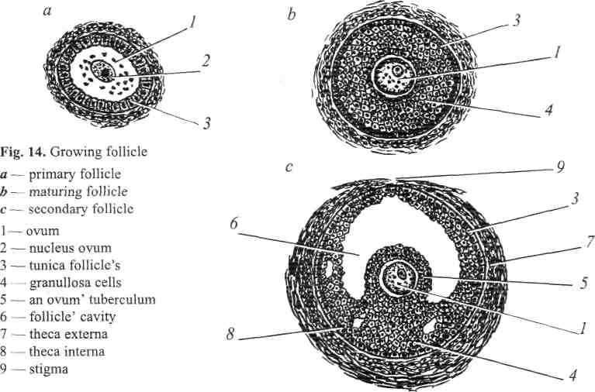
In the beginning of this phase follicle consists of ovum which is surrounded by the thick membrane. It is 2-2,5 mm in diameter. An ovum increases in its sizes and has brilliante membrane in the surface that is called zona pellucida. An ovum is packed with biochemicals that new organism will use until its own genes begin to function. These biochemicals include proteins, RNA, ribosomes, lipids and the molecules that influence cell specialization in the early embryo. An ovum can be an impressive storehouse and it becomes maturate after two-cell divisions in meiosis I, the primary oocyte is divided to form a small polar body and a large haploid secondary oocyte. In meiosis II, reductional secondary oocyte is divided to yield another small polar body and a mature ovum.
Polar bodies are absorbed by the woman's body and normally play no further role in the development. Follicle granulosa membrane forms as a result of follicle cells proliferation. By that time in the central part of these cells the cavity is formed. The last one contains follicular liquid. Granulosa cells those form corona radiata surround an ovum. It is situated in the numerous cells which have been situated near the follicle. This number of cells is called a cumulus oophorus. The follicular fluid contains follicular or estrogenic hormones.
The dominant follicle reaches a diameter of 12-20 mm. As the dominant follicle enlarges and follicular fluid accumulates in it, it grows and rupture. It is the final stage of the follicular phase, which is called ovulation. Ovulation is the process when the membrane of mature follicle is ruptured and oocyte is expelled from the follicle.
Oocyte gets into abdominal cavity and is taken by the uterine tube fimbrias. Process of fertilization takes place in the uterine tubes. After ovulation the dominant follicle transform into the corpus luteum. The second luteal phase of the reproductive cycle begins. There is luteinization — the conversion of granulosa and theca cells to luteal cells with the acquinisation of LH receptors. After this luteal cells can synthesize and secrete large amount of progesterone, that is protein hormone inhibiting FSH secretion.
The corpus luteum has a fixed life term during 14 days, since 15-th to 28-th days of menstrual cycle. There are following processes in corpus luteum: 1) vascularization 2) blossoming 3) involution — in case when pregnancy doesn't occur corpus luteum is called corpus luteum of menstruation. Regression of corpus luteum lasts for 2 months and is over with the formation of white body. If oocyte becomes fertilized and implants within the endometrium, the early pregnancy begins secreting human chorionic gonadotropin (hCG), which sustains the corpus luteum for the following 10-12 weeks. Corpus luteum of pregnancy produces such hormone as relaxin which has tocolytic effect on the uterus.
/ level — target organs (uterus, vagina and breasts).
Uterine cycle
The endometrial lining of the uterus undergoes dramatic histologic changes during the reproductive cycle. There are cyclic changes in the uterus as well as in the ovaries. They are the most considerable in the functional layer of endometrium and are composed of such phases as desquamation, regeneration, proliferation and secretion.
Desquamation (mensis) lasts from the first to the second or fifth day of the reproductive cycle. During menstruation, the endometrium is sloughed out both with blood.
Functional layer of the endometrium is supplied with blood by spiral arteries. The spiral arteries extend from the arteries of the basal layer. Estrogen is a mitogenic hormone, which stimulates cell growth. With rising estradiol production during the follicular phase of the cycle, there is growth of the spiral arteries those extend into the surface of endometrium only at the end of the proliferative phase. There is an excessive growth of the spiral arteries in the secretory phase. They become most twisty and look like tangles. The capillaries those are situated in the superficial layer of endometrium enlarge in their sizes and look like sinusoids. Spiral arteries of the functional layer contracts before the beginning of menstruation. It causes blood stasis, thrombosis, increasing vessel's permeability and their destroying. The necrosis and sloughing of the tissue occurs. It finishes on the third or fourth day of the menstrual cycle.
At the same time there is an inverse development of corpus luteum in ovaries, progesterone level decreases, hypothalamus produces foliberin and pituitary folitropin which stimulates the maturation of the new follicle in the ovary.
Regeneration phase takes place simultaneously with desquamation and is finally completed up to the 6-7th day of menstrual cycle. The thickness of the endometrium at this moment is 2-5 mm. There is maturing of follicle in the ovary at this time (fig. 17).
Proliferation phase lasts from the 7th to the 14th days of the cycle. The endometrium continues to thicken and the endometrial glands continue to elongate under the estrogens influence. The endometrium thickness is 20 mm, but its glands don't function. Endometrial glands are straight or somewhat twisted. There is a network of argyrophile fibers inside of the endometrial strome. At the final stage of proliferation the endometrial glands become tortuous and spiral arteries reach the surface of endometrium (fig. 15, 18).
There is a completion of the follicle maturation in the ovary, the production of estrogens is peak on the 14th day until the end of proliferative phase. Pituitary stops the FSH-secretion, hypothalamus starts production of luliberin which
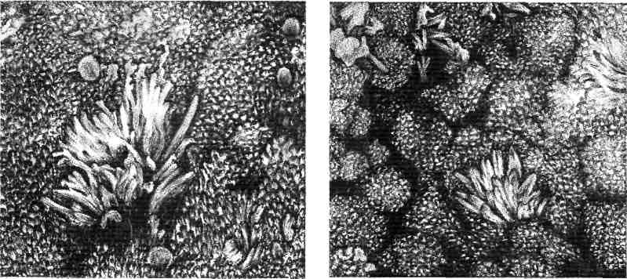
Fig. 15. Phase of endometrial proliferation Fig. 16. Phase of endometrial secretion
(electronic microscopy) (electronic microscopy)
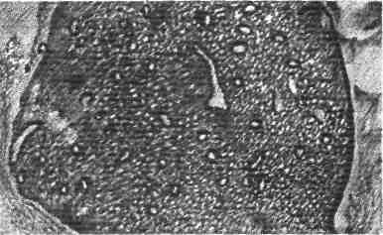
stimulates the production of LTH-in pituitary. As a result of this the level of luteonising hormone increases.
Secretion phase. After ovulation, the corpus luteum produces significant amounts of progesterone, which act on the endometrium to increase the size of endometrial glands and to promote the synthesis and secretion of proteins and other factors (secretory endometrium) in preparation for pregnancy and implantation. This phase lasts from the 14th until the 28th day of cycle (fig. 12).
Fig. 17. Biopsy of endometrium on Phase of endometrial regeneration
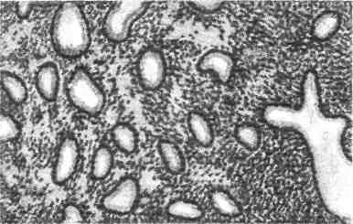
Glandular epithelium starts to produce the secretion containing glycopro-teids and glycogen. The signs of secretory transformation are revealed on the 15th-18th day. The endometrial glands become tortuous and contain secretory material within the lumina. There is maximum amount of the secretions on the 20th-21th day of cycle. Proteolytic and fibrinolytic activity at this time is the highest.On the 24-27th day of the cycle (late secretion) the endometrium is destroyed and degenerative changes occur in it. Argyrofilic fibers destroy lacunar distension of cappillaries and focal hemorrhages into stroma occur. Endometrium is ready to desintegration and ab-ruptio (fig. 19). Ovarian corpus luteum is well developed by this time. It produces progesterone, which is not a mitogen but causes differentiation of the
Fig. 18. Biopsy of endometrium on the 14th day (ovulation). Phase of endometrial proliferation
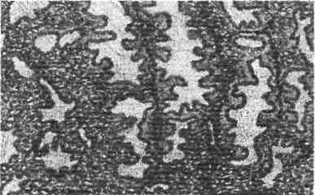
Fig. 19. Biopsy of endometrium on the 24th day. Phase of endometrial secretion
tissues containing progesterone receptors. Progesterone converts the proliferate endometrium into a secretory one (fig. 12).

If fertilization and implantation don't occur, progesterone production rapidly diminishes, menstrual corpus luteum is destroyed, functional layer of endometrium is leading to desquamation. Initiating events lead to the beginning of the new cyclic changes in the ovaries and neuroendocrinous system in the wholefemale organism. Some of the foreign authors have described three phases of reproductive cycle:
- proliferation (5-14-th day of cycle) which is divided into early (5-7th day) and late proliferation
- secretion — 15-28-th day
- desquamation — 1-4-th day of the cycle
Cervical cycle
Uterine cervix is an important biological valve that controles the flow of biological substances into the uterine cavity and from it. Besides, it protects the uterine cavity from the infective agents' penetration. It provides menstrual blood outflow and excretion from the uterine cavity. Endocervix is covered by a simple columnar epithelium which contains secretory crypts. Secretory crypts produce cervical mucus. All uterine cervix structures are very sensitive to the steroid influence. Secretory cells of the endocervix constantly produce sticky transparent liquid, which is called cervical mucus. The quantity and composition of the mucus are regulated by the ovarian hormones secretion and they change during the reproductive cycle. In periovulation period the quantity of the mucus increases up to 600 mg per day, but in luteal phase the mucus quantity is only 50 mg per day.
Hydrated gel is the main component of the mucus that contains hydrocarbo-nates and glycoproteins. Such endocervical mucus characteristics as quantity, water contents and viscosity are maximal at the time of ovulation when the estradiol production is increased. All these changes create the most favourable conditions for fertilization.
Mucus flows down from the internal os to the external one. Epithelial cell microvilli oscillations direct the mucus flow into periphery of the endocervix. It favors the movement of active spermatocytes into the uterine cavity, which are able to overcome cervical mucus flow. Defective spermatocytes move away from the uterine cavity.
Prostaglandines and relaxin also can influence on the uterine cervix. These hormones promote dilation of the cervix in pre-ovulatory period.
Under the. influence of estradiol, the endocervical glands secrete large quantity of thin transparent mucus. Pure watery endocervical mucus contains the increased number of mucin, glycoproteides, salts and decreased quantity of cellular elements. An external os of the cervical canal is more dilated in the ovulation; microfibrils of endocervix are situated parallely. The last one creates the microcanals which promote the migration of spermatocytes. Under the influence of progesterone in post-ovulatory period the cervical canal is closed, the quantity of mucus is decreased, microfibriles are situated as network which is non permeable for spermatocytes. Vaginal cycle
Estradiol stimulates vaginal thickening and maturation of the surface epithelial cells of the vaginal mucous in the follicular phase. Estradiol also facilitates vaginal transudation during the sexual excitement, creating a moist lubricated vagina for sexual intercourse. During the luteal phase of the cycle the vaginal epithelium stops its thickness but the secretory changes are diminished. The thickness of epithelium becomes twice less. In the result of this desquamation occurs. The superficial layer of vaginal epithelium is desquamated in this phase.
Cellular composition of vaginal contents is a biological test of sexual glands' hormonal activity. Superficial, intermediate, parabasal and basal cells ratio depends on the vaginal hormonal state. The quantity of superficial cells are correlated with the estradiol saturation of organism. The more estradiol production results in more superficial cells. During the luteal phase of the cycle the quantity of intermediate cells predominates. Parabasal and basal cells appear during ovarian hypofunction and menopause. They are absent during the normal ovary function in the reproductive women.
Cyclic changes in uterine tubes
The fallopian tubes mucus has parallel folds, which are well developed in the ampulla and become smooth in the isthmus. Folds' height and their direction depend on the ovarian estrogen influence. They are high and parallel in the follicular phase of the cycle that makes sperms' and ovum' migration easier. The fold surface becomes complicated in the luteal phase that blocks the sperm movement.
Under the estrogenic influence the direction of uterine tubes cilia epithelium, fluid composition, contractile activity are changed. The last ones create favorable nditions for fertilization.
Breast cycle
The ductal elements in the breasts, nipples and areolae respond to estradiol ;cretion. After ovulation, progesterone stimulates the acinar (milk producing) ds. Because the acinar glands are located in the tissue of breasts, it gives the ~ts a more rounded configuration. Moreover, progesterone makes the venous m on the surface of the breasts and it appears more prominent and accentuates В small Montgomery glands contained within the areolae. These dynamic changes can be observed during the reproductive cycle.
BIOLOGICAL ACTION OF THE OVARIAN SEX STEROIDS AND GONADOTROPINS
Estrogens
Estrogens are produced by the follicular internal membrane cells and in less quantity by the adrenal cortex. Estradiol, estron and estriol are the main estrogenic hormones. Estradiol is the most active. Estrogenic hormones are circulated in the blood in free state and binding together with proteins. The last one is biological inactive form.
Cholesterol that has been created from lipoproteids is the main structural compound for all the steroid hormones. Steroid hormone secretion is stimulated by FSH and LH and by some enzyme systems, for example aromatases.
The quantity of estrogens predominates in blood plasma. Estrogens enter the liver, then they go into the intestine. Estrogenic hormones are destroyed in the liver and excreted with urine via kidneys. Uterus (endometrium and myometrium), vagina and breasts are target organs for this group of hormones.
The main biological effects of estrogenic hormones:
- provoke the growing and development of uterus and breasts during puberty
- stimulate hypertrophy and hyperplasia of myometrium during pregnancy
- cause the proliferative phase of endometrium
- uterine-placental blood circulation regulation, increase blood supply of uterus
- stimulate vaginal mucus epithelial cells maturation and differentiation
- myometrium sensibilizing to contractile drugs, thus increasing uterine tension, excitability and contractivity
- increase uterine tubes peristalsis during ovulation that accelerates sperm migration
- endocervical stimulation to mucus production, increase mucus plug permeability for sperm
- nitrogen, sodium and fluid retention in the organism; calcium and phosphorus retention in the bones
- decrease the level of blood cholesterol
- reticuloendothelial system stimulation in physiologic quantities, phagocytes activity that respond for antibacterial immunity
Thus, in general, estrogenic hormones promote fertilization, interm onse' and normal duration of labor. Menopausal estrogenic deficiency leads to the bone's calcium and phosphorus loss, increases quantity of cholesterol. These factors provoke bones' fractures and cardiac diseases. Estrogenic action inti organism depends on the doses: small or average doses stimulate ovaries, follicul lar development and maturation; large doses depress ovulation; too large dosei lead to atrophic processes in the ovaries.

METHODS OF EXAMINATION IN GYNECOLOGY
Examination of gynecological patient consists of history taking, objective (general and special) and additional methods of examination. The examination begins with obtaining the history in accordance with a certain plan.
First of all, the passport data is required: surname, name, patronymic, and also birth date (woman's age). This is done because each phenomenon in different age of women lifecycle can have different meaning, for example, absence of menses in young women and women in menopause.
History taking. History has extraordinary value in gynecology. Sometimes it deals with the intimate life problems, that's why it is necessary to ask a patient delicately and accurately for obtaining sufficiently full and exact information. Carefully taken history sometimes is sufficient for making the previous diagnosis. At first patient should be asked about complaints, development of the disease (anamnesis morbi), life conditions and the previous diseases (anamnesis vitae). Gynecological history should be taken in such a way.
Patient Complaints. Most often patients complain of pain, pathological secretions from vagina, bleeding and also of the adjacent organs' dysfunction. The character of pain may point out the disease: the dull pain arises due to abnormal uterine position and chronic inflammatory processes of ovaries. Colicky pain appears in case of uterine or tube contraction (tube or uterine abortion, protruding myoma). Pain has stabbing and stinging character in case of inflammation. Its intensity becomes more severe that is followed by peritoneal irritation. Such pain appears at blood presence in abdominal cavity. Pain has an acute, cutting character at uterine tube and pyosalpinx rupture. Permanent pain is typical for chronic inflammatory diseases and malignant tumors. Pain appeares in sacrum and dorsal lumbar region in dorsal uterine dislocations (retropositio uteri), parametritis and perimetritis. In adnexal diseases pain is present in lateral regions of the lower parts of abdomen. In the diseases of external genital organs pain is situated in place of lesion. Pain irradiation into sacrum, thigh, supraclavicular region (phrenicus-symptom) is typical for some gynecological diseases.
Leucorrhea is a discharge from vagina, that is common at inflammatory processes, uterine disposition and tumors. It is important to pay attention to amount, colour and smell of the discharge. For instance, at trichomoniasis it has "foamy" character, in case of candidiasis it is cheese-like, at cervix erosions it has mucous character, and in case of malignant tumors it looks like "meat slops".
Bleeding can be the manifestation of irregular menstrual cycle, malignant processes and pregnancy.
The physician should inquire about disorders of adjacent organs such as the character and frequency of urination (pain, urine incompetence, extremely frequent urination), defecation (constipation presence, pain at defecation act) and also about the general disorders (hot flushes, palpitation, dizziness, loss of weight or, to the contrary the obesity).
Gynecologic History (anamnesis morbi). The following questions are typical for gynecologic history:
- Is the onset of the disease acute or gradual?
- Have you had any previous examinations or treatment? Notes from the previous physicians may be helpful.
- What were the circumstances at the time when the problem has began (i. e. supercooling, physical overload, previous abortions and traumas)? Correct taking of gynecological history gives a possibility to make a previous
diagnosis with sufficient exactness. However, doctor can perform definitive conclusion about disease only after carrying out an objective examination.
Life history (anamnesis vitae) should define, in which conditions woman has grown up and was formed and also in which conditions she lives at present. Conditions, in which girl lived from early age can have effect on the development of the whole organism. Important value has a full-valued rational feeding, especially in the period of puberty. Excessive or, on the contrary, insufficient feeding can cause wrong forming of the genital system, menstrual and regenerative dysfunction. Material-domestic and job conditions have also a great effect on woman's health state.
Professional and work conditions. There are many professional factors, that have negative effect on woman's health. First of all this is weight lifting, that can contribute to genital organs prolapse, long standing on feet can cause blood stagnation in lower extremities and in pelvic organs causing hypersecretion of mucous membranes. Salts of heavy metals, aniline paints, varnishes and some other chemical substances and radiation have harmful effect on woman's health. Most frequently their action causes menstrual and regenerative dysfunction. Mental overloads can also cause various disorders.
Previous diseases. It is important to find out whether the patient was ill with tuberculosis and sexually transmitted diseases. It is important to know whether the operative interventions on abdominal cavity organs took place. Appendectomy in the past can provoke ovarian inflammation and lately performed appendectomy should be a cause of adhesion process. Special importance has allergic history, for instance, presence of allergic reactions on some medicines. The physician should inquire patient about harmful habits (smoking, alcoholism and drug abuse).
Gynecological history includes data about menstrual, sexual, generative and
woman's secretory functions.
Menstrual history reflects the state of sexual system and organism in a whole. It is important to establish the patient's age at first menstruation (menarche), the interval from the first day of one menstrual period to the first day of the next menstrual period (cycle length), the duration of the menstrual flow, the estimated amount of flow (number of pads) and pain presence.
Late appearing of menses can point to infantilism. Normal amount of blood loss is about 150 ml. If there is an excessive blood loss, myoma or endometriosis should be suspected. Menses duration is also increased in these diseases. Painful menses are present if inflammatory processes, endometriosis is present. It is important to know whether menses character has changed with the beginning of sexual life, after delivery and abortions. Interrogating is finished by asking about the character and date of the last menses.
If a patient has menopause it is necessary to specify, at what age it has begun, how the transitional period passed, whether she has bloody secretions from vagina (this thing can testify about endometrial cancer).
Sexual history. Special tact should be while inquiring woman about this function. It is important to know whether the woman is married or not, about the presence of sexual partners, whether there appeared any signs of disease beginning of sexual life or with partner change. Patient's contraceptive history should include the contraceptive method currently used, when it was firstly used, any problems or complications connected with the method and her partner's satisfaction with the method. It is necessary to ask about the main compounds of sexual function: sexual appetite, orgasms. In case of sexual dysfunction it is important to know whether there where any factors that could negatively affect woman's sexual function (trauma, rape etc.). Some peculiarities of sexual function can give information about presence of concomitant disease. If there is contact bleeding one can suppose cervical diseases such as erosion, endometriosis and sometimes cervical cancer. Painful sexual act can point to the inflammatory processes of peritoneum, ovaries, nearby uterine cellular space and vaginism.
Generative (childbearing) function. Child birth is the women's basic function. In this part one ought to find out, in what time after the beginning of sexual life the first pregnancy had happened without contraception, how many pregnancies were in the past, what was the duration of each one and how they have finished (with delivery or abortion), whether there were premature births or, stillborn children. One should know about babies death in early neonatal perаbout the character of the complications during and after delivery, about the operative interventions during delivery. In case of performed abortions the patient should be inquired about whether were they artificial (at woman's desire), spontaneous, or criminal, in what terms pregnancy was interrupted, were there any complications during and after abortions. If abortions were spontaneous what were their causes.
Absence of pregnancy for a year of sexual life testifies sterility, that can be a concern of woman's genital organs abnormality, ovarian dysfunction or result of the inflammatory process. Rare pregnancy and its frequent loss indicates on hormonal insufficiency. One should obligatorily find out whether the woman uses contraceptives, which ones and during what time.
Secretory history. Much discharge from genital organs is an indication of the gynecological diseases presence. It is necessary to know about amount, smell, appearance, discharge periodicity, because at different gynecological diseases their character differs (due to trichomonal vaginitis they have "foamy" character, in candidiasis — cheese-like character, in malignant tumors — the appearance of "meat slops").
Physical examination
It starts from general examination. It is important to pay attention to the colour of skin: pallor can indicate anemia, ground colour characterizes malignant neoplasm presence.
Excessive hairiness, the lipids dysmetabolism can indicate presence of endocrine diseases.
Dry, coated tongue can indicate to the inflammatory process, "raspberry" one points to candidiasis.
Attention should be paid to the form of the abdomen (tumors of abdominal cavity, ascitis). It is importnt to determine whether the abdomen takes part in breathing act. Palpation gives a possibility to find presence or absence of abdominal wall muscles tensity that is common for ovarian inflammation, torsion of the pedunculated cystoma. Extension of inflammatory process from ovaries to peritoneum or blood presence in abdomen causes positive symptoms of peritoneal irritation. Deep abdominal palpation reveals tumors or infiltrates in pelvis.
Special attention in examination of gynecological patient belongs to breasts palpation. It is important to find presence or absence of consolidations in breasts, character of discharge from nipples. Patient needs additional examination in case of sanious discharge from nipples. The axillary and inguinal lymphatic nodes should be also examined.
Auscultation of abdomen can be useful to determine of bowels peristalsis i at pelvioperitonitis it is languid, at peritonitis it is languid or absent). Auscultation й used for differential diagnostics of pregnancy and tumor.
Each symptom that is found during physical examination should be estimated in complex with the others.
Gynecologic examination. All the methods of gynecological examination are divided into basic which are obligatory, and additional those are performed according to certain indications.
To basic methods belong:
- external genital organs examination
- speculum examination
- bimanual (vaginal-abdominal and rectal-abdominal) examination Following methods belong to additional ones:
- cytological examination
- bacterioscopic examination
- bacteriological examination
- examination with tenaculum
- uterine sounding
- dilatation and curettage with the following cervical canal and uterine histological examination
- culdocentesis
- biopsy, especially aspirative one
- pelvigraphy, especially bicontrast one
- endoscopic methods: colposcopy, cervicoscopy, hysteroscopy, laparoscopy, culdoscopy
- ultrasonography
- functional tests (investigation of ovarian function)
- medical-genetic examination
Basic methods of examination
Gynecological examination is performed on the examination table. Woman lays on back, with half-flexed legs in femoral and knee joints. It is obligatory to empty the urinary bladder before examination, in some cases vacuant enema is indicated. Examination is made in sterile gloves.
Pelvic examination begins with the inspection of external genital organs. Attention should be paid to pubic hair type (masculinizing, feminizing or mixed type), presence or absence of hair on the internal thigh surfaces. Skin irritation in the same places can occur at excessive discharge. Doctor should examine the labia major and labia minor, their size, pigmentation, presence or absence of edema, ulcers, condylomatous nodes and varicose veins. The degree of pudenda cleft closing is marked. The labia are spread laterally to examine the outer o; vagina, pigmentation, colour, presence or absence of ulcers. Estimation of hymer (intact, torn, fresh ruptures) is obligatory. Making examination of clitoris an attention should be paid to its size. The urethral orifice, the areas of the urethra and Skene's glands should be examined. Doctor examines whether there are any secretions, polyps vegetation or hyperemia in this area. The region of the BartO-line's glands should be inspected. Estimation of their excretive ducts (discharge character, hyperemia, edema around orifices) is performed. Perineum state, old ruptures presence, scars, hemorrhoid nodes in anus region, condylomas, fissures, ulcers and mucous membrane are also inspected. Offering a woman to push doctor should determine the presence or absence of prolapse of vagina or uterus.
After finishing of external genitals inspection vaginal speculum examination is performed. For this purpose single-blade Sims 'speculum with vaginal retractor or bivalve Cuskoe 's speculum are used (fig. 20, 21). Recently single-use bivalve specula were used.

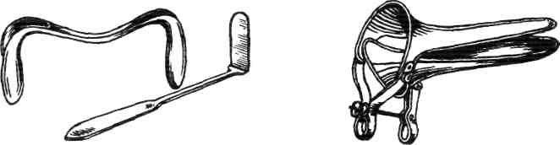

Fig. 20. Single-blade Sims Fig. 21. Bivalve Cuskoe's
speculum with vaginal retractor speculum

Bivalve speculum is introduced into vagina with closed values. With thumb and index fingers of the left hand labia are drawn and speculum is inserted into vagina, placing blades parallel to pudendal cleft. After insertion speculum is turned on 90°. The speculum is inserted as far as it goes which in most women means insertion of the entire speculum length. The speculum is then opened in a smooth delicate way with slight tilting of the speculum, the cervix slides into space between the blades of the speculum. The speculum is then locked into the opened position using the thumb screw (fig. 22).
Sims speculum is inserted into vagina in such a way: with left hand labia major and minor are drawn laterally and with right one the speculum turned, slantwise to pudendal cleft is inserted into vagina, slightly pressing on perineum. Flat anterior speculum (lateral) should be inserted parallely, lifting up anterior wall of vagina (fig. 23). Flat speculum should be inserted additionally in case if vagina is wide and its lateral walls are hanging.

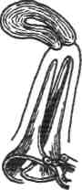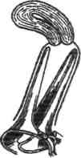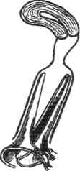

а b с

Fig. 22. Examination of uterine cervix by Cuskoe's speculum:
a — Bivalve Cuskoe's speculum inserted in vagina; b — Bivalve Cuskoe's speculum is opened; с — incorrect insertion of speculum into vagina
Uterine cervix, its size, shape (cylindrical, conic), shape of external os (round in nonparous women, fissured in parous ones) (fig. 24) must be inspected. Character of the cervical mucous membrane (cyanosis, hyperemia), erosions, ruptures, inversions, condylomas presence, hyperemia around external cervical orifice, secretions character may be marked.

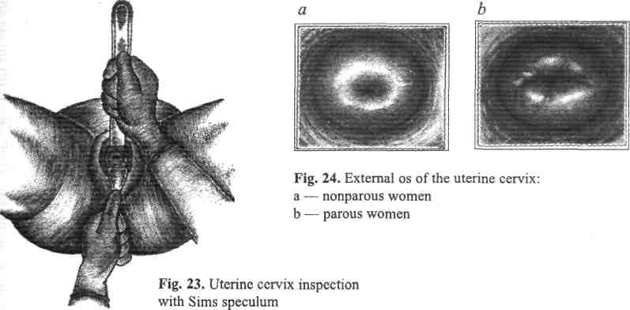
After cervical examination speculum is gradually withdrawn, inspecting vaginal walls. Attention should be paid to the state of mucous membrane (hyperemia, edema), discharge character.
During inspection by Sims speculum at first the elevator, and then the speculum are withdrawn.
After finishing speculum examination, bimanual vaginal-abdominal (fig. 25) and rectal-abdominal examination should be performed.
The bimanual (vaginal-abdominal) examination. With thumb and index fingers of the left hand labia minor are spread. The middle and index fingers of the right hand are inserted into vagina, nameless and little fingers are pressed to palm, and thumb finger is facing the pubis. An examination is made by one
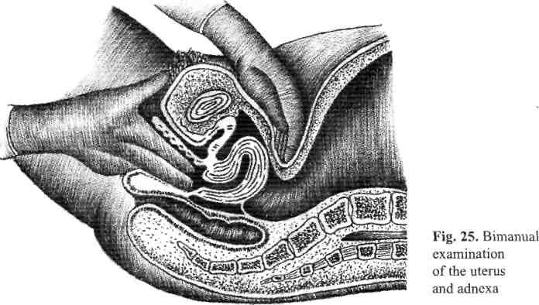

finger if vagina is narrow. Fingers during insertion into vagina should be gently pushed downwards to avoid unpleasant feelings of irritation of the most sensible areas such as anterior wall, clitoris, region of urethra. During introducing fingers into vagina following signs are estimated: presence or absence of pain, outer width (in women, which live sexual life, two fingers enter easily). Determination of the muscles tone and perineum state is performed with pressing on the muscles of the pelvic floor. During gradual moving of fingers into vagina its length, width, ability to tension, rugosity, humidity degree, septums presence, tumors, scars, constrictions are determined. An attention to vaults depth, presence or absence of pain, hanging, shortening should be paid. After palpation cervical form (cylindrical, conic, deformed), its size (underdeveloped, normal size or hypertrophied), presence or absence of ruptures, state of external os (opened, closed, deformed), consistence (dense, sclerosed, softened, of heterogeneous consistence), tumors presence are determined. Cervical attitude to pelvis axis is also estimated. Then fingers are placed into anterior vault and cervix is pushed to back. With abdominal hand one should cautiously press on the front abdominal wall towards fingers those are inserted into vagina. So, uterus is found between fingers of the abdominal and vaginal hands. If uterus is retroflected, then vaginal fingers are placed into the posterior fornix.
Uterus is situated in pelvis in such a way that its body and cervix form an angle, opened frontally (anteflexio), and the whole uterus is flexed forward (ante-versio). It is sufficiently mobile at displacement attempt. Overmobility of the uterus is observed at its descent and prolapses due to incompetence of ligament system. Limited movability is common at adhesions and infiltrates presence in true pelvis.
During uterus examination its size (in nonparous women it is smaller than in parous ones) is determined. Diminish of the uterus size is observed at genital infantilism and menopause. Enlarged uterus can be found at pregnancy and tumors presence. Uterine shape normally is pear-like, flattened in front-back direction, at pregnancy it can be asymmetric due to protrusion of implantation place, at subserous fibromyoma it is tuberous. Uterine consistency is tightly-elastic and painless.
Bimanual examination of the adnexa begins with placing the vaginal fingers to the side of the cervix deep in the lateral fornix. It is important to note that the fallopian tubes are not palpable. Ovaries can be palpated as elastic painless structures. They are mobile and rather sensitive. Normal uterine and ovarian ligaments could not determined. Normally there is no pain and infiltration in paramethrium.
Recto-abdominal examination. In girls, or in case of athresia or stenosis of vagina recto-abdominal examination is made. This method should be used for more detailed inspection of pelvic organs tumors. The examination is made by introducing index finger into rectum. As at previous examination external hand is placed on the anterior abdominal wall over pubis. Vaginal part of cervix which directly adjoins to the anterior wall of rectum is palpated. Its size, mobility, uterine and adnexa sizes, sacral-uterine ligaments and parametriums are palpated.
Additional methods of examination
They are: bacterioscopy examination (smear for purity degree), cytologic investigation of vaginal smears, bacteriological checkup, methods of functional diagnostics, colposcopy, biopsy, uterine sounding, fractional diagnostic curettage of cervical canal and uterine cavity with the following histological research, culdocentesis, pertubation and hydrotubation. X-ray examination methods such as hysterosalpingography, pelviography and bicontrast pelviography are also used. Colposcopy, hysteroscopy, laparoscopy and culdoscopy are endoscopic methods in gynecology. Ultrasonic examination is wide-spreaded nowadays. These methods are used for verification of the diagnosis. Cytologic investigation is obligatory for women who undergo monitoring.
Nurse or midwife prepares the woman and necessary instruments (specula, sets for abrasion, spoons or brushes for smear taking) for carrying out additional examinations. Nurse must prepare a bottle with 10 % formalin solution for tissual fixation of the biopsy tissue after curettage. Proper assignment registration on research is of great importance.
Smears from vagina are taken for purity degree, gonorrhea, oncocytologic investigation, "hormonal mirror".
Following instruments are necessary for material taking:
- vaginal specula
- Folkman's spoon or gynecological spatula or brush
- forceps
- glass slide
- cotton swab
- antiseptic solution
- registration form for laboratory
Patient's preparation:
- to place the patient on examining table
- to make desinfection of external genitalia
- to insert gynecological speculum into vagina, dispose cervix in speculums
Bacterioscopic investigation of vaginal discharge gives possibility to determine vaginal purity degree, bacterial flora, presence of contraindications to different diagnostic manipulations. This method gives possibility to diagnose inflammatory process.
Technique of smear taking for examination on vaginal purity degree:
- to insert a gynecological speculum into vagina
- to take some discharge from the posterior vaginal fornix with gynecologic forceps, spatula, gutter sound, or Folkman's spoon and by stroking motions to drift it on a glass slide
- withdraw a speculum from vagina
- write out an order to laboratory
Laboratory assistant quantifies epithelium cells, leukocyte number, microflora character (Doderlein's bacillus, pathogenic flora — gram-negative bacillus, cocci, fungi, trichomonades, gonococci) and also reaction of vaginal discharge.
There are 4 stages of vaginal discharge purity.
Smear on gonorrhea presence. Material for research is taken just from the cervical canal, urethra (before urination after light massage of the posterior urethra wall) and rectum drift on a glass slide as separate strokes.
Bacteriological research is taken to find the pathogene and its sensitiveness to antibiotics. Material for research is a content of cervical canal, vagina, urethra and puncture material. This material should be sent into bacteriological laboratory. It is necessary to indicate the date and time when the material was taken.
Oncocytologic research (Pap smear) is made for the early diagnostics of oncologic diseases.
Smear taking technique for oncocytologic research:
- speculum insertion
- carefully taking the discharge from the cervix by cotton swab which is clutched in forceps
- material for investigation is taken by gynecological disposable wooden spatula from the anterior and lateral vaults of vagina, external cervical os, vaginal part of cervix and from pathologically altered parts which are revealed during colposcopy. Material is taken by brush or gutter probe (fig. 26 a, b)
- drift it on the glass slide (fig. 27)
- withdraw a speculum
- write an order to the laboratory
Cytological investigation gives a possibility to reveal women who need more detailed examination (biopsy, diagnostic curretage, etc).
There are 5 Pap smear types:
- I type — unaltered epithelium
- II-а type — inflammatory process
- Il-b type — proliferation, metaplasia, hyperkeratosis (at corresponding clinical picture they are interpreted as polyp, simple leukoplakia, endocervicosis
- Ill-a type — light, moderate, dysplasia on the background of benign processes on unaltered epithelium
- Ill-b type — severe dysplasia of squamous epithelium on the background of benign processes and on unaltered epithelium

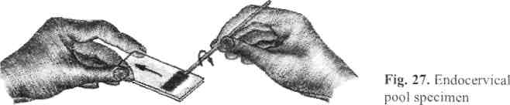

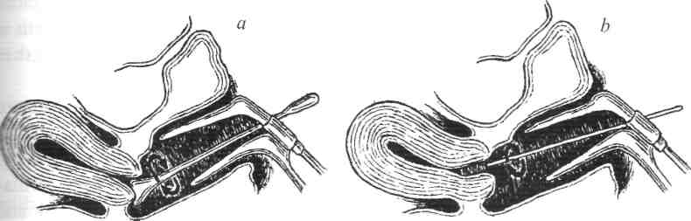

Fig. 26. Pap smear:
a — obtaining exocervical portion of Pap smear
b — obtaining endocervical sample
- IV type — suspicion on malignisation, intraepithelial cancer should be possible
- V type — cancer
- VI type — smear is non-informative (material has been taken in a wrong way)
Smear on "hormonal mirror". Material is taken by light touch of instrument from the upper one-third of lateral vaults not earlier than in 2 days after cessation of any manipulations in vagina. The taken material is thinly smeared on a glass slide. Woman's age, pregnancy term or day of menstrual cycle is indicated.
This method can be used for diagnostics of pregnancy loss, menstrual cycle disordes and also as a control for hormone therapy results.
Methods of functional diagnostics
Properties of cervical mucus. Properties of cervical mucus are changing due to estrogen and progesterone action during menstrual cycle. Maximum quantity is secreted during ovulation, the minimum is secreted before menses.
- The mucus tension symptom. In case, when you place some mucus from cervical canal between forceps legs and carefully move them apart, then you'll get a mucus string, the length of which depends on the mucus viscosity. Maximum length of the string will be in ovulation period when mucus viscosity is maximal. String's length is measured in centimeters (the greater estrogen production the longer is the string) and is estimated for 3-point system: 1 point (+) at string length up to 6 cm (early follicular phase), 2 point (++) — 8-10 cm (medium follicular phase, moderate estrogen saturation), and 3 point (+++) when string length is 15 cm and more (maximum estrogen saturation). Tension symptom diminishes and then disappears in luteal phase of menstrual cycle.
The "pupil symptom". Cervical tone and its external os diameter are changing during menstrual cycle under the influence of estrogen hormones. Dilatation of external cervical os and mucus appearance in it starts from the 8-9th cycle day and up to the 14th day it is maximally dilated (up to 3-6 mm in diameter). Mucus drop, that comes forward from external os seems to be dark and looks like a pupil at illumination on the background of pink cervix. This is a positive "pupil" symptom. Amount of mucus begins to decrease during the next days and up to 18th-20th day of the cycle this symptom disappears and cervix becomes "dry". Such changes are typical for normal menstrual cycle. In case of follicle persistence, the "pupil" symptom does not disappear up to the time when bleeding occurs. This indicates on hyperestrogenemia and absence of luteal phase in ovaries. The "pupil" symptom is slightly positive or absent at amenorrhea. This symptom is also absent during pregnancy. The "pupil" symptom is estimated on the 3-point system: presence of small dark dot means 1 point (+), early follicular phase; 2,0-2,5 mm — 2 points (++), medium follicle phase; and 3,5 mm — 3 points (+++), ovulation. If cervix is strained by postnatal ruptures, erosion or endocervicitis test is unreliable.
3. The "fern symptom". The "fern test" is used to distinguish the ovaries functional state. It is named from the pattern of absorbtion that occurs when discharge is placed on a slide and is allowed to be dried in the room air. Arborisation intensity depends on the menstrual cycle phase i.e. on the ovarian estrogenic effect. Mucus is taken by forceps, which are inserted into cervical canal to depth of 5 mm. Then it is drifted on a glass slide, dried up and examined under the microscope. Such varieties of "ferm symptom" are distinguished (fig. 28 a-d) as:
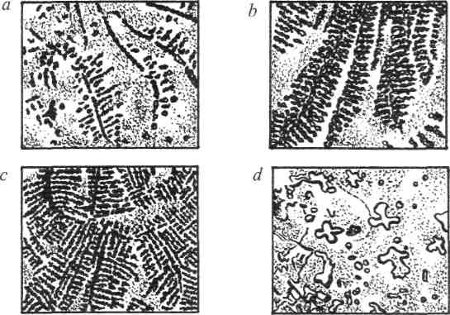
Fig. 28. The «fern symptom»
- separated leaves of the fern plant (when the quantity of estrogen secretion is the minimal) — 1 point (+), early follicular phase;
- expressed leaves of the fern plant — 2 points (++), medium follicle phase with moderate estrogen secretion;
- thick stems and leaves deviate at angle of 90° (in the period of ovulation, when more estrogens are present) — 3 points (+++);
- negative symptom.
This test like the previous one is used for ovulation determination. Presence of "fern symptom" during the whole menstrual cycle indicates on high estrogen saturation (persistation of the follicle) and absence of the luteal phase; absence of this symptom can testify about estrogen insufficiency. Diagnostic value of all the described above tests is considerably increased in their complex using.
Cervical index estimation

Test name | Points quantity
 | 0 | 1 | 2 | 3
Amount of mucus | Absent | Slight | Moderate | Considerable
Mucus tension | Absent | Up to 6 cm | 8-10 cm | 15 cm
"Pupil symptom" | Absent | Dark dot | 2,0-2,5 mm | 3,5 mm
"Fern symptom" | Absent | Small crystals  and seperate  stems | Expressed  leaf  pattern | Big leaves  with thick  stem
Cervix index or cervical number (maximum value of each point is — 3, minimum — 0 (table 1) should be determined after the summarizing of the amount of all the points received from each test.
Cervical index up to 3 numbers indicates on the expressed estrogen insufficiency, 4-6 — moderate estrogen insufficiency, 7-9 — sufficient estrogen saturation, 10-12 — high saturation. Cervical index estimates presence or absence of ovulation and cyclic changes of the organism's estrogen stimulation.
Basal temperature. Basal temperature (ВТ) changing is based on the hyperthermic influence of progesterone on hypothalamus. ВТ is measured in rectum in the morning regularly by the same thermometer with the empty stomach, without getting up. In first phase of menstrual cycle temperature is below 37 °C (0,2-0,3° lower), after ovulation it rises and holds on between 37,1-37,4 °C. Basal temperature change indicates on presence or absence of ovulation, follicle persistence, threatened abortion and some other states. This test is simple, easily available and sufficiently objective, however one should remember, that any causes of non-hormonal character (diseases, that are accompanied with temperature reaction) can affect it. It is necessary to carry out measuring during 2-3 cycles. Only in this case this method has the diagnostic value.
Cytological examination of vaginal smears
During examining degree of estrogen saturation determines the morphology of vaginal epithelium, which is changing during menstrual cycle. Basal, parabasal, intermediate, superficial layers are distinguished in the stratified squamous epithelium of vagina. Vaginal epithelium is exposed to rhythmic changes during menstrual cycle, that is characterized by different stages of mucous membrane proliferation. According to degree of organism saturation by estrogens, superficial, intermediate and basal cells in different ratio are differed. Method of colpocyto- diagnostics is based on the determination of quantity and morphological peculiarities of epithelial cells.1
Such indexes are determined:
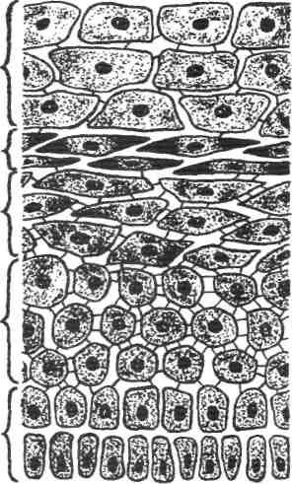
- maturity index is a correlation of superficial, intermediate, parabasal and basal ² cells ratio, expressed in percents; index is written in such a way: parabasal/inter- 3 mediate/superficial (parabasal and basal cells are counted up together)
- cariopicnotic index (CPI) is a correlation of superficial cells with picnotic nuclear and general amount of cells ratio expressed in percents. CPI is directly proportional to the degree of organism's estrogen , saturation
Fig. 29. Squamous vaginal epithelium:
- — superficial
- — intraepithelial
- — intermediate
- — parabasal
- — basal
- eosinophile index — superficial cells with eosinophile cytoplasm and cells with basophilic cytoplasm ratio expressed in percents

Cells' disposition (layers presence) and amount of the "rolled up" cells should be determined for revealing of progesterone effect on vaginal epithelium. Progesterone stimulation degree is estimated for 3-point system too: the plenty of the "rolled up cells" makes 3 points (+++), moderate amount makes 2 points (++), low quantity makes 1 point (+), undetermined cells makes 0 (-).
Assignments for Self - assessment.

II. Multiple Choice.
Choose the correct answer / statement:
1 External female genital organs include:
A –Menstrual pain;
B - Folate-deficiency anemia;
C – Mons pubis;
2. Which of the following is not characteristic of internal female genital organs?
A- Decreased factor VII;
B - Uterus;
C - Vagina;
D - Mons pubis.
3. Which of the following is Not characteristic of external female genital organs :
A - Vagina;
B- Hymen;
C- Labia minora;
D- Uterus;

III.Answers to the Self- Assessment. 1.C. 2.B. 3.D.

Students must know:
1 - Eexternal female genital organs.
2- Internal female genital organs.
3- Normal menstrual cycle.
4. Physical examination.
5.Methods of functional diagnostics.

5.2. Theoretical questions
- What are the external female organs, the structure, blood vessels and innervation.
- Vagina: structure, blood vessels, innervations;
- Uterus: structure, function, blood vessels, innervations
- Uterine tubes: structure, function, blood vessels;
- Ovaries: structure, function, blood vessels;
- Suspensive apparatus of the uterus
- Clinical peculiarities of anatomical structure of the female reproductive organs in different age periods;
- Regulation of menstrual cycle on different steps;
- The role of hormones, bioactive substances.

5.3. Practical work:
- Collection the anamnesis;
- Estimation the patient;
- To make the plan of additional research.

References:
1.Danforth's Obstetrics and gynaecology. - Seventh edition.- 1994. - P. 351-464.
2.Obstetrics and gynaecology. Williams & Wilkins Waveriy Company. – Third Edition.- 1998.-P." 196-236.
3. Basic Gynecology and Obstetrics. - Norman F. Gant, F. Gary Cuimingham. 1993.-P. 444-456.

