EUROPEAN JOURNAL OF BUSINESS SCIENCE AND TECHNOLOGY

Decision making on various approaches to Importance-Performance Analysis (IPA)
Abstract
Purposes: The purpose of this paper is to compare several approaches to Importance-Performance Analysis (IPA) and show how different criteria can be used for dividing the IPA matrix to decision-making fields.
Methodology: The authors performed the IPA analysis basing on the data collected in customer satisfaction survey. The survey was conducted from January to April 2016 in selected dentist’s surgeries in cities Żywiec and Bielsko-Biała (southern Poland). Over 200 questionnaires were distributed, 100 of them returned. The data was used to generate and compare several forms of IPA matrix.
Findings: The study showed how the assumed form of the matrix can determine the qualification of the same attribute to different decision field.
Practical implications: The study may facilitate the selection of appropriate form of matrix used in customer satisfaction surveys. It may be useful in future studies on adequate approach to IPA analysis.
Originality: The paper is based on unpublished, own study.
Keywords: customer research, customer satisfaction, customer satisfaction survey, Importance-Performance Analysis, IPA.
JEL Code: M300 (General Marketing), I110 (Analysis of Health Care Markets).

Introduction

Importance-Performance Analysis (IPA)
IPA is a tool that is easily applicable in marketing research. It helps to indicate main factors, attributes of product or service which require an immediate response (improvement). Furthermore the visualization of data can clearly show areas of concern and facilitate changes.
The IPA analysis was introduced by Martilla and James (1977). Since then IPA has been applied to a diverse range of context including various branches, among them: automotive (Meng and Yun, 2016), food (Tzeng and Chang, 2011), health care (Yavas and Shemwell, 2001; Olbrych and Łopyta, 2011; Gajewska and Piskrzyńska, 2016), tourism (Guadagnolo, 1985; Haahti and Yavas, 2004), educations (Biesok and Wyród-Wróbel, 2015; Kitcharoen, 2004), banking (Joseph et al. 2005).
The classic form of IPA, proposed by Martilla and James (1977), recognizes satisfaction as the function of two components: the importance of the product or service to the client and the performance of business in providing that service or product.
The means of importance and performance rating are placed on the Cartesian diagram in which one axis represents importance of selected attributes and the other one shows the product's/service's performance in relation to these attributes. This graphic interpretation of the IPA is called an Importance-Performance matrix or grid. The matrix is divided into four quadrants (2x2). Each quadrant suggests a different marketing strategy, recommendation for the attribute. Fig. 1 illustrates the classic IPA matrix.
D
Possible overkill
Restrain
High importance
[Concentrate efforts]
Low importance
[Do not focus]
Good performance
[Maintain]
Poor performance
[Improve]
C
Low priority

A
Keep up the
good work

B
Concentrate here
Focus your efforts
Improve immediately
IMPORTANCE
PERFORMANCE
Figure 1: The IPA matrix (adapted from Martilla and James, 1977).
The four quadrants in importance-performance analysis are characterized as (Martilla and James, 1977; Silva and Fernandes, 2011):
- A. Keep up with the good work – high importance, high performance: attributes placed here indicate opportunities for achieving or maintaining competitive advantage and are major strengths,
- B. Concentrate here – high importance, low performance: these attributes require immediate attention for improvement and are major weaknesses,
- C. Low priority – low importance, low performance: these attributes are minor weaknesses and do not require additional effort,
- D. Possible overkill – low importance, high performance: these attributes indicate that business resources committed to them would be overkill and should be deployed elsewhere.
The organization should focus their attention on those attributes for which importance is high and performance is low. If the organization is able to improve on these attributes they represent the largest potential gains (Eskildsen and Kristensen, 2006).

Alternative Approaches to the Analysis
Despite of simplicity IPA analysis several different approaches to inferring priorities and measuring importance have emerged in the literature (e.g. Oh, 2001; Bacon, 2003; Fuchs and Weiermair, 2003; Abalo et al., 2007; Biesok and Wyród-Wróbel, 2015). Usually modifications rest on different division of the matrix. For example Abalo, Varela and Manzano (2007) proposed such solution: the main matrix was divided by diagonal line (45-degree line, also called iso-line) into two equal parts (the new area occupies the whole of the zone below the priority line). The quarter below the diagonal line is an area that requires special attention. In relation to the criteria contained in this part of the graph improvement actions should be introduced (Figure 2a). The interpretation of the areas above the diagonal line is the same as in the original Martilla and James (1997) diagram.
For comparison, Biesok and Wyród-Wróbel (2015) used other convention. The data for the analyses were gathered in survey on satisfaction of students of management at the University of Bielsko-Biala. In conclusion of the study, the authors proposed applying 6 decision fields (Fig. 2b):
- Field A1 – keep up the good work,
- Field A2 – warning: good work, but worsening of these factors implicates immediate improvement because it can affect on customer satisfaction in a large extent,
- Field C1 – factors of low priority with which you do not have to deal,
- Field C2 – factors that can be improved in some time horizon,
- Fields B and D have the same meaning as in classical IPA matrix.
Importance
Concentrate here
Performance
Low priority
Possible overkill
Keep up the good work
a
b
Importance
Performance
B
Concentrate here
C1
Low priority
D
Possible overkill
Leave
A1
Keep up the good work
A2
Warning
C2
Improve
Figure 2: Modifications of the IPA matrix ((a) Abalo, Varela and Manzano (2007); (b) Biesok and Wyród-Wróbel, 2015, adapted from Martilla and James (1997), Bacon (2003)).

Methodology and Data

Research Instrument
Various approaches to IPA analysis was tested using data gathered in the survey on customer satisfaction of dental surgeries in Żywiec and Bielsko-Biała (Silesian Voivodship, Poland). The survey was performed from January to April 2016.
The questionnaire for this study included four main sections. The first section included questions connected with dental service and among them the question about overall satisfaction of the dental service. The second section of the questionnaire contained 15 dental service attributes which were identified basing on a focus group discussions.
In the survey, the respondent was asked to evaluate importance and the performance of these attributes. For evaluating the attributes 5-point scale was used, ranging from 1 – not important at all, very bad (performance) to 5 – very important, very good performance.
The other sections of the questionnaire included questions about loyalty, expectations and recommendations.

The Sampling Method
Data was collected using a paper questionnaire that was available in selected dental surgeries. Patients could take a part in the survey voluntarily, filling the questionnaire. There were no age or other limitations for participation in the study. Over 200 questionnaires were distributed and 100 valid questionnaires were received, so the response rate reached nearly 50%.

Data Analysis
The data was analysed in two variants:
- classical – the IPA matrix was constructed using mean performance and importance rating taken from the survey,
- in the second variant the importance measures was estimated using linear regression.
The second variant is part of a broader problem: how to perform the analysis without data about the importance of the attributes, for example in case of using survey data in which respondents were not asked about the importance of quality attributes. In the literature you can find various proposals of the solution of the problem: with using multiple regression coefficients (e.g. Matzler and Sauerwein, 2002) or linear correlation coefficients (e.g. Biesok and Wyród-Wróbel, 2015).
In this case we used another approach. The measures of the attributes importance was estimated using single linear regression. We assumed that overall satisfaction rating (SAT) expressed by respondents in the survey is linear and related to every studied attribute. The relation among them can be shown as a such linear equation:

(1)
where:
SAT – overall satisfaction rating expressed by respondents,
Pi – performance rating of i = 1 – 15 attributes expressed by respondents,
Ii – linear regression coefficient,
bi – linear regression intercept.

Then we calculated linear regression coefficients I1 – I15 between overall satisfaction rating (SAT) and ratings of every attribute performance. These coefficients were used for analysis as measures of importance of the attributes.
In both variants the matrix was divided into four decision fields in the “centre of gravity” of the importance and performance rating and cut in half with priority-line (iso-line). Then the attributes were classified into decision fields, using following approaches:
- simple – based only on priority line (iso-line),
- classical 4-field,
- 6-field, proposed by Biesok and Wyród-Wróbel (2015).
At the end we compared the results of the analysis and showed both the similarities and differences and different approaches witch influenced conditions for decision making, based on the IPA analysis.

Results
In the first variant of the study, we performed IPA analysis in a classical way. Lines dividing the matrix were lead in the relative middle (“centre of gravity” of the attributes) with additional 45-degree iso-line. The classical IPA matrix is shown on the Fig 3.
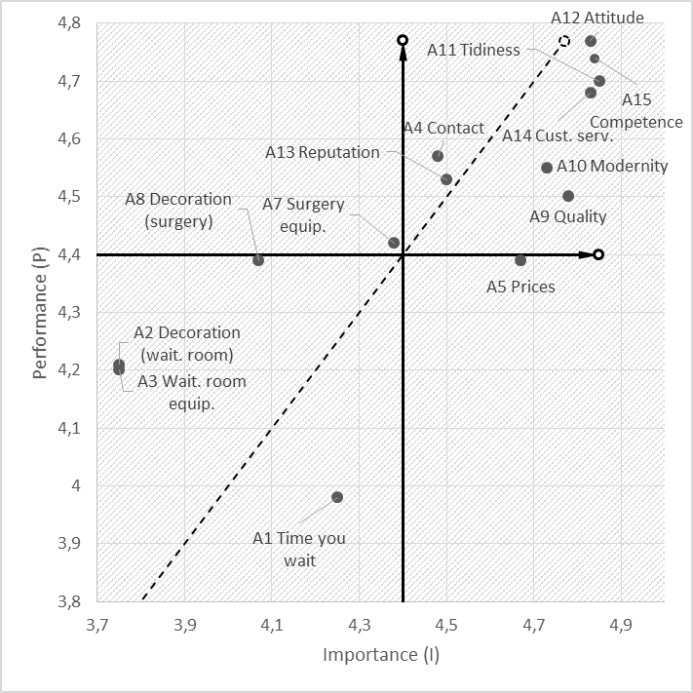
Figure 3: Classical IPA matrix. Attribute A6 (Acceptability of credit cards) is over the range because of its low importance.
Table 1 shows the results of IPA analysis in the first variant. All three decision criteria are consistent only in one case: attribute A5 and suggest focusing attention on the prices in the office.
The approach based on priority line (iso-line) causes the biggest differences in the assessment of attributes. It gives only dichotomous response (concentrate or leave) and its recommendations stand out from other approaches.
In the case of analysed survey, the classical division of the IPA matrix gives to many attributes recommendation “keep up”, so therefore it may seem that respondents are satisfied with them. Here 6-field approach is more accurate because most of these attributes have the recommendation “warning”, which means that despite the good reception by the respondents, we should pay attention to them, because their worsening can have a significant impact on the perception of the service and customer satisfaction.
Table 1: Classical IPA analysis results and decisions about attributes
Attribute | I | P | Priority line criterion | 4-field criterion | 6-field criterion
A1 Time you wait for appointment | 4.25 | 3.98 | Concentrate | Low prio. | Improve
A2 Interior decoration of the waiting room | 3.75 | 4.21 | Leave | Low prio. | Low prio.
A3 Waiting room equipment | 3.75 | 4.20 | Leave | Low prio. | Low prio.
A4 Contact with a patient | 4.48 | 4.57 | Leave | Keep up | Keep up
A5 Prices of treatments | 4.67 | 4.39 | Concentrate | Concentrate | Concentrate
A6 Acceptability of credit cards | 3.23 | 3.39 | Leave | Low prio. | Low prio.
A7 Doctor’s surgery equipment | 4.38 | 4.42 | Leave | Leave | Leave
A8 Interior decoration of the doctor’s surgery | 4.07 | 4.39 | Leave | Low prio. | Low prio.
A9 Quality of treatments | 4.78 | 4.50 | Concentrate | Keep up | Warning
A10 Modernity of tools and treatments | 4.73 | 4.55 | Concentrate | Keep up | Warning
A11 Tidiness | 4.85 | 4.70 | Concentrate | Keep up | Warning
A12 The attitude to the patient | 4.83 | 4.77 | Concentrate | Keep up | Warning
A13 The reputation of the office | 4.5 | 4.53 | Leave | Keep up | Keep up
A14 Customer service quality | 4.83 | 4.68 | Concentrate | Keep up | Warning
A15 The competence of the staff | 4.84 | 4.74 | Concentrate | Keep up | Warning

In the second variant of the study, IPA analysis was performed with a regression-derived importance values. Fig. 4 and the Table 2 show the results of IPA analysis with obtained regression coefficients (I-r) in function of importance measure. Additionally their statistical significance at level 0,05 is marked with an asterisk (*). The lines dividing the matrix were lead in the same way, as in the preceding variant.
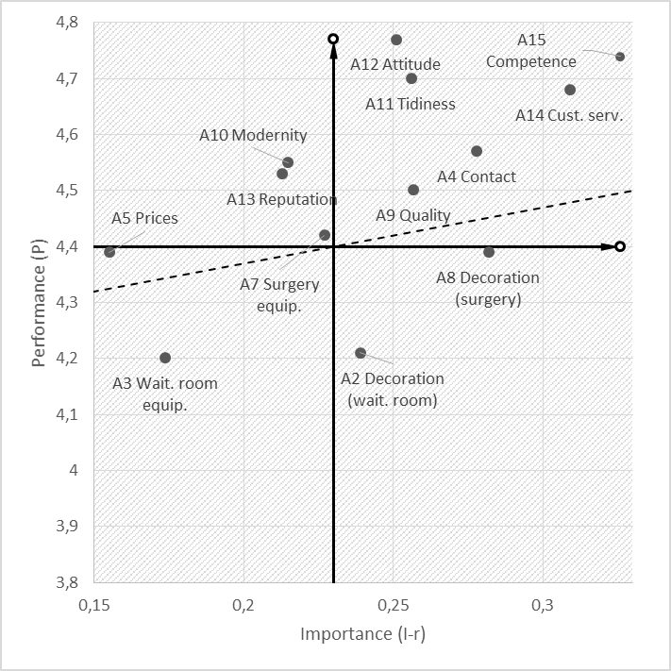
Figure 4: IPA matrix with a regression-derived importance values. Attribute A6 (Acceptability of credit cards) is over the range because of its low importance.
This variant used different importance values, so the matrix structure was rebuilt. Although it does not differ considerably from the classic IPA matrix. We can notice a greater compatibility between 4-field and 6-field approaches. The attributes A2, A7, A10, A8, A13 have the same recommendations, regardless of the used criterion. The disadvantage of this result, limiting the possibility of proper conclusions, is that not all that received the regression coefficients are statistically significant (statistically different from zero).
Table 2: IPA analysis with a regression-derived importance measure and decisions about attributes
Attribute | I-r | P | Priority line criterion | 4-field criterion | 6-field criterion
A1 Time you wait for appointment | 0.140 (ns) | 3.98 | Concentrate | Low prio. | Improve
A2 Interior decoration of the waiting room | 0.239* | 4.21 | Concentrate | Concentrate | Concentrate
A3 Waiting room equipment | 0.174* | 4.20 | Concentrate | Low prio. | Improve
A4 Contact with a patient | 0.278* | 4.57 | Leave | Keep up | Keep up
A5 Prices of treatments | 0.155 (ns) | 4.39 | Leave | Low prio. | Low prio.
A6 Acceptability of credit cards | 0.055 (ns) | 3.39 | Concentrate | Low prio. | Improve
A7 Doctor’s surgery equipment | 0.227* | 4.42 | Leave | Leave | Leave
A8 Interior decoration of the doctor’s surgery | 0.282 | 4.39 | Concentrate | Concentrate | Concentrate
A9 Quality of treatments | 0.257* | 4.50 | Leave | Keep up | Keep up
A10 Modernity of tools and treatments | 0.215* | 4.55 | Leave | Leave | Leave
A11 Tidiness | 0.256* | 4.70 | Leave | Keep up | Keep up
A12 The attitude to the patient | 0.251 (ns) | 4.77 | Leave | Keep up | Keep up
A13 The reputation of the office | 0.213* | 4.53 | Leave | Leave | Leave
A14 Customer service quality | 0.309* | 4.68 | Leave | Keep up | Keep up
A15 The competence of the staff | 0.326* | 4.74 | Leave | Keep up | Keep up
* statistically significant al level 0,05 (ns) non-significant

As already stated, in presented case, the matrix obtained by estimating the importance measures does not differ much from the classical matrix IPA. Table 3 shows the results of these analyses and recommendations obtained in both variants with 6-field criterion used.
Table 3: Results and recommendations of IPA analysis in classic variant (I) and with importance measures estimated using linear regression (I-r)
Attribute | I | I-r | Recommen-dation
A1 Time you wait for appointment | Improve | Improve | The same
A2 Interior decoration of the waiting room | Low prio. | Concentrate | Different
A3 Waiting room equipment | Low prio. | Improve | Similar
A4 Contact with a patient | Keep up | Keep up | Similar
A5 Prices of treatments | Concentrate | Low prio. | Similar
A6 Acceptability of credit cards | Low prio. | Improve | Similar
A7 Doctor’s surgery equipment | Leave | Leave | The same
A8 Interior decoration of the doctor’s surgery | Low prio. | Concentrate | Similar
A9 Quality of treatments | Warning | Keep up | Similar
A10 Modernity of tools and treatments | Warning | Leave | Different
A11 Tidiness | Warning | Keep up | Similar
A12 The attitude to the patient | Warning | Keep up | Similar
A13 The reputation of the office | Keep up | Leave | Different
A14 Customer service quality | Warning | Keep up | Similar
A15 The competence of the staff | Warning | Keep up | Similar

Discussion and Conclusions
In classic way, importance of attributes in the IPA analysis is rated consciously by the respondents. In contrast, importance measures estimated with the statistical methods can be considered as an importance expressed indirectly. Matzler and Sauerwein (2002) call those two importance measures as the explicit and implicit importance.
The importance of the attributes rated by the respondents is different from the statistically derived ones. It can be assumed that the importance of attributes will correlate with overall assessment of satisfaction (very important attributes should have a strong impact on overall satisfaction score). However, it is not like this attribute having significant statistical influence on overall satisfaction may not always be rated by the respondent as the most important.
Our short study also showed, that a change in approach to IPA analysis, implies taking various decisions. All of these approaches are equal and literature or studies do not indicate any of them as a model. Oh (2001) says explicitly that one of the IPA limitations is the lack of framework for this method. Therefore various approaches to IPA may provide contradictory results.
The main limitation of our study is the selection of the sample. The sample was rather small and its random nature may cause that the sample is unrepresentative. The second limitation of the study may also be a branch where we performed our survey. Dental surgeries are expected to be a specific type of services and our results cannot be directly generalized to other commercial services. The third limitation is that not all received regression coefficients are statistically significant, which limits the possibility of proper conclusion in the second variant of our study.
Future research should test and compare various variants of the analysis, especially in other branches. Researchers should also look for other, more effective methods of importance measurement. This will facilitate future research (the respondent would not have to asses twice the same list of attributes) and will give an opportunity to provide the IPA analyses using data, where respondents did not rated the importance of attributes.
References
ABALO, J., VARELA, J. and MANZANO, V. 2007. Importance values for Importance-Performance Analysis: A formula for spreading out values derived from preference rankings, Journal of Business Research, 60: 115–121.
ABALO PIÑEIRO, J., VARELA MALLOU, J. and RIAL BOUBETA, A. 2006. El análisis de importancia-valoración aplicado a la gestión de servicios. Psicothema, 18(4): 730–737.
BACON, D.R. 2003. A comparison of approaches to Importance–Performance Analysis. Journal of Market Research, 45(1): 55–71.
BIESOK, G. and WYRÓD-WRÓBEL, J. 2015. Podejście do analizy IPA w badaniach satysfakcji klienta. Problemy Jakości, 6: 26–31.
ESKILDSEN, J. K. and KRISTENSEN, K. 2006. Enhancing IPA international. International Journal of Productivity and Performance Management, 55(1): 40–60.
FUCHS, M. and WEIERMAIR, K. 2003. New perspectives of satisfaction research in tourism destinations. Tourism Review, 58(3): 6–14.
GAJEWSKA, P. and PISKRZYŃSKA, K. 2016. CSI Method of assessing patient satisfaction in selected maternity wards. Journal of Modern Accounting and Auditing, 12(5): 277–283.
GUADAGNOLO, F. 1985. The Importance–Performance Analysis: An evaluation and marketing tool. Journal of Park and Recreation Administration, 3(2): 13–22.
HAAHTI, A. and YAVAS, U. 2004. A multi-attribute approach to understanding image of a theme park. The case of Santa Park in Lapland. European Business Review, 16 (4): 390–397.
JOSEPH, M., ALLBRIGTH, D., STONE, G., SEKHON, Y. and TINSON, J. 2005. IPA of UK and US Bank: Customer perceptions of service delivery technologies. International Journal of Financial Services Management, 1(1): 66–88.
MARTILLA, J. and JAMES, J. 1977. Importance-Performance Analysis. Journal of Marketing, 41(1): 77–79.
MATZLER, K. and SAUERWEIN, E. 2002. The factor structure of customer satisfaction. An empirical test of the importance grid and the penalty-reward-contrast analysis. International Journal of Service Industry Management, 13(4): 314–332.
MENG, L.J. and YUN, CH.T. 2016. Consumer Preference Toward Super-Mini Cars in Malaysia: An Importance-Performance Analysis Approach. Regional Conference on Science. Technology and Social Sciences (RCSTSS 2014): 259–268.
OH, H. 2001. Revisiting importance-performance analysis. Tourism Management, 22 (6): 617–627.
OLBRYCH, B. and ŁOPYTA, B. 2011. Technika IPA jako narzędzie oceny satysfakcji pacjentów w jednostkach ochrony zdrowia. Studies & Proceedings of Polish Association for Knowledge Management. Nr 38. [Online]. Available at: http://www.pszw.edu.pl/images/publikacje/t038_pszw_2011_olbrych_lopyta_-_technika_ipa_jako_narzedzie_oceny_satysfakcji_pacjentow_w_jednostkach_ochrony_zdrowia.pdf. [Accessed: 20 November 2016).
SILVA, F.H. and FERNANDES, P.O. 2011. Importance-performance analysis as a tool in evaluating higher education service quality: the empirical results of ESTiG (IPB). In the 17th International Business Information Management Association Conference. University of Pavia. Milan, Italy. (CD-ROM), 306–315.
TZENG, G.-H. and CHANG, H.-F. 2011. Applying Importance-Performance Analysis as a Service Quality Measure in Food Service Industry. Journal of Technology Management & Innovation, 6 (3): 106–115.
YAVAS, U. and SHEMWELL, D.J. 2001. Modified importance-performance analysis: An application to hospitals. International Journal of Health Care Quality Assurance Incorporating Leadership in Health Services, 14(2-3): 104–110.

