Forward Head Correction Exercises For Management Of Myogenic Tempromandibular Joint Dysfunction

Fatma A. El-Hamalawy

Musculoskeletal Department, Misr University for Science and Technology, 6 October City- 2nd Districts – 1st area 198 / 2
Fatma_therapy@yahoo.com

Abstract: Objectives: To investigate the effect of independent forward head postural exercise on myogenic tempromandibular joint dysfunction. Methods :The study included fifteen females , diagnosed as myogenic TMJ dysfunction with limited mouth opening aged between 20-40 years(27.1± 4.6 years).TMJ pain was Persistent for at least six months( 12.3±5.3) and Patients were observed to have a forward head posture .The measurements included vertical mouth opening measured in millimeters by Standard ruler, pain intensity using visual analogue scale and craniocervical posture on lateral cephalometic .Each patient received exercise program consisting of 1-strengthening exercise of deep cervical flexors and scapular retractors 2- stretching exercise of the suboccipital muscles and pectoralis muscles. Results: The result showed significant decrease in crainocervical angle and lower cervical curvature. Also there was a significant increase in vertical active mouth opening (P=0.000) and decreased pain level of masticatory system (P=0.000). The correlation between mouth opening and the Craniocervical angle was found to be significant .No significant correlation was found between upper and lower cervical curvature. Independent forward head correction exercise program was found to be effective in improving myogenic TMJD and support the relation between forward head posture and TMJD.
[Fatma A. El-Hamalawy. Forward Head Correction Exercises For Management Of Myogenic Tempromandibular Joint Dysfunction. Journal of American Science 2011;7(8):71-77]. (ISSN: 1545-1003). http://www.americanscience.org.

Keywords: Myogenic; tempromandibulr joint; dysfunction; myofascial pain; forward head posture; posture exercise.

1. Introduction:
Tempromandibular disorders can be subdivided into muscular and articular categories .Myogenic disorders include myalgia (myofascial pain, fibromyalgia), myospasm, splinting, and fibrosis/contracture ^{[1]} Tenderness to palpation of muscle, limitation in mandibular range of motion, perceived alteration in the dental occlusion, and changes in mood are conceptualized as consequences of myogenic pain ^{[2]}. It has been reported that approximately 50% of all TMDs are masticatory myalgias or painful masticatory muscle disorders^{[3]}. Within Myogenic Disorders myofacial pain (MFP) and myofacial pain dysfunction syndrome (MPD) are encountered frequently. Patients suffering from MFP will have tenderness to palpation of two or more muscle sites. Myalgias involving the muscles of mastication predominate MFP escalates to (MPD) when there is concomitant limitation of jaw opening^{[4]}.Many researchers have examined the role of estrogen in the etiology of masticatory myalgias ^{[5]}, the fact that the condition is more sever in women than men,and that it occurs mor frequently in women of reproductive age bears further investigation^{[1]}.
Forward head position is characterized by an extension of the head together with the upper cervical spine (C1 to C2) accompanied by a flexion of the lower cervical spine (C4 to C7) This posture is associated with weakness in deep cervical short flexor muscles (capital flexors), and mid thoracic scapular retractor (i.e., rhomboids, middle and lower fibers of trapezius) and shortening of the opposing cervical extensor and Pectoralis muscles ^{[6]}. When the head is positioned forward the upper trapezius muscles activity is significantly higher than it is when in the normal alignment, the more the patient is to have pain from overusing the muscles^{[7]}. Forward head posture mostly occurs by the weakness of the anterior cervical neck flexor muscles which result in tightness of the sternocledomastoid ^{[8].}Forward head posture and flexion of the trunk form the main components of slumped sitting. When sitting in the slump sitting posture, the muscle activities of the serratus anterior, middle trapezius muscle and external abdominal oblique were significantly lower and that of the masseter, upper trapezius, L3 paraspinal muscles were significantly higher^{[9].}
There is a significant relation ship between forward head posture and tempromandibular disorders ^{[10]}. The cervical muscle activity influnces the masticatory muscle activity^{[11]}. Forward head posture produces a greater muscle activity in the temporal and masseter muscles ^{[12]} .The muscle activity resulting from craniocervical extension of the head produces an elevation and retrusion force that act on the mandible which results in decrease in free way space of TMJ ^{[13]}. Some studies have investigated the relationship between the masticatory muscles and head posture using electromyographic (EMG) analysis ^{[14]}.There is higher resting activities of sternocledomastoid and trapezius muscles of myogenous TMD patient^{[15]}.The functional link between the masticatory and cervical muscle is probably through a co-activation mechanism ^{[16,17].}. Most cervical muscle myofascial trigger point (MTrPs) have referred pain pattern into the head and face region ^{[18]} Carlson^{[19]}demonstrated the clinical significance of referred pain by eliminating pain of the masseter muscle by treating MTrPs in the trapezius muscle.
Two studies examined the effect of postural training in combination with other therapies on myogenic TMDs ^{[20,21]}..As independent effects of postural training on myogenic TMDs are unknown²². So, the purpose of this study was to investigate the forward head posture correction in the management of myogenic temporomandibular joint dysfunction and in changing of craniocervical posture.

Patients and Methods
The study was conducted in the Department of Oral and Maxillofacial Surgery, Faculty of Oral and Dental Medicine, Cairo University. Fifteen subjects were selected consequently and agreed to participate in this study, they were all females, they met all of the following criteria 1) Patients diagnosed as myogenic TMD with limited mouth opening. 2) Age range between 20-40 years (27.1± 4.6). 3) Persistent temporomandibular joint pain for at least six months. 4) Patients were observed to have a forward head posture. Subjects exhibiting the following conditions were excluded from the study.
1) Temporomandibular joint dysfunction includes disc displacement, arthritis or arthralgia. 2) Recent macro trauma history in the head or cervical area. 3) History of previous posture correction treatment. 4) Recent surgery in head or neck. 5) Patients currently receiving medication or other treatment. 6) Patients with upper respiratory or major psychological problems.

Measurements
Patients were evaluated for pain intensity, range of motion (ROM) of active mouth opening, and craniocervical posture before and after the treatment. Visual analogue scale was used to measure pain. The scale is straight undivided line 10 cm in length, the ends of which is marked by statement indicating the extreme limits of pain sensation to be measured, that is "No pain" at the far left end, and "extreme Pain" at far right end (Subjects was asked to record the intensity of their pain complain on a visual analogue scale (VAS). Pain score will be obtained by measuring the distance in millimeters from the far left end of VAS). vertical mouth opening was measured in millimeters by Standard ruler, each patient was asked to open her mouth as wide as possible without feeling any strain and without causing pain and discomfort .The intercisal distance was measured by placing one end of the ruler against the incisal edge of one of the upper central incisors, and the other end against the incisal end of the opposing lower incisor, then the opening range will be recorded in millimeters.
X-rays were taken by the operator with the patient's mid- sagittal plane parallel to the X- ray film plane, feet together in an orthostatic posture. The patient was instructed to look towards the horizon ^{23.} It is important that the operator does not grab or push the head or neck with the hands since this will change the cranio-cervical angle. Four lines were traced on lateral cephalometric. The relationship between the head and the cervical spine( craniocervical angle) is expressed as the angle between the line from the posterior nasal spine to lower surface point of the occipital bone (McGregor plane) and line tangent to the odontoid apophysis posterior surface. The lower cervical curvature is measured and expressed by the angle between the line extended from the posterior margin of the third cervical vertebra and up from the posterior margin of the six cervical vertebral body as shown in fig 1 a as the seventh cervical vertebra is not well clear in some x rays), hence the lower cervical curvature is measured from C3- C6 instead C4- C7.The measurements were taken on x rays using a protractor.

Exercise therapy
A six week program was conducted. Each patient received three sessions per week day after day. The program included two categories of exercises. In each session the exercises were practiced and any error observed was corrected. The program was based on a program by Harman ^{[6]} .These exercises were:

Strengthening exercises
Strengthening exercise was preceded by kinesthetic training .The goal of kinesthetic training was to develop proprioceptive awareness of posture, positioning and safe movement. . Reinforcement technique was used in kinesthetic training such as verbal reinforcement and tactile reinforcement ^{24.}

Strengthening of deep cervical flexor muscles
Each patient was instructed to sit with her arms relaxed at the side. The area above the lip and under the nose was lightly touched and the patient was asked to tuck her head down and in. The correct movement of tucking the chin in and straightening the spine was verbally reinforced. From sitting position the patient then was asked to tuck her chin so that her ears were in line with the tip of her shoulders. The exercise was performed for three sets of 12 repetitions with holding of six seconds.

Strengthening of the scapular retractor muscles
The patient sat on a chair without back support, tactile and proprioceptive training is preceded. The movement of the inferior angle of the scapula was gently resisted and the patient was asked to pinch them together "retraction". The patient was asked to imagine "holding a quarter between both the shoulder blades". Each patient was instructed not to extend the shoulders or elevate the scapulae. The patient then stood with her hands grasped together behind the lower back (this activity cause scapular adduction). She was instructed to adduct scapula and hold the adducted position with both arms lowered downwards for six seconds. This exercise was performed for three sets with 12 repetitions with holding 6 seconds.

Stretching exercises
Stretching of suboccipital muscles.
The exercise was performed from sitting position. The spinous process of the second cervical vertebra was identified, and stabilized by the therapist's thumb. The patient was asked to slowly nod, doing just a tipping motion of the head on the upper spine. The exercise was done three times with holding 30second each time.

Stretching of the Pectoralis major muscle
This exercise was done from sitting with hands behind the head, shoulders abducted and externally rotated 90 degree. Passive stretch was applied by the therapist at the end of range. This exercise was done three times with holding 30 seconds.

Statistical analysis
Paired T test and correlation coefficient were used to judge statistical significant difference. The level of significance used was p<0.05. All data were analyzed using SPSS program version 12.0
1- Paired T test for craniocervical angles, mouth opening and visual analogue scale of pain.
2- Correlation between the change of upper and lower cervical angles.
3- Correlation between the change of craniocervical angles, mouth opening, intensity of pain.

Results
A total of 15 female patients participated in this study. The mean value of “age” was 27.1 ±4.6 years. They received an exercise program for correcting forward head posture. The mean value of duration of temporomandibular dysfunction in the sample selected was (12.3± 5.3).
There was a significant reduction in craniocervical angle, lower curvature of cervical spine (c3-c6), and pain. There was also a significant increase in mouth opening in Table 1. It was noticed that all cases show reduction in cervical curvature post treatment except one case show increase in cervical curvature as shown in Figs. 1a,b. There was a significant correlation between the change in craniocervical angle and change in range of motion equal to -.519, P value = .047.There was a correlation between range of motion and lower cervical curvature but not significant . A significant correlation was found between the change of VAS of pain and only the lower cervical curvature equal to -.596. The change of VAS of pain is well correlated with change in range of motion, the correlation equal to-.704 Table 2. No significant correlation was found between craniocervical angle and lower cervical curvature before treatment. The correlation improved post treatment but still not significant Table 3.

Table 1: Comparison between pre and pos treatment variables( postural angles, mouth opening and VAS of pain.
 | Pre-  Treatment | Post- treatment | Mean difference | T value | Significance
Craniocervical angle | 99± 8. | 87.9±7.3 | 11. ±6.5 | 6.56 | .000
Lower cervical curvature | 18±10.3 | 7.4±10.7 | 10.6±10.4 | 3.9 | .001
Mouth opening | 24.9±2.2 | 41.2±2.7 | -16.2±3.2 | -19.717 | .000
VAS* of pain | 7.4± .75 | 2.3±1.5 | 5.14±1.5 | 13.251 | .000
*Visual analogue scale.

Table 2: Correlation between difference of pre and post treatment for the postural angles, range of motion and VAS of pain
Variables | Correlation | Significance(2tailed)
Craniocervical angle & Range of motion | -.519* | .047
Cervical curvature & Range of motion | .479 | .071
VAS Pain & Range of motion | -.704** | .003
VAS of pain & Crainocervical angle | .401 | .139
Lower Cervical curvature & VAS of pain | -.596* | .019
* Correlation is significant at the 0.05 level (2-tailed) * * Correlation is significant at the 0.01 level (2-tailed)

Table 3 : Correlation between upper and lower curvature pre and post treatment
Craniocervical angle & lower cervical | Correlation | Significance
P re-treatment | .127 | .652
Post –treatment | -.442 | .099

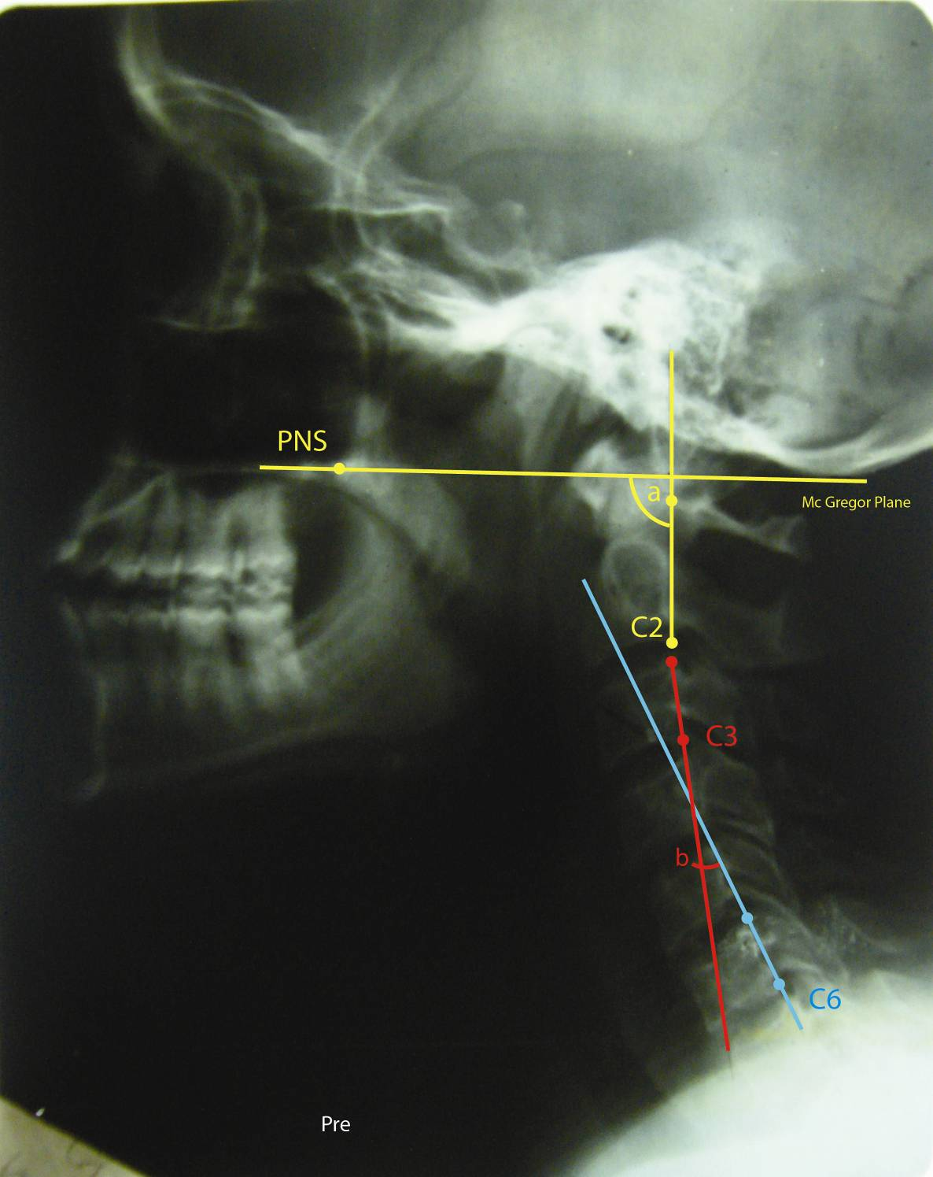
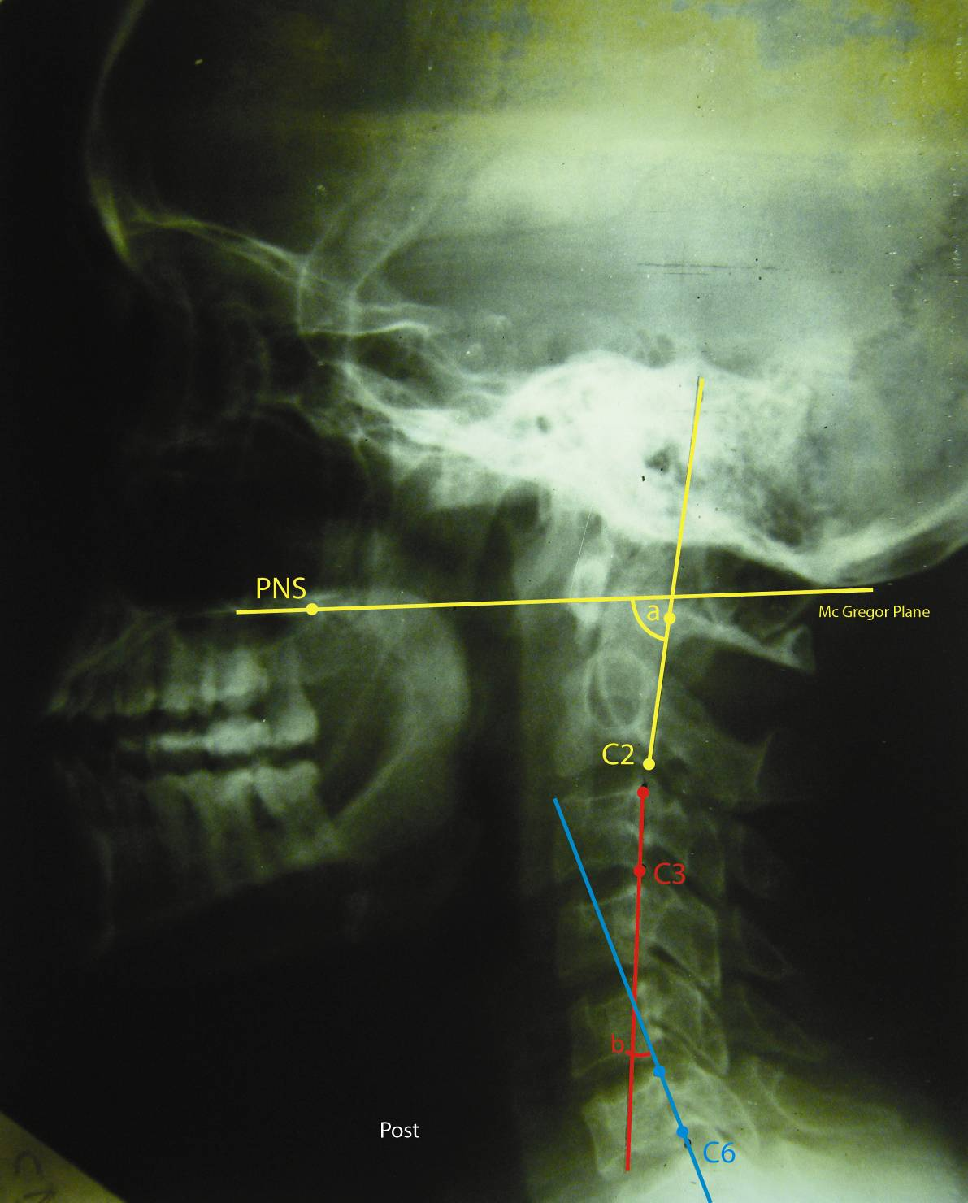

(a) Pretreatment (b) Post treatment
Fig .1. lateral X-ray measurement for craniocervical angle (a) and cervical curvature angle (b).

* PNS: Posterior nasal line

4. Discussion
The current study investigated the independent effect of forward head postural correction in the management of myogenic temporomandibular joint disorder. The program is not combined with other techniques as previously don by Komiyamama et al.^{[20]}.The study gives details about posture correction on mechanical basis which is not found in other study ^{[21]}. The studies done by Komiyamama et al.^{[20]} and Write ^{[21]} were considered weak studies according to JADA score because the treatment protocols were not described in adequate details to allow replication of the intervention used in other researches ^{[25]}. On the other hand, in this study the patients complaining from myogenic TMD received a program of six week postural correction. This program was based on a mechanical aspect that forward head posture is associated with weakness of deep cervical flexors (craniocervical flexor) and scapular retractors and shorting of suboccipital muscles, and Pectoralis muscles ^{[6]}.
This study showed a significant decrease in two angles, the craniocervical posture angle and the angle of the lower cervical curvature. The exercise program in this study included strengthening of the deep flexors of the neck along with stretching of suboccipital muscles. Since the deep cervical flexors have a major postural role in supporting and straightening of the cervical spine ^{[26]} and normal balance of the head and neck unit requires balance of the anterior and posterior muscles ^{[27]}. Our finding disagrees with Luen ^{[28]} who suggest that posture should not be interpreted as an etiological factor predisposing TMJD.
Results of the current study agree with Harman et al.^{[6]} who reported improvement in head posture by using program of posture correction similar to the program of this study. The results of this study disagree with Wright et al.^{[21]} who did not find any improvement in head posture in patients with myogenic temporomandibular disorder receiving posture correction program. This can be explained by the fact that his study used a program of treatment that included neck retraction training and stretching of the anterior chest muscles in addition to strengthening of shoulder retractors without including stretching of the suboccipital muscles and the duration of the treatment was four weeks (performed as a home regime only and the therapist saw subjects once only during the treatment to correct errors). Also the subject's age range for that study was too wide (ranged from 18 to 56 years) .Other studies concerning posture correction for the treatment of myogenic TMJD didn’t measure head posture^{[20, 29].}
There is a significant correlation between change in range of motion and changes in craniocervical angle which may support the relation between forward head posture and TMJD, but the change in VAS was significantly correlated with the lower cervical curvature. Improvement of pain and range of motion of mouth opening may also be due to the fact that exercise causes relaxation of the neck muscles thereby relaxing masticatory muscles and so decreasing pain and increasing range of motion.
A weak statistically significant negative correlation in asymptomatic volunteers females was observed between the measured angles of the upper and lower cervical spine ^{[30]}, this may be due to the wide variation in the degree of cervical curvature from kyphosis to lordosis. Non lordosis or angular kyphosis have been reported to be often observed in the normal population ^{[31]}. In the current study the correlation between the upper and lower cervical spine improved post treatment but still not significant. A further study needed to investigate the relation between upper and lower cervical in myogenic TMJ disorders.
Proper alignment of the upper back is essential for proper alignment of the head and neck .Round upper back (thoracic kyphosis) which affect cervical posture is associated with weakness of thoracic spine extensor muscles ^{[32]}. Magee ^{[33]} reported that forward head posture and flexed upper back are characterized by weakness of the lower cervical and thoracic erector spinae. Falla ^{[26] ,} found that forward drift of the head was associated with an increase in the thoracic flexion curve in patients with neck pain, our program did not include strengthening of thoracic extensor muscles to improve round upper back posture if any. McDonnell ^{[34]} suggests that impairments, not only in the cervical region, but also in the scapulothoracic and lumbar regions, may be important to consider in the treatment of cervicogenic headache.

Conclusion
Correction exercise program of forward head posture is effective in improving head posture and range of motion of active mouth opening and reducing pain of the masticatory system. The data of this study support the relation of forward head posture and myogenic TMJD. It is recommended that impairments, not only in the cervical region, but also in the scapulothoracic and lumbar regions should be corrected thus indirectly decrease the prolonged loading into extension in the cervical region .A further investigation of the effect of postural correction on the relation between upper and lower cervical spine is recommended.

Corresponding author
Fatma A. El-Hamalawy
Musculoskeletal Department, Misr University for Science and Technology, 6 October City- 2nd Districts – 1st area 198 / 2
Fatma_therapy@yahoo.com

References
1-Herb K, Cho S. and Stiles M A., 2006. Temporomandibular Joint Pain and Dysfunction. Curr Pain Headache Rep.; 10:408–414
2-Stohler CS., 1999. Muscles related temporomandibular disorder. J Orofac Pain., 13: 27-284.
3-Stohler CS., 2000. Masticatory myalgias. In Oral and Maxillofacial Surgery. Temporomandibular Disorders. Fonseca RJ, et al.: Philadelphia: WB Saunders; 38–45.
4- Ogle OE. and Hertz MB., 2000. Myofascial pain. Oral Maxillofac Surg Clin North Am.; 12:217–231.
5-Milam SB., 2000. Pathophysiology of articular disk displacements of the temporomandibular joint. In Oral and Maxillofacial Surgery. Temporomandibular Disorders. Fonseca RJ, et al.: Philadelphia: WB Saunders;:46–72.
6-Harman K, Hubley-kozey CL. and Butler H., 2005. Effectiveness of an exercise program to improve forward head posture in normal adults: A randomized, controlled 10- week trial, J Man Manip Ther.; 13:163-176,
7-Schuldt K,Ekholm J, Harms –Ringdahl K, Nemth G. and Arborelius UP., 1986. Effects of changes in sitting work posture on static neck and shoulder muscle activity. Ergonomics.; 29:1525-37
8-SilvermanJL,Rodriquez AA. and Agre JC., 1991. Quantitive cervical flexor strength in healthy subjects and in subjects with mechanical neck pain. Arch Phys Med Rehabil.; 72:679-681
9-Yoo W, Yi C, Kim H, Kim M, Myeong S. and Choi H., 2006. Effect of slump sitting on the masticatory, neck, shoulder, and trunk muscles associated with work related musculoskeletal disorders. PTK.;13: 39-46.
10-Lee WX, Okeson JP. and Lindroth J., 1995. The relation between forward head posture and temporomandibular disorders. J Orofac Pain G., 161-167,
11-Braun LB., 1991. Postural differences between asymptomatic men and women and craniofacial pain patient. Arch Phys Med Reh.; 72: 653-656,.
12-Boyed CH, Slagle WF. and Boyd CM., 1987. The effect of head position on electromyographic evaluation of representative mandibular positioning muscle groups. Cranio J., 5:55
13-Gonzalez HE. and Manns A., 1999. Forward head posture: its structural and functional influence on stomatognathic system, a conceptual study. Cranio.; 14: 71-80,
14-Solow B. and Sandham A., 2002. Cranio-cervical posture: a factor in the development and function of the dentofacial structures. Eur J orthodont.; 24: 447-456,
15- PAllegama R W,RanasingheA W,weerasingheV S. and SitheequeM A M., 2004. Influence of masticatory pain on electromyographic activities of cervical muscles in patients with myogenous tempromandibular disorders. J oral Rehabil ., 31: 423 -42
16-Mirrales R, Mendoza C Stander H, Zuniga C. and Moya H., 1992. Influence of stabilization occlusal splints on sternoclediomastoid and masseter electromyographic activity. Cranio.;10:297-304
17-Milanove I,Bogdanova D ,Ishpekova B., 2001. The trigemino cervicalreflex in normal subjects. Funct Neurol.;16:129
18-Simons DG, Travel JG . and Simons LS., 1999. Travel, Simons myofacilal pain and dysfunction; The trigger point manual ,2 ed.Baltimore:Williams and Willkins; 251-254
19-Carlson CR, Okeson JP, Falace DA, Nits AJ. and Lindroth JE., 1993. Reduction of pain and EMG activity in the masseter region by trapezius trigger point injection. Pain.; 155:397-400
20-Komiyama O, Kawara M, Arai M, Asano T. and Kobayashi K., 1999. Posture correction as part of behavioral therapy in treatment of myofascial pain with limited opening. J oral Rehabil. ; 26:428-435.
21-Wright EF, Domench MA. and Fischr JR., 2000. Usefulness of posture training for patient with temporomandibular disorder.; J Am Dent Assoc., 131: 22-10
22- Medlicott MS, Harris SR., 2006. A systematic review of the effectiveness of Exercise, manual therapy, electro therapy, Relaxation training, and biofeedback in the management of temporomandibular disorder. Phys Ther.; 86: 955-973.
23- Munhoz WC, Marques AP. and Tesseroli de Siqeira, 2004. Radiographic evaluation of cervical spine of subjects with temporomandibular joint internal disorder. Braz. Oral Res.;18: 283-9.
24-Kisner C. and Colby LA., 2002. Therapeutic exercise foundation and techniques. Fourth Edition, Philadelphia: F.A. Davis. , :638- 647
25 McNeely ML. and Olivo SA.,2005. A systematic review of the effectiveness of physical therapy intervention for temporomandibular disorders. Phys Ther.;86 : 710-725,
26-Falla D, Jull G, Russel T, Vicenzino B. and Hodges P., 2007. Effect of neck exercise on sitting posture in patients with chronic pain. Phys Ther.; 87: 408- 417,
27-Cuccia A. and Caradonna C., 2009. The relationship between the stomatognathic system and body posture. Clinics.; 64: 61-66
28- Lunes DH, Carvaho LCF,Oliveria AS. and Bevilaqua-Grossi D., 2009. Cranio cervical postural analysis in patients with tempromandibular disorder. Rev Bras Fisioter .;13:89-95
29-Nicolakis P, Erdogmus CB, and Koff A., 2002. Effectiveness of exercises therapy in patients with myofascial pain dysfunction syndrome. J Oral Rehab.; 29: 362-368
30- Sherekar S K, Yadav Y R, Basoor A. S, Baghel A. and Adam N., 2006. Clinical implications of alignment of upper and lower cervical spine. Neurology India., 54:264-267
31--Eyadeh AA, Kondeva M,Khamees MF. and Hussein FM., 2004. Neck pain , Neck mobility and alignment of cervical spine in 30 patients with cervical strain .Kuwait Medical Journal ,36:186-190
32-Kendall FP, Mecreary EK, 29-Sonnesen L., Bakker M. and Solow B., 2001. Temporomandibular disorders in relation to craniofacial dimensions, head posture and bite force in children selected for orthodontic treatment. Eur J Orthodont.;23: 179-192,.
33- Magee D J., 2006. Orthopedic physical examination. Fourth Edition. Philadelphia: Saunders, Elsevier.. 873 – 901
34- McDonnel MK, Sahrmann SA . and Dillen LV., 2005. Aspecific exercise program and modification of postural alignment for treatment of cervicogenic headache. J Orthop Sports Phys Ther.; 35(1).

7/20/2011

