Hands-On Lab
Lab 1: Fourth Coffee Solution Overview

Lab version: 1.0.0
Last updated: 7/28/2026

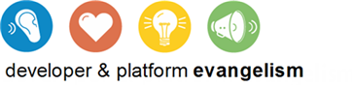
Contents
Overview 3
Introducing Fourth Coffee 3
About the Labs 5
Summary 8

Overview
This document provides an overview of the Fourth Coffee solution.

Objectives
Understand the Fourth Coffee solution that will be built over the course of these labs.
Understand the Fourth Coffee ordering process
Know how to run the final solution at any time

Introducing Fourth Coffee
Fourth Coffee is a fictional online coffee merchant. By visiting Fourth Coffee's website, customers can order from a selection of beans/roasts, and personalize the packaging of the coffee beans. The process begins with a customer placing an order through the website. The order includes a custom image for use on a personalized label. The website submits the order to the Order Fulfillment Service, which is a workflow service that will orchestrate the processing of the order (shown in the figure below).
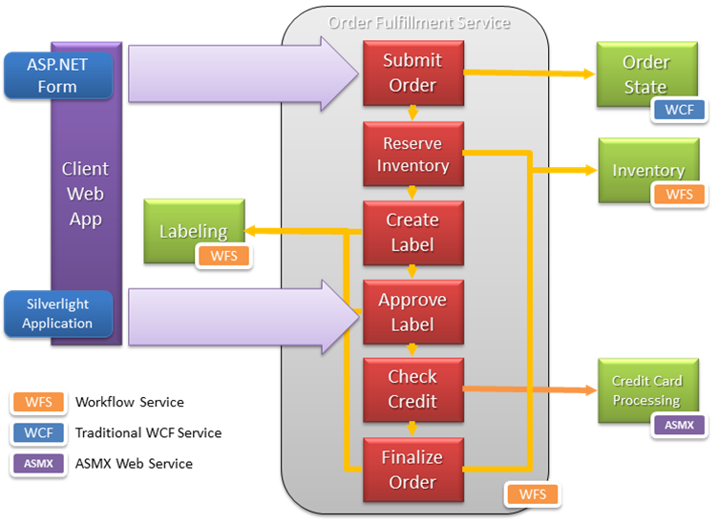
The Order Fulfillment Service begins by adding the submitted order as a new entry into the Order State Service. The Order State Service is a self-hosted WCF service that maintains an in-memory copy of the submitted order. It tracks the order and its status, which is updated at various milestones in the Order Fulfillment Service workflow.
The Order Fulfillment workflow continues by checking that the requested beans are in stock and reserving the requested amount via a call to the Inventory Service workflow service. This is followed by a call to the Labeling Service workflow service, which takes the customer submitted image, formats it to fit on a coffee bag and super-imposes the Fourth Coffee label. The labeling service workflow instance will wait for the customer to approve the proof of the generated label before continuing. The customer submits proof approval via a Silverlight application hosted in the Fourth Coffee website. The customer's approval from the website is sent to the Order Fulfillment Service and then relayed to the Labeling Service. The waiting labeling service workflow instance then resumes and waits for the call to clean up the temporary proof file.
Once both the inventory reservation and label generation steps have completed, the customer is billed. The Order Fulfillment Service makes a call to the Credit Card Processing Service, an ASMX web service, to charge the credit card. If successful, the order is then queued for physical fulfillment and the Order Fulfillment Service workflow completes. As part of that completion, the Order Fulfillment Service calls the Labeling Service and instructs it to clean up the proof file. The Label Service workflow instance deletes the generated image and completes.

The Order Fulfillment Service demonstrates approaches to handling issues that occur while processing the order. In the case that the inventory is not available to satisfy the items requested in the order, the workflow instance will suspend and wait for an administrator to resume it via IIS Manager when the items are available. In the case that the credit card was not approved, the Order Fulfillment workflow undoes the work done by the Inventory and Labeling Services by invoking service operations on them that replace the ordered items in inventory and delete the generated label image, respectively.

All of the aforementioned services, excepting the self-hosted Order Memory State Service, are hosted in IIS and configured, managed and monitored with the AppFabric Host.

About the Labs
The Fourth Coffee labs will guide you in building all of the major components of the Fourth Coffee solution. While each lab builds upon the previous one, you are free to approach the labs in the order hat suits your needs. Each lab exercise contains starting files and a configuration script that will configure your system with the environment necessary to begin following the lab steps.
Nine labs demonstrate various aspects of building Workflow Services using .NET 4 and hosting and managing them in the AppFabric Host in the context of the Fourth Coffee solution.
Lab 0 – Developer Environment Setup
Lab 1 – Fourth Coffee Solution Overview
Lab 2 – Introducing WCF Services
Lab 3 – WCF Workflow Services
Lab 3b – Going Deeper with Workflow Services
Lab 4 – Custom Activities
Lab 5 – Securing WF Services
Lab 6 – Calling Services from ASP.NET and Silverlight
Lab 7 – Managing Services with AppFabric
Lab 8 – Module Deployment
Lab 9 – Versioning Workflow Services
Lab 10 – AppFabric in the Enterprise

Seeing it in Action
The Labs\Final Solution folder includes the result of completing all of the labs. If you want to see the completed Fourth Coffee solution in action first, follow these steps:
  - To simplify the process of registering the numerous Fourth Coffee applications with IIS, we have provided a utility called LabStarter that you should run as the first step in any lab. To use it, run LabStarter.exe from the %InstallFolder%\Assets directory and click the button corresponding to the Lab exercise you wish to open. This will perform the requisite configuration and then open the desired solution in Visual Studio for you automatically.
  - From the Lab Starter, click the Hosting tab, and then the Lab 1: Fourth Coffee Solution Overview button.
  - Build the solution.
  - Open your browser and navigate to http://localhost/Website/PlaceOrder.aspx.
  - The majority of the form is pre-filled. Just click the Browse… button next to the Private Label Image field and select an image to use as the custom label. There is a sample image located in C:\FourthCoffee\Input\SampleInput.jpg.
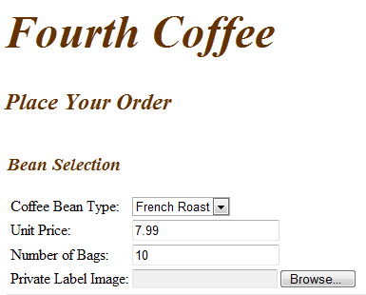
  - Click Submit Order at the bottom left of the page.
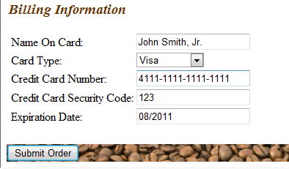
  - You should see briefly see a loading screen while the website waits for the label generation workflow service to create the label image.

  - When the image is ready, it should appear similar to the following. Click Approve to make the LabelReady call and complete the order. 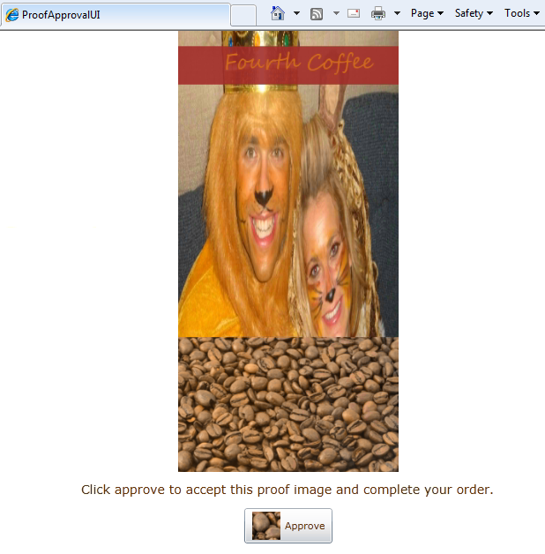
  - You should be taken to the order confirmation page.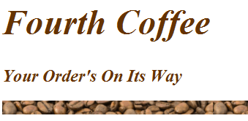

Summary
This lab provided an overview of the Fourth Coffee solution, the labs which will be used in building it and a way to take a sneak peak by running the final solution.

