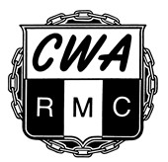
CWA Retired Members’ Council
Lifetime Membership

We encourage you to join, by working together we can help increase CWA’s bargaining power with employers as we fight to protect our retirement.

Yes, sign me up for Lifetime membership in the CWA Retired Members’ Council!
Here’s my one-time $25 payment to the Council for Lifetime membership.

(Kindly print)
Name __________________________________________________

Address ________________________________________________

City/State/Zip ____________________________________________

Home Phone __________________ Cell Phone ________________

Email __________________________________________________

Retirement Date__________________________________________

Home Local _____________ Former Employer _________________

Payment Method for Council Lifetime Membership Fee:

___ Here is my $25 check made payable to the CWA Retired Members’ Council

___ Charge the $25 fee to my credit card:
___Visa ___MasterCard ___Discover ___AMEX

Card # ___-___-___-___ ___-___-___-___ ___-___-___-___ ___-___-___-___
Expiration Date (MM/YY): ____/____ Card Security Code: ______ *
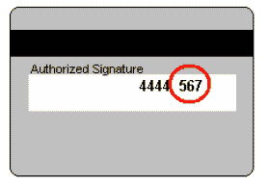
* The Card Security Code ("CSC" for short) is a three-or four-digit number printed on the credit card for security purposes. On most cards, the CSC is three digits long and is printed on the back of the card (usually in the signature field). Other numbers may appear to the left of the CSC

_______________________________________ ______________
Signature Date

Return to: CWA Retired Members’ Council,
501 3rd St NW, Washington, DC 20001-2797

You can also sign up for the Lifetime Membership on our secure website at: www.CWARetirees.org

Thank you
Revised 6-2-16
RMC - 01

