
OUTER DISTRICT Dated: 02.08.11
PRESS RELEASE
ONE AUTO-LIFTER ARRESTED, THREE STOLEN MOTOR CYCLES RECOVERED, 04 CASES WORKED OUT

HIGHLIGHTS
- One Auto-Lifter, Ajay @ Kale (22 yrs) s/o Maha Singh arrested.
- 4 Motor Cycles recovered.
- 4 cases of MV Theft workout.
BRIEF FACTS:

With the arrest of accused Ajay @ Kale (age-22 yrs) S/o Maha Singh r/o D-112, Gali No. 4 Gopal Nagar, Najafgarh, Delhi by AATS/OD, four motor-cycles stolen from PS-South Rohini, PS-Mangol Puri, PS-Sadar, Sonepat (Haryana) & PS- City Sonepat (Haryana) were recovered . Four MV theft cases worked out.
INCIDENT/INVESTIGATION:

Due to sudden rise in the incidents of MV theft cases in the area of Outer Distt. Delhi, a special team of AATS/OD was constituted to pay special attention towards culprits involved in MV Theft. On 01.08.11 a surprise checking was conducted at Sec. 15/16 Road Rohini Picket in the jurisdiction of PS K. N. Katju Marg. During checking, at about 7:00 PM one boy namely Ajay @ Kale S/o Maha Singh r/o D-112, Gali No. Gopal Nagar, Najafgarh, Delhi on Apache motorcycle bearing no. DL8S-ND-0787 was stopped by the checking team. During the document verification, the motorcycle was found stolen from PS-South Rohini vide FIR No. 159/11 dt. 29.06.1. He was arrested u/s 41.1(d) CrPC and motorcycle was taken into police possession u/s 102 CrPC. During further interrogation, he disclosed that three more stolen motor cycles are kept at his rented house at D-112, Gali No. 4 Gopal Nagar, Najafgarh, Delhi. On his instance three motorcycles bearing No. DL-7S-AB-4625 stolen from PS Mangol Puri vide FIR No. 302/11 u/s 379 IPC, HR-10-J-8459 PS Sadar Sonepat 138/11 u/s 379 IPC and HR-10-J-8961 vide FIR No. 239/11, PS City Sonepat u/s 379 IPC were recovered .

ACCUSED ARRESTED:-

- Ajay @ Kale s/o Maha Singh r/o D-112, Gali No. 4 Gopal Nagar, Najafgarh, Delhi.

INTERROGATION/ MODUS OPERANDI:-

On interrogation, accused Ajay @ Kale disclosed that he had stolen motor cycles for pecuniary gain. He was having the master key and with its help succeeded to open the locks of these four motor cycles. He was in search of buyer of these stolen motor cycles.

TEAM:-
The special team comprising of following officers of AATS/OD comprising under the close supervision of Shri Ved Prakash, ACP/Ops/OD.
- Insp. Swadesh Prakash,
- HC Devanand,
- HC Davender,
- Ct. Mukesh Nain

PROFILE OF ACCUSED ARRESTED:

Ajay @ Kale (age-22 yrs) S/o Maha Singh r/o D-112, Gali No. Gopal Nagar, Najafgarh, Delhi. He was born and brought up at 25/1056 Vishal Nagar, Kalupur, Sonepat, (Haryana) and studied upto 10+2 level from Lal School, City Sonepat, (Haryana).
RECOVERY:
Sl. No | Vehicle type | Reg. no.
1 | Pulsar Motor Cycle | DL-7S-AB-4625
2 | Apache Motor Cycle | DL-8S-ND-0787
3 | Red Honda Shine Motor Cycle | HR-10-J- 8459
4 | Platina Motor Cycle | HR-10-J- 8961

CASES WORKED OUT:
Sl. No | FIR No., dt. and U/s | Police station
1 | 159/11, dt. 29.06.11, u/s 379 IPC | PS South Rohini, Delhi
2 | 302/11, dt. 25.07.11,u/s 379 IPC | PS Mangol Puri, Delhi
3 | 138/11, dt. 16.06.11,u/s 379 IPC | PS Sadar Sonepat, Haryana
4 | 239/11, dt. 01.08.11 u/s 379 IPC | PS City Sonepat, Haryana

(B.S. JAISWAL) IPS
Dy. Commissioner of Police
Outer Distt.

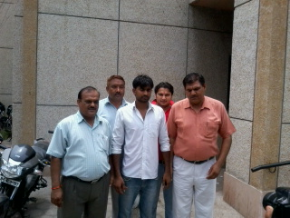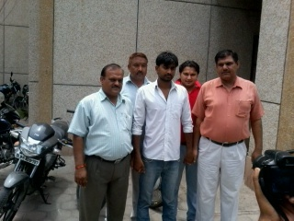

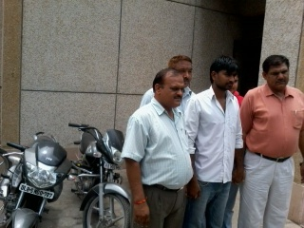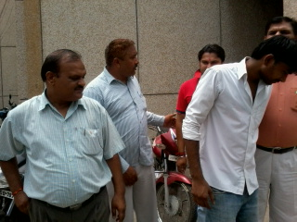

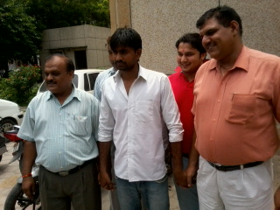

Dated : 02.08.11

WOMEN ACCUSED INDULGED IN THEFT OF CREDIT / ATM / DEBIT CARDS ARRESTED AND RECOVERED EXPENSIVE MOBILE PHONES, LAPTOPS, JEWELLERY, ETC. PURCHASED FROM THE STOLEN ATM CARDS

Staff of PS K.M. Pur apprehended a lady accused namely Ujjala @ Pooja @ Sneha (20 years) d/o Suraj Singh r/o H. No- 296, Sector-21, behind Chawla Restaurant, Dhundehera, Gurgaon (Haryana), who was indulged in theft of Credit / ATM / Debit Cards and recovered jewellery, mobile phones, laptops, ATM Cards and wallets from her possession.

INCIDENT / BRIEF FACTS :

Since last several months, complaints regarding theft of ATM Card / Debit card / Credit Card had been reported to PS K.M. Pur. Similarly on 29/7/11, a complainant Ms. Apeksha Khandelwal r/o Alwar, Rajasthan visited PS K.M. Pur and reported that she is residing in B-48, ‘N’ Block, South Extension (Part-I) as PG for the last 2-3 years. She further reported that recently some unknown person had stolen her purse and ATM Card from her room. In this regard, she had informed the bank authorities to block her card. Now, she has came to know that by swapping her ATM Card, some one had conducted shopping for around Rs. 30,000/-.

In order to nab the accused involved in such activities, a team comprising SI Vishal Choudary, Ct. Jagdish, W/Ct. Nellu headed by Inspr. Ajay Vedwal, SHO/K.M. Pur under the close supervision of Sh. Mehar Singh, ACP/Defence Colony was formed. During investigation, details of shopping were obtained from the bank, which revealed that accused had conducted shopping from two shops located in South Extension. CCTV footages of both the shops were analyzed minutely and involvement of a lady in the crime was established. During investigation, mobile number of accused and IMEI number of mobiles, which were purchased by the accused by swapping the ATM Card were also obtained. Criminal intelligence was also obtained, which revealed that accused is residing somewhere in Village Dhundhehera, Gurgaon (Haryana). Immediately, the members of team raided in Village Dhundhehera and apprehended accused Ujjala @ Pooja @ Sneha. At her instance, jewellery, 3 laptops, 3 mobile phones and other articles which she had purchased from stolen ATM / Credit Cards were recovered from her house. In this regard, a case vide FIR No. 175/11 u/s 380/419/420/471 IPC PS K.M. Pur was registered.

INTERROGATION :

On sustained interrogation, it revealed that since last two years accused along with her associate Aarti had been stealing ATM Cards / Debit Cards / Credit Cards. They only target PGs as it is safe and secure place for them and in case of being caught by the owner of the PG, they would take the benefit of being lady. They used to enter into any PG and enquire about room available on rent and easily get familiar with the girls already residing in the PG. As soon as they get any chance, they would escape from there by stealing whatsoever is easy to carry, special ladies bag which contain ATM / Credit Cards. Soon after that, they would go to nearby market and would buy articles by swapping the card. They usually purchase cosmetic items, cloths, shoes, jewellery, mobile phones and articles of daily use. They are always careful about the fact that the ATM Card would be blocked soon by its real owner. She further disclosed that earlier she was working in Gurgaon and co-accused Aarti used to meet her in the bus. Later on, they became close and started committing thefts in PG houses. Further investigation is on to locate co-accused Aarti and to apprehend her.

With her arrest, a case FIR No. 75/10 u/s 403/419/379 IPC dated 28/02/11 PS Hauz Khas has also been worked out wherein accused had stolen ATM Card from a PG house in Gautam Nagar.

PROFILE OF ACCUSED :

Ujjala @ Pooja @ Sneha (20 years) d/o Suraj Singh r/o H. No- 296, Sector-21, behind Chawla Restaurant, Dhundehera, Gurgaon (Haryana) is unmarried. Accused was aspiring to appear in “Indian Idol”. She is previously involved in case FIR No. 276/10 u/s 380 IPC PS Civil Lines, Gurgaon (Haryana).

RECOVERY MADE :

- Jewellery purchased by swapping stolen ATM Cards.
- ATM Cards
- Mobile Phone (Blackberry) purchased by swapping stolen ATM cards.
- Invoice of articles purchased through swapping stolen ATM cards.
- Four Internet Data Cards
- Two Mobile Phone (Sony Erricsson and Nokia)
- One Spectacles (mojo)
- Four empty ladies wallets
- Three laptops
- One DELL Laptop Bag
- Seven passport size photographs of unknown girl.

(CHHAYA SHARMA)
DCP/SOUTH DISTRICT

 | PRESS RELEASE
 | DELHI POLICE
 |  | 02.08.2011
NORTH DISTRICT
GANG OF EXTORTIONISTS NABBED, EXTORTION MONEY AND MOBILE PHONE RECOVERED
With the arrest of one accused namely Puran Chand aged 20 years s/o Sh. Lekh Raj r/o B-1438, Shastri Nagar, Delhi & apprehension of two juveniles in conflict with law, police officials of North District have nabbed a gang of extortionists and recovered the extortion money worth rupees 1,00,000/- (one lakh) and one mobile phone, which was used for extortion.
TEAM AND INCIDENT
On 30.7.11, a complaint regarding extortion made to Sh. Parveen Kumar s/o Sh. Uma Shanker r/o L-21, Shastri Nagar, Delhi was received in PS Sarai Rohilla and it was alleged that an extortion call was made to him on his mobile. The caller demanded rupees one lakh within 24 hours, otherwise threatened to kill any member of his family. On receipt of this complaint and considering the gravity, details of mobile number from which the extortion call was made obtained. Again, on 31.7.2011 at about 1240 hours a call from a landline number was received by the complainant and the extortionist told him to deliver the amount near Roshanara Bagh, Subzi Mandi, Ghantaghar, Delhi specifying to bring the money only in the denomination of rupees 100/-. Acting upon the received call, a dedicated team headed by SI Jitender Kumar and consisting of SI Abhijeet, Ct. Vikas, Ct. Satbir, Ct. Aman Kumar and Ct. Yoginder Giri under the supervision of Insp. M. P. Singh ATO/Sarai Rohilla was constituted. The raiding party along with the complainant reached near the gate of Roshanara Club, Roshanara Bagh, Ghanta Ghar, Delhi. The complainant was sent with two packets worth rupees one lakh to be delivered to the extortionists and all members of raiding party were deployed at different points. After a little while, the complainant was seen giving the extortion money while the extortionists who were with covered face were receiving money. On getting indication, the raiding party overpowered the three extortionists and caught hold of them. During enquiry, it was revealed that two of the three boys are juveniles in conflict with law. Accordingly, a case vide FIR No. 271/11 dated 31.7.11 U/S 384/506/34 IPC was registered in P.S. Sarai Rohilla, Delhi.
INTERROGATION
On sustained interrogation accused Puran Chand s/o Sh. Lekh Raj r/o B-1438, Shastri Nagar, Delhi disclosed that he along with his friends planned to extort money after drawing inspiration from the movie ”Shoot out at Lokhandwala”. All the three extortionists are students of the same school and residents of the same locality. They required money for enjoyment.
PROFILE
Puran Chand aged 20 years s/o Sh. Lekh Raj r/o B-1438, Shastri Nagar, Delhi is a student.
RECOVERY
- Rupees 1,00,000/- (one lakh)
- One mobile phone.

(I. B. RANI) IPS
Deputy Commissioner of Police
North District, Delhi


PRESS RELEASE

WEST DISTT.
02.08.2011
HUGE QUANTIY OF ILLICIT LIQUOR RECOVERED
The Staff of PS Ranhola, West District has arrested Smt. Chhammo Devi W/o Ram Karan R/o B-99/2 Vikas Vihar, Vikas Nagar, Delhi and recovered 706 Quarters of liquor.
NAME AND PROFILE OF ACCUSED PERSON
(1) Smt. Chhammo Devi W/o Ram Karan R/o B-99/2 Vikas Vihar, Vikas Nagar, Delhi. (Arrested)
RECOVERY MADE
1. 170 quarters of Golden Border whisky,
2.146 quarters of NV Besto whisky.
3. 90 quarters of Falcon’s Orange country made liquor.
4. 300 quarters (6 cartons) Falcon’s Orange country made liquor.
5. Honda City Car No.DL-8C V 0076.
INFORMATION AND OPERATION
On 01-08-2011 HCs. Gajender Singh No.971/W and Gulab singh No.1002/W received an information regarding illegal liquor in a Honda City car No. DL 8C V 0076 parked in front of house No. B-99/2 Vikas Vihar, Vikas Nagar, Uttam Nagar, Delhi. On receipt of information, both the HCs reached the above mentioned address and saw that one boy was lifting a carton (Box) from the dicky of the said car and after seeing the Police party he fled away from there. On checking the car,6 cartons illegal liquor were found kept in the dicky. Further the premises ie house No.B-99/2 Vikas Vihar, Vikas Nagar,Delhi was also raided where one old lady namely Chhammo was found counting the boxes of illegal liquor. On checking, 170 quarters of Golden Border whisky, 146 quarters of NV Besto whisky and 90 quarters of Falcon’s orange country made liquor were recovered from the premises. On further checking of the dicky of car, 300 quarters (6 cartons) Falcon’s Orange country made liquor were recovered. The illegal liquor and vehicle No DL 8C V 0076 have been taken in to Police possession and accused Chhammo Devi was arrested vide FIR No.154/11 u/s 33/38 Delhi Excise Act 2010, Police Station Ranhola dated 01.08.11. One accused Ram Lakhan who came in the car is absconding. Sincere efforts are being made to trace the absconding accused.

Staff involved in good work is being rewarded suitably.

(V.RENGANATHAN) IPS
ADDL. COMMISSIONER OF POLICE,
WEST DISTRICT, NEW DELHI
2nd August, 2011

PRESS NOTE CENTRAL DISTRICT

MEETING HELD WITH THE HOTEL MAHASANGH OF PAHAR GANJ & NABI KARIM IN CONNECTION WITH INDEPENDENCE DAY
On 02.08.11, a meeting was conducted by the undersigned in Ambedkar Bhawan, Pahar Ganj with the members of Delhi Hotel Mahasangh and association of hotels/guest houses of Pahar Ganj and Nabi Karim area of Central District, Delhi. About 200/250 hotels/guest houses owners attended the meeting. ACP/Pahar Ganj, SHOs/Pahar Ganj and Nabi Karim also attended the meeting. In view of the forthcoming Independence Day celebration, the following security measures/precautions were suggested :-

- CCTV camereas should be installed in the hotels/guest houses with the recording facility.
- Proper entry of the guests should be made in the register on the prescribed format and no column should be left blank. The copy of I.D. proof of the guests should be procured at the time of arrival and time of leaving the room should also be mentioned in the register.
- The mobile phone/contact number of the guests should be obtained and mentioned in the register.
- Every hotel/guest house should be equipped with HHMDs and the big hotels should install DFMDs/Bag Scanners etc. so that the belongings of the guests/visitors could be searched thoroughly.
- A close watch should be kept on the persons visiting the guests of the hotel/guest house.
- Complete record of the staff of the hotel/guest house including waiters should be maintained and their police verification should also be got conducted through local police.
- The security guard deployed at the hotel/guest house should also be got verified through local police.
- In case of any suspicion on any person or object, the police should be informed immediately.

The police officers present in the meeting were also directed that every guest house/hotel of their respective areas should be checked on daily basis by the division/beat staff and they should themselves check the security measures of the hotels/guest houses on random basis.
Some of the photographs of the meeting are also attached. The meeting ended with vote of thanks.

DY. COMMISSIONER OF POLICE,
CENTRAL DISTRICT, DELHI

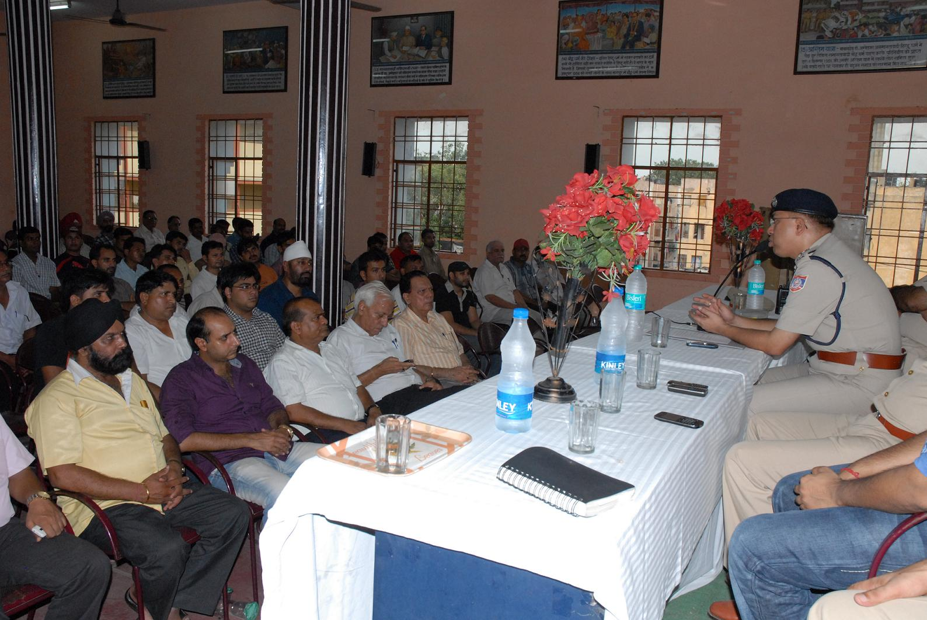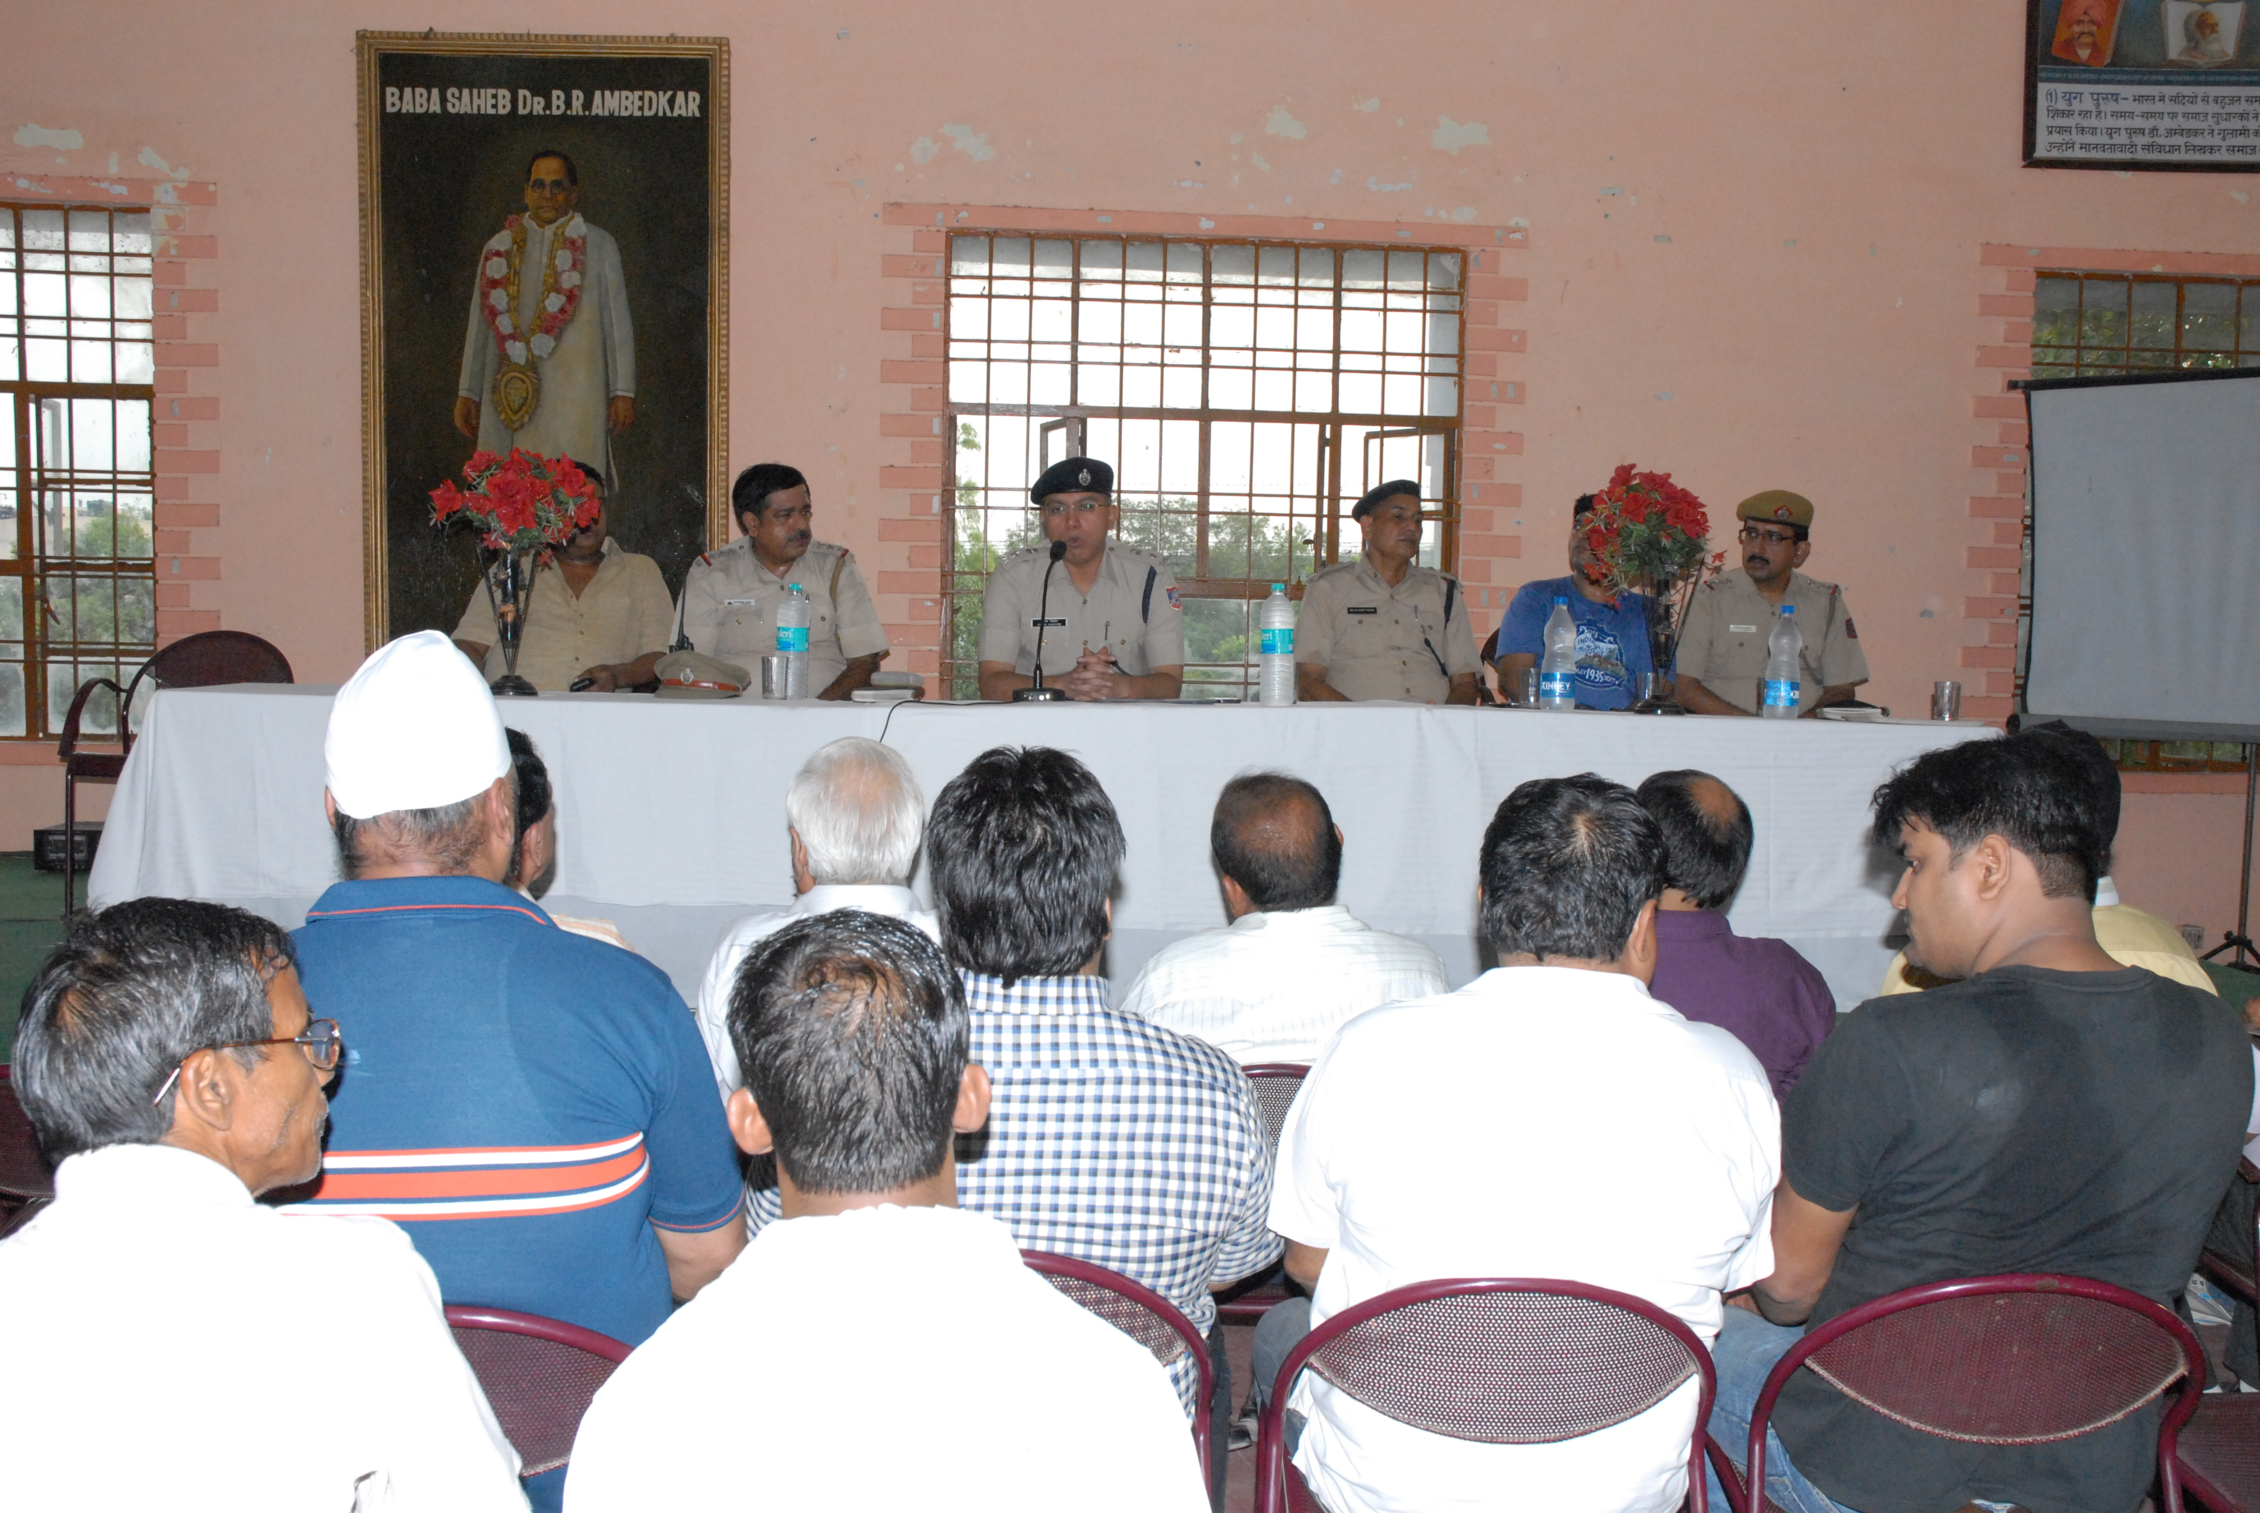

OUTER DISTRICT Dated: 02.08.11
PRESS RELEASE
DESPERATE CRIMINAL SURJEET @ BETI ARRESTED: 1 BUTTON OPERATED KNIFE AND 1 CASE OF M.V. THEFT WORKED OUT, ACCUSED WAS ALSO WANTED IN THREE CASES OF PS SULTAN PURI AND PS KESHAV PURAM, DELHI
HIGHLIGHTS
- One Notorious criminal namely Surjeet @ Beti S/o Raj Kumar was arrested.
- One button actuated knife from the possession of the Accused was recovered.
- One stolen motorcycle ( Bajaj Pulsar ) bearing Regn. No. DL-8S-AM-5021 recovered.
- 1 case of M.V. Theft worked out
BRIEF FACTS:
With the arrest of one Surjeet @ Beti S/o Raj Kumar R/o M-930 & M-951, Mangol Puri, Delhi, a desperate and notorious criminal previously involved in theft, hurt, and Arms Act etc, staff of PS Mangol Puri, Outer District have recovered one button operated knife and worked out 1 case of M. V. theft.
Incident :-
On 1-08-11 Ct. Manoj No. 1220/OD & Ct. Babloo No. 676/OD, while on patrolling duty were present in M-Block Mangol Puri, Delhi. At about 7.10 PM one youth on seeing the police party tried to flee from there on a Bajaj Pulsar motorcycle bearing Reg. No. DL-8S-AM-5921. On suspicion police team chased and nabbed him. On enquiry it revealed that he is the BC of PS Mangol Puri, Delhi namely Surjeet @ Beti S/o Raj Kumar R/o M-930 & M-951, Mangol Puri, Delhi. On his personal search one button actuated knife was recovered from his person and on verification the motorcycle was found to be stolen from the area of PS Keshav Puram, Delhi.
INTERROGATION:
On sustained interrogation of Surjeet @ Beti S/o Raj Kumar R/o M-930 & M-951, Mangol Puri, Delhi, it was revealed that he is a desperate criminal and is a BC of PS Mangol Puri, Delhi, who was previously involved in large number of cases of Arms Act, theft, M. V. theft, chain snatching and hurt.

PROFILE OF ACCUSED:
Surjeet @ Beti S/o Raj Kumar R/o M-930 & M-951, Mangol Puri, Delhi, is a school dropout. He is married. He is a BC of PS Mangol Puri, Delhi.
PREVIOUS INVOLVEMENT:-
S.No. | FIR No. | U/Sec | P.S.
1 | 574/05 | 324/34 IPC | Mangol Puri
2 | 781/06 | 308/506/427/34 IPC | Mangol Puri
3 | 323/08 | 324/34 IPC | Mangol Puri
4 | 152/09 | 25 Arms Act. | Crime Branch
5 | 279/09 | 324/34 IPC | Mangol Puri
6 | 352/09 | 379/411 IPC | South Rohini
7 | 620/10 | 25 Arms Act & 411 IPC | Mangol Puri
8 | 623/10 | 379/411 IPC | Mangol Puri
9 | 41/11 | 25 Arms Act | Mangol Puri
10 | 319/11 | 25 Arms Act & 411 IPC | Mangol Puri

RECOVERY MADE :-
- One button actuated knife from the possession of the Accused
- One motorcycle ( Bajaj Pulsar ) bearing Regn. No. DL 8S AM 5021 which was found stolen from the area of PS Keshav Puram, Delh

CASE S WORKED OUT :-
- Case FIR No. 85/11 u/s 379 IPC, PS Keshav Puram, Delhi
- Case FIR No. 233/11 u/s 379/356/34 IPC, PS Sultan Puri, Delhi
- Case FIR No. 239/11 u/s 379/356/34 IPC, PS Sultan Puri, Delhi
- Case FIR No. 242/11 u/s 379/356/34 IPC, PS Sultan Puri, Delhi
(B. S. JAISWAL) IPS
DY.COMMISSIONER OF POLICE
OUTER DISTRICT, DELHI
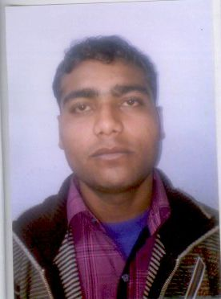

PRESS RELEASE

SOUTH EAST DISTT

Dated: 02.08.2011
duo zipped for autolifting

Major Highlights:
- Two auto lifters nabbed.
- Seven stolen motor cycles recovered.
- Six four wheelers recovered.
- A racket of selling stolen vehicles, on as you demand basis – unearthed.

With the arrest of accused namely Aslam S/o Ilyas (26 yrs.) and Mohd. Ishtkar S/o Mansoob Ali (23 yrs.) official of Police station Pul Prahlad Pur have unearthed a crime syndicate indulged in the illegal activities of on demand auto lifting and disposing off the same.
INCIDENT
On 31.07.2011, ASI Dilbagh Singh, Ct. Manoj, Ct. Prashant and Ct. Vikran Singh of Police Station Pul Prahlad Pur were on vehicle checking duty at Okhla T-Point, Lal Kuan, M.B. Road, New Delhi. The staff was checking vehicles going to Badarpur side. At about 4.45 PM informer informed that a blue coloured motor cycle, make Bajaj Pulsar without number plate would come from Sangam Vihar side, which is stolen somewhere from Uttar Pradesh. At about 4.55 PM, a vehicle with similar specification, so rendered by the informer, was found coming from Sangam Vihar side and going towards Badarpur Side on M.B. Road. Accordingly, the biker i.e. the one who was driving the vehicle along with the pillian rider, were signaled to stop, but they did not pay heed to the signal of the police party and tried to drive the vehicle over-speedily. The youths were apprehended in a chase, who were later identified as Aslam S/o Ilyas (26 years) and Mohd. Ishtkar S/o Mansoob Ali (23 years). Accused were directed to furnish documents in respect of the vehicle, which they were driving. None of them could produce any of such documents to the police party. On scrutiny of the official records, it revealed that the said vehicle was stolen vide FIR No. 305/11 PS Mehrauli, New Delhi. Accordingly, the duo accused persons were arrested.
Team
On receipt of the above information, the same was immediately communicated to Sh. Mahipal Singh, Assistant Commissioner of Police, Sub-Division Ambedkar Nagar, who immediately constituted a team comprising of ASI Dilbagh Singh, HC Naeem, HC Parveer, Ct. Manoj, Ct. Prashant, Ct. Parveen, Ct. Ajay and Ct. Vikran Singh, all of PS Pul Prahlad Pur under the close supervision of Insp. Harish Kukreti, Station House Officer, PS Pul Prahlad Pur.
MODUS OPERANDI
The accused were put to sustained interrogation. During interrogation accused Aslam disclosed that he is high school pass out from Ghaziabad and learnt driving different vehicles from his schoolmates and neighbours. Being a weak student, he chose driving as his career and worked in the capacity of driver to various persons. Meanwhile, Aslam came in contact with one Chand, who is his cousin brother. Chand is doing the work of denting / painting of vehicles at Masoori, Ghaziabad. At Chand’s place Aslam came in contact with various auto-lifters, who used to approach Chand for disposing off the stolen vehicles. Amongst others Aslam met Ishtkar who was also having a denting / painting shop at Hapur, UP. Ishtkar is a 7th standard pass from a school at Ghaziabad.

By the passage of time, both Aslam and Ishtkar became good friends. After meeting each other, they discussed about their financial problems etc., which they were facing in their daily lives. Accused Aslam suggested Ishtkar to indulge in trade of auto-lifting, as his cousin would help him in disposing of the stolen vehicles and they would never come to light. This way, they could be fetched with handsome returns, without any hotch-potch. Finding the proposal suitable and lucrative, accused Ishtkar gave his consent and the duo started illegal and unlawful act / practices of auto-lifting. They used to steal the vehicles from Delhi and NCR region and dispose of the same with the help of one Inderjeet, whom they met at Chand’s shop. Both the accused used to go for recce of the area in the morning, from where they had to lift the vehicle and in the night the duo steal the vehicle. The stolen two wheelers were being sold by accused persons for a sum of Rs.20,000/- whereas the four wheelers were being sold for Rs.60,000/-.
Apart from above the duo used to provide documents for the stolen vehicles on demand by the purchaser. The duo accused used to get forged registration papers of the stolen vehicle prepared with the assistance of one Abbas, who is a practicing lawyer in a court at Uttar Pradesh. For preparation of documents of the stolen vehicle, accused persons used to charge Rs.4,000/- extra from the purchaser. From the possession of accused persons three fake Registration Certificates have been recovered. On 31.07.2011, when the accused persons were arrested, they were returning after recce of the area from where they had to lift a vehicle.
INVESTIGATION
During investigation both the occupants of the stolen vehicle were arrested and subjected to sustained interrogation. During interrogation they disclosed that they had stolen various vehicles from Delhi and NCR region. They used to steal the vehicles in bid to earn quick bucks. Accused persons led the police party to different parts of Uttar Pradesh and got 09 stolen vehicles recovered.
RECOVERIES:
SN | Displayed Reg. No. | Make | Stolen from
 | Without Number Plate | Bajaj Pulsar (Blue) | FIR No. 305/11 PS Mehrauli, Delhi
 | UP 164 1149 | Bajaj Pulsar | FIR No. 558/09 PS New Ashok Nagar, Delhi
 | DL 7SAS 8536 | Bajaj Pulsar | FIR No. 1969/10 PS Indirapuram, Ghaziabad
 | DL 5SAA 9971 | Bajaj Pulsar | FIR No. 928/10 PS Sector 24, Noida
 | UP 14BC 6203 | Bajaj Pulsar | Yet to be ascertained
 | DL 7SAJ 3220 | Bajaj Pulsar | Yet to be ascertained
 | DL 7SR 4970 | Hero Honda Passion | Yet to be ascertained
 | HR 16E 9326 | Maruti 800 | FIR No. 391/06 PS Nand Nagri
 | HR 34C 1888 | Hyundai I-10 | FIR No. 9/11 PS Kamla Market
 | No number | Maruti Zen Estillo | Yet to be ascertained
 | No number | Lancer | FIR No. 3/11, PS Lajpat Nagar
 | No number | Wagon R | Yet to be ascertained
 | No number | Cheverolet | Yet to be ascertained

The registration numbers of above mentioned recovered stolen vehicles are missing. Therefore, the original registration number along with the details of FIR and police stations are being ascertained. Concerned police authorities have been informed to take necessary legal action against the accused persons. Antecedents of arrested accused persons are being verified.

Further investigation of the case is on and more arrests and recoveries are likely. Antecedents of the arrestees are being verified.

AJAY CHAUDHRY)
Addl. Commissioner of Police,
South East District, New Delhi.

PRESS RELEASE

WEST DISTT.

Dated 02.08.2011
INTRUDER ARRESTED
The staff of Police Station Maya Puri, West District has arrested a burglar namely Shiv Dutt from Punjab National Bank, Nangal Raya, Delhi and recovered 30 bank cheques and one Iron Rod.

NAME AND PROFILE OF ACCUSED PERSON
Shiv Dutt S/o Ram Chander, R/o Room No.22 House No.RZ-353, Gali No.2, Main Sagar Pur, Delhi- age 21 years.

RECOVERY MADE
- 30 stolen cheques.
- 01 Iron Rod.

INFORMATION AND OPERATION

On 02.08.2011, an information was received at PS Maya Puri that somebody has intruded in to Punjab National Bank, D-2 Janak Puri, Nangal Raya and was trying to commit a theft. Immediately, SHO/ Maya Puri alongwith SI Amit Kumar, HC Kailash Kumar and Const. Shivdan reached the spot and the bank was found closed. The staff of Punjab National Bank was called. After arrival of bank staff, the main door of the bank was got opened. Thereafter, a complete search was done inside the bank. The fall ceiling of the bank was found broken from two-three places. On further checking one person was found hiding himself between the roof and ceiling. He was brought down and apprehended.

INTERROGATION AND INVESTIGATION
On sustained interrogation, he disclosed that he has been selling cosmetic items in weekly markets in Delhi for the last 2-3 years. Some time back he saw an advertisement in Newspaper for taking easy loan from Indus Bank. Thereafter, he contacted on the given mobile number in the advertisement. On calling, the caller assured him of fast loan and directed him to deposit 13,500/- through cheque in an account. As per instruction, he borrowed the said amount from one of his friends with the promise to return him back the amount within short period. As soon as he deposited the cheques in stated account, the caller switched off his mobile phone and could not be contacted further. On the other hand, his friend started mounting pressure on him to return the borrowed amount immediately. Finding no other way he planned to commit burglary either in ATM or bank. Since, he was much familiarized with the working of PNB Nangal Raya Branch which is located just across the road of his colony he chose the same and finally he acted upon his plan. In the evening he entered in to the bank and hid himself there only and waited for closing of bank. When the bank was closed, he came out and tried to break open the Iron Almirah which was found empty then he saw one Strong Room. It was gigantic task for him to break open it. Smelling failure of his plan, he took some cleared cheques and tried to break the window grill to come out from the bank but he could not succeed. In this process, hearing the noise, one passer by informed the police. He thought he will be caught in the morning so he hid himself in the fall ceiling thinking in mind that he will come out stealthily in the morning. Amazingly, in the morning in the presence of police and bank staff he kept hiding himself in the fall ceiling but due to painstaking search, he was caught from the edge of the ceiling near the main door from where he was trying to jump down.

Staff involved in good work is being rewarded suitably.

(V. RENGANATHAN) IPS
ADDL. COMMISSIONER OF POLICE,
WEST DISTT. NEW DELHI
DELHI POLICE BULLETIN 2-8-11
ONE ARRESTED FOR FIRING AT HEAD CONSTABLE : P.S. Rajori Garden police arrested one Sunil 25/26 years R/o Andha Mughal Delhi, today in the evening. According to Addl CP/ West Dsitt., one Head Constable Mahesh Kumar of Traffic Unit of Rajori Garden Circle was on duty at Rajagarden Chowk with motor cycle. Around 4.45 pm two boys came on a motor cycle and crossed the red light. Head constable Mahesh Kumar intercepted them on the spot and asked them for their names and document, for this the duo offered the H.C. Rs 200/-. H.C. whistled to call his colleague Const. Singare in the mean time one of them took out a katta and fired at Head constable the bullet fortunately went by the side. During the time one const. Vivek of PS Kirti Nagar came at the spot, the trio over powered one of them namely Sunil and his associate namely Jitender @ Suja manage to escape on his M/Cycle. Bothe are resident of Andha Mughal and BCs of PS Gulabi Bagh. Effort are afoot to nab his associate. One Katta (contry made Pistol) , 4 live cartridges and 3 robbed chain recovered from his possession .

