Conference Registration

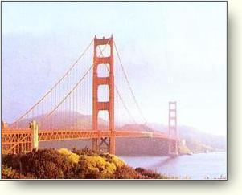
2002 SLS® Users Group Conference
September 29-October 2, 2002
Hyatt @ Fisherman’s Wharf
San Francisco, California
☞ Call the Hyatt at (415) 563-1234 by September 9th, 2002 for
the SLS Users Group rate of $149.00 (USD)

Name: | __________________________ | Mail Code: | ____________________
Title: | __________________________ | E-Mail: | ____________________
Dept: | __________________________ | Phone: | ____________________
Company: | __________________________ | Fax: | ____________________
Address: | __________________________
__________________________

Jacket Size (Check One):
Men’s: S___ M___ L___ XL___ XXL___ / Women’s: S___ M___ L___ XL___

Regale Tour, Wednesday, October 2nd, Noon – 4 PM (Check One):
___ I will attend the Regale tour / ___ I will not attend the Regale tour

$ | $400.00 if postmarked or received by September 13th, 2002
$ | $450.00 if postmarked or received after September 13th, 2002 and through on-site registration
$ | $25.00 per guest for Monday’s Dinner/Vendor Fair/Parts Fair
$ | $75.00 per guest for Tuesday’s Group Excursion (Hornblower Yacht cruise)
 | Total Conference Registration Fee
[Registration fee includes all breakfasts, breaks, lunches, the Sunday evening reception (dinner on own), Monday night’s dinner/Vendor/Parts Fair, & Tuesday night’s off-site event/dinner.]

*** Payment can be made by check, money order, credit card, or wire transfer ***

Credit card type: Visa__ MasterCard__ American Express__

Credit card #: ___________________________________ Exp. Date: ___________
Authorized signature: _____________________ Print name: _____________________

For Wire Transfers:
Chase Bank of Texas N.A.
Routing #113000609 / Account #3667596998-65
SLS Users Group IRS Employer ID #: 74-2918580

Send this completed form, along with your credit card information or your check or money order, made payable to ‘SLS USERS GROUP’, to:
Tony Furdock
Creative Technical Solutions
6880 Hillsdale Court

Indianapolis, IN 46250
Ph: 317-578-3445
Fx: 317-578-3446
Email: tonyf@3dresource.com

