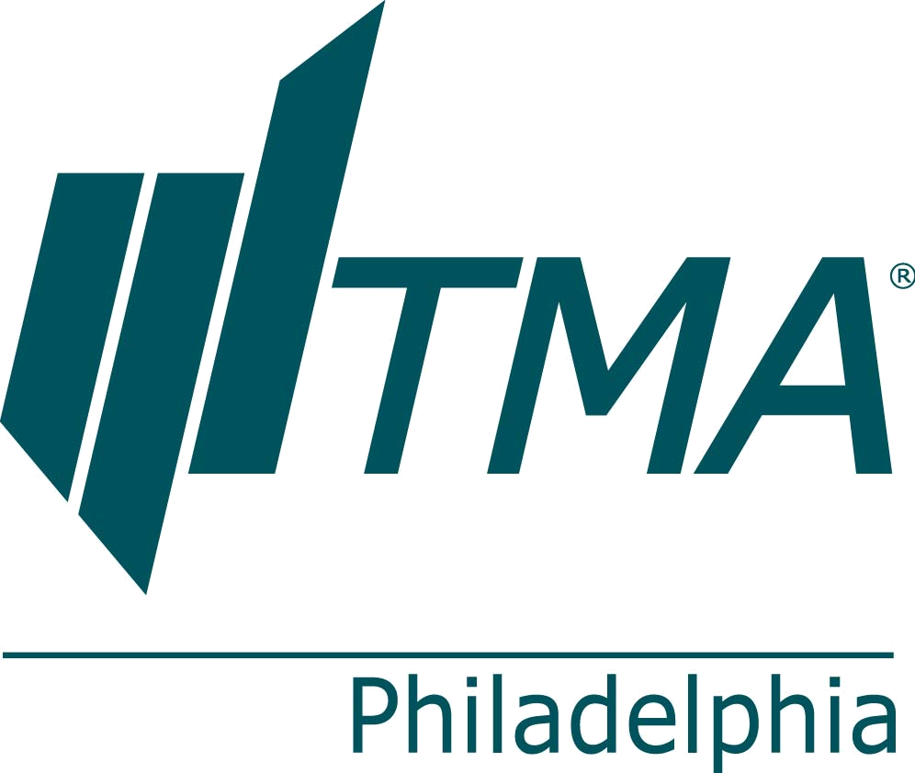

Philadelphia Chapter of the TMA
Breakfast, Education & Networking
The Outlook
Featuring Dr. Mark Zandi, Chief Economist
Moody’s Analytics

Academy of Music, Corner of Broad & Locust Sts., Philadelphia, PA

February 8, 2012
7:00am – 9:15am

Full Name _______________________________________ Nickname (for badge) ____________________
Company ______________________________________________________________________________
Address ________________________________________City ________________State ____ Zip _______
Phone (____) ____-________ Email _________________________________________________________

Special needs: ____________________________________________________________

Register Online, Renew TMA Membership/Join TMA: www.tmaphila.org

Agenda:

7:00-8:00am Registration/Breakfast/Networking 8:00-9:15am Speaker

Speaker:
Dr. Mark Zandi, Chief Economist of Moody’s Analytics

Registration Fees:

TMA Philadelphia Member, FREE (must be Philadelphia TMA member by February 8, 2012)
Guest of Philadelphia TMA Member, FREE
Guest Name (first & last) _________________________
Guest Company Name ___________________________
Guest email ___________________________________
Guest phone (____) ____-________

TMA Member (from another chapter), $20 Chapter Affiliate: ___________________________
Non-Member, $20

Payment:

___ Check enclosed (payable in U.S. funds to Turnaround Management Association)

___ Visa ___ MasterCard ___ American Express

Card Holders Name: _______________________________________________________________
Credit Card number: _______________________________________________________________
Expiration Date: ___________________ Signature: ______________________________________
Total Amount Paid: $ _____________
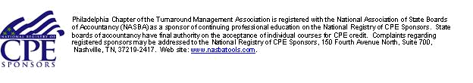
Mail or Fax your completed registration form to:
TMA, C/O Andrea Pauson, 3213 Ayr Lane, Dresher, PA 19025, Fax: 215.657.1964

