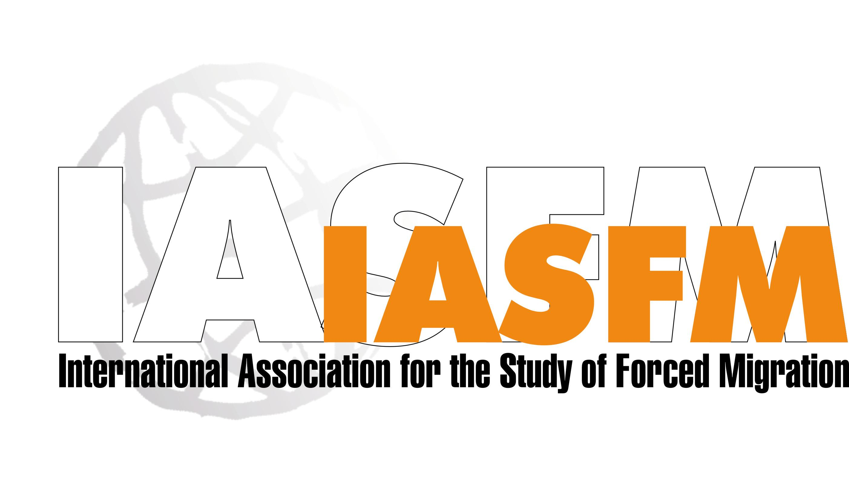

Newsletter

Vol. 2 No. 1 Winter/Summer 2005-2006

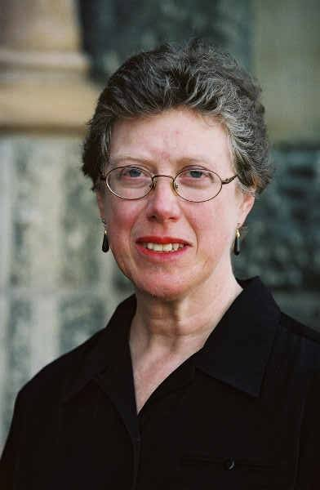
Message from the President…

I am honoured to be addressing you as the new President of IASFM. I am looking forward to serving the members of IASFM and to working with the Executive Committee to continue to strengthen the association.

IASFM brings together academics, practitioners and decision-makers working on forced migration issues. Through the ages, the forced movement of people, displaced within their own countries or across borders, has been of concern to states and to humanitarians alike. Whether people have been forced to migrate due to persecution, to flee war, to escape famine, or because of a major development project, they face a need for protection and/or assistance. Since the end of the Cold War this issue has seen renewed attention. The problems seem ever greater: the solutions ever more scarce. The issue is increasingly perceived to be global in scope, while some solutions may be very local. By coming together, scholars, policy-makers, NGO advocates and those working in the field can think together and develop greater understanding of the implications of forced movement.

The members of IASFM meet at biennial conferences. They share their news through a Newsletter. They form a vibrant and active community. If you have not already joined us, please do so today.

Please contact us at:
IASFM International Secretariat,
c/o Refugee Studies
University of Oxford
3 Worcester Street
Oxford OX1 2PZ
United Kingdom
tel: +44 1865 270728
fax: + 44 1865 270721
e.mail: secretariat@iasfm.org

I want to take this opportunity to thank the outgoing Executive Committee members who by force of will and hard work have strengthened IASFM’s platform: Joanne van Selm who performed a tremendous feat in her years as President by facilitating the development and professionalisation of the IASFM Secretariat; Khalid Koser, who as Treasurer and Vice President, kept IASFM’s finances robust and in order; and Heloisa Szymanski for her amazing work on IASFM9. In other Secretariat news, Fancy has now fully taken over as Desk Officer, following Heidi’s departure to a new position in April. The continuity and excellent support provided by Fancy has been much appreciated.
Dr Susan F Martin
IASFM President
2005-2007

Since assuming direction of IASFM, the new Executive Committee has been working with the appointed Programme Committee to ensure an interesting conference programme for the 10th Conference of the IASFM in Toronto from 17-23 June 2006. We have also been working hard to secure funding to increase the number of grants and bursaries to participants this year. The call for papers on the theme Talking Across Borders: New Dialogues in Forced Migration Studies is out and more details are included in this third issue of the IASFM newsletter. We’ve had a great response from both within and outside membership and encourage all of you, if you have not already done so, to participate. All information regarding IASFM10 is available at www.iasfm10.org.

By way of further introduction of our new team, the Member Profile in this issue is of our new Secretary, Khoti Kamanga, and my own organization, the Institute for the Study of International Migration at Georgetown University, is the subject of this newsletter’s Centre Profile.

Instead of an article in this issue, we decided to give everyone access to the notes and letters sent in by members who unfortunately missed our 9th Conference as a result of the tsunami in the Indian Ocean on 26 December 2004. On the first anniversary of the tsunami, our thoughts remain with those members and their families, friends and societies.

Over the last two years we have had a number of achievements: the successful 9th conference (thanks also to the Programme Committee and in particular Laura Hammond); the development of the Secretariat; the establishment of Institutional Sponsorships; three issues of an IASFM newsletter; and the new logo. Nonetheless, many challenges lie ahead and I look to you, our membership, for advice and expertise to help IASFM grow and become ever more firmly established.

As always, your contributions to the newsletters would be very much appreciated! Please enjoy reading this one, and send in your news, publication information and other items for future issues.

Susan F Martin

IASFM 10 * Centre for Refugee Studies, York University, Toronto, Canada * IASFM 10
18-22 June 2006-01-19 * www.iasfm10.org

Proposals! Abstracts! Register! Become a Member!

IASFM’s 10th International Conference, Toronto, Canada 18-22 June 2006

Although memories of Sao Paulo are only beginning to fade, work on the next IASFM conference is well underway. IASFM’s 10th biennial conference will take place in Toronto between the 17th and 23th of June 2006.

The conference in Toronto will mark the first return of an IASFM conference to the northern hemisphere since its origins in Oxford, United Kingdom. Appropriately, one of the themes of the conference will be the discussion of the divide that often separates the North from the South in matters of forced migration.

More generally, IASFM 10 will attempt to look critically at the various discussions that are taking place within the field of forced migration. The overarching theme of IASFM 10 will be these dialogues, as reflected in the conference title: “Talking across borders: New dialogues in forced migration studies”. Geographical, sectoral and disciplinary dialogues will all be the subject of discussion. If IASFM 10 is anything like previous IASFM conferences, this discussion will span all disciplines and regions. We encourage all those interested in forced migration issues to respond to the recently issued Call for Papers for IASFM 10.

All of this will take place over the course of nine days of summer weather in Canada’s largest city. The Centre for Refugee Studies (CRS) of York University will act as host of the conference. In the middle of the conference, Toronto will celebrate World Refugee Day (20 June 2006). As arguably the most diverse city on earth, the location of the conference will mirror the diversity of opinions and participants presented at IASFM 10. Toronto is home to one hundred cultures and over 7,000 restaurants representing all forms of cuisine – some of which we hope to have you sample as part of the social events planned for the conference.

It is our intention that IASFM 10 will truly reflect Toronto’s origins in the Huron Indian word for “meeting place”. Beyond the vast and varied membership of the IASFM, we are hoping to attract a wide assortment of individuals and groups involved with forced migration issues. The Canadian Council for Refugees (CCR) will hold one of its semi-annual meetings as part of IASFM 10. In addition, the CRS, IASFM and CCR are working to attract a range of local and international refugee and forced migration organizations (including academic, NGO and governmental organizations) to the conference.

More information about IASFM 10 can be found on the conference website (www.iasfm10.org).

Our host in June 2006 . . . www.yorku.ca/crs/
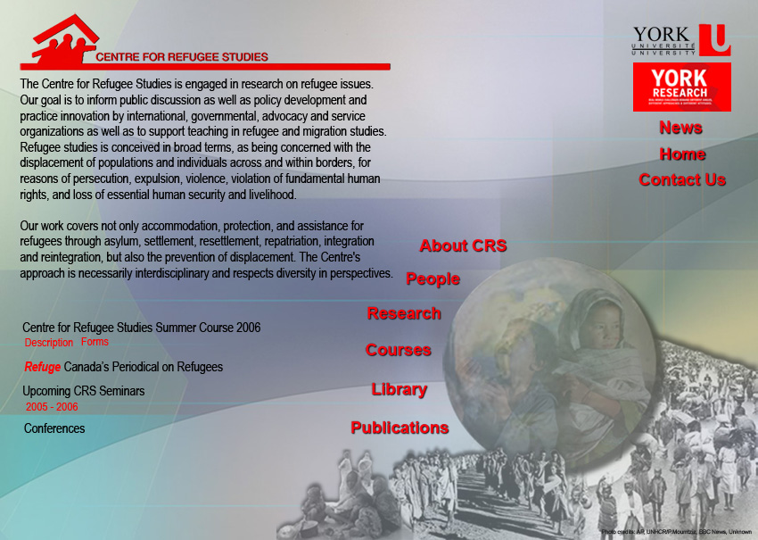


Centre Profile

The Institute for the Study of International Migration [ISIM] is part of the Edmund A. Walsh School of Foreign Service and affiliated with the Law Centre at Georgetown University. ISIM brings the best social science, legal and policy expertise to the complex and controversial issues raised by international migration. Staffed by leading experts on immigration and refugee policy, the Institute draws upon the resources of Georgetown University faculty working on international migration and related issues on the main campus and in the law centre. ISIM provides balanced, interdisciplinary analyses of the complicated issues raised by immigration policy and law. The Institute conducts research and convenes workshops and conferences on immigration and refugee law and policies. In addition, the Institute seeks to stimulate more objective and well-documented migration research by convening research symposia and publishing an academic journal that provides an opportunity for the sharing of research in progress as well as finished projects. ISIM is committed as well to building the next generation of experts on international migration through teaching and mentoring activities.

Policy Studies on International Migration
The Institute’s policy research projects fall into five program areas:

Immigration Law and Policy. This program area focuses on policies for admission of legal migrants for work, study and family reunification, control of unauthorized migration, border management, trafficking in persons, and the rights of immigrants. Since September 11, ISIM has focused particular attention on the security ramifications of immigration policy.
- Migration and Development. ISIM’s work in this area focuses on ways to increase the developmental impact of migration on source countries of immigration. In particular, this program examines the impact of worker remittances on economic and social development, the role of return migrants and expatriate communities in stimulating economic growth, democratization and respect for human rights, the impact of migration on demographic trends and the role of migrant women in the development of their home countries.
- Forced Migration and Humanitarian Emergencies. Millions of individuals have been displaced from their homes because of persecution, human rights violations, conflicts and repression. Institute projects fall into five principal areas: asylum and temporary protection in developed countries, refugee and displaced women and children, institutional responses for addressing humanitarian emergencies, practical protection of refugees and displaced persons, and post-conflict repatriation and reintegration.
- Integration of Immigrants. The fourth policy program area focuses on the adaptation and integration of immigrants. Projects assess the economic, social and civic integration of immigrants in the United States and other receiving countries. Of particular interest are issues pertaining to labor force integration and language acquisition. ISIM also examines the integration of the children of immigrants.
- Global Management of International Migration. The final program area focuses specifically on the international management of migration. Migration issues are increasingly on the bilateral, regional and multilateral agenda of governments. ISIM advises governments and international organizations on the most effective mechanisms to increase cooperation in managing migration. ISIM provides policy research support to the Global Commission on International Migration.

Teaching and Student Mentoring
The Institute is committed to building the next generation of experts on international migration. The Institute offers a Certificate in Refugee and Humanitarian Emergencies to masters’ level students at Georgetown University. ISIM also offers a summer program entitled Managing Complexity in Humanitarian Emergencies for mid-career professionals. Institute staff teaches courses on U.S. immigration and refugee law and policy; the causes and consequences of immigration, and the interconnections between international migration, foreign policy and development.

The Institute also provides work opportunities for students. Students are involved in the various activities undertaken by the Institute, including policy-oriented research, symposia and conferences of policy experts and government officials, site visits, and key informant interviews. They also have the opportunity to attend outside conferences, Congressional hearings, and meetings at which migration policy issues are discussed.

Advancing Research on International Migration
The Institute seeks to stimulate international migration research. ISIM convenes research symposia that provide an opportunity for the sharing of research in progress as well as finished projects. ISIM has also established a Visiting Scholars program for academics and graduate students pursuing research on migration and refugee issues.

Publications
The Institute produces research papers and policy briefs aimed at policy makers and practitioners as well as articles for academic publication. ISIM faculty serves as editors of International Migration, one of the few peer-reviewed journals in this field. ISIM faculty also serves as advisors to the student edited Georgetown Journal of Immigration Law.

Susan Forbes Martin, President IASFM
IASFM 10 * Executive Committee * IASFM

SUSAN MARTIN serves as Visiting Professor and the Director of the Institute for the Study of International Migration in the School of Foreign Service at Georgetown University. Dr. Martin is also Director of the Certificate Program on Refugees and Humanitarian Emergencies. Previously Dr. Martin served as the Executive Director of the U.S. Commission on Immigration Reform, established by legislation to advise Congress and the President on U.S. immigration and refugee policy, and Director of Research and Programs at the Refugee Policy Group. Her publications include the World Migration Report: 2000 (ed.), Refugee Women, The Uprooted: Improving Humanitarian Responses to Forced Migration, Beyond the Gateway: Immigrants in a Changing America (ed.), Managing Migration: The Promise of Cooperation (forthcoming) and numerous monographs and articles on immigration and refugee policy. She is also the principal author of the 2004 World Survey on Women and Development: Women and Migration, produced for the United Nations. She earned her MA and Ph.D. in American Studies from the University of Pennsylvania and her BA in History from Douglass College, Rutgers University.

Susan may be reached at:

Susan Martin
Director
Institute for the Study of International Migration
Georgetown University
Harris Building
3300 Whitehaven St NW
Third Floor
Washington, DC 20007
Tel: 202 687 2153
Fax: 202 687 2541
email: martinsf@georgetown.edu

Aninia Nadig, V. President/Treasurer IASFM

ANINIA NADIG is country analyst for the Internal Displacement Monitoring Centre in Geneva. She previously worked as International Policy Officer for the Dutch Refugee Council in Amsterdam, and was coordinator of the Working Group on International Refugee Policy. She has a Masters in International Relations and has published several articles on refugee policy issues. Aninia has been active for IASFM since 2000.

Aninia may be reached at:
Aninia Nadig
Pelly
74270 Desingy, France
aninia@nadig.net

Khoti Kamanga, Secretary IASFM
Please see Member Profile

Karen Jacobsen, Development Officer, IASFM

KAREN JACOBSEN is a Visiting Associate Professor at the Fletcher School (Tufts University), and leads the Refugees and Forced Migration Program at the Feinstein International Famine Center. She directed the Alchemy Project from 20012005, which provided grants and conducted research and impact evaluations on microenterprise initiatives in conflictaffected communities in Africa. Jacobsen’s current research project is in partnership with the FMSP at Witwatersrand University in Johannesburg and uses surveys and qualitative research to compare the experiences of refugees and locals in Johannesburg, Maputo and Nairobi (funded by the MacArthur Foundation). She is also working with IRC on a survey of Burmese refugees in Thailand. Her most recent book, The Economic Life of Refugees was published in 2005. She teaches courses on Field Methods and on Forced Migration. Her earlier research investigated security and protection issues for refugees and relief workers in refugee camps, a study for UNHCR on selfsettled refugees and local integration; research on security problems in refugee camps, on the environmental impact of refugees in asylum countries, and on the policy responses of host governments in Africa and Southeast Asia to refugees. She holds a B.A. from University of Witwatersrand (Johannesburg) and a Ph.D. from the Massachusetts institute of Technology.
Karen may be reached at:

Karen Jacobsen
Feinstein International Famine Center
Tufts University
126 Curtis Street
Medford, MA 02155 USA
Tel: +617 627 3423
karen.jacobsen@tufts.edu

Holly Reed, Officer for Programme Affairs & Innovation IASFM

HOLLY REED is a doctoral candidate in sociology and demography at Brown University in Providence, Rhode Island, USA. Her dissertation research focuses on internal and international migration (particularly historical forced
migration) in South Africa, and especially the role of social networks in the relationship between migration and local and national development. Ms. Reed is a recipient of the U.S. National Science Foundation Graduate Research Fellowship and previously worked as a program officer for the Committee on Population of the National Academies, Washington, DC. Her research with the Committee dealt with the demography of forced migration, the demographic dynamics and implications of urbanization in the developing world, and other international population issues. Ms. Reed holds a B.S. in international relations and an M.A. in demography from Georgetown University.
IASFM 10 * Executive Committee * IASFM

Holly may be reached at:

Holly Reed
Brown University
Dept. of Sociology
Box 1916
Providence RI 02906 USA
Tel: +1 401 751 3499
Holly_Reed@brown.edu

Renu Modi, Communications Officer IASFM

RENU MODI is a lecturer at the Department of African Studies, University of Mumbai. She is a political scientist, having graduated from the Lady Shree Ram College for Women, Delhi University and received her Ph. D. from the Jawaharlal Nehru University, New Delhi. She is currently working on issues of migration, displacement and resettlement. Her recent publications include articles on livelihood reconstitution at resettlement sites and the gender aspects of involuntary resettlement, in the AfroAsian context.

Renu may be reached at:
Department of African Studies
University of Mumbai
Ranade Bhavan, 2nd Floor, Vidya Nagri Campus
Kalina, Santa Cruz (East)
Mumbai , Maharashtra 400 098 India
renumodi2003@yahoo.com

Susan McGrath, Officer for Conference Venue IASFM

SUSAN McGRATH has extensive experience working with marginalized community groups including refugees and immigrants as a social work practitioner and researcher. With colleagues at three other Canadian universities, she recently completed a Social Sciences and Humanities Research Council of Canada (SSHRC) funded project, The State of Community Practice within Marginalized Groups in Ontario. Her focus in this research was on refugee communities across Ontario. From this research, several articles have been published and a book is in progress (Wilfrid Laurier Press). Dr. McGrath has a particular interest in the needs of refugees who have experienced trauma and has written on her work with the Canadian Centre for Survivors of Torture where she is active as a board member. Currently Dr. McGrath is a coapplicant on an Association of Universities and Colleges of Canada Tier 2 project Rebuilding Health in Rwanda). She is the Canadian lead on a team looking at mental health issues for women and children in Rwanda. Dr. McGrath also has the lead on a SSHRC funded clusters grant directed at establishing a Canadian based network of researchers in the field of refugee studies.

Susan may be reached at:

Susan McGrath
Director, Centre for Refugee Studies
Associate Professor, School of Social Work
York University
321A York Lanes
4700 Keele Street
Toronto ON M3J 1P3 Canada
Phone: +416 736 2100 #66662
Fax: +416 736 5837
smcgrath@yorku.ca

Michael Collyer, Chair IASFM10

MICHAEL COLLYER is a research fellow in the Department of Geography and the Sussex Centre for Migration Research at the University of Sussex in Brighton, UK. He has published widely on migration in and around the Mediterranean region and is currently completing a book entitled Life is Elsewhere? Locating and Localising Transnational Space in the Moroccan Diaspora. Recently, he has held visiting fellowships at Abdelmalek Essaadi University in Tetouan, Morocco and the American University in Cairo. He completed his PhD at the University of Sussex in 2002 which explored the movement of Algerian asylum seekers around the European Union. Before starting his PhD he spent four years in Marseilles, with an NGO supporting refugees from the Algerian conflict of the 1990s. He currently serves as reviews editor for the Journal of Ethnic and Migration Studies and is a member of the EU funded Network of Excellence on Immigration, Integration and Social Cohesion in Europe (IMISCOE).

Michael may be reached at:

Michael Collyer
Department of Geography and Sussex Centre for Migration Research
IASFM 10 * Executive Committee * IASFM

IASFM
Member Profile

Who is … Dr Khoti Kamanga

Many of you may know Khoti Kamanga from IASFM’s conferences or perhaps at separate meetings both in Tanzania and abroad. However, you may not know that Khoti’s work in forced migration is a reflection of his life story. Khoti was a refugee from 1980 to 1994 during which time he became a Malawian citizen. His story is a unique one in that though Tanzania is his country of birth it also became his country of asylum and only in April 2005 did he acquire his Tanzanian citizenship through naturalisation.

Khoti has a demanding consultancy and teaching regime. He is a Senior Lecturer in International Law and Coordinator for the Centre for the Study of Forced Migration at the University of Dar Es Salaam, Tanzania. His background in International Law stems from training in Russia as well as at the University of Amsterdam where he undertook an LL.M. in European Union International Trade Law.

Khoti has held many professional honors and positions including being a Founding Member of the International Criminal Law Network at The Hague, a Member of the Editorial Board of the Journal of Refugee Studies at University of Oxford, and more recently serving as a Member of the UNHCR Steering Committee for the Strengthening of Protection Capacity Project.

His most recent publications include:
- Co-editor, The Refugee Convention at Fifty: A View from Forced Migration Studies, Lexington Books, 2003
- (with B. Rutinwa), Study Report on the Impact of the Presence of Refugees in Northwestern Tanzania, 2003
- Historical and Contextual Overview of the 1951 UN Convention and the 1969 OAU Convention (mimeo).
- Respect for International Humanitarian Law: Handbook for Parliamentarians, 1999, ICRC (translation from English to Kiswahili)

Thank you! Khoti for all that you do for IASFM!

Dr Khoti Kamanga
Department of International Law, Faculty of Law, University of Dar Es Salaam, P.O. Box 35093, Dar Es Salaam, TANZANIA
E-mail: kkamanga@uccmail.co.tz
Telephone: (255 22) 241 05 93, 241 01 97, Cel: 0748 31 44 78
Languages: Kiswahili, English, Russian, French (Intermediate).

Arts C333
University of SussexBrighton, BN1 9SH, UK

Tel. +44(0)127 387 2772
Email: M.Collyer@sussex.ac.uk

Ronald Kalyango, Chair IASFM10

RONALD KALYANGO is an Assistant lecturer in the Department of Women and Gender Studies and the Faculty of Law, Makerere University, Kampala Uganda. Ronald teaches courses on Refugee livelihoods and household economy and women in Conflict and post conflict situations. Prior to joining Makerere, he served as Senior Education and Training Officer for the Refugee law Project in Kampala from 20002002 where he established a training program for people working with forced migrants in Uganda. He is a member of several academic associations such as the Council for the Development of Social Research in Africa (CODESRIA), the African Association of Political Scientists (APPS) and the Net Work of African Peace Builders (NAPs). His research interests encompass gender issues in conflict and forced migration in Africa. Publications include: Refugees in the City: Status Determination, Resettlement and the changing nature of the refugee regime; forth coming publications: Land conflicts and their impact on women’s livelihoods in refugee hosting areas in South Western Uganda and Interfaces of care, institutional policies and livelihood strategies of refugee women in Uganda. Ronald graduated with an MA Social Sector Planning and Management and a Bachelors degree in Social Sciences from Makerere University.

Ronald may be reached at:

Kalyango Ronald
Assistant Lecturer,
Department of Women and Gender Studies
Makerere University,
P.O.Box 15016, Kibuye Kampala Uganda

Tel: +256 4134 34 41
Mob. +256 774 58022

Email: kalyango@infocom.co.ug
kalyango@ss.mak.ac.ug

An IASFM Members Story….

Surviving Tsunami

R.Cheran

Department of Sociology and the Centre for Refugee Studies,
York University, Toronto, Canada, January 7, 2005

The American author James Baldwin titled one his novels, “The Fire Next Time”. But, let me talk about water this time. There is no rationale for me to stand here in front of you, and talk about my harrowing tale of survival. I wonder whether my voice is actually my own or borrowed from thousands and thousands of other survivors that are nameless and voiceless and languishing in various refugee camps and relief centres that dot the coastal regions of Indonesia, Sri Lanka, Thailand and India.

I was born in Jaffna, in northern Sri Lanka. We had no mountains; no rivers. Monsoon rains were insufficient and unpredictable. Nothing naturally grew in my beloved but barren land, except perhaps, men’s beards. But we grew up with the sea. The only beautiful natural asset we had was the sea; the vast, open sea. It was not always blue.

For those of you who don’t me - I am a poet who happens to be moonlighting in academia! My first published poem appeared in a Sri Lankan literary journal in 1975. It was titled, “The Sea”. Ironically, my seventh collection of poems that was released in India a few days before the tsunami, was titled “Return to the Sea”. My fantasies, imagination and dreams have always been inseparably linked to the sea in all its forms, sounds, colors and depth.

On that fateful day, December 26, 2004, I was on the beach with my sister, her two children and my brother-in-law, in a small village called Bentota, on the southern coast of Sri Lanka. Bentota is a small fishing village with many beach resorts along the coast. It was the time of the full moon and many Sri Lankans had come to these resorts and the adjacent public picnic areas with their families to celebrate. It was 8:45 in the morning and we had just returned from our breakfast. The children wanted to be in the pool and we pondered over the possibility of going for a swim or a enjoying a lazy, sit back and read-snooze session. When we started walking on the beach trying to locate a few deck chairs, I noticed something strange. We were not that close to the sea but I saw the water rushing towards us with ferocious speed. My intellect did not light up but my instincts did. We ran and the sea chased us. I have never run that fast in my entire life even when chased by gun-toting Sri Lankan soldiers in the mid 1980s. Putting her own instincts to work at the right moment, my sister managed to grab her daughters and run. With great difficulty we negotiated the rising water, floating debris and sinking hope. Our rooms were on the third floor and we got there beating back the surging waves. By the time we reached our room, the first floor was gone. In twenty minutes or so, the sea crawled back taking everything on the ground.

What followed in the aftermath were moments of silence. I had no idea what happened. All I could sense was that this was not ordinary. This body of water is not the one I came to know, love and cherish.

We decided to pack and leave the place. However, that wasn’t possible. The sea came back for a second time - with a vengeance. This time the waves had metamorphosed into giant monsters. They hit the second floor of our hotel with such power that all the glass windows, doors and patios were broken and tossed away like plastic toys. Fortunately, the third floor remained untouched. Then the sea receded again. We made our way downstairs, walked through the waist-deep water that was moving less quickly by then. We scrambled up to the platform of Bentota’s railway station - the highest terrain we could locate. The rest was just a dream.

When the waves hit for the third time, we were safely on our way to the capital city of Colombo.

Now, after 11 days of recurring nightmares with sounds of broken glass and pounding waves, what I do not remember was how I survived. But what I do remember is the color of the wave. It was not blue.

I no longer have the same relationship with the sea. It has been permanently altered, perennially shifted and perilously wounded.

We all know that disasters bring out the best and worst in human beings. We witness both as I speak. However, the generosity of ordinary people here and everywhere far surpasses the posturing of governments and international agencies that now we have one million reasons to place all our faith in humanity.

The unprecedented catastrophe has paved the way for an equally unprecedented international relief effort in the tsunami affected countries. However, there are two crucial issues that most of the relief organizations have not adequately addressed. The first one is that the most effected areas in Indonesia and Sri Lanka are the sites of ethnic conflict. In the case of Sri Lanka, the large territory in the north and eastern regions is controlled and administered by the Tamil Tigers. The Aceh province of Indonesia is the stronghold of Aceh rebels. Relief efforts in these areas need to be conflict sensitive. That is, the rebels and the local population need to be equally represented in any relief and rehabilitation effort. Unfortunately, the governments of Indonesia and Sri Lanka do not appear willing to accommodate any kind of conflict sensitivity in their relief efforts. Instead they are sending in the military and taking over the distribution of relief supplies.

The second aspect is the lack of gender sensitivity in the relief efforts to date. Women’s groups in Sri Lanka are already voicing their concerns - highlighting incidents of rape and sexual harassment in the refugee camps. The specific needs of women, pregnant and lactating mothers and children are not being addressed. Yet, the majority of the victims are women and children.

The tsunami disaster brought all humanity together in grief and suffering irrespective of ethnicity, religion or politics. Nature has demonstrated mightily that there can be no “heroic’ battles waged for the control or ownership of territory by humans. This could well be the moment- the moment to bury all our conflicts and join hands for peace, sustainable development and a greener world.

IASFM Working Group Guidelines

Overall goals for IASFM working groups:
- to offer more frequent possibilities for the IASFM membership to meet (in addition to the biennial conferences);
- to further promote the exchange of experience and knowledge in the field of forced migration;
- to attract new members and funds from a variety of geographic regions, academic and practitioner fields, and organizations.

Working groups should:
- be longer term processes (not a one-time event);
- be relevant to the membership of IASFM;
- preferably be held in both English and local languages;
- be a locally-run and funded (with possible contribution by IASFM, subject to availability of funds) effort with assistance as needed from the IASFM executive committee and membership;
- present their proceedings and activities at each International Biennial Conference.

IASFM encourages proposals for working groups that are located in geographic regions where IASFM previously has not been active and working groups that address innovative issues or groups to encourage new membership and collaborations. Working group proposals with existing funding or a high probability of obtaining funding are also strongly encouraged. Working group organizers must be current members of IASFM.

To submit a proposal for a working group, please draft a brief proposal (5 pages maximum) that includes the following information:

Name of Sponsoring Organisation
- Name of Primary Contact Person
- Topic/Name of Proposed Working Group
- Short description of the envisaged project
- Short description of how the project fits with the broader aims of IASFM
- Timeline for working group’s activities (number of meetings, date of first and last meeting)
- Estimated number of participants
- Geographic area of interest
- Languages to be used by the working group
- Draft budget including rough estimates of costs for meetings and other activities
- Potential funders and information about likely funding potential

Working group proposals should be submitted via email to Holly Reed, IASFM Officer for Programme Affairs and Innovation on an ongoing basis (send to Holly_Reed@brown.edu). Proposals will be evaluated by the IASFM Executive Committee.

Renew your membership!
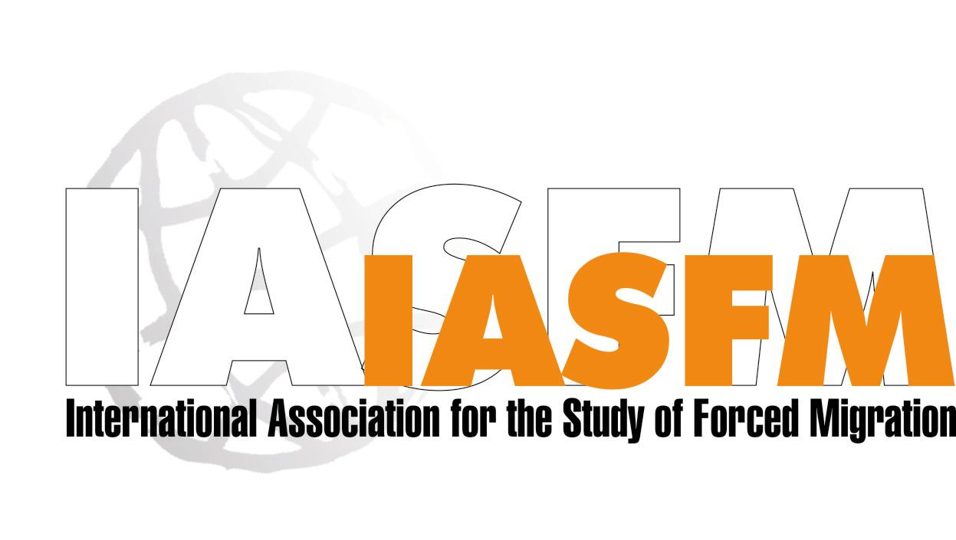
MEMBERSHIP APPLICATION FORM

Please fax to +44-20-7704-0599 or e-mail to secretariat@iasfm.org
I wish to become a member of the International Association for the Study of Forced Migration. I have taken notice of the IASFM statutes and rules (available on the membership page) and subscribe to the objects and rules of the Association.

|_| Mr. |_| Mrs. (please tick)  Title, First Name, Surname/Family Name:  Profession:  Special research/teaching interests:  Regions of concern:  Address for correspondence:  Tel:  E-Mail (required): | Institutional affiliation:  Recent publications:  Fax:

Membership Dues: Payment Details
Payable/to: (please circle one) $ USD / EURO €  Regular dues, two (2) years: $160/€ 150. Reduced rates apply to nationals/permanent residents of developing countries and students. Please see below and/or website or request information. | The International Association for the Study of Forced Migration (IASFM)  Payment Amount: $ €
Method of Payment: (please circle one) Credit Card (Visa/MasterCard only), or Bank Transfers:
The IASFM is an international association registered at the Chamber of Commerce in Utrecht, The Netherlands (Reg. No. 30147400). IASFM bank accounts: No. 52 32 78 365 (US $) No. 50 50 87 189 (Euro and other curr.) ABN/AMRO Bank Utrecht Code BIC ABNANL2A
Credit Card Number
Name Printed on Card
Expiration Date
3 Digit-Security Code (found on back near signature)
Signature

Guide to IASFM Membership Fees

Membership fees are charged for two-year periods, currently 2006 and 2007. For fairness, they are calculated on the basis of annual GDP in the country of residence, as follows:

Full members

Regular dues, two years - US$160 /Euros 150 | Members residing in a country with a GDP per capita over US$/Euros 10,000
Reduced dues, two years - US$95/Euros 90 | Nationals and residents of a country with a GDP per capita between US$/Euros 4,000 and US$/Euros 10,000 who do not earn any income from international organizations, or income of a comparable amount from other sources.
Very low dues, two years – US$55/Euros 50 | Nationals and residents of a country with a GDP per capita under US$/ Euros 4,000, who do not earn any income from international organizations, or income of a comparable amount from other sources.

Student Associate members*

Student Associate Members, in ‘regular dues’ countries per year - US$30/Euros 25 | Students residing in a country with a GDP per capita over US$/Euros 10,000
Student Associate Members ALL other countries – FREE | Students residing in a country with a GDP per capita under US$/Euros 10,000

*Candidates must be graduate students and provide confirmation from their institute that they are registered as full time students. Student Associate Members will not receive a discount on the Journal of Refugee Studies.

Countries qualifying for ‘Regular dues’:
[based on real GDP according to UNDP Human Development Index (over 10,000 US$ GDP)]
Australia, Austria, Bahamas, Bahrain, Barbados, Belgium, Brunei Darussalam, Canada, Cyprus, Denmark, Finland, France, Germany, Greece, Hong Kong (China), Iceland, Ireland, Israel, Italy, Japan, Korea, Kuwait, Luxembourg, Malta, Mauritius, Netherlands, New Zealand, Norway, Portugal, Qatar, Saint Kitts and Nevis, Singapore, Slovenia, Spain, Sweden, Switzerland, United Arab Emirates, UK, USA

Countries qualifying for ‘Reduced dues’:
[based on real GDP according to UNDP Human Development Index (between 4,000 and 10,000 US$ GDP)]
Algeria, Antigua and Barbuda, Argentina, Belarus, Belize, Botswana, Brazil, Bulgaria, Chile, Colombia, Costa Rica, Czech Republic, Dominica, Ecuador, Estonia, Fiji, Grenada, Hungary, Iran, Jordan, Korea, Lebanon, Libyan Arab Jamahiriya, Macedonia (FYR), Malaysia, Mexico, Namibia, Oman, Panama, Poland, Romania, Russian Federation, Saint Lucia, Saint Vincent, Saudi Arabia, Seychelles, Slovakia, South Africa, Suriname, Syrian Arab republic, Thailand, Trinidad and Tobago, Tunisia, Turkey, Uruguay, Venezuela

Countries qualifying for ‘Very low dues’:
[based on real GDP according to UNDP Human Development Index (under 4,000 US$ GDP)]
Albania, Angola, Armenia, Azerbaijan, Bangladesh, Benin, Bhutan, Bolivia, Burkina Faso, Burundi, Cambodia, Cameroon, Cape Verde, Central African Republic, Chad, China, Comoros, Congo, Congo (Dem. Rep. of), Côte d’Ivoire, Croatia, Cuba, Djibouti, Dominican Republic, Egypt, El Salvador, Equatorial Guinea, Eritrea, Ethiopia, Gabon, Gambia, Georgia, Ghana, Guatemala, Guinea, Guinea-Bissau, Guyana, Haiti, Honduras, India, Indonesia, Jamaica, Kazakhstan, Kenya, Kyrgystan, Lao People’s Dem. Rep., Latvia, Lesotho, Lithunia, Madagascar, Malawi, Maldives, Mali, Mauritania, Moldova, Rep. Of Mongolia, Morocco, Mozambique, Myanmar, Nepal, Nicaragua, Niger, Nigeria, Pakistan, Papua, New Guinea, Palestinian Territories, Paraguay, Peru, Philippines, Samoa (Western), São Tomé and Principe, Senegal, Sierra Leone, Solomon Islands, Sri Lanka, Sudan, Swaziland, Tajikistan, Tanzania, Togo, Turkmenistan, Uganda, Ukraine, Uzbekistan, Vanualu, Vietnam, Yemen, Zambia, Zimbabwe.

Institutional Sponsorship of IASFM

Institutions around the world are invited to sponsor the International Association for the Study of Forced Migration.

IASFM brings together people with an interest in understanding and dealing with the challenges of Forced Migration. Members are drawn from the academic, policy-making and practitioner communities. A growing network, the IASFM holds biennial conferences and circulates a biannual newsletter. The Association has an International Secretariat based at the Refugee Studies Centre in Oxford, UK. Both membership and activities are expanding. The sponsorship of these efforts by your institution can support IASFM and all its members, as well as bringing benefits to your institution.

Sponsorship is possible at three levels, with the benefits and costs shown overleaf.

Sponsorship income will be used for several IASFM goals including:

• To support the operating costs of the International Secretariat
• To support international and regional workshops on key forced migration issues
• To develop materials to encourage wider membership of the Association
• To support conference participation by scholars and practitioners from less wealthy countries.

Institutional Sponsorship APPLICATION FORM

NAME of Institutional Sponsor:  Full Name of Contact:  Address for correspondence:  Telephone Number:  Fax Number:  E-Mail (required): | Recent publications:  Institute’s/Organisation’s areas of  interest/research themes:  Institute/Organisation’s LOGO (for advertisement on IASFM’s homepage):  Website Address:

Method of Payment: Institutional Sponsorship

Please fax +44 (0) 20 77040599, email secretariat@iasfm.org or mail to IASFM, Secretariat, c/o Fancy Sinantha, 41 Canonbury Street, Flat 2, London, N1 2TA, United Kingdom

Payable/to: | The International Association for the Study of Forced Migration (IASFM)  Payment Amount: $
Method of Payment: (please circle one)  Credit Card (Visa/MasterCard only),  Check, or Bank Transfers: The IASFM is an international association registered at the Chamber of Commerce in Utrecht, The Netherlands (Reg. No. 30147400). IASFM bank accounts: No. 52 32 78 365 (US $) No. 50 50 87 189 (Euro and other curr.) ABN/AMRO Bank Utrecht Code BIC ABNANL2A | Credit Card Check Bank Transfer
Credit Card Number
Name Printed on Card
Expiration Date
3 Digit-Security Code (found on back near signature)
Signature

IASFM Sponsorship level ONE

Fee (two years) | Institutes and Organizations in the North – $3,000 and above*  Institutes and Organizations in the South - $1,000
Benefits | Up to FOUR conference registrations to be used by employees or Board Members of the Sponsoring Organization (within one sponsorship period)
 | Inclusion in the SPONSORS page on the IASFM website list of funders and in the conference materials;
 | Pre-conference meeting of sponsoring organization’s directors to identify projects for collaboration/fundraising opportunities etc.
 | The Programme Committee will consult directors of Benefactor Sponsoring Institutes and Organizations during the Conference Preparations, with regard to the theme and content of the conference. These directors’ input in this capacity does not preclude them from being invited, on a personal basis, to join the Advisory Group under the usual rules regarding the composition and appointment of that Group.

IASFM Sponsorship level TWO

Fee (two years) | Institutes and Organizations in the North - $2,000  Institutes and Organizations in the South - $750
Benefits | Up to THREE conference registrations to be used by employees or Board Members of the Sponsoring Organization (within one sponsorship period)
 | Inclusion in the SPONSORS page on the IASFM website list of funders and in the conference materials;
 | Pre-conference meeting of sponsoring organization’s directors to identify projects for collaboration/fundraising opportunities etc.

IASFM Sponsorship level THREE

Fee (two years) | Institutes and Organizations in the North - $1,000  Institutes and Organizations in the South - $400
Benefits | ONE conference registration to be used by employees or Board Members of the Sponsoring Organization (within one sponsorship period)
 | Inclusion in the SPONSORS page on the IASFM website list of funders and in the conference materials;
 | Pre-conference meeting of sponsoring organization’s directors to identify projects for collaboration/fundraising opportunities etc.

∗ Sponsors may choose to exceed this fee at their own discretion. All additional support to the work of IASFM is gratefully received.
Announcements . . .

Lisa Gilad Prize winners 2005
Jennifer Hyndman, author of the article "Preventive, Palliative or Punitive? Safe Spaces in Bosnia Herzegovina, Somalia and Sri Lanka"
AND
Loren Landau, author of the article "Beyond the Losers: Transforming Governmental Practice in Refugee Affected Tanzania".
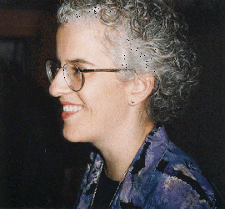

Bids are now open for IASFM’s 12th conference. Please visit our website for more details.

From Members …

New Books!

Rights in Exile: Janus-Faced Humanitarianism, Verdirame, V. and B.E. Harrell-Bond 2005, Berghahn Books.

Dangerous Sanctuaries: Refugee Camps, Civil War, and the Dilemmas of Humanitarian Aid (Ithaca, NY: Cornell University Press, 2005), Dr. Sarah K. Lischer, Dept. of Political Science, Wake Forest University

State, Society and Displaced People in South Asia
Editors: Imtiaz Ahmed, Abhijit Dasgupta and Kathinka Sinha-Kerkhoff
Published by The University Press Limited, Dhaka

……Please Send Us
Information about your whereabouts and activities for inclusion in future issues of our Newsletter under Members Notes. Please send us news about your recent publications, research projects, work/research related travels, and thoughts/quotes in response to current forced migration issues. We look forward to hearing from you!

Send your notes to:
Fancy Sinantha
IASFM International Secretariat
c/o Refugees Studies Center, University of Oxford
3 Worcester Street
Oxford OX1 2PZ
United Kingdom
E-mail: secretariat@iasfm.org

www.iasfm.org

