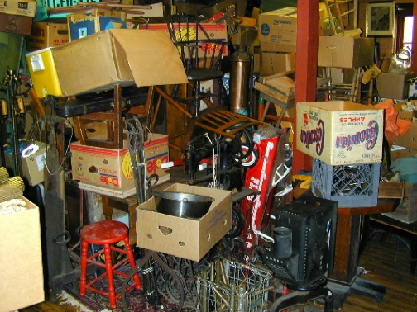
2 ESTATE AUCTIONS

Contents from a 91 yr old “pack rat” from Winchester MA
Session 1: SAT, MAY 1st , 10:00 AM(prev 8 AM)
HG Webber Auction Gallery Under Tent

495 Lafayette Rd. (Rt. 1), Hampton, NH

Dir: Rt. 95 (Exit 2) to Hampton Center across from The Old Salt. Auction Hall in back of HG Webber store
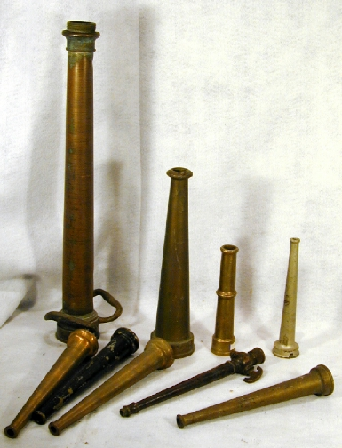
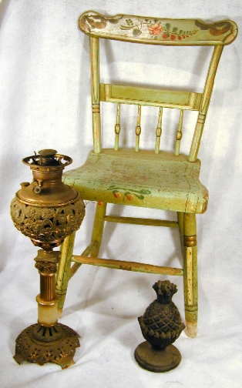
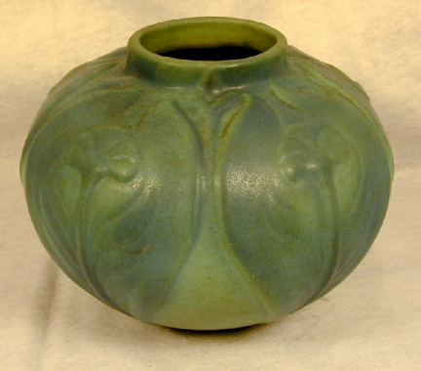
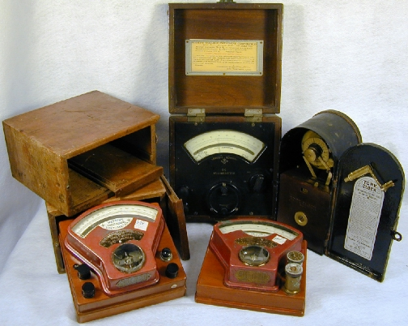
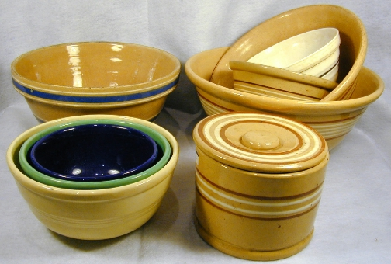
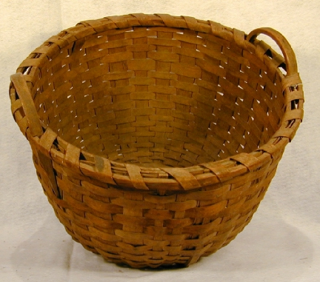
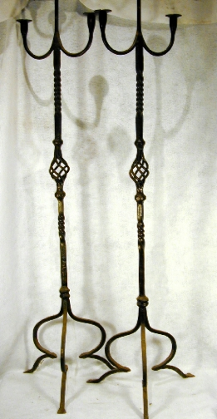
Partial listing: Metal signs incl. RR, Agfa porcelain thermometer, CI d/stops incl. Policeman, Odd Fellows, Sunbonnet Witch, Dec. crock, 2 color Van Briggle 7” vase , Yelloware butter crock & bowls, 8 CI door hinges, Wooden ware, Saw buck table, Windsor-style child’s sack back armchair (great grunge), Oak folding RR bench, Folding prim. table, Quilts, Toleware, Hanging map of Carroll County (1861), 2 lg. splint baskets & others, 2 dr. Empire stand w/tiger drawers, Oak table, Granite & Agateware bowls, Pineapple cast iron ornament, Early lap desk, Dovetailed putty grain box, 2 game boards, Leather suitcases, Card files, Brass & iron andiron sets, tools, etc., Lg. cast iron book press, Lg. Nickel brass cream dispenser, Copper/brass fire extinguishers, Lanterns, Telephone box, Cast ice tongs, Floor lamps, Early brass fire hose nozzles, Copper boilers, Fire engine pedal car, Stools, Paintings, Prints, Etchings, Oak folding screen, RR bell, ship’s bell, Deer horns, Copper tea kettles, Owl adj. book rack, Boxed celluloid dresser set, 1915 porc. license plate, Early camera parts, Box lots of camera equipment, Books incl 1949 Am. Rifleman books, Sleds, 6 breadboards, Book racks, Linens, Pink depression glass, Naughty Nelly bootjack, Cast brass hooks, pulls, Horse hanes, Mint oil cans w/labels, Dry Measures & pantry boxes, Old buoys, Many chairs, “Seat” walking stick, Symbol hooked rug & others, C I floor lamps, Old Bottles , etc…
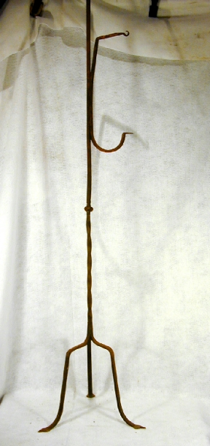
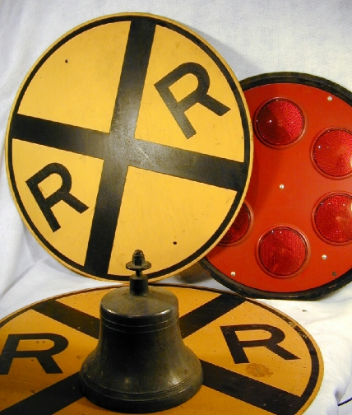
Session 2: MON, MAY 3rd, 5 PM TWILIGHT SALE
200+ lots…This sale is full of more we can’t see in all the stacks of boxes! Future Tool Auction upcoming!
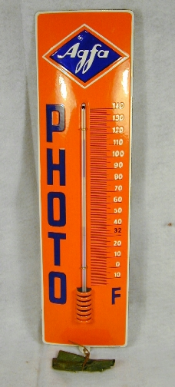
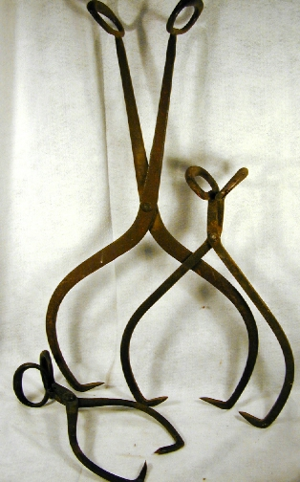
H. G. WEBBER AUCTIONS
See listing at www.antiquesforyou.com
Robert& Harvey Webber, Auctioneers
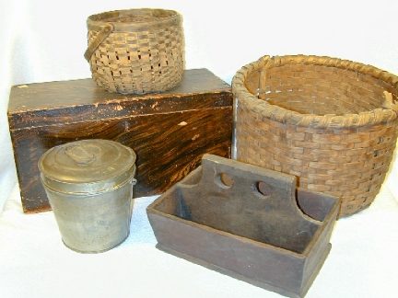
Hampton, NH 03843 (603) 926-3349
NH Lic #2114 , 2457 Subject to error All goods sold "As Is"; Terms: 13% Buy Prem., Cash/Gd. Check, Credit Cards (3% disc. for Cash/Gd.check)
