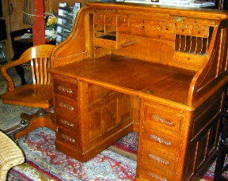
ESTATE AUCTION

Contents of Hampton, NH residence
Monday, JUNE 28th , 5:00 PM (prev 3 PM)
HG Webber Auction Gallery Under Tent

495 Lafayette Rd. (Rt. 1), Hampton, NH

Dir: Rt. 95 (Exit 2) to Hampton Center across from The Old Salt. Auction Hall in back of HG Webber store

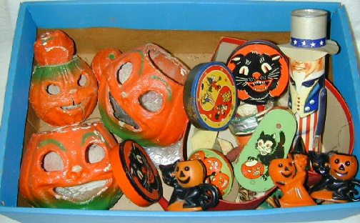
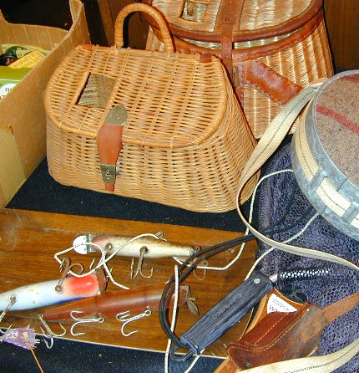
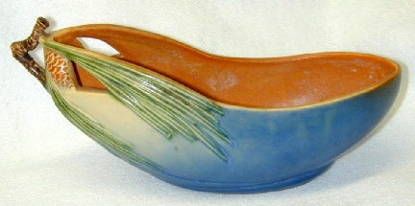
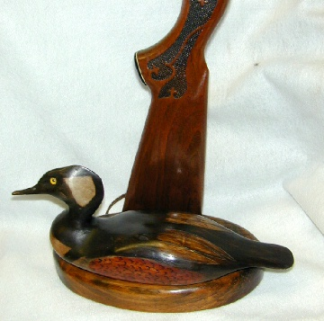
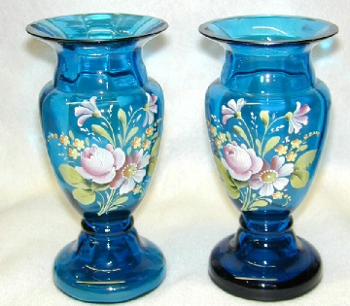
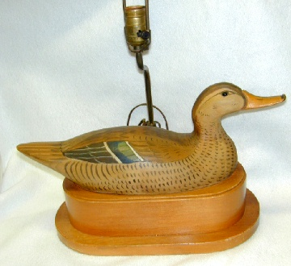
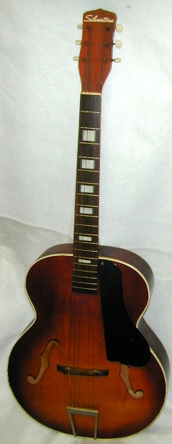
Partial listing: 54” Oak S roll top desk, Stenciled Hitchcock maple 4 dr. chest w/ mirror, Eastlake 4 drawer chest, Rock maple drop-leaf dining tbl. w/ leaves, 2 maple, bedroom sets, raised panel credenza, Pair of blue enameled vase, Lg. Paisley coverlet, Candlewick punch set & bowl, Cut glass incl compote, glasses, dishes, Large set of stemware, Camel stool, Roseville “Pine Cone” Blue #429 10” bowl, Glass baskets, Decanters, Pair of Chinese vase lamps, Hanging Chinese 4-panel folding screen, Cricket boot jack, Print, Tall copper cylindrical bucket, Camera equipment and complete darkroom setup, Silvertone Guitar, Damask upholstered pair of armchairs, 2 wgt cuckoo clock, Burlwood Chinese style coffee table, Pole lamps, Mahogany 2 tier table, Pair of Deco glass candelabra, 2 Carved duck decoy lamps, one marked on bottom “E Boyd,”, Fishing equipment incl tackle box of fishing lures, box of reels, creel, rods, Books on fishing, Wildlife, etc, Lot of 30 pipes, Sterling Tarza, Cigar humidor, colored glass cup plates, , Box lot of silver plate, Lewis Whitney, Rockport hand wrought bowl, Fish sculpture, 2 braided rugs, Craftsman band Saw and table saw, Halloween & Xmas items incl. paper machine Jack O’ Lanterns, 6 Toleware trays, 50’s archery bow & leather quiver of arrows, 50’s 7-Up thermometer, Planter Peanuts covered glass jar, Set of Royal Doulton “Wild Cherry” dinner set, Friar Tuck liquor pourer/stopper by Goebel, 4 musical Swiss liquor pourers, Fiesta serving plate, Carved ivory bangle bracelet & necklace, Bradley & Hubbard bronze bookends, Small painted chest of drawers, Black painted rocking chair, 2 sofas, Prints & framed contemporary photos, 12 modern hunting duck decoys, Mint Lowery Tube Organ, Theater Spinet organ w/bench, Glass candlestick sets, Games, Glassware lots, Garden tools, Lots of pots, pans, kitchenware, Linens and lace lots, Costume and sterling jewelry, Lots of ladies gloves, Tools lot…Many box lots of books and household items, 2 sofas.
H. G. WEBBER AUCTIONS
See listing at www.antiquesforyou.com
Robert & Harvey Webber, Auctioneers
Hampton, NH 03843 (603) 926-3349
NH Lic #2114 , 2457 Subject to error All goods sold "As Is,
Terms: 13% B.P., Cash or Check (3% disc.), Credit Cards

