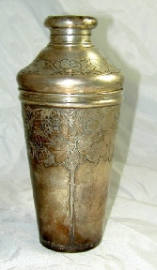
STERLING SILVER AUCTION

Faro Gardens, Rt 1, Hampton Falls, NH
Sunday, October 3rd, 11:00 AM (PREV. 8:30 AM)

DIRECTIONS TO HALL: Rt. 95 (Exit 1) to Rt. 107E to Rt. 1N. Hall is ½ mi. on left.

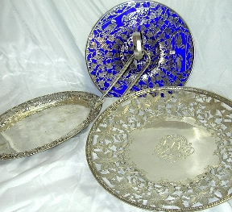
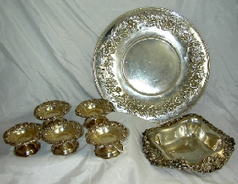
Auction to include items primarily from James Collector James Connelly of Winchester, MA, a buyer of silver for 50 years, along with some select additions from local estates all to be sold without reserve.
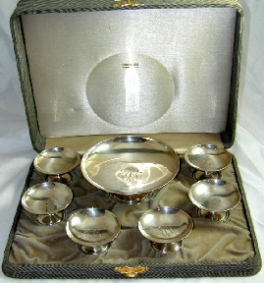
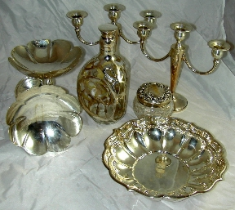
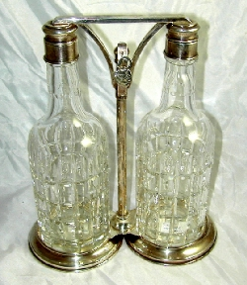
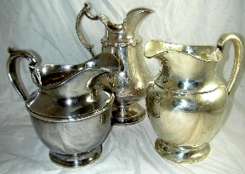
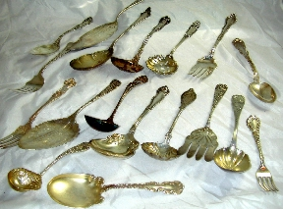
350+ lots of Sterling silver There will be bag lots of assorted flatware as well as boxed sets, Serving Pieces, Hollowware, & Accessories.

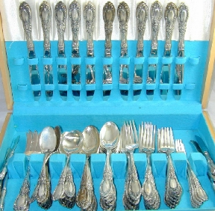
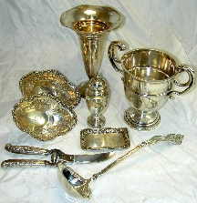
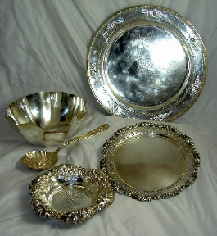
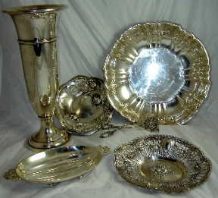
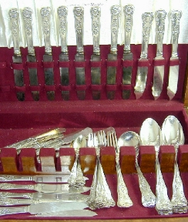
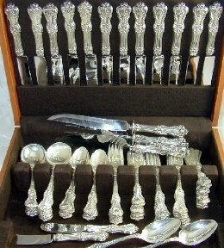
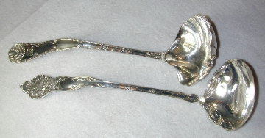
Partial listing: Items to include Tiffany Sterling Makers’ Martini shaker in Arts & Crafts form, Bowl in hexagon shape, Melon-form bowl, etc., Pair of Cut Glass Hawkes liquor decanters in sterling tantalus, Overlay liquor decanter and vinegar cruet, Crichton of London sterling loving cup, Tiffany Makers’ “Wave Edge” punch ladle, Shiebler “Fionto” punch ladle,, Steiff serving plate with repousse floral border, Reed & Barton bowls, Black Starr & Frost tray, Kirk small salt compotes, Sterling compact/purse with chain and mirror, Cobalt blue glass serving tray with Swan overlay, Towle “King Richard” large boxed set, Many Sterling bowls, trays, & plates, Candlesticks and candelabra, Water pitchers, 15” trumpet vase, Sterling decanter labels, Ice tea spoons in Danish modern form, Muffineer, Pierced sterling cake plate, Rand and Crane card tray, Sterling serving gravy ladles, punch ladles, Butter pats, Coaster, Wine coasters, George III ladle, Lots incl. Continental silver, Sugar shells, Bag lots of coin silver, Tea strainers, Creamer & sugar sets, Full and partial sets of boxed flatware, Cigarette cases, 20 1st Edition silver coins, & much more!
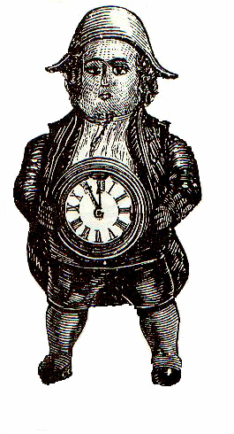H. G. WEBBER AUCTIONS
FOR LIST OR COLOR PHOTOS, SEE www.antiquesforyou.com
ROBERT & HARVEY B. S. WEBBER, Auctioneers
Hampton, NH 03843 (603) 396-0192, NH Lic #2114 , 2457
Subject to error, all goods sold "As Is"
TERMS: Credit Cards Accepted, 12½ % Buyer’s Prem., (2½% discount for Cash/Good Check)

