CITGO BILLING DOCUMENT GUIDE

Overview

CITGO Petroleum Corporation’s billing document guide provides examples so you may familiarize yourself with CITGO invoice formats.

Summary of invoice

- Invoice number and date located in the upper right hand corner consists of 9 digits.
- Remit to notice located in the upper right hand corner.
- Invoice currency and payment terms.
- CITGO’S Customer Service toll free number – refer to the last page of this brochure for the extension number.
- Customer information
  - Ship to field: The 6 digit number defines the delivery destination.
  - Sold to field: the 6 digit number defines the sold to address.
  - Payer field: The 6 digit number defines your account payable number.
- Shipping Information
- Delivery and Order, Contract, Purchase order, Vessel and Voyage. Some of the fields are not normally used in your business. However, it would be helpful if you have the delivery and order numbers available when calling with a question.
- Description of Material or Service
- Item field indicates the number of products sold.
- Unit price listed on invoice will be expressed in six places after the decimal.
- Invoice amount excludes all items marked with an asterisk (deferred tax).
- A new summary field has been added to break down the product and taxes billed.
- Notes: Cash discount allowed.
- The EPA registration number and product requirements are located at the bottom of the invoice.

All invoices types (debits, credits, rebills) will be assigned a new invoice number.

Credit invoice – see example.
Rebill invoice – see example.
Deferred Tax invoice – see example.
DTN invoice – see example.

This summary of descriptions applies to each invoice provided.
REGULAR INVOICE

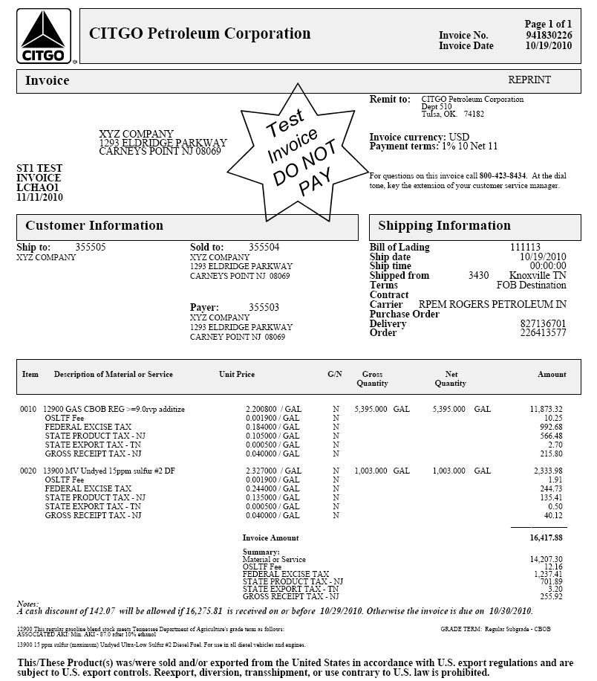
CREDIT MEMO

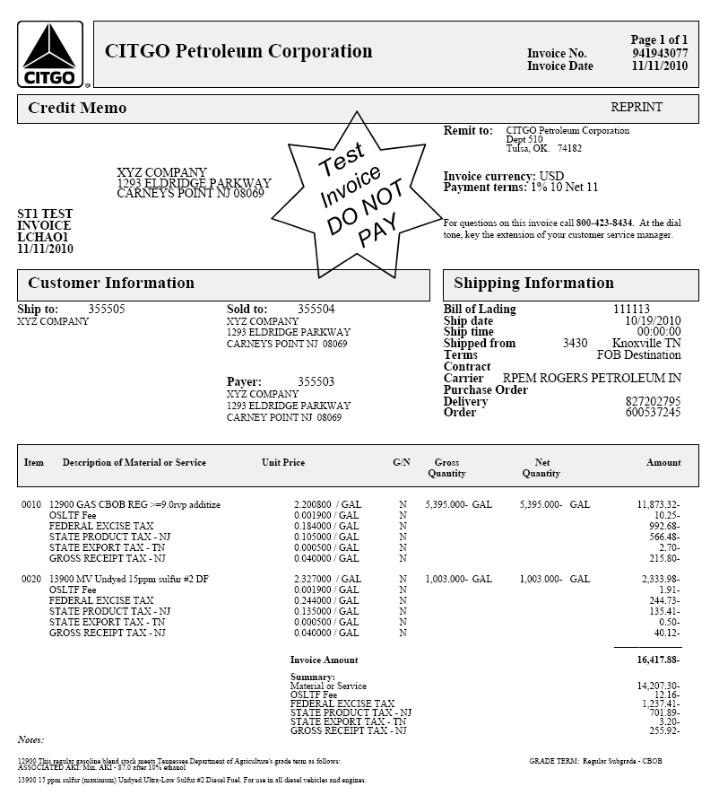
REBILL

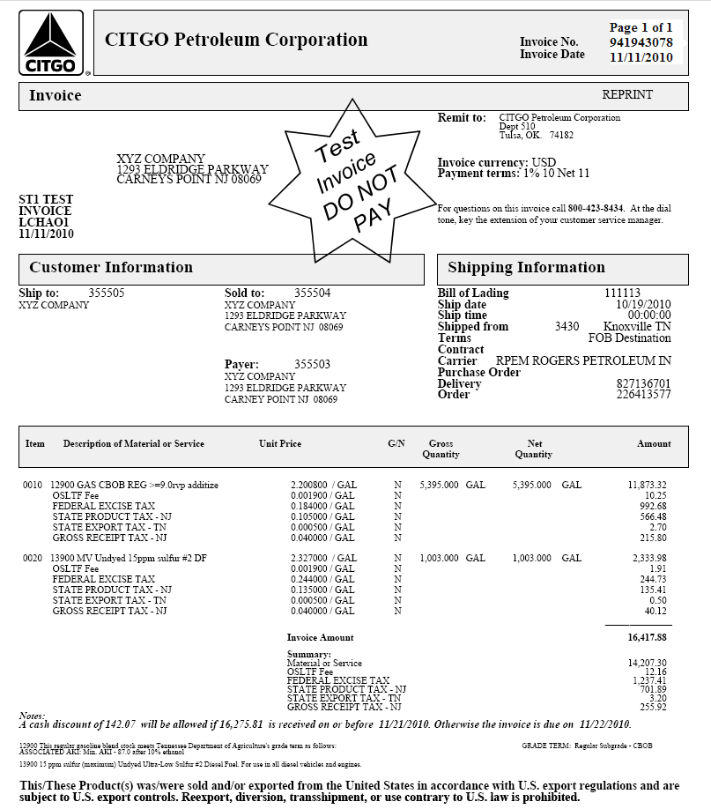
TAX DEFERRED INVOICE

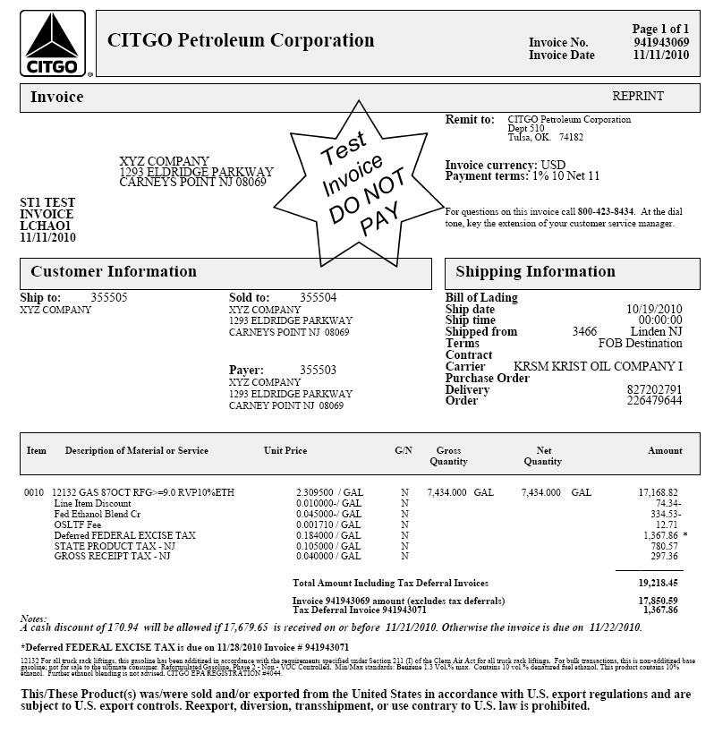
DTN Services

DTN is a paid service Marketers can subscribe to receive CITGO product invoices, credit card settlement information, product pricing, BOLS, and system messages. DTN will transmit information from CITGO’s systems to your back-end office data, eliminating the need for manual entry.

Listed below are several DTN reports that are disseminated daily from CITGO through DTN to our customers.

DTN Examples

DTN Prepaid Card Activations Report

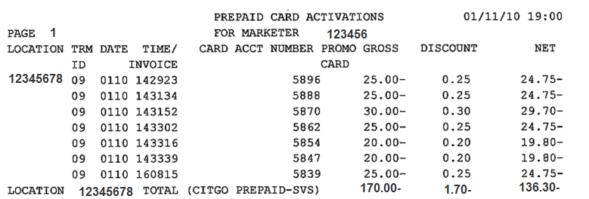

DTN CBR Messages

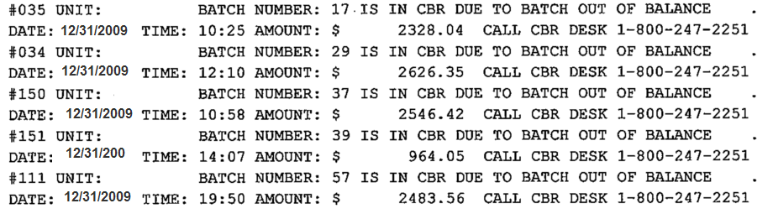

DTN Chargeback Notices

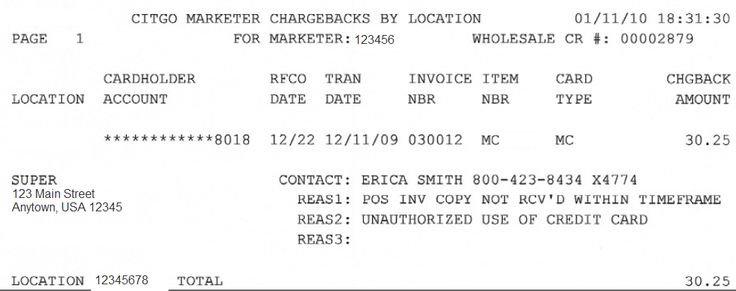

DTN Transmitted Messages

DTN Invoice

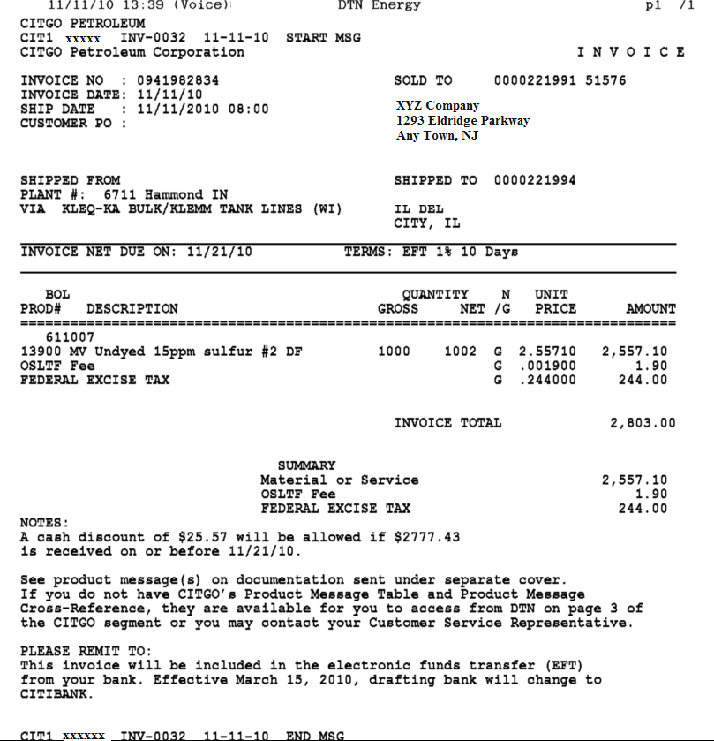

Daily Settlement Report

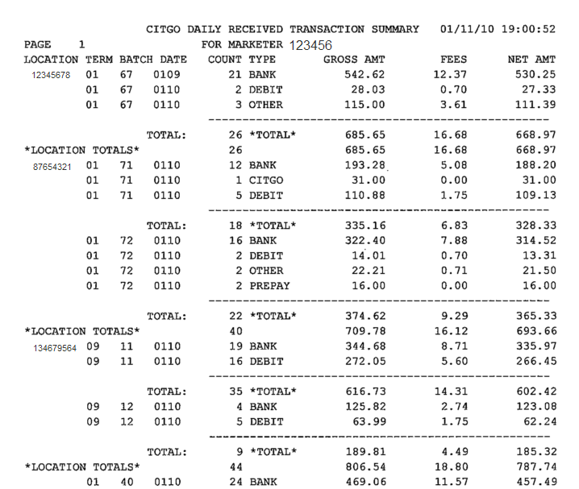

DTN Request for POS Copies

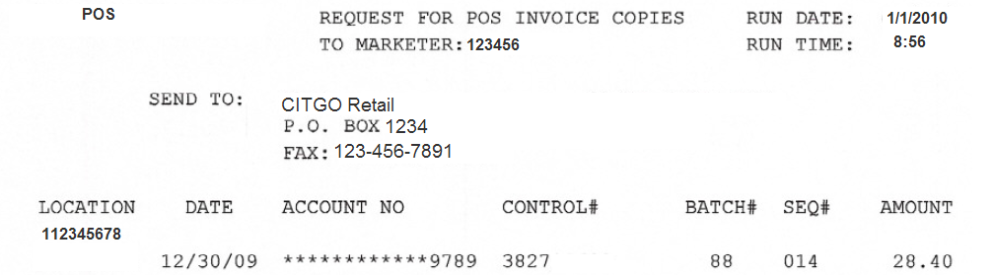
Closing Points

If you have questions regarding the invoice formats, please contact your CITGO Customer Service Team.

CITGO Customer Service Team Toll Free number

1-800-423-8434
(dial appropriate extension below at the tone)

Central Region: Linda Ezell 5321 Southern Region: Dana Lack 5322
Denise Frazier 5326 David Fuentes 5550

Northeast Region: Linda Bender 5320 Com./Aviation: Teri Beach 5326
Roslyn Prashell 5325 Roslyn Prashell 5325

