REVIEW
May 2006 to September 2006 Vol. 17 No. 2

Environmental Professionals of Iowa is a multidisciplinary organization that promotes education and standards of conduct and performance in the environmental field. The organization also provides a forum for environmental professionals to express a collective statement and provide a professional perspective on environmental issues.

2006 EPI Officers

Sid Juwarker, President
Phone: 515-256-8814
E-Mail: sjuwarker@barkerlemar.com

Jeff King, Past President
Phone: 800-858-5227
E-Mail: jking@keystonelabs.com

Matt Deutsch, President Elect
Phone: 515-283-0500
E-Mail: mdeutsch@hydro-klean.com

Jasmine Bootman, Secretary
Phone: 515-271-9608
E-Mail: jbootman@gmail.com

Helga Mayhew, Treasurer
Phone: 515-256-8814
E-Mail: hmayhew@barkerlemar.com

Ryan Blackburn, Program Chair
Phone: 515-283-0500
E-Mail: rblackburn@hydro-klean.com

Steve Reinders, Newsletter Editor
Phone: 515-276-8046
E-Mail: reinders@gabrobins.com

Environmental Professionals of Iowa
P.O. Box 65484
West Des Moines, Iowa 50265
www.epiowa.org

Editor’s Corner
By Steve Reinders

This is the last official week of summer, and as you can tell from the temperature and the football games going on, fall is really already here. That also means that EPI’s busy season is also upon us. I would like to introduce myself as the new EPI newsletter editor. Most of you know me from my role at GAB Robins.

We have a meeting this Thursday night (September 21st) in Ames. This is late notice but please attend if you can. There are more details regarding the meeting location in this newsletter. Also, the EPI symposium will be held on Wednesday and Thursday, November 15th & 16th at the Embassy Suites in Des Moines. There are more details regarding the symposium, plus a registration form, at the back of this newsletter.

We have come up with a lot of good ideas for symposium topics and invitations are being extended to potential speakers and vendors. If you know of a good topic/speaker or of a vendor who may be interested in presenting at the symposium, please email your suggestions along with contact information to an EPI officer. We hope to continue with EPI’s success in putting on a quality symposium and all EPI members are invited to contribute. There will be an EPI planning meeting on October 3rd at Hydro-Klean to iron out the details of the symposium and all members are welcome to attend.

________________________________________________________________________________

August Board Meeting

An EPI board meeting was held on August 29th, 2006. Those present included:

Matt Deutsch – President Elect
Jasmine Bootman – Secretary
Steve Reinders – Newsletter Editor
Ruth Hummel - Member
James Gastineau - Member
Brian Lenz - Member

- The content of the fall edition of the EPI newsletter was discussed.

- Planning continued for the upcoming Fall 2006 EPI Symposium (Nov. 15th & 16th, 2006).

- The next EPI dinner meeting is planned for Thursday, September 21st, at the Environmental Health and Safety Services Building in Ames.

- The next EPI Board meeting will be held on October 3rd and will primarily be a planning meeting for the EPI Symposium. All EPI members are welcome to attend.
________________________________________________________________________________

Opportunity for EPI Member to be a Representative on SIC (Software Investigation Committee) to Look at Possible Revisions to the RBCA
Software Using Lessons Learned from Real World Experience.
In the Spring & Summer of 2006, the Iowa DNR Underground Storage Tank Section held a series of Business Process Improvement meetings to consider the RBCA process. One recommendation resulting is the idea to reexamine and possibly modify the DNR's RBCA Tier 2 model. A Software Investigation Committee (SIC), with members representing various stakeholders, is being formed for this task. An invitation has been extended to EPI to have one member join the SIC team.
The EPI member desired for this position should be a practicing groundwater professional with both field experience and some hydrogeologic modeling experience, beyond use of the existing RBCA models. The member should be available to attend periodic meetings beginning in October 2006, and likely extending into early 2007. The meetings will be held in the Des Moines area.
If you are interested in representing EPI on the SIC team, please send a statement of interest along with your qualifications to the EPI officer's at their email address: President, Sid Juwarker (sjuwarker@barkerlemar.com), President-Elect, Matt Deutsch (mdeutsch@hydro-klean.com), Secratary, Jasmine Bootman (jasmine.m.bootman@mwhglobal.com), Newsletter Editor, Steve Reinders (reinders@gabrobins.com), and Program Chair, Ryan Blackburn (rblackburn@hydro-klean.com). Your statement of interest must be submitted by and no later than Sept. 18, 2006. A discussion and selection will be made at the EPI meeting on September 21, 2006.
If you have any questions regarding this notice, please contact James
Gastineau at 515/440-7016 or at James_Gastineau@ars.aon.com.
________________________________________________________________________________

Upcoming September 2006 EPI Dinner Meeting

Don’t forget to put September 21st, 2006, on your calendar! EPI will be having their dinner meeting in Ames and will be touring Iowa State University’s (ISU) new Environmental Health and Safety Services Building. The building is very impressive and has some unique features.

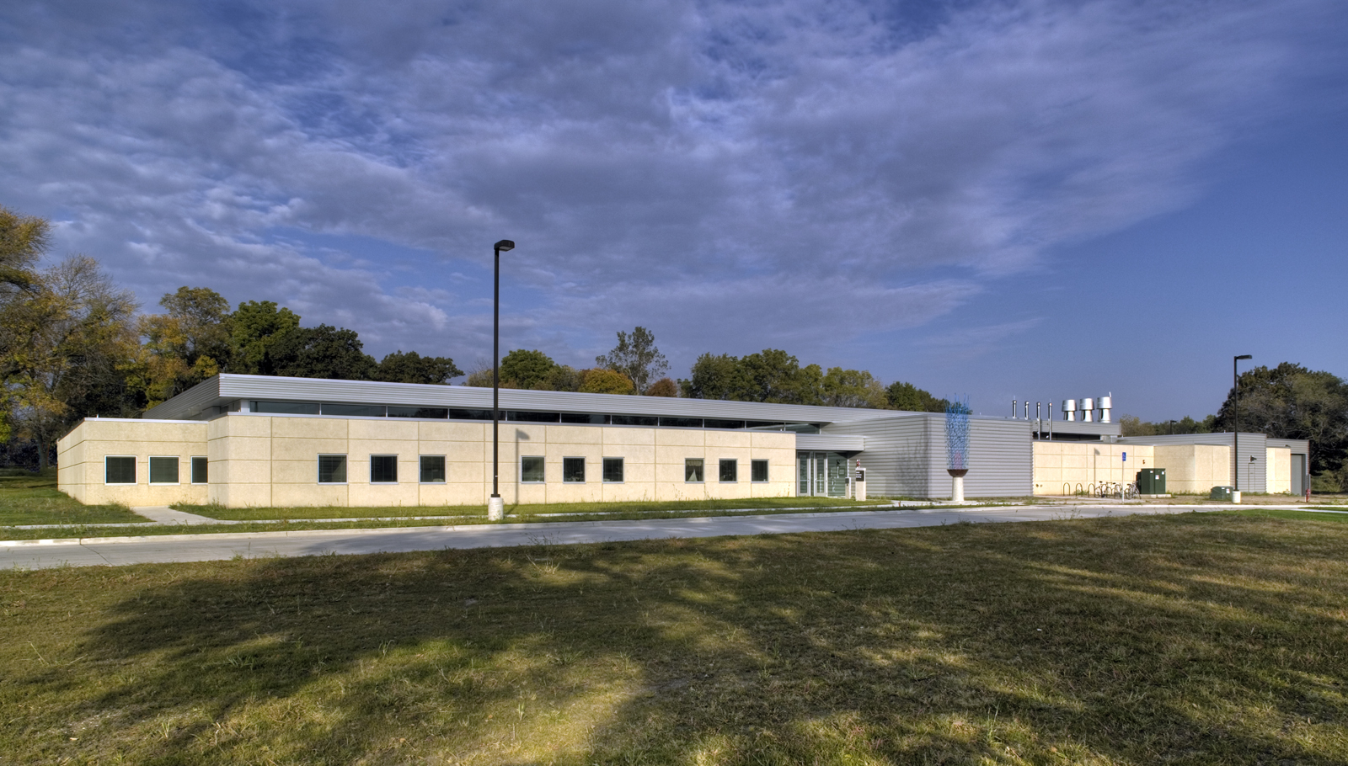

Environmental Health and Safety Services Building
Iowa State Campus
6pm

Please RSVP in advance so that we know how many servings to provide. The dinner fee is $15/person. To register, please email an EPI member. The EPI member email addresses are provided on the front of this newsletter.

Take the Elwood Drive Exit off of Hwy 30
Stay on Elwood Drive until it curves west (past Jack Trice Stadium
and Hilton Colosium and north of Lincoln Way) and intersects Stange Rd.
Take a right (north) on Stange Rd., then take a left
on Wanda Daley Drive. EH&S Bldg. is at the end on the right.

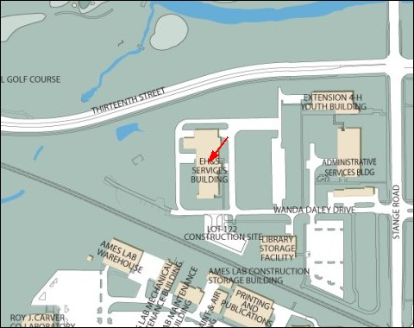

________________________________________________________________________________

EPI Tip of the Day

“When calibrating a multiparameter water quality meter for dissolved oxygen, input the barometric pressure reading from a barometer that is calibrated against NIST traceable instrumentation .” (Adam R. Newman, MWH)

TIPS
Got a better way of doing things in the field or in the office? Send a brief explanation by email to the EPI newsletter editor for publication in the newsletter. The person who provided the tip that is selected for the next newsletter will be awarded a $10 gift card.

________________________________________________________________________________

Calendar of Events

9/21/06 EPI Dinner Meeting 6PM at ISU Environmental Health and Safety Services Bldg.
10/03/06 EPI Board Meeting, 6PM at HydroKlean.
11/15 – 11/16 EPI Symposium
1/18/07 EPI Workshop on Field Techniques

** If there are any questions about upcoming EPI events please feel free to contact an EPI officer.**

________________________________________________________________________________

Workshop on Field Techniques Set for January 2007

In January 2007, EPI will sponsor a half-day workshop on field techniques, including soil classification according to the Unified Soil Classification System and conducting slug tests. The training date is tentatively set for Thursday morning, January 18, 2007 from 8:00 to 12:00 a.m. EPI has been offered the use of a training room at the Barker Lemar Engineering facility in West Des Moines.
Personnel from the Iowa Geological Survey Bureau will conduct the soil classification workshop. What skills would you like to see polished? PID use on soil cores? Soil gas sampling? If you have a topic that you would like to see covered in the workshop, or wish to have input, please contact Jeff White at Jeff.White@dnr.state.ia.us.
EPI will apply for four CEUs from the UST Section of the DNR.

2006 Environmental Professionals of Iowa Symposium
Wednesday, November 15th and Thursday November 16th
Embassy Suites Hotel on the River
101 E Locust Street
Des Moines, IA 50309
(515) 244-1700
The Environmental Professionals of Iowa (EPI) are again sponsoring their annual symposium to bring together those involved with environmental concerns in Iowa. Topics include new available remediation technologies, environmental issues and updates from regulatory agencies. Iowa Groundwater Professionals can expect to receive eight (8) hours of Continuing Education Units for attending.
Lunch and an opportunity to visit with numerous vendors providing environmental services are included in the Symposium fee. For an additional fee, you are also welcome to join us for dinner Wednesday evening where we will hold a short EPI meeting and elect officers for the upcoming year. Those interested in taking a more active role in EPI are encouraged to volunteer for an open position. To complete the evening, we will be having a guest speaker. As soon as the details are finalized, we will post additional information.
For those wishing to spend the night, rooms are available at the Embassy Suites by calling (515) 244-1700. Please note this is a change of venue for the Symposium and with major construction along Interstate 235 through downtown Des Moines, be sure to plan accordingly. You can visit www.i235.com for construction updates to make your trip as efficient and safe as possible.

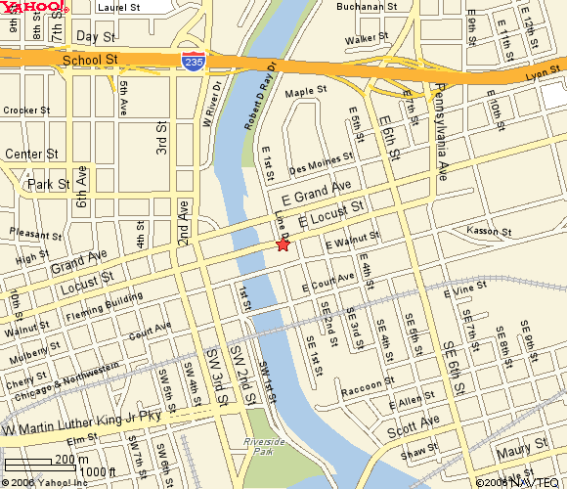
2006 Environmental Professionals of Iowa Symposium
Wednesday, November 15th and Thursday November 16th
Embassy Suites Hotel on the River
101 E Locust Street
Des Moines, IA 50309
(515) 244-1700
To register for the 2006 EPI Symposium, please select the portions of the event you would like to attend and send this completed form with a check payable to EPI to the address shown below. EPI will not be able to accept credit cards at the Symposium so please plan accordingly.
Environmental Professionals of Iowa
P.O. Box 65484
West Des Moines, IA 50265
If you have any additional questions regarding the symposium, registration or would like to become an EPI member, but cannot attend the symposium, please contact Matt Deutsch, Program Chair at mdeutsch@hydro-klean.com or (515) 283-0500.
Name:
Title:
Organization:
Address:
City, State, Zip:
Phone:
FAX:
Email:

Event | Registration Postmarked by November 2, 2006 |  | Registration Postmarked after November 2, 2006
 | Cost | Payment | Cost | Payment
Symposium Only | $100.00 |  | $125.00
Dinner Meeting & Symposium | $125.00 |  | $150.00

Total Enclosed
Symposium attendance includes 2006 EPI Membership.
Questions or issues for Question & Answer session at end of Symposium:
_________________________________________________________________________________________________________________________________________________________________________________________________________________________________________

