
QPR Gatekeeper Trainer Certification

June 2, 2010

~~~~~~~~~~~~~~~~~~~~~~

Sponsored by:
Pennsylvania Adult/Older Adult Suicide Prevention Coalition

In Collaboration with:
Feeling Blue Suicide Prevention Council

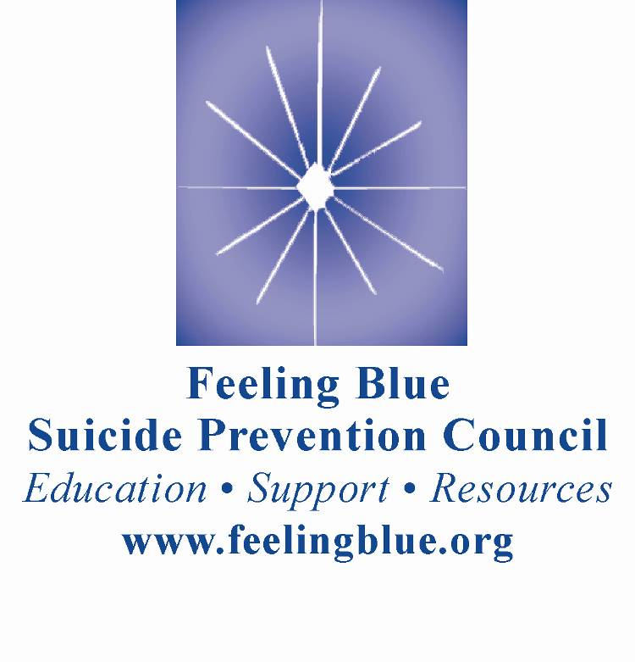

QPR Gatekeeper Trainer Certification (T4T)

For any person or organization interested in preventing suicide in their community

Course Description:
This certification course trains Instructors to teach QPR for Suicide Prevention to their community. Participants first learn about the nature of suicidal communications, what forms these communications take and how they may be used as the stimulus for a QPR intervention. To gain perspective, participants are introduced to the history of suicide, suicide prevention and the spectrum of modern day public health suicide prevention education efforts. The history, background and research support for QPR are reviewed. Participants then learn to market QPR, target potential Gatekeepers, and how to teach the QPR curriculum. Participants also learn to deal with pent up audience demand to talk about suicide, survivor issues and how to make immediate interventions and referrals. Each participant has the opportunity for individual rehearsal and practice through role-plays.
Certification Program includes:
- A full-day training course
- A QPR Instructor’s Manual complete with:
- Detailed teaching information
- QPR Instructor’s Teaching CD with suicidal communications vignettes, suicide statistics, QPR introductory video hosted by Carrie Fisher, PowerPoint slides for the core QPR Gatekeeper training, overhead masters for handouts
- Audio CD of a QPR Gatekeeper training
- 25 QPR booklets and QPR wallet cards
- A copy of Tender Leaves of Hope booklet
- Tool kit (continuously updated) with information on issues related to suicide
- Two of Dr. Quinnett’s books: Suicide: The Forever Decision Counseling and Suicidal People: A Therapy of Hope
- Access to QPRI’s toll free number for consultations on QPR training
- QPR Times, a newsletter created for QPR Certified Gatekeeper Instructors
Trainers will be certified for 3 years.

CREDIT/CONFERENCE INFORMATION

Target Audience:
Teachers, School Personnel, Counselors, College and University Counseling staff, LSW’s, MSW’s, County Health and Mental Health Employees, Elder Care Staff, Corrections Personnel, Juvenile Justice Staff, and the General Population.

CREDIT INFORMATION
APA (Psychology): Drexel University College of Medicine, Behavioral Healthcare Education is approved by the American Psychological Association to sponsor continuing education for psychologists. Drexel University College of Medicine, Behavioral Healthcare Education maintains responsibility for this program and its content.

LSW (PA SBSWE Licensed Social Workers in Pennsylvania): This Conference is approved for a maximum of 5 credit hours through a formal agreement with the Bryn Mawr College Graduate School of Social Work and Social Research. Bryn Mawr College GSSWSR, as a CSWE accredited school of social work, is an approved provider of continuing education for social workers in Pennsylvania and many other states.

NBCC (National Counselors): Drexel University College of Medicine is recognized by the National Board for Certified Counselors to offer continuing education for National Certified Counselors. We adhere to NBCC continuing education guidelines. We can award 5 hours of continuing education credit for this conference (or training).

PA Educators Act 48: Drexel University College of Medicine, Behavioral Healthcare Education is recognized by the Pennsylvania Department of Education to offer continuing education credits under Act 48 guidelines. Drexel University College of Medicine, Behavioral Healthcare Education adheres to Act 48 Continuing Education Guidelines. PA educators will receive a maximum of 5 hours of credit for attending this conference.

PCB (PA Certified Addictions Counselor (CAC); Certified Co-Occurring Disorders Professional (CCDP); and CCDP-D (Diplomate): Drexel University College of Medicine, Behavioral Healthcare Education will award a maximum of 5 PCB Approved Hours of Education for this training. Our program is certified by the Pennsylvania Certification Board, Provider # 133.

PSNA (Nursing): Drexel University College of Medicine, Behavioral Healthcare Education is an approved provider of continuing nursing education by the PA State Nurses Association, an accredited approver by the American Nurses Credentialing Center’s Commission on Accreditation. Participants will be awarded a maximum of 5 contact hours for attending this conference.

CEU (IACET) The Drexel University College of Medicine, Behavioral Healthcare Education has been reviewed and approved as an Authorized Provider by the International Association for Continuing Education and Training (IACET), 1620 I Street, NW, Suite 615, Washington, DC 20006. The Drexel University College of Medicine, Behavioral Healthcare Education has awarded a maximum of .5 of CEU’s to participants who successfully complete this program.


QPR Gatekeeper Instructor
Certification Course

Workshop Schedule:
Upon arrival Complete the pre-conference surveys
8:00-8:30 Overview of the training day and review of the handout materials
8:30-9:00 Suicide in America, risk groups and risk factors
9:00-10:00 Suicidal communications: analysis and discussion
10:00-10:15 Break
10:15-11:00 Suicide and Suicide Prevention in History
11:00-12:00 QPR Gatekeeper training
12:-00-1:00 Lunch
1:00-1:15 QPR: Its history, development and research
1:15-2:30 Teaching QPR (video and lecture)
2:30-2:45 Break
2:45-3:15 Role-play exercise
3:15-3:30 Break
3:30-4:00 How to conduct the Q & A period
4:00-4:45 "Boot Camp" exercise (handling audience questions)
4:45-5:00 What certification means
QPR Institute support services
Completion of the evaluations
Awarding of three year Instructor certificates

Course Objectives:
- To understand the nature, range and importance of suicidal communications and their importance in preventing suicide.
- To review and understand the groups at greatest risk of suicide and why QPR can work for them.
- To train participants to teach QPR, for Suicide Prevention.
- To gain a historical perspective about suicide prevention and how QPR fits into national efforts.
- To acquire specific knowledge about how audiences may respond to the QPR message and how to react in a helpful manner.
- To learn how to effectively promote suicide prevention in their own communities.
- To gain the competence and confidence to teach others how to save lives and help prevent suicidal behaviors.
This program is offered for 6 credits.

WORKSHOP LOCATION:

DGS ANNEX COMPLEX, CLOTHES TREE BUILDING

21 Beech Drive*

Harrisburg, PA 17110-3591

CONFERENCE FEE of $50.00 includes tuition, lunch, morning and afternoon breaks, conference materials, and continuing education certificate.

Real Cost for QPR Gatekeeper Trainer Certification is $495

Please note: This training is limited to 15 participants. Registrations will be accepted on a first come first serve basis ONLY and is limited to 2 people per organization.

A block of rooms at the Staybridge Suites Harrisburg-Hershey has been reserved. The cost of the room is $102; please refer to QPR when making your reservation. The address and phone number for the hotel is:
920 Wildwood Park Drive
Harrisburg, PA 17110
1-717-233-3304

Refund and Cancellation Policy:
If you are unable to attend the conference, you are welcome to send a substitute in your place. Please call Feeling Blue Suicide Prevention Council at 610-715-0076 with the name and address of your substitute. Registration fees are refunded upon written request via fax, e-mail or regular mail received 3 business days prior to the event, minus a $15 processing fee. No refund will be issued for cancellations received less than 3 business days before the event. Late requests for refunds due to a family emergency only will be considered on a case-by-case basis

*For GPS purposes, the DGS Annex Complex is located across from the Farm Show Complex, 2300 Cameron Street, Harrisburg, PA 17110

REGISTRATION FORM

PLEASE COMPLETE ALL INFORMATION REQUESTED BELOW: (Please print)

Name: |  |  |  |  |  |  |  |  | Degree:

Job Title/Position:

Agency:

Address:

City/State/Zipcode:
Day Phone # with area code: |  |  |  |  |  |  |  | Evening#:

Email Address:

Fax Number:

SPECIAL REQUESTS: Vegetarian Lunch Require Special Assistance (ADA)

Type of Credit Desired: APA CEU LSW NBCC PA Act 48 PCB PSNA

□ Enclosed is a check for the total amount of PA Adult/Older Adult Blue SPC

□ Please charge $ _________ to my: VISA Mastercard

Cardholder’s Name: ______________________________________________________________(please print)
Cardholder’s Signature: _______________________________________________________________________
Credit Card Number: _____________________________________________
Expiration Date: __________________

Mail or Fax E-mail Registration to Register for this series:
Heidi Bryan, pasp@feelingblue.org
Pennsylvania Adult/Older Adult Suicide Prevention Coalition
c/o Feeling Blue Suicide Prevention Council
PO Box 7193
Radnor, PA 19087-7193
610-715-0076 (Phone)
610-687-2990 (Fax)
Credit card payments must be mailed or faxed – no credit card payments will be accepted through email

