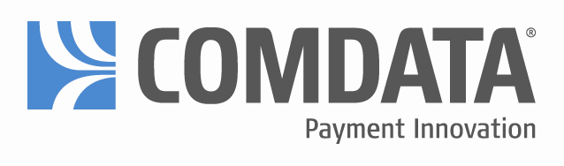

Comdata® MasterCard® FAQ’s

How can I get a COMDATA Fleet Card?

Contact your agency fleet manager for information about the COMDATA Fleet Card.

Where can I use my COMDATA Fleet Card?

You may use your COMDATA State of Washington Fleet Card at any MasterCard retail gas locations, Comdata's truck stop network for diesel fuel and numerous commercial fueling sites.

Can the COMDATA Fleet Card be used as a standard MasterCard credit card?

No. The COMDATA Fleet Card differs in that the card can only be used to buy retail fuel and maintenance necessary for servicing a vehicle while on the road. Comdata Fleet Cards are for official State of Washington business.

What makes the COMDATA Fleet Card beneficial to me?

The sheer number of fueling facilities that you can quickly and efficiently use! Comdata Fleet Card’s are axcepted anywhere a major credit card is accepted.

How many sites are on this network?

There are over 170,000 sites in the continental United States, where you can buy fuel. Major locations include Shell, Texaco, Mobil, Amoco, BP, Chevron, Cenex, Circle K, Citgo, Getty, Phillips 66, Sunoco, Union 76 and Exxon. Comdata Cards are accepted at Pacific Pride locations that accept a MasterCard. The number of accepting locations increases as you use your Comdata card

What information am I required to enter when buying fuel?

Agencies can choose what prompts they would like at the point of sale. To ensure you are authorized to buy fuel with your card, a location will ask and/or prompt you for (1) your driver ID number given to you when you receive your new card and (2) your odometer reading (some locations may ask you for hub, which is the same as odometer. Please see your agency Fleet Manager for instructions.

Can I use my COMDATA Fleet Card at an island card reader?

Yes. You may use your COMDATA Fleet Card at any island card reader or any other Point of Sale Terminal at gas stations that accept MasterCard cards.

If I have to go inside a retail gas station to pay, will the employees recognize my card?

Yes. MasterCard is the largest payment system in the world and the MasterCard brand and products are recognized at 12 million locations. This network allows the attendant to use the same credit card machine that they use for any MasterCard transaction.

What do I do if my COMDATA FLEET Card is lost or stolen?

As soon as you are aware of a missing card, call Customer Service at 1-866-662-3535 and it will be cancelled immediately. You will receive a new card. Your driver ID number will stay the same. Make sure you also notify your Fleet Manager.

How can Customer Service assist me?

COMDATA Fleet Services is backed by COMDATA, the transportation industry’s leading service provider. Our Customer Service professionals are available 24 hours a day, toll free, to assist you. The number to call is 1-866-662-3535.

