Second Announcement and Call for Papers

The 2nd SHANGHAI INTERNATIONAL CONFERENCE
ON PHYSIOLOGICAL BIOPHYSICS - AUDITION & VISION
(Shanghai ICPB’06)

Shanghai Convention Center, Chinese Academy of Sciences，(Hope Hotel)
500 Zhaojiabang Road, Shanghai 200031, P.R.China, .
Nov. 3 – 7, 2006

To make the meeting special, it is necessary to attract the very best (not necessarily the most famous) thinkers in the filed and ask them to explore new ideas.
We can mount a full scale effort to summarize what we know about both senses so that our ideas about each can help in studying the other.
Nelson Yuan-sheng Kiang

The 2nd Shanghai International Conference on Physiological Biophysics - Audition & Vision (Shanghai ICPB'06) have been going smoothly since it was announced in July, 2005. Prof. Nelson Y S Kiang has accepted our invitation to be the Honorary Chair of the conference and give a keynote speech. Many leading scientists such as Aage Mollor (Chief Editor of Hearing Research) and Dennis Levi (Chief Editor of Vision Research) have also accepted our invitation to give plenary talks in the conference.
Organizing committee of the conference:

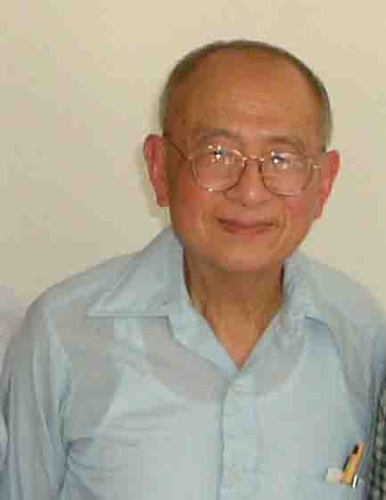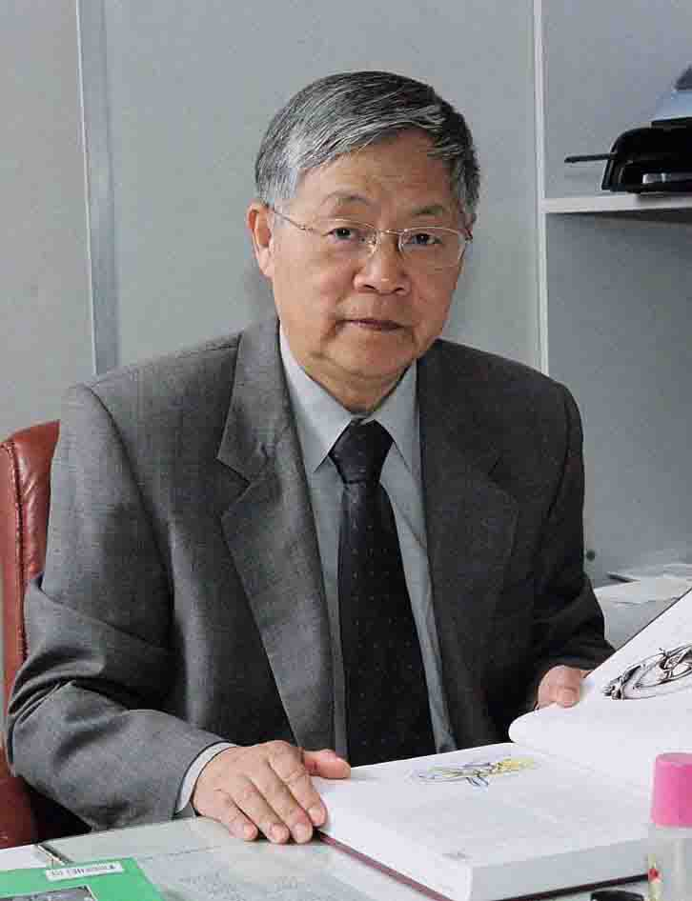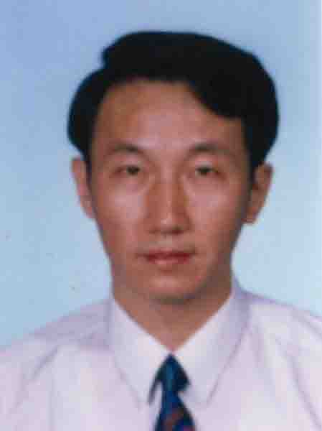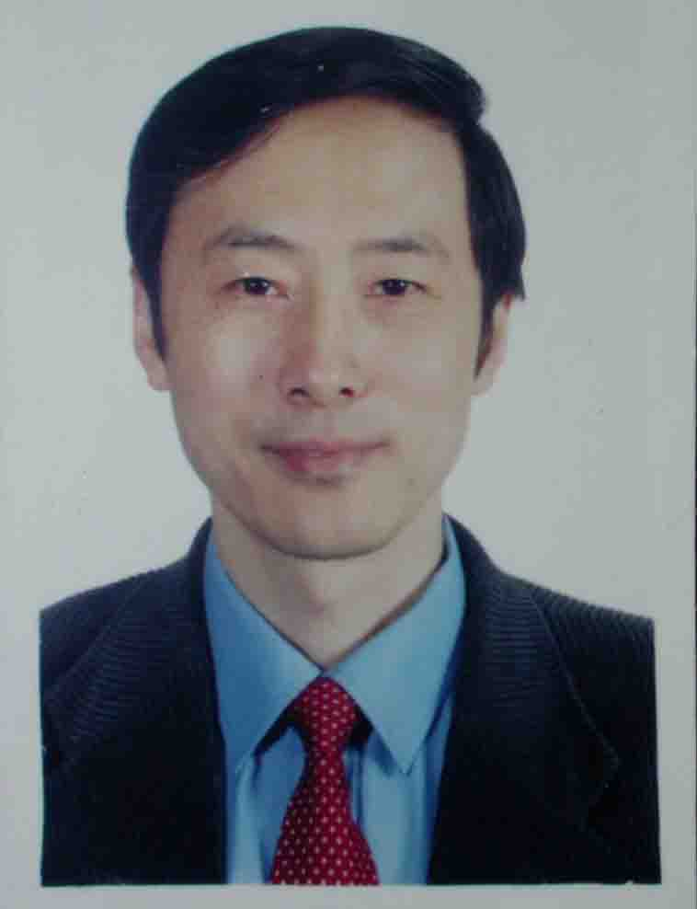
Kiang, Nelson Y. S Wang, Zhengmin Sun, Xinghuai Chi, Fanglu

Honorary Chair
Kiang, Nelson Y. S. MIT USA

General Chairs:
Chair:
Wang, Zhengmin Fudan University, China
Liberman, Charles M Harvard University, USA
Salvi, Richard University of Buffalo, USA
Sun, Xinghuai Fudan University, China

Co-Chairs:
Chi, Fanglu Fudan University, China
Levi, Dennis, University of California USA
Gao, Wenyuan Second Military Med University, China
Moller, Aage R University of Texas at Dallas, USA

International Advisory Committee Chairs:
Chairs:
Shou, Tiande Fudan University, China
Henderson, Donald State University of New York at Buffalo , USA

Co-Chairs:
Chu, Renyuan Fudan University, China
Ding, Dalian State University of New York at Buffalo, USA
Nuttall Alfred L Oregon Hearing Research Center, USA
Lee, Choongkil Seoul National Univ., Korea
Li, Huawei Fudan University, China
Tanaka, Keiji Brain Sci. Inst., RIKEN, Japan
Wang, Wenji Fudan University, China

Members:
Altschuler,RA University of Michigan, USA
Balaban C University of Pittsburgh, USA
Bobbin, RP Louisiana State University, USA
Barabino S Harvard Medical School, USA
Canlon, B Karolinska Institutet, Sweden
Cazals, Y Universite de la Mediterranee, France
Chalupa L M University of California Davis, USA
Christoph, E. S University of California San Francisco,USA
Cotanche, DA Children's Hospital(?), USA
Dai CF Fudan University, China
Dong, W Columbia University USA
Drescher, DG. Wayne State University , USA
Ge, J Sun Yat-sen University, China
Guinan, J. University of Harvard, USA
Gummer, AW University of Tubingen, Germany
Harris JP UCSD, USA
He DW Creighton University, USA
He JF Hong Kong Polytechnic University, China
He, SG Institute of Biophysics, CAS, China
Holley MC. Institute of Molecular Physiology, University of Sheffield, UK.
Jastreboff P J Emory University School of Medicine
Juhn SK University of Minnesota, USA
Juichi Ito Kyoto University, Japan
Kalinec Federico House Ear Institute, USA
Kaufman HE Louisiana State University, USA
Kathleen , C Southern Illinois School of Medicine, USA
Klinke, R. Universitat Frankfurt, Germany
Klis, SF University Medical Center, Netherland
Lychakov，DV Sechenov Institute of Evolutionary Physiology and Biochemistry of Russian Academy of Sciences, Russia
Lee, Soo-Young Advanced Institute of SCI. & Tech, Korea
Lee,H. J. Gyeongsang National University, Korea
Lefebvre P University of Liège, Belgium
Li, CY Institute of Neuroscience, CAS, China
Li DW University of Minnesota, USA
Li,K.Y University of Communication, China
Li,XX Beijing University, China
Lonsbury-Martin, BL University of Colorado, USA
Malmierca MS University of Salamanca, Span
Matsumoto, N Kyushu University,Japan
Melcher J Harvard University USA
Middlebrooks J University of Michigan USA
Moore, BC University of Washington,USA
Moore, DR MRC Institute of Hearing Research, UK
Nñnez A Universidad Autonoma de Madrid, SPAIN
Pelizzone M University of Geneva, Switzerland
Phoenix DA University of Central Lancashire, UK
Petit C Institut Pasteur, France
Raphael, Y University of Michigan,USA
Salzberg B M University of Pennsylvania USA
Santos-Sacchi J Yale University School of Medicine, USA
Song L Yale University School of Medicine, USA
Sterkers, O Service d'ORL, Hopital Beaujon Paris, France
Suga N Washington University USA
Sun, XD East China Normal University, China
Syka, J Academy of Sciences, Czech Republic
Usui, Shiro .BSI, ,RIKEN, Japan
Wang XQ Johns Hopkins University, USA
Wangemann P Kansas State University USA
Wu,H Xinhua Hospital , China
Xu, L Beijing Ophthalmic Center, China
Yan , J University of Calgary, Canada
Yang ,WY General Hospital of PLA, China
Yang, XL Fudan University, China
Yin,ZQ Southwest Hospital, China
Ylikoski, J University of Helsinki, Finland
Yuan F ZhongShang Hospital, Fudan University
Yu, DY The University of Western Australia, Australia
Zhang SW Australian National Univ. , Australia,
Zhang ZH Fudan University, China
Zhou YD Second Military Medical University, China
Zhou, ZN Shanghai Institute for Biological Sciences, China
Zhou, GM Fudan University, China
Zine A Montpellier University, France.

Plenary Talks

Nelson Y S Kiang Possible Directions for Research in Vision and Audition
Zhengmin Wang Cochlea implantation in China
Dennis Levi A re-evaluation of critical periods in human adults: teaching old dogs new tricks.
Aage Moller Neural plasticity and disorders of the auditory system
Keiji Tanaka Mechanisms of visual object recognition
Richard Salvi Measuring the Phantom Sound of tinnitus: Brain imaging, animal models, physiological assessment and gene expression
Donald Henderson Oxidaitive stress as a factor in noise, drug and age related hearing loss
Christine Petit Usher syndrome: insight into the role of adhesion links in hair cells and photoreceptor cells
Dave Moore Dynamics of auditory cortex function
Soo-Young Lee Computational Models of Speech Feature Extraction, Binaural Processing, Top-Down Attention, and Audio-Visual Combined Perception
Choongkil Lee Vision at the time of saccadic eye movement
Herbert Kaufman New approaches to lamellar corneal surgery
Shao-Wu Zhang Visual Cognition in Honeybee Navigation
Dalian Ding Cellular changes in the cochlea due to aminoglycoside antibiotics
Daoyi Yu Retinal cellular metabolism
Barbara Canlon How steroid hormone receptors modulate hearing sensitivity

Mini-symposiums:

MS-1
Development and plasticity of auditory and visual system
Organizer: Leo M Chalupa
Division of Biological Sciences, USA Email:lmchalupa@ucdavis.edu
MS-2
Corticofugal modulation on audition and vision
Organizer: Jun Yan
University of Calgary, Canada Emial: juyan@ucalgary.ca
Co- Organizer: Philip Jen
University of Missouri in Columbia, USA Emial:jenp@missouri.edu
Co-Organizer: Jufang He
The Hong Kong Polytechnic University, China Emial: rsjufang@polyu.edu.hk
MS-3
Neural coding in audition and vision
Organizer: Xiaoqin Wang
Johns Hopkins University School of Medicine,U.S.A. Email: xiaoqin.wang@jhu.edu
MS-4
Regeneration of the inner ear and the retina cells
Organizer: Juichi Ito
Graduate School of Medicine, Kyoto University Japan Email: ito@ent.kuhp.kyoto-u.ac.jp
Co-Organizer: Li, Huawei
Shanghai EENT Hospital, Fudan University, China Email: hwli@shmu.edu.cn
MS-5
Protection and Rescue of hearing and vision
Organizer: Dalian Ding
University of Buffalo USA Email: dding@buffalo.edu
Co-Organizer: Donald Henderson
University of Buffalo USA Email: caltman@buffalo.edu
MS-6
Pathophysiology, diagnosis, and current treatment of Meniere's disease
Organizer: Steven K Juhn
University of Minnesota, USA Emial: juhnx001@umn.edu
Co-Organizer: Jeffrey P Harris
UCSD School of Medicine USA Emial:jeffreyHarris@ucsd.edu
MS-7
Oxidative stress and hearing loss
Organizer: Pr. Azel Zine
INSERM U583 -Institute of Nerurosciences- Montpellier University, France
Email: zine@montp.inserm.fr
Co-Organizer: Lefebvre P University of Liège Belgium Email: pp.Lefebvre@ulg.ac.be
MS-8 Cochlear Amplification
Organizer: Joseph Santos-Sacchi
Yale University School of Medicine, USA Emial:joseph.santos-sacchi@yale.edu
MS-9 Invertebrate Visual Perception and Navigation
Organizer: S.W. Zhang
The Australian National University, Australia E-mail: shaowu.zhang@anu.edu.au
MS-10
Advances in the Pathophysiology and Treatment of Dry Eye Disease
Organizer: Stefano Barabino
University of Genoa, Genoa, Italy E-mail: barabino@vision.eri.harvard.edu
MS-11
Refractive surgery and biomechanics of the cornea and lamellar corneal surgery
Organizer: Herbert E. Kaufman
Louisiana State University,College of Medicine,USA Email: hkaufm@lsuhsc.edu
MS-12
Cochlea Implantation
Organizer: Zhengmin Wang
Shanghai EENT Hospital China E-mail:
Co-Organizer: Fanglu Chi
Shanghai EENT Hospital China E-mail: chifanglu@yahoo.com.cn
MS-13
Visual cortical function and perception: Human and Mammals
Organizer: Dannis M Levi
University of California at Berkeley, USA E-mail: dlevi@berkley.edu
Co- Organizer: Trichur Vidyasagar
University of Melbourne, Australia Emial: Unimelb.edu.au
MS-14
Energy transmission and signal transduction in eyes and ears
Organizer: David ZZ He
Creighton University School of medicine USA Email: DavidHe@creighton.edu
Co- Organizer: David W Li
University of Minnesota USA Email: dwcli@hi.umn.edu
Co- Organizer:GuoMin Zhou
Fudan University, China
MS-15
Auditory and visual Central Processing (through imaging) in human and primates
Organizer: Jennifer Melcher
Harvard University USA Email: Jennifer_melcher@meei.harvard.edu
Co- Organizer: Brian M Salzberg
University of Pennsylvania School of Medicine Email: bmsalzbe@mail.med.upenn.edu
MS-16
Recognition of vocal and visual communication signals
Organizer: Jag Kanwal
Georgetown University USA Email: kanwalj@georgetown.edu
MS-17
Hearing Aids-equipments and application
Organizer: not decided
Co- Organizer: not decided
MS-18 Retinal implants
Organizer: Marco Pelizzone
University of Geneva Switzerland Email: marco.Pelizzone@hcuge.ch
Co- Organizer: Joseph Rizzo
Harvard University USA Email: Joseph Rizzo@ meei.harvard.edu
Co- Organizer: Wyatt John
Massachusetts Institute of Technology USA Email: Jlw@mit.edu
MS-19 Treatment of tinnitus including Reversing re-organization of the auditory nervous system
Organizer: Aage R. Møller,
University of Texas at Dallas USA Email: amoller@utdallas.edu
MS-20 Otolith organ physiology and pathophysiology in gravity and microgravity
Organizer: D.V. Lychakov
Sechenov Institute of Evolutionary Physiology and Biochemistry of Russian Academy of Sciences, Russia Email: dlv2007@yandex.ru
MS-21 Novelty detection in the auditory system.
Organizer：Manuel S. Malmierca
University of Salamanca, Span Email: msm@gugu.usal.es

Important Deadlines:
July 31, 2006 Submission of abstracts & proposals for mini-symposium & special session are due. All the abstracts and proposals should be e-mailed to:
Sicpb2006@ssbiophysics.com.cn
and copied to:
fjgu@fudan.edu.cn or info@ssbiophysics.com.cn

August 31, 2006 Acceptance notification

September 15, 2006 Advanced registration
Proposals of organizing mini-symposiums or special sessions are welcomed and encouraged, in which information about the organizers, topics, and estimated number of speakers should be included.

Instructions for Detailed Abstract:

- Except for the invited talks, all the submitted abstracts should include the following sections: 1) Objective of the research; 2) Novelty of the work; 3) Methods and techniques; 4) Main results; 5) Conclusions. For the invited talks, abstracts are also needed in a way the author decides by her/himself.
- Detailed abstracts should not be longer than two A4 pages, but should be detailed enough so that referees can judge if this work is interesting enough to be presented in the conference. It is strongly suggested that the abstract can be printed within one A4 page.
- Detailed abstracts should be typed in Word format, Times New Roman font, single spaced, so that it could be easily edited to be published in an abstract book.
- The title of the abstract should be typed in bald face letters (size 14) on the top, then the name of the authors, their affiliations, mailing addresses and e-mail address should be followed in the next several lines. The text should be typed with Times New Roman font (size 10), 2.5 cm margin should be left both on the top and bottom, and 3 cm margin should be left both on the right and left.
- The mailing address for every author should be noted clearly, so that the organizing committee can mail her/him invitation letter easily. At least one of the authors’ e-mail addresses should be noted.
- No more than 3 references should be listed at the end of the abstract.
- Category code (such as "1.3.1 Molecular basis for hearing loss" etc.) or mini-symposium number (such as "MS-6 Meniere’s Disease and Inner Ear Homeostasis Disorders") of each abstract should be noted on the right top of the abstract. This is important for arrange your presentation in a proper session. Preferred form of presentation (oral or poster) should also be noted clearly, although it may be adjusted by the program committee at last.
- Abstracts should be sent to:
sicpb2006@ssbiophysics.com.cn
and copied to:
fjgu@fudan.edu.cn or info@ssbiophysics.com.cn

Registration fees:

(1) The registration fee is US$500 for regular participants before the deadline (Sept. 15, 2006), US$550 after the deadline, which includes a copy of the abstract book, reception, coffee break, one evening entertainment, daily meals, banquet, and a whole day tour to Suzhou (a beautiful city in China) or Shanghai.
(2) The registration fee for students is US$250 before the deadline, US$300 after the deadline, which includes a copy of the abstract book, reception, coffee break and daily meals. A photocopy of the student ID card should be presented for registering. Students are charged US$100 for the banquet, evening entertainment, and the whole day tour, if they wish.
(3) Any accompanied family member should pay US$150 for reception and daily meals before the deadline (US$200 after the deadline) if they want to participate in these activities; additional US$100 for the banquet, evening entertainment, and the whole day tour, if they wish.
(4) Equivalent Euro or Japanese Yen is accepted.

Accommodation:

Hope Hotel is in the same building of the venue. The conference will provide the participants with a special rate for rooms, discounted only for the conference. All the payment should be paid to the secretary general of Shanghai ICPB’06. The hotel will not accept your payment directly with this discounted amount.

Hope Hotel (three star, including breakfast)
Standard Room A (with two beds): US$70
Standard Room B (with two beds): US$65
Standard Room C (with two beds): US$60
Business Single Room (with one bed and free web service): US$55
Small Suite (with two beds): US$85
Large Suite (with two beds): US$165

Hotel Address: 500 Zhaojiabang Road, Shanghai 200031, P.R.China.
Tel: 0086-21-64716060
Fax: +86-21-64710089
Web: http://www.hope-hotel.com

MEANS OF PAYMENT:
All payment including registration fee, accommodation and excursions should be made in US dollars or equivalent Euro or Japanese Yen (except for the participants from the mainland of China, an additional announcement will be given a little later) by one of the following means:
(1) Bank Transfer:
Account Number: 1001221009008935253
Account Name: Shanghai Society of Biophysics
Bank: The Industrial and Commercial Bank of China, Shanghai Branch, Xu-hui District Sub-branch, International Department.
022210-Huai-Hai Zhonglu Division, Shanghai, P.R.China.
Attn: Prof. Shi Yong-De, Secretary General of Shanghai ICPB'06
Swift address of the bank: ICBKCNBJSHI
(2) Bank Draft or Check to:
Prof. Shi Yong-De, Secretary General of Shanghai ICPB'06
Secretary General, Shanghai Society of Biophysics
Department of Biophysics
Medical College, Fudan University
Yi Xue Yuan Rd 138, Shanghai 200032, P.R.China.
Note: The above underlined black words must be written on your check or draft.
(3) Pay Cash or using Credit Card at:
The Shanghai ICPB'06 registration desk, during registration time, Nov. 3 - 7, 2006

Cancellation & Refund:
Any cancellation must be notified to the secretariat and the Secretary General of Shanghai ICPB'06 for a refund of the registration fee.
Received by September 20, 2006, 80% Refund
Received until October 15, 2006, 50% Refund
Received after October 15, 2006, No Refund

You are encouraged to register for the conference as soon as possible. For advance registration and hotel reservation, please complete the Registration and Hotel Reservation Form attached, and return it to the Secretary General, Prof. Yongde Shi at your earliest convenience but no later than September 15, 2006. Personal Check is only accepted before September 15, 2006. Prof. Shi's address is as follows:

Prof. Yongde Shi,
Secretary General, Shanghai Society of Biophysics, Department of Biophysics, Shanghai Medical College, Fudan University,
138 Yi Xue Yuan Road, Shanghai 200032, China
FAX: 0086-21-64275720,
e-mail: info@ssbiophysics.com.cn

Due to the high tourism season, earlier reservation is highly recommended. The reservation should be made via e-mail with the following information to the Secretary General before September 15, 2006. He will reserve rooms only for the participants who mail him the registration and hotel reservation form and the advanced payment of registration fee or give him the information about your credit card.

RECEIPT OF REGISTRATION:
Please contact the Secretary General by e-mail when you pay, and your payment will be confirmed by him in time. A formal receipt will be distributed at the registration desk with the registration packets during the conference.

CERTIFICATE OF ATTENDANCE:
If you require a Certificate of Attendance, please contact the Shanghai ICPB ２００６ Secretariat.

Social events

Nov. 3, 2006 19:00 - 21:00 Reception
Nov. 4 or 5, 2006 19:00 - 21:00 Acrobatic show or other Chinese traditional show
Nov. 6, 2006 19:00 - 21:00 Banquet in a Chinese traditional restaurant where former Chinese president Zemin Jiang, former US president Bill Cliton, Queen Elizabeth II of United Kingdom and other leaders have had meal there.
Nov. 7, 2006 whole day You can chose one of the following two tours:
A Suzhou tour. Free for all the participants who pay regular registration fees.
B Shanghai tour Free for all the participants who pay regular registration fees.
About Suzhou
Suzhou is a beautiful resort near Shanghai. A Chinese old saying says: "There is the paradise above us, there are Suzhou and Hangzhou on the earth". Suzhou is famous for its beautiful Chinese gardens, pavilions, temples, hills to visit and silk products to buy. The town itself is built on a network of interlocking canals whose waters feed the series of renowned classical gardens which are Suzhou's pride and glory. Suzhou was founded in 600 BC as Wu State's capital. In the late thirteenth century, Marco Polo reported "six thousand bridges, clever merchants, cunning men of all crafts, very wise men called Sages and great natural physicians". A lot of historical remains are still there.
About Shanghai:
Shanghai is the biggest city in China, and a harmonic mixture of the traditional and the modern, the east and the west. Shanghai has completely changed in the last decade, she is a symbol of the fast development of China. Visiting and touring Shanghai are truly enjoyable for visitors. For more information, see:
http://travel.yahoo.com/p-travelguide-191501624-shanghai_vacations-i

Venue–Shanghai Convention Center, Chinese Academy of Sciences (Hope Hotel):
Shanghai Convention Center, Chinese Academy of Sciences (Hope Hotel) is located at the main place of West-East Zhaojiabang Road standing in the “intelligence-valley” with a quiet and green environment. It is near Xujiahui shopping center, one of the biggest centers in Shanghai.

Conference daily meals are free for all participants who pay registration fees

The 2nd Shanghai International Conference on Physiological Biophysics-Audition and Vision
International Convention Center, Chinese Academy of Science, Shanghai, China, Nov. 3-7, 2006
Registration & Hotel Reservation Form
Paper ID number: #
Title: [ ]Prof. [ ]Dr. [ ]Mr. [ ]Ms.
Name: (First name) (Middle name) (Last name)
Sex: [ ]Male [ ]Female
Nationality:
Passport number:
Date of birth: (m/d/y)
Place of birth:(city/country)
Affiliation:
Mailing address:
Zip code:
Tel:
Fax:
E-mail address:

I would like to submit abstract(s)
I would like to have an oral presentation
I would like to have a post presentation
I would like to organize a symposium, the topic is
I prefer to join the tour A [ ], B[ ]

Accompany family member
Name: (First name) (Middle name) (Last name)
Sex: [ ]Male [ ]Female
Nationality:
Passport number:
Data of birth (m/d/y): Place of birth (city/country):

Payment of registration fee by
[ ]Bank Transfer [ ]Bank Draft or Check [ ]Pay Cash or Using Credit Card on Desk
The amount of your payment totally:
and the tentative date (m/d):

Hope Hotel (three star, including breakfast)
Standard Room A (with two beds): US$70 [ ]
Standard Room B (with two beds): US$65 [ ]
Standard Room C (with two beds): US$60 [ ]
Business Single Room (with one bed and free web service): US$55 [ ]
Small Suite (with two beds): US$85 [ ]
Large Suite (with two beds): US$165 [ ]
-------------------------------------------------------------------------------------------------------
*There is a computer connected to the web in the Business Single Room, it is free for the customer. For other type of rooms, there is only web socket, you should use your own computer, and you should pay.
Web: www.hope-hotel.com

Please return this form to the Secretary General of Shanghai ICPB'06 before September 15, 2006.
Prof. Y-D Shi
Dept. Biophysics, Fudan University Medical School,
Yi Xue Yuan Rd 138, Shanghai 200032, China
TEL: 0086-21-64275720
FAX: 0086-21-64275720
E-mail: info@ssbiophysics.com.cn

Contact Us

For academic affairs, please contact Prof. Wenyuan Gao, his e-mail address is:
wygao2005@vnet.citiz.net
For submitting abstracts and other program affairs, please contact Prof. Fanji Gu, his e-mail address is:
fjgu@fudan.edu.cn
For financial affairs and visa affairs, please contact Prof. Yongde Shi, his e-mail address is:
info@ssbiophysics.com.cn

Please also check our web site from time to time. Its address is
http://www.ssbiophysics.com.cn

Main Topics
Topics include but are not limited to the following:
1. Auditory basic research

1.1 Inner ear development

1.2 Inner ear mechanics
1.2.1 Inner ear mechanisms
1.2.2 Mechanotransduction
1.2.3 Cochlear amplification

1.3 Hearing impairment
1.3.1 Hereditary hearing impairment from genes to underlying basic mechanisms
- early-onset forms
- late-onset forms
    - Hearing impairment duo to environment causes
- noise
- ototoxic drugs
1.3.3 Oxidative stress and hearing loss
1.3.4 Prevention
1.3.5 Others

1.4 Biological therapy approach for hearing loss
1.4.1 Hair cell regeneration
    - Spiral ganglion cell regeneration
    - Stem cells and hearing loss
    - Gene therapy and sensorineural hearing loss
    - Drug/gene delivery to the inner ear
    - Others

1.5 Hair cell synapses- afferent and efferent system
1.5.1 Hair cell Neurotransmitter release
1.5.2 Afferent system: physiology and basic molecular mechanisms
1.5.3 Efferent system: physiology and basic molecular mechanisms
1.5.4 New techniques for exploring hair cell synaptic ttransmission
1.6.5 Others

1.6 Auditory function
1.7 Auditory central nervous system
1.7.1 Auditory cortex
1.7.1.1 functional and structural organization of auditory cortex
1.7.1.2 excitatory and inhibitory interactions in cortical neurons
1.7.1.3 processing of vocalization in auditory cortex
1.7.1.4 cortical plasticity
1.7.1.5 effects of hearing loss on auditory cortex
1.7.2 Sound localization
1.7.2.1 neural basis for sound localization
1.7.2.2 bilateral auditory pathways and localization of sound
1.7.3 CNS physiology
1.8.3.1 cochlear nuclei
1.8.3.2 superior olivary complex
1.8.3.3 inferior colliculus
1.7.4 corticofugal modulation
1.8 Middle ear
1.8.1 Middle ear mechanics
1.8.2 Middle ear pressure regulation
1.8.3 mechanics of eardrum healing
1.8.4 middle ear pressure monitoring
1.9 Others
2 Auditory clinical research

2.1 Cochlear implants
2.1.1 Clinical issues
2.1.2 Electronic cochlear devices
2.1.3 Speech intelligibility and training
2.1.4 Effects on the spiral ganglion cells
2.1.5 Others
2.2 Other auditory prostheses
2.2.1 Auditory brainstem implant
2.2.2 Auditory midbrain implant
2.2.3 Auditory nerve prostheses
2.3 Meniere‘s disease
2.3.1 Mechanism of inner ear fluid homeostasis
2.3.2 Ion channels, aquaporins , ion pumps involved in cochlear homeostasis
2.3.3 Factors involved in fluid homeostasis
2.3.4 Role of the cochear lateral wall components (spiral ligament, stria vascularis, gap junctions, blood-labyrinth barrier) in the auditory dysfunction
2.3.5 Treatment of Meniere‘s disease
2.4 Idiopathic sudden sensory-neural hearing loss
2.5 Acoustic neuroma
2.6 Tinnitus
2.6.1 Mechanism of tinnitus
2.6.2 Etiology
2.6.3 Plasticity and tinnitus
2.6.4 Neurotransmitter and tinnitus
2.6.5 Evaluation of tinnitus
2.6.6 Treatment
2.6.7 Others
2.7 Hyperacusis
2.8 Middle ear implantable hearing devices
  - Hearing aids
  - Others
3 Visual basic research
3.1 Retina
3.1.1 Retina and photoreceptors: anatomy and gene expression
3.1.2 Retina and photoreceptors: physiology and modeling
3.1.3 Retinal functions under pathological conditions
3.2 Subcortical visual pathways
3.2.1 Thalamus,
3.2.2 Superior colliculus and tectum
3.3 Visual cortex
3.3.1 Visual cortex: optical functional imaging
3.3.2 Visual cortex: plasticity
3.3.3 Visual cortex: functional projections and organization
3.3.4 Visual cortex: form, motion, color and depth
3.3.5 Visual cortex; response properties and perception
3.3.6 Visual cortex: attention and cognition
3.3.7 Visual cortex: corticocortical connections and interaction

3.4 Photobiology, Pigment and the Eye

3.5 Glaucoma

3.6 Myopia

3.7 Retinoblastoma

3.8 Retinitis Pigmentosa
3.9 Retinal Diseases
3.10 Others
4 Visual clinical research
4.1 Glaucoma
4.2 Treatments in the Retina Realm
4.3 Refractive Surgery and lamellar corneal surgery
4.4 Biophysics basic research on the cornea and lens.
4.4.1 Elasticity measurements and relationships
4.4.2 Refractive index modeling of lens shells
4.4.3 Biomechanics of the cornea
4.4.4 Dry eye in the cornea
4.5 Macular Diseases
4.6 Diabetic Retinopathy
4.7 Amblyopia
4.8 Vision correction and artificial Vision
4.9 Others

5 Comparing and cross research on Auditory and visual system

5.1 Transmission and sensory transduction in auditory and visual system
5.2 Diseases of audition and vision including Hereditary syndromes: Usher and other syndromes
5.3 Neural coding in vision and audition
5.4 Central processing and centrifugal effects in vision and audition and integration of the two sensory informations
5.5 Neural prostheses in audition and vision
5.6 Development and Plasticity in audition and vision
5.7 Regeneration of auditory and visual system
6 Other fields of physiological biophysics

