
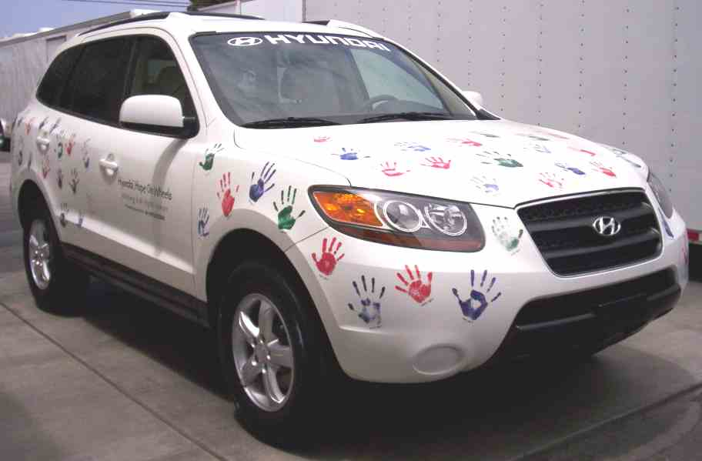

Hyundai ‘Hope On Wheels’ Graphics Order Form
The ‘Hope On Wheels’ graphics package consists of two (2) 5-inch x 24-inch door logos, windshield ‘eyebrow’ decal,
rear bumper fascia ‘.com’ logo, and eighty-five (85) colorful child, teenager and adult hand images. Order each package in either durable and weatherproof die-cut (adhesive) vinyl decals or silk-screened on clear ‘static cling’ (non-adhesive) vinyl sheet for easy removal and re-use.
BILLING/SHIPPING INFO
Your Name & Title:
Company Name:
Street Address:
City, State, Zip:
Phone:
E-mail:
Reference Note:

- Return this completed order form WITH PAYMENT (company check only, no credit cards) to the street address listed below.
- Graphics kits are ready 2 to 4 days after receipt of order and payment.
- Check off your preferred FedEx shipping method for all graphics kits ordered. To avoid separate shipping and handling charges, note your corporate FedEx Account Number directly below:

Your FedEx Account Number: ____________________________________________________________________________
ORDERING INFO
QTY. | Kit Description | Cost Each | Total $$
 | Static-cling (non-adhesive) graphics | $495.00
 | FedEx One-day shipping & handling | $75.00
 | FedEx Two-day shipping & handling | $35.00
 |  | Sub-Total Die-cuts (w/shipping & handling)
QTY. | Kit Description | Cost Each | Total $$
 | Die-cut (adhesive) graphics | $495.00
 | FedEx One-day shipping & handling | $75.00
 | FedEx Two-day shipping & handling | $35.00
 |  | Sub-Total Die-cuts (w/shipping & handling)
 |  | GRAND TOTAL
CAR PREP INC.
FILM PRODUCTION SERVICES
18095 Mt. Shay St. Fountain Valley, CA 92708
Ph: (714) 965-7737 Fx: (714) 965-9805
bob_carprep@verizon.net www.carprepinc.com

