CENTURY 21 ACCOUNTING, 10e
with Sage 50 Accounting 2016

This manual explains how to use the Sage 50 Accounting 2016 software with Century 21 Accounting, 10E, first-year accounting textbooks. You will complete selected end-of-chapter problems with Sage 50 Accounting 2016.
CONVENTIONS USED
As you work through the problems and activities, you will be expected to read and follow the step-by-step instructions. Numerous screen illustrations are provided to assist with instruction and allow you to check your work.

The following conventions are used:

1. Information that you are to type is set in bold.
Examples: 3-MPXX
Cash
3-M Mastery Problem

2. Keys on the keyboard that should be pressed appear as shown below.
Example: <Enter>

3. Sequential menu selections are separated by >.
Example: Start>All Programs>Sage 50 Accounting 2016

4. Names of buttons appear in bold.

5. Unnamed buttons and picture icons are shown as they actually appear on the screen.

Examples:


3-M Mastery Problem

Journalizing Transactions

The instructions that follow demonstrate how to:

- Start Sage 50 Accounting 2016.

- Restore the starting data.

- Identify the directory where Sadie’s Car Wash is stored on the file server or on the computer’s hard drive.

- Change the company name.

- Journalize transactions in the general journal.

- Print the general journal.

- Back up (save) Sage 50 Accounting data.

- Complete 3-M Mastery Problem.

Before starting 3-M Mastery Problem, ask your instructor if Sadie’s Car Wash, the company used for 3-M Mastery Problem, has already been restored on the computer. The following instructions explain how to set up the Sadie’s Car Wash company for the first time.

GETTING STARTED

Use the following instructions to start Sage 50 Accounting and restore the starting data for Sadie’s Car Wash, owned by Sadie Berkowitz.

- If Sage 50 Accounting 2016 is not installed, ask your instructor how to access the program.

- When Sage 50 was installed, an icon on the desktop was created for Sage 50 Accounting. To start Sage 50 Accounting, place the mouse pointer on the Sage 50 Accounting icon, then double-click with the left mouse button.

Or, click Start>All Programs>Sage 50 Accounting 2016. Then, select Sage 50 Accounting 2016. (These instructions are consistent with Windows 7. If you are using a different version of Windows, these instructions will differ slightly.)

- The startup window appears.

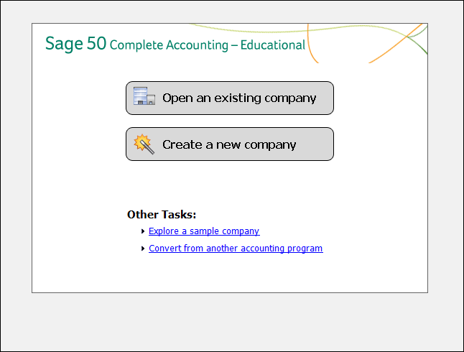

The options from the startup window include Open an existing company; Create a new company; Explore a sample company; and Convert from another accounting program.

SAGE 50 ACCOUNTING DATA FILES

Each problem begins with restoring a Sage 50 file. In Sage 50 Accounting, when data is restored you are copying over (or over-writing) the existing company data. The steps that follow explain how to restore the 03-MP.ptb file. Refer back to these steps as needed when restoring files for future problems.

The steps that follow assume 3 Mastery Problem will be started for the first time, and that Sadie’s Car Wash has not been previously restored. Check with the instructor before continuing to make sure the Sadie’s Car Wash company is not set up Sage 50 Accounting.

- From the startup menu, there are four menu bar options: File, Options, Services, and Help. Click File; Restore.

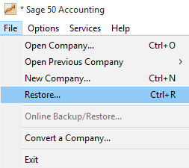

The Restore Wizard - Select Backup File window appears. Observe that the Location field shows where Sage 50 Accounting is stored on your computer. The default location is C:\Sage\Peachtree\Company. Your Location field may differ. The location field shown below represents Sage 50 Accounting’s default program and data path when the program is installed on drive C. Compare your Select Backup File window with the one shown below. (The directory shown in the Location field is consistent with Sage 50 Accounting installed on Windows 7. If you are using a different version of Windows, the directory will differ slightly.)

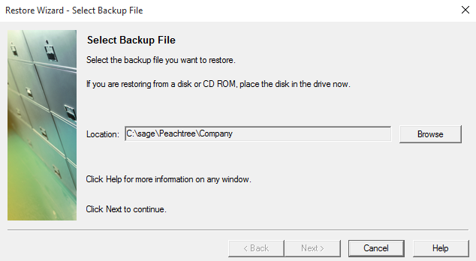

Click . The Open Backup File window appears. In the Look in field, double-click the appropriate location of the Sage 50 Files folder. Then, click 03-MP.ptb to select it. (Select the appropriate hard drive letter, then double-click the Sage 50 Files folder. Click 03-MP.ptb to select it). To identify the location of the Sage 50 Accounting data files, the instructions in this book refer to a Sage 50 Files folder. The folder name and its location on your computer may differ.

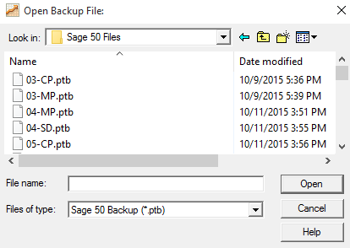

Note:

If you do not have a .ptb extension, follow these steps:
- Click Start>Control Panel>Folder Options.
- From the Folder Options window, select the View tab. The box next to Hide extensions for known file types should be unchecked

For Windows XP:

- Click Start>All Programs>Accessories>then Windows Explorer.
- From the Windows Explorer menu bar, select Tools; Folder Options.
- Click the View tab. The box next to Hide extensions for known file types should be unchecked

Make sure the 03-MP.ptb file is selected. Click .

The Restore Wizard - Select Backup File window appears. Make sure the Location field shows the correct location for the 03-MP.ptb file; for example, C:\Sage 50 Files\03-MP.ptb. The Select Backup File window below shows the location as drive C because that is the drive letter of where the author downloaded the Sage 50 Accounting student template files from the website.

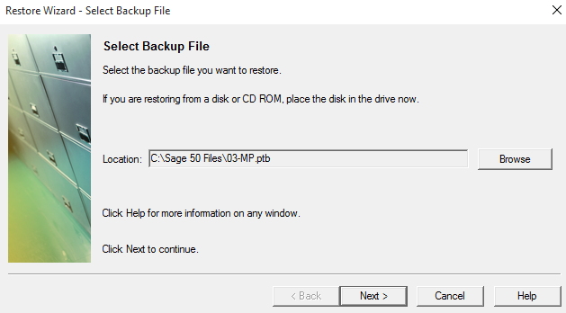

Click . The Select Company window appears. Click the radio button next to A New Company. Compare your Select Company window to the one shown below. The Location field shown in this book indicates the default location where drive C is used to install Sage 50 Accounting. Your Location field may differ. Make sure that the Location field ends in sadcarwa. Read the information below the screen illustration before continuing with step 7.

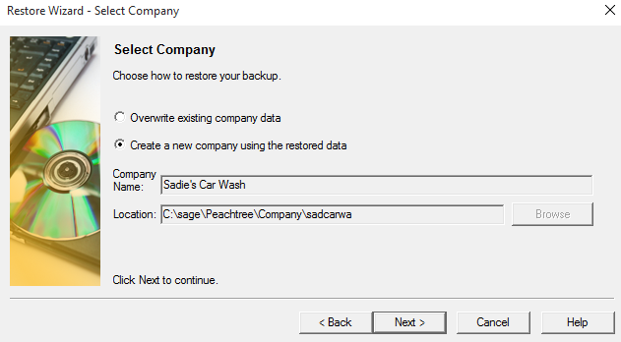

When you select A New Company to restore, a company folder is set up in Sage 50 Accounting; and the company name is shortened. The shortened company name is added to Sage 50 Accounting’s program and data path. If the company has never been restored to the computer, the shortened name is “sadcarwa.”

If Sadie’s Car Wash (the company name for 3 Mastery Problem) is already set up on the computer, Sage 50 Accounting changes the shortened name of the company and creates a different company name folder. For example, the company’s shortened name shows “sadcarwb.” Notice that the last letter of the shortened name is changed. This means that Sadie’s Car Wash was already restored. If this is the case, select An Existing Company, then click . Double-click Sadie’s Car Wash (or, 03-MP). An Existing Company is selected and your Location field shows the shortened company name sadcarwa. Continue with step 7.
- Click . The Restore Options window appears.

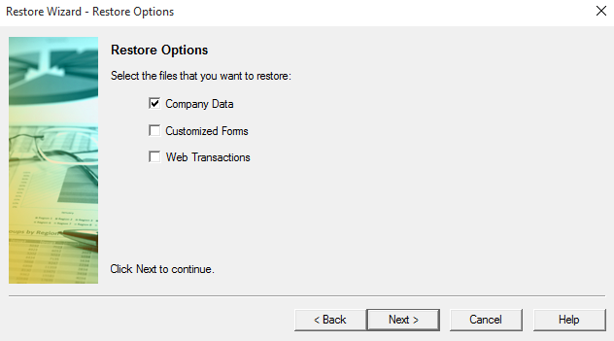
- Make sure that the box next to Company Data is checked. Click .

- The Confirmation window appears. Check the From and To fields to make sure they are correct. In the illustration below the From field indicates drive C for the Backup Files folder. Your drive letter may differ. The To field indicates the default program and data path for Sage 50 Accounting when it has been installed on drive C. Your drive letter and path may differ. Compare your Confirmation window with the one shown below.

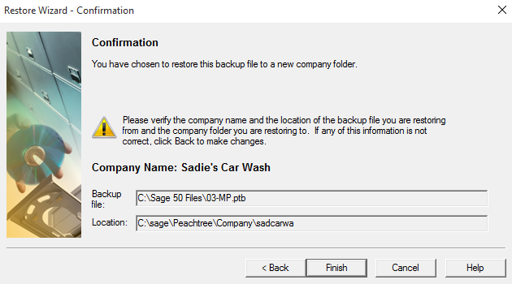

  - Click . When the Restore Company scale is 100% complete, your data is restored and the Sadie’s Car Wash – Sage 50 Accounting menu bar appears.

Note:
Since the Restore Wizard includes the ability to restore An Existing Company or A New Company, you can also restore starting data for Sage 50 Accounting by selecting that company from the Company Name list.

- You start Sage 50 Accounting and notice that the company you want to use is already listed on the Company Name list. For example, on the Open Company window, the Company Name list includes Sadie’s Car Wash (or, 03-MPXX).
- Double-click the company name. The Sage 50 Accounting: Sadie’s Car Wash menu bar appears.
- Click File; Restore. The Restore Wizard’s Select Backup File window appears.
- Click . Open the appropriate file from the Sage 50 Files folder; for example, open the 03-MPXX.ptb file. Click .
- Observe that the Select Company window defaults to An Existing Company. Accept the default for An Existing Company by clicking .
- On the Restore Options window, make sure there is a check mark next to Company Data. Click .
- At the Confirmation window, click . The starting data for 3 Mastery Problem, Sadie’s Car Wash, has now been restored.

CHANGING THE COMPANY NAME

Before recording transactions for 3 Mastery Problem, look at the company information included on the 03-MP.ptb file. Follow these steps to look at company information.

- The Sadie’s Car Wash menu bar should be displayed. From the menu bar, click Maintain; Company Information. The Maintain Company Information window appears. Compare your Maintain Company Information window to the one shown below.

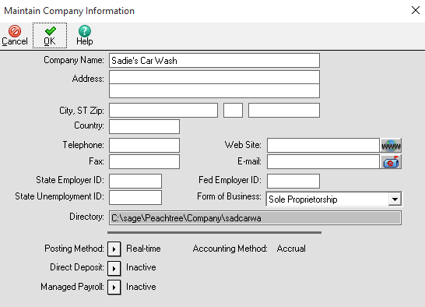

Observe that the Company Name field shows Sadie’s Car Wash. The Form of Business field shows Sole Proprietorship. The Directory field shows the location on the hard drive where the company data is stored – C:\Sage\Peachtree\Company\sadcarwa. When a company is created in Sage 50 Accounting, the company name is shortened. The shortened company name is added to Sage 50 Accounting’s Program and data path. If you are working in a computer lab, Sage 50 Accounting’s location may differ.

- In order to make sure that each printout displays your name and the problem number, in the Company Name field, type 03-MPXX. Replace the X’s with your initials. The screen illustration shows the author’s initials ML.

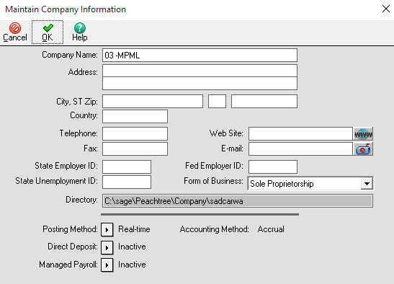

Note:

Why do I have to change the company name?

You change the company name so that printouts will show the problem number and your initials. (The instructor may require different directions.) After the company name is changed, when Sage 50 Accounting is started at a later time, the company will appear with its new name. Remember, starting data can be retrieved for this problem by restoring the 03-MP.ptb file from the Sage 50 Files folder. Once the Sage 50 Accounting data file is restored (03-MP.ptb for this problem), you have fresh, starting data.

- After typing 03-MPXX as the company name, click . Once you have changed the Company Name, each one of the printouts will show the problem number and your initials.

Nothing has changed on your computer’s hard drive. The Sage 50 Accounting program and data path for Sadie’s Car Wash is C:\Sage\Peachtree\Company\sadcarwa. (Check this by selecting Maintain>Company Information and observe what is shown in the Directory field.) The previous steps changed the company name so that printouts will display the problem number and your initials. Remember when you restore problem data, Sage 50 Accounting sets up a subfolder with a shortened company name. In this case, the subfolder is \sadcarwa. Using Maintain>Company Information to rename your company does not change the shortened company name.

Here is what has been completed so far:

- Started Sage 50 Accounting.
- Restored the data file from the Sage 50 Files folder
- Identified the directory where Sage 50 Accounting is stored on your computer’s hard drive.
- Changed the company name so that printouts will show the problem number and your initials.

These are the steps that you will follow each time you start a new problem in South-Western Accounting with Sage 50 Accounting.

Note:

Each time you end a work session, you will need to back up your work. If you need to end this work session before completing the 3 Mastery Problem, skip ahead to the “Back Up Your Sage 50 Accounting File” section and complete those steps. When you begin your next work session, you will restore the 3 Mastery Problem.ptb file before continuing the problem. To Restore the backup file, refer to the Restore “Sage 50 Accounting Data Files” section.
THE NAVIGATION BAR
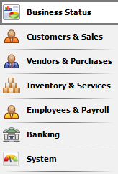
On the left side of Sage 50 Accounting main window
is the Navigation Bar. Each selection on the Navigation Bar offers access to seven pages called Navigation Centers. Collectively, the Navigation Centers provide for a convenient area to access some of the most common windows used for viewing and entering information.

After clicking on one of the seven selections on the Navigation Bar, the Navigation Center displays information related to that area of the program. Throughout this manual, both Sage 50 Accounting’s Navigation Centers and menu bar are used to access features of the program. The individual Navigation Centers are identified as pages, for example, if you select "Customers & Sales", the Customers and Sales page appears.

SAGE 50 ACCOUNTING CHART OF ACCOUNTS

As you know from your study of accounting, a chart of accounts is the list of accounts used by a business. Sage 50 Accounting’s chart of accounts is organized as follows:

Account Number: Sadie’s Car Wash uses three-digit account numbers, within a division by 10s. The Account ID field shows the account number.

Account Description: Use the Description field to name the account.

Account Type: In Sage 50 Accounting, you must also select the type of account you are setting up. The account type classifies the accounts for the financial statements. For example, Cash is set up as a Cash account, Accounts Receivable is set up as an Accounts Receivable account. The account type determined whether the account is a balance sheet account (an asset, liability, or owner’s equity account) or an income statement account (a revenue or an expense account). Use the Account Type field for account classifications.

Another feature specific to Sage 50 Accounting is how the income summary account is classified. In Sage 50 Accounting, income summary is classified as Equity-Retained Earnings. In order for Sage 50 Accounting to post to the general ledger, one account must be set up as Retained Earnings. The retained earnings account represents the earnings of the company.

- From the menu bar, select Reports & Forms, then General Ledger.

- The Select a Report or Form window appears. The Chart of Accounts is highlighted.
- Click the  icon.

- Compare your chart of accounts to the one shown on the next page.

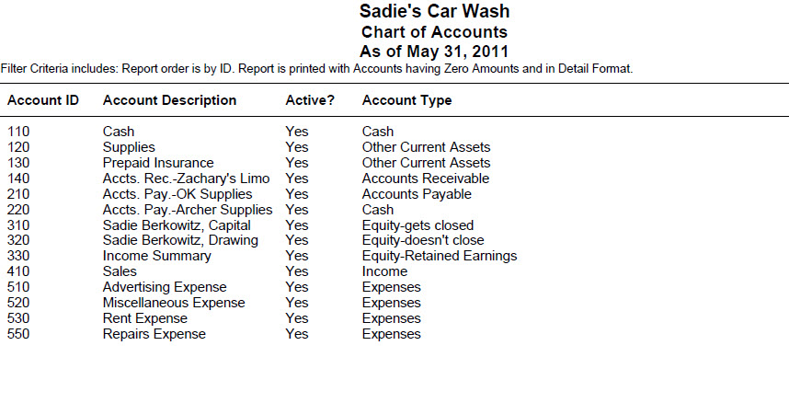

These are the accounts to journalize and post the May transactions shown in the textbook.

Read Me

Notice that an Income Summary account appears on the chart of accounts. Sage 50 Accounting requires that one Equity-Retained Earnings account be included for every company. This account is named Income Summary. You will not make any entries using this account in 3 Mastery Problem.

- Click the 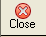 Close icon to return to the Select a Report window. Click the icon again to return to the menu bar.

- Before journalizing transactions, add Account No. 540, Utilities Expense to Sadie’s Car Wash Chart of Accounts. To add an account:

  - From Sage 50 Accounting’s navigation bar, select , then click the 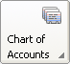 icon and select New Account. The Maintain Chart of Accounts window displays.
  - In the Account ID field, type 540 and press <Enter>.
  - In the Description field, type Utilities Expense and press <Enter>.
  - In the Account Type field, select Expenses. The Account Type field is important. The correct classification places the accounts correctly in the general ledger and on financial statements.

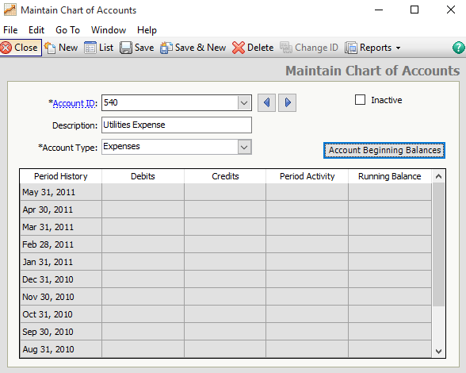

  - Make sure that your Account ID, Description, and Account Type are correct. Then click .
  - Click to close the Maintain Chart of Accounts window.
  - An alternative way to access Sage 50 Accounting’s Maintain Chart of Accounts window is, from the menu bar select Maintain; Chart of Accounts.

JOURNALIZING TRANSACTIONS IN A GENERAL JOURNAL

The data that was restored from the Sage 50 Files folder contains starting data for 3 Mastery Problem. Read the information that follows regarding Sage 50 Accounting’s general journal and general ledger.

Sage 50 Accounting’s General Journal

Sage 50 Accounting includes two ways to journalize general journal transactions. You can select General Journal Entry from the Banking navigation page or you can select General Journal Entry from Sage 50 Accounting’s Tasks drop down menu as accessed from the menu bar.

Instructions: You are going to journalize the May transactions for 3 Mastery Problem. The steps that follow explain how to use Sage 50 Accounting’s general journal to journalize the first transaction.

Date Transaction

May 1 Received cash from owner as an investment, $5,500.00

Follow these steps to enter the May 1 transaction.

- From Sage 50 Accounting’s Navigation bar, select  to display the Company page. Then, click the 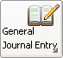 icon and select New General Journal Entry. (An alternate way to access the General Journal Entry window is, from the menu bar select Tasks; General Journal Entry).

2. The General Journal Entry window appears. Your cursor is in the Date field. Accept the default for 5/1/11 by pressing the <Enter> key. Observe that the date changes to May 1, 2011. (Hint: For purposes of using Sage 50 Accounting, the year is 2011.)

3. Your cursor is in the Reference field. Type R1, then press <Enter> two times.

- Your cursor is in the GL Account field. Observe that the GL Account field has a magnifying-glass icon 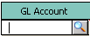 in it. Click the (magnifying-glass icon) and a chart of accounts list pops up. Since you are going to debit Cash for this transaction, and Cash is highlighted, accept the default by pressing <Enter> or clicking on .

- Type Cash in the Description column, then press <Enter>.

- Your cursor is in the Debit column. Type 5500 in the Debit column. (If 55.00 displays instead of 5,500.00, click Options>Global. Make sure that “Manual” and “Number of decimal places, 2” is selected in the Decimal Entry part of the window. Click . Type 5500 again. Your entry should appear as 5,500.00 in the Debit column.) Press <Enter> three times.

- Your cursor is in the GL Account column. Click the , then select Account No. 310, Sadie Berkowitz, Capital.

- Your cursor is in the Description column. Type Sadie Berkowitz, Capital as the description. Press the <Enter> key two times.

- Your cursor is in the Credit column. Type 5500 as the credit. Observe that the Debit column shows 5,500.00, and the Credit column shows 5,500.00.

- The “Out of Balance” field shows 0.00. This shows that your debits equal your credits. Compare your General Journal entry screen with the one below.

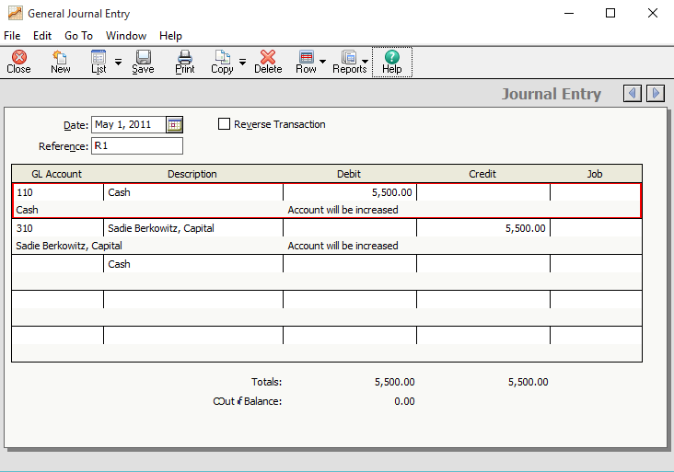

Saving Transactions in the General Journal

Follow these steps to journalize the May 1 transaction in the general journal.

- The General Journal Entry window shown above should be displayed on your
window. Click the  icon.

- Your General Journal Entry window is ready for the May 2 transaction.

- Using the transactions shown for 3 Mastery Problem, journalize and post each transaction from May 2 through 31. To change the date in the Date field, type the number of the date or select the calendar icon then select the appropriate day of the month. For the description column, type the name of the account that you are debiting and crediting. (Hint: Remember, you must click the icon after entering each transaction so that the transaction will post to the general ledger.)

4. After completing the instructions for the May 1st transaction, refer to the 3 Mastery Problem and use the General Journal Entry window to enter the May 2-31 transactions.
5. After completing the general journal transactions, click .

Printing the General Journal

- From the menu bar, select Reports & Forms, then General Ledger.

- Click General Journal to highlight it.
- Click . Make the selections to print your general journal.

Printing the General Ledger

- From the Select a Report or Form window, click General Ledger to highlight it.
- Click . Make the selections to print your general journal.

- Exit Sage 50 Accounting.

BACK UP YOUR SAGE 50 ACCOUNTING FILE

Before leaving the computer lab, remember to back up your data. Backing up Sage 50 Accounting data enables you to save your work. The instructions that follow assume that a hard drive is the location of the Sage 50 Accounting backup. External media such as a CD-R; DVD-R; Zip disk; or USB drive can also be used as backup locations.

Follow these steps to back up 3 Mastery Problem.

- From the Navigation Bar select . Then, click the icon. The Back Up Company window appears.

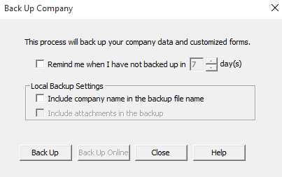

- Click .

- Click the down-arrow in the Save in field. If necessary, select drive D or other location for your backup. The instructions that follow show how to back up to Sage 50 Accounting’s default hard-drive location: C:\Sage\Peachtree\Company\sadcarwa. Type 3 Mastery Problem in the File name field.

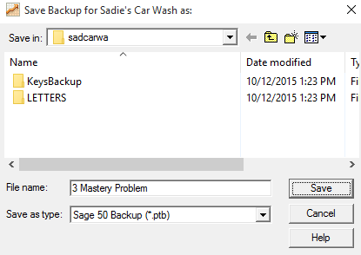

Observe that the Save as type box shows that you are making a Sage 50 Accounting Backup, which is abbreviated ptb. This is the standard default for Sage 50 Accounting backups.

- Click .

- When the window prompts that This company backup will require approximately 7.29MB, click .

- When the Back Up Company scale is 100% complete, you have successfully backed up your data. You are returned to the menu bar.

- Click File; Exit to exit Sage 50 Accounting.

- An alternate way to access the Back Up Company window is from the menu bar. Select File; Back Up.

RESTORE SAGE 50 ACCOUNTING DATA

The Restore Wizard can also be used to continue using Sage 50 Accounting from a previous point of where you left off the last time Sage 50 Accounting was used. For example, if you back up work before all the transactions were completed in a particular problem (such as 3 Mastery Problem), then exit Sage 50 Accounting, follow these steps to restore the file and continue working:

In Sage 50 Accounting, when you restore data you are copying company data.

- Start Sage 50 Accounting. At the startup menu, select Open an Existing Company.

- Open the 03-MPXX company; or, if Sadie’s Car Wash is shown on the Company List, double-click it.

- From the Navigation Bar, select and click the icon. (Or, from the menu bar, select File; Restore.) Once you restore, you will overwrite the company data. From the Select Backup File window, click to select the appropriate location of your backup file.

- Check the Location field to make sure the correct file is being restored. Click .

- The Select Company window defaults to An Existing Company. The Company Name field shows Sadie’s Car Wash. The Location field shows C:\Sage\Sage 50 Accounting\company\sadcarwa.

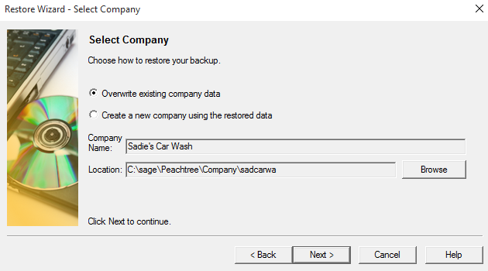

- Click .

- The Restore Options window appears. Make sure that the box next to Company Data is checked. Click .

- The Confirmation window appears. Observe that the Company Name is Sadie’s Car Wash. Check the From and To fields to make sure they are correct. Click . When the Restore Company scale is 100% complete, the data is restored and the menu bar appears.

- If necessary, remove the external media and continue with 3 Mastery Problem. Remember; always back up before exiting Sage 50 Accounting and leaving the computer lab.

- An alternate way to access the Restore Wizard – Select Back Up File window is, from the menu bar select File; Restore.

You have completed the work for 3 Mastery Problem – Journalizing Transactions.
3-C Challenge Problem

Journalizing Transactions

The instructions that follow demonstrate how to:

- Start Sage 50 Accounting 2016.

- Restore the starting data.

- Change the company name.

- Journalize transactions in the general journal.

- Print the general journal.

- Back up (save) Sage 50 Accounting data.

- Complete 3-C Challenge Problem.

Before starting 3-C Challenge Problem, ask your instructor if Malnick’s Tailors, the company used for 3-C Challenge Problem, has already been restored on the computer. The following instructions explain how to set up the Malnick’s Tailors company for the first time.

GETTING STARTED

Refer to pages 2 through 8 to restore a Sage 50 Accounting file from the Sage 50 Files folder. Each time you begin a problem, restore the starting data from a Sage 50 Accounting file. Then, pages 9 through 11 explain how to change the company name to include your initials.

Malnick’s Tailors is a sole proprietorship owned by Misha Malnick. Change the company name from Malnick’s Tailors to 03-CPXX (X’s represent your initials).

DISPLAYING THE CHART OF ACCOUNTS

The data that you restored from the Sage 50 Files folder contains starting data for 3 Challenge Problem. This file includes a chart of accounts for Malnick’s Tailors. Follow these steps to display the chart of accounts that is included in the starting data for 3 Challenge Problem.

- From the menu bar, select Reports & Forms, then General Ledger.

- The Select a Report or Form window appears. In the General Ledger: Account Information list, click Chart of Accounts.
- Click .

- The Chart of Accounts Filter window appears. Click . Compare your chart of accounts to the one shown.

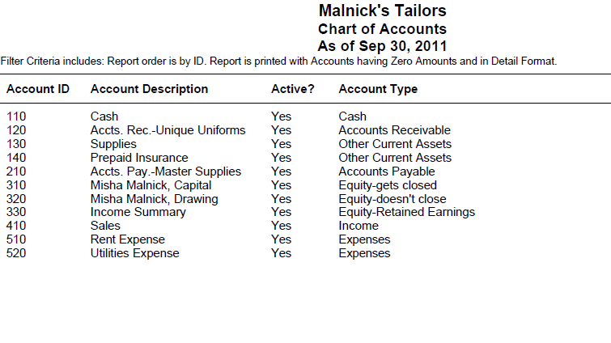

- These are the accounts you will use to journalize and post transactions for 3 Challenge Problem.

- Click to return to the Select a Report or Form window. Click again to return to the menu bar.

CHANGING THE COMPANY NAME

Before recording transactions for the 3 Challenge Problem, look at the company information included on the 03-CP.ptb file. Follow these steps to look at company information.

- The Malnick’s Tailors menu bar should be displayed. From the menu bar, click Maintain; Company Information. The Maintain Company Information window appears. Compare your Maintain Company Information window to the one shown.

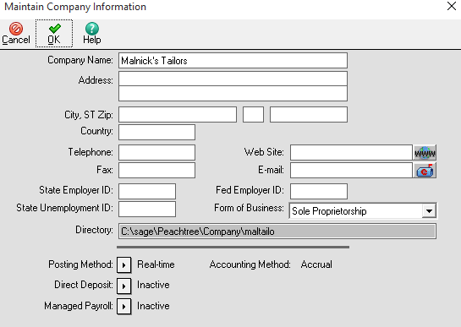

Observe that the Company Name field shows Malnick’s Tailors. The Form of Business field shows Sole Proprietorship. The Directory field shows the location on the hard drive where the company data is stored – C:\Sage\Peachtree\Company\maltailo. When a company is created in Sage 50 Accounting, the company name is shortened. The shortened company name is added to Sage 50 Accounting’s Program and data path. If you are working in a computer lab, Sage 50 Accounting’s location may differ.

- In order to make sure that each printout displays your name and the problem number, in the Company Name field, type 03-CPXX. Replace the X’s with your initials. The screen illustration shows the author’s initials ML.

- After typing 03-CPXX as the company name, click . Once you have changed the Company Name, each one of the printouts will show the problem number and your initials.

Nothing has changed on your computer’s hard drive. The Sage 50 Accounting program and data path for Malnick’s Tailors is C:\Sage\Peachtree\Company\maltailo. (Check this by selecting Maintain>Company Information and observe what is shown in the Directory field.) The previous steps changed the company name so that printouts will display the problem number and your initials. Remember when you restore
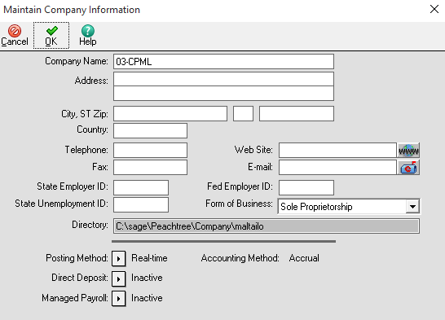

problem data, Sage 50 Accounting sets up a subfolder with a shortened company name. In this case, the subfolder is \maltailo. Using Maintain>Company Information to rename your company does not change the shortened company name.

JOURNALIZING TRANSACTIONS IN A GENERAL JOURNAL

The data that was restored from the Sage 50 Files folder contains starting data for 3 Challenge Problem. Read the information that follows regarding Sage 50 Accounting’s general journal and general ledger.

Sage 50 Accounting General Journal

Sage 50 Accounting includes two ways to journalize general journal transactions. You can select General Journal Entry icon from the Banking navigation page or, from the menu bar, click Tasks; General Journal Entry.

- The 03-CP problem file should be restored and the Malnick’s Tailors menu bar displayed.

- From the textbook, journalize the September transactions in Sage 50 Accounting’s General Journal. For Sage 50 Accounting, use 2011 as the year.

- Print the General Journal. From the menu bar, select Reports & Forms, then General Ledger.

- Click General Journal to highlight it.
- Click . Make the selections to print the general journal.

- Back up the 3 Challenge Problem. From the Navigation Bar, select . Then, click the icon. The Back Up Company window appears.
- Click .

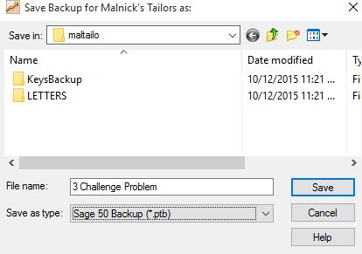

- Click the down arrow in the Save in field. If necessary, select drive C or other location for your back up. The instructions that follow show how to back up to Sage 50 Accounting’s default hard-drive location: C:\Sage\Peachtree\ Company\maltailo. Type 3 Challenge Problem in the File name field. Observe that the Save as type box shows that you are making a Sage 50 Accounting Backup, which is abbreviated ptb. This is the standard default for Sage 50 Accounting backups.

- Click .

- When the window prompts that This company backup will require approximately 7.29MB (this number may vary), click .

- When the Back Up Company scale is 100% complete, you have successfully backed up your data. You are returned to the menu bar.

- Click File; Exit to exit Sage 50 Accounting.

- An alternate way to access the Back Up Company window is, from the menu bar select File; Back Up.

4-M Mastery Problem

Journalizing Transactions and Posting to a General Ledger

- Start Sage 50 Accounting 2016.

- Restore the starting data.

- Change the company name.

- Journalize transactions in the general journal.

- Post transactions to the general ledger.

- Print the general journal and general ledger.

- Back up (save) Sage 50 Accounting data.

- Complete 4-M Mastery Problem.

Before starting 4-M Mastery Problem, ask your instructor if Ford Lawn and Garden, the company used for 4-M Mastery Problem, has already been restored on the computer. The following instructions explain how to set up the Ford Lawn and Garden company for the first time.

GETTING STARTED

Refer to pages 2 through 8 to restore a Sage 50 Accounting file from the Sage 50 Files folder. Each time you begin a problem, restore the starting data from a Sage 50 Accounting file. Then, pages 9 through 11 explain how to change the company name to include your initials.

Ford Lawn and Garden is a sole proprietorship owned by Brian Ford. Change the company name from Ford Lawn and Garden to 04-MPXX (X’s represent your initials).

DISPLAYING THE CHART OF ACCOUNTS

The data that you restored from the Sage 50 Files folder contains starting data for 4 Mastery Problem. This file includes a chart of accounts for Ford Lawn and Garden. Follow these steps to display the chart of accounts that is included in the starting data for 4 Mastery Problem.

- From the menu bar, select Reports & Forms, then General Ledger.

- The Select a Report or Form window appears. In the General Ledger: Account Information list, click Chart of Accounts.
- Click .
- The Chart of Accounts Filter window appears. Click . Compare your chart of accounts to the one shown.

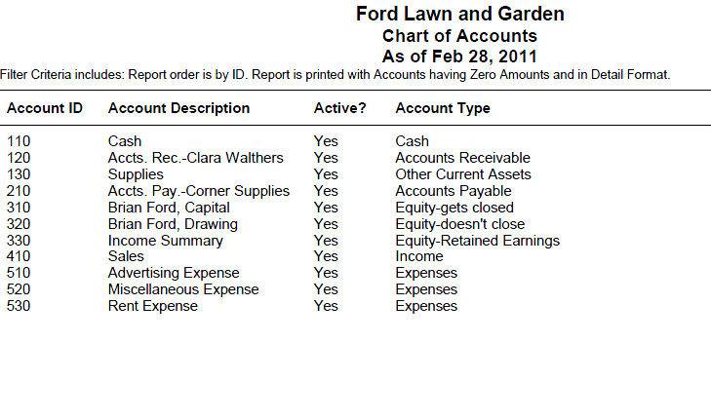

- These are the accounts you will use to journalize and post transactions for 4 Mastery Problem.

- Click to return to the Select a Report or Form window. Click again to return to the menu bar.

CHANGING THE COMPANY NAME

Before recording transactions for the 4 Mastery Problem, look at the company information included on the 04-MP.ptb file. Follow these steps to look at company information.

- The Ford Lawn and Garden menu bar should be displayed. From the menu bar, click Maintain; Company Information. The Maintain Company Information window appears. Observe that the directory field shows where the company is stored on your computer: C:\Sage\Peachtree\Company\forlawan.

- Type 04-MPXX in the Company Name field.

- Click . Once you have changed the Company Name, each one of your printouts will show the problem number and your initials.

- Click to return to the Select a Report or Form window. Click again to return to the menu bar.

SAGE 50 ACCOUNTING’S GENERAL JOURNAL

Refer to the textbook 4 Mastery Problem. Sage 50 Accounting includes two ways to journalize general journal transactions. You can select General Journal Entry from the Company page or you can select General Journal Entry from Sage 50 Accounting’s Tasks drop down menu as accessed from the menu bar.

- Before journalizing transactions, add Account No. 540, Utilities Expense to Ford Lawn and Garden’s Chart of Accounts. To add an account:

  - From Sage 50 Accounting’s navigation bar, select , then click the icon and select New Account. The Maintain Chart of Accounts window displays.
  - In the Account ID field, type 540 and press <Enter>.
  - In the Description field, type Utilities Expense and press <Enter>.
  - In the Account Type field, select Expenses. The Account Type field is important. The correct classification places the accounts correctly in the general ledger and on financial statements.

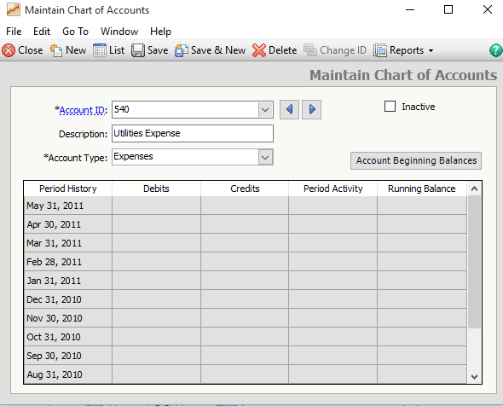

  - Make sure that your Account ID, Description, and Account Type are correct. Then click .
  - Click to close the Maintain Chart of Accounts window.
  - An alternative way to access Sage 50 Accounting’s Maintain Chart of Accounts window is, from the menu bar select Maintain; Chart of Accounts.

- Use Sage 50 Accounting’s general journal to journalize the February transactions.

Posting to the General Ledger

After you record a transaction in Sage 50 Accounting, you can post to the general ledger.
Observe that the General Journal Entry window has a Save icon . When you select the Save icon on Sage 50 Accounting’s journal window, you are also posting to the general ledger.
Follow these steps to print the February general journal.

  - From Sage 50 Accounting’s menu bar, select Reports & Forms, then General Ledger.

  - Click General Journal to highlight it.
  - Click .

  - Make the selections to print.

- Follow these steps to print the February general ledger.

  - From Sage 50 Accounting’s menu bar, select Reports & Forms, then General Ledger.

  - Click General Ledger to highlight it.
  - Click .

  - Make the selections to print.

- Back up your data. The suggested filename is 4 Mastery Problem.ptb.

4-S Source Documents Problem

Journalizing Transactions and Posting to a General Ledger

- Start Sage 50 Accounting 2016.

- Restore the starting data.

- Change the company name.

- Journalize transactions in the general journal.

- Post transactions to the general ledger.

- Print the general journal and general ledger.

- Back up (save) Sage 50 Accounting data.

- Complete 4-S Source Documents Problem.

Before starting 4-S Source Problem, ask your instructor if Darlene’s Music Studio, the company used for 4-S Source Problem, has already been restored on the computer. The following instructions explain how to set up the Darlene’s Music Studio company for the first time.

GETTING STARTED

Refer to pages 2 through 8 to restore a Sage 50 Accounting file from the Sage 50 Files folder. Each time you begin a problem, restore the starting data from a Sage 50 Accounting file. Then, pages 9 through 11 explain how to change the company name to include your initials.

Darlene’s Music Studio is a sole proprietorship owned by Darlene Steffens. Change the company name from Darlene’s Music Studio to 04-SDXX (X’s represent your initials).

Nothing has changed on your computer’s hard drive. This company is identified in the program folder and data folder as C:\Sage\Peachtree\Company\ darmusst. The company name has been changed so that Sage 50 Accounting printouts will show the problem number and your initials. Using Maintain; Company Information to rename the company does not change the shortened company name.

DISPLAYING THE CHART OF ACCOUNTS

The data that you restored from the Sage 50 Files folder contains starting data for 4 Source Problem. This file includes a chart of accounts for Darlene’s Music Studio. Follow these steps to display the chart of accounts that is included in the starting data for 4 Source Documents Problem.

- From the menu bar, select Reports & Forms, then General Ledger.

- The Select a Report or Form window appears. In the General Ledger: Account Information list, click Chart of Accounts.
- Click .
- The Chart of Accounts Filter window appears. Click . Compare your chart of accounts to the one shown.

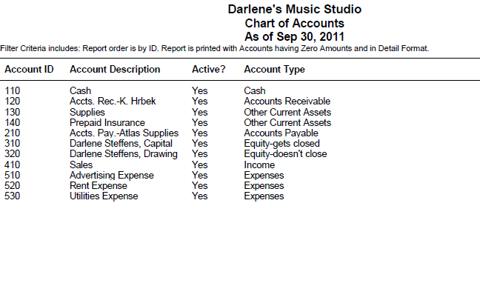

- These are the accounts you will use to journalize and post transactions for 4 Source Documents Problem.

- Click to return to the Select a Report or Form window. Click again to return to the menu bar.

CHANGING THE COMPANY NAME

Before recording transactions for the 4 Source Documents Problem, look at the company information included on the 04-SD.ptb file. Follow these steps to look at company information.

- The Darlene’s Music Studio menu bar should be displayed. From the menu bar, click Maintain; Company Information. The Maintain Company Information window appears. Observe that the directory field shows where the company is stored on your computer: C:\Sage\Peachtree\Company\darmusst.

- Type 04-SDXX in the Company Name field.

- Click . Once you have changed the Company Name, each one of your printouts will show the problem number and your initials.

- Click to return to the Select a Report or Form window. Click again to return to the menu bar.

SAGE 50 ACCOUNTING’S GENERAL JOURNAL

Refer to the textbook’s 4 Source Documents problem. Sage 50 Accounting includes two ways to journalize general journal transactions. You can select General Journal Entry from the Company page or you can select General Journal Entry from Sage 50 Accounting’s Tasks drop down menu as accessed from the menu bar.

- Use Sage 50 Accounting’s general journal to journalize the September transactions.

Posting to the General Ledger

After you record a transaction in Sage 50 Accounting, you can post to the general ledger.
Observe that the General Journal Entry window has a Save icon . When you select the Save icon on Sage 50 Accounting’s journal window, you are also posting to the general ledger.

- Follow these steps to print the September general journal.

  - From Sage 50 Accounting’s menu bar, select Reports & Forms, then General Ledger.

  - Click General Journal to highlight it.
  - Click .

  - Make the selections to print.

- Follow these steps to print the September general ledger.

- From Sage 50 Accounting’s menu bar, select Reports & Forms, then General Ledger.

- Click General Ledger to highlight it.
- Click .

- Make the selections to print.

- Back up your data. The suggested filename is 4 Source Documents Problem.ptb.
5-M Mastery Problem

Reconciling a Bank Statement; Journalizing a Bank Service Charge, a Dishonored Check, and Petty Cash Transactions

The instructions that follow demonstrate how to:

- Start Sage 50 Accounting 2016.

- Journalize and post petty cash and dishonored check transactions.

- Use Sage 50 Accounting’s account reconciliation feature.

- Complete 5-M Mastery Problem.

Before starting 5-M Mastery Problem, ask the instructor if Fresh Flowers, the company used for 5-M Mastery Problem, has already been restored. The following instructions assume the company, Fresh Flowers, has not been restored. If Fresh Flowers exists as a Sage 50 Accounting company, remember to restore An Existing Company rather than a new company.

GETTING STARTED

Refer to pages 2 through 8 to restore a Sage 50 Accounting file from the Sage 50 Files folder. Each time you begin a problem, restore the starting data from a Sage 50 Accounting file. Then, pages 9 through 11 explain how to change the company name to include your initials.

Fresh Flowers is a sole proprietorship owned by Lauryn Iverson. Change the company name from Fresh Flowers to 05-MPXX (X’s represent your initials).

Nothing has changed on your computer’s hard drive. This company is identified in the program folder and data folder as C:\Sage\Peachtree\Company\freflowe. The company name has been changed so that Sage 50 Accounting printouts will show the problem number and your initials. Using Maintain; Company Information to rename the company does not change the shortened company name.

DISPLAYING THE CHART OF ACCOUNTS

The data that you restored from the Sage 50 Files folder contains starting data for 5 Mastery Problem. This file includes a chart of accounts for Fresh Flowers. Follow these steps to display the chart of accounts that is included in the starting data for 5 Mastery Problem.

- From the menu bar, select Reports & Forms, then General Ledger.

- The Select a Report or Form window appears. In the General Ledger: Account Information list, click Chart of Accounts.
- Click .
- The Chart of Accounts Filter window appears. Click . Compare your chart of accounts to the one shown.

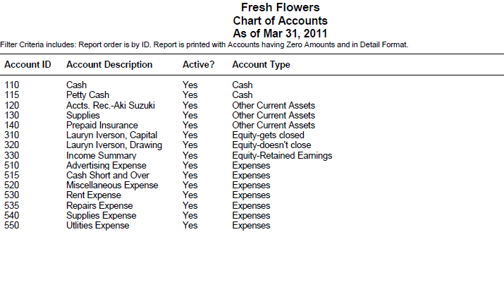

These are the accounts you will use to journalize and post transactions for 5-5M Mastery Problem.

- Click to return to the Select a Report window. Click again to return to the menu bar.

JOURNALIZE AND POST TRANSACTIONS

Refer to the textbook for 5-5M Mastery Problem. Journalize and post the transactions completed during May 2011. Type the check numbers (C110, etc.) and the memo number (M33) in the Reference field of the General Journal entry window. C110 is an abbreviation of Check No. 110. Remember to save after each transaction.

RECONCILING THE BANK STATEMENT; JOURNALIZING A BANK SERVICE CHARGE, A DISHONORED CHECK, AND PETTY CASH TRANSACTIONS

Sage 50 Accounting’s account reconciliation feature allows you to reconcile the bank statement. As you know from your study of accounting, the process of bringing the balance of the bank statement and the balance of the cash account into agreement is called bank reconciliation. Sage 50 Accounting calls this account reconciliation.

The textbook shows that Fresh Flowers received a bank statement on March 31. The following information is shown:

Bank statement balance $3658.00
Bank service charge 30.00
Outstanding deposit, March 31 700.00
Outstanding checks, No. 224 and No. 225
Checkbook balance on Check Stub No. 226 3603.00

Instructions:

- From the Navigation bar, select and click 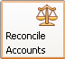. The Account Reconciliation window appears.

- In the Account to Reconcile field, select Account No. 110, Cash. In the Checks and Bank Debits column, click each check and memo that has cleared the bank. Remember, check numbers 224 and 225 are outstanding so there should be no checkmark next to them.

- In the Deposits and Bank Credits area do not put a checkmark next to the deposit. The March 31 deposit is outstanding.

- Type 30 in the Service charges field. In the Account field select Account No. 520, Miscellaneous Expense, for the service charge.

- Type 3658 In the Statement Ending balance field. Observe that the Unreconciled Difference shows 0.00. Observe that the GL (System) Balance is the same as the Adjusted Check Stub Balance shown on the Reconciliation of Bank Statement in the Working Papers.

- Click .

PRINTING THE ACCOUNT RECONCILIATION REPORT AND GENERAL JOURNAL

- From the menu bar, select Reports & Forms>Account Reconciliation.

- The Select a Report window appears. Account Reconciliation is highlighted. Click .

- Make sure that the GL Account ID field shows 110. If not, select Account No. 110 for the Cash account.

- Click . Make the selections to print your account reconciliation report.

- Close the Select a Report window to return to the menu bar.

- Print the general journal.

BACK UP YOUR SAGE 50 ACCOUNTING FILE

Before leaving the computer lab, remember to back up your data. Backing up Sage 50 Accounting data enables you to save your work. The instructions that follow assume that a hard drive is the location of the Sage 50 Accounting backup. External media such as a CD-R; DVD-R; Zip disk; or USB drive can also be used as backup locations.

Follow these steps to back up 5 Mastery Problem.

- From the Navigation Bar select . Then, click the
icon. The Back Up Company window appears.

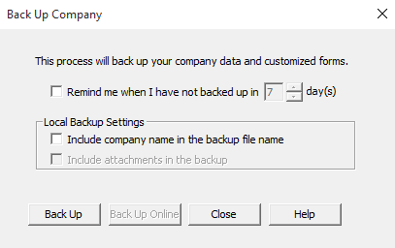

- Click .

- Click the down-arrow in the Save in field. If necessary, select drive C or other location for your backup. The instructions that follow show how to back up to Sage 50 Accounting’s default hard-drive location: C:\Sage\Peachtree\Company\freflowe. Type 5 Mastery Problem in the File name field. Observe that the Save as type box shows that you are making a Sage 50 Accounting Backup, which is abbreviated ptb. This is the standard default for Sage 50 Accounting backups.

- Click .

- When the window prompts that This company backup will require approximately 7.29MB, click .

- When the Back Up Company scale is 100% complete, you have successfully backed up your data. You are returned to the menu bar.

- An alternate way to access the Back Up Company window is from the menu bar. Select File; Back Up.

- Click File; Exit to exit Sage 50 Accounting.

You have completed the work for 5-M Mastery Problem: Reconciling a bank statement; journalizing a bank service charge, a dishonored check, and petty cash transactions.

5-C CHALLENGE PROBLEM

RECONCILING A BANK STATEMENT AND RECORDING A BANK SERVICE CHARGE

The instructions that follow demonstrate how to:

- Start Sage 50 Accounting 2016.

- Restore the starting data.

- Change the company name.

- Journalize and post petty cash and dishonored check transactions.

- Use Sage 50 Accounting’s account reconciliation feature.

- Complete 5-C Challenge Problem.

Before starting 5-C Challenge Problem, ask the instructor if Pool Clean, the company used for 5-C Challenge Problem, has already been restored. If Pool Clean exists as a Sage 50 Accounting company, remember to restore An Existing Company rather than a new company.

GETTING STARTED

Pool Clean is a sole proprietorship owned by Eduardo Gomez. Change the company name from Pool Clean to 05-CPXX (X’s represent your initials).

Nothing has changed on the computer’s hard drive. This company is identified in the program folder and data folder as C:\Sage\Peachtree\Company\pooclean. The company name has been changed so that Sage 50 Accounting printouts will show the problem number and your initials. Using Maintain, Company Information to rename the company does not change the shortened company name

DISPLAYING THE CHART OF ACCOUNTS

The data that you restored from the Sage 50 Files folder contains starting data for 5 Challenge Problem. This file includes a chart of accounts for Pool Clean. Follow these steps to display the chart of accounts that is included in the starting data for 5 Challenge Problem.

- From the menu bar, select Reports & Forms, then General Ledger.

- The Report or Form window appears. In the General Ledger: Account Information list, click Chart of Accounts.
- Click .

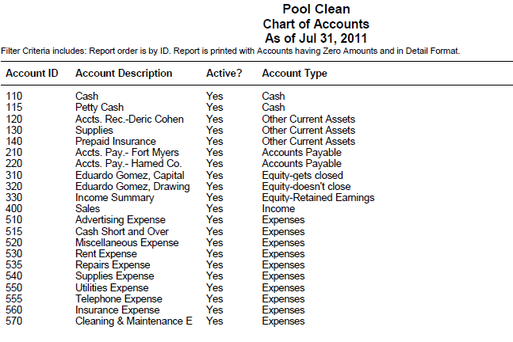

- These are the accounts you will use to journalize and post transactions for 5-C Challenge Problem.

- Click to return to the Select a Report window. Click again to return to the menu bar.

RECONCILING THE BANK STATEMENT AND RECORDING A BANK SERVICE CHARGE

To complete the account reconciliation, use the bank statement, canceled checks, check stubs, and transactions for Pool Clean given in the Working Papers.

Transactions: For Sage 50 Accounting, use July 31, 2011 as the date for the transactions.

July 1 Received bank statement showing July bank service charge, $10.00. M114
1 Received notice from the bank of a dishonored check from Daric Cohen, $320.00, plus $30.00 fee; total, $350.00. M115.

Instructions:

- Refer to the bank statement, canceled checks, and check stubs to complete account reconciliation. Review the bank statement to determine outstanding checks and deposits. Remember to record the bank service charge.
- Follow these steps to print the Account Reconciliation.

a. From the menu bar, select Reports & Forms; Account Reconciliation.
b. The Select a Report or Form window appears. Account Reconciliation is highlighted. Click Print.
c. Make sure that the GL Account ID field shows 110. If not, select Account No. 110 for the Cash account.
d. Click <OK>. Make the selections to print account reconciliation report.
- Close the Select a Report window to return to the menu bar.

- Journalize and post the dishonored check transaction.

- Follow these steps to print the July 31, 2011 general journal.

  - From the menu bar, select Reports & Forms; General Ledger.
  - In the Report or Form list, select General Journal, and click Print.
  - The Modify Report – General Journal window appears. Type 7/31/11 in the From field. Press <Enter>. The To field shows July 31, 2011.
  - Make the selections to print.

- Back up. The suggested filename is 5 Challenge Problem.

You have completed 5-C Challenge Problem: Reconciling a bank statement and recording a bank service charge.

Reinforcement Activity 1—Part A

An Accounting Cycle for a Proprietorship:
Journalizing and Posting Transactions

The instructions that follow demonstrate how to:

- Start Sage 50 Accounting 2016.

- Restore the RA01-A.ptb file.

- Complete Reinforcement Activity 1—Part A.

Before starting Reinforcement Activity 1—Part A, ask the instructor if Extreme Adventures, the company used for Reinforcement Activity 1—Part A, has already been restored on the computer. If Extreme Adventures exists as a Sage 50 Accounting company, remember to restore An Existing Company rather than a new company

GETTING STARTED

Peak Performance is a sole proprietorship owned by Jasmine Quinn. Change the company name from Peak Performance to RA01-AXX (X’s represent your initials).

Nothing has changed on the computer’s hard drive. This company is identified in the program folder and data folder as C:\Sage\Peachtree\Company\peaperfo. The company name has been changed so that Sage 50 Accounting printouts will show the problem number and your initials. Using Maintain>Company Information to rename the company does not change the shortened company name.

DISPLAYING THE CHART OF ACCOUNTS

Before recording transactions, print or display Sage 50 Accounting’s chart of accounts and compare it to the one displayed in the textbook (Reinforcement Activity 1—Part A). Refer to these account numbers when recording transactions.

1. From the menu bar, select Reports & Forms, then General Ledger.

2. The Report or Form window appears. In the General Ledger: Account Information list, click Chart of Accounts.
3. Click .

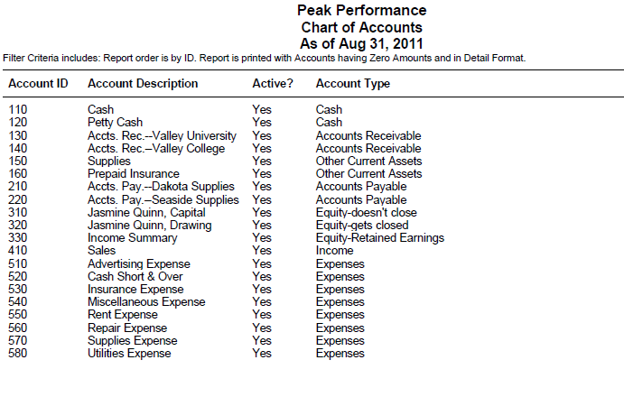

4. These are the accounts you will use to journalize and post transactions for Reinforcement Activity 1—Part A.
5. Click to return to the Select a Report window. Click again to return to the menu bar.

RECORDING TRANSACTIONS

Instructions:

- Using Sage 50 Accounting’s general journal, journalize and post the August 1 through 28 transactions. Use the appropriate check number for each transaction shown in the textbook. For example, type C1 in the Reference field on the General Journal Entry screen.

Read Me

Refer to pages 13 - 16 to review journalizing and posting transactions.

- Using the bank statement information, complete account reconciliation. (Hint: The first deposit that you will check off is the $18,000 cash investment by the owner. The bank statement was received on August 29.)

Bank statement balance $24,295.00
Bank service charge 25.00
Outstanding deposit, May 28 600.00
Outstanding checks:
No. 14 85.00
No. 15 35.00
No. 16 220.00
Checkbook balance on Check Stub. No. 17 $24,580.00

Read Me

Refer to pages 36 and 37 to review reconciling the cash account.

- Print the account reconciliation report.

Read Me

Refer to pages 37 and 38 to review printing the account reconciliation report.

- Journalize and post the following transactions for August 29 through 31.

Aug 29 Received bank statement showing August bank service charge, $25.00. M3
    - Paid cash for supplies, $40.00. C17.
31 Paid cash to replenish the petty cash fund, $130.00: miscellaneous expense, $70.00; repairs, $58.00; cash short, $2.00. C18..
- Paid cash to owner as a withdrawal of equity, $1200.00. C19. C19.
31 Received cash from sales, $3190.00. T31

- Print the general journal.

- Print the general ledger.

- Back up your company data. The suggested filename is Reinforcement Activity 1-Part A.ptb. This backup is important. Keep it in a safe place. You will use it again for Part B of this problem.

Note

Refer to pages 16-18 if you need help backing up your company data.

You have completed the work for Reinforcement Activity 1–Part A, An Accounting Cycle for a Proprietorship—Journalizing and Posting Transactions.

6-M Mastery Problem

Completing a Work Sheet; Journalizing and Posting Adjusting Entries

The instructions that follow demonstrate how to:

- Start Sage 50 Accounting 2016.

- Complete a work sheet.

- Journalize and post adjusting entries in Sage 50 Accounting’s general journal.

- Complete 6-M Mastery Problem.

Before starting 6-M Mastery Problem, ask the instructor if Naples Electric Repair, the company used for 6-M Mastery Problem, has already been restored. If Naples Electric Repair exists as a Sage 50 Accounting company, remember to restore An Existing Company rather than a new company.

GETTING STARTED

Naples Electric Repair is a sole proprietorship owned by Kaelynn Guerero. Change the company name from Naples Electric Repair to 06-MPXX (X’s represent your initials).

Nothing has changed on the computer’s hard drive. This company is identified in the program folder and data folder as C:\Sage\Peachtree\Company\napelere. The company name has been changed so that Sage 50 Accounting printouts will show the problem number and your initials. Using Maintain; Company Information to rename the company does not change the shortened company name.

Displaying Sage 50 Accounting’s Trial Balance

Follow these steps to display Sage 50 Accounting’s General Ledger Trial Balance.

- From Sage 50 Accounting’s menu bar, select Reports & Forms; then General Ledger.

- The Report or Form window appears. In the General Ledger: Account Information list, click General Ledger Trial Balance to highlight it.

- Click .

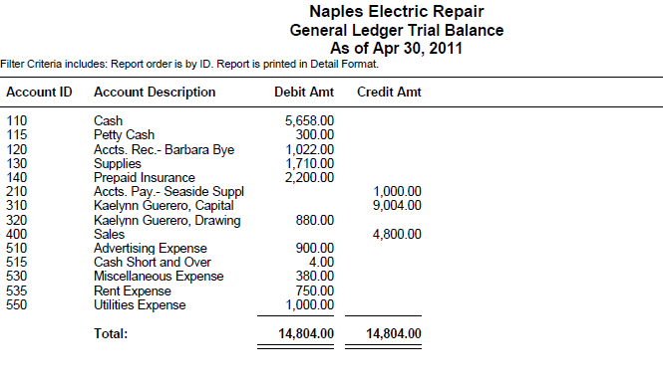

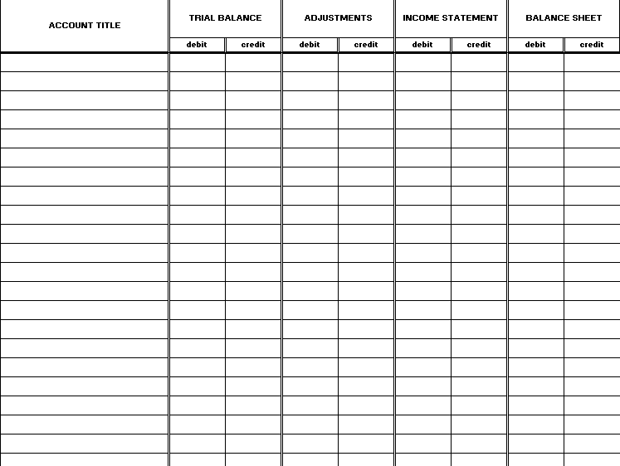

Instructions:

- Complete the work sheet shown. Insert the appropriate column headings. (Or, you may use the work sheet shown in the Working Papers for 6 Mastery Problem.)

- Using information from the adjustments column of your work sheet, journalize and post the adjusting entries in Sage 50 Accounting’s general journal. Use April 30, 2011 as the date. (Or, if you completed 6-5 Mastery Problem in the Working Papers, you can use the adjusting entries that you recorded in the general journal.) Type Adj. entry a or Adj. entry b in the Reference field.

- Print the April 30, 2011 general journal. (Hint: Remember to change the To field to 4/30/11. The From field shows 4/30/11).

- Display or print Sage 50 Accounting’s income statement. (Hint: Reports; Financial Statements, <Standard> Income Statement, make the selections to display or print, uncheck Show Zero Amounts.) Compare Sage 50 Accounting’s income statement to the one completed on the worksheet. Observe that the net loss is shown in parenthesis.

- Display or print Sage 50 Accounting’s Balance Sheet. (Hint: From financial statements Report List, select <Standard> Balance Sheet. Make the selections to display or print.) Compare Sage 50 Accounting’s balance sheet to the one completed on the worksheet. Observe that Sage 50 Accounting organizes the balance sheet differently than the worksheet. The account balance on the worksheet and Sage 50 Accounting’s balance sheet are the same.

- Back up your work. The suggested filename is 6 Mastery Problem.ptb.

You have completed the work for 6-M Mastery Problem: Completing a work sheet; Journalizing and Posting Adjusting Entries

7-M Mastery Problem

Preparing Financial Statements with a Net Loss

The instructions that follow demonstrate how to:

- Start Sage 50 Accounting 2016.

- Print an income statement and balance sheet.

- Complete 7-M Mastery Problem.

Before starting 7-M Mastery Problem, ask the instructor if Eiler Copy Service, the company used for 7-M Mastery Problem, has already been restored. If Eiler Copy Service exists as a Sage 50 Accounting company, remember to restore An Existing Company rather than a new company.

GETTING STARTED

Eiler Copy Service is a sole proprietorship owned by Cheryl Eiler. Change the company name from Eiler Copy Service to 07-MPXX (X’s represent your initials).

Nothing has changed on the computer’s hard drive. The company you set up is identified in the program folder and data folder as C:\Sage\Peachtree\ Computer\eilcopse. The company name has been changed so that Sage 50 Accounting printouts will show the problem number and your initials. Using Maintain; Company Information to rename the company does not change the shortened company name.

Instructions:

- Refer to the Multicolumn worksheet in the textbook. Print an income statement. (Hint: Remember to uncheck Show Zero Amounts.)

- Using a blank piece of paper or the Working Papers, calculate and record the ratios for total expenses and net loss. Place the percentage for net loss in parentheses to show that it is for a net loss. Round percentage calculations to the nearest 0.1%.

- Print the Balance Sheet.

- Back up your work. The suggested filename is 7 Mastery Problem.ptb.

7-C CHALLENGE PROBLEM

PREPARING FINANCIAL STATEMENTS WITH TWO SOURCES OF REVENUE AND A NET LOSS

The instructions that follow demonstrate how to:

- Start Sage 50 Accounting 2016.

- Print an income statement and balance sheet.

- Complete 7-C Challenge Problem.

Before starting 7-C Challenge Problem, ask the instructor if Scow Art School, the company used for 7-C Challenge Problem, has already been restored. If Scow Art School exists as a Sage 50 Accounting company, remember to restore An Existing Company rather than a new company.

GETTING STARTED

Scow Art School is a sole proprietorship owned by Greg Scow. Change the company name from Scow Art School to 07-CPXX (X’s represent your initials).

Nothing has changed on the computer’s hard drive. This company is identified in the program folder and data folder as C:\Sage\Peachtree\Company\scoartsc. The company name has been changed so that Sage 50 Accounting printouts will show the problem number and your initials. Using Maintain; Company Information to rename the company does not change the shortened company name.

Instructions:

- Print an income statement. (Hint: Remember to uncheck Show Zero Amounts.)

- Using a blank piece of paper or the Working Papers, calculate and record the ratios for total expenses and net loss. Place the percentage for net loss in parentheses to show that it is for a net loss. Round percentage calculations to the nearest 0.1%.

- Print the Balance Sheet.

- Back up your work. The suggested filename is 7 Challenge Problem.ptb.

You have completed the work for 7-C Challenge Problem: Preparing financial statements with two sources of revenue and a net loss.

8-M Mastery Problem

Journalizing and Posting Closing Entries with a Net Loss; Preparing a Post-Closing Trial Balance

The instructions that follow demonstrate how to:

- Start Sage 50 Accounting 2016.

- Journalize and post adjusting and closing entries.

- Print a post-closing trial balance.

- Complete 8-M Mastery Problem.

Before starting 8-M Mastery Problem, ask the instructor if Rausch Company, the company used for 8-M Mastery Problem, has already been restored. If Rausch Company exists as a Sage 50 Accounting company, remember to restore An Existing Company rather than a new company.

GETTING STARTED

Rausch Company’s partial work sheet for the month ended October 31, 2011 is shown below. To check the general ledger accounts, you should display or print the general ledger trial balance. The Debit Amt and Credit Amt shown in each account are the account’s balances before adjusting and closing entries are posted.

Rausch Company is a sole proprietorship owned by Rhonda Rausch. Change the company name from Rausch Company to 08-MPXX (X’s represent your initials).

Nothing has changed on your computer’s hard drive. This company is identified in the program folder and data folder as C:\Sage\Peachtree\Company\scoartsc. The company name has been changed so that Sage 50 Accounting printouts will show the problem number and your initials. Using Maintain; Company Information to rename the company does not change the shortened company name.

JOURNALIZING AND POSTING CLOSING ENTRIES

Use the partial worksheet shown in the textbook to complete the closing entries. Or, if you completed 8 Mastery Problem in the Working Papers, use the closing entries recorded in the general journal.

Instructions:

- Journalize and post the closing entries in Sage 50 Accounting’s general journal. For the first closing entry, type Closing entries in the Reference field.

- Follow these steps to print the October 31 general journal.

  - From Sage 50 Accounting’s menu bar, select Reports & Forms, then General Ledger.

  - Click the General Journal to highlight it.
  - Click . Select 31 as the date in the From calendar field. The date changes to Oct 31, 2011. The To field also shows Oct 31, 2011.

  - Make the selections to print.

- Print the general ledger.

- Follow these steps to print a post-closing trial balance.

  - From Sage 50 Accounting’s menu bar, select Reports & Forms, then General Ledger.

  - Click General Ledger Trial Balance to highlight it.
  - Click . Make the selections to print.

- Back up your data. The suggested filename is 8 Mastery Problem.ptb.

You have completed the work for 8-M Mastery Problem Journalizing and posting adjusting and closing entries with a net loss; preparing a post-closing trial balance.

8-C CHALLENGE PROBLEM

JOURNALIZING AND POSTING CLOSING ENTRIES WITH TWO REVENUE ACCOUNTS AND A NET LOSS; PREPARING A POST-CLOSING TRIAL BALANCE

The instructions that follow demonstrate how to:

- Start Sage 50 Accounting 2016.

- Journalize and post closing entries.

- Print a post-closing trial balance.

- Complete 8-C Challenge Problem.

Before starting 8-C Challenge Problem, ask the instructor if Yanta’s Yard Care, the company used for 8-C Challenge Problem, has already been restored. If Yanta’s Yard Care exists as a Sage 50 Accounting company, remember to restore An Existing Company rather than a new company.

GETTING STARTED

Yanta’s Yard Care’s partial work sheet for the month ended June 30, 2011 is shown below. To check the general ledger accounts, you should display or print the general ledger trial balance. The Debit Amt and Credit Amt shown in each account are the account’s balances before adjusting and closing entries are posted.

Yanta’s Yard Care is a sole proprietorship owned by Jon Yanta. Change the company name from Yanta’s Yard Care to 08-CPXX (X’s represent your initials).

Nothing has changed on your computer’s hard drive. This company is identified in the program folder and data folder as C:\Sage\Peachtree\Company\yanyarca. The company name has been changed so that Sage 50 Accounting printouts will show the problem number and your initials. Using Maintain; Company Information to rename the company does not change the shortened company name.

JOURNALIZING AND POSTING CLOSING ENTRIES

Use the partial worksheet shown above to complete the closing entries. Or, if you completed 8-C Challenge Problem in the Working Papers, use the closing entries recorded in the general journal.

Instructions:

- Journalize and post the closing entries in Sage 50 Accounting’s general journal. For the first closing entry, type Closing entries in the Reference field.

- Print the June 30, 2011 general journal.

- Print a post-closing trial balance.

- Back up your data. The suggested filename is 8 Challenge Problem.ptb.

- Jon Yanta, owner of Yanta’s Yard Care, is disappointed that his business incurred a net loss for June. Mr. Yanta would have preferred not to have to reduce his capital by $880.00. He knows that you are studying accounting, so Mr. Yanta asks you to analyze his work sheet for June. Based on your analysis of the work sheet, what would you suggest might have caused the net loss? What steps would you suggest so that Mr. Yanta can avoid a net loss in future months? (Use the Working Papers or a blank piece of paper to answer this question.)

You have completed the work for 8-C Challenge Problem Journalizing and posting adjusting and closing entries with two revenue accounts and net loss; preparing a post-closing trial balance.
Reinforcement Activity 1— Part B

An Accounting Cycle for a Proprietorship:
End-of-Fiscal-Period Work

The instructions that follow demonstrate how to:

- Start Sage 50 Accounting 2016.

- Restore data from Reinforcement Activity 1—Part A, Peak Performance, to complete Part B.

- Complete Reinforcement Activity 1—Part B.

You must complete the Reinforcement Activity 1—Part A, pages 43-45, before starting Reinforcement Activity 1—Part B.

GETTING STARTED

Follow these instructions to restore data from Reinforcement Activity 1—Part A.

- Start Sage 50 Accounting.

- At the startup menu, select Open an existing company. From the Open list, select Extreme Adventures. If Extreme Adventures is not listed, click Browse. Select Extreme Adventures from the Company Name list.

Read Me: What if Extreme Adventures is not listed on either the Open list or when I select Browse?

- Use Windows Explorer to see if you have a program and data path identified as C:\Sage\Peachtree\Company\peaperfo. Close Windows Explorer.
- From Sage 50 Accounting’s Open list, select Peak Performance. It may be identified by RA01-AXX. The X’s stand for a student’s initials.
- Restore the backup file made on page 45. The suggested filename was Reinforcement Activity A-Part A.ptb. Once you restore the backup file that you made on page 45, you will be able to start where you left off the last time you worked with Peak Performance.

If you have checked Windows Explorer and Peak Performance does not have a folder (\peaperfo), do the following.

- Start Sage 50 Accounting. If a company opens, click File; Close Company to go to Sage 50 Accounting’s startup window.
- On Sage 50 Accounting’s startup window, there are three menu bar options . Select File; Restore.
- Browse to the location of the Reinforcement Activity 1-Part A.ptb backup file. Restore A New Company. Sage 50 Accounting will restore the backup data and create the company at the same time.

  - From Sage 50 Accounting’s menu bar, click File; Restore.

  - Check the Location field to make sure you are restoring the correct file. Click .

  - The Select Company window defaults to An Existing Company. The Company Name field shows Extreme Adventures. The Location field shows C:\Sage\Peachtree\Company\perperfo. Click .

  - The Restore Options window appears. Make sure that the box next to Company Data is checked. Click .

  - The Confirmation window appears. Observe that the Company Name is Extreme Adventures. Check the From and To fields to make sure they are correct. Click . When the Restore Company scale is 100% complete, your data is restored and you are returned to the menu bar.

  - If necessary, remove the external media. You can now continue with Reinforcement Activity 1—Part B.

CHANGING THE COMPANY NAME

In order to make sure that each one of your printouts shows your name and problem number, follow these steps to change the name of the company.

- From Sage 50 Accounting’s menu bar, select Maintain, then Company Information.

- The Maintain Company Information screen appears. In the Company Name field, type RA01-BXX. Replace the X’s with your initials.
- When you are finished typing RA01-BXX as the company name, click . Once you have changed the Company Name, each one of your printouts will show the problem number and your initials.

Nothing has changed on the computer’s hard drive. This company is identified in the program folder and data folder as C:\Sage\Peachtree\Company\peaperfo. What you’ve done is changed the company name so that printouts will show the problem number and your initials. Using Maintain, Company Information to rename your company does not change the filename of the company folder.

JOURNALIZING AND POSTING ADJUSTING ENTIRES

Instructions:

- After restoring the backup that you made at the end of Reinforcement Activity 1—Part A, print a general ledger trial balance. This is the unadjusted trial balance. Compare it to the one shown below. If you completed the worksheet in your Working Papers, compare this trial balance to the one on your worksheet.

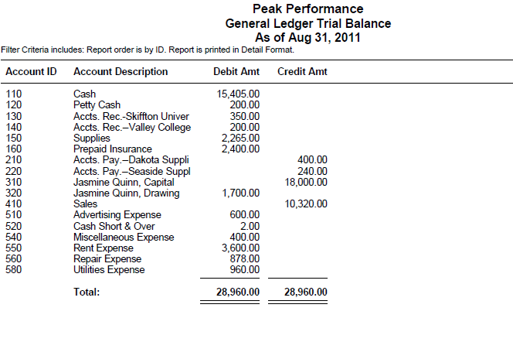

- Analyze the following adjustment information into debit and credit parts.

Adjustment Information, August 31

Supplies on hand $ 845.00
Value of prepaid insurance 2,200.00

- Using the August 31 adjustment information, journalize and post the adjusting entries in Sage 50 Accounting’s general journal. Or, if you completed Reinforcement Activity 1--Part B in the Working Papers, you can use the adjusting entries that you recorded in the general journal. Type Adjustment a or Adjustment b in the Reference field.

- Follow these steps to print an income statement.

  - From Sage 50 Accounting’s menu bar, select Reports & Forms, then Financial Statements.

  - Click <Standard> Income Stmnt to highlight it.

Read Me

Sage 50 Accounting’s standard income statement is a predefined form that is included with the software. Along with Revenues and Expenses, Sage 50 Accounting’s standard income statement also shows a Cost of Sales section. Cost of Sales will be covered later in your textbook and in this book. For now, observe that there are zeroes in the Cost of Sales section and that Gross Profit is the same amount as Total Revenues.

  - Click . Uncheck the boxes next to Print Page Numbers and Show Zero Amounts. Make the selections to print.

3. Follow these steps to print a balance sheet.

  - From the Select a Report or Form screen, click <Standard> Balance Sheet to highlight it.
  - Click . Make the selections to print.

- Back up your work. The suggested filename is Reinforcement Activity-Part B.adjusted.ptb.

JOURNALIZING AND POSTING CLOSING ENTRIES

Instructions:

- Journalize and post the closing entries in Sage 50 Accounting’s general journal. If you completed the Working Papers, you can use the closing entries shown there or use your income statement (or the unadjusted trial balance) for closing entry information. Type Closing entries in the Reference field.

- Follow these steps to print the August 31 general journal.

  - From Sage 50 Accounting’s menu bar, select Reports & Forms, then General Ledger.

  - Click the General Journal to highlight it.
  - Click . Select 31 as the date in the From calendar field. The date changes to August 31, 2011. The To field also shows August 31, 2011.

  - Make the selections to print.

Read Me: Why does my August 31 general journal show more than the adjusting and closing entries?

The general journal transactions shown for Peak Performance include two other August 31 transactions—a cash sale for $3,190.00 and the bank service charge of $25.00. Since you are printing a August 31 general journal, all the transactions journalized and posted for that date are shown. These include the adjusting and closing entries and the two other entries for the same date.

- Follow these steps to print a post-closing trial balance.

  - From the Report or Form List, click the General Ledger Trial Balance to highlight it.

  - Click . Make the selections to print.

- Back up your data. The suggested filename is Reinforcement Activity 1-Part B.closed.ptb.

You have completed the work for Reinforcement Activity 1—Part B: An Accounting Cycle for a Proprietorship: End-of-Fiscal-Period Work.

9-M Mastery Problem

Journalizing Purchases, Cash Payments, and Other Transactions

The instructions that follow demonstrate how to do:

- Start Sage 50 Accounting 2016.

- Restore the starting data.

- Journalize and post Purchases Journal and Cash Disbursements Journal transactions.

- Complete 9-M Mastery Problem.

Before starting 9-M Mastery Problem, ask the instructor if Denmar Automotive, the company used for 9-M Mastery Problem, has already been restored. If Denmar Automotive exists as a Sage 50 Accounting company, remember to restore An Existing Company rather than a new company.

GETTING STARTED

Refer to pages 2 through 8 to restore a Sage 50 Accounting file from the Sage 50 Files folder. Each time you begin a problem, restore the starting data from a Sage 50 Accounting file. Then, pages 9 through 11 explain how to change the company name to include your initials.

Denmar Automotive is a corporation that sells car parts and accessories. Change the company name from Denmar Automotive to 09-MPXX (X’s represent your initials).

Nothing has changed on your computer’s hard drive. This company is identified in the program folder and data folder as C:\Sage\Peachtree\Company\ denautom. The company name has been changed so that Sage 50 Accounting printouts will show the problem number and your initials. Using Maintain; Company Information to rename the company does not change the shortened company name.

DISPLAYING THE CHART OF ACCOUNTS

The data that you restored from the Sage 50 Files folder contains starting data for 9 Mastery Problem. This file includes a chart of accounts for Denmar Automotive. Follow these steps to display the chart of accounts that is included in the starting data for 9 Mastery Problem.

- From the menu bar, select Reports & Forms, then General Ledger.

- The Select a Report or Form window appears. In the General Ledger: Account Information list, click Chart of Accounts.
- Click .
- The Chart of Accounts Filter window appears. Click . Compare your chart of accounts to the one shown.

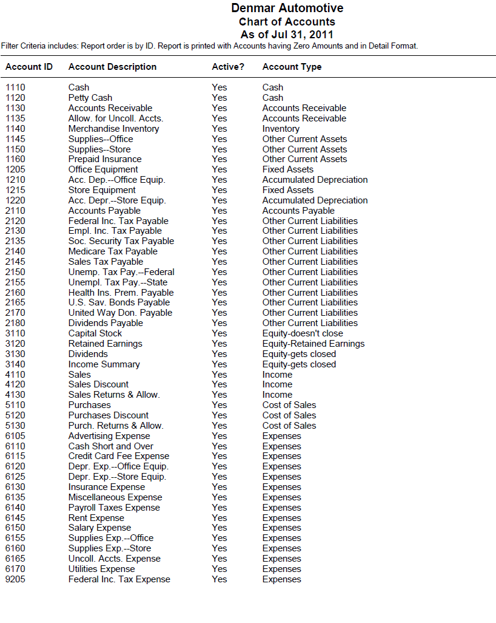

JOURNALIZING TRANSACTIONS

From the textbook, use the July transactions to journalize and post to the purchase journal and cash disbursement journal. (In Sage 50 Accounting, the cash payments journal is called the cash disbursements journal.) The instructions that follow explain the steps for using Sage 50 Accounting’s Cash Disbursements Journal and Purchase Journal.

Purchase Journal: Purchasing Merchandise on Account

Sage 50 Accounting’s Purchases/Receive Inventory task is used when merchandise or assets are purchased on account. Notice that the Sage 50 Accounting process is different than the process described in your accounting textbook. If you completed the problem manually using the Working Papers, you used the general journal to record the purchase of assets and the purchases journal to record the purchase of merchandise. In Sage 50 Accounting, whenever you make a purchase from a vendor (whether it is merchandise or an asset), you use the Purchases/Receive Inventory task. The Purchases/Receive Inventory task functions as the purchases journal. Another difference is the return of merchandise. In Sage 50 Accounting, whenever merchandise is returned to a vendor, you use the Vendor Credit Memos task not the general journal.

Your textbook shows the following transaction for July 2.

Date Transaction

July 2 Purchased merchandise on account from Rackley Industries, $2,950. P184.

In Sage 50 Accounting, the Purchases/Receive Inventory task functions as the Purchase Journal. Each time you record a purchase of merchandise on account, Sage 50 Accounting debits Account 5110, Purchases; and credits the selected vendor and accounts payable.

Instructions

- The Denmar Automotive menu bar should be displayed and the 09-MP.ptb file restored. From the Navigation bar, select and click the 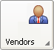 icon. Then, choose New Bill and the Purchases/Receive Inventory screen appears.

- Select RI240 Rackley Industries as the vendor.

- Type or select 2 as the Date.

- Type P184 in the Invoice No. field.

- Make sure the Apply to Purchases tab is selected. Type 1 in the Quantity column.

- Type Merchandise purchased on account in the Description column.

- Make sure that Account No. 5110, Purchases, is shown in the GL Account column.

- Type 2950 as the Unit Price. (Hint: The Amount column should also show 2,950.00.)

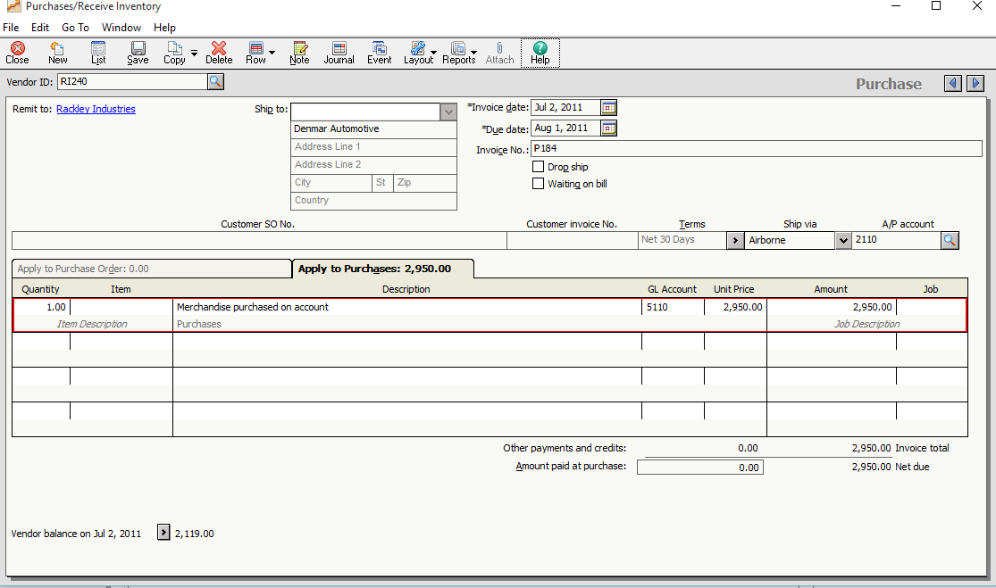

- Post this purchase.

- Close the Purchases/Receive Inventory screen.
Cash Disbursements Journal: Making a Vendor Payment

Use these steps to journalize and post the July 3 transaction.

Date Transaction

July 3 Paid cash on account to Helms Supply, $1,280.00, covering P166, less 2% discount. C318.

Each time you pay a vendor in Sage 50 Accounting, you use the Cash Disbursements Journal (this is referred to as the Cash Payments Journal in the textbook). This is done by selecting Tasks, then Payments.

- From the Navigation bar, select and click the 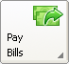 icon. Then, choose Pay Bill.

- The Select a Cash Account window appears.

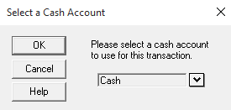

- Make sure Cash is selected; then click . The Payments window appears.

- In the Vendor ID field, select Pacific Industries.

- Type C318 as the Check Number.

- Type or select 3 in the Date field. Notice that the Apply to Invoices tab is selected and that Invoice No. P166 is shown.

- Type 28.00 in the Discount column.

Note:

Since the July 3 transaction is payment for Helms Supply’s beginning balance (invoice from June), you need to type 2% Discount ($1,280 x .2% = $25.60). On July 1 payment is made to Rackley Industries, less a 2% discount. Sage 50 Accounting will automatically compute Rackley Industries’ 2% discount.

- Click the Pay box. The upper portion of the Payments window shows a check. Notice that once you clicked the Pay box 1,254.40 is automatically completed in the $ field. Also, the Discount Account field shows Account No. 5120, Purchases Discounts.

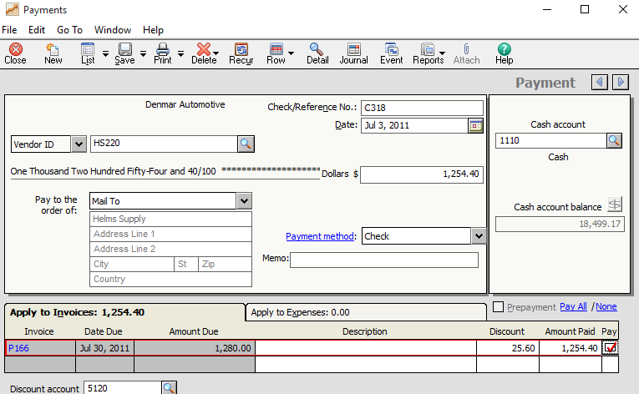

- Post (Save) this payment, and then close the Payments window.

- Complete the July 6 transaction. Refer to the transactions shown in the book. Remember, you have already journalized and posted transactions for July 2 and 3.

Cash Disbursements Journal: Paying Cash for Expenses

In Sage 50 Accounting, the Write Checks task is used to pay cash for expenses. The Write Checks task is also the cash disbursements journal. Each time you write a check for an expense, use the Write Checks task. For example, when you record a transaction to pay for advertising, you select the appropriate account to debit; then, Sage 50 Accounting automatically credits cash. When you record a transaction to pay a vendor account, use the Payments task. Both the Write Checks task (used to pay expenses) and the Payments task (used to pay vendors), posts to the Cash Disbursements Journal.

Use these steps to journalize and post the July 7 transaction.

Date Transaction

July 7 Paid cash to WCKF Radio for advertising, $800.00. C319.

Instructions

- From the Navigation bar, select and click the 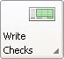 icon. Then, select New Check.

- If the select a Cash Account screen appears, make sure Cash is shown.

- If necessary, click on the Select a Cash Account window. The Write Checks window appears.

- Your cursor is in the Vendor ID field. Since you are going to issue a check for advertising, press the <Enter> key so that your cursor is in the Pay to the Order of field. Type WCKF Radio in the Pay to the Order of field.

- Click the Check Number field. Type C319 in the Check Number field. Press <Enter>.

- Type or select 7 in the Date field.

- Type 800 in the $ field.

- In the Expense Account field, select Account No. 6105, Advertising Expense. Observe that the Description field is automatically completed.

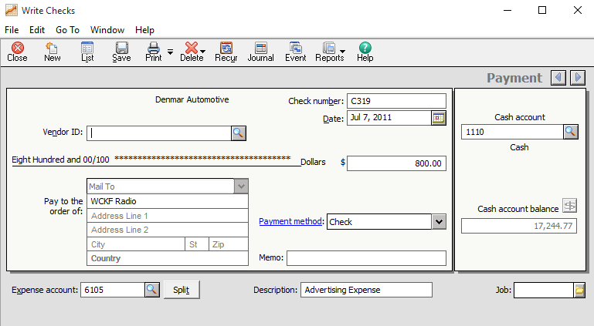

If you click , observe that this transaction is shown in the Cash Disbursements Journal as a debit to Account No. 6105, Advertising Expense; and a credit to Account No. 1110, Cash. Close the Accounting Behind the Screens window.

- Click  to post.

- Journalize and post the July 8, 9, 10, 11 transactions. Refer to the transactions shown in this book. (Hint: Remember when assets are purchased, for example Supplies—Store, select the appropriate GL account to debit on the Purchases/Receive Inventory window.) Sage 50 Accounting automatically computes the vendor discount; for example, the July 11 payment to Woodland Computers includes a 2% discount. When you record this payment, observe that the Discount column is automatically completed.

Split Transactions: Write Checks Task

For the second July 31 transaction to replenish the Petty Cash fund, use the Write Checks task. Follow these steps to record a compound transaction).

Date Transaction

July 31 Replenished the $200.00 petty cash fund, Receipts were submitted for the following: office supplies, $45.60; store supplies, $67.30; miscellaneous, $23.89; a cash count shows $61.98 in the petty cash box. C330.
- From the Navigation bar, select and click the icon. Then, choose New Check.

- Type Petty Cash Fund in the Pay to the Order of field.

- Type C330 in the Check Number field.

- Type 31 in the Date field.

- Type 138.02 in the $ field.

- Click . The Split Transaction window appears. Complete the following fields.

Account No. Description Amount

1145 Supplies—Office 45.60
1150 Supplies—Store 67.30
6135 Miscellaneous Expense 23.89
6110 Cash Short and Over 1.23

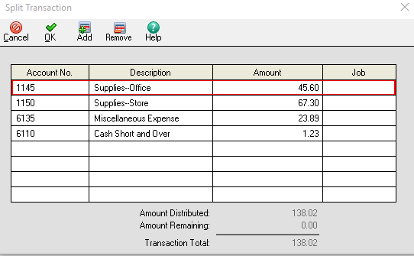

- Click . You are returned to the Write Checks window. Observe that the Expense account field is grayed with the icon blackened.

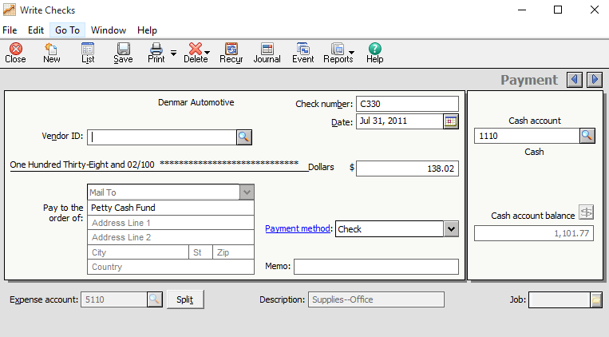

- Post and close the Write Checks window.
Printing the Cash Disbursements Journal

- From the Reports & Forms menu, select Accounts Payable; Cash Disbursements Journal.

- Make the selections to print.

Printing the Purchases Journal

- From the Reports & Forms List, select Purchase Journal.

- Make the selections to print.

- Back up. The suggested filename is 9 Mastery Problem.

You have completed the work for 9-M Mastery Problem Journalizing purchases, cash payments, and other transactions.

9-C Challenge Problem

Journalizing Purchases and Cash Payments

The instructions that follow demonstrate how to:

- Start Sage 50 Accounting 2016.

- Restore the starting data.

- Journalize and post Purchases Journal and Cash Disbursements Journal transactions.

- Complete 9-C Challenge Problem.

Before starting 9-C Challenge Problem, ask the instructor if SoundStage Music, the company used for 9-C Challenge Problem, has already been restored. If SoundStage Music exists as a Sage 50 Accounting company, remember to restore An Existing Company rather than a new company.

GETTING STARTED

Refer to pages 2 through 8 to restore a Sage 50 Accounting file from the Sage 50 Files folder. Each time you begin a problem, restore the starting data from a Sage 50 Accounting file. Then, pages 9 through 11 explain how to change the company name to include your initials.

SoundStage Music is a Corporation that sells car parts and accessories. Change the company name from SoundStage Music to 09-CPXX (X’s represent your initials).

Nothing has changed on your computer’s hard drive. This company is identified in the program folder and data folder as C:\Sage\Peachtree\Company\soumusic. The company name has been changed so that Sage 50 Accounting printouts will show the problem number and your initials. Using Maintain; Company Information to rename the company does not change the shortened company name.

DISPLAYING THE CHART OF ACCOUNTS

The data that you restored from the Sage 50 Files folder contains starting data for 9 Challenge Problem. This file includes a chart of accounts for SoundStage Music. Follow these steps to display the chart of accounts that is included in the starting data for 9 Challenge Problem.

- From the menu bar, select Reports & Forms, then General Ledger.

- The Select a Report or Form window appears. In the General Ledger: Account Information list, click Chart of Accounts.
- Click .

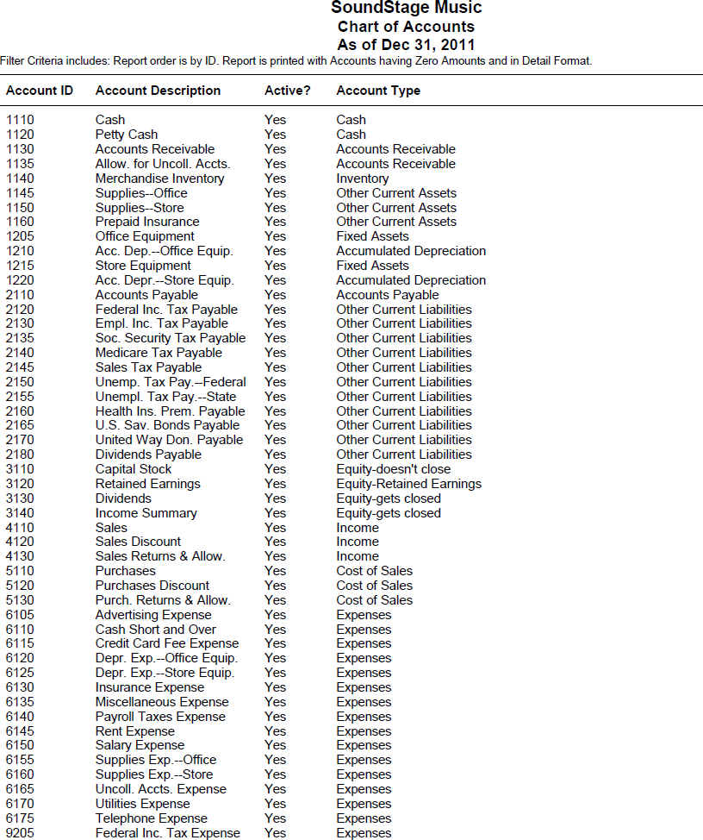

- The Chart of Accounts Filter window appears. Click . Compare your chart of accounts to the one shown.

Instructions:

- From the textbook, journalize and post the December transactions in Sage 50 Accounting’s Purchase Journal and Cash Disbursements Journal. (Hint: When paying vendors, make sure that the Purchase Discount is calculated correctly.)

- Print the Purchase Journal.

- Print the Cash Disbursements Journal.

- Back up. The suggested filename is 9 Challenge Problem.ptb.

You have completed the work for 9-C Challenge Problem Journalizing purchases, cash payments, and other transactions.

10-M Mastery Problem

Journalizing Sales and Cash Receipts Transactions

The instructions that follow demonstrate how to:

- Start Sage 50 Accounting 2016.

- Restore the starting data.

- Journalize and post Sales Journal and Cash Receipts Journal transactions.

- Complete 10-M Mastery Problem.

Before starting 10-M Mastery Problem, ask the instructor if University Designs, the company used for 10-M Mastery Problem, has already been restored on the computer. The following instructions explain how to set up the University Designs company for the first time.

GETTING STARTED

Refer to pages 2 through 8 to restore a Sage 50 Accounting file from the Sage 50 Files folder. Each time you begin a problem, restore the starting data from a Sage 50 Accounting file. Then, pages 9 through 11 explain how to change the company name to include your initials.

University Designs is a Corporation that installs and maintains swimming pools and spas. Change the company name from University Designs to 10-MPXX (X’s represent your initials).

Nothing has changed on your computer’s hard drive. This company is identified in the program folder and data folder as C:\Sage\Peachtree\Company\ unidesig. The company name has been changed so that Sage 50 Accounting printouts will show the problem number and your initials. Using Maintain; Company Information to rename the company does not change the shortened company name.

DISPLAYING THE CHART OF ACCOUNTS

The data that you restored from the Sage 50 Files folder contains starting data for 10-M Mastery Problem. This file includes a chart of accounts for University Designs. Follow these steps to display the chart of accounts that is included in the starting data for 10 Mastery Problem.

- From the menu bar, select Reports & Forms, then General Ledger.

- The Select a Report or Form window appears. In the General Ledger: Account Information list, click Chart of Accounts.
- Click .
- The Chart of Accounts Filter window appears. Click . Compare your chart of accounts to the one shown.

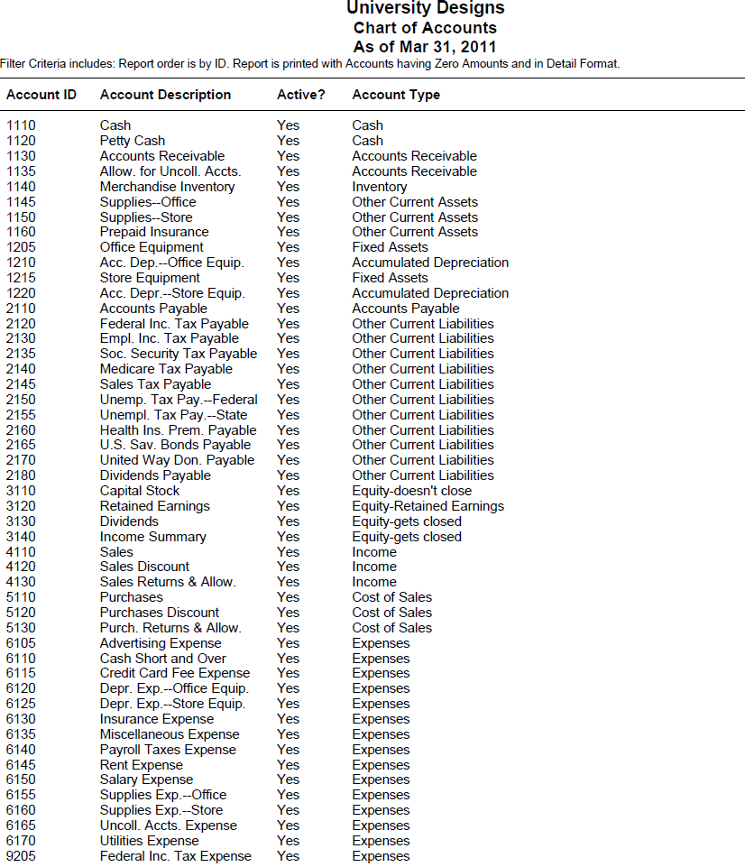

- The Chart of Accounts Filter window appears. Click . Compare your chart of accounts to the one shown.

JOURNALIZING SALES AND CASH RECEIPTS TRANSACTIONS

The transactions for University Designs dated March 4 through March 16 are associated with the sales journal and cash receipts journal. The instructions that follow describe steps for recording transactions in Sage 50 Accounting’s Sales Journal and Cash Receipts Journal.

Sage 50 Accounting’s Sales Journal

The following March 3 sales journal transaction is shown. The sales tax rate for the 10-M Mastery Problem is 7%.

Date Transaction

Mar 3 Sold merchandise on account to Trailer Stores, $3,248.00, plus sales tax. S321.

In Sage 50 Accounting, the Sales/Invoicing task functions as the Sales Journal. Each time you enter a credit sale, Sage 50 Accounting automatically debits the customer’s account and Accounts Receivable. The credit side of the transaction defaults to Account No. 4110, Sales. You can also credit account(s) that you specify.

Instructions

- From the Navigation bar select , and click the 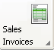 icon. Then, select New Sales Invoice. The Sales/Invoicing window appears.

- Your cursor is in the Customer ID field. Select Trailer Stores as the customer.

- Type 3 (or select 27) as the Date.

- Type S321 in the Invoice No. field. Press <Enter>.

- Make sure that the Apply to Sales tab is selected.

- Type 1 in the Quantity column. Press <Enter> two times.

- Type Sold merchandise on account in the Description column. Press <Enter>.

- Observe that Account No. 4110, Sales, is shown in the GL Account column. Press <Enter>.

- Type 3248 in the Unit Price column. Press <Enter> four times.

- Type 1 in the Quantity column. Press <Enter> two times.

- Type Sales Tax Payable in the Description column.

- Select Account No. 2145, Sales Tax Payable, in the GL Account column.

- Type 227.36 in the Unit Price column. Observe that the Net Amount Due is 3475.36. (Hint: This is shown at the bottom of the Sales/Invoicing window.)

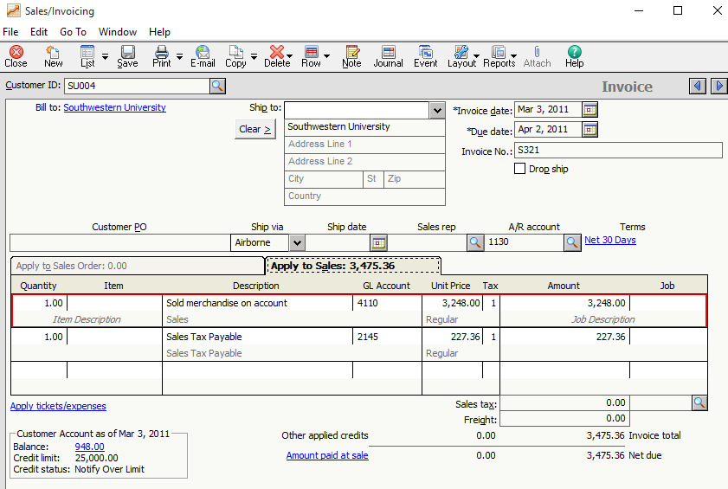

Note:

If the GL Account column does not appear on the Sales/Invoicing window, it is because the Hide General Ledger Accounts option is selected. The boxes in the Hide General Ledger Accounts area must be unchecked. From the menu bar on the Sales/Invoicing window, select Edit; Global Options. The Maintain Global Options window appears, uncheck the three boxes in the Hide General Ledger Accounts area.

Observe that Account No. 1130 is shown as the A/R Account. This is shown at the middle, right side of the window, and confirms that the accounts receivable account (Account No. 1130) is being debited.
- You can also click  to see how this transaction is shown in the Sales Journal.

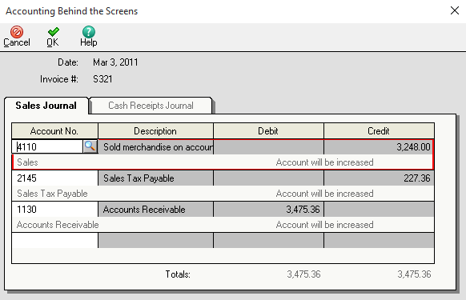

15. Click  to close the Accounting Behind the Screen window
16. Click  to post this transaction.

- Close the Sales/Invoicing window.

Sage 50 Accounting’s Cash Receipts Journal

Date Transaction

Mar 4 Received cash on account from Jenkins & Sanders LLP, covering S312 for $945.00, R348.

In Sage 50 Accounting, the Receive Money task functions as the Cash Receipts Journal. Each time you enter a cash receipt, Sage 50 Accounting automatically debits Cash. The offsetting credit part of the transaction goes to Sales or the account that you specify.

Instructions

- From the Navigation bar, select and click the 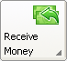 icon, then choose Receive Money from Customer. The Select a Cash Account window appears.

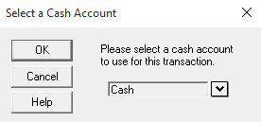

- Make sure Cash is selected. Click . The Receive Money window appears.

- Your cursor is in the Deposit ID field. Type the transaction date 03/04/11 and press the <Enter> key.

- In the Customer ID field, select Jenkins & Sanders LLP. Observe that the Apply to Invoices tab is selected.

- Type S435 in the Reference field. Press <Enter>.

- Type R293 in the Receipt Number field. Press <Enter>.

- Type 4 in the Date field. Press <Enter>.

- Verify that Account No. 1110, Cash, is displayed in the Cash Account field. Observe that the Balance field displays 6,544.15. That is the starting balance in Account No. 1110, Cash.

- If necessary, click the Apply to Invoices tab.

- Type Received cash on account in the Description column. Press <Enter>.

- Click the Pay box for Invoice S312 to place a check mark in it. Observe that the Amount Paid column and the Receipt Amount fields (945.00) are automatically completed.

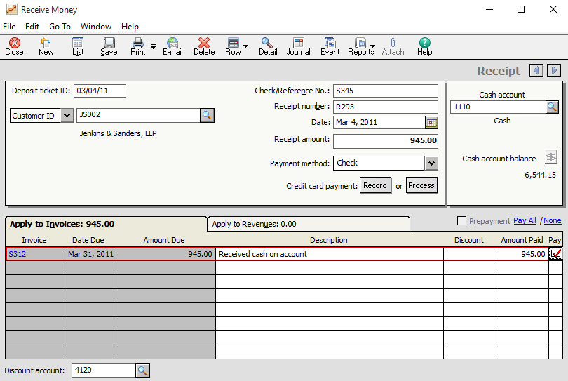
- Click to post.

- Close the Receive Money window.

Observe that Account No. 1130 is shown as the A/R Account. This is shown at the middle, right side of the window, and confirms that the accounts receivable account (Account No. 1130) is being debited.
14. You can also click to see how this transaction is shown in the Sales Journal.

- Click to post this transaction.

- Close the Sales/Invoicing window.

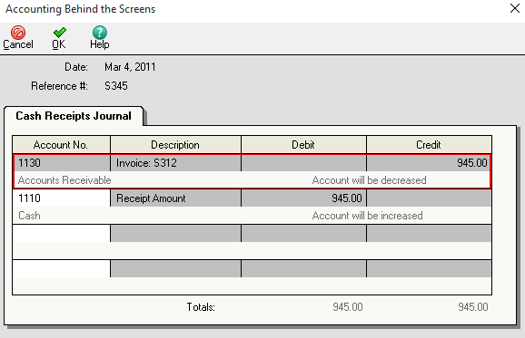

- Journalize and post the March 5 cash and credit card receipt transaction. (Hint: Use the Receive Money task to record cash and credit card sales. Type the terminal summary (TS) number in the Reference field. Use the transaction date for the Deposit Ticket ID.)

Recording a Cash Receipt with a Discount

Date Transaction

Mar 9 Received cash on account from Luxury Suites, 4219.00, covering S320, less a 2% discount. R349.

In Sage 50 Accounting, the Receive Money task functions as the Cash Receipts Journal. Each time you enter a cash receipt, Sage 50 Accounting automatically debits Cash. The offsetting credit part of the transaction goes to Sales or the account that you specify.

Instructions

- From the Navigation bar, select and click the icon, then choose Receive Money from Customer. The Select a Cash Account window appears.

- Your cursor is in the Deposit ID field. Type the transaction date 03/09/11 and press the <Enter> key.

- In the Customer ID field, select Luxury Suites. Observe that the Apply to Invoices tab is selected.

- Type S320 in the Reference field. Press <Enter>.

- Type R349 in the Receipt Number field. Press <Enter>.

- Type 9 in the Date field. Press <Enter>.

- Verify that Account No. 1110, Cash, is displayed in the Cash Account field. Observe that the Balance field displays 9066.29. That is the starting balance in Account No. 1110, Cash.

- If necessary, click the Apply to Invoices tab.

- Type Received cash on account in the Description column. Press <Enter>.

- Since there is a 2% discount, type 84.38 in the Discount column. (Make sure account 4120, Sales Discount, is selected.

- Click the Pay box for Invoice S320 to place a check mark in it. Observe that the Amount Paid column and the Receipt Amount fields (9,066.29) are automatically completed.
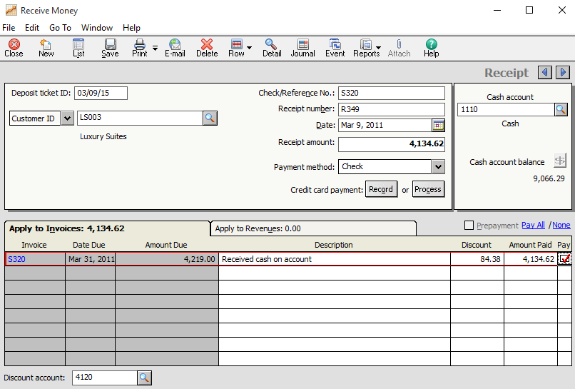

- Click to post this transaction.

- Close the Sales/Invoicing window.

- Journalize and post the March 10, 12 and 16 transactions.

- For the March 31credit of $4,174.46 in the General Ledger cash account, Sage 50 Accounting requires an extra general journal entry (Hint: Debit Store Equipment). Please see the General Ledger in the Working Papers.

PRINTING THE SALES JOURNAL

Follow these steps to print the sales journal.

- From the menu bar, click Reports & Forms; Accounts Receivable. From the Select a Report or Form List, click Sales Journal to highlight it.

- Click . In the From calendar field, select Mar 3, 2011. The To calendar field shows Mar 10, 2011.

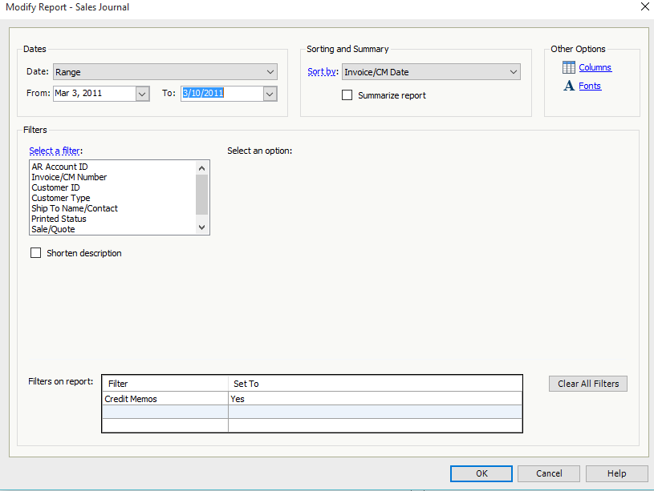

3. Make the selections to print.

PRINTING THE CASH RECEIPTS JOURNAL

- From the Select a Report or Form List, click Cash Receipts Journal to highlight it.
- Click . Select Mar 4, 2011 in the From calendar field. The To field shows Mar 16, 2011.
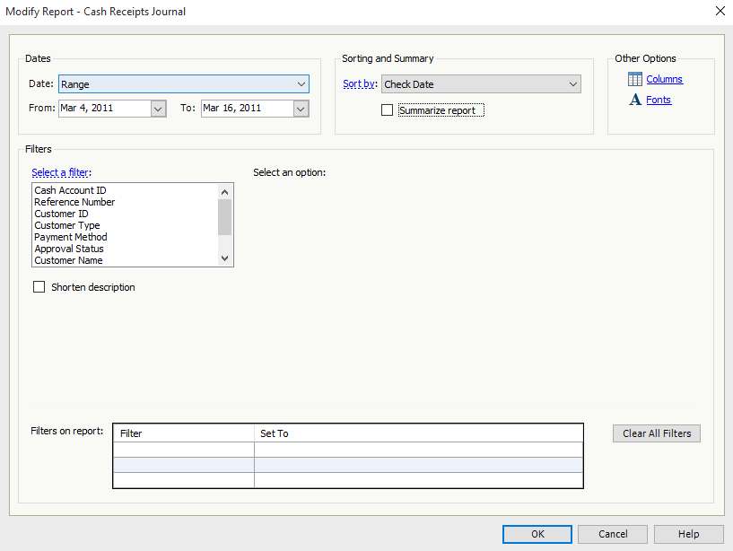

- Make the selections to print the cash receipts journal.

- Print the Customer Ledgers. From the menu bar, select Reports & Forms; Accounts Receivable, Customer Ledgers.

4. Back up your work. The suggested filename is 10 Mastery Problem.

You have completed the work for 10-M Mastery Problem Journalizing sales and cash receipts transactions.

10-C Challenge Problem

Journalizing Sales and Cash Receipts

The instructions that follow demonstrate how to:

- Start Sage 50 Accounting 2016.

- Restore the starting data.

- Journalize and post Sales Journal and Cash Receipts Journal transactions.

- Complete 10-C Challenge Problem.

Before starting 10-C Challenge Problem, ask the instructor if Innovative Technology, the company used for 10-C Challenge Problem, has already been restored on the computer. The following instructions explain how to set up the Innovative Technology company for the first time.

GETTING STARTED

Refer to pages 2 through 8 to restore a Sage 50 Accounting file from the Sage 50 Files folder. Each time you begin a problem, restore the starting data from a Sage 50 Accounting file. Then, pages 9 through 11 explain how to change the company name to include your initials.

In Sage 50 Accounting, Innovative Technology is set up as a corporation. This merchandising company specializes in selling computer and network equipment to small businesses. Change the company name from Innovative Technology to 10-CPXX (X’s represent your initials).

Nothing has changed on your computer’s hard drive. This company is identified in the program folder and data folder as C:\Sage\Peachtree\Company\inntechn. The company name has been changed so that Sage 50 Accounting printouts will show the problem number and your initials. Using Maintain; Company Information to rename the company does not change the shortened company name.

Instructions

- The 10-CP problem file should be restored and the Innovative Technology menu bar displayed. From the textbook, journalize and post in the appropriate journal the Dec. 2-24 transactions. The sales tax rate is 6%. Calculate and add the appropriate sales tax amount to each sale.

- Add account 4140 Unearned Sales Discount, Account Type Income.

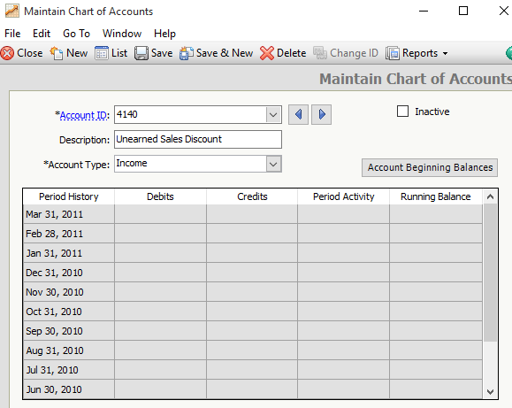

- When entering transactions in the Receive Money window, remember to select the appropriate sales discount account in the Discount account field . If the receipt is received by the sales discount due date then select account 4120 Sales Discount. If not, then select account 4140 Unearned Sales Discount.

- The December 7 cash receipt requires two separate transactions to be recorded in Sage 50 Accounting. First, record and post the receipt of $3000.00.

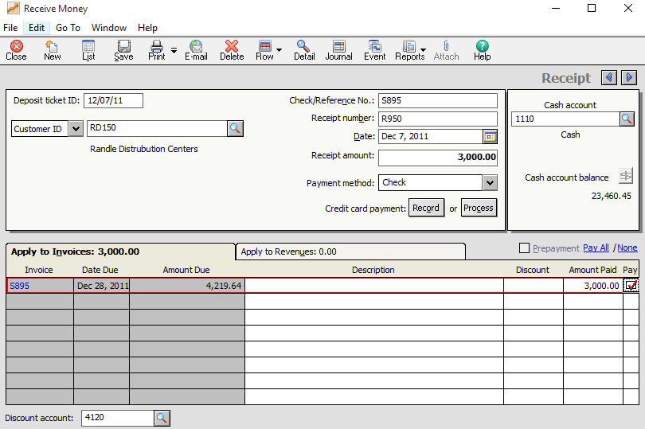

- Second, record the sales discount amount of $61.22 in the Receive Money window.
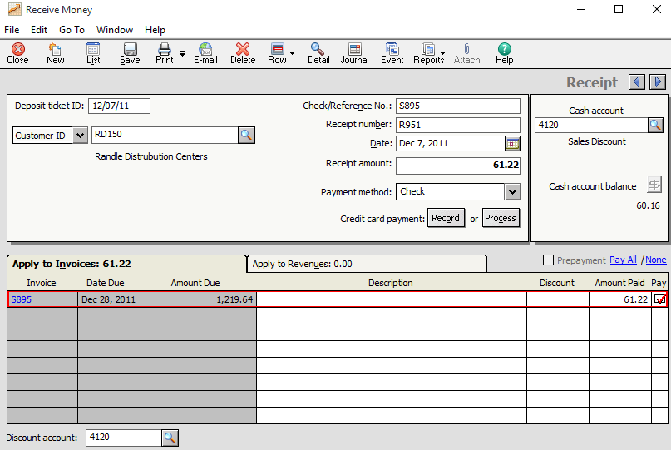

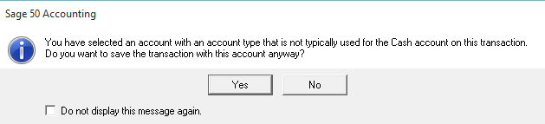

- Click Yes.

- In order to record appropriate amounts in the Unearned Sales Discount and Sales Discount accounts, the December 8th transaction requires two separate entries. First record and post a receipt for $648.08 with a $12.96 unearned sales discount and then record a second receipt for $323.39 with a $6.60 sales discount.

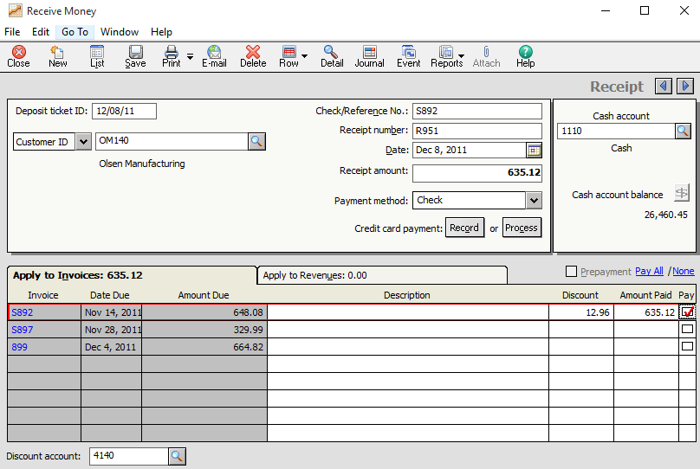
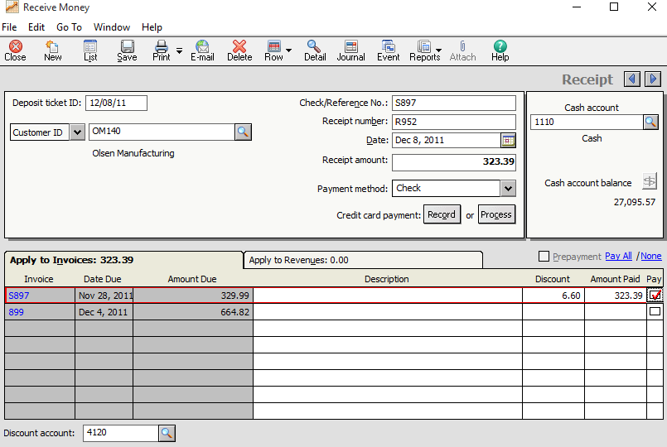

- Print the sales journal, cash receipts journal and customer ledgers.

- Use a blank piece of paper or the Working Papers to prove cash.

- Back up your work. The suggested filename is 10 Challenge Problem.

You have completed the work for 10-C Challenge Problem Journalizing transactions.
11-M.1 Mastery Problem

Journalizing and Posting Transactions Using a General Journal and a Cash Payments Journal

The instructions that follow demonstrate how to:

- Start Sage 50 Accounting 2016.

- Restore the starting data.

- Print the purchase journal, cash disbursements journal, sales journal, cash receipts journal, general ledger, vendor ledgers, and customer ledgers.

- Complete 11-M Mastery Problem (In textbook, 11-M.1 Mastery Problem).

Before starting 11-M.1 Mastery Problem, ask the instructor if Williams Market, the company used for 11-M.1 Mastery Problem, has already been restored on the computer. The following instructions explain how to set up the Williams Market company for the first time.

GETTING STARTED

Refer to pages 2 through 8 to restore a Sage 50 Accounting file from the Sage 50 Files folder. Each time you begin a problem, restore the starting data from a Sage 50 Accounting file. Then, pages 9 through 11 explain how to change the company name to include your initials.

In Sage 50 Accounting, Williams Market is set up as a corporation. Change the company name from Williams Market to 11-MPXX (X’s represent your initials).

Nothing has changed on your computer’s hard drive. This company is identified in the program folder and data folder as C:\Sage\Peachtree\Company\wilmarke. The company name has been changed so that Sage 50 Accounting printouts will show the problem number and your initials. Using Maintain; Company Information to rename the company does not change the shortened company name.

The 11-MP problem file should be restored and the Williams Market menu bar displayed.

Sales Returns: Credit Memos

To record a sales returns use Sage 50 Accounting’s Credit Memos task. This transaction will post to the Sales Journal.

Date Transaction

Dec. 2 Granted credit to JD’s Cafe for damaged merchandise, $49.00, plus sales tax, $3.92, from S678; total, $52.92. CM68.

- From the Navigation bar, select , then click the 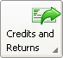 icon and select New Credit Memo. The Credit Memos window appears.

- In the Customer ID field, select JD’s Cafe.

- Type or select 2 in the Date field.

- Type CM68 in the Credit No. field. Press <Enter>.

- Make sure the Apply to Sales tab is selected and click the down hour to select S678 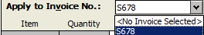.

- Type 1 in the Returned column.

- Type Returned damaged merchandise in the Description columns. Press <Enter>.

- In the GL Account column, select Account No. 4130, Sales Returns & Allowances.

- Type 49.00 in the Unit Price column; press <Enter> two times.

- In the Sales tax lookup up field select MI.

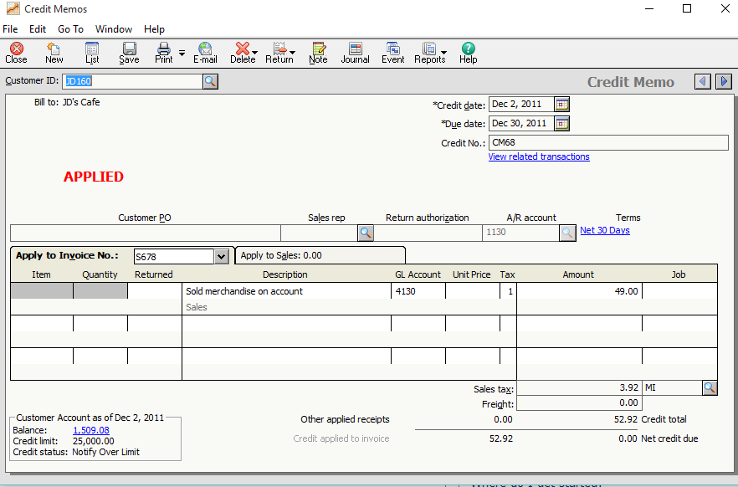
- If you would like to see how this transaction is journalized, click ; to close the Accounting Behind the Screens window.

- Click .

- Journalize and post the December 3 transaction.

Voiding a Sales Invoice

Date Transaction

Dec. 6 Learned that a sale on account to Rib Shack was incorrectly charged to the account of Restaurant Deville, $754.00. M336.

- To Void the Sales Invoices recorded for Restaurant Deville, from the Navigation bar select ; click the 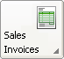 icon and select New Sales Invoice.

- From the icon bar, click , then the down arrow in the Date Range field 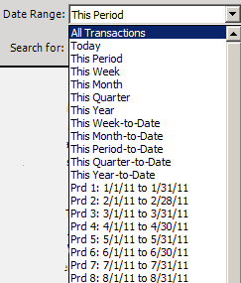, select All Transactions.

- In the Customer ID column, double-click RD180 dated 11/29/2011 to display Invoice No. S678 in the Sales/Invoicing window.

- From the icon bar, click the  icon, choose  and .

- To record the voided transaction, click .

- Enter the December 6 Sales Invoice with the correct Customer ID, RS 190 Rib Shack.

Purchase Returns: Vendor Credit Memos

When entering a purchase return, it is recorded as a vendor credit memo. The following transaction is for merchandise returned to a vendor:

Date Transaction Description

Dec. 12 Returned merchandise to Great Lakes Produce, $256.00. DM93.

- From the Navigation Bar select , and click the 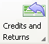 icon. Then choose New Vendor Credit Memo.

- In the Vendor ID field, select Great Lakes Produce.

- Type or select 12 in the Date field.

- Type DM93 in the Credit No field.

- The Apply to Invoice No. tab is selected. Click the down arrow to select P102.

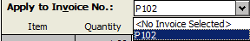

- Type 1 in the Returned column.

- Type Returned merchandise in the Description field.

- In the GL Account column, select Account No. 5130, Purch. Returns & Allow.

- Type 256 in the Unit Price field.

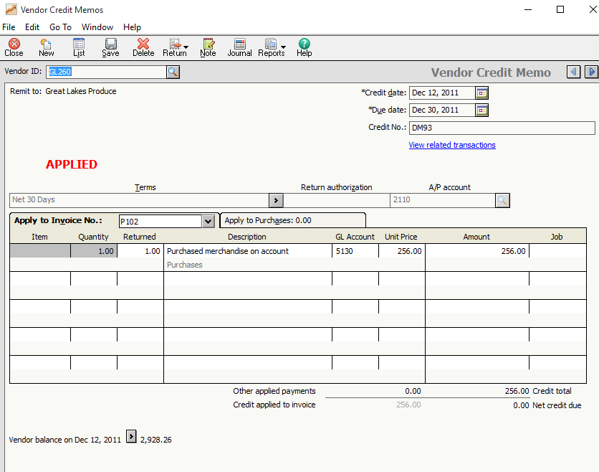
- To see how the vendor credit memo is journalized, click . Notice that Account No. 5130, Purchases Returns & Allow., is credited for $256 and Account No. 2110, Account Payable, is debited for $256. Click  to close the Accounting Behind the Screens window.

- Click  to post, then  the Vendor Credit Memos window.

- Journalize and post the December 15 transaction in the General Journal

- Continue to journalizing and post the December 23 and 28 transactions.

- Use Sage 50 Accounting’s Write Checks window to record the January 15, 2012 transaction.

- Print the Sales Journal, cash receipts journal and purchase journal.

- Follow these steps to print the Accounts Payable Ledger.
  - From the Reports & Forms menu, select Accounts Payable, Vendor Ledgers.

  - Make the selections to print.

  - Compare it to the accounts payable ledger the Working Papers.

- Follow these instructions to print the accounts receivable ledger.

- From the Select a Report or Form List, select Accounts Receivable; Customer Ledgers.

- Make the selections to print.

- Compare it to the accounts payable ledger in the Working Papers.

- Back up. The suggested filename is 11 Mastery Problem.

You have completed the work for 11-M.1 Mastery Problem Journalizing and Posting Business Transactions.

11-C Challenge Problem

Journalizing Business Transactions

The instructions that follow demonstrate how to:

- Start Sage 50 Accounting.2016

- Restore the starting data.

- Print the purchase journal, cash disbursements journal, sales journal, cash receipts journal, general ledger, vendor ledgers, and customer ledgers

- Complete 11-C Challenge Problem.

Before starting 11-C Challenge Problem, ask the instructor if Discount Warehouse, the company used for 11-C Challenge Problem, has already been restored on the computer. The following instructions explain how to set up the Discount Warehouse company for the first time.

GETTING STARTED

Refer to pages 2 through 8 to restore a Sage 50 Accounting file from the Sage 50 Files folder. Each time you begin a problem, restore the starting data from a Sage 50 Accounting file. Then, pages 9 through 11 explain how to change the company name to include your initials.

In Sage 50 Accounting, Discount Warehouse is set up as a corporation. Change the company name from Discount Warehouse to 11-CPXX (X’s represent your initials).

Nothing has changed on your computer’s hard drive. This company is identified in the program folder and data folder as C:\Sage\Peachtree\Company\diswareh. The company name has been changed so that Sage 50 Accounting printouts will show the problem number and your initials. Using Maintain; Company Information to rename the company does not change the shortened company name.

Instructions:

Journalize and post the following transactions completed during October 2011. Source documents are abbreviated as follows: check, C; memorandum, M; purchase invoice, P; receipts, R; sales invoice, S; terminal summary, TS. debit memorandum, DM; credit memorandum, CM.

- The 11-CP problem file should be restored and the Discount Warehouse menu bar displayed.
- From the textbook, journalize and post the October transactions. For Sage 50 Accounting, use 2011 as the year.

- To correct the October 17 transaction, delete the October 17th Dividends Payable ($8,000.00) transaction and correctly record the general journal entry.

- Print the sales journal, cash receipts journal, purchase journal, and cash disbursements journal.

- Print the vendor ledgers and customer ledgers.

- Print the general journal.

- Prove the accuracy of the subsidiary ledgers by comparing the totals with the balances of the controlling accounts in the general ledger. If the totals are not the same, you can use Sage 50 Accounting’s drill down feature or Sage 50 Accounting’s editing journal entries feature to correct errors. Read the information that follows about drill down and editing journals.

DRILL DOWN

Let’s say you add up the balances in the vendor ledger and it does not agree with the accounts payable balance in the general ledger. Follow these steps to use Sage 50 Accounting’s drill down-down feature.

- Display the Vendor Ledgers.

- Click one of the account balances. A zoom icon appears. Double-click .

- This takes you to the Purchases/Receive Inventory window. Make sure the transaction was entered correctly. If necessary, make any needed corrections, then post.

These instructions show you how to drill down from the vendor ledger report to the Purchases/Receive Inventory window. Use similar steps from other reports.

EDITING JOURNALS

Another way to edit transactions is to go directly to the journal. Here is how you would do that.

From the Tasks menu, select Purchases/Receive Inventory.

- Click . The Purchase List window appears.

- Double-click one of the entries. This takes you to the Purchases/Receive Inventory window. Make any needed corrections, then post.

- Read the paragraph about sales taxes before you answer.

In states that have sales taxes, businesses are required to collect taxes on their sales and submit the taxes to the state. This additional activity requires considerable extra effort: keeping a separate record of the taxes collected at the time of sale, maintaining a separate account for the sales taxes collected, Sales Taxes Payable, and recording the collection and payment of the sales taxes in the account. These additional activities place an additional administrative burden on businesses, especially small businesses with few employees.

Can you think of a procedure that would not require the separate record for collecting and accounting for sales taxes, yet comply with a state’s requirement to collect and submit sales taxes based on sale of merchandise sold? Using a blank piece of paper or the Working Papers, write a brief response providing an alternative approach to collecting and paying sales taxes.

- Back up. The suggested filename is 11 Challenge Problem.

You have completed the work for 11-C Challenge Problem Journalizing Business Transactions.

12-4 Application Problem

Preparing Payroll Checks

The instructions that follow demonstrate how to:

- Start Sage 50 Accounting 2016.

- Restore the starting data.

- Journalize and post payroll transactions.

- Complete 12-4 Application Problem.

Before starting 12-4 Application Problem, ask the instructor if Castle Electronics, the company used for 12-4 Application Problem, has already been restored on the computer. The following instructions explain how to set up the Castle Electronics company for the first time.

GETTING STARTED

Refer to pages 2 through 8 to restore a Sage 50 Accounting file from the Sage 50 Files folder. Each time you begin a problem, restore the starting data from a Sage 50 Accounting file. Then, pages 9 through 11 explain how to change the company name to include your initials.

In Sage 50 Accounting, Castle Electronics is set up as a corporation. Change the company name from Castle Electronics to 12-4APXX (X’s represent your initials).

Nothing has changed on your computer’s hard drive. This company is identified in the program folder and data folder as C:\Sage\Peachtree\Company\caselect. The company name has been changed so that Sage 50 Accounting printouts will show the problem number and your initials. Using Maintain; Company Information to rename the company does not change the shortened company name.

The 12-4AP problem file should be restored and the Castle Electronics menu bar displayed.

JOURNALIZING PAYROLL TRANSACTIONS

Castle Electronics’ net payroll for the semimonthly pay period ended May 15, 2011, is $7,498.80. Payroll checks are prepared on May 15, 2011.

Payroll information for two employees is shown below. Use this information to journalize and post transactions in the Cash Disbursements Journal. Detailed steps are shown below for the first employee, Mitchell R. Haynes.

Before journalizing and posting the payroll transactions, establish the payroll account. Use the following transaction information:

Date Transaction

May 15 Make a check payable to The Peoples Bank, Payroll Account 518-481-148 (Account No. 1115) for $7,498.80, Check No. 1056. This is the total net pay for May 15, 2011.

- Use Sage 50 Accounting’s Payments task to journalize the May 15 transaction to establish the payroll account; Check No. 1056 in the amount of $7,498.80.

- In the select a Cash Account screen, make sure Cash is shown.

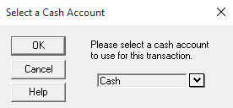

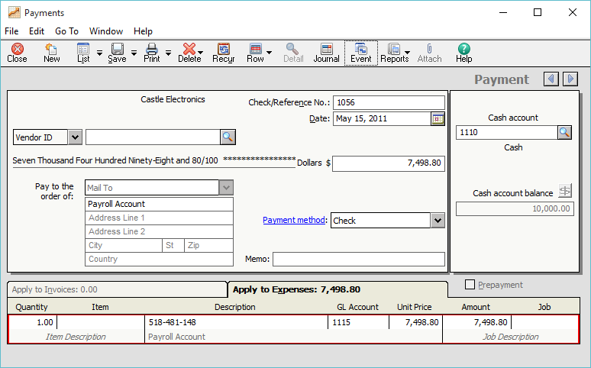

- Use the instructions that follow to journalize the May 15 paycheck for Mitchell R. Haynes, Check No. 658.

Date Transaction

May 15 Mitchell R. Haynes
Check No. 658
Regular Earnings $1280.00
Overtime Earnings 60.00
Deductions:
Federal Income Tax $71.00
Social Security Tax 83.08
Medicare Tax 19.43
Health Insurance 50.00
Retirement 25.00

- If necessary, select Payments from the Tasks menu. When the Select a Cash Account window appear, select Payroll Account. Or, if the Payments window is displayed, select Account No. 1115 in the Cash Account field.

- Make sure that Account No. 1115, Payroll is shown in the Cash Account field. Type Mitchell R. Haynes in the Pay to the Order of field.

- Type 658 in the Check Number field.

- If necessary, type or select 15 as your date.

- Type 1 for the Quantity; type Regular earnings for the Description; select Account No. 6150 for the GL Account; type 1280 for the Unit Price. Press the <Enter> key three times.

- Complete the following fields. Make sure that you put minus signs in front of each amount deducted.

Quantity Description GL Account Unit Price

1 Overtime earnings 6155 60.00
1 Federal income tax 2120 -71.00
1 Social security tax 2135 -83.08
1 Medicare tax 2140 -19.43
1 Health insurance 2160 -50.00
1 Retirement 2165 -25.00

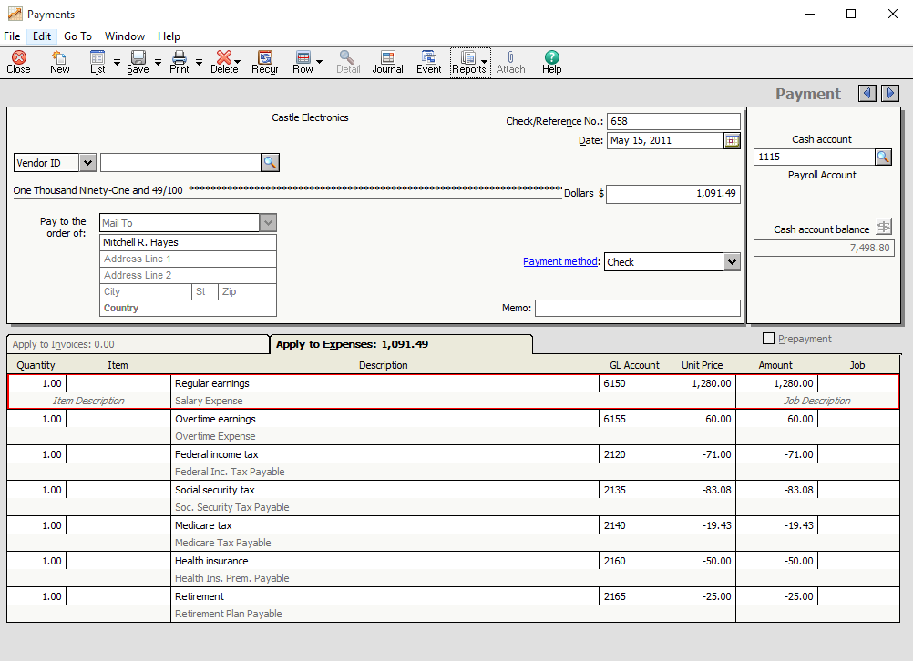

- Post this payment.

- Journalize and post the following transaction.

Date Transaction

May 15 Sharon V. Bricken
Check No. 659
Regular earnings $1,160.00
Overtime earnings 36.98
Deductions:
Federal income tax $86.00
Social security tax 74.21
Medicare tax 17.36
Health insurance 65.00
Retirement 40.00

- Post this payment.

- When you journalize paycheck number 658 and 659, put minus signs in front of each amount deducted.

- Print the cash disbursements journal.

- Back up. The suggested filename is 12-4 Application Problem.ptb.

You have completed the work for 12-4 Application Problem Journalizing Payroll Checks.

12-M Mastery Problem

Preparing a Semimonthly Payroll

The instructions that follow demonstrate how to:

- Start Sage 50 Accounting 2016.

- Restore the starting data.

- Journalize and post payroll transactions.

- Complete 12-M Mastery Problem.

Before starting 12-M Mastery Problem, ask the instructor if Malone Company, the company used for 12-M Mastery Problem, has already been restored on the computer. The following instructions explain how to set up Malone Company for the first time.

GETTING STARTED

Refer to pages 2 through 8 to restore a Sage 50 Accounting file from the Sage 50 Files folder. Each time you begin a problem, restore the starting data from a Sage 50 Accounting file. Then, pages 9 through 11 explain how to change the company name to include your initials.

In Sage 50 Accounting, Malone Company is set up as a corporation. Change the company name from Malone Company to 12-MPXX (X’s represent your initials).

Nothing has changed on your computer’s hard drive. This company is identified in the program folder and data folder as C:\Sage\Sage 50 Accounting\company\ malcompa. The company name has been changed so that Sage 50 Accounting printouts will show the problem number and your initials. Using Maintain; Company Information to rename the company does not change the shortened company name.

The 12-MP problem file should be restored and the Malone Company menu bar displayed.

JOURNALIZING PAYROLL TRANSACTIONS

Instructions

Use the Working Papers form or use a blank piece of paper to prepare a payroll register. In the textbook, use the income tax withholding tables from Lesson 12-2 to find the income tax withholding for each employee. Calculate social security and Medicare tax withholdings using 6.2% and 1.45% tax rates, respectively. None of the employees has accumulated earnings greater than the social security tax base.

- On August 15, 2011, journalize and post Check No. 1895 for the total amount of the net pay. Make the check payable to the Payroll Account. (Hint: Remember to select Account No. 1110 as the Cash Account.)

- Starting with check number 452, journalize and post payroll checks for all the employees listed in the payroll register in the Working Papers. (Hint: Remember to select Account No. 1115 as the Cash Account for checks 452-459).

- Print the cash disbursements journal.

- Back up. The suggested filename is 12-M Mastery Problem.ptb.

You have completed the work for 12-M Mastery Problem Preparing a semimonthly payroll

13-4 Application Problem

Paying Withholding and Payroll Taxes

The instructions that follow demonstrate how to:

- Start Sage 50 Accounting Complete Accounting.

- Restore the starting data.

- Journalize and post payroll transactions.

- Complete 13-4 Application Problem.

Before starting 13-4 Application Problem, ask the instructor if Webster Company, the company used for 13-4 Application Problem, has already been restored on the computer. The following instructions explain how to set up Webster Company for the first time.

GETTING STARTED

Refer to pages 2 through 8 to restore a Sage 50 Accounting file from the Sage 50 Files folder. Each time you begin a problem, restore the starting data from a Sage 50 Accounting file. Then, pages 9 through 11 explain how to change the company name to include your initials.

In Sage 50 Accounting, Webster Company is set up as a corporation. Change the company name from Webster Company to 13-4 APXX (X’s represent your initials).

Nothing has changed on your computer’s hard drive. This company is identified in the program folder and data folder as C:\Sage\Peachtree\Company\ webcompa. The company name has been changed so that Sage 50 Accounting printouts will show the problem number and your initials. Using Maintain; Company Information to rename the company does not change the shortened company name.

JOURNALIZING PAYROLL TRANSACTIONS

The following payroll data are for Webster Company for the first quarter of the current year.
Federal Income
Total Earnings Tax Withheld
March 21,640.00 $1,395.00
First Quarter 63,180.00
In addition, total earnings are subject to 6.2% employee and 6.2% employer social security tax, plus 1.45% employee and 1.45% employer Medicare tax. The FUTA tax rate is 0.8%, and the state SUTA tax rate is 5.4% of total earnings. No total earnings have exceeded the tax base for calculating unemployment taxes.

Instructions

Journalize and post the April 15 and 30 transactions in Sage 50 Accounting’s cash disbursements journal.

- Print the April 1-30, 2012 cash disbursements journal.

- Print the April 30, 2012 general ledger trial balance

- Back up. The suggested filename is 13-4 Application Problem.ptb.

You have completed the work for 13-4 Application Problem: Paying Withholding and Payroll Taxes.
13-M Mastery Problem

Journalizing Payroll Transactions

The instructions that follow demonstrate how to:

- Start Sage 50 Accounting 2016.

- Restore the starting data.

- Journalize and post payroll transactions.

- Complete 13-M Mastery Problem.

Before starting 13-M Mastery Problem, ask the instructor if Keller Systems, Inc., the company used for 13-M Mastery Problem, has already been restored on the computer. The following instructions explain how to set up Keller Systems, Inc. for the first time.

GETTING STARTED

Refer to pages 2 through 8 to restore a Sage 50 Accounting file from the Sage 50 Files folder. Each time you begin a problem, restore the starting data from a Sage 50 Accounting file. Then, pages 9 through 11 explain how to change the company name to include your initials.

In Sage 50 Accounting, Keller Systems, Inc. is set up as a corporation. Change the company name from Keller Systems, Inc. to 13-MPXX (X’s represent your initials).

Nothing has changed on your computer’s hard drive. This company is identified in the program folder and data folder as C:\Sage\Peachtree\Company\kelsysin. The company name has been changed so that Sage 50 Accounting printouts will show the problem number and your initials. Using Maintain; Company Information to rename the company does not change the shortened company name.

JOURNALIZING PAYROLL TRANSACTIONS

Keller Systems, Inc. completed payroll transactions during the period May 1 to June 15, 2005. Payroll tax rates are as follows: social security, 6.2%; Medicare, 1.45%; federal unemployment, 0.8%; state unemployment, 5.4%. No total earnings have exceeded the tax base for calculating unemployment taxes, Keller Systems is a monthly schedule depositor for payroll taxes.

Instructions

Journalize and post the January and February 2012 transactions in Sage 50 Accounting’s cash disbursements journal. Use the general journal to record the employer payroll taxes expense for January 15, January 31 and February 15, 2012.

CHANGE THE ACCOUNTING PERIOD

Before you journalize and post the Jan. 15 transactions, you should change accounting periods. Observe that the Sage 50 Accounting’s status bar at the bottom of your screen shows Period 13 – 01/01/12 to 01/31/12. In order to change accounting period to Period 14 – 02/01/12 to 02/29/12, follow these steps.

- From the Tasks menu, select System; Change Accounting Period.

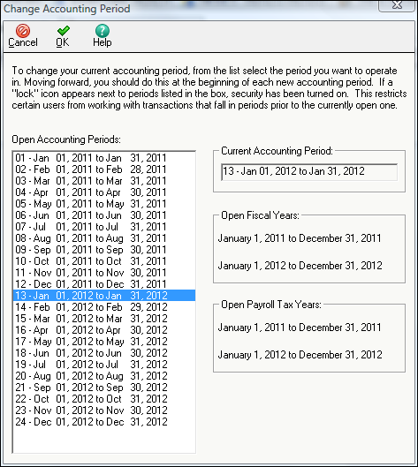

- Click 14-Feb 01, 2012 to Feb 29, 2012 to highlight it.
- Make sure period 14 is selected; click .

- When the window appears asking Would you like to print your reports before continuing?, click . Observe that the status bar shows Period 14 – 2/1/12 to 2/29/12.

- From the textbook, journalize and post the transactions. Use the cash disbursements journal for semimonthly payroll transactions. Use the general journal for the monthly payroll tax expense transactions.

- Print the Jan 15 through Feb 15, 2011 cash disbursements journal.

- Print the Jan 1 through Feb 29, 2012 general journal

- Print the Feb 29, 2012 general ledger trial balance.

- Back up. The suggested filename is 13 Mastery Problem.ptb.

You have completed the work for 13-M Mastery Problem: Journalizing payroll transactions.
Reinforcement Activity 2—Part A

An Accounting Cycle for a Corporation:
Journalizing and Posting Transactions

The instructions that follow demonstrate how to:

- Start Sage 50 Accounting Complete Accounting.

- Restore the problem file for Gulf Uniform Supply.

- Identify the program and data path for Gulf Uniform Supply.

- Complete Reinforcement Activity 2—Part A.

Before starting Reinforcement Activity 2—Part A, ask the instructor if Gulf Uniform Supply, the company used for Reinforcement Activity 2—Part A, has already been restored. The following instructions explain how to set up Gulf Uniform Supply for the first time.

GETTING STARTED

Refer to pages 2 through 8 to restore a Sage 50 Accounting file from the Sage 50 Files folder. Each time you begin a problem, restore the starting data from a Sage 50 Accounting file. Then, pages 9 through 11 explain how to change the company name to include your initials.

In Sage 50 Accounting, Gulf Uniform Supply is set up as a corporation. Change the company name from Keller Systems, Inc. to RA02-AXX (X’s represent your initials).

Nothing has changed on your computer’s hard drive. This company is identified in the program folder and data folder as C:\Sage\Peachtree\Company\gulunisu. The company name has been changed so that Sage 50 Accounting printouts will show the problem number and your initials. Using Maintain; Company Information to rename the company does not change the shortened company name.

DISPLAYING THE GULF UNIFORM SUPPLY’S TRIAL BALANCE

Before recording transactions, print or display Sage 50 Accounting’s general ledger trial balance and compare it to the one shown on the next page. (Hint: From the menu bar, select Reports & Forms, General Ledger, General Ledger Trial Balance. Then, make the selections to display or print.)
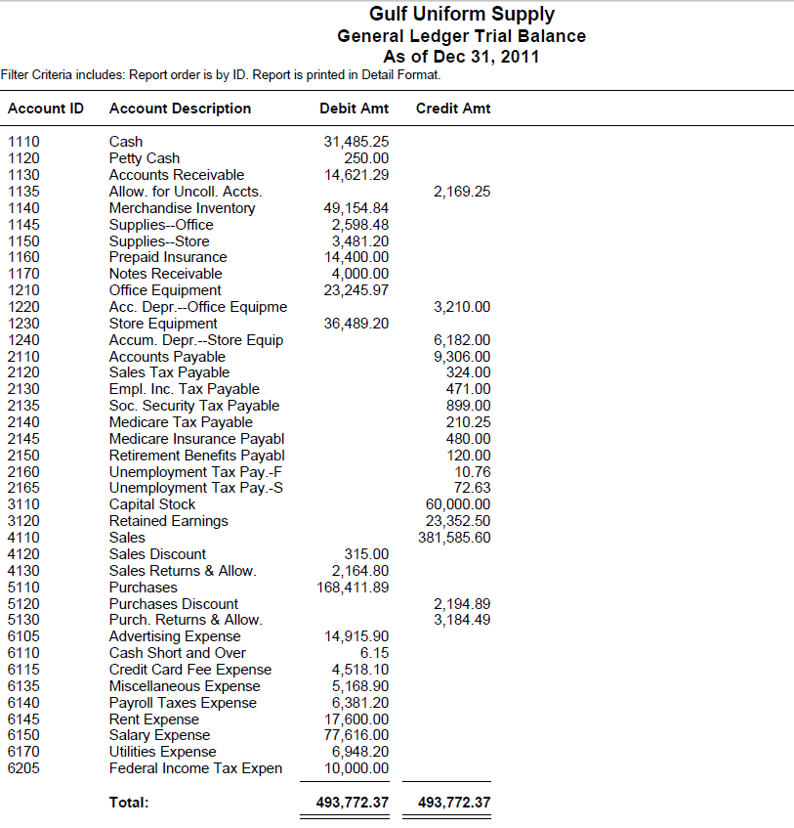

RECORDING TRANSACTIONS

The accounting work of a single merchandising business for the last month of a yearly fiscal period is used in this reinforcement activity. The records kept and reports prepared illustrate the application of accounting concepts for all merchandising businesses.

Gulf Uniform Supply (GUS), a merchandising business, is organized as a corporation. The business sells a complete line of uniforms for a variety of businesses and organizations, including schools, medical offices, and retail stores. GUS is located in an open-area shopping center and is open for business Monday through Saturday. A monthly rent is paid for its store space in the shopping center. GUS accepts credit sales for approved customers and credit cards from individual customers.

The December 1, 2011 account balances for the general ledger subsidiary ledgers are included on the RA02-A.ptb file.

Instructions:

- From the textbook, journalize and post the following transactions completed during December 2011. Use the sales journal, purchase journal, general journal, cash receipts journal, and cash disbursements journal. The sales tax rate is 6%. Source documents are abbreviated as follows: check, C; memorandum, M; purchase invoice, P; receipt, R; sales invoice, S; terminal summary, TS; debit memorandum, DM; credit memorandum, CM.

- Print the sales journal, purchase journal, general journal, cash receipts journal, and cash disbursements journal.

- Print the customer ledgers and vendor ledgers.

- Print the December 1 – 31, 2011 general ledger.

- Use the Working Papers or a blank piece of paper to prove cash.

- Back up your company data. The suggested filename is Reinforcement Activity 2-Part A.ptb. This backup is important. Keep it in a safe place. You will use it again for Part B of this problem.

You have completed the work for Reinforcement Activity 2–Part A, An Accounting Cycle for a Corporation—Journalizing and Posting Transactions. Keep your backup file in a safe place. You will use the backup made in this activity for Part B of this problem.

14-2 Application Problem

Recording Entries Related to Uncollectible
Accounts Receivable

The instructions that follow demonstrate how to:

- Start Sage 50 Accounting 2016.

- Restore the starting data.

- Journalize and post transactions.

- Complete 14-2 Application Problem.

Before starting 14-2 Application Problem, ask the instructor if Rosario Equipment, the company used for 14-2 Application Problem, has already been restored on the computer. The following instructions explain how to set up Rosario Equipment for the first time.

GETTING STARTED

Refer to pages 2 through 8 to restore a Sage 50 Accounting file from the Sage 50 Files folder. Each time you begin a problem, restore the starting data from a Sage 50 Accounting file. Then, pages 9 through 11 explain how to change the company name to include your initials.

In Sage 50 Accounting, Rosario Equipment is set up as a corporation. Change the company name from Rosario Equipment to 14-2 APXX (X’s represent your initials).

Nothing has changed on your computer’s hard drive. This company is identified in the program folder and data folder as C:\Sage\Peachtree\Company\rosequip. The company name has been changed so that Sage 50 Accounting printouts will show the problem number and your initials. Using Maintain; Company Information to rename the company does not change the shortened company name.

JOURNALIZING TRANSACTIONS

Rosario Equipment completed the following transactions during May 2012 and June 2012.
Transactions:

May 6. Wrote off Suarez Consulting’s past-due account as uncollectible, $1,648.11. M89.

May 14. Wrote off Durham Supply’s past due account as uncollectible, $948.50. M92

May 23. Received cash in full payment of Foley Corp’s account, previously written off as uncollectible, $1,109.80. M98 and R334.

Jun 7. Wrote off Pennington Co.’s past-due account as uncollectible, $488.93. M104

Jun 29. Received cash in full payment of Suarez Consulting’s account, previously written off as uncollectible $1,648.11. M109 and R356.

- For the May 6, May 14 and June 7 transactions:

  - From the menu bar, click Tasks; Receive Money.
  - In the Deposit ticket ID: filed type 05/06/12.
  - Select 140 Suarez Consulting in the Customer ID field.
  - In the Reference field type M89.
  - Type or select 6 in the Date field.
  - In the Cash account look-up field, select Account 1130, Allow. for Uncoll. Accts.

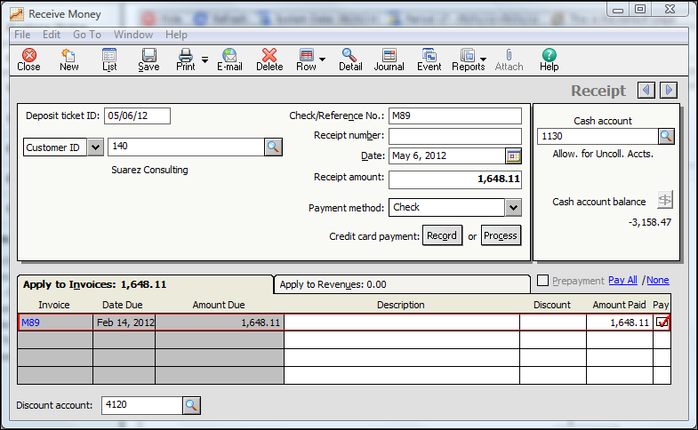

  - Click .
  - Click Yes at the Sage 50 Accounting window. (Select the box next to Do not display this message again.)

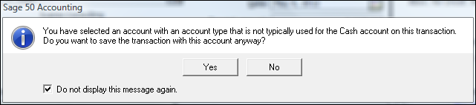

- For May 23 transaction, there are two separate entries required to record payments previously written off as uncollectible.

  - From the menu bar, select Tasks; Sales/Invoicing.
  - In the Customer ID: Field select 120 Foley Corp.
  - Type or select 23 in the Date field.
  - Type M98 in the Invoice No.
  - Type 1 in the Quantity field.
  - Select Account 1130 Allow. for Uncoll. Accts. In the GL Account field.
  - Type 1,109.80 in the Unit Price field.

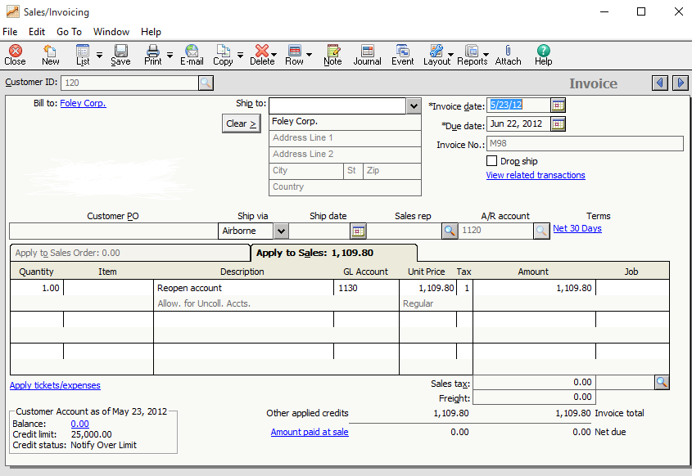

- After posting the Sales/Invoicing window, open the Receive Money window:

a. In the Deposit ticket ID: field type 05/23/12.
b. In the Customer ID field select 120 Foley Crop.
c. In the Reference field type M98.
d. Type or select 23 in the date field.
e. In the Cash account look-up field select 1110 Cash.
f. Check the pay box .
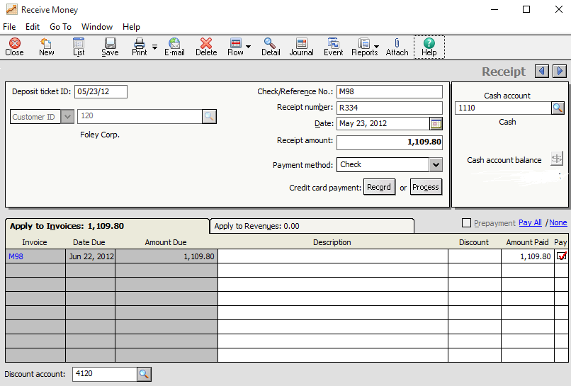

- Post the Receipt.

- Change accounting periods from Period 17, May 1-31, 2012; to Period 18, June 1-30, 2012.

- Print the May 1, 2012 to Jun 30, 2012 Customer Ledgers.

- Print the May 1, 2012 to June 30, 2012 Cash Receipts Journal.

- Print the May 1, 2012 to June 30, 2012 Sales Journal.

- Print the General Ledger Trial Balance.

- Back up. The suggested filename is 14-2 Application Problem.ptb.

14-M Mastery Problem

Recording Entries for Uncollectible Accounts

The instructions that follow demonstrate how to:

- Start Sage 50 Accounting 2016.

- Restore the starting data.

- Journalize and post adjusting entries.

- Complete 14-M Mastery Problem.

Before starting 14-M Mastery Problem, ask the instructor if Sing Industries, the company used for 14-M Mastery Problem, has already been restored on the computer. The following instructions explain how to set up Sing Industries for the first time.

GETTING STARTED

Refer to pages 2 through 8 to restore a Sage 50 Accounting file from the Sage 50 Files folder. Each time you begin a problem, restore the starting data from a Sage 50 Accounting file. Then, pages 9 through 11 explain how to change the company name to include your initials.

In Sage 50 Accounting, Sing Industries is set up as a corporation. Change the company name from Sing Industries to 14-MPXX (X’s represent your initials).

Nothing has changed on your computer’s hard drive. This company is identified in the program folder and data folder as C:\Sage\Peachtree\Company\sinindus. The company name has been changed so that Sage 50 Accounting printouts will show the problem number and your initials. Using Maintain; Company Information to rename the company does not change the shortened company name.

DISPLAYING THE TRIAL BALANCE

The trial balance for Sing Industries as of December 31, 2012 is included on the 14-MP.ptb file. Display or print Sage 50 Accounting’s general ledger trial balance to see the account balances. Compare the trial balance with the one shown below.

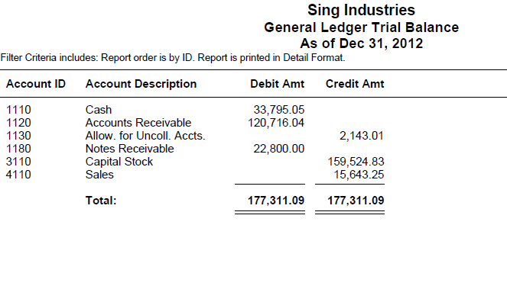

      - Journalize the December 2012 transactions in Sage 50 Accounting’s sales journal and cash receipts journal.

      - If the Sage Accounting window displays, place a check mark next to Do not display this message again and select .

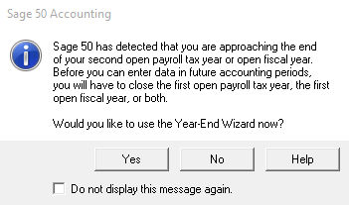

      - Record the December 10 transaction in the Sales Journal.

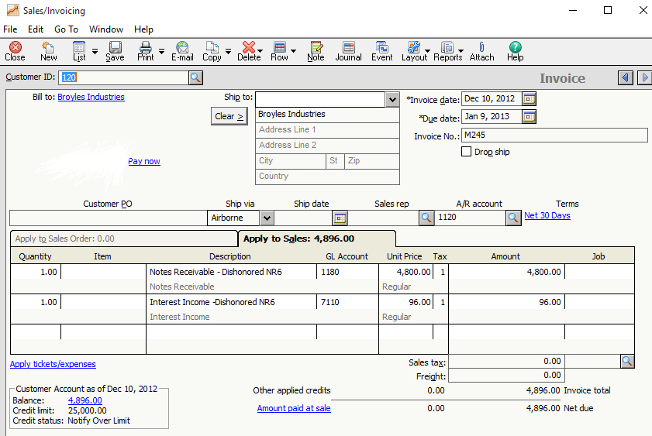

      - Record the December 18 transaction in the cash receipts journal.

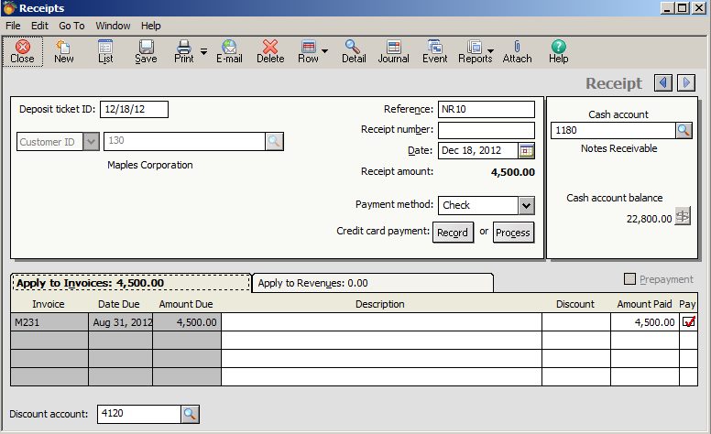

- Print the December 2012 sales journal.

- Print the December 2012 cash receipts journal.

- Print the General Ledger Trial Balance.

- Back up. The suggested filename is 14 Mastery Problem.ptb.

You have completed the work for 14-M Mastery Problem: Recording Entries for uncollectible accounts.

15-4 Application Problem

Preparing the Adjusting Entries

The instructions that follow demonstrate how to:

- Start Sage 50 Accounting 2016.

- Restore the starting data.

- Print financial statements.

- Complete 15-4 Application Problem.

Before starting 15-4 Application Problem, ask the instructor if New England Arts, the company used for 15-4 Application Problem, has already been restored on the computer. The following instructions explain how to set up New England Arts for the first time.

GETTING STARTED

Refer to pages 2 through 8 to restore a Sage 50 Accounting file from the Sage 50 Files folder. Each time you begin a problem, restore the starting data from a Sage 50 Accounting file. Then, pages 9 through 11 explain how to change the company name to include your initials.

In Sage 50 Accounting, New England Arts is set up as a corporation. Change the company name from New England to 15-4APXX (X’s represent your initials).

Nothing has changed on your computer’s hard drive. This company is identified in the program folder and data folder as C:\Sage\Peachtree\Company\ newengar. The company name has been changed so that Sage 50 Accounting printouts will show the problem number and your initials. Using Maintain; Company Information to rename the company does not change the shortened company name.

Instructions

- Use the information from Application Problems 15-1 to 15-4 to journalize and post adjusting entries in Sage 50 Accounting’s general journal.

- Print an income statement. From Sage 50 Accounting’s menu bar, select Reports or Forms; Financial Statements and single left-click to hi-light <Standard> Income Stmnt. From the icon bar, click . In the Time Frame: field, choose Current 3 Periods and then . Make selections to print.

Note:

Merchandise Inventory does not appear on Sage 50 Accounting’s income statement. Sage 50 Accounting organizes their financial statements according to how each account is classified on the chart of accounts. Merchandise Inventory is classified as an asset (inventory); therefore, it appears on Sage 50 Accounting’s balance sheet. If you are preparing the income statement manually in the Working Papers, please note that this difference affects the ratios and the income statement results. The account balances on Sage 50 Accounting’s income statement are the same as the manually completed income statement. Sage 50 Accounting’s income statement lists all accounts classified as revenue and expense accounts.

- Print a balance sheet. Observe that the information necessary for the statement of stockholders’ equity is contained in Sage 50 Accounting’s balance sheet. You may decide to prepare the statement of stockholders’ equity manually in the Working Papers. Or, continue with instruction 3 to print Sage 50 Accounting’s statement of Retained Earnings.

Note:
Sage 50 Accounting’s balance sheet includes the following amounts in its Capital section related to Retained Earnings. Complete the following calculation to obtain total retained earnings:

Retained Earnings 72,649.37
Dividends (4,000.00)
Income Summary (1,909.10)
Net Income 55,217.55
Total Retained Earnings $121,957.82

This $121,957.82 represents the Ending Retained Earnings amount on Sage 50 Accounting’s Statement of Retained Earnings

- Substitute Sage 50 Accounting’s statement of retained earnings for the statement of stockholders’ equity. Print Sage 50 Accounting’s <Standard> Retained Earnings statement. Sage 50 Accounting’s Statement of Retained Earnings does not show the beginning Capital Stock balance of $20,000. Add that balance to the Ending Retained Earnings balance ($121,957.82 + $20,000 = $141,957.82) so that Sage 50 Accounting’s statement agrees with the manually prepared statement of stockholders’ equity in the Working Papers.

- Back up. The suggested filename is 15-4 Application Problem.ptb.
15-M Mastery Problem

Journalizing Adjusting Entries

The instructions that follow demonstrate how to:

- Start Sage 50 Accounting 2016.

- Restore the starting data.

- Print financial statements.

- Complete 15-M Mastery Problem.

Before starting 15-M Mastery Problem, ask the instructor if Winterland Rentals, the company used for 15-M Mastery Problem, has already been restored on the computer. The following instructions explain how to set up Winterland Rentals for the first time.

GETTING STARTED

Refer to pages 2 through 8 to restore a Sage 50 Accounting file from the Sage 50 Files folder. Each time you begin a problem, restore the starting data from a Sage 50 Accounting file. Then, pages 9 through 11 explain how to change the company name to include your initials.

In Sage 50 Accounting, Winterland Rentals is set up as a corporation. Change the company name from Winterland Rentals to 15-MPXX (X’s represent your initials).

Nothing has changed on your computer’s hard drive. This company is identified in the program folder and data folder as C:\Sage\Peachtree\Company\winrenta. The company name has been changed so that Sage 50 Accounting printouts will show the problem number and your initials. Using Maintain; Company Information to rename the company does not change the shortened company name.

Instructions

- Journalize and post adjusting entries in Sage 50 Accounting’s general journal.

- Print an income statement. From Sage 50 Accounting’s menu bar, select Reports or Forms; Financial Statements and single left-click to hi-light <Standard> Income Stmnt.
  - From the icon bar, click . In the Time Frame: field, choose Range.
  - In the From: field choose Period 13, (1/1/12).
  - In the To: field choose Period 24, (12/31/12).
  - Uncheck the box next to Print Page Numbers
  - Uncheck the box next to Show Zero Amounts.

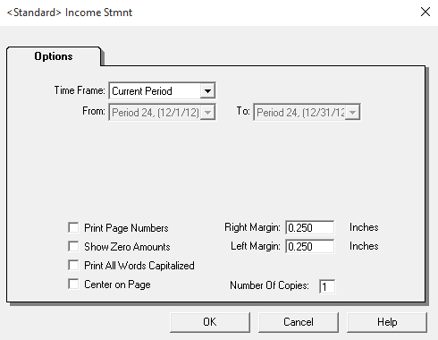

  - Click .

Note:

Merchandise Inventory does not appear on Sage 50 Accounting’s income statement. Sage 50 Accounting organizes their financial statements according to how each account is classified on the chart of accounts. Merchandise Inventory is classified as an asset (inventory); therefore, it appears on Sage 50 Accounting’s balance sheet. If you are preparing the income statement manually in the Working Papers, please note that this difference affects the ratios and the income statement results. The account balances on Sage 50 Accounting’s income statement are the same as the manually completed income statement. Sage 50 Accounting’s income statement lists all accounts classified as revenue and expense accounts.

- Print a balance sheet. Observe that the information necessary for the statement of stockholders’ equity is contained in Sage 50 Accounting’s balance sheet. You may decide to prepare the statement of stockholders’ equity manually in the Working Papers. Or, continue with instruction 3 to print Sage 50 Accounting’s statement of Retained Earnings.

Note:

Sage 50 Accounting’s balance sheet includes the following amounts in its Capital section related to Retained Earnings. Complete the following calculation to obtain total retained earnings:

Retained Earnings 52,826.35
Dividends (40,000.00)
Income Summary 3986.50
Net Income 92,922.77
Total Retained Earnings $109,735.62

This $109,435.62 represents the Ending Retained Earnings amount on Sage 50 Accounting’s Statement of Retained Earnings

- Substitute Sage 50 Accounting’s statement of retained earnings for the statement of stockholders’ equity. Print Sage 50 Accounting’s <Standard> Retained Earnings statement. Sage 50 Accounting’s Statement of Retained Earnings does not show the beginning Capital Stock balance of $20,000. Add that balance to the Ending Retained Earnings balance ($109,735.62 + $20,000 = $129,735.62) so that Sage 50 Accounting’s statement agrees with the manually prepared statement of stockholders’ equity in the Working Papers.

- On a blank piece of paper or in the Working Papers, calculate earnings per share and price-earnings ratio. Current market price of the stock is $28.50.

- Back up. The suggested filename is 15 Mastery Problem.ptb.

You have completed the work for 15-M Mastery Problem: Preparing financial statements.
16-4 Application Problem

Journalizing Closing Entries

The instructions that follow demonstrate how to:

- Start Sage 50 Accounting 2016.

- Restore the starting data.

- Journalize and post closing entries.

- Print a post-closing trial balance.

- Complete 16-4 Application Problem.

Before starting 16-4 Application Problem, ask the instructor if Top-Light Corporation, the company used for 16-4 Application Problem, has already been restored on the computer. The following instructions explain how to set up Top-Light Corporation for the first time.

GETTING STARTED

Refer to pages 2 through 8 to restore a Sage 50 Accounting file from the Sage 50 Files folder. Each time you begin a problem, restore the starting data from a Sage 50 Accounting file. Then, pages 9 through 11 explain how to change the company name to include your initials.

In Sage 50 Accounting, Top-Light Corporation is set up as a corporation. Change the company name from Top-Light Corporation to 16-4APXX (X’s represent your initials).

Nothing has changed on your computer’s hard drive. This company is identified in the program folder and data folder as C:\Sage\Peachtree\Company\topcorpo. The company name has been changed so that Sage 50 Accounting printouts will show the problem number and your initials. Using Maintain; Company Information to rename the company does not change the shortened company name.

DISPLAY THE TRIAL BALANCE

Print or display Sage 50 Accounting’s general ledger trial balance. The 16-4AP.ptb file includes general ledger account balances shown on the work sheet’s trial balance columns. Compare these account balances to the ones shown on Sage 50 Accounting’s general ledger trial balance.

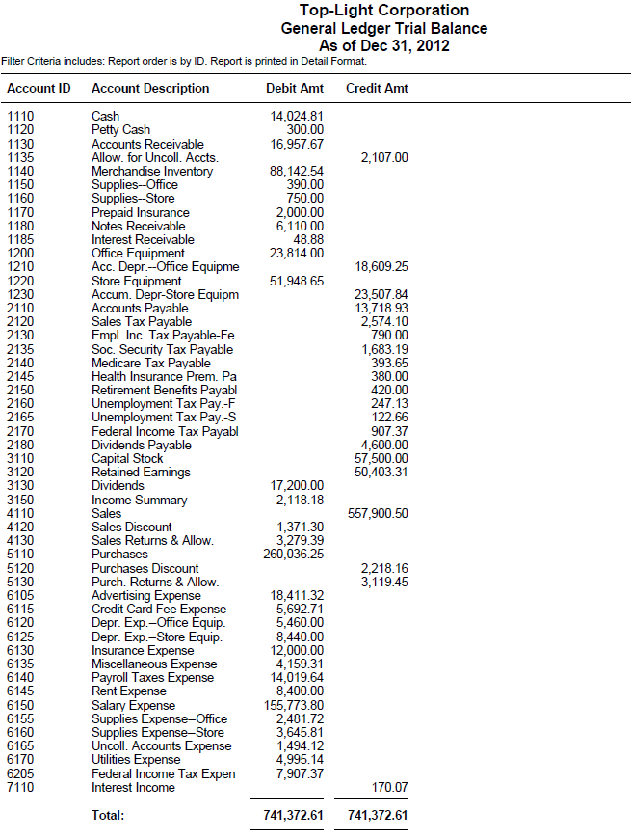

Instructions

- Print the income statement. Compare the account balances on Sage 50 Accounting’s income statement to the income statement columns in the Working Papers. (Hint: You must print the income statement before journalizing and posting the closing entries. As you know from your study of accounting, after completing the closing entries revenues, cost of sales, and expense accounts have zero balances.)
Note:

Sage 50 Accounting does not report Merchandise inventory or Income Summary on its income statement. They are asset and equity accounts, respectively; which are reported on Sage 50 Accounting’s balance sheet.

- Print a balance sheet. Observe that the information necessary for the statement of stockholders’ equity is contained in Sage 50 Accounting’s balance sheet. You may decide to prepare the statement of stockholders’ equity manually in the Working Papers. Or, continue with instruction 3 to print Sage 50 Accounting’s statement of Retained Earnings.

Note:

Sage 50 Accounting’s balance sheet includes the following amounts in its Capital section related to Retained Earnings. Complete the following calculation to obtain total retained earnings:

Retained Earnings 50,403.31
Dividends (17,200.00)
Income Summary (2,118.18)
Net Income 45,840.30
Total Retained Earnings $76,925.43

This amount, $76925.43, agrees with the Retained Earnings account in the manually prepared balance sheet in the Working Papers.

- Substitute Sage 50 Accounting’s statement of retained earnings for the statement of stockholders’ equity. Print Sage 50 Accounting’s <Standard> Retained Earnings statement. Sage 50 Accounting’s Statement of Retained Earnings does not show the beginning Capital Stock balance of $57,500. Add that balance to the Ending Retained Earnings balance ($76,925.43 + $57,500 = $134,425.43) so that Sage 50 Accounting’s statement agrees with the manually prepared statement of stockholders’ equity in the Working Papers.

- Journalize and post the closing entries.

- Print the December 31, 2012 general journal.

- Print the general ledger.

- Print the post-closing trial balance.

- Back up. The suggested filename is 16-4 Application Problem.ptb.

16-M Mastery Problem

Preparing Financial Statements and Closing Entries

The instructions that follow demonstrate how to:

- Start Sage 50 Accounting 2016.

- Restore the starting data.

- Journalize and post closing entries.

- Print a post-closing trial balance.

- Complete 16-M Mastery Problem.

Before starting 16-M Mastery Problem, ask the instructor if Paulson Corporation, the company used for 16-M Mastery Problem, has already been restored on the computer. The following instructions explain how to set up Paulson Corporation for the first time.

GETTING STARTED

Refer to pages 2 through 8 to restore a Sage 50 Accounting file from the Sage 50 Files folder. Each time you begin a problem, restore the starting data from a Sage 50 Accounting file. Then, pages 9 through 11 explain how to change the company name to include your initials.

In Sage 50 Accounting, Paulson Corporation is set up as a corporation. Change the company name from Paulson Corporation to 16-MPXX (X’s represent your initials).

Nothing has changed on your computer’s hard drive. This company is identified in the program folder and data folder as C:\Sage\Peachtree\Company\paucorpo. The company name has been changed so that Sage 50 Accounting printouts will show the problem number and your initials. Using Maintain; Company Information to rename the company does not change the shortened company name.

DISPLAY THE TRIAL BALANCE

Print or display Sage 50 Accounting’s general ledger trial balance. The 16-MP.ptb file includes general ledger account balances shown on the work sheet’s trial balance columns. Compare these account balances to the ones shown on Sage 50 Accounting’s general ledger trial balance.

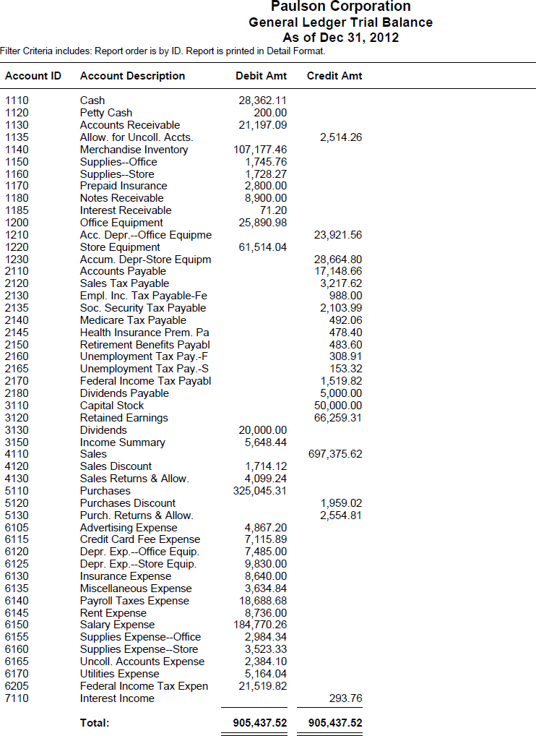

Instructions

- Print the income statement. Compare the account balances on Sage 50 Accounting’s income statement to the income statement columns in the Working Papers. (Hint: You must print the income statement before journalizing and posting the closing entries. As you know from your study of accounting, after completing the closing entries revenues, cost of sales, and expense accounts have zero balances.)

Note:

Sage 50 Accounting does not report Merchandise inventory or Income Summary on its income statement. They are asset and equity accounts, respectively; which are reported on Sage 50 Accounting’s balance sheet.

- Print a balance sheet. Observe that the information necessary for the statement of stockholders’ equity is contained in Sage 50 Accounting’s balance sheet. You may decide to prepare the statement of stockholders’ equity manually in the Working Papers. Or, continue with instruction 3 to print Sage 50 Accounting’s statement of Retained Earnings.

Note:

Sage 50 Accounting’s balance sheet includes the following amounts in its Capital section related to Retained Earnings. Complete the following calculation to obtain total retained earnings:

Retained Earnings 66,259.31
Dividends (20,000.00)
Income Summary (5,648.44)
Net Income 81,981.04
Total Retained Earnings $122,591.91

This amount, $122,591.91, agrees with the Retained Earnings account in the manually prepared balance sheet in the Working Papers.

- Substitute Sage 50 Accounting’s statement of retained earnings for the statement of stockholders’ equity. Print Sage 50 Accounting’s <Standard> Retained Earnings statement. Sage 50 Accounting’s Statement of Retained Earnings does not show the beginning Capital Stock balance of $50,000. Add that balance to the Ending Retained Earnings balance ($122,591.91 + $50,000 = $172,591.91) so that Sage 50 Accounting’s statement agrees with the manually prepared statement of stockholders’ equity in the Working Papers.

- Journalize and post the closing entries.

- Print the December 31, 2012 general journal.

- Print the general ledger.

- Print the post-closing trial balance.

- Back up. The suggested filename is 16 Mastery Problem.ptb.

You have completed the work for 16-M Mastery Problem: Preparing Financial Statements and Closing Entries.

Reinforcement Activity 2–Part B

An Accounting Cycle for a Corporation:
End-of-Fiscal-Period Work

The instructions that follow demonstrate how to:

- Start Sage 50 Accounting 2016.

- Restore data from Reinforcement Activity 2—Part A, Gulf Uniform Supply, Inc to complete Part B.

- Complete Reinforcement Activity 2—Part B.

You must complete Reinforcement Activity 2—Part A, pages 109-111, before starting Reinforcement Activity 2—Part B.

GETTING STARTED

Follow these instructions to restore data from Reinforcement Activity 2—Part A.

- Start Sage 50 Accounting.

- At the startup menu, select Open an existing company. From the Open list, select Gulf Uniform Supply. If Gulf Uniform Supply is not listed, click Browse. Select Gulf Uniform Supply from the Company Name list.

Read Me: What if Gulf Uniform Supply is not listed on either the Open list or when I select Browse?

- Use Windows Explorer to see if you have a program and data path identified as C:\Sage\Peachtree\Company\gulunisu. Close Windows Explorer.
- From Sage 50 Accounting’s Open list, select Gulf Uniform Supply. It may be identified by RA02-AXX. The X’s stand for a student’s initials.
- Restore the backup file made on page 111. The suggested filename was Reinforcement Activity 2-Part A.ptb. Once you restore the backup file that you made on page 111, you will be able to start where you left off the last time you worked with Gulf Uniform Supply.

If you have checked Windows Explorer and Gulf Uniform Supply does not have a folder (\gulunisu), do the following.
- Start Sage 50 Accounting. At the startup menu, click .
- The File, Options, Help menu bar appears. Select File; Restore.
- Using the Restore Wizard, select the appropriate location of the backup file that was made on page 111 (Reinforcement Activity 2-Part A.ptb), then restore A New Company. Sage 50 Accounting will restore your backup data and create the company at the same time.

- From Sage 50 Accounting’s menu bar, click File; Restore.

  - Check the Location field to make sure you are restoring the correct file. Click .

  - The Select Company window defaults to An Existing Company. The Company Name field shows Medical Services Company. The Location field shows C:\Program Files\Peachtree\Company\gulunisu. Click .

  - The Restore Options window appears. Make sure that the box next to Company Data is checked. Click .

  - The Confirmation window appears. Observe that the Company Name is Gulf Uniform Supply. Check the From and To fields to make sure they are correct. Click . When the Restore Company scale is 100% complete, your data is restored and you are returned to the menu bar.

  - If necessary, remove the external media. You can now continue with Reinforcement Activity 2—Part B.

CHANGING THE COMPANY NAME

In order to make sure that each one of your printouts shows your name and problem number, follow these steps to change the name of the company.

- From Sage 50 Accounting’s menu bar, select Maintain, then Company Information.

- The Maintain Company Information screen appears. In the Company Name field, type RA02-BXX. Replace the X’s with your initials.
- When you are finished typing RA02-BXX as the company name, click . Once you have changed the Company Name, each one of your printouts will show the problem number and your initials.

Nothing has changed on the computer’s hard drive. The company you set up is identified in the program folder and data folder as C:\Sage\Peachtree\Company\ gulunisu. What you’ve done is changed the company name so that printouts will show the problem number and your initials. Using Maintain, Company Information to rename the company does not change the filename of the company folder.

JOURNALIZING TRANSACTIONS

Instructions:

- Restore the backup that you made at the end of Reinforcement Activity 2—Part A.

- Journalize and post the following transactions:

Dec. 31. Accepted a $1500.00, 120 day, 8% note from Western Theaters. NR7.
.
Dec. 31 Wrote off the remaining balance of Western Theaters’ account. M62.

- Print a general ledger trial balance. This is the unadjusted trial balance. Compare it to the one shown below. If you completed the worksheet in the Working Papers, compare this trial balance to the one on your worksheet.

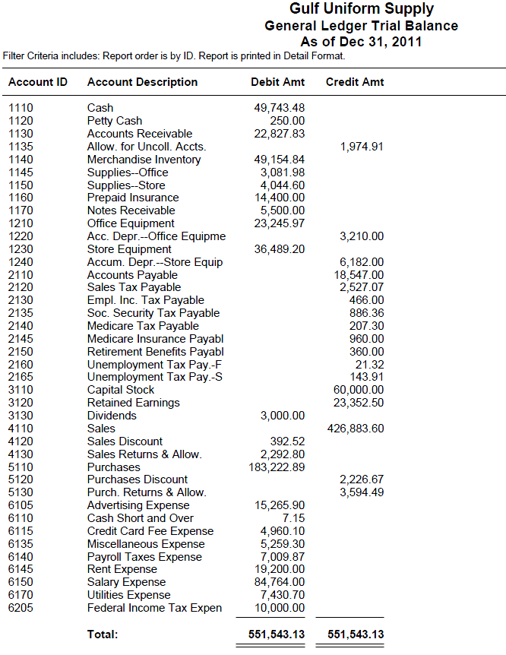

- Journalize and post the following adjustment information.

Adjustment Information, December 31, 2011

a. Office supplies inventory $845.60
b. Store supplies inventory 995.00
c. Merchandise inventory 53,148.00
d. Uncollectible accounts are 2.0% of credit sales of 65,000.00
e. Value of prepaid insurance 2,400.00
f. Note receivable-6%, 90-day, dated November 10,
face amount 3,520.00
g. Estimate of office equipment depreciation 5,460.00
h. Estimate of store equipment depreciation 6,980.00
i. Federal Income Tax adjustment 1,442.05

- Print an income statement. On a blank piece of paper or in the Working Papers, calculate the following ratios: (a) cost of merchandise sold, (b) gross profit on sales, (c) total expenses, and (d) net income or loss before federal income tax. Round percentage calculations to the nearest 0.1%.

- On a blank piece of paper or in the Working Papers, complete the following calculation. The company had 5,500 shares of $10.00 par value stock outstanding on January 1. The company issued an additional 500 shares during the year.

- Print the statement of retained earnings. (Hint: Sage 50 Accounting’s statement of retained earnings does not show the capital stock balance on December 31. Once you factor that in, Sage 50 Accounting’s statement of retained earnings will be in agreement with the manually prepared statement of stockholders’ equity in the Working Papers.)

- Print the balance sheet.

- Journalize and post the closing entries.

- Print the December 31 general journal.

- Print the general ledger.

- Print the post-closing trial balance.

Back up your work. The suggested filename is Reinforcement Activity 2-Part B.ptb.

18-3 Application Problem

Journalizing the Sale of Common and Preferred Stock

The instructions that follow demonstrate how to:

- Start Sage 50 Accounting 2016.

- Restore the starting data.

- Journalize and post transactions in the general journal.

- Complete 18-3 Application Problem.

Before starting 18-3 Application Problem, ask the instructor if Southern Supply, the company used for 18-3 Application Problem, has already been restored on the computer. The following instructions explain how to set up Southern Supply for the first time.

GETTING STARTED

Refer to pages 2 through 8 to restore a Sage 50 Accounting file from the Sage 50 Files folder. Each time you begin a problem, restore the starting data from a Sage 50 Accounting file. Then, pages 9 through 11 explain how to change the company name to include your initials.

In Sage 50 Accounting, Southern Supply is set up as a corporation. Change the company name from Southern Supply to 18-3APXX (X’s represent your initials).

Nothing has changed on your computer’s hard drive. This company is identified in the program folder and data folder as C:\Sage\Peachtree\Company\sousuppl. The company name has been changed so that Sage 50 Accounting printouts will show the problem number and your initials. Using Maintain; Company Information to rename the company does not change the shortened company name.

Instructions:

- From the textbook, journalize and post the following transactions.

- Print the September 2012 General Journal.

- Print the General Ledger Trial Balance.

- Back up. The suggested filename is 18-3 Application Problem.ptb.

18-M Mastery Problem

Journalizing transaction related to debt and equity financing.

The instructions that follow demonstrate how to:

- Start Sage 50 Accounting 2016.

- Restore the starting data.

- Journalize and post transactions.

- Print the general journal and selected general ledger accounts.

- Complete 18-M Mastery Problem.

Before starting 18-M Mastery Problem, ask the instructor if Teller Tires, the company used for 18-M Mastery Problem, has already been restored on the computer. The following instructions explain how to set up Teller Tires for the first time.

GETTING STARTED

Refer to pages 2 through 8 to restore a Sage 50 Accounting file from the Sage 50 Files folder. Each time you begin a problem, restore the starting data from a Sage 50 Accounting file. Then, pages 9 through 11 explain how to change the company name to include your initials.

In Sage 50 Accounting, Teller Tires is set up as a corporation. Change the company name from Teller Tires to 18-MPXX (X’s represent your initials).

Nothing has changed on your computer’s hard drive. This company is identified in the program folder and data folder as C:\Sage\Sage 50 Accounting\Company\teltires. The company name has been changed so that Sage 50 Accounting printouts will show the problem number and your initials. Using Maintain; Company Information to rename the company does not change the shortened company name.

Instructions:

- From the textbook, journalize and post the July 2012 transactions in the general journal.

- From the textbook, journalize and post the December 2012 transactions in the Write Checks window.

- Print the July 2012 general journal.

- Print the December 2012 Cash Disbursements Journal.

- Print the general ledger trial balance as of December 31, 2012.

- Back up. The suggested filename is 18-M Mastery Problem.ptb.

You have completed the work for 18-M Mastery Problem: Journalizing transactions related to debt and equity financing.

19-4 Application Problem

Recording the Disposal of Plant Assets

The instructions that follow demonstrate how to:

- Start Sage 50 Accounting 2016.

- Restore the starting data.

- Journalize and post transactions.

- Print the purchase journal, general journal and general ledger trial balance.

- Complete 19-4 Application Problem.

Before starting 19-4 Application Problem, ask the instructor if Quick Mart, the company used for 19-4 Application Problem, has already been restored on the computer. The following instructions explain how to set up Quick Mart for the first time.

GETTING STARTED

Refer to pages 2 through 8 to restore a Sage 50 Accounting file from the Sage 50 Files folder. Each time you begin a problem, restore the starting data from a Sage 50 Accounting file. Then, pages 9 through 11 explain how to change the company name to include your initials.

In Sage 50 Accounting, Quick Mart is set up as a corporation. Change the company name from Quick Mart to 19-4APXX (X’s represent your initials).

Nothing has changed on your computer’s hard drive. This company is identified in the program folder and data folder as C:\Sage\Peachtree\Company\quimart. The company name has been changed so that Sage 50 Accounting printouts will show the problem number and your initials. Using Maintain; Company Information to rename the company does not change the shortened company name.

Instructions:

In Sage 50 Accounting, use 2012 as the year. QuickMart had the following transactions involving the sale of plant assets. Use the plant asset records completed in Problem 19-3.1.

For each plant asset disposed of in 2012, journalize an entry for additional depreciation, if needed.

Transactions:

- From the textbook, journalize and post the January 6, 2012 through July 8, 2012 transactions in the general journal and cash receipts journal.

- Print the cash receipts journal.

- Print the general journal.

- Print the general ledger trial balance.

- Back up. The suggested filename is 19-4 Application Problem.ptb.

You have completed the work for 19-4 Application Problem: Recording the disposal of plant assets.

19-M Mastery Problem

Recording Transactions for Plant Assets

The instructions that follow demonstrate how to:

- Start Sage 50 Accounting 2016.

- Restore the starting data.

- Journalize and post transactions in the cash disbursements journal.

- Restore the starting data (2016).

- Journalize and post transactions in the general journal and cash receipts journal.

- Print the cash disbursements journal, cash receipts journal, general journal and general ledger trial balance.

- Complete 19-M Mastery Problem.

Before starting 19-M Mastery Problem, ask the instructor if Hillside Resort, the company used for 19-M Mastery Problem, has already been restored on the computer. The following instructions explain how to set up Hillside Resort for the first time.

GETTING STARTED

Refer to pages 2 through 8 to restore a Sage 50 Accounting file from the Sage 50 Files folder. Each time you begin a problem, restore the starting data from a Sage 50 Accounting file. Then, pages 9 through 11 explain how to change the company name to include your initials.

In Sage 50 Accounting, Hillside Resort is set up as a corporation. Change the company name from Hillside Resort to 19-MPXX (X’s represent your initials).

Nothing has changed on your computer’s hard drive. This company is identified in the program folder and data folder as C:\Sage\Peachtree\Company\hilresor. The company name has been changed so that Sage 50 Accounting printouts will show the problem number and your initials. Using Maintain; Company Information to rename the company does not change the shortened company name.

Instructions:

In Sage 50 Accounting, use 2012 and 2016 as the year for making entries. Hillside Resort records plant assets in two accounts: Furniture, Account No. 1205, and Equipment, Account No. 1215. Furniture is depreciated using the double declining-balance method. Equipment is depreciated using the straight-line method.

Instructions:

- Restore the 19-MP file.

- Record the following transactions completed during 2012 in the general journal:

Transactions:

Jan. 5. Bought an X-ray machine and a supply cabinet: cost, $30,000.00. C521. X-ray machine: estimated value, $22,000.00; estimated salvage value, $0.00; estimated useful life, 5 years; plant asset No. 715; serial number, ZYX487-6. Supply cabinet: estimated value, $11,000.00; estimated salvage value, $800.00; estimated useful life, 5 years; plant asset No. 716; serial number, 74-3554-L8.

Feb. 26. Paid property taxes on plant assets assessed at $600,000.00. The tax rate is 1.1%. C560.

Apr. 5. Bought a testing machine for the exam room: cost, $6500.00, estimated salvage value, $500.00; estimated useful life, 6 years; plant asset No. 717; serial number, 7-H256. C602.

- Use the form provided in the Working Papers to calculate the beginning book value.

- Use the form provided in the Working Papers to calculate beginning book value, annual depreciation, accumulated depreciation, and ending book value for each new plant asset.

- Complete Section 3 of the plant asset records for 20X1-20X4. (Sage 50 Accounting uses 2012).

- Back up. The suggested filename is 19 Mastery Problem.ptb.

- Restore the 19 MP 2016 file. The company name has been changed to Hillside New Resort. This enables Sage 50 Accounting to assign a different shortened company name in the directory.

- From the textbook, journalize and post the January 6, 2016 through July 8, 2016 transactions to the general journal and cash receipts journal. The accounting period is set at Period 12 – 12/01/16 through 12/31/16. Record all 2016 entries. It is not required to change accounting period.

Jan 6. Received cash for sale of a supply cabinet, plant asset No. 716, $1,500.00, R321.

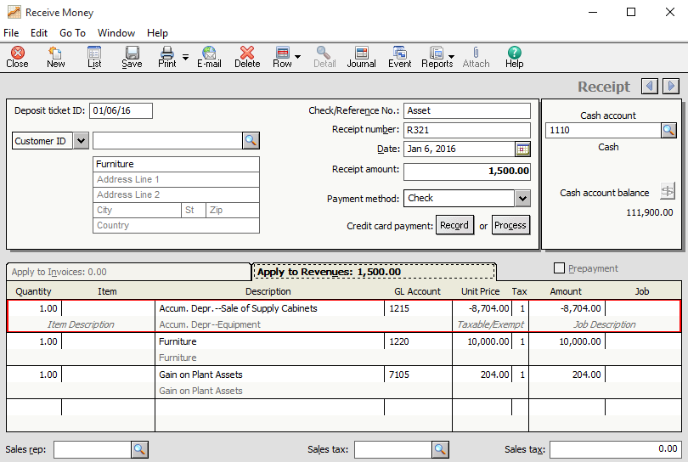

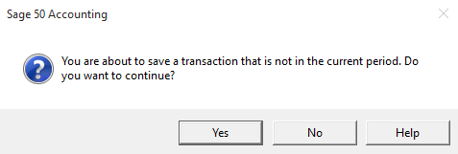

(In the Sage 50 Accounting Window, click Yes.)

July 2. Received cash for sale of an X-ray machine, plant asset No. 715, $1,700.00. M112 and R382.

Dec. 31. Recorded the adjusting entry for depreciation. Total 2016 depreciation expense of furniture was $29,500.00. Total 2016 depreciation expense of equipment was $65,750.00.

- Print the cash receipts journal.

- Print the general journal.

- Print the general ledger trial balance.

- Back up. The suggested file name is 19 Mastery Problem 2016.ptb.

You have completed the work for 19-M Mastery Problem: Recording Transactions for Plant Assets.

20-2 Application Problem

Determining the cost of inventory using the FIFO, LIFO, and weighted-average inventory costing methods

The instructions that follow demonstrate how to:

- Start Sage 50 Accounting 2016.

- Restore the starting data.

- Journalize and post purchases and sales of inventory on account.

- Print the purchase journal, sales journal, inventory valuation report and trial balance.

- Complete 20-2 Application Problem.

Before starting 20-2 Application Problem, ask the instructor if Oakland Supply, the company used for 20-2 Application Problem, has already been restored on the computer. The following instructions explain how to set up Oakland Supply for the first time.

GETTING STARTED

Refer to pages 2 through 8 to restore a Sage 50 Accounting file from the Sage 50 Files folder. Each time you begin a problem, restore the starting data from a Sage 50 Accounting file. Then, pages 9 through 11 explain how to change the company name to include your initials.

In Sage 50 Accounting, Oakland Supply is set up as a corporation. Change the company name from Oakland Supply to 20-2APXX (X’s represent your initials).

Nothing has changed on your computer’s hard drive. This company is identified in the program folder and data folder as C:\Sage\Peachtree\Company\oaksuppl. The company name has been changed so that Sage 50 Accounting printouts will show the problem number and your initials. Using Maintain; Company Information to rename the company does not change the shortened company name.

Instructions:

- Using 2011, journalize and post each of the following transactions. You do not need to change accounting periods.

Purchase Date Quantity Unit Price

January 1, beginning inventory 100 $4.00
March 13, purchases 88 $4.10
June 8, purchases 90 $4.25
September 16, purchases 94 $4.30
December 22, purchases 98 $4.40

There are 192 units in ending inventory.

Calculate the cost of ending inventory using the FIFO, LIFO, and weighted-average methods.

- Restore the 20-2AP_FIFO.ptb file.

- Record the sale of Item R001, Quantity 278.00 (100+88+90+94+98=470, 470-192=278) on January 20, 2011.

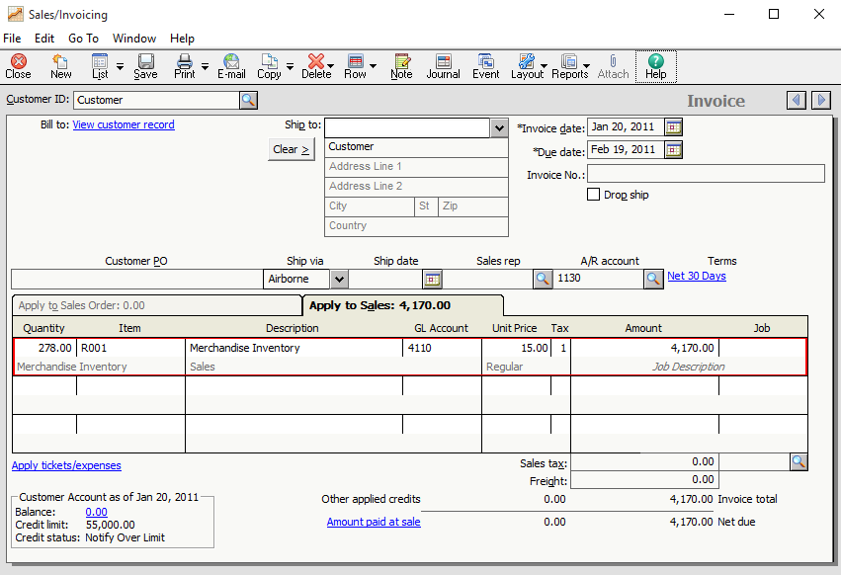

- Record purchases of inventory on account in the Purchases/Receive Inventory window.

- Print the January 1, 2011 to December 31, 2011 Purchase Journal.

- Print the January 1, 2011 to December 31, 2011 Sales Journal.

- Print the Inventory Valuation Report, as of December 31, 2011.

- Back up. The suggested filename is 20-2 Application Problem_FIFO.ptb.

- Restore the 20-2AP_Average.ptb file.

- Record the sale of Item R001, Quantity 278.00 (100+88+90+94+98=470, 470-192=278) on December 31, 2011.

- Record purchases of inventory on account in the Purchases/Receive Inventory window.

- Print the January 1, 2011 to December 31, 2011 Purchase Journal.

- Print the January 1, 2011 to December 31, 2011 Sales Journal.

- Print the Inventory Valuation Report, as of December 31, 2011.

- Back up. The suggested filename is 20-2 Application Problem_AVERAGE.ptb.

- Restore the 20-2AP_LIFO.ptb file.

- Record the sale of Item R001, Quantity 278.00 (100+88+90+94+98=470, 470-192=278) on December 31, 2011.

- Record purchases of inventory on account in the Purchases/Receive Inventory window.

- Print the January 1, 2011 to December 31, 2011 Purchase Journal.

- Print the January 1, 2011 to December 31, 2011 Sales Journal.

- Print the Inventory Valuation Report, as of December 31, 2011.

- Back up. The suggested filename is 20-2 Application Problem_LIFO.

You have completed the work for 20-2 Application Problem: Determining the cost of inventory using the FIFO, LIFO, and weighted-average inventory costing methods.

20-M Mastery Problem

Determining the cost of inventory using the FIFO, LIFO, and weighted-average inventory costing methods

The instructions that follow demonstrate how to:

- Start Sage 50 Accounting 2016.

- Restore the starting data.

- Journalize and post purchases and sales of inventory on account.

- Print the purchase journal, sales journal, inventory valuation report and trial balance.

- Complete 20 Mastery Problem.

Before starting 20 Mastery Problem, ask the instructor if Computer Supply Company, the company used for 20 Mastery Problem, has already been restored on the computer. The following instructions explain how to set up Computer Supply Company for the first time.

GETTING STARTED

Refer to pages 2 through 8 to restore a Sage 50 Accounting file from the Sage 50 Files folder. Each time you begin a problem, restore the starting data from a Sage 50 Accounting file. Then, pages 9 through 11 explain how to change the company name to include your initials.

In Sage 50 Accounting, Computer Supply Company is set up as a corporation. Change the company name from Computer Supply Company to 20-MPXX (X’s represent your initials).

Nothing has changed on your computer’s hard drive. This company is identified in the program folder and data folder as C:\Sage\Peachtree\Company\comsupco. The company name has been changed so that Sage 50 Accounting printouts will show the problem number and your initials. Using Maintain; Company Information to rename the company does not change the shortened company name.

Instructions:

- Using 2011, journalize and post each of the following transactions. You do not need to change accounting periods.

Transactions:

Jan. 6 Purchased 40 units from Printers Plus for $10.24 per unit, 2/10, n/30. P361.

Apr. 5 Sold 44 units to Glenville Hospital, n/30. S812.

14 Purchased 40 units from Printers Plus for $10.36 per unit, 2/10, n/30. P437.

Jul. 5 Sold 50 units to Hills Department Store, n/30. S971.

Aug. 3 Purchased 40 units from Printers Plus for $10.46 per unit, 2/10, n/30. P512.

Dec. 2 Sold 30 units to ABC Company, n/30. S1186.

12 Purchased 40 units from Printers Plus for $10.54 per unit, 2/10, n/30. P556.

- Restore the 20-M_FIFO.ptb.

- Journalize and post the following transactions in the Purchase Journal and Sales Journal. You do not need to change accounting periods.

- Print the January 1, 2011 to December 31, 2011 Purchase Journal.

- Print the January 1, 2011 to December 31, 2011 Sales Journal.

- Print the Inventory Valuation Report, as of December 31, 2011.

- Back up. The suggested filename is 20 Mastery Problem_FIFO.ptb.

- Restore the 20-M Average.ptb.

- Journalize and post the following transactions in the Purchase Journal and Sales Journal. You do not need to change accounting periods.

- Print the January 1, 2011 to December 31, 2011 Purchase Journal.

- Print the January 1, 2011 to December 31, 2011 Sales Journal.

- Print the Inventory Valuation Report, as of December 31, 2011.

- Back up. The suggested filename is 20 Mastery Problem_AVERAGE.

- Restore the 20-M_LIFO.ptb.

- Journalize and post the following transactions in the Purchase Journal and Sales Journal. You do not need to change accounting periods.

- Print the January 1, 2011 to December 31, 2011 Purchase Journal.

- Print the January 1, 2011 to December 31, 2011 Sales Journal.

- Print the Inventory Valuation Report, as of December 31, 2011.

- Back up. The suggested filename is 20 Mastery Problem_LIFO.ptb.

You have completed the work for 20-M Mastery Problem: Determining the cost of inventory using the FIFO, LIFO, and weighted-average inventory costing methods.

Reinforcement Activity 3—Part A

An Accounting Cycle for a Corporation:
Journalizing and Posting Transactions

The instructions that follow demonstrate how to:

- Start Sage 50 Accounting 2016.

- Restore the starting data.

- Journalize and post transactions.

- Complete Reinforcement Activity 3—Part A.

Before starting Reinforcement Activity 3—Part A, ask the instructor if Restaurant Warehouse, Inc, the company used Reinforcement Activity 3—Part A, has already been restored on the computer. The following instructions explain how to set up Restaurant Warehouse, Inc. for the first time.

GETTING STARTED

Refer to pages 2 through 8 to restore a Sage 50 Accounting file from the Sage 50 Files folder. Each time you begin a problem, restore the starting data from a Sage 50 Accounting file. Then, pages 9 through 11 explain how to change the company name to include your initials.

In Sage 50 Accounting, Restaurant Warehouse, Inc. is set up as a corporation. Change the company name from Restaurant Warehouse to RA03-AXX (X’s represent your initials).

Nothing has changed on your computer’s hard drive. This company is identified in the program folder and data folder as C:\Sage\Peachtree\Company\reswarin. The company name has been changed so that Sage 50 Accounting printouts will show the problem number and your initials. Using Maintain; Company Information to rename the company does not change the shortened company name. If Restaurant Warehouse, Inc. exists as a Sage 50 Accounting company, remember to restore An Existing Company rather than a new company.

GETTING STARTED

Restaurant Warehouse, Inc. is organized as a corporation. Transactions are recorded in the year 2011 (in Sage 50 Accounting).

DISPLAYING THE SPARKLE, INC. CHART OF ACCOUNTS

Before recording transactions, print or display Sage 50 Accounting’s chart of account and compare it to the one shown. Refer to these account numbers when recording transactions.

Note:

Sage 50 Accounting’s chart of accounts classifies the following accounts as Income:

4200 Gain on Plant Assets
4210 Interest Income
4220 Rent Income

Your textbook classifies account numbers 7105, 7110 and 7115 as “Other Revenue.” Since there is no Other Revenue (or Other Income) classification in Sage 50 Accounting, all revenue accounts are classified as Income.

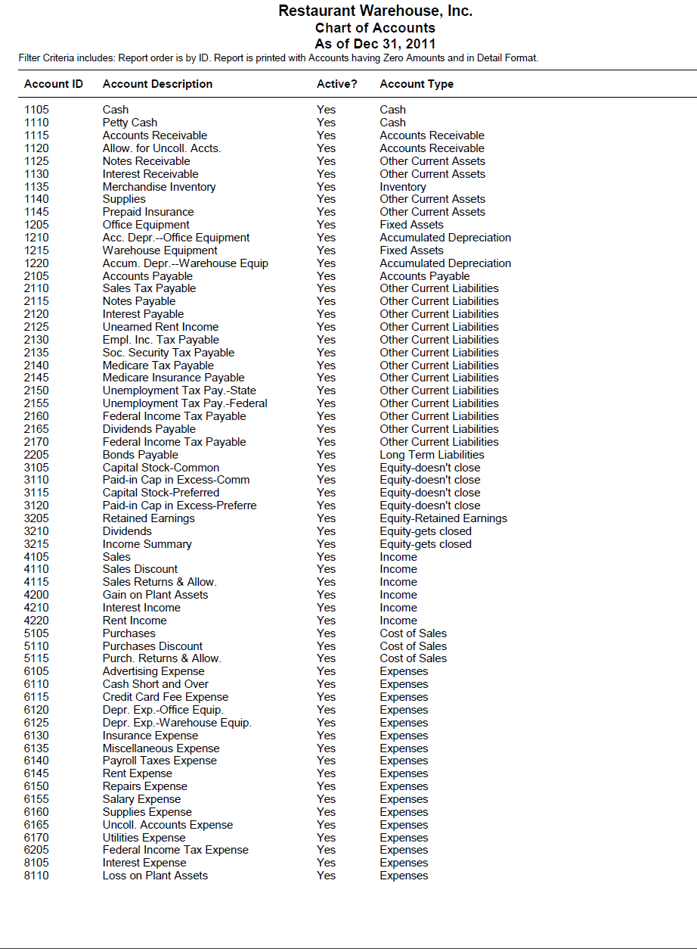

RECORDING TRANSACTIONS

The chart below shows which journals are used for Reinforcement Problem 3. The journals are abbreviated as follows: sales journal, SJ; cash receipts journal, CRJ; purchase journal, PJ; cash disbursements journal, CDJ; general journal, GJ.

Transactions | SJ | CRJ | PJ | CDJ | GJ
Customers - accounts receivable | √
Cash, credit card, customer receipts |  | √
Vendors – accounts payable |  |  | √
Vendor payments |  |  |  | √
Depreciation |  |  |  |  | √
Payroll taxes expense |  |  |  |  | √
Adjusting entries |  |  |  |  | √
Closing entries |  |  |  |  | √

Reinforcement Activity 3 covers a complete accounting cycle for a merchandising business organized as a corporation. Reinforcement Activity 3 is a single problem divided into two parts: Part A includes learning from Part 2 and Chapters 17 through 20 of Part 3 of the textbook. Part B includes learning from Chapters 21 and 22 of the textbook.

The accounting work of a single merchandising business for the last month of 2011 (in Sage 50 Accounting) is used in this reinforcement activity. The records kept and reports prepared illustrate the application of accounting concepts for all merchandising businesses.

Restaurant Warehouse, Inc., a merchandising business, is organized as a corporation. The business sells a complete line of restaurant supplies, mostly to business customers. Restaurant Warehouse is located within an industrial park and is open for business Monday through Saturday. Monthly rent is paid for the building. Restaurant Warehouse subleases some of its warehouse space. Restaurant Warehouse sells to some businesses on account and accepts cash or credit cards from small business owners.

The December 25, 2011 account balances for the general ledger and subsidiary ledgers are included on the RA03-A.ptb file.

Instructions:

From the textbook, journalize and post the following transactions completed during December 2011 (in Sage 50 Accounting). Use the sales journal, purchase journal, general journal, cash receipts journal, and cash disbursements journal. The sales tax rate is 6%. Source documents are abbreviated as follows: check, C; memorandum, M; purchase invoice, P; receipt, R; sales invoice, S; terminal summary, TS; debit memorandum, DM; credit memorandum, CM.

- Print the general journal from December 14 to December 31, 2011; sales journal, purchase journal, cash receipts journal, and cash disbursements journal.
- Print the vendor ledgers and customer ledgers.
- Print the general ledger.
- Use the Working Papers or a blank piece of paper to update depreciation.
- Back up your company data. The suggested filename is Reinforcement Activity 3-Part A.ptb. This backup is important. Keep it in a safe place. You will use it again for Part B of this problem.

You have completed the work for Reinforcement Activity 3–Part A, An Accounting Cycle for a Corporation—Journalizing and Posting Transactions. Keep your backup file in a safe place. You will use the backup made in this activity for Part B of this problem.

21-1 Application Problem

Journalizing Entries for Accruals

The instructions that follow demonstrate how to:

- Start Sage 50 Accounting 2016.

- Restore the starting data.

- Journalize and post adjusting and closing entries to the general journal.

- Journalize and post reversing entries.

- Journalize and post notes payable and notes receivable transactions.

- Print the general journal, cash receipts journal and cash disbursement journal.

- Complete 21-1 Application Problem.

Before starting 21-1 Application Problem, ask the instructor if Spano Corporation, the company used for 21-1 Application Problem, has already been restored on the computer. The following instructions explain how to set up Spano Corporation for the first time.

GETTING STARTED

Refer to pages 2 through 8 to restore a Sage 50 Accounting file from the Sage 50 Files folder. Each time you begin a problem, restore the starting data from a Sage 50 Accounting file. Then, pages 9 through 11 explain how to change the company name to include your initials.

In Sage 50 Accounting, Spano Corporation is set up as a corporation. Change the company name from Spano Corporation to 21-APXX (X’s represent your initials).

Nothing has changed on your computer’s hard drive. This company is identified in the program folder and data folder as C:\Sage\Peachtree\Company\spacorpo. The company name has been changed so that Sage 50 Accounting printouts will show the problem number and your initials. Using Maintain; Company Information to rename the company does not change the shortened company name.

Instructions:

On December 31, 2011(In Sage 50 Accounting), Spano Corporation has one note receivable outstanding, a 120-day, 6%, $16,000.00 note dated November 16, and one note payable outstanding, a 90-day, 6%, $18,000.00 note dated December 1. One note receivable and one note payable are the only notes on hand at the end of the fiscal period. Source documents are abbreviated as follows: receipt, R; check, C; note receivable, NR.

Transactions:

- Journalize and post the adjusting entries for accrued interest income and accrued expense on December 31, 2011. (Hint: To plan the adjustments, use a blank piece of paper or the work sheet in the Working Papers.)

- Journalize and post the closing entries for interest income and interest expense.

- Journalize and post the January 1, 2012 reversing entries for accrued interest income and accrued interest expense.

- Journalize and post the payment of cash for the maturity value of the note payable on March 1, 2012. Check No. 321.

- Journalize and post the receipt of cash for the maturity value of note receivable on March 16, 2012. Receipt No. 587

- Journalize the cash payment for the maturity value of the note payable.

- Print the December 31, 2011 to January 1, 2012 general journal.

- Print the March 16, 2012 cash receipts journal.

- Print the March 1, 2012 cash disbursements journal.

- Back up. The suggested filename is 21-4 Application Problem.ptb.
21 Mastery Problem

Journalizing Entries for Accruals and Deferrals

The instructions that follow demonstrate how to:

- Start Sage 50 Accounting 2016.

- Restore the starting data.

- Journalize and post adjusting and closing entries to the general journal.

- Journalize and post reversing entries.

- Journalize and post notes payable and notes receivable transactions.

- Print the general journal, cash receipts journal and cash disbursement journal.

- Complete 21-M Mastery Problem.

Before starting 21-M Mastery Problem, ask the instructor if Figlmiller Corporation, the company used for 21-M Mastery Problem, has already been restored on the computer. The following instructions explain how to set up Figlmiller Corporation for the first time.

GETTING STARTED

Refer to pages 2 through 8 to restore a Sage 50 Accounting file from the Sage 50 Files folder. Each time you begin a problem, restore the starting data from a Sage 50 Accounting file. Then, pages 9 through 11 explain how to change the company name to include your initials.

In Sage 50 Accounting, Figlmiller Corporation is set up as a corporation. Change the company name from Figlmiller Corporation to 21-MPXX (X’s represent your initials).

Nothing has changed on your computer’s hard drive. This company is identified in the program folder and data folder as C:\Sage\Peachtree\Company\figcorpo. The company name has been changed so that Sage 50 Accounting printouts will show the problem number and your initials. Using Maintain; Company Information to rename the company does not change the shortened company name.

RECORDING TRANSACTIONS

Figlmiller Corporation collected $30,000 on November 1 for six months’ rent. On December 31, 2011(in Sage 50 Accounting), Figlmiller Corporation has one note receivable outstanding, a 90-day, 5%, $13,000.00 note dated December 1, and one note payable outstanding, a 120-day, 4%, $8,000.00 note dated November 16. One note receivable and one note payable are the only notes on hand at the end of the fiscal period. Source documents are abbreviated as follows: receipt, R; check, C; note receivable, NR.

Instructions:

- Journalize and post the adjusting entries for accrued interest expense, and rent earned on December 31. (Hint: To plan the adjustments, you may want to use a blank piece of paper or the work sheet in the Working Papers.)

- Journalize and post the closing entries for all income and expense accounts. Record the closing entry for both income accounts in one entry.

- Journalize and post the January 1, 2012, reversing entries for accrued interest income and accrued interest expense.

- Journalize the receipt of cash for the maturity value of the note receivable on March 1, 2012. Receipt No. 125.

- Journalize the receipt of cash for the maturity value of the note receivable on March 1, 2012. Check No. 185.

- Print the December 31, 2011 to January 1, 2012 general journal.

- Print the March 1, 2012 cash receipts journal.

- Print the December 16, 2012 cash disbursements journal.

- Back up. The suggested filename is 21 Mastery Problem.ptb.

22-4 Application Problem

Journalizing Closing and Reversing Entries for a Corporation

The instructions that follow demonstrate how to:

- Start Sage 50 Accounting 2016.

- Restore the starting data.

- Journalize and post closing and reversing entries.

- Print the financial statements.

- Print the general journal.

- Complete 22-4 Application Problem.

Before starting 22-4 Application Problem, ask the instructor if Handy Hardware Corporation, the company used for 22-4 Application Problem, has already been restored on the computer. The following instructions explain how to set up Handy Hardware Corporation for the first time.

GETTING STARTED

Refer to pages 2 through 8 to restore a Sage 50 Accounting file from the Sage 50 Files folder. Each time you begin a problem, restore the starting data from a Sage 50 Accounting file. Then, pages 9 through 11 explain how to change the company name to include your initials.

In Sage 50 Accounting, Handy Hardware Corporation is set up as a corporation. Change the company name from Handy Hardware Corporation to 22-4 APXX (X’s represent your initials).

Nothing has changed on your computer’s hard drive. This company is identified in the program folder and data folder as C:\Sage\Peachtree\Company\hanharco. The company name has been changed so that Sage 50 Accounting printouts will show the problem number and your initials. Using Maintain; Company Information to rename the company does not change the shortened company name.

RECORDING TRANSACTIONS

Handy Hardware Corporation completed the following during December 2011 and January 2012.

Instructions:

Display Handy Hardware Corporation’s general ledger trial balance. Journalize and post closing entries using the information included on the general ledger trial balance.

- Journalize and post the December 31, 2011 closing entries.

- Journalize and post the January 1, 2012 reversing entries. (There is no need to change accounting periods.)

- Back up. The suggested filename is 22-4 Application Problem.ptb

- Journalize and post the reversing entries.

- Print the December 31, 2011 to January 1, 2012 general journal.

- Back up. The suggested filename is 22-4 Application Problem.ptb.

You have completed the work for 22-4 Application Problem: Preparing a worksheet, financial statements, and end-of-fiscal-period entries for a corporation.
22-M Mastery Problem

Journalizing Adjustments, Preparing Financial Statements, and End-of-Fiscal-Period Entries for a Corporation

The instructions that follow demonstrate how to:

- Start Sage 50 Accounting 2016.

- Restore the starting data.

- Journalize and post adjusting, closing, and reversing entries.

- Print the financial statements.

- Print the general journal.

- Complete 22-M Mastery Problem.

Before starting 22-M Mastery Problem, ask the instructor if Ramel Corporation, the company used for 22-M Mastery Problem, has already been restored on the computer. The following instructions explain how to set up Ramel Corporation for the first time.

GETTING STARTED

Refer to pages 2 through 8 to restore a Sage 50 Accounting file from the Sage 50 Files folder. Each time you begin a problem, restore the starting data from a Sage 50 Accounting file. Then, pages 9 through 11 explain how to change the company name to include your initials.

In Sage 50 Accounting, Ramel Corporation is set up as a corporation. Change the company name from Ramel Corporation to 22 MPXX (X’s represent your initials).

Nothing has changed on your computer’s hard drive. This company is identified in the program folder and data folder as C:\Sage\Peachtree\Company\ramcorpo. The company name has been changed so that Sage 50 Accounting printouts will show the problem number and your initials. Using Maintain; Company Information to rename the company does not change the shortened company name.

RECORDING TRANSACTIONS

Ramel Corporation completed the following transactions during December 2011 and January 2012.

Instrucitons:

Display Ramel Corporation’s general ledger trial balance. Journalize and post closing entries using the information included on the general ledger trial balance.

- Journalize and post the December 31, 2011 closing entries.

- Print the December 31, 2011 general journal.

- Back up. The suggested filename is 22 Mastery Problem.closed.ptb

- Journalize and post the January 1, 2012 reversing entries. (There is no need to change accounting periods.)

- Print the December 31, 2011 to January 1, 2012 general journal.

- Back up. The suggested filename is 22 Mastery Problem.ptb.

You have completed the work for 22-M Mastery Problem: Preparing an income statement, statement of stockholders’ equity, and balance sheet for a corporation.
Reinforcement Activity 3—Part B

An Accounting Cycle for a Corporation:
End-of-Fiscal-Period Work

The instructions that follow demonstrate how to:

- Start Sage 50 Accounting Complete Accounting.

- Restore the starting data from Reinforcement Activity 3—Part A, Sparkle, Inc., to complete Part B.

- Complete Reinforcement Activity 3—Part B.

You must complete Reinforcement Activity 3—Part B on pages 136-140, before starting Reinforcement Activity 3—Part B.

GETTING STARTED

Follow these instructions to restore data from Reinforcement Activity 3—Part B.

- Start Sage 50 Accounting.

- At the startup menu, select Open an existing company. From the Open list, select Sparkle, Inc. If Sparkle, Inc. is not listed, click Browse. Select Sparkle, Inc. from the Company Name list.

Read Me: What if Restaurant Warehouse, Inc. is not listed on either the Open list or when I select Browse?

- Use Windows Explorer to see if you have a program and data path identified as C:\Sage \Peachtree\Company\reswarin. Close Windows Explorer.
- From Sage 50 Accounting’s Open list, select Restaurant Warehouse, Inc. It may be identified by RA03-AXX. The X’s stand for a student’s initials.
- Restore the backup file made on page 156. The suggested filename was Reinforcement Activity 3-Part A.ptb. Once you restore the backup file that you made on page 156, you will be able to start where you left off the last time you worked with Restaurant Warehouse, Inc.

If you have checked Windows Explorer and Restaurant Warehouse, Inc. does not have a folder (\reswarin), do the following.

- Start Sage 50 Accounting. At the startup menu, click .
- The File, Options, Help menu bar appears. Select File; Restore.
- Using the Restore Wizard, select the appropriate location of the backup file that was made on page 156 (Reinforcement Activity 3-Part A.ptb), then restore A New Company. Sage 50 Accounting will restore your backup data and create the company at the same time.

  - From Sage 50 Accounting’s menu bar, click File; Restore.

  - Check the Location field to make sure you are restoring the correct file. Click .

  - The Select Company window defaults to An Existing Company. The Company Name field shows Sparkle, Inc.. The Location field shows C:\Sage\Peachtree\Company\reswarin. Click .

  - The Restore Options window appears. Make sure that the box next to Company Data is checked. Click .

  - The Confirmation window appears. Observe that the Company Name is Sparkle, Inc.. Check the From and To fields to make sure they are correct. Click . When the Restore Company scale is 100% complete, your data is restored and you are returned to the menu bar.

  - If necessary, remove the external media. You can now continue with Reinforcement Activity 3—Part B.

CHANGING THE COMPANY NAME

In order to make sure that each one of your printouts shows your name and problem number, follow these steps to change the name of the company.

- From Sage 50 Accounting’s menu bar, select Maintain, then Company Information.

- The Maintain Company Information screen appears. In the Company Name field, type RA03-BXX. Replace the X’s with your initials.
- When you are finished typing RA03-BXX as the company name, click . Once you have changed the Company Name, each one of your printouts will show the problem number and your initials.

Nothing has changed on your computer’s hard drive. The company you set up is identified in the program folder and data folder as C:\Sage\Peachtree\Company\reswarin. What you’ve done is change the company name so that printouts will show the problem number and your initials. Using Maintain, Company Information to rename the company does not change the filename of the company folder.

JOURNALZING TRANSACTIONS

Instructions:

- After restoring the backup that you made at the end of Reinforcement Activity 3—Part A, print the general ledger trial balance. This is the unadjusted trial balance. Compare it to the one shown below. If you completed the worksheet in the Working Papers, compare this trial balance to the one in your worksheet.

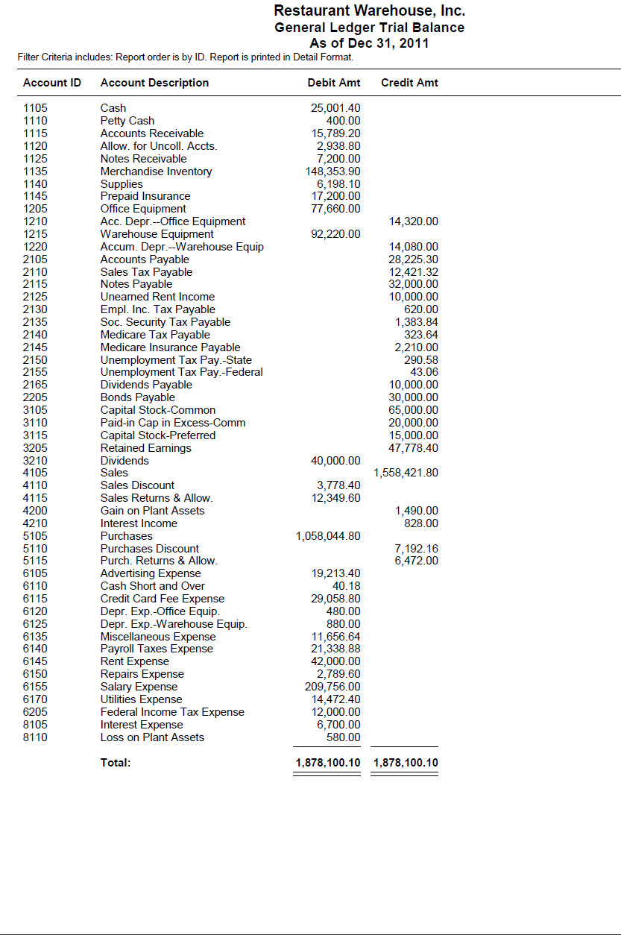
- On a blank piece of paper or in the Working Papers, record the 20X4 (2011 in Sage 50 Accounting) depreciation on the plant asset record of plant asset no. 9422 (Plant assets 452 and 453 will not have depreciation in this accounting period because they were purchased at the end of the year.

- Journalize and post the following adjustment information.

Adjustment Information, December 31, 2011 (in Sage 50 Accounting)

a. Estimated uncollectible accounts based on aging accounts receivable, $1261.20.
b. Outstanding notes receivable consist of NR30, a 60-day, 11% note accepted from Northside Catering on December 7, 2011, for an extension of time on its account, $7,200.
c. Merchandise inventory $150,983.90
d. Supplies inventory 850.00
e. Value of prepaid insurance 9,200.00
f. Estimate of office equipment depreciation 15,040.00
g. Estimate of warehouse equipment depreciation 28,420.00
h. Outstanding notes payable consist of (1) NP19, a 100-day, 9% note for $20,000.00 signed on October 31, 2011, and (2) NP22, a 90-day, 10% note for $12,000.00 signed on December 28, 2011.
i. Rent earned 3,000.00
j. Federal income tax 5,362.49

- Print the income statement. On a blank piece of paper or in the Working Papers, calculate the following component percentages: (a) cost of merchandise sold, (b) gross profit on operations, (c) total operating expenses; and (d) net income from operations; (3) net additional or deduction resulting from other revenue and expenses; and (f) net income before federal income tax. Round percentage calculations to the nearest 0.1%.

Note:

Use the information on Sage 50 Accounting’s income statement, and the adjustment information above, to determine the component percentages. You will need to rework Sage 50 Accounting’s income statement to match the income statement prepared in the Working Papers. Remember, Sage 50 Accounting does not include the merchandise inventory adjustment on the income statement nor does it separately report Other Revenue, Other Expenses, and Net Income before Federal Income Tax.

- On a blank piece of paper or in the Working Papers, analyze the corporation’s income statement by determining if the component percentages are within acceptable levels. If any component percentage is not within an acceptable level, suggest steps that the company should take. The corporation considers the following component percentages acceptable:

Cost of merchandise sold: Not more than 62.0%
Gross profit on operations: Not less than 38.0%
Total operating expenses: Not more than 28.0%
Income from operations: Not less than 10.0%
Net deduction from other revenue and expenses: Not more than 0.5%
Net income before federal income tax: Not less than 9.5%

- Print the statement of retained earnings. The company had 6,000 shares of $10.00 par value common stock and no shares of $50.00, 5% preferred stock outstanding on January 1. The company issued 500 shares of common stock and 300 shares of preferred stock during the year. (Hint: Sage 50 Accounting’s statement of retained earnings does not show the capital stock balance on December 31. Once you factor that in, Sage 50 Accounting’s statement of retained earnings will be in agreement with the manually prepared statement of stockholders’ equity in the Working Papers.)

- Print the balance sheet.

- Back up. The suggested filename is Reinforcement Problem 3-Part B.adjusted.ptb.

- Journalize and post the closing entries.

- Print the post-closing trial balance.

- Back up. The suggested filename is Reinforcement Problem 3-Part B.closed.ptb.

- Journalize and post the reversing entries. (Hint: There is no need to change accounting periods.)

- Print the December 31, 2011 to January 1, 2012 general journal.

- Print the December 1 to January 31, 2012 general ledger.

- Back up your work. The suggested filename is Reinforcement Activity 3-Part B.reversed.ptb.

You have completed the work for Reinforcement Activity 3—Part B: An Accounting Cycle for a Corporation; End-of-Fiscal-Period Work.

23-3 Application Problem

Liquidating a Partnership

The instructions that follow demonstrate how to:

- Start Sage 50 Accounting 2016.

- Restore the starting data.

- Journalize and post transactions related to liquidating a partnership to the general journal.

- Print the general journal, cash receipts journal and cash disbursements journal.

- Complete the 23-3 Application Problem.

Before starting 23-3 Application Problem, ask the instructor if Dixon Partnership, the company used for 23 Application Problem, has already been restored on the computer. The following instructions explain how to set up Dixon Partnership for the first time.

GETTING STARTED

Refer to pages 2 through 8 to restore a Sage 50 Accounting file from the Sage 50 Files folder. Each time you begin a problem, restore the starting data from a Sage 50 Accounting file. Then, pages 9 through 11 explain how to change the company name to include your initials.

In Sage 50 Accounting, Dixon Partnership is set up as a Partnership. Change the company name from Dixon Partnership to 23-3 APXX (X’s represent your initials).

Nothing has changed on your computer’s hard drive. This company is identified in the program folder and data folder as C:\Sage\Sage 50 Accounting\Company\dixpartn. The company name has been changed so that Sage 50 Accounting printouts will show the problem number and your initials. Using Maintain; Company Information to rename the company does not change the shortened company name.

RECORDING TRANSACTIONS

Instructions:

Journalize and post the following transactions affecting sales and cash receipts completed during February 2005. Use the general journal and cash receipts journal for recording transactions. (Hint: Cash receipts journal transactions involve cash.)

Transactions

Apr. 1 Received cash from the sale of office equipment, $8000.00. R364.
1 Received cash from sale of supplies, $400.00. R365.
3 Recorded cash from sale of truck, $10,000.00. R366.
5 Paid cash to all creditors for amounts owed. C534.
6 Distributed balance of Loss and gain on Realization to Rebecca Dixon, 65%; to Doris Dixon, 35%. M141.
6 Distributed remaining cash to partners. C535 and C536.
.
- Journalize and post the transactions in the appropriate journal.

- Print the April 1, 2011 to April 30, 2011 general journal.

- Print the April 1, 2011 to April 30, 2011 cash receipts journal.

- Print the April 1, 2011 to April 30, 2011 cash disbursements journal.

- Back up. The suggested filename is 23-3 Application Problem.ptb.

You have completed the work for 23-3 Application Problem.

23-M Mastery Problem

Recording partners’ investments and withdrawals, preparing financial statements, and liquidating a partnership

The instructions that follow demonstrate how to:

- Start Sage 50 Accounting 2016.

- Restore the starting data.

- Journalize and post transactions related to liquidating a partnership to the general journal.

- Print the general journal, cash receipts journal and cash disbursements journal.

- Complete the 23 Mastery Problem.

Before starting 23-M Mastery Problem, ask the instructor if CarpetClean, the company used for 23-M Mastery Problem, has already been restored on the computer. The following instructions explain how to set up CarpetClean for the first time.

GETTING STARTED

Refer to pages 2 through 8 to restore a Sage 50 Accounting file from the Sage 50 Files folder. Each time you begin a problem, restore the starting data from a Sage 50 Accounting file. Then, pages 9 through 11 explain how to change the company name to include your initials.

In Sage 50 Accounting, CarpetClean is set up as a Partnership. Change the company name from CarpetClean to 23 MPXX (X’s represent your initials).

Nothing has changed on your computer’s hard drive. This company is identified in the program folder and data folder as C:\Sage\Peachtree\Company\carpetcl. The company name has been changed so that Sage 50 Accounting printouts will show the problem number and your initials. Using Maintain; Company Information to rename the company does not change the shortened company name.

RECORDING TRANSACTIONS

Instructions:

Journalize and post the following investment transactions completed by CarpetClean during the year. Use the general journal and cash receipts journal for recording transactions. (Hint: Cash receipts journal transactions involve cash.)
There are two separate student template files restored for 23 Mastery Problem.

- Restore the 23-MP.ptb file.

Transactions

Jan. 15 Received cash as an investment from partner, Sean Fleming, $12,000.00. Receipt No. 110.
15 Received cash of $3000.00 and equipment valued at $10,000.00 from partner, Shannon Fleming, as an investment. Receipt No. 111.
Mar. 31 Shannon Fleming, partner, withdrew merchandise for personal use, $2000.00. Memorandum No 81.
31 Sean Fleming, partner, withdrew cash for personal use, $1600.00. Check No. 212.
.
- Journalize and post the transactions to the appropriate journal.

- Print the April 1, 2011 to April 30, 2011 general journal.

- Print the April 1, 2011 to April 30, 2011 cash receipts journal.

- Print the April 1, 2011 to April 30, 2011 cash disbursements journal.

- Back up. The suggested filename is 23 Mastery Problem.ptb

- Restore the 23-MP liquidate.ptb file.

The Flemmings decided to liquidate CarpetClean and retire on December 31, 2011 (In Sage 50 Accounting). On that date, after financial statements were prepared and closing entries were posted, the general ledger accounts had the following balances as displayed in the general ledger trial balance below.

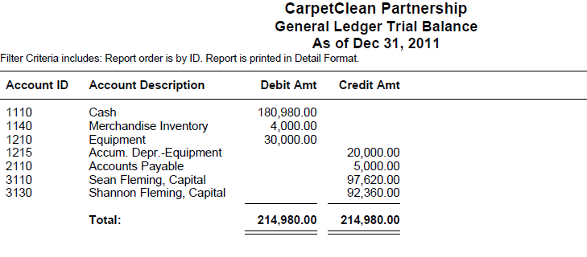

- Journalize and post the Dec 31, 2011 (In Sage 50 Accounting) transactions.

- Back up. The suggested filename is 23 Mastery Problem.liquidate.ptb.

You have completed the work for 23-M Mastery Problem: Recording partners’ investments and withdrawals, preparing financial statements, and liquidating a partnership.

24-1 Application Problem

Journalizing International Sales Transactions

The instructions that follow demonstrate how to:

- Start Sage 50 Accounting Complete Accounting.

- Restore the starting data.

- Journalize and post transactions related to international sales transactions to the general journal.

- Journalize and post transactions related to cash receipts from international sales transactions.

- Complete the 24-1 Application Problem.

Before starting 24-1 Application Problem, ask the instructor if Jan Hakeem Exports, Ltd., the company used for 24-1 Application Problem, has already been restored on the computer. The following instructions explain how to set up Jan Hakeem Exports, Ltd. for the first time.

GETTING STARTED

Refer to pages 2 through 8 to restore a Sage 50 Accounting file from the Sage 50 Files folder. Each time you begin a problem, restore the starting data from a Sage 50 Accounting file. Then, pages 9 through 11 explain how to change the company name to include your initials.

In Sage 50 Accounting, Jan Hakeem Exports, Ltd. is set up as a Partnership. Change the company name from Jan Hakeem Exports, Ltd. to 24-1 APXX (X’s represent your initials).

Nothing has changed on your computer’s hard drive. This company is identified in the program folder and data folder as C:\Sage\Peachtree\Company\janhakex. The company name has been changed so that Sage 50 Accounting printouts will show the problem number and your initials. Using Maintain; Company Information to rename the company does not change the shortened company name.

RECORDING TRANSACTIONS

Instructions:

Journalize and post the following investment transactions completed by Jan Hakeem Exports, Ltd during the year. Use the general journal and cash receipts journal for recording transactions. (Hint: Cash receipts journal transactions involve cash.)

Transactions

Jun. 1 Recorded an international cash sale, $14,000.00. M79.
5 Received a 30-day time draft from Bella Lamas for an international sale, $12,000.00. TD27.
9 Received cash for the value of Time Draft No. 24, $18,000.00. R115.
12 Received a 60-day time draft from Elias Harmon for an international sale, $7000.00. TD33.
19 Received cash for the value of Time Draft No. 21, $22,000.00. R117.
21 Recorded an international cash sale, $13,500.00. M83.
25. Received a 30-day time draft from Juan Mendez for an international sale, $26,500.00. TD34.
.
- Restore the 24-1 AP.ptb file.

- Journalize and post the transactions to the appropriate journal.

- Print the June 1, 2011 to June 30, 2011 general journal.

- Print the June 1, 2011 to June 30, 2011 cash receipts journal.

- Print the June 1, 2011 to June 30, 2011 general ledger trial balance

- Back up. The suggested filename is 24-1 Application Problem.ptb.

24-M Mastery Problem

Journalizing International and Internet Sales

The instructions that follow demonstrate how to:

- Start Sage 50 Accounting 2016.

- Restore the starting data.

- Journalize and post transactions related to international sales transactions to the general journal.

- Journalize and post transactions related to cash receipts from international sales transactions.

- Complete the 24-M Mastery Problem.

Before starting 24-M Mastery Problem, ask the instructor if Dexter Corporation, the company used for 24-M Mastery Problem, has already been restored on the computer. The following instructions explain how to set up Dexter Corporation for the first time.

GETTING STARTED

Refer to pages 2 through 8 to restore a Sage 50 Accounting file from the Sage 50 Files folder. Each time you begin a problem, restore the starting data from a Sage 50 Accounting file. Then, pages 9 through 11 explain how to change the company name to include your initials.

In Sage 50 Accounting, Dexter Corporation is set up as a Partnership. Change the company name from Dexter Corporation to 24 MPXX (X’s represent your initials).

Nothing has changed on your computer’s hard drive. This company is identified in the program folder and data folder as C:\Sage\Peachtree\Company\dexcorpo. The company name has been changed so that Sage 50 Accounting printouts will show the problem number and your initials. Using Maintain; Company Information to rename the company does not change the shortened company name.

RECORDING TRANSACTIONS

Instructions:

Journalize and post the following investment transactions completed by Dexter Corporation during the year. Use the general journal and cash receipts journal for recording transactions. (Hint: Cash receipts journal transactions involve cash.)

Transactions

May 5 Received a 30-day time draft from Cooper Doi for an international sale, $3000.00. TD10.
8 Recorded Internet credit card sales, $14,500.00. TS23.
12 Recorded an international cash sale, $8,800.00. M8.
14 Received cash for the value of Time Draft No. 4, $22,000.00. R35.
18 Recorded Internet credit card sales, $18,300.00. TS24.
21 Received cash for the value of Time Draft No. 7, $6,000.00. R37.
24 Recorded an International cash sale, $12,400.00. M12.
27 Recorded Internet credit card sales, $7,100.00. TS25.
28 Received a 30-day time draft from Strizi Percheki for international sale of merchandise, $5000.00.
.
- Restore the 24-MP.ptb file.

- Journalize and post the transactions to the appropriate journal.

- Print the May 1, 2011 to May 30, 2011 general journal.

- Print the May 1, 2011 to May 30, 2011 cash receipts journal.

- Print the May 1, 2011 to May 30, 2011 general ledger trial balance.

- Back up. The suggested filename is 24 Mastery Problem.ptb.

