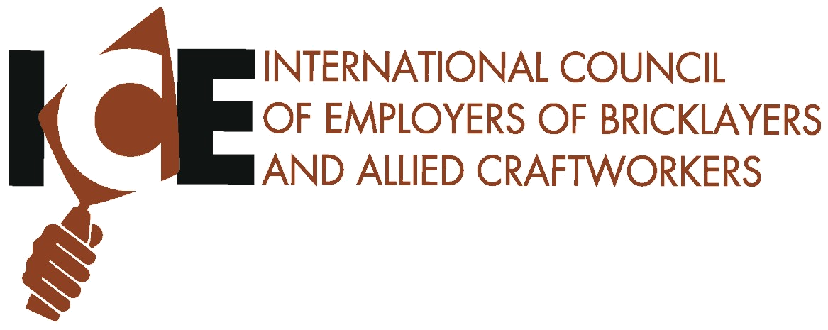
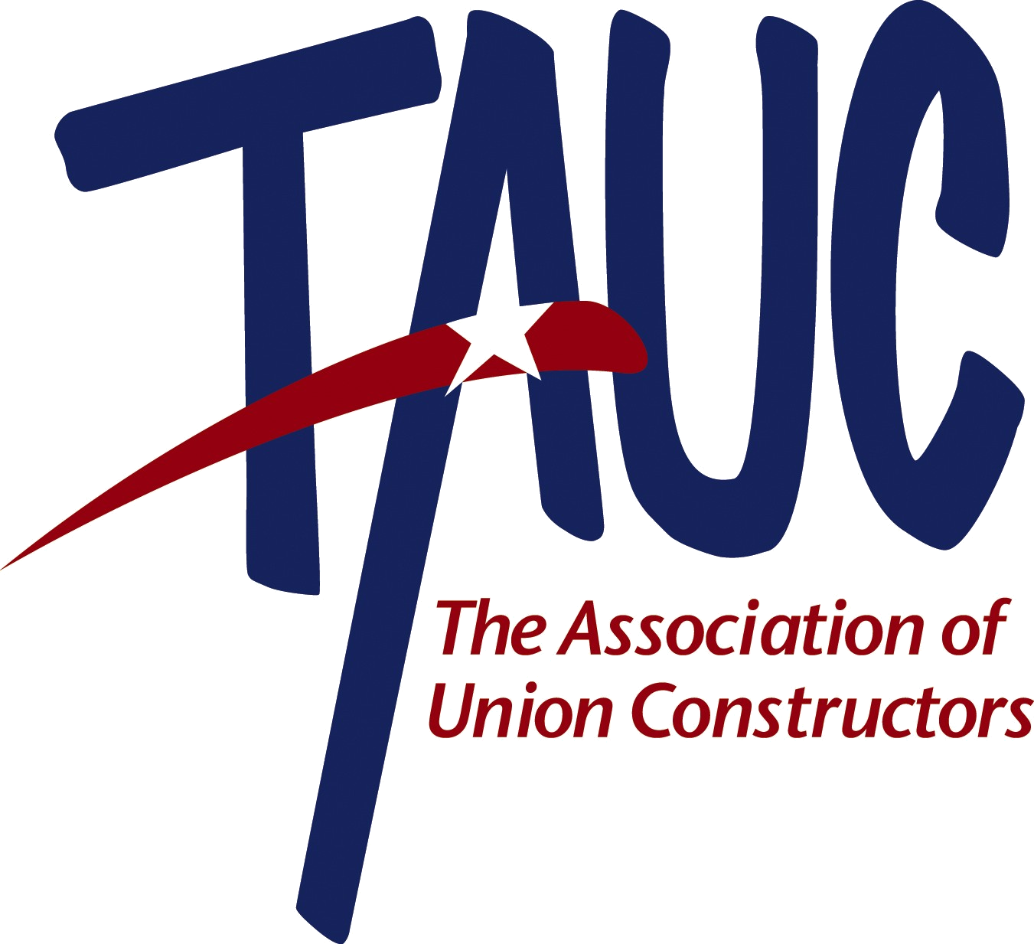


Specialty Construction Industry 2008 National Issues Conference

Partnering with

The International Foundation of Employee Benefit Plans
Annual Legislative Update


May 19-20, 2008

Washington Court Hotel
Washington, DC
Specialty Construction Industry 2008 Legislative Conference

In ongoing efforts to adapt to the rapidly changing political landscape in Washington, and in anticipation of more rapid changes in the future, the International Council of Employers of Bricklayers and Allied Craftworkers (ICE), the Mechanical Contractors Association of America (MCAA), and The Association of Union Constructors (TAUC) are proud to be holding our legislative program in conjunction with the joint labor/management health and welfare, pension, and apprenticeship and training program trustees who attend the International Foundation of Employee Benefits Plans (IFEBP) Annual Legislative Update.

By joining programs with the trustees who develop the basic workforce development infrastructure under our union-signatory jointly administered programs, ICE, MCAA and TAUC are laying a solid foundation of support for a great many of our management public policy initiatives on Capitol Hill and with the regulatory agencies in Washington DC. Our greatest distinction from the open-shop sector of the industry is the union-signatory employers' longstanding investment in the jointly administered health and welfare, pension, and workforce apprenticeship and journey worker upgrade training programs.

So this year, we will join with the IFEBP program on the first day of the conference (May 19th), focusing on health care reform proposals - beginning to anticipate changes that will affect all our plans nationwide when reforms eventually are enacted. ICE, MCAA and TAUC are readying to play a key role in protecting our jointly administered systems from harm when Congress eventually acts on this most important issue - it's not too early to start getting ready. After that, the conference will have a broad scope review of labor and employment laws changes that will fill out the remaining days of the 110th Congress and then pick up momentum in the early days of the 111th Congress after the general election in the Fall.

With the coming changes in the political dynamic on Capitol Hill, union-signatory employers have to get ready to capitalize on policy changes that fully address the big issues facing our industry:

- Responding to competitive pressures to develop and maintain a skilled workforce
- Overcoming the adverse workforce demographics in the industry
- Maintaining workforce standards for all employers
- Addressing immigration reform while maintaining the integrity of lawful employment policies and workforce standards.

On Monday evening, ICE, MCAA and TAUC will sponsor a reception for their conference attendees and invited lawmaker guests. Then, on the second day of the conference, after the breakfast speaker, ICE, MCAA and TAUC will have their separate legislative briefing session focusing on our top three issues:

- Repealing the new 3% withholding tax on public contracts
- Supporting reforms to stem independent contractor/misclassification of employees
- Enacting Federal contract procurement reforms.

On Tuesday afternoon, appointments will be made for members’ lobbying meetings with Congressional offices. Please mark your calendars and join this inaugural conference in conjunction with the IFEBP as we prepare for the likely new legislative and regulatory agenda in Washington in the coming years.

ICE, MCAA, and TAUC members who are trustees on jointly administered benefit funds and who attend the IFEBP program on Monday will receive a certificate of attendance that may entitle them to some reimbursement of expenses from the local benefits funds.

Participants are encouraged to consult with their local fund counsel in advance about whether participation in the IFEBP one-day program would qualify for partial expense reimbursement.
Tentative Agenda

Monday May 19, 2008
7:30 a.m. – 8:45 a.m. Breakfast and Keynote Presentation -Surveying the 2008 Presidential Campaign Ronald Brownstein, Los Angeles Times presidential campaign correspondent and political author and analyst
9:00 a.m. – 10:00 a.m. Overview of the Presidential Candidates Health Care Reform Proposals
Part 1 – Mandates, financing mechanisms, quality of care and impact on Taft-Hartly jointly administered health plans
10:15 a.m. – 11:15 a.m. Assessment of Leading Studies of Health Care Reform Proposals
Part 2 – Impact on cost, efficiency of health care delivery, ways to improve quality of care, financial incentives to improve health outcomes, and impact on Taft-Hartley jointly administered plans.
11:30 a.m. – 12:30 p.m. Congressional reaction on the proposals
Part 3 – Policy recommendations are one thing, legislative policy making is another. A panel of Congressional experts will forecast the political tangles that will ensue in the 111th Congress based on experiences on past legislative efforts in the national health policy thicket.
12:30 p.m. – 2:00 p.m. Lunch and Panel Discussion
Public Opinion Polling on the National Health Care Policy Debate
2:15 p.m. – 3:30 pm Recent Developments in Labor and Employment Law
Impact of recent regulatory developments and legislative proposals on jointly administered plans and employer sponsors, proposed reform of independent contractor misclassification abuses, card check organizing under the proposed Employee Free Choice Act, and immigration reform proposals and regulatory developments.
3:30 p.m. – 4:15 p.m. Apprenticeship Program Update
An analysis of the impact of recent regulatory proposals on apprenticeship program registration, approval and administration. Update on Workforce Investment Act funding and administration, and an update on the activities of the Federal Advisory Committee on Apprenticeship
6:00 p.m. – 7:00 p.m. ICE, MCAA, TAUC Reception for Member Attendees

Tuesday, May 20, 2008
7:30 a.m. – 8:45 a.m. Breakfast and Keynote Speaker
A Candid View on the Future of the Employment-Based Health Care System Andrew Stern (invited), President of Service Employees International Union
9:00 a.m. – 12:00 p.m. ICE, MCAA, TAUC Legislative Issue Briefing Sessions:
Stemming Worker Misclassification Abuses
Legislative proposals and regulatory changes to prevent misclassification of employees as independent contractors - the competitive benefit to ICE, MCAA, and TAUC employers.
Repealing the Public Contract 3% Withholding Tax
How long before Congress fixes this mistake enacted in 2006 and waiting to mature in 2011, or will it?
Enacting Federal Contracting Procurement Reforms
The prospects for good-government reforms to shore up lax public contractor responsibility determinations and ways to use bid listing to bolster the lagging use of price-only low-bid selection for Federal construction contracts.
12:30 p.m. – 4:00 p.m. ICE, MCAA and TAUC lunch and afternoon lobbying meetings on Capitol Hill
Specialty Construction Industry 2008 National Issues Conference
The Washington Court Hotel  Washington, DC
May 19-20, 2008

Attendee Information
Name |  |  |  | Badge Name
Spouse/Guest |  |  |  | Badge Name
Company Name |  |  |  | Title
Street Address
City |  |  |  | State |  |  | Zip
Registrant’s E-mail |  |  |  | Work Phone |  |  | Fax
E-mail address to send confirmation of receipt of registrations:
Registered Voting ZIP Code  (For Congressional Appointments) |  |  | Mobile Phone  (For Congressional Appointments)

Registration Fees

IMPORTANT REGISTRATION INFO
- TWO separate registrations charges will appear on your credit card for reimbursement purposes. $390 will be charged separately by the IFEBP and $150 will be charged by MCAA for the remaining program.
- Hotel reservation deadline is April 16, 2008
- Your credit card will be charged $350 for your hotel deposit when your reservations are made.
Specialty Construction Industry 2008  National Issues Conference | $540
Total Due | $

Hotel Registration
Reservation Deadline: April 16, 2008 (Include $350 Deposit)
Room Type | Single/Double | King | Double | Non Smoking Only
Washington Court Hotel Room | $305

Reservations are made on a first-come, first-served space available basis. Local occupancy taxes apply (14.5% Tax) (Smoke Free Property). ⬆Please contact MCAA Convention Department at 1-800-556-3653 if you require special accommodations to fully participate in this event.
Arrival Date |  |  | Departure Date
Total Number of People in Room
Do you have any special hotel requirements?

Payment Options
Credit Card Only  AMEX  MC  VISA
Account Number |  | Expiration
Cardholder Name |  | Billing Zip Code
Signature

Registration Made Easy: |  | For Office Use
 Register Online at www.mcaa.org
 FAX your completed registration and hotel reservation forms to: (301) 869-3520 |  | Payment:
 Mail your completed forms to: |  | Database:
MCAA Convention Department • 1385 Piccard Drive • Rockville, MD 20850-4340 |  | Hotel:
Questions?  E-mail us at eventregistration@mcaa.org |  | IFEBP

