Dated : 09.09.11

A NOTORIOUS GANG INVOLVED IN AUTO LIFTING BUSTED : 5 ACCUSED INCLUDING RECEIVER ARRESTED, 16 STOLEN VEHICLES RECOVERED AND 16 CASES OF M.V. THEFT WORKED OUT.

Staff of PS Malviya Nagar, South District have arrested five notorious auto lifters of the auto lifting gang including receiver, headed by accused Arman. With their arrest, 16 cases of M.V. theft have been solved and 16 stolen vehicles have been recovered at their instance from Delhi, Dimapur and Aizwal.

ACCUSED ARRESTED:

- Arman (21 years) s/o Rashid Khan R/o Village & PS Yairpok Singa, District Tioubal, Manipur.
- Firoz Khan (27 years) s/o Mohd. Nizamudin r/o Village & PS Yairpok Singa, District Tioubal, Manipur.
- Riyaz Khan (22 years) s/o Junab Ali r/o Village & PS Yairpok Singa, District Tioubal, Manipur.
- Anwar (31 years) s/o Nasir Hussain r/o Village & PS Yairpok Singa, District Tioubal, Manipur.
- Saqkib (25 years) s/o Firozudeen r/o H. No 1605, Sui Walan, Sakkewali Gali, Turkman Gate, Delhi.

INCIDENT, TEAM & ARREST :

In order to prevent the incidents of M.V. theft, a team consisting of SI Rakesh, ASI Islamudin, ASI Hukam Chand, ASI Gulab Singh, HC Kishore Kumar, HC Love Kumar, HC Dara Singh, HC Sanjeev Malik, HC Naterpal, Ct. Hari Kishan, Ct. Ram Niwas, Ct. Rajinder, Ct. Lukman headed by Inspr. Arvind Kumar, ATO/PS Malviya Nagar under the overall supervision of Inspr. Atul Kumar, SHO/Malviya Nagar and Sh. Manishi Chadra, ACP/Hauz Khas was formed to develop the information and apprehend criminals involved in such activities.

The members of team worked relentlessly and collected details of several criminals previously involved in such cases and activated their secret informers to develop information about the criminals involved in these cases. On 26.08.11, while the team members were patrolling in the area of Shivalik, information was received from a reliable source by ASI Hukam Chand and ASI Islamudin regarding roaming of 3 auto lifters in a stolen car in Shivalik, area of PS Malviya Nagar to commit auto lifting. Immediately, the members of team swung into action and started checking of vehicles at Shivalik Road Picket near Jal Board Office. On seeing a Santro Car without number plate, the picket staff signaled the vehicle to stop for checking. As soon as, the vehicle was stopped, 4 occupants came out of the car and tried to abscond but the alert members of team overpowered all of them after a minor chase. On enquiry, they revealed their identities as Arman, Firz, Riyaz and Anwar. On verification through the SMS facility, the Santro Car was found to be stolen from the area of PS Malviya Nagar. In this regard, a case vide FIR No. 242/11 u/s 379/411/34 IPC PS Malviya Nagar was already registered. Accordingly, all the accused persons were arrested and investigation taken up.

INVESTIGATION :

On sustained interrogation, accused persons disclosed that Saqib s/o Firozudeen r/o H. No. 1605, Sui Walan, Sakkewali Gali, Turkman Gate, Delhi is receiver of their stolen vehicles. They also disclosed the name of their accomplice Ayub Khan who belongs to Nagaland. Thereafter, a trap was laid to apprehend accused Saqib by calling him through the gang members at a designated place. As soon as, accused Saqib came on Kinetic Scooter, the alert members of team apprehended him. On verification, Kinetic Scooter was found stolen from the area of PS Sarai Rohilla. Accused Arman, Firoz and Saqib were taken on police custody remand and raids were conducted in different parts of the Delhi, Nagaland and Mizoram and 16 stolen vehicles recovered at the instance of accused persons. Accused Ayub Khan who is the master mind and key player in the registration of the vehicles in North Eastern States on fake NOC is still absconding. Further investigation of the cases is under progress.

CASES WORKED OUT :

- FIR No. 152/11 PS Sarojini Nagar.
- FIR No. 247/11 PS Punjabi Bagh
- FIR No. 242/11 PS Malviya Nagar
- FIR No. 203/11 PS Vasant Vihar
- FIR No. 214/11 PS Vasant Vihar
- FIR No. 293/11 PS Shakarpur
- FIR No. 111/11 PS Kavi Nagar, Ghaziabad, UP
- FIR No. 279/10 PS Dwarka, Sector-23
- FIR No. 1288/05 PS Lajpat Nagar
- FIR No. 450/07 PS Defence Colony
- FIR No. 547/05 PS Vasant Kunj
- FIR No. 123/09 PS Shaibabad, UP
- FIR No. 75/11 PS Bara Hindu Rao
- FIR No. 262/11 PS Sarai Rohilla

PROFILE OF ACCUSED PERSONS :

- Arman (21 years) s/o Rashid Khan R/o Village & PS Yairpok Singa, District Tioubal, Manipur belongs to the poor family. He studying up to 8th class in his native place, he started work at a hotel as helper. Then, he worked in an MNC as helper of mechanic. There, he was not earning sufficient money to meet his requirement and meanwhile came in contact with one Nazir from Manipur who was doing the business of sale / purchase of second hand vehicles. When he was in Jama Masjid, he met one Saqib who was the receiver of the stolen vehicles and he formed his own gang and called his accomplices from Manipur and started committing auto lifting. Later, he met Ayub Khan at Dimapur who assured him that he would get the stolen vehicles registered at the Transport Authorities in North Eastern States for their further disposal as genuine vehicles. So, he started sending the stolen vehicles from Delhi to Nagaland and Mizoram.
- Firoz Khan (27 years) s/o Mohd. Nizamudin r/o Village & PS Yairpok Singa, District Tioubal, Manipur is graduate from a prestigious university in Manipur. Since he did not get any job in Manipur, he came to Delhi and started working as a cook in a hotel and later on he came in contact with Arman and joined his gang.
- Riyaz Khan (22 years) s/o Junab Ali r/o Village & PS Yairpok Singa, District Tioubal, Manipur has studied up to 12th class. Earlier, he was working in a private company in Goa. At present, he was unemployed and joined Arman.
- Anwar (31 years) s/o Nasir Hussain r/o Village & PS Yairpok Singa, District Tioubal, Manipur has studied up to 12th class. Earlier, he was doing second hand clothes business but since he was not getting sufficient money from this business, he indulged in auto lifting.
- Saqkib (25 years) s/o Firozudeen r/o H. No 1605, Sui Walan, Sakkewali Gali, Turkman Gate, Delhi is a school dropout. Earlier, he was working at the shop of Ball Bearings in old Delhi area. Later, he came in contact with the miscreants and started receiving stolen vehicles.

RECOVERIES :

- Stolen Santro Car No. DL 2CAP 4773
- Stolen Hyundai I-10 Car No. DL 2CAE 1296
- Stolen Santro Car No. DL 5 CQ 0040
- Stolen Bolero Car No. HR 30E 1107
- Stolen Alto Car No. DL 9CP 4738
- Stolen Hyundai Verna Car No. DL 7CJ 0549
- Stolen Wagon-R Car No. UP 14AC 7777
- Stolen Maruti Zen Car No. DL 6CR 0503
- Stolen Maruti Swift Car (Regn. No. to be verified)
- Stolen Santro Car No. DL 2FFQ 0036
- Stolen Santro Car No. DL 2CAD 3906
- Stolen Santro Car No. DL 3CAP 2394
- Stolen Hyundai I-10 Car No. UP 14AN 9689
- Stolen Bajaj Pulsar No. DL 6SAF 9888
- Stolen Kinetic Scooter No. DL 6SAD 8737
- Stolen Bajaj Pulsar (Regn. No. to be verified)
(CHHAYA SHARMA)
DCP/SOUTH DISTRICT
Dated : 09.09.11
GANG OF PICK POCKETS INVOLVED IN THEFTS OF MOBILE PHONE AND PURSE BY POSING AS STUDENTS IN BUSES BUSTED : 3 ACCUSED ARRESTED, 9 STOLEN PHONES AND 1 BUTTON ACTUATED KNIFE RECOVERED
With the arrest of 3 accused namely Shahanwaj (20 years) s/o Mohd. Shamshad r/o 1636 A, Gali No. 14, Gobind Puri, New Delhi, Summit (19 years) s/o Babu Ram r/o H Block, Gali No. 16, Sangam Vihar, New Delhi and Bhuriyal (21 years) s/o Mohd. Mumtaj r/o K-1, H. No. 548, Sangam Vihar, New Delhi, staff of PS Saket, South District recovered 9 stolen mobile phones and one knife from their possession.
BRIEF FACTS :
On 08.09.11, Sh. Vijay Singh (a resident of Punjab), temporarily staying at H. No. 1254 (Ist floor), DDA Flats, Madangir, New Delhi was travelling in bus route No. 34 plying between Noida and Mehrauli. He got down at Saket Metro Station Bus Stop at M.B. Road and found that his cell phone was missing. He immediately raised alarm, which was heard by the staff of PS Saket consisting of SI Paramjeet, SI Nitu Singh, HCs Suresh, Asgar and Prakash who were deployed in plain clothes to keep surveillance at and around Saket Metro Station in connection with recent bomb blast and nabbed three suspected persons, looking as students and carrying school bags. On search of their bags, a knife and 9 stolen cell phones which they had stolen from the passengers of the same bus were recovered. In this regard, a case vide FIR No. 293 dated 8.9.11 u/s 379/411/34 IPC & 25 Arms Act PS Saket was registered and investigation taken up.
INTERROGATION:
On sustained interrogation, accused Shahnawaj confessed the crime along with his associates. He disclosed that he used to work as ‘machine’ in the gang (accused who actually commits pick pocketing) and his two associates used to work as ‘Thekbaaz’ (accost the passenger from both sides). Accused Buriyal also carry a button actuated knife with him to use the same in case of resistance or being apprehended by anyone. They further disclosed that they used to wear school uniform and carry bags to look like student so that nobody could not suspect them and they could commit theft of mobile phones, purse, etc. easily and escape from the spot.
RECOVERY:
- 9 stolen cell phones
- One buttondaar knife
(CHHAYA SHARMA)
DCP/SOUTH DISTRICT

Dt.:09/09/2011

- Student murderer apprehended.
- Wanted in a case of murder of an Insurance Agent.
- Insurance agent was shot dead under the jurisdiction of PS Masuri, Ghaziabad, UP

A team of officers of Crime Branch led by Insp. Sunil Kumar and consisting of SI Ravinder Teotia, SI N. S. Rana, Ct. Sajjad Ali, HC Vasik Ahmed, HC Vikram, HC Ravinder Baliyan, Ct. Devender, Ct. Ishwar and Ct. Kusum Pal under the supervision of ACP Udaivir Singh Rathi have apprehended a murder accused wanted in a case of murder of an insurance agent of PS Masuri, Distt. Ghaziabad, UP. The murder had taken place near Masuri, Muradnagar Road, Jungle Village Chittora, PS Masuri, Distt. Ghaziabad, UP

On 06/09/2011, specific information was received by Ct. Sajjad Ali that Mohd. Asif a murder accused wanted in a case of murder of Insurance Agent of PS Masuri, Distt. Ghaziabad, UP would come near Anand Vihar ISBT. On this information a trap was laid and Mohd. Asif (aged 20 years) s/o Muzammil r/o Mohalla Bad Walian, Town Kithor, Distt. Meerut, UP was apprehended.

Mohd. Asif on interrogation disclosed that he is a student of B.Sc in Delhi and was residing in Abul Fazal Enclave. There he came in contact with one Fasad r/o Rathdhana, UP student of Computer Science in Delhi. They both shared the same boarding house at Abu Fazal Enclave, Delhi and gradually became good friends. About two months back, Fasad told Mohd Asif that he had a dispute with Mohd. Shabir, an insurance agent of Bijnor, UP. Fasad wanted to eliminate him and asked Mohd. Asif for his help. Fasad also told Mohd. Asif that he would provide financial help of Rs. 50,000/- so that he could finance his academic career. Financial status of Mohd. Asif was not sound and he was in great need of money and as such he agreed. Mohd. Asif roped in his relative Musahid. On the fateful day i.e. 10.08.11, Mohd. Asif lured the victim Mohd. Shabir s/o Dhamman Khan r/o Distt. Bijnor, UP near Jindal Factory, Masuri, UP on the grounds that he was interested for an insurance policy. When Mohd. Sabir reached there he was shot dead by Mohd. Asif and his associates Musahid and Fasad. The body was disposed off in the jungle near Masuri Canal, Distt. Ghaziabad, UP. A case of murder was registered at PS Masuri, UP.

The local police managed to arrest Fasad and Musahid. However, Mohd. Asif evaded the police dragnet by continuously changing his hideouts till he was apprehended by the Crime Brach.

Local police has been informed about his arrest.

(ASHOK CHAND)
DY. COMMISSIONER OF POLICE:
CRIME & RAILWAYS: DELHI.

Dt.: 09/09/2011

- Aasif - don of snatchers apprehended.
- Involved in over more than 40 cases of snatching of Delhi.
- A Cash reward of Rs. 50,000/- was declared by Delhi Police for his arrest.

A team of officers of Crime Branch led by Inspr. Jai Bhagwan and consisting of HC Upender Singh, HC Azad, HC Braham Pal and HC Amit under the supervision of ACP O. P. Yadav and overall supervision of Addl.DCP/Crime Sanjay Bhatia have apprehended the don of snatchers – Aasif.

Information was received by HC Upender Singh that on 07/09/2011, Aasif r/o Sunder Nagri and the don of snatchers in Delhi would come to Nand Nagri, Delhi to meet his associates. On this information a trap was laid and one Aasif @ Aashu @ Noor Alam s/o Masuk Ali r/o Sunder Nagri, Delhi was apprehnded.

Aasif @ Aashu @ Noor Alam is known as the don of snatchers in the criminal world. He provides the gangs of snatchers shelter, logistic support and disposes of their snatched property. He provided the snatchers, Kailash, Iqbal Bali, Muzammil, Deepak Jhanjhi, Amit, Dhananjay Pathan and Faisal his patronage. Kailash and Iqbal @ Bali had already been arrested by crime branch.

Aasif @ Aashu @ Noor Alam is involved in more than 40 cases of snatching of East and North-East Delhi. A cash reward of Rs. 50,000/- had been declared for his arrest.

Further investigation is in progress.

(ASHOK CHAND)
Deputy Commissioner of Police,
Crime & Railways: Delhi.

ORDER

Whereas, a large number of people sell and purchase Second Hand Vehicles including Motor Cycles, Scooters and Cars in Delhi through dealers engaged in this profession.
2. And whereas, it has been noticed that the Second Hand Vehicles are commonly sold without filling all the columns especially date of transaction of Form No.29 and Form No.30 (Part-I & II) thereby resulting in transfer of vehicle in the records of Transport Authority. This is to circumvent the requirement of section-50 of the Motor Vehicle Act, 1988, that the fact of transfer of vehicle should be reported to the Transport Authority within 14 days for local transfer and 45 days for inter-district transfer.
3. And whereas, it has been noticed that the stolen vehicles involved in crime are sold to several purchasers through dealers/agents of Second Hand Vehicles. Such second hand vehicles are likely to be used for commission of various type of crime like robbery etc. and may be used even in terrorist activity.
4 And whereas, it has also been observed that the record of seller and purchaser are not kept by the dealers or agents engaged in the business of facilitating sale and purchase of second hand vehicles making it difficult for the investigation agencies to identify the criminals involved in such crimes.
5 And whereas, it is rendered imperative to put regulatory check on the vehicle dealers who deal in sale and purchase of Second Hand Vehicles so that the anti social elements may not use them to sell the stolen vehicles through them and it is felt that immediate action is necessary in this regard.
6. Now, therefore, in exercise of the powers conferred upon the Commissioner of Police Delhi by Section 144 of the Criminal Procedure Code, 1973 read with Govt. of India, Ministry of Home Affairs, New Delhi’s Notification No. 11036/3/1978(1) UTL, dated- 01.07.1978, and further delegated to the undersigned vide Govt. of India, Ministry of Home Affairs, New Delhi’s Notification No. 11.36/1/2010 UTL, dated- 09.09.2010, I, VINOD KUMAR, Assistant Commissioner of Police of Sub-Division Gandhi Nagar, East District, Delhi, do hereby make this written order that all such vehicle dealers who deal in sale and purchase of second hand vehicles including Motor Cycles, Scooters and Cars in the jurisdiction of Sub-Division Gandhi Nagar, East District, Delhi shall :-
(a) Maintain a register of seller and purchasers of all the transactions of Second Hand Vehicles.
(b) Ensure that Form No. 29, Form No. 30 and the delivery letter are duly filled with clear mention of the date of transaction.
(c) Affix photographs of the seller and purchaser on the register.
(d) Keep copies of identification documents like election card, ration card, PAN card, Driving license etc. as well as copies of Form 29, Form 30 (Part-I and II) and delivery letter for access by the police as and when required..
(e) Inform the nearby police station if the seller or buyer is found suspicious.
7. These orders shall come into force with effect from 08/09/2011 and shall remain in force for a period of 60 days i.e. up to 08/11/2011 (both days inclusive) unless withdrawn earlier.
8. Any person dealing in business of sale and purchase of second hand vehicles as dealer or agent who contravening this order shall be liable to be punishable under Section 188 of the Indian Penal Code.

9. As the notice can not be served individually on all concerned, the order is hereby passed ex-parte. It shall be published for the information of the public through the press and by affixing copies on the notice board of the offices of all District DCsP, Addl. DCsP, ACsP, Tehsil Offices, all Police Stations concerned and the offices of NDMC and MCD.
(VINOD KUMAR)
Assistant Commissioner of Police,
Sub-Division, Gandhi Nagar, Delhi.

- Whereas a large number of commercial places / steps have come up in Delhi which are popularly known as Cyber Cafes and a large number of people visit them to use the facilities available in such places including e-mail facility.

- And whereas it has come to notice that certain criminal anti-social elements / terrorists are using these facilities to mislead the security / investigation agencies, create panic in the public, endanger the security of VVIPs and Govt. institutions, help in the terrorist activities directly affecting the security of the state.

- And whereas it is necessary to take speedy measures in this behalf to prevent danger to human life or safety to prevent terrorist activities, which may affect the security of the state and disturbance of public order and tranquillity.

- Now, therefore, in exercise of the powers conferred upon the Commissioner of Police, Delhi by Section 144 of Criminal Procedure Code, 1973 read with Govt. Of India, Ministry of Home Affairs, New Delhi’s Notification No. U-11036/3/1978 (I)-UTL, 1.7.1978 and further delegated to the undersigned vide Govt. Of India, Ministry of Home Affairs, New Delhi’s Notification No. F. No. 11036/1/2010-UTL dated 09/09/2010, I, Pankaj Kumar Singh, Assistant Commissioner of Police, Sub-Division Tilak Nagar of West District do hereby make this written order, for strict compliance by the owner of such cyber cafes within the territory of Tilak Nagar Sub-division of the National Capital Territory of Delhi.

- Prohibiting the use of Cyber Café by unknown person and whose identity has not been established by the owner of the Café.
- Maintaining a register for identity of the visitor / user.
- Make an entry in the handwriting of the visitor / user mentioning name, address, telephone number and identity proof. The visitor / user shall also sign in the register kept for the purpose.
- The identity of the visitor / user shall be established through identity card, voter card, ration card, driving license, passport and photo credit card (any one of them).
- Activity server log should be preserved in main serer and its record should be preserved for at least six months.
- If any activity of the visitor is of suspicious nature, the owner of Cyber Café will immediately inform the police station.
- The record be maintained about the specific computer used by the person.
- It must be made obligatory on the Cyber Café owners to ensure that the users of Cyber Café are photographed on continuous basis and a record of the same is maintained properly.

- This order shall come into force with effect from 08/09/2011 and shall remain in force for a period of 60 days i.e. up to 06/11/2011 (both days inclusive) unless withdrawn earlier.

- Any person contravening this order shall be punishable under Section 188 of Indian Panel Code.

- As the notice cannot be served individually on all concerned, the order is hereby passed exparte. It shall be published for the information of public through Press and by affixing copies on the notice boards of the offices of all DCsP, Addl. DCsP, ACsP, Tehsil offices, all Police Stations concerned and the offices of the NDMC, MCD, PWD, DDA, Delhi Cantt. Board.
{PANKAJ KR. SINGH} IPS
ASSTT. COMMISSIONER OF POLICE
SUB-DIVISION : TILAK NAGAR
WEST DISTRICT : NEW DELHI
ORDER

Whereas, a large number of people sell and purchase Second Hand Vehicles including Motor Cycles, Scooters and Cars in Delhi through dealers engaged in this profession.

2. And whereas, it has been noticed that the Second Hand Vehicles are commonly sold without filling all the columns especially date of transaction of Form No.29 and Form No.30 (Part-I & II) thereby resulting in transfer of vehicle in the records of Transport Authority. This is to circumvent the requirement of section-50 of the Motor Vehicle Act, 1988, that the fact of transfer of vehicle should be reported to the Transport Authority within 14 days for local transfer and 45 days for inter-district transfer.

3. And whereas, it has been noticed that the stolen vehicles involved in crime are sold to several purchasers through dealers/agents of Second Hand Vehicles. Such second hand vehicles are likely to be used for commission of various type of crime like robbery etc. and may be used even in terrorist activity.

4 And whereas, it has also been observed that the record of seller and purchaser are not kept by the dealers or agents engaged in the business of facilitating sale and purchase of second hand vehicles making it difficult for the investigation agencies to identify the criminals involved in such crimes.

5 And whereas, it is rendered imperative to put regulatory check on the vehicle dealers who deal in sale and purchase of Second Hand Vehicles so that the anti social elements may not use them to sell the stolen vehicles through them and it is felt that immediate action is necessary in this regard.

6. Now, therefore, in exercise of the powers conferred upon the Commissioner of Police Delhi by Section 144 of the Criminal Procedure Code, 1973 read with Govt. of India, Ministry of Home Affairs, New Delhi’s Notification No. 11036/3/1978(1) UTL, dated- 01.07.1978, and further delegated to the undersigned vide Govt. of India, Ministry of Home Affairs, New Delhi’s Notification No. 11.36/1/2010 UTL, dated- 09.09.2010, I, Pankaj Kr. Singh, Assistant Commissioner of Police of Sub-Division Tilak Nagar, West District, Delhi, do hereby make this written order that all such vehicle dealers who deal in sale and purchase of second hand vehicles including Motor Cycles, Scooters and Cars in the jurisdiction of Sub-Division Tilak Nagar, West District, Delhi shall :-

(a) Maintain a register of seller and purchasers of all the transactions of Second Hand Vehicles.

(b) Ensure that Form No. 29, Form No. 30 and the delivery letter are duly filled with clear mention of the date of transaction.

(c) Affix photographs of the seller and purchaser on the register.

(d) Keep copies of identification documents like election card, ration card, PAN card, Driving license etc. as well as copies of Form 29, Form 30 (Part-I and II) and delivery letter for access by the police as and when required..

(e) Inform the nearby police station if the seller or buyer is found suspicious.

7. These orders shall come into force with effect from 08/09/2011 and shall remain in force for a period of 60 days i.e. up to 06/11/2011 (both days inclusive) unless withdrawn earlier.

8. Any person dealing in business of sale and purchase of second hand vehicles as dealer or agent who contravening this order shall be liable to be punishable under Section 188 of the Indian Penal Code.

9. As the notice can not be served individually on all concerned, the order is hereby passed ex-parte. It shall be published for the information of the public through the press and by affixing copies on the notice board of the offices of all District DCsP, Addl. DCsP, ACsP, Tehsil Offices, all Police Stations concerned and the offices of NDMC and MCD.

{PANKAJ KR. SINGH} IPS
Assistant Commissioner of Police,
Sub-Division, Tilak Nagar, Delhi.

9th September, 2011

PRESS RELEASE CENTRAL DISTRICT
THEFT COMMITTED BY SERVANT : ONE ARRESTED :
CASH RS. 11,30,000/- RECOVERED
With the arrest of one Manoj aged 27/28 years s/o Shanti Prasad r/o Vill. Gulabipurva, Moja Katnapur, Distt. Ghonda, UP, the staff of Police Station Karol Bagh, Central District has solved a case of servant theft. Cash Rs. 11,30,000/- has been recovered.
INCIDENT
Shri Amit Jain s/o Shri Harish Jain r/o Balram Nagar, Loni, Ghaziabad, UP reported that he is running auto parts business at Naiwala, Karol Bagh, Delhi. One Vinod @ Chhotu r/o Vill. Gulabipurva, Moja Katnapur, Distt. Ghonda, UP was working as servant/employee in his shop for 7-8 years and also residing at Ist floor of the shop. The keys of shop and office remained with him. On the morning of 03.09.11, the complainant had kept cash Rs. 12,50,000/- in the drawer of the office and locked the same. On 04.09.11, he found the cash stolen from the office and his servant was also not found there. Consequently, a case vide FIR No. 123/11 u/s 381 IPC was registered at PS Karol Bagh and investigation was taken up.
TEAM AND INVESTIGATION
A team led by Inspr. ATO Brijesh Mishra along with SI Satender Kumar, HC Mohinder Pal and HC Ravinder Kumar was constituted under the supervision of Inspr. Ram Mehar Singh SHO/Karol Bagh and overall supervision of Shri S. Saravanan, ACP/Karol Bagh.
During investigation, extensive search of the accused Vinod @ Chhotu was made but his whereabouts could not be ascertained. Further, it was learnt that his elder brother Manoj is working in Naiwala, Karol Bagh for 10 years and he had introduced Vinod @ Chhotu to the complainant for employing in his office. It was also learnt that Manoj had gone to his native place 2/3 days before the incident. Subsequently, a police team was sent to the native village where complainant identified Manoj. On search, the keys of the shop and office were recovered from his possession and he was apprehended.
INTERROGATION
Manoj was subjected to interrogation in which he admitted that his brother Vinod @ Chhotu had stolen the cash from complainant’s office as they both wanted to establish their own business. After stealing the cash, Vinod had come to the village and he kept the cash with his sister’s house at Tariapurva. Thereafter, a raiding party was sent to Tariapurva and at the instance of Manoj, the stolen cash Rs. 11,30,000/- and cheque book of the complainant’s firm were recovered. Accused Manoj has been arrested.
Further investigation is under progress and efforts are being made to arrest Vinod @ Chhotu who is still at large.
RECOVERY
              - Cash Rs. 11,30,000/-
              - Cheque book of complainant’s firm
              - Keys of office and shop of complainant
PROFILE
Manoj aged 27/28 years s/o Shanti Prasad r/o Vill. Gulabipurva, Moja Katnapur, Distt. Ghonda, UP is working as a helper in a shop at Naiwala, Karol Bagh, Delhi.
(VIVEK KISHORE)
DY. COMMISSIONER OF POLICE,
CENTRAL DISTRICT, DELHI.


s
OUTER DISTRICT Dated: 09.09.11
PRESS RELEASE
KIDNAPPER ARRESTED AND A 4 YEAR OLD GIRL RESCUED WITH IN FOUR HOURS OF KIDNAPPING BY MANGOLPURI POLICE
HIGHLIGHT:-
- Sonu @ Billi (20 years) s/o Naresh Kumar r/o 4/31, New Vishwas Nagar, Shahdra, Delhi and Rohit s/o Surmukh r/o B-542, JJ Colony, Bakarwala, Delhi were arrested.
- The girl child was rescued from the clutches of kidnappers.
- One mobile phone used in making ransom calls recovered.
BRIEF FACTS OF THE INCIDENT:
Exhibiting brilliant investigating skills & professional competence, the Outer District police comprising of staff of PS Mangol Puri achieved a major success in solving a Kidnapping case of a 4 year old girl by arresting one person namely Sonu @ Billi (20 years) s/o Naresh Kumar r/o 4/31, New Vishwas Nagar, Shahdra, Delhi, who had kidnapped a 4 year old girl from Mangol Puri in the night intervening 07/08.09.2011 who was later on recovered within hours of kidnapping from the clutches of the kidnapper.
On 07.09.2011, Smt. Rekha came to Police Station at about 11 pm, and stated that her 4 year old daughter was playing near MCD Park E-Block during which two persons came on a motorcycle and kidnapped her daughter and fled away from the spot. Later on at about 12:30 AM in the same night a ransom call for Rs. 50,000/- was made. On the complaint, a case vide FIR No. 381/11, U/s 3636/364-A IPC was registered at PS Mangol Puri.
INVESTIGATION:
During the course of investigation, one more call was received and the kidnapper told the complainant to reach Bank Colony Mandoli, Nand Nagri, Dellhi and also warned of dire consequences if police is informed. The police team alongwith the complainant reached the place told by kidnapper but no one was found there. Again a call was received from the kidnapper who now changed the meeting place to Welcome Bridge. On reaching the place no one was found again, kidnapper asked telephonically to meet at the main gate of GTB Hospital. The kidnapper kept on changing the meeting place and finally asked the complainant to come to a secluded place near Tulsi Niketan, Gaziabad, U.P adjacent to Bhopara Border. Police party parked their vehicle at some distance from the meeting place in the dark and followed the complainant keeping some distance with her. When the kidnapper came out and started talking to the complainant, police party without delay overpowered him and on his instance the girl was recovered from the nearby bushes. It was also known that the co-accused has fled away from the spot after apprehension of his friend.

INTERROGATION:
On sustained interrogation, accused Sonu @ Billi stated that he is basically from Mumbai and after leaving his parents he came to Delhi. Initially he used to work in DJ in Shahdra where he came in contact with Rohit, who is a hardened criminal and is a externee from Delhi. It was also known that he fell in love with one Savita @ Khannu who is already married and is a distant relative of complainant. Savita fled away with the accused but about a week ago she came back to Mangol Puri. The financial condition of the accused was very poor, as he doesn't have any work nor had any other means of livelihood. In desperation and to teach a lesson to the relatives of Savita he planned to kidnap a child of their family with help of his friend Rohit. They planned to take the child to a rented accommodation in Tulsi Niketan. Finally as per plan they kidnapped the girl from Mangol Puri on the black colour Apache Motorcycle of Rohit and took the girl to Tulsi Niketan. After reaching there they made a call for ransom to one Somwati who is a distant relative of the complainant and also resides in same locality of the complainant. They had also planned to fled away to some distant place after getting the ransom money for some time till everything cools down. Rohit s/o Surmukh r/o B-542, JJ Colony, Bakarwala, Delhi was arrested from his house at the instance of Sonu @ Billi.
TEAM :
- Insp. Gajendra Singh, SHO/Mangol Puri
- SI Sachin Mann
- HC Illa Khan
- Ct Ashok
PROFILE OF THE ACCUSED:
- Sonu @ Billi s/o Naresh Kumar r/o 4/31 New Vishwas Nagar, Shahdra Delhi aged 20 years, he studied upto 11th Std. and he doesn't have any sibling.
- Rohit s/o Surmukh r/o B-542, JJ Colony, Bakarwala, Delhi is a hardened criminal and is an externee from Delhi, currently staying in a rented room in Tulsi Niketan, Gaziabad U.P.

RECOVERIES:
- One mobile phone used in making ransom calls.
PREVIOUS INVOLVEMENTS OF ROHIT:
- FIR No. 597/08, U/s 186/353/332 IPC, PS Nangloi, Delhi.
- FIR No. 29/09, U/s 325 IPC, PS Nangloi, Delhi.

(B.S.JAISWAL)IPS
Dy. Commissioner of Police
Outer District, Delhi
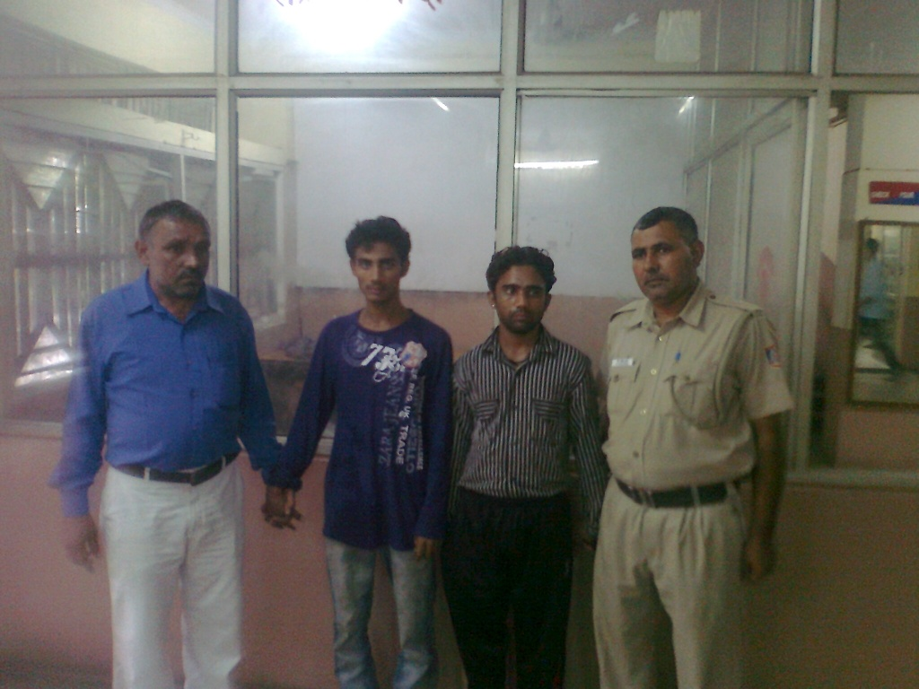
Photographer of kidnappers

OUTER DISTRICT Dated: 09.09.11
PRESS RELEASE

KIDNAPPERS ARRESTED, A FOUR MONTH BABY RECOVERED BY STAFF OF PS NORTH ROHINI
HIGHLIGHTS:-
- Krishna age 50 years W/o Phool Chand R/o F-1/222 Mangol Puri, Delhi, Kamla age 67 Years w/o Late Budhram/o E-49, II nd Floor, Shastri Nagar, Delhi, Kusuma age 52 years w/o Begali Babu r/o E-2/27, Shastri Nagar, New Delhi and Jai Prakash age 35 Years s/o Bengali Babu both r/o E-2/27, Shastri Nagar, New Delhi were arrested.
- Kidnapped baby was recovered.
BRIEF FACTS OF THE INCIDENT:
On 7.09.2011 a PCR Call regarding theft of a baby from Baba Saheb Ambedkar Hospital, Rohini was received at Police Station North Rohini. The Police immediately rushed to BSA Hospital and came to know that Smt. Muskan had come at Baba Saheb Ambedkar Hospital Rohini for treatment of her four month old baby. While she was standing in queue for her turn to see the doctor, a lady standing behind her became friendly with her. The lady offered help to Smt. Muskan to hold the baby for some time while standing in queue. Smt. Muskan in her all innocence and faith in goodness of humanity handed over her baby to that lady. Taking advantage of the crowd in the OPD of Hospital the lady disappeared with the Baby. A case vide FIR No. 256/11 U/s 363 IPC was registered at Police Station North Rohini.

INVESTIGATION:
During the course of investigation team worked hard relentlessly day and night and started exploring all possibilities. CCTV footage at the hospital were collected and watched carefully. Lots of persons were questioned; secret sources were deployed, door to door enquiries were conducted at number of houses. The team was working incessantly as the infant baby was kidnapped in a planned manner with some ulterior motive.
Ultimately the painstaking efforts of the police team paid rich dividends and on 9/9/2011 the baby was recovered from the possession of accused Krishana from her house.

INTERROGATION:-
On sustained interrogation accused Krishna disclosed that the baby was kidnapped at the behest of Jai Prakash, his mother Kusuma and aunt (Tai) Kamla. Jai Parkash had offered her Rs. 4,00,000/- for a male baby. Rs 1,50,000/- was paid to her in advance and rest of the money was to be paid at the time of handing over the baby to Jai Parkash. Rs. 1,50,000/- which was given to accused Krishana as token money has been recovered from her house.

MODUS OPERANDI:
Sh. Jai Prakash s/o Bengali Babu r/o E-3/27 Shastri Nagar, Delhi had married one Radha 13 years ago. He is having no child. He was feeling it as stigma on his manhood. He considered that he could be considered a complete man in society only if his wife could deliver a child. He conspired with his mother Kusma Devi, TAI Kamla Devi and Krishna Devi to steal a newly born baby from Hospital and wanted to show that it has been delivered by his wife. For that purpose they started keeping wife of Jai Prakash within the limits of their house. Krishna Devi agreed to steal/kidnap the Baby from some Hospital. Jai Praksh spread the news that his wife is pregnant. In the meantime Krishna started search for baby in different Hospitals. After doing recede at several places she had chosen BSA Hospital. Jai Prakash, Kusma Devi and Kamla Devi agreed to pay Rs. 4 Lacs and a Computer to Krishna Devi in exchange of a newly born baby. Rs. 1.5 Lacs was paid as advance to Smt. Krishan Devi by Jai Prakash in the presence of Kusum and Kamla for this purpose. Krishna was frantically searching for the Baby in the Maternity Wards and other possible places with in the hospital but could not succeed due to the security arrangements. Finally Krishna Devi adopted above deceptive means for kidnapping the child. After kidnapping the child on 07.09.11 she rushed to Shastri Nagar to show the Baby to Jai Prakash, Kusum and Kamla. All of them agreed to take the baby. But it was required to be shown as delivered by the wife of Jai Praksh. For that they decided that the baby will remain with Smt. Krishna for two/three days in the meantime they will take wife of Jai Praksh to somewhere on the pretext of admitting her at Hospital for delivery, during that time the baby would be delivered.

TEAM :
- S.I. Mahabir Singh
- H.Ct. Ajay
- H.Ct. Dinesh
- Ct. Sunil
- Ct. Ashwani
- Ct. Sumit
- Ct. Sunil
- Ct. Surinder
- W/ct. Neelam

ACCUSED ARRESTED:-
- Krishna (50 years) W/o Phool Chand R/o F-1/222 Mangol Puri, Delhi.
- One Kamla (67 Years) w/o Late Budhram/o E-49, II nd Floor, Shastri Nagar, Delhi.
- Kusuma (52 years) w/o Begali Babu r/o E-2/27, Shastri Nagar, New Delhi.
- Jai Prakash (35 Years) s/o Bengali Babu both r/o E-2/27, Shastri Nagar, New Delhi.

PROFILE OF THE ACCUSED:
  - KRISHNA: Accused Krishna used to live with her parents at Manak Pura. She was married to Phool Chand in the year 1982. After some time she shifted to Mangol Puri, Delhi in a rented premises. Her husband used to work in private factory who later on started his Kabari shop. She has five children including one son. Earlier she used to work at Sarai Rohilla as labour in a private company. For last one month the factory has shifted to Gurgoan and she became jobless.
  - JAI PRAKASH: Accused Jai Prakash was born in the year 1975 in Delhi at his own house at Shastri Nagar. He has studied up to 10th class. His father was a labour in a factory. He has set up a small cardboard manufacturing factory in his house.
  - KUSUMA: Accused Kusuma was married to Begali Babu about 40 years back in District Agra and after some time she shifted to Delhi and started living at Shastri Nagar in a rented accommodation. She is illiterate. Her husband was working as a labour in a small cardboard manufacturing factory. She has three children.
  - KAMLA: - Accused Kamla was married to Budh Ram in the year 1961 in Delhi. She has studied up to 5th class. Her parents used to reside at Filmistan in Delhi. After her marriage she started living with her husband at Manak Pura. Her husband expired four years back. She has two sons. She has been running a small cardboard manufacturing factory in her house.

RECOVERIES:

- Rs.1,50,000/- which was given to accused Krishana as token money has been recovered.

(B.S.JAISWAL)IPS
Dy. Commissioner of Police
Outer District, Delhi

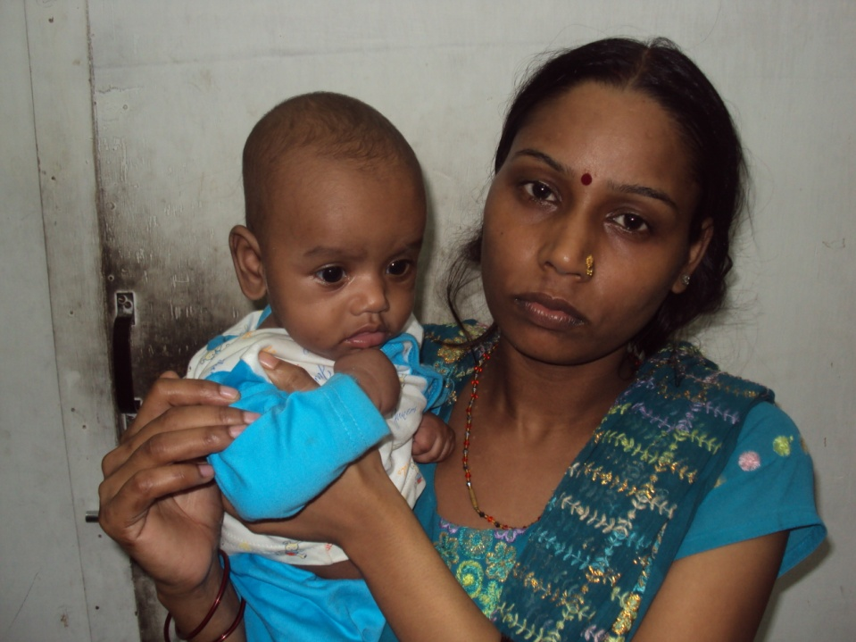

Recovered baby with mother

