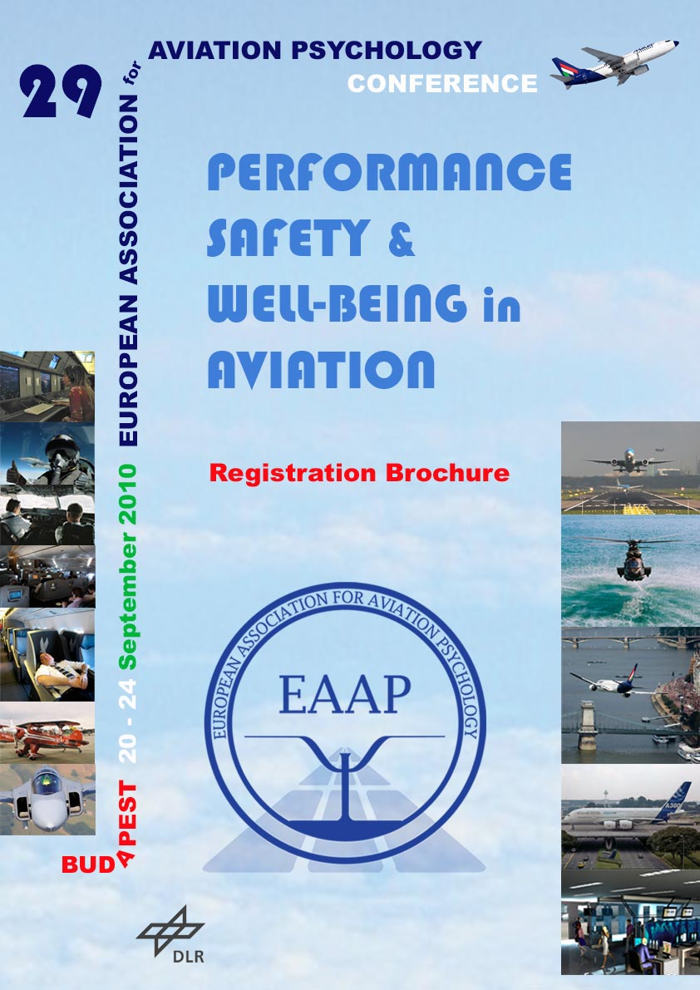

The 29th conference of the European Association for Aviation Psychology will be held from 20 – 24 September 2010 in the Margitsziget Hotel in Budapest, Hungary.  It is organized by the EAAP board in co-operation with the local organzing team Budapest, consisting of EAAP members working with EUROCONTROL CRDS, Budapest, and Budapest Airport.  Theme of the 29th EAAP Conference  The overall theme of the 29th EAAP Conference will be  Performance, Safety and Well-being  in Aviation  The aviation system needs the best possible operational performance. Meeting the ever increasing traffic demand was the challenge for a long period. However, surviving economic crises also seems to be a standard routine for working in aviation. Economic thunderstorms and competition raise the pressure on all organizations that contribute to flight operations and all human participants in the aviation system. More effective tools are needed to ease the work and assure or improve output while working under the pressures of time and loss of jobs.  Cost cutting can be a threat to safety, but also forces us to creative thinking and innovation. Safety is not a state but a process, requiring continuous and relentless effort. Any disturbance in the efficiency of that process can lead to catastrophic failures. How to make contemporary safety robust and resilient to circumstantial and environmental variation?  Psychological stresses are increasing and the well-being of the people in the system is essential.  The passenger is at the core of the aviation business. It is the passenger that provides the finances to keep this industry running. Passengers have not always been treated as such. Limited seat space, long waiting cues, incomprehensible pricing, etc. have been accepted as ‘normal’ for a long time. Not anymore. Raging passengers have developed into a problem. Low cost airlines have educated the public in finding cheap deals and value for money. New aircraft made of composites allow the air in the cabin to be moisturised resulting in more passenger comfort. However, there is still much left to do. | Special conference topics  The conference will also address specific topics in which new developments take place. For example, better treatment comes available for passengers suffering from Fear of Flying.  The airline industry must also deal with people living close to ever busier airports who develop anger and hostility towards flying. Noise and nuisance problems of this group are complex and include many mediating psychological effects and possible remedies. More understanding of the problem and research are needed to help the industry to resolve and manage this dilemma.  Target audience  Our target audience are psychologists and human factors practitioners working in aviation (e.g. in selection, training, clinical practice, workplace design, regulation, research, incident and accident investigation, safety management, etc.), as well as aviation professionals (pilots, instructors, cabin staff, air traffic controllers, maintenance personnel, managers) and students interested in the contribution of psychology and human factors to safety in aviation.  You are all most welcome to participate and contribute.  Preliminary Program  Invited keynote speakers will address the main conference themes and initiate discussion between the participants. Paper and Poster sessions will be held and a number of Tutorials will be conducted by professionals in their psychological field.  The program will start on Monday 20 September at 9 o’clock and will come to an end on Friday 24 September around noon.  The preliminary outline program looks as follows:  Sunday 19.09.2010  - Registration desk  Monday 20.09.2010  - Welcome and introduction  - Introductory Keynote Speakers and discussion  Tuesday 21.09.2010  - Paper sessions and discussions  - EAAP Business Meeting (16:00 – 18:00)

Wednesday 22.09.2010  - Paper session and discussions (AM)  - Budapest Sightseeing (PM)  Thursday 23.09.2010  - Tutorials AM and PM  - Gala Dinner and EAAP 2010 Award Ceremony  Friday 24.09.2010  - Paper session and closing of the conference (AM)  - Conference Certificates and Proceedings  Conference Certificates  Participants attending the conference including two tutorials will receive the conference certificate which may serve for the registration or re-registration as EAAP Certified Aviation Psychologist, Human Factors Specialist or Junior Aviation psychologis, in accordance with the EAAP certification rules to be found on the EAAP website www.eaap.net.  Conference Venue  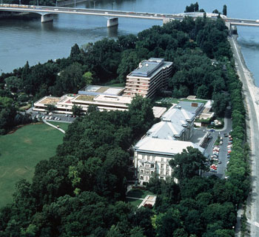  The venue of the conference will be the Danubius Health Spa Resort Margitsziget, which has a direct connecting passage with the Danubius Grand Hotel Margitsziget.  The EAAP conference facilities will be in the Danubius Health Spa Resort Margitsziget. There are hotel rooms available in both parts of the hotel. | The Margitsziget hotel is a deluxe hotel located on the peaceful Margaret Island which is located in the river Danube. The Danube divides the parts ‘Buda’ and ‘Pest’ and so the island is in the city centre close to historical sights and shops.  Due to the restricted nature of the hotel’s setting, there is no traffic noise around the hotel since car traffic is not allowed. The island offers excellent walking, jogging and bicycling facilities.  The hotel is the island's original spa hotel, with attractive ambience, style and elegance. It offers many thermal spa facilities and everything you need to keep fit! Jogging path, tennis courts, rowing boats, bicycles and lidos all on the island. It’s also an ideal place for groups to take Danube cruise ship excursions, departing from directly outside the hotel entrance.  For detailed information visit the website: www.danubiushotels.com -> Budapest, Hungary -> Danubius Health Spa Resort Margitsziget.  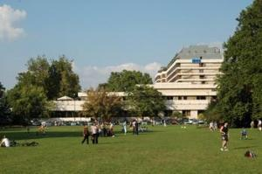  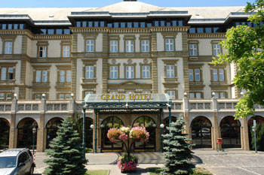  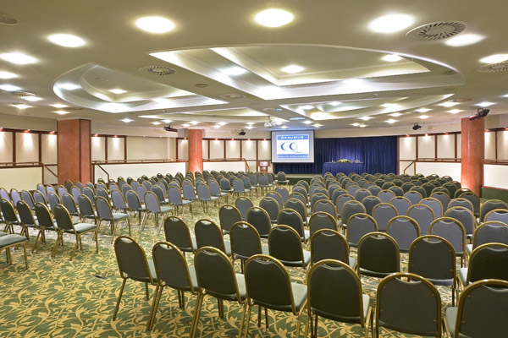  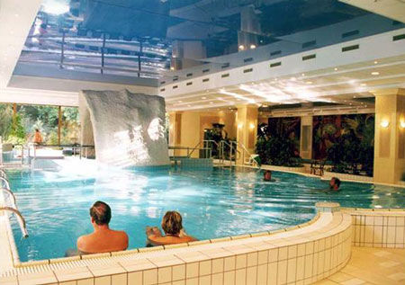

Conference Registration and Accommodation Booking

Registration for the conference as well as the booking of the hotel accommodation should be done with the Conference Registration Form (attached). The form should be sent to:

Mr. A. Droog, EAAP Secretary, eaapconference@gmail.com

The EAAP Secretary will make the hotel booking for you and you will receive confirmation of the booking.

Participants pay EAAP a conference fee and pay the hotel for their accommodation and for the conference related services like coffee breaks, lunch, Gala Dinner and conference facilities. A package price including accommodation and conference related services has been negotiated with the hotel.

Conference fees

Conference fees include the Welcome Reception.

An Early Bird discount will apply to all registrations done before 31. May and registration fees paid by 30.June 2010.

Those presenting a Tutorial (max. 2 persons per tutorial) are exempted from paying the conference fee.

Employees of Corporate Members pay the reduced rate for EAAP members.

If three or more employees of the same company or organization participate in the conference, a fee discount of 50% will be given from the third participant on.

The fees for attendance of the full conference and the daily fees, which apply in case you are not able or don’t want to attend the entire conference, are presented in the tables below.

Full Conference Fees

Full Conference fees 2010  (prices are in EURO’s) | Early Bird Fees  Registration before 31 May 2010 and payment before 30 June 2010 |  | Standard Fee  Registration after 31 May 2010 and payment before  13 September 2010 **
 |  | Special  Offer * |  | Special  Offer *
EAAP Member | 380 | - | 480 | -
EAAP Student member | 170 | - | 210 | -
EAAP Retired member | 195 | - | 235 | -
Not an EAAP member | 470 | 380+90 | 570 | 480+90
Student, not an EAAP member | 215 | 170+45 | 255 | 210+45

* Special Offer for EAAP membership
Conference particpants who are not yet EAAP member may choose to become a member of EAAP together with their registration for this conference. They pay the extra special price of EUR 90 (students EUR 45), which will then cover their EAAP membership for 2010 and 2011. This will also allow them to benefit from the lower conference fees for EAAP members. In case you choose this option, your Membership Application Form (MAF) should be filled out together with your registration for the conference and be sent to EAAP Membership Administration. Details about membership and application forms are available on the EAAP website, www.eaap.net. The special offer will not apply if no membership application form is available to the EAAP Secretary and secretariat.

The Special Offer opportunity also applies if you can not attend the entire conference.

** NOTE: EUR 50 extra will be charged for payment made after 13. September 2010.

Daily Conference Fees

Daily fees (in case participant cannot attend the full conference) are as follows:

Daily fees 2010  (prices are in EUROs) | Early Bird Fees  Registration before 31 May 2010 and payment before 30 June 2010 | Standard Fee  Registration after 31 May 2010 and payment before  13 September 2010 **
EAAP Member | 95 | 120
EAAP Student member | 45 | 55
EAAP Retired member | 50 | 60
Not an EAAP member | 120 | 140
Student, not EAAP member | 55 | 65

** NOTE: EUR 50 extra will be charged for payment made after 13. September 2010.

Cancellation policy

In case of cancellation the fees minus EUR 100 will be refunded if cancellation is done before 23 August 2010. Cancellation between 23 August and 18 September will result in a deduction of EUR 200 from the refund. There will be no refund in case of cancellation on or after 18 September.

Hotel Accommodation and Conference Facilities

A group accommodation booking has been made at the Margitsziget Hotel for at least 120 rooms,
shared between the Danubius Health Spa Resort and the Grand Hotel Margitsziget

It is recommended that all participants stay in the hotel during the conference. All participants and accompanying persons will have the full use of the facilities of the hotel.

Bookings should be done by sending the Conference Registration Form (see below) to the EAAP
Secretary at eaapconference@gmail.com.

Package Rate

A special rate for this conference has been negotiated with the hotel.

The conference package includes:
- accommodation and buffet breakfast
- 2 coffee breaks per day
- buffet lunch
- gala dinner
- use of the conference rooms and facilities
- use of the spa (swimming pool, sauna, thermal baths, aroma- and steam bath, jacuzzi) and of the 400sqm Danubius Premier Fitness Centre
- VAT, service charge, local tax
- free parking.

The rate of the conference package for a single conference participant attending the full conference is 147 EURO per day consisting of the room rate of 87 EUR (including the room, breakfast and use of spa/fitness facilities) and the Conference Related Services rate of 60 EUR (including the coffee breaks, lunches, Gala Dinner, and use of conference facilities).

Accompanying Persons
An accompanying person can be either an other conference participant or a spouse/partner/guest.

Supplements for Accompanying Persons
The room supplement for an accompanying person, be it a second EAAP conference participant or a spouse/partner/guest, is 20 EUR per day, which includes the room, breakfast, use of all spa/fitness facilities, and taxes.
Accompanying persons being EAAP conference participants pay the hotel the package rate for the Conference Related Services of 60 EUR per day.
Spouses, partners or guests who want to have lunch at the hotel buy a lunch ticket at the EAAP Reception Desk. Costs for lunch: 25 EUR.
Spouses, partners or guests who want to attend the Gala Dinner buy a Gala Dinner ticket at the EAAP Reception Desk. Costs for Gala Dinner: 50 EUR.

Participants not attending the full conference
Participants staying in the conference hotel but attending less than 5 days, pay the standard 147 EUR per day and an additional 50 EUR if they want to attend the Gala Dinner. They buy the Gala Dinner ticket at the EAAP Reception Desk.

Participants not staying in the hotel
Participants not staying in the conference hotel pay the Conference Related Services rate of 60 EUR per day. If they want to attend the Gala Dinner they have to buy an additional Gala Dinner ticket (50 EUR) at the EAAP Reception Desk.

Student participants not staying in the conference hotel pay 30 EUR per day for the Conference Related Services, not including the lunch and the Gala Dinner. If they want to attend the EAAP lunch and/or the Gala Dinner they buy additional lunch tickets (25 EUR) and/or Gala Dinner ticket (50 EUR) at the EAAP Reception Desk.

Payment

The payment for the accommodation should be done directly to the hotel when checking out.

For the EAAP conference fee + the Conference Related Services participants will receive an invoice by email from the EAAP Conference Treasurer, Mr. Harald Kolrep, after their registration has been received by the EAAP Secretary and together with the confirmation of their hotel booking.

Payment of the invoice should be made most preferably by electronic transfer to:
Bank : CENTEA BANK (BIC-code: SPAABE22)
Account name: EAAP
Address bank-account: Berkenlaan 30, 3110 Rotselaar, Belgium
Account number: 850-8173647-37
IBAN: BE35 8508 1736 4737
Please state participant’s name(s) and the invoice number when making payment.

Electronic money transfer within the EU countries is free of charge. In any case payments received by EAAP should be exactly the amount you are due, so that you have to inform your bank that you will pay all transfer costs (“franco provision”).

If you prefer payment by credit card, please fill out completely the attached Credit Card Authorization form and send it to us together with your conference registration.

NOTE: Only VISA or Euro/Master cards can be accepted and an extra amount of 10 EUR will be charged in case of payment by Credit Card.

For inquiries regarding fee payments and special payment requests contact Mr. Harald Kolrep at eaapconference@gmail.com.

29 EAAP CONFERENCE REGISTRATION FORM

(if you have reason to fax your registration use FAX + 49 30 6576 3299 of Mr. Harald Kolrep)

The EAAP Secretary will make the hotel booking for you and you will receive confirmation of the booking.

Participant Contact Details

First name
Family name
Title (Mr/Ms)
Organization /Company
Job/Function title
Postal address
City:
Postal code:
Country
Email
Tel
Fax

Conference Registration Fee to be paid

Please answer each of the following questions by erasing the option that does not apply:

I register before 31 May 2010 and will have paid my fees before 30 June 2010 |  |  | YES/NO
I am EAAP member: |  |  | YES/NO
I apply for the Special Offer for EAAP membership in combination with the conference participation and will attach my Membership Application |  |  | YES/NO | Which means that I pay  90 EUR / 45 EUR(student) for the EAAP membership 2010 + 2011
I register for the full conference (Monday – Friday): |  |  | YES/NO
I register only for the following days: |  | Mon 20 | Tue 21 | Wed 22 | Thurs 23 | Fri 24
I will present a Paper |  |  | YES/NO
I will present a Poster |  |  | YES/NO
I will conduct a Tutorial |  |  | YES/NO | No fee for max. 2 tutors per tutorial
I will pay my conference fees by: | Electronic  bank transfer | Credit card  (I pay 10 EUR extra) |  | Other, in agreement with the Conference Treasurer of EAAP

Participation in Social Events

Please indicate if you will participate in the following social events and with how many guests, if any.

I will participate in the Welcome Reception | YES/NO with 0 / 1 / 2 guest(s)
I will participate in the Gala Dinner | YES/NO with 0 / 1 / 2 guest(s)

Hotel Accommodation Booking Form

Please answer each of the following questions by erasing the option that does not apply:

I will share the room with another conference participant and I make the booking | YES / NO
I will share a room with another conference participant and my colleague makes the booking, so I leave the following questions unanswered | YES / NO

NUMBER OF PERSONS NEEDING ACCOMMODATION

Nº of Persons:
Children:

ARRIVAL AND DEPARTURE DATA

Day of Arrival:
Day of Departure:

TYPE OF ACCOMMODATION NEEDED

Single room | YES / NO
Double room with guest (spouse / partner) | YES / NO
Double room with conference participant | YES / NO : NAME PARTICIPANT:
Extra bed for child (indicate bed or cot) | YES / NO
Non-smoking room | YES / NO
Double bed | YES / NO
Separate beds | YES / NO

ANY SPECIAL REQUESTS REGARDING YOUR ACCOMMODATION?

CREDIT CARD AUTHORIZATION FORM

No need to fill out this form if you make your payment by electronic bank transfer, which we highly prefer!

I authorize the Treasurer of EAAP to charge my credit card (please type or write in clear capital letters!):

Type of credit card:

VISA | Euro/Mastercard

Cardnumber :

Expiration date: …… / ……

CVC-code::

for the amount of EUR

Amount in words:

INVOICE NUMBER

NAME

ADDRESS

NOTE : The address above should be the same as the address under which your credit card is registered in the administration of the credit card organization!

Signature

If you pay by company credit card, please specify NAMES and INVOICE NUMBERS of the persons for whom you are paying :

NAME INVOICE NUMBER

Send this form together with the conference registration and hotel booking to Mr. A. Droog at eaapconference@gmail.com.

