
HUBLI ELECTRICITY SUPPLY COMPANY LIMITED

INVITATION FOR BIDDS
(e-procurement portal)
1 | Enquiry number | HESCOM/2018-19/IND529/CALL-3
2 | Scope | Manufacture and Supply of Electrical Seamless Rubber/Latex Hand Gloves Type-3 Electrical Purposes as per Standards.
3 | Quantity | 4100 No.s
4 | Bid Validity | 180 Days.
5 | Tender System | Two part tender.  Part-I : Techno-commercial Bid  Part-II : Price Bid  (Both in e-procurement portal only)
6 | Tender processing fee | Refer e-procurement website.
7 | EMD (Refundable) | EMD of Rs. 90,400.00/-(Rupees Ninety Thousand And Four Hundred only) is payable as mentioned in EMD clause. The mode of payment of EMD shall be paid through any of the four e-payment modes mentioned in the e-procurement portal.
8 | Last date for submission of bid | 22/06/2019 16:00:00
9 | - Date of opening of  Techno commercial bid  b) Date of opening of Price Bid | 24/06/2019 11:00:00
10 | Schedule of requirement | As per the Delivary schedule mentioned in the Purchase order.
I-Qualifying requirements of Bidder :

TECHNICAL REQUIREMENTS:

- The bidder shall be manufacturer OR authorized dealer of tendered material or any tools & plants material. If the bidder is manufacturer, they shall upload valid documentary proof such as license issued by Commerce & Industries department or any other Government statutory authority such as SSI or NSIC certificate or MOA or if the bidder is an authorized dealer, they shall upload authorization letter issued by the manufacturer and also shall upload copy of valid license of manufacturer.
The bidder shall upload GST registration certificate to establish the claim that the bidder is a manufacturer/Authorized dealer.

- The bidder should have executed the purchase order successfully for supply of 50% of the Tendered quantity or any safety material (to be used by Powerman/Lineman) in any one of the preceding three financial years i.e, 2016-17 ,2017-18 &2018-19 to HESCOM / other ESCOMs / Distribution Companies / any public distribution utility or to any other Govt. Institutions or Private Companies.
Documentary proof of purchase order copies along with order completion certificate issued by competent authority (not below the rank of Executive Engineer) shall be uploaded.

- The bidder must furnish one sample of materials as per the standards on or before last date of bid submission. The samples received after the due date will not be considered and the bidder is liable for rejection.
The sample will be subjected for verification and acceptance before the tender scrutiny committee. If the sample is rejected in the committee, the offer of the bidder of such samples will not be considered and the price bid of such bidders will not be opened.

- The bidder must not have defaulted/blacklisted in supplies against previous Purchase Orders placed by KPTCL/ any ESCOM/Public utilities as on the last date of submission of Techno commercial bid. Self-declaration in this regard shall be uploaded.

- The bidder shall submit the self-declaration stating that the tendered materials will be manufactured and supplied as per technical specification of HESCOM.

- The bidder shall upload the type test certificates issued by CPRI/ERDA/any NABL accredited laboratories conforming to relevant IS Standards for the materials for which type test certificates are mandatory & shall not be older than five years from the date of submission of techno-commercial bids. The Type test certificates shall be in the name of the Manufacturer.
The bidder shall submit the self-declaration stating that the tendered materials will be manufactured and supplied as per Standards only & as per IS Standards IS:4770.

FINANCIAL REQUIREMENTS :

- The annual turnover of the bidder shall not be less than 50% of the amount put to tender in any one of the preceding three financial years i.e. 2016-17 &,2017-18 &2018-19 and copies of IT Returns and audited annual accounts shall be uploaded. In case audited annual accounts FY- 2018-19 is not finalized, provisional annual accounts duly certified by charted accountant shall be uploaded.
- The Liquid Assets as on 31.03.2019 or at a later date consisting of Cash at Bank plus Term Deposits plus availability of fund based credit facility in any Nationalized/scheduled Bank shall not be lesser than 25% of the amount put to tender. The credit facility certificate shall be uploaded as per Annexure-A.

II) GENERAL TERMS & CONDITIONS :

  - Tenders shall be uploaded through e-procurement portal on or before the date as mentioned in e-procurement portal Hard copy of the tender documents will not be accepted.
  - The bids can be submitted up to 16:00 on or before the date as mentioned in e-procurement portal and techno-commercial bids will be opened on the date as mentioned in e-procurement.
  - If the office happens to be closed on the last day of the opening of bids for any reasons, the bids will be opened on the next working day of the office at the same venue and time.
  - The prices are FIRM thoughout the peroid of contract.
  - The bids shall be accompanied by EMD as mentioned in EMD cluase. Bid documents without EMD will be summerily rejected.
  - The PEMD holders also must pay the EMD amount.
  - All the tender documents shall be scanned and uploaded through e-procurement portal only. The hard copy of the tender document shall not be submitted.
  - The bidder shall upload documentary evidence in support of the quallifing requirements stipulated as above.
  - Even though the bidder meet above qualifing criteria as per their statements, they are subject to be disqualified if they have,
- Made misleading or false representations in statements and attachments submitted as proof of the quaification requirement and /or
- Record of poor performance such as poor quality of product, not properly completing the contract, in ordinate delay in supply completion or financial failure etc,.
  - The offers shall be in general confirmity with the specifications. Any technical/commercial deviations from the specification shall be clearly brought out in the techno-commercial sheet of the offer.
  - Quantities indicated are provisional and subject to change without any notice.
  - The Validity of the tender shall be 180 days from the date of opening of techno-commercial bid.
  - Price bids of those bidders, whose technical bids are found responsive will be opened at a later date under intimation to such bidders in the pressence of bidders/representatives who choose to be present.
  - HESCOM reserves the right to cancel OR withdraw OR reject OR Modify any or all the bids without assigning any reasons thereof and shall bear no liability whatsoever cansequent upon such a decission.
  - Tender Accepting authority may vary the quantity finally ordered only to the extent of twenty five percent either way of the requirement indicated in the tender documents.
  - The prices are FIRM through the period of contract. No price variation will be allowed
  - The offer of the bidders taking deviations in the following clauses, will be summerily rejected :
  - Stipulated delivery schedule.
  - Payment cluase.
  - Price basis.

  - HESCOM will not be responsible for not getting internet connection while downloading the electronic bid sheets/documents or while uploading their offers.
  - Bidder shall upload only desired documents against each Qualifying Requirement. If unwanted documents are noticed under any of the Qualifying Requirment and if the required documents are loaded at any other places other than desired Qualifying Requirement, such tender is liable for rejection at the discretion of Tender Inviting Authority
  - In the event of the information furnished by the bidder found to be false at any stage of tendering, HESCOM at its discretion may take action against such bidders and may forfeit the bid security and disqualify the offer of such bidder and blacklist the firm.

  - In the event of the information furnished by bidder is found to be false during the execution stage, then HESCOM at its liberty to cancel the Purchase Order other than forfeiting the Security Deposit against the Purchase Order and may blacklist the firm and recover the losses and levy liquidated damages.
  - Conditional offers are liable for rejection.

  - HESCOM will not be responsible for not getting internet connection while downloading the Electronic Bid sheets/documents or while uploading their offers.

III) E-PAYMENT MODES FOR TENDER PROCESSING FEE & EARNEST MONEY DEPOSIT (EMD) :

The bidder should pay the Earnest Money Deposit (EMD) & Tender Fee in the e-Procurement portal using any of the following payment modes :
- Credit Card
- Direct Debit
- National Electronic Fund Transfer (NEFT)
- Over the Counter (OTC)

- CREDIT CARD PAYMENT METHOD:

To pay the registration fee through your credit card, click on the “Credit Card (Online Payment)” option. If you choose to pay the fees, later click on “Close” button. Click Pay after verifying details on the screen that appears. Click on “Pay” button to proceed with payment process. Click “Back” if you wish to choose a different payment method. Click on “OK” button on the payment method. Confirmation window will be displayed. Choose your card type (VISA, master Card), enter your credit card details. Card details shall be completely filled.
The screen will look like as shown above, when you have completely filled the card details.

Click on “PAY NOW” button to effect the payment. Your card details are verified by the payment gateway service and you will receive confirmation of payment debited to your card account if the card is valid. If the card is not valid you will receive alert about it and system will wait for you to correct any errors in the card details provided by you.

A successful transaction message will be displayed.

- DIRECT DEBIT METHOD:

Click on “Direct Debit Using Internet Banking (Online Payment)” option to pay from your bank account through Internet Banking facility.

Click on “Pay” to proceed or “Back” to change the payment method on the Payment details screen.

Click on “OK” on the confirmation window to effect the payment. Click on “Cancel” and then on “Back” to change the payment method.

You will receive information on your screen about successful completion of payment process.

- OTC PAYMENT PROCEDURE:

If a contractor/supplier chooses to make payment of EMD/tender processing fees Over The Counter (OTC) in any of the designated Axis Bank branches listed in the e-Procurement web-site (https://www.eproc.karnataka.gov.in) the contractor/supplier will need to log into e-Procurement system, access the tender for which bid is being created and then select the OTC option under the payment section and print the Challan shown in that section. The printed challan will have the unique bid reference number and the amount to be remitted. Along with the challan, contractor can choose to make the payment either in the form of cash or in the form of Demand Draft. Cheque payments will not be accepted. The contractor is requested to specifically inform the bank officer to input the unique bid reference number printed in the challan in the banking software. Upon successful receipt of the payment, the bank will provide a 16-digit reference number acknowledging the receipt of payment. This 16-digit reference number has to be inputted by contractor in the payment section of its bid as payment confirmation before the bid is submitted (i.e.) as a pre-requisite for bid submission.

- NEFT PAYMENT PROCEDURE:

If a contractor/supplier chooses to make payment of EMD/tender processing fees using Reserve Bank of India's (RBI) National Electronic Fund Transfer (NEFT) system, the contractor/supplier will need to log into e-Procurement system, access the tender for which bid is being created and then select the NEFT option under the payment section and print the Challan shown in that section. The printed challan will have the unique bid reference number, account details of Government of Karnataka and the amount to be remitted. The contractor has to submit the printed challan to its bank-branch (NEFT-enabled) and request for an account-to-account transfer, wherein the money will get transferred from the contractors' bank account to GoK's bank account. The contractor should ensure that NEFT transfer instructions are executed and the funds are wired to the Government of Karnataka's principal account before the last date for bid submission and preferably 24 hours before the last date for bid submission. If the contractor's bank transfers/wires the money after the last date for bid submission, the contractor's bid will be liable for rejection. Upon executing the transfer, the contractor's bank will provide a reference number generated by NEFT software as confirmation of transfer which has to be inputted by contractor in the payment section of its bid as payment confirmation before the bid is submitted (i.e.) as a pre-requisite for bid submission. Also, the account number from which the funds were transferred have to be inputted in the e-Procurement system as part of its bid.

The supplier/contractor’s bid will be evaluated only on confirmation of receipt of the payment (EMD) in the Government of Karnataka central pooling a/c held at Axis Bank.

For details on e-Payment services refer to e-procurement portal for more details on the process.
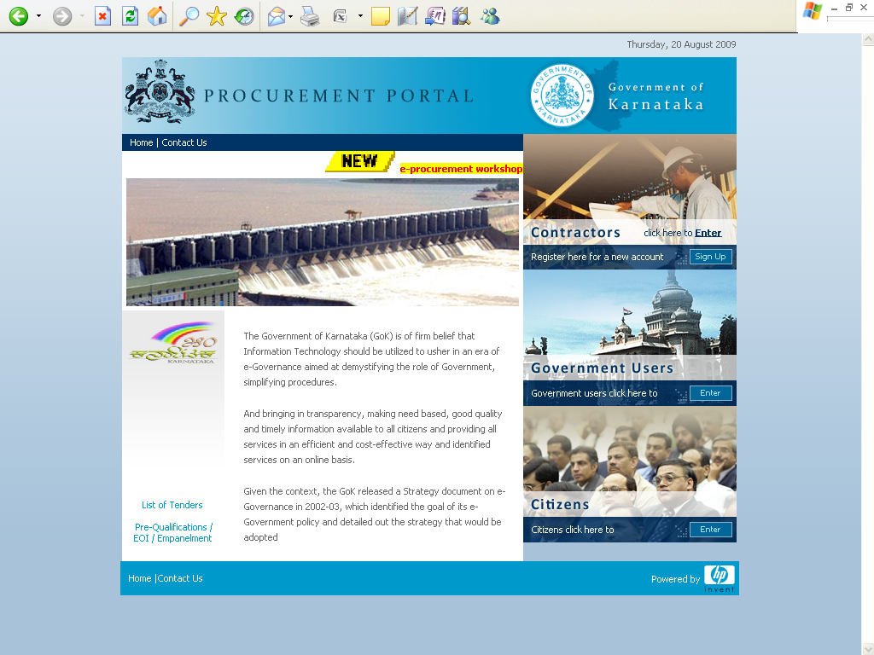

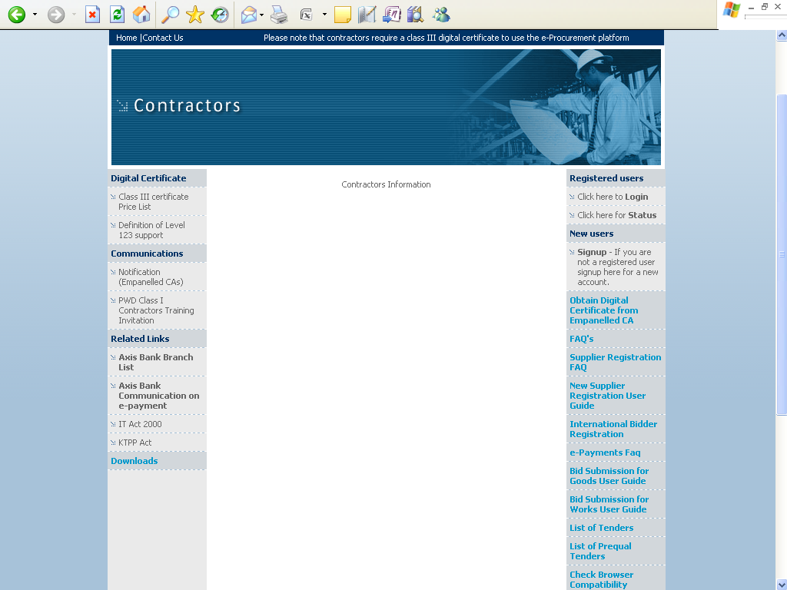
Note: In e-Procurement Portal, Contractor has the option of
Withdrawing the Bid by digitally signing to ‘withdraw/cancel
bid’ before the bid submission Date/time.

Support Timings: (9.00 am to 9.00 pm)

Help Desk: 080-25501216/25501227
OR
E-mail: hphelpdesk.blr@rteservices.com
Sd/-
Superintending Engineer Ele.,
(Tendering & Procurement),
HESCOM., Hubballi.

Technical Specification for Lineman Electrical Rubber Insulating Hand Gloves-Electrical Purposes

- SCOPE
This specification covers design, manufacture, method of sampling and testing & supply of lineman Electrical Rubber Insulating Hand Gloves for Electrical Purposes.

- Applicable Standards

  - Standards
Following Indian/International Standards, which shall mean latest revision, with amendments/changes adopted and published, unless specifically stated otherwise in the Specification, shall be referred while accessing conformity of Lineman Electrical Rubber Insulating Hand Gloves.

2.1.1 In the event of supply of Electrical Rubber Insulating Hand Gloves confirming to Standards other then specified, the bidder shall confirm in his bid that these standards are equivalent or better to those specified. In case of award, salient features of comparison between the standards proposed by the bidder and those specified in this document will be provided by the supplier to establish equivalence.

Sl.  No. | Indian Standard | Title | International Standard
1. | IS: 4770 | Definition, test methods and acceptance criteria for Electrical Rubber Insulating Hand Gloves for Electrical Purposes. | IEC: 60903
2. | IS: 1876: 1961 | Method for voltage measurement by means of sphere-gaps (one sphere earthed).
3. | IS: 1885 (Parts 1-66) | Electro technical vocabulary
4. | IS: 3400 | Methods of test for vulcanized rubbers:
4. | IS: (Part-1): 1987 | Tensile stress-strain properties (second revision)
4. | IS: (Part-4): 1987 | Accelerated ageing (second revision)
4. | IS: (Part-13): 1983 | Tension set (first revision)
4. | IS: (Part-17): 1974 | Tear strength-angular test pieces
4. | IS: (Part-20): 1977 | Resistance to ozone
5. | IS: 3708 | Methods of test for natural rubber latex:
5. | IS: (Part-8): 1986 | Determination of total nitrogen (NRL:12) (first revision)
5. | IS: (Part-9): 1986 | Determination of total ash (NRL:16) (first revision)
6. | IS: 7503 (Parts 1-6) | Glossary of terms used in rubber industry

- REQUIREMENTS

  - Composition

    - Type-3, for use at voltage not exceeding 7500 ac rms shall be gauntlet type. Gloves shall be made from good quality Natural or Synthetic Rubber or from a mixture thereof confirming to IS: 4770: 1991, with latest revision/amendments/changes adopted and published.

    - Construction
Gloves shall be made out of latex by dipping. The Natural Rubber Construction of gloves should offer the required dielectrical properties combined with flexibility strength, 100% shock proof and durability applications. The gloves shall be seamless construction and should have smooth finish (inside & outside).
Gloves shall be made out of latex by dipping. The Natural Rubber Construction of gloves should offer the required dielectrical properties combined with flexibility strength, 100% shock proof and durability applications. The gloves shall be smooth finish & the cuff edges shall be finished with a roll or reinforcing strip of rubber.

    - Shape & Size
The type-3, gloves shall be of loose fitting contoured shape has given in figure-2, and the recommended size has in Annexure-A of IS: 4770: 1991 with latest amendments if any.

    - Length
The minimum internal length from the tip of the second finger to the edge of the cuff shall be 400 mm (gauntlet type).

    - Thickness
The thickness of the gloves when determined as in Annexure-C shall meet the requirements specified in table-1of IS: 4770: 1991.

    - The gloves shall have smooth surface and shall be free on both are inner & outer surfaces from visual defects like patches, blisters, porosity, embedded foreign matters or other physical defects.

    - The rubber forming gloves shall comply with requirements given in table-2 of IS: 4770: 1991.

    - Proof (Test) voltage and leakage current
Each glove shall withstand the 50 Hz ac proof (test) voltage (rms value) according to the method prescribed in Annexure-F. The test voltage shall be applied continuously for 1 minute and the glove shall withstand it without breakdown and the leakage current shall not be more than as prescribed in col 6 of table-3 of IS: 4770: 1991.

    - Breakdown Voltage
Gloves when tested according to the method prescribed in Annexure-G, shall not breakdown at voltage below the value shown against each type in table-4 of IS: 4770: 1991.

- WORKMANSHIP

  - The material shall be latest design and confirm to the best engineering practices adopted in the field. Bidder shall offer only such Electrical Rubber Insulating Hand Gloves as are guaranteed by them to the satisfactory and suitable for continued good services in lineman electrical gloves.

  - The design, manufacturing process and material control at various stages shall be such as to give maximum working voltage, highest mobility, good finish and elimination of sharp edges and corners.

  - The design of Electrical Rubber Insulating Hand Gloves shall be such that stresses due to electrical contact should not expand or contract in any part of the gloves.

- PACKING AND MARKING

  - The gloves shall be packed in polyethylene bags, and marked indelibly at the back with the following information.
- Size and type of glove;
- Maximum working potential in volts, followed by the word 'working' in brackets;
- Identification of the source of manufacture;
- Month and year of manufacture and
- Property of "HESCOM".

  - The gloves shall be colour coded as per IS: 4770: 1991.

  - Time lapse between receipt of material, testing & test piece shall be as per IS: 4770; 1991.

- TESTS & STANDARDS
Lineman Electrical Rubber Insulating Hand Gloves offered shall be manufactured with the same configuration and raw materials as used in the Lineman Electrical Rubber Insulating Hand Gloves for which design and type test reports are submitted. The manufacturer shall submit a certificate for the same. The design and type tests reports submitted shall not be more than 3 years old.

  - The following constitute type test.
- Thickness Test
- Tensile strength Test
- Elongation at break Test
- Tension set test
- Tensile stress at 200% elongation test
- Tear strength
- Tensile strength and elongation at break after heat ageing test
- Puncture resistance test
- Moisture absorption test
- Nitrogen content (for natural rubber only) test
- Ash content (for natural rubber only) test
- Proof voltage and leakage current test
- Breakdown voltage; and
- Ozone resistance (for type 4 only)

  - It shall be the option of the owner to accept the Lineman Electrical Rubber Insulating Hand Gloves based on test reports submitted by the manufacturer. The owner shall be free to repeat the type tests and may be witness same.

  - Sample batch for type testing
The bidder shall offer material for sample selection for type testing only after getting Quality Assurance Programme approved by the owner. The bidder shall offer at least three times the quality of materials required for conducting all the type tests for sample selection. The sample for type testing will be manufactured strictly in accordance with Quality Assurance Programme approved by the owner.

  - Following shall constitute acceptance test
- Thickness Test
- Tensile strength and ultimate elongation test
- Puncture resistance test
- Moisture absorption test
- Proof voltage and leakage current test
- Breakdown voltage test

6.2.1 The number of samples for acceptance test shall be as given in Annexure-J of IS: 4770: 1991.

6.3 Routine Tests
- Thickness test
- Proof voltage and leakage current test

- ADDITIONAL TEST

    - The owner reserves the right at bidder's expenses, for carrying out any other test (s) of reasonable nature carried out at suppliers premises, at site, or in any other place in addition to the aforesaid type, acceptance and routine tests to satisfy himself that the material comply with the specifications.

    - The owner also reserves the right to conduct all the tests mentioned in this specification at his own expense on the samples drawn from the site at suppliers premises or at any other test center. In case of evidence of non compliance, it shall be binding on the part of the supplier to prove the compliance of the items to the technical specifications by repeat tests or correction of deficiencies or replacement of defective items, all without any extra cost to the owner.

- QUALITY ASSURANCE PLAN

    - The successful bidder shall submit following information to the owner;

    - Test certificates of the raw materials and bought out accessories.

    - Statement giving list of important raw materials, their grades along with names of sub-suppliers for raw materials, list of standards according to which the raw materials are tested. List of tests normally carried out on raw materials in presence of bidder's representative.

    - List of manufacturing facilities available

    - Level of automation achieved and lists of areas where manual processing exists.

    - List of areas in manufacturing process, where stage inspections are normally carried out for quality control and details of such tests and inspection.

    - List of testing equipments available with the bidder for final testing of equipment along with valid calibration reports.

    - The manufacture shall submit manufacturing quality plan (MPQ) for approval & the same shall be followed during manufacture and testing.

    - The successful bidder shall submit the routine test certificates of bought out raw material/accessories and central excise passes for raw material at the time of inspection.

- GUARANTEE
The supplier of lineman Electrical Rubber Insulating Hand Gloves shall guarantee overall satisfactory performance of the Lineman Electrical Rubber Insulating Hand Gloves.

  - At least three copies of type test reports shall be furnished. One copy shall be returned duly certified by the owner, only after which the commercial production of the concerned material shall start.

  - Copies of acceptance test reports shall be furnished in at least three copies. One copy shall be returned duly certified by the owner, only after which the materials shall be dispatched.

  - Record of routine test reports shall be maintained by the supplier at his works for periodic inspection by the owner's representative.

  - Test certificates of test during manufacture shall be maintained by the supplier. These shall be produced for verification as and when desired by the owner.

- INSPECTION

  - The owner's representative shall at all times be entitled to have access to the works and all places of manufacture, where Lineman Electrical Rubber Insulating Hand Gloves, and its component parts shall be manufactured and the representatives shall have full facilities for unrestricted inspection of the supplier's and sub-supplier's works, raw materials, manufacture of the material and for conducting necessary test as detailed herein.

  - The material for final inspection shall be offered by the supplier only under packed condition. The owner shall select samples at random from the packed lot for carrying out acceptance tests. The lot offered for inspection shall be homogenous and shall contain Lineman Electrical Rubber Insulating Hand Gloves manufactured in 3-4 consecutive weeks.

  - The supplier shall keep the owner informed in advance of the time of starting and the progress of manufacture of material in their various stages so that arrangements could be made for inspection.

  - No material shall be dispatched from its point of manufacture before it has been satisfactory inspected and tested unless the inspection is waived off by the owner in writing. In the later case also the material shall be dispatched only after satisfactory testing specified here in has been completed.

  - The acceptance of any quantity of material shall in no way relieve the supplier of his responsibility for meeting all the requirements of the specifications and shall not prevent subsequent rejection, if such materials are later found to be defective.

  - The bidders shall furnish the GTP of Lineman Electrical Rubber Insulating Hand Gloves and upload the same in the e-mode.
Sd/

Superintending Engineer Ele.,
Tendering & Procurement,
HESCOM. Hubballi.

