Kane District “This Week”
Pray, Donate and Act: for all those affected by flooding, wildfires in the Western U.S., mudslides in Sierra Leone, earthquake in Mexico. One way to help U.S. survivors, beyond monetary donations, is training to be on an Early Response Team (ERT).
Rev. Gary Atkinson's son, Mike, liver transplant. His sister, Carrie, the donor of a portion of her liver.
Candy Frey’s brother Todd
Pastor Craig Smith
The Commission on a Way Forward
Continued prayers for Tammy Hay, former Connellsville District Administrator
East Kane UMC
New- Bishop’s Response to Las Vegas Violence - From Bishop Cynthia Moore-Koikoi: “In times like these, our response must be grounded in prayer. I urge every United Methodist in Western Pennsylvania to commit to pray for the next 59 days for the families who were impacted by this violence.” Read more.
Prayers

JOYS

CONTACT INFORMATION
The Kane District Office and Chris at Olmsted Manor: 17 East Main PO 8 Ludlow, PA 16333
The phone number for our district office there is 814-945-6975.
RSVP for: NOVEMBER 5, 6 ENGAGING & SERVING YOUR COMMUNITY

UPCOMING DATES OF INTEREST
October 14: Russell 4p until gone Chicken Dinner $9 donation
October 15: Laity Sunday
October 15: 12:30p @ Tionesta PPRC Tionesta/Tylersburg/Helen Furnace/Scotch Hill 1p Church Charge
October 16: 6:30 Warren: First PPRC 7P Church Charge
October 18: 6:30 East Kane PPRC 7p Church Charge
October 19: 6:30 PPRC Evans Memorial 7p Church Charge
October 21st & 28th: Lay Ministry Classes Kane District Advanced course; “Living Our United Methodist Beliefs
October 22: 12 Allegheny Valley @ Clarendon 12:30 Church Conference
October 22: 6p Lander/Chandlers Valley @ Lander PPRC 6:30 Church Conference
October 23: 6:30 Hazel Hurst/Mt Jewett @ Hazel Hurst PPRC 7p Church Conference
October 29: 9a West Hickory PPRC 9:30 Church Charge
October 29: 6p Eldred PPRC 6:30 Church Charge
October 29: Pastor Appreciation Sunday
October 30: 6:30p Grand Valley/Sanford @ Grand Valley PPRC 7p Church Conference
November 2: 6:30p PPRC Marienville/Greenwood @ Marienville 7p Church Conference
November 5: 2-4 Open House 200th Birthday Warren: First
November 6: 6:30 PPRC @ Kersey Brockport Charge 7 Ch. Conf.

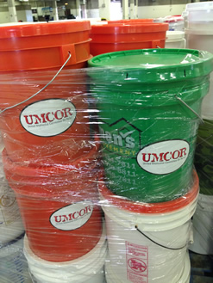
UMCOR DISASTER KITS
Help Purchase Supplies If you prefer to donate toward the purchase of supplies instead of buying and shipping them, give through your local church or online to Material Resources, UMCOR Advance #901440.
If you are putting together disaster kits and can’t get them to Mission Barn 20 or more Buckets call Calvin Cook at Kane: First 837 – 7120 and he will come and pick them up to deliver. Or bring them to Youngsville Evangelical United Methodist Rick Nelson will deliver them to Mission Barn
How to assemble a cleaning kit video

NEW INFORMATION KANE DISTRICT LAY MINISTRY
Lay Ministry School; Advanced Class,” Living Our United Methodist Beliefs” by George Hovaness Donigan and the Basic Course will be held October 21st and 28th from 10a.m. – 4p.m. Deadline to register will be October 9. The courses will be held in @ Tionesta and Evans Memorial in Lewis Run. Pastors Andy Blystone, Barb Moore and Jay Tennies instructors. NOTE: If attending one of these schools, it is your responsibility to make sure that the Kane District Office receives a copy of your certificate of completion.

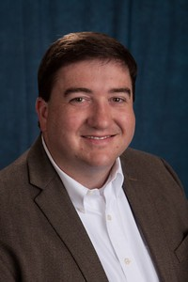
Kane District will host Rev. Jeff Campbell
Discipleship Ministries
Engaging & Serving Your Community
November 5 and 6, 2017


Jeffrey Campbell
Director Annual Conference Relationships
Discipleship Ministries is one of fourteen international agencies of The United Methodist Church, based in Nashville, Tennessee. Discipleship Ministries has over 150 employees that resource The United Methodist Church in the areas of new church starts, leadership development, Christian education, spiritual formation, worship, stewardship, evangelism, and other areas.
Kane District will be hosting Rev. Jeff Campbell from Discipleship Ministries.
November 5 and 6, 2017 Clergy and Laity both are welcome to attend Jeff’s presentation at Olmsted Manor Retreat Center beginning Sunday at 3:00p.m. and ending Monday afternoon. RSVP required. Kane District Clergy are strongly urged to attend
$30.00—for Single room (includes 3 meals plus room)
$20.00—for Shared room (includes 3 meals plus room)
$5.00—for Sunday only (includes evening meal).
$15.00—for Commuter Rate
For Reservations contact Anne@Olmstedmanor.org or 814/ 945-6512 .75 CEU Available
SAVE THE DATE KANE DISTRICT MISSION SUMMIT
January 27th with Stephanie Gottschalk 10-3 Clergy & Laity are invited to attend @ Sheffield UMC


Birthdays: OCTOBER: 7th Samantha Penwell, 9th Mark DeBaise, 14th Laura Blake, 19th Calvin Cook, 20th Shelby Hernan,
20th Nancy Hoover, 27th Barb Moore,
 Anniversaries: OCTOBER: 4TH Glea & Jeff Foor, 10th Pam & Dan Richter

INFORMATIONAL UPDATES
NEW - POSITIONS AVAILABLE:
The First United Methodist Church – 200 Market St. in Warren is currently seeking candidates to fill three positions:
Office Manager – a full time position. The person in this position will need to be familiar with and able to use both standard office software and financial systems software.
Receptionist – a part time position. Familiarity with standard office software systems beneficial. Above average inter-personal and communication skills are needed in this position.
Custodian – a part time position evenings and some weekends. The person in this position should be self-motivated and familiar with cleaning techniques and products.
Receptionist - Youngsville Evangelical 18 Second Street Youngsville, PA 16371 – a part time position. Familiarity with standard office software systems beneficial. Above average inter-personal and communication skills are needed in this position.
Act 33 and 34 clearances are required for each of these positions. Employment applications, job descriptions and salary information can be obtained at the church office Monday through Thursday 9:00 AM to 4:00 PM and on Friday 9:00 AM to 11:30 AM.

Camping Initiative Update:
Camping Coordinator Jessica Gamache, Conference leaders, and the Camping and Retreat Center Corporations Committee have been meeting online and in person through the past few months to set the stage for a fundraising campaign for the Bishop’s Camping Initiative. Several donations were received from individuals and churches over the summer, but the official launch of the formal fundraising effort is still a few months away. A professional fundraising consultant has been selected and is working with leaders to determine the most effective ways to proceed. Help will be needed from individuals and congregations throughout Western PA. Stay tuned for more information.
Individuals and organizations external to WPAUMC can make an online contribution using their bank account or credit card by clicking the brown button below; Individuals affiliated with WPAUMC should give through their local church. Churches can also contribute online; however, they should continue to use the Local Church Remittances page. Camping & Retreat Ministries – Bishop’s Initiative

KANE DISTRICT HERE & THERE PROJECT;
Zaka East Sanctuary, Zimbabe and Ruth M. Smith Home
To support the projects donations are sent to:
The United Methodist Center 1204 Freedom Rd. PO Box 5002 Cranberry Twp., PA 16066-02204
Use #ZIMKA on your check for support to Zaka East Project & for Ruth M. Smith Center #0011007

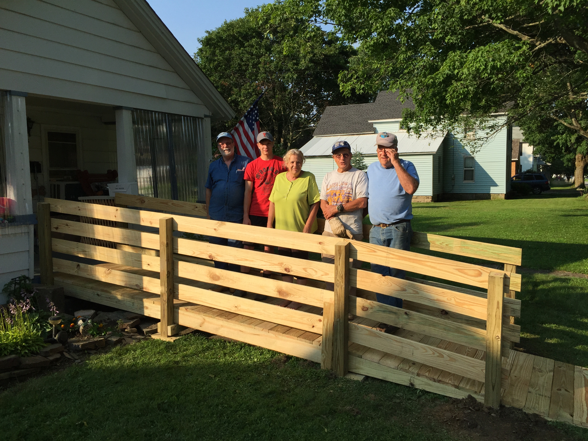
Kane District Ramps Ministry
In the past 3 years our ministry has completed 30 ramps. We serve those with a short or long term need. Ramps are semi-permanent and can be relocated if no longer needed. Youngsville’s “shop” class has participated in the building of modules along with many other volunteers. We are funded through offerings from participating churches, private donations, grants and fund raisers.
Rick Nelson 563-4351 or rick@nelsonrb.net Chris Swanson 945-6975 or kane.office@wpaumc.org.
Donations can be sent to the Kane District Office mark as ramp donation
Thanks to the Congregations of; Duke Center, Barnes UMC Marienville UMC, Shinglehouse , Sugar Grove, Russell, Evans Memorial, Port Allegany Christian and Missionary Alliance Church
Thanks to; Dotty Louise Christy, Gregory J. Harmon, Shirley & Ronald Carrinton, Gourdon Gould, Linda Gilbert

Butler District Fall Lay Servant Ministry School:
“Leading Worship” Saturdays 1:00 – 5:00 pm October 14, 21 & 28
Aliquippa: First UM Church, 2816 Brodhead Rd, Aliquippa, PA 15001
Fall- 2017-THORNCREEK Lay Servant Ministries-Brochure.pdf Fall 2017-ALIQUIPPA FIRST Lay Servant Ministries-Brochure.pdf

OCTOBER


BELONG. YOUTH RETREAT
Wesley Woods Friday, October 13 – Sunday, October 15. God knows you and He loves you anyway. Here is your chance to unplug from the daily struggles in your life and find some space – to think, to rest and to learn about the love that God has for each of us. Enjoy time to catch up with God and yourself! Ages 6th – 12th grade. Cost $95/person (Zipline and Airsoft $10 extra/person.) Starts at 5 pm on Friday and ends at 1 pm on Sunday. Register

NEW - Chicken Dinner

Saturday October 14th 4:00– until gone $9.00 minimum donation Eat in or take out Come to the Russell UMC for a delicious barbequed Chicken Dinner , macaroni salad, baked beans, roll, dessert and beverage.

FIRST ANNUAL CLERGY COLLEGE AT JUMONVILLE
It will begin on Sunday, October 15th with registration at 4:30pm and end on Tuesday, October 17th with closing communion at 11am. The total cost of the event is $200 per person for double occupancy and $260 per person for single occupancy. This includes your lodging either in Washington Lodge or The Inn and it includes Sunday dinner, three meals on Monday, and Tuesday breakfast. To register please visit us online at https://jumonville.org/clergy-college-registration or call us at the Jumonville office at 724-439-4912.

NEW – RACIAL JUSTICE GRANTS:
Applications are available for grants to help UM young people with a passion for racial justice to initiate projects that can influence their church, community and world. Three agencies and the Connectional Table are collaborating to provide up to $2,500 per project. The deadline is October 15. To apply Read Discipleship Ministries press release.

JUMONVILLE’S SPONSOR DINNER
Wednesday, October 18, 2017 at the South Hills Country Club. It is one of three fundraising events each year. The sponsor’s dinner has traditionally been held in mid-October. Bishop Cynthia Moore-Koikoi, Bishop of the WPA Conference of the United Methodist Church, will share her enthusiasm for the ministry of Christian Camping that takes place on the Jumonville Mountaintop.

KANE DISTRICT LAY MINISTRY
Lay Ministry School; Advanced Class,” Living Our United Methodist Beliefs” by George Hovaness Donigan and the Basic Course will be held October 21st and 28th from 10a.m. – 4p.m. Deadline to register will be October 9. Locations and instructors to be announced. NOTE: If attending one of these schools, it is your responsibility to make sure that the Kane District Office receives a copy of your certificate of completion.

SUNDAY,OCTOBER 15,2017
Laity Sunday 2017: “Therefore, Go! with HOPE Through Hospitality” on Often when we think of hospitality, we think of it through the lens of how we receive guests in our midst. But the reality is, we practice hospitality wherever we are, even when we are outside our home or church. Resources

WPA Conference Minister’s Chorus on October 19, 2017 at Mount Hope UMC. Contact Don & Shirley Bloomster (814-927-8692), Pat Cleary (254-241-0680, wpcleary@gmail.com) or Lola Turnbull (814-745-2231, pastorljt@yahoo.com) with any questions.

RUCK THE BAY
A 15K Military-Style Ruck March/Walk in honor of our local fallen heroes and to end Veteran homelessness. It will take place on Sunday, Oct. 15, 2017 with Registration at 1 pm with the Ruck starting at 2 pm at Presque Isle State Park, Beach 11, Erie. Online registration will begin July 1.
Ruck the Bay participants will complete the 15K (or optional 5K) carrying a loaded rucksack/backpack, and will observe memorials at every kilometer honoring those who have lost their lives in service to our country. Participants are encouraged to fill their rucksack with items to donate to Liberty House (such as men’s hygiene products, paper products, laundry and cleaning supplies, linens and blankets, towels, etc.) Drop-off boxes to unload your donations will be located at the finish line. Pre-registration until Sept. 15: Individual: $30; Team of 4+: $25; * includes Ruck the Bay official t-shirt Registration Sept. 15 through day of event: Individual: $35; Team of 4+: $30 For more information, contact the EUMA office at (814) 456-8073 or SGT Kelly Whitney at 814-602-3602.

NEW - WOMEN’ S RETREAT
The plans have begun for the LUMC Women’s Retreat which will be held October 20th and October21st at the beautiful Olmsted Manor. This year our guest speaker will be Sherry Lawson and the theme will be “Drinking From the Saucer.” The cost is $50.00 which includes your hotel accommodation, breakfast, lunch, and all supplies needed for the retreat. Scholarships are available; we do not want anyone to miss out because of finances. We are giving preference to our church attending women and women who have attended the retreat in the past before opening reservations to other women. Please make your reservation with one of us by September 5th as we have several women outside the church that are interested in attending! If you have questions or are in need of a scholarship please speak to Kathy Hurst, Tracy Kirkpatrick, Marcy Stanton, or Jeanette Walter.

CONFERENCE UMW ANNUAL FALL MEETING
Saturday, October 28 at Faith Delmont UMC, 305 Freeport Street, Delmont, PA 15626 from 9:30 am to 2:30 pm. Speaker: Bishop Cynthia Moore-Koikoi. All women welcome! Contact Diane Miller at diane.miller2747@gmail.com

NOVEMBER
2018 EQUITABLE COMPENSATION FORMS
Due - Wednesday, November 1 (where applicable)


EXPLORATION 2017 !
Young adults who may sense God calling them to ordained ministry in the UMC are invited to attend Exploration, a three-day event held every two years to help those age 18-26 explore their gifts for service as a deacon or elder. This year’s event will be held November 3-5 in Portland, Oregon. Learn more.

NEW - FALL RUMMAGE SALE @ GRACE U.M.C
The Outreach team will be hosting a Fall rummage sale at Grace on November 4 from 8:00 a.m. until 2:00
p.m. to raise funds for Grace Missions. Clear out some space
and donate your usable items. Kids clothes are welcome, but please, no adult clothes. You can drop off items in Higginbotham Hall on Thursday, November 2, from 5:00 – 7:00 p.m. and Friday, November 3, from 4:00 – 6:00 p.m. Please contact Chuck Keeports @ 814-688-8534 for more info.

NEW- WARREN FIRST U.M.CELEBRATING 200TH ANNIVERSARY!
We are inviting our brothers and sisters in the District to join us as we celebrate 200 years of Methodism in Warren County 200 Market Street, Warren Sunday, November 5th 2:00 – 4:00 PM Open House for the congregation and community with organ music provided from CDs of John Slaney, Organist Emeritus; displays from the Outreach, Nuture, and Worship Committees, and refreshments. Invite your friends and neighbors to an afternoon in the beauty of our church.

RSVP ENGAGING & SERVING YOUR COMMUNITY
Kane District will host Jeff Campbell at Olmsted Manor November 5-6. The event which includes Laity & Clergy begins Sunday at 3p.m. end ends Monday afternoon. Contact Anne@Olmstedmanor.org or 814/ 945-6512
$30.00—for Single room (includes 3 meals plus room)
$20.00—for Shared room (includes 3 meals plus room)
$5.00—for Sunday only (includes evening meal).
$15.00—for Commuter Rate .75 CEU Available

HOME CAMP UMC INVITES YOU
On A Mission Trip to Jamaica November 5 -12, 2017 The total trip price of $1550.00 includes airfare, accommodation, transportation, food, building material, wages, tips, and taxes. The trip will be partnering with Won By One To Jamaica (www.wonbyonetojamaica.com), a group with over 25 years’ experience in bring mission groups to Jamaica. A down payment of $100.00 reserves your spot on the trip. Don’t worry about being the only one from your church on the trip. As a part of God’s family we are all part of the same group. After attending for the first time last year, his congregation has seen the change that it has made on his life and he advises anyone that has ever wanted to go on a trip to contact him rp_howe@yahoo.com or (814)583-7330 if they have questions or wish to reserve a spot to go along.

ONLINE LAY SERVANT WORKSHOP:
Your Ministry of Leading Worship 101 Course Dates: November 6 – December 8, 2017. This online course will focus on basic understandings of worship, gaining skills for lay servants planning and leading worship and fulfilling requirements for Lay Speaker Certification. This class is approved by United Methodist Discipleship Ministries as an advanced course in Lay Servant Ministries, and is the “worship” class required for Lay Speaker Certification. This course is eligible for 1.0 CEU. Details
MORNING WORSHIP WITH BISHOP CYNTHIA MOORE KOIKOI
Warren: First Sunday, November 12th 10:30 AM Morning worship with Bishop Cynthia Moore-Koikoi speaking. Music will be provided by the Chancel Choir, the Aldersgate Choir, the Epworth Bellringers, the Men’s Quartet, organists Michele Sandberg and David Powell, percussionist David Dorn, trumpeter Mikki Gifford, and flutist Laura Whitten. Members who joined the church 50 or more years ago will be recognized.
Sunday, November 12th 12:30 PM
Celebration buffet dinner in Founders Hall. Menu will include baked chicken, beef tips in gravy, mashed potatoes, green bean casserole, pasta salad, fresh vegetables with dip, rolls and butter, beverages, and cupcakes. Reservations are due no later than October 23rd. Please return the response card that you will receive in the mail or call the church office (723-4930) no later than Monday, October 23rd. This dinner is by reservation only. Following dinner a program will be presented with greetings from former pastor Rev. Bill Starr and entertainment by David Crone, a ventriloquist and puppeteer and a son of this congregation.

WPA CONFERENCE MINISTER’S CHORUS
Nov. 16th Brookville First UMC at 7:00 pm

MISSION OF PEACE
Each year a group of youth and young adults from the Northeastern Jurisdiction travel shortly after Christmas on a Mission of Peace to another area of the globe. Applications are available now for the 2018 MOP to Cuba. It’s scheduled from about December 28, 2017- January 12, 2018. Applications are due to Greg Cox by Feb. 1, 2017. Get application.
DECEMBER
KANE DISTRICT CLERGY FAMILY CHRISTMAS PARTY
Active, Retired & Widows gather in Founders Hall Warren: First December 8 for punch at 630:p.m. Dinner will begin 7:00p.m. The Epworth Bell Choir will play immediately following dinner. Warren: First is located at 200 Market Street in Warren and is handi-capped accessible. RSVP required to the Kane District Office 814/ 945 6975 or kane.office@wpaumc.org There is a minimal cost $5 per person or $10 a family payable to Kane District

OLMSTED CHRISTMAS OPEN HOUSE
Sunday, December 3 & 10, 2017 from 4 p.m. to 8 p.m. both evenings. Join the staff and friends of Olmsted as we open our doors to celebrate the Christmas season. Guests can enjoy homemade cookies and punch next to the warm fireplace, or take a tour of the freshly decorated manor. Whether you are coming to visit your "home away from home" or are seeing Olmsted for the first time, we hope you will join us for an evening of celebration and fellowship. Click to Download Flyer

MISSION OF PEACE
Each year a group of youth and young adults from the Northeastern Jurisdiction travel shortly after Christmas on a Mission of Peace to another area of the globe. Applications are available now for the 2018 MOP to Cuba. It’s scheduled from about December 28, 2017- January 12, 2018. Applications are due to Greg Cox by Feb. 1, 2017. Get application.

SPARK 2018
Jan. 19-21, 2018 Sheraton Station Square Registration is open now!
SPARK is our annual retreat for youth in grades 6-12 and 2018 is our tenth year! For more information and to register, check out www.wpaumc.org/spark

