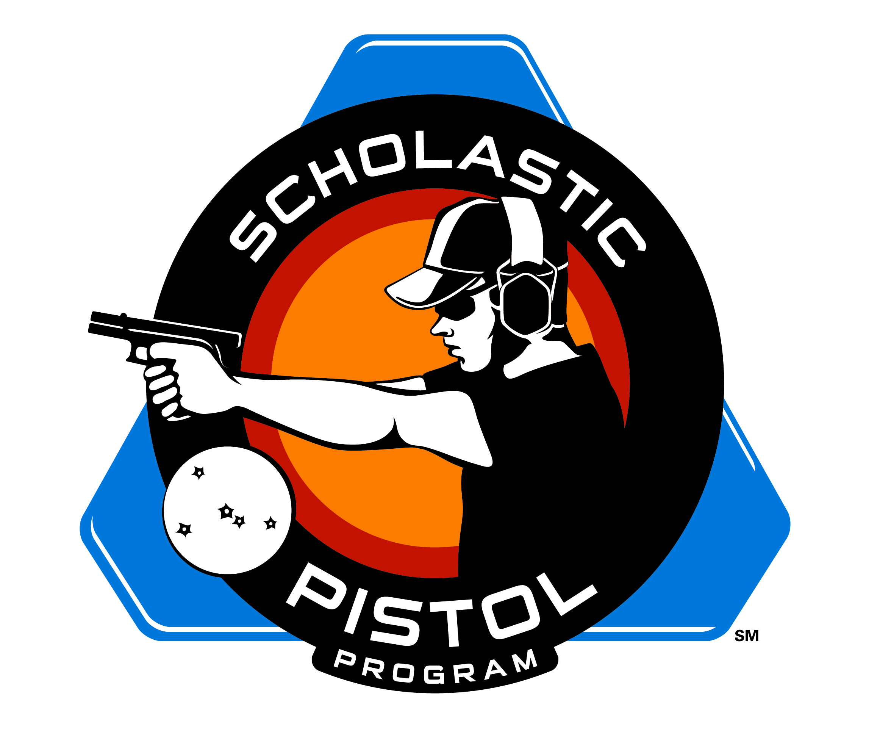
2014 Scholastic Pistol Program (SPP)
Northeast Fall Regional Match
Sponsored by Smith & Wesson
October 4, 2014

GENERAL INFORMATION:
The Northeast Fall Regional match will be held at Camp Hinds Boy Scout Camp in Raymond, Maine on Saturday, October 4. The match is open to all Junior, Senior, and Collegiate SPP teams.

MATCH FEE: $20 per shooter

SPP SCHEDULE: Registration begins at 8:00 a.m.
8:30 a.m. shooter’s meeting
9:00 a.m. 1st flight of shooters begin
12:00 p.m. 2nd flight of shooters begin

AWARDS: Both Centerfire and Rimfire (JV) Divisions will be recognized.

Endowment funds will be available for this match.

We will be offering the teams the opportunity to place an ammo order for the match. The cost of the 9mm will be approximately $25.00 for 100 rounds and approximately $204 for 4,000 rounds of .22lr.

Each athlete is limited to 10 boxes of 9mm.

The entire team is limited to 4,000 rounds of .22lr.

If there is a change in the ammo availability or cost, we will let you know.

The pre-order ammo deadline is September 25.
**Loaner guns will be available for those who will need to borrow the day of the match**

ADDITIONAL MATCH INFO:

Camping: Camping is available on a first-come, first-served basis for anyone who would like to come up on Friday or stay over on Saturday. Tent camping (must provide own tents), 4-person cabins, and multi-bunk bunk rooms are available. Cabins and bunkrooms have cots and field mattresses. No outside firewood, please. Firewood will be available for purchase. Cost for camping is $2.00 per person, and reservations must be made in advance by calling Tammy at 207-797-5252 ext. 10 or emailing tachapma@scouting.org. Checks, cash, and credit cards accepted.

Crew 51 Fundraiser: Pancake Breakfast Saturday Morning, 6:30 - 8:30 am. Pancakes, maple syrup, bacon, coffee, and milk. $5.00 per person. Please let us know if you'll be joining us for breakfast by calling Annie at 207-200-6814 or emailing annie.tarbox@gmail.com. Checks, cash and credit cards accepted.

Lunch: Food is available for purchase at lunch. Hot dog or hamburger, chips, and a drink (and probably coleslaw as well) for $5.00 per person. Cash only, please.

2014 Scholastic Pistol Program (SPP)
Northeast Fall Regional Match
Sponsored by Smith & Wesson
October 4, 2014
PRE-REGISTRATION IS REQUIRED!!!!

Match Fee: $20 per shooter

TEAM:

COACH:

AGE CLASS JUNIOR SENIOR COLLEGIATE
FOR TEAM: (Circle) (12 – 16) (17—20)

DIVISION: (Circle) CENTERFIRE RIMFIRE (choose 1 only)

SQUADDING TIME: 9:00 a.m. 12:00 p.m.
(Circle)

SQUAD: 1.
2.
3.
4.

(Please use additional forms for enrolling more than 1 squad)

Match Fee Per Shooter $ 20.00 X =

Ammo (prices are approximate)
9mm (100 rounds) $ 25.00 X =

22lr (4,000 rounds) $204.00 X =

Athlete Membership Registration Due $ 20.00 X =
(If not a current member)

Coach Membership Registration Due $ 30.00 X =
(If not a current member)

Total Due:

REMINDER: THE SPP NEW SEASON BEGINS SEPTEMBER 1. ALL TEAMS MUST SUBMIT NEW PAPERWORK AND MEMBERSHIP FEES, PLUS REGISTER TEAM ONLINE.

*All Team Members Must Be Current SPP Members, if Athlete or Coach paperwork is needed for a new shooter or coach, please contact Tammy Mowry at tmowry@sssfonline.com

PLEASE COMPLETE REGISTRATION FORM AND RETURN TO TAMMY MOWRY

Questions, please contact Scott Moore at jsmoore357@yahoo.com
Or Tammy Mowry at tmowry@sssfonline.com

Questions, please contact Scott Moore at jsmoore357@yahoo.com
or tammy.mowry@zoominternet.net

