DEVELOPMENT AND CHARACTERIZATION OF BACTERICIDE AND FUNGICIDE GLASS CONTAINING IONIC ZINC SPECIMENS FOR USE AS ANTIMICROBIAL ADITIVE

Mendes, E.^{2,a}, Carradore, M. A.¹, Oliveira, C. M.¹, Piletti, R.¹, Riella, H. G.² and Fiori, M. A.¹
ª Rua Juceli Rodrigues, 396, CEP 88815-270 Criciúma/SC – elt.kof@hotmail.com
¹ Departamento de Engenharia de Materiais e Engenharia Química, Universidade do Extremo Sul Catarinense - UNESC, Criciúma, Santa Catarina, Brasil
² Departamento de Engenharia Química, Programa de Pós-Graduação em Engenharia Química Universidade Federal de Santa Catarina - UFSC, Florianópolis, Santa Catarina, Brasil

ABSTRACT

Through the oligodynamic effect some metals promote microorganisms death and prevent their proliferation. In particular, the zinc ions incorporation provides to the material high bactericidal and fungicidal properties, with proportional effects to the ion concentration. This work presents preliminary results in a vitreous base biocide additive development, obtained by ionic exchange between sodium ions, present in the glass matrix, and zinc ions, present in the ionic exchange medium. Powdered glass was submitted to ionic exchange in an ionic medium containing ZnSO₄ as zinc ions source and NaNO₃ as melted medium. Different ZnSO₄ amounts in ionic medium (4.00, 11.00, 18.00 g) and different reaction times (2.0, 5.0, 8.0 h) were used in the samples development and the bactericidal and fungicidal properties were evaluated using factorial experimental design and microbiological analysis – disk diffusion method for the bacteria species Echerichia coli and Staphylococcus aureus, and fungal species Candida albicans. Results showed that the biocidal effect was dependent only on ZnSO₄ amount in ionic exchange medium for the tests with Staphylococcus aureus and Candida albicans. For Escherichia coli bacterium species the ZnSO₄ amount did not affect the biocidal effect, but the reaction time and the both factors variation together were significant to the inhibition halo formed.

Keywords: Ionic Exchange; Antimicrobial Materials; Oligodynamic Effect; Biocidal Glasses.

INTRODUCTION

The development and use of antimicrobial materials has proven an effective way to reduce risks posed to human life by the action of fungi, bacteria and others.
In recent years many works had been developed on biocides materials applied to polymer and ceramic materials ⁽¹⁻⁴⁾. These works deal with studies regarding biocide addition efficiency, methodologies for the production of bactericidal and fungicidal materials and the optimization of biocide properties.
Some metallic ions present oligodynamic properties and are used by industries in the production of biocidal materials. Oligodynamic properties are the ability of small amounts of metallic ions to exert a lethal effect on living cells, algae, fungus, bacteria, virus or others microorganisms, even in relatively low concentrations. This antimicrobial effect is shown for ions: mercury, silver, copper, iron, zinc, gold, aluminum and other metals. Especially heavy metals exhibit this effect ⁽⁵⁻⁷⁾.
Zinc is an essential element for human health life. It is one of the components of certain proteins inside the human body. Although zinc is a key element for humans, free zinc ion in solution is highly toxic to some organisms. It has been known that zinc ions possess antimicrobial properties and the ionic exchange with this metal imparts antibacterial activity to the zeolites ^{(8, 9)}.
Ionic zinc specimens can be incorporated into glasses or natural clays by ionic exchange process. Differing zinc concentrations can be realized depending on the kind of matrix chosen and on the ionic exchange process parameters utilized. The bactericidal and fungicidal activities of compounds containing zinc ion specimens are proportional to the ionic concentration due to the oligodynamic effect ⁽⁵⁻⁷⁾.
Ionic exchange involving oligodynamic specimens is favored by the sodium presence in the glass structure. Sodium ions are more easily removed from the glass structure that other cations and thus are more easily exchanged by zinc ions ⁽¹⁰⁾. The other factors that influence the efficiency of ionic exchange are the reactive area and the porosity ⁽¹¹⁾.
This study evaluates the effects of different zinc sulfate (ZnSO₄) amounts in ionic medium and different ionic exchange reaction times on antimicrobial activity. An ionic medium containing ZnSO₄ was used to develop an ionic exchange processes between sodium ions already present in the glass and the biocidal zinc ions present in the ionic medium. Samples were fabricated varying the ZnSO₄ amounts in ionic medium (4.00, 11.00, 18.00 g) and the reaction times (2.0, 5.0, 8.0 h) while keeping constant the temperature. The antimicrobial activity of the samples was evaluated by disk diffusion method for the bacteria species Echerichia coli and Staphylococcus aureus, and fungal species Candida albicans. The experiments were conducted in 2^{k} factorial designs with two factors.

Experimental procedure

Glass Development

The efficiency of the ionic exchange reaction depends on the sodium presence in the vitreous material structure. Thus, the glass used in this work must contain a high sodium concentration.
The glass was prepared following the composition and methodology developed by Fiori et al. ⁽²⁾. The raw materials were melted at 850 ºC for 30 min and at a heating rate of 10 ºC/min. They were then heated to 1450 ºC for 120 min at the same heating rate. In sequence, the glass obtained was crushed to particle sizes less than 40 μm and submitted to ionic exchange treatment in ZnSO₄ ionic media at different concentrations.

Ionic Exchange Treatment

The ionic exchange process was performed utilizing powdered glass in an ionic medium containing ZnSO₄.7H₂O (Vetec, 99.0% purity) as the zinc source and NaNO₃ as the melted medium (Reagan, 99.0% purity). The powdered glass was immersed in an aqueous solution containing the ionic medium and kept under magnetic stirring. This process was repeated for different reaction times – 2.0, 5.0 and 8.0 h – and different ionic media, keeping a constant NaNO₃ concentration but varying the zinc sulfate amounts between 4.00, 11.00 and 18.00 g, according to the 2^{k} factorial design. Tab. 1 shows the experimental design used in the samples development.

Table 1 – Experimental design.
Sample | Glass  (g) | Reaction Time  (h) | ZnSO₄  (g) | NaNO₃  (g)
1 | 30.00 | 8.00 | 18.00 | 15.00
2 | 30.00 | 2.00 | 18.00 | 15.00
3 | 30.00 | 8.00 | 4.00 | 15.00
4 | 30.00 | 2.00 | 4.00 | 15.00
5 | 30.00 | 5.00 | 11.00 | 15.00
6 | 30.00 | 5.00 | 11.00 | 15.00
7 | 30.00 | 5.00 | 11.00 | 15.00

After the ionic exchange treatment, the samples were washed and kept in deionized water for two days. This procedure was used to dissolve the sodium residues that had been incorporated onto the glass surface during the ionic exchange process. The samples were then dried in an oven at 70 ºC and crushed again to ungroup the particles.

Microbiological Tests

Bactericidal and fungicidal activities of the samples were evaluated using the agar diffusion test (disk diffusion method). The bacteria species utilized were Echerichia coli (ATCC 25922) and Staphylococcus aureus (ATCC 6538), and the fungal species utilized was Candida albicans (ATCC 10231).
The tests were conducted in Petri dishes containing three wells 10 mm in diameter. Measured quantities of 0.050 (± 0.001) g of biocide powdered glass were placed into each well followed by 10 µL of sterile water. Each sample was placed in its individual Petri dish and each sample configuration was performed in triplicate.
All tests were conducted at 37 °C after the microorganism was submitted to a 24 hour incubation period. For all samples, microbiological tests were carried out to evaluate the influence of the ionic medium and reaction time on the production of a biocidal glass.
In order to evaluate the performance of the antimicrobial effect in the agar well diffusion test, the biocide action areas (total and sample areas) were modeled as circles, as shown in Fig. 1. The biocidal areas were calculated as

A_{bio} = A_{ex} – A_{in} | (A)

where A_{bio} is the biocide area representing the biocide action, A_{ex} is the area where the microorganism was destroyed and A_{in} is the sample area ⁽²⁾.

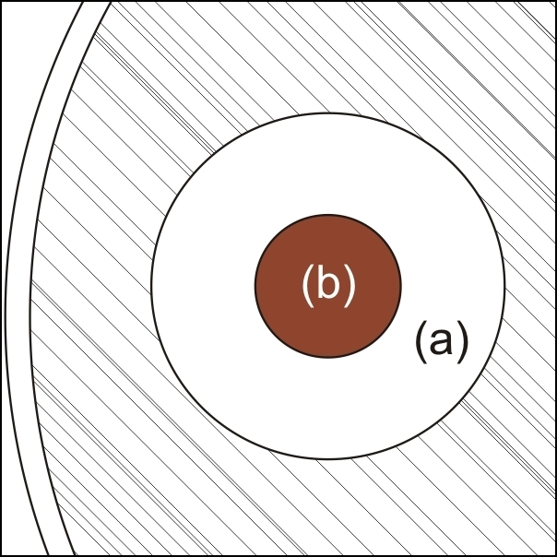
Figure 1 – Model utilized for evaluating the biocide area A_{bio}: (a) biocide area and (b) sample area.

Results and Discussion

Microbiological tests show excellent bactericidal and fungicidal activities for the glass produced under all conditions of reaction time and zinc sulfate mass. Figures 2, 3 and 4 show the agar diffusion test results for samples with differing reaction times and ZnSO₄ amounts for the Echerichia coli and Staphylococcus aureus bacteria, and for the Candida albicans fungus respectively.
Tables 2, 3 and 4 show the triplicate values for the biocide area (A_{bio}) for all reaction times and zinc sulfate mass, according to the 2^{k} factorial design, utilizing Escherichia coli, Staphylococcus aureus and Candida albicans microorganisms respectively.

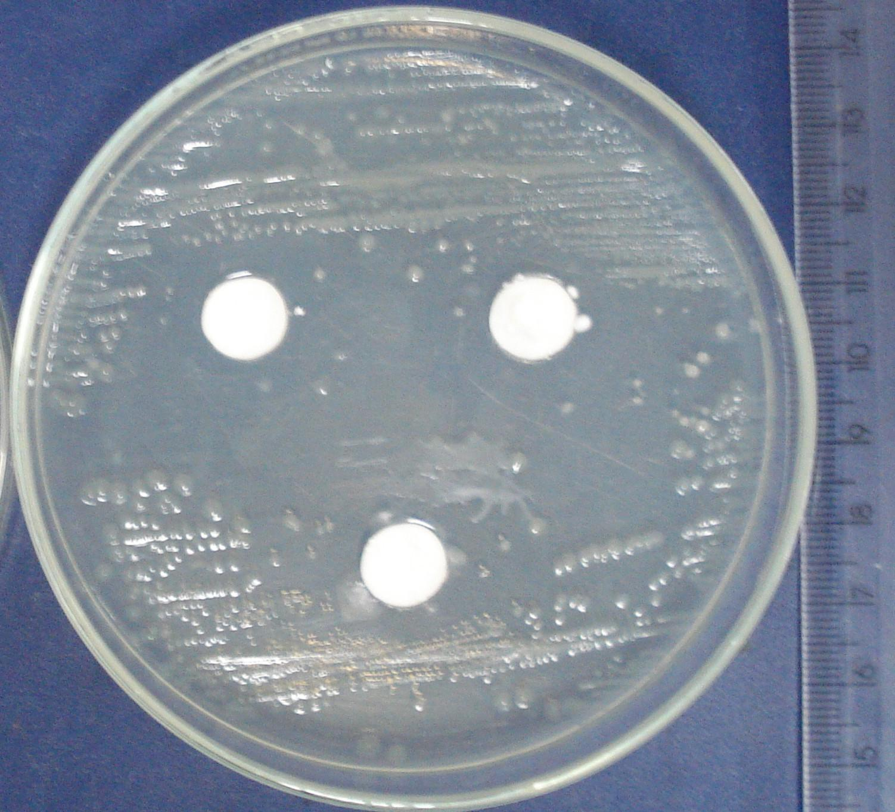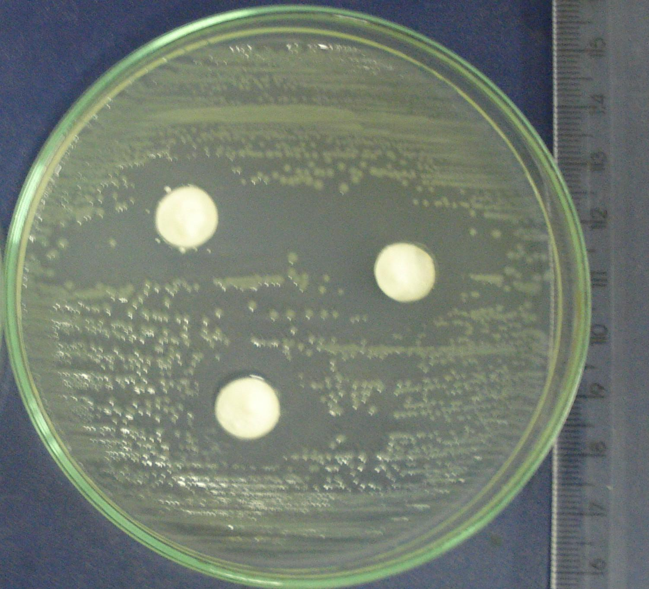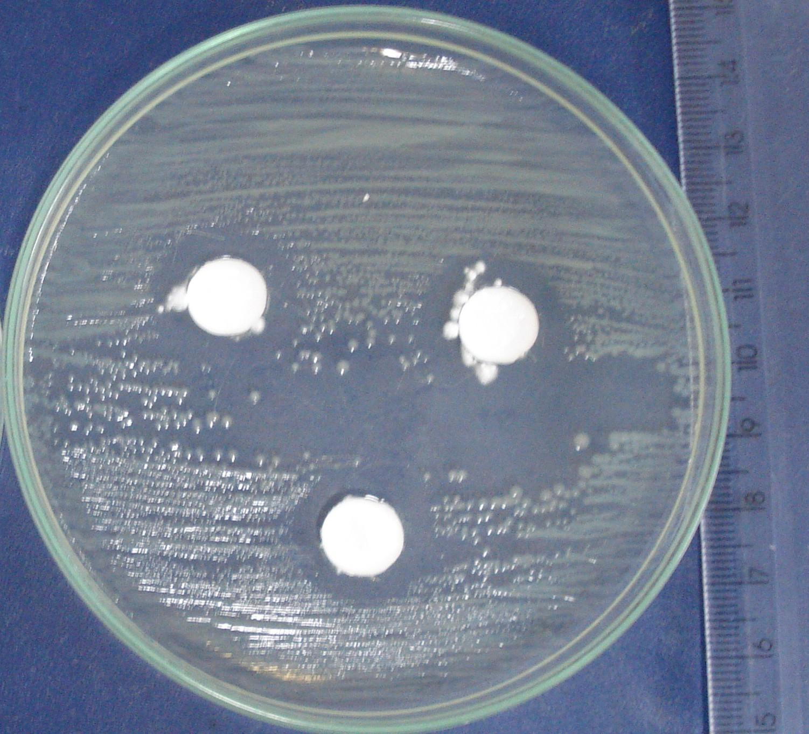
(C)
(A)
(B)

Figure 2 – Microbiological results with Echerichia coli bacterium for different reaction times and zinc sulfate amounts: (a) 2.00 h and 18.00 g of ZnSO₄, (b) 8.00 h and 4.00 g of ZnSO₄ and (c) 5.00 h and 11.00 g of ZnSO₄.

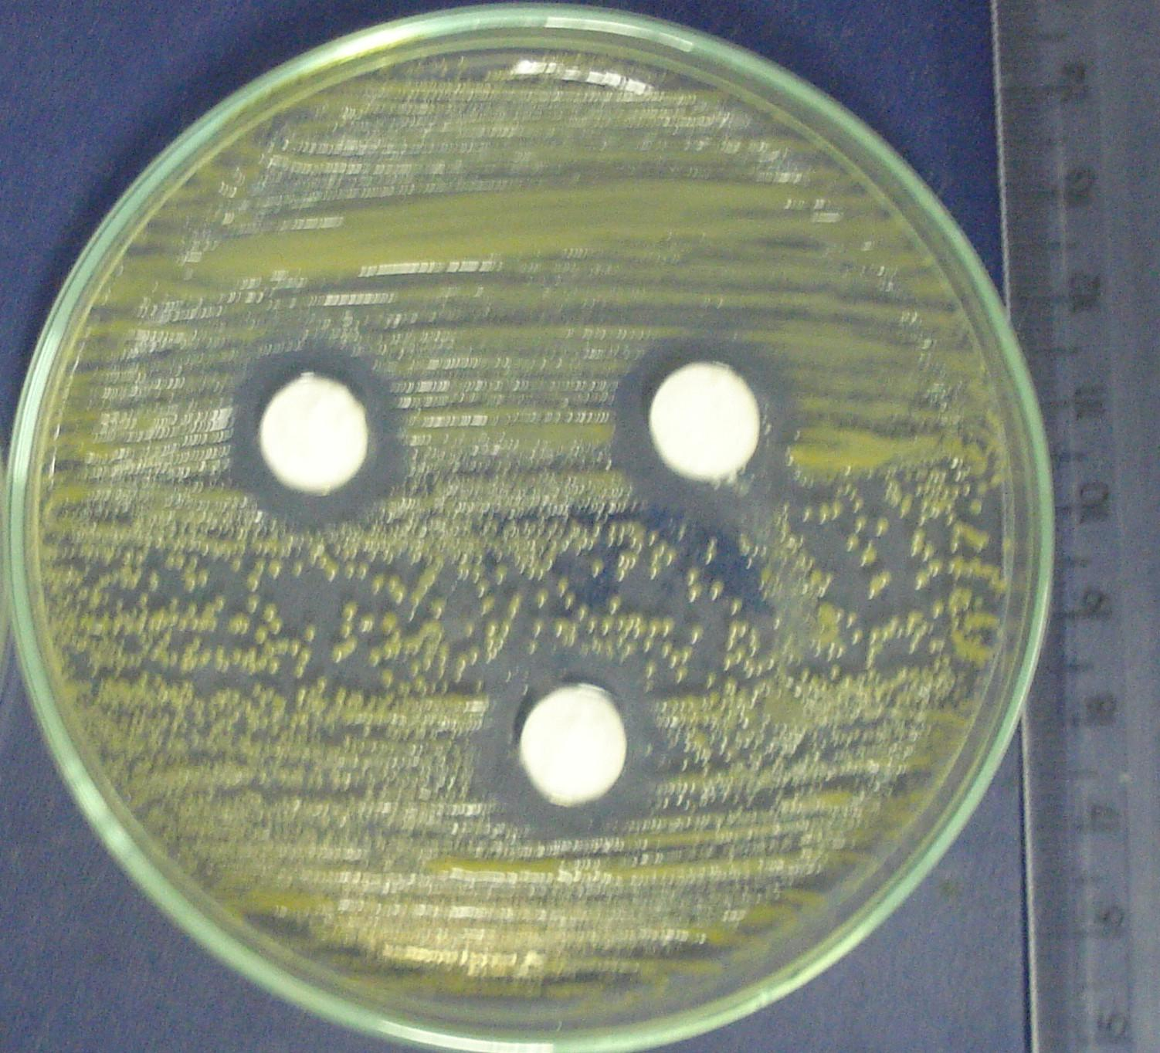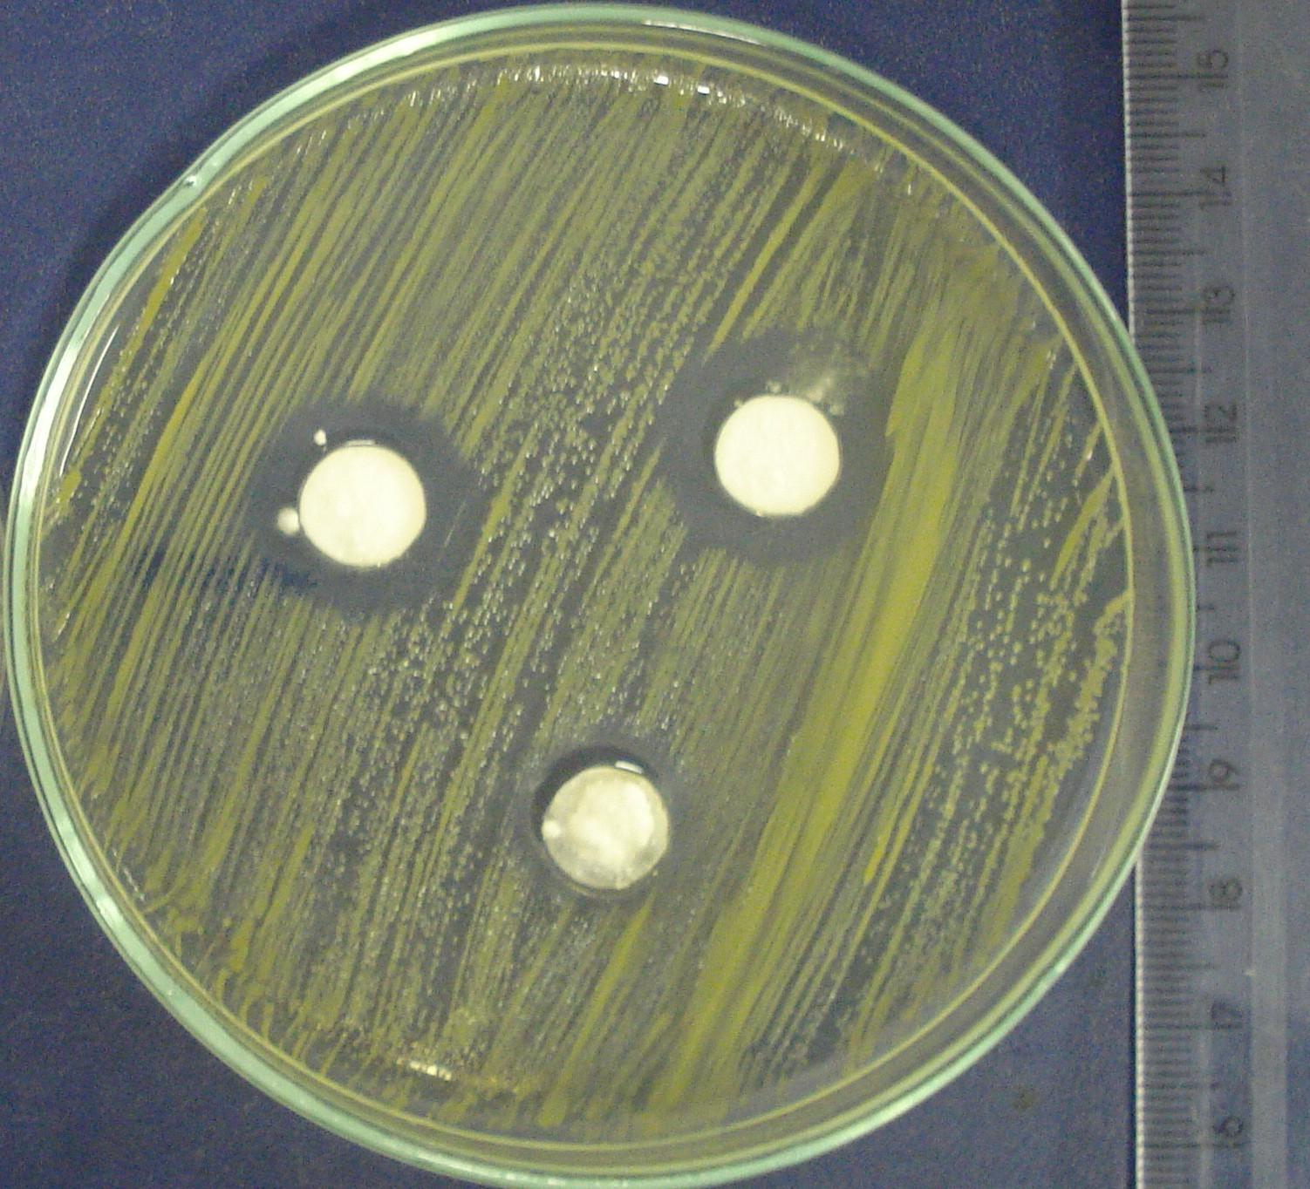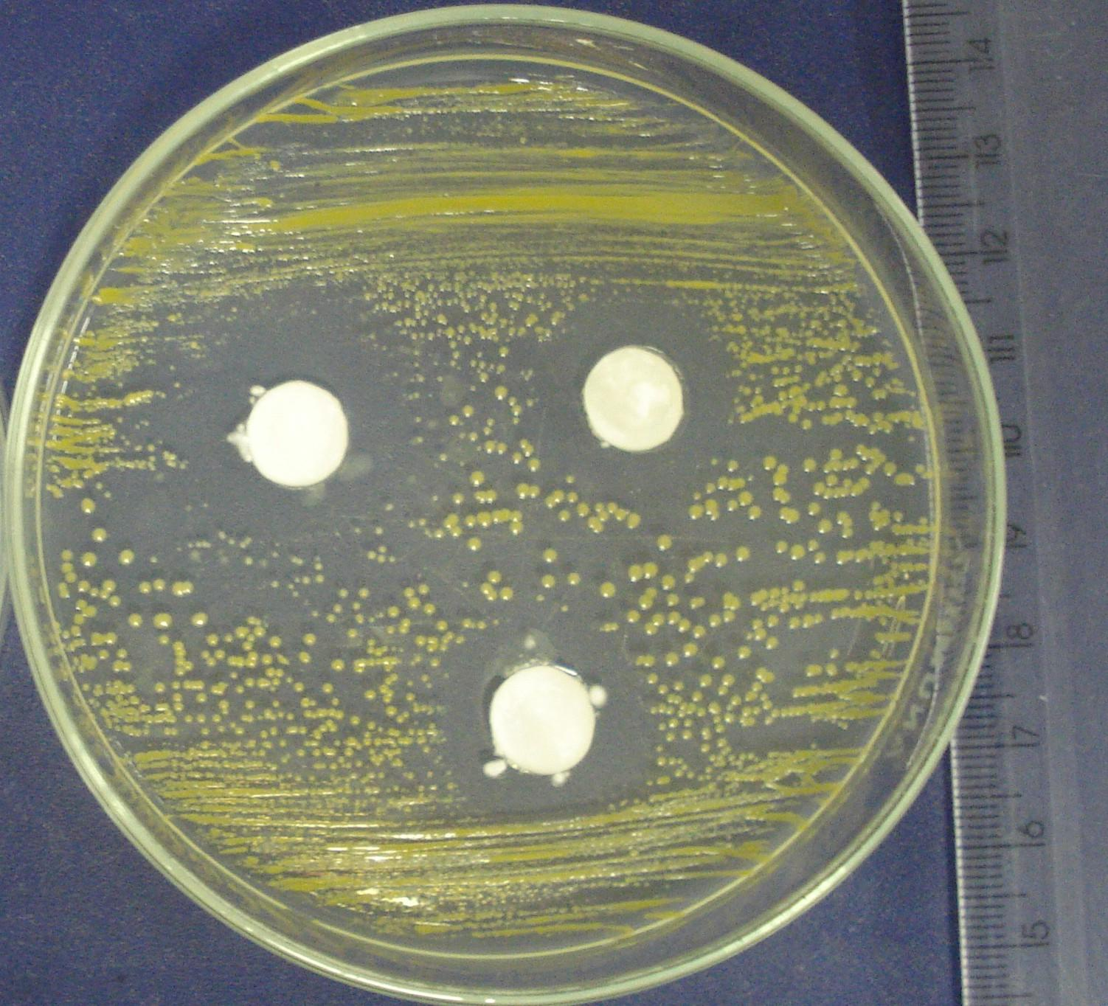
(C)
(A)
(B)

Figure 3 – Microbiological results with Staphylococcus aureus bacterium for different reaction times and zinc sulfate amounts: (a) 2.00 h and 18.00 g of ZnSO₄, (b) 8.00 h and 4.00 g of ZnSO₄ and (c) 5.00 h and 11.00 g of ZnSO₄.

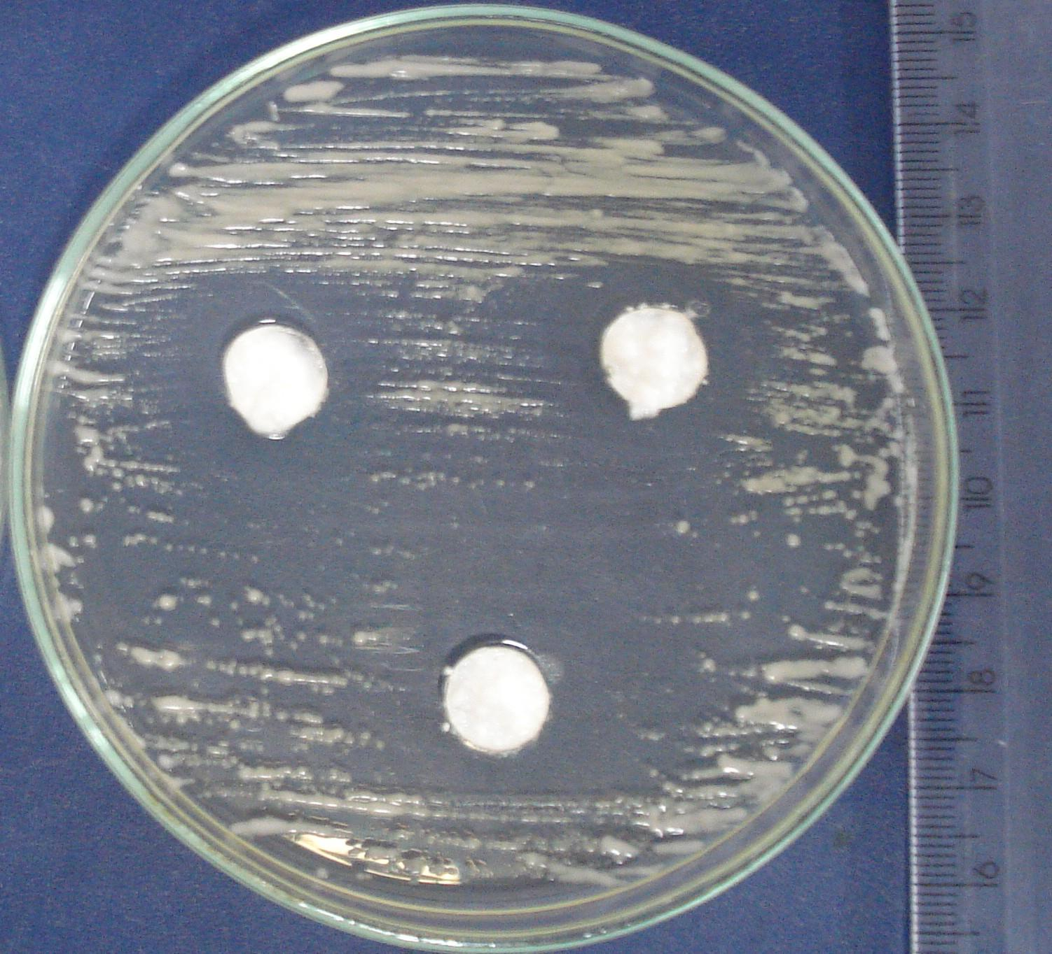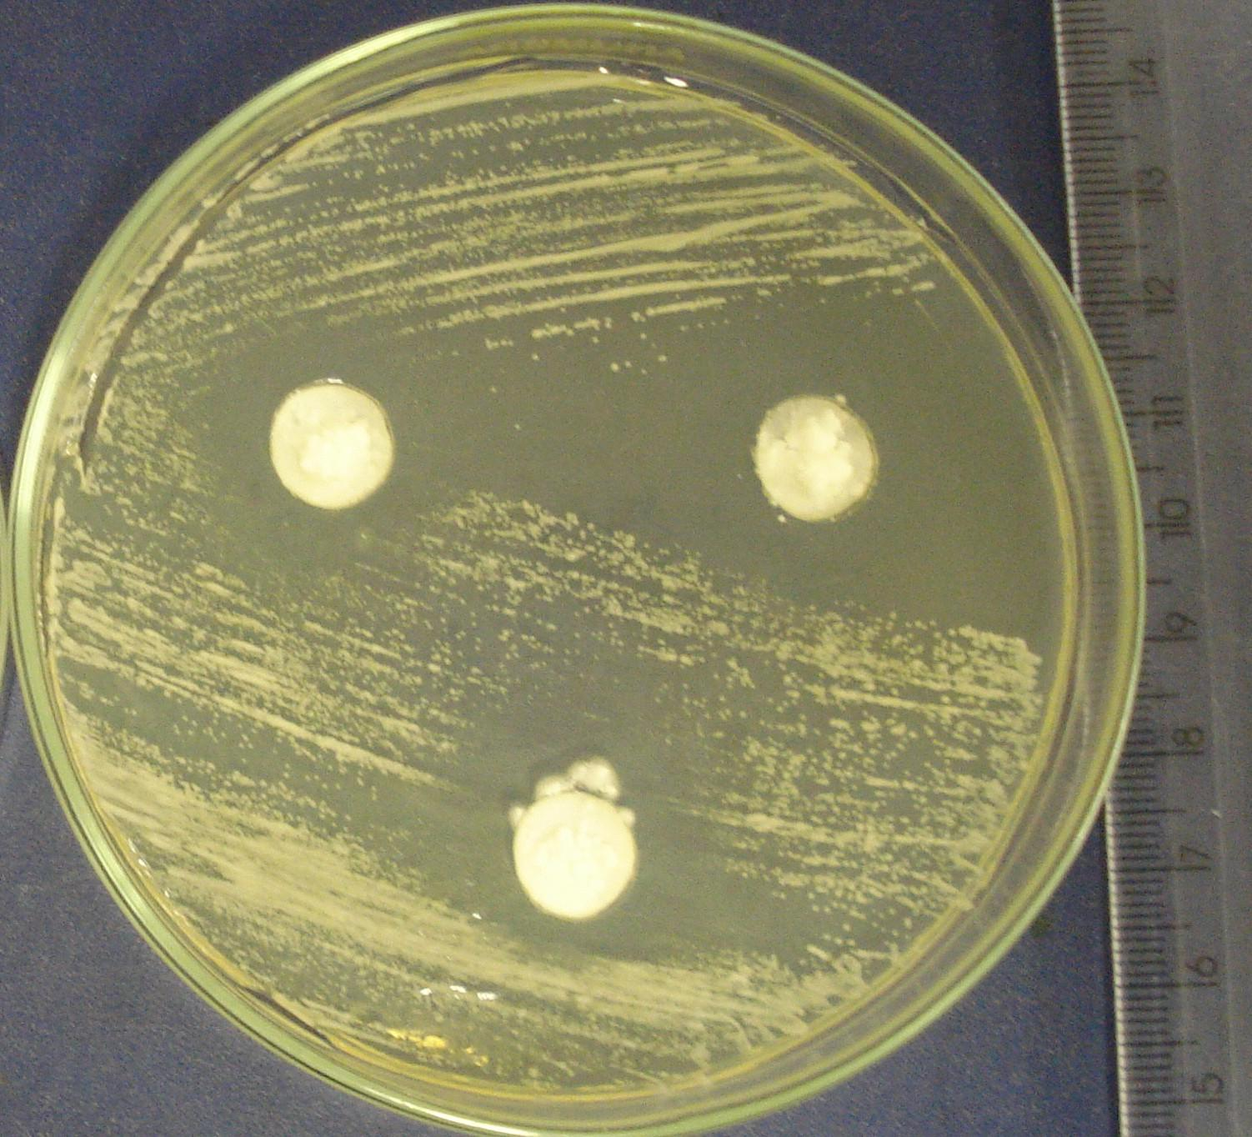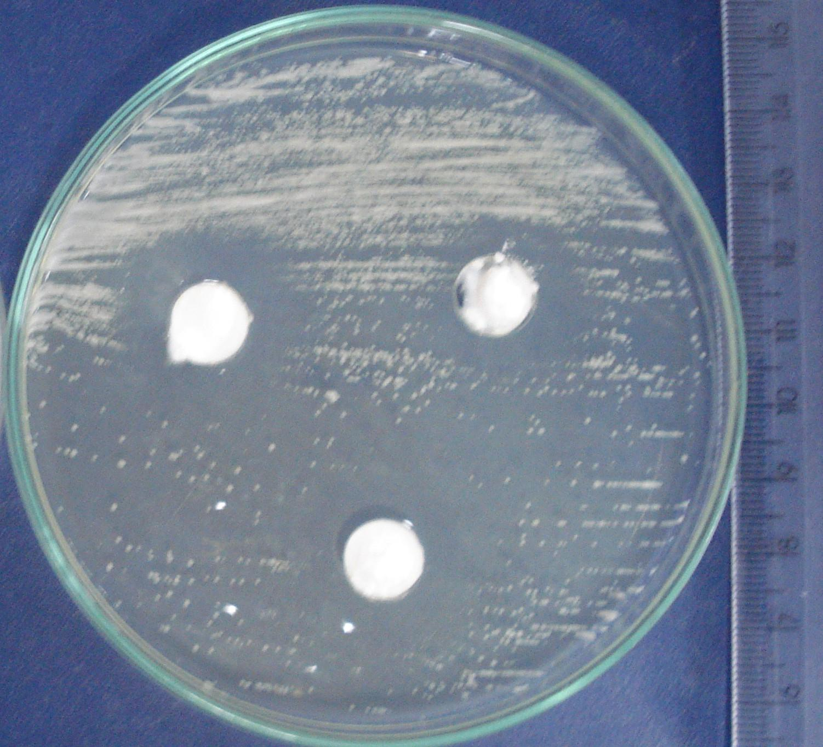
(C)
(A)
(B)

Figure 4 – Microbiological results with Candida albicans fungus for different reaction times and zinc sulfate amounts: (a) 2.00 h and 18.00 g of ZnSO₄, (b) 8.00 h and 4.00 g of ZnSO₄ and (c) 5.00 h and 11.00 g of ZnSO₄.

Values obtained in agar diffusion test with Escherichia coli (Tab. 2) were statistically analyzed, and the reaction time and zinc sulfate mass in the ionic medium for each sample were the independent variables while the bactericidal activity observed in Escherichia coli bacteria was the dependent variable.

Table 2 – Microbiological results for Echerichia coli bacterium.
Sample | Reaction Time  (h) | ZnSO₄  (g) | A_{bio}  (cm²) |  |  | <A_{bio}>  (cm²)
1 | 8.00 | 18.00 | 0,54 | 0,54 | 0,98 | 0,69
2 | 2.00 | 18.00 | 2,05 | 2,36 | 2,05 | 2,15
3 | 8.00 | 4.00 | 1,76 | 1,76 | 2,36 | 1,96
4 | 2.00 | 4.00 | 2,36 | 1,22 | 0,98 | 1,52
5 | 5.00 | 11.00 | 0,98 | 1,76 | 0,98 | 1,24
6 | 5.00 | 11.00 | 1,76 | 1,48 | 1,76 | 1,67
7 | 5.00 | 11.00 | 1,76 | 1,48 | 0,98 | 1,41

Table 3 – Microbiological results for Staphylococcus aureus bacterium.
Sample | Reaction Time  (h) | ZnSO₄  (g) | A_{bio}  (cm²) |  |  | <A_{bio}>  (cm²)
1 | 8.00 | 18.00 | 1,48 | 1,76 | 0,98 | 1,41
2 | 2.00 | 18.00 | 0,35 | 1,48 | 1,23 | 1,02
3 | 8.00 | 4.00 | 1,48 | 1,48 | 0,54 | 1,17
4 | 2.00 | 4.00 | 2,05 | 1,48 | 2,05 | 1,86
5 | 5.00 | 11.00 | 2,05 | 2,36 | 2,05 | 2,15
6 | 5.00 | 11.00 | 1,76 | 2,05 | 2,05 | 1,95
7 | 5.00 | 11.00 | 3,02 | 2,36 | 2,36 | 2,58

Table 4 – Microbiological results for Candida albicans fungus.
Sample | Reaction Time  (h) | ZnSO₄  (g) | A_{bio}  (cm²) |  |  | <A_{bio}>  (cm²)
1 | 8.00 | 18.00 | 2,36 | 4,12 | 1,76 | 2,75
2 | 2.00 | 18.00 | 2,36 | 4,12 | 2,36 | 2,95
3 | 8.00 | 4.00 | 1,48 | 2,36 | 3,74 | 2,53
4 | 2.00 | 4.00 | 3,37 | 4,12 | 4,12 | 3,87
5 | 5.00 | 11.00 | 4,12 | 4,12 | 2,36 | 3,53
6 | 5.00 | 11.00 | 4,12 | 4,52 | 4,12 | 4,26
7 | 5.00 | 11.00 | 3,37 | 3,02 | 2,05 | 2,81

The statistical results indicate that the area obtained in the agar diffusion test with Escherichia coli bacterium is related to ionic exchange reaction time, but it is not related to ZnSO₄ amount. The variation of two parameters simultaneous interfered in the biocide area, with interconnection between the effect of the reaction time and ZnSO₄ mass in the ionic exchange medium on the antimicrobial property in Escherichia coli tests.
The powdered glass samples statistical results in the Staphylococcus aureus and Candida albicans tests indicate a positive significant dependence of the biocide area only on the ZnSO₄ amount. The reaction time and the variation of both parameters simultaneous were not statistically significant for A_{bio} in the available area ranges.

Conclusion

This study confirms the bactericidal and fungicidal properties of powdered glass treated with an ionic medium containing a zinc sulfate compound. These results indicate that ionic exchange is an adequate method for obtaining biocide powdered glass.
For microbiological tests with Echerichia coli bacterium the time reaction and the simultaneous variation of both factors were significant to the bactericide area variations, but zinc sulfate amount in ionic medium alone did not interfere in the biocide area. While Staphylococcus aureus is a gram-positive bacterium, Escherichia coli is gram-negative. Among the differences between these two kinds of bacteria, there is the resistance and sensitivity that each one has to antimicrobial materials. Escherichia coli bacterium is less sensitive to the powdered glass bactericidal effect.
Microbiological tests with Staphylococcus aureus and Candida albicans microorganisms indicate a significant influence of the zinc sulfate concentration compound in the ionic medium on the biocidal activity. However, statistical analyses do not indicate that there is a significant effect of the ionic exchange reaction time on the antimicrobial activity in the size range studied.

References

1. Appendini, P.; Hotchkiss, J. H.. Innovative Food Science & Emerging Technologies. 3 (2002), p. 113-126.

2. Fiori, M. A., Paula, M. M. S., Bernardin, A. M., Riella, H. G.; Angioletto E. Materials Science and Engineering C. 29 (2009), p. 1569-1573.

3. Fiori, M. A.; Paula, M. M. S.; Angioletto, E.; Santos, M. F.; Riella, H. G.; Quadri, M. G. Materials Science Forum. 591-593 (2008), p. 362-367.

4. Angioletto, E. Desenvolvimento de processo de fabricação de cerâmicas com propriedades antimicrobianas (Development of the Fabrication Process of Ceramics with Antimicrobial Properties), Universidade Federal de Santa Catarina, Florianópolis (Brazil), 2003.

5. Chakravarti, A.; Gangodawila, S.; Long, M. J.; Morris, N. S.; Blacklock, A. R.; Stickler, D. J. The Journal of Urology. 174 (2005), p. 1129-1132.

6. Tien, D.; Tseng, K.; Liao, C.; Tsung, T. Journal of Alloys and Compounds. (2008), p. 1-5.

7. Ahn, S.; Lee, S.; Kook, J.; Lim, B. Dental Materials. 25 (2009), p. 206-213.

8. SHEK, T.; MA, A.; LEE, V. K. C.; McKAY, G. Chemical Engineering Journal. 146 (2009), p. 63-70.

9. TOP, A.; ÜLKÜ, S. Applied Clay Science. 27 (2004), p. 13-19.

10. WOINARSKI, A. Z.; SNAPE, I.; STEVENS, G. W.; STARK, S. C. Cold Regions Science and Technology. 37 (2003), p. 159-168.

11. Perry, H.; Chilton, C. H. Manual de engenharia química. 5 ed. Rio de Janeiro: Guanabara Dois, 1986.

