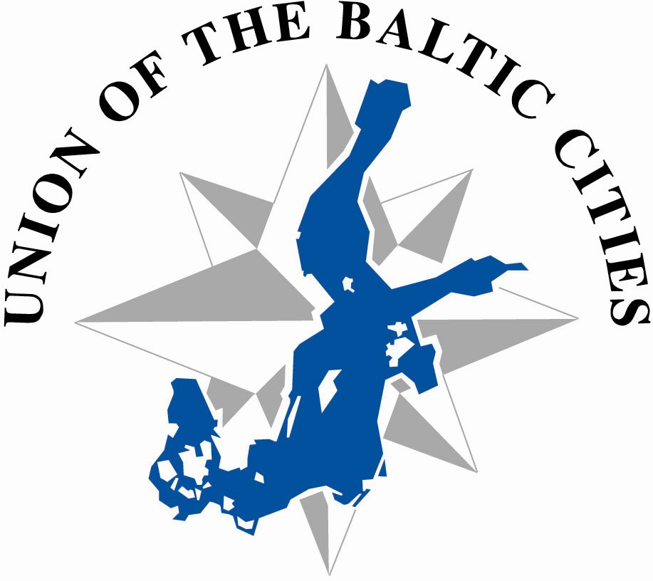




Union of Baltic Cities
Commission on Urban Planning
Project - Alliance of Baltic Cities (ABC)

Registration for the Fifth ABC Seminar
in Gdynia, Poland
20th- 24th April, 2005

INVITATION

The Commission on Urban Planning, the participants in work-package 2, and especially the city of Gdynia, warmly invite you to the fifth seminar of the ABC-project which is to be held in Gdynia, Poland, from 20th to 24th April 2005. The topic of the seminar will be as follows:

“CITIES AS REGIONAL ENGINES, Improving the City Core”.

The attached programme is preliminary and is subject to some minor changes. You will receive a final conference programme on 1st of April 2005.
We would be grateful if we could receive the registration form until 18th of March 2005.

We look forward to meeting you in at the seminar in Gdynia.

Marek Karzyński Marek Stępa
Head of Urban Planning Department Deputy Mayor of Gdynia

PRACTICAL INFORMATION

ABC Gdynia Seminar Secretariat

Urban Planning Department

Gdynia City Hall
Al. Piłsudskiego 52/54
81 – 382 Gdynia
Poland
Tel. +48 58 668 83 40
Fax +48 58 668 83 42

e-mail: wydz.urbanistyki@gdynia.pl

Anna Wołejko Marek Karzyński

Head of Department
e-mail: a.wolejko@gdynia.pl e-mail: m.karzynski@gdynia.pl

GENERAL INFORMATION

WEATHER
The weather in April is rather capricious but most of the time it is warm and shiny. The temperature is about 15 degrees Celsius. The old Polish proverb says that there is a bit of winter and a bit of summer in April.

BORDERS
Poland is the member of EU. No visas needed for representatives from EU countries.

CURRENCY
Our national currency is 1 zloty [zl] = 100 groszy 1 € (EUR) ~ 4,07zł
Credit cards are accepted in most places and cash dispensers are widely available.
When going out, tips at the rate of some 5 -10% are welcomed at bars and restaurants (if not indicated as included on the bill).

YOU CAN FIND MORE INFORMATION ABOUT GDYNIA ON THE INTERNET
www.gdynia.pl

Participation
According to the agreement in the ABC project, the participating cities are requested to send one or two representatives to the seminar. Travel and hotel costs as well as some meals will be covered by the ABC project for Representatives from EU cities.
Travel and hotel costs of Polish Participants will be covered by Phare founds.

Please note:
- Only APEX Flight Tickets will be refunded by the ABC project.
- Expenditures will not be refunded for more participants than agreed in the ABC project.
- The organisers of the seminar in Gdynia will provide a special bus for transfers from the airport. The cost of hiring the bus will be covered by the project. The project however will NOT cover any other means of transport from the airport (regular bus service/taxi/car).
- It might be necessary for the participants to pay for one of the meals themselves.

Transport
By air:
Arrival at Gdańsk Lech Wałęsa Airport on Wednesday, April 20. A hired bus will be arranged to take all of you to Gdynia. The information about the departure time of the bus will be given later – when we find out what time most of the participants will arrive.
A taxi to Gdynia would cost some 60 zl. Only few taxis accept credit cards - so you have to check it first.
By ferry:
The ferry from Karlskrona to Gdynia arrives twice a day – about 9 a.m. and about 7 p.m. All the information about getting by fairy is available on http://www.stenaline.pl

Stay
Rooms will be booked for all the participants who will send in their registration forms. The number of the reservation is 15588.
You will stay in GDYNIA HOTEL (Armii Krajowej Street 22) located in the city centre near the beach,. You can find more information about on http://www.orbis.pl

Seminar meetings
General meetings will be held in conference rooms of the Gdynia Hotel.
The group work will be arranged in other locations - closer to the sites under discussion.

Work Groups
Please, specify in the registration form, in which of the following groups you would prefer to participate.
In order to share your competence and experiences as well as possible, it is advisable that participants from the same city take part in different workshops.
Specific information on the scope of group work will be sent to the interested participants.
Group 1:
Redevelopment of post harbour areas
Dalmor – the Deep Sea Fishing Company has reduced its activities, and a large waterfront space alnog the President’s and Cutter Quay (Nabrzeże Prezydenta i Nabrzeże Kutrowe) was rendered free for a new development. This area is attractively located as it is close to the city centre, its function should be adequate to the role of Gdynia in the region.
Goals:
- put forward investment proposals for the area,
- exchange experience, ideas about possible strategies for action,
- discuss how to attract potential investors

Group 2:
Revitalisation of housing quarters in the city centre
A substantial part of the central district was planned and erected in the 1920’s and the 1930’s as residential areas. Currently, expansion on central business district functions and the rise in popularity of car usage necessitates a transformation of housing quarters to the new situation. Revitalisation is made difficult by complicated, distributed ownership.
Goals:
- suggest how to adapt housing quarters to best serve their current functions,
- discuss how to involve the residents/owners in the process of revitalisation.

Group 3:
New proposals for Plymouth Square
In the 1920’s plans the area along the Piłsudski Avenue was designated as building grounds. These plans however were never realized. In effect a wide green corridor just outside the city centre remains. Plymouth Square, a park on one end of the Piłsudski Avenue opposite the City Hall is an attractive area for investmenst. Within this area there is a demand for an office building (to house City Hall) and parking spaces.
Goals:
- evaluated what kind of development will beneficial for the area,
- discuss whether commercial investors should be involved in the process.

AGENDA FOR THE ABC GDYNIA SEMINAR

Wednesday 20th April 2005
07.00 pm Early arrivals meet for informal
“get together evening”

Thursday 21st April 2005
08.30 am Registration
09.00 am Plenum
Conference room at Gdynia Hotel
Welcome, short presentation of Gdynia
Wojciech Szczurek, Mayor of Gdynia

Welcome to the Gdynia ABC – seminar
Jussi Kautto, Chairman of the UBC Commission on Urban Planning
Marek Karzyński, Head of Urban Planning Department, Gdynia City Hall
10.00 am Gdynia – the birth of the city
Maria Jolanta Sołtysik,
Technical University of Gdańsk
10.30 am Gdynia and its role in the Pomeranian Region
Marek Stępa,
Deputy Mayor of Gdynia
11.00 am The Polish planning system
Feliks Pankau, Office of Pomeranian Region President, Department of Regional and Spatial Development
12.00 am Lunch
01.00 pm Introduction to problems taken into consideration by workshop groups
02.00 pm Guided tour of Gdynia (by bus),
including coffee break
07.00 pm Dinner, in workshop groups

Friday 22nd April 2005
09.00 am Group work. Assemble in hotel lobby.
Excursions to the sites chosen by the workgroups
12.30 pm Lunch
01.30 pm Group work. Preparing presentations.
07.00 pm Banquet hosted by the City of Gdynia

Saturday 23rd April 2005
09.00 am Plenum
Conference room at Gdynia Hotel
Presentations of the workshops 1-3
‘Small scale investments” proposals
Conclusions and closing remarks
Coffee break
11.30 am Press conference
12.00 am Excursion, including lunch and dinner

Sunday 24th April 2005
10.00 am Plenum
Conference room at Gdynia Hotel
Looking ahead - seminar in Malmö
Lars Brattberg, Project Leader
10.45 am Closing the seminar
11:00 Excursion to Sopot and Gdańsk - will be finished at Lech Walesa Airport

REGISTRATION FORM ABC GDYNIA SEMINAR

20th – 24th April 2005

(one person per form only)

First Name: | ❑ Mr  Mrs  Ms  (please indicate)
Family Name:
Position:
Official postal address:
City:
Country:
Personal E-mail:
Tel. / Fax

Full seminar programme participation (4 nights): | ❑ Yes  No  (please indicate) | Excursion 24/04/05: | ❑ Yes  No  (please indicate)
Arrival date: |  | Approx. time:
Departure date: |  | Approx. time:
Transport (indicate) | ❑ Flight (to Gdańsk) | ❑ Ferry | ❑ Other

I want to participate in (please indicate)
Workshop 1 | Workshop 2 | Workshop 3 | plus presentation
❑ | ❑ | ❑ | ❑

❑ I am interested in presenting the following project, as a good example of a seminar topic:
...................................................................................................................................................................
...................................................................................................................................................................
...................................................................................................................................................................
...................................................................................................................................................................

Date / Signature .....................................................................................................................................................

This Registration Form must reach Gdynia before March 18th, 2005.
Please, send it to Ania Wolejko, fax +48 58 668 83 42 AND e-mail: a.wolejko@gdynia.pl

