

COMMERCIAL BANK OF SYRIA

ANNUAL REPORT 2011

MANAGEMENT
Yousef Azmeh Square
P.O Box 933
Damascus
Syrian Arab Republic
SWIFT:CMSYSYDA
Reuter:CMDA

E-mail:cbos@mail.sy
Telex:411002-411206
Fax:00963 11 22 16 975/22 28 524
Tel:00963 11 22 18 891/22 18 890/22 22 481
www.cbs-bank.sy

Contents
Page
- From the General Manager 4
- About CBS 5
- CBS Organizational Structure 9
- Selected Financial Indicators 10
- Significant Events in 2011 11
- Board of Directors 13
- Head Office Departments 14
- CBS Branches – banking service offices – exchange points 15
- E-Cards issued by CBS 27
- Management Report – Financial Analysis 29
- Deposits (Liabilities to customers)
- Management Report – Financial Analysis 31
- Assets –a– Accounts with Banks
- Management Report – Financial Analysis 32
- Assets –b– Claims on Customers
- Management Report – Financial Analysis 39
- Returns, Expenses, and profits
- Profitability 40
- Management Report – Financial Analysis 40
- Returns, Expenses, and profits
- Returns
- Management Report – Financial Analysis 42
- Returns, Expenses, and profits
- Expenses
- Modernization of the Organizational structure
and Human Resources Management 44
- Consolidated Closing Financial Statement on 31.12.2011 47

2011

COMMERCIAL BANK OF SYRIA

ثقة .... أمان

From the General Manager

Throughout its relatively long history that spans more than half a century, Commercial Bank of Syria has played a major and significant role in the development of the national economy, ably and competently performing this duty, endeavoring through its policies to support and raising levels of confidence to new levels in the national economy, particularly so, since it is considered the state’s financial arm, efficiently contributing to the growth and development of numerous economic sectors in Syria, and coping with the nation-wide development plans. CBS with its well-balanced strategy has managed to consolidate its leadership in providing financial services in Syria. This strategy is based on return and risk calculations, horizontal expansion by way of branches and service offices, and vertical expansion represented by diversification of products available to customers. This effort as a whole is based on a well-informed study of predictable risks and efficient management of cash liquidity aiming at protecting depositors’ funds, increasing profits and contributing to the realization of the state’s broad finance plans.

In 2011 Commercial Bank of Syria continued its efforts focusing on providing top-quality products and highly professional service to all its customers through diverse channels. Besides CBS has adopted up-to-date technology to ensure the use of diverse, more appropriate and better efficient cost-wise banking techniques in the provision of customer service through electronic banking service channels.

It is noteworthy to say that CBS tradition, its long history and immense accumulated experience, not to mention its huge materialistic capabilities will certainly enable it to play a larger role on the national level at the current circumstances and in the coming years, to achieve better advantages for the benefit of all concerned parties represented by the state, business community and individuals. In the face of escalating political events and circumstances' developments in Syria, the fear shadowing the individuals and the business community from potential negative reflections on the banking sector, which might lead to an increase in risk on financial, commercial and investment business, not to mention the package of sanctions imposed on certain banking institutions in Syria including CBS have added to the challenges and hardships facing it. Nevertheless, CBS in cooperation with the government and the Central Bank of Syria seeks to alleviate the effects of those hardships and challenges and will never cease efforts to protect the monetary stability, and strengthen confidence in the national economy and the Syrian Pound.

With Godspeed we proceed.

About CBS

The oldest banking institution operating in Syria, CBS was licensed by the Ministry of Economy and Foreign Trade and duly registered under Commercial Register No. 2755 dated 4.6.1959. It was established at the beginning of 1967 as a result of the nationalization of five banks serving the Syrian economic and commercial activity. It was listed No. 1 on 28.12.2002 in the Banks Register with the Directorate of the Government Commission with banks in the Central Bank of Syria.

With its paid up capital of seventy billion Syrian Pounds, CBS captures a very large share of Syria’s total banking activities, notably a share that ranges between 50% - 70% of banking activities according to the standards taken as a basis in ownership rights, capital, assets, or profits.

CBS main activity used to focus on financing both domestic and foreign trade in harmony with the objectives of the economic plan, which was effected through the facilities that CBS used to provide in various currencies in the following domains :

- Corporate loans.
- Debit current accounts (overdraft).
- Commercial bills discount.
- Import and export documentary letters of credit.
- Letters of guarantee of all types.

In addition to other banking services as follows :

- Sight customer deposit.
- Time deposits.
- Saving accounts.
- Inward and outward transfer.
- Certified, sold, tourist and clearing check
- Leasing of safes.

Ever since the beginning of open competition with incoming banks to Syria in 2003, CBS has adopted a policy that preserved its leading position in the banking market, which is quite evident from direct comparison with those banks in terms of size of profits, deposits, or capital. The reason is the dynamic policy pursued by CBS and its restructuring aiming at coping with local and international developments. In order to achieve such targets CBS proceeded towards:

- Development of infrastructure including the software imported from professional international companies specialized in this area, or those which were developed by CBS staff because of difficulties that sometimes stood in the way of getting the required softwares. Of such local softwares that proved excellent efficiency are the credit system, retail loans system, the system of automated mail and archiving being employed by CBS since some years ago and was spread to Ministry of Higher Education, Damascus Governorate, and the Bank Affairs Bureau at the Finance Ministry.

- Development of the organizational structure that included the creation of Department of Compliance, restructuring of internal auditing and other structures.

- Improving the quality of provided services and simplifying procedures, making best use of the advantages of automation.

- Introducing new products and services that are added to CBS already operating products. Thus CBS provides :

- A wide spectrum of e-payment services which cover local payment cards via various channels such as mobile phone, ATM, Internet and points of sale; e-billing which enables payment of mobile phone, and telephone bills by card; continuing with the process of further spreading ATMs that now number more than 470 ATMs throughout the country.

- Short, medium, and long term retail loans including car loans at diverse payment terms, house-completion loans, lift (elevator) loans. Moreover, personal loans, used-car loans , housing loan under the brand name of Al-Adel and Al-Amer loans.

- Introducing diverse credit cards with different credit ceilings up to 500 thousand Syrian Pounds. In this respect “Nasheet” (Active) cards were put in service with different credit ceilings.

Whereas banks financial standings are tested in times of crises more than any other time, and despite the very harsh circumstances imposed by the world financial crisis that has stormed various world countries , in contrast to the banks that lack safety elements to counter various extraordinary situations, banks whose solvency are well seem to be more capable of continuing with the selfsame stimulus to provide various types of services even when conditions change. Accordingly it is safe to say that CBS has adopted an endurance policy that stems from the spirit of acceptable risk-taking of a degree that enabling it to realize the largest possible profits. For this reason, CBS continued with operation along its own strategic directions that can be summed up as follows:

- Continuing the diversification of services and loans in order to satisfy all emerging needs of individual and corporate in operation and investment.

- Further development of the policy of e-payment and e-billing in service of the purpose of simplifying procedures and reduce bank-note dealings.

- In a step towards consolidating its social role, CBS continues to improve the electronic management model that has been developed locally, and acts towards spreading this model too numerous entities.

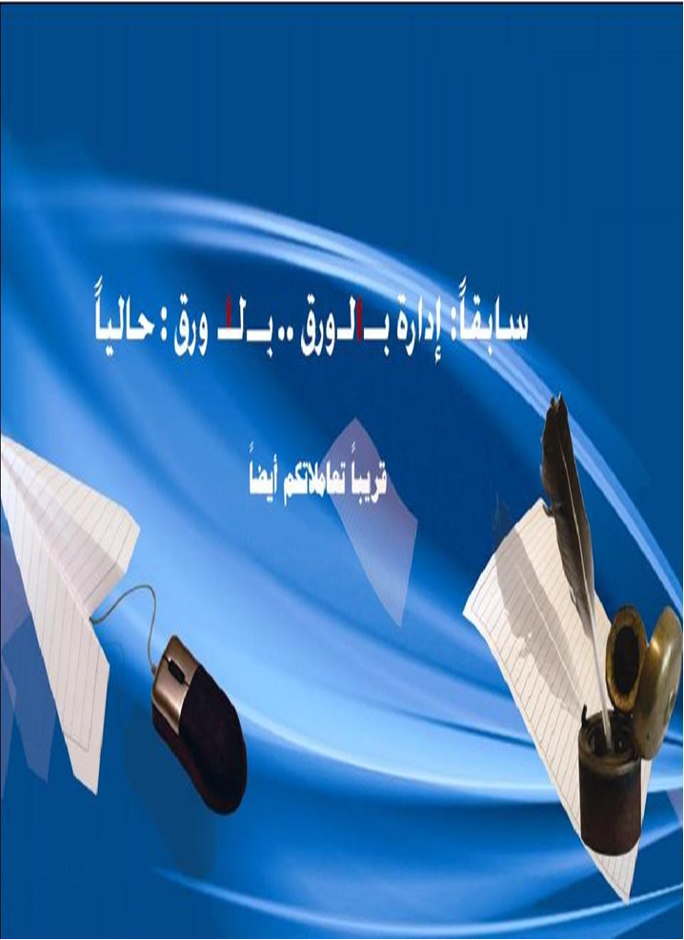
Board of Directors

CEO
Internal Controlling
Dep.
Planning & Development Dep.
Accounts Dep.

Financial
Dep.
Risks Management Dep.
Loan &
Credit
Dep.

Foreign Relations
Dep.
Technical
Dep.

Legal
Dep.

Secretarial
Dep.

Board's secretary

The bank's Secretary

Personnel affairs
Payroll & Insurance

Personnel Control
Complaints & consultancy

Operations & information security

For. Relation division

For. Ex & statistics

Operations division

Cash
Center
Cor. Lending
Research division

Operational risk
management
Credit risk management
Market
Risk management
Budgeting
And
Expenditure

Maintenances of buildings
& services

Central accountancy &
auditing
Foreign
Exchange Accountancy
Planning & Studies
Human
resource Training
& publication
Islamic Financing & Tools

Issuing Unit

Secretary General
Deputy CEO
Electronic payments
Dep.
Producing
Division
Business
Development
Technical
Operations
Customer
Service
Accounting
And adjusting
Quality
And risk controlling
Retail lending
Compliance
Dept.
Verification Unit
Monitoring unit
Networks Division

Technical Support
Attorneys Affairs & Expenditure control

Admin Affairs
Internal auditing com.
Internal auditing unit.

Selected Financial Indicators

Growth Rate 2011 | 2010 | 2011 | In SYP Million
-13.24% | 15,044 | 13,047 | Assets
-16.70% | 7,631 | 6,345 | Customers’ deposits
+2.8% | 1,888 | 1,941 | equity
-35.82% | 241 | 156 | net profit/(loss)
-18.75% | (288) | (241) | Unrealized profit / (loss)
+51.28% | 1,401 | 2,129 | Accounts with banks
%-78.61 | 3,105 | 664 | Interest yielding deposits with banks
-13.83% | 6,991 | 6,149 | Loans and advances

2010 | 2011 | Profitability
1.60% | 1.11% | Returns / average assets
12.99% | 8.13% | Returns / average equity
2.14% | 1.55% | Returns / interest yielding assets

2010 | 2011 | Assets
75.67% | 66.90% | Interest yielding assets/  Total assets
149% | 138% | Interest yielding assets/  Deposits customer's
45.72% | 45.50% | Loans and advances/ total assets
96.37% | 102.27% | Net loans and advances in SYP/ customer's deposits in SYP
23.29% | 21.78% | Net loans and advances in foreign currencies / customers’ deposits in foreign currencies
90.15% | 93.55% | Net loans and advances/ deposits
1.63% | 3.60% | Non performance loans/ Net loans and advances

Significant Events in 2011

At the start of the internal and external crisis in the country in mid-March 2011, CBS added another target to the main headline of its strategy, namely “Achievement of the largest size possible of profits and least size of losses.” In this vein CBS proceeded to act as follows :

- To continue with granting loans and facilities, yet setting harder conditions in this respect that warrant continuity of profit realization in line with acceptable risk rates on one hand and enhancing CBS national role in alleviating the impact of the crisis through providing the economy with cash liquidity as required for the continuity of its dynamism.

- Keeping on with the policy of geographic expansion with an eye on the crisis circumstances. In this context two branches were opened in Mhardeh and Sheikh Badr, in addition to service offices in Kassab and Damascus International Airport as well as a customer service office in Aleppo. Thus the total number of CBS branches and offices operating in 2011 exceeds one hundred, seven of which exist in free zones in Damascus and other governorates.

- Taking measures in preparation for countering the effects of sanctions imposed on CBS through finding new channels for outward transfers and documentary credits.

- Taking measures in preparation for countering contingent conditions that might be created by the crisis which could cause cessation of CBS operation as represented by a successful test for remote operation. The test required all employees in the Head Office to go outside the building and conduct their work while they are in their new location. The test lasted for some months. Besides, CBS has prepared and made ready an operating centre that acts as a back-up to the main operating centre.



Board of Directors

Chairman | Board Chairman | Moh.Yasser Mortada
Vice-chairman | CBS General Manager | Dr. Douraid Ahmad Dergham
Member | Former director of administrative affairs | Mr Shaher Shamoot
Member | Faculty of Mechanical & Electrical Engineering – Computer & Automation Dept., Damascus University | Dr. Gassan Faloh
Member | Faculty of Law-Damascus University | Dr. Elias Hadad
Member | Labour Representative | Mr Hosam Mansor
Member | Labour Representative | Mr Salah uddin Al-Masry

Head Office Departments

Department | Name | Tel | Fax | E-mail  address
General Manager | Dr. Douraid Dergham | 2459536 | 2249048 | cbos@mail.sy
Deputy General Manager
Secretary General - Secretariat Department  Director | Mayssa Kudaimi | 2458345 | 2216975  2228524 | mkudaimi@cbs-bank.com
Director of Administrative Affairs | Sahar Nahlwi | 2459505 | 2222830 | cbos@mail.sy
Loan & Credit  Director | Yaarob Ali | 2229559 | 2453371 | cbos@mail.sy
Foreign Relations Director | Firas Salman | 2237836 | 2453796 | dir.cbs@mail.sy  cbos@mail.sy
Technical Department  Director | Kamal Atia | 2226680 | 2451790 | tec.cbs@mail.sy
Internal Control  Director | Ghayath Salman | 2322069 | 2322067 | cbos@mail.sy
Accounts Department  Director | Jumanah Kassar | 2216983 | 2450373 | cbos@mail.sy
Planning & Development Department Director | Souhair Al-Halabi | 2240498 | 2240536 | cbos@mail.sy
Financial Department  Director | Firas Salman | 2214298 | 2214298 | cbos@mail.sy
Legal Department  Director | Eyad Al- Kafree | 2322074 | 2324586 | cbos@mail.sy
Risk Management Department Director | Mazen Hamzeh | 2236737  2245205 | 2241635 | cbos@mail.sy
Electronic Payment Director | Bassem Al-Sa’eed | 2242513 | 2242483 | Eft.dir@cbs-bank

CBS Branches
Syria Code (+963)
Damascus Branches Area Code (011)

 | Address | Tel | Operator | Fax | P.O.Box | E-mail
Head Office | Yousef Azmeh Square |  | 2218890  2218891  2222481 | 2216975  2228524 | 933 | cbos@mail.sy
Branch No.1 | Moawiya Street  Manager:  Rema Al- magrabe | 2228728 | 2225870  2225871  2455768 | 2222597 | 2231 | dam1.cbs@mail.sy
Branch No.2 | Al Nasr Street  Manager:  Yaser Al- Massri | 2222898 | 2243142  2222456  2210445 | 2218590 | 314 | dam2.cbs@mail.sy
Branch No.3 | Harika Square  Manager:  Hanaa Al-khatib | 2216912 | 411348  411579  413079 | 2215347 | 183 | dam3.cbs@mail.sy
Branch No.4 | Moawiya Street  Manager:  Nada Sa’dy | 2224685 | 2211900  2211553  2214820 | 2211554 | 246 | dam4.cbs@mail.sy
Branch No.5 | Saadallah Jabri Street Manager:  Mazenah Gamall Aldin | 2225699 | 2212901  2212902  2212903 | 2216102 | 1 | dam5.cbs@mail.sy
Branch No.6 | Yousef Azmeh Square Manager:  Jihad Bitar | 2224580 | 2225102  2244123  2214714 | 2227154 | 2655 | dam6.cbs@mail.sy
Branch No.7 | 29 Ayyar Street  Manager:  Mhd Ali Jokhadar | 2318030 | 2314659  2318033  2318034 | 2318038 | 3179 | dam7.cbs@mail.sy
Branch No.8 | Port Said Street  Manager:  Ghada Haddad | 2323106 | 2312777  2311522 | 2319258 | 1178 | dam8.cbs@mail.sy
Branch No.9 | Kouatli Street  Manager:  Rajaa Sulaiman | 2240909 | 2228132  2226451  2216141 | 2228132 | 5972 | dam9.cbs@mail.sy
Branch No.10 | Borj El-Rouss  Manager:  Faiz Shar | 5422896 | 5422895  5422897 | 5423305 | 22241 | dam10.cbs@mail.sy
Branch No.11 | Osman Bin Affan Street  Manager:  Samia Anas | 2127855 | 2126302  2138265 | 2123790 | 6305 | dam11.cbs@mail.sy
Branch No.12 | Jisr ELAbiad  Manager:  Wafaa Saadeh | 3320356 | 3342912  3320662  3349552 | 3320579 | 12081 | dam12.cbs@mail.sy
Branch No.13 | Mazzah Jabal  Manager:  Sawsan Shribati | 6610645 | 6615986  6669386  6615987 | 6624196 | 16005 | dam13.cbs@mail.sy
Branch No.14 | AL Thaura Street  Manager:  Sahar Jarjourah | 2312850 | 2312851  2312852  2312531 | 2312853 | 11972 | dam14.cbs@mail.sy
Branch No.15 | Yarmouk Street  Manager:  Rima Rehawe | 6313107 | 6313101  6313103 | 6313102 | 29072 | dam15.cbs@mail.sy
Branch No.16 | Meyssat Street  Manager:  Heyam Abbas | 2757950 | 3319271  3340978  3340979 | 2757979 | 11893 | dam16.cbs@mail.sy
Branch No.17 | Bab Touma Street  Manager:  Maher Al-Zubi | 5415697 | 5415736  5415734 | 5415686 | 2041 | dam17.cbs@mail.sy
Rawdah Branch | Rawda Area-Zuhair Bin Abi Salma st.  Manager:  Hnada makare | 3317197 | 3317334  3328001  3328002 | 3317093 | 3857 | cbos@mail.sy
Branch in Damscus department of finance | Arnous Sq.  Manager:  Malak Dakak | 3341263 | 3341276  3341249 | 3341269 | 933 | cbos@mail.sy
Barzeh Branch | Barzeh Housings – behind Hamish hosp.  Manager:  Moutaz Al-Saleh | 5144959 | 5144947 | 5144993 | 933 | cbos@mail.s y
Free Zone | Osman Bin Affan Street  Manager:  Samia Anas | 2119601 | 413497  411427 | 2129222 | 5528 | damfzlcbs@mail.sy
Douma Branch | Jamal Abdulnaser Street  Manager:  Nada Mourad | 5743010 | 5743018  5743019 | 5743033 | 561 | damdomal.cbs@mail.sy
Al-TAL Branch | Main Street  Manager:  Khaled Sabbagh | 5942133 | 5942055  5942130 | 5942112 | 933 | cbos@mail.sy
Al-Zabadani Branch | Manager:  Mahmoud Belal | 7119410 | 7119430  7119440 | 7119420 | 933 | cbos@mail.sy
Dair Atieh | Ahmed Showki St.  Manager:  Khaled Lyla | 7836412 |  | 7836413 | 933 | cbos@mail.sy
Al- Assad District  Branch - Harasta | Commercial Complex  Manager:  Hanan Al-Issa | 5352265 | 5353132  5957261 | 5355593 | 933 | cbos@mail.sy
Zablatani Branch | Souk alhal  Manager:  Abedorahman  Alrefai | 4630906 | 4630150 |  | 933 | cbos@mail.sy
Almaza Branch | Almaza street  Manager:  Amal Sarakbe | 6613040 | 6614975  6619192 |  | 933 | cbos@mail.sy
Jdaidet Artouz Branch | Housing Area  Manager:  Mohamad Khodr | 6817855 | 6817288 |  | 933 | cbos@mail.sy

Damascus Service Offices

Office | Address | Supervised by | Tel | Fax
Shell | Dummar Project – Shell company | Branch 6 Damascus | 6185930 | 3215041
Irbeen Office | Bassel Assad Square – Municipality Bldg. | Branch 9 Damascus | 5239488 | 5239264
Jimraya | Fardous Suburb | Branch 6 Damascus | 3227147 | 3227294
Dedeman Hotel | Hotel Lobby | Branch 6 Damascus | 2229200 | 2120671
Kisweh | Municipality Bldg. Entrance | Branch 5 Damascus | 6915056 | 2216102
Adra Industrial Zone | Inside the Zone | Duma Branch | 5850156 | 5850158
Al-Fijeh Office | Al-Fijeh Square | Branch 5 Damascus | 3817678 | 2216102
Yabroud | Yabroud Consumer Est. | Deir Atieh  Branch | 7822315
Airport Office | Main Lobby | Branch 17  Damascus | 5400007 | 5400113

Damascus Exchange Points

Point | Branch | Address
Yousef Azmeh | Branch 6 | Yousef Azmeh Square  22251003
Jdaidet Yabous | Cash Center | Jdaidet Yabous – Lebanon Border  3914232
Jdaidet Yabous | Cash Center | Customs Dept. 3914231
Adra | Douma Branch | Inside Adra Free Zone 5812553
Tanf Customs | Cash Center | Syria – Iraq border
Tanf Immigration | Cash Center | Syria – Iraq border
Sayeda Zeinab | Cash Center | Next to Zeinab Mosque  6470134
Outdoor Point | Cash Center | Damascus International Airport 2450054
Arrivals New Terminal (Immigration) | Cash Center | Damascus International Airport 2450054
Departures New Terminal | Cash Center | Damascus International Airport
Airport Customs | Cash Center | Damascus International Airport
Adra Customs | Douma Branch | Adra Customs Office  2129751
Happy Land | Cash Center | Airport Road Bridge 5 – Happy Land (summer)
Al-Adl Justice | Cash Center | Nasr Street Next to Palace of Justice
Damascus Customs | Duma Branch | Customs Bldg.
Damascus Countryside Customs | Duma Branch | Customs Bldg.

Aleppo Branches Area Code (021)

 | Address | Tel | Operator | Fax | P.O.Box | E-mail
Branch No.1 | Kastal Hajjarin Street  Manager:  Riad Abiad | 3315622 | 3315602  3315606  3315220 | 3315630 | 2 | alp1.cbs@mail.sy
Branch No.2 | EL-Azmeh Street  Manager:  Adnan Hanan | 2122904 | 2112218  2125741  2119107 | 2119836 | 887 | alp2.cbs@mail.sy
Branch No.3 | Khan Al-Harir, behind the mosque  Manager:  Rameeza Al- Soubai | 3622550 | 3620150  3620151  3620152 | 3620157 | 449 | alp3.cbs@mail.sy
Branch No.5 | Kastal Hajjarin Street  Manager:  Shaza Attar | 2216201 | 2216439 | 2216430 | 6760 | alp5.cbs@mail.sy
Branch No.6 | Ugarit Street  Manager:  Mohmed Lababidi | 2114865 | 2115547  2119358  2123784 | 2120671 | 363 | alp6.cbs@mail.sy
Branch No.7 | Zahra Street.  Manager:  Ziad Zeitoni | 4643805 | 4643801  4643802  4643803 | 4643804 | 1410 | alp7.cbs@mail.sy
Branch No.8 | Kastal Hajjarin St.  Manager:  Randa mulke | 3315525 | 3315518  3315519  3321710 | 3315504 | 9588 | alp8.cbs@mail.sy
Free Zone | Kastal Hajjarin St.  Manager:  Riad Abiad | 3315622 | 3315711 | 3315712 | 2 | alpfz.cbs@mail.sy

Aleppo Service Offices

Office | Address | Supervised by | Tel | Fax
Aleppo University | University Campus | Branch 3 Aleppo | 2636631 | 2636632
Mousalmieh | Free Zone Bldg. | Branch 1 Aleppo | 6530902 | 3315630
Customer Service Office | Qasr Baladi St. | Branch 1 Aleppo | 2211930 | 2211899

Aleppo Exchange Points

Point | Branch | Address
Mousalmieh | Branch 1 Aleppo | Mousalmieh Street
Izaz-Salameh | Branch 2 Aleppo | Izaz 7850743
Airport 2 points | Branch 3 Aleppo | Aleppo airport 4216850

Lattakia Branches Area Code (041)

 | Address | Tel | Operator | Fax | P.O.Box | E-mail
Branch No.1 | Adnan Malki Street  Manager:  Wahid Kahla | 471650  471660 | 471643  471645  238851 | 471649 | 125 | ltk1.cbs@mail.sy
Branch No.2 | 8 Azar Street  Manager:  Fareedah ALAwad | 479763 | 461018  463066  463793 | 479761 | 808 | ltk2.cbs@mail.sy
Branch No.3 | Kouatli Street  Manager:  Lama Shreiteh | 451531 | 470714  475963  475985 | 470059 | 575 | ltk3.cbs@mail.sy
Branch No. 4 | Manager:  Kamala Kinjrawi | 450718 | 450276  456029 |  | 933 | cbos@mail.sy
Free Zone | Kouatli Street  Manager:  Lama Shreiteh | 477153 | 475963 | 477253 | 575 | ltkfzl.cbs@mail.sy
Jableh Branch | Al Kalaa str. Insurance Bldg.  Manager:  Ghiath Ali | 820752 | 820751  820756 | 820757 | 933 | cbos@mail.sy

Lattakia Service Offices

Office | Address | Supervised by | Tel | Fax
Lattakia Port | Lattakia Port | Branch 4  Lattakia | 456028 | 354130
Tishreen University | Campus | Branch 4  Lattakia | 425526 | 411609
Lattakia Free Zone | Free Zone | Branch 3  Lattakia | 326403 | 426402
Al-Haffeh | Peasants Union  Bldg. Ground Floor | Branch 1  Lattakia | 730595 | 730625
Kassab | Square-Anmar Hotel | Branch 1  Lattakia | 711 255  711 256 | 710098

Lattakia Exchange Points
Point | Branch | Address
Port Point | Branch 4 Lattakia | Port 354130
Kassab | Branch 1 Lattakia | Turkish Border  711942
Bassel Al-Assad Airport | Branch 1 Lattakia | Hmeimim  827195
Dedeman Hotel | Branch 2 Lattakia | Dedeman Hotel  428736
Port Free Zone | Branch 3 Lattakia | Port Free Zone  326403

Homs Branches Area Code (031)

 | Address | Tel | Operator | Fax | P.O.Box | E-mail
Branch No.1 | Hisham Ebn Abdulmalek  Manager:  Ahmad Oudeh | 2485314 | 2485270  2485271  2485274 | 2211823 | 417 | hom1.cbs@mail.sy
Branch No.2 | Al-Walid Street  Manager  Abdul Aziz Al-Subai | 2485501 | 2478897  2478798  2483719 | 2478799 | 132 | hom2.cbs@mail.sy
Branch No.3 | AL-Abbas Street  Manager:  Nawal boider | 2467839 | 2475215  2464505  2464439 | 2475103 | 203 | hom3.cbs@mail.sy
Branch No.4 | Kouatli Street  Manager:  Randa keishi | 2481231 | 2482270  2482271  2477185 | 2481232 | 4745 | hom4.cbs@mail.sy

Homs Service Offices

Office | Address | Supervised by | Tel | Fax
Marmarita | St. Yohanna Square | Branch 1 Homs | 7732530 | 2211823
Hwash | Main street, next to police station | Branch 1 Homs | 7448733 | 2211823
Tadmur | Main street, opposite Museum | Branch 1 Homs | 5918680 | 5918681
Hasia | Hasia Industrial zone Administration Bldg. | Branch 1 Homs | 5360370 | 5360370
Syrian Lebanese commercial bank Office | Branch 4 Bldg. Homs | Branch 4 Homs | 2461421 | 2481232
Customs Office | Homs – Mahatta | Branch 3 Homs | 2132852 | 2475103

Homs Exchange Points

Point | Branch | Address
Dabbosieh | Branch 1 Homs | Dabbosieh Border 710719
Joussieh | Branch 3 Homs | Joussieh Border 861435
Homs Customs | Branch 3 Homs | Customs Directorate
Jisr Qmar Office | Branch 2 Homs | Jisr Qmar Customs Center
Tadmur Office | Branch 2 Homs | Near Museum

Hama Branches Area Code (033)

 | Address | Tel | Operator | Fax | P.O.Box | E-mail
Branch No.1 | Kouatli Street  Manager:  Mamdouh Esmaeel | 2510919 | 2510917  2510918 | 2515726 | 16 | hama1.cbs@mail.sy
Branch No.2 | Kouatli Street  Manager:  Talal Milli | 2210963 | 2210961  2210962 | 2229794 | 229 | hama2.cbs@mail.sy
Branch No.3 | Dabagha Street  Manager:  Amal AL-Haiba | 2518822 | 2518821  2518823  2517824 | 2523445 | 5 | hama3.cbs@mil.sy
Branch No.4 | SALLAH ALDEEN Street  Manager:  Ibrahim Kosheje | 2519544 | 2520780  2520781 | 2520780 | 85 | cbos@mail.sy
Mouharda Branch | main Street Alslam Garden  Manager:  Raeeda alahmad | 4741615 | 4741612  4741613 | 4741611 | - | hama1.cbs@mail.sy

Hama Service Offices

Office | Address | Supervised by | Tel | Fax
Sqailbieh | Fardous, next to Municipality | Branch 2 Hama | 787853 | 424997

Hama Exchange Points

Point | Branch | Address
Hama Point | Branch 2 Hama | Baroudieh – Ali Bin Abi Taleb Street (424992)

Tartous Branches Area Code (043)

 | Address | Tel | Operator | Fax | P.O.Box | E-mail
Branch 1 | M. Abdul Razzak St. Manager: Wajih Mahmoud | 327588 | 324601  326602 | 221153 | 10 | trt1-cbs@mail.st
Branch 2 | Port Street  Manager: Nabil Sam’oul | 323803 | 323804  323805 | 323806 | 372 | trt2-cbs@mail.st
Free Zone | M. Abdul Razzak St. Manager: Wajih Mahmoud | 327588 | 324601  324602 |  | 933 | trtfzl-cbs@mail.st
Safita Branch | Hurrieh St. Manager: Najeeb Hanna | 539345 | 539340 | 539344 | 933 | cbs@mail.sy
Banias Branch | Qusour Manager: Kinana Asaad | 727234 | 724603  726609 | 727212 | 933 | cbs@mail.sy
Dreikish Branch | Thaora Street Manager: Najeeb Hanna | 566473 | 566471 | 566470 | 933 | cbs@mail.sy
Sheikh Badr | Sheikh Badr Manager: Dahi Mohamad | 734205 | 734204 | 734203 | 933 | cbs@mail.sy
Bmalkeh Branch | Tartous Karameh St. Manager: Shadi Kattoub | 750620 | 715215 | 750655 | 933 | cbs@mail.sy

Tartous Service Offices

Office | Address | Supervised by | Tel | Fax
Tartous Port | Tartous Port | Branch 2 Tartous | 325163 | 325163
Free Zone Tartous | Free Zone | Branch 1 Tartous | 310721 | 310720
Madina | Hanano Street | Branch 2 Tartous | 328983 | 323806
Mashta Al-Hilou | Inside the Spa | Safita | 586357 | 586077

Tartous Exchange Points

Point | Branch | Address
Arida | Branch 1 Tartous | Lebanon Border 651929
Madina | Branch 2 Tartous | Abdul Aziz St.  328983
Port Point | Branch 2 Tartous | Port 325163

Daraa Branches Area Code (015)

 | Address | Tel | Operator | Fax | P.O.Box | E-mail
Branch No.1 | AL-Mahatta Street  Manager:  Amjad Awad | 234665 | 231410  230582 | 231250 |  | dara1.cbs@mail.sy
Free Zone | AL-Mahatta Street  Manager:  Amjad Awad | 234665 | 480002 | 231250 |  | darafzl.cbs@mail.sy

Daraa Service Offices

Office | Address | Supervised by | Tel | Fax
Sheikh Miskeen Office | Main Intersection | Daraa Branch | 859876 | 859875
Sanamein Office | Shamali Street Damascus Road | Daraa Branch | - | 231250

Daraa Exchange Points

Point | Branch | Address
Old Daraa Border Point | Daraa Branch | Ramtha Street 231644
Nasseeb Point for Trucks | Cash Center | Nasseeb Border Point  251391
Nasseeb Point for Cars | Cash Center | Nasseeb Border Point  251408
Arrivals – Immigration for Coaches | Cash Center | Nasseeb Border Point
Arrivals – Immigration for car | Cash Center | Nasseeb Border Point
Bosra Point | Daraa Branch | Bosra Square Opposite Citadel 792799
Free Zone | Daraa Branch | Syria-Jordan Free Zone 251392

Al-Sweida Branch (Area Code 016)

 | Address | Tel | Operator | Fax | P.O.Box | E-mail
Sweida Al-Branch | Sultan Atrach Street  Manager:  Wafa Al Massri | 233920 | 231860  231791  234704 | 241960 | 21 | sweda1.cbs@mail.sy

Deir Ezzor Branches (Area Code 051)

 | Address | Tel | Operator | Fax | P.O.Box | E-mail
Dier Ezzor  Branch | Main Street  Manager:  Nadia Al-dully | 212004 | 214725  214724  221205 | 222560 | 1 | derzor1.cbs@mail.sy
Al-Boukamal  Branch | The Main str.  Manager:  Mahmoud Al-Hasou | 746738 | 746107 | 746795 | 933 | qam1.cbs@mail.sy
Al-Mayadeen  Branch | The Main str.  Manager:  Saleh Al-Hussain | 713037 | 713031  713032  713582 | 713032 | 933 | qam1.cbs@mail.sy

Deir Ezzor Exchange Points

Point | Branch | Address
Deir Ezzor Airport | Deir Ezzor Branch | Airport

Al-Hassakeh and Qamishli Branches (Area Code 052)

 | Address | Tel | Operator | Fax | P.O.Box | E-mail
Al- Hasakeh  Branch | Jamal Abdulnaser Street  Manager:  Ochana John David | 319785 | 310489  310487 | 310356 | 436 | hasaka1.cbs@mail.sy
Al – Kameshli  Branch | Kouatli Street  Manager:  Reem Yakoup | 433153 | 420670  420671 | 420630 | 13 | qam1.cbs@mail.sy

Al-Hassakeh Service Offices

Office | Address | Supervised by | Tel | Fax
Al-Hassakeh Office | Jamal Abdulnaser St. Next to Grand Mosque | Hassakeh Branch 2 | 321591 | 310356

Qamishli Exchange Points

Point | Branch | Address
Nassibeen | Qamishli Branch | Turkish Border 427910
Yaarubieh | Qamishli Branch | Iraqi Border 752727
Yaarabieh Free Zone | Qamishli Branch | Iraqi Border 752727

Idleb Branch (Area Code 023)

 | Address | Tel | Operator | Fax | P.O.Box | E-mail
Idleb  Branch | Al-Jalaa Street  Manager:  Mohamad Maari | 241363 | 239522  239580 | 238420 | 2 | edilb1.cbs@mail.sy

Idleb Service Offices

Office | Address | Supervised by | Tel | Fax
Salkeen | Al-Kossor St. Next to Cultural Center | Idleb Branch | 757232 | 757230
Jisr Al-Shoghor | Al-Asi Bridge End Next to Electricity Bldg. | Idleb Branch | 625652 | 625651
Maara Office | Abol Alaa Square next to Museum | Idleb Branch | 512071 | 512073
Ariha | President Square opposite Fire Brigade | Idleb Branch | 719180 | 719291

Idleb Exchange Points

Point | Branch | Address
Bab Al-Hawa | Idleb Branch | Turkish border 244343

Al-Rakka Branch (Area Code 022)

 | Address | Tel | Operator | Fax | P.O.Box | E-mail
Rakka Al-Branch | Rais Square  Manager:  Aiyad Atri | 210695 | 229050  210696 | 210698 | 43 | rakka1.cbs@mail.sy

Al-Rakka Service Offices

Office | Address | Supervised by | Tel | Fax
Al-Rakka Office | Kouatli St. opposite Economy Bldg. | Al-Rakka Branch | 212982 | 212982

Al-Rakka Exchange Points

Point | Branch | Address
Tal Abyad | Al-Rakka Branch | Customs Office 731438

E – CARDS Issued by CBS

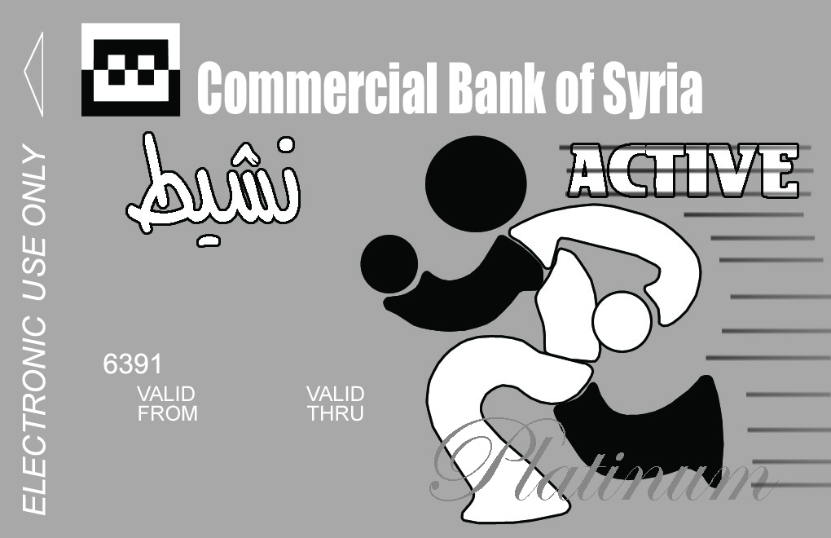

Nasheet Card – one million or 300 thousand Syrian Pounds limits. It is a local card for owners of vocations as appropriate to the volume of your weekly business. The commission is paid weekly at 2 per thousand on the entire card value. The card is interest-free.

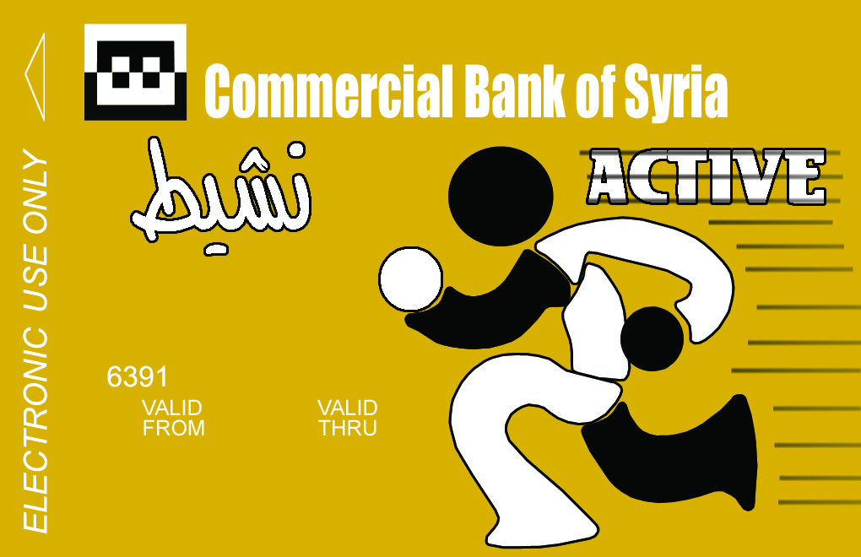

Nasheet Card – up to 500 thousand Syrian Pounds. It is a local card for owners of vocations as appropriate to the volume of your weekly business. The commission is paid weekly at 2 per thousand on the entire card value. The card is interest-free.

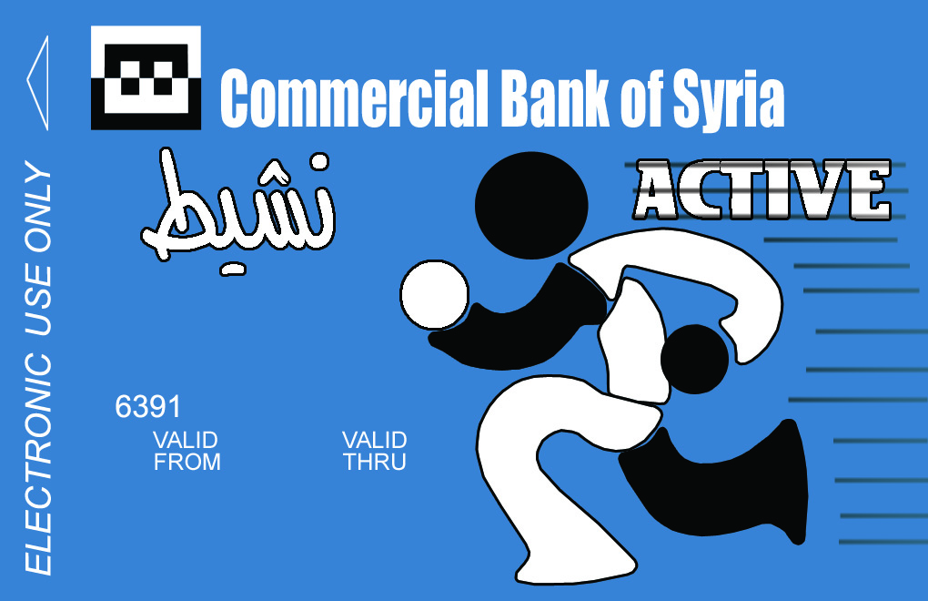

Nasheet Card – up to 100 thousand Syrian Pounds. It is a local card for owners of vocations as appropriate to the volume of your weekly business. The commission is paid weekly at 2 per thousand on the entire card value. The card is interest-free.

Mother Day E-Card


pre-paid and rechargeable with any amount at any branch of our bank, an expression of love gift to the dearest person on mother's day. You can get it with no need to have an account with the bank, and it gives you access to all the bank's services

Local E-Card

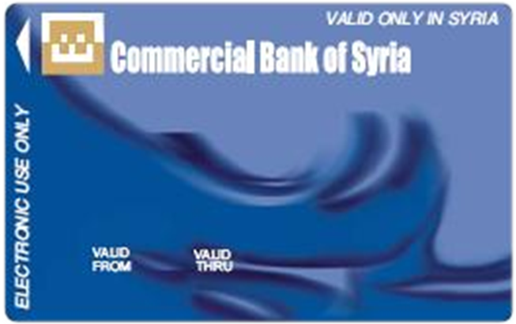
gives you access to your account with our bank via, widely spread network throughout the country, at ATMs and e-collection instruments connected to our bank as well as other local banks
Credit Card (50 thousand SYP above your salary)
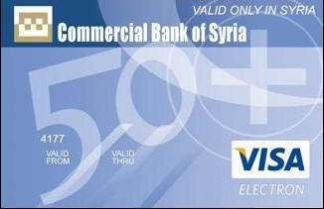
Local Credit Card given to any customer when placing his/her salary at our bank. It assists the customer with emergency expenses within 50 thousand SYP limits, such as summer holidays, children’s school expenses and covering other needs.

Ommyad Mosque E- Card

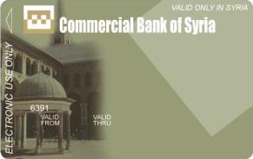
gives you access to your account with our bank via, widely spread network throughout the country, at ATMs and e-collections instruments connected to our bank as well as other local banks

Border E- Card

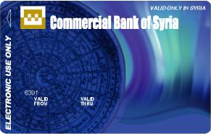
a non nominal card, pre-paid and rechargeable with any amount at any branch of our bank, used at border areas charged at first with a certain amount then it could be recharged at any CBS branch.
Credit Card (100 thousand SYP above your salary)
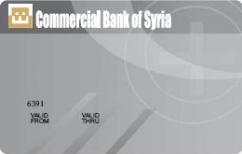

Local Credit Card given to any customer when placing his/her salary at our bank. It assists the customer with emergency expenses within 100 thousand SYP limits.

Local Pre paid E-Card

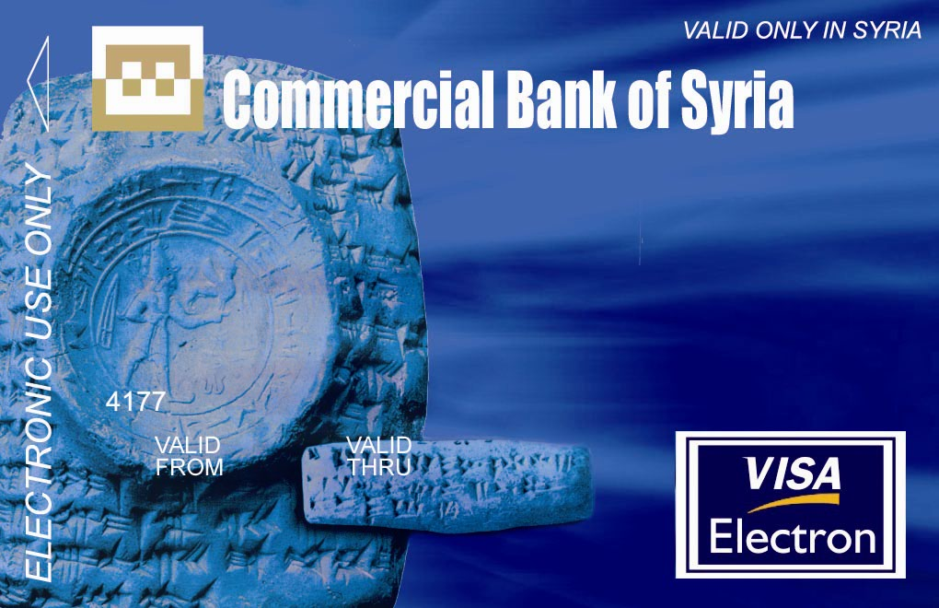
Pre-paid local card that can be used on a wide network of ATMs and e-collection instruments belonging to CBS and other local banks throughout Syria.

Platinum E- Card

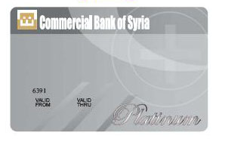
Local credit card given, under certain conditions, to assist the customer in emergency expenses within the limit of 500 thousand SYP, such as summer holidays, children’s school expenses and to cover other needs.

Golden E-Card

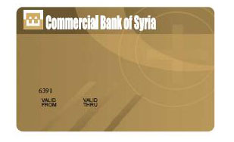
Local credit card given, under certain conditions, to assist the customer in emergency expenses within the limit of 300 thousand SYP, such as summer holidays, children’s school expenses and to cover other needs.

MANAGEMENT REPORT

Financial Analysis

1- Liabilities to Customers
Classification of Customers Deposits

2011 |  | 2010 | 2009 |  |  | In USD Million
4,213 |  | 4,916 |  | 4,386 |  | Sight Deposits
3,712 |  | 4,430 |  | 3,721 |  | In SYP
502 |  | 485 |  | 665 |  | In other currency
72% |  | 70% |  | 66% |  | Sight Deposits/ Total %
967 |  | 1,167 |  | 1,280 |  | Time Deposits
790 |  | 1,009 |  | 1,057 |  | In SYP
177 |  | 158 |  | 223 |  | In other currency
17% |  | 16% |  | 19% |  | Time Deposits/ Total %
643 |  | 979 |  | 1,020 |  | Saving deposits
11% |  | 14% |  | 15% |  | Saving deposits/ total %
5,823 |  | 7,062 |  | 6,687 |  | Total Deposits

The total of deposits in 2011 shrank by 17.50% compared to 2010, which is due to the current crisis that has negatively affected deposits in Syrian currency which led some customers to withdraw their deposits in Syrian Pounds, or, alternatively they converted them to deposits in foreign currencies as evidenced by the increase in the amounts of such deposits in the table. Or they opted to buy gold which is a value saving metal as is the habit in times of crises. However, despite the pressing effect towards withdrawing large amounts in Syrian currency leading to a drop in the bank’s liquidity in local currency, CBS management did take the decision of meeting customers’ growing demands particularly in the early months of the crisis. CBS target in this case was a kind of assurance to customers that the bank’s cash liquidity is in good shape and capable of fulfilling their withdrawings whatever the currency, thereby defeating others’ plans and designs. Thus, instead of setting restrictions on the withdrawing of customers’ deposits CBS took harder precautionary measures covering the keeping and transfer of their money which consequently asserts confidence that the bank is the safe place for money protection. Furthermore, this measure is in line with the belief that CBS role in supporting the natural progress of the economy during times of crises is more
compelling than in ordinary times. This role is undoubtedly highly effective towards rebuilding confidence in the Syrian Pound. Nevertheless, the above table shows stability in the structure of deposits distribution, as sight deposits still capture the largest share among deposit types, scoring 72% of their total in 2011, whereas time deposits kept their ratio of 17% while saving deposits shrank to 11%.

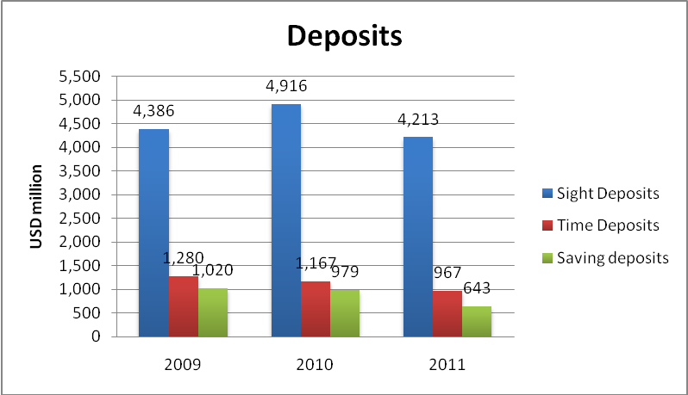

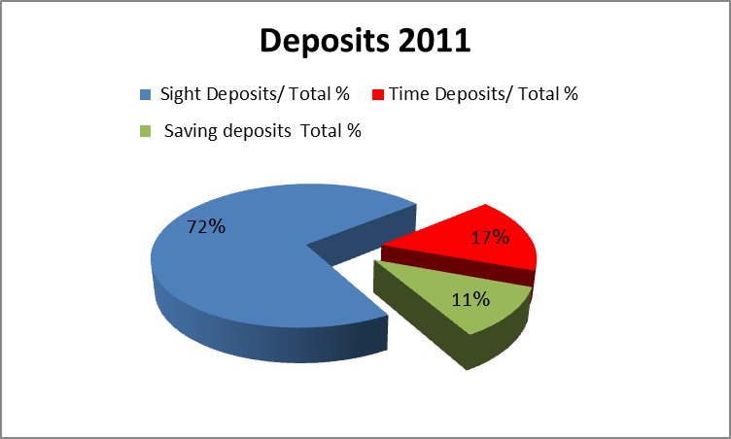
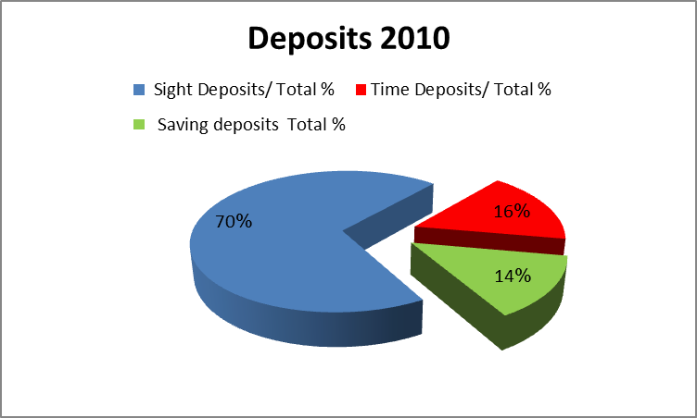

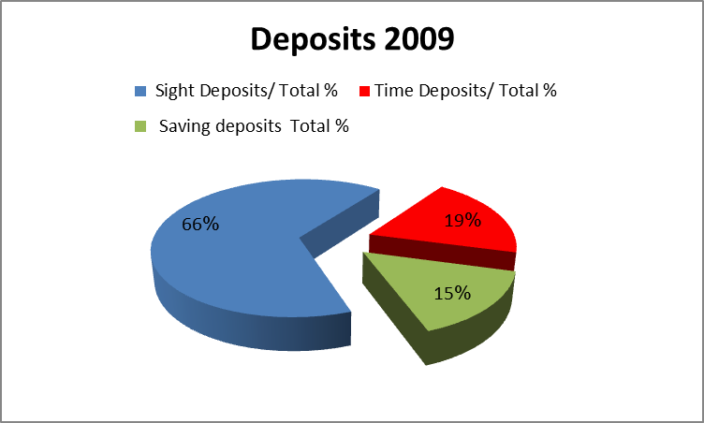

Assets 2-

Accounts with Banks a-
 | 2011 |  |  | 2010 |  |  |  | 2009 |  |  |  | In SYP Million
 | 2,129 |  |  | 1,401 |  |  |  | 1,357 |  |  |  | Current accounts
 | 76% |  |  | 31% |  |  |  | 32% |  |  |  | Current accounts / total of current + deposits %
 | 664 |  |  | 3,105 |  |  |  | 2,929 |  |  |  | Time Deposits
 | 24% |  |  | 69% |  |  |  | 68% |  |  |  | Time Deposits /Total %
 | 2,793 |  |  | 4,506 |  |  |  | 4,286 |  |  |  | Total
 | 0.20 |  |  | 0.17 |  |  |  | 0.17 |  |  |  | Frozen accounts
 | 17 |  |  | 16 |  |  |  | 16 |  |  |  | Outstanding accounts
 | 2,811 |  |  | 4,522 |  |  |  | 4,302 |  |  |  | Total

The structure of accounts with banks in 2011 reveals a change from that of 2010. The rate of those accounts rose in respect of current accounts to 76% scoring a rise of 52% over the previous year, whereas time deposits went down to 24%, recording 79% down from the previous year. The reason could be attributed to fear from the freezing of such assets with some banks because of the unfair sanctions imposed on CBS, as part of this drop goes to assets in current accounts while another part goes to financing the Syrian Airline Establishment for the renovation of its fleet.

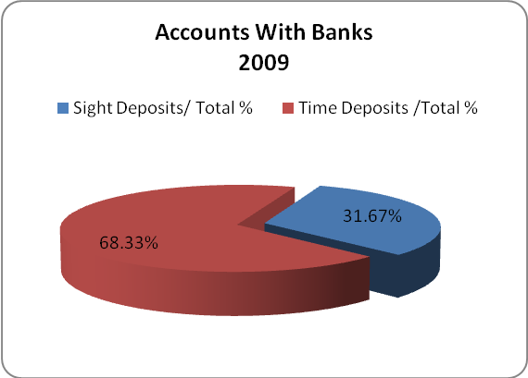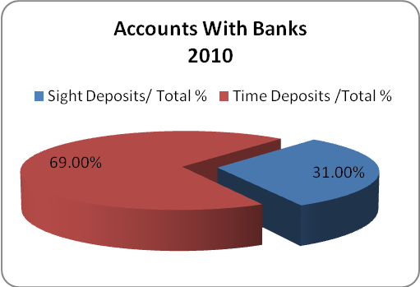

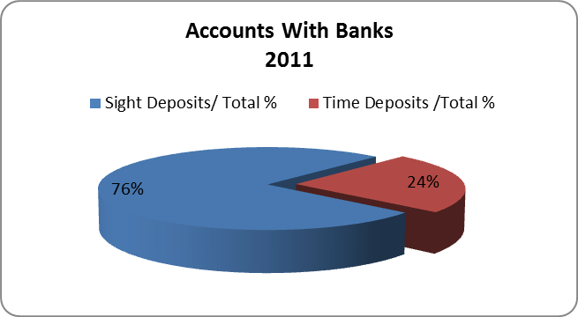

b- Claims on Customers

Conditions of 2011 had their impact on numerous commercial and industrial sectors which eventually influenced their capabilities and the ability of their workers to borrow or pay off their debts. Yet, CBS was able to preserve a certain level of the advances made in the context of retail loans, and to continue as well with the providing other facilities in addition to financing foreign trade. The following table shows the number and amounts of retail loans advanced for each type:

Retail loans advanced in 2011 ( USD thousand )

Type | Number | Value
Car loans | 377 | 8,776
Employee loan | 335 | 8,417
Al-Adel loan | 67 | 4,217
Used cars loan | 8 | 89
House finishing loan | 2 | 15
Personal loan | 7,853 | 138,262
Al-Amer loan | 287 . | 13,926.
Total | 8,929 | 173,705

The following table shows amounts of advances and loans in both Syrian and foreign currencies.

Development of Advances and Loans

2011 | 2010 | 2009 | In SYP Million
5,786 | 6,727 | 6,782 | Advances and Loans in SYP
0.97 | 0.98 | 0.99 | Advances and Loans in SYP/ Total %
150 | 151 | 82 | Advances and Loans in other currencies
0.03 | 0.02 | 0.01 | Advances and Loans in other currencies/ Total %
5,936 | 6,879 | 6,865 | Total interest yielding Advances and Loans
214 | 112 | 90 | Non – interest yielding Advances and Loans
6,149 | 6,991 | 6,955 | Total Claims on Customer
3.5% | 1.60% | 1.30% | Non – interest yielding Advances and Loans/  Total Claims on Customer %

Despite the drop in total of interest yielding advances by 13.7% due to the crisis conditions, the structure of their breakdown according to currencies remained stable in favour of the Syrian Pound at 97%, going down by only 1% from the previous year. In the meantime, advances in foreign currency amount to 3% showing a rise of 1% over last year.

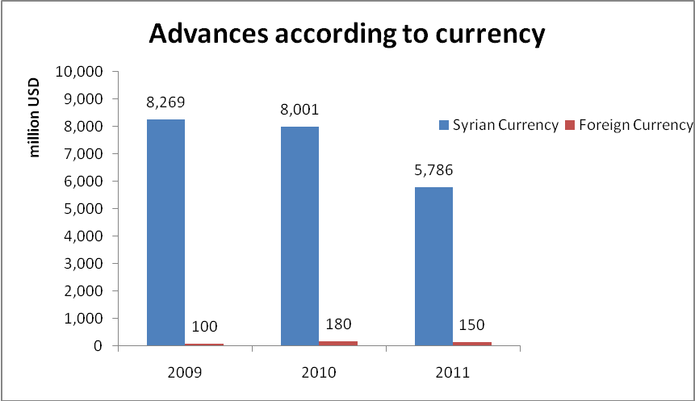
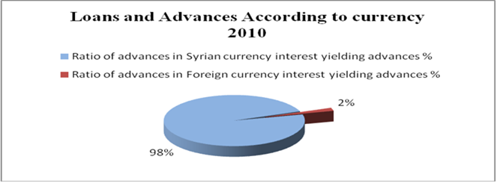
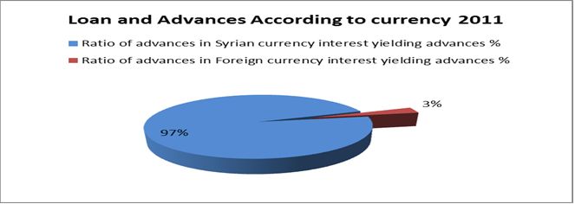
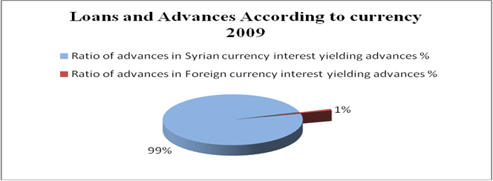

Debts classified as non-interest yielding showed a rise in 2011 up to 3.5% compared to their volume of 1.6% in 2010. The main reason for this, as explained above, is attributed to the inability of many customers to pay under the present crisis conditions although CBS did collect debts that were previously classified as non-performing loans and belonging to various customers which amount in total to over USD 3.58 million.

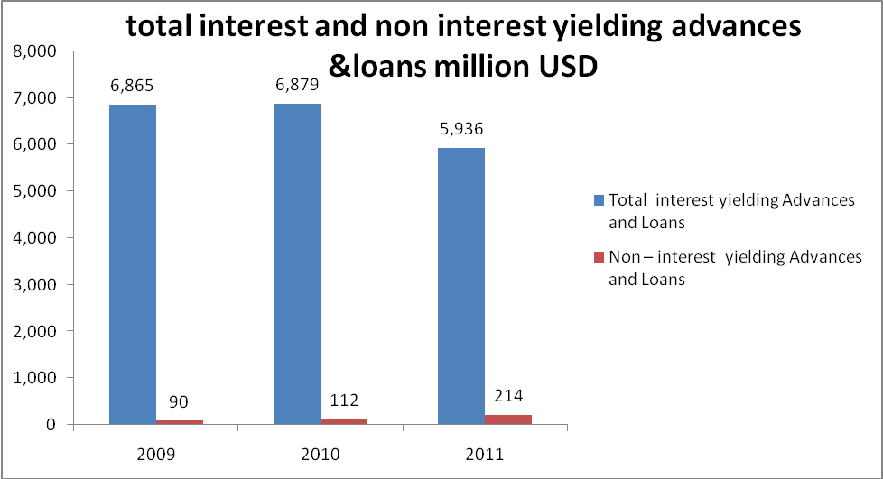

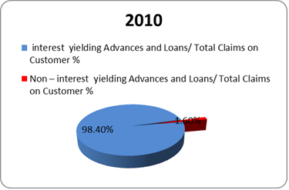
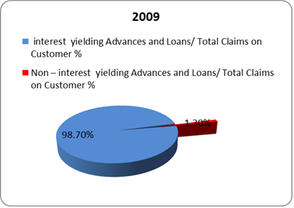
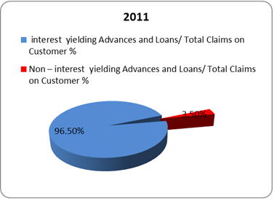

Development of Loans & Advances according to Sector and Currency

Sector / million SYP | Currency | 2009 | 2010 | 2011
Public Sector | Syrian currency | 6,449 | 6,322 | 5,202
Public Sector | Foreign currency | 13 | 42 | 49
Total |  | 6,462 | 6,364 | 5,251
Ratio of public sector advances / total of interest yielding advances % |  | 94% | 93% | 88%
Private Sector | Syrian currency | 334 | 406 | 584
Private Sector | Foreign currency | 69 | 109 | 100
Total |  | 402 | 515 | 685
Ratio of private sector advances / total of interest yielding advances % |  | 6% | 7% | 12%
Total of interest yielding loan & advances |  | 6,865 | 6,879 | 5,936

The total of advances to public sector in 2011 shows a decline by 17% from their volume of 2010, which is due to decline of such advances in Syrian currency because of the fact that part of debts owed by the Bublic Cotton Ginning Organization, and the Bublic Organization for Cereal Trade and other public sector establishments, has been paid up. But advances in Syrian currency to private sector have shown a rise by 44% due to the continuing of CBS loaning policy despite the present crisis conditions. In the meantime advances in foreign currency to private sector declined because of restrictions imposed on CBS concerning outward transfers.

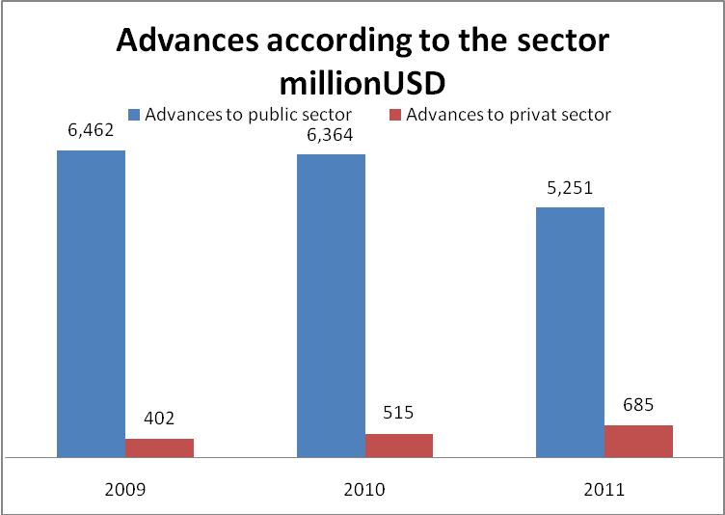
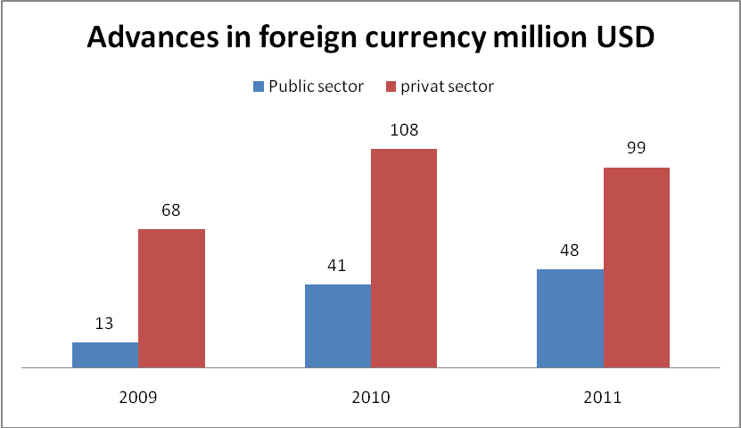

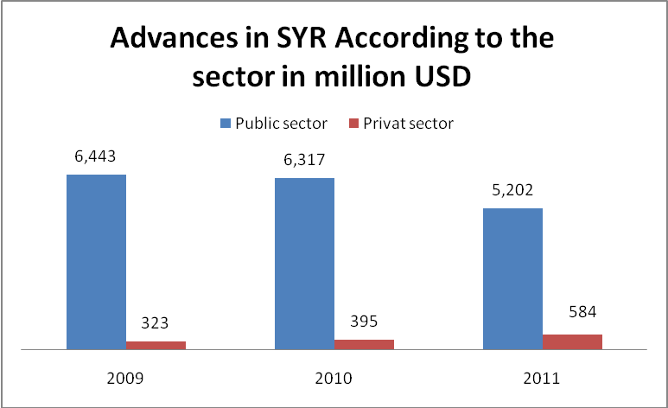

CBS Contributions to Financing Public Sector Advances (USD million)

Sector | 2009 | 2010 | 2011
CBS Contribution to financing public sector loans & advances for cotton & wheat harvest subsidy. | 2,347 | 2,489 | 2,011
Contribution / total of public sector advances & loans % | 36% | 39% | 38%
The rest of public sector lending | 4,115 | 3,874 | 3,239
The rest of public sector lending / total % | 64% | 61% | 62%
Total of public sector advances & loans | 6,462 | 6,364 | 5,251

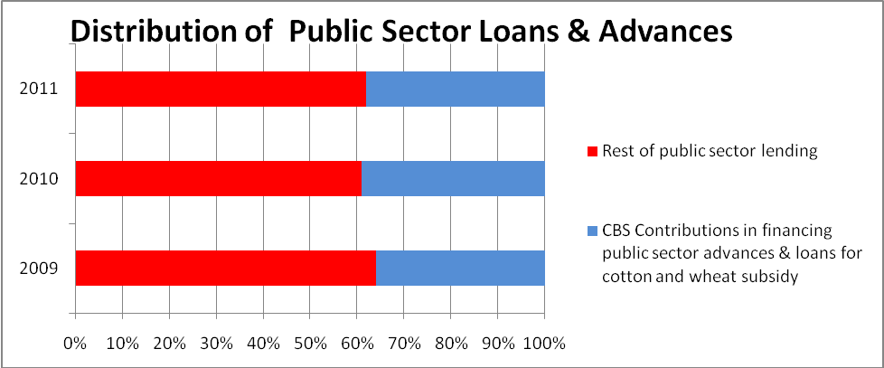

Returns, Expenses and Profit 3-
2011 | 2010 | 2009 | In SYP million
270 | 390 | 479 | Interest received
94 | 101 | 117 | Interest paid
176 | 288 | 362 | Net Interest Income
45% | 59% | 74% | Net Interest Income/ Total Income %
80 | 71 | 59 | Commissions and charges received
2 | 2 | 2 | Commissions and charges paid
78 | 69 | 57 | Commissions and charges net income
%20 | 14% | %12 | Commissions and charges net income / Total income%
254 | 357 | 419 | Total of Interest and commission income
%66 | %73 | %86 | Interest and commission income / Total income %
91 | 44 | 27 | Operating profits(losses) resulting from Foreign Exchange valuations
43 | 89 | 42 | Other operating returns plus results of free zone branches
134 | 133 | 69 | Total of other operating returns
%34 | %27 | %14 | Total of other operating returns/ Total income
388 | 490 | 488 | Total operating returns
(28) | (27) | (24) | Staff Expenses
(6) | (5) | (4) | Depreciation of tangible fixed assets
65 | (23) | (39) | Other operating expenses
98 | 55 | 67 | Total expenses
290 | 436 | 421 | Realized gross profits
%25 | 11% | %14 | Expenses/ Total operating returns%
268 | (47) | 4 | Profits(losses) in Valuations of structural Exchange position
558 | 389 | 425 | Gross Profits
% 43.36 | % -8.52 | % -5.26 | Changes in profits compared to last year

- Profitability:

Gross profits ratio in 2011 rose over that of 2010 by 43.36% because of the rise in operating profits resulting from valuations of foreign currencies by 100% as well as the rise of profits resulting from the Structural Exchange position by more than four times over their position in 2010, which in turn is a result of the rise in the exchange rate of foreign currencies. In the meantime actual gross income from interest declined by 33% from its figures in 2010 which is due to the drop in net income from interest by 38%, and the drop in other operating returns by 51%, and a rise in general expenses by 80% over that of 2010 due to the rise in risk provisions on financing non-interest yielding debts.

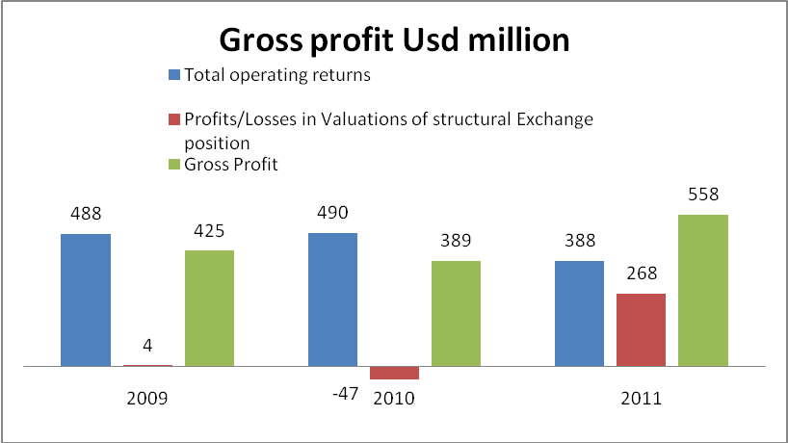

b- Operating Returns

 |  |  | (SYP million)
2011 | 2010 | 2009 |  |  | Type
270 | 390 | 479 |  |  | Interest received
%55.79 | %65.66 | %78.82 |  |  | Interest received/ Total returns %
80 | 71 | 59 |  |  | Commissions and charges received
16.55% | 11.95% | 9.78% |  |  | Commissions and charges received/ Total returns %
91 | 44 | 27 |  |  | Operating profits (losses) resulting from Foreign Exchange valuations
43 | 89 | 42 |  |  | Other operating returns plus results of free zone branches
8.84% | 14.96% | 6.89% |  |  | Other operating returns/ Total returns
484 | 594 | 607 |  | Total operating returns

The drop in 2011 returns is due to the drop in the share of interest received ratio to the total of returns by about 10% compared to the 2010 figures, which resulted from the drop in CBS accounts with banks in the form of time deposits, and the rise in non-interest yielding debts which changed to retained interest, not to mention the decline in the ratio of other operating returns by 6%.
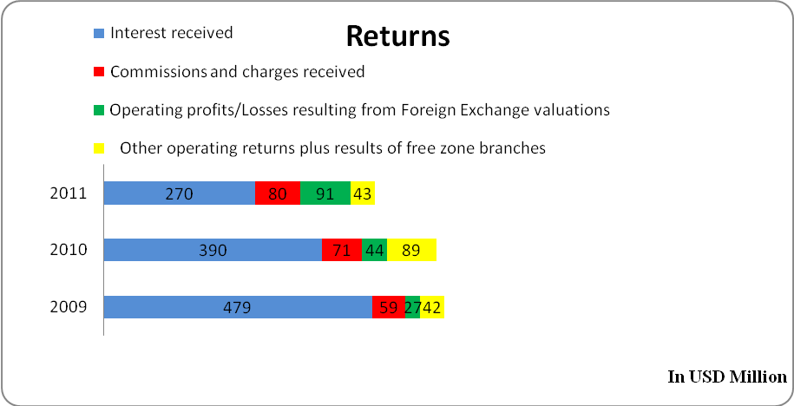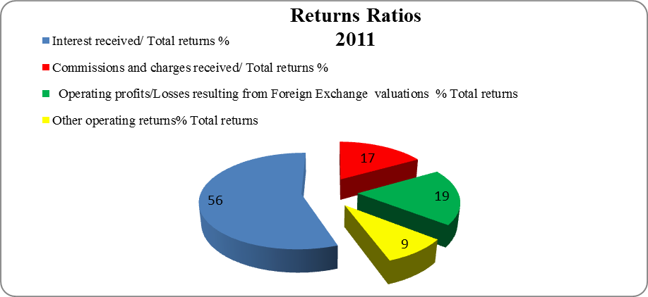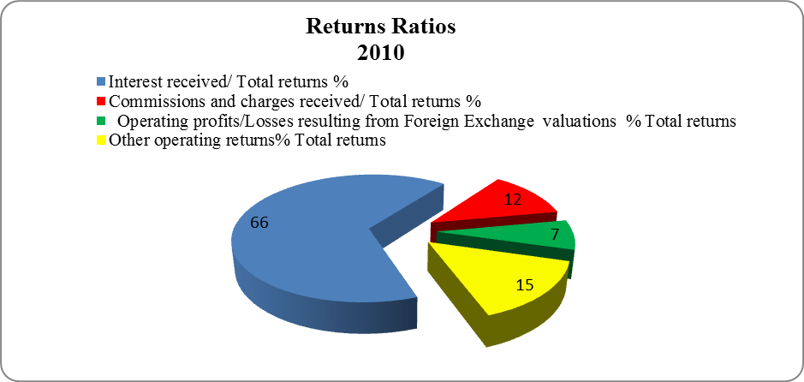
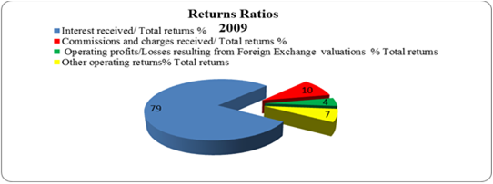

- Expenses
SYP million
2011 | 2010 | 2009 | Type
94 | 101 | 117 | Interest paid
48.28% | 64.17% | 62.74% | Interest paid/ Total expenses %
2 | 2 | 2 | Commissions and charges paid
1.12% | 1.34% | 1.13% | Commissions and charges paid/ Total expenses
28 | 27 | 24 | Staff Expenses
14.26% | 16,84% | 12.88% | Staff Expenses / Total expenses
6 | 5 | 4 | Depreciation of tangible fixed assets
2.84% | 3.16% | 2.18% | Depreciation of tangible fixed assets/ Total expenses
65 | 23 | 39 | Other operating expenses
33.50% | 14,50% | 21.08% | Other operating expenses / total expenses
195 | 158 | 186 | Total expenses
22.60% | -15.12% | 13% | Changes in expenses compared with last year.

The rise in CBS expenses by 22.6% over those of 2010 is due to the rise of other operating expense by 183% over the figures of 2010 which is a result of the rise in the drop of non-interest yielding debts.
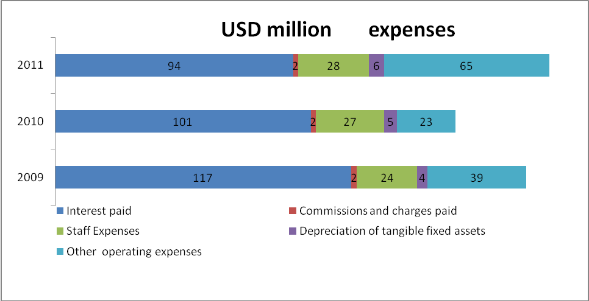

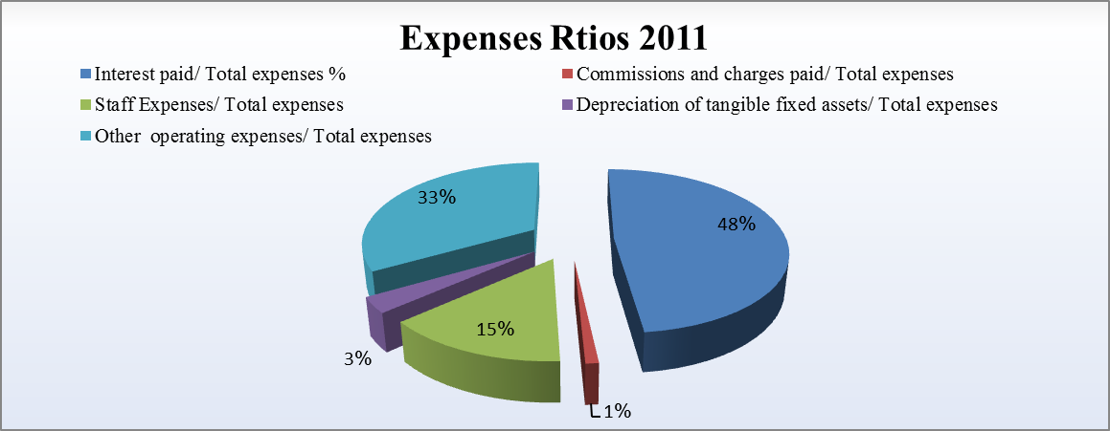
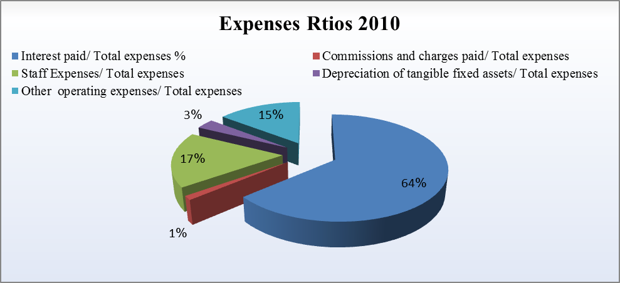
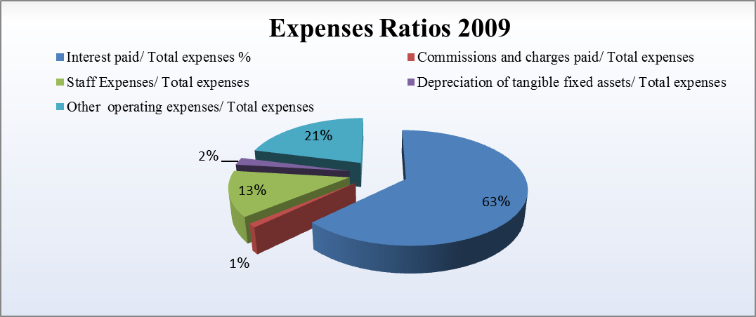

Modernization of Organizational Structure
And
Human Resources Management

- Directorate of Financial Affairs
In preparation of the restructuring project of the Financial Affairs Directorate, CBS focuses mainly and significantly on the creation of a section for the printing of cheques covering the bank’s needs for top quality printing observing best security levels, in addition to changing some operation mechanism in the directorate to ensure reduction of unnecessary expenses.

- Human Resources
In the sphere of training, CBS continued with its policy for the development of personnel through the organizing of internal and external training courses aiming at raising the levels of their skills and qualifications so that they could be up to the demands of their present and future jobs. In this connection the internal training programmes focused on:

- Developing staff skills through deepening their knowledge of the basics of
up-to-date banking operations.
- Acquainting new employees with CBS new technology system.
- Providing branch employees with details of the advantages and characteristics of CBS retail products.
- Acquainting all staff with the standards and procedures of detecting and combating money laundering.

In the same vein, CBS kept on organizing external training courses for its personnel especially programs characterized by:

- Focus on English language as a basic skill in the work of banks.
- Focus on the upgrading of skill level and technological specialization for CBS engineers and technical staff.
- Focus on raising the level of banking academic specialization among CBS personnel of whatever job type.

However, one should note with high appreciation the spirit of dedication and courage enjoyed by CBS staff generally, and in particular by the security personnel and those in charge of protecting or transporting CBS monies and properties.

- Number of CBS Personnel in 2011 :
Total number: 4188.
The following table shows distribution according to gender:

Workers on job as of 31.12.2011
Staff | Permanent | Temporary
Males | 2004 | 107
Females | 2184 | 5
Total | 4188 | 112
Distribution according to category

Category 1 and above | Category 2 | Category 3 | Category 4
1036 | 1936 | 541 | 787

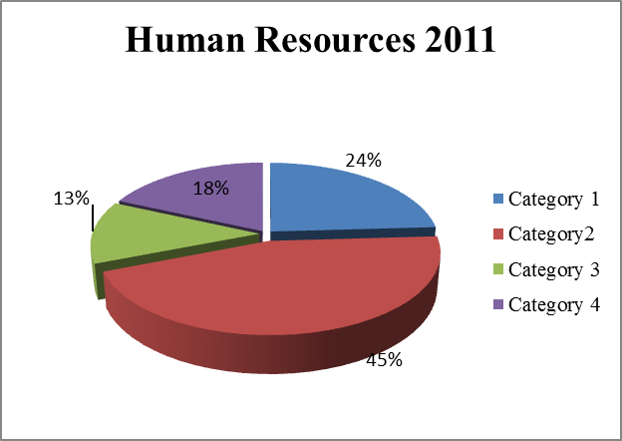

- Modernization in Bank Risk Management

- Central Bank of Syria has approved CBS policies on Credit Risks, Market Risks and Operation Risks.
- The Board of Monetary and Credit Resolution No. 74 concerning maturity gaps was duly implemented.
- The Governing guide has been completed.

- Modernization in Technical Affairs Management

- CBS automated system of administrative affairs has been put into service. It provides the possibility that enables the employee to apply for a leave through his/her account on the general mail program. It also provides the possibility of centrally tracking the employee’s working hours.
- Electronic employees’ personnel files has been completed.

- Mail link with other state entities through e-mail program, which has been applied with the Syrian-Lebanese Commercial Bank.
- Preparation of an initial model for the “turns” order which operates on personal identity card and photograph. It is being tested at one of CBS branches.
- compile a study, eventually commencing implementation of a safety network project in the General Management and branches.
- Starting connection of branches communications network with operators using high-speed optic fibers whenever a technical possibility is available.
- Compiling a study and furnishing of the substitute CBS network.
- Raising the protection and safety degree for the ATMs.

Consolidated closing Financial Statements on 31/12/2011 For the Commercial Bank of Syria and Syrian –Lebanese Bank

In SYP Million |  | Consolidated Balance Sheet
31/12/2011 | 31/12/2010 | Assets
2,127 | 1,568 | Cash on Hand & Balances with Central Bank
2,371 | 1,636 | Accounts with banks & banking institutions
664 | 3,105 | Deposits with banks & banking institutions
5,833 | 6,839 | Credit Facilities Net
1,096 | 1,059 | Financial Investments held until maturity date
0.24 | 0.24 | Investments with Subsidiaries & Allied companies  (in unconsolidated financial statements)
40 | 43 | Fixed assets
- | - | Good will and intangible fixed assets
1,216 | 1,346 | Other Assets
13,348 | 15,597 | Total Assets
 |  | Liabilities & Equity
 |  | Liabilities
358 | 371 | Deposits & accounts to other banks and banking institutions
6,477 | 7,731 | Customers' Deposits
2,741 | 2,789 | Securities in cash
1,251 | 2,417 | Borrowed funds
94 | 94 | Diversified provision
86 | 131 | Income tax provision
163 | 124 | Other Liabilities
11,171 | 13,658 | Total Liabilities
31/12/2011 | 31/12/2010 | Equity  Shareholders' Equity
1,341 | 1,331 | Paid up capital
0.20 | 0.17 | Donations
304 | 284 | Legal Reserves
294 | 274 | Private reserves
84 | 83 | Other reserves
16 | 6 | Reserves for finance risks
156 | 251 | Profits/losses after taxation ( exclusively for transitional statements)
(19) | (288) | Unrealized carried-over profits/ Accumulated losses
2,177 | 1,940 | Total equity rights - Bank' shareholders
13,348 | 15,610 | Total Liabilities & Minorities rights

Consolidated Income Statement
(CBS and Syrian-Lebanese Bank)

In SYP Million
31/12/2011 | 31/12/2010
283 | 403 | Interest received
(95) | (103) | Interest paid
188 | 300 | Net Interests income
86 | 79 | Commissions and charges received
(3) | (4) | Commissions and charges paid
82 | 76 | Net Commissions & Charges income
270 | 376 | Net Interests and Commissions Income
91 | 44 | Operating profits(Losses) resulting from Foreign Exchange valuations
268 | (47) | Profits/Losses in Valuations of structural non- cash position
43 | 92 | Other operating returns
672 | 465 | Total Operating Income
(31) | (30) | Staff Expenses
(6) | (5) | Depreciation of tangible fixed assets
(78) | (27) | Other operating expenses
(114) | (62) | Total Operating expenses
558 | 403 | Operating Profits (Losses)
84 | 131 | Income Taxes
21 | 31 | Legal Reserves
21 | 31 | Private reserves
9 | 6 | General finance risk reserves
268 | (47) | Unrealized carried-over losses(Valuations Losses)
156 | 250 | The state's dividends in the Profits
558 | 403 | Gross Total

In SYP Million |  | Cash Flow Statement  (CBS and Syrian – Lebanese Bank)
Changes | 31.12.2011 | 31.12.2010 | A-Cash Flows of operating activities
155.04 | 557.72 | 402.67 | Net result prior to taxation
 |  |  | Plus:
(1.24) | 11.39 | 12.63 | Unpaid-up due expenses
153.80 | 569.11 | 415.31 | Net result prior to taxation (plus above)
 |  |  | Less:
0.79 | 10.83 | 11.62 | Realized commissions & interests not due for payment
 |  |  | Changes in Assets & liabilities
(4,249.91) | 26,209.25 | 21,959.35 | Increase(decrease) in the Head office ' and branches' accounts domestic & overseas ))
(1.74) | 17.51 | 15.77 | Increase(decrease) in letters of credits' securities, frozen accounts & under -clearance accounts
1,004.73 | 5,834.78 | 6,839.51 | Increase(decrease) in credit facilities accounts
31.58 | 772.09 | 803.67 | Increase(decrease) in other debtor accounts
133.21 | 298.66 | 431.88 | Increase(decrease) in other assets
4,278.12 | 26,137.81 | 21,859.69 | Increase(decrease) in the accounts of the Head Office & the branches
(1,255.65) | 6,477.19 | 7,732.85 | Increase(decrease) in deposits
(186.72) | 2,116.34 | 2,303.05 | Increase(decrease) in cash securities
(7.39) | 45. | 52.39 | Increase(decrease) in values of short-time payments account
146.41 | 580.02 | 433.61 | Increase(decrease) in other creditor account
(1.22) | 15.59 | 16.81 | Increase(decrease) in other earnings paid in advance
46.00 | 2,797.92 | 2,751.92 | Net outcome funds(used) in operating activities prior taxation
46.80 | 83.82 | 130.62 | Paid-up taxes
92.80 | 2,714.10 | 2,621.30 | Net outcome funds(used) in operating activities after taxation(Total A)
(3.31) | 21.86 | 18.55 | Increase(decrease) in accounts with the central bank of Syria (excluding current accounts& mandatory cash reserves for deposits.
(36.59) | 1,091.37 | 1,054.78 | Increase(decrease) in bonds claimed on the state, in treasury bills(excluding public bonds & treasury bills for trading
2,568.20 | 664.03 | 3,232.23 | Increase(decrease) in Banks' accounts(excluding current accounts & certificates of deposits purchased from banks for trading)
(0.50) | 4.62 | 4.12 | Increase(decrease) in shares & subscriptions with banks and financial institutions
0 | 0 | 0 | Increase(decrease) in intangible fixed assets
2.90 | 39.19 | 42.10 | Increase(decrease) in tangible fixed assets
2,530.71 | (1,821.07) | (4,351.78) | Net outcome funds (used )in investments activities (Total B)
 |  |  | C- Cash flows of Financial activities
(1,166.55) | 1,239.51 | 2,406.05 | Increase(decrease) in the account of the Central Bank of Syria
0.31 | 2.00 | 1.68 | Increase(decrease) in Banks' accounts  ( excluding current accounts)
0.87 | 11.89 | 11.01 | Increase(decrease) in borrowed funds
(2.01) | 4.21 | 6.22 | Increase(decrease) in valuations discrepancies
80.70 | 1,989.20 | 1,908.49 | Increase(decrease) in the capital, reserves & Allowance
(45.20) | 180.46 | 225.66 | Other accounts
(18.85) | 68.86 | 87.70 | Other accounts to pay
(44.95) | (286.73) | (241.76) | Valuation profit /( loss)
(1,195.66) | 3,209.39 | 4,405.04 | Net outcome funds (used) in financial activities (Total C)
1,427.85 | 4,102.42 | 2,674.57 | Net outcome funds(used)in all type of activities(total A+B+C)
 | 4,458.54 | 3,043.89 | Monetary, Semi-monetary & current accounts opened with other banks at the end of the previous period
 | 356.12 | 369.32
1,427.85 | 4,102.42 | 2,674.57 | Total

