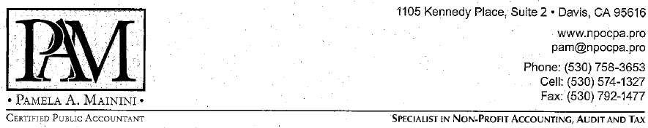

December 29, 2015

1099 ALERT

Filing Deadline – Monday, February 1, 2016

Dear Clients,
2015 has ended and it is once again time to start preparing 1099-MISC forms. A Form 1099-MISC needs to be filed for each individual or business which is not incorporated, to whom your organization paid more than $600 for services, rent or attorney fees during the past calendar year. Your fiscal year is not applicable. Similar to payroll forms, the 1099 reporting is for the preceding calendar year. I have enclosed summary information about the 1099 filing requirements for tax exempt organizations for the 2015 Form 1099-MISC. The 1099 filing requirements are the same for all types of businesses, including non-profit organizations. The IRS instructions are available on the IRS website at www.irs.gov. Please call me with any questions you may have.
Payments made with a credit card or payment card and certain other types of payment, including third party network transactions, must now be reported on Form 1099-K and are not subject to reporting on Form 1099-MISC. These payments will be reported by the processing company. None of my clients need to prepare the 1099-K. However, many of you, (those who use PayPal to accept payments), will receive one.
A Form 1099 Information Worksheet is included in this envelope if you would like me to assist you by preparing these forms for your organization. My fee for this service will generally be $60 for 10 or fewer forms. 1099 forms are due to the recipients by Monday, February 1, 2016. The forms are not due to be filed with the IRS until Friday, February 29, 2016 (paper) or Thursday, March 31, 2016 (electronic). Please complete and return the worksheet to us as soon as possible so that we can get your forms properly completed and filed on time.
Wishing you a happy and prosperous new year,
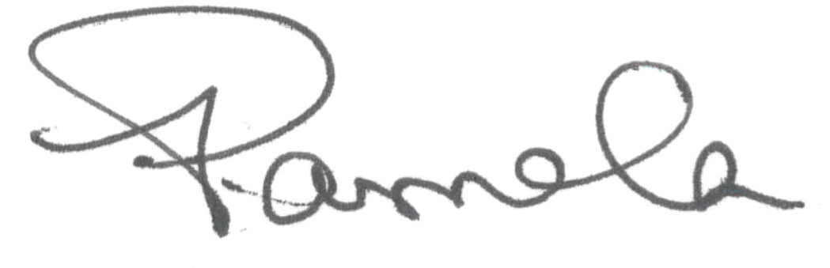
Pamela A. Mainini, CPA
Enclosures

