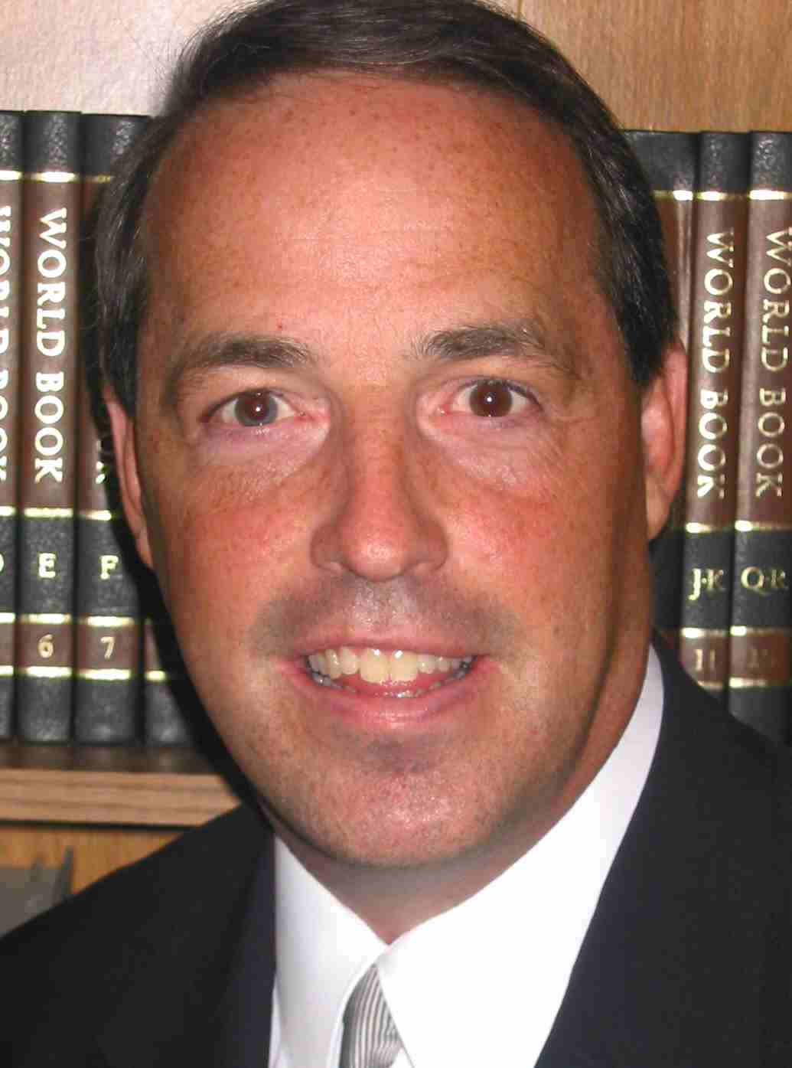
ABOUT THE AUTHOR

Brian Kluth is a frequent guest commentator on Larry Burkett's financial radio programs nationwide, and has been a financial speaker across America and many other countries overseas.

He is the author of:
- "40 Day Journey to a More Generous Life"
- “God's Word on Wealth, Finances & Generosity”
- “The Maximum Generosity Guide for Churches”
- And other Biblically-based financial teaching materials.
His written materials have been distributed to Christians in more than 100 countries. His written materials can read or ordered on-line at: www.MAXIMUMgenerosity.org.

He has given financial interviews for NBC's Dateline, The Chronicle of Philanthropy, & Kiplinger's Magazine.

Brian is the past national president of the Christian Stewardship Association. He is the Founder of MAXIMUM Generosity and the Senior Pastor of the First Evangelical Free Church of Colorado Springs (www.1freechurch.org).

© Brian Kluth of www.MAXIMUMgenerosity.org


Finding True
Financial Stability
In Unstable Times
By Brian Kluth
Jesus said: “Everyone who hears these words of mine and puts them into practice is like a wise man who built his house on the rock.” Matt 7:24

Quips & Quotes

Your checkbook and your calendar are theological documents. They will tell you who and what you worship.

Your use of money shows what you think of God.

The world asks: "What does a man own?"
God asks, “How does he use what he’s been given?”

If we belong to Christ, it's logical
that everything we have truly belongs to Him.

People go through 3 conversions:
their head, their heart and their pocketbook.
Unfortunately, not all at the same time. Martin Luther

The real measure of our wealth is how much
we'd be worth if we lost all our money.

When a man becomes rich, either God gains a partner or the man loses a soul.

The poorest man in the world
is the man who has nothing but money.

Our real worth is what will be ours in eternity.

A Christian is one who does not have to consult his bank book to see how wealthy he really is.

Money can buy a house, but not a home.
Money can buy a bed, but not sleep
Money can buy a wedding ring, but not love.
Money can buy a clock, but not time.
Money can buy an education, but not wisdom.
Money can buy jewelry, but not beauty.
Money can buy insurance, but not safety.
Money can buy a crucifix, but not a Savior.

God’s Principles
For Financial Freedom

Ancient Wisdom for Our Modern World:

Finding True Financial Stability
In Unstable Times
By: Brian Kluth

Did you know how much God talks in the Bible about…
Baptism? 40 verses Faith? 350 verses
Prayer? 275 verses Love? 650 verses
Finances/Material Possessions/Wealth? 2,350 verses

Your definition of financial freedom: ___________________
___________________________________________________
New definition of financial freedom: Building your life on God’s financial principles so you can completely trust God to guide you and provide for you.

Man's Ways | God's Way
1 - All I have is “Mine” | All I have is God’s
Dt 8:17,18 You may say to yourself, "My power and...strength... produced this wealth for me." But remember the Lord, for He gives you the ability to produce wealth.
Ps 62:10 If your riches increase, don't be proud.
Ps 24:1 The earth belongs to God! Everything in all the world is his! Col 1:17 All things were created by Him and for Him...in Him all things hold together. Also see: £1 Chron 29:11 £ Ps 50:12 £1 Cor 10:26

When it comes to money, always be sure to act your wage.

When your outgo exceeds your income,
your upkeep will lead to your downfall.

The only sure path to financial stability and success is to spend less than you earn for a long, long time. Ron Blue

One may commented, “I’m a walking economy. My hairline’s in recession, my waist is a victim of inflation, and together they’re putting me in a deep depression!”

A recession is a period when sales go down
and staff meetings go up.

There are only two ways to become richer:
Spend less than you make OR make more than you spend.

With the price of everything else going up these days, aren’t you glad the Lord hasn’t increased the tithe to 15%?

We're living in a land of plenty—Everything costs plenty.

Twenty-five years ago $50,000 bought a lot of house.
Today it buys a lot.

A recession is when your neighbor loses his job.
A depression is when you lose yours.

I read something the other day that made me cry - -
my quarterly investment and pension statements.

People who play the market are often led astray
by false profits.

You know your stock investments are in trouble when your favorite companies stop appearing in the newspaper business section and start appearing in the political cartoons or classified ad legal notices.
Man's Ways | God's Ways
2 – “More” | Manage
Ecc 5:11 The more you have, the more you spend, right up to the limits of your income.
Prov 21:20 The wise man saves for the future, but the foolish man spends whatever he gets.
Lu 16:10 Whoever can be trusted with little can also be trusted with much, and whoever is dishonest with very little will also be dishonest with much.
Ps 37:16 Better the little that the righteous have than the wealth of many wicked.
Pr 21:17 A man who loves pleasure becomes poor.
Pr 23:19 Don't carouse with drunkards and gluttons...they are on their way to poverty.

3 - FEAR of loss  or hard times | FAITH in God  to provide
Ps 37:18-19 The Lord cares (for the godly) even when times are hard; even in famine, they will have enough. Ps 33:18-19 The eyes of the LORD are on those who fear him, on those whose hope is in his unfailing love, to...keep them alive in famine. Rom 8:35 Who shall separate us from the love of Christ? Shall trouble or hardship or...famine...? Also see: £Gen 12:10 Abraham £Gen 26:1 Issac £Gen 41:29,30,50 Joseph £Gen 42:5 Jacob £ Ruth 1:1-4 Ruth £2 Sam 21:1 David £I Kgs 18:2 Elijah £II Kgs 4:38 Elisha £Neh 5:3 Nehemiah £Jer 52:6 Jeremiah £Acts 11:28

A joint checking account is never overdrawn by the wife; it’s just under-deposited by her husband.

You are only poor when you want more than you have.

The trouble with most people is their earning capacity doesn't match their yearning capacity.

The most expensive vehicle to operate, per mile,
is the shopping cart.

A “bargain” is something you can't use
at a price you can't resist.

The safest way to double your money
is to fold it in half and put it in your pocket.

DEFINITION: Luxury = something that someone else has that I don’t have - - everything I have, I need.

It's not the high cost of living, it's the cost of living
too high that gets most people in trouble.

Many people spend money on things they don't need,
with money they don't have,
to try and impress people they don't like.

If you want to feel rich,
just count all the things you have that money can't buy.

Remember: The most important things in life aren’t things
and the best things in life are always free.

Where God guides, He provides.
What God orders, He pays for.

Use it up, wear it out, make it do, or do without.

A good architect can improve the looks of your house merely by discussing the cost of a new one.
Man's Ways | God's Ways
4 – Envy and the pursuit of Possessions | Contentment and released resources
Ex 20:17 Do not covet your neighbor's house…or anything else your neighbor owns. Ps 73:2-28 My feet were slipping...For I was envious of the prosperity of the proud & wicked...all the time their riches multiply. Luke 12:15^{LB} (Jesus said) “Beware! Don't always be wishing for what you don't have. For real life and real living are not related to how rich we are.” Heb 13:5-6 Keep your lives free from the love of money and be content with what you have, because God has said, "Never will I leave you; never will I forsake you."
1 Tim 6:6 Godliness with contentment is great gain.
Psalm 127:2^{CEV} It is useless to get up early and stay up late in order to earn a living. God takes care of his own, even while they sleep. Also see: £Phil 4:11,12 £Prov 23:17 £1 Pet 2:1-2

Matt 6:33 Seek first his kingdom and his righteousness, and all these things will be given to you as well.
Ecc 2:26 To the sinner he gives the task of gathering and storing up wealth to hand it over to the one who pleases God.
Prov 13:22 A sinner's wealth is stored up for the righteous.
Ps 105:44 (God's people) fell heir to what others had toiled for.
Job 27:16-17 The evil man may accumulate... closets jammed full of clothing...but the righteous shall wear that clothing.
Also see: £Is 45:3 £Pr 28:8 £Ps 39:5 £Isa 23:18 £Dt 6:10-12 £Jos 11:14,24:13 £Ne 9:25

People who live beyond their means
must always be given a lot of credit.

If you think nobody cares you are alive,
just miss a couple monthly payments.

There are bigger things in life than money -- bills.

"I have to have a raise," the man said to his boss.
"Three other companies after me."
"Is that so?" asked the manager.
"What other companies are after you?"
"My mortgage company, the electric company,
and the telephone company."

Sign in the store window:
Use our easy credit plan – 100% down
and 0% monthly payments.

Car sickness is what some adults suffer from
every month when they have to make their car payment.

These days it’s easy to buy a $50,000 car, just buy a $15,000 car with 48 monthly payments.

By the time some people discover that money doesn't grow on trees, they are already way out on a limb.

Credit is what keeps you from knowing
how far past broke you are.

Those who think money grows on trees are the ones who have a hard time getting out of the woods.

Number of years it takes to pay off an $8,000 18% credit card balance with minimal monthly payments: 54 years

Number of years you will take off a 30-yr mortgage if you make 13 payments/year (or bi-weekly payments): 12 years
Man's Ways | God's Ways
5 – Growing indebtedness | Actively eliminate or avoid indebtedness
Proverbs 17:18^{MSG} It's stupid to try to get something for nothing, or run up huge bills you can never pay. Pr 22:7 The borrower is servant to the lender. See: II Kings 4:1, Dt 28:43-44
Rom 13:8 Owe no one anything except to love one another.
Deut 28:12 God will open to you his wonderful treasury of rain in the heavens, to give you fine crops every season. He will bless everything you do; and you shall lend to many nations, but shall not borrow from them. Ps 37:21 Evil men borrow and "cannot pay it back"! Prov 22:26 Unless you have the extra cash on hand, don't countersign a note. Why risk everything you own? They'll even take your bed!

6 – Foolish pride and  lack of good counsel | Knowledgeable and  godly Counsel
Prov 12:15 The way of a fool seems right to him, but a wise man listens to advice. Prov 16:25 There is a way that seems right to a man, but in the end it leads to death (ruin, destruction).
Ps 1:1-2 ^{TLB} Oh, the joys of those who do not follow evil men's advice, who do not hang around with sinners, scoffing at the things of God. 2 But they delight in doing everything God wants them to, and day and night are always meditating on his laws and thinking about ways to follow him more closely. Prov 13:10 Pride only breeds quarrels, but wisdom is found in those who take advice. Prov 19:20 Listen to advice and accept instruction, and in the end you will be wise. Prov 20:18^{TLB} Don't go ahead with your plans without the advice of others. Prov 15:5^{TLB} Only a fool despises his father's advice; a wise son considers each suggestion.

When you give to God, you discover that God gives to you.

When it comes to giving, some people stop at nothing.

Giving to God is a grace—but not giving is a disgrace.

There's no good reason to be the richest man in the cemetery. Colonel Sanders

What I kept, I lost. What I gave, I have.

If a pauper gives to God, he’ll feel like a prince.
If a prince doesn’t give to God, he’ll feel like a pauper.

When we give to God, we are just taking our hands off
what already belongs to Him.

Give to God what's right--not what's left.

Some people give God a tenth—
a tenth of what they ought to give.

You should give according to your income,
lest God make your income according to your giving.

Do your givin' while you are livin'—
then you're knowin' where it's goin'.

There are no pockets in a shroud
and no U-hauls behind a hearse.

Two things ruin a church--loose living and tight giving.

There are many who will give the Lord the credit
but never give Him the cash.

God looks at the heart, not the hand--the giver, not the gift.

If everyone in your church followed your pattern of giving, would your church receive a token, a tip or a tithe?
Man's Ways | God's Ways
7 – Giving to God has low or no priority | Giving to God is your highest priority
Deut 14:23^{TLB} The purpose of tithing is to teach you always to put God first in your lives. Gen 28:20-22 Jacob made a vow, saying, "If God will be with me and will watch over me...then the LORD will be my God...and of all that You give me I will give you a tenth."
I Kg 17:13-16 Elijah said to (the starving widow), "Don't be afraid... first make a small cake of bread for me from what you have and bring it to me, and then make something for yourself and your son. For this is what the LORD says: 'The jar of flour will not be used up and the jug of oil will not run dry...". She went away and did as Elijah had told her. So there was food every day for Elijah and for the woman and her family. Hag 1:5-12 "Give careful thought to your ways...You expected much, but see, it turned out to be little. What you brought home, I blew away. Why?" declares the LORD Almighty. "Because of my house, which remains a ruin, while each of you is busy with his own house." Mal 3:10 The Lord says: "Bring all the tithes into the storehouse...if you do, I will open up the windows of heaven for you and pour out a blessing... "Try it! Let me prove it to you!"
2 Cor 8:7 See that you...excel in this grace of giving.
Deut 16:16-17 No man should appear before the LORD empty-handed: Each of you must bring a gift in proportion to the way the LORD your God has blessed you.
1 Cor 16:2 On the first day of the week let every one of you lay something aside, as God has prospered you.
2 Cor 9:7 God loves a cheerful giver.

A dad is a man who has replaced the money in his wallet with snapshots of his family.

You know what a YUPPIE is, but have you ever heard of DINKs & WOOFs? New terms: D.I.N.K.s = Double Income, No Kids. W.O.O.F.’s = Well Off Older Folks

$650,000,000,000 ($650 billion) was spent on legalized gambling in 1997 compared to $450,000,000,000 spent in grocery stores. This $650 billion represents $2300 spent annually for every man, boy, woman and girl in America. Source: U.S. Abstract as reported by Focus on the Family.

Lottery = A voluntary tax for people that are bad at math.

Hard work is the yeast that raises the dough.

The best investment is in the tools of one's own trade.

If you want to feel rich, just count all the things you have that money can't buy.

Money isn't everything, but it sure keeps you in touch with the children.

Many people spend most of their life losing their health to try and gain wealth, and then spend the end of their life losing their wealth trying to gain their health.

Many people have finally realized that money can't buy happiness. Now they're trying credit cards.

Before you borrow money from a friend,
decide which you need more.

Life insurance is what keeps a man poor
all of this life so he can die rich.

In every insurance policy the big print giveth
and the small print taketh away.
Man's Ways | God's Ways
8 – Arguments and unrest about $ issues | Agreement and unity (through prayer)
Pr 15:16-17 Better a little with the fear of the LORD than great wealth with turmoil. Better a meal of vegetables where there is love than a fattened calf with hatred. 1 Pet 3:7 Husbands... be considerate as you live with your wives, and treat them with respect...so that nothing will hinder your prayers. Ps 34:17 The righteous cry out, and the LORD hears them; he delivers them from all their troubles. Prov 14:11 The house of the wicked will be destroyed, but the tent of the upright will flourish.
Isa 32:18 My people will live in peaceful dwelling places, in secure homes, in undisturbed places of rest.
Ps 128:3 Your wife shall be contented in your home.

9 – Get rich quick schemes &/or gambling | Steady plodding and hard work
Prov 22:26^{MSG} Don't gamble on the pot of gold at the end of the rainbow, hocking your house against a lucky chance.
Pr 13:11 Wealth from gambling quickly disappears; wealth from hard work grows.
Pr 28:19 He who works his land will have abundant food, but the one who chases fantasies will have his fill of poverty.
Pr 28:20 The man who wants to get rich quick will quickly fail. Pr 20:21 Quick wealth is not a blessing in the end.
1 Tim 6:9 People who long to be rich soon begin to do all kinds of wrong things to get money, things that hurt them...
Prov 10:4 Diligent hands bring wealth. Prov 21:5 Good planning and hard work lead to prosperity, but hasty shortcuts lead to poverty.
Also see: Prov 6:6-11, 10:5, 12:27, 13:4; 2 Th 3:10-13, Ecc 10:16-19

The “Report Card on the Ethics of American Youth,” a study of the attitudes and habits of 8,600 students in grades 9 through 12, found:
- 7 in 10 students admitted cheating on a test at least once within the past year.
- 92 percent had lied to their parents in the past year.
- 78 percent had lied to their teachers.
- More than 1 in 4 said they would lie to get a job.

Deception – 32% of American’s would not report $2000 of money made on the side to the IRS.

How much better to be honestly poor
than questionably rich.

You should file your income tax, not chisel it.

Income is a small matter to me--especially after taxes.

An honest letter was sent to the Internal Revenue Service.
It stated: "Dear Sirs: I cannot sleep. Last year, when I filed my income tax return, I deliberately misrepresented my income. Now I cannot sleep. Enclosed is a check for $150 for taxes. If I still cannot sleep, I will send you the rest!"

Money talks. It says, “Good bye.” Prov 23:4 tells us: “Don't weary yourself trying to get rich. Why waste your time? For riches can disappear as though they had the wings of a bird!”

Be sure to budget! It is always better to know where your money is suppose to go rather than asking where it went.

Beware of little expenses:
a small leak will sink a great ship.

Man's Ways | God's Ways
10 – Deception and uncertainty | Honesty  and knowledge
Prov 21:6 Wealth created by lying is a vanishing mist and a deadly trap.
Prov 19:1^{TLB} Better be poor and honest than rich and dishonest.
Prov 12:19 Truthful lips endure forever, but a lying tongue lasts only a moment.
Prov 6:12-15 Let me describe for you a worthless and a wicked man; first, he is a constant liar… He is always thinking up new schemes to swindle people. He stirs up trouble everywhere. But he will be destroyed suddenly, broken beyond hope of healing.
Lev 19:11 Do not steal. Do not lie. Do not deceive one another.

Prov 27:23^{TLB} Riches can disappear fast. And the king's crown doesn't stay in his family forever-so watch your business interests closely. Know the state of your flocks and your herds.
Hag 1:5-7 This is what the LORD Almighty says: "Give careful thought to your ways. You have planted much, but have harvested little. You eat, but never have enough. You drink, but never have your fill. You put on clothes, but are not warm. You earn wages, only to put them in a purse with holes in it." This is what the LORD Almighty says: "Give careful thought to your ways.”
2 Kings 20:1 "This is what the LORD says: Put your house in order, because you are going to die.”

What Next? Choose 5 Smooth Stones
1 Sam 17:40 Here are the 5 “smooth stones” I discovered in the stream of teaching from Brian Kluth that will help me slay my financial giants:
1)_______________________________________________________
2)_______________________________________________________
3)_______________________________________________________
4)_______________________________________________________
5)_______________________________________________________

20 Symptoms of Financial Bondage
- You have difficulty reading your Bible or listening to a sermon because of your money worries
- You make minimum payments on your credit cards and loans
- You consistently think and worry about money
- You've made impulsive purchases or expenditures you later regretted
- In the past, you have used consolidation loans or second mortgages to relieve the financial pressures you were under and you're now in worse financial trouble than ever
- You regularly pay monthly bills w/credit cards because you're broke (i.e. You know you have more month than money).
- You don't faithfully give to the Lord because you think you can't afford it.
- You argue about money.
- You are angry, envious or jealous of others who have enough money to pay their bills or who are debt free
- You have trouble sleeping at night because you worry about bills
- You have borrowed money to make investments in the past
- You have no written spending plan to guide your financial giving, savings and spending - - i.e. no budget.
- You are constantly thinking about getting involved in some get rich quick schemes
- You think that getting more money is the answer to your problems.
- You've bought a brand new car on monthly payments because you thought it would save money on your car repair bills.
- You have borrowed from family and friends and you are not actively repaying the loan.
- You have bounced several checks in the past year.
- You have maxed out some or all of you credit cards
- You have no realistic written plan to pay off all your debts
- You have never been in a Bible study group where you've learned God's principles for handling your finance
Source: A combination of info from a variety of financial websites.

HELPFUL RESOURCES

Brian Kluth’s Website (www.MAXIMUMgenerosity.org): Helpful articles and resources on Biblical generosity, debt reduction, and financial freedom.

Crown Financial Ministries (www.crown.org): Crown offers excellent website resources, articles, financial calculators (on their webste), books, and radio programs.

Ronald Blue & Company (www.ronblue.com): This nationwide organization with offices in 15 cities offers financial counsel, investment management, estate planning, tax services, charitable giving counsel. They especially specialize in assisting individuals with a high net worth.

Sound Mind Investing (www.soundmindinvesting.com): A financial newsletter and services by Austin Pryor for today’s Christian family. Provides solid advice on investment strategies.

Generous Giving (www.Generousgiving.org): Resources for those who want to deeper their commitment to Biblical generosity and increase their giving to advance the kingdom of God.

Consumer Credit Counseling Agency (www.cccs.net) Counseling and assistance with debt and credit card problems.

TOP 10 SIGNS YOU ARE BROKE
10. American Express calls and says: "Leave home without it!"
9. You’re formulating a plan to rob the food bank.
8. Long distance companies don’t call you to switch.
7. You rob Peter...and then rob Paul.
6. You finally clean your house, hoping to find change.
5. You think of a lottery ticket as an investment.
4. Your bologna has no first name.
3. Sally Struthers sends you food.
2. McDonalds supplies you with all your kitchen condiments.
1. At communion you go back for seconds.

