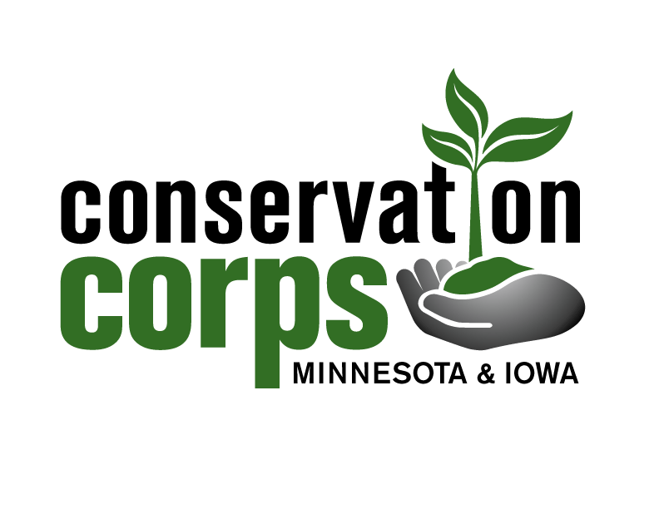
Conservation Corps Minnesota & Iowa
Summer Youth Corps
Assistant Director Position Description

Position: Assistant Director (Summer Youth Corps)
Location: Minnesota (statewide)
Schedule: Seasonal; May 22- August 25, 2017
Time off: July 16-18; one three-day period of your choosing
Pay rate: Stipend $1,990 per month
Benefits: Food and lodging, cell phone reimbursement
Reports to: Summer Youth Corps Program Manager
Criminal History Check: NSOPW, state criminal history and FBI fingerprint checks due to reoccurring access to vulnerable populations

The Conservation Corps provides hands-on environmental stewardship and service-learning opportunities to youth and young adults while accomplishing energy conservation, natural resource management projects and emergency response work.
Position summary: Assistant Directors are integral to the Summer Youth Corps’ program goals of accomplishing environmental projects, as well as providing training, education and leadership to ensure a positive and safe experience for participants. All Assistant Directors will work collaboratively with one another and the Program Coordinator to provide comprehensive support to youth crews throughout the summer season. There are four Assistant Directors, each with a particular focus. The Logistics Coordinator will handle most program paperwork along with the proper storage of youth medication. The Operations Coordinator will handle the distribution, collection and maintenance of all tools and equipment used throughout the program as well as all vehicle logistics, paperwork and upkeep. The Education Activities Coordinator will handle the distribution, collection and teaching of educational materials as well as coordinating logistics for weekend and in-camp activities. The Kitchen Coordinator/Cook will manage and care for the kitchen and dining hall facility – following and enforcing all ServSafe and kitchen policies; will handle food planning, purchasing, and preparation – working with swampers, temporary cooks, and volunteers as needed to provide nutritious food for members of all different dietary needs or restrictions; and will coordinate and implement a banquet meal at end of both summer sessions.

If an applicant possesses strong American Sign Language (ASL) interpreting skills and/or is fluent in ASL, the AD position may be modified to include managing and supporting ASL interpreters and deaf crew leaders. In this case, they would also serve as the main contact and support for the ASL community. The ASL community coordinator will interpret all large community events, set-up interpreting schedules during Crew Leader and Youth trainings, and meet daily with Deaf crew leaders and interpreters.

Requirements:
- Experience working with 15 to 25 year olds and ability to coach this age group to work safely and productively to complete service projects.
- Excellent organizational skills.
- Excellent interpersonal and coaching skills.
- Ability to evaluate crew leader performance and administer discipline/recognition to leaders & youth.
- Desire and ability to:
  - Work hard in an outdoor setting in adverse conditions with limited time off.
  - Work with diverse youth in conservation, education and recreation settings.
  - Foster strong work habits, environmental ethics, youth leadership and team unity.
  - Display a positive attitude, interest in service and community work and desire to make a difference.
- Valid driver’s license with good driving record.
Preferred qualifications:
- Working knowledge of conservation projects from a variety of disciplines such as trail construction, invasive plant management and prairie/forest management, and knowledge of tool safety and use.
- Fluency in ASL and/or ASL interpreter training.
Essential functions:
- Training
- Facilitate participant trainings in areas such as risk management, defensive driving, tool use, camping and backcountry gear, leadership development.
- Train crew leaders in food purchasing, management, nutrition, preparation and safety.
- Provide ongoing support to corpsmembers to ensure personal and program success.
- Safety
- Promote and follow all safety requirements of OSHA, project hosts and the Corps.
- Assist in accident investigations as applicable.
- Assure proper safety and maintenance of vehicle fleet and Corps-owned equipment.
- Inventory and restock first-aid kits as needed.
- Organize and inventory all med-bags & assist crew leaders with restocking their medical supplies.

Education and Community
- Assist program coordinator with updating and revising the EA curriculum
- Foster understanding of Deaf culture through learning sign language and always leading inclusive activities.
- Create, organize and facilitate Conservation Corps Summer Olympics.
- Assist with organizing two end-of-program banquets (slideshow, certificates, activities, etc.).
- Put together a summer book and a collection of photographs from each half to post online.
- Assist with organizing two end-of-program banquets (slideshow, certificates, activities, etc.).
- Manage distribution of educational materials, evaluations and weekly agenda for your crews.
- Ensure crew leaders and youth meet daily/weekly expectations for education and training.
- Plan and coordinate weekend and evening activities at the residential base camp and for crews working at other sites in the region.
- Inventory education and activity materials and restock as needed.

Equipment
- Keep work areas, office, shop, pod and vehicles neat and orderly.
- Assist with proper cleaning, maintenance and bug eradication in all buildings.
- Communicate with crew leaders about what tools and gear they will need for their projects.
- Organize, distribute, collect, manage and repair camping equipment and tools.
- Record and manage technology distribution for each crew.
- Collect and record full equipment inventory at the end of the summer.
- Crew operations and management
- Mentor crew leaders and support crews in the field (conduct site visits to work with crews, assist crews with technical projects and assist crew leaders with any issues that arise).
- Provide energetic and inspiring leadership to participants.
- Take weekly call-ins from assigned crew leaders and provide appropriate feedback.
- Collaborate with head staff to determine appropriate work crews.
- Participate in daily head staff meetings.
- Model and enforce Corps policies at all times. Provide explanation for program policies.
- Assist with disciplinary action, including suspension and/or termination of participants.
- Report all leader and youth behavioral and medical issues to Program Coordinator.

Administration
- Directly supervise 6-8 crew leaders at all times during the summer, conduct mid- and end-tern evaluations for these leaders and provide support to other crew leaders as needed.
- Indirectly supervise up to 85 youth participants per session.
- Spike Binders
  - Organize, collect and restock all spike binder material.
    - Collect, review and submit Survey of Accomplished Work (SAW) reports.
    - Collect First Report of Injury forms and hand to Program Coordinator.
    - Collect and file all evaluations.
    - Collect and file all youth notes.
- Youth Medication
  - Collect, organize, properly/safely store and communicate procedures to crew leaders.
- Create Bios for ALL youth to give State legislators.
- Submit coded receipts and monthly credit card log to Program Coordinator.
- Produce final report at end of summer.
Service conditions:
- Because of residential nature or our program, Assistant Directors must be willing to work long hours with limited time off. Must be willing to live in tents and in variety of locations throughout summer.
- Position is emotionally demanding in terms of patience working with youth from all different backgrounds and providing support to crew leaders.
- Service projects are primarily completed outside during all seasons.
- Expected to complete service during hot/cold weather, rain/snow and other seasonal conditions.
- Extensive travel is likely in order to support crews across the state.
- Required to live at residential base camp or project locations around the region.
Equipment used:
- Hand tools: Pulaski, loppers, hammers, shovels, wheelbarrows, pick mattock, ax mattock, hazel hoe, rock bar, bow saw, hand saw, chain saw and other conservation hand tools.
- Power tools: drill, air compressor, chain saw, weed whip and other power tools as needed.
- Vehicles: 12 passenger vans, minivans, truck with canoe trailer and others as needed.
Conditions of agreement:
Assistant Directors will be subject to all state and federal laws, and the rules and regulations of OSHA and Conservation Corps. They are expected to fully understand and follow the policies described within the Crew Leader Manual. Violations will result in disciplinary action according to program guidelines, including written warnings, suspension without pay and/or termination. Assistant Directors are accountable for meeting or exceeding the responsibilities of this position as described above, and will be evaluated at 60 days after position start and at the end of the term by Corps Program Staff, with input from crew leaders, crew members and project hosts. Failure to receive satisfactory evaluations may be grounds for non-renewal and in serious cases may result in termination.

This program is available to all, without regard to disability, race, religion, national origin, gender, sexual orientation, political affiliation, or other non-merit factors. Reasonable accommodations available upon request.
Benefits:
- Two periods off: July 16-18 and one three-day period of your choosing. Any day(s) missed in excess of scheduled “days off” are considered “excessive” and will result in a reduction of the stipend amount for each day missed.
- Personal protective equipment and uniform.
- Training specific to the responsibilities of the position.
- Cell phone reimbursement.
- Assistant Directors are not eligible for AmeriCorps education award, comp time accrual, overtime pay, retirement benefits or unemployment insurance.

Terms of agreement:
The Assistant Director position is a seasonal position. Assistant Directors considered program participants and may be terminated at any time without cause.

Submit cover letter and resume to: Summer Youth Corps Program Manager
Jonathan@conservationcorps.org
60 Plato Blvd. E. Ste 210, St. Paul, MN 55107
Phone: 651-209-9900 x27; 612-417-9968

