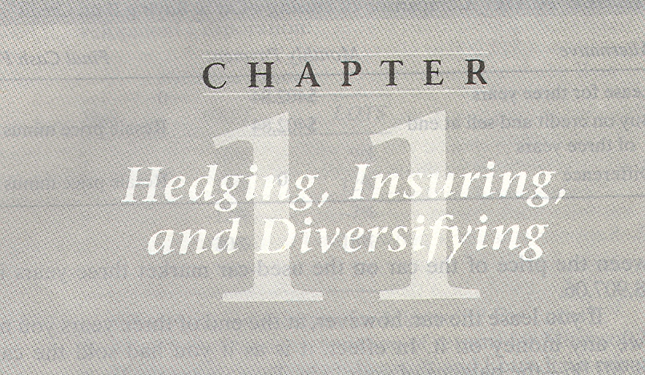

OBJECIIVES
· To explain the various methods and institutional mechanisms for the transfer of risk through the financial system by hedging,insuring,and diversifying.
· To explain how diversification can reduce the cost of insurance.

CONTENTS
11.1 Using Forward and Futures Contracts to Hedge Risk
11.2 Hedging Foreign-Exchange Risk With Swap Contracts
11.3 Hedging Shortfall Risk by Matching Assets to Liabilities
11.4 Minimizing the Cost of Hedging
11.5 Insuring versus Hedging
11.6 Basic Features of Insurance Contracts
11.7 Financial Guarantees
11.8 Caps and Floors on Interest Rates
11.9 Options as Insurance
11.10 Diversification Principle
11.11 Diversification and the Cost of Insurance

In the previous chapter we said that there are three ways of transferring risk to others: hedging, insuring, and diversifying. The purpose of this chapter is to give you a more detailed and concrete understanding of all three methods and how they are used in practice.
One is said to hedge a risk when reducing one's exposure to a loss entails giving up the possibility of a gain. Thus, farmers who sell their future crops at a fixed price in order to eliminate the risk of a low price at harvest time give up the possibility of profiting from higher prices at harvest time. Financial markets offer a variety of mechanisms for hedging against the risks of uncertain commodity prices, stock prices, interest rates, and exchange rates. In this chapter we explore the use of derivatives and the matching of assets to liabilities in order to hedge market risks.
Insuring means paying premium (the price paid for the insurance) to avoid losses. By buying insurance, you substitute a sure loss (the premium you pay for the policy) for the possibility of a larger loss if you do not insure.
In addition to insurance policies, there are other types of contracts and securities not usually called insurance that serve the same economic function of providing compensation for losses. A common example is a credit guarantee, which insures creditors against losses stemming from a debtor's failure to make promised payments. Option contracts are another means for insuring against losses. This chapter explores these different contractual mechanisms for insuring against risk.
Finally, diversifying is the pooling and sharing of risks. Diversifying your portfolio of stocks means splitting your investment among several stocks rather than concentrating it all unjust a single stock. The volatility oaf diversified portfolio is generally less than the volatilities of each of its individual components. In this chapter we will explore the way diversification works to reduce volatility and the cost of insurance.

11.1 USING FORWARD AND FUTURES CONIRACTS TO HEDGE RISK
Anytime two parties agree to exchange some item in the future at a prearranged price they are entering into a forward contract. Often people enter into forward contracts without knowing that is what they are called.
For example, you may be planning a trip from Boston to Tokyo a year from now. You make your night reservations now, and the airline reservation clerk tells you that you can either lock in a price of $1,OOO now or you can pay whatever the price may be on the day of your night. In either case payment will not take place until the day of your night. If you decide to lock in the $1,OOO price, you have entered into a forward contract with the airline.
In entering the forward contract you eliminate the risk of the cost of your airfare going above $1,000.If the price of a ticket turns out to be $1500 a year from now, you will be happy that you had the good sense to lock in a forward price of $1,000.On the other hand, if the price turns out to be $500 on the day of your night, you will still have to pay the $1,000 forward price to which you agreed. In that case, you will regret your decision.
The main features of forward contracts and the terms used to describe them are as follows:
·Two parties agree to exchange some item in the future at a price specified now-the forward price.
·The price for immediate delivery of the item is called the spot price.
·No money is paid in the present by either party to the other.
·The face value of the contract is the quantity of the item specified in the contract times the forward price.
·The party who agrees to buy the specified item is said to take a long position, and the party who agrees to sell the item is said to take a short position.
A futures contract is essentially a standardized forward contract that is trade on some organized exchange. The exchange interposes itself between the buy and the seller, so that each has a separate contract with the exchange. Standardization means that the terms of the futures contract (e.g., quantity and quality of to the item to be delivered, etc.) are the same for all contracts.
Forward contract can often reduce the risks faced by both the buyer and the seller: Let us illustrate how with a detailed example.
Suppose a farmer has planted her fields with wheat. It is now a month before harvest time, and the size of the farmer's crop is reasonably certain. Because a lard fraction of the farmer's wealth is tied up in her wheat crop, she may want to eliminate the risk associated with uncertainty about its future price by seeing it now at a fixed price for future delivery.
Let's also suppose that there is a baker who knows that he will need wheals month from now to produce bread. The baker has large fraction of his wealth tied up in his bakery business. Like the farmer, the baker is also faced with uncertainty about the future price of wheat, but the way for him to reduce the price risk is to buy wheat now for future delivery. Thus, the baker is a natural match for the farmer, who would like to reduce her risk by selling wheat now for future delivery.
The farmer and the baker, therefore, agree to a certain forward price that baker will pay the farmer at the time of delivery.
The forward contract stipulates that the farmer will deliver a specified quantity of wheat to the baker at the forward price regardless of what the spot price turns out to be at the delivery date.
Let's put some actual quantities and prices into our example to see how forward contracts work. Suppose that the size of the farmer's wheat crop is 100.000 bushels and that the forward price for delivery a month from now is $2 per bushel. The farmer agrees to sell her entire crop to the baker with delivery a month form now at $2 per bushel. At that time, the farmer will deliver 100,OOO bushels of wheat to the baker and receive $200,000 in return. With an agreement such as this, both parties eliminate the risk associated with the uncertainty about the spot price of wheat at the delivery date. They are both hedging their exposures.
Now let us consider why it is convenient to have standardized futures contracts for wheat that are traded on exchanges instead of forward contracts. The forward contract in our example calls for the farmer to deliver wheat to the baker on the contract delivery date. However, it can be difficult for a farmer to find a baker who wants to buy wheat at the time and place that are most convenient to the farmer. Similarly, it may be difficult for the baker to find a farmer who wants to sell wheat at the time and place that are most convenient to the baker.
For example, suppose that the farmer and the baker are separated by a great distance, for example, the farmer might be located in Kansas and the baker in New York. The baker usually buys wheat from a local supplier in New York and the farmer usually sells her wheat to a local distributor in Kansas. By using wheat futures contracts, the farmer and the baker can retain the risk-reducing benefits of the forward contract (and save paying costs to transport wheat) without having to change their usual supplier and distributor relationships.
The futures exchange operates as an intermediary matching buyers and sellers. Indeed, the buyer of a wheat futures contract never knows the identity of the seller because the contract is officially between the buyer and the futures exchange. Similarly, the seller never knows the identity of the buyer. Only a small fraction of the wheat futures contracts traded on the exchange result in actual delivery of wheat. Most of them are settled in cash.
Let us illustrate how this works in the case of the farmer and the baker. Instead of entering a forward contract calling for the farmer in Kansas to deliver her wheat to the baker in New York at a delivery price of $2 per bushel, there are two separate transactions. The farmer and baker each enter a wheat futures contract with the futures exchange at a futures price of $2 per bushel. The farmer takes a short position; the baker takes a long position, and the exchange matches them. In a month's time, the farmer sells her wheat to her normal distributor in Kansas, and the baker buys his wheat from his normal supplier in New York at the spot price. They settle their futures contract by paying to (or receiving from)the futures exchange the difference between the $2 per bushel futures price and the spot price multiplied by the quantity specified in the contract(100,OOO bushels). The future exchange transfers the payment from one party to the other.
Let us further illustrate how this all works step by step with the help of Table 11.1. Consider first the farmer, whose situation is shown in the top panel. To hedge her exposure to the price risk, she takes a short position in a one-month wheat futures contract for 100,OOO bushels at a futures price of $2 per bushel.
Table 11.1 illustrates what happens at three different spot prices on the delivery date: $150, $2.00, and $250 per bushel. If the spot price of wheat turns out to be $150 per bushel a month from now (column 1), the fainter’s proceeds from the sale of wheat to the distributor in Kansas are $150,000. However, she gains $50,OOO from her futures contract. Thus, her total receipts are $200,000.
If the spot price turns out to be $2.OO per bushel (column 2), the farmer's proceeds from the sale other wheat to the distributor in Kansas are $200,000, and there is no gain or loss on the futures contract. If the spot price turns out to be $2.50 per bushel, the farmer receives $250,OOO from the sale of her wheat to the distributes Kansas but loses $50,000 on the futures contract. Her total receipts are then $200,000.
Thus, no matter what the spot price of wheat turns out to batch farmer winds up with total receipts of $200,OOO from the combination of selling her wheat to the distributor in Kansas and her short position in the wheat futures contract.
The bottom panel of Table 11.1 shows the situation of the baker. A month from now the baker buys wheat from his supplier in New York at the spot price. If the spot price is $150 per bushel (column 1), the baker pays only $150,OOO to the supplier for the wheat but also loses $50,OOO on his wheat futures contract. His total outlay, therefore, $200,000. If the spot price is $2.OO per bushel (column 2), the baker pays the supplier $200,000, and there is no gain or loss on the futures contract. If the spot price is $250 per bushel (column 3), the baker pays the supplier $250,000 for wheat but gains $50,OOO on his futures contract, thus making his total outlay $200,000.
To better understand Table 11.1 consider what would happen without the future contract. If the spot price of wheat turns out to be $150 per bushel, then the farmer receives and the baker pays $150,000. If the spot price turns out to be $2.50, then the farmer receives and the baker pays $250,000. But with the futures contract, no matter what the spot price turns out to be,the farmer receives and the baker pays a total of $200,000. Because both parties know for certain what they will get and what they will pay out, the futures contract has eliminated the risk posed by price uncertainty.
Figure 11.1 displays the same information that is contained in the top pass Table 11.1.It shows the total cash flows to the farmer from selling her wheat and the futures contract combined for any spot price on the delivery date.

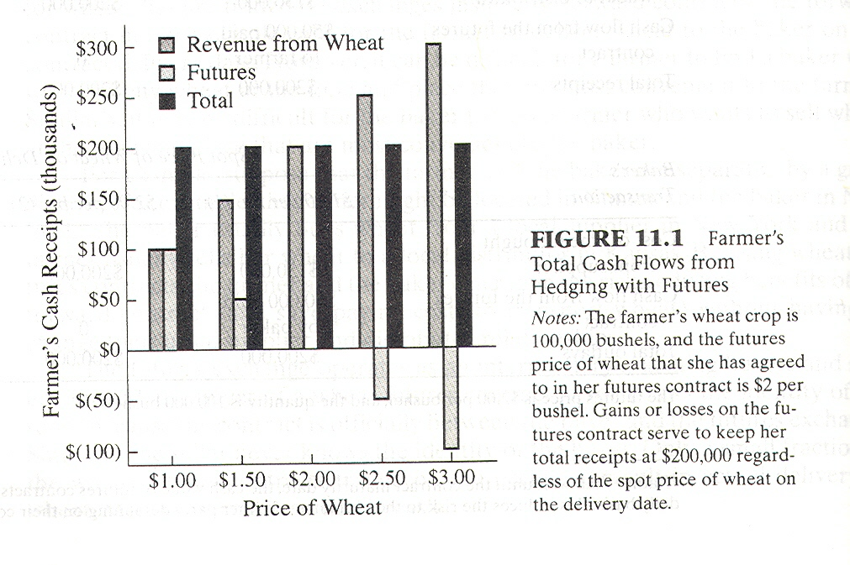

Figure 11.1 illustrates that no matter what the spot price of wheat turns out to be on the delivery date, the farmer will wind up with $200,000.
To summarize, the farmer is able to eliminate the price risk she faces from owning the wheat by taking a short position in a futures contract, effectively selling the wheat for future delivery at the futures price. The baker too is able to eliminate the price risk he faces by taking a long position in the futures market for wheat, effectively buying wheat for future delivery at a fixed price. Futures contracts make it possible for both the farmer and the baker to hedge their exposure to price risk while continuing their normal relationships with distributors and suppliers.
The example of the farmer and the baker illustrates three important points about risk and risk transfer:
Whether a transaction is risk reducing or rook increasing depends on the particular context in which it is undertaken.
Transactions in futures markets are sometimes characterized as being very risky. But for the farmer, whose wealth is tied up in the business of growing wheat, taking a short position in a wheat futures contract is risk reducing. For the baker, whose wealth is tied up in the business of baking bread, taking a long position in a wheat futures contract is risk reducing.
Of course, for someone who is not in the business of either growing wheat or producing products that require wheat as an input, taking a position in wheat futures might be risky. Thus, the transaction of buying or selling wheat futures should not be characterized as risky in the abstract. It may be risk reducing or risk increasing depending on the context.
Both parties to a risk-reducing transaction can benefit by it even though in retrospect it may seem as if one oftheparties has gained at the expense of the other.
When entering the futures contract, neither the farmer nor the baker knows whether the price of wheat will turn out to be greater or less than $2.OO per bushel. By entering the futures contract, they both achieve a reduction in risk and are thereby both made better off. In a month's time, if the spot price of wheat is different from $2.00, one of them will gain and the other will lose on the futures contract. But that does not alter the fact that they were both made better off by entering the contract when they did.
Even with no change in total output or total risk, redistributing the way the risk is borne can improve the welfare of the individuals involved.
This last point is related to the second. From a social perspective, the total quantity of wheat produced in the economy is not directly affected by the existence of the futures contract between the farmer and the baker. It might, therefore, appear as though there is no gain in social welfare from the existence of futures contracts.
However, as we have seen, by allowing both the farmer and the baker to lower their exposure to price risk, the futures contract improves their welfare.
Using futures contracts to hedge commodity price risk has a long history. The earliest known futures markets came into existence in the Middle Ages to meet the needs of farmers and merchants. Today many organized futures exchanges exist around the world not only for commodities (such as grains, oilseeds, livestock, meat, metals, and petroleum products)but also for a variety of financia1 instruments(such as currencies, bonds, and stock market indexes). The futures contracts traded on these exchanges allow businesses to hedge against commodity-price risk, foreign exchange risk, stock market risk, and interest-rate risk and the list is constantly expending to include other sources of risk.

11.2 HEDGING FOREIGN-EXCHANGE RISK WITH SWAP CONTRACTS

A swap is another type of contract that facilitates the hedging of risks. A swaps contract consists of two parties exchanging (or “swapping”) a series of cash flows at specified intervals over a specified period of time. The swap payments are base on an agreed principal amount (the notional amount). There is no immediate pea’s of money and, hence, the swap agreement itself provides no new funds to either party.
In principle, a swap contract could call for the exchange of anything. In current practice, however, most swap contracts involve the exchange of return on commodities, currencies, or securities.
Let's look at how a currency swap works and how it can be used to hedge risk. Suppose that you have a computer software business in the United State, and a German company wants to acquire the right to produce and market your software in Germany. The German company agrees to pay you 100,OOO marks (DM100,000) each year for the next 10 years for these rights.
If you want to hedge the risk of fluctuations in the dollar value of your expected stream of revenues (due to fluctuations in the dollar/mark exchange rate), you can enter a currency swap now to exchange your future stream of marks for a future stream of dollars at a set of forward exchange rates specified now.
The swap contract is therefore, equivalent to a series of forward contract. The notional amount in the swap contract corresponds to the face value of the implied forward contracts.
To illustrate with numbers, suppose the dollar/mark exchange rate is currently $0.50 per mark and that that exchange rate also applies to all forward contracts covering the next 10 years. The notional amount in your swap contract is 100,000 marks per year. By entering the swap contract, you lock in a dollar revenue of $50 per year(DM100,000 × $0.50 per DM). Each year on the settlement date you will receive (or pay) an amount of cash equal to 100,OOO marks times the difference between the forward rate and the actual spot rate at that time.
Thus, suppose that one year from now on the settlement date, the spot rate of exchange is $0.40 per mark. The party on the other side of your swap contract, called the counterparty (the German company in our example),is obliged to pay you 100,OOO times the difference between the $0.50 per mark forward rate and the $0.40 per mark spot rate (i.e., $10,000).
Without the swap contract, your cash revenues from the software license agreement would be $40,000 (100,OOO times the spot rate of $0.40 per mark). But with the swap contract, your total revenues will be $50,000; You receive DM 100,OOO from the German company, which you sell to get $40,000,and you receive another $10,OOO from the counterparty to your swap contract.
Now suppose that in the second year on the settlement date, the spot rate of exchange is $0.70 per mark. You will be obliged to pay the counterparty to your swap agreement 100,000 times the difference between the $0.70 per mark spot rate and the $0.50 per mark forward rate, i.e., $20,000. Without the swap contract your cash revenues from the software license agreement would be $70,000 (100,000 times the spot rate of $0.70 per mark). But with the swap contract, your total revenues will be $50,000. Thus, in the second year, you will probably wish that you did not have the swap contract. (But the possibility of giving up potential gains in order to eliminate potentia1 losses is the essence of hedging.)
The international swap market began in the early 1980s and has grown rapidly. In addition to currency and interest-rate swaps, many other items can be and are exchanged through swap agreements, for example, returns on deferent stock indexes, and even bushels of wheat for barrels of oil.

11.3 HEDGING SHORTFALL RISK BY MATCHING TO LIABILITIES

As we saw in chapter 2, insurance companies and other financial intermediaries that sell insured savings plans and other insurance contracts need to assure their customers that the product they are buying is free of default risk. One way to assure customers about the risk of contract default is for insurance companies to hedge their liabilities in the financial markets by investing in assets that match the characteristic of their liabilities.
For example, suppose that an insurance company sells a customer a guaranteed investment contract that promises to pay $1,OOO five years from now for a one- time premium today of $783.53.(This implies that the customer is earning an interest rate of 5% per year.) The insurance company can hedge this customer liability by buying a default-free zero-coupon bond with a face value of $1,000 issued by the government.
The insurance company is matching assets to liabilities. In order to earn a profit on this set of transactions, the insurance company has to be able to buy the five-year government bond for less than $783.53.(In other words, the interest rate on the five-year government bond must be greater than 5% per year.)If instead of hedging its liability by buying a bond, the insurance company invests the premium in a portfolio of stocks, then there will be a risk of a shortfall-the value of the stocks in five years may turn out to be less than the $1,OOO promised to the customer.
Many financial intermediaries pursue hedging strategies that involve matching their assets to their liabilities. In each case objective is to reduce the risk of a shortfall. The nature of the hedging instrument varies with the type of customer liability.
Thus, if a savings bank has customer liabilities that are short-term deposits earning an interest rate that floats, the appropriate hedging instrument is a floating-rate bond, or a strategy of “rolling over” short-term bonds. Another way the bank might hedge its floating-rate deposit inabilities is to invest in long-term fixed-rate bonds and enter into a swap contract to swap the fixed rate it receives on its bonds for a floating rate.

11.4 MINIMIZING THE COSI OF HEDGING

As just noted, there is often more than one mechanism for hedging risk available to a decision maker. When there is more than one way to hedge risk, a rational manager will choose the one that costs the least.
For example, suppose that you live in Boston and are planning to move to Tokyo a year from now for an extended visit. You have found a wonderful apartment there and have agreed to buy it for 10.3 million yen, which you will pay to the apartment's current owner at the time you move in. You have just sold your condominium in Boston for $100,000, and plan to use that money to pay for the apartment in Tokyo. You have invested the money in one-year U.S.Treasury bills at an interest rate of 3%, so you know that you will have $103,OOO a year from now.
The dollar/yen exchange rate is currently $0.01 per yen (or 100 yen per dollar).If it remains unchanged for a year, you will have exactly the 10.3 million yen you need to pay for the Tokyo apartment a year from now. But you discover the past year the dollar/yen exchange rate has fluctuated quite a bit. It was as low as $0.008 per yen and as high as $0.011. You are, therefore, concerned that, one year from now, your $103,000 may not buy enough yen to pay for the Tokyo apartment.
If the exchange rate is $0.008 per yen in a year, you will receive 12.875 million yen you’re your $103000($103000/$0.008 per yen) enough to buy the apartment and some nice furnishings. If, however, the exchange rate is $0.012 per yen a year from now, then you will get only 8.583 million yen ($103000/$0.012 per yen), and you will be 1.717 million yen short of the purchase price you agreed to a year earner.
Suppose that there are two ways you can eliminate your exposure to the risk of a rise in the dollar price of the yen. One way is to get the owner of the Tokyo apartment to sell it to you for a price fixed in U.S. dollars. The other way is by entering a forward contract for yen with a bank.
Let us compare the costs to you of the two methods of hedging the foreign-exchange risk. Suppose that in our example the bank's forward price is $0.01 per yen. Then by entering into a forward contract with the bank to exchange your $103,000 in a year at $0.01 per yen, you can completely eliminate your risk. No matter what happens to the dollar/yen exchange rate over the next year, you will the 10.3 million yen you need to buy your apartment in Tokyo one year from now.
Now consider the other alternative of negotiating a fixed price in U.S. dollars with the owner of the apartment. If the owner of the Tokyo apartment is will to sell you the apartment for a dollar price less than $103,000, then that is a better deal than entering into a forward contract with the bank.
On the other hand, if the owner of the Tokyo apartment demands a dollar price higher than $103,000, then you are better off setting the price in yen (10.3 million yen) and entering into a forward contract with the bank to exchange the yen for dollars at the forward price of $0.01 per yen. You also have to consider the transaction costs (broker fees, the amount of time and effort involved, etc.) associated with each method of hedging the risk.
The important point to recognize in this example is that the mechanism mechanism chosen to implement the hedge should be the one that minimizes the cost of achieving the desired reduction risk.

11.5 ENSURING VERSUS HEDGING

There is a fundamental difference between insuring and hedging. When you hedge, you eliminate the risk of loss by giving up the potential for gain. When you insure, you pay a premium to eliminate the risk of loss and retain the potential for gain.
Let us return to an earlier example to clarify the difference between insuring and hedging. You are planning a trip from Boston to Tokyo a year from now. You make your night reservations now, and the airline reservation clerk tells you that you can either lock in a price of $1,OOO now, or you can pay whatever the price turns out be on the day of your night. If you decide to lock in the $1,OOO price, you have hedged against the risk of loss. It costs you nothing to do so, but you have given up the possibility of paying less than $1,OOO for your night a year from now.
Alternatively, the airline may offer you the possibility of paying $20 now for the right to purchase your ticket a year from now at a price of $1,000.By buying this right you have insured that you will pay no more than $1,000 to fly to Tokyo. If the price should turn out to be more than $1,OOO a year from now, you will exercise this right; otherwise you will let it expire. By paying $20 you have purchased insurance against the risk that you will have to pay more than $1,OOO for the ticket and, thus, you have insured that the total cost to you will not exceed $1,020 ($1,OOO for the ticket plus $20 for the insurance).
Earlier we discussed a farmer who has wheat to sell in another month. The size of the farmer's wheat crop is100,OOO bushels, and the forward price for delivery a month from now is $2 per bushel. If the farmer hedges with a short position in a forward contract for 100,OOO bushels, she will receive $200,OOO a month from now regardless of what the price of wheat turns out to be on the delivery date.
Instead of taking a short position in the forward market, however, she can buy insurance that guarantees a minimum price of $2 per bushel. Say the insurance costs $20,000. Then, should the price of wheat turn out to be higher than $2.OO per bushel, the farmer will simply not need to use the insurance, and the policy will expire. If however, the price should turn out to be less than $2.OO per bushel, the farmer will collect on her insurance and wind up with $200,000 less the cost of the insurance or $180,000.
Figure 11.2 illustrates the difference between the farmer's revenues a month from now under three different alternative courses of action: (1) taking no measures to reduce her exposure to price risk, (2)hedging with a forward contract, and (3)insuring.
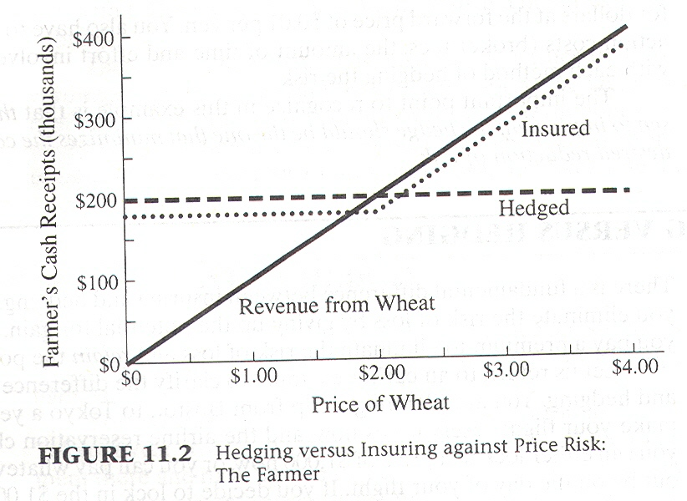

Note that by insuring, the farmer retains much of the economic benefit of an increase in the price of wheat while eliminating the downside risk. This benefit comes at the cost of paying a premium for the insurance.

Note that none of the three alternatives depicted in Figure 11.2 is supervise the others under all circumstances. Of course, it would never pay to buy the isle acne if the future price were known with certainty.
Thus, if the farmer knew for sure that the price was going to be higher than $2.OO per bushel, she would choose not to reduce her risk exposure at all (dizzy tive1).If she knew the price was going to be lower than $2.OO per bushel, she would sell forward at $2.00(alternative2). But the essence of the farmer's risk-management problem is that she does not know in advance what the price will be.

11.6 BASIC FEATURES OF INSURANCE CONTRACTS
In discussing insurance contracts and understanding how to use them to manage risk, it is important to understand some basic terms and features. Four of the most important features of insurance contracts are exclusions, caps, deductibles, and co-payments. Let us briefly explain each.

11.6.1 Exclusions and Caps
Exclusions are losses that might seem to meet the conditions for coverage under the insurance contract but are specified excluded. For example, life insurance policies pay benefits if the insured party dies, but such policies typically exclude payment of death benefits if the insured person takes his own life. Health insurance policies may exclude from coverage certain illnesses the insured party had before the policy was purchased. Thus, a health insurance policy may state that it excludes coverage for preexisting medical conditions.
Caps are limits placed on compensation for particular losses covered under an insurance contract. Thus, if a health insurance policy is capped at$1 million, it means the insurance company will pay rely more than this amount for the treatment of an illness.

11.6.2 Deductibles
Deductible is an amount of money that the insured party must pay out of his or her own resources before receiving any compensation from the insurer. Thus if your automobile insurance policy has a $1,OOO deductible for damage due to accidents, you must pay the first $1,OOO in repair costs and the insurer will only pay for the amount in excess of $1,000.
Deductibles create incentives for insured parties to control their losses. People with automobile insurance who have to pay the first $500 of repair costs out of their own pockets tend to drive more carefully than drivers with no deductibles. However, this incentive to control losses disappears once the loss exceeds the deductile amount.

11.6.3 Copayments
A copayment feature means that the insured party must cover a fraction of the loss. For example, an insurance policy might stipulate that the copayment is 20% of any loss, and the insurance company pays the other 80%.
Copayments are similar to deductibles in that the insured party winds up paying part of the losses. The difference is in the way the partial payment is computed and in the incentives created for the insured party to control losses.
Take the case of a health insurance policy that covers visits to the physician. With a copayment feature, the patient must pay part of the fee for each visit. If the policy had a $1,000 deductible instead of a copayment feature, the patient would pay the entire cost of all visits until the $1,OOO deductible was met and then north in for additional visits. Thus, the deductible feature does not create any incentive for patients to forgo additional visits once the $1,OOO deductible is met; a copayment feature does. Insurance policies can contain both deductibles and copayments.

11.7 FINANCIAL GUARANTEES

Financial guarantees are insurance against credit risk, which is the risk that the other party to a contract into which you have entered will default. A loan guarantee is a contract that obliges the guarantor to make the promised payment on a loan if the borrower fails to do so. Loan guarantees are pervasive in the economy, play, in a critical role in facilitating trade.
For example, consider credit cards, which in today's world have become a principal means of payment by consumers. Banks and other issuers of credit cards guarantee to merchants that they will stand behind all customer purchases made with their credit cards. Credit card issuers thus provide merchants with insurance against credit risk.
Banks, insurance companies, and on occasion, governments offer guarantees on abroad spectrum of financial instruments ranging from credit cards to interest-rate and currency swaps. Parent corporations routinely guarantee the debt obligations of their subsidiaries. Governments guarantee residential mortgages, farm and stud loans, loans to small and large business firms, and loans to other governments. Governments sometimes serve as the guarantor of last resort, guaranteeing the promises made by guarantors in the private sector such as banks and pension funds. However, in cases in which the credit standing of a governmental organization is in doubt, private vote sector organizations have been called upon to guarantee the government's debts.

11.8 CAPS AND FLOORS ON INTEREST RATES

Interest-rate risk depends on one's perspective-whether you are a borrower or a lender. For example, suppose you have $5,OOO on deposit in a bank money market account in which the interest rate you earn is adjusted on a daily basis to reflect current market conditions. From your perspective as a depositor (i.e., a lender), interest risk is the risk that the interest rate will fall. An interest-rate insurance policy for you would take the form of an interest-rate floor, which means a guarantee of a minimum interest rate.
But suppose that you are a borrower. For example, suppose that you just bought arouse and took a $100,OOO adjustable-rate mortgage loan from a bank. Suppose the mortgage interest rate you pay is tied to the one-year U.S. Treasury bill rate. Then from your perspective, interest-rate risk is the risk that the interest rate will rise. An interest-rate assurance policy for you would take the form of an interleafed cap, which means a guarantee of a maximum interest rate.
Most adjustable-rate mortgage loans (ARMs) made in the United Stated during the 1980s and 1990s contain interest-rate caps. Often the cap takes the form of a maximum amount that the mortgage interest rate can rise in any one-year period and then there may also be a global cap on the interest rate for the life of the mortgage loan.

11.9 OPTIONS AS INSURANCE

Options are another ubiquitous form of insurance contract. An option is the right to either purchase or sell something at a fixed price in the future. As we saw before in the case of the airline ticket, the purchase of an option to reduce risk is insuring against loss. An option contract is to be distinguished from a forward contract, which is the obligation to buy or sell something at a fixed price in the future.
Any contract that gives one of the contracting parties the right to buy or sell something at a prespecified exercise price is an option. There are as many different kinds of option contracts as there are items to buy or sell: commodity options, stock options, interest rate options, foreign-exchange options, and so on. Some kinds of option contracts have standardized terms and are traded on organized exchanges such as the Chicago Board Options Exchange in the United States or the Osaka Options and Futures Exchange in Japan.
There is a special set of terms associated with option contracts:
·An option to buy the specified item at a fixed price is a call; an option to sell is a put.
·Ice fixed price specified in an option contract is called the option's strike price
or exercise price.
·The date after which an option can no longer be exercised is called its expiration date or maturity date.
If an option can only be exercised on the expiration date only, it is called a European-type option. If it can be exercised at any time up to and including the expiration date it is called an American-type option.

11.9.1 Put Options on Stocks
Put options on stocks protect against losses from a decline in stock prices. For example, consider Lucy, a manager working for XYZ Corporation. Suppose that she has received shares of XYZ stock as compensation in the past and now owns 1,000 shares. The current market price of XYZ is $100 per share. Let us consider how she can insure against the risk associated with her shares of XYZ stock by buying XYZ put options.
An XYZ put option gives her the right to sail a share of XYZ stock at a fixed exercise price, thus insuring her that she will receive at least the exercise price at the option's expiration date. For example, she can buy XYZ puts at an exercise price of $100 per share expiring in l year. Say the current price of a one-year European-style put on a single share of XYZ with a $100 exercise price is $10. Then the premium she must pay to insure her 1,OOO shares foxy(currently worth $100,000)for the year is $10,000.
Buying put options on a stock portfolio is similar in many respects to buying term insurance on an asset such as a house or a car. For example, suppose that in addition to her shares of XYZ, Lucy owns an apartment in a condominium complex. The apartment's market value is $100,000. Although she cannot buy a put option on her apartment to protect her against a decline in its market value, she can buy insurance against losses of certain types. Suppose sic buys a one-year fire insurance policy with a $100,OOO cap for $500.
Table 11.2 summarizes the analogy between a put option and a term insurance policy. The insurance policy provides Lucy with protection against losses in the value of her apartment that stem from fire for a period of one year. The put option provides her with protection against losses in the value of her XYZ stocks that stem from a decline in their market price for a period of one year.
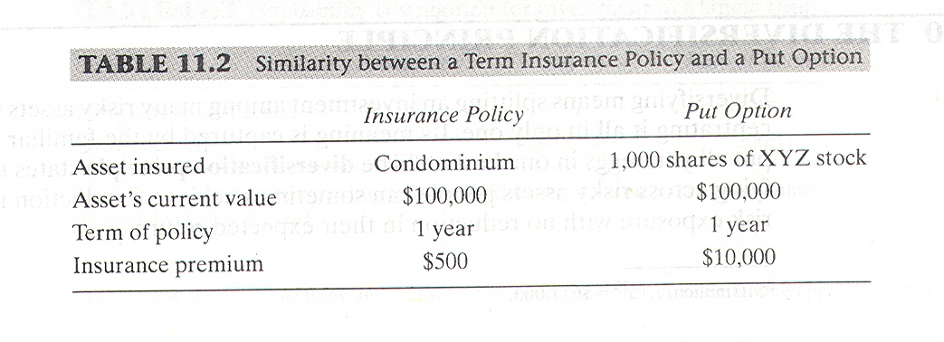

Lucy can lower the cost of her fire insurance by having a deductible. For example, if Lucy's fire insurance policy has a deductible of $5,000, then she has to pay the first $5,OOO of any losses, and the insurance company compensates her only losses in excess of $5,000. Analogously, Lucy can lower the cost of the insurance on her XYZ stock by choosing puts with a lower exercise price. If the current t price is $100, and Lucy buys puts with an exercise price of $95, then she must absorbs the first $5 per share of any loss resulting from a stock price decline. By choosing a put with a lower exercise price, she increases the deductible and lowest cost of the insurance.

11.9.2 Put Options on Bonds
As we saw in chapter8, even when bonds are free of default risk, their prices can fluctuate substantially as a result of changes in interest rates. When bonds are subject to default risk, then their prices can change cither because of changes in the level of risk-free interest rates or changes in the possible losses to bondholders from default. A put option on a bond, therefore, provides insurance against losses stemming from either source of risk.
For example, consider hypothetical 20-year zero-coupon bonds issue by Risky Realty Corporation. The bonds are secured by the fictitious firm’s assets, which consist of apartment houses in various cities in the northeastern part of United States. The firm has no other deities face value of the bonds is $10 million and the value of the firm's real estate holdings is currently $15 million.
The market price of the bonds reflects both the current level of risk-free interest rates, say 6% per year, and the market value of the real estate securing the bonds. Suppose that the yield to maturity on the bonds is 15% per year. Then the current market price of the bonds is $ 611,003.
Suppose that you buy a one-year put option on the bonds with an exercise price of $600,000. Then if the bond's price falls either because the level of risk-free interest rates rises during the year (say from 6% per year to 8% per year)or because the value of the apartment houses securing the bonds falls (say from $15 million to $8 million),you are guaranteed a minimum price of $600,OOO for the bonds.

11.10 THE DIVERSIFICATION PRINCIPLE

Diversifying means splitting an investment among many risky assets instead of concentrating it all in only one. Its meaning is captured by the familiar saying: “Don’t put all your eggs in one basket.” The diversification principle states that by diversifying across risky assets people can sometimes achieve a reduction in their overall risk exposure with no reduction in their expected return.

11.10.1 Diversification with Uncorrelated Risks
To clarify how portfolio diversification can reduce your total risk exposure, let us return to an example introduced in chapter 10, in which risks were uncorrelated with each other. You are thinking about investing $100,OOO in the biotechnology business because you believe that the discovery of new genetically engineered drugs offers great profit potential over the next several years. For each drug you invest in, success means that you will quadruple your investment, but failure means a loss of your entire investment. Thus if you invest $100,000 in a single drug, either you wind up with $400,OOO or nothing.
Assume there is a .5 probability of success for each drug and a .5 probability of failure. Table 11.3 shows the probability distribution of final payoffs and rates of return on an investment in a single drug.
If you diversify by investing $50,000 in each of two drugs, there is still a chance of winding up with either $400,000(if both drugs succeed) or nothing (if both drugs fail).However, there is also the intermediate possibility that one drug succeeds and the other fails. In that event, you will wind up with $200,000(four times your investment of $50,000 in the drug that succeeds and zero from the drug that fai1s.
Thus, there are now four possible outcomes and three possible payoffs:
1. Both drugs succeed, and you receive $400,000
2. Drug 1 succeeds and drug 2 doesn’t, so you receive $200,000.
3. Drug 2 succeeds and drug 1 doesn’t, so you receive $200,OOO.
4. Both drugs fail, and you receive nothing.
Thus, by diversifying and holding a portfolio of two drugs you reduce the probability of losing your entire investment to only one-half of what it would be without diversification. On the other hand, the probability of winding up $400,OOO has fallen from .5 to .25. The other two possible outcomes result hour receiving $200,000. The probability of this happening is .5(computed as 2×.5×.5). Table 11.4 summarizes the probability distribution of payoffs facing you if you split your investment between two drugs.
$E(x)=\sum_{i=1}^{n}{p_{i}X_{i}}$Now let us look at this probability distribution of payoffs in terms of expected payoffs and standard deviations. The formula for the expected payoff is:

Expected Payoff =Sum of (Probability of Payoff) × (Possible Payoff)
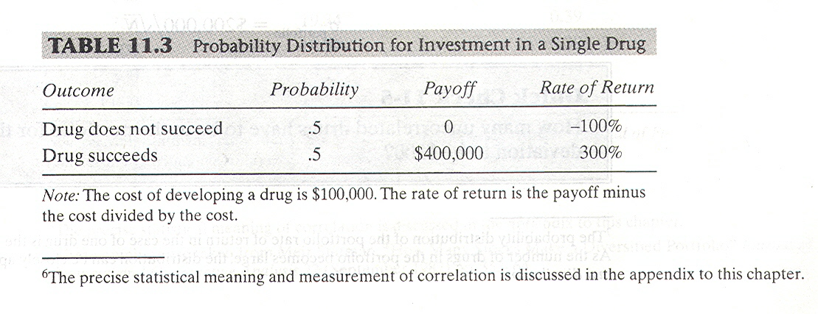

Applying this formula to the case of a single drug, we find:
Expected Payoff =.5 × 0+.5 × $400,000=$200,000
The formula for standard deviation is:
Standard Deviation (σ)=Square Root of the Sum of (Probability)(Possible Payoff-Expected Payoff)²
Applying this formula to the case of a single drug, we find:
σ =Square Root of [(5)(0 - $200,000)2+(5)($400,000 - $200,000)2] σ =$200,000
For the case of a portfolio of two uncorrelated drugs, we find:
Expected Payoff =.25 × 0+.5×$200,000+.25×$400,000
Expected Payoff =$200,000
σ =Square Root of [(.25)( 0-$200,000)²+(.5)($200,000 - $200,000)+(.25)($400,000 - $200,000)]
σ =$200,000/1.414=$141,421
Heathen we diversify between two uncorrelated drugs the expected payoff remains $200,000, but the standard deviation falls by factor of l/1.414 from $200.000 to $141,421. The standard deviation of the rate of return falls from 200% t0 141.4%.
Now consider what happens to the expected payoff and the standard deviation as the number of drugs in the portfolio increases even further (under the assumption that the success of each drug uncorrelated with the success of the others). The expected payoff stays the same, but the standard deviation declines in proportion to the square root of the number of drugs:
$σ_{\text{portfolio}}=\$\text{200},{\text{000}}/{\sqrt{N}}$

11.10.2 Nondiversifiable Risk
In our example of diversification in the previous section, we assumed that the risks were uncorrelated with each other. In practice, many important risks are posited correlated with each other. This is because they are affected by common underlying economic factors.
For example, the returns to investors who buy shares in stocks are all related to the health of the economy. An economic downturn will tend to have an adverse impact on the profits of almost all firms resulting in poor stockholder returns for aye most all stocks. Consequently, one's ability to reduce role’s exposure to stock market risk by buying many different stocks is limited.
Suppose that you buy a portfolio of stocks traded on the New York Stock Exchange. To achieve diversification you choose stocks by pasting the stock listings on a wall, blindfolding yourself, and throwing darts at them. You select those stocks that your darts land onions results in a randomly selected portfolio.
Table 11.5 and the colored curve in Figure 11.3 show the effect of increasing the number of stocks in your randomly sedated portfolio on the standard deviation of the portfolio's rate of return. In column 2 of Table 11.5, we see that the average volatility for a single randomly selected stock traded on the New York Stock Exchange is about 49.24% per year. If you selected an equally weighted portfolio of two stocks by such a random procedure, the average volatility would be about 37.36%. A three-stock portfolio would have a volatility of 29.69%, and so on.
The black curve in Figure 11.3 shows what the portfolio's volatility would be if there were zero correlation among all the stocks. Note that both the colored and black curves show that the reduction in standard deviation that comes from adding more stocks to the portfolio seems less and less significant as the number in the portfolio grows. After about 30 stocks, further reductions in the portfolio’s volatility are barely noticeable.

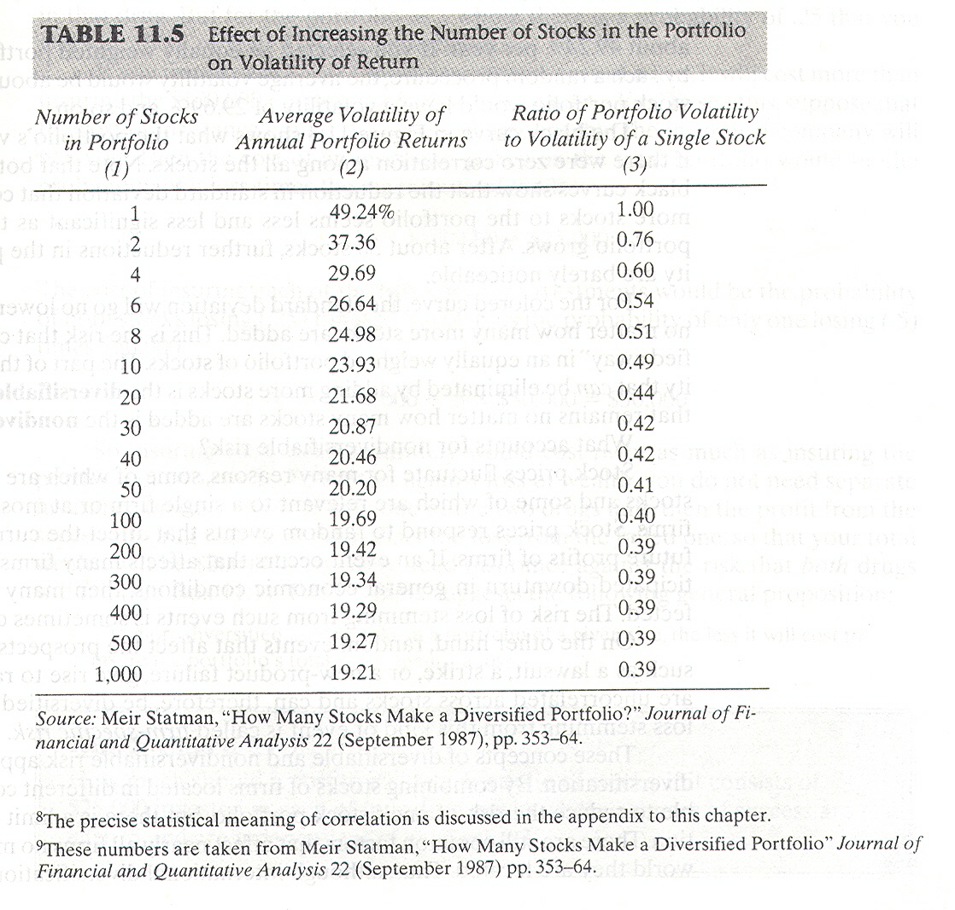

For the colored curve, the standard deviation will go no lower than about 19.2% no matter how many more stocks are added. This is the risk that cannot be “diversified away” in an away" in an equally weighted portfolio of stocks. The part of the portfolio volatility that can be eliminated by adding more stocks is the determinable risk, and the part that remains no matter how many stocks are added is the nondiversifiable risk.
What accounts for no diversifiable risk?
Stock prices fluctuate for many reasons, some of which are common to many stocks and some of which are relevant to a single firm or at most a small group of firms. Stock prices respond to random events that affect the current and expected future prints of firms. If an event occurs that affects many firms, such as an unanticipated downturn in general economic conditions, then many stocks will be affected. The risk of loss stemming from such events is sometimes called market risk.
On the other hand, random events that affect the prospects of only one firm such as a lawsuit, a strike, or a new-product failure, give rise to random loss that are uncorrelated across stocks and can, therefore, be diversified away. The risk of loss stemming from this kind of event is called firm-specific risk.
These concepts of diversifiable and nondiversifiable risk apply to international diversification. By combining stocks of firms located m different countries it is possible to reduce the risk of role’s stock portfolio, but there is a limit to this risk reduction. There are sti1l common factors that affect nearly all arms no matter where world they are located. Thus, although international diversification can improve the prospects for risk reduction for people around the world, a significant amount of risk remains for even the best-diversified global stock portfolio.

11.11 DIVERSIFICATION AND THE COST OF INSURANCE

The cost of insuring a diversified portfolio of risks against a loss is almost always less than the cost of insuring against each risk separately. To see why, let us return to the biotechnology exempt of section 11.10.1. You are investing $100,OOO in drug stocks. The success or failure of each drug is independent of the others.
Let us assume that you have decided to invest $50,OOO in each of two drug stocks and, therefore, face the probability distribution in Table 11.4.For each separate drug stock there is a probability of .5 that you will lose 100% of your investment in that drug. But for the portfolio as a whole there is a probability of .25 that you will lose 100% of your $100,000 investment.
If you insure each $50,OOO stock investment against a loss, it will cost more than insuring the $100,OOO portfolio of both stocks against a loss. To see this, suppose that the cost of insurance equals the expected amount that the insurance company will pay you. Then the cost of an Insurance policy on the total portfolio would be the probability of a loss times the magnitude of the loss:
.25 × $100,000=$25,000
The cost of insuring each of the two separate investments would be the probability of both stocks losing (.25) times $100,OOO plus the probability of only one losing (.5) times $50,000:
.25 × $100,000+.5 × $50,000=$50,000
So insuring each stock separately would cost twice as much as insuring the portfolio of two stocks. To protect against loss of wealth, you do not need separate insurance on each stock. If only one of the two drugs fails, then the profit from the successful drug will more than offset the loss from the failed one, so that your total wealth will be $200,000. You only need insurance against the risk that both drugs will fail (see Box 11.1.) his example suggests the following general proposition:
The more diversified are the risks in a portfolio of a given size, the less it will cost to insure the portfolio's total value against a loss.

Summary

- Market mechanisms for hedging risk exposures are forward and futures contracts, swaps, and matching assets to liabilities.
- A forward contract is the obligation to deliver a specified asset at a specified future delivery date at a specie price. Futures contracts arc standardize forward contracts that are traded on exchanges.
- A swap contract consists of two parties exchanging a series of payments at specified intervals over a specified period of time. A swap contract could call for the exchange of almost anything. In current practice, however, most swap contracts involve the exchange of commodities, currencies, or securities.
- Financial intermediaries such as insurance companies often hedge their customer liabilities by matching their assets to their liabilities. This is done to reduce the risk of a shortfall.
- When there is more than one way to hedge a given risk exposure, the mechanism chosen should be the one that minimizes the cost of achieving the desired reduction of risk.
- There is a fundamental difference between insuring and hedging. When you hedge, you eliminate the risk of loss by giving up the potential for gain. When you insure, you pay a premium to eliminate the risk of loss and retain the potential for gain.
- Put options on stocks protect against losses from a decline in stock price.
- Financial guarantees act as insurance against credit risk. Interest-rate floors and caps offer insurance against interest--rate risk to lenders and borrowers, respectively. A put option on a bond offers the bondholder insurance against both default risk and interest-rate risk.
- The more diversified are the risks in a portfolio of a given size, the less it will cost to insure the portfolio against a loss.

