NOVEL CUTANEOUS HUMAN PAPILLOMAVIRUSES AND BIOMARKERS IN SKIN LESIONS

Nataša Vasiljević

DOCTORAL THESIS

With permission of the Medical Faculty of Lunds University, to be presented for public examination at the Pathology lecture hall, Entrance 78, University Hospital Malmö, on Tuesday, May 20th 2008, at 9.15 am

FACULTY OPPONENT

Professor Lutz Gissmann
Deutsches Krebsforschungszentrum
Heidelberg, Germany

Department of Laboratory Medicine, Division of Medical Microbiology, Malmö University Hospital, Lund University, Sweden, 2008

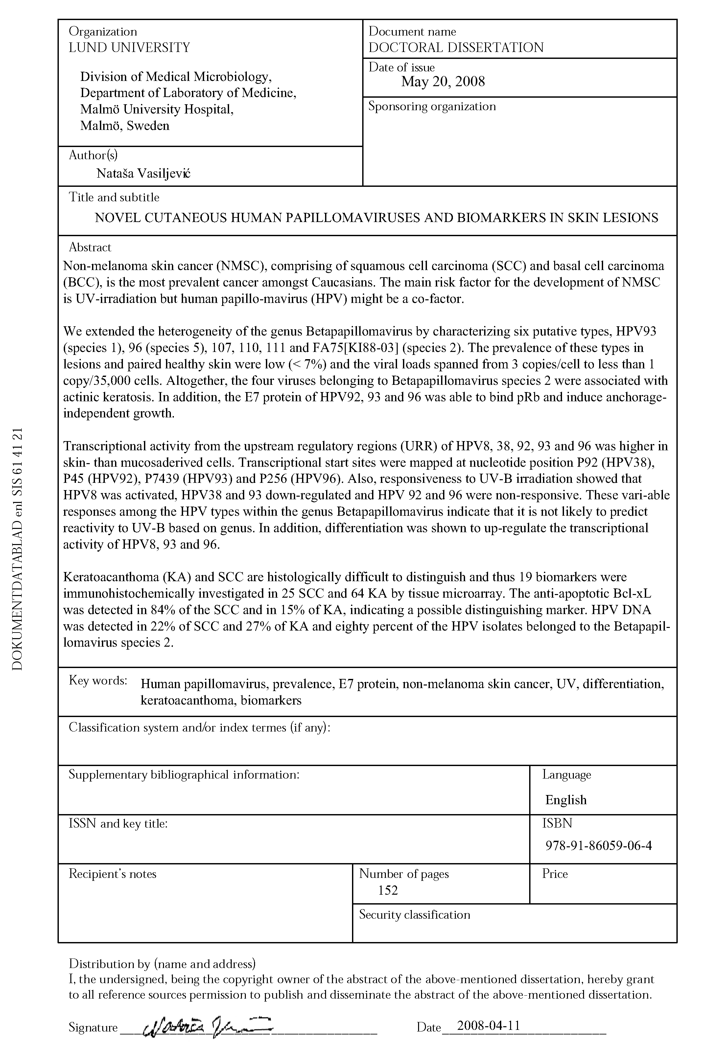
NOVEL CUTANEOUS HUMAN PAPILLOMAVIRUSES AND BIOMARKERS IN SKIN LESIONS

Nataša Vasiljević

DOCTORAL THESIS



Medical Microbiology
Department of Laboratory Medicine
Malmö 2008, Sweden

Published and printed by Media Tryck, Lund University, Sweden
cover: “The papillomavirus universe” by Nataša Vasiljević
© Nataša Vasiljević 2008
ISSN: 1652-8220
ISBN: 978-91-86059-06-4
Lund University, Faculty of Medicine Doctoral Dissertation series 2008:53

FOR MY FAMILY
Mami
Tati
Bratu
i
Baki

TABLE OF CONTENTS

SUMMARY 9
POPULÄRVETENSKAPLIG SAMMANFATTNING 10
ORIGINAL PAPERS 12
ABBREVIATIONS 13
INTRODUCTION 14
HUMAN PAPILLOMAVIRUSES 14
History 14
The structure 15
Evolution and Classification 16
Genomic organization 20
The viral proteins and their effect on the host 21
E1 protein 21
E2 protein 21
E4 protein 22
E5 protein 23
E6 protein 24
E7 protein 25
L1 and L2 proteins 26
The upstream regulatory region 27
THE PAPILLOMAVIRUS LIFE CYCLE 29
HPV-ASSOCIATED DISEASE 32
Mucosal infections 32
High-risk types and cervical cancer 33
Other mucosal infections 33
Cutaneous infections 34
Skin warts 34
Epidermodysplasia verruciformis 35
Other skin disorders 36
NON-MELANOMA SKIN CANCER 36
Development and epidemiological aspects 36
HPV and NMSC 37
The role of E6 and E7 proteins in NMSC 38
THE IMMUNE RESPONSE 40
HPV evading the host immune system 40
The HPV vaccine 41
PRESENT STUDIES 42
AIMS 42
MATERIALS AND METHODS 43
Paper I and II 43
Characterization of novel types 43
Procedure for sample collection 43
Prevalence and viral loads 44
HPV92, 93 and 96 E7 proteins 44
Paper III 46
Luciferase assays 46
The localization of promoters 47
Paper IV 48
The patient panel and tissue microarray 48
HPV analysis 49
RESULTS AND DISCUSSION 49
Paper I – Characterization of two novel cutaneous human papillomaviruses, HPV93 and HPV96 49
Unpublished results 50
Paper II - Four novel human Beta-2 papillomaviruses preferentially found in actinic keratosis 51
Paper III – Differences in transcriptional activity of cutaneous human papillomaviruses 54
Paper IV - The Bcl-xL inhibitor of apoptosis is preferentially expressed in cutaneous squamous cell carcinoma compared to keratoacanthoma 57
CONCLUDING REMARKS 59
ACKNOWLEDGEMENTS 60
REFERENCES 62
THE APPENDIX (PAPERS I – IV) 77

SUMMARY

Non-melanoma skin cancer (NMSC), comprising of squamous cell carcinoma (SCC) and basal cell carcinoma (BCC), is the most prevalent cancer amongst Caucasians. The main risk factor for the development of NMSC is UV-irradiation but human papillomavirus (HPV) might be a co-factor.
We extended the heterogeneity of the genus Betapapillomavirus by characterizing six putative types, HPV93 (species 1), 96 (species 5), 107, 110, 111 and FA75[KI88-03] (species 2). The prevalence of these types in lesions and paired healthy skin were low (< 7%) and the viral loads spanned from 3 copies/cell to less than 1 copy/35,000 cells. Altogether, the four viruses belonging to Betapapillomavirus species 2 were associated with actinic keratosis. In addition, the E7 protein of HPV92, 93 and 96 was able to bind pRb and induce anchorage-independent growth.
Transcriptional activity from the upstream regulatory regions (URR) of HPV8, 38, 92, 93 and 96 was higher in skin- than mucosaderived cells. Transcriptional start sites were mapped at nucleotide position P₉₂ (HPV38), P₄₅ (HPV92), P₇₄₃₉ (HPV93) and P₂₅₆ (HPV96). Also, responsiveness to UV-B irradiation showed that HPV8 was activated, HPV38 and 93 down-regulated and HPV 92 and 96 were non-responsive. These variable responses among the HPV types within the genus Betapapillomavirus indicate that it is not likely to predict reactivity to UV-B based on genus. In addition, differentiation was shown to up-regulate the transcriptional activity of HPV8, 93 and 96.
Keratoacanthoma (KA) and SCC are histologically difficult to distinguish and thus 19 biomarkers were immunohistochemically investigated in 25 SCC and 64 KA by tissue microarray. The anti-apoptotic Bcl-xL was detected in 84% of the SCC and in 15% of KA, indicating a possible distinguishing marker. HPV DNA was detected in 22% of SCC and 27% of KA and eighty percent of the HPV isolates belonged to the Betapapillomavirus species 2.

POPULÄRVETENSKAPLIG SAMMANFATTNING

Det finns en mångfald av olika typer av humant papillomvirus (HPV) som infekterar människan. Översiktligt delas de in i typer som infekterar slemhinnor och de som infekterar hud. HPV typer som infekterar genitala slemhinnor är väl studerade då dessa är en känd orsak till livmoderhalscancer. Vissa HPV-typer som infekterar hud orsakar vårtor på händer och fötter. Andra hud-HPV-typer är möjliga riskfaktorer för utveckling av icke-melanom hudcancer (NMSC) i vissa patientgrupper. Dessa omfattar patienter under immunnedsättande behandling samt de som drabbas av den sällsynta sjukdomen epidermodysplasia verruciformis. Under senare år har dessa HPV-typer även uppmärksammats som en möjlig risk faktor till utveckling av NMSC hos annars friska personer. NMSC är den vanligast förekommande cancern bland jordens vithyade befolkning och trots dess låga dödlighet, utgör dess stora förekomst en stor belastning för sjukvården. Den absolut största riskfaktorn för utveckling av NMSC är ultraviolett (UV)-ljus. Då HPV påvisas i både frisk och malign hud är det svårt att avgöra dess roll i cancerutvecklingen. Det har dock föreslagits att HPV är en bidragande faktor i kombination med UV-ljuset.
Förutom de cirka 25 hudtyper vars hela genomsekvens är känd, har det isolerats en stor mängd förmodade nya HPV-typer, där endast en liten del av genomet är känt. Vi har därför utökat kunskapen om hud-HPV-typer genom att karakterisera ytterliggare sex nya hud-HPV-typer och dessutom undersöka deras förekomst i tumörer, förstadier till tumörer och normal hud. Virusen hittades hos få patienter (~3-7%), men vi visade att det fanns ett svagt samband mellan förekomst av de fyra nya typer HPV107, 110, 111 och FA75[KI88-03] och aktinisk keratos, som kan vara ett förstadium till tumörer. Dessutom tenderade HPV-typerna att hittas oftare i tumörer (6.5%) än i frisk hud (2.7%), men mängden virus som detekterades per cell var låg. Vidare undersökte vi det virala onkogena E7-proteinet från de nya typerna HPV93 och 96, samt den tidigare karakteriserade typen HPV92. E7-proteinerna kunde binda till den cellulära tumörregulatorn pRb, likt de typer som orsakar livmoderhalscancer, och dessutom kunde proteinet sätta igång transformation av musceller.
De virala proteinerna uttrycks från en icke-kodande region (URR) av genomet. Vi undersökte hur UV-ljus och den cellulära differentieringen påverkade transkriptionen från URR hos utvalda hudtyper. Våra resultat visade att cellulär differentiering stimulerade transkriptionen från URR, medan UV-ljuset hade olika effekt på de olika hudtyperna. Vi identifierade dessutom möjliga startpunkter för gentranskription inom URR.
Keratoakantom (KA) är en hudförändring som uppkommer snabbt och läker av sig självt. Det förs debatt bland dermatologer kring KA, om huruvida KA är ett förstadium till skivepitelcancer eller om den endast är en godartad tumör. Det kan vara svårt att urskilja dessa hudförändingar histologiskt och som säkerhetsåtgärd behandlas KA som om det vore cancer, men markörer för säker urskiljning är eftersökta. Vi undersökte 19 möjliga sådana markörer och fann att Bcl-xL uttrycktes i skivepitelcancrar (85%) men däremot sällan i KA (15%) och frisk hud (3%). Därför kan Blc-xL, som är ett protein som motverkar programmerad celldöd (apoptos), vara en potentiell markör för att histologisk särskilja skivepitelcancrar från KA. HPV förekomst hos skivepitelcancer (22%) och KA (27%) fann vi ej vara markant olika.
Eftersom endast en av de 19 undersökta markörerna skiljdes mellan de olika lesionerna, kan denna studie inte utesluta att KA är ett förstadium till SCC.

ORIGINAL PAPERS

This thesis is based on the following papers:
I. Vasiljević, N., Hazard, K., Eliasson, L., Ly, H., Higgins, G., Hunziker, A., de Villiers, E-M., Dillner, J., and Forslund, O.
Characterisation of Two Novel Cutaneous Human Papillomaviruses, HPV93 and HPV96
Journal of General Virology (2007), 88, 1479-1483
II. Vasiljević, N., Hazard, K., Dillner, J., and Forslund, O
Four Novel Human Beta-2 Papillomaviruses Preferentially Found in Actinic Keratosis
Manuscript
III. Vasiljević, N., Nielsen L., Doherty, G., Dillner, J., Forslund, O., and Norrild, B.
Differences in transcriptional activity of cutaneous human papillomaviruses
Manuscript
IV. Vasiljević, N., Andersson, K., Bjelkenkrantz, K., Kjellström C., Månsson, H., Nilsson, E., Landberg, G., Dillner, J., and Forslund, O.
The Bcl-xL inhibitor of apoptosis is preferentially expressed in cutaneous squamous cell carcinoma compared to keratoacanthoma
Manuscript

ABBREVIATIONS

Ab Antibody
AK Actinic Keratosis
BCC Basal cell carcinoma
bp Base pair
BPV Bovine papillomavirus
CI Confidence interval
CRPV Cottontail rabbit papillomavirus
DNA Deoxyribonucleic acid
EV Epidermodysplasia verruciformis
HLA Human leukocyte antigen
HPV Human Papillomavirus
KA Keratoacanthoma
OR Odds ratio
ORF Open reading frame
PCR Polymerase chain reaction
PV Papillomavirus
mRNA Messenger RNA
NMSC Non-melanoma skin cancer
nt Nucleotide
PML Promyelocytic leukemia protein
pRb Retinoblastoma protein
SCC Squamous cell carcinoma
SK Seborrhoeic keratosis
TMA Tissue microarray
URR Upstream regulatory region
VLP Virus like particle

INTRODUCTION

HUMAN PAPILLOMAVIRUSES
The papillomaviruses are small non-enveloped DNA viruses belonging to the family Papillomaviridae. These viruses infect epithelial cells, either mucosal or cutaneous, and can cause various degrees of proliferation from genital warts or common warts on the skin to cervical cancer.

History
Warts, a common manifestation of human papillomavirus (HPV) infection, had awaken interest already in the ancient times, when Hippocrates used the term thymia to describe warts and suggested they be treated with the herb Parthenium parviflorum ¹. It was first in the end of the 19th century that the concept of virology was born with the pioneering work of Mayer, Ivanofsky and Beijerinck on tobacco mosaic disease as they demonstrated an agent that was filtered through filters known to retain all identified bacteria ². These experiments inspired scientist to similar experiments with animal and human warts and in 1898 McFadyan and Hobday were first to reveal cell-free transmissibility of canine warts ³. Some years later, in 1907, Ciuffo transmitted human warts by cell-free extract ⁴ making the viral etiology of the human warts evident. In 1933, Shope and Hurst laid another milestone in papillomavirus (PV) history by describing clinical and pathologic picture of cutaneous papillomatosis in cotton tail rabbits ⁵. One year later, the carcinogenic nature of the virus known today as cotton tail rabbit papillomavirus (CRPV), was observed by Rous and Beard as they described malignant potency of the papillomas when transplanted to muscles or internal organs ⁶. Further experiments with CRPV, in combination with tar, resulted in skin cancer development of the infected rabbits ⁷. Shortly thereafter in 1939, scientists could actually see a virus, tobacco mosaic virus, for the first time by electron microscopy ⁸. However, first a decade later, Strauss used the same method to look at the HPV in cutaneous warts ⁹ and in 1968 Crawford and Crawford showed the physical properties of HPV DNA completing the basic picture of the structure and composition of this virus ¹⁰.
In the 1970’s and 80’s important steps within the PV field were made. A rare hereditary disease, epidermodysplasia verruciformis, had previously been associated with HPV infection ¹¹ and in 1972 Jablonska suggested that this condition could serve as a model to study the role of HPV in oncogenesis ¹². In 1974 an indication of existence of different HPV types was given by zur Hausen¹³ and soon there after confirmed by Gissmann ^{14,15} and Orth ^{16,17} as several new types were described. New HPV types were continuously isolated during the first half of the 80’s. During this time, HPV 6, 11, 16 and 18 were discovered ¹⁸⁻²¹. Already in 1976, zur Hausen had made an hypothesis that HPV infection causes cervical cancer ²², but this was first confirmed in 1987 when an epidemiologic study on etiology in cervical cancer was published ²³. Today, it is a well known fact that HPV causes cervical cancer and the molecular biology behind the carcinogenesis is relatively well described ²⁴, although new aspects on the mechanisms of different viral proteins interacting with human cells are yet to be revealed. On the contrary, the role of HPV in development of cancers of the skin is not clear but this field of research is expanding ²⁵.
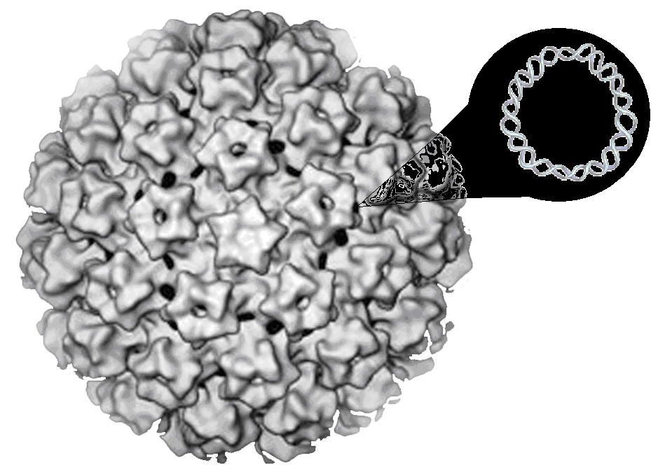
Figure 1. Human papillomavirus is a small, non-enveloped DNA virus.

The structure
The PV consists of a closed-circular double-stranded DNA molecule contained within a capsid that is approximately 55 nm in diameter. The capsid has icosahedral symmetry and consists of two virally encoded proteins, L1 and L2. Five monomers of the L1 protein build up a capsomer, which is either pentavalent, surrounded by five other capsomers, or hexavalent, surrounded by six other capsomers. One PV capsid is composed of 72 such capsomers i.e. the capsid consists in total of 360 L1 monomers. The capsomers located at each of the 12 vertices are pentavalent while the remaining 60 capsomers are hexavalent ²⁶ (Figure 1). A reconstruction of cryo-electron micrographs suggests that the L2 protein is associated with the pentavalent capsomers and that there are 12 copies of L2 in the capsid ²⁷. The capsid embraces a histone-associated DNA genome of about 8000 base pairs (bp) ²⁸.

Evolution and Classification
Evolution of papillomaviruses and which part of their genomes that should be used for evolutional analysis and characterization has been debated over the years. Current prevailing opinion is that all the HPV types existed already at the evolutionary origin of humans. This theory is based on the fact that PVs have wide geographic distribution but require close contact for transmission and the evidence suggests that the HPVs, just like human kind, originated in Africa and from there have followed the man during the migration and settlement ^{29,30}. In further support of this theory, the viral genome is very stable and evolves at the same rate as the human genome, mainly through rare point mutations. One study has suggested 12,000 years of evolution per one established mutation in a less conserved part of HPV genome ³⁰. This stability is most certainly a consequence of that PV utilizes the cellular machinery for the replication of the viral genome and thus draw benefits from the high fidelity of the DNA polymerase α with proofreading and DNA repair mechanisms ².
Originally, papillomaviruses were grouped together with the polyomaviruses into the virus family Papovaviridae due to several properties that these viruses share, e.g. the viruses are icosahedral, non-enveloped and have double-stranded circular DNA. However, comparative molecular biologic studies revealed fundamental differences in genome size, composition and organization and thus the two families were separated into Polyomaviridae and Papillomaviridae ².
The PVs are widespread in nature and infect a large number of different species including humans, domestic mammals, rodents, nonhuman primates and birds. The site of infection is cutaneous or mucosal epithelial cells, consequently causing infections in the skin or the oral and anogenital tract ³¹. The HPV viruses show a high degree of tissue tropism, however there are some types, such as HPV7, that are associated with both mucosal and cutaneous infections ³². Besides the tissue tropism, PV infection is also highly species specific and only occasional interspecies transmission has been observed between closely related species ³³.
Today, the majority of characterized PV types are isolated from humans as this is the most extensively studied host ³⁴. As a result, over 100 HPV types are known and an additional hundred putative HPV types appear to exist, with sequence information so far only available as PCR amplicons ^{35,36}. Hypothetically, isolation of all PV types from every other infected species could reveal equivalent numbers of types infecting each host, and therefore Papillomaviridae might be the largest, most diverse viral family ³⁷.
When referring to different PVs, the term “types” is used over the more commonly used term “serotypes”. This is a consequence of lack of serologic reagents to distinguish the known types. Rather than serology, the classification is instead based on the host species that the virus infects and the degree of identity between the nucleotides within the L1 open reading frame (ORF) ³⁴. The L1 ORF has been used to distinguish the new PV types during the last two decades given that this is the most conserved gene within the PV genome. A new PV type is established as its entire genome is cloned, sequenced and its L1 ORF displays at least 10% dissimilarity to the closest related type ³⁴. Each type is identified by a unique Arabic number assigned in the order of isolation from the originating species. Also, besides the abbreviation PV and the designated number, one or two letters from the originating host’s scientific name or English name is used for the identification, e.g. Felis domesticus papillomavirus – FdPV, Bovine papillomavirus 1 – BPV1 or human papillomavirus 16 - HPV16.
Phylogenetically, the PV types are clustered, hitherto, into 16 genera that are represented by Greek numbers. The L1 ORF of PV types from different genera share an identity of less than 60%. The genera are further divided into low order clusters – species – denoted by Arabic numbers 1, 2, 3 and so on. The species within a genus share between 60 – 70 % identity within the L1 ORF ³⁴ (Figure 2). The different PV types within a species share 71 – 89 % identity and if identity is higher than 90%, but is less than 98%, the term “subtype” is used (Figure 2). Subtypes are denoted by small Latin letters (e.g. HPV38b) and are considered rare ³⁷, however a recent study indicates that they are common, particularly in the genus Betapapillomavirus ³⁸. In addition, repeated isolation and genome sequencing of a specific type due to the clinical importance, such as HPV16, have displayed minute (less than 2%) differences in the nucleotide composition. These different isolates are denoted by the term “variant” (Figure 2) ³⁴. Variants are quite common, but studies have shown that there is a limited number of the variants (10-100) of any given type and that these variants diverge the most when isolated from different ethnic groups which have evolved separately for a long time, e.g. Africans (HPV16 Af) and American Indians (HPV16 AA) ²⁹.
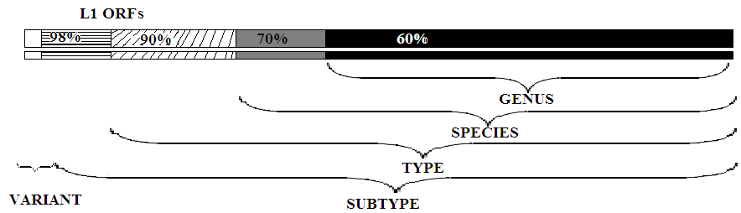

Figure 2. Schematic overview of the PV classification based on the identity shared between the L1 OFRs.
In addition, HPVs are also classified according to the degree of severity of the lesion they are associated with. The genital types which are highly associated with development of cervical cancer are classified as high-risk types while those genital types causing development of warts or lesions with low severity are classified as low-risk types ^{39,40}. Amongst the cutaneous types, similar associations have not yet been confirmed.
A phylogenetic study of 118 PV types demonstrate their relatedness and also the classification system used today (Figure 3) ³⁴. The HPV types are clustered in genera Alpha-, Beta-, Gamma-, Mu- and Nu-papillomavirus and the different animal and bird PVs in the remaining genera (Figure 3). Genus Alphapapillomavirus is divided into 15 species and includes almost exclusively HPV types, with exception of Pygmy Chimpanzee PV and Common Chimpanzee PV in species 10 and Rhesus PV1 representing the species 12. Interestingly, 12 out of 15 classified HPV high-risk types belong to the two species 7 and 9 of the Alpha-genus. Most of the other HPV types in this genus also cause mucosal infection. However, in species 2 (HPV3, 10, 28, 78 and 94), 4 (HPV 2, 27 and 57) and 8 (HPV7, 40, 43 and 91) there are HPV types with cutaneous tropism (Figure 3). Genus Betapapillomavirus is divided into 5 species and comprises, so far, only of types detected in cutaneous tissue. For instance, all of the HPV types associated with the rare skin disease epidermodysplasia verruciformis ⁴¹ are grouped into species 1, 2 and 3 of this genus.
Genus Gammapapillomavirus is divided into 5 species with only 7 types in total. However, a phylogenetical analysis of the putative types, with only about 450 bp of their genome sequenced, suggests that this genus might comprise an additional 97 types ³⁵. The same study, suggests an expansion of the Beta-genus with 36 putative types, making these two genera enormously diverse. All of the characterized and putative types in the Gamma-genus are so far associated with cutaneous infection. Further, while the Alpha-, Beta- and Gammapapillomavirus genera are particularly rich in different types, the Mu- and Nupapillomavirus genera comprise of only three types in total, HPV1, 41 and 63 and no reported putative types. The HPV types from these two genera are associated with common cutaneous warts.
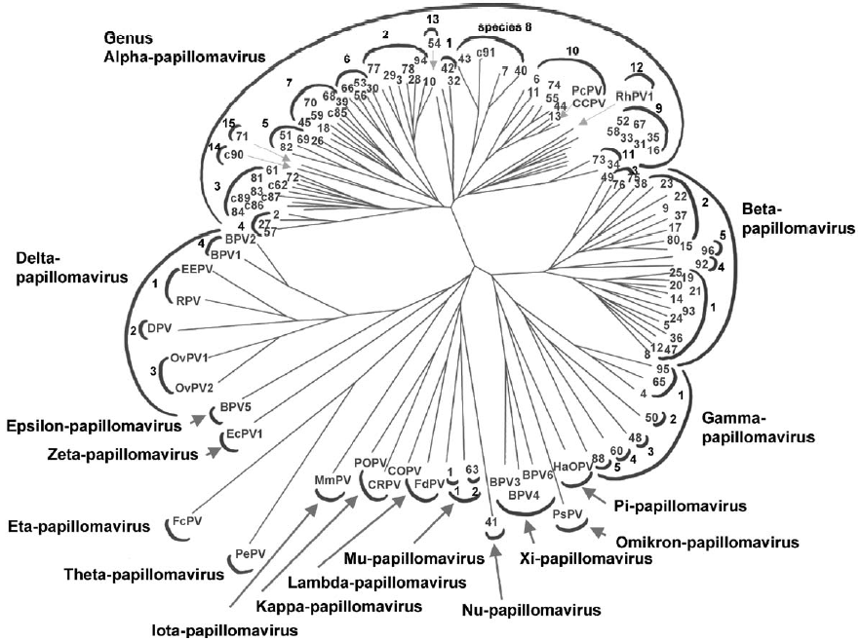

Figure 3. Phylogenetic tree demonstrating the Papillomaviridae classification.
Reprinted from Virology, de Villers et al, Classification of papillomaviruses (2004), with permission from Elsevier.
As previously mentioned, the remaining genera are comprised of mammal and bird PVs. In agreement with the theory that PV have evolved in linkage with their hosts, a PV isolated from any new species has usually, after phylogenetical analysis, been classified into a new genus e.g. Theta-genus with parrot PV (PePV)⁴² and Iota-genus with natal multimammate mouse PV (MnPV) ⁴³. As only small number of species has been investigated, one can anticipate that the current naming of the genera by Greek alphabet, with its 24 letters, will be challenged in the future.

Genomic organization
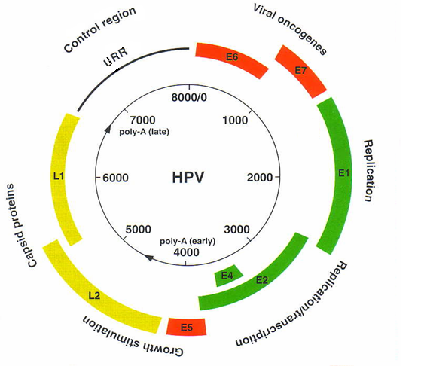
The double-stranded circular DNA genome of PVs ranges in size, from the smallest of BPV4 – 7265bp ⁴⁴ to the largest of canine oral papillomavirus – 8607bp ⁴⁵. The genome structure is very similar within the family Papillomaviridae and only one DNA strand serves as template for transcription ⁴⁶. Furthermore, there is a remarkable degree of conservation in the localization of ORFs. Roughly divided, there are three regions in all PV types: early (E) and late (L) protein coding region, referring to order of expression during the PV life cycle, and a non-coding region also known as upstream regulatory region (URR). HPV genomes code for at most six early proteins, E1, E2, E4, E5, E6 and E7, and two late, structural proteins, L1 and L2 (Figure 4) ³¹. Proteins E3 and E8 have been assigned in the early region of some animal PVs, however only E8 has been shown to code for a protein, which is implicated in viral transforming properties ^{47,48}, and will not be further discussed here.
Figure 4. Circular map of a mucosal HPV genome indicating the localization of the early and late ORFs as well as the non-coding URR.

The viral proteins and their effect on the host

E1 protein
E1 is the only PV protein that possesses enzymatic activity. Furthermore, this protein has the largest, rather conserved, ORF within the PV genome. The E1 protein shares structural similarity to a part of the SV40 large tumor antigen ⁴⁹, which is the essential replication protein of that virus, also, the PV E1 protein plays an essential role in the replication of the PV DNA. Initially, E1 protein binds to the origin of replication site – ori – of the viral DNA ⁵⁰ (Figure 5). However, since E1 alone binds to the ori with low affinity, it has to be stabilized through an interaction with a second viral protein, E2 ⁵¹. After promotion of the DNA binding, E1 undergoes ATP-dependent conformational changes, thereby releasing the E2 protein and transitioning into an hexameric form ⁵². Next, E1 binds the host DNA polymerase α-primase and as other essential parts of the host replication machinery are recruited replication can begin ⁵³. Since the N-terminal domain of the E1 protein binds to the histones and can displace them ⁵⁴ while the C-terminal domain shows DNA-dependant ATPase and DNA helicase activity ^{52,55}, the E1 protein utilizes unpacking and unwinding of the DNA helix to facilitate replication of the viral DNA (Figure 5).
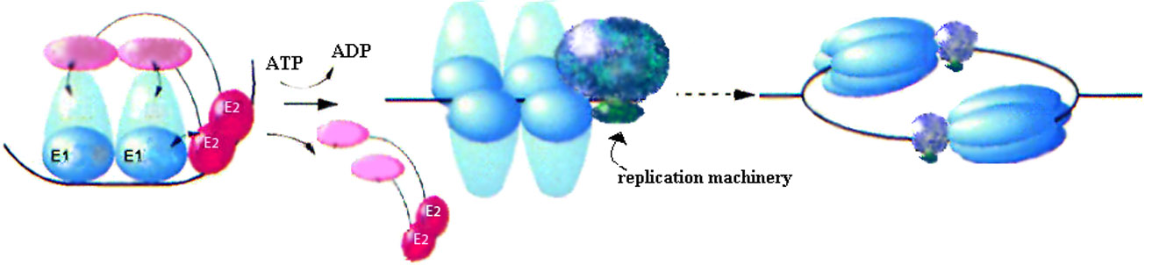
Figure 5. A proposed model for PV replication initiation. Details are given in the text above.

E2 protein
Besides its important auxiliary role in replication of viral DNA, the E2 protein is crucial in regulation of the viral transcription. The E2 ORF is relatively well conserved amongst PVs, particularly in the N-terminal region, with the E1 binding domain and a transactivating domain, and the C-terminal region, with the sequence specific DNA binding domain and dimerization domain ⁵⁶. Separating these two regions, there is an internal hinge region, which is poorly conserved among PVs considering both the amino acid composition and the size. The E2 hinge region of HPVs belonging to the Betapapillomavirus genus is larger than that of mucosal types and has for HPV5 been demonstrated to bind cellular splicing factors ⁵⁷.
The URR of all PVs contain numerous binding sites for the E2 protein. These binding sites have the consensus sequence ACCN₆GGT ⁵⁸. By binding to this sequence, the E2 protein acts as a transcriptional regulator on the proximal promoters and can either repress or activate them ⁵⁹. The structural studies have shown that E2 forms a dimer. This structure might be important for the stabilization of DNA loops and thereby recruitment of distally bound transcription factors to the site of the HPV transcription initiation and activation ⁶⁰. Alternatively, binding of E2 can also repress transcription, probably by blocking binding sites of important transcription factors and thereby interfering with the formation of transcription preinitiation complex ⁶¹, e.g. E2 protein usually serves as a negative regulator of E6 and E7 proteins transcription.
Another important role of the E2 protein is the long-term episomal maintenance of viral genomes (see section Viral life cycle). The E2 protein is believed to serve as a connector that links the viral plasmid to the cellular mitotic chromosome, ensuring that the viral genomes are partitioned to the daughter cells after cell division ⁶². This interaction is mediated by the cellular bromodomain-4 protein ⁶³. Also the protein E1 might be important for the episomal maintenance ⁶⁴. In addition, the E2 protein has been shown to induce apoptosis in an array of different cell lines and it is suggested that it does so by activating caspase-8 ⁶⁵ or the p53 pathway ⁶⁶.

E4 protein
There is a discrepancy whether the E4 protein should really be termed an early protein, as it is mostly expressed during the later stages of the viral life cycle ². However, the expression of the E4 still precedes that of late proteins and, in addition, a comparison of expression patterns with the mucosal HPV16 and cutaneous HPV63 has shown that HPV63 E4 expression starts in the lower epidermal layers, i.e. earlier in the viral life cycle, than the expression of HPV16 E4 ⁶⁷.
The E4 ORF overlaps with that of E2 but as the ORFs are in different reading frames, the amino acid composition is entirely different. The E4 ORF is one of the less conserved ORFs within the PV genome. The protein is translated from E1^E4 fusion transcript generated as a result of RNA splicing and therefore consist of the first five codons for E1 and the entire ORF of E4 ⁶⁸. This fusion protein is the most abundantly expressed of all proteins throughout the HPV viral life cycle but its role is not completely clear, although, promoting genome amplification and S phase maintenance during differentiation has been suggested ⁶⁹. Also, E1^E4 protein has been shown to associate with keratin cytoskeleton and when overexpressed it induced a collapse of the cytokeratin network ⁷⁰. This suggests that E1^E4 fusion protein is a facilitator of the viral egress. In addition, E1^E4 associates with an RNA helicase involved in regulation of the mRNA stability, and thus is proposed to be involved in post-transcriptional control of gene expression ⁷¹.

E5 protein
The HPV E5 ORF encodes a hydrophobic protein that is mainly detected in the Golgi and endoplasmic reticulum ⁷². Interestingly, analysis of the HPV types infecting the mucosa has shown that all high-risk types encode E5, while some low-risk types either lack a definable E5 ORF or its translation start codon ⁷³. In addition, the PV infecting the cutaneous tissue also lack the E5 ORF ³⁴.
The BPV E5 protein transforms cells by binding to and activating the platelet-derived growth factor (PDGF) receptor ⁷⁴. On the contrary, this potential is not observed with the high-risk mucosal HPV E5 proteins, which possess only weak transforming ability in cell culture but have been shown to have an additive effect on the transforming properties of E6 and E7 ^{75,76}. One potential target of HPV E5 is the epidermal growth factor (EGF) receptor leading to activation of mitogen-activated protein (MAP) kinase ^{77,78}. As with the BPV E5, binding of HPV E5 to vacuolar proton-ATPase and subsequent decreased endosomal acidification has been documented ⁷⁹. This might implicate an alteration of the host cell antigen presentation, and thereby avoidance of the immune-surveillance. Concurringly, cells expressing the E5 protein display decreased levels of surface HLA class I ⁸⁰. In addition, the E5 protein is important for the productive stage of the viral life cycle ⁸¹. However, since E5 has not been detected in most HPV-positive cancers and as most of the experimental settings for its studying have been in vitro, the implication of this protein in carcinogenesis remains elusive.

E6 protein
The E6 protein, along side with E7, is the most well studied protein of the HPVs. This HPV protein has transforming properties. The HPV E6 ORF encodes protein made up of two domains, each of which contains two C-x-x-C repeats, involved in zinc-binding ⁸². These zinc-binding domains may determine the protein conformation or protein-protein interaction and they are important for the E6 transformation ability ⁸³. Also, the zinc-binding domain gives the E6 protein a DNA-binding ability, which may implicate this protein in regulation of DNA replication and transcription ^{84,85}. The C-terminal region of the E7 protein contains also a zinc-binding domain and therefore it has been postulated that the E6 and E7 ORFs may have arisen by gene duplication ⁸⁶.
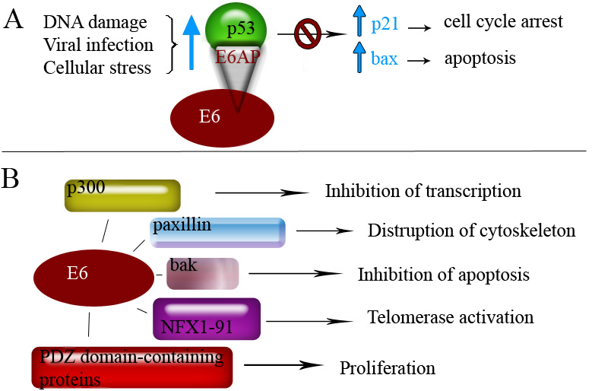
The transforming properties of E6 were first realized when it was shown that presence of both E6 and E7 was required for efficient immortalization of primary human fibroblasts or keratinocytes ^{87,88}. The main effect of the E6 protein on the infected cell is to accelerate degradation of the tumor suppressor p53 and thereby stop the cell from going into cell cycle arrest and eventual apoptosis (Figure 6A) ⁸⁹.
Figure 6. The cellular targets of HPV E6 protein. A) The level of p53 in a normal cell is low, but is induced by various harmful agents. The E6 protein promotes degradation of p53 via E6AP and thus prevents cell cycle arrest and apoptosis. B) The E6 protein interacts with several other cellular proteins resulting in a range of cellular effects.
.
It is by formation of a complex with ubiquitin-protein ligase E6AP that HPV E6 turns this ligase into a p53-specific ligase and consequently accelerates the p53 degradation ⁹⁰. However, the E6 protein of the low-risk HPVs do not seem to be able to induce the degradation of p53 in the same way as those of the high-risk types ⁹¹. In addition to p53, many other proteins have been proposed as targets of E6 protein such as telomerase repressor NFX1-91 ⁹², PDZ domain-containing proteins ⁹³, Bak ⁹⁴ and others ^{95,96} (Figure 6B).

E7 protein
The E7 protein is the major transforming protein of HPVs and is predominantly found in the nucleus of an infected cell. E7 has a zinc-binding domain in its C-terminal region and a phosphorylation site in the N-terminal region, phosphorylated by casein kinase II to regulate the E7 during the cell cycle ^{97,98}. Another important conserved region within the E7 ORF is the LxCxE binding site in the N-terminal region, which is necessary for E7 binding to the retinoblastoma tumor suppressor protein (pRb) family, including pRB, p107 and p130 ⁹⁹. The binding of E7 to pRb leads to degradation of pRb ¹⁰⁰ and thereby circumvents cell cycle arrest by releasing the pRb-controlled E2F transcription factor (Figure 7). In addition to the N-terminal pRB-binding site, the ability of HPV-16 E7 to disrupt pRB/E2F complexes also involves sequences in the C-terminal of E7 protein ⁹⁹.

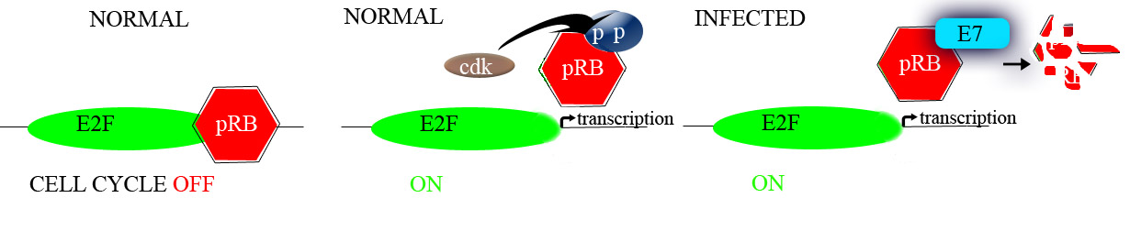

Figure 7. The disruption of cell cycle control by E7 protein. Normally, the cyclin-dependant kinases (cdk) mediate the phosphorylation of pRb, releasing it from E2F and letting the cell move on to S-phase. In presence of HPV E7, the pRb is sequestered and degraded leaving the cell cycle activated.
It is established that the E7 proteins of high-risk types bind to the pRb protein with 10-fold higher efficiency than those of the low-risk types ¹⁰¹. Consistently, the low-risk HPV E7 proteins do not efficiently transform cells and are phosphorylated by CK II at a lower rate ⁹⁷. Importantly, also for the high-risk HPV types, the sole disruption of pRB/E2F complex is not enough for cellular transformation and interactions with an array of other cellular proteins, such as p27 and subsequent inactivation of a cyclin dependant kinase (cdk) inhibitor has been reported ^{89,102}.

L1 and L2 proteins
As described in a previous section, L1 and L2 are structural proteins building up the viral capsid. The dependence of the productive phase of the HPV life cycle on epithelial differentiation (see section Viral life cycle) has made it difficult to study the mechanisms regulating the production of structural proteins and their assembly. However, development in molecular biology techniques and development of raft culture systems has contributed greatly to the understanding of these proteins. It has been learned that when L1 protein alone, or in combination with L2, is over-expressed in variety of expression systems, it self-assembles into virus-like particles (VLP) with a shell similar to that of the native virion, ^{103,104}. The presence of the L2 protein enhances this assembly 50-fold ¹⁰⁵. Because of their strong resemblance to the native virion, VLPs have been used for structural studies and form the basis for the prophylactic vaccines.
The L1 proteins are synthesized in the cytoplasm, where they form capsomers, ¹⁰⁶ and then they are translocated through a nuclear pore complex into the nucleus ¹⁰⁷ where packaging of the viral chromatin takes place. The synthesized L2 protein is separately translocated into the nucleus. L2 constitutes only a minor part of the capsid but is suggested to play a major role in recruiting viral genomes for encapsidation. This role is proposed as the L2 proteins has been shown to bind DNA and is localized to major sites of DNA replication ¹⁰⁸. In addition, the L2 protein mediates the egress of the viral genome from endosomes ¹⁰⁹ upon internalization and accompanies it to promyelocytic leukemia protein (PML) bodies ¹¹⁰, major sites for replication.

The upstream regulatory region
The URR is the non-coding region of the HPV genome localized between the stop codon of L1 ORF and start codon of E6 ORF (Figure 4). This region is generally not well conserved between the different PV types and the types in the Beta-genus have usually shorter URR than most types infecting the mucosal tissue (Table 1). The URR contains the ori which is distinguished by an A+T rich region, E1 binding site of dyad symmetry and an adjacent E2 binding site ¹¹¹.

Table 1. The sizes of URRs of HPV belonging to different genera.
Genus | Species | HPV type | URR size (bp)
Alpha | 4  6  7  9  10 | 2  53  18  16  6 | 675  804  826  833  675
Beta | 1  2  3  4  5 | 5  9  49  92  96 | 479  366  420  391  400
Gamma | 1 | 4 | 560
Mu | 1  2 | 1  63 | 982  558
Nu | 1 | 41 | 629

The transcription of the viral genes is initiated and regulated from the URR. HPV express at least seven different proteins but, so far, approximately two promoters have been found in all the investigated types – late and early promoters ². Consequently, polycistronic RNAs are made and therefore the control of HPV RNA processing plays an important role in regulating the HPV gene expression. The levels of HPV protein expression is determined by efficacy of RNA splicing and polyadenylation ¹¹².
In Figure 8, HPV16 transcription map is drawn including 20 different transcripts all generated by splicing of 2 – 3 major RNAs, however, even though these transcripts are known it is still unclear which proteins are translated from each transcript ¹¹². The initiation of different transcripts is linked to the cellular differentiation state supported by a finding that an early and a late promoter are activated in early and late stages of differentiation, respectively ¹¹³.
Furthermore, the URR contains binding sites for several transcription factors, both with activating (AP-1, NF1, Oct1, and SP1) ¹¹⁴⁻¹¹⁶ and repressing (YY1)¹¹⁷ effect. Also, as previously described, several E2 binding site are present. Location, frequency and characteristics of the binding sites are to a large extent conserved within each HPV genus but differ between the genera ¹¹⁸. Complex interplay between the transcriptional factors at different differentiation stages control the promoter sites within the URR. In addition to differentiation, other factors such as cytokines and UV-irradiation can affect the transcriptional control of the URR ¹¹⁹.

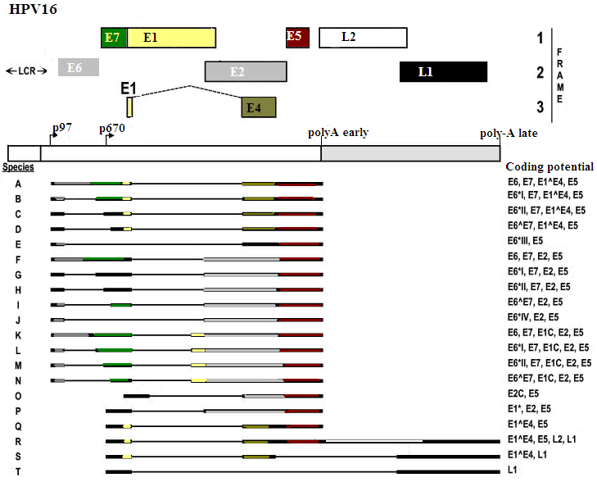
Figure 8. Transcription map of HPV 16 exemplifying the vast array of HPV transcripts initiated from the early, P₉₇, or late promoter, P₆₇₀. (Adapted from Zheng et al, 2006)

THE PAPILLOMAVIRUS LIFE CYCLE

The life cycle of papillomaviruses is closely coupled to the differentiation of the host cell. In order to understand the interplay between the viral life cycle and the cellular differentiation, we should briefly think about the process of epithelial differentiation. Normal squamous epithelium is built up of approximately 30 layers grouped into: stratum basale, stratum spinosum, stratum granulosum and stratum corneum (Figure 9). Only the stratum basale contains stem cells that are actively dividing, and as a cell leaves this basal layer, it starts its journey throughout the different phases as it exits the cell cycle and starts the differentiation process ¹²⁰. In about two weeks this cell will transit stratum spinousum, granulosum and finish off in the corneum layers which are constantly sloughed off into the environment (Figure 9).
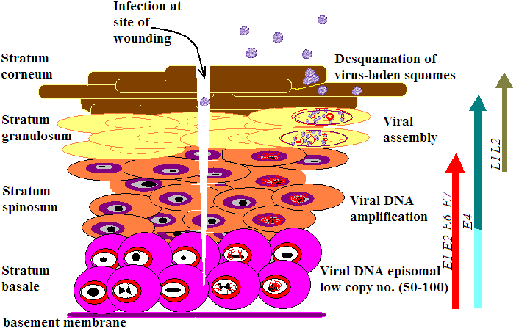
Figure 9. Stages of the papillomavirus life cycle in the squamous epithelium.
The virus must infect the stem cells in order to be able to induce productive infection and, as these cells are deeply embedded and protected, it is believed that the virus obtains access to the basal layer through microabrasions in the epithelia ^{121,122} (Figure 9). The mechanism behind the viral entrance into the cells has not been fully revealed. However, studies with VLPs have shown that for adherence, the virus binds to heparan sulphate glycosaminoglycans ^{123,124}. After adherence, possibly the virus interacts with a secondary receptor (α6ß4 integrin has been suggested), which leads to internalization of the virion ¹²⁴. The internalization is believed to take hours and occur trough the endocytosis of clathrin-coated vesicles ^{125,126}. Once in the cell, the vesicles are disrupted, a mechanism dependent on the L2 protein, and the viral genome is escorted to the cell nucleus by the same protein ^{109,110}. The pattern of expression of viral proteins after the entrance to the nucleus is uncertain, however, it is proposed that the early promoter is activated and the first proteins to be produced, in low amounts, are E1 and E2 as they are needed to bind to the ori and initiate replication of the viral genomes. Approximately 50 – 100 copies of genome are established as a nuclear episome in the nucleus of the basal cell (Figure 9). The E1 and E2 proteins are needed for the maintenance of this episome ¹²⁷. In the basal cell, the infection is latent and the viral episome stable until the cell division. During the cell division, viral DNA is replicated in synchrony with the cellular DNA ¹²⁸ and the E2 protein sees to it that the viral DNA is equally partitioned to the daughter cells ⁶².
Eventually, the basal cell migrates into the suprabasal cell layer where the cell undergoes the process of terminal differentiation. The terminal differentiation involves shutting down the cell cycling and cross-linkage of the keratin intermediate filament to form cornified envelopes as well as secretion of lipids. All together, these changes promote formation of an epithelial surface which is a physical barrier against the environment ¹²⁹. In the PV infected cell that starts the migration, E6 and E7 proteins are expressed and therefore the cell cycle arrest is abolished and normal terminal differentiation is moderately retarded ¹³⁰. The purpose of the viral proteins E6 and E7 is to maintain the cellular environment suitable for the viral replication and harming the host is not favorable. As already discussed, the E7 protein interacts with the pRb family and targets them for degradation (Figure 7), making the cell cycle progress to S phase and thereby making sure that all the machinery necessary for the viral replication is available. The deregulation of cell cycle awakes the “guardian of the genome” p53 which can reinforce the cell cycle stop or initiate apoptosis ¹³¹. However, the viral E6 protein (Figure 6) promotes degradation of the p53 as well as it interacts with many other regulatory proteins in order to maintain cellular replicatory machinery available to the virus. At this stage the viral DNA may replicate to thousands of copies per cell. Current models suggest that an increase in the early promoter activation during this stage of differentiation leads to increased levels of E1 and E2 and also E4 and E5, which subsequently increases the viral copy number. The roles of the viral proteins E1, E2, E4 and E5 have been described in previous sections.
Once the viral genome amplification has been completed and the cells have reached certain differentiation level, the late promoter is activated and the expression of structural proteins L1 and L2 is initiated ¹³². The L2 protein seems to accumulate at PML bodies during viral assembly, a site where the viral DNA replication is believed to take place, and this accumulation probably facilitates the packaging of the virus ^{110,133}. It is not exactly known how the virus is released but the PVs are non-lytic and it has been suggested that they are shed within the cornified squame ¹³⁴. However, E4 protein might also be implicated in the viral egress as previously mentioned.
This general description of the viral life cycle is mostly based on the experiments done with HPVs infecting the mucosal sites, specifically the high risk types, as these are most well studied. However, it is probable that detailed functions of the viral life cycle might differ between viruses belonging to different genera and even species. For example, the HPVs of the genus Gammapapillomavirus lack the necessary binding for the pRb proteins ¹³⁵ and therefore probably have adapted different mechanism to circumvent the cell cycle arrest. Also, the viruses of the genus Betapapillomavirus have not been shown to induce degradation of p53 protein ¹³⁶⁻¹³⁹, but may employ other mechanism, such as inactivation of apoptotic pathways, in order to avoid its host-cells death ¹³⁹.
The ability of the PV viruses to maintain cell cycling in the cell that should be at rest can have various consequences. Proliferation can result in low grade lesions in the epithelium that self-resolves within a year or less, time depending on the HPV type involved ¹⁴⁰. Lesions may also persist and can in some instances progress to cancer as the persistent HPV infection, with disturbance of the cellular tumor suppressors, can induce acquirement of chromosomal instability, mutations and aneuplody ²⁴. This scenario is not favorable for the virus as it cannot complete its life cycle in malignant cells, where differentiation is impaired. In addition, in HPV-associated cervical cancer, integration of the viral genome is often detected leading to abnormal expression of the viral proteins ³¹. The integration leads to interruption of the E2 and, to lesser extent, E1 ORFs ¹⁴¹ resulting in disruption of regulation of the E6 and E7 transcription, this in turn resulting in a higher expression of these oncogenes. The carcinogenesis is the worst case scenario outcome of the PV life cycle for both the host and the virus.

HPV-ASSOCIATED DISEASE
Papillomaviruses can be grouped by the preferential site they infect – mucosal or cutaneous. Moreover, based on the severity of disease they cause, mucosal types are usually referred to as either high-risk or low-risk HPV types.

Mucosal infections
HPV infection is considered to be one of the most commonly sexually transmitted diseases worldwide with prevalence ranging from 20 – 46 % among young women ¹⁴². The detection of HPV infection is most efficiently done by polymerase chain reaction (PCR) detection of the viral DNA.
Among the low-risk HPV types we find types, 6, 11, 34, 40, 42, 43, and 44 that cause genital warts – condylomas, which rarely ever develop into cancer (Table 2) ¹⁴³. In some extreme cases, condylomas may progress into giant condylomas, also called Buschke-Löwenstein tumors ¹⁴⁴. Less than 1% of infected individuals with these types display visible symptoms of infection, warts, and the incubation period is uncertain, a couple of weeks to several months ¹⁴³. Furthermore, in 90% of patients that do develop condyloma, HPV6 and 11 are detected ¹⁴⁵. The condylomas are usually self-limiting, regressing spontaneously or after local treatment. A wide variety of treatments are available such as surgical removal, cryo-therapy, laser surgery or topic treatments with podophyllotoxin, imiquimod, 5-fluoruracil or the antiviral cidofovir ¹⁴³.

Table 2. Summary of HPV types, their site of infection and disease.
Tissue | HPV type | Site of infection | Acute outcome | Chronic outcome
mucosal | Low-risk: 6, 11, 34, 40, 42, 43, and 44 | Genital area | Condylomas | None
mucosal | High-risk: 16, 18, 31, 33, 35, 39, 45, 51, 52, 56, 58, 59, 68, 73, and 82 | Oral and anogenital mucosa | Lesion (CIN 1) | Progression to cancer
cutaneous | 1, 2, 3, 4, 10, 41, and 57 | Skin | Warts | None
cutaneous | Beta- and Gamma-papillomavirus genera | Skin | Lesions? EV | SCC?

High-risk types and cervical cancer
Today, there are 15 recognized high-risk HPV types that are associated with cervical carcinoma: HPV16, 18, 31, 33, 35, 39, 45, 51, 52, 56, 58, 59, 68, 73, and 82 (Table 2) ³⁹. In the majority of individuals, HPV infections with these types are transient and asymptomatic – 70% of new infections resolve within 1 year and about 90% resolve within 2 years ^{142,146}. So, while most individuals spontaneously clear the HPV infection some individuals harbor persistent infections which can within a period of 5 – 15 years, and a series of stages of cervical intraepithelial neoplasia (CIN) grade I through III, cause cervical cancer ¹⁴⁷. HPV can be detected in virtually all cervical cancers ¹⁴⁸. This cancer form is the third most common cancer among women worldwide and in the developing countries it is the most common cancer amongst women ^{149,150}. Furthermore , infection with type HPV16 alone is responsible for more than 50% of the cervical cancers in the world and together with HPV18 this number is over 70% ³⁹. Also, multiple infections are commonly detected in infected patients. Since the progression to cancer takes years, the interval lesions CIN I – III can be detected by cervical screening with Pap smears or liquid based cytology, and HPV DNA detection, and treated before cancer is developed. Even though HPV infection is necessary cause of cervical cancer it may not be sufficient ¹⁴⁸. There are several co-factors that may increase the risk of progression to cervical cancer, such as multi-parity ¹⁵¹, use of oral contraceptives ¹⁵², cigarette smoking ¹⁵³ and infection with other sexually transmitted diseases such as herpes simplex virus type 2 and Chlamydia trachomatis ^{154,155}.

Other mucosal infections
The high-risk HPVs are a risk factor for cancer development in the oral cavity ¹⁵⁶. The HPV infection of the oral cavity is frequent, with these infections being attributable to about 12% of oro-pharyngeal and 3% of mouth cancers, prevailingly caused by HPV16 and 18 ¹⁵⁷. Infection of respiratory tract, specifically the larynx, with the low-risk types HPV6 and 11 can give rise to recurrent respiratory papillomatosis. This condition, common in children, is quite serious and needs repeated surgical intervention as the outgrowths on the vocal cords can obstruct airways and cause death. The HPV infection in the affected children is believed to be transmitted from mother to child during the passage through the birth canal ¹⁵⁸.

Cutaneous infections
HPV is non-enveloped and therefore resistant to desiccation, hence it can last long periods outside the host e.g. on towels, doorknobs, floors etc. Therefore, we are constantly exposed to this virus and probably infected already in infancy ¹⁵⁹. Our skin is a barrier not easily infected by the virus, however, microabrasions can arise if the skin is dehydrated, exposed to chemicals or is scraped. Also, hair follicles of the skin might be an important place of viral entry ¹²². The hair follicles appear to be an important reservoir of the HPV and, in support, stem cells are abundant here. Furthermore, HPV is often detected in plucked eyebrow samples ^{160,161}. Apart from hair follicles, the healthy skin of majority of people harbors different types of HPV ¹⁶²⁻¹⁶⁶. Due to its high prevalence in healthy skin, the HPV infection in skin has been proposed to be of commensal nature ¹⁶². In a study where different parts of the body were swabbed and investigated by PCR, forehead was the site most often positive for the viral DNA ¹⁶². However, a question arises – does the HPV detected in the swabbed skin surface represent current infection of the skin or is it rather a contamination from the environment? One study has shown that removal of lesion’s superficial layers, by applying and removing tape several times, lowered the proportion of HPV positive biopsy samples compared to that of swab samples collected prior to the tape stripping ¹⁶⁷. Additionally, in at least half of these biopsies the same type was detected before and after stripping indicating that some detected types did emerge from underlying skin. Further, electron microscopy of a skin swab of an SCC patient demonstrated HPV virions, indicating productive infection in the skin as exceptionally high concentrations of virus particles is needed in order to be seen by this method ¹⁶⁷. The HPV infection has been associated with development of common warts and lesions in specific groups of patients.

Skin warts
The manifestations of cutaneous HPV infection that most people are familiar with are skin warts. Warts are prevalent, benign dermatological proliferations most frequently occurring in children and adolescents (Table 2) and they typically spontaneously regresses over time. Based on the clinical appearance, there are different types of warts: myrmecia, verruca vulgaris and verucae plana, with specific HPV types being associated with the different kind of warts. Myrmecia is associated with HPV1 and are also called plantar warts since these warts are preferentially placed on pressure points of the foot and sometimes hand palms. The verruca vulgaris or common warts develop most commonly on the hands and HPV types 2, 4, 7 are regularly detected while HPV57 is less common ¹⁶⁸. Verruca plana or flat warts can occur all over the body, including the face, and are associated with types HPV3 and 10 ¹⁶⁸. Interestingly, HPV7 causes warts so called butchers warts, in about 3 out of 10 butchers and meat-handlers, however, the mechanism and behind-lying reasons are yet unknown.

Epidermodysplasia verruciformis
It was in patients with epidermodysplasia verruciformis (EV) that the first evidence of HPV involvement in skin cancer was discovered already in the 1950’s ¹¹. EV is an extremely rare hereditary skin disease, which is characterized by abnormal susceptibility to infection with specific HPV types. Characteristically, the EV patients develop numerous warts early in life that have no tendency to regress and by the fourth decade of their life, the warts further develop to non-melanoma skin cancer, specifically squamous cell carcinoma (SCC). These SCCs usually develop on sun-exposed sites ¹⁶⁹. HPV types detected in lesions of EV patients have been termed “EV-types” and are today classified in the genus Betapapillomavirus. They include: HPV5, 8, 9, 12, 14, 15, 17, 19-25, 36-38, 47 and 49 (Table 2). According to several studies the types most usually found in the SCC lesions of EV patients are HPV5 and 8 ¹⁷⁰.
The EV patients have a yet unknown immunological defect that unable them to control the HPV infection which results in that the HPV infection persists. Susceptibility loci to the EV have been mapped to chromosome 17q25, genes EVER1 and EVER2, and chromosome 2 p21-p24. A recent study reported that EVER1 and EVER2 form a complex with a zinc-transporter protein, thereby regulating cellular zinc balance and affecting the transcription factor activities induced by the zinc ¹⁷¹. Nevertheless, current research is still investigating the role of these mutated genes in the development of EV and their interaction with the viral infection ²⁵.

Other skin disorders
The HPV types associated with EV have further been associated with another benign hyper-proliferative skin disorder – psoriasis. HPV, predominantly type 5 and 36, have been detected in 90% of psoriatic skin samples ^{172,173}. Still, this finding is debated and the role of HPV is uncertain. Furthermore, patients undergoing immunosuppressive therapy are highly susceptible to extensive wart and lesion development. The lesions of these patients have about 100-fold increased risk to develop into SCC, especially on sun-exposed sites ¹⁷⁴.

NON-MELANOMA SKIN CANCER

Skin cancer occurs when there is an uncontrollable growth of abnormal cells in the epidermis. There are three common forms of skin cancer that are distinguished by the type of cells affected: basal cell carcinoma (BCC), squamous cell carcinoma (SCC) and malignant melanoma. Melanoma is the least common of the three and is the most aggressive form as it is prone to metastasize resulting in high mortality rate. BCC and SCC go under the common name non-melanoma skin cancer (NMSC).

Development and epidemiological aspects
NMSC is the most commonly diagnosed cancer amongst Caucasians and it is also one of the cancer forms that have increased the most over the last few decades ^{175,176}. The main risk factor for development of NMSC is exposure to UV-irradiation but other factors such as fair skin, older age, male gender, immunosuppression and exposure to certain chemicals are also implicated ¹⁷⁷. It is estimated that in a single cell, over 80,000 pyrimidine dimers are induced during one hour of exposure to sunlight ¹⁷⁸. Fortunately, the cells constantly monitor and repair the UV-induced genomic damage. One of the most important proteins in the line of defense is p53, which accumulates upon UV irradiation and induces cell-cycle arrest allowing repair of the DNA damage and in case that the damage cannot be repaired the p53 induces apoptosis ¹⁷⁹. Still, damage can sometimes cause persisting mutations that due to the chronic exposure to sunlight accumulate, leading to development of skin cancer. The p53 gene is particularly frequently mutated in skin cancers and certain “hot spots” within the gene have been recognized ¹⁷⁹. Also, the mutation of p53 occurs early in development of skin cancer seeing as p53 mutant cell clones are often found in normal sun-exposed skin ¹⁸⁰. Few patients die or are hospitalized as a direct cause of skin cancer, however the treatment of skin cancer is an enormous healthcare burden because of their very high prevalence ¹⁷⁶.
The BCC is the most frequently occurring form of skin cancer and it appears mainly on the face. It is believed that it develops de novo, i.e. it has no known precursors, and metastasizes extremely rarely ¹⁸¹. The BCC is four times more common than SCC among immunocompetent patients ¹⁸². SCC can metastasize but the incidence of spreading in immunocompetent patients is low ¹⁸¹. Also, SCC is believed to develop trough a multistep process and one of the known precursors is actinic keratosis (AK) that in 10% of the cases develops to SCC ¹⁸³. An other common benign lesion seborrhoeic keratosis (SK) is not associated to progression to SCC ¹⁸⁴.
Another lesion that has arisen great deal of discussions among dermatologists is keratoacanthoma (KA). This common neoplasm of the skin shares such resemblance to SCC that it is controversially either classified as its own benign entity or a variant of SCC ¹⁸⁵. KA is characterized by its fast growth (~6 weeks) and self-resolution within a year. Advantage of reliable criteria to distinguish the two diagnoses would be fewer unnecessary surgeries, lower burden on the healthcare system and most importantly less anxiety for the patients.

HPV and NMSC
The implication of HPV infection in development of NMSC is relatively established in patients with EV and transplant patients treated by immunosuppressants, however, the role of the infection in immunocompetent patients is still uncertain ^{25,170}. The viruses are often found in healthy skin and are therefore suggested to be a commensal ¹⁶². Also, while up to 90% of the NMSC in immunosuppressed patients harbor HPV, only about 30-50% of NMSC in immunocompetent patient harbor the virus ^{25,186}. Nevertheless, recent large studies in immunocompetent patients show an association between HPVs belonging to Betapapillomavirus species 2 and SCC (OR, 4.40 [95% CI, 1.92–10.06] and 4.0 [95% CI, 1.3–12.0]) ^{187,188}.
In contrast to findings in cervical cancer, where HPV is detected in virtually each cell, low viral loads – about 1 copy per 10,000 cells – are detected in cutaneous lesions and hitherto integration has not been observed ¹⁸⁹⁻¹⁹². On the other hand, persistent HPV infection in the skin of both healthy and immunosuppressed individuals has been reported ^{193,194}. Also, multiple infections are regularly detected ^{170,192}. Furthermore, the propagated cell-lines of NMSC show loss of HPV DNA after in vitro passage ¹⁹⁵ suggesting that the virus is not needed for the maintenance of the malignant phenotype. However, HPV has been associated with precursors of NMSC ^{164,196} and it is currently theorized that the HPV infection is a co-factor to UV-irradiation in skin carcinogenesis (Figure 10).
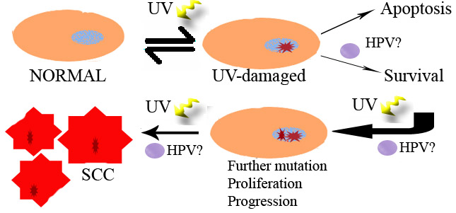
Figure 10. A model illustrating development of NMSC and a possible contributing role of HPV infection. HPV may promote survival of DNA-damaged cells by inhibition of apoptosis and DNA repair. With further exposure to UV irradiation, and possibly viral proteins, additional mutations are introduced and cells progress to cancer.

The role of E6 and E7 proteins in NMSC
Studies with the oncoproteins E6 and E7 of the HPVs belonging to the genus Beta have shown that the E6 does not bind p53 but the E7 binds pRb ¹³⁶⁻¹³⁹. Also the E6 protein of cutaneous types HPV1 and 8, as well as low-risk mucosal types, do not contain the consensus PDZ-binding domain in contrast to that of the high-risk mucosal types ¹⁹⁷.
The E6 and E7 proteins of HPV38 have shown ability to increase the lifespan of primary human keratinocytes ¹³⁷. This alteration of the lifespan might be attributable to the ability of HPV38 E6 to activate telomerase by an interaction with NFX1-91 but even though the E6 protein of other cutaneous HPVs (HPV5, 8, 20 and 22) than HPV38 also demonstrated this interaction, they were not able to activate telomerase in primary keratinocytes ¹⁹⁸ demonstrating differences amongst the cutaneous types. Another recent study investigating the E6 and E7 proteins of cutaneous types HPV12, 14, 15, 24, 36 and 49 showed transforming properties in vitro and indicated that E6 is the major transforming protein of these viruses ¹⁹⁹.
Experiments with transgenic mice have further pointed out a transforming potential. In one study, the transgenic mice expressing the HPV8 E6 and E7 proteins spontaneously developed skin tumors and in 6% of cases SCC ²⁰⁰. In another study, HPV38 E6 and E7 deregulated cell-cycle and induced hyperproliferation, however, the mice did not develop tumors unless treated with certain chemical carcinogens ²⁰¹. In the same study, it was demonstrated that the oncogenes interfere with cellular defense processes induced by UV-irradiation. Similar experiment with HPV 20 and 27 E6 and E7 have shown tumor development in transgenic mice after UV-exposure ²⁰².
The contributing role of HPV to UV-mediated carcinogenesis has further been implied by demonstration that the E6 proteins of HPV5, 10 and 77 target the apoptotic protein Bak for degradation ¹³⁹ and also HPV8 E6 has shown ability to bind a protein involved in DNA repair, XRCC1, and impair its function ²⁰³.

THE IMMUNE RESPONSE
The immune system uses innate and adaptive immunity to recognize and combat foreign agents that invade the body, but these defenses are usually ineffective against HPVs. The HPVs have evolved ways of evading the immune system; however, most of the infections are cleared.

HPV evading the host immune system
The response of the immune system to HPV has been difficult to define. A large number of reports have shown that lesions or warts of both mucosal and cutaneous nature do not self-resolve in immunosuppressed patients at the same rate as they do in immunocompetent patients ¹⁴⁰. This emphasizes the importance of the immune response to HPV infection. Although, in comparison to other viral infections, the HPV induces a weak and slow immunologic response ²⁰⁴. This is likely due to the fact that the HPV infection is non-lytic and induces proliferation rather than cytolysis, thereby causing minimal/no tissue destruction, and consequently, infection is not accompanied by inflammation giving no alerting signal to the immune system. Also, there is no viraemic phase in course of the infection minimizing the viral exposure to the immune surveillance. Moreover, the viral proteins have been seen to have several intracellular effects in order to further evade the immune system e.g. down-regulation of INF-α-inducible gene expression ²⁰⁵, inhibition of interaction between epithelial cells and dendritic cells ²⁰⁶, inhibition of the processing of antigenic peptides ⁸⁰ and down-regulation of HLA antigens ⁸⁰.
Despite the HPVs ability to avoid the immune system, cell-mediated immunity eventually leads to clearance of the infection. Immunohistologic studies of spontaneously regressing warts have shown that a high infiltration with T-cells and macrophages are distinctive for regression ²⁰⁷. Also, antibodies specific for the L1 protein are detected in HPV infected individuals. However, the antibodies are detected only in about half of the infected women, in low titers, and they develop first four months to five years after the infection ²⁰⁸⁻²¹¹. The antibody development to HPV capsid is probably not involved in clearance of the ongoing infection, but may be important in prevention of HPV spreading to new sites and reducing the likelihood of re-infection ²¹².

The HPV vaccine
Originally, studies in animals showed that antibodies, induced by immunization with inactivated PV virion and targeted to L1 epitopes, were sufficient to prevent infection with corresponding type of PV ²¹³. Today, vaccines that prevent infection by the distinguished genital HPV types are available from two different companies: Gardasil® from Merck & Co, marketing a quadrivalent vaccine incorporating HPV6, 11, 16 and 18, and Cervarix® from GlaxoSmithKline Biologicals incorporating HPV16 and 18 ²¹⁴. In June 2006, Federal Drug Administration in the USA approved the use of Gardasil® in clinics. Both vaccines are administered as 3 intramuscular doses spread over 6 month’s time.
The available vaccines are based on the VLPs. The VLP share great resemblance to native virus and as they contain no DNA, they are not infectious and therefore considered safe to use. The studies, phase II and III clinical trials, conducted with young women in their late teens or early twenties have shown substantial protection in vaccine recipients against HPV infection ^{210,215-218}. Both vaccines have shown efficacies of over 90% against persistent infection. Nevertheless, these vaccines are prophylactic and effect in women already exposed to the infection gives poor protection for development of cancer ^{219,220}. Therefore the vaccine should be distributed to girls before the onset of the sexual debut, which has raised a debate over the appropriate age of vaccination. Still, a development of therapeutic vaccine is exceedingly necessary, knowing that humongous numbers of women worldwide are already infected by HPV and millions will develop cancer over the coming years. It is however reassuring to know that vaccine, able to prevent 70% of worldwide cervical cancers, is available and over time will lead to substantial reduction of this disease. Future development of vaccine protective against all HPV types may lead to eventual eradication of the diseases caused by this widespread virus.

PRESENT STUDIES

AIMS

The purpose of the studies upon which this thesis is based was to:

- Characterize novel HPV types in the genus Betapapillomavirus and investigate their prevalence in non-melanoma skin cancer and in benign lesions.
- Examine the ability of HPV92, 93 and 96 E7 proteins to bind tumor suppressor protein (pRB) and investigate their transforming ability.
- Identify putative promoters and investigate the transcriptional activity from upstream regulatory region (URR) of novel cutaneous HPV types as well as their responsiveness to UV-irradiation and cellular differentiation.
- Determine HPV prevalence and investigate 19 different cellular proteins as potential distinguishing markers between keratoacanthoma (KA) and squamous cell carcinoma SCC.

MATERIALS AND METHODS

Paper I and II

Characterization of novel types
Putative types, with only about 450 bp of their sequence known, FAIMVS6, FA47, FA5, FA51, FA75 and FA85 were all isolated from lesions of immunocompetent patients (Table 3). The full genome of these types was sequenced using ether primer walking (HPV93, 96 and 107) or using random transposon insertion reaction EZ-Tn5™ <TET-1> on clones containing the entire viral genomes, and subsequent sequencing with transposon specific primers (HPV110, 111 and FA75[KI88-03]). The sequences of all the characterized types, as well as closely related HPV types, were aligned using ClustalW and a phylogenetic tree was created using MEGA (Molecular Evolutionary Genetic Analysis) software, version 4.
Table 3. The origin of isolation of the characterized HPV types.
Partial DNA sequence | HPV type | The index patient
Partial DNA sequence | HPV type | Lesion | Age | Sex | Location
FAIMVS6 | HPV93 | AK | 82 | male | Hand (dorsum)
FA47 | HPV96 | SCC in situ | 75 | male | Chest
FA85 | HPV107 | AK | 76 | male | Temple
FA5 | HPV110 | SCC in situ | 88 | female | Cheek
FA51 | HPV111 | SCC in situ | 79 | female | Ear
FA75 | FA75[KI88-03] | SCC | 93 | male | Ear

Procedure for sample collection
A patient panel consisting of 269 immunocompetent patients was selected from a larger study ¹⁸⁸. Before collection of a biopsy, the skin was stripped with a piece of tape, i.e. the tape was attached and removed five times and then same procedure was done with new piece of tape. Thereafter, a punch biopsy with a diameter of approximately 2 mm was taken from the underlying skin. The purpose of the stripping was to remove possible contaminant viral particles residing on the skin surface and increase likelihood to detect virus produced in the skin itself. A biopsy was collected from the lesion and adjacent healthy skin from all patients. The DNA was extracted and dissolved in 200µl TE buffer (10mM Tris-HCl, 0.1mM EDTA, pH 8.0) using a phenol-free method ²²¹. Prior to the stripping of the biopsy, a swab sample was also collected and suspended in 1ml saline from the top of the lesion of each patient.

Prevalence and viral loads
The prevalence and viral loads of the novel types, as well as a previously by our group characterized type – HPV92 ²²², were investigated in the stripped lesions and the paired healthy skin biopsies. In paper I, the entire panel of 269 patients, with diagnoses AK (n = 52), SK (n = 47), basal cell carcinoma (n=118) and squamous cell carcinoma (n=52) were analyzed by a quantitative real-time PCR with type specific primers and probes. The same procedure was used in paper II, however, due to consumption of some samples, the panel consisted of 263 patients (Table 5). No cross-hybridization to closely related HPV types was observed with any of the primer pairs. Additionally, in paper II, the swab samples were also analyzed with real-time PCR for those lesions that were positive for either of HPV107, 110, 111 or FA75[KI88-06].

HPV92, 93 and 96 E7 proteins
In order to investigate the pRb binding ability of HPV92, 93 and 96 E7 proteins, immunoprecipitation assays were performed.
Additional, unpublished, experiments in soft agar were made to establish the transforming potential of E6 and E7 proteins of HPV92, 93 and 96 in rodent cells. First, the E6 and E7 ORF were amplified and inserted into pEF/FRT/V5-D-TOPO. These vectors, along with the empty vector and a vector carrying HPV16 E6 and E7 ORFs were transfected into Flp-In-3T3 cell line (Figure 11). The cells were transfected at 80 % confluence in 75 cm² flasks with 12 µg DNA (1 µg construct-vector and 11 µg recombinase expressing pOG44 vector), 38.5 µl Lipofectamine™ Reagent and 25 µl Plus™ Reagent. The theory behind the Flp-In-system is explained in Figure 11. Post transfection, 48h, cells were grown in medium supplemented with 100 µg ml⁻¹ hygromycin B for two-three weeks to select for the stably transfected cells, then foci were pooled and subcultured. DNA was extracted from cells by a phenol-free method ²²¹ and checked by PCR for presence of HPV-DNA. mRNA was isolated cells with a mRNA isolation kit (Roche Diagnostics GmbH) and checked for contaminating HPV-DNA by PCR. mRNA was subjected to reverse transcription using polyT primer and AMV Reverse Transcriptase. The presence of E6 and E7 transcript of each HPV-type was checked by PCR with the type specific primers. Soft agar assays were performed as three independent experiments in six well plates, where 0.64 % bottom agarose in growth medium was topped with 0.4 % agarose (Sigma-Aldrich) in growth medium containing 3x10⁴ cells. The cells were fed every four days with growth medium for three weeks, whereupon the colonies were scored microscopically within an area of 2.25 cm².

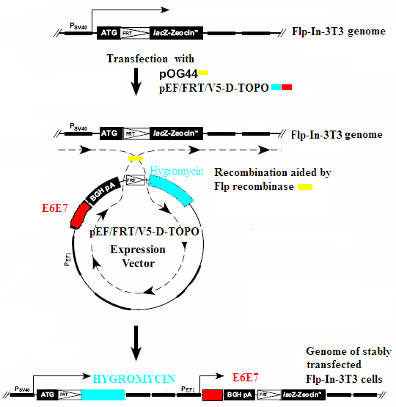

Figure 11. Schematic presentation of the Flp-In system used to produce cells expressing E6 and E7 of HPV16, 92, 93 and 96.

Paper III

Luciferase assays
The URRs of HPV8, 38, 92, 93 and 96 were amplified and inserted upstream of luciferase reporter gene in the vectors pGL3-Basic and pGL3-Enhancer (Figure 12).

Figure 12. Schematic presentation of the position of the HPV URR within pGL3 vectors. A nonsense sequence was inserted upstream of the HPV URR in order to minimize risk of transcriptional activity coming from the vector itself.

Two human cell lines, SiHa - derived from cervical cancer cells, and HaCaT from spontaneously immortalized skin keratinocytes, were transiently transfected with each pGL3-Enhancer vector containing the URR of different types and luciferase activity was measured to asses the transcriptional activity of the different HPV types.
The effect of 15 mJ/cm²UV-B irradiation on the transcriptional activity of HPV8, 38, 92, 93 and 96 as well as of HPV-16 was examined in HaCaT cells. In order to avoid cooperative effects of UV-B from the pGL3-Enhancer vector, constructs made with pGL3-Basic vector were used. Twenty-four h post after transfection, the HaCaT cells were UV-B irradiated and luciferase activities measured after 4h and 24h. A set of cells were not irradiated but transfected and harvested at the same time points. These were used as reference values in calculations of the relative UV-B mediated changes.
The effect of cellular differentiation on the transcriptional activity of HPV8, 93 and 96 was also examined in HaCaT cells. The cells were transfected and the luciferase activity measured at 13, 45 and 117 (5 days) h post transfection. In order to induce cellular differentiation, cells were supplemented with high concentration of Ca²⁺ [5.8 mM ] 13 h post transfection and harvested 5 days post transfection. A parallel experiment was made in the same way, except that instead measuring of luciferase, RNA was isolated. The RNA was used to determine levels of differentiation markers K10 and involucrin at each time point by real-time PCR.

The localization of promoters
The localization of promoters within the URR of HPV8, 92, 93 and 96 was done by 5’RACE PCR (Figure 13).

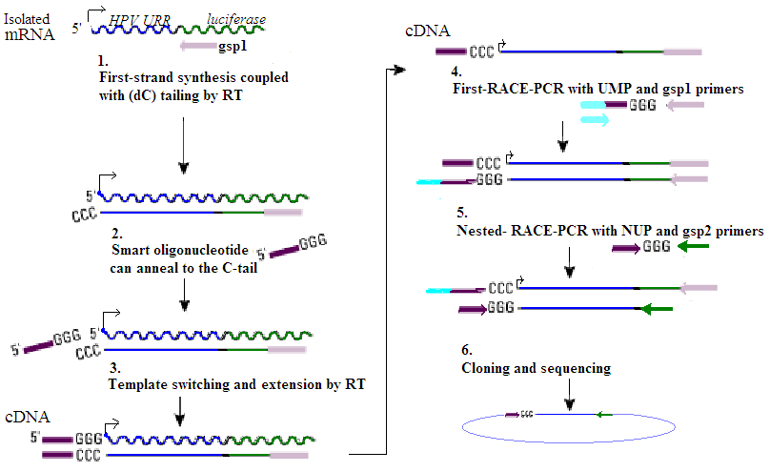
Figure 13. The identification of transcription start site by 5’RACE PCR. This method utilizes the SMART™ (Switching Mechanism at 5’ End of RNA Template) technology, based on specific features of the reverse transcriptase (MMLV RT). (1) As the RT reaches the 5’ end of mRNA it uses its terminal transferase activity (2) a SMART oligonucleotide with guanosines in the 3’-end anneal and (3) the RT switches template, making a full cDNA with known sequences in both 3’ and 5’-end (4) Thus a PCR can be performed with UMP, a primer-mix containing primers specific for the SMART oligonucleotide, and gsp1 (5), and subsequently a nested PCR with NUP and gsp2 primers. (6) The amplified products are cloned and sequenced.

HaCaT cell-line was transfected with each construct and 48 h later the mRNA was isolated. 5’ RACE PCR was performed with BD SMART^{tm} RACE cDNA amplification kit using 400ng of isolated mRNA and following general guidelines of this kit. The obtained amplicons were cloned and sequenced.

Paper IV

The patient panel and tissue microarray
One-hundred-thirty-one patients with SCC specimens stored at the Pathology Department in Malmö, MAS, Sweden were identified from the Swedish cancer registry and the paraffin-embedded tissues were retrieved. The quality of the blocks was evaluated; areas representative of tumor and normal squamous epithelia were selected and also diagnoses were re-evaluated by two expert pathologists. After evaluations, a total of 25 SCC, 64 KA and 49 normal tissues were included in this study. One mm punch was taken from the selected areas in each donor block and then mounted in a recipient block using manual arrayer (MTA-1, Beecher Inc, WI, USA). Four µm sections of the tissue microarray (TMA) were dried, deparaffinised, rehydrated and treated in target retrieval solution before being processed in automatic Techmate 500 immunohistochemistry staining machine. Antibodies covering different aspects of carcinogenesis - the immune response, apoptotic pathways, proliferation and cell cycle regulation were used for the staining (Table 4).
Table 4. Overview of the investigated antigens.
Immune  response | CD3+ | Marker commonly used to distinguish T cells
Immune  response | CD20+ | Marker commonly used to distinguish B cells
Immune  response | CD68+ | Marker commonly used to distinguish mononuclear phagocytes
Transcription factors | NFκB/p65 | Induce proliferative and anti-apoptotic gene products
Transcription factors | IκB-α | Inhibitor of p65
Transcription factors | STAT3 | Induce proliferative and anti-apoptotic gene products
Transcription factors | p53 | Tumor suppressor, induce cell cycle arrest and apoptosis
Tumor  suppressors | TRAP-1 | TGFß receptor associated protein with role as inhibitor of the growth factor TGFß.
Tumor  suppressors | pRB | Tumor suppressor, inhibits transcription factor important for cell cycle progession
Tumor  suppressors | Cyld | Tumor suppressor, inhibitor of NFκB
Tumor  suppressors | p21 | Activated by p53, induces cell cycle arrest
Tumor  suppressors | p16^{INK4} | Tumors suppressor, induces cell cycle arrest
Apoptosis | Survivin | Inhibitor of cellular apoptosis
Apoptosis | Bcl-xL | Inhibitor of cellular apoptosis by interaction with initiators.
Apoptosis | Caspase 3 | Involved in execution of apoptosis
Apoptosis | BAK | Initiator of apoptosis
Receptor | FLK-1 /VEGF-r2 | Growth of endothelial cells
Marker | Ki-67 | Proliferation marker
The stained TMAs were evaluated by pathologist (KB) by light microscopy estimating population of the stained cells and scoring: negative staining, weak but detectable staining of some or all cells and strong staining of some or all cells.

HPV analysis
A section of a block from each included patient was deparaffinized, dried and DNA was extracted by a phenol-free method ²²¹. The extracted DNA was checked for the presence of β-globin gene ¹⁶⁷, as a quality control, and the positive samples were further checked for HPV presence by two different nested PCR methods ^{223,224}. The amplicons of positive samples were cloned and sequenced to identify the HPV type.

RESULTS AND DISCUSSION

Paper I – Characterization of two novel cutaneous human papillomaviruses, HPV93 and HPV96
The complete genome of HPV93 (GenBank accession no. AY382778) was 7,450 bp and it was closest related to HPV24 with 79% sequence identity between the L1 ORFs. HPV93 was phylogenetically classified in Betapapillomavirus species 1 (Figure 14). The complete genome of HPV96 (GenBank accession no. AY382779) comprised of 7,438 bp and it was closest related to HPV92 with 71% sequence identity between the L1 ORFs. Accordingly, HPV96 was phylogenetically classified as a new species, 5, of Betapapillomavirus (Figure 14). In similarity to other HPVs of the genus Beta, HPV93 and 96 genomes display the lack of the E5 ORF (Figure 17), the pRb-binding domain in the E7 protein and both the E6 and E7 proteins contain zinc-binding domains.
The prevalence and viral loads of HPV92, 93 and 96 in samples were low. In total, 2.6% of tumors and 0.4% of healthy skin samples were positive for either of the types and the viral loads spanned from one copy per 45 cells to less then one copy per 10,000 cells (Table 5). The prevalence of these novel types are lower than among lesions and healthy skin of Australian immunocompetent patients ²²⁵ but may be due to the different levels of sun-exposure amongst the populations and the use of the stripping in sample collection in the present study. Multiple infections were detected in 2 out the 7 HPV positive patients.
The immunoprecipitation assays showed that the E7 protein of HPV92, 93 and 96 were able to bind to pRb in vitro, a binding which has been also demonstrated for other HPVs belonging to the genus Betapapillomavirus ^{137,226}.

Figure 14. Neighbor joining tree based on the alignment of the complete L1 ORF of HPV93, 96, 107, 110, 111 and FA75[KI88-03] and closely related HPV types within genus Betapapillomavirus species 1 and 2. HPV 49, 92 and 16 were added for orientation. The novel types characterized in this thesis are marked by *. Bootstrap value was set to 500.

Unpublished results
Additionally, the transforming ability of the E6 and E7 proteins of HPV 92, 93 and 96 was investigated. Surprisingly, in spite of the presence of DNA (Figure 15A), mRNA of the E6 gene could not be detected in the established cell-lines (Figure 15B). However, the E7 transcripts were detected (Figure 15C). Speculatively, the lack of E6 transcripts might be due to splicing, causing removal of primer site, or to presence of a promoter within the E6 gene, overriding the EF-1 promoter within the used vector. Interestingly, earlier attempts to express E6 of HPV92 failed in a rabbit reticulocyte-lysate-system where the E6 proteins from 19 mucosal and 2 cutaneous HPV types were successfully expressed (T. Iftner, personal communication) ²²⁷.

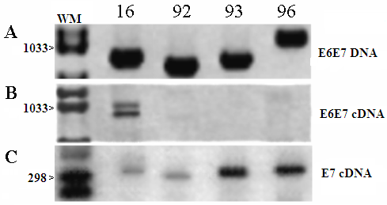
Figure 15. Detection of E6 and E7 DNA or cDNA from the Flp-In-3T3 cells stably transfected with vectors carrying E6 and E7 genes of HPV 16, 92, 93 and 96. (A) E6E7 DNA detected with PCR with type specific primers. (B) PCR analysis of cDNA with the same set of primers as in (A). (C) PCR analysis of cDNA with type specific primers for the E7 gene.
Nonetheless, induction of anchorage-independent growth in the transfected cells-lines was observed for HPV92, 93 and 96. The number of colonies formed by HPV93 and 96 was about half compared to that of HPV16, expressing both E6 and E7 (Figure 16). HPV92 gave rise to less than one fourth of colonies compared to that of HPV 16, only slightly more than the negative control. The binding of E7 to pRB and the transforming capability of these viruses support a possible role for these HPV types in development of skin cancer. Still, the transformation of rodent fibroblasts does not necessarily reflect the in vivo situation.
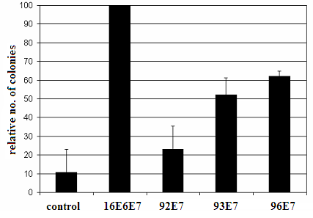

Figure 16. Soft agar assay with the stably transfected Flp-In-3T3 cells. Colonies formed within 2.25 cm² were scored microscopically and the number of HPV 16 colonies was set to 100. Bars represent the average of formed colonies in three experiments, and error bars one standard deviation.

Paper II - Four novel human Beta-2 papillomaviruses preferentially found in actinic keratosis
The complete genome of HPV107 (GenBank accession no. EF422221) comprised 7,562 bp and this type was closest related to HPV80 (74.3% sequence identity in the L1 ORF). The complete genome of HPV110 (GenBank accession no. EU410348) contained 7,423 bp and was also most closely related to HPV80 (80.3%). The complete genome of HPV111 (GenBank accession no. EU410349) contained 7,384 bp and was most closely related to HPV9 (78.1%). The complete genome of HPV isolate FA75[KI88-03] (GenBank accession no. EU410347) contained 7401 bp and was closest related to HPV80 (75.8%). All four novel HPV types were phylogenetically classified in the genus Betapapillomavirus species 2 (Figure 14). In accordance, the genomes of the four novel types shared the same structural properties as the other HPV types of this genus (Figure 17).
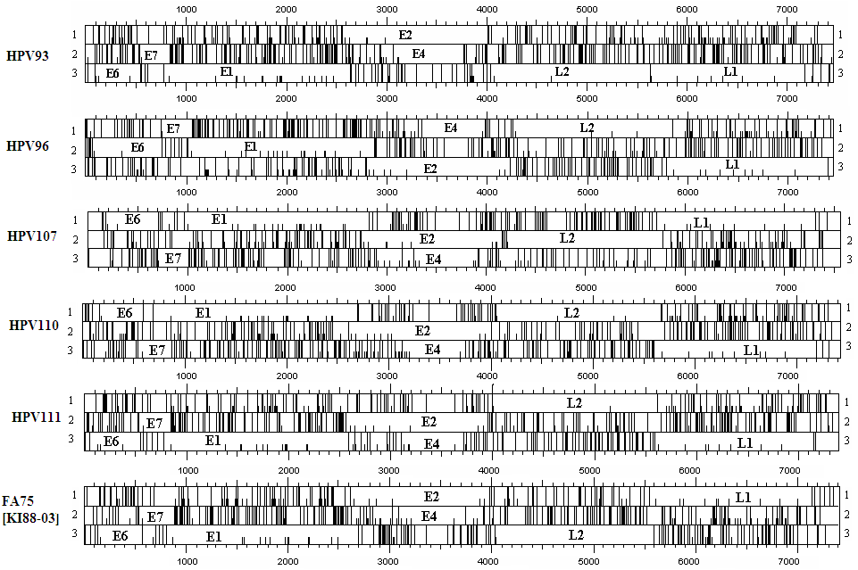

Figure 17. The putative ORFs of HPV93, 96, 107, 110, 111 and FA75[KI88-03].
HPV107, 110, 111 and FA75[KI88-03] tended to be found more often in the skin lesions than in the healthy skin (Table 5). In total, 6.5% of the patients harbored at least one HPV type in the lesion whereas 2.7% harbored HPV in the healthy skin (Table 5) (OR: 2.53, 95% CI: 0.97-6.84). Multiple infections were found in 3 out of the 19 positive patients with one patient being infected with all four types. In addition, an association of the four HPV types with actinic keratosis was observed (OR: 5.0, 95% CI: 1.4-17.5). This finding is in line with previous studies reporting an association of this pre-cancerous stage and HPV infection ^{164,196}. The viral loads were low (Table 5) and several lesions harbored higher amounts of virus on top of the lesion than in the lesions themselves - probably reflecting a productive viral life cycle. The characterization of the six novel types expanded the heterogeneity of HPV types in the genus Betapapillomavirus, particularly the species 2 that increased from 8 to 12 HPV types. However, a large number of additional putative types exist within this species ³⁵ and much more effort will be required to fully elucidate the medical implication of these viruses.
Table 5. Presence and viral loads of HPV92, 93, 96, 107, 110, 111, and FA75[KI88-03] in skin lesions.
Diagnosis | No. of patients | HPV type | Viral copies/cells
Diagnosis | No. of patients | HPV type | Lesion | Healthy skin | Top of lesion
SK | Paper I  (n = 47) | - | - | - | -
SK | Paper II  (n = 45) | HPV107³  HPV110³  HPV107 | 3/1  -  1/48 | -  1/83  - | -  -  -
AK | Paper I  (n=52) | HPV92  HPV93³  HPV96³  HPV96 | 1/298  1/380  1/1,410  1/3,238 | -  -  -  - | NA¹  NA¹  NA¹  NA¹
AK | Paper II  (n = 50) | HPV107  FA75[KI88-03] ²  HPV107 ²  HPV110 ²  HPV111 ²  HPV110  HPV110  HPV110  HPV110  FA75[KI88-03] | 1/156  1/256  1/1,141  1/438  1/2,109  1/877  1/910  1/2,147  1/3,042  - | -  -  -  -  -  -  -  -  -  1/97 | 2/1  1/5  1/13  1/13  1/13  -  -  2/1  -  -
SCC | Paper I  (n = 52) | HPV92  HPV92³  HPV93³ | 1/114  1/10,325  1/45 | -  -  1/2,987 | NA¹  NA¹  NA¹
SCC | Paper II  (n = 50) | HPV110  HPV110  FA75[KI88-03]  FA75[KI88-03] | 1/2  1/35,279  1/4,390  - | -  -  -  1/1,669 | 4/1  -  -  -
BCC | Paper I  (n = 118) | HPV92  HPV96 | 1/1,948  1/953 | -  - | NA¹  NA¹
BCC | Paper II  (n = 118) | HPV107  HPV107³  HPV111³  HPV107  HPV107³  HPV111³  HPV110  HPV110³  HPV111³ | 1/8  1/279  1/6,383  1/2,378  -  1/22,649  -  -  1/333 | -  -  -  1/21  1/4,104  -  1/354  1/1,768  1/231 | 137/1  1/2  -  1/18  -  1/211  -  -  1/2
¹ NA = not analyzed; ² Quadruple infection; ³ Infection of same patient.

Paper III – Differences in transcriptional activity of cutaneous human papillomaviruses
Here, we demonstrated the transcriptional activity of HPV92, 93 and 96 URR for the first time. All the types displayed significant activity, although the activities were lower than that of HPV8 (Figure 18). The cutaneous HPV types showed 1.6-fold to 12-fold higher activity in the skin-derived HaCaT cell-line than that in cervical cancer-derived SiHa cells (p<0.001), which may reflect their skin tropism. In concordance, similar results have been reported for HPV5 ²²⁸.
Figure 18. Comparison of the transcriptional activities of HPV8, 38, 92, 93 and 96 URR. Luciferase measurements were compared in two different cell-lines: closed bars, HaCaT and open bars, SiHa. The transcriptional activity from the HPV-16 URR was used as the reference and was arbitrarily set to 100%.
Using 5’RACE PCR we aimed to identify transcriptional start sites within the URRs. HPV8 URR was used as a positive control, since the transcriptional start sites are known for this type, and the expected start site at nt 7535 (P₇₅₃₅) was obtained verifying the used method. Furthermore, transcription initiation for HPV-38 was detected at nt. 92 (P₉₂), for HPV-92 at nt. 45 (P₄₅), for HPV-93 at nt.7439 (P₇₄₃₉) and for HPV-96 at nt.256 (P₂₅₆) (Figure 18). Notably, these sites are not within range of 7 to 20 bp upstream of the E6 ORF as shown for the main promoters of the mucosal HPV types ^{132,229}, but rather 50 to 120 bp upstream of the E6 ORF. The sequence similarity between the URRs was low, roughly 23%, (Figure 19). Thus, the composition of probable binding sites within the URRs may differ thereby effecting the position of the transcriptional start sites. Nonetheless, four conserved regions were recognized, one containing the AP1 binding motif, two containing the E2 binding motif (ACCGN₄CGGT) and a polyadenylation site (polyA-late) for late transcripts (Figure 19).
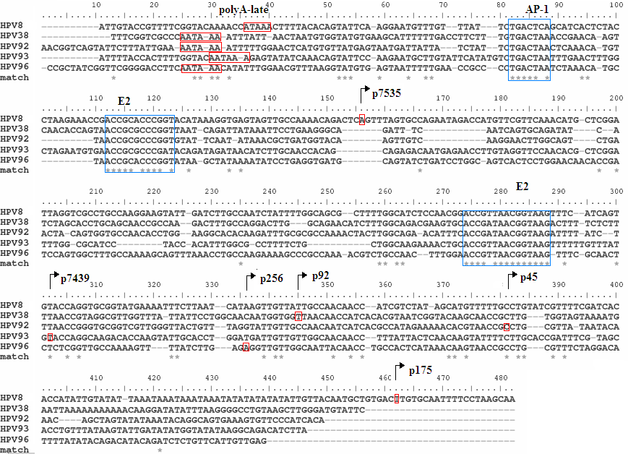
Figure 19. The alignment of the URR of HPV8, 38, 92, 93 and 96 demonstrating the identified transcriptional start sites and the overall low sequence identity amongst the types. The promotors of HPV 8 have been described by Stubenrauch et al ²³⁰. The putative late polyA site, two conserved consensus E2 motifs and one AP-1 binding site are marked.
As HPV is proposed co-factor in development of NMSC, the effect of UV-irradiation on viral transcriptional activity was investigated. Four h after the UV-irradiation the activity of HPV38 and 93 was significantly reduced. After 24h, the effect of UV-B irradiation showed changes in the promoter activity of HPV16, 8, 38 and 93. HPV-8 was the only type showing activation, 2.7 fold, by the UV-B, whereas the activity of HPV16 and HPV38 and 93 were down-regulated. HPV 92 and 96 did not show any responsiveness to the UV-irradiation (Figure 20).

Figure 20. The effect of UV-B on the URR of HPV-16, 8, 38, 92, 93 and 96 was calculated by comparing the activities of the irradiated cells to the non-irradiated cells and the relative fold change in activities is displayed. The closed bars represent 4h time point and open bars 24h. Significant differences between the two time points are marked by * = P<0.05, ** = P<0.01 and *** = P <0.001.

It is noteworthy that among the investigated HPV types, only HPV-8 (an EV-associated type) was activated by the UV-irradiation. This observation, in addition to the finding of a relatively high transcriptional activity, might suggest that HPV-8 is a high-risk skin type. However, the connection between UV-stimulation of HPV and the oncogenic potential of the HPV type is not established. In addition, as we showed variable UV-B responses among the HPV types within the same species it is not possible to predict how the different HPV types might react to UV-B irradiation based on genus they belong to.
The effect of cellular differentiation was investigated on the two novel types HPV93 and 96 in addition to HPV8. The cellular differentiation up-regulated the transcriptional activity of the investigated types (Figure 21A). The increased transcriptional activity during differentiation has also been reported for number of genital HPVs as well as for cutaneous HPV-5 ²³¹⁻²³³.
Surprisingly, the measurement of indicators of differentiation, K10 and involucrin, showed that differentiation was induced by transfection itself and thus already 45h after transfection, without Ca²⁺ supplementation, cells were differentiated (Figure 21C). At this time point, also the highest transcriptional activity was measured for HPV8, 93 and 96. In the cells that were cultured for 5 days (and Ca²⁺ supplemented) same level of differentiation was observed but the transcriptional activities of all three the types dropped (Figure 21B and C).
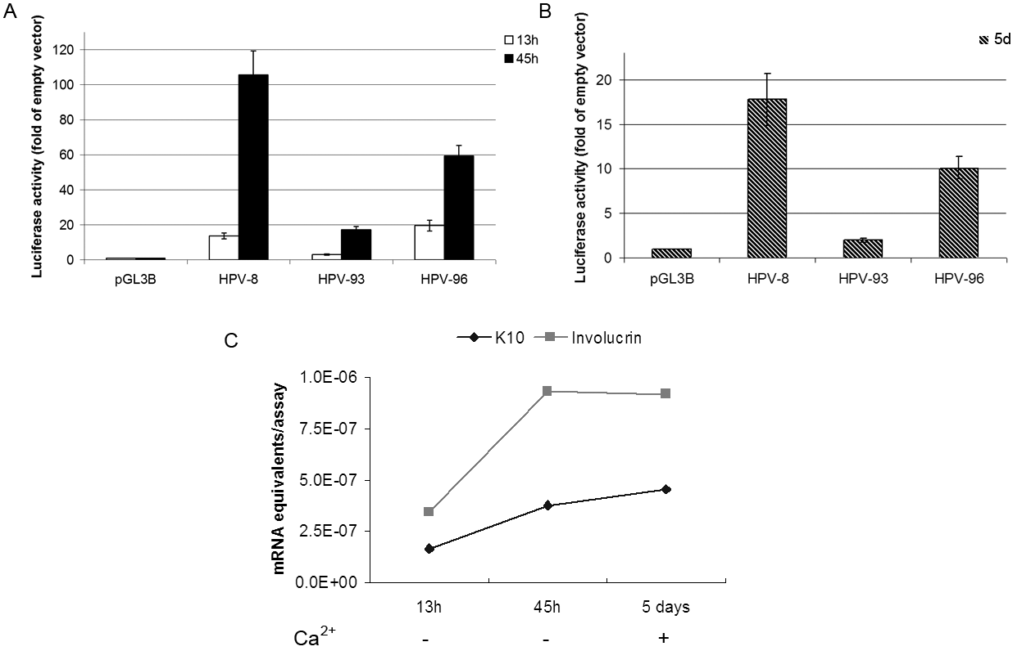
Ca+
Ca-
Figure 21. Effects of differentiation on transcriptional activities of HPV8, 93 and 96. A) Transcriptional activity after 13h (open bars) and 45h (closed bars) B) Transcriptional activity after 5d (lined bars). To the cells harvested at day 5, additional Ca2⁺ was added 13 h after transfection. C) Presence of differentiation markers involucrin and K10 at each time point show that cellular differentiation is induced by transfection.

Therefore, we emphasize that the Ca²⁺ and transfection mediated differentiation is merely a surrogate for in vivo differentiation as the general effect of Ca²⁺ on the cellular functions or the HPV URR should not be disregarded and that additional studies using multi-layered epithelium, e.g. raft cultures, are required to further understand the coordinated activity of viral promoters to host cell differentiation.

Paper IV - The Bcl-xL inhibitor of apoptosis is preferentially expressed in cutaneous squamous cell carcinoma compared to keratoacanthoma
Because KA is difficult to distinguish from SCC histologically, it is regarded and treated as SCC. Demonstrating this difficulty, in this study less than one third of the retrieved SCC specimens were confirmed as SCC in a re-evaluation by two expert pathologists. The aim was therefore to find a suitable distinguishing marker between the two lesions types.
In this TMA-based study, 19 biomarkers were examined (Table 4) of which only one, the anti-apoptotic protein Bcl-xL, was indicated as possible distinguishing marker. We found that 84% of the SCCs stained positive for this protein compared to only 15% of the KAs and 3% of the surrounding healthy tissue. Therefore we speculate that apoptosis is not inhibited in KA which also is supported by the actual regressive nature of this lesion. A previous study, based on small study material and using other evaluation techniques, found however no difference in expression of Bcl-xL between the lesions ²³⁴. Therefore, the identified candidate Bcl-xL deserves further studies in order to investigate its reliability to distinguish SCC from KA in routinely histopathology practice. Furthermore, the prevalence of HPV was investigated in order to gain insight of a possible contribution of the infection to the lesions. The viral DNA was detected in 22% of SCC and 27% of KA patients, thus demonstrating no difference between the lesions. HPV presence has been shown in the KA previously with no significant associations to the etiology of this disease ²³⁵ . Eighty percent of the identified HPV types belonged to Betapapillomavirus species 2.
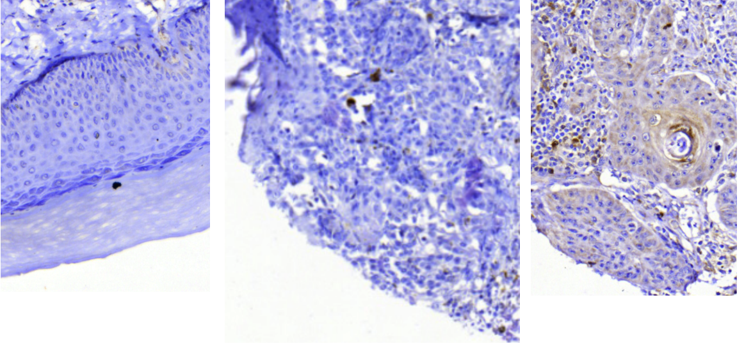
Our results suggest that SCC and KA might not be separate entities but that there is a difference in regulation of apoptosis. The inhibition of apoptosis in SCC may perhaps represent an acquired mutation that contributes to progression to carcinogenesis.

Normal Keratoacanthoma SCC

Figure 22. Tissue microarray stained with Bcl-xL antibody (brown). Cytoplasmic staining was observed in 85% of SCC, in 15 % of KA and 3% of normal tissues.

CONCLUDING REMARKS

The causal link between human genital PV and cervical neoplasia is well established but the role of cutaneous HPV in development of NMSC remains unclear. However, HPV types within Betapapillomavirus species 2 have recently been associated with NMSC in two epidemiological studies. As many of the HPV types within this genus are still uncharacterized, we obtained the complete genomes of six novel types, HPV93, 96, 107, 110, 111 and FA75[KI88-03] and thereby substantially expanded the Betapapillomavirus genus. Although we detected low prevalence and viral loads of these viruses, the four viruses belonging to the species 2 were together found associated with actinic keratosis and had a tendency for association with skin lesions. Furthermore, the E7 protein of HPV92, 93 and 96 was able to induce anchorage-independent growth in a rodent cell-line and also bind the cellular tumor suppressor protein pRb suggesting a possible role of these viruses in skin carcinogenesis.
The transcriptional activity from URR of HPV93 and 96 as well as HPV8 was activated by cellular differentiation; however a differentiation effect from transfection treatment on HaCaT cells was observed and should be taken into consideration in further studies. The UV-light had different effect on the URRs of HPV8, 38, 92, 93 and 96 suggesting that the viral co-operation in UV-mediated carcinogenesis could depend on the type and thus high-risk types might also exist amongst cutaneous HPVs. Moreover, we identified possible transcriptional start sites in the URRs.
The resemblance between KA and SCC makes it difficult to make a correct histological diagnosis. We suggest that Bcl-xL, an anti-apoptotic protein, could serve as a possible histologic distinguishing marker since it is found in majority of SCCs and significantly less in KA and healthy skin. This finding is in line with the self-regressive nature of the KA lesion. As we investigated 19 possible markers and only one differed significantly, we can not confirm these lesions as separate entities.

ACKNOWLEDGEMENTS
My colleagues, friends and family have constantly supported me during this work and I want to express special gratitude to:
- My supervisors:
Ola Forslund, for always making time for discussions, your enthusiasm, your patience and for the guidance in to the world of cutaneous papillomaviruses.
Joakim Dillner, for opening the door to your group, helping and guiding me along the way.
Bodil Norrild, for great support, for teaching me and encouraging me with constant confidence in me and of course all the comfort during my downturns.

- My colleagues:
Christina Gerouda, min solstråle, without your friendship I surely wouldn’t be where I am today. Thank you for always being there, spreading the positive energy around you!
Kristina Hazard, thank you for all your help, support and care. It has been a pleasure collaborating as well as traveling with you!
Janka Ryding, for all the fun times abroad and at home, countless lunches with inspiring discussions on everything between heaven and earth!
Aline Marshall, for being a great support, cheering me up, always believing in me, teaching me about many thing in life and just for being there!
Johanna Kullander, for being a great roommate both in the lab and away, always helpful and cheerful!!
All the past and present members of our group, especially: Kia Sjölin, Anna Södelund Strand, Maria Anderberg, Sofia Harlid, Carina Eklund, Zoltan Korodi, Malin Sjöholm, Annika Lundstig, Camilla Lagheden, and of course my co-author Kristin Andersson.
Helena Persson and Anna Olofsson-Franzoia, for making all the administrative things run so smoothly, always being helpful and understanding, and for doing such a great job!!
All the neighboring bacteriologists, with special thanks to Andrea Möllenkvist, Johan Jendholm, Martin Samuelsson and Elena Ronander for sharing good and bad times over the years.

All of you have made our lab a hard place to leave!!!
- My colleagues at the Panum Institute: Christina Hansen, Jacob Glahder, Lone Nielsen, Nikolaj Mikkelsen, Michael Jensen, Mette Petsch and Solvej Jensen for making room for me in your lab and always being helpful.

- Margareta, Anki, Gertrud and Našida for all the help with preparing plates and medium and making our job at the fifth floor much easier.

- Lars-Göran Pitzum for always being helpful with ordering of supplies.

- Kaj Bjelkenkrantz for a great collaboration and teaching me to interpret TMA stainings.

- All the others at the Entrance 78 of MAS who made my days there happier.

- Karolina Förnvik, min brud, your friendship, kindness, care, support and understanding has meant a lot! I’ll always be there for you and your boys ;)

- Rebecka, Ali G, Camilla, Christian, Toby, Mino, Antonija and Vladimir, for all the support outside the lab, making my life full of fun evenings with loads of laughter!

- Ardeshir, Maryam and Ziba for always supporting me with kind words and good foods. Mersi!

- Cyrus, my baby, my partner in life, thank you for listening, comforting, taking care of me, believing in me, cheering me up when I most needed it and giving me so much love during these challenging years of my life.

- Finally, my stronghold, my incredible family – my mum Alica, my dad Božidar, my brother Boris and grandma Mila! Bez vašeg podrška, vaše ljubavi, i truda da mi u svemu pomognete i olakšate ovo ništa ne bih postojalo. Zato vam ovaj rad posvećujem i zahvaljujem se iz sveg srca za sve. Volim vas beskonačno!

REFERENCES

1. Routh, H.B., Bhowmik, K.R. & Parish, L.C. Myths, fables and even truths about warts and human papillomavirus. Clin Dermatol 15, 305-307 (1997).
2. Howley, P.M. Papillomavirinae: The viruses and their replication. in Fields Virology (eds. Fields, B.N., et al.) 2045-2109 (Lippincott-Raven, New York, 1996).
3. zur Hausen, H. Roots and perspectives of contemporary papillomavirus research. Journal of cancer research and clinical oncology 122, 3-13 (1996).
4. Ciuffo, G. Innesto positivo con filtrado di verrucae volgare. G. Ital. Mal. Venereol. 48, 12-17 (1907).
5. Shope, R.E. Infectious papillomatosis of rabbits. With a note on histopathology. J. Exp. Med. 58, 607-624 (1933).
6. Rous, P. & Beard, J. Carcinomatous changes in virus-induced papillomas of the skin of the rabbit. Proc Soc Exp Biol Med 32, 578-580 (1934).
7. Rous, P. & Kidd, J.G. The carcinogenic effect of a papilloma virus on the tared skin of rabbits. The Journal of experimental medicine 67, 399-422 (1938).
8. Kausche, G., Ankuch, P. & Ruska, H. Die Sichtbarmachung von PF lanzlichem Virus im Ubermikroskop. Naturwissenschaften 27, 292-299 (1939).
9. Strauss, M.J., Shaw, E.W., Bunting, H. & Melnick, J.L. Crystalline virus-like particles from skin papillomas characterised by intranuclear inclusion bodies. Proc. Soc. Exp. Biol. Med. 72, 46-50 (1949).
10. Crawford, L.V. & Crawford, E.M. A Comparative Study of Polyoma and Papilloma Viruses. Virology 21, 258-263 (1963).
11. Jablonska, S. & Milewski, B. [Information on epidermodysplasia verruciformis Lewandowsky-Lutz; positive results of auto- and heteroinoculation.]. Dermatologica 115, 1-22 (1957).
12. Jablonska, S., Dabrowski, J. & Jakubowicz, K. Epidermodysplasia verruciformis as a model in studies on the role of papovaviruses in oncogenesis. Cancer Res 32, 583-589 (1972).
13. zur Hausen, H., Meinhof, W., Scheiber, W. & Bornkamm, G.W. Attempts to detect virus-secific DNA in human tumors. I. Nucleic acid hybridizations with complementary RNA of human wart virus. Int J Cancer 13, 650-656 (1974).
14. Gissmann, L. & Hausen, H.Z. Human papilloma virus DNA: physical mapping and genetic heterogeneity. Proc Natl Acad Sci U S A 73, 1310-1313 (1976).
15. Gissmann, L., Pfister, H. & Zur Hausen, H. Human papilloma viruses (HPV): characterization of four different isolates. Virology 76, 569-580 (1977).
16. Orth, G., Favre, M. & Croissant, O. Characterization of a new type of human papillomavirus that causes skin warts. J Virol 24, 108-120 (1977).
17. Orth, G., Jablonska, S., Favre, M., Croissant, O., Jarzabek Chorzelska, M. & Rzesa, G. Characterization of two types of human papillomaviruses in lesions of epidermodysplasia verruciformis. Proc Natl Acad Sci U S A 75, 1537-1541 (1978).
18. Boshart, M., Gissmann, L., Ikenberg, H., Kleinheinz, A., Scheurlen, W. & zur Hausen, H. A new type of papillomavirus DNA, its presence in genital cancer biopsies and in cell lines derived from cervical cancer. Embo J 3, 1151-1157 (1984).
19. Gissmann, L., deVilliers, E.M. & zur Hausen, H. Analysis of human genital warts (condylomata acuminata) and other genital tumors for human papillomavirus type 6 DNA. Int J Cancer 29, 143-146 (1982).
20. Gissmann, L. & zur Hausen, H. Partial characterization of viral DNA from human genital warts (Condylomata acuminata). Int J Cancer 25, 605-609 (1980).
21. Dürst, M., Gissmann, L., Ikenberg, H. & zur Hausen, H. A papillomavirus DNA from a cervical carcinoma and its prevalence in cancer biopsy samples from different geographic regions. Proc Natl Acad Sci U S A 80, 3812-3815 (1983).
22. zur Hausen, H. Condylomata acuminata and human genital cancer. Cancer Res 36, 794 (1976).
23. de Villiers, E.M., Wagner, D., Schneider, A., Wesch, H., Miklaw, H., Wahrendorf, J., Papendick, U. & zur Hausen, H. Human papillomavirus infections in women with and without abnormal cervical cytology. Lancet 2, 703-706 (1987).
24. zur Hausen, H. Papillomaviruses causing cancer: evasion from host-cell control in early events in carcinogenesis. J Natl Cancer Inst 92, 690-698 (2000).
25. Akgul, B., Cooke, J.C. & Storey, A. HPV-associated skin disease. J Pathol 208, 165-175 (2006).
26. Baker, T.S., Newcomb, W.W., Olson, N.H., Cowsert, L.M., Olson, C. & Brown, J.C. Structures of bovine and human papillomaviruses. Analysis by cryoelectron microscopy and three-dimensional image reconstruction. Biophys J 60, 1445-1456 (1991).
27. Trus, B.L., Roden, R.B., Greenstone, H.L., Vrhel, M., Schiller, J.T. & Booy, F.P. Novel structural features of bovine papillomavirus capsid revealed by a three-dimensional reconstruction to 9 A resolution. Nature structural biology 4, 413-420 (1997).
28. Pfister, H. & Fuchs, P.G. Anatomy, taxonomy and evolution of papillomaviruses. Intervirology 37, 143-149 (1994).
29. Bernard, H.U., Calleja-Macias, I.E. & Dunn, S.T. Genome variation of human papillomavirus types: phylogenetic and medical implications. Int J Cancer 118, 1071-1076 (2006).
30. Ong, C.K., Chan, S.Y., Campo, M.S., et al. Evolution of human papillomavirus type 18: an ancient phylogenetic root in Africa and intratype diversity reflect coevolution with human ethnic groups. J Virol 67, 6424-6431 (1993).
31. zur Hausen, H. Papillomavirus infections-a major cause of human cancers. Biochim Biophys Acta 1288, F55-78 (1996).
32. Ritzkowsky, A., Weissenborn, S., Krieg, T., Pfister, H. & Wieland, U. Extensive human papillomavirus type 7-associated orofacial warts in an immunocompetent patient. Acta Derm Venereol 81, 130-133 (2001).
33. Chambers, G., Ellsmore, V.A., O'Brien, P.M., Reid, S.W., Love, S., Campo, M.S. & Nasir, L. Association of bovine papillomavirus with the equine sarcoid. J Gen Virol 84, 1055-1062 (2003).
34. de Villiers, E.M., Fauquet, C., Broker, T.R., Bernard, H.U. & zur Hausen, H. Classification of papillomaviruses. Virology 324, 17-27 (2004).
35. Forslund, O. Genetic diversity of cutaneous human papillomaviruses. J Gen Virol 88, 2662-2669 (2007).
36. Berkhout, R.J., Tieben, L.M., Smits, H.L., Bavinck, J.N., Vermeer, B.J. & ter Schegget, J. Nested PCR approach for detection and typing of epidermodysplasia verruciformis-associated human papillomavirus types in cutaneous cancers from renal transplant recipients. J Clin Microbiol 33, 690-695 (1995).
37. Bernard, H.U. The clinical importance of the nomenclature, evolution and taxonomy of human papillomaviruses. J Clin Virol 32 Suppl 1, S1-6 (2005).
38. Hazard, K., Andersson, K., Dillner, J. & Forslund, O. Human papillomavirus subtypes are not uncommon. Virology 362, 6-9 (2007).
39. Munoz, N., Bosch, F.X., de Sanjose, S., Herrero, R., Castellsague, X., Shah, K.V., Snijders, P.J. & Meijer, C.J. Epidemiologic classification of human papillomavirus types associated with cervical cancer. N Engl J Med 348, 518-527 (2003).
40. Lörincz, A.T., Reid, R., Jenson, A.B., Greenberg, M.D., Lancaster, W. & Kurman, R.J. Human papillomavirus infection of the cervix: relative risk associations of 15 common anogenital types. Obstet Gynecol 79, 328-337 (1992).
41. Orth, G. Genetics of epidermodysplasia verruciformis: Insights into host defense against papillomaviruses. Seminars in immunology 18, 362-374 (2006).
42. Tachezy, R., Rector, A., Havelkova, M., Wollants, E., Fiten, P., Opdenakker, G., Jenson, B., Sundberg, J. & Van Ranst, M. Avian papillomaviruses: the parrot Psittacus erithacus papillomavirus (PePV) genome has a unique organization of the early protein region and is phylogenetically related to the chaffinch papillomavirus. BMC microbiology 2, 19 (2002).
43. Tan, C.H., Tachezy, R., Van Ranst, M., Chan, S.Y., Bernard, H.U. & Burk, R.D. The Mastomys natalensis papillomavirus: nucleotide sequence, genome organization, and phylogenetic relationship of a rodent papillomavirus involved in tumorigenesis of cutaneous epithelia. Virology 198, 534-541 (1994).
44. Patel, K.R., Smith, K.T. & Campo, M.S. The nucleotide sequence and genome organization of bovine papillomavirus type 4. J Gen Virol 68 ( Pt 8), 2117-2128 (1987).
45. Delius, H., Van Ranst, M.A., Jenson, A.B., zur Hausen, H. & Sundberg, J.P. Canine oral papillomavirus genomic sequence: a unique 1.5-kb intervening sequence between the E2 and L2 open reading frames. Virology 204, 447-452 (1994).
46. Danos, O., Katinka, M. & Yaniv, M. Human papillomavirus 1a complete DNA sequence: a novel type of genome organization among papovaviridae. Embo J 1, 231-236 (1982).
47. Pennie, W.D., Grindlay, G.J., Cairney, M. & Campo, M.S. Analysis of the transforming functions of bovine papillomavirus type 4. Virology 193, 614-620 (1993).
48. Han, R., Cladel, N.M., Reed, C.A. & Christensen, N.D. Characterization of transformation function of cottontail rabbit papillomavirus E5 and E8 genes. Virology 251, 253-263 (1998).
49. Seif, I. Sequence homology between the large tumor antigen of polyoma viruses and the putative E1 protein of papilloma viruses. Virology 138, 347-352 (1984).
50. Liu, J.S., Kuo, S.R., Broker, T.R. & Chow, L.T. The functions of human papillomavirus type 11 E1, E2, and E2C proteins in cell-free DNA replication. J Biol Chem 270, 27283-27291 (1995).
51. Mohr, I.J., Clark, R., Sun, S., Androphy, E.J., MacPherson, P. & Botchan, M.R. Targeting the E1 replication protein to the papillomavirus origin of replication by complex formation with the E2 transactivator. Science 250, 1694-1699 (1990).
52. Sedman, J. & Stenlund, A. The papillomavirus E1 protein forms a DNA-dependent hexameric complex with ATPase and DNA helicase activities. J Virol 72, 6893-6897 (1998).
53. Masterson, P.J., Stanley, M.A., Lewis, A.P. & Romanos, M.A. A C-terminal helicase domain of the human papillomavirus E1 protein binds E2 and the DNA polymerase alpha-primase p68 subunit. J Virol 72, 7407-7419 (1998).
54. Swindle, C.S. & Engler, J.A. Association of the human papillomavirus type 11 E1 protein with histone H1. J Virol 72, 1994-2001 (1998).
55. Fouts, E.T., Yu, X., Egelman, E.H. & Botchan, M.R. Biochemical and electron microscopic image analysis of the hexameric E1 helicase. J Biol Chem 274, 4447-4458 (1999).
56. McBride, A.A., Byrne, J.C. & Howley, P.M. E2 polypeptides encoded by bovine papillomavirus type 1 form dimers through the common carboxyl-terminal domain: transactivation is mediated by the conserved amino-terminal domain. Proc Natl Acad Sci U S A 86, 510-514 (1989).
57. Lai, M.C., Teh, B.H. & Tarn, W.Y. A human papillomavirus E2 transcriptional activator. The interactions with cellular splicing factors and potential function in pre-mRNA processing. J Biol Chem 274, 11832-11841 (1999).
58. Androphy, E.J., Lowy, D.R. & Schiller, J.T. Bovine papillomavirus E2 trans-activating gene product binds to specific sites in papillomavirus DNA. Nature 325, 70-73 (1987).
59. Bouvard, V., Storey, A., Pim, D. & Banks, L. Characterization of the human papillomavirus E2 protein: evidence of trans-activation and trans-repression in cervical keratinocytes. Embo J 13, 5451-5459 (1994).
60. Antson, A.A., Burns, J.E., Moroz, O.V., Scott, D.J., Sanders, C.M., Bronstein, I.B., Dodson, G.G., Wilson, K.S. & Maitland, N.J. Structure of the intact transactivation domain of the human papillomavirus E2 protein. Nature 403, 805-809 (2000).
61. Stenlund, A. & Botchan, M.R. The E2 trans-activator can act as a repressor by interfering with a cellular transcription factor. Genes & development 4, 123-136 (1990).
62. Bastien, N. & McBride, A.A. Interaction of the papillomavirus E2 protein with mitotic chromosomes. Virology 270, 124-134 (2000).
63. McBride, A.A., McPhillips, M.G. & Oliveira, J.G. Brd4: tethering, segregation and beyond. Trends in microbiology 12, 527-529 (2004).
64. Frattini, M.G., Lim, H.B. & Laimins, L.A. In vitro synthesis of oncogenic human papillomaviruses requires episomal genomes for differentiation-dependent late expression. Proc Natl Acad Sci U S A 93, 3062-3067 (1996).
65. Blachon, S. & Demeret, C. The regulatory E2 proteins of human genital papillomaviruses are pro-apoptotic. Biochimie 85, 813-819 (2003).
66. Webster, K., Parish, J., Pandya, M., Stern, P.L., Clarke, A.R. & Gaston, K. The human papillomavirus (HPV) 16 E2 protein induces apoptosis in the absence of other HPV proteins and via a p53-dependent pathway. J Biol Chem 275, 87-94 (2000).
67. Doorbar, J., Foo, C., Coleman, N., et al. Characterization of events during the late stages of HPV16 infection in vivo using high-affinity synthetic Fabs to E4. Virology 238, 40-52 (1997).
68. Doorbar, J., Campbell, D., Grand, R.J. & Gallimore, P.H. Identification of the human papilloma virus-1a E4 gene products. Embo J 5, 355-362 (1986).
69. Wilson, R., Fehrmann, F. & Laimins, L.A. Role of the E1--E4 protein in the differentiation-dependent life cycle of human papillomavirus type 31. J Virol 79, 6732-6740 (2005).
70. Doorbar, J., Ely, S., Sterling, J., McLean, C. & Crawford, L. Specific interaction between HPV-16 E1-E4 and cytokeratins results in collapse of the epithelial cell intermediate filament network. Nature 352, 824-827 (1991).
71. Doorbar, J., Elston, R.C., Napthine, S., et al. The E1E4 protein of human papillomavirus type 16 associates with a putative RNA helicase through sequences in its C terminus. J Virol 74, 10081-10095 (2000).
72. Conrad, M., Bubb, V.J. & Schlegel, R. The human papillomavirus type 6 and 16 E5 proteins are membrane-associated proteins which associate with the 16-kilodalton pore-forming protein. J Virol 67, 6170-6178 (1993).
73. Schiffman, M., Herrero, R., Desalle, R., et al. The carcinogenicity of human papillomavirus types reflects viral evolution. Virology 337, 76-84 (2005).
74. DiMaio, D., Lai, C.C. & Mattoon, D. The platelet-derived growth factor beta receptor as a target of the bovine papillomavirus E5 protein. Cytokine & growth factor reviews 11, 283-293 (2000).
75. Valle, G.F. & Banks, L. The human papillomavirus (HPV)-6 and HPV-16 E5 proteins co-operate with HPV-16 E7 in the transformation of primary rodent cells. J Gen Virol 76 ( Pt 5), 1239-1245 (1995).
76. Bouvard, V., Matlashewski, G., Gu, Z.M., Storey, A. & Banks, L. The human papillomavirus type 16 E5 gene cooperates with the E7 gene to stimulate proliferation of primary cells and increases viral gene expression. Virology 203, 73-80 (1994).
77. Straight, S.W., Hinkle, P.M., Jewers, R.J. & McCance, D.J. The E5 oncoprotein of human papillomavirus type 16 transforms fibroblasts and effects the downregulation of the epidermal growth factor receptor in keratinocytes. J Virol 67, 4521-4532 (1993).
78. Crusius, K., Auvinen, E. & Alonso, A. Enhancement of EGF- and PMA-mediated MAP kinase activation in cells expressing the human papillomavirus type 16 E5 protein. Oncogene 15, 1437-1444 (1997).
79. Straight, S.W., Herman, B. & McCance, D.J. The E5 oncoprotein of human papillomavirus type 16 inhibits the acidification of endosomes in human keratinocytes. J Virol 69, 3185-3192 (1995).
80. Ashrafi, G.H., Haghshenas, M.R., Marchetti, B., O'Brien, P.M. & Campo, M.S. E5 protein of human papillomavirus type 16 selectively downregulates surface HLA class I. Int J Cancer 113, 276-283 (2005).
81. Genther, S.M., Sterling, S., Duensing, S., Munger, K., Sattler, C. & Lambert, P.F. Quantitative role of the human papillomavirus type 16 E5 gene during the productive stage of the viral life cycle. J Virol 77, 2832-2842 (2003).
82. Barbosa, M.S., Lowy, D.R. & Schiller, J.T. Papillomavirus polypeptides E6 and E7 are zinc-binding proteins. J. Virol. 63, 1404-1407 (1989).
83. Vousden, K.H., Androphy, E.J., Schiller, J.T. & Lowy, D.R. Mutational analysis of bovine papillomavirus E6 gene. J Virol 63, 2340-2342 (1989).
84. Ristriani, T., Masson, M., Nomine, Y., Laurent, C., Lefevre, J.F., Weiss, E. & Trave, G. HPV oncoprotein E6 is a structure-dependent DNA-binding protein that recognizes four-way junctions. J Mol Biol 296, 1189-1203 (2000).
85. Grm, H.S., Massimi, P., Gammoh, N. & Banks, L. Crosstalk between the human papillomavirus E2 transcriptional activator and the E6 oncoprotein. Oncogene 24, 5149-5164 (2005).
86. Cole, S.T. & Danos, O. Nucleotide sequence and comparative analysis of the human papillomavirus type 18 genome. Phylogeny of papillomaviruses and repeated structure of the E6 and E7 gene products. J Mol Biol 193, 599-608 (1987).
87. Hawley-Nelson, P., Vousden, K.H., Hubbert, N.L., Lowy, D.R. & Schiller, J.T. HPV16 E6 and E7 proteins cooperate to immortalize human foreskin keratinocytes. Embo J 8, 3905-3910 (1989).
88. Watanabe, S., Kanda, T. & Yoshiike, K. Human papillomavirus type 16 transformation of primary human embryonic fibroblasts requires expression of open reading frames E6 and E7. J Virol 63, 965-969 (1989).
89. Munger, K. & Howley, P.M. Human papillomavirus immortalization and transformation functions. Virus Res 89, 213-228 (2002).
90. Huibregtse, J.M., Scheffner, M. & Howley, P.M. Localization of the E6-AP regions that direct human papillomavirus E6 binding, association with p53, and ubiquitination of associated proteins. Mol Cell Biol 13, 4918-4927 (1993).
91. Scheffner, M., Werness, B.A., Huibregtse, J.M., Levine, A.J. & Howley, P.M. The E6 oncoprotein encoded by human papillomavirus types 16 and 18 promotes the degradation of p53. Cell 63, 1129-1136 (1990).
92. Gewin, L., Myers, H., Kiyono, T. & Galloway, D.A. Identification of a novel telomerase repressor that interacts with the human papillomavirus type-16 E6/E6-AP complex. Genes & development 18, 2269-2282 (2004).
93. Kiyono, T., Hiraiwa, A., Fujita, M., Hayashi, Y., Akiyama, T. & Ishibashi, M. Binding of high-risk human papillomavirus E6 oncoproteins to the human homologue of the Drosophila discs large tumor suppressor protein. Proc Natl Acad Sci U S A 94, 11612-11616 (1997).
94. Thomas, M. & Banks, L. Inhibition of Bak-induced apoptosis by HPV-18 E6. Oncogene 17, 2943-2954 (1998).
95. Tong, X. & Howley, P.M. The bovine papillomavirus E6 oncoprotein interacts with paxillin and disrupts the actin cytoskeleton. Proc Natl Acad Sci U S A 94, 4412-4417 (1997).
96. Zimmermann, H., Degenkolbe, R., Bernard, H.U. & O'Connor, M.J. The human papillomavirus type 16 E6 oncoprotein can down-regulate p53 activity by targeting the transcriptional coactivator CBP/p300. J Virol 73, 6209-6219 (1999).
97. Barbosa, M.S., Edmonds, C., Fisher, C., Schiller, J.T., Lowy, D.R. & Vousden, K.H. The region of the HPV E7 oncoprotein homologous to adenovirus E1a and Sv40 large T antigen contains separate domains for Rb binding and casein kinase II phosphorylation. Embo J 9, 153-160 (1990).
98. Massimi, P. & Banks, L. Differential phosphorylation of the HPV-16 E7 oncoprotein during the cell cycle. Virology 276, 388-394 (2000).
99. Huang, P.S., Patrick, D.R., Edwards, G., Goodhart, P.J., Huber, H.E., Miles, L., Garsky, V.M., Oliff, A. & Heimbrook, D.C. Protein domains governing interactions between E2F, the retinoblastoma gene product, and human papillomavirus type 16 E7 protein. Mol Cell Biol 13, 953-960 (1993).
100. Gonzalez, S.L., Stremlau, M., He, X., Basile, J.R. & Munger, K. Degradation of the retinoblastoma tumor suppressor by the human papillomavirus type 16 E7 oncoprotein is important for functional inactivation and is separable from proteasomal degradation of E7. J Virol 75, 7583-7591 (2001).
101. Gage, J.R., Meyers, C. & Wettstein, F.O. The E7 proteins of the nononcogenic human papillomavirus type 6b (HPV-6b) and of the oncogenic HPV-16 differ in retinoblastoma protein binding and other properties. J Virol 64, 723-730 (1990).
102. Zerfass-Thome, K., Zwerschke, W., Mannhardt, B., Tindle, R., Botz, J.W. & Jansen-Durr, P. Inactivation of the cdk inhibitor p27KIP1 by the human papillomavirus type 16 E7 oncoprotein. Oncogene 13, 2323-2330 (1996).
103. Kirnbauer, R., Booy, F., Cheng, N., Lowy, D.R. & Schiller, J.T. Papillomavirus L1 major capsid protein self-assembles into virus-like particles that are highly immunogenic. Proc Natl Acad Sci U S A 89, 12180-12184 (1992).
104. Sasagawa, T., Pushko, P., Steers, G., Gschmeissner, S.E., Hajibagheri, M.A., Finch, J., Crawford, L. & Tommasino, M. Synthesis and assembly of virus-like particles of human papillomaviruses type 6 and type 16 in fission yeast Schizosaccharomyces pombe. Virology 206, 126-135 (1995).
105. Hagensee, M.E., Yaegashi, N. & Galloway, D.A. Self-assembly of human papillomavirus type 1 capsids by expression of the L1 protein alone or by coexpression of the L1 and L2 capsid proteins. J Virol 67, 315-322 (1993).
106. Paintsil, J., Muller, M., Picken, M., Gissmann, L. & Zhou, J. Carboxyl terminus of bovine papillomavirus type-1 L1 protein is not required for capsid formation. Virology 223, 238-244 (1996).
107. Nelson, L.M., Rose, R.C. & Moroianu, J. Nuclear import strategies of high risk HPV16 L1 major capsid protein. J Biol Chem 277, 23958-23964 (2002).
108. Zhou, J., Sun, X.Y., Louis, K. & Frazer, I.H. Interaction of human papillomavirus (HPV) type 16 capsid proteins with HPV DNA requires an intact L2 N-terminal sequence. J Virol 68, 619-625 (1994).
109. Kamper, N., Day, P.M., Nowak, T., Selinka, H.C., Florin, L., Bolscher, J., Hilbig, L., Schiller, J.T. & Sapp, M. A membrane-destabilizing peptide in capsid protein L2 is required for egress of papillomavirus genomes from endosomes. J Virol 80, 759-768 (2006).
110. Day, P.M., Baker, C.C., Lowy, D.R. & Schiller, J.T. Establishment of papillomavirus infection is enhanced by promyelocytic leukemia protein (PML) expression. Proc Natl Acad Sci U S A 101, 14252-14257 (2004).
111. Ustav, E., Ustav, M., Szymanski, P. & Stenlund, A. The bovine papillomavirus origin of replication requires a binding site for the E2 transcriptional activator. Proc Natl Acad Sci U S A 90, 898-902 (1993).
112. Zheng, Z.M. & Baker, C.C. Papillomavirus genome structure, expression, and post-transcriptional regulation. Front Biosci 11, 2286-2302 (2006).
113. Grassmann, K., Rapp, B., Maschek, H., Petry, K.U. & Iftner, T. Identification of a differentiation-inducible promoter in the E7 open reading frame of human papillomavirus type 16 (HPV-16) in raft cultures of a new cell line containing high copy numbers of episomal HPV-16 DNA. J Virol 70, 2339-2349 (1996).
114. Bodily, J.M. & Meyers, C. Genetic analysis of the human papillomavirus type 31 differentiation-dependent late promoter. J Virol 79, 3309-3321 (2005).
115. Apt, D., Chong, T., Liu, Y. & Bernard, H.U. Nuclear factor I and epithelial cell-specific transcription of human papillomavirus type 16. J Virol 67, 4455-4463 (1993).
116. Chong, T., Apt, D., Gloss, B., Isa, M. & Bernard, H.U. The enhancer of human papillomavirus type 16: binding sites for the ubiquitous transcription factors oct-1, NFA, TEF-2, NF1, and AP-1 participate in epithelial cell-specific transcription. J Virol 65, 5933-5943 (1991).
117. Dong, X.P., Stubenrauch, F., Beyer Finkler, E. & Pfister, H. Prevalence of deletions of YY1-binding sites in episomal HPV 16 DNA from cervical cancers. Int J Cancer 58, 803-808 (1994).
118. Garcia-Vallve, S., Iglesias-Rozas, J.R., Alonso, A. & Bravo, I.G. Different papillomaviruses have different repertoires of transcription factor binding sites: convergence and divergence in the upstream regulatory region. BMC evolutionary biology 6, 20 (2006).
119. de Villiers, E.M., Ruhland, A. & Sekaric, P. Human papillomaviruses in non-melanoma skin cancer. Semin Cancer Biol 9, 413-422 (1999).
120. Fuchs, E. & Raghavan, S. Getting under the skin of epidermal morphogenesis. Nature reviews 3, 199-209 (2002).
121. Egawa, K. Do human papillomaviruses target epidermal stem cells? Dermatology 207, 251-254 (2003).
122. Doorbar, J. The papillomavirus life cycle. J Clin Virol 32 Suppl 1, S7-15 (2005).
123. Joyce, J.G., Tung, J.S., Przysiecki, C.T., Cook, J.C., Lehman, E.D., Sands, J.A., Jansen, K.U. & Keller, P.M. The L1 major capsid protein of human papillomavirus type 11 recombinant virus-like particles interacts with heparin and cell-surface glycosaminoglycans on human keratinocytes. J Biol Chem 274, 5810-5822 (1999).
124. Giroglou, T., Florin, L., Schafer, F., Streeck, R.E. & Sapp, M. Human papillomavirus infection requires cell surface heparan sulfate. J Virol 75, 1565-1570 (2001).
125. Culp, T.D. & Christensen, N.D. Kinetics of in vitro adsorption and entry of papillomavirus virions. Virology 319, 152-161 (2004).
126. Day, P.M., Lowy, D.R. & Schiller, J.T. Papillomaviruses infect cells via a clathrin-dependent pathway. Virology 307, 1-11 (2003).
127. Wilson, V.G., West, M., Woytek, K. & Rangasamy, D. Papillomavirus E1 proteins: form, function, and features. Virus genes 24, 275-290 (2002).
128. Gilbert, D.M. & Cohen, S.N. Bovine papilloma virus plasmids replicate randomly in mouse fibroblasts throughout S phase of the cell cycle. Cell 50, 59-68 (1987).
129. Madison, K.C. Barrier function of the skin: "la raison d'etre" of the epidermis. J Invest Dermatol 121, 231-241 (2003).
130. Sherman, L., Jackman, A., Itzhaki, H., Stoppler, M.C., Koval, D. & Schlegel, R. Inhibition of serum- and calcium-induced differentiation of human keratinocytes by HPV16 E6 oncoprotein: role of p53 inactivation. Virology 237, 296-306 (1997).
131. Oren, M. Decision making by p53: life, death and cancer. Cell death and differentiation 10, 431-442 (2003).
132. Ozbun, M.A. & Meyers, C. Temporal usage of multiple promoters during the life cycle of human papillomavirus type 31b. J Virol 72, 2715-2722 (1998).
133. Becker, K.A., Florin, L., Sapp, C., Maul, G.G. & Sapp, M. Nuclear localization but not PML protein is required for incorporation of the papillomavirus minor capsid protein L2 into virus-like particles. J Virol 78, 1121-1128 (2004).
134. Bryan, J.T. & Brown, D.R. Transmission of human papillomavirus type 11 infection by desquamated cornified cells. Virology 281, 35-42 (2001).
135. Munger, K., Basile, J.R., Duensing, S., Eichten, A., Gonzalez, S.L., Grace, M. & Zacny, V.L. Biological activities and molecular targets of the human papillomavirus E7 oncoprotein. Oncogene 20, 7888-7898 (2001).
136. Elbel, M., Carl, S., Spaderna, S. & Iftner, T. A comparative analysis of the interactions of the E6 proteins from cutaneous and genital papillomaviruses with p53 and E6AP in correlation to their transforming potential. Virology 239, 132-149 (1997).
137. Caldeira, S., Zehbe, I., Accardi, R., et al. The E6 and E7 proteins of the cutaneous human papillomavirus type 38 display transforming properties. J Virol 77, 2195-2206 (2003).
138. Steger, G. & Pfister, H. In vitro expressed HPV 8 E6 protein does not bind p53. Arch Virol 125, 355-360 (1992).
139. Jackson, S., Harwood, C., Thomas, M., Banks, L. & Storey, A. Role of bak in UV-induced apoptosis in skin cancer and abrogation by HPV E6 proteins. Genes & development 14, 3065-3073 (2000).
140. Frazer, I.H. Prevention of cervical cancer through papillomavirus vaccination. Nat Rev Immunol 4, 46-54 (2004).
141. Schwarz, E., Freese, U.K., Gissmann, L., Mayer, W., Roggenbuck, B., Stremlau, A. & zur Hausen, H. Structure and transcription of human papillomavirus sequences in cervical carcinoma cells. Nature 314, 111-114 (1985).
142. Ho, G.Y., Bierman, R., Beardsley, L., Chang, C.J. & Burk, R.D. Natural history of cervicovaginal papillomavirus infection in young women. N Engl J Med 338, 423-428 (1998).
143. Dupin, N. Genital warts. Clin Dermatol 22, 481-486 (2004).
144. Cogliano, V., Baan, R., Straif, K., Grosse, Y., Secretan, B. & El Ghissassi, F. Carcinogenicity of human papillomaviruses. The lancet oncology 6, 204 (2005).
145. Greer, C.E., Wheeler, C.M., Ladner, M.B., Beutner, K., Coyne, M.Y., Liang, H., Langenberg, A., Yen, T.S. & Ralston, R. Human papillomavirus (HPV) type distribution and serological response to HPV type 6 virus-like particles in patients with genital warts. J Clin Microbiol 33, 2058-2063 (1995).
146. Evander, M., Edlund, K., Gustafsson, A., Jonsson, M., Karlsson, R., Rylander, E. & Wadell, G. Human papillomavirus infection is transient in young women: a population-based cohort study. The Journal of infectious diseases 171, 1026-1030 (1995).
147. Snijders, P.J., Steenbergen, R.D., Heideman, D.A. & Meijer, C.J. HPV-mediated cervical carcinogenesis: concepts and clinical implications. J Pathol 208, 152-164 (2006).
148. Walboomers, J.M., Jacobs, M.V., Manos, M.M., et al. Human papillomavirus is a necessary cause of invasive cervical cancer worldwide. J Pathol 189, 12-19 (1999).
149. Parkin, D.M., Pisani, P. & Ferlay, J. Estimates of the worldwide incidence of 25 major cancers in 1990. Int J Cancer 80, 827-841 (1999).
150. Kane, M.A., Sherris, J., Coursaget, P., Aguado, T. & Cutts, F. Chapter 15: HPV vaccine use in the developing world. Vaccine 24 Suppl 3, S132-139 (2006).
151. Munoz, N., Franceschi, S., Bosetti, C., Moreno, V., Herrero, R., Smith, J.S., Shah, K.V., Meijer, C.J. & Bosch, F.X. Role of parity and human papillomavirus in cervical cancer: the IARC multicentric case-control study. Lancet 359, 1093-1101 (2002).
152. Moreno, V., Bosch, F.X., Munoz, N., Meijer, C.J., Shah, K.V., Walboomers, J.M., Herrero, R. & Franceschi, S. Effect of oral contraceptives on risk of cervical cancer in women with human papillomavirus infection: the IARC multicentric case-control study. Lancet 359, 1085-1092 (2002).
153. Hellberg, D. & Stendahl, U. The biological role of smoking, oral contraceptive use and endogenous sexual steroid hormones in invasive squamous epithelial cervical cancer. Anticancer research 25, 3041-3046 (2005).
154. Smith, J.S., Herrero, R., Bosetti, C., et al. Herpes simplex virus-2 as a human papillomavirus cofactor in the etiology of invasive cervical cancer. J Natl Cancer Inst 94, 1604-1613 (2002).
155. Anttila, T., Saikku, P., Koskela, P., et al. Serotypes of Chlamydia trachomatis and risk for development of cervical squamous cell carcinoma. Jama 285, 47-51 (2001).
156. Hansson, B.G., Rosenquist, K., Antonsson, A., Wennerberg, J., Schildt, E.B., Bladstrom, A. & Andersson, G. Strong association between infection with human papillomavirus and oral and oropharyngeal squamous cell carcinoma: a population-based case-control study in southern Sweden. Acta Otolaryngol 125, 1337-1344 (2005).
157. Parkin, D.M. & Bray, F. Chapter 2: The burden of HPV-related cancers. Vaccine 24 Suppl 3, S11-25 (2006).
158. Wiatrak, B.J., Wiatrak, D.W., Broker, T.R. & Lewis, L. Recurrent respiratory papillomatosis: a longitudinal study comparing severity associated with human papilloma viral types 6 and 11 and other risk factors in a large pediatric population. The Laryngoscope 114, 1-23 (2004).
159. Antonsson, A., Karanfilovska, S., Lindqvist, P.G. & Hansson, B.G. General acquisition of human papillomavirus infections of skin occurs in early infancy. J Clin Microbiol 41, 2509-2514 (2003).
160. Boxman, I.L., Berkhout, R.J., Mulder, L.H., Wolkers, M.C., Bouwes Bavinck, J.N., Vermeer, B.J. & ter Schegget, J. Detection of human papillomavirus DNA in plucked hairs from renal transplant recipients and healthy volunteers. J Invest Dermatol 108, 712-715 (1997).
161. Boxman, I.L., Russell, A., Mulder, L.H., Bavinck, J.N., Schegget, J.T. & Green, A. Case-control study in a subtropical Australian population to assess the relation between non-melanoma skin cancer and epidermodysplasia verruciformis human papillomavirus DNA in plucked eyebrow hairs. The Nambour Skin Cancer Prevention Study Group. Int J Cancer 86, 118-121 (2000).
162. Antonsson, A., Forslund, O., Ekberg, H., Sterner, G. & Hansson, B.G. The ubiquity and impressive genomic diversity of human skin papillomaviruses suggest a commensalic nature of these viruses. J Virol 74, 11636-11641 (2000).
163. Antonsson, A., Erfurt, C., Hazard, H., Holmgren, V., Simon, M., Kataoka, A., Hossin, S., Håkangård, C. & Hansson, B.G. Prevalence and type spectrum of human papillomaviruses in healthy skin samples collected in three continents. J Gen Virol 84, 1881-1886 (2003).
164. Boxman, I.L., Russell, A., Mulder, L.H., Bavinck, J.N., ter Schegget, J. & Green, A. Association between epidermodysplasia verruciformis-associated human papillomavirus DNA in plucked eyebrow hair and solar keratoses. J Invest Dermatol 117, 1108-1112 (2001).
165. Favre, M., Majewski, S., Noszczyk, B., Maienfisch, F., Pura, A., Orth, G. & Jablonska, S. Antibodies to human papillomavirus type 5 are generated in epidermal repair processes. J Invest Dermatol 114, 403-407 (2000).
166. Wieland, U., Ritzkowsky, A., Stoltidis, M., et al. Communication: papillomavirus DNA in basal cell carcinomas of immunocompetent patients: an accidental association? J Invest Dermatol 115, 124-128 (2000).
167. Forslund, O., Lindelof, B., Hradil, E., Nordin, P., Stenquist, B., Kirnbauer, R., Slupetzky, K. & Dillner, J. High prevalence of cutaneous human papillomavirus DNA on the top of skin tumors but not in "Stripped" biopsies from the same tumors. J Invest Dermatol 123, 388-394 (2004).
168. Jablonska, S., Majewski, S., Obalek, S. & Orth, G. Cutaneous warts. Clin Dermatol 15, 309-319 (1997).
169. Majewski, S., Jablonska, S. & Orth, G. Epidermodysplasia verruciformis. Immunological and nonimmunological surveillance mechanisms: role in tumor progression. Clin Dermatol 15, 321-334 (1997).
170. Harwood, C.A. & Proby, C.M. Human papillomaviruses and non-melanoma skin cancer. Curr Opin Infect Dis 15, 101-114 (2002).
171. Lazarczyk, M., Pons, C., Mendoza, J.A., Cassonnet, P., Jacob, Y. & Favre, M. Regulation of cellular zinc balance as a potential mechanism of EVER-mediated protection against pathogenesis by cutaneous oncogenic human papillomaviruses. The Journal of experimental medicine 205, 35-42 (2008).
172. Favre, M., Orth, G., Majewski, S., Baloul, S., Pura, A. & Jablonska, S. Psoriasis: A possible reservoir for human papillomavirus type 5, the virus associated with skin carcinomas of epidermodysplasia verruciformis [see comments]. J Invest Dermatol 110, 311-317 (1998).
173. Weissenborn, S.J., Hopfl, R., Weber, F., Smola, H., Pfister, H.J. & Fuchs, P.G. High prevalence of a variety of epidermodysplasia verruciformis-associated human papillomaviruses in psoriatic skin of patients treated or not treated with PUVA. J Invest Dermatol 113, 122-126 (1999).
174. Lindelof, B., Sigurgeirsson, B., Gabel, H. & Stern, R.S. Incidence of skin cancer in 5356 patients following organ transplantation. Br J Dermatol 143, 513-519 (2000).
175. Stern, R.S. The mysteries of geographic variability in nonmelanoma skin cancer incidence. Arch Dermatol 135, 843-844. (1999).
176. Kiviat, N.B. Papillomaviruses in non-melanoma skin cancer: epidemiological aspects. Semin Cancer Biol 9, 397-403 (1999).
177. Alam, M. & Ratner, D. Cutaneous squamous-cell carcinoma. N Engl J Med 344, 975-983 (2001).
178. Setlow, R.B. DNA repair, aging, and cancer. National Cancer Institute monograph 60, 249-255 (1982).
179. Benjamin, C.L. & Ananthaswamy, H.N. p53 and the pathogenesis of skin cancer. Toxicology and applied pharmacology 224, 241-248 (2007).
180. Nakazawa, H., English, D., Randell, P.L., Nakazawa, K., Martel, N., Armstrong, B.K. & Yamasaki, H. UV and skin cancer: specific p53 gene mutation in normal skin as a biologically relevant exposure measurement. Proc Natl Acad Sci U S A 91, 360-364 (1994).
181. Boukamp, P. UV-induced skin cancer: similarities--variations. J Dtsch Dermatol Ges 3, 493-503 (2005).
182. Silverberg, E., Boring, C.C. & Squires, T.S. Cancer statistics, 1990. CA: a cancer journal for clinicians 40, 9-26 (1990).
183. Boukamp, P. Non-melanoma skin cancer: what drives tumor development and progression? Carcinogenesis 26, 1657-1667 (2005).
184. Lim, C. Seborrhoeic keratoses with associated lesions: a retrospective analysis of 85 lesions. Australas J Dermatol 47, 109-113 (2006).
185. Schwartz, R.A. Keratoacanthoma: a clinico-pathologic enigma. Dermatol Surg 30, 326-333; discussion 333 (2004).
186. Pfister, H. Chapter 8: Human papillomavirus and skin cancer. J Natl Cancer Inst Monogr, 52-56 (2003).
187. Asgari, M.M., Kiviat, N.B., Critchlow, C.W., et al. Detection of Human Papillomavirus DNA in Cutaneous Squamous Cell Carcinoma among Immunocompetent Individuals. J Invest Dermatol (2008).
188. Forslund, O., Iftner, T., Andersson, K., et al. Cutaneous human papillomaviruses found in sun-exposed skin: Beta-papillomavirus species 2 predominates in squamous cell carcinoma. The Journal of infectious diseases 196, 876-883 (2007).
189. Bens, G., Wieland, U., Hofmann, A., Hopfl, R. & Pfister, H. Detection of new human papillomavirus sequences in skin lesions of a renal transplant recipient and characterization of one complete genome related to epidermodysplasia verruciformis-associated types. J Gen Virol 79, 779-787 (1998).
190. Meyer, T., Arndt, R., Christophers, E., Nindl, I. & Stockfleth, E. Importance of human papillomaviruses for the development of skin cancer. Cancer Detect Prev 25, 533-547 (2001).
191. Weissenborn, S.J., Nindl, I., Purdie, K., Harwood, C., Proby, C., Breuer, J., Majewski, S., Pfister, H. & Wieland, U. Human papillomavirus-DNA loads in actinic keratoses exceed those in non-melanoma skin cancers. J Invest Dermatol 125, 93-97 (2005).
192. Vasiljevic, N., Hazard, K., Eliasson, L., Ly, H., Hunziker, A., de Villiers, E.M., Norrild, B., Dillner, J. & Forslund, O. Characterization of two novel cutaneous human papillomaviruses, HPV93 and HPV96. J Gen Virol 88, 1479-1483 (2007).
193. de Koning, M.N., Struijk, L., Bavinck, J.N., Kleter, B., ter Schegget, J., Quint, W.G. & Feltkamp, M.C. Betapapillomaviruses frequently persist in the skin of healthy individuals. J Gen Virol 88, 1489-1495 (2007).
194. Hazard, K., Karlsson, A., Andersson, K., Ekberg, H., Dillner, J. & Forslund, O. Cutaneous human papillomaviruses persist on healthy skin. J Invest Dermatol 127, 116-119 (2007).
195. Purdie, K.J., Sexton, C.J., Proby, C.M., Glover, M.T., Williams, A.T., Stables, J.N. & Leigh, I.M. Malignant transformation of cutaneous lesions in renal allograft patients: a role for human papillomavirus. Cancer Res 53, 5328-5333 (1993).
196. Pfister, H., Fuchs, P.G., Majewski, S., Jablonska, S., Pniewska, I. & Malejczyk, M. High prevalence of epidermodysplasia verruciformis-associated human papillomavirus DNA in actinic keratoses of the immunocompetent population. Arch Dermatol Res 295, 273-279 (2003).
197. Pim, D., Thomas, M. & Banks, L. Chimaeric HPV E6 proteins allow dissection of the proteolytic pathways regulating different E6 cellular target proteins. Oncogene 21, 8140-8148 (2002).
198. Bedard, K.M., Underbrink, M.P., Howie, H.L. & Galloway, D.A. The E6 oncoproteins from human betapapillomaviruses differentially activate telomerase through an E6AP-dependent mechanism and prolong the lifespan of primary keratinocytes. J Virol 82, 3894-3902 (2008).
199. Massimi, P., Thomas, M., Bouvard, V., Ruberto, I., Campo, M.S., Tommasino, M. & Banks, L. Comparative transforming potential of different human papillomaviruses associated with non-melanoma skin cancer. Virology 371, 374-379 (2008).
200. Schaper, I.D., Marcuzzi, G.P., Weissenborn, S.J., Kasper, H.U., Dries, V., Smyth, N., Fuchs, P. & Pfister, H. Development of skin tumors in mice transgenic for early genes of human papillomavirus type 8. Cancer Res 65, 1394-1400 (2005).
201. Dong, W., Kloz, U., Accardi, R., et al. Skin hyperproliferation and susceptibility to chemical carcinogenesis in transgenic mice expressing E6 and E7 of human papillomavirus type 38. J Virol 79, 14899-14908 (2005).
202. Michel, A., Kopp-Schneider, A., Zentgraf, H., Gruber, A.D. & de Villiers, E.M. E6/E7 expression of human papillomavirus type 20 (HPV-20) and HPV-27 influences proliferation and differentiation of the skin in UV-irradiated SKH-hr1 transgenic mice. J Virol 80, 11153-11164 (2006).
203. Iftner, T., Elbel, M., Schopp, B., Hiller, T., Loizou, J.I., Caldecott, K.W. & Stubenrauch, F. Interference of papillomavirus E6 protein with single-strand break repair by interaction with XRCC1. Embo J 21, 4741-4748 (2002).
204. Frazer, I.H. Immunology of papillomavirus infection. Current opinion in immunology 8, 484-491 (1996).
205. Nees, M., Geoghegan, J.M., Hyman, T., Frank, S., Miller, L. & Woodworth, C.D. Papillomavirus type 16 oncogenes downregulate expression of interferon-responsive genes and upregulate proliferation-associated and NF-kappaB-responsive genes in cervical keratinocytes. J Virol 75, 4283-4296 (2001).
206. Matthews, K., Leong, C.M., Baxter, L., Inglis, E., Yun, K., Backstrom, B.T., Doorbar, J. & Hibma, M. Depletion of Langerhans cells in human papillomavirus type 16-infected skin is associated with E6-mediated down regulation of E-cadherin. J Virol 77, 8378-8385 (2003).
207. Coleman, N., Birley, H.D., Renton, A.M., Hanna, N.F., Ryait, B.K., Byrne, M., Taylor Robinson, D. & Stanley, M.A. Immunological events in regressing genital warts. Am J Clin Pathol 102, 768-774 (1994).
208. Kirnbauer, R., Hubbert, N.L., Wheeler, C.M., Becker, T.M., Lowy, D.R. & Schiller, J.T. A virus-like particle enzyme-linked immunosorbent assay detects serum antibodies in a majority of women infected with human papillomavirus type 16. J Natl Cancer Inst 86, 494-499 (1994).
209. Wikstrom, A., van Doornum, G.J., Quint, W.G., Schiller, J.T. & Dillner, J. Identification of human papillomavirus seroconversions. J Gen Virol 76 ( Pt 3), 529-539 (1995).
210. Villa, L.L., Costa, R.L., Petta, C.A., et al. Prophylactic quadrivalent human papillomavirus (types 6, 11, 16, and 18) L1 virus-like particle vaccine in young women: a randomised double-blind placebo-controlled multicentre phase II efficacy trial. The lancet oncology 6, 271-278 (2005).
211. Carter, J.J., Koutsky, L.A., Hughes, J.P., Lee, S.K., Kuypers, J., Kiviat, N. & Galloway, D.A. Comparison of human papillomavirus types 16, 18, and 6 capsid antibody responses following incident infection. The Journal of infectious diseases 181, 1911-1919 (2000).
212. Viscidi, R.P., Schiffman, M., Hildesheim, A., et al. Seroreactivity to human papillomavirus (HPV) types 16, 18, or 31 and risk of subsequent HPV infection: results from a population-based study in Costa Rica. Cancer Epidemiol Biomarkers Prev 13, 324-327 (2004).
213. Bell, J.A., Sundberg, J.P., Ghim, S.J., Newsome, J., Jenson, A.B. & Schlegel, R. A formalin-inactivated vaccine protects against mucosal papillomavirus infection: a canine model. Pathobiology 62, 194-198 (1994).
214. Ames, A. & Gravitt, P. Human papillomavirus vaccine update. Current infectious disease reports 9, 151-158 (2007).
215. Harper, D.M., Franco, E.L., Wheeler, C.M., et al. Sustained efficacy up to 4.5 years of a bivalent L1 virus-like particle vaccine against human papillomavirus types 16 and 18: follow-up from a randomised control trial. Lancet 367, 1247-1255 (2006).
216. Harper, D.M., Franco, E.L., Wheeler, C., et al. Efficacy of a bivalent L1 virus-like particle vaccine in prevention of infection with human papillomavirus types 16 and 18 in young women: a randomised controlled trial. Lancet 364, 1757-1765 (2004).
217. Ault, K.A. Effect of prophylactic human papillomavirus L1 virus-like-particle vaccine on risk of cervical intraepithelial neoplasia grade 2, grade 3, and adenocarcinoma in situ: a combined analysis of four randomised clinical trials. Lancet 369, 1861-1868 (2007).
218. Paavonen, J., Jenkins, D., Bosch, F.X., et al. Efficacy of a prophylactic adjuvanted bivalent L1 virus-like-particle vaccine against infection with human papillomavirus types 16 and 18 in young women: an interim analysis of a phase III double-blind, randomised controlled trial. Lancet 369, 2161-2170 (2007).
219. Hildesheim, A., Herrero, R., Wacholder, S., et al. Effect of human papillomavirus 16/18 L1 viruslike particle vaccine among young women with preexisting infection: a randomized trial. Jama 298, 743-753 (2007).
220. Cutts, F.T., Franceschi, S., Goldie, S., et al. Human papillomavirus and HPV vaccines: a review. Bulletin of the World Health Organization 85, 719-726 (2007).
221. Forslund, O., Antonsson, A., Nordin, P., Stenquist, B. & Hansson, B.G. A broad range of human papillomavirus types detected with a general PCR method suitable for analysis of cutaneous tumours and normal skin. J Gen Virol 80, 2437-2443 (1999).
222. Forslund, O., Antonsson, A., Higgins, G., Ly, H., Delius, H., Hunziker, A. & Villiers, E.M. Nucleotide sequence and phylogenetic classification of candidate human papilloma virus type 92. Virology 312, 255-260 (2003).
223. Forslund, O., Ly, H. & Higgins, G. Improved detection of cutaneous human papillomavirus DNA by single tube nested 'hanging droplet' PCR. J Virol Methods 110, 129-136 (2003).
224. Nordin, P., Hansson, B.G., Hansson, C., Blohme, I., Larko, O. & Andersson, K. Human papilloma virus in skin, mouth and uterine cervix in female renal transplant recipients with or without a history of cutaneous squamous cell carcinoma. Acta Derm Venereol 87, 219-222 (2007).
225. Forslund, O., Ly, H., Reid, C. & Higgins, G. A broad spectrum of human papillomavirus types is present in the skin of Australian patients with non-melanoma skin cancers and solar keratosis. Br J Dermatol 149, 64-73 (2003).
226. Yamashita, T., Segawa, K., Fujinaga, Y., Nishikawa, T. & Fujinaga, K. Biological and biochemical activity of E7 genes of the cutaneous human papillomavirus type 5 and 8. Oncogene 8, 2433-2441 (1993).
227. Hiller, T., Poppelreuther, S., Stubenrauch, F. & Iftner, T. Comparative analysis of 19 genital human papillomavirus types with regard to p53 degradation, immortalization, phylogeny, and epidemiologic risk classification. Cancer Epidemiol Biomarkers Prev 15, 1262-1267 (2006).
228. Mistry, N., Simonsson, M. & Evander, M. Transcriptional activation of the human papillomavirus type 5 and 16 long control region in cells from cutaneous and mucosal origin. Virology journal 4, 27 (2007).
229. Smotkin, D. & Wettstein, F.O. Transcription of human papillomavirus type 16 early genes in a cervical cancer and a cancer-derived cell line and identification of the E7 protein. Proc Natl Acad Sci U S A 83, 4680-4684 (1986).
230. Stubenrauch, F., Malejczyk, J., Fuchs, P.G. & Pfister, H. Late promoter of human papillomavirus type 8 and its regulation. J Virol 66, 3485-3493 (1992).
231. Apt, D., Watts, R.M., Suske, G. & Bernard, H.U. High Sp1/Sp3 ratios in epithelial cells during epithelial differentiation and cellular transformation correlate with the activation of the HPV-16 promoter. Virology 224, 281-291 (1996).
232. Haller, K., Stubenrauch, F. & Pfister, H. Differentiation-dependent transcription of the epidermodysplasia verruciformis-associated human papillomavirus type 5 in benign lesions. Virology 214, 245-255 (1995).
233. Cheng, S., Schmidt Grimminger, D.C., Murant, T., Broker, T.R. & Chow, L.T. Differentiation-dependent up-regulation of the human papillomavirus E7 gene reactivates cellular DNA replication in suprabasal differentiated keratinocytes. Genes & development 9, 2335-2349 (1995).
234. Wrone-Smith, T., Bergstrom, J., Quevedo, M.E., Reddy, V., Gutierrez-Steil, C. & Nickoloff, B.J. Differential expression of cell survival and cell cycle regulatory proteins in cutaneous squamoproliferative lesions. Journal of dermatological science 19, 53-67 (1999).
235. Forslund, O., DeAngelis, P.M., Beigi, M., Schjolberg, A.R. & Clausen, O.P. Identification of human papillomavirus in keratoacanthomas. J Cutan Pathol 30, 423-429 (2003).

THE APPENDIX (PAPERS I – IV)

