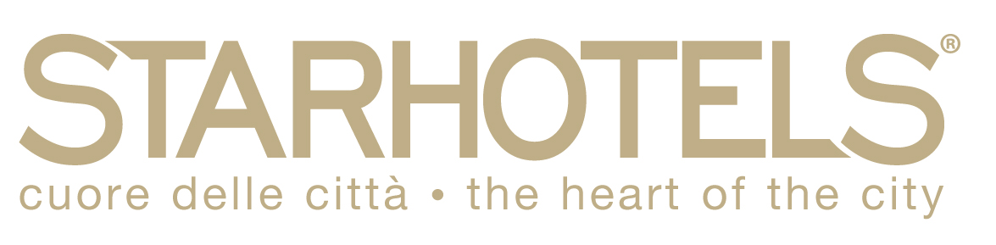

HOTEL RESERVATION FORM

ARTEMIS-IA MEETING
(Turin, 05 – 09 OCTOBER 2015)

STARHOTELS MAJESTIC
C.so Vittorio Emanuele II, 54
10123 Torino
Tel. 0039-011-539153 Fax 0039-011-534963
majestic.to@starhotels.it www.starhotels.com

Dear Sirs, please, complete the reservation form to be used for reserving your Hotel Room. Once filled please send it by fax or e-mail before August, 18th 2015. After this date we cannot guarantee hotel availability and same rates.

Name and Last Name____________________________________________________________

Check in date: ___________________________
Check out date: __________________________

□ Double sole use Classic Room – 1 pax € 139,00 BB Nr of nights in total _________
□ Double Classic Room – 2 pax € 159,00 BB Nr of nights in total _________

Rates are per room, per night, inclusive of American buffet breakfast, wi-fi, service and Vat 10%.
Not included of city tax as € 3.70 per person, per night – for a maximum of 4 consecutive nights

Method of payment:
In order to process your hotel reservation, credit card guarantee is required in advance. No request will be considered without guarantee.

Cancellation policy:
- Cancellation / amendments received till 7 days before arrival date: any penalty will be charged;
- Cancellation / amendments received from 6 to 4 days before arrival date: 50% of the total stay will be applied as penalty;
- Cancellation / amendments / no show received starting from 3 days before arrival date: total penalty will be applied.

Credit card details:
□ Visa □ Mastercard □ Diners □ American Express

CREDIT CARD NR. EXP. DATE _______________

Cardholder’s name: _______________________________
Cardholder’s signature: _______________________________

For any kind of request you could contact our reservations office:
Tiziana and Samanta: reservations.majestic.to@starhotels.it
Direct tel.: 0039-011-534618 – Fax: 0039-011-534963

