Controversial Issue Lesson Plan

Lesson Title: Celebrity Activists and the Civil Rights Movement §

1

Author Name: Farrell Vaughn

Contact Information: fvaughn@washoeschools.net

Appropriate for Grade Level(s): ¹¹th US History

US History Standard(s):
H1.[9-12].7 Evaluate how cultural developments in the arts, literature, architecture, education, media, and leisure activities have reflected and changed society.
H3.[9-12].9 Identify and describe the major issues, events, and people of minority rights movements,
H3.[9-12].16 Analyze the responses of individuals to restrictive social and political systems.
H3.[9-12].17 Analyze how ideals and institutions of freedom, equality, justice, and citizenship have changed.
H3.[9-12].19 Explain how literature, music, and art are ways people voice protest or support, and prompt social change.
H3.[9-12].22 Explain the changing role of race, class, and gender.
H3.[9-12].23 Explain how literature, music, media, and the visual arts affect social change.
H3.[9-12].24 Examine the ideals and institutions of freedom, equality, justice, and citizenship, and explain how they have changed.

Controversial Issue: The role of athletes and celebrities as activists in promoting political and social change has been, and is often, contested within the public sphere.

Objective(s): At the end of this lesson, students will be able to…
SWBAT: Evaluate how cultural developments in the arts, literature, architecture, education, media, and leisure activities have reflected and changed society.
SWBAT: Identify and describe the major issues, events, and people of minority rights movements.
SWBAT: Analyze the responses of individuals to restrictive social and political systems.
SWBAT: Analyze how ideals and institutions of freedom, equality, justice, and citizenship have changed.
SWBAT: Explain how literature, music, and art are ways people voice protest or support, and prompt social change.
SWBAT: Examine the ideals and institutions of freedom, equality, justice, and citizenship, and explain how they have changed.

Rationale: Why Teach This Issue? (50-100 words) My overall goal for the lesson is to help the students understand that many times social and political change is instigated by individuals who seek out the support of organizations and the public at large to create progressive change. Quite often, they do this at great personal sacrifice. The lesson is also designed to help students understand the current controversy surrounding pop-culture figures as spokesman for a cause. For instance, Carlos Santana was recently honored by being asked to perform at the Major League Baseball All Star Game, but pilloried because of his public attack towards Arizona’s SB 1070 “anti-immigrant” Bill.

Student Readings (list):
Asmerom, R. Sports, Race, and Power: How Athletes are Instrumental to Black America. The Atlanta Post, 3-1-2011. http://atlantapost.com/2011/03/01/sports-race-and-powerhow-athletes-are-instrumental-to-black-america/2/
Kaufman, Peter and Wolf, Eli A. Playing and Protesting: Sports as a Vehicle for Social Change. “Journal of Sport and Social Issues” XX(X) 1-22, 2-16-2010. http://www.northeastern.edu/sportinsociety/pdfs/Playing_and_Protesti.pdf
Library of Congress; Hope for America: Performers, Politics, and Pop-Culture. http://myloc.gov/Exhibitions/hopeforamerica/causesandcontroversies/artsandpolitics/ExhibitObjects/CelebritySupportForCivilRights.aspx
Zirin, David. When Fists are Frozen: The Statue of Tommy Smith and John Carlos. Common Dreams.org, 10-20-2005. http://www.commondreams.org/views05/1020-28.htm
Total Time Needed: Three 55 minute classes

Historical Background & Context (+/- 250 words):
Celebrity activism has always been a hotly contested issue. In the United States, there is a long tradition of individuals who have used their celebrity status to advocate for political and social justice. In this lesson plan, the students will examine individuals who have used their role as athletes and/or celebrities to engage in social or political activism in order to foster progressive social change. Jackie Robinson, Muhammad Ali, Paul Robeson, Joe Louis, Althea Gibson, and Eartha Kitt are all names that if not so familiar to this generation were cultural icons in their day. Each of these figures used their status as celebrities to raise awareness about the injustices taking place in the American political and social systems at that time. While some of these figures have been recognized and honored for their commitment to the civil rights movement, the sacrifices of many other celebrities has been forgotten. Also what is not clearly understood, are the degrees of persecution many of these celebrities faced as a result of their activism. While some were publicly humiliated and degraded, others might have been physically attacked, arrested, called before Congressional committees to testify, jailed, and/or suffered economic retaliation by their employers. Each of those pop-culture figures became vehicles for progressive social change. Their actions displayed the contradictions between the American ideals and institutions of freedom, equality, justice, and citizenship to the restrictive social and political systems put in place through de jure and de facto, segregation.

Detailed Steps of Lesson (including teaching methods/strategies that engage student participation):
Time Frame  (e.g. 15 minutes) | What is the teacher doing? | What are students doing?
D1 - 10 minutes | Facilitating Essential Question | Answering Essential Question: Throughout modern times, celebrities and athletes have used their status to raise awareness about perceived social and political inequalities. Sometimes these activists were saluted by supporters as heroes and other times attacked by opponents as uninformed, un-patriotic, or as radicals. Explain whether you believe it’s appropriate for celebrities and athletes to use their popularity to address political and social issues?
10 minutes | Discussion of the Essential Question | Actively Engaged in Discussion
5 minutes | Facilitating Photo Analysis and Discussion Questions – P1; (Muhammad Ali & Malcolm X) P2; (Tommy Smith & John Carlos 1968 Mexico City Olympics) P3; (Craig Hodges) | Answering Discussion Questions- Who, What, When, Where, & Why = Contextualize the photographs
15 minutes | Lecture/Power Point / Notes – Library of Congress Virtual Exhibit: Hope for America: Performers, Politics, and Pop-Culture. Large selection of slides to choose from… | Students will be actively involved in note taking by providing a title for the chosen photographs, identifying the subjects, and providing a summary.
10 minutes | You Tube Video: Fox News “Celebrities are Hypocrites: Civil Rights and Religion.” And, “Harry Belafonte: Celebrities Advanced Civil Rights.” | Students will be actively involved in note taking by providing a title for the chosen video clip, identifying the topic, and providing a summary of the opposing arguments.
Homework | Drinking a beer while I grade and prepare for another day. | Trading Card Activity.
D2 - 30 minutes | Facilitating Trading Card Presentations | Presenting. Actively Listening = Develop one question for each presenter or ask for a key point to be clarified.
25 minutes | Facilitating Trading Card Points Game and Discussion | Actively participating by examining point structure and categories while totaling scores. Students with the highest and lowest scores can be given extra-credit points. Discussion Question: What qualities make up an effective civil rights leader?
Homework | Ibid. | Read Journal Article: “Playing and Protesting: Sport as a Vehicle for Social Change.”
D3 – 10 minutes | Facilitating Discussion | Free Response Discussion of Journal Article.
10 minutes | Handout articles for Socratic seminar 1) Trying to Define Craig Hodges: Craig Hodges was Outspoken on Racial issues as a Player, did the NBA Blackball him? And, 2) When Fists are Frozen: The Statue of Tommy Smith and John Carlos. | Sustained Silent Reading
45 minutes | Establish rules, guidelines, and roles for the Socratic seminar. | Actively participating in the Socratic seminar. Essential Question: Do Craig Hodges, Tommy Smith, and John Carlos deserve to be compensated, financially or in some other way, for lost revenue as a result of their political activism?
Homework | Prepare to grade 75 – 80 essays: See Five Paragraph Essay Rubric provided | Formal Assessment: Five paragraph persuasive essay; identify three celebrity activists, and structure an essay around them that analyzes the responses of individuals to restrictive social and political systems and explains how sports, literature, music, and art are ways people voice protest or support, and prompt social change.
 |  | (Add more rows, if necessary.)

How will students reflect on their learning & understanding? The students understanding of the topic will be summatively assessed through writing prompts, class discussions and a Socratic seminar, along with the biographical research projects and presentations. They will be formally assessed by means of the five paragraph essay.

Description of Lesson Assessment Tied to Objective/Standards: The formal assessment for this lesson is a five paragraph essay. A rubric is provided for the students to guide them in the writing process. The essential question posed to the students; identify three celebrity activists, and structure an essay around them that analyzes the responses of individuals to restrictive social and political systems and explains how sports, literature, music, and art are ways people voice protest or support, and prompt social change, is a direct translation from the standards. My objectives also directly support the standards; in fact they are a reflection of the standards.

Attached to the following pages are all readings, primary sources, guided questions, worksheets, assignment guidelines, rubrics, etc.

Trading Card Activity
Using the list of names below, either; assign names, draw names randomly, or allow students to choose their own. Tell students: this activity will require research and presentation skills. Baseball trading cards place an image of the athlete/player on the front and their profile / statistics / fun facts on the back. You are going to do the same thing with any five celebrity/athlete civil rights’ activists.
First, create a list of facts about your historical person. Choose some of the most interesting facts to use to tell that person’s story.
Second, find a picture of that person to decorate the front of your card.
Third, create a list of facts, and offbeat categories to describe that person and their impact on the Civil Rights’ movement.

Think About: Important Facts & Fun Facts
Occupation- Nicknames-
Type of activism = political, social, economic, Ideal date-
Greatest Achievement- Favorite food-
Famous Quote- Desert Island Book-
Most embarrassing moment- Favorite song-
Mood- Best Friend/s-
Celebrity/Athlete Activist’s Point Total _________________

Trading card presentations: Students will present their top three cards; alternate student presentations so that the same historical figures are not presented repeatedly.

Trading card point’s game: provide students with the point values listed below (after their presentations) and tell them to total those points and write the amount for each individual activist in the appropriate area on their cards. When they’re finished discuss who acquired the most points and why that may, or may not, be important.

1 point – Is the individual a celebrity or an athlete?
2 points – Did they use their job or position to raise awareness about a civil rights issue?
3 points – Did they give speeches to the public on issues, lead marches, and/or lobby political representatives about specific civil rights issues?
4 points – Did they lead and/or create an organization to support civil rights’ reform?
5 points – Did they suffer economically as a result of their activism?
6 points – Were they jailed as a result of their activism?
7 points – Were they assaulted as a result of their activism?
8 points – Were they assassinated as a result of their activism?
9 points – Is there a national holiday named after that person, or a museum or monument dedicated to their activism, a great piece of literature or epic poem written about them, or has a major motion picture been made about their lives? In other words, have they become a cultural icon?
10 points – Did that person’s activism directly result in some type of new legislation, legal ruling/judicial precedent, or cultural shift (be specific)?

Celebrity and Athlete Activists Involved in the Civil Rights Movement
W.E.B. Du Bois, Booker T. Washington, Marcus Garvey, Bill Willis, Marion Motley, Kenny Washington, Billie Holiday, Jim Brown, Muhammad Ali, Tommy Smith, John Carlos, Chris Hodges, Woody Strode, Jackie Robinson, Leroy “Satchel” Paige, Ted Rhodes, Chuck Cooper, Earl Lloyd, Nat “Sweetwater” Clifton, Althea Gibson, Willie O’Ree, James Baskett - aka Uncle Remus, Sidney Poitier, Dorothy Dandridge, Harry Belafonte, Louise Beavers, Bill Cosby, Alex Hailey, Bo Diddly, Little Richard, Miles Davis, Louis Armstrong, Paul Robeson, Josephine Baker, Langston Hughes, Jack Johnson, Kareem Abdul Jabbar, Lena Horne, Ray Charles, James Brown, Tupac Shakur, Gil Scott-Heron, Rubin “Hurricane” Carter, Arthur Ashe, Bill Russell, Wilma Rudolph, Hank Aaron, Willie Mays, Richard Pryor, Dave Chapelle, Queen Latifah, John Singleton, Morgan Freeman, Marian Anderson, John Legend, Kanye West, Mary J. Blige, Dionne Warwick, Richard Wright, Maya Angelou, James Baldwin, Jean-Michel Basquiat, Claude McKay, Toni Morrison, Countee Cullen, Spike Lee, Eartha Kitt, Martin Luther King Jr., Malcolm X,
Biographical Resources for Trading Card Activity: http://www.authentichistory.com/1946-1960/8-civilrights/celebrity/index.html
http://www.biography.com/blackhistory/people/legal.jsp

Background Information on Craig Hodges:
When the Chicago Bulls visited the White House after winning the 1992 NBA Championship, Hodges dressed in a dashiki and delivered a hand-written letter addressed to then President George H. W. Bush, expressing his discontent at the administration's treatment of the poor and minorities.^{[14]}
Hodges also criticized his Bulls teammate Michael Jordan for not using his fame to draw attention to social and political issues, and said Jordan was "bailing out" for not being politically outspoken.^{[15]}
In 1996, Hodges filed a $40 million lawsuit against the NBA and its then 29 teams, claiming they blackballed him for his association with Louis Farrakhan and criticism of "African-American professional athletes who failed to use their considerable wealth and influence to assist the poor and disenfranchised."^{[12]} After he was waived by the Bulls in 1992, he did not receive an offer or a tryout from a single NBA team, even though he was only 32 years old and still able to contribute to contenders. The lawsuit claimed that Bulls assistant coach Jim Cleamons told him that the team was troubled by his criticism of players' lack of involvement in inner-city communities.^{[14]} The suit also claimed Billy McKinney, the director of player personnel for the Seattle SuperSonics initially showed interest in Hodges in 1992, and then shortly after backed away, telling Hodges he could do nothing because "brothers have families, if you know what I mean." While a Bulls official said Hodges was waived as he was getting old and could not play defense, head coach Phil Jackson said, "I also found it strange that not a single team called to inquire about him. Usually, I get at least one call about a player we've decided not to sign. And yes, he couldn't play much defense, but a lot of guys in the league can't, but not many can shoot from his range, either."^{[12]}
http://en.wikipedia.org/wiki/Craig_Hodges#Political_activism
http://sports.espn.go.com/espn/blackhistory2008/news/story?page=granderson/080211
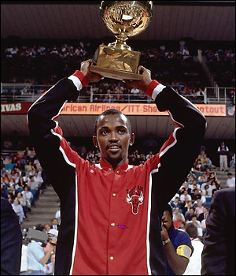
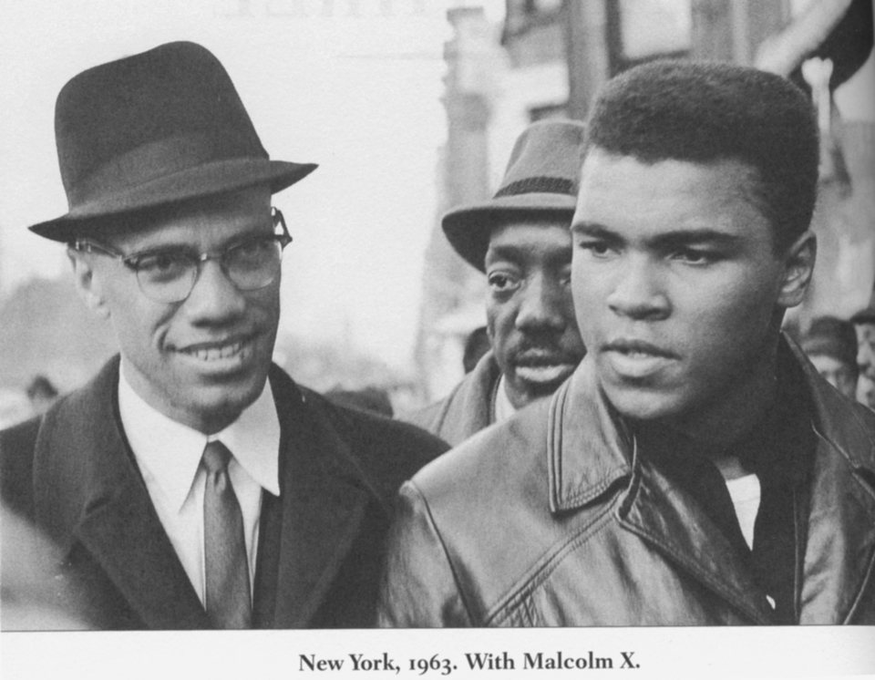

http://bleacherreport.com/articles/159331-muhammad-ali-and-the-myth-of-a-civil-rights-hero
"I am American. I am the part you won't recognize. But get used to me. Black, confident, cocky; my name, not yours; my religion, not yours; my goals, my own; get used to me. " http://www.mondostars.com/sports/muhammadali.html

Tommie Smith and John Carlos; 1968 Mexico City Olympics
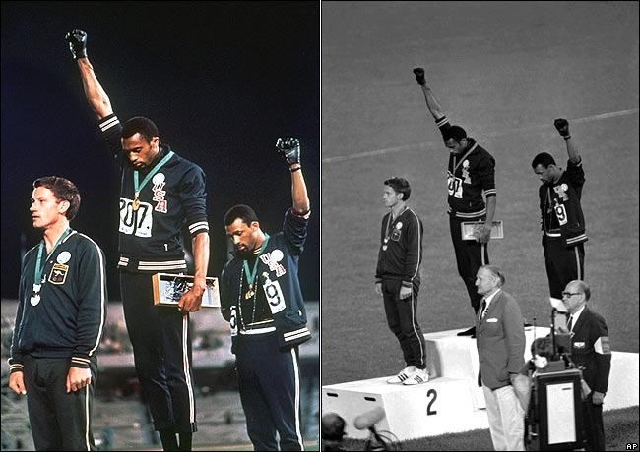
http://articles.latimes.com/2008/jul/08/sports/sp-forty8

Works Cited
Asmerom, R. Sports, Race, and Power: How Athletes are Instrumental to Black America. The Atlanta Post, 3-1-2011. http://atlantapost.com/2011/03/01/sports-race-and-powerhow-athletes-are-instrumental-to-black-america/2/
Granderson, L.Z. Trying to Define Craig Hodges: Craig Hodges was Outspoken on Racial issues as a Player, did the NBA Blackball him? SportsESPN.go. http://sports.espn.go.com/espn/blackhistory2008/news/story?page=granderson/080211
Kaufman, Peter and Wolf, Eli A. Playing and Protesting: Sports as a Vehicle for Social Change. “Journal of Sport and Social Issues” XX(X) 1-22, 2-16-2010. http://www.northeastern.edu/sportinsociety/pdfs/Playing_and_Protesti.pdf
Library of Congress; Hope for America: Performers, Politics, and Pop-Culture. http://myloc.gov/Exhibitions/hopeforamerica/causesandcontroversies/artsandpolitics/ExhibitObjects/CelebritySupportForCivilRights.aspx
Zirin, David. When Fists are Frozen: The Statue of Tommy Smith and John Carlos. Common Dreams.org, 10-20-2005. http://www.commondreams.org/views05/1020-28.htm
Video Clips:
Celebrities are Hypocrites: Civil Rights and Religion. http://www.youtube.com/watch?v=63ZSkzn1NOc
Harry Belafonte: Celebrities Advanced Civil Rights http://www.biography.com/video.do?name=musicians&bcpid=1740031443&bclid=1803311557&bctid=1620576788

Research Report: Five Paragraph Historical Essay

CATEGORY | 4 | 3 | 2 | 1
Organization | Information is very organized with well-constructed paragraphs and subheadings. | Information is organized with well-constructed paragraphs. | Information is organized, but paragraphs are not well-constructed. | The information appears to be disorganized. 8)
Paragraph Construction | All paragraphs include introductory sentence, explanations or details, and concluding sentence. | Most paragraphs include introductory sentence, explanations or details, and concluding sentence. | Paragraphs included related information but were typically not constructed well. | Paragraphing structure was not clear and sentences were not typically related within the paragraphs.
Quality of Information | Information clearly relates to the main topic. It includes several supporting details and/or examples. | Information clearly relates to the main topic. It provides 1-2 supporting details and/or examples. | Information clearly relates to the main topic. No details and/or examples are given. | Information has little or nothing to do with the main topic.
Mechanics | No grammatical, spelling or punctuation errors. | Almost no grammatical, spelling or punctuation errors | A few grammatical spelling, or punctuation errors. | Many grammatical, spelling, or punctuation errors.
Sources | All sources (information and graphics) are accurately documented in the desired format. | All sources (information and graphics) are accurately documented, but a few are not in the desired format. | All sources (information and graphics) are accurately documented, but many are not in the desired format. | Some sources are not accurately documented.
Three Components of an Essay | Introduction Paragraph - Should include a Thesis Statement that outlines your main argument and is supported by the Body Paragraphs | Body Paragraphs - Should contain information (facts and events) that supports your thesis statement. | Closing Paragraph - Should restate your thesis using the evidence detailed in the body paragraphs and close with your opinion. | Complete the circle; explain to your audience why your argument is brilliant.

