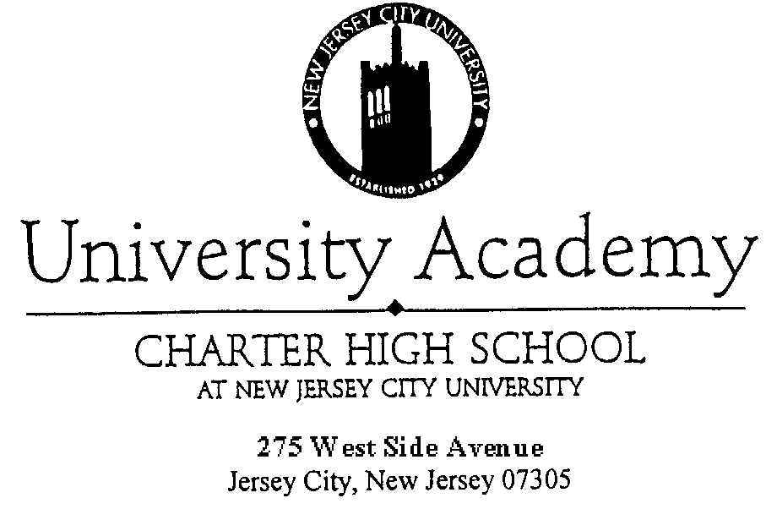Tel. 201.200.3200
Board of Trustees:

Mr. Ruddys Andrade, President
Ms. Karen E. Ridley, Vice President
Mr. Frank Mercado, Treasurer
Mr. Marco Valdivia, Secretary
Dr. Elba Herrero, Parliamentarian
Dean’s Office:

Mr. John A. Marquet, Dean
Ms. Linda C. Green, Asst.Dean
Mr. Erie Lugo, Jr., Director of Reporting & Compliance

Mr. Nicholas Puzo, Business Administrator

Fax 201.200.3262
www.njcu.edu/programs/uachs

Board of Trustees Meeting
University Academy Charter High School
Holiday Inn’s Hancock Room in Atlantic City
November 11, 2006
2:00 PM

Attendance: Ruddys Andrade, Karen Ridley, Marco Valdivia, John Melendez, Frank Stella, John Coccioli, Nadine Muhammad, Angela Rivera, Migdalia Viole-Hernandez, Jo Bruno, John Marquet, Erie Lugo, Nick Puzo, Paul Mastrodonato, Deborah Murray

Public Session
No public audience

President’s Report
President Andrade reported the recent committee appointments as follows:
Parent Advisory Board: Nadine Muhammad, Chair
Audra Stokes
Angela Rivera
Ethel Ashley
Karen Ridley
Deborah Murray

Academic Performance Committee: Jo Bruno, Chair
Linda Green
Karen Ridley
James Lennon as School Psychologist
John Marquet

Personnel Committee: (Removed) Nadine Muhammad
John Cocciolli
Angela Rivera
John Marquet

Community Outreach Committee: John Melendez, Chair
Ruddys Andrade
Nadine Muhammad
Linda Green
Erie Lugo
Service Learning Coordinator
Facilities Committee: Nadine Muhammad, Chair
Ruddys Andrade
Erie Lugo
Deborah Murray
Angela Rivera

Nominating Committee: Marco Valdivia, Chair
John Cocciolli
Frank Mercado
Frank Stella

Fundraising Committee: Ben Dineen, Chair
Migdalia Viole-Hernandez
Marilyn Bennett

Deborah Murray
Nadine Muhammad

Bylaws Adhoc Committee: Marco Valdivia, Chair
Frank Mercado
John Cocciolli

Dean’s Report
John Marquet read over Dean’s Report, pointed out specific dates for events, and stated the following:
- Mr. Gallo will coordinate the “Think Tank Talkers” program (an after school program which students can participate in the research, writing, and production of a videotaped and eventually televised educational talk show/panel discussion).
- HSPA Committee for Mathematics will be implemented by December 1, 2006, to conduct HSPA Data analysis so that we may have a reasonable opportunity to improve scores by March 2007.
- Looking into College Credit Program at $50.00 per student.

Erie Lugo stated that 50 students made the Dean’s list this marking period in comparison to the 30 students last year.

Mr. Marquet continued to report that…
- a decision will be made at the end of this week for a Service Learning Coordinator – interviews have taken place and have narrowed it down to two candidates.
- He has met with guidance and Mr. Lugo to strategize on increasing enrollment/recruitment.
- He has also seen a decrease in detention since the first day the Discipline Policy took effect.
- He has a meeting scheduled with the Vice Principal of Snyder HS to discuss violence prevention.

Erie Lugo thanked the Board of Trustees for approving Power School which made the fall report a breeze and also helped with data for NJ Smart.

- John Marquet thanked Mr. Lugo for all of his hard work with the Power School software.
- Nadine Muhammad asked how students are being recruited from elementary schools.
- John Marquet responded that brochures have been sent to the schools and staff members have been attending there open house.
- Ruddys Andrade requested copies of the brochure which were immediately distributed to the Board of Trustees.
- Marco Valdivia stated that the UACHS administration should make sure that someone is trained on Power School besides Mr. Lugo and that UACHS should adopt an anti-bullying policy. (Mr. Valdivia provided a copy of a policy adopted by a school in Mountain Lakes as a reference)
- Ruddys Andrade asked about the status on the teachers’ evaluations.
- John Marquet responded that they are currently being typed up and anticipates completion on Monday, November 20th, 2006.
- Ruddys Andrade asked if the post conferences had taken place.
- John Marquet responded that the post conferences are not done until the evaluation has been completed.
- Ruddys Andrade clarified that the Assistant Dean is evaluated by the Dean however the Director of Reporting and Compliance and the Business Administrator are evaluated by the Board of Trustees.
- Ruddys Andrade asked which employees are sent to elementary schools for recruitment and Mr. Marquet responded that the person(s) are Michele Bruce and Keisha Terry of the Guidance Office.
Ruddys Andrade introduced Denise Campbell of Foley, Campbell to the Board of Trustees.

Committee Reports
Personnel
Karen Ridley presented a resolution to hire three (3) candidates for hire:
- Dolores Bullock - Permanent Substitute $22,887
- Melissa Burroughs - Temporary Part-time Clerk $10/hr (as needed basis)
- Susan Nowicki - Mathematics Teacher $45,004
Resolution was moved by Karen Ridley, seconded by Frank Stella, and approved unanimously as presented.

Finance
Nick Puzo reported that for the fourth (4th) year UACHS successfully ran its budget as per the auditor’s report which had been previously distributed. Mr. Puzo also stated that UACHS is required to disclose the auditor’s findings at a public meeting and referred the Board to the 2nd page of the finance report. Mr. Puzo read over the auditor’s responses and their findings:
1st finding – Failure to establish a separate account for the purpose of tax deductions.
2nd finding – Use of an actual credit card account provided by Staples (which must seize).
3rd finding - Presentation of “No Child Left Behind” must be broken down by separate title line item.
Mr. Puzo presented a Resolution for Corrective Action on Audit Findings for AY2006-07.
Resolution was moved by Karen Ridley, seconded by Migdalia Viole-Heranandez and approved unanimously as presented.
Mr. Puzo presented the summary of revenues, operating expense summary, listing of purchase orders that have been issued and sent, check register and bill list which must reflect an amendment for the Old Fashion Candy Co. invoice in the amount $1,764.00, which must be paid through the student activity fund.
- Motion to approve the UACHS “bill list” was moved by Marco Valdivia, seconded by John Melendez. The Finance Report and bill list was approved unanimously as amended.

Resolution to approve New Bank Account for Drill Team moved by Karen Ridley, seconded by Angela Rivera and approved unanimously.

Old Business
No old business.

New Business
- Resolution to approve Equipment Upgrade - moved by Karen Ridley, seconded by John Coccioli and approved unanimously.
- Resolution to approve SEMI program - moved by John Melendez, seconded Nadine Muhammed and approved unanimously.
- Resolution to approve On-Site Police Officer at $35 per hour – moved by Nadine Muhammad, seconded by Viole-Hernandez and approved as amended.
- Discussion followed:
- John Melendez asked Mr. Puzo how spending $300 a day is affecting the balance sheet on the school’s budget. Nick Puzo responded that it may put the school over on certain line items therefore those line items may need to be amended on our budget. However, if the Board approves the expense we may pay from surplus.
- John Melendez stated that the financial issue is just one issue but should be discussed in more depth because of the seriousness of having someone in the school with a gun may be dangerous regardless whether police officer or not.
- Ruddys Andrade suggested amending the Resolution to authorize the expense and presence of the police officer until the month of December for a full discussion on the matter, including further research on a resource officer.
- Resolution to approve Mentoring Program - moved by John Coccioli, seconded by Karen Ridley and approved unanimously.
Erie Lugo stated that it is a very comprehensive plan and it is mandated by the state. We must also have mentors for our teachers.
- Resolution to approve Mentoring Program Facilitator moved by Angela Rivera, seconded by Viole-Hernandez and approved unanimously.
- Resolution to approve memorandum of agreement – Moved by Karen Ridley, seconded by Marco Valdivia and approved unanimously.

Announcements
Nadine Muhammad announced that the 3rd annual fashion show will be on Saturday, November 18th at 1:00pm. Please come and approved unanimously.

Motion to enter into executive session – moved by John Coccioli, seconded by Karen Ridley.

Adjournment
Adjourned at 4:30pm.

