Use Case Diagrams Examples
Here we provide some examples of UML use case diagrams:
- Business Model - Airport Check-In and Security Screening
- Business Model - Restaurant
- e-Library OPAC
- Point of Sales Terminal
- Online Shopping
- Credit Card Processing System
- Bank ATM
- Hospital Management

Airport Check-In and Security Screening
This is an example of Business Use Case Diagram which is created during Business Modeling and is rendered here in notation used by Rational Unified Process (RUP).
Business actors are Passenger, Tour Guide, Minor (Child), Passenger with Special Needs (e.g. with disabilities), all playing external roles in relation to airport business.
Business use cases are Individual Check-In, Group Check-In (for groups of tourists), Security Screening, etc. - representing business functions or processes taking place in airport and serving the needs of passengers.
Business use cases Baggage Check-in and Baggage Handling extend Check-In use cases, because passenger might have no luggage, so baggage check-in and handling are optional.
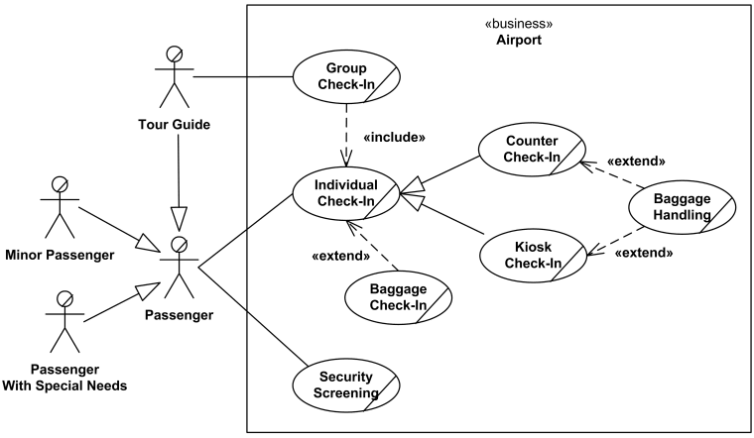
An example of use case diagram for airport check-in and security screening

Restaurant
Here we provide two alternative examples of Business Use Case Diagram for a Restaurant rendered in notation used by Rational Unified Process (RUP).
First example shows external business view of a restaurant. We can see several business actors having some needs and goals as related to the restaurant and business use cases expressing expectations of the actors from the business.
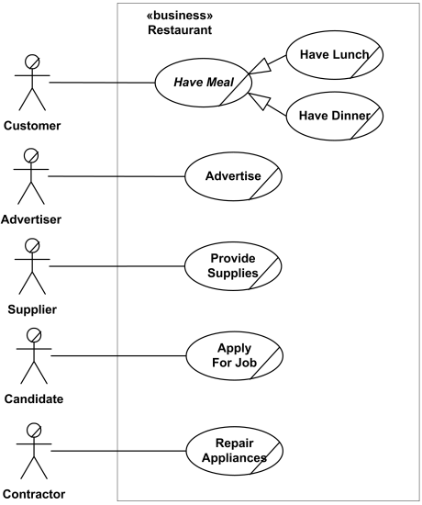
Business use case diagram for Restaurant - External view
For example, Customer wants to Have Meal, Candidate - to Apply for Job, and Contractor - to fix some appliances. Note, that we don't have such actors as Chef or Waiter. They are not external roles but part of the business we model - the Restaurant, thus - they are not actors. In terms of RUP Chef and Waiter are business workers.
Second example shows internal business view of a restaurant. In this case we can see that restaurant has several business processes represented by business use cases which provide some services to external business actors. As in the previous example, actors have some needs and goals as related to the restaurant.
This approach could be more useful to model services that the business provides to different types of customers, but reading this kind of business use case diagrams could be confusing.
For example, Customer is now connected to Serve Meal use case, Supplier - to Purchase Supplies. We have now new actor Potential Customer participating in Advertise use case by reading ads and getting some information about restaurant. At the same time, Contractor actor is gone because Repair Appliances is not a service usually provided by restaurants.
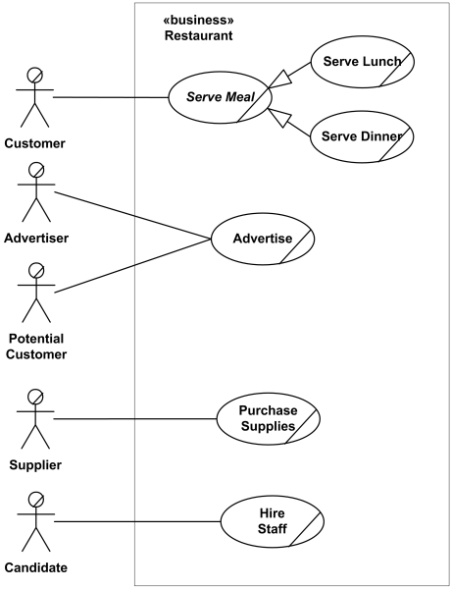
Business use case diagram for Restaurant - Internal view
Still, in this example we don't have actors as Chef or Waiter for the same reasons as before - they both are not external roles but part of the business we model.

e-Library OPAC
An Online Public Access Catalog (OPAC) is e-Library website which is part of Integrated Library System (ILS), also known as a Library Management System (LMS), and managed by a library or group of libraries.
Patrons of the library can search library catalog online to locate various resources - books, periodicals, audio and visual materials, or other items under control of the library. Patrons may reserve or renew item, provide feedback, and manage their account.
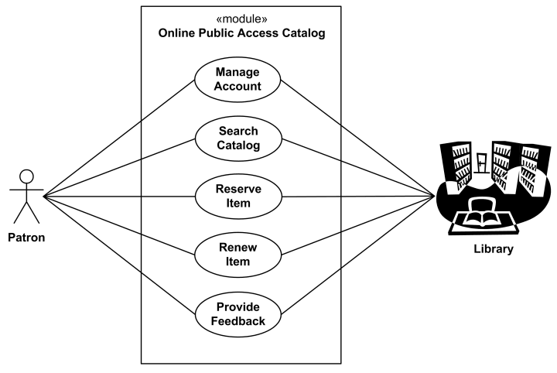
An example of use case diagram for e-Library Online Public Access Catalog

Point of Sales Terminal
An example of use cases for Point of Sale (POS) Terminal or Checkout. A retail POS system typically includes a computer, monitor, keyboard, barcode scanners, weight scale, receipt printer, credit card processing system, etc. and POS terminal software.
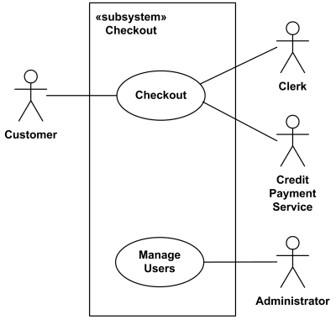
Top level use cases for Point of Sales Terminal.
Checkout use case involves Customer, Clerk and Credit Payment Service actors and includes scanning items, calculating total and taxes, payment use cases. This is an example of large and complex use case split into several use cases each describing some logical unit of behavior. Note, that including use case becomes incomplete by itself and requires the included use cases to be complete.
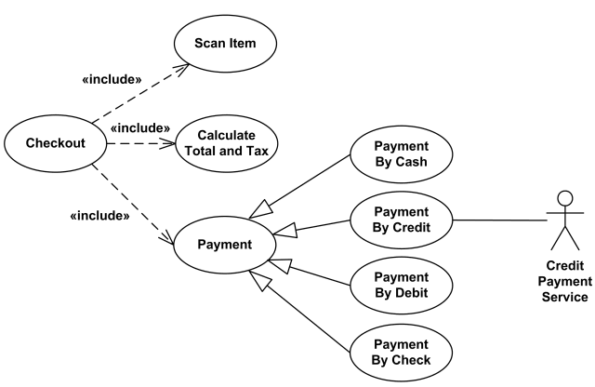
Checkout use case in detail.
Payment use case is represented using generalization relationship. It means that only one specific type of payment is accepted - either by cash, or by credit, debit, or with check. An alternative to such representation could be to use include relationship so that not just single but several forms of payment could be accepted from the same client during checkout.

Online Shopping
Web Customer actor uses some web site to make purchases online. Top level use cases are View Items, Make Purchase and Client Register. View Items use case could be used by customer as top level use case if customer only wants to find and see some products. This use case could also be used as a part of Make Purchase use case. Client Register use case allows customer to register on the web site, for example to get some coupons or be invited to private sales. Note, that Checkout use case is included use case not available by itself - checkout is part of making purchase.
Except for the Web Customer actor there are several other actors which will be described below with detailed use cases.
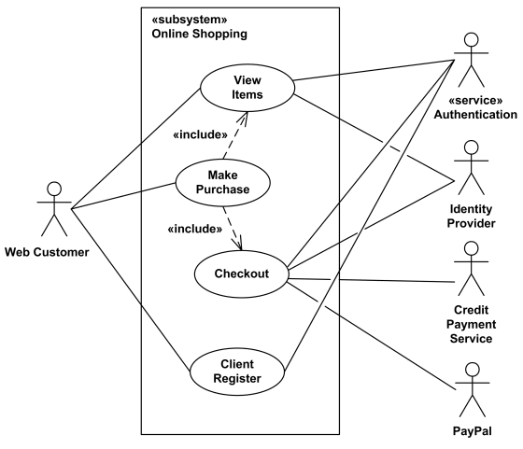
Online Shopping - Top Level Use Cases
View Items use case is extended by several optional use cases - customer may search for items, browse catalog, view items recommended for him/her, add items to shopping cart or wish list. All these use cases are extending use cases because they provide some optional functions allowing customer to find item.
Customer Authentication use case is included in View Recommended Items and Add to Wish List because both require customer to be authenticated. At the same time, item could be added to the shopping cart without user authentication.
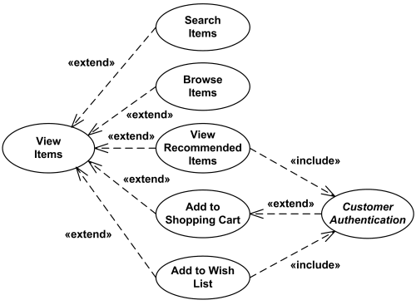
Online Shopping - View Items Use Case
Checkout use case includes several required uses cases. Web customer should be authenticated. It could be done through user login page, user authentication cookie ("Remember me") or Single Sign-On (SSO). Web site authentication service is used in all these use cases, while SSO also requires participation of external identity provider.
Checkout use case also includes Payment use case which could be done either by using credit card and external credit payment service or with PayPal.
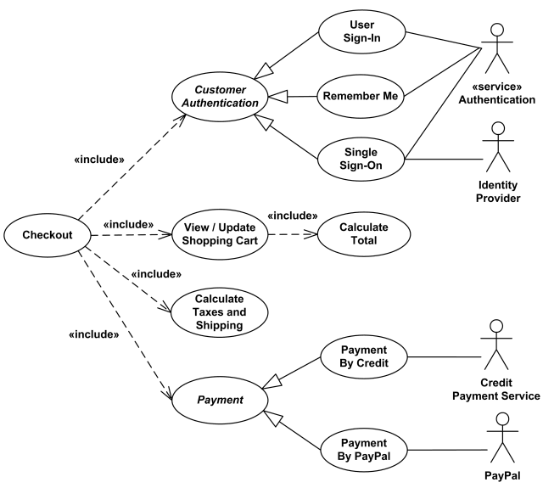
Online Shopping - Checkout, Authentication and Payment Use Cases

Credit Card Processing System Use Cases
In this use cases example, Credit Card Processing System (Credit Card Payment Gateway) is a subject, i.e. system under design or consideration. Primary actor of the system is the Merchant’s Credit Card Processing System. The merchant submits a credit card transaction request to the credit card payment gateway on behalf of a customer. Bank which issued customer's credit card is actor which could approve or reject the transaction. If transaction is approved, funds will be transferred to merchant's bank account.
Authorize and Capture use case is the most common type of credit card transaction. The requested amount of money should be first authorized by Customer's Credit Card Bank, and if approved, is further submitted for settlement. During the settlement funds approved for the credit card transaction are deposited into the Merchant's Bank account.
In some cases, only authorization is requested and the transaction will not be sent for settlement. In this case, usually if no further action is taken within some number of days, the authorization expires. Merchants can submit this request if they want to verify the availability of funds on the customer’s credit card, if item is not currently in stock, or if merchant wants to review orders before shipping.
Capture (request to capture funds that were previously authorized) use case describes several scenarios when merchant needs to complete some previously authorized transaction - either submitted through the payment gateway or requested without using the system, e.g. using voice authorization.
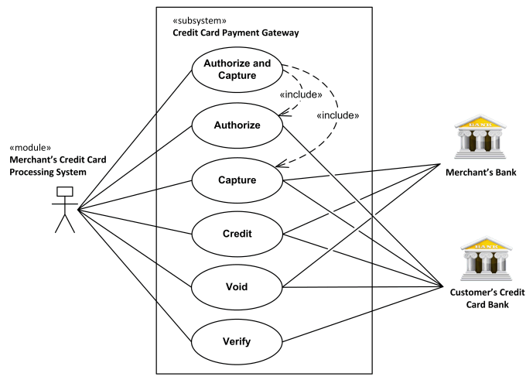
Credit Card Processing System Use Cases.
Credit use case describes situations when customer should receive a refund for a transaction that was either successfully processed and settled through the system or for some transaction that was not originally submitted through the payment gateway.
Void use case describes cases when it is needed to cancel one or several related transactions that were not yet settled. If possible, the transactions will not be sent for settlement. If the Void transaction fails, the original transaction is likely already settled.
Verify use case describes zero or small amount verification transactions which could also include verification of some client's data such as address.
You can find excellent resources, documentation, white papers, guides, etc. related to the credit card processing at Authorize.Net - Payment Gateway to Accept Online Payments.

Bank ATM Use Cases
An automated teller machine (ATM) or the automatic banking machine (ABM) is banking subsystem (subject) that provides bank customers with access to financial transactions in a public space without the need for a cashier, clerk or bank teller.
Customer (actor) uses bank ATM to check balances of his/her bank accounts, deposit funds, withdraw cash and/or transfer funds (use cases). ATM Technician provides maintenance and repairs. All these use cases also involve Bank actor whether it is related to customer transactions or to the ATM servicing.
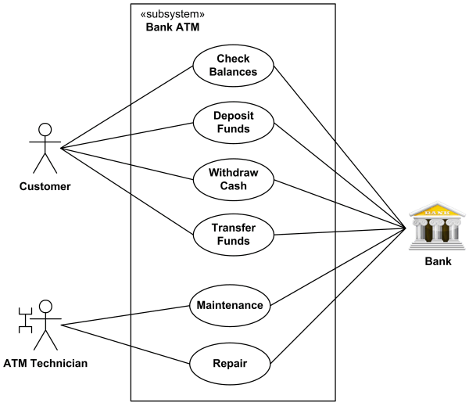
An example of use case diagram for Bank ATM subsystem - top level use cases.
On most bank ATMs, the customer is authenticated by inserting a plastic ATM card and entering a personal identification number (PIN). Customer Authentication use case is required for every ATM transaction so we show it as include relationship. Including this use case as well as transaction generalizations make the ATM Transaction an abstract use case.
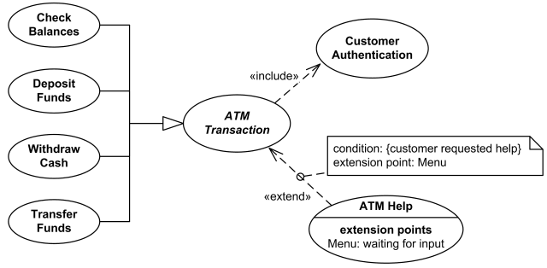
Bank ATM Transactions and Customer Authentication Use Cases Example.
If needed, customer may ask ATM for help. ATM Transaction use case is extended via Menu extension point by the ATM Help use case whenever ATM Transaction is at the location specified by the Menu and the bank customer requests help, e.g. by selecting Help menu item.
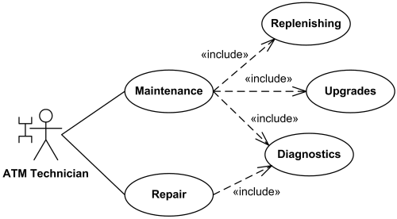
Bank ATM Maintenance, Repair, Diagnostics Use Cases Example.
ATM Technician maintains or repairs Bank ATM. Maintenance use case includes Replenishing ATM with cash, ink or printer paper, Upgrades of hardware, firmware or software, and remote or on-site Diagnostics. Diagnostics is also included in (shared with) Repair use case.

Hospital Use Cases
Hospital Management System is a large system including several subsystems or modules providing variety of functions.
Hospital Reception subsystem or module supports some of the many job duties of hospital receptionist. Receptionist schedules patient's appointments and admission to the hospital, collects information from patient upon patient's arrival and/or by phone. For the patient that will stay in the hospital (inpatient) s/he should have a bed allotted in a ward. Receptionists might also receive patient's payments, record them in a database and provide receipts, file insurance claims and medical reports.
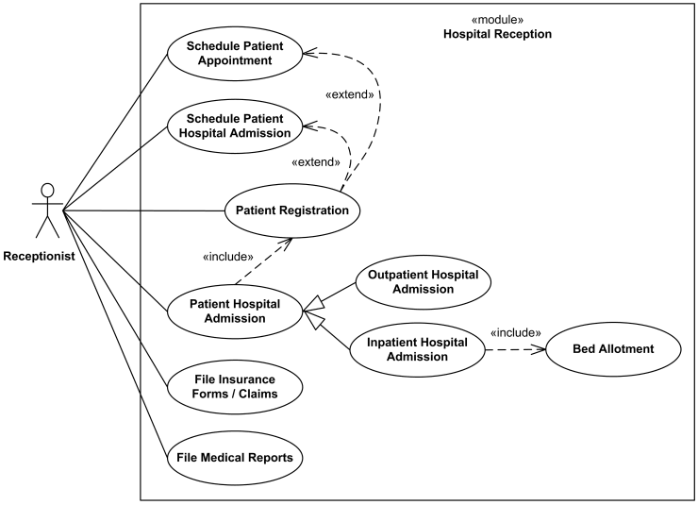
An example of use case diagram for Hospital Reception.

Use case diagram for buying ticket
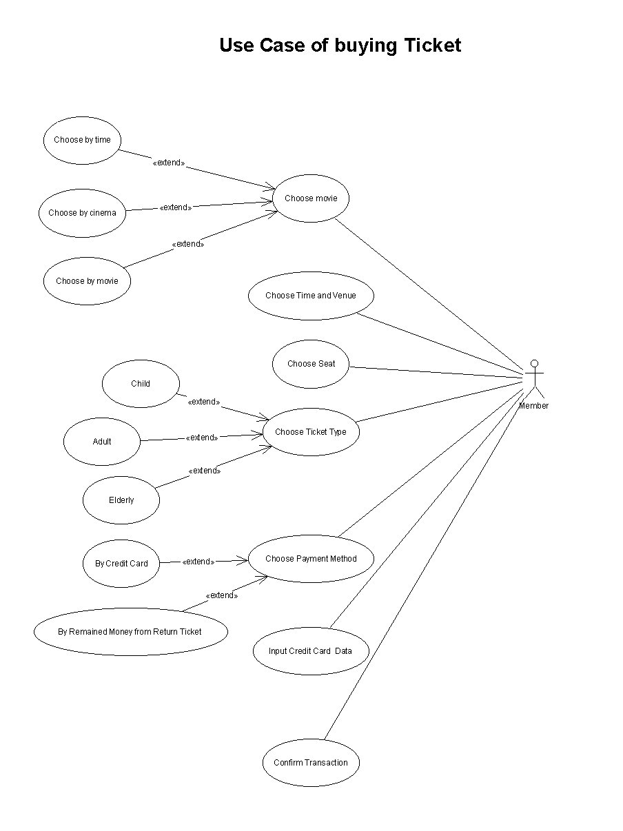

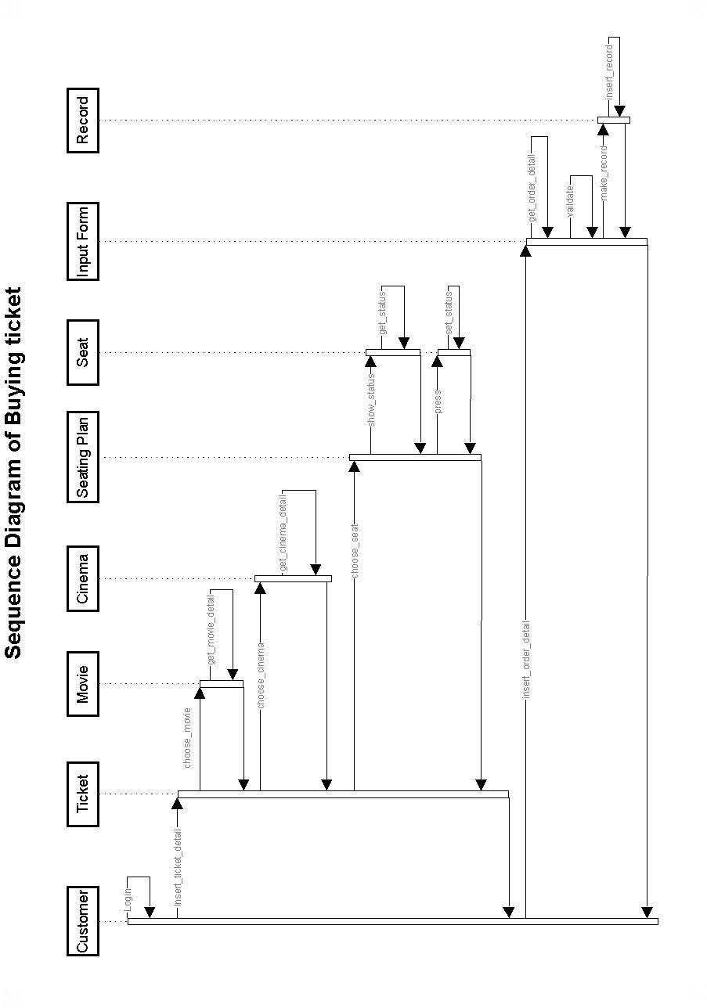

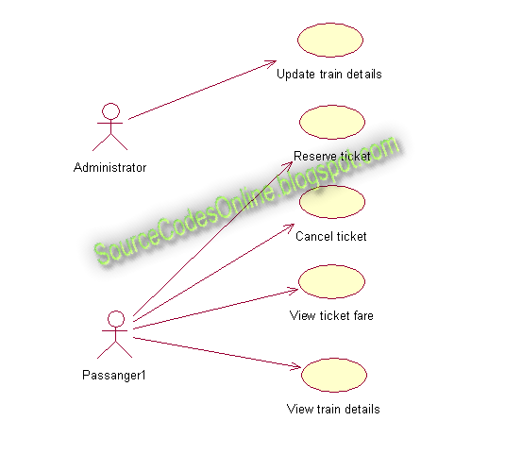

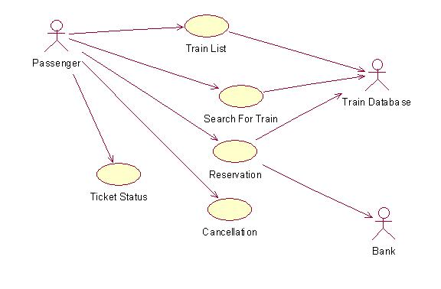

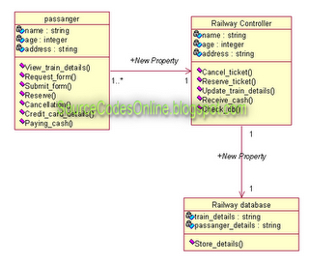

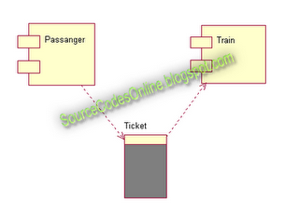

Component diagram
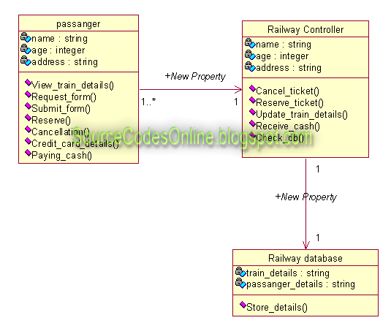

AIM:
To model the "Student Marks Analysis System" using the software Rational Rose with various UML (Unified Modeling Language) diagrams.
UML DIAGRAMS:

USE CASE DIAGRAM:
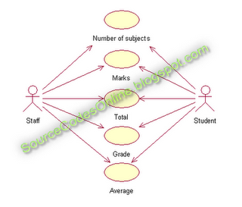
Click to view full image!

SEQUENCE DIAGRAM FOR STAFF:
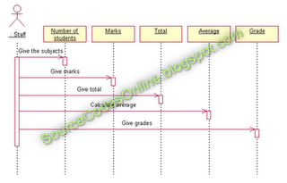
Click to view full image!

COLLABORATION DIAGRAM FOR STAFF:
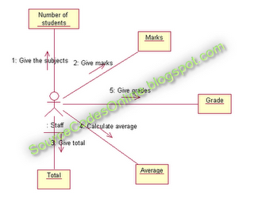
Click to view full image!

SEQUENCE DIAGRAM FOR STUDENT:
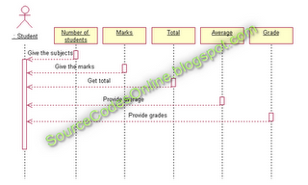
Click to view full image!

COLLABORATION DIAGRAM FOR STUDENT:
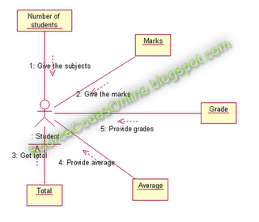
Click to view full image!

CLASS DIAGRAM:
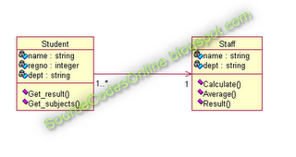
Click to view full image!

ACTIVITY DIAGRAM:
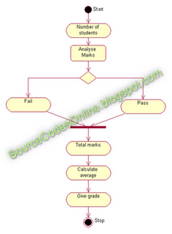
Click to view full image!

COMPONENT DIAGRAM:
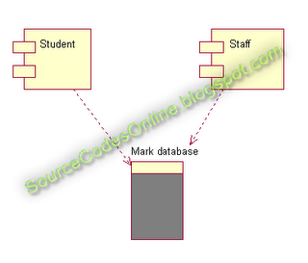
Click to view full image!

RESULT:
Thus the Student Marks Analysis System application was successfully designed and the output was verified.

AIM:
To model the "Quiz System" using the software Rational Rose with various UML (Unified Modeling Language) diagrams.
UML DIAGRAMS:

USE CASE DIAGRAM:
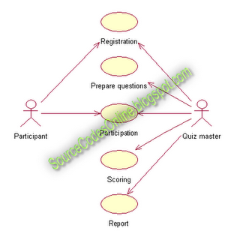
Click to view full image!

SEQUENCE DIAGRAM:
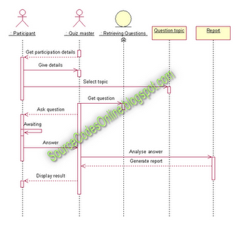
Click to view full image!

COLLABORATION DIAGRAM:
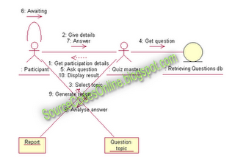
Click to view full image!

CLASS DIAGRAM:

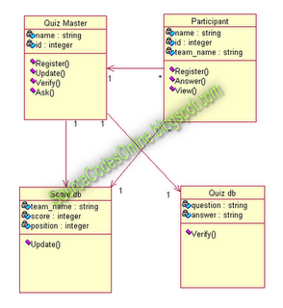
Click to view full image!

ACTIVITY DIAGRAM:
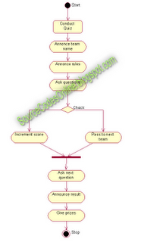
Click to view full image!

COMPONENT DIAGRAM:
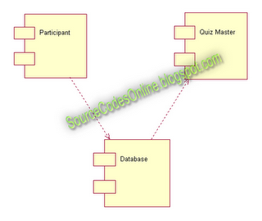
Click to view full image!

AIM:
To model the "Payroll System" using the software Rational Rose with various UML (Unified Modeling Language) diagrams.

UML DIAGRAMS:

USE CASE DIAGRAM:
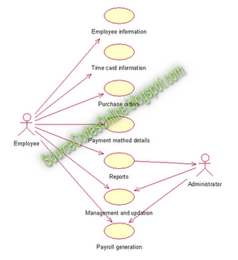
Click to view full image!

SEQUENCE DIAGRAM:
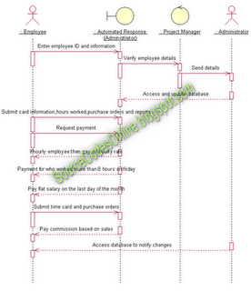
Click to view full image!

COLLABORATION DIAGRAM:
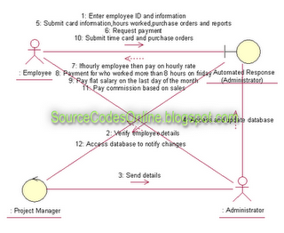
Click to view full image!

CLASS DIAGRAM:
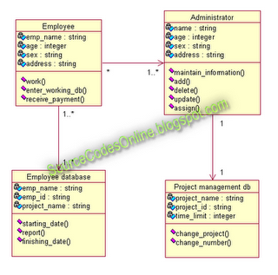
Click to view full image!

ACTIVITY DIAGRAM:
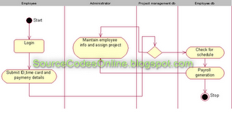
Click to view full image!

COMPONENT DIAGRAM:
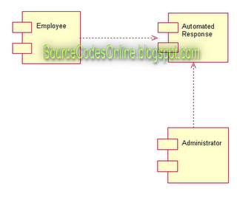
Click to view full image!

AIM:
To model the "Course Registration System" using the software Rational Rose with various UML (Unified Modeling Language) diagrams.
ABSTRACT:
The course registration project helps the user to know the procedures followed in universities to enroll students for a particular course.

The limitation of the existing system are :the system is not efficient to meet the needs, the system is very slow and time consuming, not more than one choice can be given by a student, the number of seats left out and the course details cannot be known.

The problems that are overcome are the existing system uses spreadsheet as backend now the proposed system uses access as backend, the basic requirement of
the system has being improved, its has become user friendly.

The proposed system is very efficient. Now a student can know the number of seats that are being allotted in a day. The person can even get the course detail. The report displays the number of students per course and the number of students allotted seat on a particular day.
SYSTEM ANALYSIS PHASE:
The proposed system offers a student to select course. The students can check the number of seats available. The students can know the details of the person who have been
allotted seat on a day. Every time a seat is allotted the number of seats in the database gets reduced. The proposed system is being designed for counseling of students in single window system.
PRESENT SYSTEM:
The present system is inefficient and time consuming. The students can choose only one course if seat is available the student are allotted, else the student are not allotted and can also not give second choice. The student cannot know the number of seats left out. The backend used is an older version and the processing time is too slow.
PROPOSED SYSTEM:
The system that is being developed is a user friendly system. The processing speed is very high when compared to the existing system. The space occupied by the system in the memory is also very less. The course details can be known. Second choice can be given if the course is not available. Date wise report and course wise report are generated.
SOFTWARE REQUIREMENT SPECIFICATION(SRS):
OPERATING SYSTEM: WIN2000/XP
PROGRAMMING PACKAGE: VISUAL BASIC
DATABASE: MICROSOFT ACCESS
DESIGING SOFTWARE: RATIONAL ROSE
UML DIAGRAMS:

USE CASE DIAGRAM:
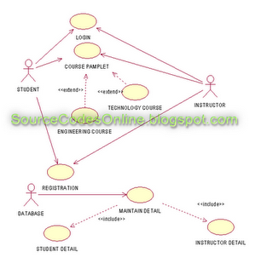
Click to view full image!

SEQUENCE DIAGRAM:
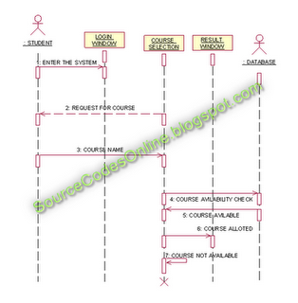
Click to view full image!

COLLABORATION DIAGRAM:
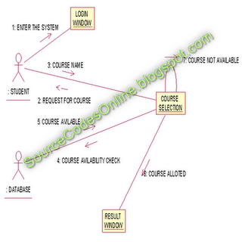
Click to view full image!

CLASS DIAGRAM:
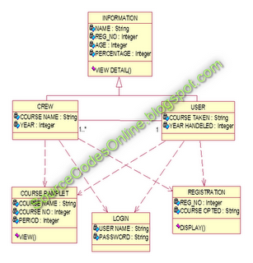
Click to view full image!

ACTIVITY DIAGRAM:
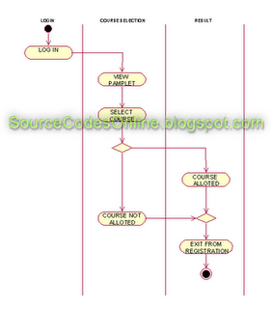
Click to view full image!

COMPONENT DIAGRAM:
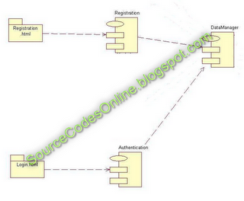
Click to view full image!

DEPLOYMENT DIAGRAM:
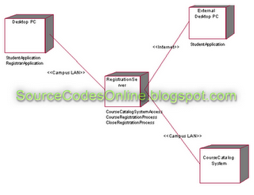
Click to view full image!

RESULT:
Thus the Course Registration System application was successfully designed and the output was verified.

AIM:
To model the "Stock Maintenance System" using the software Rational Rose with various UML (Unified Modeling Language) diagrams.
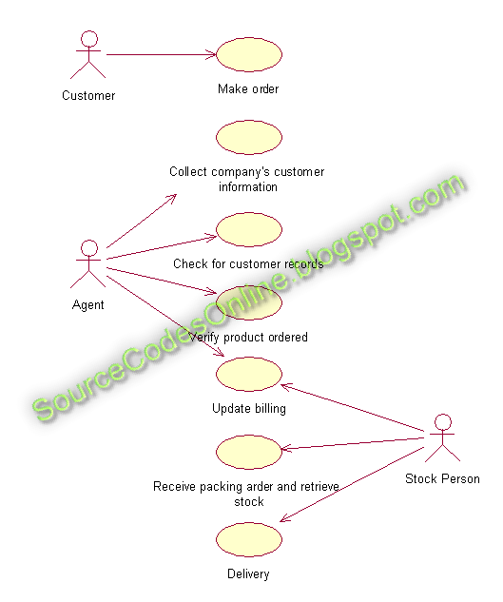

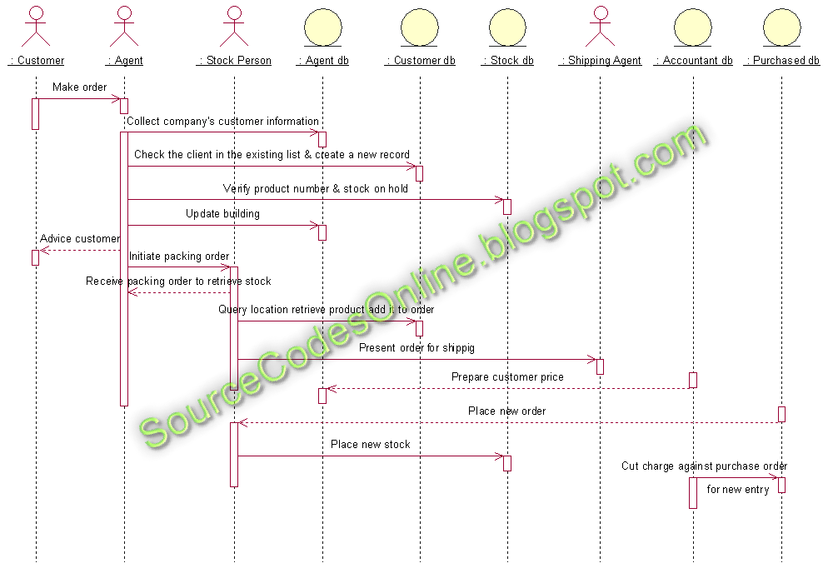

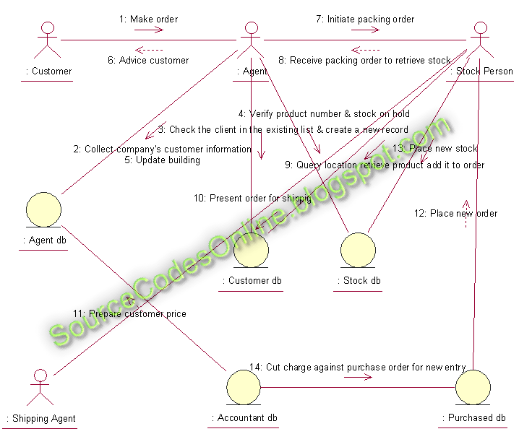

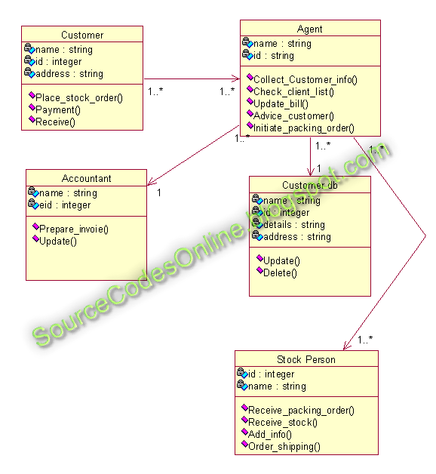

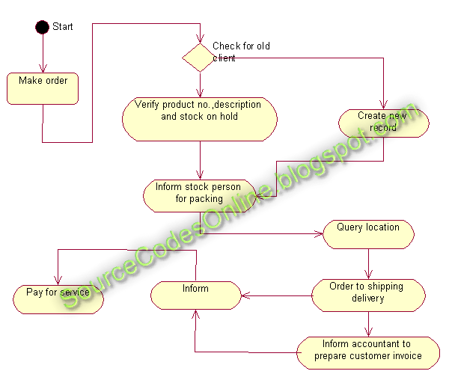

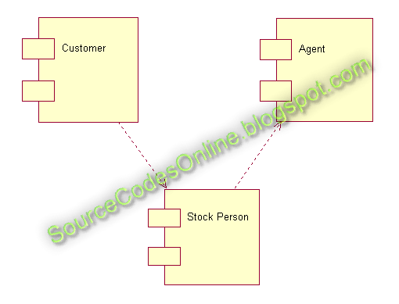
component diagram

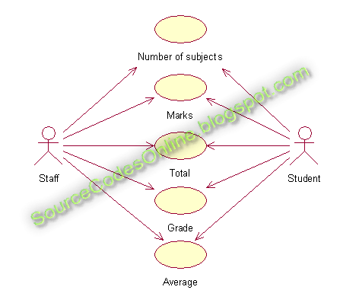
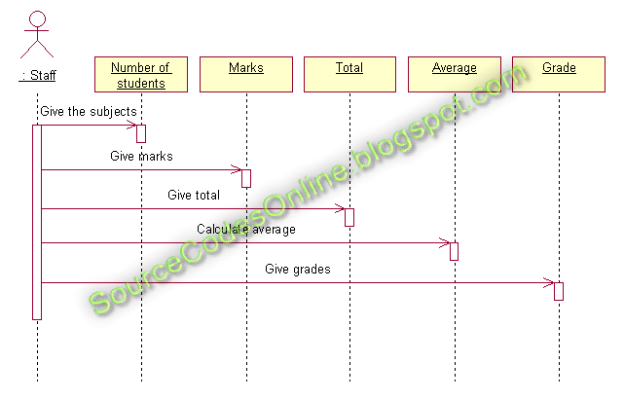
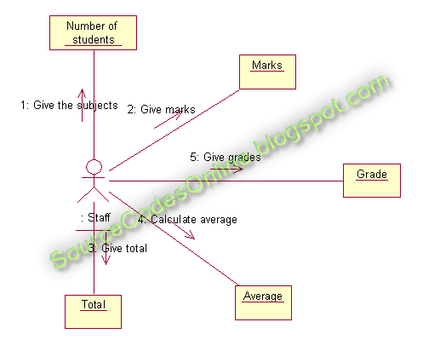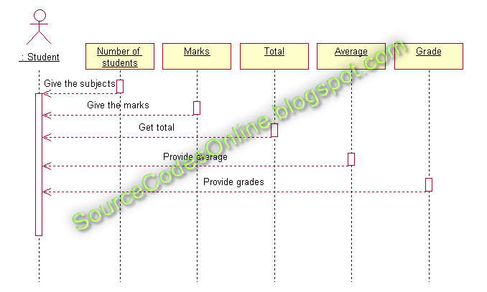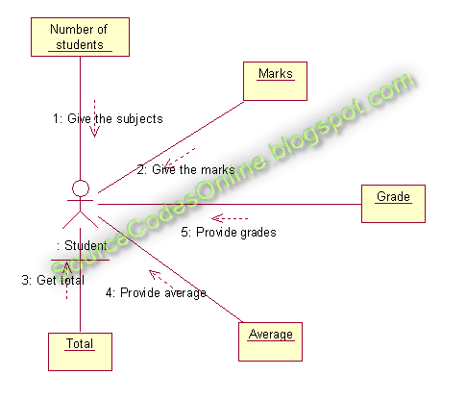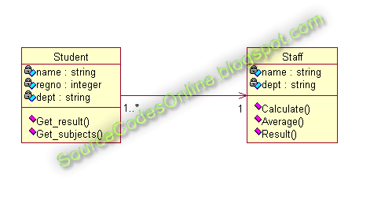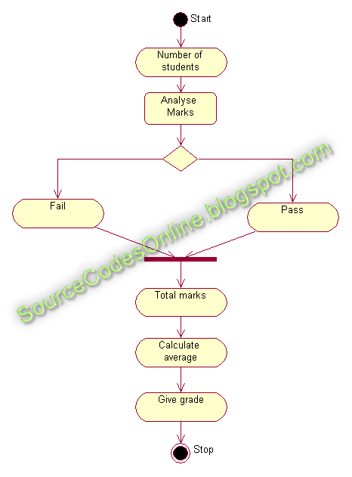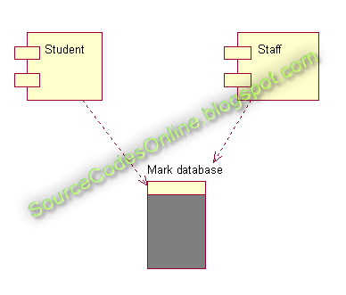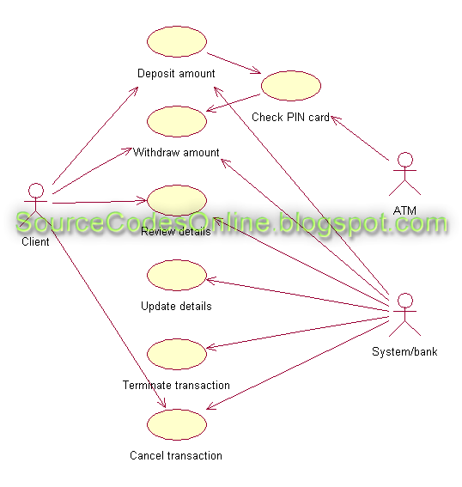
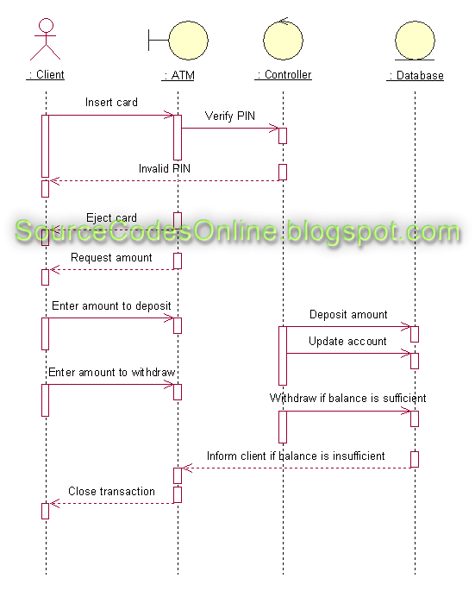
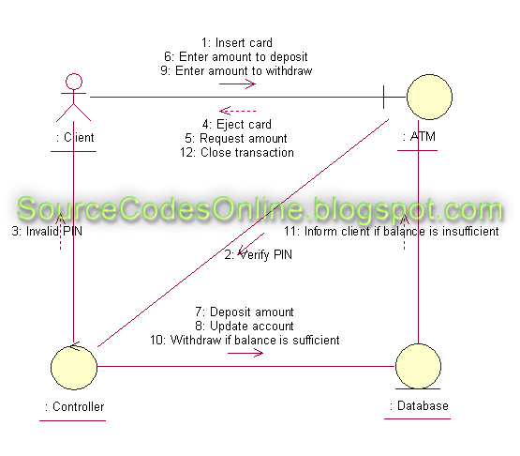
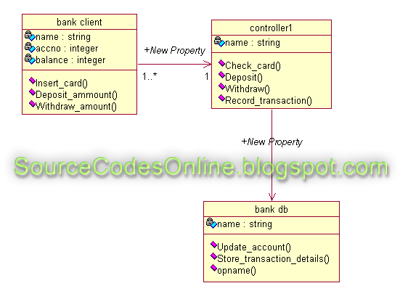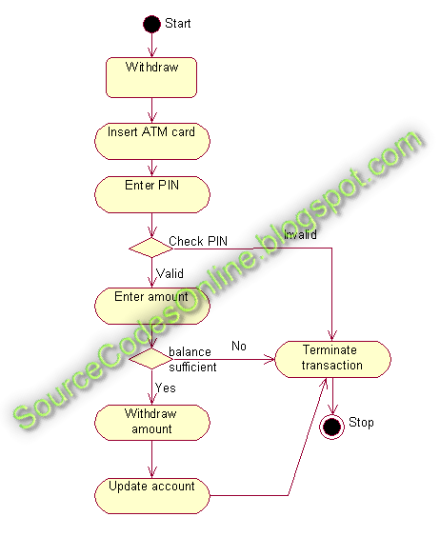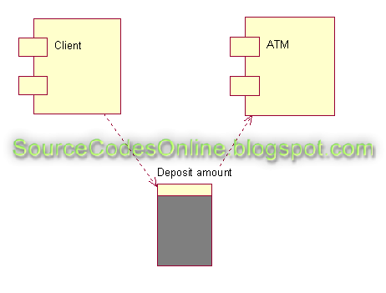

Quiz System
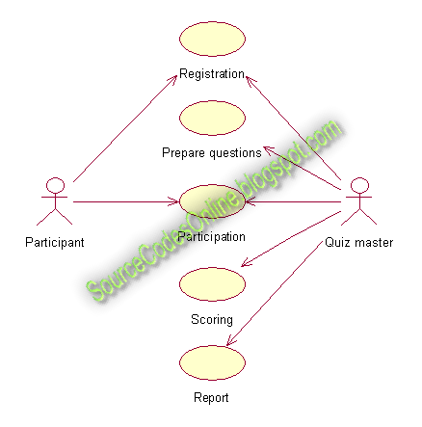

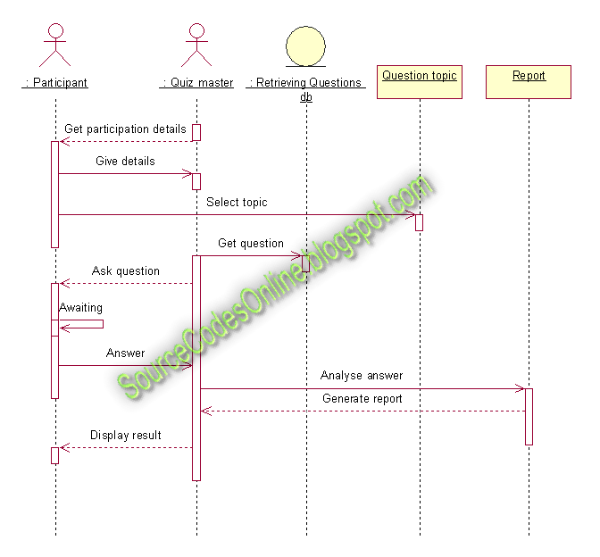
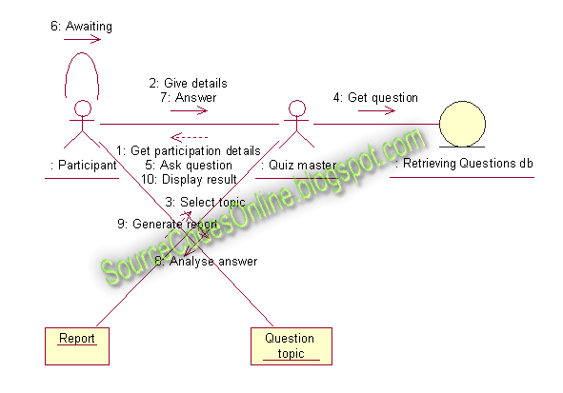
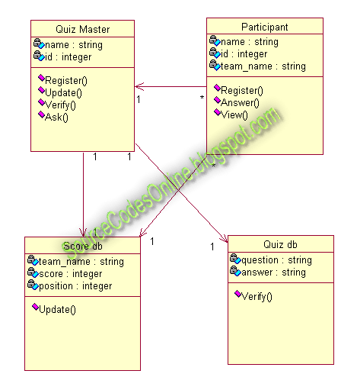
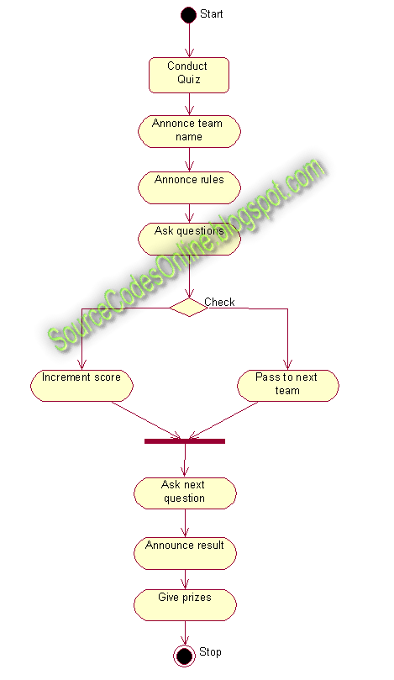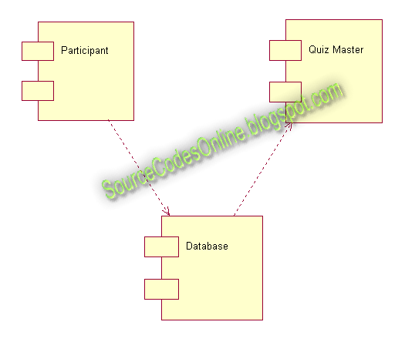

Library Management System
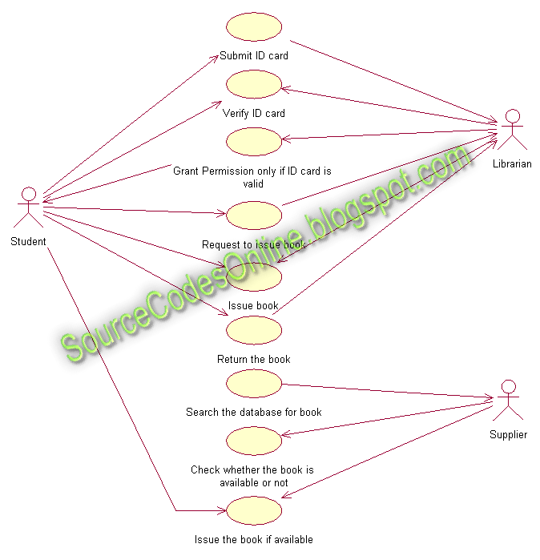
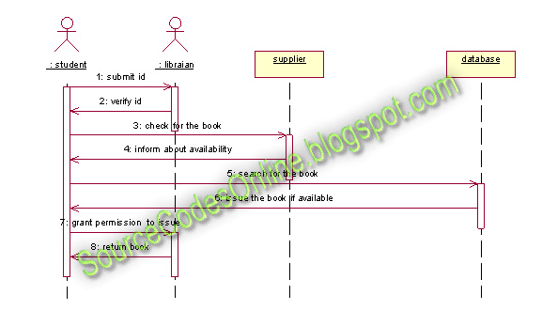
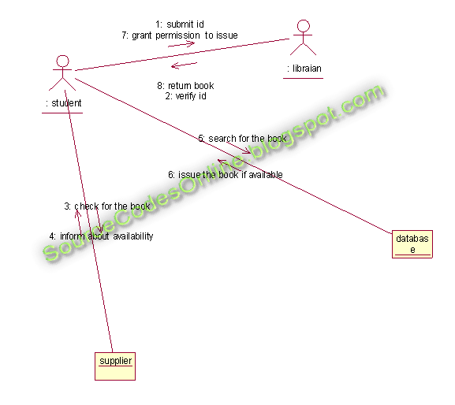
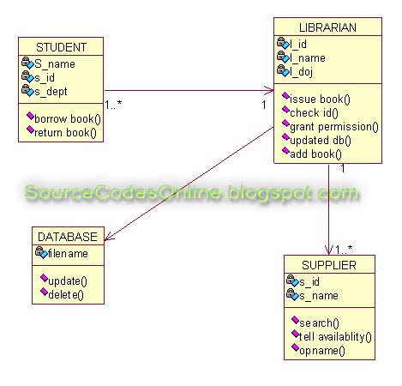
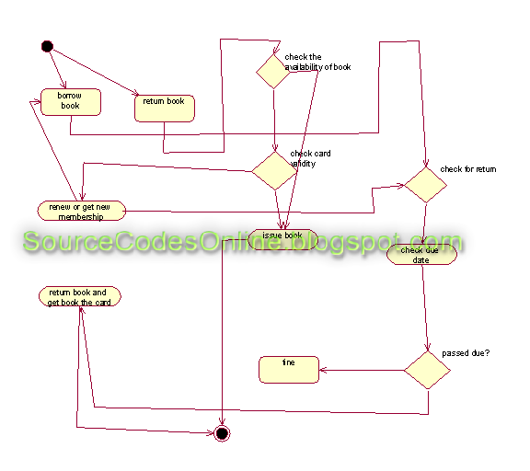
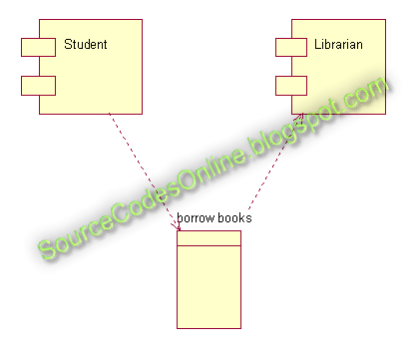

Course Registration System
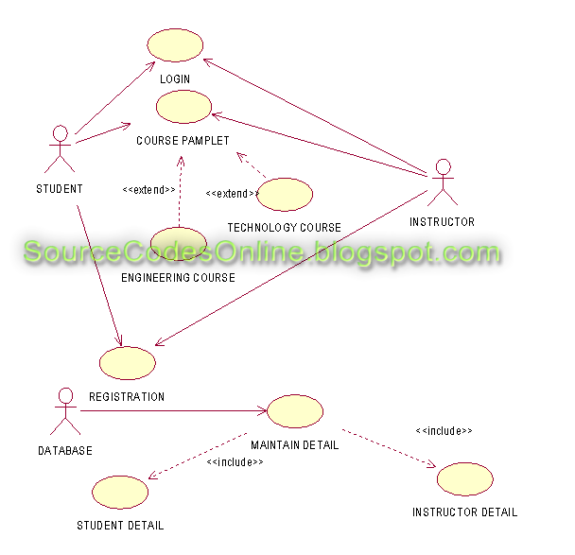

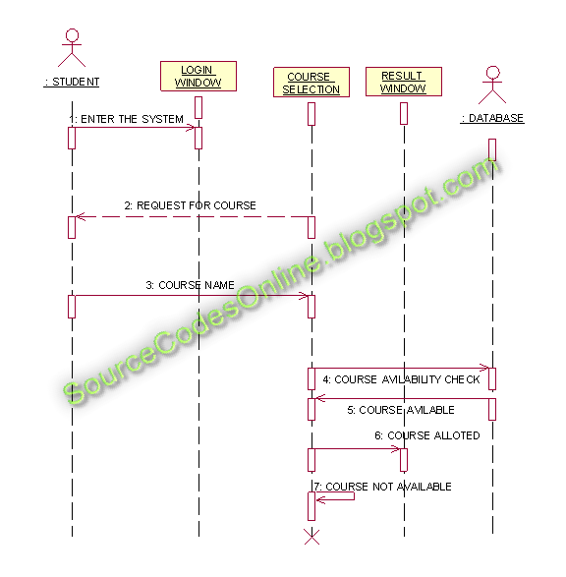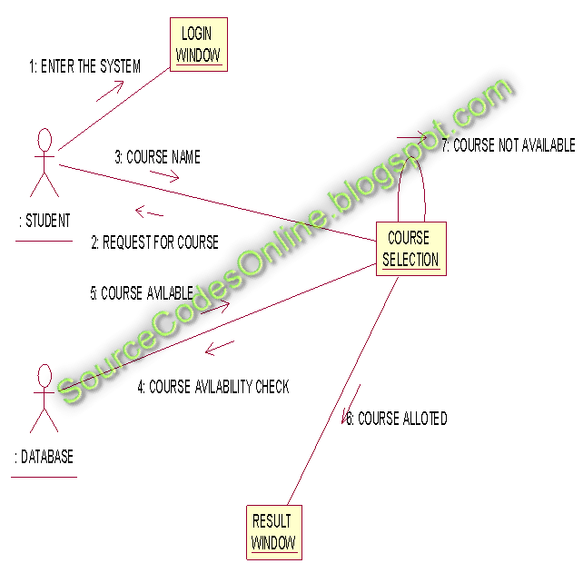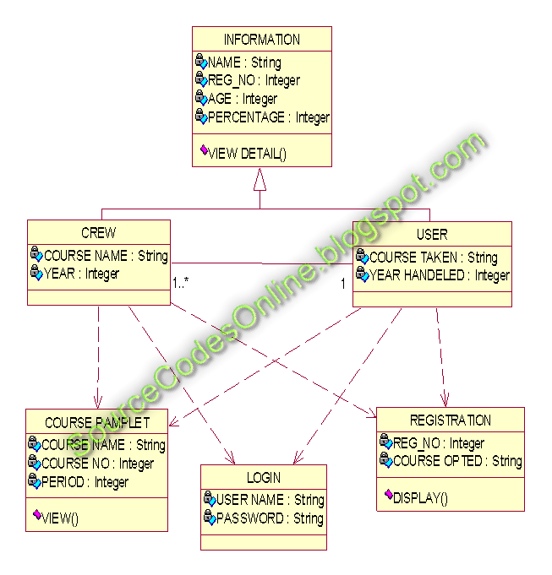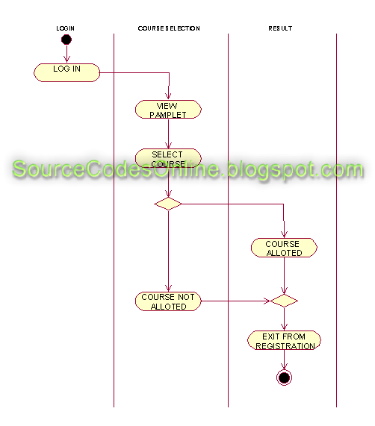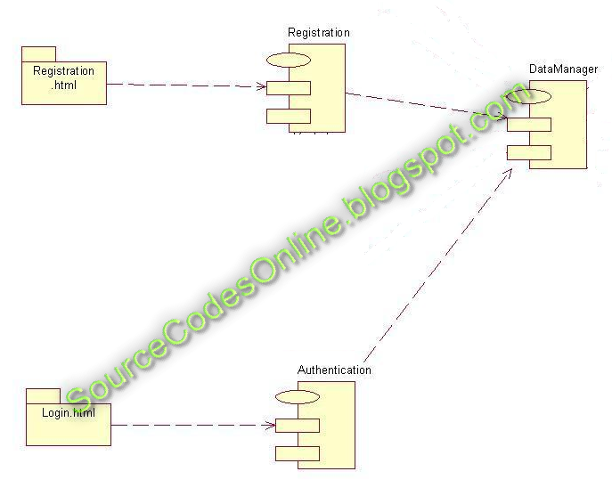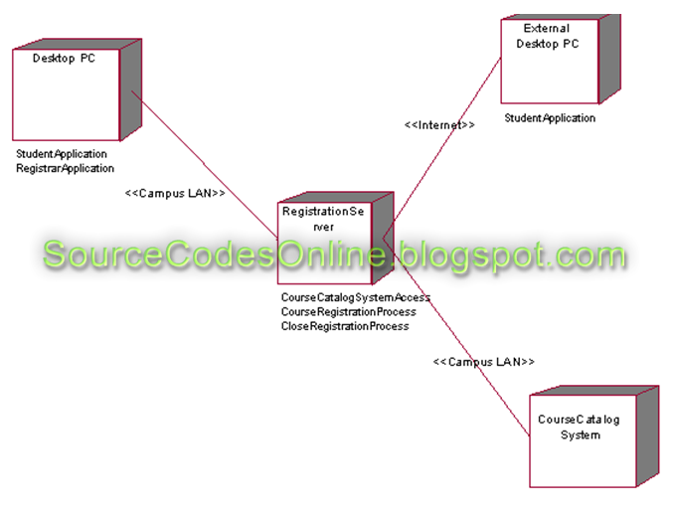
Deployment diagram

