CHRISTMAS PARTY
All Catholics and friends are invited to a Christmas Party on Monday, December 19th, at 6:00 pm at the Holiday Inn. Cost is $18 per person (including tax & tip). Meal choices are Roasted Sirloin and Chicken Cordon on Bleu. Reservations with payment need to be in by Monday, December 12th. Call Betty Blasi, 846-7605 or Louise Slavec, 846-3369 x28 to make your reservation. Once the reservation is made, payment will not be refunded.

THANK YOU!!
Fr. Becker has enough leaves and thanks and appreciates everyone who brought him leaves.

BINGO
The Knights of Columbus 1st Tuesday Bingo will be held this Tuesday, December 6th, at the Knights Home on South Commercial St. As usual the 50-50 Raffle will be conducted as well as pull tabs being sold. Burritos with green or red chili will be sold. The Progressive Jackpot will be close to $500. Doors open at 6pm, Bingo begins at 7pm. Come early to enjoy good food with your friends.
WELCOME NEW KNIGHTS
The Knights of Columbus would like to welcome three new members to their council. New members are Leroy Perea, Bob Lucero, and Paul Tortorice. They were initiated as Knights last Wednesday, the 23rd, by the 1st Degree Team of local council #1072. Congratulations and welcome.
COAT DRIVE
The Coats for Kids Program intention is to collect and provide “Easy Used” coats to kids in Trinidad who are in need of them this winter. Sponsored by the Knights of Columbus, you are asked to leave any good coats at the St. Vincent de Paul Clothing Store located across the church or in a box that will be provided in the back of the church. This nation-wide program was started in 2006 by the Knights of Columbus during the Christmas Season to help families living in colder climates. We thank you in advance for your donations of coats.

The Solemnity of the Immaculate Conception of the Blessed Virgin Mary is Thursday, December 8. The schedule for this solemn feast is: Wednesday, December 7—anticipatory Mass at 6:30 pm. The Masses for the feast on Thursday are: 8:00 am and 12:05 pm. This feast is a holy day of obligation.

For Your Information: Christmas and New Year’s Mass Schedule
It’s not as early as you may think!!
Please be aware of the Mass Schedule for the Christmas and New Year’s Feasts:

Christmas Eve (Saturday, December 24): 3:00 pm (Family Mass)
6:00 pm
9:00 pm
Christmas Day (Sunday, December 25): 9:00 am
9:00 am St. Ignatius
New Year’s Eve (Saturday, December 31): 5:00 pm
5:00 pm San Isidro
New Year’s Day (Sunday, January 1): 9:00 am
11:00 am
(Please Note: There is no 7:00 am Mass on New Year’s Day.)
DECEMBER 4, 2011 SECOND SUNDAY OF ADVENT

HOLY TRINITY MASSES, DECEMBER 4 – DECEMBER 11, 2011
Sat | 5:00 | Anv. Mass for: John Skalko
 |  | Niccoli Family; LeAndra Gyurman, Florence Ringo, Marie A. Massarotti, Rose Foster,
 |  | John Coszalter, John Hatton
Sat | 5:00 | SAN ISIDRO INTENTIONS:
 |  | Deceased members of Silva Family; Asencionita Vialpando
Sun | 7:00 | Anv. Mass for: Fr. Ralph Passarelli, S.J., Annie Slavec
 |  | Minnie Hurtado, Fred Sola, Florence Ringo
 | 9:00 | Anv. Mass for: Martha Bonacquista
 |  | Living & deceased members of Modica & Sudar Families; John & Antoinette Coszalter;
 |  | Rochelle “Shelly” Casias, Carl DiPaolo, Anna Marie Abeyta
 | 11:00 | Anv. Mass for: Rocky Kaiser
 |  | Gagliardi & Mollica Families; Frances Falco, Rose Foster, Carl DiPaolo, Anna Marie Abeyta,,
 |  | Pete Santistevan, Jr.
Mon | 8:00 | Anv. Mass for: Caroline Reorda
 |  | Liduina Tomasi,Dominic Pachelli, John Coszalter, Carl DiPaolo, Carl Amato, Sr.,
 |  | George Salbato
Tue | 8:00 | Anv. Mass for: Frank Massarotti, Jim Hattoni
 |  | Florence Ringo, George Salbato, Rosita Romero, Sally Sawaya
Wed | 8:00 | Anv. Mass for: Michael Veltri, Frances Guadagnoli
 |  | Carl DiPaolo, George Salbato
 | 6:30p | Anticipatory Mass – Anv. Mass for: Fermin Quinonez, Ercilia Mestas
Thu | 8:00 | Anv. Mass for: Tom & Mae Abeyta, Loren Archuletta
 |  | Hildegarde Bersano, Ethel Ritzus, George Salbato
 | 12:05p | George Salbato, Carlota Mealer
Fri | 8:00 | Living & deceased members of Abbene & Spanno Families; Mary Arellano, Carl Amato, Sr.,
 |  | Josephine spanno, John Coszalter, George Salbato
Sat | 5:00 | All deceased members of the Knights of Columbus; Ann Boswell, Sam Garbo, Roseann Alt,
 |  | Edmund Cordova, Marie A. Massarotti, Rose Foster, Carl DiPaolo, George Salbato;
 |  | In honor of the Blessed Mother, Healing of Jack Stanton
Sat | 5:00 | ST. IGNATIUS INTENTIONS:
 |  | Anna Marie Abeyta
Sun | 7:00 | Anv. Mass for: Dorothy Zappanti
 |  | Jennie Salbato, Robert Ozzello, Raphkel Chichon, Fred Sola
 |  | Living & deceased of Tarabino, Foghino and Castelano families et al
 | 9:00 | Anv. Mass for: Patricia Sanchez
 |  | Christine Nolte Rizzo, George Salbato, Carl DiPaolo, John Coszalter
 |  | Healing of San & Kathy Thompson Family
 | 11:00 | Anv. Mass for: Tom Wright, Frank A. “Babe” Gagliardi, Gilbert Duran
 |  | DeBono, Pasquin & Gassino Families; Carl Amato, Sr., Theresa Duran

For Liturgical Ministers: Please Note
The new Liturgical Ministry Schedules are available for pick up in the back of the church. These schedules include: Advent, Christmas and Ordinary Time

TRINIDAD AREA CATHOLIC COMMUNITY

OFFERTORY 11-27-11
Trinidad: $5,714.85
Readings for the Week of December 4, 2011
Monday: Is 35:1-10 Lk 5:17-26
Tuesday: Is 40:1-11 Mt 18:12-14
Wednesday: Is 40:25-31 Mt 11:28-30
Thursday: Gn 3:9-15,20 Eph 1:3-6,11-12
Friday: Is 48:17-19 Mt 11:16-19
Saturday: Sir 48:1-4,9-11 Mt 17:9a-10:13
Next Sunday: Is 61:1-2a10-11 Jn 1:6-8,19-28

P.V. 244.00

Thank You !

2011 DMF

Goal: $93,634.00
Pledged: 55,545.00
Balance: 38,089.00
Pledges 195


 | PARISH HAPPENINGS, DEC. 4 – DEC. 11, 2011
Sunday | Second Sunday of Advent
 | Mass, 10:00 am, Trinidad Nursing Home Inn
 | Televised Celebration of Holy Trinity Mass, 1:00 pm, Channel 71
Monday
Tuesday | Knights of Columbus Bingo, Knights Hall; doors open at 6:00 pm, Bingo starts at 7:00 pm
Wednesday | New Hope Catholic Charismatic Prayer Group, 6:00 pm, Holy Family Hall
 | RCIA, 6:30-8:00 pm, Religious Formation Center
Thursday
Friday | Adoration, 8:30 am, Holy Trinity Church
Saturday
Sunday | Third Sunday of Advent
 | Feast of Our Lady of Guadalupe Bi-lingual Mass, 2:00 pm, Holy Trinity Church, reception
 | following in Holy Family Hall
 | Word & Communion Service, 10:00 am, Trinidad Nursing Home Inn
 | Televised Celebration of Holy Trinity Mass, 1:00 pm, Channel 71

CHRISTMAS CONCERT
The Trinidad Community Band will be having a free Christmas Concert in Sebastiani Gym on Wednesday, December 14th, from 6:30 – 9:00 pm? This concert is sponsored by Holy Trinity Parish/Trinidad Area Catholic Community, Pioneer Natural Resources and the Trinidad Arts Council. Come and enjoy an evening of great entertainment.

DMF (DIOCESAN MINISTRY FUND)
Just a reminder to anyone who is making their pledge in payments, if you want credit for the full amount this year, your pledge needs to be paid in full by December 31st. to date, we are short $38,089 from reaching our goal. We are asking everyone to make a pledge of any amount if you haven’t already done so. Thank you to everyone who has already given.

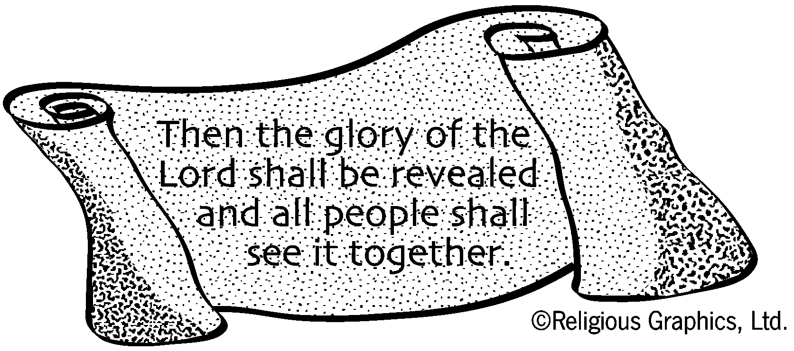

FROM THE DESK OF

THE DIRECTOR OF RELIGIOUS FORMATION

RELIGIOUS EDUCATION DATA AND SCHEDULE
We maintain an open door policy and children/young people are always welcome to register. Parents may also register their children at any of the listed meeting times. However, please be informed that anyone enrolling at this point most likely, will not receive First Holy Communion or be Confirmed this academic year.

Sunday, December 4, 2011 (10:30 – 12:00) Grades K-6
(1:00 – 2:30) Second yr. Confirmation

Sunday, December 11, 2011 (10:30 - 12:00) Grades K-6
(1:45 - 3:30) 2nd Yr. Confirmation
NOTE TIME CHANGE FOR THIS CONFIRMATION CLASS

Children, all Youth and parents are invited to attend 2:00 Liturgy
in Honor of Our Lady of Guadalupe.

Sunday, December 18, 2011 (Advent Family Potluck)
11:50 in Formation Center
St. Nicholas and photographer will be present.

Friday, December 24, 2011 (Christmas Mass for Children and Youth)
3:00 pm
This Liturgy is intended for children-youth and their parents who participate
in our Religious Education programs. They will have primary seating.



PRISON MINISTRY
The parish still provides a ministry to the local Trinidad Corrections Facility. We are happy to announce that one inmate is ready for Full Initiation into the Church and three others are prepared and formed to celebrate the Sacrament of Confirmation. As important as this special ministry is, we are in need of more Catechists. Two persons who have faithfully served in this capacity are now recovering from a serious illness. Therefore, we need other Catechists. Would anyone interested in this service to the parish please call Brother Harry at the Pastoral Center. This ministry is very important to Bishop Isern and he is personally involved in and certified to minister to inmates.
From the Desk of Sister Didyaknow

The Holy Season of Advent: The Advent Wreath
Our Advent traditions reflect a spirit of expectation and unfold gradually. The most popular tradition is the lighting of candles on the Advent Wreath in church and at home. This custom originated among Lutherans in Germany in the 16th century and gained in popularity. Along with the Christmas tree, the Advent Wreath is an example of Christianizing practices popular from pre-Christian times. The Advent Wreath came to America with German immigrants. It became popular among Catholics with the liturgical movement in the mid-1990’s.

The Advent Wreath may be of any size and is usually made of evergreens. There are four candles, one for each week of Advent. The color of the candles is not an essential factor because the symbolism is the flame. Wreaths have always been symbolic of victory and glory. The symbolism of the Advent Wreath goes beyond this. It lies in the tension between darkness and light. It represents the time when people lived in spiritual darkness, waiting for the coming of the Messiah, the Light of the World. Each year in Advent we wait once again in darkness for the coming of the Lord, his historical coming in the mystery of Bethlehem, his final coming at the end of time and his special coming in every moment of grace.

Tuesday, December 6 is the feast of Nicholas of Myra, bishop. Nicholas’s life, although he was one of the most universally venerated saints in both East and West, is virtually unknown. He lived in the 4th century and was the bishop of Myra, located in Lycia, south-western Turkey and called Mugla. He had a special love for children and every year would quietly give little gifts to the children of Myra around the Christmas season. He was also especially loved by sailors and young unmarried women—their protector and champion. Nicholas of Myra is the patron of children and perfumiers.

For Your Information
- Due to circumstances beyond our control, there will not be an Advent Reconciliation Service this year. All parish members are encouraged to receive the sacrament of Reconciliation (Confession) on Saturdays at the scheduled time (check the front of the bulletin for those times) or call the Pastoral Center to make an appointment with either Father Becker or Father Kenny.
- The Mass Cards which incorporate the additions and changes with the new translations from the Roman Missal may be found in the book racks in the pews. Please leave these cards in the pews after all Masses so that they will be available for use at all weekday and weekend Masses. Thank You.
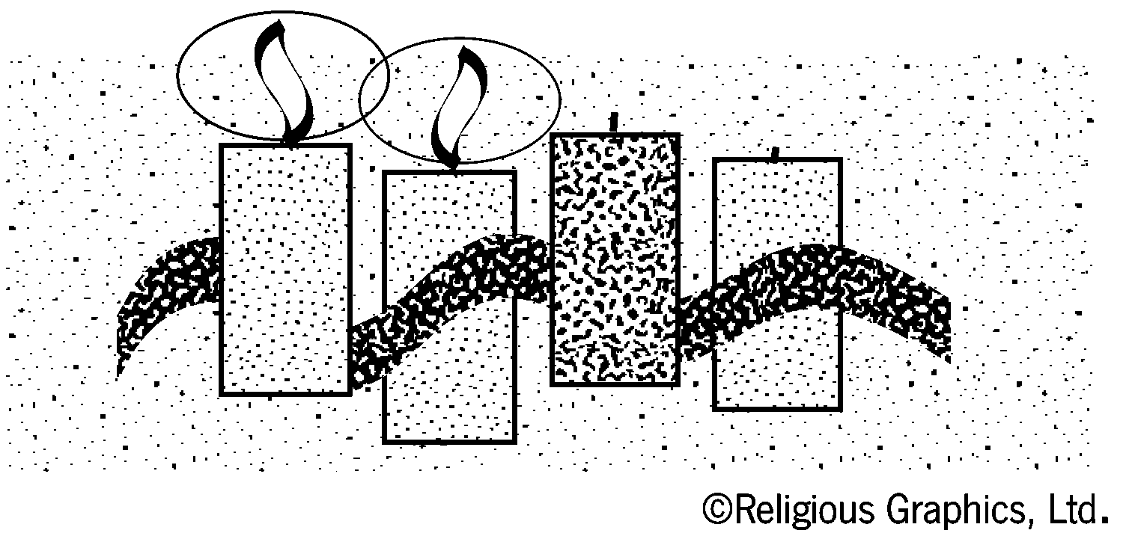
Youth News

Come and Join Us…If a young person is interested in participating in youth activities and did not yet register, please contact Alicia at 846-3369 ext 13 or attend one of the activities and pick-up a registration sheet and calendar.

Sessions are in the Holy Trinity Formation Center/School from 10:30am – 12:00 (unless noted)

December Sun – 4 Session
December Sun – 11 Session
December Sun – 18 11:50 AM Advent and Family Potluck in Formation Center
December Fri – 24 3:00 PM Children’s and Young People’s Mass

First Year Confirmation: In the Diocese of Pueblo, the Sacrament of Confirmation is a two- year process and youth need to be 16 years of age to be confirmed. Please plan ahead. High school youth who want to celebrate the Sacrament of Confirmation need to begin attending sessions to complete their first year. Please contact Alicia (846-3369 ext 13) with questions.

Feast of Our Lady of Guadalupe
The Feast of Our Lady of Guadalupe is Monday, December 12. In order to accommodate those who would like to celebrate this feast, a Eucharistic celebration will take place on Sunday afternoon, December 11. Because this 2:00 pm Mass will be a bi-lingual Mass, the 11:00 am Mass on Sunday, December 11 will not be bi-lingual. There will be a reception at Holy Family Hall following the Mass. For more information, contact Dolores Olguin or any member of the Guadalupe Society.

REFLECTIONS CELEBRATION & TREE LIGHTING
Reflections is a celebration to reflect on the special people who have touched our lives and to honor our loved ones who remain forever in our hearts. Join us for the Tree Lighting and Reading of Names at the First Christian Church on December 8th at 6:00 pm. For details, call 846-5940. This event is sponsored by the Sangre De Cristo Hospice Center.

“DATE NITE” INVITATION
Martin & Andrea Dula, in conjunction with other members of our marriage preparation program, have been planning a monthly “Date Nite” for recently married couples and couples with young children. There will be free food, free on-site babysitting and a variety of speakers. Father Kenny has volunteered to go first, speaking about Nigerian traditions and perhaps offering some Nigerian food. Sessions will be on Friday evenings at Holy Family Hall. This is being offered by the parish as a fun way to strengthen marriages and therefore our parish family. Watch the bulletin for the announcement of the first session and if you are interested, call the Parish Office and leave your name and phone number.

