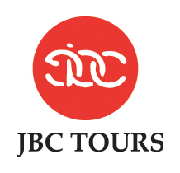 12 DAYS CLASSIC INDIA
Featuring 4* Hotels
DELHI / VARANASI / KHAJURAHO / AGRA / RANTHAMBORE / JAIPUR
Validity: October 2018 – March 2019
Daily arrival for a minimum party of 2
CAD3000 per person

DETAILED TOUR Program:
Date:2019 | Sector | Activities
DAY 1 | Arrive Delhi | Welcome to India! Arrive Delhi.  After clearing customs & immigrations.  You will be met by our representative in the arrival hall who will transfer you to your hotel.  Contact: Mithlesh Kumar- +91-8447787584.  Accommodation: Radisson Udyog Vihar  Room Cat: Superior Room  Meals: Dinner.  Web: https://www.radisson.com/gurgaon-hotel-hr-122016/indrguv
DAY 2 | DELHI | 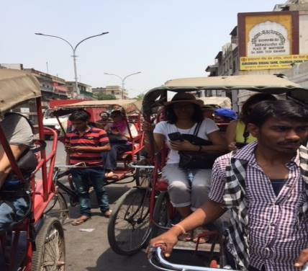  Visit Old Delhi: Jama Masjid Mosque  See Chandni Chowk.  Drive by Red fort Raj Ghat - Memorial to M. Ghandi  Visit New Delhi, Drive past Parliament House, The Secretariat Building and Vice Regal Palace  Qutab Minar Tower  Accommodation: Radisson Udyog Vihar  Room Cat: Superior Room  Meals: Breakfast + Dinner.  Web: https://www.radisson.com/gurgaon-hotel-hr-122016/indrguv
DAY 3 |   DELHI/VARANASI  SG-116  0935/1100 | Fly to Varanasi and transfer to your hotel  Afternoon visit Sarnath Ruin & Museum  Hotel: Radisson  Room Cat: Superior Room  Meals: Breakfast + Dinner  Web: https://www.radisson.com/varanasi-hotel-up-221002/indvaran
DAY 4 | VARANASI | Morning boat ride on River Ghat – sunrise scenery Viswanath Temple  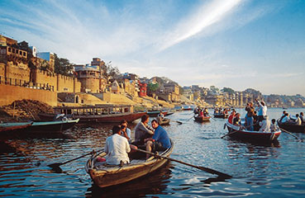  Return hotel for breakfast  Tour Bharat Mata Temple, New Viswanath Temple, Mosque of Mughal Emperor  Evening watch Aarti ceremony at the Ghat  Hotel: Radisson  Room Cat: Superior Room  Meals: Breakfast + Dinner  Web: https://www.radisson.com/varanasi-hotel-up-221002/indvaran
DAY 5 | VARANASI – KHAJURAHO  (9W2423 1225/1315) (B/D) | Fly to Khajuraho, met and transfer to hotel  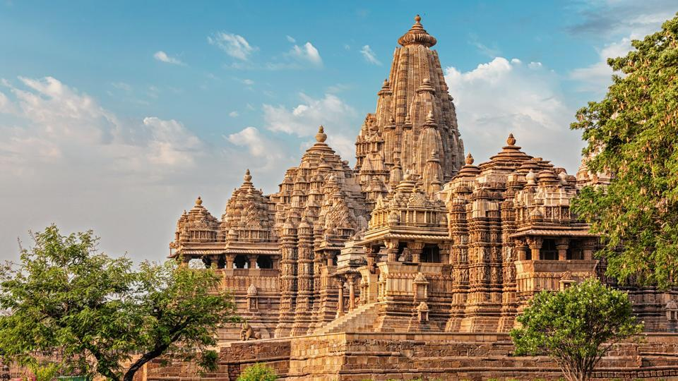  Afternoon tou r to Western and Eastern Group of temples  Accommodation: Radisson  Room Cat: Deluxe Room  Meals: Breakfast + Dinner  Web: https://www.radisson.com/khajuraho-hotel-in/indkhaj
DAY 6 | KHAJURAHO – JHANSI (DRIVE, 170 KMS / 4 HRS)  JHANSI – AGRA BY SHATABDI EXPRESS TRAIN (1800-2030)  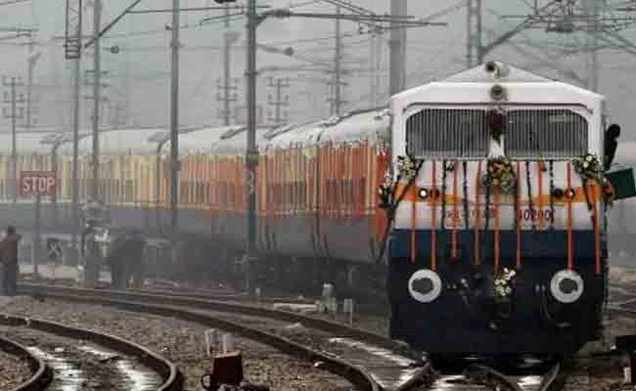 | Drive to Jhansi railway Station, en-route visit Orchha Fort  Later, transfer to train station to board train to Agra  Upon arrival, met and transfer to hotel .  Hotel: Crystal Sarovar Premiere  Room Cat: Deluxe Room  Meals: Breakfast + Dinner.  Web: http://www.sarovarhotels.com/crystal-sarovar-premiere-agra/
DAY 7 | AGRA | Visit Taj Mahal at sun rise. Back to hotel for breakfast  Agra Fort  Free afternoon. Dinner at hotel  Hotel: Crystal Sarovar Premiere  Room Cat: Deluxe Room  Meals: Breakfast + Dinner.  Web: http://www.sarovarhotels.com/crystal-sarovar-premiere-agra/
DAY 8 | AGRA – BHARATPUR (50 KMS, 1.5 HOURS DRIVE)  BHARATPUR – RANTHAMBORE BY TRAIN KOTA JANSHTBDI EXPRESS (1550/1802)  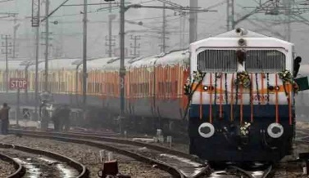 | Drive to Bharatpur Railway Station, en-route visit Fatehpur Sikri  Board train to Ranthambore  Upon arrival, met and transfer to hotel.  Hotel: Ranthambhore regency  Room Cat: Standard Room  Meals: Breakfast + Dinner  Web: http://www.ranthambhor.com/
DAY 9 | RANTHAMBORE – | Early morning, proceed for a jungle safari  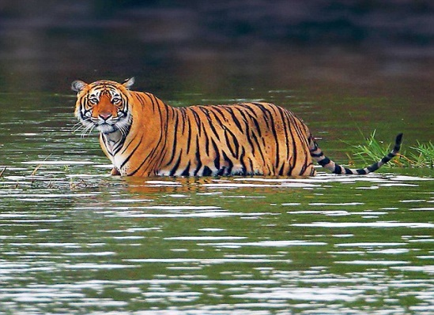  Hotel breakf ast. Free until proceed for another jungle safari in the afternoon  Hotel: Ranthambhore regency  Room Cat: Standard Room  Meals: Breakfast + Dinner  Web: http://www.ranthambhor.com/
DAY 10 | RANTHAMBORE – JAIPUR (170 KMS / 4 HOURS DRIVE) (B/D) | Ranthambore – Jaipur (170 Kms / 4 hours drive) (B/D)  A walk in the village after breakfast  Drive to Jaipur in the afternoon.  Hotel: Radisson  Room Cat: Superior room.  Meals: Breakfast + Dinner  Web: https://www.radisson.com/jaipur-hotel-in-302001/indrjcc
DAY 11 | JAIPUR | Amber Fort in the morning  Afternoon city tour, include Maharaja’s City Palace, Janta Mantar Observatory  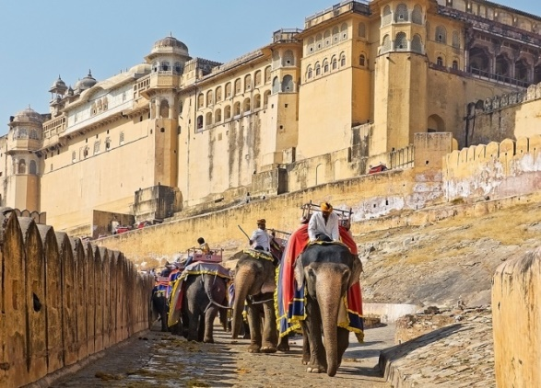  Photo stop at Hawa Mahal (Palace of the Winds)  Drive past residential and business areas of Jaipur  Hotel: Radisson  Room Cat: Superior room.  Meals: Breakfast + Dinner  Web: : https://www.radisson.com/jaipur-hotel-in-302001/indrjcc
DAY 12 | JAIPUR – DELHI AIRPORT (250 KMS / 5 HOURS DRIVE) (B) | After breakfast. Spend some time at local market in Jaipur  Drive to Delhi Airport to check-in for your departure flight  ****Tour end*******

hotels
Date- | City | Hotel | Room Cat: | Night | Meal
01-03 | Delhi | Radisson Udyog Vihar | Superior Room | 02 | HB
03-05 | Varanasi | Radisson | Superior Room | 02 | HB
05-06 | Khajuraho | Radisson | Deluxe Room | 01 | HB
06-08 | Agra | Crystal Sarovar Premiere | Deluxe Room | 02 | HB
08-10 | Ranthambore | Ranthambhore regency | Standard Room | 02 | AP
10-12 | Jaipur. | Radisson | Superior Room | 02 | HB
HB: Breakfast + Dinner
AP: Breakfast + Lunch+ Dinner

Price Sheet: ValiditY: october 2018 to march 2019 as per the itinerary
(Excluding 20th Dec 2018 to 10th Jan 2019)

PRICES- CA$ - Per person | 2 Pax | 4-6 Pax | 7-10 Pax | 11-14 Pax
Cost of Land Arrangements | $ 3000 | $ 2750 | $ 2620 | $ 2510
Single room supplement | $ 1080
Supplement for requesting tour escort from start to Finish | $ 1300 per group

PP: Per person

flight : ECONOMY CLASS:
DATE | SECTOR | FLIGHT NO. | ARR/DEP | BAGGAGE ALLOWANCE | FARE
Day 4 | Delhi/Varanasi | SG-116 | 0935/1100 | 15 KG PP | $-170 PP
Day 5 | Varansi/Khajuraho | 9W-2423 | 1225/1315 | 15 KG PP | $-170 PP
PP: Per person AIR FARE IS SUBJECT TO CHANGE AT THE TIME OF ISSUANCE OF TICKETS.

Prices Include:
- Accommodation for (11) nights on twin sharing basis.
- Buffet breakfast + Dinner as mentioned in above Hotels.
- Meet and greet at Airport and Station
- Transport in an air conditioned Vehicle.
- Services of Local English speaking guide during sightseeing
- Entrance fee as per itinerary
- Boat ride in Varanasi.
- Visit to Khajuraho Temple
- Visit Taj Mahal
- sightseeing as per the itinerary
- All activities mentioned in the itinerary
- Train cost for Jhansi/Agra and Bharatpur/Ranthambore
- Private and Exclusive Jeep Safari in Ranthambore National Park
- Sightseeing as per the itinerary.
- All currently applicable taxes

Prices DO NOT Include:
- International air fare, visa fees, airport tax or any kind of insurance cover
- Items of personal nature like drinks, laundry, telephone calls, tips, camera fees etc
- Any other meals than those mentioned in the itinerary
- Car at disposal or any sightseeing on leisure days - unless specified above
- Early check-in or a late check-out room (s) at any hotel (s) - unless specified above
- Any other item not specifically mentioned above as 'INCLUDED'
- Visa charges
- Insurance coverage
- Airfare / any airport taxes
- Any other Govt. tax increase

For 2 Passengers: Toyota Crystaa (Luxury vehicle) It provides a comfortable ride, particularly on bumpy roads, as well as having versatile space.
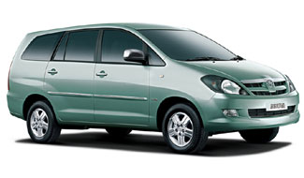
Amenities
- Ice Box.
- Mineral water.
- Hand sanitizer.
- News paper
- Umbrella.
- Wet Tissues.
- Coke

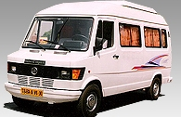
For 4 – 9 Passengers:
Tempo Traveler – Mini Van
- Manufactured by Indian company, Bajaj, this spacious minivan is a good option for small groups of 3-6 passengers. It is a durable vehicle that has good height and leg room.

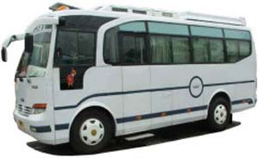
For 10 – 14 passenger (Mini Coach)
- Manufactured by Indian companies, Tata and Ashok Leyland, this coach has 18 seat capacities, each seat with a ‘push back’ facility.

Average Temperatures

City | Temperature in Degree Celsius
City | Dec-Jan |  | Feb-Mar |  | Apr-June |  | Jul-Sept |  | Oct-Nov
City | Min | Max | Min | Max | Min | Max | Min | Max | Min | Max
Delhi | 05 | 25 | 12 | 32 | 24 | 43 | 24 | 40 | 12 | 32
Agra/ Jaipur | 05 | 25 | 12 | 32 | 24 | 43 | 24 | 40 | 12 | 32
Varanasi/Khajurao | 05 | 25 | 12 | 32 | 24 | 43 | 24 | 40 | 12 | 32

GENERAL GUIDELINES
Passports & Visa’s.
Passports must be valid at least six months beyond the date of intended departure from India. Ideally, each traveller must be in possession of a multiple entry India visa. Travellers are advised to carry a photocopy of their passport and Indian visa.
Please see the link https://indianvisaonline.gov.in/visa/tvoa.html
Now obtaining E-Toursit Visa for India is very simple

Airports
While travelling in India, you will encounter a variety of airports, ranging from quite modern to rustic. Security procedures, while seemingly cumbersome, have been significant in ensuring trouble free travel. At each airport, checked luggage is x-rayed before being forwarded to the check in counters. Checked luggage must sometimes be identified prior to boarding a flight.
Hand luggage is also x-rayed quite thoroughly and, very occasionally, physically searched. Regulations do not allow any knives, knitting needles, canned food, camera batteries and film to be carried in hand luggage. As all checked luggage is x-rayed, do ensure adequate protection for camera batteries and film.

Credit Cards & Foreign exchange
American Express, Diners Club, MasterCard and Visa are commonly accepted at virtually all hotels, restaurants and major stores. Virtually all hotels you stay at offer foreign exchange conversion facilities, at a rate usually on par with what is quoted by banks.

ATMs are available at various locations in Bangalore, Bombay, Calcutta, Delhi,
Hyderabad and Madras, and some of the smaller metros along popular travel circuits, and user cards must be compatible with Amex, Cirrus, Maestro, MasterCard, Visa/Visa Electron/Visa Plus

Clothing:
Relative to the places you will be visiting, and the season, we will assist you with information on the most appropriate clothing. The hotels are smart but not hugely formal and the smart casual label is the best description for suggested dress code. Do carry a warm coat/jersey for early morning starts and especially for any train journeys, as the onboard air-conditioning can be very severe.

Electricity:
The standard is 220-240 volts, 50 Hz.Adaptors for electrical gadgets, and power surge cables for laptops, must be carried to protect such equipment from voltage fluctuations. Triple round pin plugs would also be very handy.

Health:
Hotels follow the strictest norms of cleanliness and hygiene. Tap water at all hotels is filtered. Drinking water provided in flasks in hotel rooms is boiled and filtered. Although ice is made from boiled and filtered water, avoid it in case of the slightest doubt. Safe and high quality bottled water is easily available, as are soda and tonic water, and excellent tetrapacked fruit juices. Each vehicle used during your journey will be adequately stocked with bottled water, with our compliments. Simple precautions like avoiding raw salads and cut fruit will ensure that your remain healthy and enjoy the gastronomic variety available during your journey. Another precaution is to stay away from seafood at inland locations. Should you use prescription drugs, bring along an adequate supply, together with your doctor’s prescription(s). Substitutes available here may not be quite suitable.

Health regulations:
Should you have visited or transited a yellow fever area at least ten days before the date of your arrival into India, a yellow fever inoculation certificate will be mandatory. While there are no other regulations in force, anti malaria medication is always strongly recommended.

Luggage:
We recommend soft sided luggage and duffel bags. Always remember to keep luggage locked while travelling, whether it is stored in the hold of a car or bus, or during domestic flights and train journeys.

Monuments :
The cost of entry tickets to monument and museums are always included in the price of your tour, except in the rare instance where you have opted to pay such fees directly. Touring inevitably includes visits to sacred places, where footwear must be removed. Always remember to wear, or carry, thick and comfortable cotton socks, which is much more preferable to walking about barefoot. Visits to sacred places also call for modest clothing, such as half or full sleeved upper garments and, on occasion, headscarves for ladies. Leatherware cannot be carried into Hindu temples. As much as tourism has developed, some facilities have not kept pace and one considerable inconvenience is the lack of decent toilets at virtually every site.

“No smoking” restrictions
Domestic flights, trains, tour vehicles, certain areas of hotels, monuments, public areas and public buildings are smoke free.

Shopping:
We always recommend that silk carpets, jewellery and pashmina shawls are examined very carefully before purchase. Antiques over a hundred years old require permission to be exported, and this can be a time consuming process. The sale of shahtoosh and ivory, among other items, is banned.

Tipping:
It is usual to tip the waiters, porters, guides and drivers. Tips are not included in the bills, whether of hotels, transport companies or any other suppliers. At hotels and restaurants, about 10% of the bill is usually acceptable.

Currency:
India’s currency is 'Rupee', abbreviated as ‘Rs’. One Rupee is equal to 100 paise. Coins are in various small denominations of 10, 25, 50 Paise (these are rarely in circulation these days) & 1, 2, & 5, Rupees. Notes (Bills) are in denominations of 10, 20, 50, 100, 500 & 2000 Rupees.

