
PROCEDURE: Department Cashier Procedures

OVERVIEW 1
STATUTES AND GUIDELINES 3
OPERATING PRINCIPLES 4
PROCEDURES 5
1. Change Fund 5
2. Department Cashiering – Change Fund 5
3. Credit Card Machines 6
4. Deposit Card on Web 7
5. Deposit Procedures 8
6. Uncollected funds on NSF Checks 11
7. Direct Deposit Departments 11
8. Incoming Wires 12
9. Use and Replenishment of Petty Cash 12
10. Cash Withdraws 15
11. Paid Outs 15
12. Credit Card Machine Check Out (short-term) 16
13. Cash Exchange 16
14. Foreign Currency/Checks 17
15. Check Cashing 17

OVERVIEW

The University of Montana Treasury Area (Treasury) maintains a cashiering function for the purpose of receiving monies due The University.

It is the Departmental Cashiers responsibility to process incoming funds for their respective departments. At the end of each day or cashiering session, departments will balance their tills and summarize their daily activity. A deposit will then be prepared and sent to the Treasury Services Area within Business Services for further processing.

Treasury Services will verify the cash (unless the department is an approved Direct Deposit Department) and record the funds in Banner. At the end of each day, Treasury prepares a deposit of their day’s activities and the deposit is sent to the bank the following morning.

Part of The University of Montana’s cashiering process involves reconciliation of the funds between Banner and the Bank. This is done through an automated process that matches transactions in Banner with transactions at the Bank. This process is date sensitive. For this process to operate properly, Departments must follow the Daily Processing Procedures (Reference Section 2, Department Cashiering on Page 5 of this document). This process has been developed to allow for very efficient and accurate reconciliation of The University of Montana’s Funds.

Departments must deliver deposits to Treasury on days when they are required. [See the Deposit Procedures in Section 5]. This allows the reconciliation process to take place in a systematic fashion, eliminating unnecessary reconciliation items due to tardy processing. The following table describes the Department and Treasury daily workflow.

Department Workflow
Day 1 | Day 2 | Day 3 | Day 4
- Receive Cash, Checks and Credit Cards  - Batch out Credit Card Sales  - Balance till and days activities  - Prepare a deposit for Treasury Services | - Send Deposit to Treasury Services | - Verify that the Deposit was entered into the correct Departmental Account
Treasury Workflow
Day 1 | Day 2 | Day 3 | Day 4
 | - Verifies Departments cash, checks, credit cards  - Enters funds into departmental accounts  - Balances days activities  - Prepares a deposit to go to the Bank | - Sends the deposit to the Bank | - Reconciles the Bank with Banner

Treasury Services is located on the 2nd floor of the Lommasson Center, Room 236 and is open from 9:00 am to 4:00 pm.

STATUTES AND GUIDELINES

The state of Montana has provided statute and guidelines for all State agencies to follow. The following items reference those Statutes and Guidelines. A link to the Montana Code MCA 17-6-101 is provided.

MCA 17-6-101
MOM 2-1210.10
MOM 2-1210.20

The following Flow chart outlines The University of Montana’s Funds Collection and Depository process. This process has been integrated into an automated cash/bank reconciliation, which occurs daily. Due to the automated daily reconciliation process, departments are required to follow transaction and depository procedures. Business Services Treasury Services Area and The University’s Bank and Credit Card processors are also required to process transactions according to the depository procedures and timeline.

FUND DEPOSITORY PROCESS

OPERATING PRINCIPLES

Your department is responsible for completing a Change Fund Request/Increase form or completing a Petty Cash Fund Request/Increase Form. You can open a change fund or a petty cash fund by filling out the online form and giving it to Treasury Services. Click on the following links to access the forms.

Change Fund Request/Increase Form

Petty Cash Fund Request/Increase Form

Under no circumstances may goods be purchased using Change Fund money. Any violation of this will result in closure of the Change Fund. If the Department needs to make small purchases, please see “Petty Cash”. [See Section 9]

Petty cash funds can only be used to make departmental expenditures. Check cashing, loans, compensation to employees, consulting services, independent contractor services, travel, entertainment, controlled items identified in the Purchasing/Payables Tool Kit, or items restricted by State or UM policy may not be made from petty cash funds.

Completing the forms provides the following information for Treasury Services.
    - A detailed description of why fund is needed.
    - The amount being requested.
    - The name of the fund custodian who will be responsible for the funds.
    - Number of people permitted to have access to the fund.
    - Describe how the fund will be used.
    - How the fund will be secured while in use or at night.

SECURITY OF CASH

Departmental revenue should be secure at all times.

Cash drawers, Petty Cash and Change funds should be in a secure location both during use and overnight. Departmental revenue should be sent to Treasury and should be in a secure deposit bag if over $500. It is recommended that for sending large amounts, discretion is used in considering a security service when sending money to Treasury. If the Department does not already have deposit bags they should contact the Treasury Services Area for help in ordering them. The cost will be the department’s responsibility and departments will pay the vendor directly.

The Fund Custodian for a Petty Cash or Change Fund is responsible for insuring that funds are adequately safeguarded as well as compliance with all applicable policy and procedure with regard to the funds.

PROCEDURES

Change Fund

A Change Fund is required to allow departments to perform cashiering functions.

  - Change Fund Setup

    - The Department chairperson must sign the Change Fund Request Form before it can be turned it in to Treasury.
    - The request must be approved by the Business Services Director or Assistant Director.
    - A DA-105 form is filled out by Treasury and Treasury sends the form to the State for final approval.
    - After approval from the State, a check is issued (revolving fund) to the designated Fund Custodian determined by your department. The Fund Custodian will then need to come to Treasury and endorse the check.
    - Treasury Services cashes the check and issues the predetermined denominations to the Custodian.
  - It is very important that you plan ahead in order to allow enough time for this process to take place, this process can take up to a week.

- Department Cashiering – Change Fund

- When not working in the Drawer, it should be locked.
- Only one person should work out of the drawer per shift.
- Departmental abuse or failure to comply with the procedures regarding Change Funds, Credit Card machine processing, or Deposit timing, may result in loss of those privileges.
- Change funds are used to make change only. They are not to be used for cashing personal checks, making purchases or for reimbursements.
- The balance of the change fund at any given time must be equal to the requested amount.

  - Daily Processing

    - At the beginning of each day remove the cash drawer from its secure, locked location and place it in the register. Count the cash and coin to verify that change fund is the amount provided from Business Services.
    - Run the departments daily revenue (cash, check and credit card transactions) as your department requires.
    - At the end of each shift the drawer needs to be balanced (reconciled) using the appropriate balancing sheet. Balancing sheets are available through Treasury or Departments may create sheets that are tailored to their specific needs. Treasury must review any balancing sheets not provided directly by Treasury before first use.
    - To balance, print the tally sheet for total sales for the day.
    - Leave the amount of cash in the register that equals the allotted change fund amount. For example if $100.00 is issued for the change fund, determine the total cash for the day and deposit the total cash less the $100.00 issued amount keeping an appropriate denomination spread for the following day.
    - Total the checks and make sure they match the total number of checks brought in for the day, do the same with cash and credit card receipt slips.
    - Fill out the deposit card reflecting the sales. If the fund is over or short, it is the department’s responsibility to place the funds in their over/short account with the deposit for that day.

Credit Card Machines

Departments that transact credit card sales and credit card payments for University of Montana business must follow the PCI-DSS Global Security Standard for the protection and transmission of cardholder data. Departments should be familiar with this standard and also follow the Business Services Information Security policy which addresses PCI-DSS.

  - Only trained authorized personnel are allowed to transact credit card sales and payments. Authorized personnel are trained by your department.
  - Cash advances on credit cards are not allowed for any reason.
  - Settlement Report- “Settlement Successful” is required for all Credit Card Deposits–This means that all credit card sales must be authorized through the bankcard service company by using the Zon machine, prior to being entered into Banner. Under no circumstances will Treasury accept unverified charges.
  - Training with Treasury – Treasury has basic instructions for entering credit card payments and closing out the credit card machine. Refer to 3.7 for information on contacting TransFirst Health and Government Services (TransFirst.).
  - If the department has a credit card machine, the department must settle the credit Card Machine each day. This will be done at the end of day when the department begins the balancing process.
  - The department must verify that the credit card machine is settled and the SETTLEMENT REPORT shows “SETTLEMENT SUCCESSFUL” (this is printed at the bottom of the batch out slip). If the department does not receive one of these slips, the department has not batched out correctly and must repeat the process correctly. If the credit card slip does not say SETTLEMENT REPORT on the top and SETTLEMENT SUCCESSFUL at the bottom of the batch slip, it will not be accepted by Treasury.
  - Any problems with the credit card machine need to be taken care of through TransFirst. TransFirst can be reached at 1-800-654-9256-. Departments will need their merchant number on the slip when calling. The deposit report that shows “Settlement Successful” is required for Treasury Cashiers to enter Credit Card deposits into BANNER.
  - If a credit card machine has been used, a deposit MUST be made daily.

  - Credit Card Chargeback’s and Reversals.

    - Each Department is responsible for responding to chargeback notices.
    - TransFirst (Merchant Services) will provide all chargeback and reversal notifications to Business Services.
    - These Notifications will be faxed or emailed to the departments the same day they are received by Business Services.
    - The departments will need to decide if the Chargeback is contestable or not.
    - If not contestable or if the chargeback cannot be reversed, within 3 business days the department needs to provide Treasury with accounting information so it can be entered into banner.
    - If the department contests the chargeback and wins, Treasury will then reverse the debit to their account in banner.

- Deposit Card on Web

  - Deposit Card

    - The Deposit Card is an Excel Spreadsheet that can be found at the above link. It is also available in card form from Treasury Services.
    - Enter the date.
    - Complete one line on the card for each departmental account that funds should be deposited into.
    - The amounts will be totaled on the top of the form as each amount is entered.
    - Enter the Cash Total, Check Total, and Credit Card Total where indicated and compare the total to the total at the top. Please remember that the Credit Card total entered on the deposit card must match the Settlement Report which must say “SETTLEMENT SUCCESSFUL”.
    - Fill in the Department; enter who prepared the form and the telephone extension where they can be reached if Treasury Services has any questions.
    - If you have any questions filling out the form, contact Treasury Services extension 2492.

- Deposit Procedures

  - After departments have balanced their till for the day, a deposit should be prepared and delivered to Treasury Services for BANNER Revenue entry. The deposit should be verified by an individual who did not work in the till for that day. Departments should close on the current business day and deposit on the next business day.
  - Deposits must be made daily if any of the following exist:

    - If Cash collected total more than $100.00.
    - If there is a credit card transaction.
    - If the total of Cash and Checks is greater than $500.

  - At a minimum, departments with funds must make deposits weekly.

The following flow chart will assist you in determining when deposits should be made.

  - Cash Bundling

    - Both cash and checks must be counted with a calculator and the tape attached. Departments are responsible for verifying the amount of cash and checks submitted to Treasury for deposit.
    - Cash must also be bundled (with rubber bands or paper clips) in the appropriate amounts.

      - ($1’s) Ones bundled in the amount of $25.00 per bundle.
      - ($5’s) Fives bundled in the amount of $100.00 per bundle
      - ($10’s) Tens bundled in the amount of $250.00 per bundle.
      - ($20’s) Twenties bundled in the amount of $500.00 per bundle.
      - ($50’s) Fifties bundled in the amount of $1,000.00 per bundle.
      - ($100’s) One hundreds bundled in the amount of $1,000.00 per bundle.

If there is not enough to bundle in the required amount; please DO NOT bundle them.

  - Restrictively Endorse Checks (MOM 2-1210.10)

    - All checks will be restrictively endorsed at the time of initial receipt.
    - The following restrictive endorsement shall be placed on all checks accepted by departments:

FOR DEPOSIT ONLY
TO THE DEMAND ACCOUNT OF
THE STATE OF MONTANA TREASURER
5103
UNIVERSITY OF MONTANA

  - Double verify that the calculator tape on the checks is added correctly. If there is an error in addition of the checks it is the department’s responsibility to take the appropriate over or short.
  - Departments must determine the total to be deposited (Cash, checks and credit cards summed). When completing the Departmental Deposit Card, departments must provide the correct Detail Code, Index Number, and Account Number for each amount the department desires to be entered in each revenue account. There are several lines on each Departmental Deposit Card. If additional lines are needed, complete another Departmental Deposit Card and attach them together. The Departments must verify that their total Cash, Checks, and Credit Cards match the total of the revenue distribution on the completed Departmental Deposit Card(s) with double verification by calculator tape. The Departmental Deposit Card(s) must be filled out clearly, to eliminate encoding errors.
  - Departments need to place the deposit into a secure bag and deliver it to Treasury Services for deposit processing.
  - When Departments take their deposit to Treasury for processing, they need to wait for the cashiers to enter the deposit and ask for a receipt. Take the receipt back to your department to be filed with the balancing sheet for that day. Record retention for the receipts is 5(five) years.
  - Departments are responsible to verify in BANNER, that the deposit was posted to the correct account(s). If the deposit submitted to Treasury does not balance (Cash, checks, and Credit Cards do not match revenue) the entire deposit will be removed from processing. The department will be contacted and are required to correct the deposit immediately.
  - If questions arise during preparation of the deposit, please contact Treasury at 2492. Instructions for BANNER verification follow:

Steps for a department to check deposits made at Treasury Services:

- In Banner, use the direct access shortcut for Organization Budget Status Form “JGITRND”.

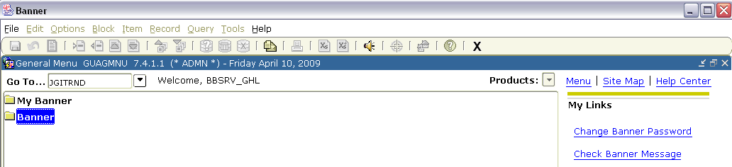

- In JGITRND, the cursor will default in the “COA” box. Tab to the next box, which displays the “FY,” and enter the desired fiscal year (last two digits, e.g. “08” or “09”). Then, tab to “Index”, and enter the index code that the deposit was coded to, such as MFR100 in this example.

- The Fund, Orgn, and Prog will auto-fill. In the Acct field, enter the account code that the deposit should have been coded to (for this example, enter 61123).

- Press Cntrl + Page Down and the F8 button to execute the query. The details supporting the transactions are shown.
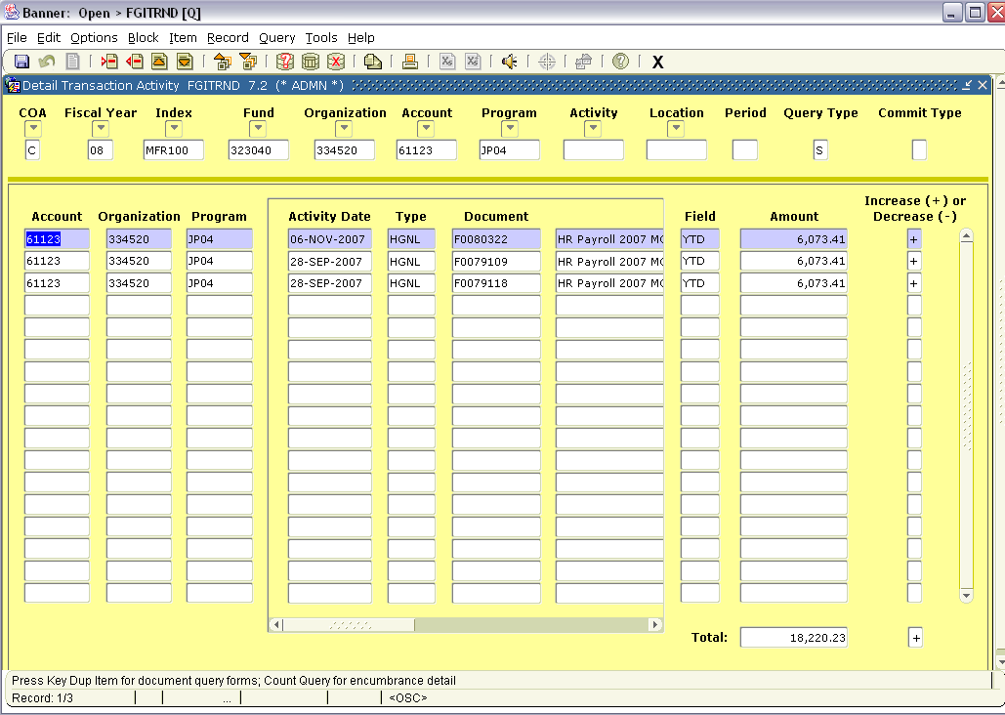

- To query for the amount of the deposit, hit “F7.” Click the first box under the “Amount” column, type in the amount that should have been deposited into this index/account code, and press “F8.” Banner will populate all transactions in this index/account for the amount queried. If the deposit is not shown, call Treasury Services and ask them to investigate.

- Uncollected funds on NSF Checks

  - Business Services will contact departments if they are unable to collect on NSF checks. The amount of the uncollected funds will be charged back to the department. Departments will be required to identify the account that should be charged.

- Direct Deposit Departments

Direct deposits are typically available for large depository departments.

  - Proceed with daily cashiering routine and balance at the end of the day.
  - Prepare departmental deposit card.
  - Provide descriptions and correct accounting to be entered by Treasury.
  - Separate cash, checks, and credit cards at the bottom of the deposit card and provide a document total.
  - Prepare bank deposit slip.
  - Put cash, checks and the white and pink copy of the bank deposit slip in a locked bank bag.
  - The cash and checks will not be verified by Treasury, they will be sent directly to the bank for verification. If a deposit ticket error is identified, the bank will contact Treasury Services and Treasury Services will then contact the departments.
  - Departments have 24 hours to make corrections or Treasury will credit or debit a predetermined account.
  - Put the completed departmental deposit card, the yellow bank deposit slip and credit cards in an unlocked bag.
  - Security Armored will collect both bags in the morning and deliver them to Treasury Services the same day.
  - The accounting information will then be entered and the locked bank bag obtaining cash and checks will be sent to the bank to be deposited the following day.

- Incoming Wires

The University, in very rare circumstances and with prior approval may accept one-time wires directly into The University’s bank account. Please submit a memo to Treasury Services stating that the department would like to receive a wire. Treasury will determine if a wire is the best way to handle the deposit.

  - If Treasury approves the wire Transaction, Departments will need to provide to Treasury the following information:
    - Vendor contact info
    - Vendor Name
    - Vendor’s Bank and Country
    - Department Accounting
    - Amount of Wire
    - Date that the wire is to be sent
  - Treasury will provide the wiring Instructions directly to the vendor
  - When the wire is received, Treasury will contact departments and record the Revenue for the department in BANNER.

- Use and Replenishment of Petty Cash

Petty Cash is used to facilitate minor purchases under $50 and must be replenished at least monthly.
  - Petty Cash Fund Setup

    - The Department chairperson must sign the Petty Cash Fund Request Form before it can be turned it in to Treasury.
    - The request must be approved by the Business Services Director or Assistant Director.
    - A DA-105 form is filled out by Treasury and Treasury sends the form to the State for final approval.
    - After approval from the State, a check is issued (revolving fund) to the designated Fund Custodian determined by your department. The Fund Custodian will then need to come to Treasury and endorse the check.
    - Treasury Services cashes the check and issues the predetermined denominations to the Custodian.
    - It is very important that you plan ahead in order to allow enough time for this process to take place, this process can take up to a week.

  - Reimbursement of Petty Cash Fund

    - The petty cash fund must be replenished as needed, but at a minimum on a monthly basis from July through May. For the month of June, replenishment must occur according to the date outlined in the Fiscal Year End Critical Cut-Off Memo, sent to departments by Business Services.
    - The accounting information on the Petty Cash Vouchers must be summarized on a Petty Cash Charge Summary Form if there are two or more petty cash vouchers being reimbursed. The total reimbursement requested on the Petty Cash Charge Summary form must be in agreement with the total of the Petty Cash Vouchers.
    - The Petty Cash Charge Summary Form should be presented to Treasury Services to be exchanged for cash.
    - Departmental petty cash funds may be used for expenditures from more than one index. The fund custodian must obtain the signature(s) of individual(s) authorized to make expenditures from each index
    - Other monies that may come into custody of a department may not be used to increase or create a petty cash fund.

  - Changes in Custodians

    - Any changes in responsibilities or personnel involving the petty cash fund custodian must be reported by submitting a new Change Fund/Petty Cash Fund Request form to Treasury Services. When the fund has been relinquished by the previous custodian to the new custodian or the department chairperson, Treasury Services will train the new custodian.

  - Shortages / Overages

    - If a material shortage or theft occurs, all differences must be documented and reported to the Office of Public Safety and Internal Audit.
    - Shortages must be replenished as soon as possible.
    - Small shortages can be replenished by completing a Petty Cash Voucher; larger shortages require replenishment by check.
    - Overages must be segregated from the fund and deposited with Treasury Services. The departmental Index Code and account code 62825 (Overages/Shortages) must be used to record the overage or shortage

  - Internal Control

    - Each department’s chair or director has the responsibility to establish and maintain a system of internal controls over the operation of petty cash funds, with frequent verification of accountability by someone who does not have custodial responsibilities.
    - At least monthly, the chair or director must review petty cash funds to assure that
      - 1) All sections and signatures on cash-out slips and petty cash vouchers are complete, accurate and appropriate,
      - 2) All petty cash vouchers have business invoices and/or cash register receipts which clearly describe item(s) and amount(s) of purchase.
    - Upon discovering deficiencies in control, those in charge must take appropriate action to correct the problem. Contact the Internal Audit Department for more information.
    - A documented reconciliation performed in a timely manner is one of the primary internal controls used to safeguard cash. The custodian must make a cursory count every time replenishment is needed.
    - Formal monthly reconciliation is required for all petty cash funds and must be completed and signed by someone other than the fund custodian (preferably the supervisor of the fund custodian). Documentation must be maintained by the department for a minimum of three (3) years and records of petty cash funds available to the Internal Auditor, Legislative Auditors or Business Services representatives upon request.

  - Security – Petty Cash

    - When a petty cash fund is not in use or is unattended for even a brief period of time, it must be appropriately secured.
    - At a minimum, a lockable strongbox must be provided which must be secured in a locked cabinet or drawer during non-working hours.
    - Petty cash funds must be returned to Treasury Services if not used during the summer or for a period of three (3) consecutive months.
    - Petty cash funds must be maintained on campus unless otherwise approved by Treasury Services. Funds that are no longer used must be returned to Treasury Services.
    - Petty cash funds will not be deposited in departmental accounts

.

- Cash Withdraws

  - Cash withdraws are for rare temporary events to provide short-term funds to make change.
  - Departments must receive Prior approval form Treasury before completing the Cash Withdraw Slip.
  - Departments complete the cash withdrawal slip (from Treasury Services) entirely before presenting Treasury with the request.
  - There are lockable cash boxes available at Treasury for short-term departmental use.
  - The withdraw and cash box must be returned to Treasury within five Business days.
  - The return must be in cash only. No checks.
  - It is the department’s responsibility to prepare the deposit from the sales made from the withdrawal. (See Deposit Procedures – Section 5)

- Paid Outs

Paid Outs are only to be used when the vendor or payee is known in advance, a receipt or supporting documentation will be available and processing a check is not appropriate.

  - Notify appropriate Business Services fund accountant of intention to utilize a paid out.
  - The department will need to provide the fund accountant information on the situation.
  - The accountant will determine if a paid out is the appropriate method of payment.
  - The department will need to provide documentation as to who will receive the funds.
  - The department must state in writing, the denominations of the funds that they want.
  - The paid out will be processed by Treasury.
  - The paid out will be available in Treasury.
  - Within 48 hours of the departmental receipt of the paid out, it must be cleared.
  - The department must bring any non-expended funds and receipts back to Treasury.
  - The fund accountant will process the return.

- Credit Card Machine Check Out (short-term)

  - Treasury Services has a credit card machine that is available to Departments for short term check out. (4 weeks or less)
  - It may be used for registration to conferences put on by The University and other various departmental activities.
  - Departments must call Treasury to verify availability of the Credit Card Machine.
  - Instructions on how to use the machine will be provided to departments at the time that the department receives the machine.
  - Departments are responsible for releasing the batch and making sure it says “Settlement Successful” at the bottom of the print out. If it does not, the department must call TransFirst for assistance, Treasury will not accept credit card slips that are not in balance.
  - Departments should fill out a deposit card with the proper accounting and bring it to Treasury on a daily basis until the credit card machine is returned.
  - A $10.00 per week fee will be charged to Departments for use of the credit card machine. The department will also be responsible for any fees charged to Business Services for their transactions.

- Cash Exchange

  - When doing cash exchanges departments need to fill out a cash exchange form for amounts over $50. Any Departments sending exchanges to Treasury through armored security are required to provide a cash exchange slip (from Treasury Services). For exchanges less than $50 done in person, simply bring the cash to treasury and we will exchange it for you. Treasury will need at least 48 to 72 hours prior notice for exchanges larger than $1000.00 in order to get the cash from the bank.

- Foreign Currency/Checks

  - Treasury does not accept foreign coin or currency, including Canadian coin or currency. If foreign coin or currency is accepted by an employee, that department will take the foreign amount as a shortage for the day’s deposit.
  - Departments Notify Treasury that they have a foreign check to deposit.
    - Department verifies check is in US funds and determines the bank it is drawn upon.
    - If the check is in US funds and the foreign bank has a branch bank in the United States, Treasury will accept the check for Deposit. This deposit must be on a separate deposit card.
    - Most checks will have micr encoding on the bottom of the check with a bank routing number(see examples), if a check does slip through and it has no micr encoding or a branch bank in the US, any exchange charges and fees that are charged to The University’s account will be recharged to the depositing department or student’s account.
    - Foreign checks not accepted by the bank will be charged back to the department or student account plus additional transaction fees.

- Check Cashing
  - As of 7-1-04 The University of Montana no longer cashes checks for Employees or Students. Regardless of whether these checks are personal, third party, are issued by The University of Montana, The State of Montana or any affiliated agency’s.

