CONTENTS

3.6. Estonia 88
3.7. Ireland 95
3.8. Greece 102
3.9. Spain 108
3.10. France 114
3.11. Italy 120
3.12. Cyprus 126
3.13. Latvia 133
3.14. Lithuania 140
3.15. Luxembourg 146
3.16. Hungary 152
3.17. Malta 160
3.18. Netherlands 164
3.19. Austria 171

3.6. Estonia
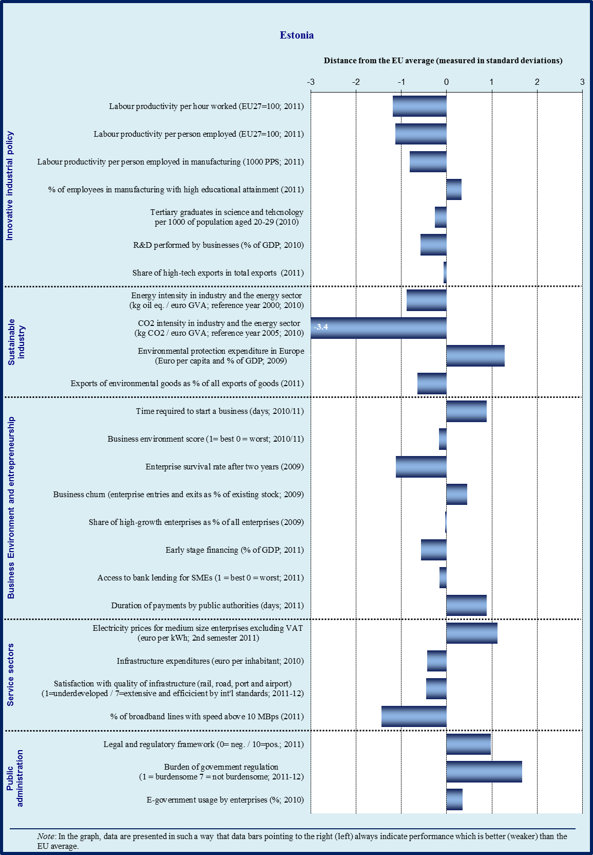

Sectoral specialisation of manufacturing – Estonia (2009)
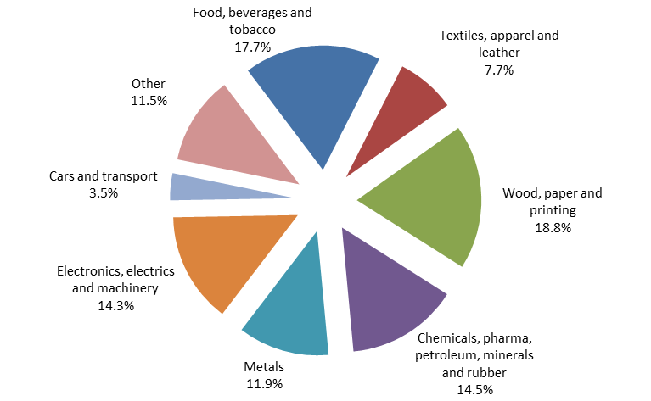
Source: Eurostat

3.6.1. Introduction

Estonia is one of the countries that are catching up fast: it has a highly developed e-government, a SME-friendly business environment and is highly supportive of entrepreneurship; manufacturing production has regained the ground lost during the crisis producing 17.3 % of value added (EU average is 15.5 %). However, Estonia has a weak innovative business culture with low R&D intensity; it has relatively lower income levels and a relative specialisation in labour-intensive industries. In general, Estonia is improving its competitiveness and, if it keeps momentum, it will join the group of higher income countries that are specialised in labour-intensive industries.

In terms of trade and industry specialisation, Estonia’s rapid recovery in industrial production has been driven by manufacturing of food, electronic products and equipment, wood products, fabricated metal products, motor vehicles, electrical equipment as well as machinery and equipment, 70 % of which were sold on the external market. Estonia’s main trading partners are Sweden and Finland, Russia, other Baltic States and the rest of the EU. While Estonia still has sectors with low or medium innovation and education intensity and predominantly exports low-to-medium tech products, it has been climbing the technology ladder thanks to dynamic medium-to-high tech exports.

3.6.2. Innovative industrial policy

Estonia ranks slightly below the EU average according to the 2011 Innovation Union Scoreboard. In spite of the government’s efforts to create competitive framework conditions for businesses innovation, Estonia has no clearly formulated industrial policy and its R&I system appears too fragmented. To increase its competitiveness, Estonia needs a comprehensive innovation strategy that would allow the identification of knowledge-intensive sectors that could push the country up on the value chain.

The R&D intensity target of 3 % of GDP in 2020 is achievable only if business R&D grows significantly and Estonia is able to attract more R&I intensive foreign direct investments. Despite recent improvements, only about 10 % of Estonian companies are active in R&I. The support and investment tools available for fast-growing innovative firms include: KredEx technology loan, the Estonian Development Fund pilot programs, a start-up programme supporting innovative companies, and the ‘start-up Estonia’ pilot scheme aimed at training fast growth start-ups on how to get funding from the market. However, the current grants are aiming at cutting edge technology and therefore have fewer candidates among companies. To remedy this, Enterprise Estonia has launched a new program supporting innovation in the manufacturing industry; KredEx is also offering a simpler loan scheme with a lower technological threshold but targeting technological upgrade. There are no specific tax measures acting as incentives for companies to invest in R&I, but the retained profits of firms are not taxed, thus encouraging investment in general.

Cooperation between academia and business continues to be weak; hence the need to significantly encourage the exploitation of research results by the business sector, particularly for boosting the productivity of existing industries. There has been some progress in terms of technology transfer: the number of patents and industrial designs has increased, in part as a consequence of the six technology transfer offices operating in universities (part of the Spinno programme). In general, neither universities nor the twelve excellence centres engaged in academic research have enough incentives to promote an efficient commercialization of research output, in spite of the fact that they own the intellectual property rights. In an effort to undertake industrial research and develop innovative products, eight competence centres, co-financed by companies, have been created; some of their products have been already released on the market. The government is planning to evaluate these centres against their work programme and cut financial support in cases where progress is insufficient.

On the demand side, the innovation vouchers program, intended to open the doors for SMEs towards R&I, has been extended: the price is now 4 000 EUR/voucher, limited to one per company. The list of R&D providers has been extended to include private entities – i.e. competence centres – and the possibility of including designers is being studied. However, while universities and companies seem satisfied by the program, its real impact has not been thoroughly evaluated.

In terms of the skills gap, there is still an insufficient supply of scientists, engineers and ICT professionals, which also constitutes a hindrance for foreign R&I investments. In order to increase the level of highly skilled graduates, the government initiated an ‘industrial PhD scheme’ two years ago, whose final impact still cannot be estimated. In addition, the Estonian Development Fund has initiated an IT Academy and the Chamber of Commerce has been campaigning to raise awareness about vocational schools, as these are historically not well regarded in Estonia. Further, a matching portal that intends to bring Estonian talents back home has been started in 2011, with 11 people (out of 500 subscribers) returning as a result of using this service.

3.6.3. Sustainable industry

Estonia needs to step up its efforts to promote greener growth, as it has an industry with high energy intensity, high CO₂ emissions, and high dependence on non-renewable resources, as most electricity is generated by oil shale. However, the share of renewable energy has been growing in recent years, as Estonia has been developing a renewable energy support scheme, in spite of the fact that the transposition of EU legislation on renewable energy (and the electricity and gas sectors) is lagging behind. Most environmentally friendly tools are co-financed by the Environment Investment Fund.

Estonia still suffers from high dependence on imported energy from Russia and a relative isolation from the EU gas and electricity networks. The construction of the Estlink 3 marine cable ensuring an electricity interconnection with Finland has been started in 2011. In addition, the first stage of the Tartu-Sindi high voltage line has been completed. Estonia is considering some supply diversification through the participation in a regional LNG terminal as well as strengthening the energy interconnection with Latvia.

In order to reduce GHG emissions and improve energy efficiency, particularly in the building and transport sectors, Estonia has made some investments, including from the sale of CO₂ permits trading. Most notably, some 500 electric cars have been distributed to social workers and the government plans to complete the charging infrastructure by 2012. In terms of public transportation, some 18 new electric trains have been acquired and the upgrading of the rail at the Russian border has started. There are some plans to introduce environmentally friendly trams and buses, start the works on the main Tallinn-Tartu highway and in the Eastern parts of the country, acquire a more fuel-efficient air fleet and expand the national airport; however, these plans need to be materialized in due course. Further, the energy efficiency of some blocks of flats and public buildings is being improved through a building renovation program that started last year. In spite of this progress, there is a modal shift of passenger transport from public transport towards private cars (a volume decrease of more than 10 %), and of freight transport from rail to road. Consequently, the National Energy Efficiency Action Plan should effectively address the need to make the public transport more efficient. Further, a commitment to the ‘Rail Baltica’ project, which foresees a double track electrified line connecting Poland, Lithuania, Latvia, Estonia and Finland, would increase the modal share of a more sustainable rail freight and passenger transport.

In terms of co-generation of heat and electricity, the gradual decommissioning of 3 oil shale plants that will be partially replaced with biomass plants has started last year. The most pressing problem remains the renovation of district heating networks, as they have areas entailing losses of up to 50 %; the problem is exacerbated by municipalities lacking the capacity to oversee district heating.

One of the main environmental challenges in Estonia is waste management: the discharge of waste generated by oil shale (70 %) needs to be reduced. While 4 landfills have been closed and some 70 contaminated sites are being cleaned up, there are hundreds of smaller sites left from the Soviet era that need to be tackled. While the state-owned Estonian energy company is planning to invest in a waste incineration co-generation power plant in 2013, municipalities lack the capacity to oversee waste collection.

3.6.4. Business environment

The OECD Economic Review considers Estonia to be a dynamic business environment with good network readiness, as well as high levels of corporate governance and transparency. Estonia’s entrepreneurship-friendly business environment is strongly supported by e-government – one of the best in Europe.

In general, access to finance remains tight in Estonia: loan volumes dropped by 5 % in 2011, in spite of the fact that the number of lenders increased by 12 %, leading to a healthier competition between banks. On the one hand, banks have become more risk-averse – the loan rejection rate is approximately 30 %. Moreover, some companies are involved in the informal economy and tax evasion, being therefore unable to secure traditional financing. At the same time, smaller companies and start-ups complain about banks becoming stricter in terms of required collaterals. On average, microenterprises seem to have a much harder time accessing financial support schemes.

Estonia has made some progress in developing programmes financed with structural funding and state support. Approximately 130 companies have benefitted from start-up loans, as well as export guarantees offered by KredEx, whose number of credit guarantees for loans has increased 3.5 times. Further, Enterprise Estonia provides business plans advice and has offered some support financed through the European Social Fund: a EUR 7 000 start-up grant and a EUR 32 000 development grant for companies up to 3 years old focused on fast growth; a new ‘start-up Estonia’ scheme is being started, aimed at coaching start-ups on getting funding from the market. However, a 2010 Report by the National Audit Office, cited by OECD Economic Surveys: Estonia 2011, argues that enterprise support is inflexible and fragmented, benefiting only a few companies, while support policies have not been focused on whether the distributed funds have created any permanent development benefits.

In terms of venture capital, the Estonian Development Fund is specialized in early stage (seed and start-up) venture capital investment. So far, the Fund has the biggest early stage investment portfolio in Estonia (EUR 7 million) with 15 investments; in general, investments must be made together with private investors, only for equity expansion, and in exchange of a holding of 10-49 %. A new venture capital targeting seed and start-up financing is under discussion – the Baltic Investment Fund, supported by the European Investment Fund (EUR 40 million) – but the commitment of both Latvia and Lithuania is not entirely clear yet; Estonia has already announced its support for the initiative (EUR 20 million).

When it comes to access to foreign markets, about 15 Estonian start-ups (mostly in biotech and ICT) have obtained financing in the UK and/or the US. The Export Revolution Program has had some initial success: the first 24 export managers that were matched with companies lacking international experience are still employed; the second offer of another 25 export manager places had 500 applications, which shows room for program expansion. On the contrary, the program supporting the hiring of foreign engineers and developers has had more limited results, as only approximately 25 foreign export managers were hired. In addition, the Chamber of Commerce has set up an Export Academy offering training and export awareness services. Further, Estonian companies are encouraged to participate in international trade fairs and explore foreign markets: currently, five Estonian enterprises are supported in their efforts to enter the Chinese market.

Estonia supports entrepreneurship through a set of targeted measures. In the educational system, entrepreneurship is offered as an elective in five universities and will be introduced as mandatory in secondary education starting with 2013; students can also participate in an ‘entrepreneur shadowing’ programme. In addition, the competition for business ideas is being continued and a new initiative – ‘Garage 48’ – has been designed to build a company/prototype in 48 hours.

Given Estonia’s geographical position, transport and transit are crucial for the economy. While the coverage of infrastructure networks is in general adequate, its quality could be improved. Further progress could be made in increasing the interoperability of transport systems, the availability of intermodal connection points (especially those linking ports and railways), and upgrading the infrastructure of hubs, especially in border sections. Public transport faces several problems, such as: a fragmented market approach, an inadequate quality of the services, an ineffective subsidising system and a poor state of the fleet.

3.6.5. Services sector

Services are quite a significant part of the Estonian economy and constitute approximately 18 % of total imports and 24 % of total exports. IT seems to be the most competitive sector – exports increased during the crisis by 12 % in 2009 and 16 % in 2010 – followed by telecommunications, financial services and retail. The number of regulated professions in Estonia is quite low. As far as competition is concerned, the efficiency gains from having merged the 3 competition authorities into one are not yet apparent.

3.6.6. Public administration

In terms of the overall performance of the public administration, Estonia is at the EU average, as measured by the World Bank’s Government Effectiveness Indicator. Similarly, the perceptions of the quality of public services and policy implementation, respectively, are at the EU average. However, Estonia scores significantly better than the EU average in terms of tools for administrative modernisation, which is mainly due to the expansion of business related e-government services.

Corruption seems to be a relatively minor issue in Estonia: ‘diversion of public funds’ occurs seldom, and the experience of corruption reported by individuals is only half the EU average. Estonia ranks in the top group of Member States in terms of licenses and starting a business; the time required to start a business is half the EU average and the corresponding cost is approximately a third of the EU average.

Payment delays from public authorities are just 10 days compared to an EU average of 28 days. Further, Estonia is considerably above the EU average in terms of tax compliance and tax administration efficiency: it takes only 85 hours per year to pay taxes in Estonia, compared to the EU average of 208 hours. As for the efficiency of civil justice, Estonia is at the EU average.

Recent initiatives

The government has set the target of reducing administrative burden by 20 % in 2014 in 4 sectors: permits & licences, environment, construction and social services. The obligation to submit annual reports and tax returns electronically has reduced the burden on companies by 29.7 %, according to the government. E-invoicing has started to be used by public authorities, but further expansion is hindered by the high costs of digitalization. Email notifications on VAT liabilities are sent to companies, which has reduced the number of companies being late. The government is planning to further expand e-services by further increasing the availability of electronic pre-filled tax declarations and creating an application for smart phones. However, the e-bookkeeping platform is not operational yet, as the project seems to have stalled at the Ministry of Justice. Recently, Estonia has prohibited the duplicate collection of the data included in companies’ annual reports: the Business Register is using an electronic data transmission system for submitting annual reports, and government authorities cannot request any of such data that has been already submitted.

The law on public procurement has been amended, such that e-procurement for at least 50 % of tenders becomes mandatory in 2013. In an effort to increase transparency, procurements above EUR 10 000 must be announced in the public procurement register and companies are required to draw up a procurement plan every year. However, the participation of companies is rather low, in part due to a frequently changing and rather complex procedure. According to the 2012 Report of Transparency International, the capacity of the body overseeing public procurement is severely limited, compared with the body monitoring the use of EU structural funds, which poses an increased corruption risk.

Estonia has indicated its intentions to extend the powers of the Tax Office to fight tax evasion. In 2011, Estonia adopted a package of legislative proposals that reduce the tax burden on labour, provide incentives to increase participation in lifelong learning, and reduce incentives to borrow; the fringe-benefit tax on work–related studies has been abolished as of 2012. In addition, Estonia enacted the first stage of a comprehensive reform of the preferential excise taxation system for motor fuels, narrowing the scope of application of the reduced excise rate; this measure is intended to reduce market distortions, minimise fraud and create incentives to improve energy efficiency.

Despite this progress, a few areas still remain problematic. The current rules for accepting/rejecting construction and planning permits are still confusing and interpretable, and it is not clear if the amendments of the Construction Law, to be enforced in 2014, tackle this issue. While a new regulatory impact assessment system has been introduced in 2012, its implementation is
less advanced. In spite of the fact that the Reorganization Act has been amended, little progress has been achieved to make insolvency processes faster and cheaper.

The comprehensive reform of the legal system has produced good results, and a new Public Service Act has been adopted by Parliament, coming into effect in 2013. This civil service reform aims at increasing the openness, flexibility and transparency of the public service.

Overall profile of public administration
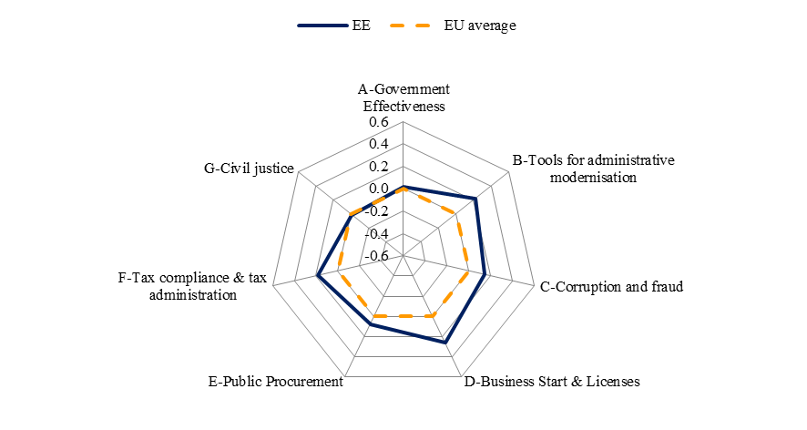
Source: WIFO

In terms of local administration, a comprehensive reform remains outstanding, as there is a need to ensure a better provision of public services. Local resources are currently dispersed and local authorities do not have the capacity needed to handle projects financed through EU structural funding.

As for fighting fraud and corruption, a new Anti-corruption Act is currently in Parliament. It aims at widening the scope of the e-register to include declarations of interests from civil servants, local authorities and enterprises. In addition, there is no legislation for regulating lobbying and protecting whistle-blowers, which, according to Transparency International, weakens the quality of the integrity system in Estonia.

3.6.7. Conclusions

Estonia has a well performing business environment, supported by strong e-government and a developed culture of entrepreneurship. In order to increase productivity and thus improve its competitiveness, Estonia should promote a coherent industrial policy and a systematic and comprehensive research and innovation strategy. Particular attention could be paid to the following: encouraging companies to innovate and better exploit the resources offered by universities and research institutes, improving access to finance and creating a more competitive environment, increasing the supply of high-skilled labour according to market needs, and improving training schemes, and promoting greener growth by continuing to increase the share of renewables and modernizing the infrastructure. At the same time, Estonia’s share of higher value added products and services, in particular in exports, could be further raised. Finally, cooperation opportunities in the Baltic region could be exploited in a more fruitful way.

3.7. Ireland
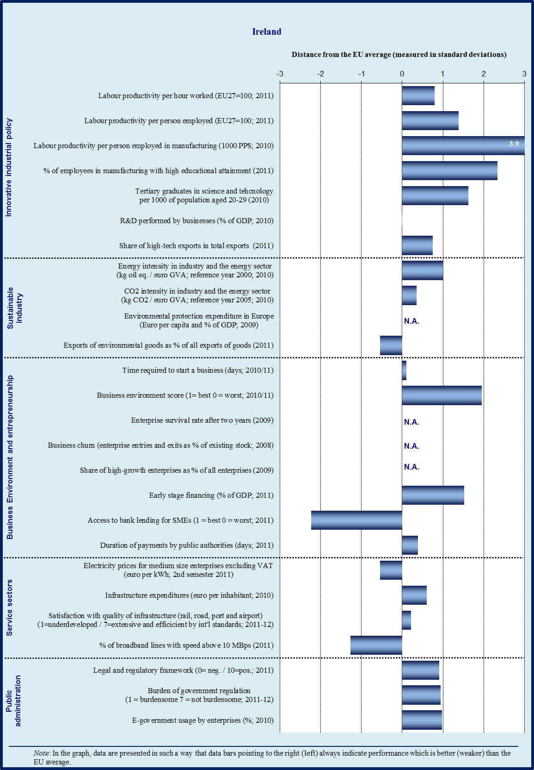

Sectoral specialisation of manufacturing – Ireland (2009)
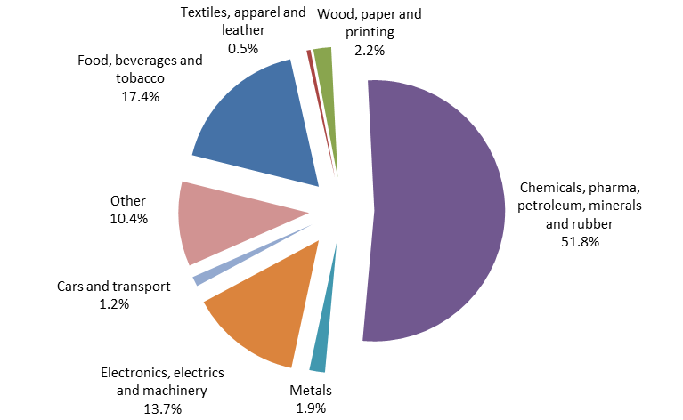
Note : No data available for sectors C12 (tobacco products), C19 (coke and refined petroleum products) and C31 (furniture)
Source: Eurostat

3.7.1. Introduction

Ireland has a diversified economy with a strong manufacturing base that produces 25.8 % of total value added (the EU average is 15.5 %, 2011). However, the economy has two distinctive parts: the export-oriented and technology-driven part (including information technology, medical technology, pharmaceuticals, and chemicals), and the domestic, small business sector that is less innovative, less technology-oriented, and exports less. The key challenge for Ireland is to improve the prospects of these domestic firms.

The technology-driven multinationals, in particular in the chemicals and pharmaceuticals sectors, are driving the high labour productivity improvements in Ireland. However, it should be noted that the extremely high labour productivity figures are to some extent inflated by research and marketing activities undertaken mainly outside Ireland, as well as by transfer pricing.

3.7.2. Innovative industrial policy

The difficult economic situation has continued to have an effect on Irish research and innovation. Business expenditure on research and development fell about 2 % between 2009 and 2010, driven by a decrease in the foreign affiliates. Although research spending by the indigenous firms rose by 3.6 %, the foreign affiliates continued to spend about two thirds of the total. To address this discrepancy, the R&D tax credit has been made more flexible and SME friendly by the Government. The headline target for R&D investment is 2 % of GDP and Ireland is on track towards the goal.

The policy response was spelled out in the Irish strategy for science, technology and innovation for 2006-2013. One of the recent achievements is the Innovation Fund Ireland that seeks to support the development of a vibrant venture capital market. The use of technology transfer has increased considerably since 2007 when Enterprise Ireland started a programme for this. In 2011 the overall number of spin-out firms was 30, with 95 technology licences issued. Recommendations on managing intellectual property, based on good practices have recently been published.

A number of partial evaluation reports of the strategy have been published, but there are no plans to conduct an overall evaluation of the national innovation system.

A new research prioritisation report was published in March 2012. It identifies 14 priority areas, with an added focus on increasing the efficiency and effectiveness of the Irish science, technology and innovation ecosystem. The priorities are to be complemented with an implementation focus on coherency, monitoring, cooperation with industry, and upgrading of skills as part of initiatives aiming to accelerate the commercialisation of research, in particular through cooperation with businesses.

Ireland’s well-educated workforce has continued to expand as the number of science, engineering and technology postgraduate students has increased by 33 % between 2005 and 2010. The Government has this year also allocated EUR 20 million to a new Education and Training Fund to retrain long-term unemployed.

The Government has introduced a new ‘Procuring Innovation’ initiative which focuses on procuring solutions to cover needs, rather than prescriptive products or services. This practice of purchasing often favours SMEs, as they can have innovative solutions, and SMEs’ access to public procurement seems already to be improving.

The widely recognised policy challenge is to continue to improve the financial and managerial capacity, and ambition, of indigenous companies to research, innovate and to turn these into growth.

Overall, the policy response on research and innovation currently being implemented is comprehensive, but the number of strategies and priorities might lead it being too fragmented, with diminished efficiency and effectiveness. To make sure that this is not the case, and to enable a sharper policy focus, a comprehensive evaluation of the innovation system and related past policies should be carried out and efforts focused on the most successful policies.

3.7.3. Sustainable industry

The use of environmental technologies in Ireland has increased in waste and energy use, in particular in the food industry; and energy efficiency has improved in the engineering sector. However, there is potential to increase awareness about sustainability issues among Irish firms. At least for smaller firms, the adoption of cleaner technologies largely depends on demand pull from customers (whether other firms or consumers), and even here awareness-raising might be useful.

There is a series of programmes seeking to provide support for greener businesses, including the ‘National Action Plan on Green Public Procurement’ that addresses the purchase of energy-using products, energy services, and capital projects.

Concerning the use of energy, the Irish energy intensity is lower than the EU average, reflecting structural changes in the economy, in particular the trend towards higher value added goods like pharmaceuticals, electronics and high-value foods. Further improvements have been obtained from fuel mix changes and energy efficiency improvements. Over the period 1995 to 2010, the energy intensity of industry fell by 54 % (5.0 % per annum). However, if the structural change had not occurred, the annual fall in energy intensity would have been only one-tenth of this.

Despite the progress achieved in the environmental performance of the Irish industry, there is considerable potential for Ireland to get the indigenous firms to grasp the opportunities a comprehensive greening of the economy.

3.7.4. Business environment

Access to finance

The severe banking crisis has had a considerable influence on SMEs’ access to finance. Although the low level of final demand has led to a sharp contraction in investment, many SMEs also signal that they find access to working capital difficult. The Irish rejection rate for credit applications is the second highest in the euro area, and Irish SMEs are among the most likely to have faced increased collateral requirements, increased interest rates, and lower loan amounts.

The Irish credit demand would seem to be close to the euro area average, as measured by changes in firms’ reported need for external financing. Application rates for credit are slightly lower than the EU average. The difference between Ireland’s ranking on demand and application rates is partly explained by a share of discouraged borrowers, who need loans but have not applied for credit. For Ireland, this figure is double the euro area average.

The Credit Review Office was set up in 2010 to resolve disputes between banks and their SME clients about loan refusals. Although the absolute number of cases reviewed has been relatively small (197), the banks have become more careful as a result of its existence. Of the cases where a decision has been reached, over half of the bank decisions contested have been overturned.

The Government has set lending targets of EUR 3.5 billion in 2012 and EUR 4 billion in 2013 for the two largest Irish-owned banks. The 2011 lending targets were achieved, but 2012 is proving to be more difficult. Banks have been slow in reorienting their practices from lending against real estate collateral to lending for general business purposes, while SMEs have had to adjust to providing a greater volume of information needed for banks to make cash flow-based analysis. To improve the decision-making processes and to facilitate SMEs’ access, four banks have introduced a standardised application form for SME loans and are training front-line staff on SME credit issues. The Government has also taken upon itself to further address the problem through actions that seek to contribute to informed lending decisions at the banks, improved sectoral expertise and better lending products.

These are included in the ‘Action Plan for Jobs 2012’, and the Government has already launched actions to provide capital for high-growth firms; partial guarantees for business loans; allocated funds for the delivery mechanism of the micro-lending scheme; and increased investment in private venture capital funds. Further action is scheduled for strategic investment, and improving the quality of loan applications.

Irish legislation mandates a 30-day payment period for business payments (unless otherwise specified), but this is not enforceable and the average payment period between firms in 2012 is 66 days, causing problems for many SMEs. For public sector payments there is a code of paying suppliers within 15 days. The Government has also requested business organisations to introduce guidelines on prompt payments charter.

Overall, access to finance continues to be one of the weak points of the Irish business environment. It remains to be seen how quickly and to what extent bank lending recovers, and whether complementary financing options emerge when Irish SMEs start to invest again. The government should follow developments closely and, if need be, intervene with supportive policy measures.

Regulatory and support environment

Despite the business-friendly regulatory environment, SMEs are concerned about the rising costs of doing business, including rates for energy, transport, refuse collection, and municipal taxes. Despite the high unemployment, skills gaps have been emerging for some businesses

Exports of the SME sector are mainly going to the UK, and lack of language and management skills have been hindering further export efforts. The Government is attempting to provide more targeted support for SMEs, particularly in terms of assisting firms to access new markets, and identifying businesses with growth potential at an early stage.

Key measures in the ‘Action Plan for Jobs 2012’ include establishing a new Potential Exporters Division within Enterprise Ireland to target potential exporting companies, and the setting up of a new one-stop-shop support structure by creating a new Small Business Unit in Enterprise Ireland and a new network of Local Enterprise Offices. These measures are in line with the objectives of Europe’s Small Business Act (SBA) and should have a positive impact on the small business sector.

Export promotion assistance for indigenous SMEs is being complemented by efforts to attract inward entrepreneurial start-ups through specific cooperation between Enterprise Ireland and the Industrial Development Agency, an initiative designed to complement targeted inward foreign direct investment from larger firms. Enterprise Ireland supported 93 new high-potential start-ups in 2011 and approved EUR 20.4 million in funding.

Policy initiatives focusing on improved SME participation in public procurement include the lowered minimum values for public contracts and reduced company size restrictions. In addition, a new Procuring Innovation initiative is intended to focus on procuring solutions to specific needs, rather than being limited only to pre-defined products or services.

In conclusion, the Government has identified most of the areas that Irish businesses and their organisations have identified as problematic. The actions of the ‘Action Plan for Jobs 2012’ are a reasonable attempt to address these problems, but the challenge is to ensure coherent and efficient implementation of the plan, in particular keeping enough flexibility to increase focus on measures that are working well.

3.7.5. Services sector

Improving the implementation of e-government initiatives continues. Telecommunication services are competitive, which has driven mobile prices lower despite the consolidation towards only four operators. However, the spread of broadband is hindered by a lack of business demand, especially in areas with low population density.
The Act liberalising postal services was enacted in August 2011 and competing courier services have started to appear on the scene. The Government policy is to keep An Post as a strong participant in the marketplace.

High dependence on imported fuels and past underinvestment in distribution networks have kept electricity prices relatively high. However, recent investment in the network, increased competition, the single market with Northern Ireland, and the deregulation of electricity markets have improved the situation. The customer charter of the electricity company promises a connection in 14 days and customer surveys indicate an 80% satisfaction rate on the service.

The Government has indicated that it sees the motorway infrastructure substantially complete, and the ‘Medium Term Capital Investment Framework 2012-2016’ prioritises health, education and water services. On the rail network, provision of freight and international passenger services have been opened to competition, but Irish Rail is still the only operator. The separation of the provision of essential functions for rail infrastructure is planned for before March 2013.

3.7.6. Public administration

The public administration of Ireland performs better than the average of other studied Member States, but the progress in the use of administrative modernisation tools (e-government, impact assessments, performance and service orientation, accountability) is uneven. On one hand, Ireland has a comprehensive set of business-related e-government services, and the use of regulatory impact assessments is sophisticated. On the other hand, the internal management methods of Ireland’s public administration are traditional, in particular in human resources.

Further development of e-government services is outlined in the ‘eGovernment 2012-2015’ plan, requiring that information and transactional services are easily identifiable, and that e-procurement, e-invoicing and e-payment facilities are expanded to new devices. The Government is will also make data (e.g. on environment, transport, education and crime) held by public bodies available and easily accessible for reuse and redistribution.

Despite past cases of corruption and fraud, currently indicators do not point to problems in this area. The perceptions-based indicators on irregular payments and on the diversion of public funds are better than the EU average and individual corruption has been experienced in only 2 % of the cases.

Ireland also performs well in starting up a business and obtaining licenses. The time required to start a company is 12.3 days (World Bank measure), which is slightly below the average (13.7 days), and the costs are substantially lower (0.4 % as compared to the average of 5 % of income per capita). In line with this, the overall licensing complexity is low despite the fact that there is not yet a fully operational one-stop shop.

Public procurement procedures are efficient and it takes 15 person days per firm and per tender to participate, which puts Ireland above the EU average of 16.6 days. The typical cost of taking part in a tender is smaller (0.13 %) than the EU average (0.19 %). The average payment time is 13 days compared to the EU average of 28.3 days.

On tax compliance and tax administration Ireland is among the top performers. The average time to prepare and file tax returns is 76 hours (EU average is 208 hours). The administrative costs of taxation per 100 units of revenue collected are 1.1 % (EU average is 1.3 %).

The civil justice system score is better than average but there is scope for improvement. Both the time (650 days) and the costs (26.9 % of a claim) of enforcing contracts are high. However, resolving an insolvency only takes 0.4 years, which is significantly faster than the EU average (1.95 years). The perceived independence of the judiciary is high.

The costs and uncertainty of using the judicial system, including many courts’ limited understanding of business issues have been identified as problems by SMEs. As part of its Euro Plus Pact commitments, the Government has proposed liberalisation of the legal profession, likely to be enacted in 2012. Taken together with a price transparency initiative, this could over time lead to lower costs and more efficient legal procedures, including the time and costs of contract enforcement. In addition, the Government has drafted a ‘Mediation Bill’ to promote mediation as an alternative to court proceedings, reducing legal costs and speeding up dispute resolution.

Overall profile of public administration
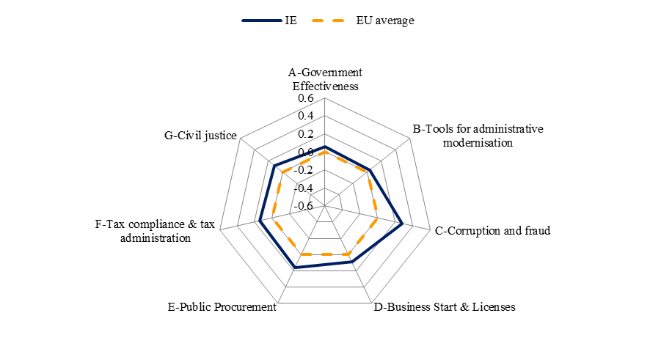
Source: WIFO

The Government’s plans for reforming the public service are largely driven by the need to reduce the number of public servants so that gross pay expenditure would be 15 % lower in 2015 than it was in 2008. The plan also is to rationalise state agencies, use shared and e-services and otherwise streamline the public administration. It is important that this is done without detrimental effects for users of the public services.

3.7.7. Conclusions

Ireland has made good progress in achieving the goals of the Memorandum of Understanding guiding its adjustment programme, and despite the remaining challenges, these efforts have contributed to the improving business prospects and strengthening competitiveness.

The Government faces the challenge of improving the prospects of the domestic sector.
The indigenous sector is held back by weak domestic demand, relatively weak innovation, problems with access to finance, and rising costs of doing business at local level. The government should keep a close eye on access to finance, as improvement in this area is crucial for future growth.

The Government’s answer has been the ‘Action Plan for Jobs 2012’ that contains over 270 actions, a detailed timetable for their implementation and quarterly implementation reports. The breadth of the plan, and the way implementation has started are promising signs that Ireland is making a determined effort to reduce the differences in the competitiveness of the domestic and multinational sectors. The challenge is to avoid the fragmentation of efforts, and increasing policy focus on the most promising initiatives enhancing innovation and growth.

3.8. Greece
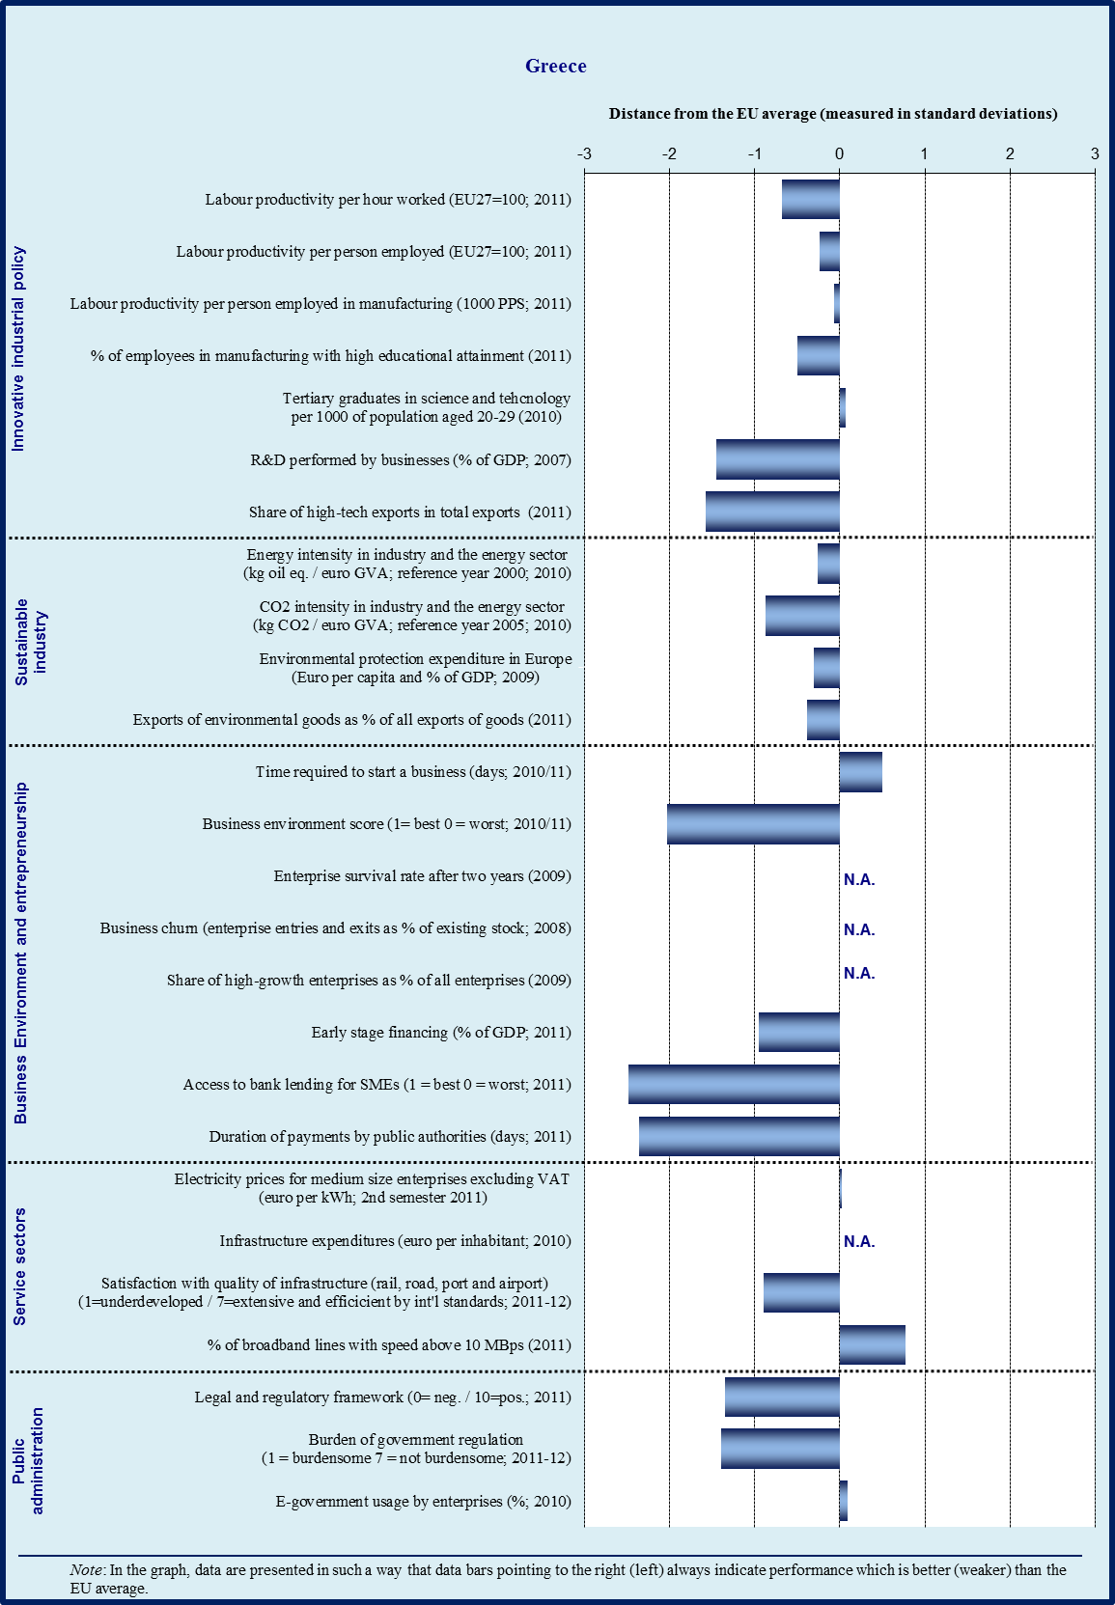

Sectoral specialisation of manufacturing – Greece (2009)
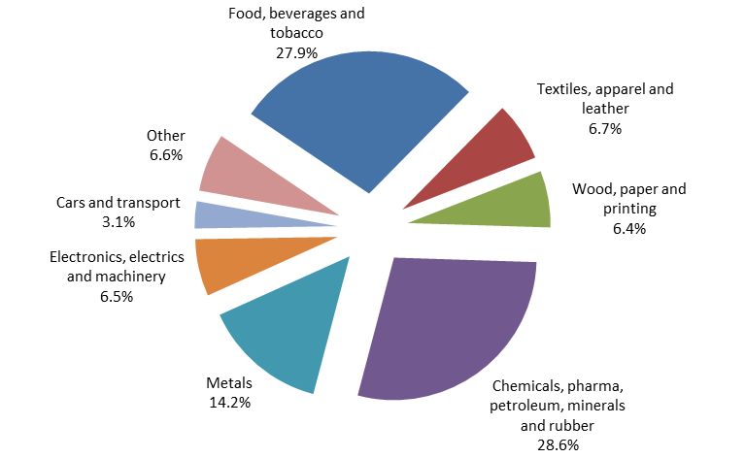
Source: Eurostat

3.8.1. Introduction

The service sector is the primary sector in the Greek economy. Tourism is one of the key sectors both in terms of economic growth and employment. Travel and Tourism supported directly 332 000 jobs or 8.0 % of the country’s total employment (3.2 % in the EU), and 768 000 jobs or 18.4 % of total employment if indirectly supported jobs are added (8.4 % in the EU). Manufacturing contributes 9.9 % of the total value added (EU average 15.5 % in 2011), where Greece features strong specialisation in the food processing industry (manufacture of vegetable oils, processing and preserving of fruit and vegetables). Other important sectors are metal, chemicals, cement and textile. The Greek merchant fleet is the largest in the world. Greek ship owners control 15 % of the world’s shipping capacity.

Greece has been in recession since 2008, one of the most severe ever experienced by a Member State. 150 000 jobs were lost in SMEs in 2011. In 2012 it is estimated that a further 240 000 jobs will be lost. Unemployment has soared to over 20 %, with youth unemployment above 50 %. 6 out of 10 firms saw deterioration in their earnings in 2011 compared to 2010.

Difficult economic conditions and continuing uncertainty are taking a heavy toll on Greek businesses. Structural reform is a key priority of the Greek government's strategy for economic recovery. The Memorandum of Understanding for economic adjustment includes several commitments which aim to address concerns on the Greek business environment. The recession, aggravated by austerity measures, has made efforts to reduce the deficit ever more challenging.

According to the World Economic Forum Competitiveness Report 2011-2012, the three most problematic factors for doing business in Greece are:

- Inefficient government bureaucracy
- Access to finance
- Corruption

The World Bank ‘Ease of doing business 2012 Report’ ranks Greece 100 out of 183 economies. There are a number of well documented weaknesses of the business environment. Progress has been made with newly adopted legislation, in the context of the adjustment programme, which has addressed competitiveness weaknesses.

The reform impetus, reinforced by the current crisis, has been underlined by the OECD in its report ‘Economic Policy Reforms 2012: Going for Growth’ according to which Greece has achieved the most considerable progress in promoting reforms from 2008-09 to 2010-11. However, an effort is still needed to open up the economy and continue implementing much needed structural reforms. Change is essential because the private sector is crucial to re-start the economy and spur growth.

3.8.2. Innovative industrial policy

The dominance of the low-tech sectors, lower value added production and reluctance of the financial sector to finance innovation under the current difficult financial situation, are hindering increased investments in R&D. Greece has fallen to 20th position of the Innovation Union Scoreboard 2011. Based on their average innovation performance, the EU Member States fall into four performance groups. Greece belongs to the third performance group which is below that of the average of the EU27. It is a moderate innovator. The Innovation Scoreboard notes that relatively strong elements in Greek innovation include human resources and entrepreneurship. Greece is lagging behind in finance, firm investments and intellectual assets. To improve its innovation performance Greece would need a new orientation of policies and an environment which is more innovation-friendly.

Due to the difficult economic situation, R&D investments both from the public and private sectors have decreased. EU structural funds are the most important funding source for Greek innovation. In order to bring innovation closer to the market, the General Secretariat of Industry launched in May 2011 the programme ‘New Innovative Entrepreneurship”. The main objective of the Programme is to encourage a shift from necessity-driven to opportunity-driven entrepreneurship by supporting young companies in the development of both product and service innovations. 1 170 project proposals of EUR 192.9 million were submitted to this Programme. 439 have been positively evaluated, out of which more than half are start-ups.

In addition, during the period 2007-2011, EUR 622 million has been granted to Greek organisations from the Seventh Framework Program for Research and Technological Development. The economic crisis has further weakened the production sector and squeezed access to finance leading to a negative impact of the innovation performance. Many well educated Greeks have moved abroad looking for better work opportunities. It relieves pressure on the job market but some fear it will create a brain drain.

3.8.3. Sustainable industry

Although Greece has a favourable climate, only a small fraction of energy production is attributed to renewable energy sources. Project Helios is a plan for an expansion of Greece’s solar power production from 206 MW to 2.2 GW by 2020, and then 10 GW by 2050. The project aims to attract up to EUR 20 billion in investments and is expected to create thousands of jobs.

Several projects have been launched to encourage improved environmental performance, e.g. programmes to promote the development of green products and services as well as improved waste management treatment.

A new law simplifies procedures for environmental licencing. and should reduce the time needed for issuing permits. It introduces specific deadlines for each of the administrative steps in the authorisation process, reduces the number of projects for which an environmental impact assessment is required and the number of signatures needed have been decreased from 3 to 1. Several implementing decisions are still needed for full implementation of the law.

3.8.4. Business environment

Greece has some recognized weaknesses of the business environment. Legislation which is burdensome has been set up to protect certain interest groups and bureaucracy hampers entrepreneurship. In addition, the lack of competition holds back productivity and competitiveness, as noted by the Task Force for Greece. The focus of further efforts should be on the removal of regulatory and administrative restrictions that close markets and stifle opportunities. Greek public authorities and agencies need to be organised and equipped to design and implement growth-friendly business policies. In 2010 and 2011 a number of laws were adopted to improve the business environment. They address well-known deficiencies, such as starting-up a company, licensing of manufacturing activities, investment authorisations and administrative burden to exports.

Economic reforms have addressed the liberalisation of several closed professions, which are a major cause for inefficiencies in Greece. Legislation aims, inter alia, to abolish fixed prices or compulsory minimum fees and reduce geographical restrictions and fixed profit margins. In this respect, new legislation aims at lifting restrictions on entry and exercise of regulated professions. Notaries’ fees have been cut by almost 30 %, although they still remain above the level of fees charged in other euro area countries with the same notarial system. The rules governing minimum fees of lawyers, engineers and architects still need to be streamlined.

Law 4072 was adopted on 11 April 2012 on Business-Friendly Greece. The Law contains several policy actions to remedy barriers to entrepreneurship. It includes provisions on company law, starting up, establishment and winding-up of a business, simplification of license procedures, public procurement, taxation and the absorption of EU Structural funds.

In 2010 a fast track procedure for strategic investments was adopted (3894/2010). The fast track procedure curtails the licencing process with shorter and binding deadlines and the elimination of overlapping or repetitive acts by the public administration. On 1 February 2011 a new Investment Incentives Law was voted by the Greek Parliament (3908/2011). The Investment Law provides incentives for investment plans exceeding EUR 100 000.

Greek companies are confronted with more administrative hurdles to company registration than observed in other Member States. According to the World Bank Ease of Doing Business Report 2012, Greece is ranked 135 of 183 countries on the ease of starting up a company. Given the severe recession, the high rise in unemployment and the freeze of public sector hiring, simplified procedures for start-ups are crucial elements to create the right environment for growth. To simplify start up procedures, in April 2011 the one-stop shop system for registering new companies was launched. The system aims to facilitate registration by reducing the number of procedures as well as time and costs. The one stop shop service is provided by 59 chambers of commerce and 3 200 notary offices. To date, over 7 000 companies have started through the new procedures. Lawyers are not required for companies with a share capital of less than EUR 100 000. Notaries are still needed for Public Limited Companies and Limited Liability Companies.

The General Commercial Registry, GEMI, became operational in April 2011. It will include all established companies. With the development of the registry, online completion of procedures for company formation and for administrative procedures should be ensured. In accordance with the Memorandum of Understanding, by July 2012 all companies established in Greece should be able to publish relevant company data through GEMI.

Law 3982/2011 on simplifying and accelerating licensing of manufacturing activities has three parts:

- Fast track procedures for licensing manufacturing activities
- Development of business parks
- Modernization of licensing procedures for technical professions

The law aims to remove bureaucracy and to strengthen the role of the public service to effectively control the obligations of enterprises. Specific reduced deadlines are set within which the administration must reply to requests.

For business activities that do not disturb others (‘low nuisance actitities’), which represent up to 80 % of requests, the licence is first issued and then checks are carried out. The licenses for such activities are issued by a statutory declaration. For medium nuisance level activities, there is the possibility to obtain the license through the submission of guarantee letters. For high nuisance level activities there is no change in the procedures.

Greek companies face serious problems in obtaining access to finance due to the severe recession and the difficult situation for the banking sector which has seen outflows of deposits and a rise in non-performing loans. The main public tool for facilitating SME access to finance is the Hellenic Fund for Entrepreneurship and Development (ETEAN). It is financed from public means and the EU structural funds and addresses financial gaps through loan guarantees, counter-guarantees, co-investments and subsidised loans to SMEs. ETEAN SA will provide revolving engineering financial instruments through the creation of funds as defined by the EU Regulations (such as holding funds, loan funds, guarantee funds, etc.). ETEAN SA will co-invest funds with banks for the provision of loans to small and medium sized enterprises with favourable terms (e.g. very low interest rate). Such funds are:

- The Fund for Energy Efficiency in households and
- The Entrepreneurship Fund, amounting to EUR 460 million, which is used to establish loan funds and guarantee funds.
A new SME Guarantee Fund has been set up and signed on 21 March 2012. The Fund is a joint initiative between Greece, the European Commission and the European Investment Bank. Established by using EUR 500 million from unabsorbed Structural Funds for Greece, the Fund will guarantee EIB loans to SMEs via partner banks in Greece totalling up to EUR 1 billion.

3.8.5. Services sector

The service sector is the most important sector in the Greek economy. It contributes to more than 70 % of the economy. Greece is traditionally associated with tourism where hotels and restaurants make a substantial contribution to the economy. Over the last decade the service sector had a strong growth with tourism and shipping taking the lead. The Greek merchant fleet is the largest in the world. Greek ship owners control 15 % of the world’s shipping capacity.

Barriers to entry can still be found in Greek legislation, in particular in the retail and education sectors, e.g. in the retail sector priority to obtain a licence is given to specific categories of persons and in the education sector Greek nationality is required for founders of private schools and the majority shareholding should also belong to Greek nationals.

3.8.6. Public administration

Improving the effectiveness, accountability and integrity of the public administration is a key priority reform to be implemented in Greece. The structural reforms needed by the country can only be delivered by a well functioning administration which is built on stable, coordinated and empowered structures, providing the basis for the necessary ownership and accountability for the reforms. Equally important, the administration must be supported by civil servants having clear responsibilities. The key objectives of the administrative reform in Greece are:

- to improve the effectiveness, accountability and integrity of the administration and to simplify the administration's decision-making processes;
- to have a strong centre of decision-making with real inter-Ministerial coordination;
- to create the necessary structures in each line Ministry for effective monitoring of procedures including expenditure, internal control and audit, human resources management and information and communications technology.

Greece’s overall public administration performance, as depicted by the World Bank’s Government Effectiveness Indicator, is well below the EU average. Perceived quality of public services, including quality of the civil service and policy implementation in Greece are very low (0.52 compared to 1.18 in the EU). Overall low scores of Greece are common, as illustrated in the diagram.

The use of tools to improve public administration performance (e-government, impact assessment, performance and service orientation, accountability) is equally far below the EU average. Especially the availability of business related e-government services is particularly low, and so is the use of impact assessment.

The corruption and fraud indicator shows a problematic situation in Greece as compared to the EU average. The irregular payments and bribes index is especially low and a strong gap can be observed in comparison with the EU average. Diversion of public funds is also problematic, while the corruption sub-indicator is closer to the EU average.

Composite summary indicators for the efficiency of the civil justice system and for tax compliance and tax administration are both below average. The time to enforce contracts is problematic as it takes 819 days for enforcement as compared to 556 days in the EU-average. The delay in payments is also very high compared to the EU average. Due to the difficult financial situation of the Greek state, payment delays have risen to 114 calendar days, 4 times longer than the EU average. The performance in terms of public procurement is also well below average.

With regard to the tax compliance and tax administration index, all the sub-indicators are slightly below the EU average. The situation is similar for the civil justice system, even if the cost for enforcing contracts is above the EU average.

Starting a business and licensing indicator is below average in Greece, mainly due to the cost to start up a business which is especially high (20 % of GDP per capita which is 4 times higher than the EU average). One exception is the time required to start up a company: in Greece it takes 10 days to start up a company which is 3 days faster than the EU average.

Overall profile of public administration
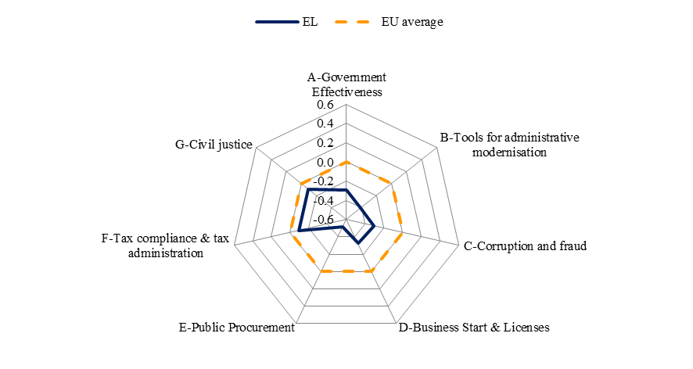
Source: WIFO

Improved efficiency of the public administration needs to be ensured to fully implement the Economic Adjustment Programme, to increase accountability and improve effectiveness. The implementation of the reform programme becomes complex due to the fact that responsibilities are dispersed across a wide range of ministries and agencies.

The Memorandum of Understanding provides for the setting up, by December 2012, of a high-level transformation steering group, chaired by the PM, which will supervise, monitor and ensure the implementation of administrative reforms. On 6 January 2012 France and Greece in collaboration with the Task Force for Greece, signed a memorandum of understanding paving the way for the implementation of the central administrative reform. The German government has started providing technical assistance for administrative reform at local and regional levels.

3.8.7. Conclusions

An effort has been made, over a very short period of time, to simplify procedures and to boost competitiveness. Measures introduced so far aim, among others, at the simplification of licencing procedures, fast-track investment authorisations, the creation of a unique Business Registry (GEMI) and a one stop shop system for all registration procedures.

Overall, the implementation of the newly adopted laws has been slow. Responsibilities fall under different Ministries that are reluctant to loose competence and certain laws face strong opposition from different interest groups. Streamlined collaboration across ministries is necessary to ensure swift implementation of adopted laws. The reform of the Greek public administration therefore remains an important task because it can contribute to raising the overall efficiency of the economy by enhancing the state’s capacity to implement newly adopted legislation and thereby improving the business environment. In addition to the difficulties with regard to the implementation of much needed structural reforms, with a contraction of the GDP of up to 18% since 2008, the lack of economic growth has made it challenging for Greece to meet its fiscal targets.

3.9. Spain
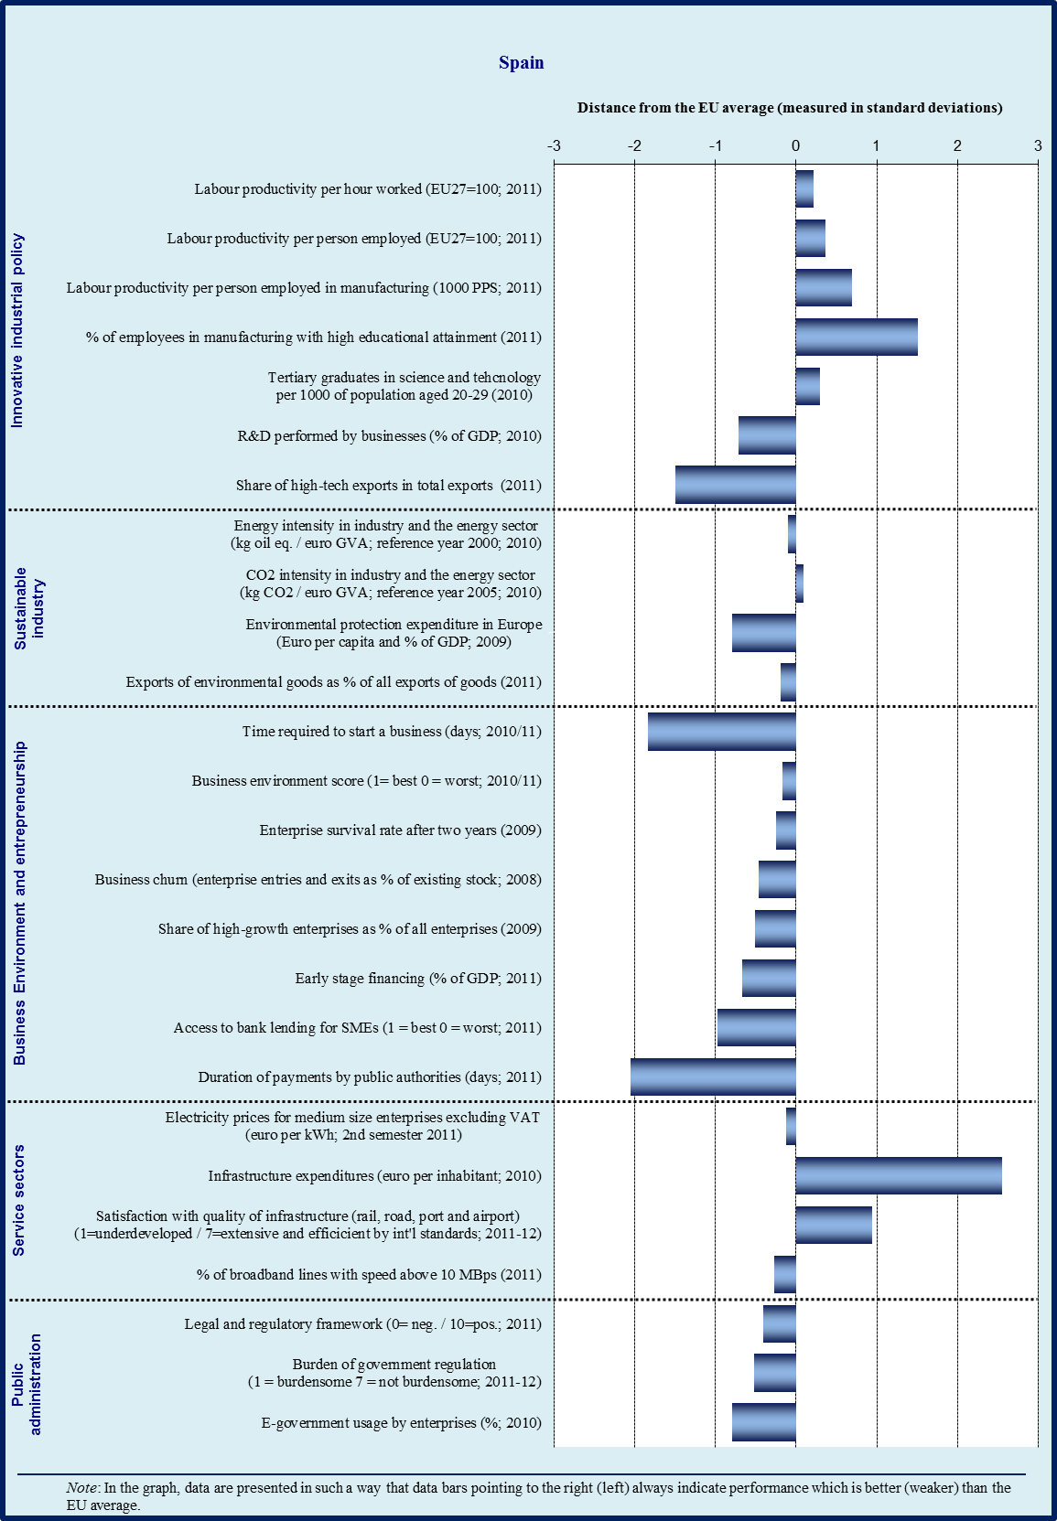

Sectoral specialisation of manufacturing – Spain (2009)
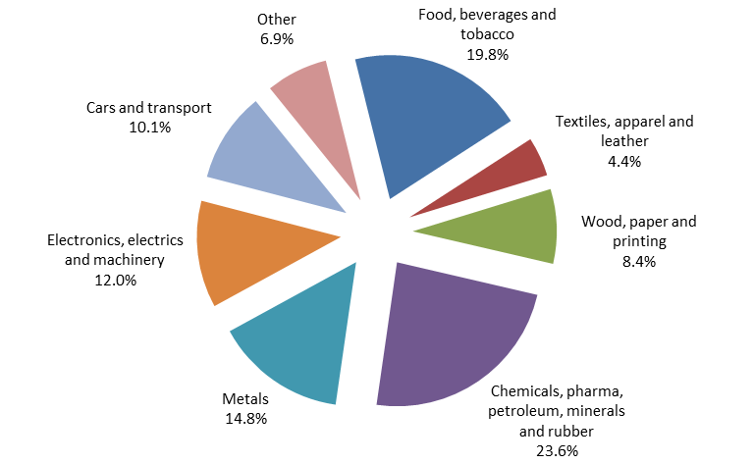
Source: Eurostat

3.9.1. Introduction

Manufacturing plays a slightly smaller role for Spain than for the EU in total (13.5 % of total value added versus 15.5 % for the EU). Spain is specialised in marketing-driven industries, capital-intensive and labour-intensive industries. At the more aggregated level, Spain is specialised in low innovation and low education sectors (manufactures for construction, wearing apparel), however in exports it also specialises in medium-high innovation sectors such as motor vehicles and in low technology sectors such as non-metallic mineral products.

Very low productivity growth and high growth of wages over the period of 1999-2008 lie behind the deterioration of price competitiveness. During the boom period, growth in Spain was driven mainly by increase in labour utilisation, while productivity measured by TFP had a negative contribution. Since 2007, Spanish labour productivity per person employed has been improving. It stays above the EU average and reached the euro-area average in 2009. However, a significant part of this improvement comes from the sharp reduction in employment since in low value added sectors and longer working hours. To achieve a long-lasting re-balancing of the economy, Spain must tackle the structural problems that are hampering growth and limiting competitiveness.

3.9.2. Innovative industrial policy

According to the Innovation Union Scoreboard 2011, the performance of Spain in innovation is still below the EU27 average, classifying the country in the group of moderate innovators. The considerable increase in R&D expenditures since 2000 until the beginning of the crisis has not resulted in a clear improvement of the innovation capacity in the country. Contrary to the trend of other economies of its group, Spain has not experienced a catching-up process towards a more innovative model of production. Indeed, only modest progress has been observed in the introduction of innovative product processes and services.

A number of reforms have been recently introduced to improve the Spanish research and innovation system, namely the Spanish innovation strategy (e2i) adopted in 2010 and the Law of Science approved in 2011. These initiatives still need to be fully implemented and their coordination with the regional innovation strategies of the Autonomous Communities is important in order to achieve more coherence and synergies. The current on-going revision of the Integral Plan on Industrial Policy (PIN 2020) may also be a good opportunity to pursue a structural change towards a more knowledge-intensive economy building on existing sectors as well as potential new growth areas.

Furthermore, Spain has set up the INNCORPORA programme, which provides support to private companies with a view to contract highly qualified workers, thus fostering knowledge and technology transfer and business innovation.
Nevertheless, the current cuts of public investment, together with the still low R&D investment performed by businesses, may represent additional challenges for the coming years. This may request a review of the efficiency of the public expenditure and introduce a more performance-based financing system, linking a proportion of institutional funding to progress in scientific excellence, level of internationalisation and public-private cooperation. A refocus of the Structural Funds for the 2014-2020 programming period towards innovation and competitiveness could contribute to this aim. Also, an evaluation of the R&D tax credits of the last years may be helpful to analyse why business R&D activities remain so low. As part of a deeper reform of university financing and governance, there is also a need to reinforce incentives for the cooperation for innovation between universities and the private sector.

3.9.3. Sustainable industry

Spanish energy infrastructure has been upgraded in the last years and has now levels above European averages in the production and distribution of electricity and gas. The energy sector should focus now in improving efficiency and offer a competitive cost for industry. In the past, Spain put forward an ambitious policy mix of measures concerning energy efficiency and support to renewable energy sources which is currently being discontinued. Increasing competition in the energy sector and completing the interconnections with neighbouring countries would improve functioning of the energy market.

A reform of the regulatory body for energy (Comisión Nacional de la Energía) has been recently proposed to merge it with other sectoral regulatory bodies and the competition authority following the Dutch model. The aim is to reduce the number of bodies and simplify their structure and functioning. The impact of this reform remains to be seen. In any case, the regulatory framework would benefit from transferring tariff setting powers from the ministry to the sectoral regulator, allowing for a more robust, transparent and predictable tariff setting process with a lower degree of political interference.

Although Spanish manufacturing industry has become more energy efficient in recent years, it still has room for improvement compared to its equivalents in other Member States. The risk of future increases in electricity prices for medium-sized industrialists, in particular, due to the on-going efforts of the government to reduce the financial deficit of the energy system may represent a strong incentive for that.

In spite of the efforts since 2009 in fostering internationalisation of Spanish enterprises in sectors related to energy and climate change, Spain still scores below the EU average in the percentage of exports of environmental goods. Some improvements have been achieved in green public procurement with the Law on Sustainable Economy which has recently introduced a system to identify the carbon print of products of public procurement.

3.9.4. Business environment

Inadequate access to finance remains the first area of concern for Spanish enterprises, especially SMEs. According to the Spanish Statistics Institute (INE), 60 % of SMEs will need financing for their working capital until 2013. Credit supply is still limited and has been scarcer since last year. Other alternative financial instruments are still underdeveloped, for lack of both demand and supply. Reinforcing the system of government backed guarantees and loans to SMEs may be a good opportunity to help in this area, including the use of Structural Funds under the JEREMIE initiative. Spain has already three JEREMIE funds in place and is developing a fourth JEREMIE with the Chambers of Commerce which should be operational by the end of the year. Late payments by public authorities remain a central issue of concern in Spain. The early transposition of the Late Payments Directive into national legislation has not shortened public payments periods yet. In fact average public payment periods have increased in 2011. The current on-going process of fiscal consolidation presents an additional element of risk. In the beginning of 2012, the government has put in place an ambitious programme to pay out the stock of bills held by the local administrations. This will help alleviate the liquidity problems of smaller enterprises but its implementation needs to be monitored in detail.

Strong investments in recent years, many co-financed by Cohesion Policy Funds, have significantly upgraded Spanish transport, telecommunications and energy infrastructure. The transport infrastructure deficit of the past has, to a large extent, already been addressed. The resulting extensive network of motorways, high-speed railway lines, airports and ports requires high on-going maintenance and renewal costs. Spain should limit new infrastructure investment to those projects for which there is genuine demand and which are affordable, taking into account the high opportunity cost of public funds. Priority should be given to freight rail transport, given its current underdevelopment and environment-friendly character. While the EU average is almost 20 % of total freight transported by rail, Spain accounts only for 4 %.

In recent years a growing number of highly productive Spanish companies have been competing successfully in key global sectors of high-added value. However, Spanish SMEs (which have a higher presence than in other big countries of EU on total production) are less internationalized than their European counterparts. Indeed, only 40 000 firms export regularly and of those only 20 000 export more than EUR 50 000 per year. Moreover, Spanish exports are still mainly directed towards the European internal market and less to high-growth world markets, the exception being some Latin American markets where Spanish telecommunications, banking and civil construction have a strong presence. Spain counts with a wide national, regional and sectoral structure of internationalisation support to SMEs which may help in expanding the base of exporting companies and consolidating a higher number of regular exporters. The Spanish economy is less oriented to exports than EU27. The increase of its base export appears to be necessary in the current context of required external surplus in order to reduce its external debt. The government has recently reviewed the status of ICEX, the Agency serving Spanish companies to promote their exports and facilitate their international expansion, in order to increase the scope and breadth of its activities. A new programme ICEX-Next has been put in place in the beginning of the year which will take over the PIPE which is in phasing out. PIPE has been an extremely successful programme which can inspire similar practices. Spain should consider strengthening the links between internationalization and innovation by developing joint programmes covering both aspects or even a unified agency. Furthermore, a deeper integration of the regional and central government export agencies would contribute to greater cost efficiencies and stronger policy coordination.

3.9.5. Services sector

According to recent studies, the services sectors (both business and local services) have the greatest development potential for the Spanish economy both in terms of growth and jobs for the coming years. Spain has created far fewer services jobs (5 %) than have been created in the rest of Europe (15 %) during the period 1995-2005. The still low productivity of these sectors may be enhanced by fostering competition, improving efficiency and upgrading the skills of the labour force.

Despite progress, significant restrictions exist in retail trade (in particular for large-scale outlets in certain regions) and in professional services by means of reserved activities, obligatory membership in professional associations and regional fragmentation of the market. However, the government is currently working on a law on professional services.

3.9.6. Public administration

Compared to other EU Member States, Spanish overall public administration performance scores low regarding the effectiveness and the quality of public services and policy implementation as perceived by entrepreneurs. High fluctuations and politicisation in the public administration together with a heavy bureaucracy may explain these results.

Indeed, the legal and regulatory framework for businesses in Spain is one of the most burdensome of the EU. Although the cost to start-up a company is fair in comparison to the average, the time needed to start up a company is still 28 days which is double the average number of days in the EU.

The time needed to obtain an operating licence is the longest in the EU with 116 days. The current government has decided to tackle this issue with ambition and is working on a number of initiatives framed in the so-called Law on entrepreneurs (Ley de Emprendedores). These initiatives encompass rationalising and improving the efficiency of the multiple one-stop shops systems, generalising the positive silence in licensing procedures, etc. Royal Decree 19/2012 of 25 May has recently eliminated the need of municipal license regarding environment and public health for retail outlets of less than 300 square meters.

In addition to the heavy bureaucracy, the proliferation of divergent regulation stemming from regional and local layers of the administration further compiles the problem by obliging enterprises to fulfil different criteria for the same activity to operate in different regions or municipalities. There is evidence that this regional fragmentation comes along with an increase in absolute terms of the regulatory acquis in the country that could be seriously hampering productivity growth. The Spanish government has acknowledged this issue in its latest National Reform Programme submitted to the Commission in April 2012 and intends to issue basic legislation to counter the high level of regulatory fragmentation of the Spanish internal market in order to harmonize and simplify the regulatory framework.

With the exception of e-government, the use of tools for enhancing administrative modernisation is globally deficient compared to EU average. Evidence-based instruments (impact assessments for new legislation, fitness checks for existing legislation) are not used as intensively as in the EU on average. The systems of human resources management in the public administration also indicate that Spain still follows predominantly a more traditional model compared to EU average.

Although Spain ranks globally well in e-government, the use of e-government by small enterprises in Spain is still below EU average. The administration has taken several initiatives to turn many procedures online in the recent years but more efforts can be done to publicize and promote its use among enterprises and citizens.

The performance of Spain in fraud and corruption is almost similar to EU average. Individual experiences of incidents relative to corruption reported are clearly below average (3 % as compared to 10 % in the EU). However, diversion of public funds and irregular payments and bribes are perceived to occur more often in Spain than in other Member States.

Regarding public procurement issues, Spain is also slightly below average, with some scope for improvement, especially in reducing the time of payment from public authorities, which is much longer than average. In Spain the average delay in payments from public authorities is 80 days nowadays which makes it one of the worst performing countries on this indicator. The costs indicators per competition however are both better than average.

Tax compliance and tax administration are slightly better than EU average. In Spain it takes annually 21 hours less to prepare and file tax returns and to pay taxes. Administrative costs of taxation are also below EU average.

Overall profile of public administration
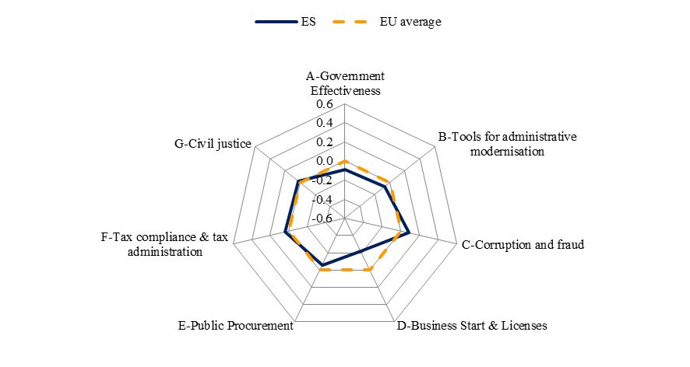
Source: WIFO

Spain has been recently working on three areas to improve tax compliance procedures: 1) improving coordination between the different layers of the Public Administration which collect taxes; 2) increasing the use of e-government; 3) accelerating the payments by the Administration. The government has prioritized two areas for the coming year: the swift implementation of the VAT directive and the compensation of debts/credits between administrations. Both measures may help alleviating the liquidity problems of SMEs. Additionally, some academics and business organisations demand the introduction of a single tax account for all taxes and administrative level (national, regional, provincial and local). This would greatly simplify tax compliance and would permit tax and debt compensation.

Civil justice is slightly more efficient in Spain than EU average. Indeed, enforcing contracts indicators, as well as the time for resolving insolvency indicators show better performance than EU average. The recently adopted labour law (RDL 3/2012) has introduced a number of instruments in view of improving the resolution of labour related disputes. Spain has also taken measures to promote mediation as an alternative to judicial litigation by means of the Royal Decree Law 5/2012 on mediation in civil and commercial matters. According to WEF-Global Competitiveness Report 2012, low independence of judiciary is a point for improvement.

3.9.7. Conclusions

Among the large economies of the EU, Spain has been the country hit the hardest by the economic crisis both in macroeconomic terms (sharp increase in unemployment, slow recovery of GDP growth) and at firm level (worsened profit margins, number of closed businesses) . The worsening business environment and the difficult access to finance for firms may have contributed to this bad performance. Also, some characteristics of the Spanish enterprises may explain their lower resilience, such as a smaller size of the Spanish average firm compared to countries with a similar development level, a lower productivity and a lower degree of innovation and internationalization.

The government is working on a number of initiatives to improve the business environment. However, important structural challenges still exist to increase growth and productivity of firms such as the excessive and slow bureaucracy, the low level of internationalisation of enterprises, difficult access to finance, low innovation activity and lack of competition in certain sectors.

3.10. France
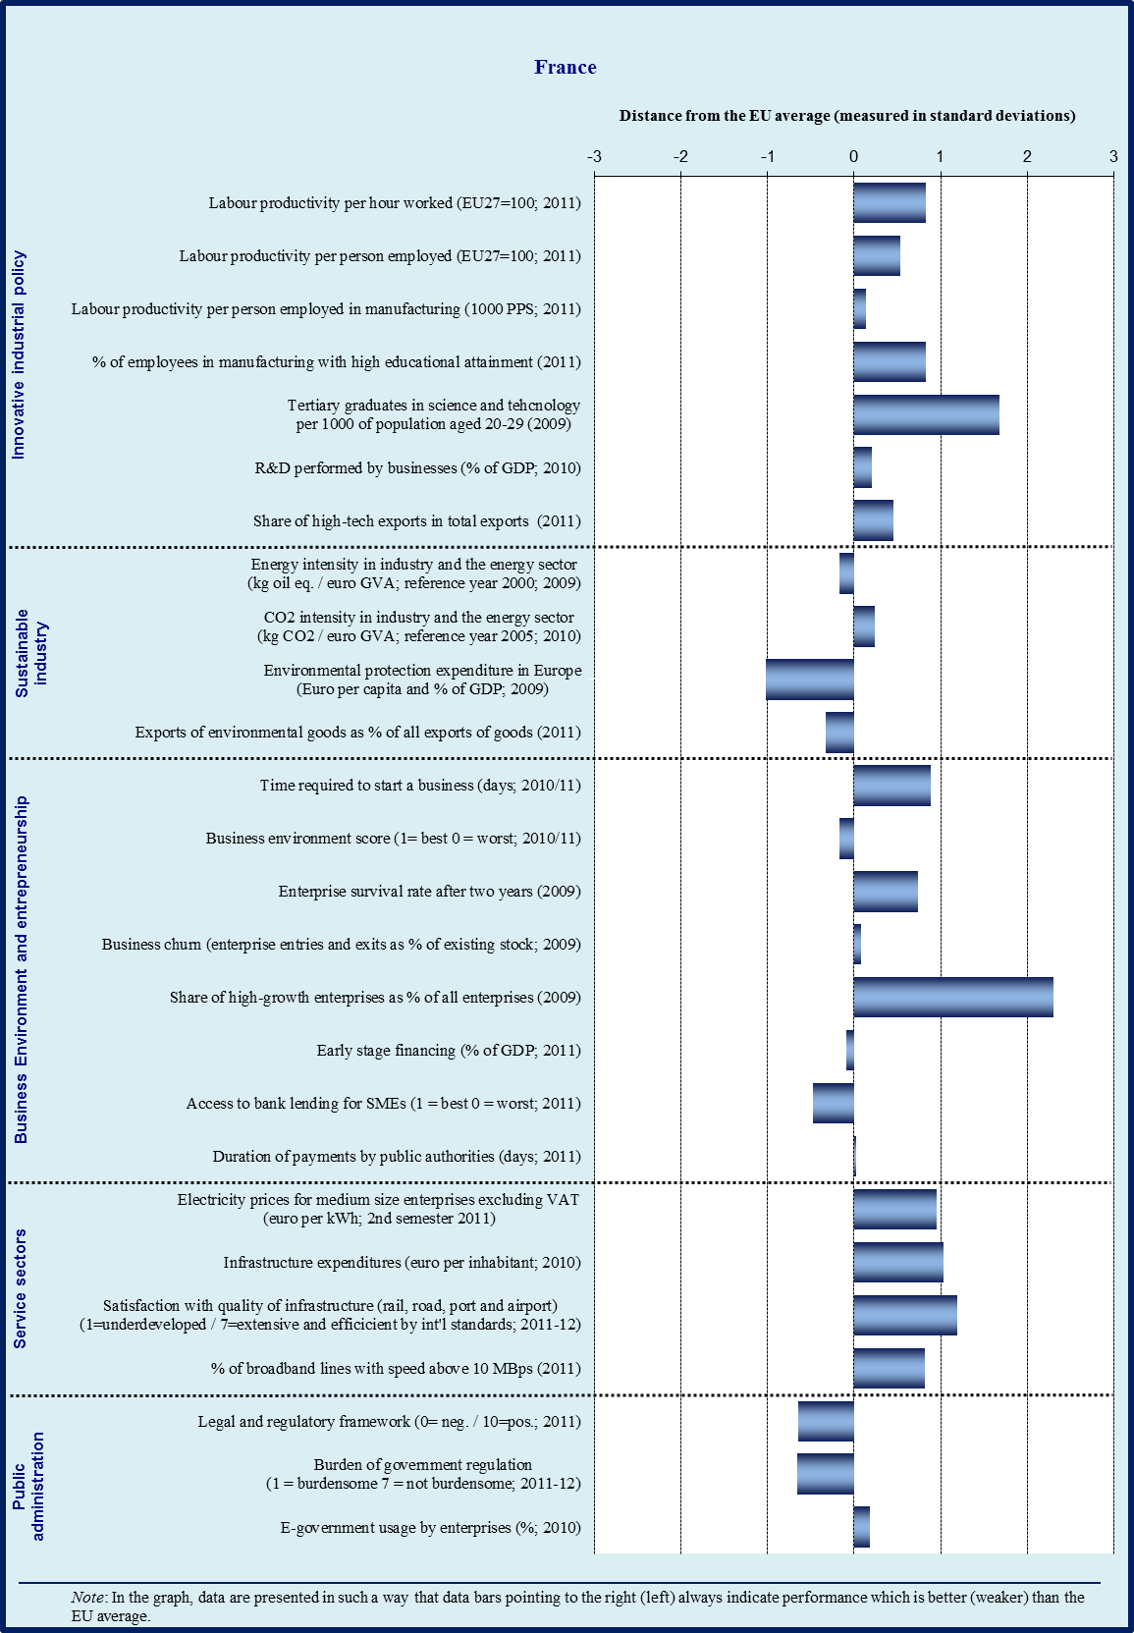

Sectoral specialisation of manufacturing – France (2009)
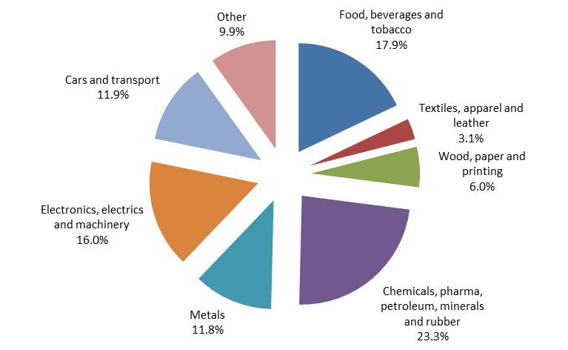
Source: Eurostat

3.10.1. Introduction

Manufacturing plays a smaller role for France than for the EU in total (10.1 % of value added in 2011 vs. 15.5 % for the EU) and its share is declining. France is specialised in medium-innovation and high-education sectors (e.g. transport equipment such as trains and aeroplanes, business services), but less in high innovation sectors, notably due to its lower specialisation in machinery and computers. It has experienced a rapid deterioration of its trade deficit, especially marked for manufacturing sectors.

France belongs to top group of EU countries in terms of productivity levels, although the competitiveness gap vis-à-vis to the best performers is growing. France has increased its industry specialisation in technology-driven industries (air- and spacecraft), while considerably decreasing its relative share of capital-intensive industries (cement, refined petroleum). In exports, France the relative share of technology-driven industries has decreased and the share of marketing-driven industries has increased. The relative share in sectors with high education (business services) has increased considerably while the share in high innovation sectors has decreased (computers, communication equipment). France has climbed further up the quality ladder, in particular in labour-intensive industries.

The external competitiveness of France has deteriorated over the past decade. This can be seen in the export market share that has dropped 19 percentage points between 2005 and 2010, and in the growing trade deficit that reached a record EUR 70 billion in 2011. This deterioration stems from both cost and non-cost factors. To improve non-cost competitiveness, significant reforms have been undertaken to promote research and innovation, and such reforms should be continued and strengthened in the future. However, the increasing labour costs have contributed to the deterioration of firm profitability, damping investment, productivity and innovation. Over the last decade, the real compensation per employee has increased more rapidly in France than in the euro area on average, whereas productivity increase has only kept pace with the euro area average. This has led unit labour costs to rise faster in France than in the euro area.

France has experienced a moderate appreciation of the real effective exchange rate over the last decade, indicating nevertheless a loss in cost and price competitiveness. Nominal unit labour costs have increased by 23 % between 2000 and 2010, compared to an increase of 14 % in the EU27 and 20 % in the Euro area. The employment legislation remains very protective and the minimum wage is among the highest in Europe. Labour productivity is about 27 percentage points above the EU27 average and about 13 percentage points above the Euro area average, but still slightly lower than in other advanced economies, reflecting the lower specialisation in high innovation sectors.

3.10.2. Innovative industrial policy

France is the EUR15 ‘innovation follower” whose performance has improved faster in 2008-2010, notably as regards non technological innovation and the propensity of enterprises (including SMEs) to commercialise innovation (including abroad). This progress may be due to the numerous measures taken in the field of innovation and industrial policy, in particular the reform of universities, the considerable budget dedicated to support R&D expenditures both in the public and private sectors (including Investments for the future programme, whose impact will be observed in the coming years), the clustering policy (Pôles de compétitivité), and the creation of France Brevets. But this has not allowed catching up with ‘innovation leaders’ yet.

Business R&D expenditures have been maintained in 2009 despite the crisis and have slightly increased in 2010. This is largely attributed to public financial support, in particular the Research Tax Credit. However, business R&D expenditures have not significantly increased over the last decade and remain insufficient overall. The business R&D intensity is slightly above the EU average, but as a whole the weight of medium and high-tech sectors in the economy and the number of mid-tier enterprises with high R&D intensity remains insufficient.

Enterprises below 500 employees have markedly increased their R&D expenditures in 2008-2009. SMEs and mid-tier enterprises do benefit from public support to business R&D, such as funding of innovative projects by the Innovation Agency OSEO. The R&D expenditures by high-tech sectors have also markedly increased in 2008-2009, and the share of medium to high-tech sectors in total exports is significantly higher than the EU average.

In terms of financial support to business R&D, the priority was given to technological expenditures in the past few years. Non R&D innovation expenditures and the number of trademarks and designs are much lower than the EU average. Non technological innovation remains a challenge, notably in the services sector. This raises the question of the dissemination of innovative techniques to the entire economic fabric, for example through clustering and training policies. International openness of innovative companies may deserve special attention too. Apart from high-tech sectors, the propensity to commercialise technologies and knowledge abroad appears to be much lower in France than in Member States which are categorised as ‘innovation leaders”. This translates for example into a lower share of knowledge-intensive services in total exports and less licence and patent revenues from abroad.

Despite notable progress, more will be necessary to catch up with ‘innovation leaders”, including in particular further public-private collaboration as regards research and innovation but also education and training (with a view to ensure stronger consistency between the skills taught, career guidance, business developments and societal challenges).

3.10.3. Sustainable industry

Energy intensity in industry and the energy sector is relatively low. However, the number of patents related to societal challenges (climate change, ageing) is well below the EU average, as well as intra-EU exports of ‘green’ products and services. The trade balance of environmental goods is negative, although France is a successful exporter of water processing and waste management technologies. The current sustainable industrial policy includes in particular the Investissements d’Avenir programme, the Pôles de compétitivité, and the steering committee for eco-industries set up in the aftermath of the États Généraux de l'Industrie. These measures, whose impact will be observed in the coming years, are totally relevant in terms of green specialisation strategies, but they do not reflect in statistics yet. They should favour in the next years investments devoted to low carbon technologies and may require complementary demand-side policies, in particular in the fields of public procurement and information to consumers and SMEs.

Besides, reaching the national 2020 targets in terms of greenhouse gas emissions and renewable energy will require a considerable transition from the whole economy, far beyond the ETS sector, and not least from the transport and construction sectors.

A relatively large number of electrical car models are available on the market since 2011. Sales increase very rapidly but account for less than 0.5 % of the market, despite financial incentives. To allow mass production, several bottlenecks need to be eliminated, in particular adequate financing to allow sufficient battery-charging infrastructures (including quick charging), standardisation (plugs, battery packs), R&D (e.g. charging terminals powered by renewable energy sources, autonomy of batteries, management of consumption peaks, wireless charging). Governmental plans are adequate but need to be fully implemented.

Satisfaction with the overall quality of transport infrastructures remains the highest in the EU, even if it is decreasing. However, France could have better exploited its geographic position to play a central role in the shift to non-road freight in Europe. In particular, rail freight volume is diminishing while entry of new operators is hindered by various competition barriers since several years. The freight potential of French ports is underexploited, notably due to insufficient interconnection of most ports with their hinterland and with other non-road transport modes, in particular rail.

Coherent national and local strategies, including infrastructure planning, and taking into account all transport modes in a coordinated manner, could help exploiting the green and competitive potential of the transport sector.

Ambitious national targets are established for energy efficiency in buildings. The challenge is now to ensure their achievement, notably through sufficient financial means, but with a high effectiveness of public spending. This could include for example continued financial support to renovation by private households, including in co-owned properties, with minimum quality control of works; a major renovation programme in state-owned buildings and tertiary buildings; targeted information for SME owners, including for example through billing and smart metering; increased number of graduates and apprentices in the construction sector and adequate professional training.

3.10.4. Business environment

Access to finance

As a whole, access to credit has improved between 2009 and 2011, with a catch-up effect since the cyclical trough, and is relatively easier than in most Member States, even if it remains relatively difficult. Existing mechanisms such as mutual guarantees, public guarantees and the Credit Ombudsman seem effective. Credit conditions have temporarily tightened in the last quarter of 2011, especially for short term cash facilities (in particular low amount overdrafts) and small or very small enterprises.

In 2012, access to credit for investment projects could get more difficult (higher interest rates, stricter collateral requirements). Given the structural lack of equity financing in France, especially for SMEs, and the downward pressure on margins, even a slight tightening of credit conditions may have a direct impact on bankruptcies and corporate investment, in particular investment in non-fixed assets and other ‘non-compulsory’ expenditures such as R&D, commercial prospection abroad, or non technological innovation. This may be particularly acute for (independent) SMEs and mid-tier enterprises and enterprises operating in high-tech and other innovative sectors.

Regulatory and support environment

In recent years France has introduced a number of reforms to limit the increase in labour costs, targeting in particular low-skilled workers. These reforms have sought to limit the rise in the minimum wage and to reduce the tax burden on labour. Regarding the minimum wage, discretionary increases on top of the regulatory adjustments were stopped since July 2006. In 2008, the procedure for the annual review of the minimal wage level was improved by the creation of an advisory committee of independent experts. In order to reduce the tax burden on labour, one of the highest in the EU, the French authorities have adopted a number of measures, in particular social security exemptions for lower salaries. However, further steps are needed to shift the tax burden from labour to other forms of taxation that weigh less on growth and external competitiveness. Unfortunately three recent measures taken by the new government tend to increase labour costs: (a) a lowering of the retirement age to be financed by social contributions on labour; (b) the abolition of a decrease in social security contributions that was to be coupled with an increase in the standard VAT; and (c) the 0.6% increase of the minimum wage in real terms.

Overall, the Loi de Modernisation de l'Économie (2008) has had a positive impact on the duration of payments in the private sector. The average duration of payments by the public sector has been over 60 days in 2010 and 2011, with particular delays by some local authorities or some specific institutions such as hospitals.

Some notable measures to promote entrepreneurship include the auto-entrepreneur statute and the individual entrepreneur statute (EIRL). Procedures for starting up a business have been considerably simplified and shortened. The cost to start-up a business is 5 times cheaper than the EU average, and the time needed to start-up a business is twice shorter than the EU average. However, despite regular batches of simplification measures, the regulatory environment of businesses remains characterised by its complexity and instability, and administrative procedures to run a business remain very burdensome overall. ‘Gold plating’ of EU laws is recurring, especially in the environmental field.

3.10.5. Services sector

The services sector is characterised by a limited and diminishing commercial deficit between 2006 and 2010, although there is still room for fully exploiting the export potential of knowledge-intensive services and environmental services. Electricity prices for medium-sized enterprises are still among the cheapest in the EU.

The number of regulated professions is in line with the EU average. Some progress has been made with regard to certain professions such as lawyers and taxi drivers, although restrictions remain in professions, such as lawyers, veterinaries and accountants. The entry of a new operator in mobile telecommunications is an important step, but the competition framework is far from being optimal in the energy and transport sectors.

3.10.6. Public administration

The performance of public administration scores above the EU average. As a whole, the quality of public services and policy formulation and implementation, and the credibility of public servants’ commitment to policies are positively perceived.

Overall, tax compliance and tax administration score slightly above the EU average. The time required to comply with taxes and the number of tax payments are both low in international comparison and several tax procedures are available on line. It takes 132 hours yearly to prepare and file tax returns and to pay taxes, against 208 hours in the EU on average. However, the total tax rate (over 65 % of commercial profits) is 30 % above the average of high income economies in the world and 20 % above the EU average (France ranks 26 out of 27 Member States).

There is less corruption and fraud in comparison to other Member States. The individual experience of corruption (3 % of all cases) is clearly lower than the EU average (10 %).

The efficiency of the civil justice system is higher than in the rest of the EU, even if time for resolving insolvency and judiciary independence are very close to the EU average. Time to enforce contracts is significantly shorter than the EU average (it takes 331 calendar days as compared to 556).

A noteworthy simplification effort was conducted in 2011. This effort led to the vote, in March 2012, of the ‘simplification and reduction of the administrative burden Law". This act includes several measures aimed at simplifying administrative procedures for enterprises, such as the simplification of the pay roll, an electronic strong-box and an advanced social ruling.

On-line availability of basic public services to businesses is in line with the EU average. An electronic one-stop shop is in place for starting up a business in the services sector, but the number of administrative procedures fully available on line remains limited. The interfaces between businesses and government at regional level have been streamlined in 2010, but there is significant scope to further streamline administrative structures, in particular at local level, and to ensure easy access to public authorities for all enterprises, including SMEs.

The use of new tools to improve public administration performance (e-government, impact assessments, performance and service orientation, accountability) is slightly below the EU average. As regards the elaboration of legislation, practices for ex-ante evaluations have been harmonized by a circular issued in February 2011. However, there is still room for improvement as concerns stakeholder consultations, in particular in terms of explaining how the results were taken into account in the relevant proposal. As a whole, by international comparison, very high public spending and tax rate does not translate into significantly higher government effectiveness or better public services for businesses.

Overall profile of public administration
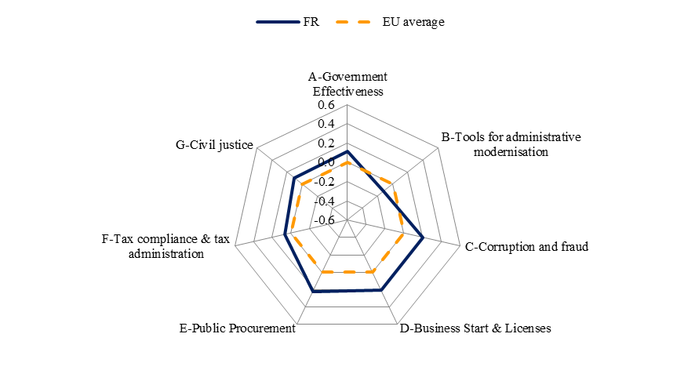
Source: WIFO

3.10.7. Conclusions

Overall, France remains among the consistent performers, although its external competitiveness has significantly deteriorated over the last decade, with trade deficits reaching record levels (EUR 70 billion in 2011). Apart from the recent rise in energy prices, this is due to the persistent rise in labour costs over the last decade that has lowered firms’ profitability to the detriment of their innovation capacity and their ability to invest in R&D. As a consequence, exports of knowledge-intensive manufacturing industries have suffered.

As regards non-cost factors, significant reforms to promote research and innovation have already been undertaken and this momentum should be maintained and strengthened. However, the measures taken so far on the cost side, mainly lower social contributions on low wages, have proved to be insufficient. Furthermore, some recent measures have tended to increase labour costs.

The relatively low business R&D intensity in France reflects the sectoral composition of the economy, with high-tech manufacturing sectors accounting for only a modest share (despite a relatively high R&D intensity in individual economic sectors). The economic fabric would benefit from a higher number and stronger growth of companies of medium and intermediary size (which still undertake limited research activities). Overall, the propensity of SMEs to innovate, commercialise knowledge and technologies and invest in non-technological innovation remains significantly lower than in Member States which are ‘innovation leaders”. Further public-private collaboration in research, innovation, education and training could help mitigate these weaknesses.

Tightening credit conditions, when combined to the lack of equity financing and the downward pressure on profit margins, could lead to shrinking investment by businesses, in particular SMEs. This could weaken in particular investment in non fixed assets and other expenditures such as R&D and non technological innovation, commercial prospection abroad and marketing, which are though crucial for non-price competitiveness.

As a whole, the performance of public administration is better than the EU average, notably as regards tax compliance. However, despite notable improvements in particular as regards cost and time to start up a business, the regulatory environment for businesses remains complex and burdensome overall.

3.11. Italy
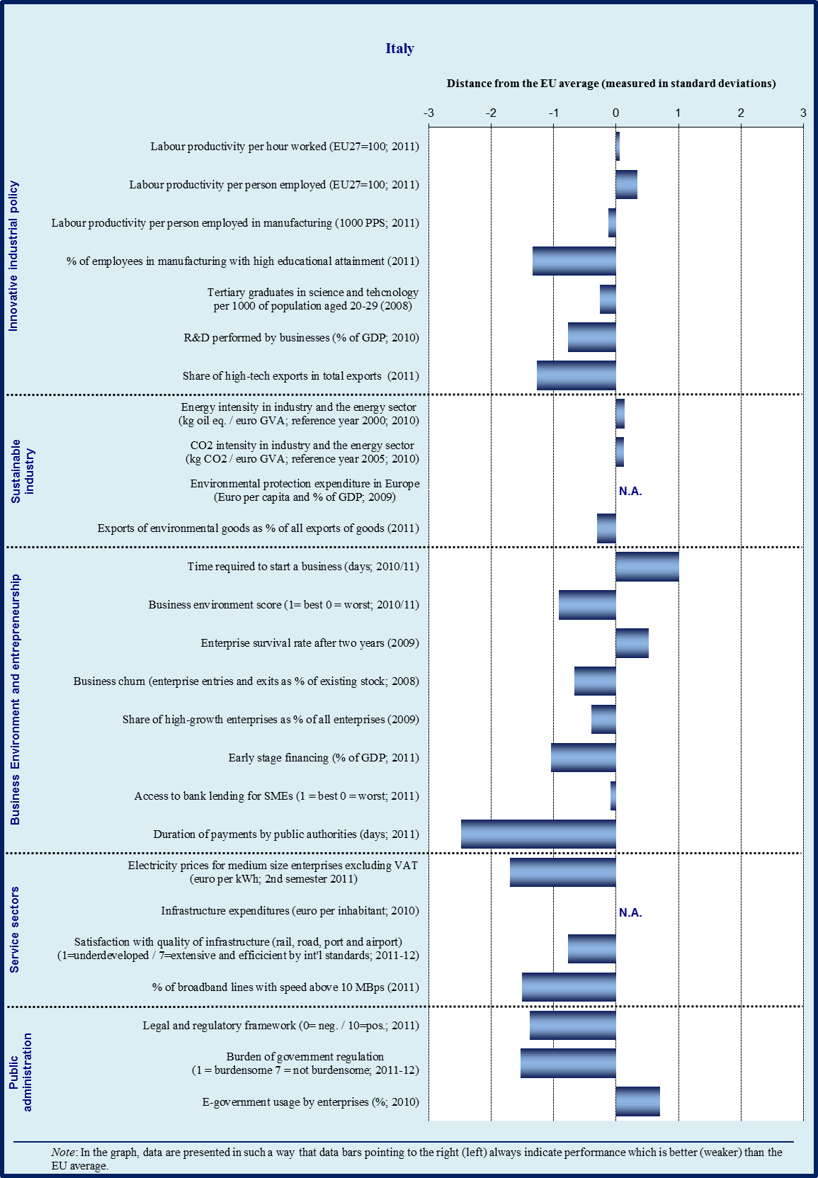

Sectoral specialisation of manufacturing – Italy (2009)
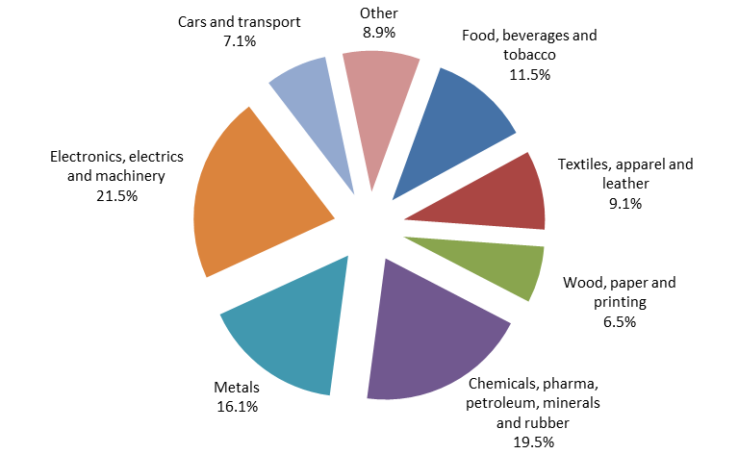
Source: Eurostat

3.11.1. Introduction

Italy has a relatively large manufacturing sector (in 2011contributing 15.9 % of its value added, compared to 15.5 % for the EU average) and shows high indices of specialisation for sectors such as leather products, textiles, machinery, and metal products. In terms of exports, the three main sectors are those of machinery (which also records the largest trade surplus), metal products and transport equipment. Looking at technological specialisation, Italy is relatively more specialised in low tech and low intermediate tech sectors than the EU as a whole. It should be noted that Italy has the largest number of enterprises in the EU. With its 3.8 million SMEs, Italy has almost twice as many as Germany. These small businesses could become more competitive global players if remaining obstacles to their growth were removed, and the existing facilities for clustering and networking were more widely used.

Italy has been recording declining competitiveness since the end-1990s, due to both cost and non-cost factors. The current account balance moved from a surplus of around 2 % of GDP in the late 1990s to a deficit of 3.2 % in 2011, mainly reflecting a deteriorating trade balance, as the surplus on manufacturing goods has not compensated the large deficit in energy products. Stagnation in productivity is the key factor behind Italy’s loss of cost competitiveness since the euro adoption. With an export product mix partly similar to that of some emerging economies, Italy has been relatively more exposed to increasing global competition. As a response to these competitive pressures, restructuring started already in the pre-crisis years; while maintaining its specialisation in labour-intensive sectors, Italy’s exports moved up the quality ladder, both by Italian companies pursuing upgrading strategies and by less-efficient firms exiting the market (in the less knowledge-intensive sectors).

3.11.2. Innovative industrial policy

The latest Innovation Union Scoreboard confirms Italy’s position in the group of moderate innovators with performances below the EU average. In particular, investments in R&D are relatively low (in particular by the private sector), as are venture capital investments, patent applications (though the situation is better for trademarks and designs), and exports of knowledge-intensive services. There is good progress in the indicators related to human resources (e.g. new doctorate graduates) and to entrepreneurship (e.g. SMEs collaborations).

The National Reform Programme announces the intention to consider the possibility of introducing an ‘automatic’ and permanent tax credit mechanism to ensure a more predictable and favourable framework for private investments in R&D. The actions taken in the past were in fact too fragmented. The main supporting programme ("Industria 2015"), organised around five thematic Industrial Innovation Projects, has been quite successful in identifying the main competitive challenges, in launching new initiatives and in favouring public-private partnerships (and, indirectly, in supporting a reform of vocational training) but has been quite disappointing as far as expenditures are concerned, also as a result of the general credit squeeze in the economy. The administrative procedures linked to ‘Industria 2015’ have been very time-consuming (considering that partnerships often involve between 20 and 25 actors).

Programmes to help companies to improve valorisation of intellectual and industrial property rights have been launched (Fondo nazionale d'innovazione).

A number of existing programmes managed by the Ministry for Education, University and Research support both fundamental and industrial research in Italy. The main ones are the Fund for the promotion of research (FAR), in the Centre-North of the country, and the Research and Competitiveness Operational Programme 2007-2013, for convergence regions in the Mezzogiorno. In recent months, new calls for proposals for the development and reinforcement of national technological clusters and on the ‘smart Cities and Communities’ theme have been published.

Following the major universities reform of 2010, the system is continuing to be modernised, and future performance could be improved thanks to the role of ANVUR, the new agency in charge of evaluating research and the quality of the R&D in universities. In particular, ANVUR opinions should be taken into account in the allocation of funds to universities. Results of the evaluation should be available by mid-2013.

3.11.3. Sustainable industry

Italy continues to register one of EU’s best performances for energy intensity of the industry and energy sectors. This is partly related to high electricity prices and high import dependence that have provided a strong incentive for investments in energy efficiency throughout the industry. There appears to be some progress towards the EU energy and climate change targets for 2020, especially with regard to the development of renewable energy sources, while progress towards the reduction of greenhouse gas emissions remains modest.

The incentives for renewable energy have been extremely successful, especially for solar photovoltaic energy, but have been less effective in supporting the emergence of a national industry in the sector. Actually, it appears that in 2010-11, imports of photovoltaic cells accounted for around 0.5 % of GDP of the increase in Italy’s trade deficit. Measures for energy saving and energy efficiency have been established or confirmed, notably a successful tax credit for energy savings in buildings (extended to the end of June 2013) and ‘white certificates’ (tradable Energy Efficiency Certificates issued to energy distributors and energy service companies that certify the reduction of consumption achieved through measures and projects of energy efficiency improvement).

In the framework of initiatives to favour the environmental restoration and industrial reconversion of local areas in difficulty, such as those of Porto Marghera in Veneto and of Porto Torres in Sardinia, there is an attempt to favour the emergence of a more sustainable industry (e.g. through the promotion of ‘green chemicals’), stressing that restructuring processes can also provide opportunities.

Concerning the diffusion of Green Public Procurement in Italy, the implementation of the 2008 national Action Plan is in progress. New Ministerial Decrees have been adopted defining minimum environmental standards for a number of goods purchased by public administrations (food, buildings’ cooling and heating). Further decrees for transport and cleaning services are in preparation.

3.11.4. Business environment

Access to finance is a key concern in Italy and the situation has worsened in the last year. Firms, especially SMEs, are facing tightening credit conditions. At the same time, banks have reported a sharp slowdown in the demand for loans from businesses in the first half of 2012, due to the general slowdown and low growth prospects. As a result, according to the Bank of Italy, loans to non-financial corporations have dropped significantly in December 2011 and again between March and July 2012.

The Central Guarantee Fund for SMEs is the main public tool to support companies in this area and has registered an increase in applications in the latest years (especially for SMEs’ liquidity needs rather than investments). It has been refinanced and its scope has been increased.

A new tax instrument (Allowance for new Corporate Equity - ACE) will be also be used to improve companies’ capitalisation. It allows companies to deduct part of the notional return on new injections of equity capital from taxable income. It is expected to encourage firms, including small and medium enterprises, to increase their capital base, while overcoming the debt bias of the tax system regarding investment financing decisions.

The risk capital market is still relatively small. The recently-established Italian Investment Fund, focusing on mid-caps companies, is playing a big role in increasing the supply of risk capital in Italy (with around EUR 1 billion, it represents 60 % of the total risk capital market). As of June 2012, the Italian Investment Fund has made direct equity investments in more than twenty companies, mostly in the manufacturing sector. The possibility to use ‘network contracts’ among SMEs (the contratti di rete were established in 2009 and allow companies, while remaining independent, to aggregate in order to implement projects of common interest in areas such as innovation and internationalisation) to improve access to credit is being considered. Concerning late payments, a key problem in Italy where average duration of payments is one of the highest in the EU and the existing stock of commercial debt is estimated between EUR 60-80 billions, a mechanism to certify existing credits vis-à-vis the public administrations and to allow for their compensation with tax debts has been defined at the end of May 2012 with specific ministerial decrees. An agreement was also signed between government, business organisations and banks, to ease the conditions for cash advances from banks totalling at most EUR 10 billion.

Italy has put in place a structured governance system to follow-up the implementation of the Small Business Act. A dedicated ‘permanent dialogue’ (tavolo permanente) involving the relevant actors has been set-up after the adoption of the SBA while the implementation of the SBA has been formally included in the law on Company Statute adopted in November 2011. An annual law on SMEs will be adopted starting from this year, possibly including an extension of the ‘network contracts’ also to professional bodies and universities. The national SME Envoy closely monitors the process.

3.11.5. Services sector

The services sector in Italy is quite heavily regulated and insufficiently open to competition, although there has been progress in the last years, notably in retail trade and the energy market – especially in electricity, although the lack of an adequate infrastructure leads to a suboptimal use of the generating capacity. Combined with the market shortcomings, this leads to higher energy prices for consumers. The transport sector and local public services (including water distribution and local public transportation) appear to be lagging behind in this process.

The government’s strategy is very much focused on increasing competition across the board and numerous measures have been introduced, notably by the so-called ‘Cresci Italia’ (‘grow Italy’) decree-law of January 2012, for example in the fields of professional services, petrol stations or pharmacies. Also, a new Transport Authority is to be established with a wide scope of competence covering both transport services and infrastructure, including highways, railways, airports, ports and local public services. Its mission is to promote competition, reduce costs, improve quality standards and fix methodologies for procurements and concessions.

The new Transport Authority is, potentially, an important step forward in sectors where much remains to be done. However, there are still services sectors where further interventions could be considered, notably the reduction in the scope for professional orders’ legally reserved activities, as this has a cross-cutting impact. A reform of professions was adopted in August 2012, but this only focused on entry, promotion, insurance and training requirements. In general, full implementation of the pro-competition measures is crucial. The wider competence granted to the Competition Authority with regards to local public services and to restrictions of economic activities can also be considered steps on the right direction.

3.11.6. Public administration

Italy’s overall public administration performance, as depicted by the World Bank’s Government Effectiveness Indicator, is well below the EU average. Both the time needed (1210 days) and the cost (29.9 % of claims) for resolving commercial disputes through the courts are matters of concern for the Italian Authorities, together with a more general problem, the slowness of the Italian justice system, which arguably damages the country’s competitiveness performance and its capacity to attract new foreign investments. This is likely to be partly linked with organisational problems within the judiciary system that are also being currently addressed by a review of the territorial organisation of the courts of first instance.

In general, Italian administrative procedures are particularly burdensome for business. A more general burden for Italy is the time to implement all sorts of infrastructure projects such as in transport, which has obvious implications for industrial competitiveness and is highlighted, for example, by surveys on the satisfaction with the quality of infrastructure where Italy is in the worst performing group within the EU.

Even if Italy is performing below average in the field of public procurement, Italy has recently adopted several measures to simplify public procurement rules, notably in the ‘salva Italia’ (‘save Italy’) law of December 2011. In particular, measures to facilitate SMEs access to tenders through e-procurement, reduction of administrative burdens, division of contracts into lots, simplification of conditions for joint bidding have been established.

The fights against corruption, tax evasion, the shadow economy and undeclared work are a priority for the Italian Government. In this regard, an initial set of measures has been established on the organisation of administration’s decision making processes, on levels of transparency within the public administration and on technical training for civil servants. A draft anti-corruption law is still being discussed in the Parliament – the swift implementation of this law could have a large beneficial effect on the business environment.

Italian tax system is quite burdensome for companies and heavily weighs on labour in particular. Once again, time is an issue as 285 hours per year are estimated to be necessary in average to comply with the major taxes, compared to 187 hours in Spain for example. The tax system is also quite unstable as it is regularly amended through urgent measures (Decree-Laws).

Italy performs relatively well with regard to the operation of one-stop-shops to start up a company and time required to start-up a company. Most one-stop-shops for start-ups are now operative at municipal level. Online services and payments are available in parts of the country but there are delays in implementation.

To encourage entrepreneurship, the Grow Italy decree-law has created the possibility for people under 35 to create a simplified limited-liability company, with fewer formalities and less capital. Some simplifications were extended to all entrepreneurs in the growth package adopted in August 2012.

Overall profile of public administration
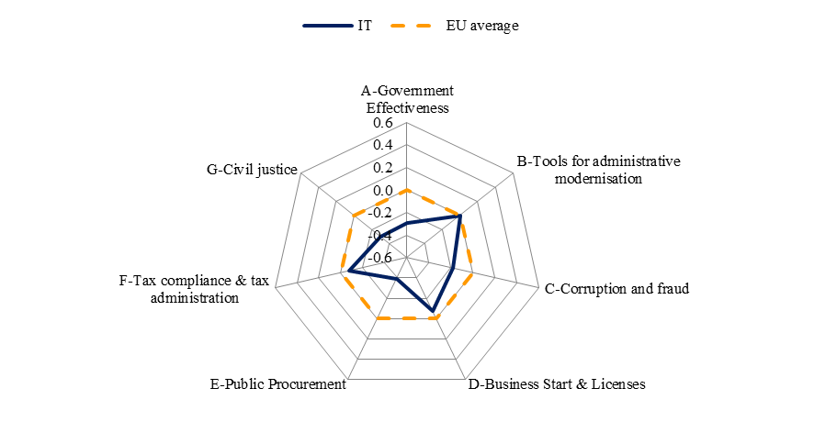
Source: WIFO

In order to improve the effectiveness of the public administration and to eliminate unnecessary costs without reducing services to citizens, the Government has launched a spending review and nominated an extraordinary commissioner for the rationalisation of expenditures. In July 2012, a decree-law was adopted aiming at saving a total of EUR 26 billion in 2012-2014. Further initiatives have been announced for the following months.

3.11.7. Conclusions

The economic crisis is having serious negative effects on the Italian industry while, at the same time, public resources are scarce. This follows a period of declining competitiveness since the end-1990s, due to both cost and non-cost factors.

In this context, Italian industrial policy focuses on four priorities: access to finance, SMEs, industrial restructuring, research and development. The new government, in place since November 2011, has broadly confirmed these priorities, and has also emphasised the importance of the Digital Agenda.
There is relatively more progress on the improvement of the business environment and on the opening of services sectors to competition and less on promoting an innovative industry, where implementation of previous measures has been somewhat disappointing and more ambition would be required given Italy’s competitive position. Also, access to finance remains a particularly problematic issue in Italy. Finally, Italy still has a large potential to develop a more sustainable and competitive industry.

3.12. Cyprus
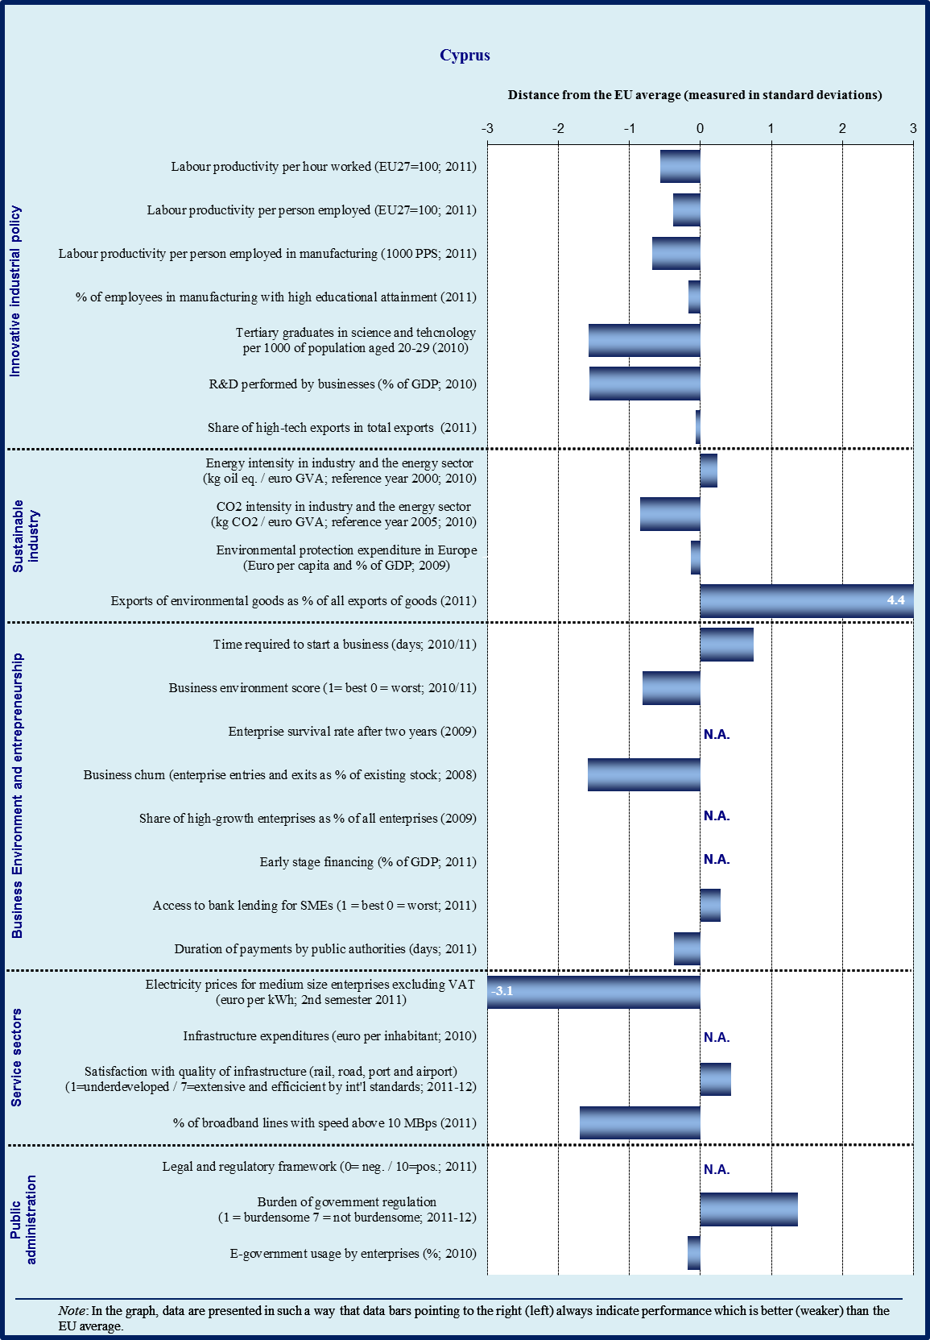

Sectoral specialisation of manufacturing – Cyprus (2009)
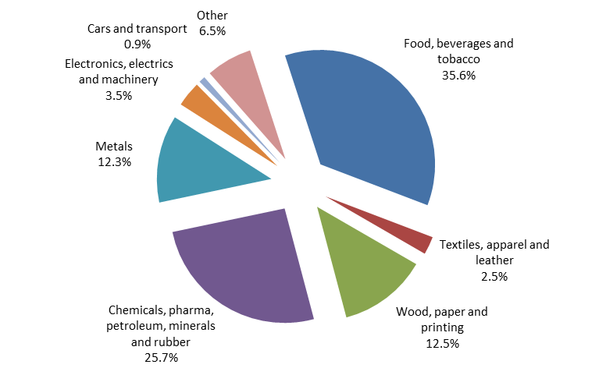
Note : No data available for sectors C12 (tobacco products) and C19 (coke and refined petroleum products)
Source: Eurostat

3.12.1. Introduction

Manufacturing plays a less important role in the Cypriot economy than in the EU on average (6.1 % of total value added against 15.5 % for the EU). Slightly more than 10 % of the total workforce is employed in this sector (EU average: 17.5 %), which is the lowest in EU. The most successful manufacturing exports are pharmaceuticals and photosensitive semiconductors devices, which accounted for 22.5 % and 12 % respectively of domestic exports in 2009. However, the revealed comparative advantage of Cyprus is concentrated in low and medium-to-low technology sectors, namely food, beverages and tobacco.

Cost competitiveness of the Cypriot economy significantly deteriorated over the last decade, reflected in the increase of real effective exchange rate. Indeed, while labour productivity grew slightly faster than the average of the euro area, not only is it more than 25 points below EU average, but it has also been offset by a faster growth of prices and wages. Rising production costs are among the causes of the gradual decline of the Cypriot manufacturing sector.

3.12.2. Innovative industrial policy

The performance of Cyprus in terms of R&D and innovation remains weak, in spite of the notable progress in building a research system and in creating a vision for its transition to a knowledge-based economy. Cyprus has a very low level of R&D expenditure as a percentage of GDP (0.50 %), which is in line with its national commitments under the Europe 2020, but far from the EU average (2.0 %). Moreover, the innovation system relies mainly on public expenditure as investment contribution of businesses to R&D is among the lowest of all Member States (0.09 % of GDP against an EU average of 1.23 %). Partly because of the structure of the economy (service sector dominance) and partly because of the characteristics of the productive sector (small companies in traditional sectors), industrial research in Cyprus is virtually absent and the approach taken by industries is to obtain technology by licensing or to buy knowledge incorporated in new machines and equipment.

In addition, the financial crisis is further weakening an already unfavourable situation, both because consolidation efforts of the Government may result in a reduction of R&D budget, and because of the absence of a venture capital market which, along with the credit crunch, is limiting the access of R&D companies to high-risk bank loans, when business expectations allow for the relaunch of investments.

In such a context of limited resources, policy makers are concentrating their efforts in selected areas with high-tech potential. This is one of the pillars of the new National Strategy for Research and Innovation 2012-2015, which is in its final stage of preparation.
The strategy foresees supply-side and demand-side measures. Besides traditional direct funding schemes, such as incentives for innovative product development, an initiative on financing innovation in business calls the public sector to lead the development of technologically innovative solutions addressing its specific needs. The new innovation policy aims also to foster cooperation among public, business and research organizations; to encourage the creation of local platforms and clusters; and to promote cooperation with European platforms such as Manufuture.

However, raising the involvement of businesses in research implies also addressing the weaknesses in the governance of the research system. Firms that have a high R&D intensity, for example, claim that their limited participation in government programmes, despite the incentives offered, is due to time-consuming bureaucratic procedures. Indeed, the success of an innovation policy presupposes also the active participation of businesses both in the design and in the implementation of innovation policies. Cyprus should strengthen the involvement of industrial community in the governance bodies of the academic and research institution, which should naturally improve the university-industry cooperation.

3.12.3. Sustainable industry

Investments in power generation using natural gas have succeded through the recent discovery of seven trillion cubic feet of natural gas in the Economic Exclusive Zone of Cyprus. According to estimates, this is enough to cover the energy needs of the island for the next 200 years and creates opportunities to become an energy hub and exporter. A pipeline carrying gas to Cyprus is expected to be operative by 2016, while the government is tendering licenses for the exploration of hydrocarbon reserves in another 12 offshore blocks.

However, there are risks associated with a small and isolated energy grid. These, and the dependency on imported oil for energy generation was illustrated by the explosion at the Vassiliko power station in July 2011. In order to meet the resulting power deficit, the Electricity Authority of Cyprus (EAC) was forced to use its old and less cost-efficient generators and to rent a large number of small-scale diesel generators from abroad.

Apart of the opportunities to build a diversified, secure and sustainable energy system, the reserves have implications for industrial policy. A smart exploitation of the gas fields has the potential to create new impetus to the economy of Cyprus, in addition to the direct exploitation revenues. However, this process needs to be properly managed by the Government, when considering the impact in terms of influx of foreign companies and workers, along with the environmental risks posed by the exploitation of gas. Thus, it is of utmost importance to design measures that minimise risks for the tourism and secure benefits for Cypriot economy in the long term. The exploitation of the gas offers also the opportunity to promote R&D in the energy sector in Cyprus and enable development of new industries to exploit the energy resources of Cyprus.

Those developments should not be detrimental to pursuing ambitious policies and concrete measures for renewable energy sources and energy efficiency. The Government provides grants and subsidies for energy efficiency investments and feed-in tariffs for electricity generated from renewable sources. The energy efficiency of the industrial sector has improved by 25 %, mainly due to improved technology in the cement industry. In addition, there has been systematic training of industry managers and engineers in energy management, good practices and energy auditing. Cyprus has exceeded the first indicative target on the contribution of renewable energy to the gross final energy consumption, as the target of 4.92 % set for 2012 was already exceeded in 2010 (5.8 %). It is also one of the few Member States where the share of environmental goods exports exceeded 1 % of total exports, reflecting the relative strength of its photovoltaic production.

3.12.4. Business environment

Access to finance

Conditions of access to credit have deteriorated, reflecting the exposure of Cyprus’s banking institutions to Greece (175 % of GDP). Recent downgrades of the three main Cypriot banks’ ratings to non-investment grade, has reduced the banks’ ability to access international markets and has caused liquidity constraints in the Cypriot financial system.

The consequent credit crunch can be seen in the sharp tightening of credit standards. Combined with anecdotal evidence of interest rates at nearly 8 %, and collateral demands at 140 %, this has squeezed an economy where SMEs mostly cover their financial needs through loans from banks and financial institutions.

Although the banks are not expecting credit standards to change much, after four quarters of consecutive decline, the net demand for loans by enterprises is expected to grow in the second quarter of 2012.
In this context, the Government is preparing a financing mechanism to facilitate SMEs access to finance, by providing guarantees to stimulate growth and job creation. The mechanism will involve the creation of a holding fund managed by the European Investment Fund (EIF), which provides guarantees to commercial banks to grant loans at competitive rates to SMEs. It is expected that this mechanism will improve the financing conditions for SMEs in the form of lower interest rates, longer repayment term and a grace period.

Regarding the implementation of two JEREMIE instruments, the 65.8% (€13.1m) of the total portfolio of the "Funded Risk Sharing Product" (FRSP) has been disbursed to the SMEs up to the end of August. More problematic is proving the implementation of the "First Loss Portfolio Guarantee Product" (FLPG) for which there seems to be a reduced demand for loans due to the fact that SMEs are currently much more interested in lower interest rates (like in the case of FRSP) than reduced collateral requirements (like in the case of FLPG).
Another source of concern for Cypriot entrepreneurs is late payments, either by Government and private sector. For instance, in 2010 it took more than three weeks longer (73 versus 54 days) for a Cypriot firm to get paid than EU average. The national law transposing the late Payment Directive is expected to be approved by the parliament by September.

Regulatory burden

In general, Cyprus offers a favourable business environment. Entrepreneurship capacity is good and the burden of government regulation is low. Satisfaction with administrative requirements is above the EU average.

Nonetheless, there are areas where there is room for improvement. Major sources of complaint among stakeholders are in the length to comply with building regulations (677 days); and, as a consequence, to get electricity; the inefficiency of the judicial system in enforcing the contracts (735 days); and the severe restrictions in key transport sectors in terms of working hours (e.g., ports, warehouses). To improve the functioning of the judicial system, Cyprus is evaluating the establishment of commercial courts to resolve trade disputes.

One of the main reasons for the loss of competitiveness in the economy is the system of wage indexation (cost-of-living-allowance – COLA), which is a twice-a-year automatic adjustment of wages linked to the average percentage changes in the consumer price index. The application of this mechanism has caused loss in costs and prices competitiveness and rapidly growing trade deficit, as wages adjustments does not reflect similar increase in labour productivity. In addition, the uniform application of the system does not allow wages to reflect productivity differences across sectors, with a consequent inefficient allocation of resources. In the context of fiscal consolidation efforts undertaken by the Government, there has been a two-year suspension of the system in the public service, which seems to be occurring also in the private sector, though this is at discretion of each employer. However, negotiations to modernise COLA are under way and the aim is to reach an agreement the soonest possible.

3.12.5. Services sector

Despite the liberalisation of the market, the Electricity Authority for Cyprus (EAC) remains the only domestic provider; The small size of the market and the high initial investment costs have made it difficult for new companies to enter the market. Hence, the demand faced by EAC is inelastic and any price increases are borne by the consumers. Since 2007, Cyprus has constantly been within the top three in the rankings for electricity prices within the EU.

The possibility that the discovery of natural gas will lead Cyprus to have a more diversified and international energy sector in the long run does not remove the short-term disincentives for investment. Given the prospects of the gas resources for the island, Cyprus needs to promote the development of a competitive energy market, in line with the requirements of the Third Energy Package.

Some restrictions remain in those regulated professional services where fixed or minimum tariffs exist (such as lawyers and architects), and these play an important role in a variety of contractual and legal obligations for businesses (and citizens). Improving the quality and reducing the cost of professional services could have a multiplier effect on the economy in the medium term.

3.12.6. Public administration

The public administration of Cyprus performs close to the average of the sample of Member States. The World Bank’s Government Effectiveness measure that can be interpreted as a comprehensive assessment of the quality of a public administration in a very broad sense indicates a public service quality that is better than the EU average.

Compared to the other Member States, Cyprus lags behind in the adoption of tools of administrative modernisation (e-government, impact assessment, performance and service orientation). In addition, all of the most important public services for enterprises are not yet online (although 75 % are), whereas their take-up rate has increased to 74 %. On the other hand, both the provision for (42 %) and take-up by (25 %) citizens are among the lowest in EU. The reliance on instruments of a modern human resources management (performance-related pay, flexibility, skills development) is also below the EU average.

Corruption measures also indicate an average performance of the administration. The index values for irregular payments and for diversion of public funds are very close to the EU average. Individual experience with corruptive public suppliers occurs slightly less than the average, i.e. in about 6 % of all cases.

The indicators for starting a business and licensing point to some scope for improvement; this holds especially for the cost for starting up a company. In Cyprus, it costs about 13.1 % of income per capita to start-up a (model) company. This is much higher than the EU average of 5 %. However, the time needed for registering and starting up a business is only 8 days, which is substantially less than the EU average of 13.7 days. Further, Cyprus is one of the Member States that have already implemented a fully operational one-stop-shop to start a business.

The public procurement system has some weaknesses in comparison with the other Member States. Although payment delays of public authorities (23 days) are slightly shorter than average (28.3 days), the typical cost and time used up in the procurement process are substantially worse than average cost and time. Public tenders can be submitted electronically via a system of e-procurement.

Cyprus offers a generally favourable tax system for enterprises, characterised by low tax (23.2 %) rates and a broad tax base. In terms of tax structure, Cyprus relies heavily on consumption taxes, while the tax burden on labour is low. Overall, Cyprus is among countries that have a fairly low share of distortionary taxation, i.e. labour and capital taxation.

Overall profile of public administration
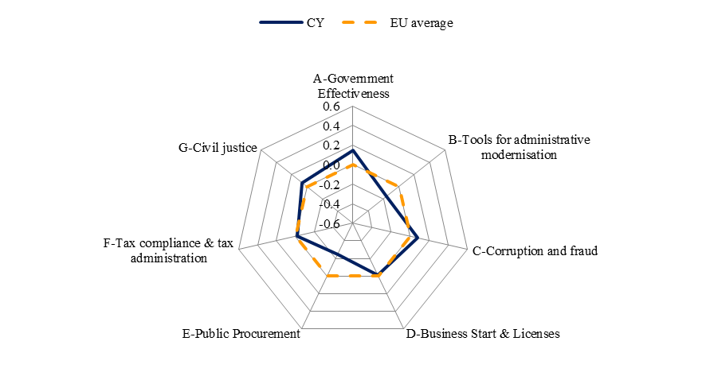
Source: WIFO

While the administrative burden of complying with taxes in Cyprus is fairly good (on average, firms spend 149 hours a year filing, preparing and paying taxes and pay total taxes amounting to 9.1 % of profits), the administrative cost of tax collection (the expenditure on tax administration as a percentage of tax revenues) is the highest in the sample with 7.4 % of total receipts. Further, personnel expenditures on core administration (without the military) are highest among the Member States.

Despite that the estimates of the size of black economy in Cyprus do not suggest that income tax evasion is higher than that of other countries, the Government is set to strengthen the prevention and inspection of combating illegal and undeclared work.

Efficiency of civil justice in Cyprus is a slightly better than EU average. Costs of enforcing contracts (16.4 % of the claim) and the time required for resolving insolvency (1.5 years) are slightly lower than the respective EU averages, whereas the time of contract enforcement is higher than on average (735 days as compared to 556 days). The overall perception of independence of the judiciary is a somewhat better than at the EU average.

Cyprus has taken significant steps to better serve the citizen and to enhance the productivity and the effectiveness of public services. The Citizens’ Service Centres (CSC) enable the provision to citizens of over 50 services of six government departments. The Companies Registration System (e-filing) was introduced to allow for complete online registration of companies, and is also expected to partly address the cost of setting up of a business, which is higher than the EU average. Additionally, the system of ‘e-procurement’ was implemented enabling the performance of public procurement competitions using electronic means.

Furthermore, Cyprus has committed to reducing the administrative burden of the national legislation by 20 % by 2012. To achieve this target, a sectoral baseline project was created for the reduction of administrative burden in all legislation relating to enterprises, based on eight priority areas. A number of proposals have been submitted in each of these priority areas on the basis of recommendations proposed by a consultancy and after a consultation with relevant government services and the private sector. It is expected that implementation of all recommendations will lead to a total reduction of 22 % of administrative burden.

Regarding e-government, a horizontal proposal was also submitted aiming at promoting the use of existing electronic systems in the Public Service.

3.12.7. Conclusions

Increasingly negative trade balance of goods indicates a lack of competitiveness in the Cypriot industry, which is a serious problem for a small open economy that relies on export-driven growth. Indeed, surpluses in the services balance have only partially offset it, resulting in average current account deficits of six percent of GDP since 1995.

The shortcomings of the cost of living adjustments have also become more evident in the current low-growth environment. The Government has started on a serious effort to modernise the system. If the wage indexation system will be reformed to better reflect sectoral productivity gains, it could improve the economy’s ability to respond to the current economic downturn. Good prospects have been created by the discovery of natural gas however the current high electricity prices damage competitiveness. Despite the small size of the domestic market, there is room for improvement. Finally, Cyprus should accelerate its effort to overhaul its R&D and innovation policies to adjust the structure of the economy towards more knowledge-intensive and high-growth activities.

3.13. Latvia
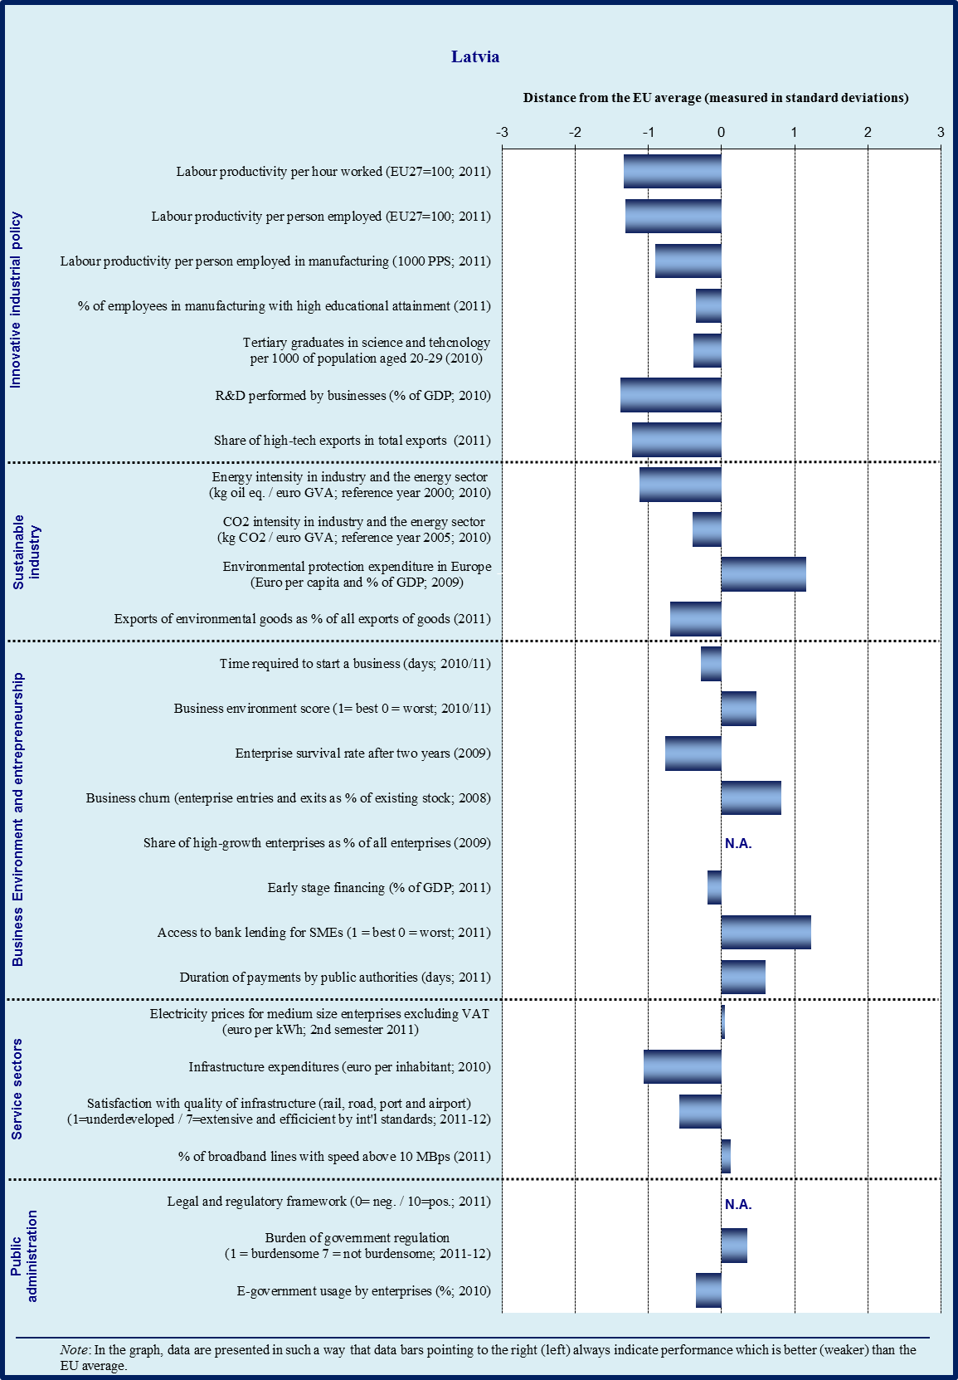

Sectoral specialisation of manufacturing – Latvia (2009)
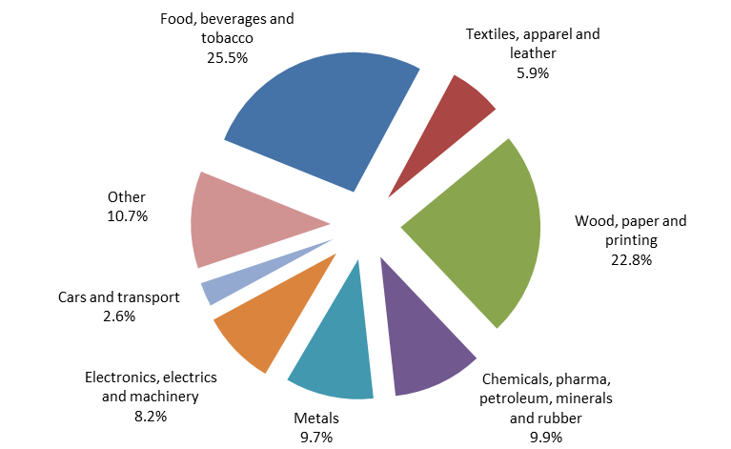
Note : No data available for sectors C12 (tobacco products), C22 (pharmaceutical products and pharmaceutical preparations) and C32 (other manufacturing)
Source: Eurostat

3.13.1. Introduction

Latvia is one of the countries that are catching up: while it cannot yet be described as a knowledge-based economy, it has made progress in terms of sustainability, and manufacturing production now exceeds pre-crisis levels. The manufacturing sector accounts for 14.1 % of total value added versus 15.5% in the EU on average. However, Latvia has very low R&D intensity and a business culture that is not yet mature; it has relatively lower income levels and a predominant specialisation in labour-intensive industries. In general, Latvia has improved its competitiveness, especially in terms of specialisation.

The manufacturing sector is focused on food processing, wood processing, and mechanical engineering. Latvia’s main trading partners are the other Baltic countries, Russia, Germany Poland, Sweden, Belarus and the rest of the EU. At the more aggregated level, Latvia is specialised in both high and medium high sectors like electrical and optical equipment, chemicals and sectors with low and medium-low intensity, such as metal processing and machinery, wood, food production, and services sector. Latvia has been climbing the technology ladder to medium-to-high tech exports.

3.13.2. Innovative industrial policy

Latvia’s poor innovation performance could impair its long-run competitiveness: Latvia has been consistently ranked amongst the last by the Innovation Union Scoreboard. The Latvian Competitiveness Report 2011 highlights its poor innovation performance as one of the main weaknesses. While R&D intensity recovered somewhat in 2010, reaching 0.6 % of GDP, it remains one of the lowest in the EU, which makes the national target of 1.5 % by 2020 rather ambitious. Latvia’s innovation policy has so far been characterised by rather disparate measures, over-dependent on structural funding, and whose effectiveness has not been thoroughly evaluated. Latvia needs a comprehensive industrial policy to provide support for the development of an entire infrastructure for innovation. The work that has started on the elaboration of a modern industrial policy is only a first step in this direction.

There is little R&D investment by both domestic companies and foreign affiliates to support trade specialisation towards knowledge-intensive and innovation-driven sectors. Latvia has one of the lowest business R&D expenditure in the EU (0.22 % GDP in 2010); in part due to the poor innovation performance of SMEs. Most of the support programs for innovative companies are financed from EU structural funding, with state co-financing. In order to help enterprises develop new products or more efficient production processes, the following support programs have been designed: ‘Development of New Products and Technologies”, ‘Introducing New Products and Technologies in Production”, ‘support for protection of industrial property rights", ‘support to Science and Research’ and ‘High Value Added Investment’ programme". Two new programmes are in the initial phase: the ‘Development Programme of New Products and Technologies by Micro-, Small and Medium-Sized Enterprises, and a programme for the development of innovative green products (supported by a Norwegian financial instrument). Under the ‘EUREKA programme”, businesses may submit projects to apply for assistance. In addition, a ‘Market oriented research programme’ is in place to support cooperation between scientists and entrepreneurs. The achievements of all these programs should be closely evaluated against their goals.

The cooperation between business and academia continues to be weak and research commercialization is rather low. Companies do not use enough of the research potential of universities and their participation in the 6 competence centres (aiming at bringing together innovative enterprises and research institutions) is rather limited. The technology transfer contact points operating in several universities have modest results, in part due to the incomplete IPR legal framework, which does not encourage universities to patent their inventions. In 2011, seven clusters were created in areas like electronics, chemistry and pharmacy, space or logistics, but their added value remains uncertain. Latvia has made a first attempt at modernization by creating nine national research centres, which seem to focus disproportionately on academic research. In addition, 381 companies have been incubated so far, out of which 79 have stayed operational; it remains to be seen if the remaining companies will survive once incubation is over.

The innovation vouchers program, intended to encourage SMEs to invest in R&D, has been developed but is not operational yet. The value has been set at LVL 10 000 /voucher, with a limit of one per company. The list of R&D providers has been limited to universities and research institutes, product certification institutions, testing and calibration laboratories as well as patent attorneys and the Latvian patent office. This program will need to be closely monitored by checking if the benefiting SMEs actually continue with R&D activities.

The skills mismatch continues to be a problem. There continues to be a lack of scientists, engineers and technicians. Many Latvian scientists chose to pursue their careers abroad. To address this, Latvia is making efforts to modernise the vocational education system: six out of the 38 vocational education institutions have become vocational education competence centers, with ERDF support. The number of doctoral students having received scholarships in priority areas (STEM) increased by 38% in 2011, with ESF support. The adopted amendments to the Law on higher education institutions stipulate, inter alia, the obligation to attract foreign academics in universities, and the recognition of study achievements obtained outside formal education.

Overall, Latvia has to put considerable effort into developing and implementing a systematic and effective research and innovation strategy, which could encourage more firmly the innovation activities of companies.

3.13.3. Sustainable industry

Latvia has made progress on the sustainable dimension but is yet to adopt a long-term strategy for energy. While most of the energy in Latvia is generated by gas, biofuel and hydropower, the industry represents 14.3 % of the total GHG emissions. Its energy intensity is more than double the EU27 average, which is mainly due to its specialisation in energy-intensive sectors. . While the energy intensity in wood processing has significantly worsened, affecting the whole manufacturing sector, sectors like cement, metal, food processing, and textiles have decreased their energy consumption. There are some environmental standards in place and companies that switch to alternative sources of fuel or are involved in technological innovation thus obtain a surplus of ETS allowances.

Latvia’s energy efficiency is significantly below the EU average – the intake of energy relative to GDP was 80% above the EU average in 2010. There are not enough incentives for shifting consumption towards energy efficient products. In particular, energy efficiency is low in the transport sector, which is the largest emitting sector in Latvia (with 25.9% of the country’s GHG emissions in 2009); the public transportation network could be further consolidated and the use of renewable energy and further railway electrification could be envisaged.

In terms of renewable energy, Latvia has committed to reach a target of 40 % of renewable energy sources in final energy consumption and a 10 % share of renewable energy in the transport sector by 2020. However, progress is lacking in developing a coherent and stable renewable energy policy; the adoption of the new Renewable Energy Law seems to have been delayed indefinitely. Given this situation, stakeholders complain about the instability of legislation that cripples the market and creates unfair competition. The Ministry of Economics has prepared the draft of the long-term policy planning document Energy Strategy 2030 and plans to submit the strategy to the Cabinet of Ministers in 2012. Renewable energy and energy efficiency projects are financed through structural funding and through the Climate Change Financial Instrument (CCFI).

The liberalisation of energy markets is undermined by the limited interconnectivity of the main network industries and the relative isolation of Latvia from the EU gas and electricity networks. In the electricity generating sector, Latvenergo has a dominant position. The National Regulatory Authority has become legally independent since August 2011. Interconnectivity with the other Baltic countries is being improved. Given that the Latvian electricity network is also interconnected with those of Belarus and Russia, a synchronisation with the EU electricity system would require negotiations with Russia and Belarus on the technical operation of the networks.

The structure of the waste management system is still not in line with the principles of resource efficiency. Latvia still landfills 90 % of municipal waste, with a low level of landfill taxes, compared to other countries. Separate waste collection and recycling are rather limited, in part due to a lack of appropriate investments and incentives. Industrial recycling is also in its incipient phase and is benefiting from state aid. Progress has been made with establishing water treatment stations in small and medium size towns. In an effort to re-start EMAS registration, which dropped dramatically during the crisis, the biggest pollutants have been offered incentives to join EMAS. In spite of this, SMEs have little incentives/possibilities to join EMAS.

3.13.4. Business environment

While Latvia has made efforts to reduce the administrative burden on business, increased focus on real efficiency gains is still needed, as most of the initiatives taken are fragmented, thus less effective. The government lacks a comprehensive strategy on supporting enterprises and improving the business environment, as it is narrowly aiming at improving international rankings – especially the World Bank’s Doing Business Report where Latvia is much better ranked than in the WEF Competitiveness Report.

The Support Measures for Micro Enterprises can be considered a ‘best practice’ for introducing simpler procedures and supporting start-ups. This measure reduced the state fee for registering an enterprise by 50 %, cut the costs of business start-ups, reduced the equity capital requirement to a minimum of EUR 1.43, and introduced a special reduced tax rate of 9 % for micro-enterprises.
In spite of the recent improvement in the availability of bank loans, access to finance still remains a problem. The cost of capital is relatively high, hindering both debt and equity financing, mainly due to: low level of information disclosure, weak corporate governance and entrepreneurial culture, poor quality of business ideas, and unwillingness to dilute ownership to attract equity investment. Companies involved in the informal economy and tax evasion are unable to secure financing, as banks refuse any candidate with ‘double accounting sheets'.

It seems that the support programmes available for enterprises, financed mostly via EU structural funding, are rather fragmented. The creation of a financial development institution is not finalized yet. Of the capital instruments available for microenterprises and SMEs, only a few investments have been made. Of the measures targeting the manufacturing industry, the programme for improving the competitiveness of enterprises has granted approximately two thirds of the available loans for 2011-2013. A new venture capital initiative targeting seed and start-up financing is under discussion – from the Baltic Investment Fund, supported by the European Investment Fund (EUR 40 million) – but the commitments of Latvia and Lithuania are not yet entirely clear.

The Strategy for attracting FDI targets sectors like machinery and metal working, wood processing and the creation of a ‘shared service centre”. Latvia has 13 Foreign Economic Representative offices in charge of promoting export and attracting FDI, but their results are yet to become concrete, especially in the face of competition from the other Baltic countries and Poland.

In terms of support for entrepreneurship, there are some measures for people who are just starting their business, such as free consultations and training. Students who submit a good business plan can obtain financing through the Innovation Motivation programme. These initiatives need to be evaluated against the survival rate of the supported start-ups.

The poor condition of infrastructure is being slowly addressed with the support of EU financing. In order to modernise regional and national roads, the quality standards for road construction need further improvement. Further, a commitment to the ‘Rail Baltica’ project, which foresees a double track electrified railway connecting Poland, Lithuania, Latvia, Estonia and Finland, would increase the modal share of a more sustainable rail freight and passenger transport.

3.13.5. Services sector

The competition climate could be improved, especially in sectors like: construction, healthcare and pharmacy, public services and food supply,which is dominated by two big chains. Licensing restrictions on opening pharmacies have been relaxed, but the market power of wholesalers still remains. There is only one big supplier on the sugar market, which is problematic. In terms of public services, port authorities occasionally run commercial-like activities that prevent private companies from offering their services, leading to legal disputes.

The number of restrictions on regulated professions seems to be moderate, except for construction where regulations are heavier, and entry requirements for notaries, as Latvia refused to repeal the nationality requirement.

The Competition Council has sufficient discretionary power in implementing the current law: the Council uses in medium less than one year to adopt a decision. However, the capacity of the Competition Council needs to be strengthened, in order to allow it to make market investigations more actively.

3.13.6. Public administration

In terms of the overall performance of public administration, Latvia ranks considerably lower than the EU average, as measured by the World Bank’s Government Effectiveness Indicator (see graph below). The perceptions of the quality of public services show a notably inferior performance when compared to the EU average. On the other hand, Latvia scores better than the EU average in terms of tools for administrative modernisation, which is mainly due to the full implementation of 8 business related e-government services, and some use of flexible recruitment and a tenure system for public service employees.

As for licenses and starting a business, Latvia is at the EU average: while the time needed to start a business is higher than the EU average and the one-stop-shop is not yet fully operational, the costs for starting a business are significantly lower than the EU average; licensing procedures are assessed as being more convenient than the EU average. In terms of public procurement, Latvia’s performance is above the EU average: payment delays from public authorities are of 18 days, compared to 28 days for the EU average, and the time to participate in tenders is considerably lower than the EU average. Further, Latvia is slightly below the EU average in terms of tax compliance: it takes 290 hours per year to pay taxes in Latvia, compared to the EU average of 208 hours, whereas tax administration efficiency is above the EU average.

Compared to the EU average, corruption is an important issue in Latvia. The Global Competitiveness Report (WEF 2011-2012) identifies corruption as the third most problematic factor for doing business, and shows relatively high levels of wastefulness of government spending, diversion of public funds, and favouritism in decisions by officials. A majority of surveyed respondents reported as common the ‘diversion of public funds’ due to the political influence of vested interests, as well as a high frequency of undocumented payments and bribes by firms in relation to public services; 16% of respondents report having experienced corruption, as compared to an EU average of 10%. Further, the Latvian Competitiveness Report (2011) identifies corruption as being highly correlated with underdeveloped financial markets, weak corporate government and inequality in Latvia. In terms of recent progress, criminal liability for private sector bribery has been expanded and public sector bribery has been criminalized. According to the 2012 Report of Transparency International, the Corruption Prevention and Combating Bureau – well-resourced and independent – has been a critical player in the fight against corruption in Latvia.

Overall profile of public administration
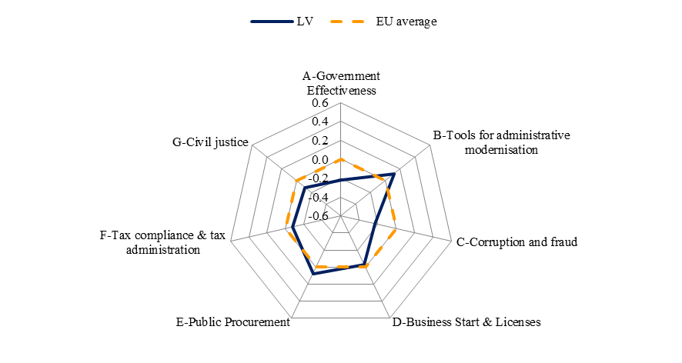
Source: WIFO

Recent studies suggest that the informal economy is quite sizeable in Latvia, considerably larger than in peer group countries, and concentrated in sectors like construction, services and retail. The government is stepping up its efforts: after several initial delays, the Action Plan to Combat Shadow Economy is being implemented; the law on reporting undeclared income has been adopted recently. However, the law on lobbying has not been adopted yet and regulatory processes are still exposed to political capture by private interests. According to the 2012 Report of Transparency International, the protection of whistle-blowers is still piecemeal, as the current legislation does not provide adequate protection for those who report on cases of bribery or abuse of office.

As for the efficiency of civil justice, Latvia performs worse than the EU average: while the time needed for the enforcement of contracts – 369 calendar days – is significantly lower than the EU average, the cost for the enforcement of contracts is notably higher than the EU average, the time needed to resolve insolvency significantly exceeds the EU average, and the independence of the judiciary is well below the EU-benchmark. In general, Latvia’s weak corporate governance structure generates a high number of business disputes, thus hurting its competitiveness. There is a large backlog of proceedings in the first and second instance courts in civil and commercial cases, especially as regards contractual obligations. While the authorities are working towards improving court infrastructure and the efficiency of procedural law, there is a need to further strengthen judicial independence as well as the professional performance of judges, especially regarding knowledge of EU law. The amendments to the Insolvency Law decreased the duration of the insolvency process from three years to one year and one month and the costs of insolvency were cut to half the previous amount; however, the law has some loopholes, for instance in terms of possibility of appeal and further improvements are being discussed.

While the first electronically registered enterprise was created in 2010, the one-stop-shop e-registration for companies is not fully operational. The government intends to introduce the one-stop-shop in the registration of real estate and real estate property rights. While the government is planning to have approximately 150 e-services in 2012, only 46 have been introduced on the portal latvija.lv; the platform is not very user-friendly, very few services are available in English, and entrepreneurs seem to have little knowledge that it actually exists. At the same time a good example is the Electronic Declaration System (EDS), which allows the submission of declarations, reports and tax calculations to the State Revenue Service (SRS) electronically; it is currently possible to submit 95 % of all the reports and declarations foreseen in normative acts.

In terms of public procurement, there are significant delays due to long tendering and appeal procedures. The number of applying SMEs is still low, as rules seem to be targeting bigger enterprises. While the government plans to introduce a one-stop-shop for local government services, the Plan for Improving the Application of the Electronic Procurement System and the guidelines for local government procurement are still not fully implemented. According to the 2012 Report of Transparency International, a large proportion of contracts are still awarded using negotiated or restricted procedures, which can reduce competition and protect certain interests.

The new Construction Law was supposed to reduce the time necessary to obtain construction permits to 69 days and the approval of architectural specifications to 6 procedures, but it has been delayed in Parliament at the second reading stage. Nevertheless, the Cabinet of Ministers approved changes to the General Construction Guidelines, which reduced the deadlines from 30 days to 10 days. However, it is still necessary to visit 11 institutions in person in order to obtain a construction permit.

3.13.7. Conclusions

In order to improve its competitiveness and move further towards a knowledge-based economy, Latvia could benefit from a further strengthening of the growth potential of its economy through a range of structural reforms. Particular attention could be paid to the following: promote a coherent industrial policy, further improve public procurement and the performance of public administration, continue to reduce the administrative burden, and improve the absorption of EU funds.

While the support for microenterprises is considered a best practice, the business environment could be further improved by encouraging companies to innovate and better exploit the resources offered by universities, improving access to finance, creating a more competitive environment, increasing the supply of high-skilled labour and improving (re)training schemes. Moreover, Latvia would benefit by promoting greener growth through continuing to improve energy efficiency and increase the share of renewables, and modernise the infrastructure, including roads, railways and public transportation. Finally, cooperation opportunities in the Baltic region could be exploited in a more fruitful way.

3.14. Lithuania
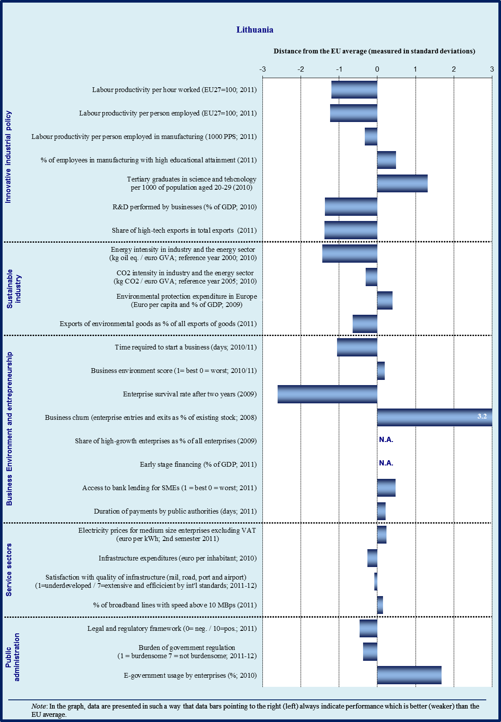

Sectoral specialisation of manufacturing – Lithuania (2009)
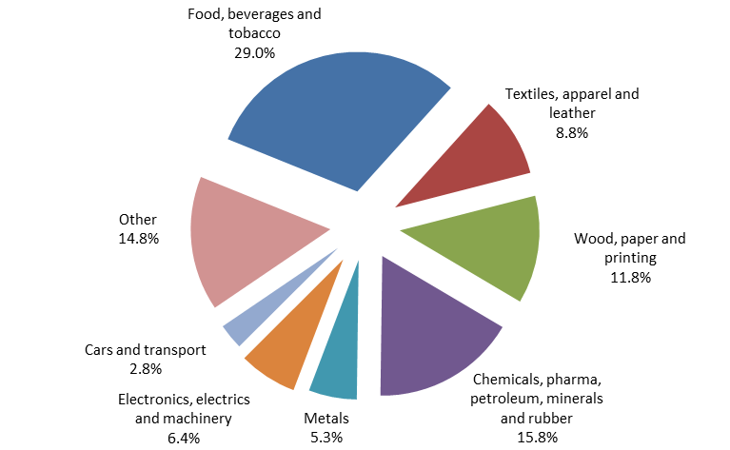
Note : No data available for sectors C12 (tobacco products) and C19 (coke and refined petroleum products)
Source: Eurostat

3.14.1. Introduction

Lithuania has a large manufacturing sector accounting for 20.4 % of value added compared to the EU average of 15.5 %. The economy is specialised in market-driven manufacturing industries (e.g. food products); medium-technology sectors (chemical products); and labour-intensive industries (e.g. wood and furniture products). Exports include both low-to-medium technology sectors (e.g. mineral products) and medium-to-high technology sectors (e.g. chemical products and textiles). Partly on account of its industrial structure, Lithuania’s R&D intensity is below the EU average, although the share of high value added production is increasing and the country is moving towards exports with higher added value.

Lithuania belongs to the group of ‘catching up’ countries. Closing the gap with better performing economies is hindered by competitiveness and business environment weaknesses. Lithuania experienced a strong real effective exchange rate appreciation over the last decade which led to a partial loss in price competitiveness. However, an internal correction has occurred since 2008 and export markets have been diversified. While labour productivity has increased over the same period, it is still significantly below the EU average. An important challenge for Lithuania is to continue to raise productivity to catch up with regional peers. Increased investment in research and education would be beneficial, in this respect, as well as a business environment that fosters more innovation.

3.14.2. Innovative industrial policy

The Lithuanian economy compares poorly against other EU member states based on the Innovation Scoreboard 2011 indicating that it is only a ‘modest innovator'. Lithuania is comparatively weak in the categories of ‘open, excellent and attractive research systems’, ‘linkages and entrepreneurship’, ‘intellectual assets’, and ’innovators and economic effects’. In particular the crisis has contributed to a strong decline in innovative SMEs collaborating with other enterprises and in license and patent revenues from abroad. Lithuania has the lowest share of knowledge intensive services in the EU. Annual R&D expenditure has remained stable since 2004 at around 0.8 % of GDP. This has the potential to hamper the development of high-technology industries and can lower long-term growth potential. Lithuania has set an ambitious target to raise annual R&D expenditure to 1.9 % of GDP per annum by 2020. This would require a significant effort on the part of the private sector and national authorities and the private sector.

At the policy level, co-ordination has improved. The Lithuanian Strategy for Innovation (2010-2020) has drawn together separate initiatives aimed at increasing innovation, including those aimed at strengthening support infrastructure; developing institutional capacity; improving cooperation between academia and the private sector, raising human capital and promoting innovative public procurement. Lithuania is also continuing to reform its science base, in particular through the development of five integrated Science, Research and Business Centres (‘Valleys’). Lithuania has introduced financial incentives, including R&D tax credits and innovation vouchers, in order help businesses procure R&D services and contract technical feasibility studies from universities and research institutes.

The main policy challenge remains to significantly increase the level of government R&D funding. The efficiency of financial support could also be improved by targeting those scientific areas where Lithuania is most competitive. To develop human capital, entrepreneurship programmes should be widely introduced into higher education curricula, and more incentives should be provided for academic researchers to cooperate and collaborate with enterprises. On the demand side, obstacles should be progressively removed to support the creation and development of innovative companies, and public support should be considered for prototyping, feasibility studies and start-up financing.

3.14.3. Sustainable industry

The energy intensity of Lithuania’s industry is twice the EU average. To comply with the EU Climate Change regulation, Lithuania is required to restrict the rise in carbon dioxide (CO₂) emissions to 15 % between 2005 and 2020 in the non-EU ETS sectors, but based on current trends CO₂ emissions are set to rise by more than 20 %. Action is required to improve the efficiency of household heating, particularly in apartment blocks, and the emission-intensive transport sector. Waste management could also be improved: 86 % of municipal waste is landfilled, and Lithuania has one of the lowest re-cycling rates, at 11 % (in 2010 5 % of municipal waste was recycled domestically and 6 % abroad), in the EU. Finally, Lithuania’s energy infrastructure would benefit from more competition and greater interconnectivity in order to bring down energy prices and better support economic development.

Lithuania has made limited progress with respect to improving the energy efficiency of buildings; only an estimated 1 000 buildings have been upgraded through the EU supported JESSICA Holding Fund. The government introduced a new version of the Multi-Apartment Building Modernisation Programme in December 2011 but it is more modest than its predecessor and is not likely bring about significant efficiency gains. Although additional financial support is foreseen for renovation projects with strong energy saving potential, the targeted number of projects has been reduced. Other aspects of energy policy may also affect the success of the programme. Lithuania currently applies a 9 % reduced VAT rate to residential heating and subsidies are provided to low-income households to cover increases in energy prices; both of these measures reduce the incentives to improve residential energy efficiency. Given that there are more than 30 000 apartment blocks with very low energy efficiency, greater efforts are needed to bring about significant gains in energy saving. This could also imply a review of fiscal incentives.

3.14.4. Business environment

Lithuania’s slipped two ranks to twenty-seven in the 2012 World Bank’s Doing business report. Despite this marginal decline of Lithuania’s comparative ranking, several measures have recently been implemented to improve the business environment, described below and in the section on public administration.

In order to improve operating conditions for businesses, the government raised the VAT registration threshold, from LTL 100 000 to LTL 155 000, and the threshold up to which firms are eligible for 5 % profit tax, from LTL 500 000 to LTL 1 million. With respect to tax administration, an electronic declaration system was introduced enabling the direct on-line submission of documents, and an electronic VAT return system was established allowing companies to apply electronically for their VAT return on goods/services acquired in other EU countries. A new law on the restructuring of enterprises was introduced on 1 October 2010 providing more favourable conditions for enterprises experiencing financial difficulties, offering an enterprise the possibility of restructuring in order to avoid bankruptcy.

Credit to enterprises started to rise again in the last quarter of 2011 after declining since 2009 when the credit bubble burst. This proved to be temporary, as it declined again in 2012 and lending remains low due to continuing deleveraging and persisting uncertainties in the economic outlook. Foreign owned banks, particularly subsidiaries of Swedish banks, play an important role in the financial sector: foreign subsidiaries manage nearly 90 % of bank assets, of which over two thirds are controlled by the three largest banks.

The banking system was badly hit by the financial crisis, and required action taken by the Lithuanian authorities and support from the foreign parent banks. Financial soundness indicators have gradually improved since the crisis although the number of non-performing loans remains high. Weak demand and a lack of good projects appears to be restraining lending rather than supply constraints, and the government continues to support financing for SMEs through the EU structural funds. The venture capital market is embryonic and not a significant source of finance for SMEs.

3.14.5. Services sector

The services sector is the largest sector in the Lithuanian economy making up just under two-thirds of GDP and attracting around a half of total FDI. The Lithuanian Government has set a strategic goal to become the Northern European Service Hub by 2015, when services are expected to make up around a half of Lithuania’s exports. One of the most important sub-sectors is information and communication technologies (ICT); Lithuania has well-developed ICT infrastructure which has helped it attract business outsourcing services from some of the EU’s largest corporations.

The Lithuanian tax system suffers from a significant degree of tax evasion; administrative efficiency could also be improved. The size of the shadow economy is estimated to be larger than the EU-average. There is also a large VAT compliance gap (i.e. the difference between VAT receipts and the theoretical net VAT liability for the economy given the VAT rate structure) implying substantial lost revenue. Administrative costs per unit of tax revenue are relatively high and the time taken for businesses to pay their taxes could be reduced by improving administrative procedures.

The Lithuanian government has recently adopted a comprehensive tax compliance strategy and a programme of measures for 2011-2012. Cash registers have been introduced for food products in markets and border controls have been strengthened. These measures are bringing results, helping to improve tax compliance and administrative efficiency. However, further steps are still needed to reduce the size of the large shadow economy, which is acting as a drain on public finances.

3.14.6. Public administration

Lithuania’s scores considerably below the EU average for overall public administration performance, as measured by the World Bank’s Government Effectiveness Indicator, and below the EU average on the use of tools for administrative modernisation (e-government, impact assessment, performance and service orientation, accountability). The latter is due to relatively lower availability of business related e-government services as well as shortcomings in the application of modern and flexible human resource management tools for public service employees. Lithuania also scores well below the EU average on corruption, in particular due to many reported incidents of corruption when dealing with public administration: 27 % of respondents in Lithuania compared the 10 % EU average.

On starting a business and licensing, Lithuania performs broadly in line with the EU average. The costs of starting a business are lower than the EU average while the procedure for obtaining licenses is comparatively more complex. After recent reforms, the time taken to set up a business is only slightly more than the EU average. On public procurement, Lithuania performs better than the EU average including lower costs incurred and less time taken to apply for tenders.

Tax compliance and tax administration is slightly better than the EU average; the time necessary to prepare and file tax returns in Lithuania is 175 hours per year and administrative costs of taxation are 1.18 per 100 units of revenue collection, compared to EU averages of 208 hours and 1.32 units, respectively. On efficiency of civil justice, Lithuania scores similar to the EU average. Although the time taken to enforce contracts is much less, the costs are slightly higher than average. Beyond that, the perceived level of judicial independence is significantly lower than the EU average indicating greater vulnerability to the influence of members of government, firms and citizens.

Overall profile of public administration
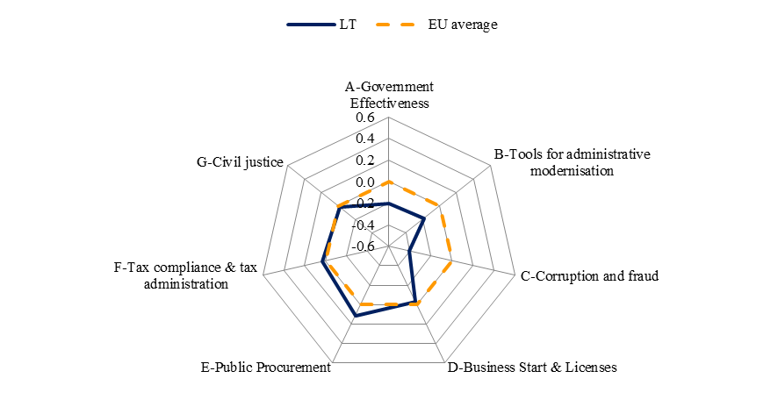
Source: WIFO

The government has undertaken several recent initiatives aimed at improving public administration. The authorities have taken measures to reduce the administrative burden on enterprises. The target for administrative burden reduction is 30 % by 2012. The authorities estimate that if current legislation is approved the administrative burden will be cut by around 27-28 %. The authorities are undertaking a major regulatory reform project aimed at streamlining business inspections, which are currently carried out by more than seventy public institutions. The reform aims to produce legislative acts and guidelines on inspections with a view to reducing their frequency, making them less burdensome and more targeted. The number of inspection agencies will also be reduced through consolidation. Checklists are being introduced to standardise inspections, inspection agencies are being encouraged to introduce risk-assessment systems and telephone consultations. The Ministry of Economy and the Ministry of Justice are closely coordinating the reform process, so that usage of these tools becomes standard practice for inspection agencies.

Start-up conditions for enterprises have been improved: the estimated number of days required to start-up a company has been reduced as well as the associated costs. The time to register a Private Limited Company (PLC) as a VAT payer was reduced from 6 to 3 days. In 2010, legislation was implemented making it possible to register a PLC online, which usually takes around 1 day. The associated costs of registering a PLC were reduced from LTL 773 to LTL 254 – (approximately 67 %). If a PLC is registered online no notary approval, which normally taking 2 days and costs LTL 500, is required, and there is the possibility of opening a bank account with the minimum required capital. Overall, the number of procedures was reduced from 6 to 3, and the time for PLC registration reduced from 22 to 6 days. There has also been some improvement in the delivery of construction permits: the number of procedural requirements was reduced from 15 to 13 and the time to deal with construction permits was reduced from 142 to 71 days.

3.14.7. Conclusions

Lithuania has taken action in several areas in order to boost competitiveness while the economy still faces a number of important challenges. Efforts should be made to significantly increase the level of R&D spending in order to encourage greater innovation; support should also be targeted in the scientific fields where Lithuania is most competitive. In relation to the goal of promoting innovation, the reforms to higher education system should also help to match the demand and supply of skills. There is a need to further develop entrepreneurial skills. Lithuania’s energy infrastructure would benefit from more competition and greater interconnectivity in order to bring down energy prices and better support economic development. There are also improvements to be made in energy efficiency.

Although measures have been taken to improve tax compliance, the Lithuanian tax system still suffers from a high degree of tax evasion which is a drain on public finances and holds back public spending in growth enhancing areas. Administrative efficiency could also be improved. The Lithuanian authorities have introduced recent reforms in public administration which will improve the environment for businesses. The reform of the state owned enterprises should be completed and further efforts should be made in areas where Lithuania compares less favourably against EU peers.

3.15. Luxembourg
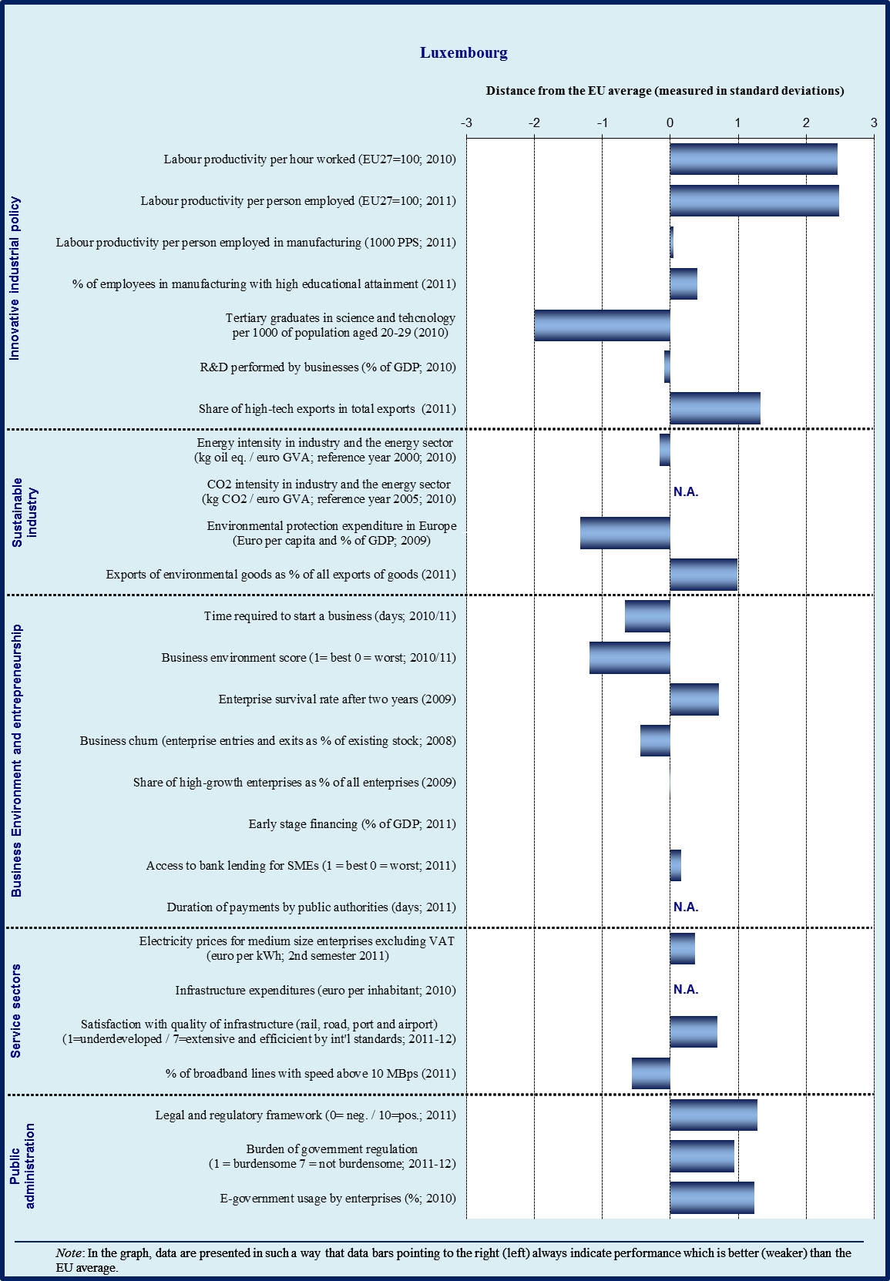

3.15.1. Introduction

Manufacturing plays a less important role in the Luxembourg economy than in other Member States, as it accounts for only 6 % of added value in the economy. Luxembourg specialises in mainstream manufacturing industries (rubber products) and capital-intensive industries (basic iron and steel, cement, basic non-ferrous metals). It also has technology-driven industries (radio and TV transmitters). Manufacturing production recovered in 2010 after the crisis, when it fell around 33 %, but has again declined since the second quarter of 2011, especially with a number of important iron and steel plants temporarily closed.

Luxembourg belongs to the group of higher-income Member States with specialisation in labour-intensive industries, which is due to the very low value-added contribution from technology-driven industries and innovation-intensive sectors, as well as to its mixed quality performance.

Cost competitiveness of the Luxembourg economy remains a challenge because of high nominal unit labour costs. These continue to increase faster than in the neighbouring Member States, especially in manufacturing, mostly because of low productivity growth. Luxembourg has temporarily modified the automatic indexation of wages by a minimum interval of 12 months between each revision round. However, from 2015 onwards the automatic indexation will again be applied.

3.15.2. Innovative industrial policy

The Innovation Union Scoreboard 2011 ranks Luxembourg as an innovation follower with innovation performance above the EU27 average. Relative weaknesses remain in firm investments and linkages & entrepreneurship. Relative strengths are in human resources and innovators. Open, excellent and attractive research systems, finance and support and intellectual assets are well above average.

Luxembourg has made substantial efforts in developing research and innovation policies and has made good progress in its transition towards a more knowledge-intensive economy, for example by strengthening links between higher education and businesses.

The project ‘Cité des Sciences’ (City of Science) is a practical implementation of a concept of the ‘triangle de la connaissance’ (the knowledge triangle), aiming at reinforcing relations between research, education and innovation. The project progressed well in 2011, the objective being to host on one site all the major public R&D institutes of Luxembourg, as well as private and start-up companies, a new technical school, an university campus, the National Archives and cultural centres. Under the ‘Biotec’ initiative, two institutes have been established: Integrated Biobank of Luxembourg (IBBL) and the Luxembourg Centre for Systems Biomedicine (LCSB). In autumn 2011 LCSB opened on the site.

Programmes like ‘ATTRACT’ and ‘PEARL 2008-2013’ of the National Funds for Research (FNR-Fonds national de la recherche) aim at attracting and keeping researchers in the country, were allocated EUR 3.8 million for the years 2008-2010. A further EUR 13.7 million is foreseen for 2011-2013. In 2011, the ‘Aides à la Formation-Recherche’ programme 2008-2013 of the FNR supported 442 young researchers in their PhD studies, and 106 in their post-PhD studies.

National efforts on R&D concentrated on limited number of priority fields notably through the CORE programme 2008-2013 of the FNR. In 2011, the programme funded 28 projects for EUR 16.2 million.

The Luxembourgish portal for innovation and research provides a guide on support for innovative projects and setting up innovative businesses. The start-up innovative firms may call for subsidies or loans, for example an equipment loan (‘crédit d'équipement’) and a start-up/takeover loan (‘prêt de création-reprise’). Special aid targets apply for small enterprises or small private research organisations which were created less than 6 years.

The 2012 National Reform Programme confirmed the targets for R&D spending (by 2020: 2.3-2.6 % of GDP, with 1.5-1.9 % from the private sector and 0.7-0.8 % from the public sector).

Though Luxembourg aims to concentrate R&D efforts on a limited number of priority fields, especially through the CORE program of the FNR, it seems that they are not selective enough to allow critical mass to be gained in all the domains identified.

3.15.3. Sustainable industry

According to a mid-term report on the implementation of the National Energy Efficiency Action Plan (September 2011), the intermediary target of 3 % for 2010 has been achieved. The 9 % target by 2016 could be reached, if all measures that are so far proposed and planned would be timely implemented. Luxembourg intends to continue the support for upgrading the energy efficiency of old buildings and the construction of energy-efficient new buildings.

Reaching the 11 % target of renewable energy sources in final energy consumption by 2020 (2.7 % in 2009) will be challenging. Therefore, the timely implementation of cooperation mechanisms (for an amount estimated by Luxembourg to 0.5 to 3.5 TWh) with other Member States will likely be necessary. Luxembourg imports the major share of its electricity and is totally dependent on imports for gas. Further interconnections with neighbouring countries could foster import of electricity from renewable sources and foster security of supply for gas. The reflection is ongoing on investment in electricity and gas infrastructure. A 10 % share of renewable energy in the transport sector is planned to be attained by 2020.

The most challenging objective, however, is the national target for the reduction of greenhouse gas emissions for sector that are not included in the EU emissions trading scheme (ETS). The tareget reduction is -20 % by 2020, when compared to 2005 levels. In order to reach the target, it is expected that Luxembourg will need to either design additional policies reducing greenhouse gas emissions or make use of costly flexibility mechanisms.

There are currently four voluntary agreements signed between the Government and companies from non-ETS sector which aim to improve energy efficiency in the participating industrial companies by 1 % per year. In March 2012, the Luxembourg authorities also announced a plan to increase the share of electric vehicles to 10 % of the car park, with the objective of reaching 40 000 electric cars by 2020. Subsidies for the purchase of electric cars have increased, while CO₂ thresholds for subsidies for the purchase of low-emission automobiles have been lowered.

With regards to eco-technologies, it should be emphasized that the 240 new aid applications motivated by Luxinnovation between 2011-2013 refers to not only those under the law dated 5 June 2009 for promoting RDI, but also covers those submitted based on the law dated 18 February 2010 on the protection of the environment and the rational use of natural resources. However, the country experiences lack of the critical mass and visibility with regard to eco-technologies. Therefore there is intention to set up an action plan defining priorities for development in specific areas. It is worth mentioning that Luxembourg has a high share of high-tech exports in total exports, and the share of environmental goods appears to be one of the highest in the EU (1.62 % of all exports of goods in 2011).

3.15.4. Business environment

Lending conditions have remained restrictive after the continuous tightening in 2007-2009. Nevertheless, credit tightening has been less pronounced in Luxembourg than elsewhere in the euro area, and SMEs continue to enjoy reasonable conditions for access to finance. It seems, however, that there were fewer requests for bank loans in 2011 than in previous years.

A set of different loan schemes for enterprises continue to apply (equipment loan; start-up/takeover loan) as well as a ‘vaccin anti-crise’ which provides counselling services to companies suffering from financial difficulties.

Luxembourg has several entrepreneurship schemes, including on female ambassadors, business mentoring, young entrepreneurship (including activities like an innovation camp), and a TV programme called ‘success Stories’.

The transfer of business are continuing to apply through the Companies Exchange based at Chamber of Commerce and Chamber of Trade and Crafts, for transfer of business and putting buyers in contact with sellers and through the Cross-border Companies Exchange, for selling and transfer companies in France, Luxembourg and Belgium.

In addition, with regard to the impact of legislation on enterprises, a simplification programme 2010-2014 is being implemented. A form to assess the impact of each legislative measure on businesses has recently been amended in order to simplify it and add SME and gender tests to the form. Issues on administrative burden can be signalled through a dedicated website of the Simplification Department of the State Ministry.

3.15.5. Services sector

The institutional competition framework was modified by the law on Competition in October 2011. Two competition bodies were merged into a single Competition Council, which is independent of the executive power. The Council must now be consulted on any draft law or regulation which may affect competition, namely leading to quantitative restrictions, exclusive market zones or standard pricing and sales practices.

New legislation was adopted in September 2011 on simplified administrative procedures for the development and operating conditions of classified establishments, notably by introducing some tacit authorisations and an obligation for the administration to respect specific deadlines.

3.15.6. Public administration

According to the World Bank’s Government Effectiveness Indicator (EU-wide average is calculated without Malta), in terms of overall public administration performance, Luxembourg is well above the EU average. Perceptions indicate a high quality of public services and a high quality of policy implementation.

The take-up of e-government services by citizens and enterprises is one of the highest in Europe (67 % and 90 % respectively). One-stop-shop and e-government services are multilingual and available to businesses mainly through the ‘Guichet Enterprises", which is one of the two main sections of a national website ‘Guichet.lu'.

‘Guichet Enterprises’ is edited by the two ministries in partnership with the Chamber of Commerce, the Chamber of Trade and Crafts and the Business Federation Luxembourg (FEDIL). The information is structured around the life cycles of a company (creation, exploitation, R&D, environment, international trade, etc.). The website also offers the possibility to download forms and to submit them online and electronically signed to the competent administration. Though not all business related e-government services are already available online, this website for businesses is an example of good practice. It is also worth mentioning that firms or those who consider setting up a company are entitled to free legal advice at the Chamber of Commerce and the Chamber of Trade and Crafts (the membership to these Chambers is mandatory but they are highly subsidised by the State).

Overall profile of public administration
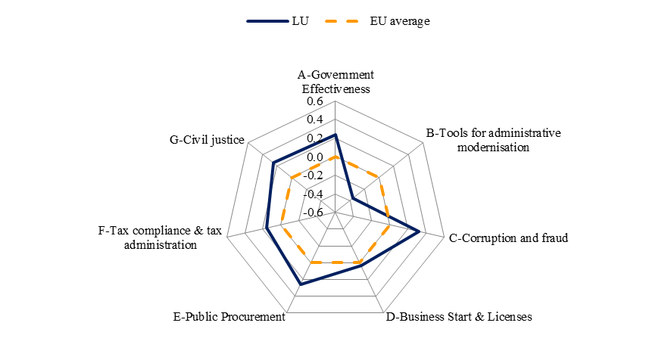
Source: WIFO

The time required to start up a company in Luxembourg is above the EU average (19 days in 2011 against the EU average of 6.5 days), but this score is balanced by a high enterprise survival rate after two years which places Luxembourg at the third position among Member States.

Corruption indicators show a better performance than the EU average. Performance is especially good regarding irregular payments and diversion of public funds which both occur almost never.

Tax regulation in Luxembourg is identified as one of the best performing in terms of administrative burden, especially thanks to the very short time to prepare and file tax returns and to pay taxes (59 hours per year as compared to the EU average of 208 hours). The structure of the Luxembourg tax system, in terms of the share of total revenue raised by the different taxes, is also relatively favourable to growth. Almost one third of tax revenue is raised from consumption taxes. Both capital and labour taxation are among the lowest in the EU.

In terms of efficiency of the civil justice system, Luxembourg is more efficient than in other Member States, mostly because lower costs and shorter time to enforce contracts, which are about half the EU average.

The performance of Luxembourg in the field of public procurement is also well above the EU average. Contracts below the thresholds are subject to specific procedures with lighter requirements. The cost for firms per competition, expressed as a per cent of per capita GDP is particularly low in Luxembourg (0.08 % compared to 0.19 % in the EU). A national procurement portal where publication of tenders is mandatory provides for a wide dissemination of procurement opportunities to potential tenderers and also for the electronic download of tender documents.

In order to enhance the efficiency of the public administration in the above areas, the reform of public administration is in preparation, notably in view of increasing the efficiency of public services.

3.15.7. Conclusions

Luxembourg scores well in the overall competitiveness of its economy. It however faces decreasing productivity gains and increasing unit labour costs, which may harm the long-term potential of its economy. Luxembourg also faces the challenge of achieving its national target for the reduction of greenhouse gas emissions.

Good progress was made towards a more knowledge-intensive economy, for instance by implementing the knowledge triangle project (education, research and innovation) and by strengthening links between higher education and businesses. However, the domestic absorption capacity of research and innovation results is limited, and further prioritisation of research and innovation activities would be necessary.

Important measures have been adopted in order to improve the business environment, for instance through the simplification of administrative procedures. As a whole, the performance of public administration is better than the EU average.

3.16. Hungary
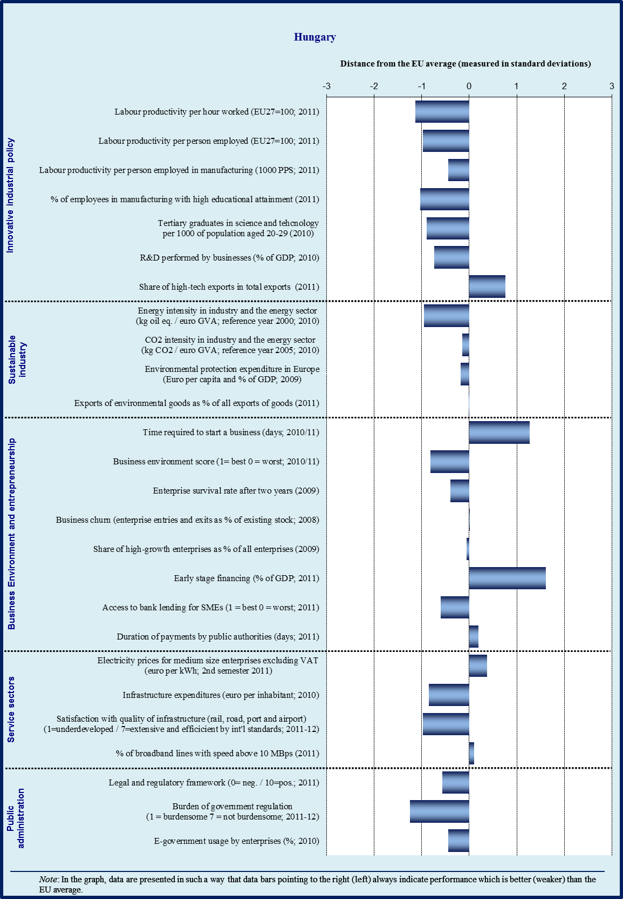

Sectoral specialisation of manufacturing – Hungary (2009)
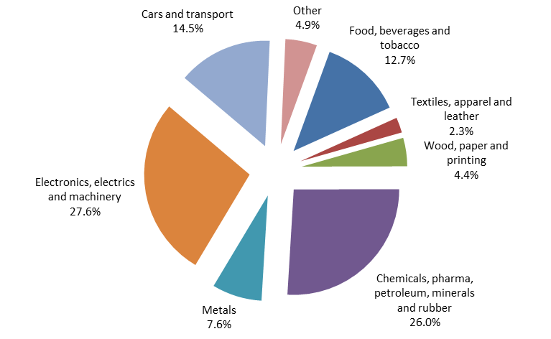
Source: Eurostat

3.16.1. Introduction

The manufacturing sector plays a more important role in the Hungarian economy than in the EU on average. The value added in manufacturing accounted for 24.3 % of the total value added in 2011 at current prices (EU25: 15.5 %). About 21 % of the total workforce is employed in this sector (EU27: 15.2 %). Hungary is specialised in technology-driven industries (production of transport equipment, computer, electronic and optical products, food, and machinery equipment) both in value-added and export terms and in capital-intensive industries (petroleum refining). With respect to services, wholesale and retail trade, real estate activities, transportation, and information and communication are the most important market services in the Hungarian economy.

Cost competitiveness of the Hungarian economy deteriorated over the last decade, as reflected in the increase of the real effective exchange rate. Labour productivity per hour worked increased again slightly after the crisis, but it is still about 40 percentage points below the EU average – in manufacturing the gap is much smaller. After a rebound from the trough of 2009, there has been a stagnation in industrial production since early 2011. Exports of manufacturing goods have contributed significantly to the GDP growth for several years.

3.16.2. Innovative industrial policy

Based on the Innovation Union Scoreboard 2011, Hungary belongs to the moderate innovators, representing a below average performance. As most important weaknesses the funding of innovation, the number of innovative SME businesses, the insufficient inter-company cooperation in the area of innovation and a low patent activity have been identified. On the other hand, human resources and economic effects, such as medium-high and high-tech product exports are considered as relative strengths. The 2012 country-specific recommendations for Hungary called for providing specific targeted incentives to support innovative SMEs.

The Government elected in 2010 identified science and innovation as priorities in the New Széchenyi Strategy Plan. The STI system went through a reorganisation in 2010-2011. Currently, the resource allocation and strategy making responsibilities are separated at ministry level which makes the system somewhat fragmented. This organisational instability affects policy formation negatively which is well reflected for instance in the significant delay of the New Innovation Strategy (2013-2020) and the reduced public support for innovation purposes.

Among the negative developments it should be mentioned that the budget of the Research and Technological Innovation Fund - the main domestic financial source to support RTDI activities - was blocked. The two most important revenues of this fund were the contributions from medium and large enterprises and the government central budget (which has not been in place any more since January 2012).

Similarly to some other NMS, the Structural Funds represent a dominant share of research and innovation policy financing. Currently, the largest support schemes are provided in the frame of the Economic Development Operational Programme (EDOP), where the main form of funding is through non-refundable grants: most importantly support to market-oriented R&D activities, cluster development, cooperation between research institutes, universities and enterprises etc. should be mentioned. Other financial tools are also in place for innovative enterprises, such as microloans, guarantees and venture capital schemes under the JEREMIE scheme of the Structural Funds.

Partly due to the changes in the funding system, negative developments can be observed in public R&D financing: total R&D appropriations (GBAORD) decreased significantly in 2010 (0.36 % in 2010 vs. 0.47 % in 2009). Public R&D expenditure accounted for 0.44 % of the GDP in 2010, which is lower than in the two previous years. On the other hand, mainly due to the rising R&D activity of large multinational enterprises, business expenditures on R&D grew significantly during the 2000s and reached 0.69 % of the GDP in 2010. (EU27 %: 1.23 %). Nonetheless, the total R&D expenditure didn´t grow on yearly basis (in 2010: 1.16 % relative to GDP) and is still far from the national Europe 2020 target (1.8 %).

Patent activity in Hungary is relatively low in European comparison. In contrast, considering another R&D output indicator, Hungary performs well above the EU average in terms of high-tech exports. However, this performance is mainly linked to the activity of foreign multinationals. Innovation activity is largely concentrated at these companies and in the most advanced regions. While in the EU 30 % of SMEs innovate in-house, in Hungary less than 15% do so. The ratio of innovative SMEs collaborating with others is also small in international comparison; however this showed a slight increase last year.

The industrial strategies (comprising 12 sectors, including automotive, electric, medicine, industry logistics etc.) prepared by the Ministry for National economy last year, recognize the importance of R&D in these fields and emphasize actions in this context.

In Hungary, similarly to the majority of the European countries, also limited attention is paid towards demand –side innovation. Alhough there have been some initiatives in this area, for example the pre-commercial procurement initiative, no concrete support measures have been launched yet.

Also in terms of human resources for R&D and innovation Hungary faces some bottlenecks. The share of science and technology graduates increased gradually from the middle of the 2000s, however it is still well below the EU average (in 2009: HU: 7.5 %, EU27: 14.3 %). The higher education reform, which takes effect as of 1 September 2012, ensures significant increase in the number of students in the fields of technical, information technology and natural sciences in the coming years.

3.16.3. Sustainable industry

Environmental sustainability of the Hungarian industry is poor. The energy intensity in industry has decreased but it is still relatively high in European comparison. In the last decade high growth can be observed in resource productivity, however significant efforts are still needed to ensure more efficient material consumption. The share of renewable energy (estimated at 8.79 % in 2010) sources in gross inland energy consumption has also grown during the last decade and exceeded the national target (7.4 % in 2010) and the trajectory of growth suggests meeting the 2020 target (14.65 %).

The new National Energy Strategy 2030 was adopted in 2011 and provides guidance in resolving energy challenges.

Measures in this policy domain can be divided into three groups. The first set of measures is designed to reduce greenhouse gas emission. Hungary´s Decarbonisation Pathway 2050 is currently under public consultation. It will determine the proposed schedule for greenhouse gas emissions by 2050. This pathway will be part of the National Climate Change Strategy (2008-2025), which is currently under review. The wider use of environmentally friendly modes of transport, such as development of fixed track transport is supported by the Transport Operational Programme co-financed from EU funds.

The second set of measures aims to increase the share of renewable energy sources. The regulatory environment for the feed-in tariff system for renewable sources is expected to change in 2013. The Government intends to reallocate resources from the Transport Operational Programme (TOP) to the Environment and Energy Operational Programme (EEOP) in order to launch new calls for investments in renewable energy sources.

Third, the energy efficiency programmes provide non-refundable sources for business and households, as well as public institutions in order to reduce their energy costs. Similarly to the second set of measures, Hungary asked the reallocation of sources for this target under the Cohesion and Structural Funds. Thanks partly to the EU co-financing environment protection expenditures in the manufacturing sector have increased in the recent years.

3.16.4. Business environment

Access to finance

According to the Global Competitiveness Report 2012, access to finance has been the main bottleneck for Hungarian enterprises. This can be explained by several factors. Firstly, the credit supply has decreased significantly since the crisis. Tight credit conditions and high interest rates hamper SMEs to receive loans from commercial banks. On the other hand, partly due to the unfavourable business climate in general, demand for credit has been also decreased.

In order to restore normal lending to the economy several actions have been taken in the past two years. The Széchenyi Card programme, extended in 2011, provides credit-card based, low-interest loans for micro-, small- and medium enterprises. Interest and guarantee fee subsidies are also offered. So far more than 150 000 cards have been issued with a credit line of about EUR 3.5 billion, and in 2011 the contracted amounts increased by more than 8 %. Other financial tools such as the micro credit programme for start-up companies and loan guarantee programmes have been also quite successful. The Hungarian Development Bank provides sector-specific direct loans and guarantees, e.g. for the agriculture and the food industry.

Among the most positive developments the reallocation of the sources available from the EU Structural Funds in favour for SMEs should be also mentioned. The JEREMIE programme was modified during the course of 2011 in order to reach better leverage effects. New calls are available in the area of venture capital. As a result of this, investments financed from venture capital more than tripled in 2011. New, combined microcredit calls offering non-refundable grants (maximum of HUF 10 million) combined with credit (maximum of HUF 20 million) to micro-enterprises are also available.

Regulatory and support environment

Institutional aspects rank high among the most problematic factors for doing business in Hungary. The low level of economic confidence is linked to a number of considerable changes in the policy environment and legal and institutional systems. Hungary is clearly below the EU average on business environment indicators, such as the legal and regulatory framework.

The high administrative burden on enterprises, such as the wide range of reporting obligations and other requirements have negative effects especially on SMEs. The administrative burdens on the private sector amount to 10.5 % of the GDP, which is almost three times higher than the European average. Yet, clear progress has been recorded in the recent years. For example, the costs of starting a business dropped from over 100 % of income per capita in 2002 to under 10 % in 2011. In general 4 days is needed to start up a company, which is very close to the target set by the Council in 2011. However, costs of establishing a business have remained high (about EUR 400). Although in the average number of days to get licences Hungary performs better than the EU average, it is still far from the best performing Member States.

In order to further improve the business environment a comprehensive programme was launched in 2011. The Simple State programme is expected to ensure administrative burden reduction on enterprises by 25 % by 2012, in total worth of some HUF 500 billion. It contains 114 measures in ten areas of intervention. Some of the measures have been applied already and the bulk of the measures will have been implemented by the end of 2012. The Government set up a high level committee led by the Minister of Public Administration and Justice that monitors the progress. An assessment on the impacts of the first measures is not yet available, however the first evaluation should have been prepared already. This might suggest a slowdown of reform efforts in this area. The country-specific recommendations of 2012 call for measures to reduce the administrative burden.

3.16.5. Services sector

While manufacturing is dominant in the Hungarian economy, the service sector plays an increasingly important role in terms of value added and employment, especially in information and communication and business services.

Regarding network services, the electricity and gas sectors have been liberalised. The market share of the largest generator in the electricity sector is above 40 %, in the gas sector it is above 30 %. Yet, import of electricity increased significantly during the 2000s, while domestic production didn´t grow. This implies regulatory and competitiveness problems of the domestic electricity market. Increase of the cross-border capacities of the electricity network would ensure independence of the energy regulator.

Several postal services remain significantly shielded from competition, particularly in the letter mail segment, despite gradual market opening introduced by the Postal Services Directives and implemented by the Postal Act in Hungary. The full opening of the postal market is scheduled for 2013, but it should be noticed that to achieve the full benefits of liberalisation, a considerable amount of commitment and market monitoring is required.

The Hungarian telecom sector is characterised by strong infrastructure based competition driven by bundle offers from the incumbent and cable operations.

The Hungarian telecommunications sector is characterised by competition driven by bundle offers from the incumbent and cable operators. The structure of the mobile market has been stable with the incumbent Magyar Telekom’s subsidiary having a 45.3% share in 2011. In 2012, a fourth mobile operator, state-backed consortium called MPVI Mobil, received its license. Incumbent telephone operators (Magyar Telecom, Invitel, UPC) hold a strong position in the fixed line market, but competition is increasing. Especially cable operators provide products that are substitutes to fixed line services. Intensified competition has led to the share of ‘voice over internet protocol’ operators to reach 18% at the end of 2010.

Competition is lacking in many professional services and is under threat from new regulations. Among the Member States included in the OECD regulatory index on professional services, Hungary is ranked fourth from the bottom. Despite the judgment of the Court of Justice, Hungary has rejected the demand to abolish the nationality requirement for notaries. The roll-back of pharmacy liberalisation has also been announced recently, and in general the government seems prone to support measures protecting domestic incumbents.

Regarding the retail sector, Hungary has temporarily imposed a general ban on the establishment of new large-scale retail stores (above 300 m²) until 31 December 2014. Exemptions may be granted on a case-by-case basis by the relevant minister, based on the advice of an interdepartmental committee.

3.16.6. Public administration

Public administration reform is essential in Hungary, since the effectiveness of the government has been rather poor in international comparison. In terms of overall public administration performance, the score of Hungary is considerably below the EU average. In addition a continuous decline can be observed since 2006. Perceptions indicate a lower quality of public services, policy formulation, its implementation and the credibility of public servants’ commitment to such policies.

A significant gap can be observed for the indicator of tools for administrative modernisation (e-government, impact assessments, performance and service orientation, accountability) in comparison to other Member States. For instance, four out of the eight business-related e-government services haven’t been yet fully implemented. The use of e-government services has remained slightly below the EU average. In addition, reliance on tools for modernisation of human resource management such as the implementation of flexible modes of public employment is also low.

Corruption is also considered as a problematic factor in Hungary. According to the Government Effectiveness Indicator bribery is still a major issue with a share of 20 % of respondents reporting an incidence whereas the EU average is only 10 %. For this reason the Government approved and launched a new anti-corruption programme on the integrity approach with the involvement of all partners.

Tax regulation in Hungary is identified as one of the main problematic factors. For the business sector, the time it takes to prepare, file and pay corporate income tax, value added tax and social contributions is 277 hours per year. According to the ʻWorld Bank Doing Business 2012ʼ, on average firms need to make 13 tax payments a year. On the other hand, Hungary’s tax administration operates more efficiently than the EU average. The Simple State administrative burden reduction programme aims to improve electronic tax submission and reduce the number of tax obligations.

A new public procurement law was adopted in July 2011 with the aim of streamlining the rules making the framework more transparent. The law also aims to improve the chances of SMEs to successfully participate in the public procurement procedures. However, the requirement that small-value contracts are exclusively reserved for SMEs seems to break Hungary’s WTO commitments and harms competition.

Hungary also exhibits a slightly better score in terms of payment delays from public authorities than the EU average. The same holds true for the indicator of starting business and licencing.

In terms of efficiency of civil justice Hungary shows a performance marginally above the EU average. Whereas costs and time necessary for the enforcement of contracts are significantly lower than the EU average, in terms of the perceived level of judicial independence Hungary’s judicial system is assessed as less independent compared to the EU average.

Overall profile of public administration
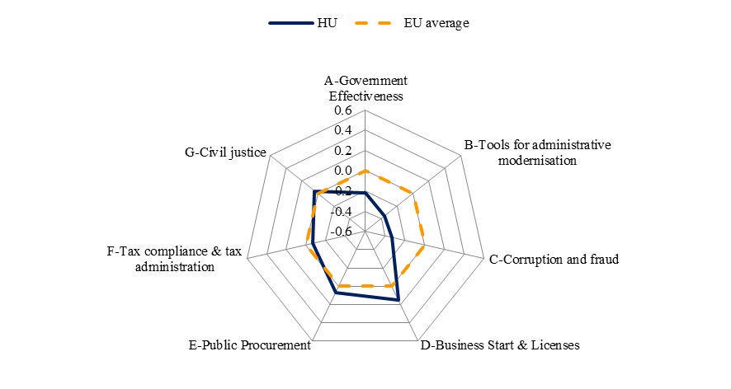
Source: WIFO

In order to enhance the efficiency of the public administration in the above areas, several initiatives have been launched recently. After the change of the government in 2010 as a first step, the total number of public administrative bodies was reduced significantly, mainly through integration. The Magyary Programme launched in 2011 initiated several measures to improve the efficiency of the public administration sector. For instance, it simplifies administration for citizens, including establishment of one-stop shops for citizens, it introduces an anti-corruption programme and develops a new career model for public servants. Electronic government is considered a key tool for modernising the Hungarian public administration. In order to support official administration with IT solutions, provide remote and electronic access to services and create comprehensive customer identification and delivery system several projects have been launched in 2012. Further developments will be gradually implemented from 2012 on.

3.16.7. Conclusions

Several factors harm the industrial competitiveness of Hungary. These include tight credit conditions, in particular for SMEs, low level of innovation in SMEs, weak competition in certain services, and low effectiveness of the public administration.

While there have been positive developments in some of these areas (government sponsored SME financing, adopting a National Energy Strategy, decreasing the administrative burden and increasing the government’s effectiveness), frequent changes in policy, and legal and institutional systems have created an unpredictable economic environment for enterprises, which reduces investment and growth. It also reduces the ability of the financial sector chanel savings to the most productive uses.

In addition to the urgent need to create a stable and predictable economic policy framework, further efforts are required in a number of areas including the reform of public administration and in reducing the administrative burden. Access to finance for SMEs also remains a major challenge. To achieve the Europe 2020 targets of R&D investment, and employment, policies that create a more business-friendly environment, and support for innovative SMEs are also essential.

3.17. Malta
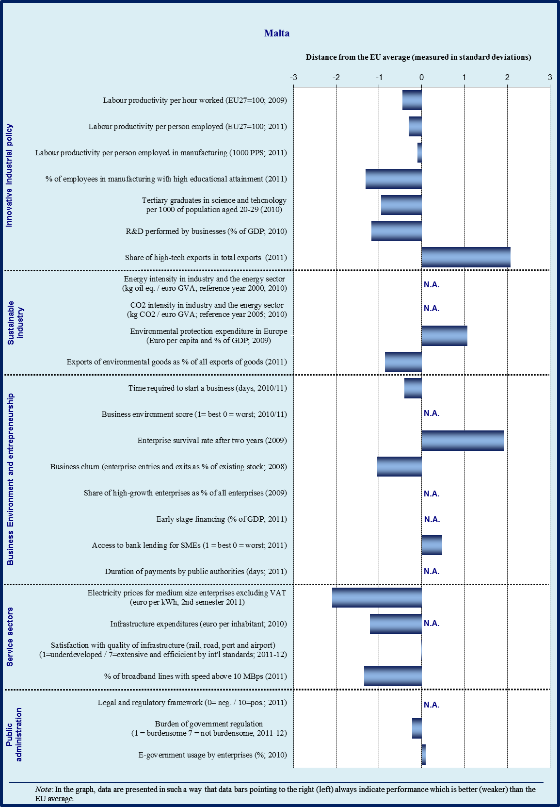

3.17.1. Introduction

Over the past decade, the Maltese economy has diversified from manufacturing to services. The manufacturing share of value added decreased from 22.4 % in 2000 to 12.9 % in 2011, although some segments of it recorded significant growth, in particular pharmaceuticals (chemical products above) and the aviation maintenance industry (transport or electrical equipment, and other manufacturing above).

The services economy, traditionally dominated by tourism (about one third of GDP) is now significantly more diversified as other activities are growing among which financial intermediation, business services (including auditing and legal services), entertainment (film production), on-line gaming and other computer-related activities. Export market shares in a number of these emerging industries are also increasing.

Growth in Malta is strongly driven by foreign investment and exports. Thus improving external trade as well as a pickup in business investment contributed to a strong rebound in economic activity in 2010, after a relatively mild GDP contraction in 2009. In 2011 as a whole, real GDP is estimated to have expanded by 2.1 %, compared to 1.5 % in the euro area.

The performance of the Maltese economy is conditioned by competitiveness challenges. The authorities are aware that efforts towards attracting more investment in high value-added activities (including in manufacturing) are a key to improve Malta’s productivity record. Growth relies strongly on SMEs (73 % of value-added in 2010, against 58 % for the European Union) for which access to finance, access to foreign markets, enhanced entrepreneurial skills, operating in a business-friendly environment, as well as efficient relations with public administrations are essential ingredients of prosperity.

3.17.2. Innovative industrial policy

Health and biotechnology, value-added manufacturing, environment and energy resources and ICT were identified as national research priorities in Malta’s National Research & Innovation (R&I) Strategic Plan 2007-2010.

One of the largest projects aimed at fostering life science innovation in Malta is the BioMalta campus. This EUR 38 million project is co-financed between the Government of Malta, Malta Enterprise and the European Regional Development Fund (ERDF). It will seek to attract foreign direct investment into research, technological development and innovation in the biotechnology and life sciences sectors as well as support the development of the local industrial community helping them to grow and internationalise. It is also aimed at creating a knowledge cluster. Investment is backed by a business angel investment fund working closely with the University of Malta and with Malta Enterprise as well as by a Malta-based private investment fund.

3.17.3. Sustainable industry

The Maltese economy heavily depends on oil supplies for the provision of energy, which is an issue for the competitiveness of Maltese businesses. Electricity prices for medium to small size firms in Malta are among the highest in the European Union. To improve the situation, the country-specific recommendations of the 2012 European Semester for Malta include the need to prioritise the completion of the electricity link with Sicily.

The interconnection to the European Energy Grid via the laying of a submarine cable linking Malta to Sicily was originally expected to be completed by August 2012. The project has been delayed for administrative reasons and the new target for commissioning the interconnector is end 2013.

The completion of the Delimara power station extension project by May 2012 was delayed essentially due to permit procedures. The project is expected to supply the expected electrical output power to the Maltese electrical grid in the summer of 2012.

Malta intends to achieve its 2020 renewable energy targets through a couple of identified major projects of large scale wind, and waste to energy projects. However a great share of renewable energy will be generated from a relatively higher number but smaller capacities of renewable energy sources distributed across all the Maltese Islands. The contribution from photovoltaics could potentially be much larger than that estimated in the National Renewable Energy Action Plan especially if the costs of this technology continue to decrease.

3.17.4. Business environment

Malta is engaged in a number of structural reforms and measures that foster the importance of SMEs in order to enhance growth and competitiveness.

Malta’s Small Business Act

Malta is one of the few EU countries that have enacted a Small Business Act (SBA – in June 2011, within a package of Euro-Plus pact measures). Parts of the Act that are now into force include the setting up of an Enterprise Consultative Council (EEC), created with the aim to hold a regular dialogue between the regulatory authorities and business organisations in order improve the business environment, particularly for SMEs. The setting up of the EEC has been welcomed by business organisations. They regard it in particular as a potentially effective tool to improve access to markets to SMEs, provided that it can meet regularly and take the time to take into account specific sector-related issues. In the view of government authorities stakeholders should be proactive in defining the agenda of the Council. In promoting the role of SMEs, The Malta envoy has a natural key role to play in it.

Parts of the Act still having to come into force include (i) a vetting of all new proposed legislation to identify potential impact on enterprise and suitable measures taken to mitigate or remove any identified negative impacts especially on the smaller firms, as far as possible ("SME test") as well as (ii) time compliance with new legislation (standstill period of eight weeks between the publication and the coming into force of such legislation).

These two proposals are expected to come into force in the third quarter 2012. The implementation of the SME test requires putting in place an independent entity which would assist government authorities in analysing and interpreting the economic impact assessment of new legislation, - in particular mitigating possible negative effects on SMEs and minimising administrative burden - taking into account consultation with SME representatives. The central entity has been set up and has been given a wider role as indicated by its name – Small Business Act Implementation Unit – although the main role will be that of overseeing and assisting in the application of the SME Test.

Stakeholders have welcomed the forthcoming introduction of the SME test from which they expect substantial improvement towards more business friendly legislation.

Consultation exercises with stakeholders on new legislation

In 2011, Malta also introduced guidelines for the Maltese public administration for consultation exercises with stakeholders (Directive no. 6 ‘Consultation Exercises with stakeholders in terms of Article 15 of the Public Administration Act). The Directive makes reference to the document ‘Parameters for Consultation Exercises with Stakeholders’ which stipulates that each new secondary subsidiary legislation text is to consider its effect on SMEs. This action is backed by an on-going training programme for public employees in consultation exercises and the Maltese impact assessment framework.

Access to finance

SMEs in Malta can be considered to have adequate access to finance. Business representatives commend government for coming up with a good portfolio of enterprise support schemes that facilitate access to finance, such as micro finance, loan guarantees and JEREMIE.

The Micro Credit Scheme (another commitment under the Euro Plus Pact), facilitates the financing of new start-ups through the provision of a government guarantee of up to 90 % of the total loan value.

In addition, through the MicroInvest tax credit scheme (also a Euro Plus Pact commitment), enterprises benefit from a tax credit of up to 40 % (with a limit of EUR 25 000) when investing in innovation implementing compliance directives and/or expansion, including through new hires. The take-up of the scheme so far has exceeded expectations and this has been linked to the low level of bureaucratic requirements. Following its success, the scheme has been extended to the end of December 2012. It is flanked by a number of other financial instruments including a micro-guarantee scheme.

Under the JEREMIE initiative, a First Loss Portfolio Guarantee instrument that caters for loans from EUR 25 000 to EUR 500 000 was launched under an agreement signed between the European Investment Fund and Bank of Valletta. JEREMIE was well received by SMEs and take-up steadily increased over time. In April 2012, about a year after the first loans were granted, total investment amounted to approximately EUR 35 million with a loan amount of approximately EUR 23 million.

The implementation of the late payments directive in Malta has been delayed due to legal issues. These delays are considered to be a serious problem by stakeholders, but last June the implementation of the Late Payments Directive (recast) in Malta was nearing completion and was to be transposed within a few weeks following submission to the Cabinet of Ministers.

Improving industrial infrastructures

With an investment of EUR 16 million, the Malta Industrial Parks (MIP) agency has started an extensive programme of upgrading works in a number of industrial zones, comprising upgrades of the road network and general service infrastructure, establishment of community facilities and the improvement of estate environment. This investment is a key requirement to the daily operations of enterprises and is expected to enhance Malta’s competitiveness as an industrial location and to sustain its growing knowledge based economy.

3.17.5. Public administration

Malta committed, under the Euro Plus Pact, to reduce administrative burden on businesses by 15 % by 2012. In this respect a number of simplification initiatives have already been implemented to date resulting in a EUR 7 million p.a. reduction in administrative burdens. Additionally, a number of further simplification initiatives have been identified.

The government is developing a Code of Practice for Regulatory Institutions so as to improve the regulatory framework and ensure more consistency and collaboration between different regulators. The Code of Practice is expected to be officially launched before the end of this year.

Court procedures on trade litigation are perceived by some business stakeholders as a bureaucratic burden for SMEs in particular.

Malta Enterprise launched its one stop shop ‘Business First’ at the end of January 2012. Apart from the schemes and services offered by Malta Enterprise, more than 50 services from various Government departments and entities are being provided through Business First (some of which though on-line forms), with the aim of facilitating the day to day operations of local enterprises, whether starting or being in operation. The authorities are committed to a delivery time frame of 10 days maximum for most cases submitted to ‘Business First”. Smaller offices are expected to be eventually opened in Gozo and at Smart City Malta.

Business representatives have welcomed the operation of this new government service which has received good feedback from its first users.

Malta already provides a number of government services on-line and has launched its next platform at the end of 2011. The Management Efficiency Unit advises on priorities for offering new services (including paying bills) on the platform.

As regards Business Statistics on Malta and most notably those on Malta’s SMEs, the situation is bad and has not improved since the last visits of the Commission in 2009 and 2010. This hampers adequate policy monitoring. A business register unit has recently been created with a view to improve data compilation and to make better use of administrative data. In addition, Malta will join the annual Doing Business survey of the World Bank in 2013.

3.17.6. Conclusions

A number of positive developments with positive feedback from stakeholders have occurred since the last version of this chapter. Delays are still experienced in a few areas (for example oil dependency) and the new services provided to businesses (Enterprise Consultative Council, one stop-shop) will have to be adjusted with time in cooperation with the stakeholders. Progress with making regulation more business friendly will have to be sustained in the coming years.

3.18. Netherlands
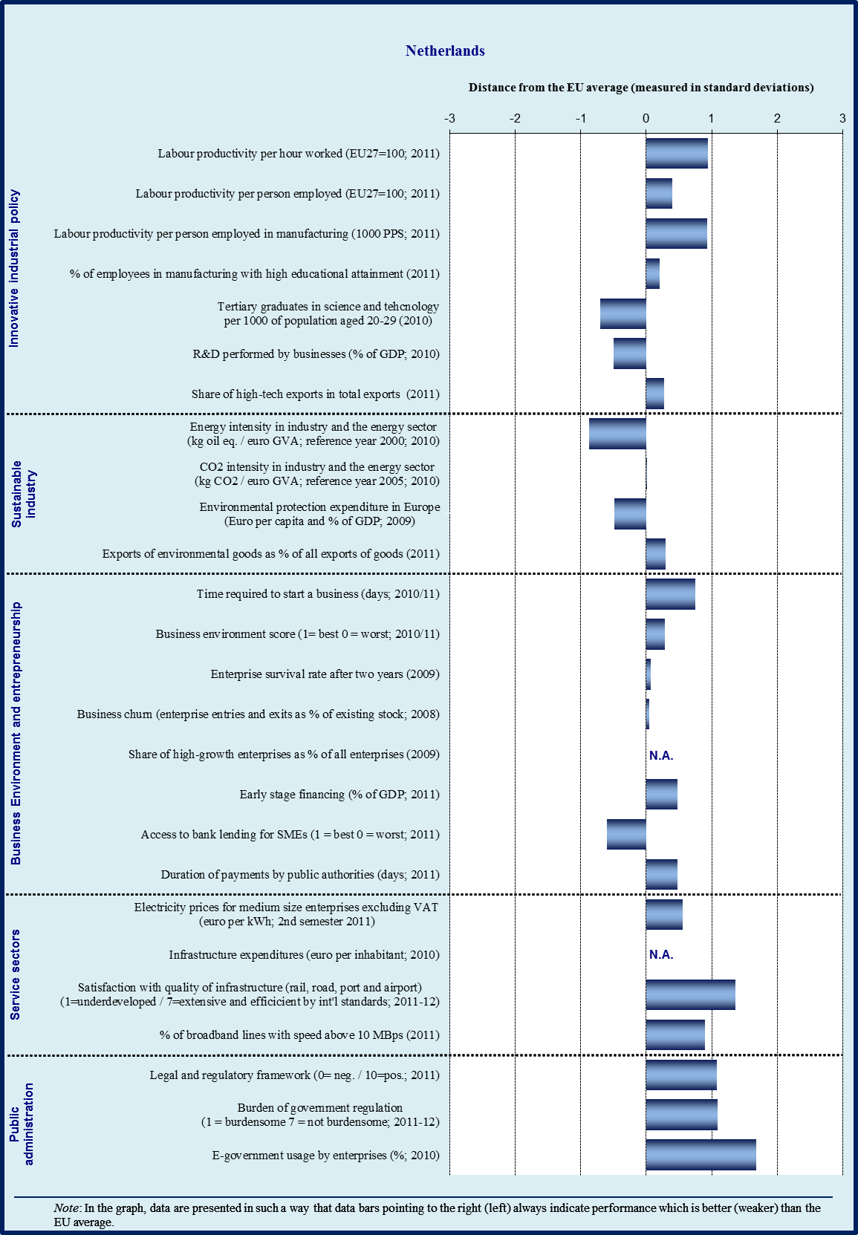

Sectoral specialisation of manufacturing – Netherlands (2009)
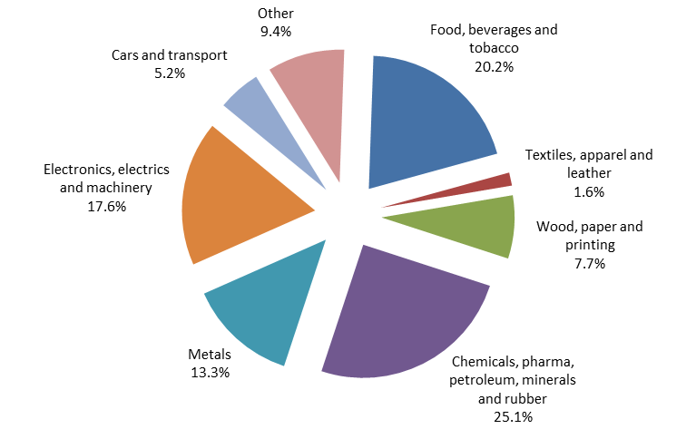
Source: Eurostat

3.18.1. Introduction

While the manufacturing sector plays a significant role in the Netherlands, with 12.9 % of total value added, it is slightly below the EU average (15.5%). The Netherlands is specialised in capital intensive manufacturing such as man-made fibres and refined petroleum as well as industries such as prepared animal feeds and tobacco. With respect to exports, the main manufacturing industries are technology driven industries such as computers, radio and TV transmitters. Other important high value added industries relate to computers, software, R&D and business services.

3.18.2. Innovative industrial policy

According to the Innovation Union Scoreboard 2011, the Netherlands is an ‘innovation follower’ with above-average performance. It excels in terms of frequently-quoted scientific publications and patent revenues from abroad. It is quickly catching up regarding non-R&D innovation expenditure. However, SMEs are still less innovative than the EU average.

The Dutch government reaffirmed its intention to reach an R&D intensity of 2.5 % of GDP in 2020, in spite of a slight cut in the public R&D budget in 2012/2013 due to gradual expiration of temporary crisis measures. The main challenge for the Netherlands is to increase private R&D expenditure.

The new enterprise policy ‘To the Top’ has three main pillars: a sectoral approach for public-private partnerships in the area of research and education ('top sector approach'), generic measures to stimulate private R&D-expenditure (tax deductions of R&D-costs as well as access to risk capital via a revolving Innovation Fund) and further administrative burden reduction and additional mechanisms for innovation.

The ‘top sector approach’ addresses a weakness in the Dutch innovation system by bringing researchers closer to businesses and putting businesses in the drivers’ seat for designing public-private partnerships for innovation. ‘Top teams’ involving various stakeholders from nine top sectors have developed sectoral ‘innovation contracts’ (including human capital agendas) which have been signed between the government, research organisations and the top sector associations in April 2012. However, a coherent rationale that would support such a sector-based approach has not been provided.

The top sector approach is promising as it could constitute a ‘smart specialisation’ strategy on the basis of the most innovative sectors which can create positive externalities for the rest of the economy. It recognises that innovation also can take place in sectors without traditional ‘white coat R&D personnel’ and fosters the economic use of publicly funded research results in market-related innovation activities. There is potential to mobilise additional private R&D funding, but the effectiveness of the approach chosen is difficult to assess at this stage.
The impacts of the top sector approach should be carefully monitored. It is important to clarify whether additional private R&D investments are mobilised, as intended, rather than a re-labelling of current R&D expenditures under the new headings of the top sectors. So far, industry has committed EUR 1.8 billion for private R&D under the top sector approach which is no more than a first step towards the 2.5 % target. It should also be monitored whether difficulties arise within fast-growing industries that do not participate in one of the ‘top sectors’. Finally, it remains to be seen whether the top sector approach will be able to address possible skills gaps. By international comparison, the Netherlands has a relatively low share of graduates in math, science and technology.

The strategy implies a 10 % shift in R&D investment to the specified themes as defined by the teams. As this approach has the potential to bring needed focus to research efforts, create cross-discipline synergies, and improve the commercialisation of research, it can enhance the societal benefits of R&D investments without endangering the long-term growth prospects of the economy.

However, the focus on top sector regions has the potential to widen regional disparities and new skills gaps could arise in other sectors. Fast-growing firms that do not fall under one of the top sectors might find it difficult to benefit from the approach. Although medium-sized enterprises are prominently represented in all top teams, it is unclear how effectively individual small and micro-enterprises will be involved.

A more general concern is whether shifting specific subsidies towards generic income and profit tax deductions for R&D expenditure is effective to promote SME innovation. Although the approach significantly reduces administrative complexity, enterprises may not generate sufficient profit to benefit from tax reductions in the same way as from a subsidy scheme.

It is particularly important for the Netherlands to continue investing in education and research. Although nominal education budgets have slightly risen in recent years, real expenditures for education are under pressure, threatening the quality of future human capital resources which are a precondition for sustainable growth.

There is close co-operation between Dutch authorities and the European Investment Fund for a pilot project involving pension funds in the provision of venture capital for innovative enterprises.

3.18.3. Sustainable industry

Environmental sustainability does not feature prominently in the policy initiatives of the current government, but the topic is officially mainstreamed in all ‘top sectors’ and taken up by the cross-cutting theme of ‘bio-economy'.

The main sustainability initiatives of the current government are (i) in the ‘top sector approach’ activities regarding the ‘energy’ sector, (ii) the specific subsidy scheme SDE+ for renewable energy investments (electricity and heat) and (iii) ‘green deals’ for energy efficiency and other environmental projects.

In the ‘top sector’ approach, SMEs confronted with a dominance of large enterprises in the renewable sector may find it hard to see how to benefit from the sectoral approach. A level-playing field between renewable energy and fossil fuels regarding sustainability criteria and indirect subsidies is absent. Currently, there is a policy debate on whether public support for Carbon Capture and Storage (CCS) technologies should be phased out to ensure that these costs are borne privately in line with the polluter pays principle.

In a broader sense, the effectiveness of the integration of environmental aspects and resource efficiency in all top sectors and in the cross-cutting theme of a ‘bio-based economy’ needs to be evaluated.

The Netherlands’ share of renewable energy in total energy use is much lower than the EU average (only 3.8 % in 2010, compared to an EU average of about 12 %). The SDE+ subsidy incentive scheme promotes the use of cost-effective technologies, including renewable sources of heat. It is meant to help the country catch up quickly with the cheapest available technology to reach about 8 % of renewables by 2015. A midterm review of the renewable energy policy is planned in 2014 and various options, including a mandatory quota system for energy suppliers, are studied by the government and in parliament. It is recognised that the current measures are probably not sufficient to reach the 2020 target of 14 % renewables.

The SDE+ scheme has a maximum of EUR 1.4 billion Euro available annually from 2015 onwards to support investment in renewables. It can also be used in the second round in 2012 to invest in renewable heat which is highly cost-effective.

Some energy-intensive or emissions-intensive sectors and activities (e.g. vans, red diesel and the partially free allocation of CO₂ emission allowances) benefit from subsidies. Phasing out environmentally harmful subsidies could improve energy efficiency, reduce emissions and increase government revenues.

A positive development is that nearly 60 ‘Green deals’ have been signed since 2011 according to the National Reform Programme 2012. The scheme has now been broadened beyond energy issues. However, a simplification of rules that would also help SMEs could be a more effective way to overcome the obstacles arising from stringent rules on environmental permits.

The Netherlands is one of the few countries in the EU with a non-negligible contribution of pollution taxes to overall tax revenue, based on a tax on pollution of surface waters and sewerage charges (0.7 % of GDP, EU27 0.1 %).

3.18.4. Business environment

Regulatory and support environment

The Netherlands ranks among the Member States with a legal and regulatory environment that highly encourages the competitiveness of enterprises. Starting a company will become even easier, once a law reducing the minimum capital requirements for limited companies enters into force, expected early 2013. Yet, the Netherlands records the second highest costs in the EU when it comes to starting a business.

Ambitious administrative burden reduction programmes are in place since 2003. Since 2007 the Netherlands gradually enlarged the scope to incorporate other regulatory costs (such as substantive compliance costs and inspection costs) and qualitative service-oriented indicators (such as ICT related measures). Inspections are now more risk-based, relaxing the frequency of controls for those enterprises which were found in good compliance in previous inspections. In 2011 the Dutch Government formally introduced one single national ex-ante framework to systematically assess substantial impacts of new policy and legislation for a better decision-making process. A new Impact Assessment Commission started in 2011 as coordination and quality control body, chaired by the Ministry of Economic Affairs, Agriculture and Innovation.

With respect to resolving insolvency, the key philosophy of the government seems to be preventive, by encouraging entrepreneurs to be cautious in their expansion plans and to set up a good credit and debit management. While this might come at the price of having less fast-growing companies, the slower growing cautious enterprises are expected to be more stable and less at risk of insolvency. In case of imminent insolvency, entrepreneurs can turn to an informal sounding board of retired entrepreneurs which offers advice to entrepreneurs in serious difficulty.

A major review of the Insolvency Act started in 2007 has not advanced much. Some stakeholders argue that the rights of creditors could be improved and that legal curators in simple bankruptcy cases are not needed because the costs are not proportionate.

An important development is the new draft SME-friendly public procurement law which has passed Parliament and is now discussed by the Senate. It encompasses all public procurement rules in one single document. A key aspect of the draft law is that SME access is made easier due to a ban on clustering smaller lots into bigger bundles, with limited exceptions. The draft also promotes the award criterion of ‘best value for money’ rather than cheapest price, which should help high-quality SMEs.

Green public procurement criteria have been revised in 2011 upon the advice of MVO, the main Dutch corporate social responsibility organisation. For simplicity, the number of environmental aspects for award criteria has been reduced from 85 to 45. The use of functional requirements instead of detailed technical requirements is encouraged, but requires qualified public procurers and evaluators. By 2015, all Dutch public authorities aim to purchase 100 % sustainable products.

Access to finance

Access to finance for innovative SMEs seems to be problematic. While the government is studying access to finance problems in detail, it is working on opening the SME loan guarantee scheme BMKB for financers other than banks, and opening the guarantee facilities GO and Groeifaciliteit to also finance new providers of SME-finance. Also a loan will be provided for the start-up of Credit Unions in the Netherlands, and the innovation fund Innovatiefonds MKB+ has been introduced, which will also consist of a fund-of-fund for the later stage market that is now under construction. A recent evaluation suggests that the scheme is very effective.

The Ministry has set up an expert group in 2011 to study key problems based on surveys among 1 500 enterprises. One key result is that more than 80 % of enterprises have no extra financing needs. Small enterprises, young enterprises and high-grow enterprises encounter problems, in particular regarding loans between EUR 500 000 and EUR 3 million. The top sector agenda should provide further insight into the sectoral problems of access to finance and may envisage sector specific solutions.

New policy ideas currently studied by the government aim to tap the potential of pension funds for venture capital. Some pilot projects with pension funds could start in 2012 while mapping credit unions and crowd financing are further ideas.

The new revolving innovation fund (Innovatiefonds MKB+) was launched in January 2012 and can provide innovation loans of EUR 95 million in 2012 (twice the amount of 2011) for SMEs and mid-cap companies. The total budget is EUR 500 million until 2015.

The Business Loan Guarantee Scheme (GO) is continued in 2012 and 2013, although initially intended as an anti-crisis measure. However, the maximum guarantee of 50 % will be lowered from EUR 75 million to EUR 25 million.

3.18.5. Services sector

Several important components of the services sector are included in the ‘top sector’ approach and therefore receive significant policy attention (e.g. energy, transport/logistics and creative industries). However, most regulation and competition policy in services is largely governed by EU legislation, including emission trading and transport liberalisation.

Competition policy in the area of electricity seems to work well in the Netherlands. Changing the supplier is relatively easy, unbundling has worked well and the information provision by suppliers to consumers is carefully supervised by the Competition Authority NMa. Still, the rate of consumers switching supplier is quite low (about 10 % per year). A review of the certificate system could lead to more innovative investment in the national green energy market.

The Netherlands has managed to maintain a very good network infrastructure and a high level of service quality in public transport, without overtly high levels of subsidies. Further, consumers have a large choice among telecommunication providers and different formulas. However, for consumers the market lacks transparency due to frequently changing service packages and prices.

The regulation of professional services is not a major bottleneck for competitiveness in the Netherlands.

3.18.6. Public administration

The overall public administration performance of the Netherlands, according to the World Bank’s Government Effectiveness Indicator, is better than the EU average. Perceived quality of public services, including quality of the civil service and policy implementation in the Netherlands is relatively high.

The use of tools to improve public administration (e-government, performance and service orientation, accountability) is more widespread than average in Member States. This is mainly due to the use of impact assessments, as well as to the use of monitoring and assessment instruments.

Corruption and fraud indicators show a significantly better than average performance. Perceptions based measures for ‘diversion of public funds’ as well as for ‘irregular payments and bribes’ indicate that corruption-related problems are very rare. This is confirmed by the individual experience of corruption, only 1 % of all cases, which is a very good score compared to the EU average of 10 %.

The composite summary indicator for the efficiency of the civil justice system is above the EU average. While the days to enforce contracts is slightly below the EU average, measuring 514 calendar days as compared to 556 days in the EU, the cost for enforcing contracts is 3.3 % higher than the EU average. The time for resolving insolvency is well below the EU average and the judiciary is considered as highly independent.

The performance of the Netherlands on the tax compliance and tax administration indicator is better than average since it only takes 127 hours yearly to prepare and file tax returns and to pay taxes as compared to 208 hours in the EU average. The administrative costs of the taxation sub-indicator are slightly below the EU average.

The Dutch tax system is rather complex, due to many possibilities for exemptions and deductions to cater for special circumstances and ensure social justice. SMEs complain that often, several rounds of questions from tax authorities need to be answered. The current administrative burden arising from the tax system is estimated to be EUR 3.5 billion annually, mainly due to VAT rules, wage taxes and income taxes. The government’s aim is to reduce this by 25 % by 2015. One step is the abolishment of seven smaller taxes from 2012/2013 onwards. Another step is the introduction of one single point of contact, with different units for SMEs and for bigger companies.

Further recent positive developments are slightly simpler income tax rules, the frequent use of digitalised tax forms, e-invoices and recycling of financial information for statistical purposes ("Standard Business Reporting"). Tax inspections will in the future be more risk-oriented.

The government is verifying whether the payments of taxes and social security contributions can be merged, to save administrative burden. This would mean that the tax authorities would in the future also collect the social security contributions. The idea of a block payment of social security contributions for all employees in one single, easy to calculate, monthly payment is envisaged for 2016.

The performance indicator for starting a business and obtaining the necessary licenses in the Netherlands is slightly below EU average, as opposed to its performance in the other indicators of the spider diagram. This is mainly due to the fact that the one-stop shop to start up a company is not fully operational. While the time required to start a company is well below the EU average, the costs are higher than the EU average. The index of total licencing complexity is similar to the EU average.

The composite public procurement index is slightly above average. The average delay in Government payments is almost 10 days less than in the EU average and the average cost per firm per competition is equally lower than the EU as a whole.

Overall profile of public administration
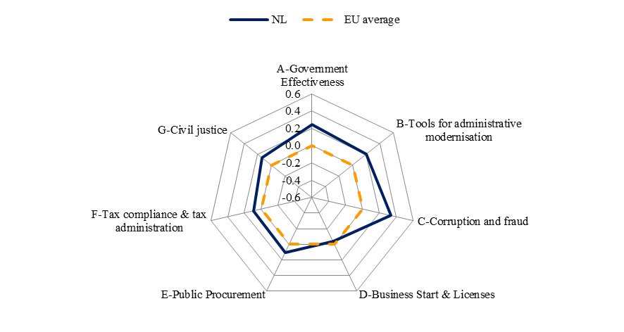
Source: WIFO

The Netherlands has a tradition of policies promoting reliability of the public administration and reductions in the administrative burden. Over the last decade, the Netherlands has been a front-runner in terms of e-government, and it scores well above the EU average in the share of business using e-government services.

Since 2010 the government has merged several ministries, centralised functions for public procurement and human resource management and improved its IT systems. In the future, a single agency (Agentschap NL) will be responsible for administrating the few remaining subsidies for enterprises. The collection of any fines for disregarding legal obligations will also be done by a single agency.

The government wants to reduce the number of public officials in central government by 10-15 % and announced further cuts in operational and programme budgets. About 20 inter-ministerial committees were set up to discuss possibilities for further streamlining and budgetary savings. Out of the total consolidation effort foreseen over the government term, at least a third will be achieved through savings in the size of the government and administration. Although this reduction has a potential for efficiency gains, it may pose a risk to retaining the high quality standards of public services.

3.18.7. Conclusions

In the area of sustainable industry, the official ambition of the government is not very high. The current measures are probably insufficient to reach the legally binding 14 % renewable energy target in 2020. A national energy efficiency target has not yet been set.

As regards short-term fiscal efforts, it is crucial to safeguard investments in long-term growth drivers like education and research from possible additional spending cuts.

Although the Dutch research and innovation system has managed to maintain and in some areas improve its innovative capacity, resting on a historically strong educational base, the underperformance of the Netherlands in private R&D expenditure may reduce future economic growth and weaken the competitiveness of the Dutch economy to an extent that cannot be offset by the use of licences and know-how transfer from other countries.

The revised policy recommendation of the Council of the European Union is to promote innovation, private R&D investment and closer science-business links, as well as foster industrial renewal by providing suitable incentives in the context of the enterprise policy, while safeguarding accessibility beyond the strict definition of top sectors and preserving fundamental research.

3.19. Austria
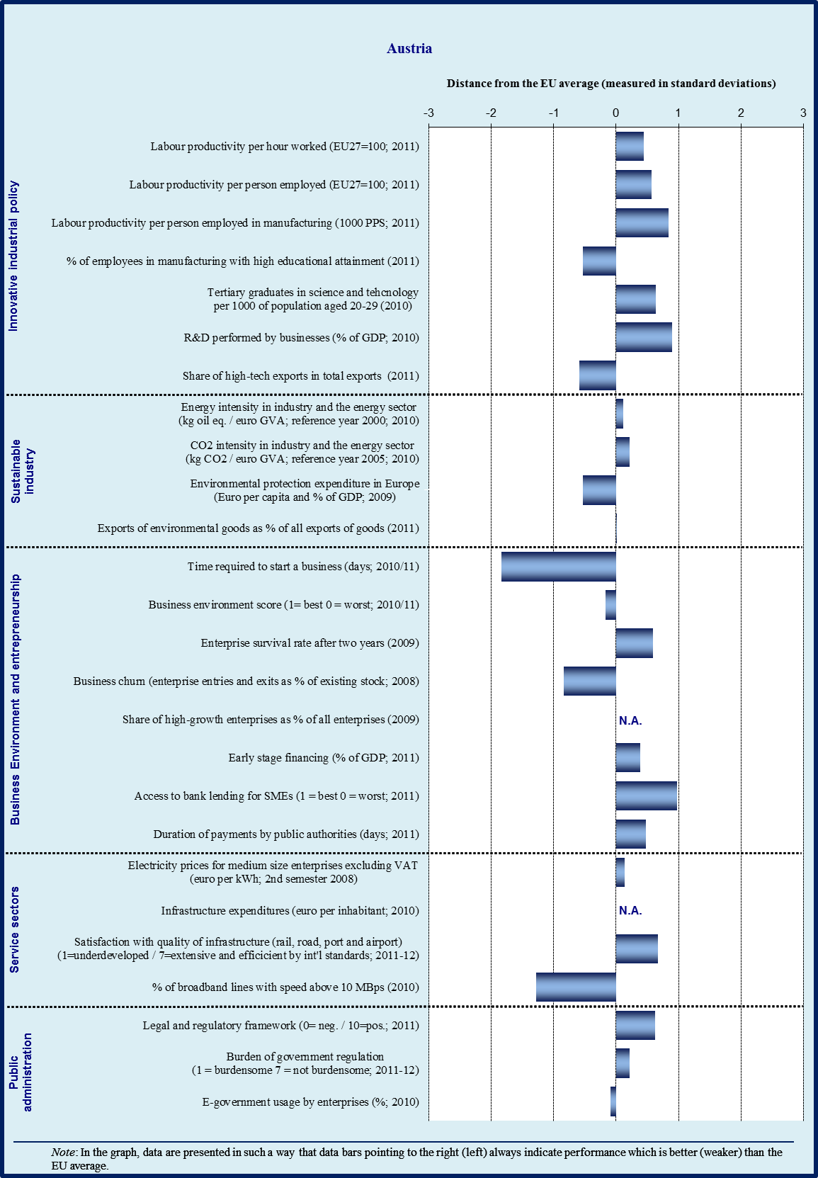

Sectoral specialisation of manufacturing – Austria (2009)
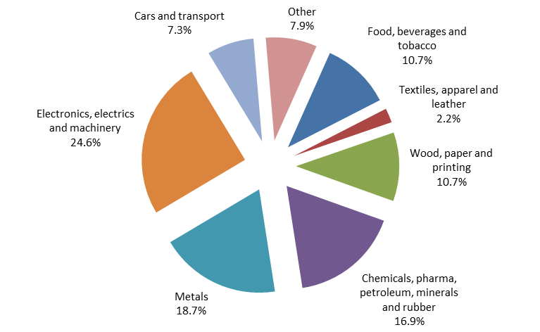
Note : No data available for sectors C12 (tobacco products) and C19 (coke and refined petroleum products)
Source: Eurostat

3.19.1. Introduction

Manufacturing contributes 18.7 % to the total value added in Austria against 15.5 % in the EU on average and labour productivity is clearly above the EU average. At the detailed manufacturing industry level, Austria features value added and export specialisation in mainstream manufacturing (manufacture of railway and rolling stock, electric motors) and labour-intensive industries (builders’ carpentry and joinery, sawmilling, machine-tools) as well as in capital-intensive industries (man-made fibres) regarding value added and in marketing-driven industries (sports goods, beverages) regarding exports. At the more aggregated sector level, Austria is specialised in highly innovation-intensive sectors such as machinery and, in exports, in medium-innovation sectors (such as wood, basic and fabricated metals), but also in sectors with low innovation and education, such as in hotels and restaurants and auxiliary transport activities. Austria’s R&D intensity considering its industrial structure is very high and its position on the quality ladder is high across industries and quality segments. Overall, Austria shows that competitiveness can be sustained in structures which are not markedly knowledge-intensive, if sectoral upgrading in terms of R&D and quality takes place, i.e. if a country moves to the knowledge-creating parts of the value chain.

3.19.2. Innovative industrial policy

According to the Innovation Union Scoreboard 2011, Austria stays an innovation follower, with a developed innovation system and an above average innovation performance.

Austria’s economy exceeds the EU average in R&D intensity. The overall investment in R&D grew from 1.93 % in 2000 to 2.76 % of GDP in 2010, which was faster than in most other EU countries. The share of private sector amounted to a remarkable 60 % of the total, including a significant portion of R&D investment coming from abroad.

The share of Austria’s innovative businesses accounts for 2/3 of total enterprises with most of them specialising in sectors demanding high and low-intermediate labour skills. After several years of incremental improvement, the number of science and technology graduates nearly reached the EU average in 2009 (14 % vs. 14.3 %). Nonetheless, Austria gradually begins to face shortage of skilled workforce and the number of researchers seems insufficient. To facilitate immigration of highly qualified labour the government introduced the so-called ‘red-white-red card’ as from July 2011. An initial analysis of applications seems to indicate a good uptake and a wide range of professions and countries of origin. Since September 2011 applicants can access information through a new migration website in German and English.

A recent measure to increase indirect public R&D expenditure is the increased tax bonus on corporate R&D investments (from 8 % to 10 %; with no conditionality of profits made through the investment) since January 2011, with an expected impact of EUR 100 million. This incentive is particularly important for the sizeable investments coming from abroad and for companies with high R&D investments relative to turnover. Another measure which is working well is an innovation voucher scheme for SMEs.

In view of the recent decline in the private sector share of R&D expenditure from 49 % in 2007 to 44 % in 2010 the relative underdevelopment of venture capital (VC) for financing innovation appears as a weakness. This seems to be the result of a strong tradition of bank financing of enterprises but also of a comparably unfavourable legal framework and fiscal treatment of VC.

In terms of governance the Austrian system suffers from a complex division of competences involving several ministries plus a number of public and semi-public agencies and bodies. A high-level inter-ministerial Task Force for Research, Technology and Innovation has been established recently to coordinate the activities of government bodies, discuss reform projects and consult stakeholders.

The strategy document from March 2011 ‘Becoming an Innovation Leader’ outlines a series of challenges of the Austrian innovation system, such as strengthening links with the education system, increasing the share of tertiary graduates, promoting high quality research infrastructure and fundamental research and using public procurement to promote innovation. The strategy addresses all major challenges and formulates feasible objectives. Though, an effective implementation and in particular a stronger prioritisation of R&D&I activities and corresponding streamlining of the governance structure will be crucial to achieve higher returns on the considerable investments.

3.19.3. Sustainable industry

The energy and carbon intensity of Austrian industry has been declining over the last decade and remains below the respective EU averages for 2010. While sectors falling under the ETS will reduce CO₂ emissions by 21 % by 2020 Austria is aiming at a 16 % reduction for the other sectors.
The key policy document to address this and other challenges in the area of energy is the national Energy Strategy from 2010 with three pillars aiming at increasing energy efficiency, energy security and the share of renewables; the latter with an ambitious target of 34 % by 2020.

The Strategy sets out a mix of horizontal and sector specific measures of regulatory, financial and information campaign nature. About 18 out of a total of 42 measures have so far been implemented. Two of the funding measures appear particularly effective: one for the ‘greening of industries’ supporting sustainable management measures in enterprises with funding of about EUR 90 million in 2011 and a reinforced and prolonged instrument for thermal insulation of residential (70 %) and industrial (30 %) buildings with an annual budget of EUR 100 million until 2014. In 2011, more than 18 000 projects (residential and industrial buildings) with a total investment volume of EUR 860 million have been funded. A key measure to increase the share of renewables is the ‘Green electricity act’ that will enter into force in July 2012.

Since October 2010 an action plan for Green Public Procurement is implemented at federal, state and municipal level. It foresees among others stronger inclusion of social criteria. There are 16 groups of procured goods and services with different criteria. They are fully applied since May 2011, e.g. for electricity.

Several environmental tax measures (increased mineral oil tax, airline ticket tax, and car registration tax reform) have entered into force recently and are expected to substantially reduce CO₂ emissions; first evaluations are expected in late 2012.

Based on a broad consultation process in 2011 and the reports of 9 working groups a strategy paper with a number of short term measures has been prepared to promote electromobility and to exploit the related opportunities for businesses and technology development in Austria. Austria has adopted in 2010 a plan on primary raw materials and recently in 2012 a resource efficiency action plan (REAP) as well on secondary resources. A challenge for its implementation is that territorial planning is a Länder competence with the latter having to integrate the mineral resources plan into their respective regional laws.

3.19.4. Business environment

Austria has a favourable business environment and scores well in the overall competitiveness of its economy. To further facilitate running a business Austria continues to implement its administrative burden reduction program after the intermediate target of a reduction of EUR 564 million has been achieved in 2010. The largest envisaged reduction measures in the pipeline to achieve the full EUR 1 billion reduction target by 2012 are the second phase of the one-stop e-government portal for businesses Unternehmensserviceportal (estimated reduction of EUR 200 million; see also below), the introduction of e-billing (making them legally equivalent to paper bills; as well estimated reduction potential of up to EUR 400 million) and the so called SME initiative including measures in trade law (e.g. establishment of a new trade register). During the second and third quarter of 2012 a package of measures should be adopted by the Government and presented to the Parliament.

The initiative on the reduction of administrative burdens on citizens is as well progressing with about one third out of 183 planned measures in implementation (i.a. on the register of births, marriages and deaths and introduction of electronic tickets for pupils for school buses). These account for a reduction of about 4.5 million hours out of estimated 8.9 million for all measures.

Austria’s SME sector resembles the EU average, both in terms of employment (67.1 %) and contribution to valued added (61.4 %). As regards its structure though, the small and medium-sized companies play a more prominent role. The business demography indicators show, on one hand, lower-than-EU-average birth and exit rate of enterprises, and one of the highest survival rates after two years on the other hand.

There is room to further improve start-up conditions. In spite of gradual reduction over recent years, the number of administrative procedures (8 among which licensing, registration, certification, announcement), minimum capital and time (28 days for a limited liability company) required for setting up a business is far above EU average for most of these indicators and would benefit from further reduction. A reform of the limited liability company has been discussed since several years but is still not proposed. It would foresee a reduction of the required (paid-in) minimum capital and of the costs for notarial certification in certain cases. Though, the announcement requirements and other procedures would remain unchanged.

In most aspects of access to finance, Austria continues to fare better than the EU average. Building upon a diverse and overall stable banking system, Austria maintains particular strengths in debt financing for SMEs. On the other hand, weaknesses persist as regards access to and supply of equity finance. The relatively underdeveloped stock market and venture capital industry do not generate sufficient alternatives of raising capital, and notably the size and depth of the venture capital market remain well below the EU average. Improving the legal framework for venture capital thus remains a challenge for 2012, e.g. by increasing the attractiveness and transparency of legal forms used for (i) venture capital funds and for (ii) investments vehicles, including measures mitigating possible tax disincentives.

3.19.5. Services sector

Austria has progressively reduced restrictions in service professions over the past years. Though, there is still room for improvement for more competition and better choice for businesses and consumers in professional service, apothecaries and some medical professions (e.g. optometrists, dental technicians). In particular possibilities to set up ‘interdisciplinary’ companies including notaries and lawyers are still limited and more restrictive than in many other Member States. Such services from a ‘one stop shop’ would offer substantial efficiency gains and reduction of transaction costs for professional and private clients. Demand for them has been confirmed by a survey conducted by the Chamber of Commerce among businesses and their associations in 2009.

In some of the network services and industries there is room for further market opening. High network access prices and distortive behaviour by incumbent firms that deter market entry, competition and innovation can still be observed. For rail freight services the degree of competition is among the lowest in the EU. As regards rail market opening, the market share of new entrants in total transport performance (December 2010) amounts to 14.6 % for freight transport and 5.8 % for passenger transport. The infrastructure manager and the incumbent rail transport operators are controlled by the same holding. The market shares of the state-owned railway carrier OeBB are still 80 % in freight and 93 % in passenger services. Similarly access to postal infrastructure still remains an issue. Considerable progress with the replacement of delivery boxes has been made and further is planned for 2012; though many such boxes are still only accessible to the incumbent operator. Competition in electronic communications would benefit from increased flexibility in spectrum management and access to spectrum.

3.19.6. Public administration

Austria’s overall public administration performance, as depicted by the World Bank’s Government Effectiveness Indicator, is well above the EU average. Perceived quality of public services, including quality of the civil service and policy implementation in Austria are high.

The use of tools to improve public administration (e-government, impact assessment, performance and service orientation, accountability) performance is slightly more intense than the average in the Member Countries. This is mainly due to the comprehensive provision of business-related e-government solutions, where Austria is well above the EU average. On the other hand, reliance on human resources management instruments such as performance-related instead of seniority pay or measures to increase the internal flexibility of the civil service, is slightly below the EU-average, i.e. Austria still follows predominantly a more traditional role of steering and managing its administrative staff.

Corruption indicators show a slightly better than average performance. Perceptions based measures for ‘diversion of public funds’ as well as for ‘irregular payments and bribes’ indicate that Austria is not free of corruption-related problems but that it still fares better than the average. As regards the individual experience of corruption (11 % of all cases), it is worse than the EU-mean (10 %), albeit only to a minor degree.

The composite summary indicators for tax compliance and tax administration are better than average. The time required for preparation of tax files is 170 hours per year, as compared to the EU-mean of 208 hours. Administrative costs of taxation in percent of total revenue amount to 0.85 % as compared to 1.32 % across the EU Member Countries.

Two composite link-level indicators show figures below the EU-average. As regards the link starting a business and obtaining licenses, this is due to especially to the longer it takes time to start up a business, as measured by Doing Business model company procedures. Although Austria already provides a fully operational one-stop shop for starting up a business, the time required to start up the model company is higher than the EU-mean of 13.7 days. While the costs of starting up are slightly below the average, licensing procedures appear to be more complex than average.

The composite public procurement index is also signalling some scope for improvement for reducing the time but especially for cutting the cost to take part in government procurements. Whereas on EU average the typical costs of taking part in a tender amount to 0.19 % of the respective domestic GDP per capita, participation in Austria causes cost of 0.26 % of GDP per capita. Payment delays of public authorities are less problematic than at the EU-average, as payment delays amount to 14 instead of 28.2 days (EU-mean).

The efficiency of the civil justice system is better than average. All sub-indicators of this link are better than the mean so that there are no notable weaknesses. For example, the time of enforcing contracts is 397 days in Austria as compared to the EU mean of 556 days. Resolving insolvency issues takes 1.1 years as compared to an EU-mean of almost 2 years.

Austria scores about average at EU level for the time needed by businesses to comply with tax obligations (67 vs. 68 hours for a benchmark model company) as well as the number of payments to be made (14 AT vs. 17 EU average). The portal ‘Finanz online’ that will be integrated in the e-Government Business Service Portal (see below for details) exists already for many years; it has been progressively extended and is widely accepted by enterprises and the public. It offers a one stop shop for all kinds of taxes for businesses and also the possibility to submit individual questions online. An example for extension is the property acquisition tax (Grunderwerbsteuer) that used to be paid via the notary and has recently been integrated in ‘Finanz online'.

While about 95 % of all taxes are calculated and raised through the federal tax administration some tax payments have to be made to the regional (Länder) or municipal level, such as the municipal tax (Kommunalsteuer).

Overall profile of public administration
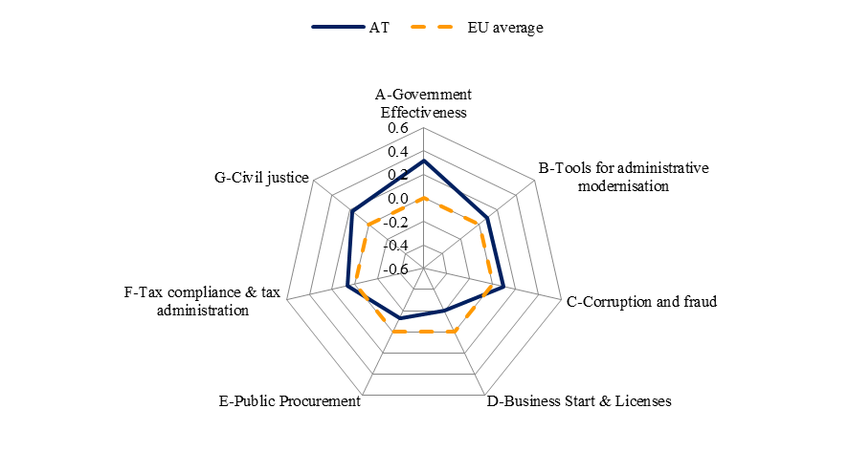
Source: WIFO

While there have been no recent initiatives for a major institutional reform to change the distribution of competences between federal and state level with a view to better aligning management of public spending and revenues there are examples of more limited reforms. The reform of the system of administrative courts was announced in June 2012. It would streamline the system to one with only two instances (9 first instance courts at state level plus 2 at federal level) with the aim to speed up procedures. The administration of long term care benefits has basically been federalised since January 2012, reducing the number of involved administrations from more than 300 (280 at state and 23 at federal level) to 8. Construction law (a state competence) remains a difficult area for businesses. In order to lighten burdens on them the procedures for construction permits and licenses for production facilities (Betriebsanlagegenehmigung) are done in parallel where possible, e.g. for construction of waste treatment plants. The planned reform of the federal competition authority (BWB) can as well be regarded as an administrative reform.

Austrian administrations offer a broad and increasing range of e-government solutions to businesses which contributes positively to the latters’ environment. Since May 2012 the e-government one-stop-shop Business Service Portal (USP) is offering its full functionality based on a single-sign-on for the most important administrative procedures at federal level, e.g. tax declarations (FinanzOnline), e-billing to federal public authorities, management of a virtual company dossier, data exchange with social insurance bodies. One focus of the next phase envisaged until 2014 is the avoidance of multiple declarations, which also contributes to administrative reform. Key advantages for businesses are also less paper use and partly direct interfaces between the USP and companies’ software. The reduction in administrative costs is estimated at up to EUR 300 million depending upon the services provided.

From 2013 Austria is planning to introduce a more comprehensive impact assessment system consisting of seven tests focusing on different types of impacts (budgetary, administrative burdens, SMEs, gender equality, consumer protection, climate change etc.). Through an IT tool which is under development all relevant test modules will be selected for a given case and the results integrated in an output report that will be attached to the policy proposal (Vorblatt).

3.19.7. Conclusions

Austria scores well in the overall competitiveness of its economy, labour productivity remains clearly above the EU average, and it need not cope with any major bottlenecks in the short run. In the context of a developed high-income country however, it faces relative structural weaknesses in some areas, which may harm the long-term potential of its economy.

The knowledge triangle (education, research and innovation) is one of the areas in need of priority action as appropriately reflected in the ‘Becoming an Innovation Leader’ strategy. A dedicated implementation of this strategy, better interaction with the education system, and more prioritised and thereby more efficient public spending in these policy areas will be instrumental to fully exploit the potential contribution of R&D to the competitiveness of its economy, and thus facilitate the structural shift towards more skill-intensive higher-value-added activities.

The favourable business environment could be made even more attractive by streamlining administrative procedures for start-ups and by increasing availability of non-banking financing.

OECD (2011), OECD Economic Surveys: Estonia 2011, OECD Publishing. http://dx.doi.org/10.1787/eco_surveys-est-2011-en, page 123-124.
A considerable number given Estonia’s size.
The World Bank Global Logistics Performance Index ranks Estonia as 43rd, weakest point being infrastructure.
http://www.djei.ie/publications/science/2011/ SSTI_Indicators_December2011.pdf .
See the chapter on Innovative industrial policy.
Energy in Ireland 1990-2010, http://www.seai.ie/Publications/Statistics_Publications/Energy_in_Ireland/Energy_in_Ireland_1990_-_2010.html .
European Commission and European Central Bank Survey of Access to Finance of Small and Medium Enterprises (SAFE) http://ec.europa.eu/enterprise/policies/finance/files/2011_safe_analytical_report_en.pdf; the Mazars SME lending demand survey commissioned by the Irish Department of Finance http://www.finance.gov.ie/documents/publications/reports/2012/mazerssme.pdf
http://www.djei.ie/publications/2012APJ.pdf .
http://per.gov.ie/wp-content/uploads/eGovernment-2012-2015.pdf .
World Bank indicator in ‘Doing Business’ — here Ireland is weighted down by the duration of the due diligence performed by the lawyers of the contracting parties. On the other hand, high-value commercial cases are dealt with by specialist judges in the Commercial list of the High Court, which can be quick.
More competitive legal services should reduce the time spent in registering property (World Bank indicator).
‘ Public Service Reform’, Department of Public Expenditure and Reform, 17 November 2011.
Entrepreneurship in Greece 2010-2011 – ‘Small’ Entrepreneurship in a period of crisis, Foundation for Economic & Industrial Research (IOBE), 2012.
http://www.weforum.org/reports/global-competitiveness-report-2011-2012 .
http://www.doingbusiness.org/reports/global-reports/doing-business-2012 .
http://ec.europa.eu/enterprise/policies/innovation/facts-figures-analysis/innovation-scoreboard/index_en.htm .
Law 4014/2011, adopted on 13 September 2011.
Second Quarterly Report (March 2012), Task Force for Greece, http://ec.europa.eu/commission_2010-2014/president/news/speeches-statements/pdf/qr_march2012_en.pdf
Law 3919/2011, in force since 2 July 2011.
Second Quarterly Report (March 2012), Task Force for Greece, http://ec.europa.eu/commission_2010-2014/president/news/speeches-statements/pdf/qr_march2012_en.pdf.
Second Quarterly Report (March 2012), Task Force for Greece, http://ec.europa.eu/commission_2010-2014/president/news/speeches-statements/pdf/qr_march2012_en.pdf. For more details, see the OECD functional review of the Greek public administration (Dec 2011).
Joint European Resources for Micro to Medium Enterprises: initiative of the European Commission together with the European Investment Fund to promote the use of financial engineering instruments to improve access to finance for SMEs via Structural Funds operations.
A growth agenda for Spain, McKinsey and FEDEA, 2009.
World Bank’s Government Effectiveness Indicator.
Commission Staff Working document ‘In-Depth Review for France’, SWD(2012) 155 final, http://ec.europa.eu/europe2020/pdf/nd/idr2012_france_en.pdf .
2011 Innovation Union Scoreboard .
Between 2008 and 2011, EUR 5.4 billion were invested in R&D projects accredited by Pôles de competitivité. On average, 900 projects have been funded each year between 2008 and 2010, with almost 800 projects being funded in 2011. During this four-year period, 2 500 innovations and almost one million patents have been generated by Pôles de competitivité.
France Brevets is a EUR 100 million investment fund specialised in industrial property. It builds upon the existing financial system of valorisation of patents. The objective of France Brevets is to enable research laboratories and SMEs to rapidly bring their inventions to market, to organise patents by technological clusters, and to make them more widely available to enterprises.
Contrary to what was observed in most Member States.
The 2010 increase has been less strong in France than in the EU on average and in comparable Member States such as Germany and the United Kingdom.
EUR 5.1 billion out of 35 can be considered to benefit to ‘green’ projects.
18 out of 71 of these ‘competitive clusters’ are specialised on eco-technologies and resource efficiency (energy and natural resources).
In particular, credit > 1 year and EUR 50 million.
The total tax rate measures the amount of taxes and mandatory contributions payable by businesses after accounting for allowable deductions and exemptions as a share of commercial profits. Taxes withheld (such as personal income tax) or collected and remitted to tax authorities (such as value added taxes, sales taxes or goods and service taxes) are excluded. Source: the World Bank http://data.worldbank.org/indicator/IC.TAX.TOTL.CP.ZS.
In June 2012, the Cypriot authorities revised the method of calculation of this figure. The new data would point to a value of 2.7%, which, although lower, is still higher than the EU average.
In 2010.
The seed and start-up capital instrument has made approximately a quarter of the investments proposed for 2010-2016, whereas the venture capital instrument has invested 21 % of the funds planned for 2010-2016. Of the mezzanine instrument launched in November 2011, 2 applications have been approved (approximately 6.3 % of the total financing). The micro-credit programme granting loans for current assets and/or investment has disbursed about 38 % of the available funds to SMEs.
See Sauka, A. and Putniņš, T. (2011), Shadow Economy Index for the Baltic countries 2009 and 2010, Stockholm School of Economics in Riga, May 2011.
Currently, there are two holding funds in operation funded by the ERDF with a total allocation of EUR 228 million, one fund administered by the EIF (EUR 170 million from ERDF) and one administered by INVEGA (EUR 58 million from ERDF). Implementation on the ground started to take off already in 2011 and further progress is expected in 2012. Based on stakeholder consultation, the products offered through the INVEGA-managed holding fund have been well received by industry.
Source : Statec.
National Reform Programme 2012, p.33.
World Bank Doing Business 2012.
Until 2012, as an incentive to encourage R&D activities firms were allowed to reduce their so-called ‘innovation contribution’ to the central budget by the amount of direct costs of in-house R&D activities, as well those of commissioned from public research and non-profit institutes, or universities financed by own sources of enterprises. It is likely that some of these activities were fictitious.
Government budget appropriations or outlays on research and development (GBAORD) are funds allocated to R&D in central government or federal budgets and therefore mean budget provisions, not actual expenditure.
Global Competitiveness Report 2012.
SWD (2012) 157, In-depth Review for Hungary.
Government Decree 1405/2011 XI.25.
SWD (2012) 157, In-depth Review for Hungary.
‘Hungary – Telecommunication Market and Regulatory Development’, DG Connect, 2011.
IMD World Competitiveness Yearbook 2011.
World Bank’s Government Effectiveness Indicator.
For businesses the figure was 71% (EU 76%), for privete citizens 38% EU : 41%).
According to Transparency International, Hungary ranks 54th out of 183 countries in the corruption perception index list. Furthermore, in 2011 no or little enforcement was reported on the progress of the OECD anti-bribery convention. .
Government Decree 1104/2012 (IV.6.)
According to the innovation contract signed on 2 April 2012 between the top sector representatives and the government: http://www.rijksoverheid.nl/onderwerpen/ondernemersklimaat-en-innovatie/nieuws/2012/04/02/innovatiecontracten-ondertekend-2-8-miljard-naar-topsectoren.html. For details see http://www.rijksoverheid.nl/onderwerpen/ondernemersklimaat-en-innovatie/documenten-en-publicaties/kamerstukken/2012/04/02/kamerbrief-over-het-bedrijvenbeleid-in-uitvoering.html and http://www.rijksoverheid.nl/onderwerpen/ondernemersklimaat-en-innovatie/documenten-en-publicaties/convenanten/2012/04/02/nederlands-kennis-en-innovatie-contract.html.
The conclusions of the Competitiveness Council of 31 May 2011 included a call for Member States to reduce the start-up time for new enterprises to 3 days at a cost of EUR 100. While the Netherlands adheres to the target to set up a company within the stipulated time frame (currently 2 days), the cost to start up a company is EUR 1 050.
http://www.rijksoverheid.nl/documenten-en-publicaties/rapporten/2011/06/20/evaluatie-borgstellingsregeling-voor-het-midden-en-klein-bedrijf-bmkb.html
http://www.ecn.nl/nl/nieuws/newsletter-nl/archief-2008/november-2008/groene-stroom/
http://ec.europa.eu/europe2020/pdf/nd/swd2012_belgium_en.pdf
http://register.consilium.europa.eu/pdf/en/12/ st11/st11275.en12.pdf
www.migration.gv.at.
Innovationsscheck.
Austria ranked 19th in the 2011-2012 Global Competitiveness Report of the World Economic Forum, and 32nd in the 2012 Doing Business Survey of the World Bank.
2012 Doing Business Survey of the World Bank; according to information provided by Austrian authorities the required time across all types of companies is 11 days.
See for instance OECD data on Product Market Regulation from 1996, 2003 and 2008.
Rail Market Monitoring Survey 2012.
As many data are unavailable, we decided to calculate EU-wide averages without Malta.
Source: Study on Excellence in public administration for competitiveness in EU Member States (WIFO, ZEW and IDEA consult 2012; not yet published).
Paying taxes Survey of the World Bank.
dito.
www.usp.gv.at .
BGBl. I Nr. 51/2012.
Unternehmensserviceportal (USP) — http://www.usp.gv.at .

