Technical Panel on Phytosanitary Treatments
26-30 January 2009
Tokyo, Japan

LOCAL INFORMATION
(Updated: 3 December 2008)

Hotel:
The meeting will be held at the “TOSHI CENTER HOTEL”, located near the Imperial Palace in the central Tokyo.
Address: 2-4-1, Hirakawa-cho, Chiyoda-ku, Tokyo 102-0093
Tel :( +81) 3-3265-8211
FAX :( +81) 3-3262-1705
Website: http://www.toshicenter.co.jp/e/index.html

Single rooms have been already booked as non-smoking rooms under your names from 25 (Sunday) to 31 (Saturday) January (for 6 nights).

Rate for room:
Single (15.5 m²):25 (Sunday) January; 10,300 yen/ night, 26 (Monday) to 31 (Saturday) January; 12,300 yen/ night
Twin (27 m²): 25 (Sunday) to 31 (Saturday) January; 18,400 yen/ night
These room rates are special price for TPPT participants including breakfast (7:00~9:30 at restaurant IRIS: Lobby floor), tax and service charge.

If you wish to change these dates or room preference, please contact Assistant organizer (yuji_kitahara@nm.maff.go.jp) before 17 December by e-mail.
Smoking rooms are available on request.

Check in time; 2:00 pm, Check out time; 10:00 am.
Entrance is open at all time at Lobby floor.
In-room amenities; Television equipped with CNN, Japanese TV programming, refrigerator, telephone, LAN cable for high-speed Internet access available at free.

Payment: Cash (Japanese yen, US Dollar and EURO), Credit Card (VISA, JCB, UC, DC, AMEX, Diners, NICOS and Master)

Conference room:
The meeting takes place at the room “708” at the 7th floor in the same hotel. Please go to the meeting room at 10:00 am on Monday, 26 January.

High-speed Internet access is available for 5 lines (wired).

Local contact:
Host; Mr. Motoi SAKAMURA
Director, Plant Quarantine Office,
Plant Protection Division
Food Safety and Consumer Affairs Bureau
Ministry of Agriculture, Forestry and Fisheries
1-2-1, Kasumigaseki, Chiyoda-ku, Tokyo
Mail Address:motoi_sakamura@nm.maff.go.jp
International call
Office: (+81) 3-3502-5978, Fax: (+81) 3-3502-3386
Domestic call
Office: 03-3502-5978, Mobile: 090-5130-0491, Fax: 03-3502-3386

Organizer; Mr. Hiroshi YOKOCHI
Assistant Director, Plant Quarantine Office,
Plant Protection Division
Food Safety and Consumer Affairs Bureau
Ministry of Agriculture, Forestry and Fisheries
1-2-1, Kasumigaseki, Chiyoda-ku, Tokyo
Mail Address:hiroshi_yokochi@nm.maff.go.jp
International call
Office: (+81) 3-3502-5978, Fax: (+81) 3-3502-3386
Domestic call
Office: 03-3502-5978, Mobile: 090-2333-1898, Fax: 03-3502-3386

Assistant organizer; Mr. Yuji KITAHARA
Officer,
Plant Protection Division
Food Safety and Consumer Affairs Bureau
Ministry of Agriculture, Forestry and Fisheries
1-2-1, Kasumigaseki, Chiyoda-ku, Tokyo
Mail Address:yuji_kitahara@nm.maff.go.jp
International call
Office: (+81) 3-3502-5978, Fax: (+81) 3-3502-3386
Domestic call
Office: 03-3502-5978, Mobile: 090-5062-9842, Fax: 03-3502-3386

Arrival at Narita Airport:
There are two terminal buildings Terminal 1 and 2 in Narita Airport, depending on air line. For your return journey after your staying, please check which terminal your flight departs from.

Transportation from Narita Airport to the hotel:
By Limousine Bus (recommended. The most convenient and economical way to access to the hotel)

Narita Airport →BUY Limousine Bus ticket to “Grand Prince Hotel Akasaka” for 3,000 yen → TAKE the bus at bus stop No.2 and No.11 in Terminal 1 or No.6 and No.16 in Terminal 2 → GET OFF at bus terminal in “Grand Prince Hotel Akasaka” and it takes 80-120minutes. → 6 minute-walk will take you the “TOSHI CENTER HOTEL” (See map 1)

Ticket counter for ”Airport Limousine Bus” is located in the arrival lobby at both Terminals of Narita Airport. After purchasing a ticket, take a bus destined for “Grand Prince Hotel Akasaka”. This bus will be stopping not only at “Grand Prince Hotel Akasaka” but at others (e.g. Hotel New Otani and Akasaka Excel Hotel Tokyu). Tickets are not available on board. Bus stop is No.2 or No.11 at Terminal 1 and No.6 or No.16 at Terminal 2.
Bus departure time at Terminal 2*;7:15, 8:20, 9:25, 10:10, 10:40, 11:10, 12:10, 13:40, 14:40, 15:40, 16:10, 16:40, 17:10, 17:40, 18:10, 18:40, 19:35, 20:35, 21:35
* Bus departure time at Terminal 1 is 5-10 minutes later than the time shown in above.
When you buy your ticket, confirm the bus stop and departure time.
Get off at “Grand Prince Hotel Akasaka”. From Grand Prince Hotel Akasaka, 6 minute-walk will take you to the TOSHI CENTER HOTEL. The map around the hotel is as follows;
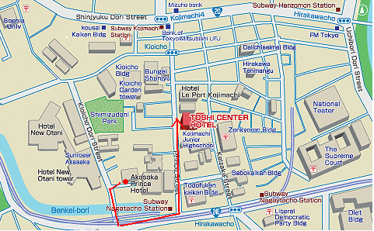(map 1)

By train

Narita Airport → BUY ticket of “Narita Express (N’EX)” to Tokyo Station for 2,940 yen at each terminal → TAKE N’EX in the JR Line* → GET OFF at Tokyo Station during and it takes aprox.60 minutes → BUY subway ticket for 160 yen after going out from JR area of underground of Tokyo Station → TAKE Marunouchi subway Line from Tokyo Station(M17) for “Ikebukuro” and then GET OFF at Otemachi Station (M18)* → TRANSFER Hanzomon subway Line(Z8) for “Shibuya” and then GET OFF at Nagatacho Station (Z04) → TAKE exit No.5 and 4 minute-walk will take you the hotel (See map 2)

*Keisei Line, which is not JR Line, serves at Narita Airport. Don’t confuse!
*A station number consists of letters representing the subway Line and a number of the station. The number is circled in RED for Marunouchi Line, in PURPLE for Hanzomon Line.

Take the JR line to Tokyo Station. Buy your reserved seat ticket at JR Reservation Ticket Offices (“Midori-no-madoguchi”). The limited express train, “Narita Express (N’EX)”, will take you to Tokyo Station in approximately 60 minutes and cost 2,940 yen.
At Narita Airport, there are two terminals depending on your flight. Each terminal has its own railway station as follows:
- If your flight arrives at Terminal 1, take a Narita Express at Narita Airport Station.
- If your flight arrives at Terminal 2, take a Narita Express at Airport Terminal 2 Station.
Train leaves every 30 minutes from 7am to 7pm and every 60 minutes from 8pm to 9pm. The time table is available at; http://jreast-shinkansen-reservation.eki-net.com/pc/english/common/timetable/e_nex_u/index.html.

At Tokyo Station, buy the subway ticket. Take the Marunouchi subway Line(M17) for Otemachi Station (M18). Then, transfer from Otemachi Station(M18) of Marunouchi Subway Line to Otemachi Station(Z08) of the Hanzomon subway Line for Nagatacho Station(Z04). Get off at Nagatacho Station (Z04). More information on the subway can be found at; http://www.tokyometro.jp/global/en/index.html.
At Nagatacho Station, take exit No.5 and 4 minute-walk will take you to the TOSHI CENTER HOTEL. The map around the hotel is as follows;
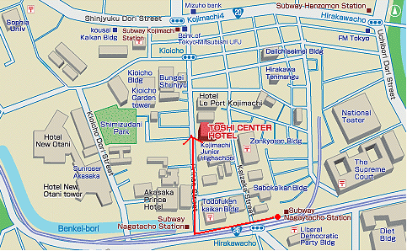(map 2)

(Option)
Transportation From Tokyo Station to the hotel:
Taxi service is available at a cost of approximately 1500-2,000 yen. It takes about 15-20 minutes. When you take a taxi, you can show the taxi driver following sign in Japanese.

Important Notice for Visa:
Visa requirements vary by nationality. Detailed information can be obtained from http://www.mofa.go.jp/j_info/visit/visa/index.html and further links from there.
For those who need Visa, please contact to Assistant organizer (yuji_kitahara@nm.maff.go.jp) before 17 December by e-mail.

Procedures necessary for getting Visa are as follow;
- Organizer will send Visa Applicants to such documents as “Letter of Reason for invitation”, “Schedule of Stay” and “Letter of Guarantee” prepared in Japan by e-mail.
- Visa Applicants need to fill out the requirements and send back to Organizer by e-mail.
- Organizer will send Visa Applicants to above-mentioned documents itself by air-mail.
- In advance, Visa Applicants need to prepare “passport”, “Visa application”, “Photo” and “Confirmation certificate of boarding ticket for an airplane”.
- When all these documents are ready, Visa Applicants may submit an application for Visa at the Japanese embassy /consulate with jurisdiction over the place of residence of applicants.

Please consult the Japanese embassy /consulate nearby for further details.
All procedures for Visa should be completed before departing your country.
Currency exchange and Banking:
The currency in Japan is called the Japanese “yen”. The value of the Japanese yen is approximately 1 US dollar = around 100 yen, but the exchange rate may change.
Foreign currency can be exchanged in banks, hotels and Narita Airport. ATMs are available in banks, Narita Airport and convenience stores. Some ATM cards may have limitation for its use in Japan. Please refer to your bank for more information.

Voltage and electricity:
100 V 50Hz (plug: A type)

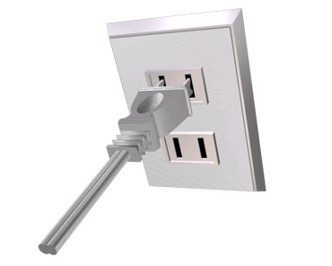

Time Zone:
GMT +0900 (JST)

Weather:
Average temperature is 2-10 ºC and dry in January. The weather will stay fine in general.

Tip:
In Japan, there is no custom to tip in restaurants or in hotels. Some restaurants charge 5-10 percent for their services.

Tax:
Five percent consumption tax is imposed on original price.

Credit Cards:
Most restaurants, hotels and shops accept credit cards. But do not at small shops. VISA and Master are the mostly available.

International Call:
You can make international call as follows;
“International Access code – 010- country code – area code – individual number”
Major telephone companies offer service through its own access code:
001 (KDDI)
0033 (NTT communications)
0041 (Softbank Telecom)
In the hotel room telephone, direct call from Japan to abroad is to dial “001 -010- country code – area code – individual number” or to dial “09” for Operator assistance.

Emergency Call:
110 for police and 119 for fire and ambulance station. No charge.

Local Language:
Japanese is the official language. English is not widely spoken in Japan.

