Sample paper - 2011
Class – XI
Subject - Informatics Practices

Max. Marks : 70 Time : 3 Hrs.

Note : Answer all the questions.
 | SECTION – A ( 20 Marks )
Q.1 | Answer the following questions : ( 5 x 2 = 10 )
 | (a) | What are the Strengths and Weakness of a Computer.
 | (b) | What are Input Devices ? Explain any three.
 | (c) | Explain the working of a dot-matrix printer.
 | (d) | Explain the various types of Operating Systems.
 | (e) | Name some port types briefly.
Q.2 | What are the differences between : ( 5 x 1 = 5 )
 | (a) | Magnetic disks and Optical disks (b) Data and Information
 | (c) | Package and Utilities (d) Firmware and Malware (e) RAM and ROM
Q.3 | Define the terms : ( 3 x 1 = 3 )
 | (a) | Kilobyte (b) Address bus (c) Adware
Q.4 | Write the full forms of the following terms : ( 4 x 1/2 = 2 )
 | (a) | OMR (b) LCD (c) VDU (d) CD - ROM
 |  | SECTION B ( 10 Marks )
Q.5 | Answer the following questions :
 | (a) | What are Identifiers ? What are the Identifiers forming rules in Java ? | 2
 | (b) | List out all the Operators in Java ? Explain briefly. | 2
 | (c) | Write a note on Java Data Types ? | 2
 | (d) | What is Type Casting ? Explain with an example. | 1
 | (e) | What will be the result of a = 5 / 3, if a is (i) float (ii) int ? | 1
 | (f) | What will be the value of expression j = - - k + 2 ∗ k . if k is 20 initially ? | 1
 | (g) | The user wants to store the values, which data type should the user take for representing.  (i) 23.197 (ii) ‘a’ | 1
1
SECTION C ( 30 Marks )
Q.6 | Answer the following questions :
 | (a) | Find the output of the following code fragments?
 |  | - int s = 14 ;  if (s < 20 )  System . out . print ( “Under“ ) ;  else  System . out . print ( “Over“ ) ;  System . out . println ( “the limit“ ) ; | 2
 |  | - int i = 3 , n = 0 ;  while ( i < 4 )  {  n + + ;  i - - ;  }  System . out . println (n ) ; | 2
 | (b) | Find out the error in the following code fragment and rewrite the corrected code with explanation.  while ( i < j ) ; {  System . out . println ( i * j ) ;  i + + ;  } | 2
 | (c) | How many times the following loop is executed ? Explain.  int x = 5 , y = 50 ;  while ( x < = y )  {  x = y / x ;  } | 2
 | (d) | Write equivalent Java expression for the following expression  √ a² + b² + c² | 1
 | (e) | Compare if and switch statements. | 1
Q.7 | Answer the following questions
 | (a) | Design a GUI, with a TextField , Label and a Button. Write the code for the Button to accept a integer into the TextField from the user and then calculate and display the factorial of a given number in the Label provided. Using do-while loop. | 2
 |  | 2
 | (b) | Rewrite the following fragment using while loop :  int sum = 0 ;  for ( int i = 0 ; i < = 5 ; + + i )  sum = sum + i ;  System . out . println ( “Sum is : “ + sum ) ; | 2
 | (c) | Rewrite the following fragment using switch :  if ( ch = = ‘E’ )  eastern + + ;  if ( ch = = ‘W’ )  western + + ;  if ( ch = = ‘N’ )  northern + + ;  if ( ch = = ‘S’ )  southern + + ;  else  unknown + + ; | 2
 | (d) | Design a GUI, with a TextField , Label and a Button. Write the code for the Button to accept a integer number into the TextField from the user and then check wither the given number is palindrome or not and display the same as “Palindrome” or “Not a Palindrome” in the Label provided. Using while loop and if-else statement. | 2
 | (e) | Design a GUI, with a TextField , TextArea and a Button. Write the code for the Button to accept a integer number into the TextField from the user and then display the multiplication table of the given number in the TextArea provided. Using for loop. | 2
Q.8 | Answer the following questions
 | (a) | 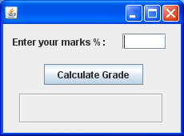  For the following GUI application. The percentage marks are to be entered in the TextField and upon clicking the Button, corresponding grade ( as per following rules ) should be displayed in the Label. | 4
  Marks Percentage | Grade
  > = 90 | A + +
  80 – 90 | A +
  75 – 80 | A
  60 – 75 | B
  50 – 60 | C
  40 – 50 | D
  < 40 | Fail
 |  | 3
 | (b) | Create a GUI application that allows the user to enter some text in a Textfield. The application has three Buttons : Move Text , Clear and Exit.  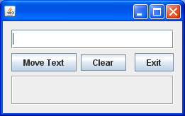  When the user clicks at
 |  | (i) Move Text Button, the text should moved to the OutputLabel. And upon clicking | 2
 |  | (ii) Clear Button, the text in the Textfield as well as in the OutputLabel should be cleared. | 1
 |  | (iii) Exit Button, the application should end. | 1
 | (c) | Using the following GUI, Write the code for the Button check wither the given number is “Even” or “Odd” and display the same in the Label provided. Using if-else.  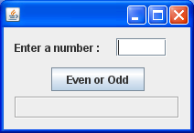 | 2
 |  | SECTION D ( 10 Marks )
Q9. | Read the following case study and answer the questions that follows :
The FOR U SHOP has computerized its billing. A new bill is generated for each customer. The shop allows three different payment modes. The discount is given based on the payment mode. The following is the data entry screen used at to generate the bill.
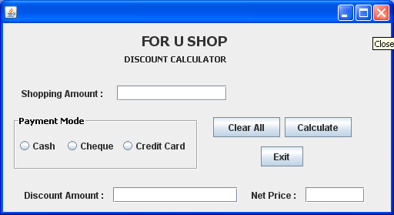
 | 4
The list of controls for the above form is as follows :
Object Type | Object Name | Description
Frame | FrmDiscount | The main frame
Text Field | TxtAmt | To input the total Shopping Amount
Text Field | TxtDisc | To display Discount Amount
Text Field | TxtNet | To display Net Price
Radio Button | OptCash | To select mode of payment as cash
Radio Button | OptCheque | To select mode of payment as cheque
Radio Button | OptCredit | To select mode of payment as credit card
Ok Button | CmdCalc | To calculate Discount and Net Price
Ok Button | CmdClear | To clear all Text Fields
Ok Button | CmdExit | To exit from the application

 | (a) | Write the code for the CmdClear Button to clear all the Text Fields | 1
 | (b) | Write the code for formWindowActivated event of FrmDiscount so as to
 |  | (i) disable the TxtDisc and the TxtNet Text Fields | 1
 |  | (ii) set default choice in the Radio Button as Cash | 1
 |  | (iii) set the Focus to the TxtAmt Text Fields | 1
 | (c) | Write the code for the TxtAmtFocusLost event of the TxtAmt Text Field to ensure that the user does not enter a negative or a zero value. If a negative or zero value is entered then the Text Field should be made blank and a warning message should be displayed. | 2
 | (d) | Write the code for the CmdCalc Button to display the Discount Amount and Net Price in the TxtDisc and the TxtNet Text Fields respectively. Note that Net Price is calculated as Shopping Amount – Discount Amount and the discount is calculated based on the credit card and the total shopping amount according to the following table. | 3
  Credit Card Type | Shopping Amount | Discount
  Cash | < 10000 | 20 %
  Cash | >= 10000 | 25 %
  Cheque | < 15000 | 10 %
  Cheque | >= 15000 | 15 %
  Credit Card | < 10000 | 10 %
  Credit Card | >= 10000 | 12 %
 | (e) | Write the code for CmdExit Ok button to display a message “Thank You “ and exit out of the application. | 1
 |  | 5

