LOGIC DESIGN LABORATORY
III SEMSTER ELECTRONICS & COMMUNICATION ENGINEERING

LIST OF EXPERIMENTS
1.Simplification and realization of given Boolean expression using Logic
gates/universal gates....................................................................
2.Realization of half/full adder and half/full subtractor using logic gates.... .
3.(i) REALISATION of parallel adder/subtractor using 7483 Chip..............
(ii) BCD to XS3 code conversion and vice versa.
4.Realisation of Binary to Gray code converter and vice versa.................
5.Realization of one/two bit comparator and study of 7485 magnitude
comparator...................................................................................
6 MUX/DEMUX and use of 74153, 74139 for arithmetic circuits and code
Converter.......................................................................................
7. Use of
Decoder chip to drive LED/LCD display.
Priority encoder.................................................................. .
8.Truth table verification of flip flops.
(i) J -K master slave
(ii) T-Type
(iii) D-Type............................................................................... .
9.Realization of 3-bit counters as a sequential circuit and mod-N counter design
(7476,7490,74192,74193)......................................................... .
10.Shift left, shift right, SIPO, SISO, PISO, PIPO operations using 7495...
11.Design and testing of Ring counter/Johnson counter........................
12.Design of sequence generator.......................................................

Experiment No 1

Aim : Simplification, realization of Boolean expression using logic gates/universal gates
a) Verification of Logic gates.
b) Realize the following expressions Using Logic gates and universal gates in
1)SOP form ii) POS form
Components required :-
Sl.No | NAME OF THE COMPONENT | IC NUMBER | QUANTITY
1  2  3  4  5  6  7  8  9 | AND gate  OR gate  Not gate  EXOR gate  NAND gate  NOR gate  EX-NOR gate  Patch chords  Trainer Kit | 7408  7432  7404  7486  7400  7402  4077 | 2  2  2  2  2  2  1

NOT GATE 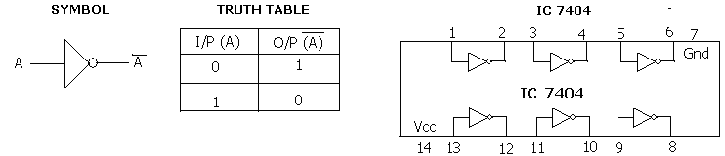
OR GATE
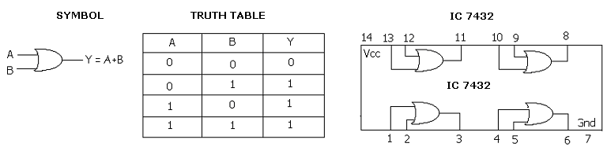

AND GATE
SYMBOL TRUTH TABLE IC 7408
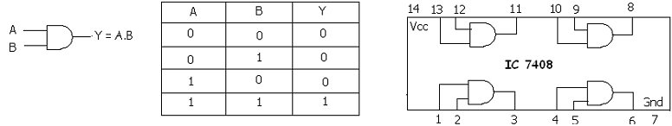
UNIVERSAL GATES
NAND GATE
SYMBOL TRUTH TABLE IC 7408
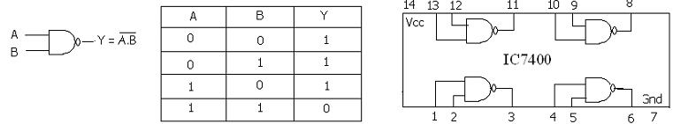
NOR GATE
SYMBOL TRUTH TABLE IC 7408
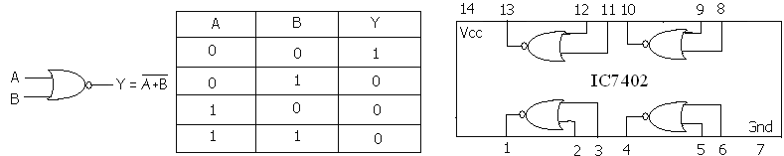
XOR GATE

SYMBOL TRUTH TABLE IC 7408
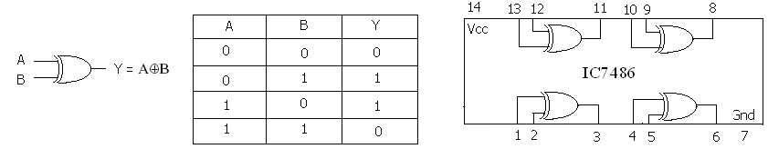

EX-NOR GATE

SYMBOL TRUTH TABLE IC 4077
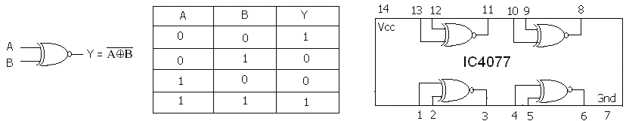

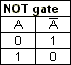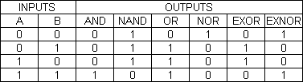

IMPIMENTATION OF BASIC GATES USUNG UNIVERSAL GATES

NAND GATE AS
- AND GATE
LOGICDIAGRAM TRUTH TABLE
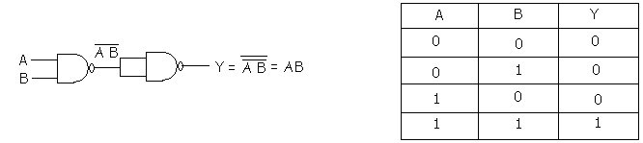

- OR GATE
LOGICDIAGRAM TRUTH TABLE

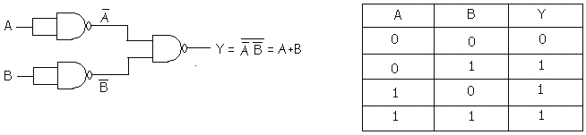
- NOT GATE

LOGICDIAGRAM TRUTH TABLE
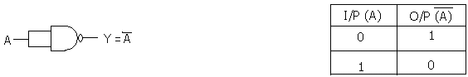

- NOR GATE

LOGICDIAGRAM TRUTH TABLE
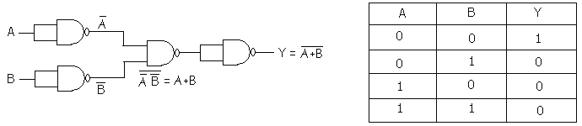
- EX-OR GATE

LOGICDIAGRAM TRUTH TABLE
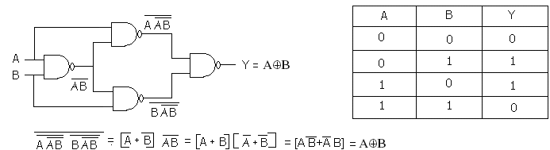
- EX-NOR GATE

LOGICDIAGRAM TRUTH TABLE
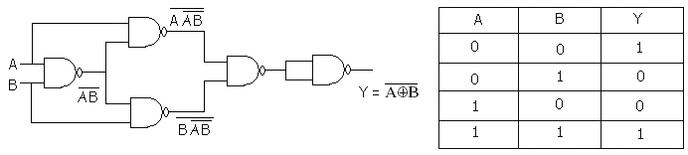
NOR GATE AS

- AND GATE

LOGIC DIAGRAM TRUTH TABLE
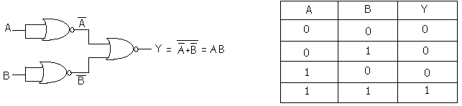
- OR GATE
LOGIC DIAGRAM TRUTH TABLE

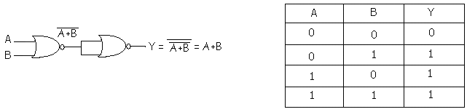
- NOT GATE

LOGIC DIAGRAM TRUTH TABLE

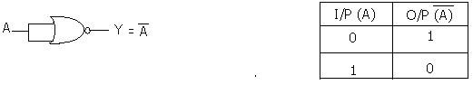

- NAND GATE
LOGIC DIAGRAM TRUTH TABLE

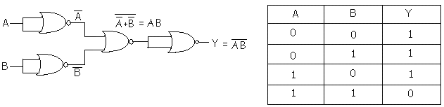

- EX-NOR GATE
LOGIC DIAGRAM TRUTH TABLE

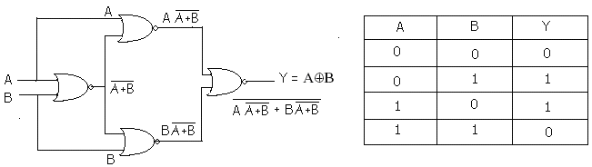
(f) EX-OR GATE

LOGIC DIAGRAM TRUTH TABLE
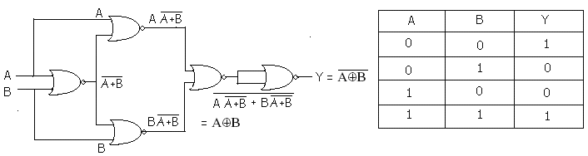
Realize the fallowing expressions in
(1) SOP form (sum of product)
(2) POS form (product of sum)

SOP FORM

F(A,B,C,D) = ∑(5,7,9,11,13,15)

Simplification- SOP form using basic gates
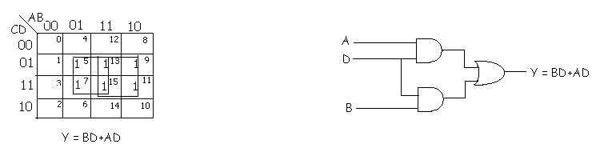
Using NAND gates using NOR gates
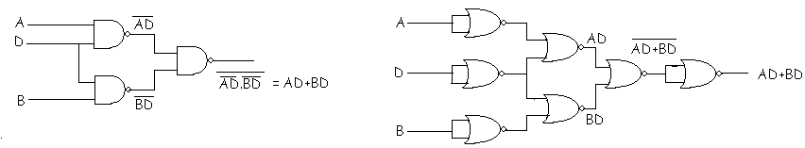
POS FORM
F(A,B,C,D) =∏(0,1,2,3,4,6,8,10,12,14)
Simplification- POS form Using basic gates
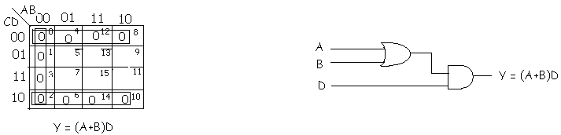
Using NAND gates Using NOR gates
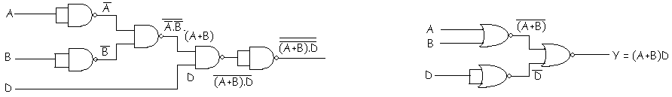
Procedure: Truth table:
A | B | C | D | Y=(A+B)D
0 | 0 | 0 | 0 | 0
0 | 0 | 0 | 1 | 0
0 | 0 | 1 | 0 | 0
0 | 0 | 1 | 1 | 0
0 | 1 | 0 | 0 | 0
0 | 1 | 0 | 1 | 1
0 | 1 | 1 | 0 | 0
0 | 1 | 1 | 1 | 1
1 | 0 | 0 | 0 | 0
1 | 0 | 0 | 1 | 1
1 | 0 | 1 | 0 | 0
1 | 0 | 1 | 1 | 1
1 | 1 | 0 | 0 | 0
1 | 1 | 0 | 1 | 1
1 | 1 | 1 | 0 | 0
1 | 1 | 1 | 1 | 1
1.Place the Ic in the socket of the trainer kit.
*complex boolean Expression s are simplified by using K
maps.
2.make the connections as shown in the circuit diagram.
3.Apply diff combinations of i/ps according to the truth table
verify the o/p.
4.Repeat the above procedure for all the circuit diagrams.

Experiment No 2
Half Adder & full adder
Aim: (a) realization of half /full adder and
(b)half/full subtractor using logic gates
Components required :-
Sl.No | NAME OF THE COMPONENT | IC NUMBER | QUANTITY
1  2  3  4  5  6  7  8  9 | AND gate  OR gate  Not gate  EXOR gate  NAND gate  NOR gate  Patch chords  Trainer Kit | 7408  7432  7404  7486  7400  7402 | 1  1  1  3  3  3

- HALF ADDER USING BASIC GATES
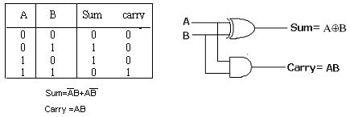
HALF ADDER USING NAND GATES
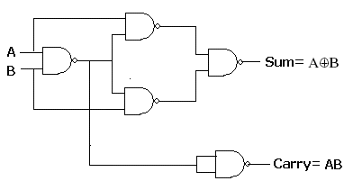
FULL ADDER USING NAND GATES

Truth table (Full adder)
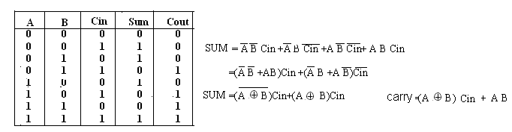

USING NAND GATES
Circuit Diagram
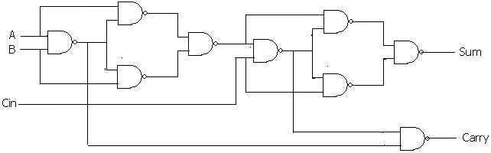

USING NOR GATES
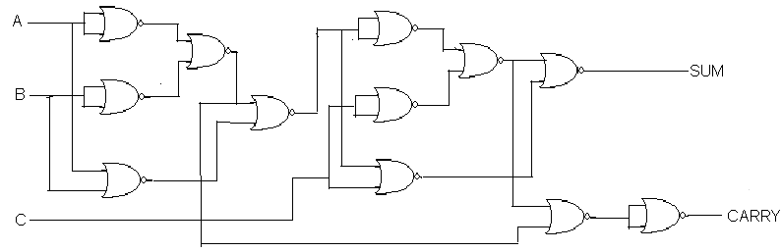
Procedure:-verify the truth table for half adder and full adder circuits using basic and universal gates.
HALF SUBTRACTOR
Truth Table Circuit Diagram
A | B | Diff | Barrow
0 | 0 | 0 | 0
0 | 1 | 1 | 1
1 | 0 | 1 | 0
1 | 1 | 0 | 0
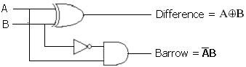

Using NAND gates
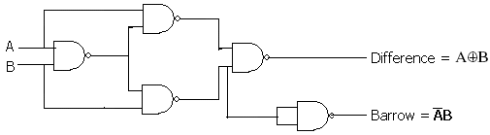
FULL SUBTRACTOR

Truth Table
A | B | Bin | Diff | Borrow
0 | 0 | 0 | 0 | 0
0 | 0 | 1 | 1 | 1
0 | 1 | 0 | 1 | 1
0 | 1 | 1 | 0 | 1
1 | 0 | 0 | 1 | 0
1 | 0 | 1 | 0 | 0
1 | 1 | 0 | 0 | 0
1 | 1 | 1 | 1 | 1

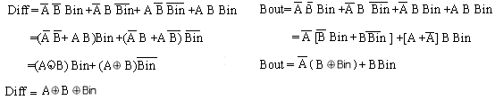

Logic Diagram
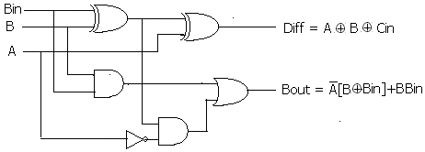

USING NANAD GATES
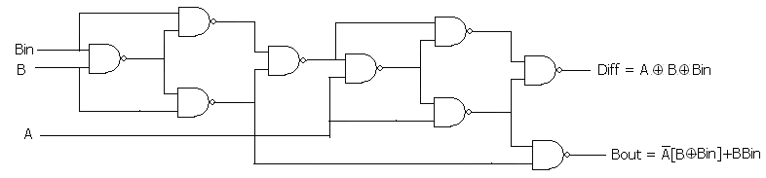

USING NOR GATES
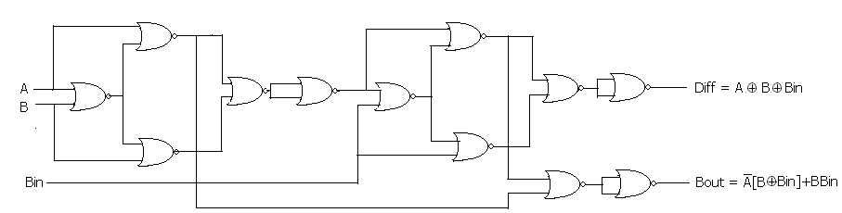

Procedure:-verify the truth table for half subtractor and full subtractor circuits using basic and universal gates.

Experiment No 3

PARALLEL ADDER/SUBTRACTOR AND CODE CONVERSION

AIM: (1) REALISATION of Parallel adder/subtractor using 7483chip
(2) BCD to XS3 code conversion and vice versa
Components required :-

Sl.No | NAME OF THE COMPONENT | IC NUMBER | QUANTITY
1  2  3  4 | EXOR gate  4 bit parallel adder/subtractor  Patch chords  Trainer Kit | 7486  7483 | 1  1

Pin diagram:

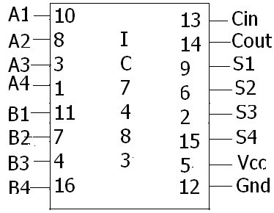

LOGIC diagram

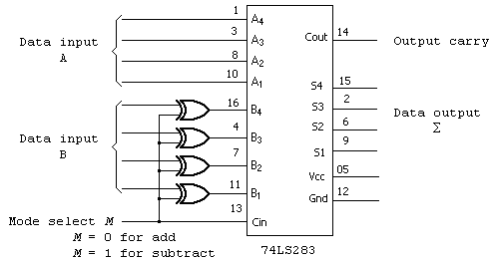

Block Diagram
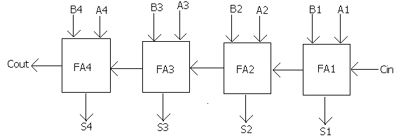
Procedure:
- Make the connections as shown .
- For addition ,make Cin=0 and apply the 4 bits as i/p for A and aply another set of A bits to B. Observe the o/p at S_{3,} S₂ S₁ S₀ and carry generated at Cout.
Repeat the above steps for different inputs and tabulate the result.
3.For subtration Cin is made equal to 1 and A-B format is used.
- First no
- second no.
By Xor –ing the i/p bits of ‘B’ by 1 , is complement of ‘B’ is obtained. Further Cin ,which is 1 is added to the LSB of the Xor –ed bits. This generates 2’s complement of B.
- verify the difference and polarity of differences at S₀, S₁, S₂, S₃.and Cout.
If Cout is 0 , diff is –ve and diff is 2’s complement form.
If Cout is 1, diff is +ve .
Repeate the above steps for different inputs. And tabulate the result.

Readings:-
Cin | A₃ | A₂ | A₁ | A₀ | B₃ | B₂ | B₁ | B₀ | Cout | S₃ | S₂ | S₁ | S₀
0 | 1 | 0 | 0 | 1 | 1 | 0 | 0 | 1 | 1 | 0 | 0 | 1 | 0
0 | 0 | 1 | 1 | 1 | 0 | 0 | 0 | 1 | 0 | 1 | 0 | 0 | 0
1 | 1 | 0 | 0 | 1 | 1 | 0 | 0 | 0 | 1 | 0 | 0 | 0 | 1
1 | 0 | 0 | 0 | 1 | 0 | 0 | 1 | 1 | 0 | 1 | 1 | 1 | 0

BCD to Ex-3
Truth table
BCD |  |  |  | XS3
B4 | B3 | B2 | B1 | X4 | X3 | X2 | X1
0 | 0 | 0 | 0 | 0 | 0 | 1 | 1
0 | 0 | 0 | 1 | 0 | 1 | 0 | 0
0 | 0 | 1 | 0 | 0 | 1 | 0 | 1
0 | 0 | 1 | 1 | 0 | 1 | 1 | 0
0 | 1 | 0 | 0 | 0 | 1 | 0 | 0
0 | 1 | 0 | 1 | 1 | 0 | 0 | 0
0 | 1 | 1 | 0 | 1 | 0 | 0 | 1
0 | 1 | 1 | 1 | 1 | 0 | 1 | 0
1 | 0 | 0 | 0 | 1 | 0 | 1 | 1
1 | 0 | 0 | 1 | 1 | 1 | 0 | 0

Ex-3 to BCD
XS3 |  |  |  | BCD
X4 | X3 | X2 | X1 | B4 | B3 | B2 | B1
0 | 0 | 1 | 1 | 0 | 0 | 0 | 0
0 | 1 | 0 | 0 | 0 | 0 | 0 | 1
0 | 1 | 0 | 1 | 0 | 0 | 1 | 0
0 | 1 | 1 | 0 | 0 | 0 | 1 | 1
0 | 1 | 0 | 0 | 0 | 1 | 0 | 0
1 | 0 | 0 | 0 | 0 | 1 | 0 | 1
1 | 0 | 0 | 1 | 0 | 1 | 1 | 0
1 | 0 | 1 | 0 | 0 | 1 | 1 | 1
1 | 0 | 1 | 1 | 1 | 0 | 0 | 0
1 | 1 | 0 | 0 | 1 | 0 | 0 | 1
Truth table

Circuit Diagram

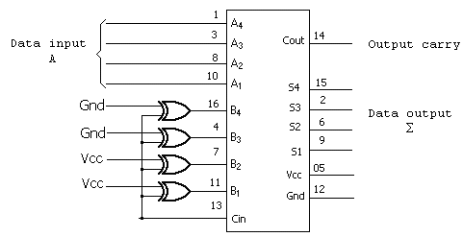
Procedure:
BCD to XS-3 code conversion and vice-versa can be implemented using Ic 7483 along with 7486 Xor gates. The four i/p bits of ‘B’ ie B_{3,} B_{2,} B_{1,} B_{0,} are fixed as 0011. cin =0, performs addition and Cin =1 performs subtraction.
  - For BCD to xs –3 code conversion 3 has to be added to i/p bits of A there for Cin =0.
  - For Xs-3 to BCD code conversion ‘3’ has to be subtarcated from the i/p of A therefor Cin =1.
  - Verify the truth table.

EXPERIMENT-4
BINARY TO GRAY CODE CONVERSION AND VICE VERSA
AIM : Realisation of Binary to Gray code conversion and viceversa

Components required :-

Sl.No | NAME OF THE COMPONENT | IC NUMBER | QUANTITY
1  2  3  4 | EXOR gate  NAND gate  Patch chords  Trainer Kit | 7486  7400 | 1  4

Binary to Gray code converter
BINARY |  |  |  | GRAY CODE
B3 | B2 | B1 | B0 | G3 | G2 | G1 | G0
0 | 0 | 0 | 0 | 0 | 0 | 0 | 0
0 | 0 | 0 | 1 | 0 | 0 | 0 | 1
0 | 0 | 1 | 0 | 0 | 0 | 1 | 1
0 | 0 | 1 | 1 | 0 | 0 | 1 | 0
0 | 1 | 0 | 0 | 0 | 1 | 1 | 0
0 | 1 | 0 | 1 | 0 | 1 | 1 | 1
0 | 1 | 1 | 0 | 0 | 1 | 0 | 1
0 | 1 | 1 | 1 | 0 | 1 | 0 | 0
1 | 0 | 0 | 0 | 1 | 1 | 0 | 0
1 | 0 | 0 | 1 | 1 | 1 | 0 | 1
1 | 0 | 1 | 0 | 1 | 1 | 1 | 1
1 | 0 | 1 | 1 | 1 | 1 | 1 | 0
1 | 1 | 0 | 0 | 1 | 0 | 1 | 0
1 | 1 | 0 | 1 | 1 | 0 | 1 | 1
1 | 1 | 1 | 0 | 1 | 0 | 0 | 1
1 | 1 | 1 | 1 | 1 | 0 | 0 | 0

G3 = ∑(8,9,10,11,12,13,14,15) G2 = ∑(4,5,6,7,8,9,10,11)
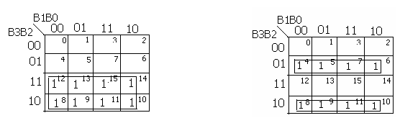
G3=B3
G2 =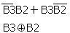

G1= ∑(2,3,4,5,10.,11,12,13) G0 = ∑(1,2,3,5,6,9,10,13,14)
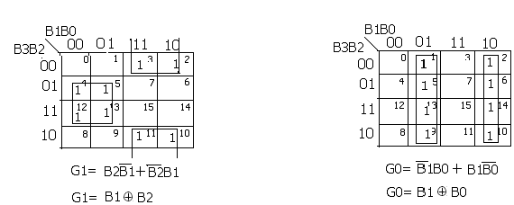

USING XOR GATES ONLY
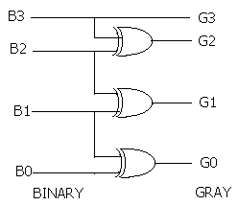
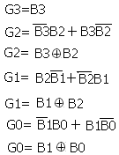
Using NAND Gates only

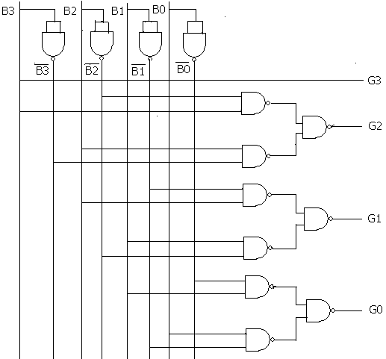

GRAY TO BINARY

GRAY CODE |  |  |  | BINARY CODE
G3 | G2 | G1 | G0 | B3 | B2 | B1 | B0
0 | 0 | 0 | 0 | 0 | 0 | 0 | 0
0 | 0 | 0 | 1 | 0 | 0 | 0 | 1
0 | 0 | 1 | 0 | 0 | 0 | 1 | 1
0 | 0 | 1 | 1 | 0 | 0 | 1 | 0
0 | 1 | 0 | 0 | 0 | 1 | 1 | 1
0 | 1 | 0 | 1 | 0 | 1 | 1 | 0
0 | 1 | 1 | 0 | 0 | 1 | 0 | 0
0 | 1 | 1 | 1 | 0 | 1 | 0 | 1
1 | 0 | 0 | 0 | 1 | 1 | 1 | 1
1 | 0 | 0 | 1 | 1 | 1 | 1 | 0
1 | 0 | 1 | 0 | 1 | 1 | 0 | 0
1 | 0 | 1 | 1 | 1 | 1 | 0 | 1
1 | 1 | 0 | 0 | 1 | 0 | 0 | 0
1 | 1 | 0 | 1 | 1 | 0 | 0 | 1
1 | 1 | 1 | 0 | 1 | 0 | 1 | 1
1 | 1 | 1 | 1 | 1 | 0 | 1 | 0
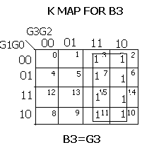

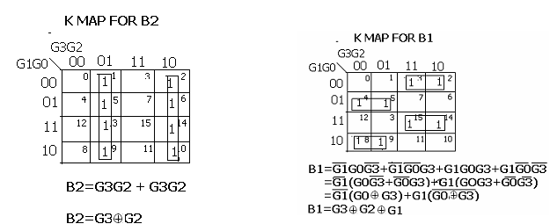

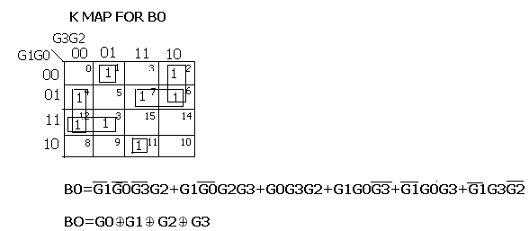

LOGIC DIAGRAM
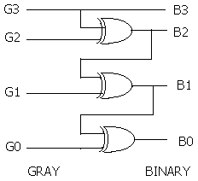

USING NAND GATE

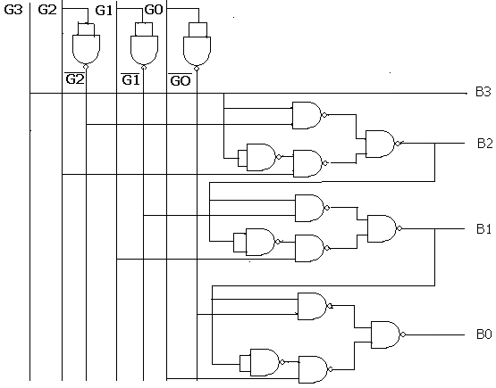

Procedure:-
1. place the Ic’s in the socket of the trainer kit.
2. make connections for the gate as shown in the circuit diagram.
3.Apply different combinations of the input according to the truth table and verify the corresponding o/ps
shown on the truth table.

EXPERIMENT-5
COMPARATOR

AIM-REALISATIION OF 1-BIT AND 2-BIT COMPARATOR AND STUDY OF 7485 MAGNITUDE COMPARATOR Components required :-

Sl.No | NAME OF THE COMPONENT | IC NUMBER | QUANTITY
1  2  3  4  5  6  7 | AND gate  OR gate  Not gate  EXOR gate  Magnitude comparator  Patch chords  Trainer Kit | 7408  7432  7404  7486  7485 | 2  1  1  1  1

PIN DIAGARM
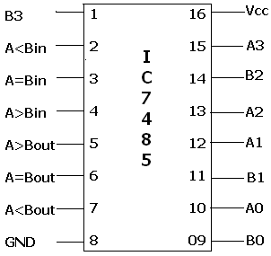

1-BIT COMARATOR

TRUTH TABLE LOGIC DIAGRAM USING BASIC GATES

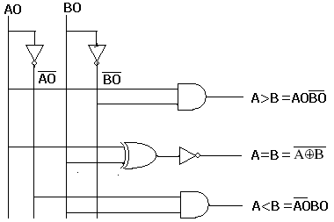
A0 | B0 | A>B | A=B | A<B
0 | 0 | 0 | 1 | 0
0 | 1 | 0 | 0 | 1
1 | 0 | 1 | 0 | 0
1 | 1 | 0 | 1 | 0

TRUTH TABLE FOR 2 BIT COMPRATOR

A12 | A01 | B12 | B01 | A>B | A=B | A<B
0 | 0 | 0 | 0 | 0 | 1 | 0
0 | 0 | 0 | 1 | 0 | 0 | 1
0 | 0 | 1 | 0 | 0 | 0 | 1
0 | 0 | 1 | 1 | 0 | 0 | 1
0 | 1 | 0 | 0 | 1 | 0 | 0
0 | 1 | 0 | 1 | 0 | 1 | 0
0 | 1 | 1 | 0 | 0 | 0 | 1
0 | 1 | 1 | 1 | 0 | 0 | 1
1 | 0 | 0 | 0 | 1 | 0 | 0
1 | 0 | 0 | 1 | 1 | 0 | 0
1 | 0 | 1 | 0 | 0 | 1 | 0
1 | 0 | 1 | 1 | 0 | 0 | 1
1 | 1 | 0 | 0 | 1 | 0 | 0
1 | 1 | 0 | 1 | 1 | 0 | 0
1 | 1 | 1 | 0 | 1 | 0 | 0
1 | 1 | 1 | 1 | 0 | 1 | 0

K MAP FOR A>B
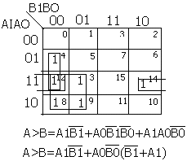
K MAP FOR A=B K MAP FOR A<B 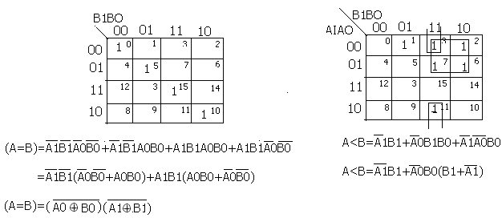
Circuit diagram

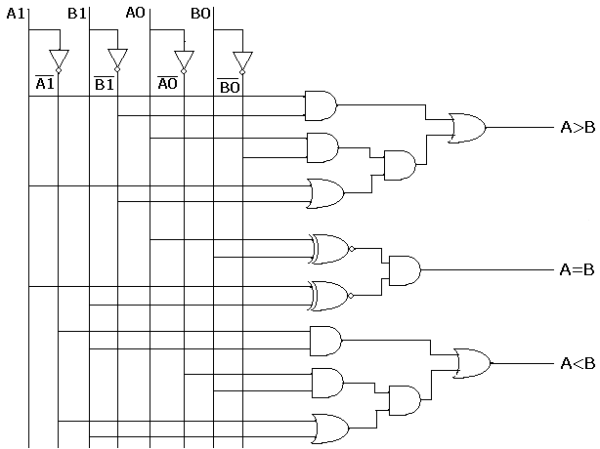

4 BIT MAGNITUDE COMPARATOR

CASCADIG INPUTS CASCADIG OUTPUT
A3 B3 | A2 B2 | A1 B1 | A0 B0 | A>B A=B A<B |  |  | A>B A=B A<B
A3>B3 | X | X | X | X | X | X | 1 | 0 | 0
A3<B3 | X | X | X | X | X | X | 0 | 0 | 1
A3=B3 | A2>B2 | X | X | X | X | X | 1 | 0 | 0
A3=B3 | A2<B2 | X | X | X | X | X | 0 | 0 | 1
A3=B3 | A2=B2 | A1>B1 | X | X | X | X | 1 | 0 | 0
A3=B3 | A2=B2 | A1<B1 | X | X | X | X | 0 | 0 | 1
A3=B3 | A2=B2 | A1=B1 | A0>B0 | X | X | X | 1 | 0 | 0
A3=B3 | A2=B2 | A1=B1 | A0<B0 | X | X | X | 0 | 0 | 1
A3=B3 | A2=B2 | A1=B1 | AO=B0 | 1 | 0 | 0 | 1 | 0 | 0
A3=B3 | A2=B2 | A1=B1 | AO=B0 | 0 | 0 | 1 | 0 | 0 | 1
A3=B3 | A2=B2 | A1=B1 | AO=B0 | X | 1 | X | 0 | 1 | 0
A3=B3 | A2=B2 | A1=B1 | AO=B0 | 0 | 0 | 0 | 1 | 0 | 1
A3=B3 | A2=B2 | A1=B1 | AO=B0 | 1 | 0 | 1 | 0 | 0 | 0
Eg-
A3 | A2 | A1 | A0 | B3 | B2 | B1 | B0 | A>B | A=B | A<B
0 | 0 | 1 | 0 | 1 | 1 | 0 | 1 | 0 | 0 | 1
1 | 1 | 1 | 1 | 1 | 1 | 1 | 0 | 1 | 0 | 0
1 | 0 | 0 | 1 | 1 | 0 | 0 | 1 |  | 1 | 0
0 | 1 | 0 | 1 | 0 | 0 | 0 | 0 | 1 | 0 | 0
Procedure:
1)Rig up the circuit for one bit &two bit comparator as shown in the figure using IC 7485 magnitude comparator and basic gates.
2)Verify the Table of values .the output obtained should match the required result.
EXPERIMENT-6

MUX/DEMUX AND CODE CONVERTER.

AIM-STUDY OF MUX/DEMUX AND USE OF 74153, 74139 FOR ARITHMETIC CIRCUITSAND CODE CONVERTER.
Components required :-

Sl.No | NAME OF THE COMPONENT | IC NUMBER | QUANTITY
1  2  3  4  5  6  7  8  9  10 | NANDgate(2 pin)  NANDgate(4 pin)  MUX  DEMUX  Not gate  NANDgate (8pin)  NAND gate(3pin)  Patch chords  Trainer Kit | 7400  7420  74153  74139  7404  7430  7410 | 3  1  1  1  1  2  2

Truth table (2:1 mux) SYMBOL
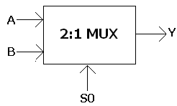
S0 | Y
0 | A
1 | B
LOGIC DIAGRAM

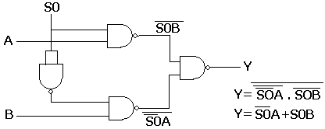

Truth table (4:1 MUX) SYMBOL
S1 | S0 | I0 | I1 | I2 | I3 | Y
0 | 0 | I0 | X | X | X | I0
0 | 1 | X | I1 | X | X | I1
1 | 0 | X | X | I2 | X | I2
1 | 1 | X | X | X | I3 | I3
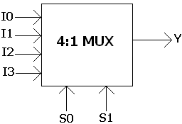
LOGIC DIAGRAM

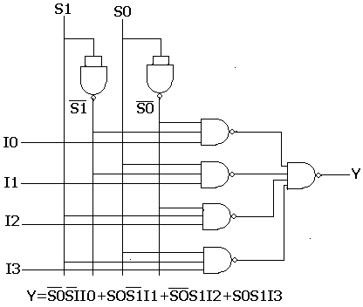

PIN DETAILS OF 74153

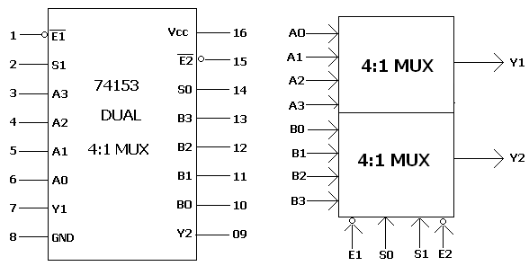

TRUTH TABLE FOR MUX 74153(DUAL 4:1 MUX)

When E1 and E2 =1, device is not enabled and outputs are zero
E | S1 | S0 | Yn
1 | X | X | 0
0 | 0 | 0 | An
0 | 0 | 1 | Bn
0 | 1 | 0 | Cn
0 | 1 | 1 | Dn

REALISATION OF HALF ADDER USING IC

TRUTH TABLE CIRCUIT DIAGRAM

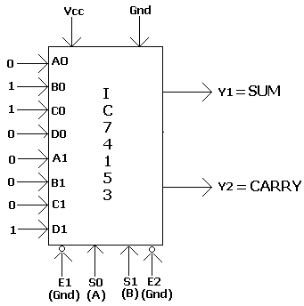
A | B | SUM | Cout
0 | 0 | 0 | 0
0 | 1 | 1 | 0
1 | 0 | 1 | 0
1 | 1 | 0 | 1

FULL ADDER

TRUTH TABLE
Here the outputs sum and carry out are represented in
Terms of input cin

A | B | SUM | Cout
0 | 0 | Cin | 0
0 | 1 |  | Cin
1 | 0 |  | Cin
1 | 1 | Cin | 1
A | B | Cin | SUM | Cout
0 | 0 | 0 | 0 | 0
0 | 0 | 1 | 1 | 0
0 | 1 | 0 | 1 | 0
0 | 1 | 1 | 0 | 1
1 | 0 | 0 | 1 | 0
1 | 0 | 1 | 0 | 1
1 | 1 | 0 | 0 | 1
1 | 1 | 1 | 1 | 1

CIRCUIT DIAGRAM
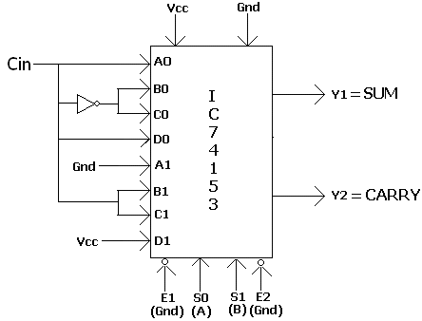
HALF SUTRACTOR

TRUTH TABLE CIRCUIT DIAGRAM
A | B | Diff | Bout
0 | 0 | 0 | 0
0 | 1 | 1 | 1
1 | 0 | 1 | 0
1 | 1 | 0 | 0
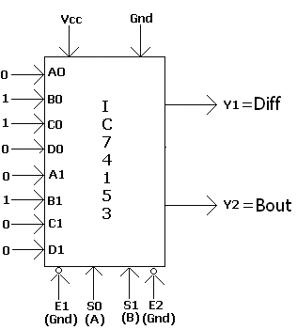

FULL SUTRACTOR
TRUTH TABLE
A | B | Bin | Diff | Bout
0 | 0 | 0 | 0 | 0
0 | 0 | 1 | 1 | 1
0 | 1 | 0 | 1 | 1
0 | 1 | 1 | 0 | 1
1 | 0 | 0 | 1 | 0
1 | 0 | 1 | 0 | 0
1 | 1 | 0 | 0 | 0
1 | 1 | 1 | 1 | 1
A | B | Diff | Bout
0 | 0 | Bin | Bin
0 | 1 |  | 1
1 | 0 |  | 0
1 | 1 | Bin | Bin

CIRCUIT DIAGRAM

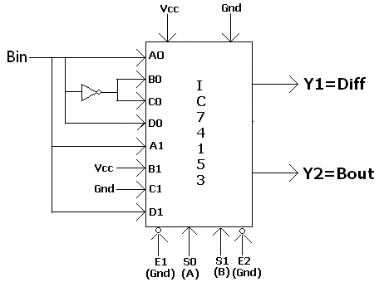

DEMULTIPLEXER

FUNCTIONAL TABLE SYMBOL
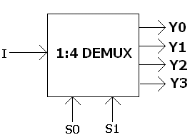
S1 | S0 | Ii | Y0 | Y1 | Y2 | Y3
0 | 0 | I | I | 0 | 0 | 0
0 | 1 | I | 0 | I | 0 | 0
1 | 0 | I | 0 | 0 | I | 0
1 | 1 | I | 0 | 0 | 0 | I
LOIC DIAGRAM

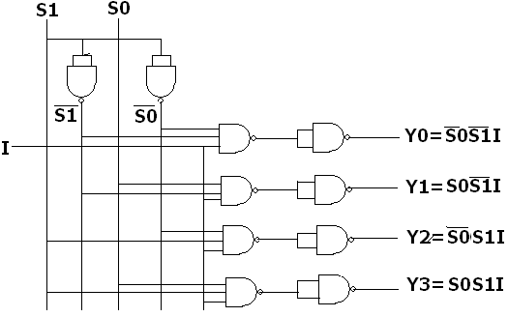

IC 74139 DEMUX/ DECODER FUNCTIONAL TABLE

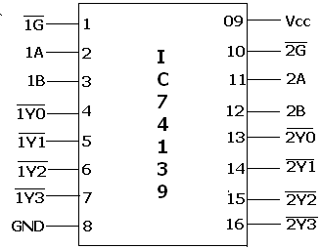
 | A(S1) | B(S0) | Y3 | Y2 | Y1 | Y0
1 | X | X | 1 | 1 | 1 | 1
0 | 0 | 0 | 1 | 1 | 1 | 0
0 | 0 | 1 | 1 | 1 | 0 | 1
0 | 1 | 0 | 1 | 0 | 1 | 1
0 | 1 | 1 | 0 | 1 | 1 | 1

74139 AS A HALF ADDER/HALF SUBTRACTOR

A | B | Sum | Carry | Diff | Bout
0 | 0 | 0 | 0 | 0 | 0
0 | 1 | 1 | 0 | 1 | 1
1 | 0 | 1 | 0 | 1 | 0
1 | 1 | 0 | 1 | 0 | 0
From truth table sum = ∑1,2
Carry =∑3
Diff =∑1,2
Bout =∑1

LOGIC DIAGRAM

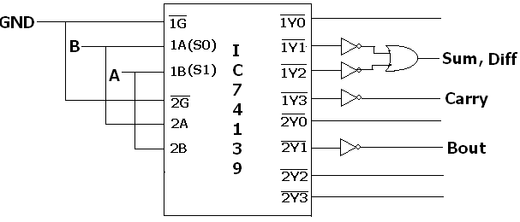
74139 AS A FULL ADDER

TRUTH TABLE
A | B | Cin | SUM | Cout
0 | 0 | 0 | 0 | 0
0 | 0 | 1 | 1 | 0
0 | 1 | 0 | 1 | 0
0 | 1 | 1 | 0 | 1
1 | 0 | 0 | 1 | 0
1 | 0 | 1 | 0 | 1
1 | 1 | 0 | 0 | 1
1 | 1 | 1 | 1 | 1

Sum =∑1,2,4,7
Carry =∑3,5,6,7
LOGIC DAIGRAM

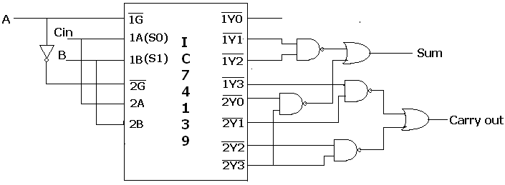
74139 AS A FULL SUBTRACTOR

TRUTH TABLE

A | B | Bin | Diff | Bout
0 | 0 | 0 | 0 | 0
0 | 0 | 1 | 1 | 1
0 | 1 | 0 | 1 | 1
0 | 1 | 1 | 0 | 1
1 | 0 | 0 | 1 | 0
1 | 0 | 1 | 0 | 0
1 | 1 | 0 | 0 | 0
1 | 1 | 1 | 1 | 1

Diff = ∑1,2,4,7
Bout = ∑1,2,3,7

LOGIC DIAGRAM

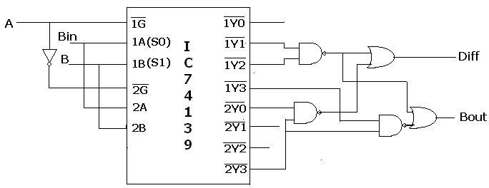

IC 74139 AS A BCD TO XS-3 CODE CONVERTOR

BCD |  |  |  | XS3
B4 | B3 | B2 | B1 | X3 | X2 | X1 | X0
0 | 0 | 0 | 0 | 0 | 0 | 1 | 1
0 | 0 | 0 | 1 | 0 | 1 | 0 | 0
0 | 0 | 1 | 0 | 0 | 1 | 0 | 1
0 | 0 | 1 | 1 | 0 | 1 | 1 | 0
0 | 1 | 0 | 0 | 0 | 1 | 0 | 0
0 | 1 | 0 | 1 | 1 | 0 | 0 | 0
0 | 1 | 1 | 0 | 1 | 0 | 0 | 1
0 | 1 | 1 | 1 | 1 | 0 | 1 | 0
1 | 0 | 0 | 0 | 1 | 0 | 1 | 1
1 | 0 | 0 | 1 | 1 | 1 | 0 | 0

From truth table, We have
X3 = ∑5,6,7,8,9 , X2 = ∑1,2,3,4,9 , X1 = ∑0,3,4,7,8 , X0 = ∑0,2,4,6,8

LOGIC DIAGRAM

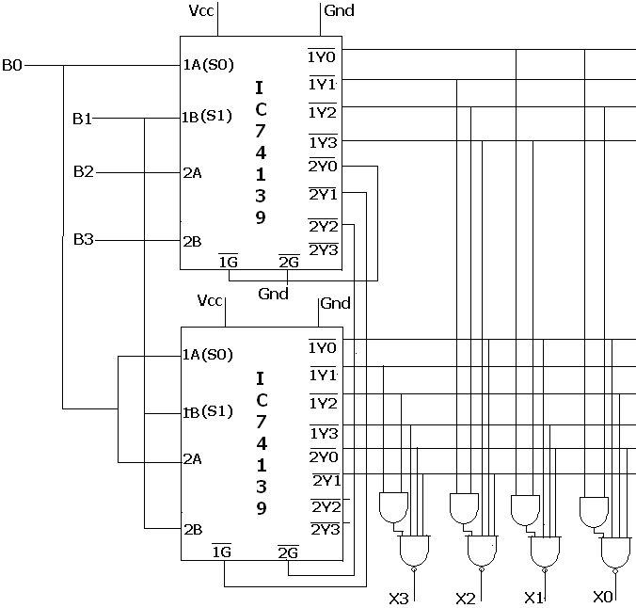

IC 74139 AS A BINARY TO GRAY CODECONVERTOR
TRUTH TABLE

BINARY |  |  |  | GRAY CODE
B3 | B2 | B1 | B0 | G3 | G2 | G1 | G0
0 | 0 | 0 | 0 | 0 | 0 | 0 | 0
0 | 0 | 0 | 1 | 0 | 0 | 0 | 1
0 | 0 | 1 | 0 | 0 | 0 | 1 | 1
0 | 0 | 1 | 1 | 0 | 0 | 1 | 0
0 | 1 | 0 | 0 | 0 | 1 | 1 | 0
0 | 1 | 0 | 1 | 0 | 1 | 1 | 1
0 | 1 | 1 | 0 | 0 | 1 | 0 | 1
0 | 1 | 1 | 1 | 0 | 1 | 0 | 0
1 | 0 | 0 | 0 | 1 | 1 | 0 | 0
1 | 0 | 0 | 1 | 1 | 1 | 0 | 1
1 | 0 | 1 | 0 | 1 | 1 | 1 | 1
1 | 0 | 1 | 1 | 1 | 1 | 1 | 0
1 | 1 | 0 | 0 | 1 | 0 | 1 | 0
1 | 1 | 0 | 1 | 1 | 0 | 1 | 1
1 | 1 | 1 | 0 | 1 | 0 | 0 | 1
1 | 1 | 1 | 1 | 1 | 0 | 0 | 0

G3 = ∑(8,9,10,11,12,13,14,15)

G2 = ∑(4,5,6,7,8,9,10,11)

G1 = ∑(2,3,4,5,10.,11,12,13)

G0 = ∑(1,2,3,5,6,9,10,13,14)

CIRCUIT DIAGRAM

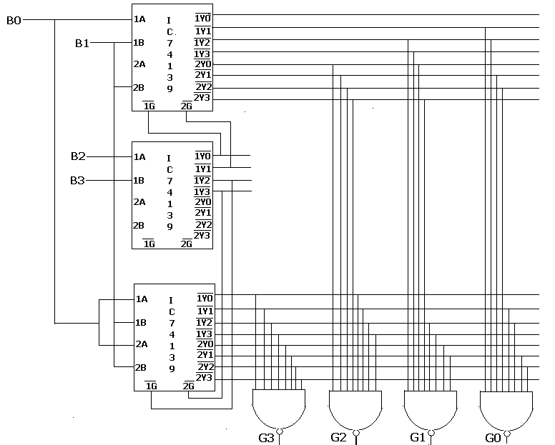

Procedure:-1) Rig up the circuit using NAND gates and then with IC74139 and 74153 as shown in figure.
2)Verify the output with the truth table Values.
3)The output obtained practically should match the required result.

EXPERIMENT-7
SEVEN SEGMENT DISPLAY AND PRIORITY ENCODER
AIM : USE OF (a) DECODER CHIP TO DRIVE LED/LCD
(b) PRIORITY ENCODER
Components required :-

Sl.No | NAME OF THE COMPONENT | IC NUMBER | QUANTITY
1  2  3  4  5  6 | LED(CA)  LED(CC)  LCD  Priority Encoder  Patch chords  Trainer Kit | 7447  7448  7448  74147 | 1  1  1  1

PIN DAIGRAM OF IC7447/8 AND LED(CC/CA)
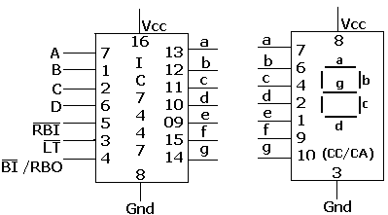

TRUTH TABLE CIRCUIT DIAGRAM-
INPUTS  D C B A | OUTPUTS  (7 SEG LED DISP)
0 0 0 0
0 0 0 1
0 0 1 0
0 0 1 1
0 1 0 0
0 1 0 1
0 1 1 0
0 1 1 1
1 0 0 0
1 0 0 1
LED DISPLAY
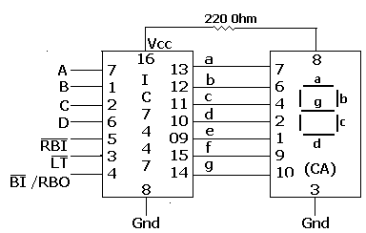

LCD DISPLAY

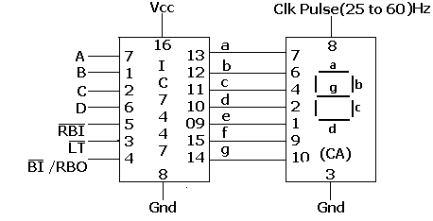

PRIORITY ENCODER

(1). To convert decimal to BCD using IC 74147

TRUTH TABLE
1 | 2 | 3 | 4 | 5 | 6 | 7 | 8 | 9 | B0 | BI | B2 | B3
1 | 1 | 1 | 1 | 1 | 1 | 1 | 1 | 1 | 1 | 1 | 1 | 1
0 | 1 | 1 | 1 | 1 | 1 | 1 | 1 | 1 | 1 | 1 | 1 | 0
X | 0 | 1 | 1 | 1 | 1 | 1 | 1 | 1 | 1 | 1 | 0 | 1
X | X | 0 | 1 | 1 | 1 | 1 | 1 | 1 | 1 | 1 | 0 | 0
X | X | X | 0 | 1 | 1 | 1 | 1 | 1 | 1 | 0 | 1 | 1
X | X | X | X | 0 | 1 | 1 | 1 | 1 | 1 | 0 | 1 | 0
X | X | X | X | X | 0 | 1 | 1 | 1 | 1 | 0 | 0 | 1
X | X | X | X | X | X | 0 | 1 | 1 | 1 | 0 | 0 | 0
X | X | X | X | X | X | X | 0 | 1 | 0 | 1 | 1 | 1
X | X | X | X | X | X | X | X | 0 | 0 | 1 | 1 | 0

PIN DIAGRAM

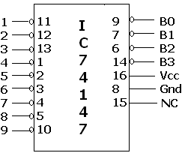

CIRCUIT DIAGRAM

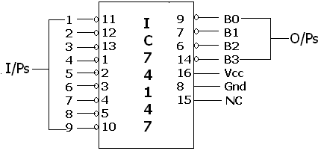

Procedure:
1.Rig up the ckt as shown in the figure.
2. Apply logic zero to LT signal and observe 7 segments of LED i.e all the lines must be ON.
3. Apply zero to blank i/p of BI and observe all the lines to be off.
4. Aplly logic 1 to LT and RBI and observe the number displayed on LED/LCD versus i/p combinations
0000 to 1001 , this is normal decoding mode.
- Apply logic 1 to LT and Zero to RBI and observe RBO o/p and number displayed on LED/LCD versus i/p combinations . this is normal decoding mode with zero blanking.
- Verify the truth table.

Observation:-
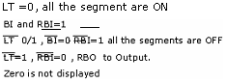

EXPERIMENT NO-08
FLIP-FLOPS
Aim:-truth Table verification of flipflops
- JK Master slave (ii) T type (iii) D –type.
Components required :-
Sl.No | NAME OF THE COMPONENT | IC NUMBER | QUANTITY
1  2  3  4  5 | Dual J.K FlipFlop  NAND gate  NOT gate  Patch chords  Trainer Kit | 7476  7400  7404 | 1  1  1

SYMBOL OF MS-JK FF PIN DIAGRAM
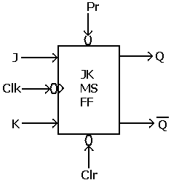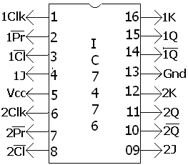

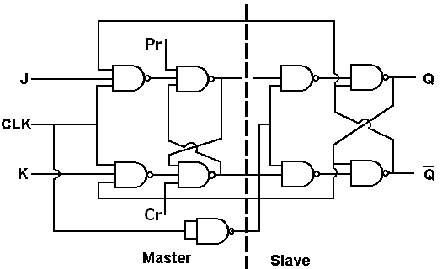

TRUTH TABLE
Table 1 Table 2
Inputs  Clk J K | Output  Qn+1 | COMMENTS
X X  0 0  0 1  1 0  1 1 | Qn  Qn  0  Qn | No Change  No change  Reset  Set  F.F. Preset(Set)
Inputs  Clk Cr pr | Output  Q | Operation Performed
1 1 1  0 0 1  0 1 0 | Qn+1  0  1 | Normal FF(Table-2)  (F.F. enabled)  F.F. Cleared(Reset)  F.F. Preset(Set)

Note: - Keep Pr= Cr=1 for verifying the truth tables JK MS F.F, T and D type FF.

T- Type FF using MS JK FF

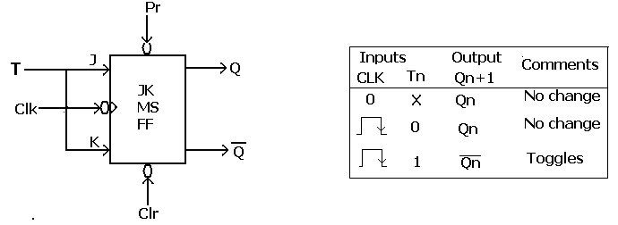

D - Type FF using MS JK FF

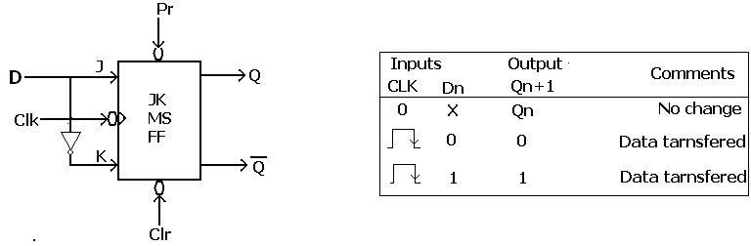
Procedure:-
1)Rig up the circuit as shown in the diagarm.
2)Apply the i/ps to these flipflops as per the Truth table and observe the o/p
Verify with the truth table.

EXPERIMENT-09
COUNTERS
Aim -Realization of 3-bit counters as a sequential circuit and mod-N counter design
(7476, 7490, 74192, 74193)
a) Asynchronous type
b) Synchronous type
Components required :-
Sl.No | NAME OF THE COMPONENT | IC NUMBER | QUANTITY
1  2  3  4  5  6 | JK flip flop  NANDgate(3 pin)  AND gate  OR gate  Decade Counter  Decade Up/down Counter  MOD 16 counter  Patch chords  Trainer Kit | 7476  7408  7432  7490  74192  74193 | 2  2  1  1  1  1  1

(A). ASYNCRONOUS COUNTERS
- Realization of 3-bit binary counters using IC7476(MOD-8)
PIN DIAGRAM
UP COUNT (MOD-8)
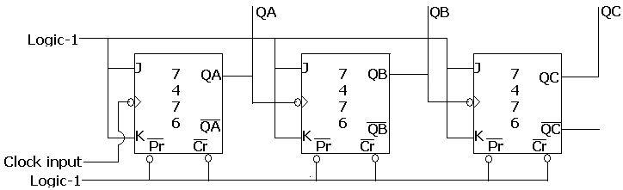

WAVE FORMS
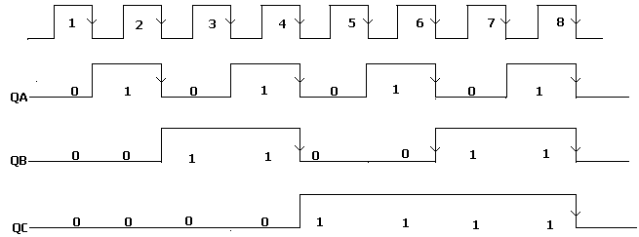

TRUTH TABLE
Number of clock pulses | Flip Flop outputs  Qc Qb Qa
0  1  2  3  4  5  6  7  8 | 0 0 0  0 0 1  0 1 0  0 1 1  1 0 0  1 0 1  1 1 0  1 1 1  0 0 0

DOWN COUNT

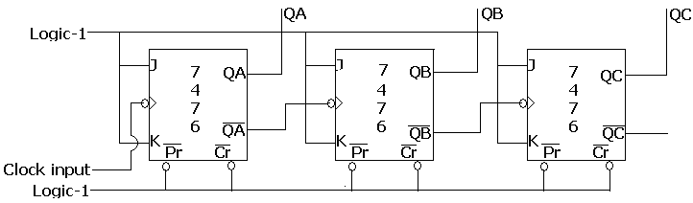

TRUTH TABLE
Number of clock pulses | Flip Flop outputs  Qc Qb Qa
0  1  2  3  4  5  6  7  8 | 1 1 1  1 1 0  1 0 1  1 0 0  0 1 1  0 1 0  0 0 1  0 0 0  1 1 1

MOD-N COUNTER (UP COUNTER)
MOD-4 COUNTER –
In MOD-4 counter 1 0 0 (Qa, Qb, Qc) is Invalid state
TRUTH TABLE
Number of clock pulses | Flip Flop outputs  Qc Qb Qa
0  1  2  3 | 0 0 0  0 0 1  0 1 0  0 1 1

Circuit diagram
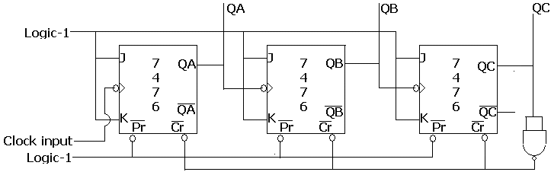

WAVE FORMS
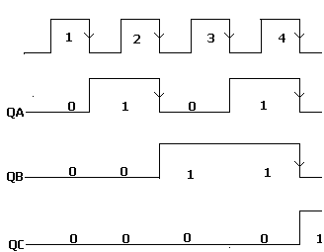

MOD-6 COUNTER TRUTH TABLE
In MOD-6 counter 1 1 0 (QC, Qb, Qa) invalid state

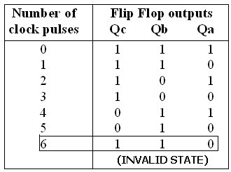
Circuit diagram

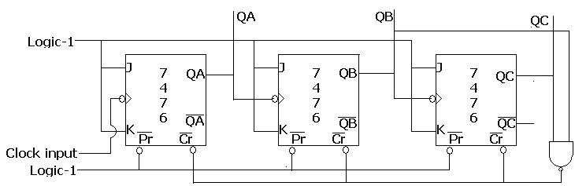

WAVEFORMS

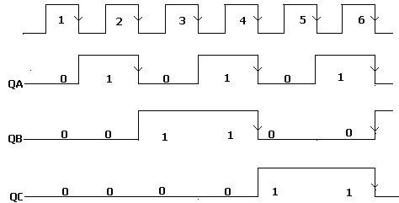

MOD-N COUNTERS (DOWN COUNTER)

MOD-4 COUNTER-
Invalid state is from 1 0 0 to 1 1 1. Then sequence is 011(C, B, A), 010,001,000,011
TRUTH TABLE
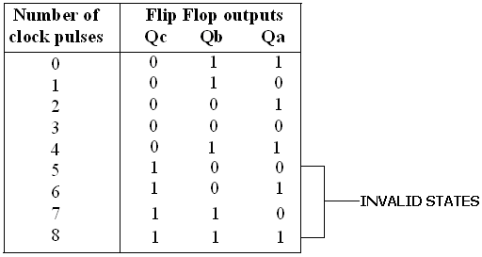

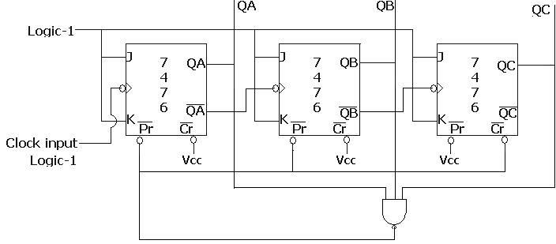

WAVEFORMS

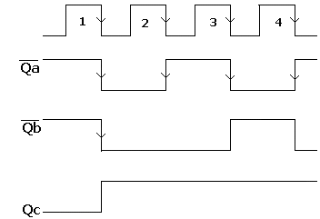
MOD-7 COUNTER

In MOD-7 Counter the invalid state is 111, the data sequence will starts from 110 and should count down to 000
Ie. 110- 101-100-011-010-001-000-110
TRUTH TABLE
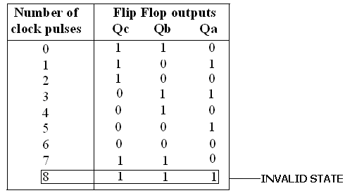
CIRCUIT DIAGRAM
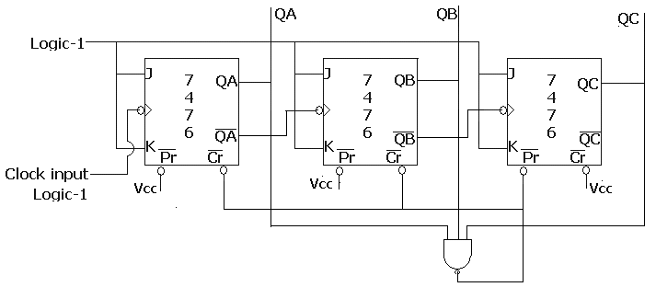

WAVEFORMS

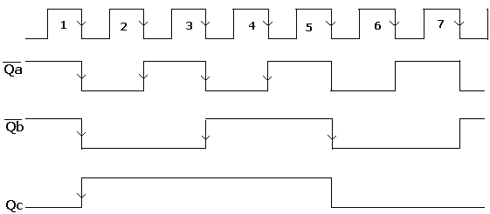

REALISATION OF 3 BIT UP/DOWN COUNTER
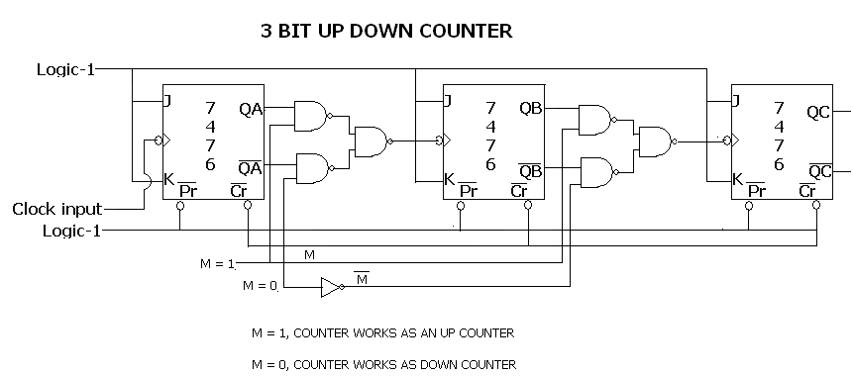

WAVEFORMS

SYNCHRONOUS COUNTERS
UP COUNTER
DESIGN AND REALIZATION OF 3 BIT SYNCHRONOUS COUNTER USING IC7476
Excitation table
Present state  output | Next  State  output | J | K
0 | 0 | 0 | X
0 | 1 | 1 | X
1 | 0 | X | 1
1 | 1 | X | 0
PRESENT STATE |  |  | NEXT STATE |  |  | EXCITATION
Qc | Qb | Qa | Qc | Qb | Qa | JC | KC | JB | KB | JA | KA
0 | 0 | 0 | 0 | 0 | 1 | 0 | X | 0 | X | 1 | X
0 | 0 | 1 | 0 | 1 | 0 | 0 | X | 1 | X | X | 1
0 | 1 | 0 | 0 | 1 | 1 | 0 | X | X | 0 | 1 | X
0 | 1 | 1 | 1 | 0 | 0 | 1 | X | X | 1 | X | 1
1 | 0 | 0 | 1 | 0 | 1 | X | 0 | 0 | X | 1 | X
1 | 0 | 1 | 1 | 1 | 0 | X | 0 | 1 | X | X | 1
1 | 1 | 0 | 1 | 1 | 1 | X | 0 | X | 0 | 1 | X
1 | 1 | 1 | 0 | 0 | 0 | X | 1 | X | 1 | X | 1
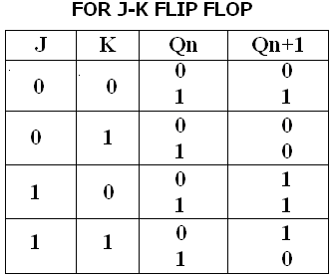
simplifications
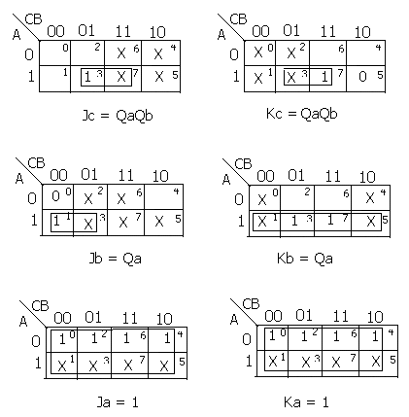CIRCUIT DIAGRAM
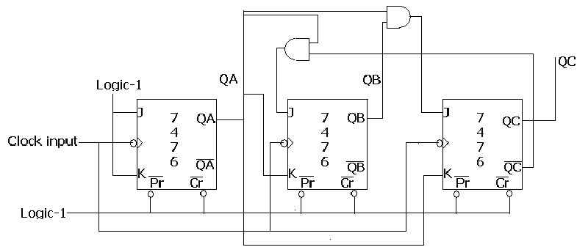
WAVE FORMS

MOD-6 COUNTER

In MOD-6 counter invalid state is 110

PRESENT STATE |  |  | NEXT STATE |  |  | EXCITATION
Qc | Qb | Qa | Qc | Qb | Qa | JC | KC | JB | KB | JA | KA
0 | 0 | 0 | 0 | 0 | 1 | 0 | X | 0 | X | 1 | X
0 | 0 | 1 | 0 | 1 | 0 | 0 | X | 1 | X | X | 1
0 | 1 | 0 | 0 | 1 | 1 | 0 | X | X | 0 | 1 | X
0 | 1 | 1 | 1 | 0 | 0 | 1 | X | X | 1 | X | 1
1 | 0 | 0 | 1 | 0 | 1 | X | 0 | 0 | X | 1 | X
1 | 0 | 1 | 0 | 0 | 0 | X | 1 | 0 | X | X | 1

simplifications
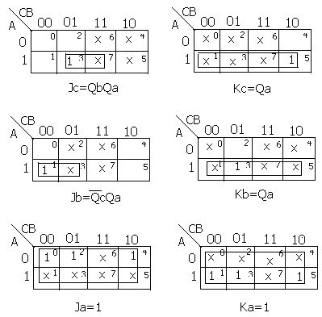

CIRCUIT DIAGRAM
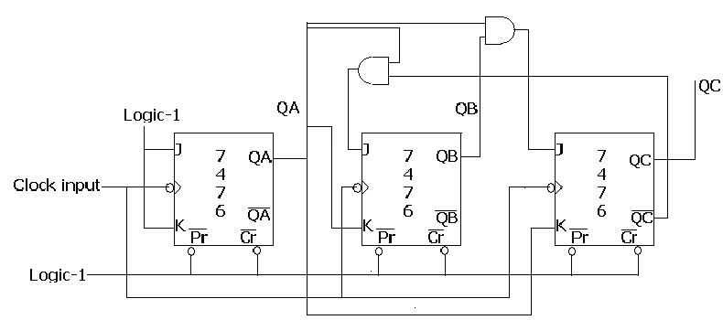
WAVE FORMS
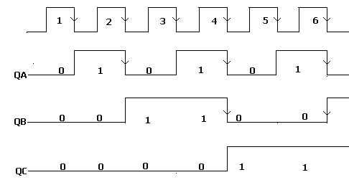
MOD-5 SYNCHRONOUS DOWN COUNTER
PRESENT STATE |  |  | NEXT STATE |  |  | FLIP-FLOPS
Qc | Qb | Qa | Qc | Qb | Qa | Jc | Kc | Jb | Kb | Ja | Ka
1 | 0 | 0 | 0 | 1 | 1 | X | 1 | 1 | X | 1 | X
0 | 1 | 1 | 0 | 1 | 0 | 0 | X | X | 0 | X | 1
0 | 1 | 0 | 0 | 0 | 1 | 0 | X | X | 1 | 1 | X
0 | 0 | 1 | 0 | 0 | 0 | 0 | X | 0 | X | X | 1
0 | 0 | 0 | 1 | 0 | 0 | 1 | X | 0 | X | 0 | X
SIMPLIFICATION
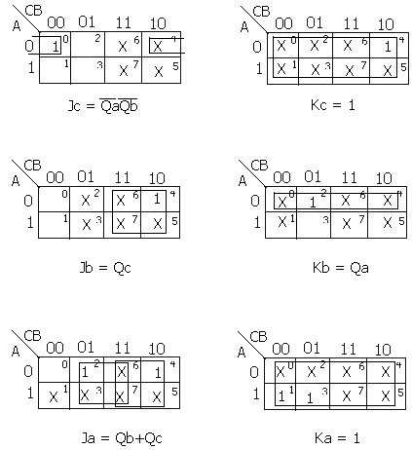
CIRCUIT DIAGRAM
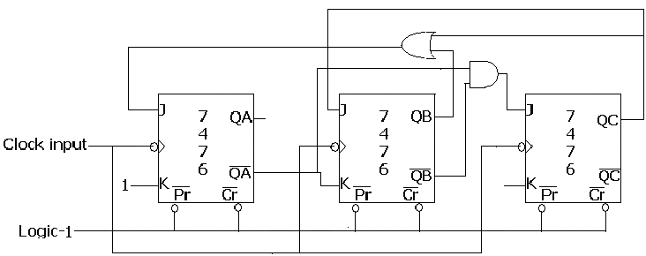
MOD-8 DOWN COUNTER
TRUTH TABLE
PRESENT STATE |  |  | NEXT STATE |  |  | EXCITATION
Qc | Qb | Qa | Qc | Qb | Qa | JC | KC | JB | KB | JA | KA
1 | 1 | 1 | 1 | 1 | 0 | X | 0 | X | 0 | X | 1
1 | 1 | 0 | 1 | 0 | 1 | X | 0 | X | 1 | 1 | X
1 | 0 | 1 | 1 | 0 | 0 | X | 0 | 0 | X | X | 1
1 | 0 | 0 | 0 | 1 | 1 | X | 1 | 1 | X | 1 | X
0 | 1 | 1 | 0 | 1 | 0 | 0 | X | X | 0 | X | 1
0 | 1 | 0 | 0 | 0 | 1 | 0 | X | X | 1 | 1 | X
0 | 0 | 1 | 0 | 0 | 0 | 0 | X | 0 | X | X | 1
0 | 0 | 0 | 1 | 1 | 1 | 1 | X | 1 | X | 1 | X

SIMPLIFICATIONS

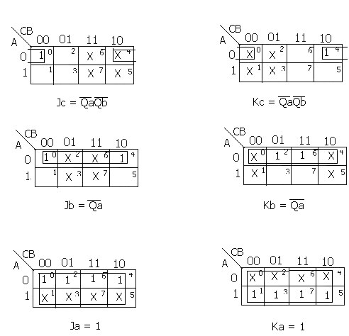
CIRCUIT DIAGRAM
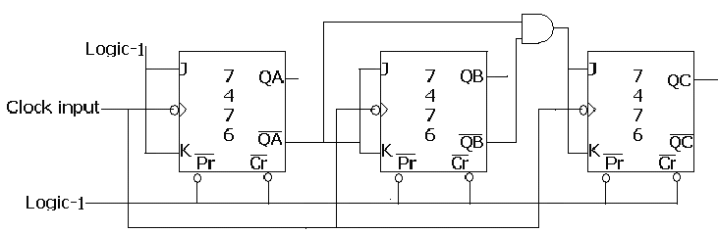

MOD-N COUNTERS

To realize a MOD-N counter using IC-74193 with a given preset value, write down the expected function table
Pin details of IC 74193(Synchronous counter)
[MOD-16 UP/DOWN COUNTER]

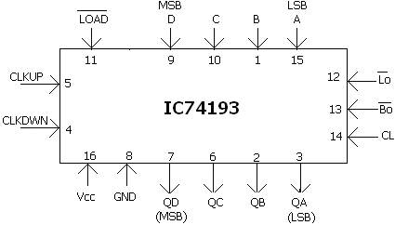
FUNCTION TABLE

 | Load | Up | Down | Qd | Qc | Qb | Qa
H | X | X | X | 0 | 0 | 0 | 0
L | L | X | X | D | C | B | A
L | H | Cp | H | COUNT UP
L | H | H | Cp | COUNT DOWN
L | H | H | H | NO CHANGE

Design a counter which counts from (6-12)

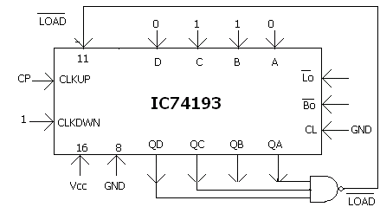

Invalid state 1101
WAVE FORMS

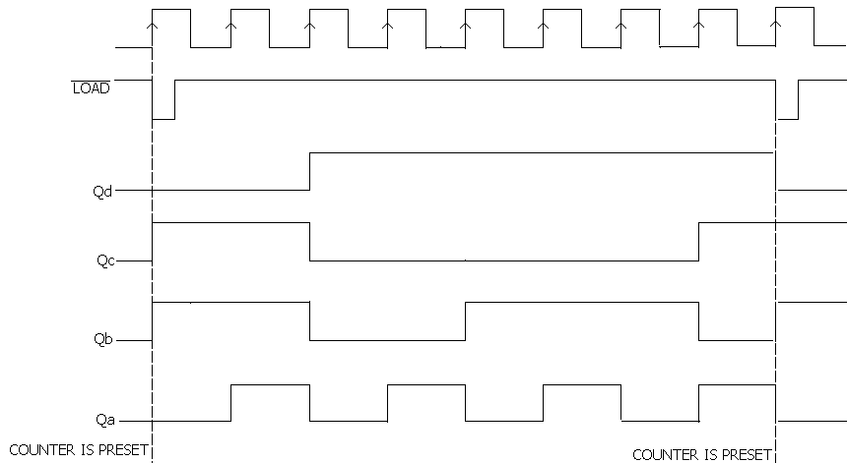

REALIZE A (15-6) COUNTER USING IC 74193

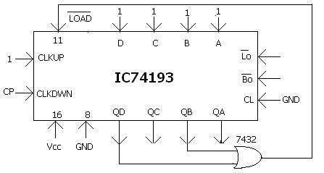
Invalid state---0101
Note:-Lo and Bo are used basically for cascading the counters

To realize a MOD-N counter using IC-74193

PIN DIAGRAM
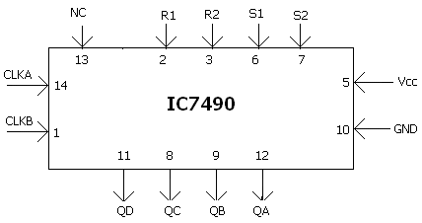
INTERNAL DIAGRAM
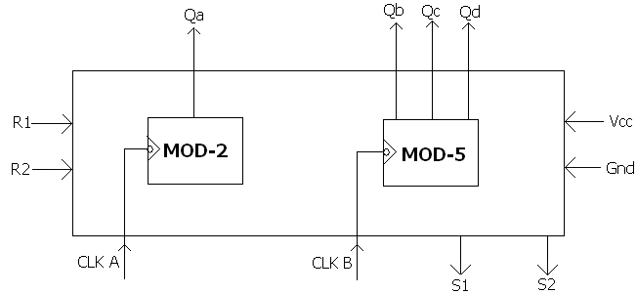

Functional Table

R1 | R2 | S1 | S2 | Qa | Qb | Qc | Qd
H | H | L | X | L | L | L | L
H | H | X | L | L | L | L | L
X | L | H | H | 1 | 0 | 0 | 1
L | X | L | X | MOD-2 COUNTER
X | L | X | L | MOD-5 COUNTER

7490 AS MOD-2 COUNTER

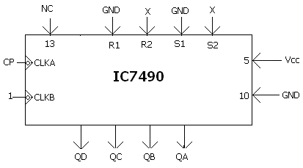
7490 AS MOD-5 COUNTER
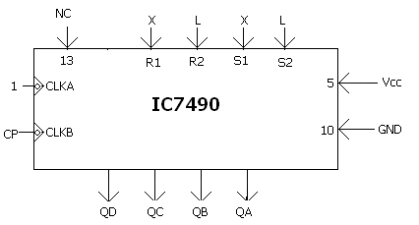
7490 AS MOD-10 COUNTER
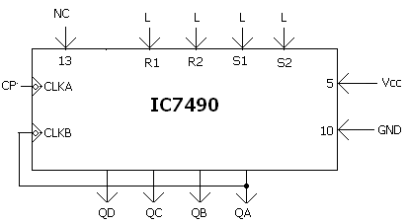
7490 AS MOD-8 COUNTER
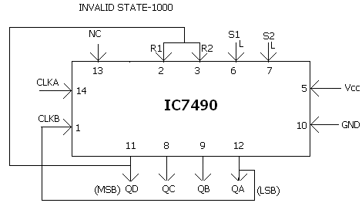

7490 AS MOD-6 COUNTER
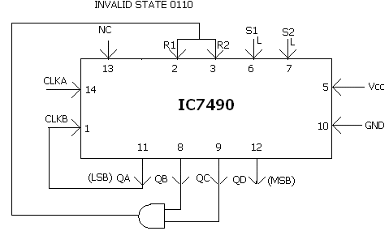

To realize a MOD-N counter using IC74192 with given preset value, write down the expected function table

SYNCHRONOUS COUNTER
PIN DETAILS OF IC-74192[ MOD-10 UP/DOWN COUNTER]

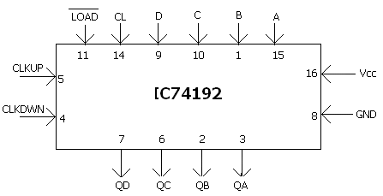

MOD-6 UP COUNTER:Invalid state o110

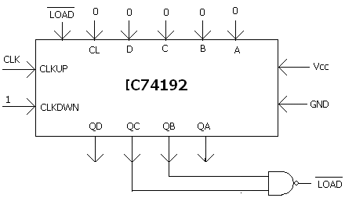

MOD-9 DOWN COUNTER:
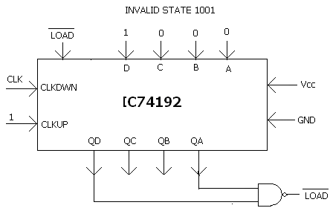

DESIGN A COUNTER WHICH CAN COUNT FROM 7 TO 9

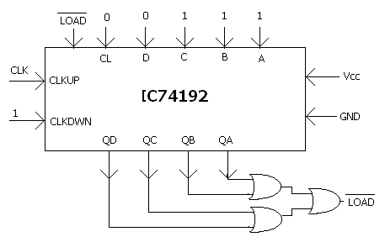
NOTE After 1001, out put becomes 0000

EXPERIMENT NO-10
SHIFT REGISTERS
Aim- To demonstrate Shift lift shift right, SIPO, SISO, PISO, PIPO operations using IC 7495

Components required :-

Sl.No | NAME OF THE COMPONENT | IC NUMBER
1  2 | Shift register  Trainer kit  Patch Chords | 7495

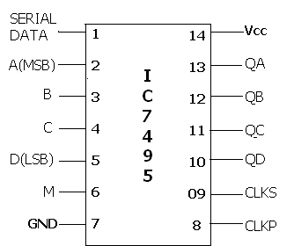
PIN DIAGRAM OF IC 7495

M=1 for parallel operation
M=0 for serial operation

SERIAL IN SERIAL OUT (SISO)-shift right

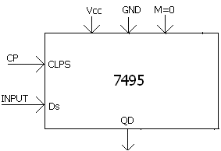
Clk | TIME | Qa | Qb | Qc | Qd
clks | T0 1 | 1
clks | T1 0 | 0 | 1
clks | T2 1 | 1 | 0 | 1
clks | T3 1 | 1 | 1 | 0 | 1
clks | T4 | x | 1 | 1 | 0
clks | T5 | x | x | 1 | 1
clks | T6 | x | x | x | 1

Serial in Parallel out (SIPO)

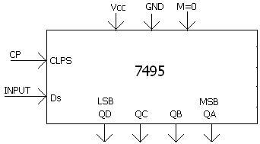
Time | Serial data | Qa | Qb | Qc | Qd
T0 | 1 | 1
T1 | 0 | 0 | 1
T2 | 1 | 1 | 0 | 1
T3 | 1 | 1 | 1 | 0 | 1

Parallel in serial out (PISO)
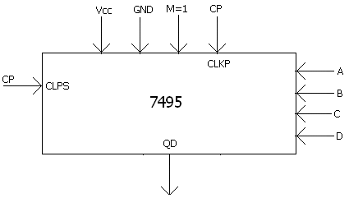
Clk | TIME | Qa | Qb | Qc | Qd
clks | T0 | 1 | 1 | 0 | 1
clks | T1 | x | 1 | 1 | 0
clks | T2 | x | x | 1 | 1
clks | T3 | x | x | x | 1
To check the serial out, M is made to 0 and clk is given clock pulse
PARALLEL IN PARALLEL OUT (PIPO)
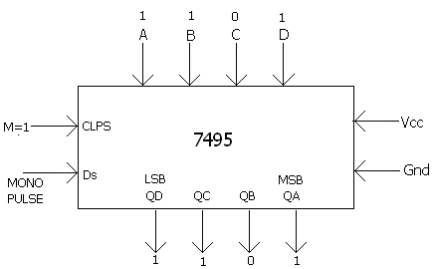

SHIFT LEFT (SERIAL)

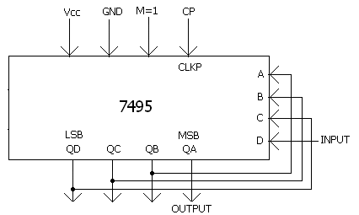
Clk | TIME | I/P | Qa | Qb | Qc | Qd
clks | T0 | 1 |  |  |  | 1
clks | T1 | 0 |  |  | 1 | 0
clks | T2 | 1 |  | 1 | 0 | 1
clks | T3 | 1 | 1 | 0 | 1 | 1
clks | T4 |  | 0 | 1 | 1 | X
clks | T5 |  | 1 | 1 | X | X
clks | T6 |  | 1 | X | X | X

Parallel clk to be given
When mode M=0, i/p is given to A A-Qa, Qa-B, Qb-C,Qc-D,Qd-LSB

Procedure:
PISO:-
1.M=1, clk-> CP, clks- >1.
2.load the parallel data ABCD , which gets stored in Q_{A,} Q_{B,} Q_{C,}Q_{D.}
3. Clks- >CP, M=0.
4.output is observed at Q_{D.}
SISO:-
1.M=0, clks-> CP,
2.i/p is given at D_{S}[give 1 or 0 at D_{S} press the mono pulsar]
3. the o/p shifts right Q_{A,} to Q_{D.}
4. after the 4th cpulse o/p is seen at Q_{A,} Q_{B,} Q_{C,}Q_{D.}
5. continue pressing the mono p[ulser , o/p is seen at Q_{D.}
SIPO:-
after the 4th clock pulse o/p is seen at. Q_{A,} Q_{B,} Q_{C,}Q_{D.}
example if i/p is 1011 o/p is 1101.
PIPO:-
1.M=1, clk-> CP
2. give the data through ABCD , give CP
3. the o/p is stored in . Q_{A,} Q_{B,} Q_{C,}Q_{D.}

Shift left:-
1.The procedure for shift right is
i/p- A-. Q_{A;}
Q_{A- >} B;
Q_{B->}C;
Q_{C} _{- >}D; Q_{D}= is the LSB
2. for shift left:
i/p -D- >Q_{D;}
Q_{D- >}C; Q_{A}= is the MSB
Q_{C- >}B;
Q_{B- >} A
3.the shift is observe from Q_{D} to Q_{A} as i/p is given.
4. o/p is observed at Q_{A} .

EXPERIMENT-11
Ring counter/Johnson counter
AIM –Design and testing of Ring counter/Johnson counter using IC-7495

RING COUNTER USING IC-7495
Components required :-

Sl.No | NAME OF THE COMPONENT | IC NUMBER | QUANTITY
1  2 | Ring Counter  NAND gate  Patch chords  Trainer Kit | 7495  7400 | 1  1

TRUTH TABLE CIRCUIT DIAGRAM
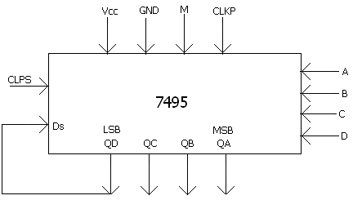
CP | QA | QB | QC | QD
t0 | 1 | 0 | 0 | 0
t1 | 0 | 1 | 0 | 0
t2 | 0 | 0 | 1 | 0
t3 | 0 | 0 | 0 | 1
t4 | 1 | 0 | 0 | 0

Procedure-
(1). Rig up the circuit as shown in the diagram,D_{S} is not given as input.
(2). Load data parallely with clkp and M=1
(3). Then make M=0,Clks-cp
(4). Verify the working of a ring counter.

JHONSON COUNTER USING

TRUTH TABLE CIRCUIT DIAGRAM
CP | QA | QB | QC | QD
t0 | 1 | 0 | 0 | 0
t1 | 1 | 1 | 0 | 0
t2 | 1 | 1 | 1 | 0
t3 | 1 | 1 | 1 | 1
t4 | 0 | 1 | 1 | 1
t5 | 0 | 0 | 1 | 1
t6 | 0 | 0 | 1 | 1
t7 | 0 | 0 | 0 | 1
t8 | 1 | 0 | 0 | 0
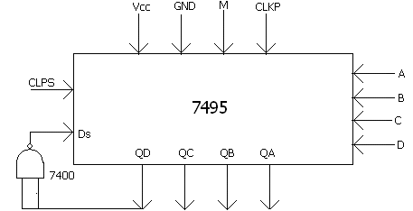

Procedure-
(1). Rig up the circuit as shown in the diagram,D_{S} is not given as input.
(2). Load data parallely with clkp and M=1
(3). Then make M=0,Clks-cp
(4). Verify the whether the ckt works as a Jhonoson counter or twisted ring counter.

EXPERIMENT-12
SEQUENCE GENERATOR
AIM: DESIGN A SEQUENCE GENERATOR
Sequence: 100010011010111
Design: There are 15 bits, so there will be 15 states s=15. So at least 4 flip-flops are required.
Components required :-

Sl.No | NAME OF THE COMPONENT | IC NUMBER | QUANTITY
1  2  3  4 | Shift register  Ex-OR  NANDgate(3i/ps)  Trainer Kit  Patch Chords | 7495  7486  7410 | 1  1  1

TRUTH TABLE SIMPLFICATION

 | 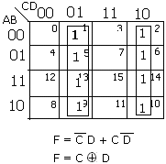  CIRCUIT DIAGRAM
  QA | QB | QC | QD | f
  1 | 1 | 1 | 1 | 0
  0 | 1 | 1 | 1 | 0
  0 | 0 | 1 | 1 | 0
  0 | 0 | 0 | 1 | 1
  1 | 0 | 0 | 0 | 0
  0 | 1 | 0 | 0 | 0
  0 | 0 | 1 | 0 | 1
  1 | 0 | 0 | 1 | 1
  1 | 1 | 0 | 0 | 0
  0 | 1 | 1 | 0 | 1
  1 | 0 | 1 | 1 | 0
  0 | 1 | 0 | 1 | 1
  1 | 0 | 1 | 0 | 1
  1 | 1 | 0 | 1 | 1
  1 | 1 | 1 | 0 | 1
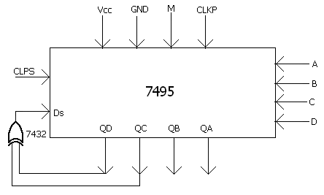
Procedure-
(1).The sequence is written such that no state repeats itself.The binary sequence is repeated
once in every 2^{N-1} clock cycles.
(2). The Expression for (Q_{A,} Q_{B,} Q_{C,} Q_{D}) is got using K-maps.
(3). Rig up the circuit as shown in the figure.
(4). Intially let M = 1,clkp = c_{p,} the intial state (A, B, C, D – 1110/1111) is losded.
(5). Then make clks =C_{p}, M = 0, output is observed at MSB (Q_{A}).
Note:-When we observe the sequence, which is to be generated, the LSB is a 1, following bit is a 0. If 0 has to be generated, then input to that particular D-FF must be a 0. There fore f(Q_{A}, Q_{B}, Q_{C}, Q_{D}) has its first entery as a 0.

VIVA QUESTION
- Define minterm and maxterm?
- Define minterm Canonical formula and maxterm canonical formula?
- What does standard SOP and standard POS mean?
- What are basic gates? disjunctive conjunctive.
- What are universal gates? Why are they called so?
- What does prime implicant, prime implicant and essential prime implicant mean?
- What does the term subsume mean?
- What are the different methods for solving Boolean expressions?
- Among K-map, VEM technique & Quine-McCluskey, which is easier to use?
- What is the other name given to K-map?
- What is the other name given to VEM technique?
- What is the other name given to Quine-McCluskey?
- What is the difference between Combinational circuit and Sequential circuit?
- What is a Parallel adder?
- If 2 10-bit numbers have to be added using Parallel adder how many full adders are required?
- What are the disadvantages of parallel adder?
- What is a look ahead carry adder?
- What is a serial adder?
- Is a serial adder a sequential circuit or a combinational circuit?
- What is a BCD adder?
- Which is better when compared to a binary adder and BCD adder?
- If 2 10-bit numbers have to be added using serial adder, how many full adders are required?
- Which is fastest among parallel adder, serial adder and look ahead carry adder?
- Which is called a reflecting code?
- Is Gray code a weighted code?
- Which is called a self complementing code?
- Is EXESSES-3 code a weighted code?
- What is an ASCII code?
- What is an EBCDIC code?
- What is parity checking?
- What is the difference between encoder and priority encoder?
- Why Enable input is generally an active LOW signal?
- What is the difference between de-multiplexer and decoder?
- What is the role of a multiplexer?
- Is it possible to realize 4-bit Binary to Gray using a 1:16 de-multiplexer?
- What are PLD’s?
- What is the difference between PAL and PLA?
- What is the difference between RAM and ROM?
- Can a PROM be reprogrammed?
- What is the difference between Static RAM and Dynamic RAM?
- Is it possible to realize comparator using Multiplexer?
- What is the difference between LCD and LED?
- What is the input voltage to a Common Anode LED?
- Why is a low frequency signal required for an LCD?
- Why is an ordinary decoder cannot be used with displays?
- What does RBI, RBO and BI mean?
- What does a basic bi-stable element mean?
- What is the forbidden state in SR latch?
- How contact de-bouncing can be eliminated using SR latch?
- What is the difference between a latch and a flip flop?
- What is meant by race around condition? How is it eliminated?
- How to convert a JK flip flop to a D flip flop?
- How to convert a JK flip flop to a T flip flop?
- How to convert a T flip flop to a D flip flop?
- How to convert a D flip flop to a T flip flop?
- Why is a D flip flop called as a transparent flip flop?
- What are the two asynchronous inputs? Why are they called so?
- What is the difference between synchronous PRESET and asynchronous PRESET?
- Design a traffic light system where in RED and GREEN do not glow simultaneously. When RED glows GREEN is OFF and when RED glows GREEN is OFF.
- What is MEALY sequential circuit?
- What is MOORE sequential circuit?
62. Can a multiplexer be used to realize a JK flip flop?
63. What is the difference between a counter and a register?
64. What is the difference between a synchronous counter and asynchronous
counter?
64. What type of flip flop is used to design a asynchronous counter?
65. In a mod-16 counter, each of the flip flop used has a delay of 20ns. To get an
output at the MSB how long does it take in a synchronous counter and in a
asynchronous counter?
66. Why is an asynchronous counter called as a ripple counter?
67. Define modulus of a counter.
68. What type of counter is 7490?
69. What type of counter is 74192 and 74193?
70. What type of flip flop is used to design a synchronous counter?
71. What is data lockout in a counter?
72. How is data lockout overcome?
73. Is the output of a counter always a square wave?
74. What is the difference between a shift register and register?
75. Is a shift register a synchronous circuit or an asynchronous circuit?
76. If a ADC is interfaced to a shift register, what type of shifting is preferred?
77. What are the features of a shift register?
78. Do we have a register which can perform all the basic shifting operation?
79. Name a combinational circuit which works similar to a PISO?
80. Name a combinational circuit which works similar to a SIPO?
81. What is a ring counter and a Johnson counter?
82. Is the output of a ring counter a square wave?
83. What is the difference between a self starting ring counter and a counter
loaded initially with a parallel data?
84. What happens if 0000 is loaded into a ring counter, provided it is not self
starting?
85. If there are 6 states in a ring counter, then how many flip flops are required?
86. If there are 7 states in a Johnson counter, then how many flip flops are
required?
87. What is the use of ring counter and Johnson counter?
88. Is the ring counter a synchronous circuit or an asynchronous circuit?
89. What are the other names by which a Johnson counter is called?
90. Define SET-UP time and HOLD time?
91. If the maximum clock frequency of a JK flip flop is 45Mhz, what happens if 100
Mhz is given?
92. What is meant by active time or triggering time?
93. What is a sequence generator? What is its application?
94. What happens if the states repeat in a sequence generator?
95. Is the sequence generator periodic in nature?
96. What is the difference between a sequence generator and a ring counter?
97. What is the sequence generator made up of?
98. Is the sequence generator a synchronous circuit or an asynchronous circuit?

99. If the length of the sequence to be generated is specified, then what is the
name given to such sequence generator?
100. Explain the working of a 555 timer?
101. What is the purpose of a monostable and astable?
102. Why is a monostable called so?
103. Why is a astable called so?
104. What is the use of the two diodes in a astable circuit?
105. Is a trigger input required for a astable?
106. Why doesn’t triggering pulse affect a monostable output when the capacitor is
still charging?
107. What is positive logic?
108. What is negative logic?
109. What are the output voltage ranges for a TTL gate?
110. What are the input voltage ranges for a TTL gate?
111. What is meant by current sourcing and current sinking?
112. Define Fan in?
113. Define Fan out?
114. Define Speed Power product?
115. In the basic circuit of transistor as an inverter, why CE configuration is used?
116. Why Diode-Transistor Logic is not used?
117. What is the advantage of Totempole configuration?
118. What is the disadvantage of Totempole configuration?
119. What is Open Collector configuration?
120. What are the advantages and disadvantages of Open Collector configuration?
121. What are Schottky diodes and transistors?
122. What are the different TTL families?
123. What does 74LS series mean?
124. If the input or output voltages fall in the intermediate range, what happens?
125. What is the difference between FET and MOSFET?
126. What is the difference between FET and BJT?
127. What are the advantages of using MOSFET?
128. Why p-MOS is not used?
129. Why n-MOS is used?
130. Why c-MOS is used?
131. What is the range of voltages that can be given as a input to MOS devices?
132. What is the output range of voltage for a MOS device?
133. What is the application of FET in digital circuits?
134. Compare the performance of different TTL sub families?
135. What is wired AND gate?
136. What is the input impedance of FET?
137. What is the input impedance of MOSFET?
138. What is enhancement MOSFET?
139. What is depletioin mode MOSFET?
140. What is inversion layer in a MOSFET?
141. Why MOS devices are preferred in digital circuits?
142. Give some application of MOS devices in digital circuits.
*****************************************************************************

