HUBLI ELECTRICITY SUPPLY COMPANY LIMITED



BID ENQUIRY NO.

HESCOM/SEEPMC/EEP2/15-16/ 02

BIDDING DOCUMENTS

FOR

EMPANELMENT OF AGENCIES FOR PREPARATION OF DPR FOR CAPITAL WORKS IMPLEMENTED BY HESCOM

TECHNIAL BID

ISSUED BY
The Superintending Engineer Ele, Tel: 080-2223860
Projects Monitoring Cell
Corporate Office,
Navanagar.
P.B.Road,
Hubli-580025

HUBLI ELECRICITY SUPPLY COMPANY LIMITED
VOLUME-I
SECTION – ITB (INSTRUCTION TO BIDDERS)
HESCOM/SEEPMC/EEP2/15-16/02

- INTRODUCTION

The Superintending Engineer Ele, PMC on behalf of Hubli Electricity Supply Company Limited (HESCOM), invites tenders vide Enquiry No. HESCOM/ SEEPMC/EEP2/15-16/02 through e-procurement portal (www. eproc. karnataka.gov.in) for “Empanelment of agencies for preparation of DPR for capital works implemented by HESCOM”.
 | 1. Enquiry No. | HESCOM/SEEPMC/EEP2/15-16/02
 | 2. Tender processing fee | Refer e-procurement website  www.eproc.karnataka.gov.in
 | 4. Earnest Money Deposit | Refer EMD Clause in the tender Documents
 | 5. Date of availability of Bids | Refer e-procurement portal
 | 4. Due date for submission of Bids | Refer e-procurement portal
 | 6. Tender System | One part tender (only technical proposal required)
 | 7.a) Pre-bid Meeting  b) Date of opening of bid | Refer e-procurement portal
 | 8. Name of the Work | “Empanelment of agencies for preparation of DPR for capital works implemented by HESCOM”.
 | 9. Schedule of requirements | As mentioned in the tender documents
 | 10. General Terms and Conditions | Enclosed herewith
 | 11. Scope of the work and  Specifications | Enclosed herewith

- ISSUE OF TENDER DOCUMENTS.
Bidders can download the tender documents from e-procurement portal (Free of cost)

- SUBMISSION OF TENDER DOCUMENTS
All the tender documents shall be submitted through e-procurement portal on or before last date of bid submission as mentioned in e-procurement portal. The bids will be opened as mentioned in the e-procurement portal. The bids would be evaluated and qualified and successful bidders would be empanelled. The limited tenders inviting bids from empanelled agencies would be called later on work basis.

- INTRODUCTION

HESCOM intends to empanel qualified agencies for “Preparation of DPR for the Capital works implemented by HESCOM". HESCOM would invite limited tenders from the list of empanelled agencies for each Capex Work, when required.

HESCOM has identified the following key areas for the need based investments.
- AT&C losses reduction :-
  - Metering
  - Reconductoring of lines (HT and LT)
  - Construction of new feeders/link lines for Urban / Rural Areas
- Construction and augmentation of Distribution Transformer Centers
- Other centre or state schemes - RGGVY, R-APDRP, NJY etc.
The key objective for appointing the agency is to prepare Detailed Project Report (DPR) for CAPEX Work planned by HESCOM. Preparation of DPR is essential to document key aspects like project objectives, implementation methodology, financial analysis, design etc and is important to take informed capital investment decision and for financing. The success of the proposed initiative shall play a key role in enhancing the capital investment decision process and implementation.

- GENERAL INFORMATION
- Technical proposals are invited from interested companies / contractors / agencies/ organizations/ firms for empanelment as DPR preparation agencies for the schemes listed out in the tender documents.
- Proposals can be submitted by an individual firm or consortium of companies/firms/agencies;
- The interested firm or consortium has to submit one “Technical proposal”.
- A pre-bid conference shall be held on as mentioned in e-procurement portal. All the interested bidders who require clarification on any aspect of this bid document, should send their queries in writing at least three days before the pre-bid conference to
Superintending Engineer Ele
Projects Monitoring Cell,
HESCOM Corporate Office,
Navanagar, Hubli-25
- Based on the outcomes of the pre-bid conference at any time prior to the deadline for submission of the technical proposal or extended date, if deemed necessary, HESCOM reserves the right to add/modify/delete any portion of this document by issue of an amendment. The amendment will be issued in e-procurement portal and such amendment will be binding on the bidders.
- Any bid received after the deadline prescribed for submission of Bids will be rejected.
- The tenders must be submitted with only ‘Technical Proposal’, no ‘Financial Proposal’ has to be submitted at this stage;
- Financial bids of only those firms will be invited during the limited tender from firms who are successful in the technical evaluation and get empanelled for preparation of DPRs.
- In case the empanelled agency or the consortium member firm invited to provide financial quote was contracted earlier, either for execution of the project or during design or in any other way that conflicts with the scope provided under this bid document shall by design be ineligible to quote under limited tender.
- If any empanelled agency chooses not to quote successively for 3 project works for which quotes are invited, then HESCOM reserves the right to cancel the empanelment of that agency.
- Technical details and operational statistics for each scheme shall be provided to the empanelled consultant before submission of the financial proposal.
- The bidder should have sufficient and experienced staff on its rolls for carrying out the preparation of DPR work across all circles of the HESCOM, if required.
- Empanelment of agencies does not mean award of contract for carrying out any works.
- HESCOM reserves the right to reject any or all of the bids, without assigning any reason thereof.
- QUALIFYING REQUIREMENTS
GENERAL CONDITIONS
- The bidder must be a registered legal entity under Companies Act in India
- The consortium can have a maximum of two member firms including the lead bidder. The lead bidder shall be responsible for the entire consortium and interact with HESCOM on the behalf of all the consortium partners. Separate requests from other consortium members shall not be entertained
- Consortium may be formed in such a manner so that the complete technical qualification criteria are met cumulatively
- The qualification criteria under the financial capabilities should be met individually by the lead bidder and members of the consortium
- The technical proposal shall be signed by the authorised signatory from bidder or each member of the consortium so as to be legally, jointly and severally binding
- In case of consortium, a copy of the consortium agreement on Non – Judicial stamp paper of INR 100/- satisfying the above conditions shall be submitted with the technical proposal indicating role and duties of all consortium members
- A consortium member shall not be partner with more than one bidder in the same tendering process. In that case, both or all such offers will be rejected.
- The bidder should furnish self-declaration stating that the firm/ consortium member has not been blacklisted by any Electricity utility/Government agencies
- TECHNICAL CAPABILITIES:
- The bidder or consortium should have prepared DPRs during last 3 years i.e. FY 2011-12 to FY 2013-14 for at least 1 Electricity Boards/Distribution Companies in India. Completion certificate from at least 1 electricity boards/ distribution utilities/ for different works as desired in this bid document, not older than 3 years should be attached;
- The bidder or consortium should have completed minimum 1 assignment of preparation of DPR for network strengthening works in power distribution sector, Completion certificates /Work orders/performance certificates to be provided to establish technical capabilities
- The technical capabilities of bidder or each of the consortium members as the case may be shall be provided in the given annexure formats (Volume II) for showcasing their eligibility for empanelment.
- FINANCIAL CAPABILITIES:
- The lead bidder shall be financially sound and shall submit audited financial reports for the years 2012-13, 2013-14, 2014-15 (For 2014-15, Provisional balance sheet, trading, profit and loss account duly certified by chartered accountant along with ITR- IV/SARALA ( For 2012 -13, 2013-14 ) should be furnished)and the annual turnover of the bidder in at least one of the last 3 years should not be less than Rs. 3 Crores
- In case of consortium, the cumulative annual turnover of all the consortium partners in any of the previous three financial years (2012-13, 2013-14, 2014-15) shall not be less than Rs 3.0 Crore, Copy of annual accounts for last 3 financial years along with ITR IV for having filed the returns of member firms showing financial eligibility should be attached.
- The submitted supporting financial documents (annual accounts, balance sheet along with ITR IV, etc) which do not belong to the bidder or consortium member or belong to its parent/ sister organization shall not be considered. Such proposal shall be out rightly rejected.

- General Conditions
- The Bidder shall upload all the necessary documentary proof in support of the qualifying requirements in the e-procurement portal. Non-submission of the proof leads to disqualification.
- Service Tax Reg. No. shall be uploaded as per Law
- The bidder must be a registered legal entity under Companies Act in India.
- The consortium can have a maximum of two member firms including the lead bidder. The lead bidder shall be responsible for the entire consortium and interact with HESCOM on the behalf of all the consortium partners. Separate requests from other consortium members shall not be entertained.
- Consortium may be formed in such a manner so that the complete technical qualification criteria are met cumulatively
- The qualification criteria under the financial capabilities should be met individually by the lead bidder and members of the consortium.
- The technical proposal shall be signed by the authorized signatory from bidder or each member of the consortium so as to be legally, jointly and severally binding.
- In case of consortium, a copy of the consortium agreement on Non – Judicial stamp paper of INR 100/- satisfying the above conditions shall be submitted with the technical proposal indicating role and duties of all consortium members.
- A consortium member shall not be partner with more than one bidder in the same tendering process. In that case, both or all such offers will be rejected.
- The bidder should furnish self-declaration stating that the firm/ consortium member has not been blacklisted by any Electricity utility/Government agencies.
- Misleading or false representations in statements and attachments submitted as proof of the qualification requirement and /or Record of poor performance such as not properly completing the contract of financial failures etc.
- After empanelment, if the related documents furnished by agency, found to be incorrect or false or fake, such agencies orders will be cancelled without any notice, apart from initiating legal action.
- HESCOM reserves the right to cancel or withdraw or modify the bid without assigning any reason for such decision. Such decision will not incur any liability whatsoever on the part of HESCOM consequently.
- The name and address along with seal of the authorized representative of the agency who will be interacting in future has to be furnished.
- The tender not submitted through e-procurement portal is liable to be rejected.
- HESCOM will not be responsible for not getting internet connection while downloading the electronic bid sheets/documents or while uploading their offers.
- The bidder should not be involved in any major litigation that may have an impact of affecting or compromising the delivery of services as required under this contract. A declaration to the above effect that the bidder is not involved in any major litigation shall be up loaded.
- The person/firm who is having criminal background or insolvent is not eligible to participate in the tender.
- HESCOM has the right to cancel the order without giving any notice.

- DISPUTE:
In the event of any dispute or difference arising under this contract agreement or that which may arise in future will be solved by taking recourse to mutual settlement failing which this shall refer the same to Chairman, HESCOM whose decision shall be final and binding on both the parties to this contract. Further any unsettled dispute will be subject to appropriate courts in Hubli jurisdiction only. In case of any dispute between Contractor and the engaged employees by the contractor, HESCOM will not be a party and this has to be settled by the contractor himself at his own cost.

- ONE PART TENDER
Tender should be in one part namely Technical Bid containing full technical particulars as required by this tender document.

- INFORMATION REQUIRED WITH TECHNICAL PROPOSAL:
Scope of the Work
HESCOM invites EOI from reputed and established agencies for Empanelment of Agencies for “Preparation of DPR for the Capital works implemented by HESCOM". The detailed list of types of capital works is provided below. HESCOM would invite limited tenders from the list of empanelled agencies for each Capex Work when required. The empanelment of the agencies shall be for a duration of two years (extendable by an additional one year based on the performance of agencies and requirements of HESCOM) on work to work basis.
Indicative list of Capex Works
- Metering initiative
- Construction of new HT and LT lines
- Re-conductoring of existing lines
- Implementation of HVDS system
- Feeder bifurcation
- Laying UG cables/AB cables
- Projects under NJY scheme (Phase III)
- Project under R-APDRP
- Projects under RGGVY 12th plan
- Metering of DTCs in non RAPDRP area
- Construction and Augmentation of Distribution Transformers Centres
The key activities proposed to be carried out by agencies for preparation of DPR are as follow:
Module 1: Stakeholder Consultation
- The agency is expected to meet the concerned staff at circle level/division level in HESCOM to understand the need for taking up the particular project, the desired outcome and framework or guidelines based on which he has to complete the activities prior to the preparation of report and the template for DPR preparation.
- If in case of a particular scheme/project, if the Detailed Project Report structure is pre-defined by a central or a state agency or the relevant authority, the same structure must be followed by the agency.
- The DPR structure provided in this bid document is only an indicative one and the specific sections may vary from scheme to scheme or project to project, agency should discuss and agree on the structure with the concerned staff of HESCOM before going ahead with preparation of the DPR.
Module 2: Field survey and investigation
- The agency shall carry out field visits in the identified project area to understand network configuration and topology with respect to implementation of selected scheme.
- The objective of field visit shall be to assess the system topology, network conditions, loss levels, system loading, asset base, equipment specifications, system adequacy and other related aspects of system as required by the scheme or nature of Capex Work.
- The selected agency wherever possible will rely on existing data and facts, studies and analyses provided by HESCOM for arriving at the conclusions on the field survey and where such data is not available in a ready form, the agency and HESCOM staff shall, on a best effort basis, compile the same from existing and available sources so as to complete the DPR preparation in a stipulated time period.
- However in specific cases HESCOM may ask the agency to carry out a detailed field survey. In which case the agency shall appoint a senior engineer and a team to carry out surveys such as walk over survey or profile survey or topographical survey to establish route alignment (wherever applicable) or the layout (wherever applicable). The survey shall provide:
  - details of land (passing through or project site)
  - details of pole markings along the route or layout requirements
  - details of right of way requirements (in either case)

- Post the survey, the agency shall provide the final profile and tower schedule or the general layout of the project and identify exact locations of various components of the project. The findings of field survey shall form an integral part of the DPR. While preparing the final profile the agency shall keep in mind the aspects concerning span, clearance levels, way-leave, proximity to roads, telecom lines, right of way issues etc. The findings shall be discussed with staff of HESCOM and corrected and updated based on the recommendations of the concerned nodal officer.

- Based on the findings from the survey and site visit, the agency shall also identify the list of clearances and approvals that need to be sought by the HESCOM for taking up the project.
Module 3: Techno Economic analysis
- The agency shall assess all the available alternatives for implementation of identified project/work/scheme, geographical area where it should be implemented based on the field survey, technical feasibility, load flow study, revised network configuration, revised loss levels, energy savings and other technical aspects of power distribution. The analysis should clearly identify the alternatives available with HESCOM for achieving the desired outcome.
- The agency shall assess the broad level financial impact/implication for implementation of each option. The broad level cost estimates shall be prepared for each scheme for financial evaluation.
- Subsequently, agency shall carry out cost benefit analysis of each option to select the most suitable approach to be taken to achieve the perceived objectives. Agency shall use tools such as payback period calculations, IRR calculations; additional revenue (if any) and other related aspects for cost benefit analysis.
- The agency shall additionally calculate social rate of return to assess the social impact of implementation such work/project/scheme. Agency shall propose the funding as per norms of KERC (Debt/Equity ratio) and assumptions on interest rates, overheads etc. shall be finalized after consulting with staff concerned in HESCOM.
- The approach for carrying out the analysis shall be discussed with HESCOM before carrying out the analysis.
- At the end of the analysis the agency shall provide the pros and cons of various available options along with justification on why a particular option is better for achieving the desired outcome.
- In case the analysis reveals an IRR rate or Payback period less than the threshold value for such projects as decided by the HESCOM management or a Cost Benefit Analysis ratio of less than 1 then the agency shall discuss with the management of HESCOM and identify measures to improve the cost benefit ratio or improve viability of the said project
Module 4: Detailed project design and BoQ
- Agency shall prepare detailed project designs, drawings, layouts, Bill of Quantity, technical specification, guaranteed technical specifications, revised network configuration and topology, network loading, network capacity, revised asset base and related technical aspects. The agency should be well aware of central level schemes like RAPDRP, RGGVY etc and shall align (where ever possible) the project objective, project design as per the guidelines provided in such schemes
- The agency shall estimate the cost of implementation for the finalized option, based on the BoQ developed. The estimates shall include cost of material/equipment, cost of installation and any other associated cost. The costs per unit of materials and equipment shall be taken from the Schedule of Rates (SR) sheet provided by HESCOM from time to time.
Module 5: Implementation schedule, KPIs and risk identification
- The agency shall prepare a detailed implementation schedule and activity plan with milestones using PERT or CPM diagrams for executing the scheme. The plan shall also include the phasing with regard to achievement of the desired objectives.
- The agency shall identify and agree with HESCOM on the Key Performance Indicators (KPI) pre implementation of specific Capex scheme based on which desired outcomes can be measured. The KPIs should be a mix of qualitative and quantitative parameters e.g. DT damage rate, AT&C loss, collection efficiency, LT-HT ratio for HVDS, reduction outages, availability of supply, power factor, segregation and bifurcation/ trifurcation, safety etc.
- The agency has to estimate targeted achievement of the objectives post implementation of the scheme through agreed upon KPIs and timeline within which such KPIs need to be achieved. This shall be driven by the stakeholder inputs, field situation assessment study, experience in other states and other related aspects.
- They should also identify key risks which can occur during execution of capex work. The steps to mitigate risks should be as well be proposed by the agency and presented to the staff of HESCOM.
Module 6: Stakeholder discussions:
- Agency shall be carrying out stakeholder discussions for each module of this bid document. They shall incorporate key inputs provided by the stakeholders at various stages. Subsequently, the option to be implemented shall be selected in consultation with HESCOM based on the findings of cost benefit analysis.
- Agency shall make presentations (as and when required) to discuss the DPR to the staff of HESCOM or to any other relevant authority on behalf of HESCOM. They shall also assist HESCOM in providing necessary clarifications to the bidders during the tendering phase.
- The agency shall also make any necessary changes to the DPR that HESCOM requires based on the feedback received from the authorities concerned. Agency shall also assist HESCOM during interactions with funding agencies for sourcing of funds. In cases where HESCOM finds it necessary, HESCOM may ask and the agency shall support HESCOM to present the findings of the DPR or the approach and analysis in front of concerned authorities or financial institutions.

Structure of DPR

  - Executive Summary: - The agency shall give introduction of the project in this section and summarize the key parameters being discussed in DPR
  - Introduction: In case of larger projects introduction should include brief about Karnataka state power sector and the utility information. In case of smaller projects it can include details of the project area, the details concerning baseline information. In addition this section should brief about the existing status of the physical infrastructure.
  - Defining objective, perceived outcomes, strategy of implementation: - The agencies shall define objectives, perceived outcomes (quantitative and qualitative), strategy of implementation and other strategic aspects of implementation of scheme (s).
  - Field survey report: - The findings and analysis of field survey shall be captured in this section of DPR. The field survey report shall be exhaustive in nature and shall provide complete details of network configuration and topology along with loss levels, DT wise loading and other related aspects as covered in the field survey.

Identification of key options and their evaluation

  - Scheme identification and technical evaluation: - In this section agency shall detail out the available alternatives for implementation of identified project/work/scheme, geographical area and based on the field survey, technical feasibility, load flow study, revised network configuration, revised loss levels etc shall be captured in the technical feasibility report.
  - Financial evaluation: - In this section agency shall assess the broad level financial impact/implication for implementation of each option. The broad level cost estimates shall be prepared for each scheme for financial evaluation.
  - Cost benefit analysis: - In this section agency shall details out cost benefit analysis including the IRR and other measures used to capture the techno-economic viability of each option and to select the most suitable approach to be taken to achieve the perceived objectives.
Detailed project design
  - Technical designs and drawings: - Agency shall include in this section the detailed project designs, drawings, layouts, Bill of Quantity, technical specification etc and related technical aspects.
  - Preparation of Cost Estimates: - The agency shall estimate the cost of implementation for the finalized option, based on the BoQ as per prevailing Schedule of Rates of HESCOM.
  - Implementation plan: - The agency shall develop the detailed implementation plan along with milestones, monitoring framework, MIS templates monitoring the progress of various activities during execution stage etc.
  - Risks in Implementations and Mitigation strategy- The agency should identify key risks which can occur during execution of Capex work. The steps to mitigate risks should be highlighted in this section.
The final DPR comprising of all aforementioned sections (but not limited to) shall be submitted to HESCOM.

- COST OF BIDDING:
The Bidder shall bear all costs and expenses associated with preparation and submission of its bid including post-bid discussions, technical and other presentations etc, and HESCOM will in no case be responsible or liable for those costs, regardless of the conduct or outcome of the bidding process.

  - THE BIDDING DOCUMENTS
- THE BIDDING DOCUMENTS

CONTENTS OF BIDDING DOCUMENT
The Bidding Document is a compilation of the following Sections:
Bid  Documents | Bid Documents in following format will be available in the web site.
Bid  Documents | Volume-I
Bid  Documents | Section-INB-Instructions to Bidders
Bid  Documents | Information Required with Technical Proposal
Bid  Documents | Volume-II
Bid  Documents | Annexure-1,2,3,4,5  Bid Form

- UNDERSTANDING OF BID DOCUMENTS
A prospective Bidder is expected to examine all instructions, forms, terms and specifications in the Bid documents and fully inform himself as to all the conditions and matters which may in any way affect the scope of work or the cost thereof. Failure to furnish all information required by the Bid document or submission of a Bid not substantially responsive to the Bid document in every respect will be at the Bidder’s risk and may result in the rejection of its bid.

- CLARIFICATIONS ON BID DOCUMENT
If the prospective Bidder finds discrepancies or omissions, in specifications and document or is in doubt as to the true meaning of any part, he shall at once make a request, in writing, for an interpretation/clarification, to owner. The owner, then, will issue interpretation(s) and clarification(s) as he may think fit in writing. After receipt of such interpretation(s) and clarification(s),
The Bidder may submit his bid but within the time and date as specified in the Invitation to Bid. All such interpretations and clarifications shall form a part of the Bidding Document and shall accompany the Bidder’s Proposal. A prospective Bidder requiring any clarification on Bidding Document may notify owner in writing. Owner will respond in writing /upload in the website/issue corrigendum in the website/issue instructions in the website to any request for such clarification of the Bidding Document which it receives not later than Seven (7) days prior to the deadline for submission of bids prescribed by Owner. Written copies of owner’s response (including an explanation of the query but without identifying its source) will be sent to all prospective Bidders who have received the Bidding Document.
Verbal clarification and information given by owner or his employee(s) or his representative(s) shall not in any way be binding on owner.

- AMENDMENT TO BIDDING DOCUMENT
At any time prior to the deadline for submission of bids, owner may, for any reason, whether at its own initiative or in response to a clarification requested by a prospective Bidder, modify the Bidding Document by amendment (s). The amendment will be notified in the e-procurement portal. Owner will bear no responsibility or liability arising out of non-acknowledgment of the same by all the prospective Bidders before submitting the Bid.
In order to afford prospective Bidders reasonable time in which to take the amendment into account in preparing their bids, owner may, at its discretion, extend the deadline for the submission of bids as deemed fit.
Such amendments, clarifications, etc, shall be binding on the Bidders and will be given due consideration by the Bidders while they submit their bids and invariably enclose such documents as a part of the bid.

C. PREPARATION OF BIDS
- LANGUAGE OF BID
The bid prepared by the Bidder and all correspondences and documents relating to the bid, exchanged by the Bidder and owner shall be written in the English language, provided that any printed literature furnished by the Bidder may be written in another language so long as accompanied by an English translation of its pertinent passages. Failure to comply with this may disqualify a bid. For purposes of interpretation of the bid, the English translation shall govern.

- DOCUMENTS COMPRISING THE BID
- The Bidder shall complete the Bid Form inclusive of all annexures, furnished in the Bid Document as detailed above and upload in the e-procurement portal.
- The Bidder shall also upload documentary evidence to establish that the Bidder meets the Qualification Requirements as detailed above and accompanying General Conditions of Contract if any.
- EARNEST MONEY DEPOSIT (BID GUARANTEE)
No EMD is required with this proposal.
- E-PAYMENT MODES FOR TENDER PROCESSING FEE
The contractor should pay Tender processing fee in the e-Procurement portal using any of the following payment modes:
a) Credit Card
b) Direct Debit
c) National Electronic Fund Transfer (NEFT)
d) Over the Counter (OTC)
- CREDIT CARD PAYMENT METHOD:
To pay the registration fee through your credit card, click on the “Credit Card (Online Payment)” option. If you choose to pay the fees later click on
“Close” button. Click Pay after verifying details on the screen that appears. Click on “Pay” button to proceed with payment process. Click “Back” if you wish to choose a different payment method. Click on “OK” button on the payment method Confirmation window that is displayed. You will choose your card type (VISA, master Card). You enter your credit card details. Card Details completely filled.
The screen will look like it is shown above when you have completely filled the card details.
Click on “PAY NOW” button to effect the payment. Your card details are verified by the payment gateway service and you will receive confirmation of payment debited to your card account if the card is valid. If the card is not valid you will receive alert about it and system will wait for you to correct any errors in the card details provided by you.
A successful transaction message is displayed.
- DIRECT DEBIT METHOD:
Click on “Direct Debit Using Internet Banking (Online Payment) option to pay from your bank account through Internet Banking facility.
Click on “Pay” to proceed or “Back” to change the payment method on the Payment details screen.
Click on “OK” on the confirmation window to effect the payment. Click on “Cancel” and then on “Back” to change the payment method.
You will information on your screen about successful completion of payment process.
- OTC PAYMENT PROCEDURE:
If a contractor/supplier chooses to make payment of tender processing fees Over The Counter (OTC) in any of the designated Axis Bank branches listed in the e-Procurement web-site (https://www.eproc.karnataka.gov.in) the contractor/supplier will need to log into e-Procurement system, access the tender for which bid is being created and then select the OTC option under the payment section and print the Challan shown in that section. The printed challan will have the unique bid reference number and the amount to be remitted. Along with the challan, contractor can choose to make the payment either in the form of cash or in the form of Demand Draft. Cheque payments will not be accepted. The contractor is requested to specifically inform the bank officer to input the unique bid reference number printed in the challan in the banking software. Upon successful receipt of the payment, the bank will provide a 16-digit reference number acknowledging the receipt of payment. This 16-digit reference number has to be inputted by contractor in the payment section of its bid as payment confirmation before the bid is submitted (i.e.) as a pre-requisite for bid submission.

- NEFT PAYMENT PROCEDURE:
If a contractor/supplier chooses to make payment of tender processing fees using Reserve Bank of India's (RBI) National Electronic Fund Transfer (NEFT) system, the contractor/supplier will need to log into e-Procurement system, access the tender for which bid is being created and then select the NEFT option under the payment section and print the Challan shown in that section. The printed challan will have the unique bid reference number, account details of Government of Karnataka and the amount to be remitted. The contractor has to submit the printed challan to its bank-branch (NEFT-enabled) and request for an account-to-account transfer, wherein the money will get transferred from the contractors' bank account to GoK's bank account. The contractor should ensure that NEFT transfer instructions are executed and the funds are wired to the Government of Karnataka's principal account before the last date for bid submission and preferably 24 hours before the last date for bid submission. If the contractor's bank transfers/wires the money after the last date for bid submission, the contractor's bid will be liable for rejection. Upon executing the transfer, the contractor's bank will provide a reference number generated by NEFT software as confirmation of transfer, which has to be inputted by contractor in the payment section of its bid as payment confirmation before the bid is submitted (i.e.) as a pre-requisite for bid submission. Also, the account number from which the funds were transferred has to be inputted in the e-Procurement system as part of its bid. The contractor’s bid will be evaluated only on confirmation of receipt of the payment (tender processing fee) in the Government of Karnataka central pooling a/c held at Axis Bank. For details on e-Payment services refer to e-procurement portal for more details on the process.
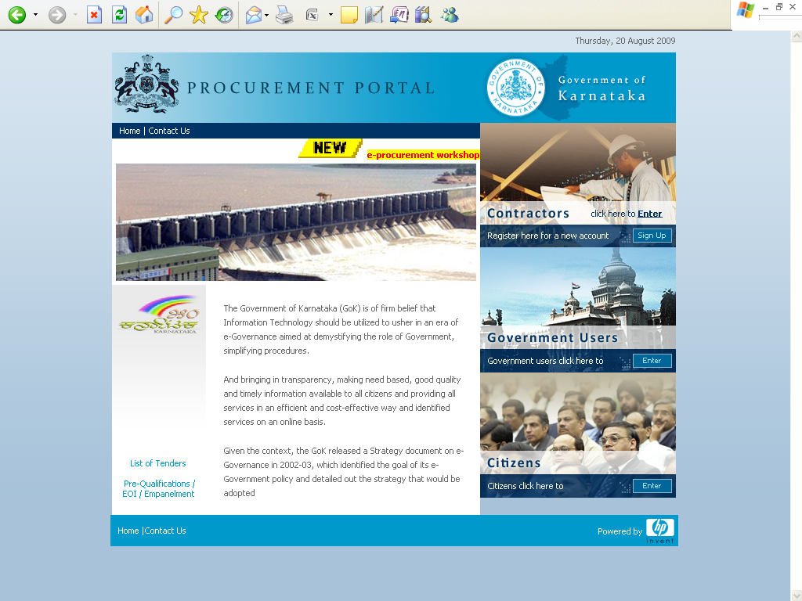

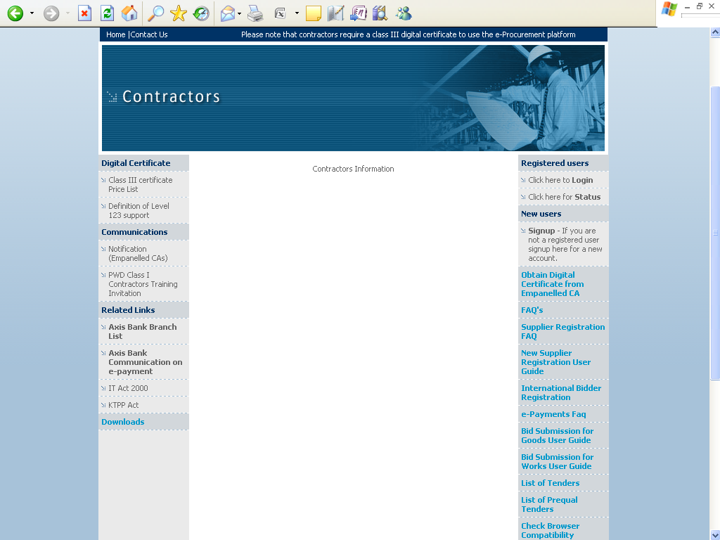
Note: In e-Procurement Portal Contractor has the option of withdrawing the Bid by digitally signing to withdraw/cancel bid before the bid submission time /Date.

    - SUBMISSION OF BIDS

- FORMAT OF BID
  - The bids shall be uploaded in the e-procurement portal, on or before the last date and time of submission of bids. Bids not submitted through e- procurement portal will be disqualified.
  - The bid shall contain no interlineations, erasures or overwriting except as necessary to correct errors made by the Bidder, in which case such corrections shall be initialled by the person or persons signing the bid.
  - All the documents in support of qualifying requirements and all necessary documents shall be scanned and uploaded in the E-Procurement website.
( www.eproc.karnataka.gov.in).

- DEADLINE FOR SUBMISSION OF BIDS
Bids must be uploaded in the e-procurement portal on or before stipulated date and time
Owner may, at its discretion, extend this deadline for the submission of bids by amending the Bidding Document, in which case all rights and obligations of owner and Bidders previously subject to the deadline will thereafter be subject to the deadline as extended.

- MODIFICATION AND WITHDRAWAL OF BIDS
- The Bidder may modify or withdraw its bid after the bid’s submission provided that written notice of the modification or withdrawal is received by owner prior to the deadline prescribed for submission of bids.
- No bid may be modified subsequent to the deadline for submission of bids.
- No bid may be withdrawn in the interval between the deadline for submission of bids and the expiration of the period of bid validity specified by the Bidder on the Bid Form. Withdrawal/modification of a bid during this interval may result in the Bidder’s forfeiture of its bid security.

    - BID OPENING AND EVALUATION
- OPENING OF BIDS
Owner will open bids submitted through e-procurement portal in the presence of Bidders’ representatives (up to 2 persons) who choose to attend at the date and time for opening of bids or in case any extension has been given thereto, on the extended bid opening date and time notified to all the Bidders. The Bidders’ representatives, who are present, shall sign in a register evidencing their attendance.
- The Bidders’ names, bid withdrawals and such other details as owner, at its discretion, may consider appropriate will be announced at the bid opening.
- No electronic recording devices will be permitted during bid opening.

- CLARIFICATION OF BIDS
To assist in the examination, evaluation and comparison of bids owner may, at its discretion, ask the Bidder for a clarification of its bid. The request for clarification and the response shall be in writing and no change in the price or substance of the bid shall be sought, offered or permitted.

- PRELIMINARY EXAMINATION
- Superintending Engineer El, Corporate Office, HESCOM shall be incharge of opening the tenders on the specified date & time.
- The bids shall be examined to determine whether:
  - They are complete and all supporting documents and annexure are filled;
  - The bidder satisfies the eligibility criteria;
  - The required sureties have been furnished;
  - The documents have been properly signed.
- HESCOM shall have the authority to waive any minor informality or non-conformity or irregularity in a bid which does not constitute a material deviation, provided such waiver does not prejudice or affect the relative ranking of any Bidder.
- TECHNICAL EVALUATION
- A substantially responsive proposal shall be one, which conforms basically to all the terms and conditions of the bid documents without deviations. Deviations, if any, shall be mentioned in a separate document to be submitted along with the technical proposal.
- The technical proposals shall be evaluated generally on the following points but not restricted to the same:
  - Qualifying Requirements;
  - Completeness of the offer to carry out all the work as per requirement and availability of manpower with the bidder;
  - Acceptance for all terms & conditions etc, as specified in the bid document.
- The scoring of the technical proposal shall be done as per the following methodology:
S.No. | Description | Details | Maximum Marks
 | Annual turnover of the bidder or consortium | - Upto INR 5 Crs (Average of three years) – 5 Marks  - Above INR 10 Crs (Average of three years) – 10 Marks | 10
 | Experience in preparation DPRs for relevant works | - Upto 4 capital expenditure schemes - 10 marks  - Upto 8 capital expenditure schemes – 20 marks  - Upto 12 capital expenditure schemes– 30 marks  - Upto 16 capital expenditure schemes – 40 marks | 40
 | Empanelment in distribution utility/Electricity Board/R-APDRP/RGGVY | - Empanelment in atleast one distribution utility/Electricity Board/R-APDRP Part B/RGGVY during FY12, FY13 and FY14 (Letter/Certificate of empanelment needs to be attached) | 10
 | CV of proposed team members | - Minimum 5 CVs having minimum experience in this field of 5 years with project manager having experience of minimum 10 years  - Maximum marks – 40 (8 marks per CV)  - Qualification - B.Tech/BE (2 Marks)  - Experience in preparation of DPR for distribution infrastructure projects or execution of distribution infrastructure projects (0.5 mark per assignment to the maximum of 6 marks) (6 marks) | 40

The minimum score for qualifying the technical evaluation and to be considered for empanelment is 75 marks.

- CONTACTING THE OWNER
Bids shall be deemed to be under consideration immediately after they are opened and until such time official intimation of award/rejection is made by owner to the Bidders. While the bids are under consideration, Bidders and/or their representatives or other interested parties are advised to refrain from contacting by any means, owner and/or his employees/representatives on matters related to the bids under consideration. Owner, if necessary, will obtain clarifications on the bids by requesting for such information from any or all the Bidders, either in writing or through personal contacts as may be necessary. Bidders will not be permitted to change the substance of the bids after the bids have been opened.

- NEGOTIATIONS:
It is absolutely essential for the bidders to quote the lowest price at the time of making the offer in their own interest, as HESCOM will not enter into any price negotiations.

    - ISSUE OF CONTRACT ORDER
- AWARD CRITERIA
HESCOM will empanel the agencies whose bid has been determined to be substantially responsive and score the technical score above 75 marks as mentioned in Clause 26, provided further that the Bidder is determined to be qualified to perform the Contract satisfactorily. Owner shall be the sole judge in this regard.

- RIGHT TO ACCEPT ANY BID AND TO REJECT ANY OR ALL BIDS:
Owner reserves the right to accept or reject any bid, and to annul the bidding process and reject all bids at any time prior to award of Contract, without thereby incurring any liability to the affected Bidder or Bidders or any obligation to inform the affected Bidder or Bidders of the grounds for owner’s action.

- NO COMMITMENT TO ACCEPT LOWEST OR ANY TENDER:
HESCOM shall be under no obligation to accept the lowest or any other offer received in response to this tender notice and shall be entitled to reject any or all offers including those received late or incomplete offers without assigning any reason whatsoever.

- NOTIFICATION OF EMPANELMENT AWARD:Prior to the expiration of the period of bid validity and extended validity period, if any, owner will notify the successful Bidder in writing by registered letter or fax, that its bid has been accepted.

- EMPANELMENT PERIOD: The empanelment shall be for a period of two (2) year from the date of selection of the consultant. The empanelment may be extended further by one (1) year depending upon the satisfactory performance of the empanelled agency. The extension shall be at the same terms & conditions.

- SECURITY DEPOSIT: The Security deposit shall be paid within two weeks from the date of the Work Award after limited tender or shall be along with the acknowledgement for having received the Work Award. Security Deposit shall be paid at FIVE PERCENT of the total value of the Work Award. The mode of payment of Security Deposit is as follows:
- If the amount of Security Deposit payable is Rs. 10,000/- and less, the same shall be payable by Cash or Demand Draft.
- If the amount of Security Deposit payable is more than Rs. 10,000/- and upto and inclusive of Rs. 10,00,000/-, it shall be payable in the form of Demand Draft and balance in excess of Rs. 10,00,000/- shall be in the form of Bank Guarantee issued by a Scheduled Commercial Bank.
- In case bidder fails to furnish the required Security Deposit within the prescribed date, the Earnest Money Deposit will be forfeited and the Work award will also be cancelled.
- The Security Deposit will be discharged without any interest at the end of successful completion of the work.

- PENALTY: The empanelled agencies (selected for preparation of DPR for any scheme during limited tendering stage) shall be penalized by 10% of the contract value in case their financial estimates (as assessed in the DPR for capital expenditure scheme) differs by +/- 20% of the actual bid value (as observed during the bidding stage). The selected firm (out of empanelled firms), for preparation of DPR for any capital expenditure scheme, has to submit an unconditional bank guarantee equivalent to the 10% of the contract value (valid for a period of Contract duration plus 120 days). This bank guarantee shall be realised by HESCOM if the financial assessment (as assessed in the DPR for capital expenditure scheme) differs by +/- 20% of the actual bid value (as observed during the bidding stage).
- TERMINATION OF EMPANELMENT CONTRACT: In case an empanelled agency chooses not to quote successively for 3 project works for which quotes are invited, then HESCOM reserves the right to cancel the empanelment of such agency.

- ISSUE OF EMPANELMENT CONTRACT
Empanelment order will be issued by the Chief General Manager (Ele), Corporate Affairs. Whatever may be the conditions of sale specified or indicated in the quotations, it is only the conditions indicated in the Empanelment Order and Scope of the work / technical specifications which will be binding upon HESCOM. On receipt of the Empanelment Order if any successful bidder finds his inability to accept any of the terms/conditions, he shall raise the issue specifically and immediately get the matter clarified.
For any enquiries/help with respect to the tender floated in the e-procurement portal the details are as follows:
Supports Timings: (9.00 am to 9.00 pm)
Help Desk: 080-25501216/25501227
Or
E-mail: hphelpdesk.blr@rteservices.com.

Sd/-

Superintending Engineer Ele
(Projects Monitoring Cell)
HESCOM, Hubli

