

CAUVERY NEERAVARI NIGAMA NIYAMITHA
(GOVT. OF KARNATAKA ENTERPRISE)

TENDER DOCUMENT

TECHNICAL BID

Name of the Work: Improvements to Road from Athur to Rehabilitation Colony Roads.

OFFICE OF THE EXECUTIVE ENGINEER,
HARANGI REHABILITATION DIVISION, KUSHALNAGAR,
KODAGU DISTRICT, KARNATAKA STATE.

CONTENTS

SECTION | PARTICULARS | PAGES
I | NOTICE INVITING TENDERS ( Two Cover System) | 3-11
2 | INFORMATION AND INSTRUCTION TO THE APPLICANTS | 12-16
3 | APPLICATION SCHEDULES AND PROFORMAS | 17
4 | Schedule – A General Information | 18
5 | Schedule – B Structure and Organization (B) | 19-20
6 | Schedule – C Project Execution Plan (PEP) | 21
7 | Schedule – D: Personnel Capabilities | 22-23
8 | Schedule – E: Equipment Capabilities (E1 to E2) | 24- 25
9 | Schedule – F: Work Experience (F1 to F10) | 26-35
10 | Schedule – G: Financial Capabilities | 36-37
11 | Schedule – H: Details of Specialized Agencies | 38
12 | Schedule – I: Affidavit | 39
13 | Schedule – J: Additional Information | 40
14 | Appendix-I : Address for Communication. | 41
15. | Decalaration | 42
16. | Drawings | 43-49

Executive Engineer
Harangi Rehabilitation Division
Kushalnagara

Superintendent Engineer Chief Engineer
Harangi Project Circle Irrigation (South), CNNL
Kushalnagara. Mysore.

SECTION – 1

NOTICE INVITING TENDERS
IN
TWO COVER SYSTEM
THROUGH e-procurement

“NOTICE INVITING TENDER”
CAUVERY NEERAVARI NIGAMA NIYAMITHA
(A Government of Karnataka Enterprises)
Office of the Executive Engineer, Harangi Rehabilitation Division,
Kushalnagara, Somwarapet Taluk (Kodagu Dist.), Ph: 08276 – 274365

SHORT TERM TENDER NOTIFICATION
Two cover System
Through e –procurement
Item rate tenders are invited on e-procurement basis by the Executive Engineer, Harangi Rehabilitation Division, Kushalnagara, Somwarapet Taluk, Kodagu Dist. on behalf of the Managing Director, CNNL, Bangalore from eligible registered contractors of PWD / Contractors of any State /Central Government /Public Sector organization and enrolled compulsorily in Cauvery Neeravari Nigama Limited, for the work mentioned here under. If not enrolled, the successful bidder shall be enrolled before entering in to the agreement.
Sl. No. | Name of work | Estimated Cost Rupees in. Lakhs | E.M.D.  In Rupees | Tender Processing Fee In Rupees | Stipulated period for Completion | Category of Contractors Eligible
1 | 2 | 3 | 4 | 5 | 6 | 7
1 | Improvements to Road from Athur to Rehabilitation Colony Roads. | 326.20 | 3,26,200/- | As per e-portal | 3 Months  (including monsoon) | Class I PWD Contractors of any State/Central Organization and enrolled in Category I-A or above category of CNNL

The tenders are through e-procurement platform only. The Blank tender documents can be obtained from the Website www.eproc.karnataka.gov.in
- Instructions to Tenderers
  - Cover – 1 (Technical bid ) shall contain the following details
- The intending bidder should furnish the certificate of registration issued by State/Central/ Public Sector Organizations and details of enrollment in CNNL.
- The contractor should furnish the Name of the individual/firm with address and telephone number with place of registration, year of incorporation etc.,
- The application made by the firm/company shall be signed by a person holding the power of attorney, in which case a copy of power of attorney shall be submitted.
- The scanned signature of the bidder / authorized representatives of the bidder shall be attached while uploading the Bid document.
- The requisite Earnest Money Deposit.
- Copy of the Income Tax Return for the last five Financial years.
- Copy of Sale Tax Clearence Certificate for the last five Financial years.
- Tendering by a Joint Venture is not permissible.
- Employees Provident Fund Registration certificate.
a). In respect of Contractors who are not registered with the EPF (Employees Provident Fund) authorities, the contractors should produce an undertaking that he shall within 7 days of the close of every month submit to the Executive Engineer, a statement showing the recoveries of contributions in respect of employees employed are through in and shall also furnish under the provision of the scheme to the commissioner, EPF.
b). However, having given an undertaking to this effect if the contractor does not furnish the information, the Nigama will deduct the necessary amount from the amount due to the contractor. Not with standing the above, the contractor will be liable for any consequential penalty /damages levied by the EPF authorities.
- The necessary certificates/ documents in support fulfilling qualification criteria stipulated separately shall be scanned and attached to e-procurement document. The original document shall be produced at the time of opening of tender containing the Technical Bid for verification.
- The Bidder should also furnish the list of work on hand with all details. Such as bid cost date of entrustment, stipulated date of completion, actual date of completion, completed cost of work, etc,.
- Necessary certificates should be signed by an officer not below the rank of the Executive Engineer..
- The intending Bidder/firm/company to furnish list of man power available with him for taking up above work.

The intending bidders are advised to visit the site of work before submitting the tenders.
2.0. Qualification Criteria
2.1 The following qualification criteria should be met by the intending bidders
- The intending bidder/firm/company should have achieved in at least two out of the last five financial years (i.e. 2010-11 to 2014-15), a minimum annual financial turnover of Rs. 652.40 lakhs.
NOTE: - Audited financial statements duly certified by Chartered Accountants shall be furnished.
- The bidder should have satisfactorily completed as a prime contractor, at least one similar work of value not less than Rs. 163.10 lakhs at 2014-15 price level in the last five years (i.e. 2010-11 to 2014-15)
NOTE: - The financial figures mentioned above are at 2014-15 price levels. Financial turnover and cost of completed works of previous years will be given a weightage of 10% per year based on the rupee value to bring them to 2014-15 price levels.
- The intending bidder / firm / company should have in the last five years satisfactorily executed in any one year the following minimum quantities of the work.
      - Embankment/Excavation = 7570 Cum
      - Water Bound Macadem /Wet mix Mecadum = 1500 Cum
      - Granular Subbase = 3980 Cum
      - Premix carpet (Asphalting) = 25000 Sqm
      - Cast in situ cement concrete = 258 Cum
Certificate in this regard from an officer not below rank of Executive Engineer.
- The bidder / firm / company shall furnish details of liquid assets and or availability of credit facilities of Rs. 163.10 lakhs exclusively for the work mentioned above for meeting the required funds in the form of credit lines / line of credit / certificate from Nationalised/ Scheduled Bank in the name of work only.

- The intending Bidder/firm/Company should furnish details of ownership/lease certificates of the following minimum requirement of machineries:

Excavator (1.00 Cum) - 02 No.s
Vibrator roller - 02 No.s
Dumpers/Tippers (5 Cum) - 04 Nos
Hot mix Plant(Suitable Capacity) - 01 No
Concrete Mixer (10/7 Cft) - 01 No.
Water Tanker with Tractor / Tipper mounted (Suitable Capacity)- 03 No.s
Road Paver(Suitable Capacity) - 01 No

All other materials required for the construction of work such as Centering materials, Vibrators etc.
NOTE: - The requirement of machineries shown above is only indecative. Should there be any changing actual requirement the biders should substantiate same with detailed calculation.

- List of Key Minimum Technical personal required for the work are as under
Sl No. | Category | Qualification and Experience | No. of persons to be deployed
1 | Civil Engineer (Graduate/Diploma holder) | B.E. (Civil)/Diploma (Civil) with minimum of 2 years experience. | 03
NOTE: - The above personnel shall be well versed in operating the total station survey instruments and the connected softwares.

  - Cover-II (Financial Bid ) shall contain Item rate supported by detailed BOQ.
3.0 Issue and Submission of Tender Documents
3.1 The contractor can access for blank e-procurement documents at the website : www.eproc.karnataka.gov.in on payment (Non Refundable) of transaction fee. While applying the contractor can pay the transaction fee in the e-procurement portal using payment modes credit cards/direct debit/ national electronic fund transfer (NEFT) / over the counter (OTC). Refer e-procurement portal. in the e-procurement during office hours. in the office of the Executive Engineer, H.R.Division, Kushalnagar, Kodagu District
1 | Last Date & Time for Tender Queries/Clarifications | Refer e-procurement portal.
2 | Last Date & Time for receipt of tenders | Refer e-procurement portal.
3 | Date & Time for Opening of Technical Bid | Refer e-procurement portal.
4 | Date & Time for Opening of Financial Bid | Refer e-procurement portal.

3.7 Tender Transaction fee and Earnest Money Deposit.
- The contractor should pay Rs 3,26,200/- as earnest money deposit (EMD) in e-procurement portal in any mode of payment such as: Credit Card / Direct Debit/ National Electronic Fund Transfer (NEFT)/ Over the Counter (OTC) as above.

- The EMD amount sbmitted by the contractor should govern the following conditions.

- The validity of the EMD shall be for period of 180 days from the date of opening of the tender.
- The contractor’s bid will be evaluated only on confirmation of receipt of the payment (EMD) in the Government of Karnataka central pooling a/c held at Axis Bank before 11.00 hrs. on the date of the opening of the Technical Bid.
- The EMD amount accepted in the form of electronic cash (and not through Demand Draft/Bank Guarantee) will be maintained in the Government Central Pooling Account at Axis Bank until the contract is closed.
- The entire EMD amount of a particular tender is to be paid in a single transaction.

OTC payment procedure

If a contractor/supplier chooses to make payment of EMD/tender processing fees Over The Counter (OTC) in any of the designated Axis Bank branches listed in the e-Procurement web-site (www.eproc.karnataka.gov.in), the contractor/supplier will need to log into e-Procurement system, access the tender for which bid is being created and then select the OTC option under the payment section and print the Challan shown in that section. The printed challan will have the unique bid reference number and the amount to be remitted. Along with the challan, contractor can choose to make the payment either in the form of cash or in the form of Demand Draft. Cheque payments will not be accepted. The contractor is requested to specifically inform the bank officer to input the unique bid reference number printed in the challan in the banking software. Upon successful receipt of the payment, the bank will provide a 16-digit reference number acknowledging the receipt of payment. This 16-digit reference number has to be inputted by contractor in the payment section of its bid as payment confirmation before the bid is submitted (i.e.) as a pre-requisite for bid submission.

NEFT payment procedure
If a contractor/supplier chooses to make payment of EMD/tender processing fees using Reserve Bank of India's (RBI) National Electronic Fund Transfer (NEFT) system, the contractor/supplier will need to log into e-Procurement system, access the tender for which bid is being created and then select the NEFT option under the payment section and print the Challan shown in that section. The printed challan will have the unique bid reference number, account details of Government of Karnataka and the amount to be remitted. The contractor has to submit the printed challan to its bank-branch (NEFT-enabled) and request for an account-to-account transfer, wherein the money will get transferred from the contractors' bank account to GoK's bank account. The contractor should ensure that NEFT transfer instructions are executed and the funds are wired to the Government of Karnataka's principal account before the last date for bid submission and preferably 24 hours before the last date for bid submission. If the contractor's bank transfers/wires the money after the last date for bid submission, the contractor's bid will be liable for rejection. Upon executing the transfer, the contractor's bank will provide a reference number generated by NEFT software as confirmation of transfer, which has to be inputted by contractor in the payment section of its bid as payment confirmation before the bid is submitted (i.e.) as a pre-requisite for bid submission. Also, the account number from which the funds were transferred have to be inputted in the e-Procurement system as part of its bid.
For details on e-Payment services refer to e-procurement portal for more details on the process. 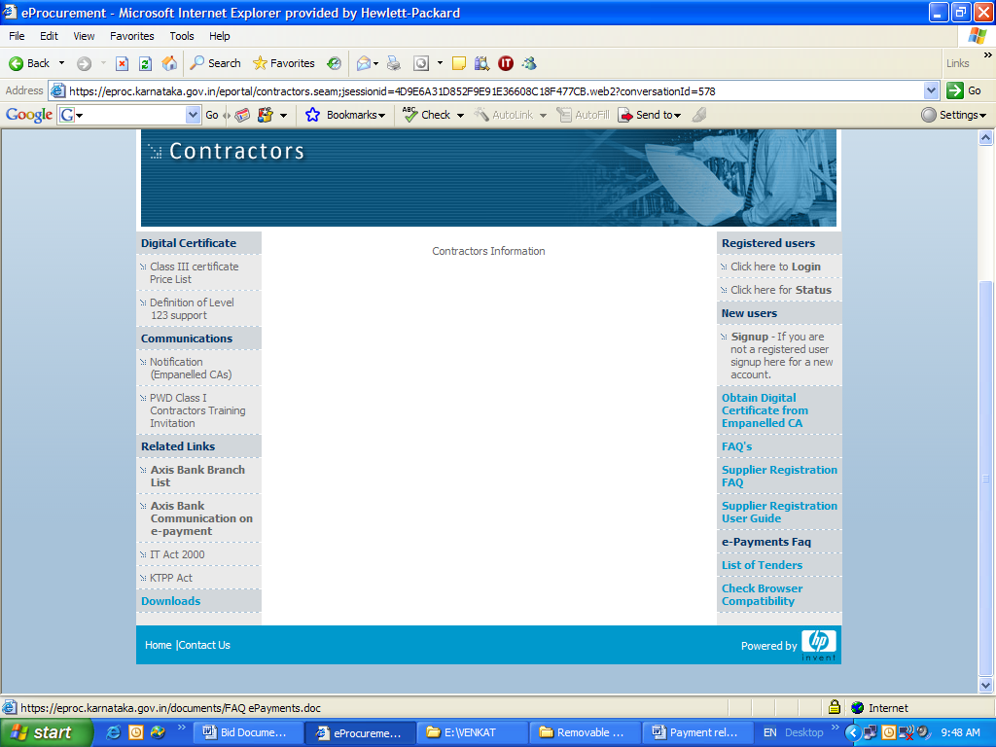
4. General conditions of Eligibility.
- EMD Payments through e-Payment mode shall be made as one single transaction and payments made in part are liable for rejection.
- EMD and Tender processing fee shall be paid through e-Payment using the following four modes of Payment:
  - Credit card payment
  - Direct debit payment
  - National electronic fund transfer
  - Over the Counter (OTC)
- Tenders from joint venture are not permissible.
- Sub-leasing / G.P.A. of work is prohibited.
- The intending bidder should furnish the certificate of registration issued by State / Central / Public Sector Organizations and certificate of enrollment in CNNL.

- Bidders shall not be under a declaration of ineligibility for corrupt and fraudulent practice issued by Government of Karnataka.

- The Bidder shall ensure credit of Tender Processing Fee and EMD into the respective receiving bank accounts of e-Procurement on or before the last date of bid submission.

- The tenderer is required to ensure browser compatibility of the computer well in advance to the last date and time for receipt of tenders.

- The departments shall not be responsible for non-accessibility of e-Procurement portal due to internet connectivity issues and technical glitches.

- Conditional tenders will be rejected.
- The tenderer shall bear all costs associated with the preparation and submission of his tender and the employer will in no case be responsible and liable for those costs.
- The tender processing fee will neither be refunded nor will be transferred to other works.
- The CNNL reserves the right of rejecting any or all of the tenders without assigning any reason and will not be bound to accept the lowest tender.
- If the rate(s) quoted by any tenderer for any item(s) is/are below the estimated rates of the department then the contractor shall furnish an additional performance security in the form of Bank Guarantee for an amount equivalent to the difference between the cost as per the quoted rate and the estimated rates. In case contractor quoting rate above 125% of the estimated rates, then the amount over and above 125% will be withheld during the progress of work.
- Royalty on construction materials and other taxes will be deducted as per prevailing Government orders.
- Amount put to tender includes cost of cement, Steel and other materials and labour charges. The rates quoted must also be inclusive of Sales Tax, Excise Duty, Royalty, Octroi, Quarry fee etc., No extra payment on this account will be entertained.
- Contractor has to make his own arrangement for procurement of all materials required for the work. There is no departmental supply of materials. Contractor should procure only ISI mark materials and submit necessary quality control certificates from the authorised quality control authority, before execution.
- One percent (1%) of the bill amount of the successful tenderer will be deducted towards the construction labour welfare fund as per Government Order LD / 300 / LET / 2006 Bangalore dated 01-01-2007 and Government letter No. PW / 134 / BMS / 2007 dated 27-07-2007.
- All scanned documents to be uploaded shall be in original and the Executive Engineer reserves the right to verify the documents before approval.
- Further details and information, if any, required can be had from the Office of the Executive Engineer, Harangi Rehabiliatatio Division CNNL, kushalnagar, Karnataka, on all working days during office hours.
- If any of the dates mentioned above happens to be a General Holiday, the next working day will hold good in lieu of the date mentioned.
- The work includes all lead and lift and work shall be carried out as per the instructions of the Engineer-in-Charge of the work. The rates in the schedule-B include all lead and lift irrespective of distance and height. No extra charges will be paid for additional lead and lift.
- The validity period for E.M.D. shall be for a minimum period of 180 days from the date of opening of tenders
- If Nigama wishes to engage third party inspecting agency for the said work, apart from the Quality Control authorities and field tests of the Nigama and Contractor, then the contractor should co-operate with the third party test and Quality Control authorities.
- Any necessary documents can be uploaded in spaces provided for general documents in upload document section.
- In addition to the above, all the conditions, as stipulated in the tender booklet of CNNL should be followed.
- No quaries are approved by CNNL for materials
- The defect liability period is 5 Years from the date of completion of work. An amount equal to 6.5% of contract value will be withheld as “Performance guarantee” out of the security deposit till the expiry of the defect liability period

(Naresegowda)
Executive Engineer,
Harangi Rehabilitation Division,
Kushalnagara, Somavarpet Taluk,
Kodagu Dist., Karnataka

No/EE/CNNL/HRD/KUS/PBC /T-N No. /ROAD / 2015-16/ / Dt :
  - Copy submitted to the Principal Secretary, Water Recourses Department, Vikasa soudha, Bangalore for kind Information.
  - Copy submitted to the Secretary, Water Recourses Department, Vikasa soudha, Bangalore for kind Information.
  - Copy Submitted to the Managing Director, CNNL,Registered Office, 3 rd & 4TH Floor Surface Water Data Analysis Building, Anand Rao Circle, Bangalore for kind Information.
  - Copy Submitted to the Managing Director, CNNL, Registered Office 4TH Floor, Gokulam, Manjunathapuram, Mysore for kind Information.
  - Copy Submitted to the Managing Director, KNNL, Registered Office 4TH Floor Coffee Board Building, Bangalore for kind Information.
  - Copy Submitted to the Managing Director, KBJNL, Registered Office, PWD Annex Building, K R Circle, Bangalore for kind Information.
  - Copy Submitted to the Chief Engineer, Irrigation (south) Zone, Mysore for kind Information
  - Copy Submitted to the Chief Engineer, Hemavathy Project Zone, Gorur, Hassan Dist for kind Information
  - Copy Submitted to the Chief Engineer, Hemavathy Canal Zone, Tumkur for kind Information
  - Copy Submitted to the Chief Engineer, WRDO, Anandarao circle, Bangalore for kind Information.
  - Copy Submitted to the Chief Engineer, C & B (South), Bangalore for kind Information.
  - Copy Submitted to the Chief Engineer, C & B (North), Dharwad for kind Information.
  - Copy Submitted to the Chief Engineer, M I (South), Bangalore for kind Information.
  - Copy Submitted to the Chief Engineer, M I (North), Bijapur for kind Information.
  - Copy Submitted to the Chief Engineer, PRED, Bangalore for kind Information.
  - Copy Submitted to the Chief Engineer, National Highways, K R circle, Bangalore for kind Information.
  - Copy Submitted to Superintending Engineer, KSRM & MIP Circle, Mandya for Kind Information.
  - Copy Submitted to Superintending Engineer, Harangi Project Circle, Kushalanagar, for Kind Information.
  - Copy Submitted to Superintending Engineer, Kabini & Varuna Canal Circle, Mysore for Kind Information.
  - Copy to the District bulletin officer, D C office, Mysore District, with request to publish the same in the District tender Buletin early and with a request to furnish a copy of the notification published to the undersigned.
  - Copy Submitted to the to Director Information and Publicity Department, No 5, Infantry Road, Bangalore for kind Information and advertise the brief notification in state level two Kannada & two English leading News Papers within the stipulated period and send 5 copies to the under signed.
  - Copy submitted to Water Resourses, kar nic .in, Principal System Analyst, National Information Centre, Ministry of Information Technology, Government of India, C wing 5th floor, Kendriya sadana, 17th main, 2nd block, koramangala, Bangalore 34.
  - Copy Submitted to the Personal Secretary to Hon’ble Minister for Water Resources Bangalore for kind Information.
  - Copy to the Compiler, Karnataka Gazette, Saraswathypuram, Mysore with request to publish the same in the State gazette early and with a request to furnish a copy of the notification published to the undersigned.
  - Copy to Audit officer/Project Branch of the Division for information.
  - Copy to Notice Board.
Sd/-
(Narasegowda)
Executive Engineer,
Harangi Rehabilitation Division,
Kushalnagara, Somavarpet Taluk,
Kodagu Dist., Karnataka

SECTION – 2

INFORMATION AND INSTRUCTIONS TO APPLICANTS

SECTION – 2

1.0. INFORMATION AND INSTRUCTIONS TO APPLICANT
1.1. INTRODUCTION:
Applications for Tender (Two cover System) are invited from experienced and competent contractors through e-procurement platform only for the work of Improvements to Road from Athur to Rehabilitation Colony Roads
The intending bidder / firm / company should be eligible contractors of PWD Class-I / Contractors of any State /Central Government /Public Sector organization enrolled compulsorily in category I-A or above category of CNNL, having requisite experience, expertise and financial capacity, and intend to bid should apply for tender in the manner set out in this Document. The Financial bid Documents of the Technically qualified bidders only will be considered and opened under this procedure.
1.2. Work:
Sl No | Work | Estimated Cost  Rs. In Lakhs | Stipulated period of completion  ( Including Monsoon)
01. | Improvements to Road from Athur to Rehabilitation Colony Roads | Rs. 326.20 Lakhs | 3 Months

1.3 INFORMATION TO APPLICANTS:
1.3.1 Earnest Money Deposit at one percent of the amount put to Tender should be paid along with the bids. Security Deposit at 6½ percent of the gross bill amount will be recovered from the contractor from the respective running bills. Besides the balance amount of the EMD due to difference between amount put to tender and the contract value will be recovered in the first running bill of the work apart from the said 6.5% of FSD.

    - All designs and works shall confirm to the specifications, standards and code of practices and other relevant Indian Standards or equivalent standards mentioned in the contract documents or as approved by the Engineer.
    - The law governing the contract will be the Indian law. The language in which the contract will be executed and operated will be English.
    - Name of the bidders who will be qualified in the Technical bid will be announced and only their financial bids will be opened on the stipulated date.

  - Arrangements for Preliminaries:
Contractor should make his own arrangements for preliminaries such as clearing of site marking the central lines etc., without any extra cost to Government.
  - Testing of work and Rejection of Defective Work:
The contractor shall furnish to the Engineer-in-charge or his authorized representative, with every responsible facility and assistance for ascertaining whether or not the performance is in accordance with requirements and is in terms of plans and specifications. Tests of materials or work will be conducted by the department wherever felt necessary. The contractor shall furnish such facilities, as the department may require for collecting and forwarding test samples of the work already completed for testing.
If on testing, it is found that the work is of substandard quality, the same will be rejected and the same is to be replaced with work of quality, as per specifications prescribed in the tender documents at no extra cost. Failure to reject any defective work during the progress of work shall not in any way prevent its rejection at the later date.
  - Entering into agreement:
The contractor whose tender is approved shall enter into an agreement within the prescribed time limit there from, failing which the Earnest Money Deposit shall be forfeited and action as described para 36 of PWG 66 will be taken.
1.7. Technical bid documents contain the following:
1. Schedules:
- Tender Application
- Schedule ‘A’ General Information
- Schedule ‘B’ Structure and Organization
Proforma B
- Schedule ‘C’ Project Execution Plan
- Schedule ‘D’ Personnel Capabilities
- Schedule ‘E’ Equipment Capabilities in
Proforma E₁ and E₂
- Schedule ‘F’ Work Experience in
Proforma F₁ to F₁₀
- Schedule ‘G’ Financial Capabilities
- Schedule ‘H’ Details of Specialized Agencies
- Schedule ‘I’ Affidavit
- Schedule ‘J’ Additional Information

  - Other Particulars.
    - Along with the above, the applicant should scan the following:
- Income tax and sales tax clearance certificate for the last three years.
- Companies audited balance sheets for the last three years. In case of a partnership or proprietary firms, the statement should be signed by a registered auditor.
- Legal status, place of incorporation, memorandum of understanding and articles of association.
- Solvency certificate from the banker.
- Power of attorney of the persons signing the document.
- Proof of experience in schedule – F.
- Registration certificates with concerned registering authority.
    - The first cover containing the Technical bid with all the above details and Documents along with necessary EMD duly superscripted as “Technical Bid” and the Second cover containing the financial bid duly filled in and superscripted as “Financial Bid “shall be put in one cover .
    - Some of the Schedules may require attachments. Such attachments should be clearly marked in the manner indicated below. Attachment 1 to Schedule ‘A’, Attachment 2 to Schedule ‘A’ etc.
    - While submitting the Schedules, applicant shall enclose latest copies of brochures and technical documentation giving additional information about the applicant.
    - No cost incurred by applicant(s) in making this offer, in providing clarification or attending discussions, conferences or site visits will be reimbursed by the Employer or the Engineer.
    - Applications for tender shall be submitted in proper format and incomplete offers are liable to be rejected.
    - The language for submission shall be English
    - The enclosed schedule should be filled in completely and all questions should be answered. If any particular query is not relevant, it should be replied as “not applicable”.
    - Back up by specialized agencies for items of work like sub-surface soil investigations and prestressing operations may be permitted, subject to the specific approval of the Employer / Engineer to the items of specification and the proposed agencies
    - Contractor shall not sublet any part of the work other than the specialized work without prior written consent of the Employer/ Engineer.
    - Financial data, project costs, value of works etc., should be given in Indian Rupees only.
    - For any clarifications, Executive Engineer, Harangi Rehabiltation Division, Kushalnagara, Somwarapet Taluk, Kodagu Dist. may be contacted by appointment.
    - The information furnished must be sufficient to show that the applicant is capable in all respects to successfully complete the envisaged work.
    - All recipients of Technical bid document (whether they submit Technical bid or not) should treat the document as strictly confidential.
    - The applicant is expected and deemed to have visited the project site before submitting Technical bid & financial Bid.
    - Even though the applicants were qualified, they are subject to be disqualified subsequently if they have;
- Made misleading or false representations in the forms, statements and attachments submitted in proof of the qualification requirements and / or.
- Record of poor performance such as abandoning the works, not properly completing the Contract, inordinate delays in completion, litigation history or financial failures etc.,
- The applicant shall bear all costs associated with the preparation of submission of his Technical bid document and the employer will in no case be responsible and liable for those costs.
    - The applicant, at his own responsibility and risk is encouraged to visit and examine the site of work and obtain all information. The costs of visiting the site shall be at the applicants own expense.
1.8.18 The tenderers while submitting the tenders for the works shall again be required to provide satisfactory evidence in respect of the information furnished by them in their application for Technical bid regarding their structure and organization, financial position/ arrangement, other resources including personnel and equipment, experience as well as work in hand etc., A legal document in the form of an affidavit to this effect, prescribed in schedule I has to be furnished along with the Technical bid application. The signing of the affidavit accompanying the Technical bid document forms is to ensure and guarantee the truth and accuracy of all statements and of all answers to questions made therein. The applicant’s attention is explicitly drawn to the fact that, even after the Technical bid of potential bidders has already been carried out, all bidders shall include a statement of the changes that may have occurred since Technical bid , with particular reference to the various items listed above and that further more, contract work shall be awarded to the successful tenderer, only on the basis of a careful scrutiny of all above information furnished by the applicant.
    - Evaluation of Technical bid Document.
The Technical bid document shall be considered to ascertain as to whether the bids.
- Meet the eligibility requirements.
- Contain all the details called for and are in proper format.
- Are accompanied by required authorization.
- Are otherwise generally in order.
    - The decision of the Employer / Engineer to accept or reject any bid will be final. The Employer/ Engineer reserve the right to reject any or all the bids without assigning any reason.
    - After Enstrustment of work to be qualified contractor, The Contractor should give the monthly physical progress.

SECTION – 3

SCHEDULES

AND PROFORMAS

SCHEDULE – A
GENERAL INFORMATION
1. | Name of Applicant:
2. | a) Head Office Address | b) Local Office Address
3 | Contact Person | Contact Person
4. | Telephone | Telephone
5. | Fax | Fax
6. | Place of incorporation/registration | Place of incorporation/registration
7 | Telex | Telex
8 | Year of incorporation/ registration | Year of incorporation/ registration

Nationality of owners
Sl. No. | Name | Nationality
1.
2.
3.
4.
5.

Date: CONTRACTOR

SCHEDULE – B

STRUCTURE AND ORGANISATION

The applicant is

An individual

A proprietary firm

A firm in partnership

A Niyamitha Company or Corporation
  - A group of firms/ joint venture
(if yes, give complete information in
Respect of each partner)

Name of applicant

Attach the Organization Chart showing the

Structure of the Organization, including the

Names of the Directors, position of officers

And the key personnel.

Number of years of experience

As a Prime Contractor (Contractor

Shouldering major responsibility)
  - As a Management Contractor

In a joint venture.

As Sub-Contractor (specify main Contractor)

- Were you ever required to suspend construction for a
Period of more than 6 month continually after you started?
If so, give the name project and reasons for there for

- Have you ever left the work awarded to you incomplete?
(If so, give name of project and reason for not completing work)

- In which fields of civil engineering Construction do you
Claim specialization and interest? Specify

For how many years has your organization

been in business of similar work under

Its present name? What were your fields

When your organization was established?

Whether any new fields were added in your

Organization? And if so, when?

Give details of your experience in

CC Lining with Mechanical paver

Give details of your experience

In using heavy earthmoving

Equipment (if any) and quality

Control in construction.

Give details of soil and material

Testing laboratory, if any, and

Describe your quality control

Procedures during construction.

Date: CONTRACTOR

SCHEDULE – C

PROJECT EXECUTION PLAN (PEP)

Name of Applicant:

The applicant is required to furnish Project Execution Plan (PEP) in the following format. A brief, but clear PEP is required describing planning and programming of the works.

Project Strategy: Outline statement of the organization and methods to be employed by the applicant to undertake the work.

Organization Chart: Preliminary organization chart indicating relationship between the head/ branch office and the local management monitoring supplies, co-ordination with the agency (Agencies) responsible for erection, testing and commissioning of the mechanical and electrical plant for the pumping stations and the supervising Cauvery Neeravary Nigama Niyamita Consulting Engineer.

Contract Information: The contractor shall indicate any specific areas of responsibilities assigned to individual members.

Responsibilities of Key Personnel: Identify all key personnel with management responsibilities by activity or section of work.

Management System: Outline the management techniques used to identify, evaluate and control the technical elements and schedule of the work.

Quality Management System: Provide a description of the Quality Assurance/ Quality Control System – Organization and procedures in use and identify the accreditation authority.

Project Safety Plan: Provide a statement outlining the Health and Safety plan operated by the company.

Contractor shall indicate any permanently established groups within the organization which would provide specific functions in the execution of the contract.

Programmer / Bar chart showing major activities.

Date:

Name: CONTRACTOR

SCHEDULE – D
PERSONNEL CAPABILITIES
Details of Personnel with the Applicant and number likely to be made available for this work.
Name of Applicant:
Sl. No. | Designation | Name | Qualification | Experience | Details of works carried out with special reference to similar insitu cement concrete work | On applicant’s payroll | Likely to be made available for this work
1 | 2 | 3 | 4 | 5 | 6 | 7 | 8
1. | Project In charge (Capable of handling projects of magnitude of the Project under consideration)
2. | Site Engineer  - Civil Engineer  ii) Mechanical Engineer
3. | Site Engineer (Ancillary Works)
4. | Technical Officers:  a) For Design of  i) Civil Works  - (Graduate)  - (Diploma Holders)  - Mechanical Works  - (Graduate)  - (Diploma Holders)

1 | 2 | 3 | 4 | 5 | 6 | 7 | 8
b) For Construction Supervision of
i) Civil Works
- (Graduate)
- (Diploma Holders)
- Mechanical Works
- (Graduate)
- (Diploma Holders)

5. | Administrative Officers (Graduate)
6. | Skilled Employees
7. | Unskilled Employees
- In the case of personnel at Sl. Nos. 1, 2, 3, 4 and 5 please give name, qualification, present posting, professional experience and ability relevant to the project in respect of those who are proposed to be posted in the present work.

CONTRACTOR

SCHEDULE – E

Proforma E1
EQUIPMENT CAPABILITIES
DETAILS OF PLANT AND EQUIPMENT PROPOSED TO BE DEPLOYED BY THE APPLICANT FOR USE ON THIS WORK.
Name of the Firm:
Sl. No. | Name of Equipment | For Each work Total Requirement |  |  | Equipment on hand |  |  |  | Equipment to be procured
Sl. No. | Name of Equipment | No. of units required for the project | Kind and make | Capacity | No. of each | Years of manufacture and present condition | Present location | Owner/ leased | No. of each | Capacity and make | Through purchase/ lease
1 | 2 | 3 | 4 | 5 | 6 | 7 | 8 | 9 | 10 | 11 | 12
1 | Excavator | 02 |  | (1.00 Cum)
2 | Vibratory roller | 02 |  | Suitable Capacity
3 | Dumpers/ Tippers | 04 |  | Optional
4 | Hot mix Plant | 01 |  | Suitable Capacity
5 | Concrete Mixer | 01 |  | (10/7 Cft)
6 | Water Tanker with Tractor / Tipper mounted (Suitable capacity) | 03 |  | Optional
7 | Road Paver (Suitable Capacity) | 01 |  | Suitable Capacity
- If leased, indicate the date when the current lease expires.

2) Describe fabrication and workshop facilities with relevant details.

CONTRACTOR
SCHEDULE - E
Proforma E2
SCHEDULE OF MACHINERY AND EQUIPMENT AVAILABLE WITH THE BIDDER
Sl. No | Name of Machinery | Requirement for the work | Capacity and Size | Nos | Make and year
1
2
3
4
5
6
7
8
9
10
11
12
13
14
15
16
17
18
19
Whether the all are owned or leased
Evidence of ownership / lease certificate to be furnished

CONTRACTOR

SCHEDULE – F
WORK EXPERIENCE

Name of the firm:
Proforma F1
Total number of years of experience in civil construction work:
 | NATURE OF WORK | NUMBER OF YEARS OF EXPERIENCE
i)
ii)
iii)
iv)
v)
vi)
Proforma F2
Total number of years of experience in specialized construction work:
(Indicate works that are relevant to the works for which this pre-qualification application is sought)
 | NATURE OF WORK | NUMBER OF YEARS OF EXPERIENCE
i)
ii)
iii)
iv)
v)

CONTRACTOR

SCHEDULE –F

PROFORMA F3
EXPERIENCE |  | Similar Road works Completed |  |  | Company
 |  | Please fill information about the similar Road works with minimum cost of Rs. 120.00 Lakhs completed during the last 5 years
Sl. No. | Name of Employer & Address | Name of contractor, location, type of contract of nature of work | Name of Engineer responsible for supervision | Contract price in Rs. Lakhs and date of award |  | Percentage of participation of company project |  | Stipulated period completion | Executed Quantity |  | Was contract satisfactorily completed in time, if not actual period of completion |  | Whether any penalty/ compensation was levied, if so, how much and for what reason.
 |  |  |  |  |  |  |  |  | Botuminous concrete in Sqm | Embankment in Cum
1 | 2 | 3 | 4 | 5 |  | 6 |  | 7 | 8 | 9 | 10 | 11

Note:

Use a separate sheet for each contract.

Certificate from the employers to be attached for individual works. (In the prescribed proforma enclosed)

CONTRACTOR

SCHEDULE F

PROFORMA F4
EXPERIENCE |  | COMPLETED ENGINEERING WORKS
 |  | Please fill information about completed engineering projects during last 5 years
Sl. No. | Name of Employer & Address | Name of location & type contract | Name of Engineer responsible for supervision | Contract price and date of award | Percentage of participation of company project |  | Stipulated period completion | Was contract satisfactorily completed in time, if not actual period of completion | Whether any penalty/ compensation was levied, if so, how much and for what reason.
1 | 2 | 3 | 4 | 5 | 6 |  | 7 | 8 | 9

Note:

Separate sheet for each work to be furnished.

Certificates from the Employers to be attached for individual works to be furnished in the Performa prescribed in page No. 66

CONTRACTOR

SCHEDULE -F

PROFORMA F5
EXPERIENCE |  | ALL WORKS IN PROGRESS
 |  | Give information about all works in progress including those where the bidder has received a letter of intent and formal contract has been awarded.
Sl. No. | Employer | Engineer responsible for supervision | Location & Description of the work | Percentage of participation of company in the project | Value of Contract |  | Value completed and certified | Percentage of work physically completed | Schedule date of completion of work
1 | 2 | 3 | 4 | 5 | 6 |  | 7 | 8 | 9

Note:

In the case of on going works, the contractor should submit certificates from the employers concerned that the work is progressing satisfactorily as per the approved work programme.

Separate sheet for each work to be furnished.

Source / Credit facilities availed for the above works to be furnished duly certified by the Auditor / Qualified Chartered Accountant.

CONTRACTOR

SCHEDULE F

PROFORMA F6
EXPERIENCE |  | LIST OF WORKS BID FOR BUT NOT AWARDED
Sl. No. | Employer | Consultant Supervising | Location & Description of the work | Percentage of participation of company in the project | Value of Contract in Indian Rupees |  | Date of Bid | Expected date of Award | Staff connected on the work | Equipment connected on the work | Position in Bid if known
1 | 2 | 3 | 4 | 5 | 6 |  | 7 | 8 | 9 | 10 | 11

Note:

This page is to be certified by the Auditor / Qualified Chartered Accountant. Certificate from Employers may be attached.

Source / Credit facilities availed for the above works to be furnished.

CONTRACTOR

SCHEDULE –F
PROFORMA – F7
DETAILS OF WORKS CARRIED OUT BY THE BIDDER
Sl. No | Name of work completed of similar nature | Estimated Cost Rs. In lakhs | Amount of Contract Rs. In lakhs | Actual amount of final bill received or to be received | Agreed period of completion |  | Actual period of completion |  | Name of Country or State in which was the executed | Guarantee period provided work after commissioning
 |  |  |  |  | From | To | From | To | Name of Country or State in which was the executed | Guarantee period provided work after commissioning
1 | 2 | 3 | 4 | 5 | 6 | 7 | 8 | 9 | 10 | 11
 | Certificate from the employer to be attached for individual works

CONTRACTOR

SCHEDULE F
PROFORMA- F8
DETAILS OF WORKS ON HAND
Sl. No | Name of work | Estimated cost Rs. In lakhs | Amount of Contractor Rs. In lakhs | Date of agreement | Agreed period of completion | Agreed progress to end of previous month | Actual progress to end of previous month | Value of outstanding works Rs. In lakhs | Name of place in which the work is being executed
1 | 2 | 3 | 4 | 5 | 6 | 7 | 8 | 9 | 10
1 | Certificate from the employer about the satisfactory progress of works to be attached for individual works.
2 | Details of all works which are at various stages of execution including works for which work order has been received but work is yet to be started
3 | Details as available at the time of preparation of this document have to be provided

CONTRACTOR

SCHEDULE –F
PROFORMA – F9
DETAILS OF WORKS ALREADY TENDERED
Sl. No | Name of work tendered for | Estimated cost | Amount of contract | Name of place in which the work is tendered and for whom
1 | 2 | 3 | 4 | 5

CONTRACTOR

SCHEDULE F

PROFORMA –F10

Work Done Certificate
Name of the Department
Name of the Zone
Name of the Circle
Name of the Division
Name of the work
Brief description and nature of work

Name of the Contractor And Class & Reg. No.
Agreement No / date
Contract Value
Date of Commencement
Date of completion as per agreement
Actual date of Completion/commissioning
Reasons for delay in completion
Total amount of work done (Value of work on completion)

CERTIFICATE

This is to certify that Sri………………………………….. Class-I Contractor has taken up the above work on tender basis costing Rs. ……………………………. (in words) …………………….. ………….. in this division and completed the work satisfactorily during the year…………….. The contractor is capable of executing works to the satisfaction of department. He is possessing required men and machinery with experienced engineers for supervising the works efficiently. The details (physical quantities) of major items of work executed by the agency are as follows.
Sl. No. | Item Description | Unit | YEAR WISE BREAK UP |  |  |  |  | TOTAL
Sl. No. | Item Description | Unit | 1 | 2 | 3 | 4 | 5 | TOTAL
 | CIVIL WORKS-ROAD
1 | EXCAVATION | CUM
2 | EMBANKMENT | CUM
3 | GRANULAR SUB BASE | CUM
4 | METALLING-WBM-GRADE-II | CUM
5 | PRIMER COAT WITH BITUMEN EMULSION | SQM
6 | TACK COAT WITH BITUMEN EMULSION | SQM
7 | OPEN GRADED PREMIX CARPET – CASE-II -MECHANICAL MEANC | SQM
8 | SEAT COAT- MANUAL MEANS- CASE-I | SQM
 | CD WORKS
1 | IN SITU CEMENT CONCRETE | CUM
2 | Steel | tone
3 | NP3 Pipes | Nos
4 | Pitching | CUM

Executive Engineer,

SCHEDULE – G

Financial Capabilities

Name of Applicant

Summary of assets and liabilities on the

Basis of the audited financial statement

of the last three financial years (attach

copies of the audited financial statements

of the last three financial years)

Banker

Name of Banker :

Address of Banker :

Telephone :

Contact Name & Title :

Fax :

Telex :

Financial Information Rs. in Lakhs.
Sl. No. | Information | Year  2010-11 | Year  2011-12 | Year  2012-13 | Year  2013-14 | Year  2014-15
a. | Total assets
b. | Current assets
c. | Cash, temporary investments; and current receivables.
d. | Total liabilities
e. | Current liabilities
f. | Profit before tax
g. | Profit after tax
h. | Net worth
i. | Working Capital

Annual value of construction works, undertaken for each of the last five years and projected for current year:
Year | Current Year | One year before | Two years before | Three years before | Four years before | Five years before
a) | Home
b) | Abroad

Net Profit before tax

Current Period :

During the last financial years:

During each of the four previous

financial years: The Profit & Loss Statements have been certified through

________________ by__________________

Applicant’s financial arrangements for the proposed work (Exact amount in Rupees to be mentioned)

Own Resources:

Bank Credits:

Others (Specify):

Certificate of financial soundness from bankers of applicant together with their full address:

Credit Facilities:

Name / Address of Nationalised

Bank providing credit line.

Total Amount of credit line

(Attach certificate from bank)

Approximate value of works on hand:

Value of anticipated orders for next financial year:

Home

Abroad

NOTE:

All items should be properly filled in. where any particular item is not applicable, it should be clearly mentioned as ‘Not applicable’.

CONTRACTOR

SCHEDULE – H

DETAILS OF SPECIALIZED AGENCIES
Section of Works | Approximate Value* | Name (S) Address of specialized Agencies | Description, Location of similar works previously executed by specialized agencies

1.
2.
3.
4.
5.
6.

* Value in Indian Rupees Equivalent

CONTRACTOR

SCHEDULE – I

AFFIDAVIT

I, the undersigned, do hereby certify that all the statement made in pre-qualification document and in the required attachments are true and correct.

The undersigned hereby authorize(s) and request(s) any bank, person, firm or corporation to furnish pertinent information dee med necessary as requested by the Department to verify this statement or regarding my (our) competence and general reputation.

The undersigned understands and agrees that further qualifying information may be requested and agrees to furnish any such information at the request of the Department/ Project implementing agency.

(Signed by an Authorized

Officer of the firm)

---------------------------------

Title of Officer

---------------------------------

Name of the firm

---------------------------------

Date

SCHEDULE – J

ADDITIONAL INFORMATION

(any further relevant information required for the evaluation of their pre-qualification bid)

CONTRACTOR

APPENDIX – I

ADDRESSES FOR COMMUNICATION

Sl. No. | Addresses | Phone No. | Fax No. | E-Mail
1 | The Managing Director, Cauvery Neeravari Nigama Niyamitha, Surface Water Data Center 3rd & 4th floor, Ananda rao Circle, BANGALORE-1. | 080-22352997 | 080-22352998 | cnnbantech@yahoo.co.in
2 | The Managing Director, Cauvery Neeravari Nigama Niyamitha, Cauvary Bhavana Sankeerna , Gokulam Manjunathapuram Mysore-1. | 0821 – 2412101 | 0821-2414191 | cnnlmysore@yahoo.co.im
3 | The Chief Engineer,  Cauvery Neeravari Nigama Niyamita, Irrigation(South) Zone, Mysore, Mysore District. | 0821-2443603 | 0821-2520477 | ceis_mysore@yahoo.co.in
4. | The Superintending Engineer, Harangi Project CircleKushalnagara Kodagu District. | 08276-274368 | 08276-274371 | seharangi@yahoo.com
5 | Executive Engineer, Harangi Rehabiltation Division  Kushalnagara,Somwarpet Taluk, Kodagu District. | 08276-274365 | 08276-274365 | eehrdksh@gmail.com

DECLARATION

NAME OF WORK:
Name of Work: Improvements to Road from Athur to Rehabilitation Colony Roads.

(A declaration to be furnished stating that, there is no deviation in technical and commercial aspect from those specified in the bid document)

Place :
Date :

SECTION-8
DRAWINGS

PLAN & SECTION OF 600 MM DIA 1 Row Pipe Culvert
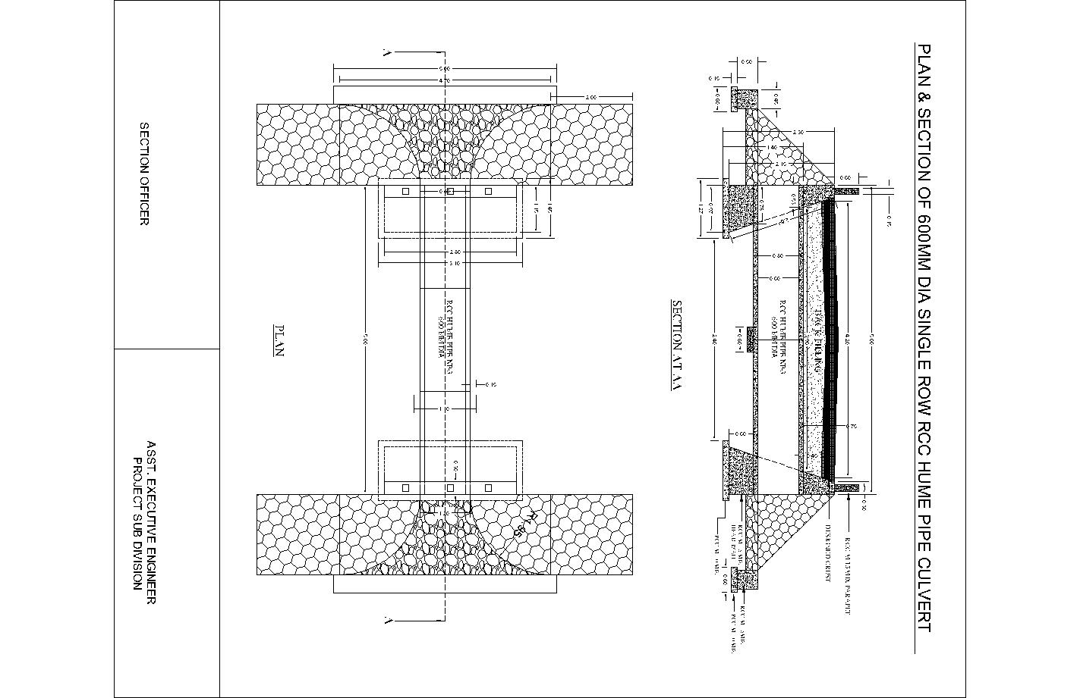

PLAN & SECTION OF 1000 MM DIA 1 Row Pipe Culvert
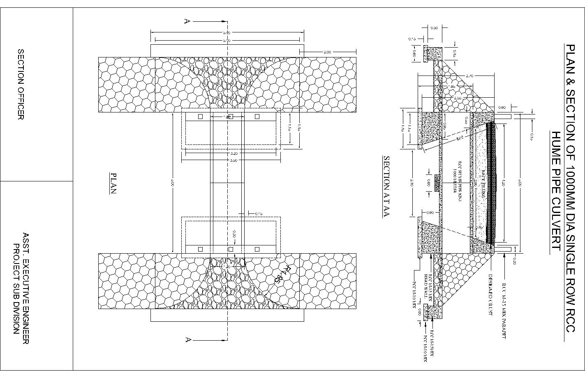

PLAN & SECTION OF 1000 MM DIA 2 Row Pipe Culvert
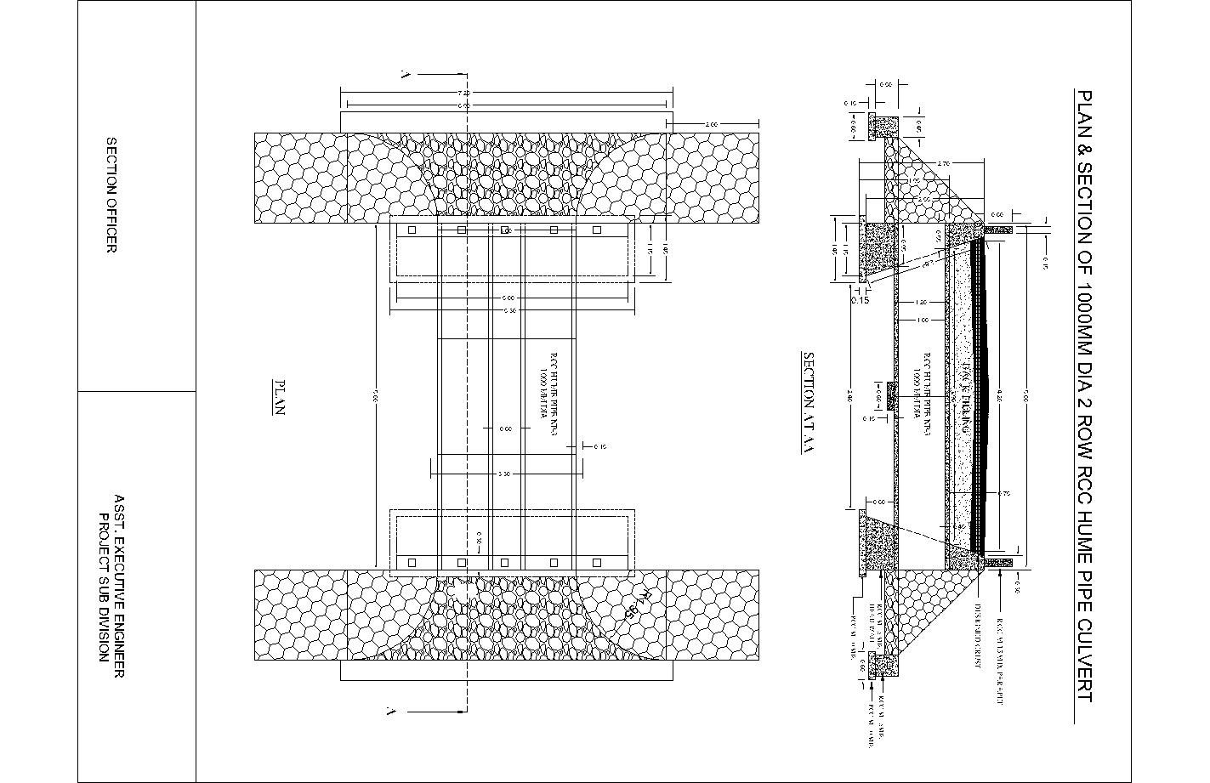

PLAN & SECTION OF 1000 MM DIA 3 Row Pipe Culvert
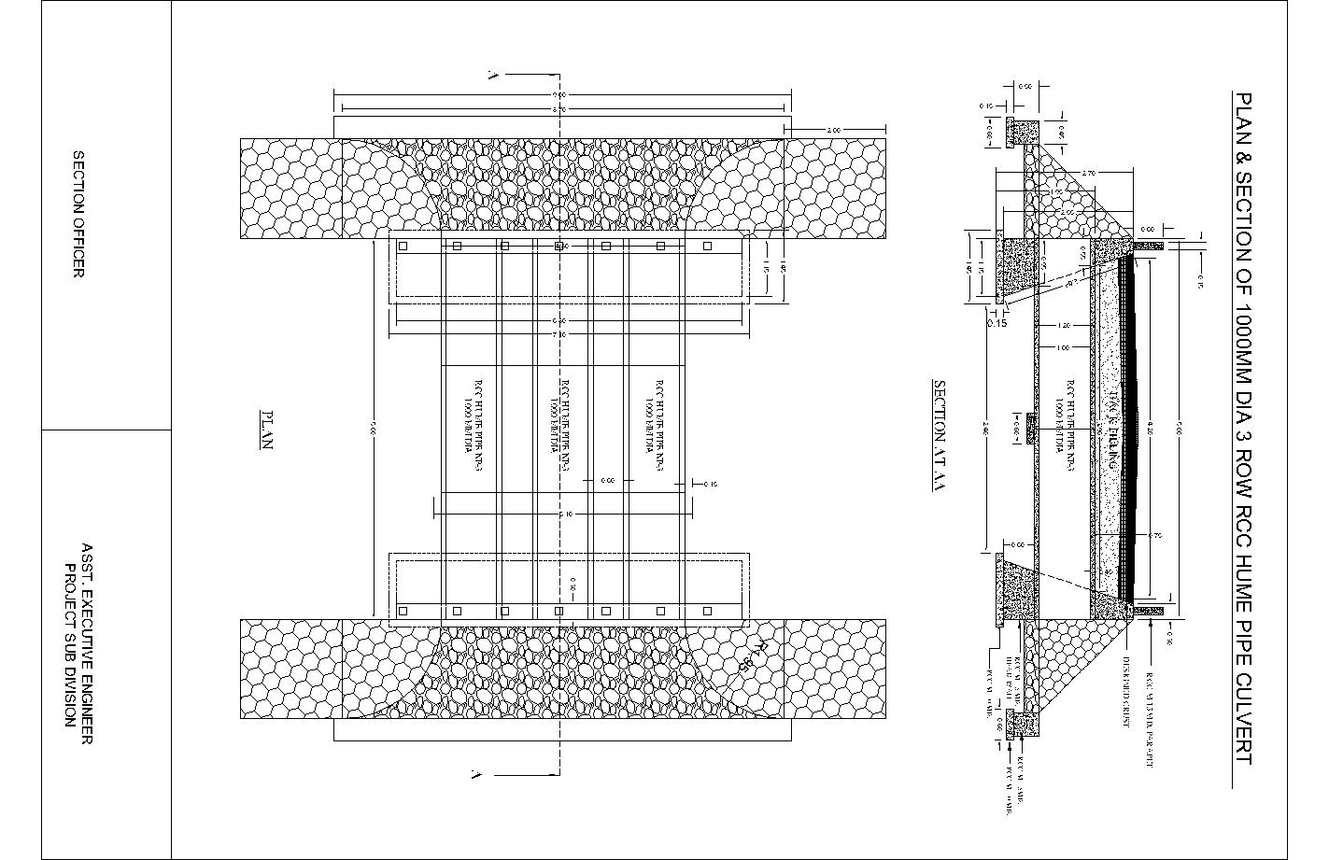

TYPICAL CROSSECTION OF ROAD
